Chapter 3: The Accounting Information System

T- accounts- for each transaction we have to identify the double entry and prepare a journal entry

Assets
Increase- left side (DR)
Decrease- right side (CR)

Liabilities
Increase- right side (CR)
Decrease- left side (DR)

Owner’s Equity
- Common shares has a credit balance (same as share capital)
- Retained earnings, contains:
  - Revenue CR balance
  - Expenses DR balance
  - Dividends DR balance

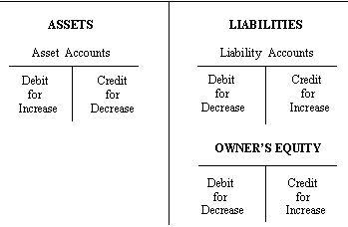
** Must have one debit, one credit

Transaction #1: Company issues common shares for cash
DR- Cash account
CR- Common shares account

Journal entry DR CR
Cash 10000
Common Shares 10000

#2 Borrow Money from bank
DR- Cash
CR- bank loan

Journal entry DR CR
Cash 6000
Bank loan 6000

Be able to do a journal entry and identify accounts (T accounts too)

The order in which we record transactions
- Transactions double entry (Which one DR which one CR?)
- Journal entry
- Post to ledger
- Trial balance

Trial Balance
Oct 31st, 2014
DR CR
Assets *
Liabilities *
Common Shares *
Retained earnings *
Revenue *
Expenses *
Dividends *

Watch out for these mistakes that may cause the trial balance to still balance:
- Transaction isn’t journalized
- An entry isn’t posted
- Entry posted twice
- Incorrect amounts used
- Errors that cancel out each other effects

Expanded Accounting Equation 

