Chapter 1: The Purpose and Use of Financial Statements
Use and Users of Accounting
- Accounting identifies and records the economic events of an organization and communicates to interested users
- There are 2 users: internal and external
  - Internal users: work for the company (managers, employees, those who run and organize the company)
  - External users: do not work for the company (investors, lenders, customers, labour unions, taxing authorities and regulators)

Ethical Behavior
- For accounting information to have value, preparers must have high ethical standards
  - Actions must be legal and responsible, consider organization’s interests
- Accountants and other professionals have to follow codes of conduct

Forms of Business Organizations
Proprietorship
- Owned by one person
- Simple set up
- Owner has control over business
- Limited life
- Unlimited liability
- Income tax paid by owner
- Reporting entity concept- business and personal records are kept separate

Partnership
- Similar to proprietorship except owned by more than one person
- Formalized in a written agreement
- Limited life
- Each partner has unlimited liability for all debts
- Income tax paid by individual partners
- Reporting entity concept

Corporations
- Separate legal entity owned by shareholders
- Indefinite life; ease of raising capital
- Shareholders enjoy limited liability
- Corporation pays income tax
- May be public or private:
  - Public if shares are publicly traded on TSX
- Reporting entity concept

Generally Accepted Accounting Principles (GAAP)
- Rules for the preparation of financial statements
- Different for publicly traded and private corporations
  - Publicly-traded corporations use International Financial Reporting Standards (IRFS)- global accounting standards
  - Private corporations may use IRFS or Accounting Standards for Private Enterprises (ASPE)- Canadian
- Proprietorships and partnerships generally follow ASPE for external reporting

Three Types of Business Activities
- All companies are involved in all 3 activities
  - Financing
  - Investing
  - Operating

Financing Activities
- Obtaining (and repaying) funds to finance the operations of the business
  - Borrowing money or repaying loans (debt)
  - Selling or repurchasing shares or distributing dividends (equity)
- Forms of debt include bank indebtedness, bank loans, noncurrent debt such as mortgages, bonds, leases
  - Bank indebtedness- results when a company uses its operating line of credit to cover cash shortfalls and overdraws its bank account
- A corporation may obtain equity financing by selling shares of ownership to investors
- Investors pay common shares- amount paid by investors for a share in the company
  - Share capital- money invested in a company by the shareholders
- When investing, you are not entitled to a return until the corporation has paid back all debts.
- Dividends- payments to shareholders

Investing Activities
- Purchase or sale of long-lived assets that the company needs to operate (investing activities don’t just involve investments)
  - Cash that is unused may be invested into investments such as bonds and shares which are assets
  - Purchase or sale of long lives assets such as property, equipment and intangible assets (patents, copyrights, trademarks)

Operating Activities
- Operating activities are the main day-to-day activities of the business
- EX. Revenue, expenses, A/R, A/P
- Supplies is a short-term asset used in day to day operations, a company must obtain inventory
- Selling merchandise generates revenue but also incurs operating expenses
- There are different expenses depending on the asset consumed ex COGS, operating and administrative expenses, interest expense and income tax expense
  - Amortization (under operating and administrative expenses)- allocation of the cost of intangible assets
- To determine if profit was made, the company compares revenue and expenses. The goal is to sell a good or service for a price above the cost of selling it.
  - Profit (loss) = revenue - expenses

Financial Statements
- Income statement
  - Reports revenues and expenses for a specific period of time (illustrates the companies performance)
- Statement of changes in equity
  - Reports the change in each component of shareholders’ equity (usually common shares and retained earnings) as well as total equity during a period of time
- Statement of Financial position
  - Shows the assets, liabilities and shareholders’ equity at a specific point in time
- Statement of cash flows
  - Shows, for a specific period of time, where company obtained cash and how that cash was used
** Additional information is reported in the notes to the financial statements
**Order of preparation of statements:
Income statement => Statement of changes in equity=> Statement of financial position=> Statement of cash flows
** Financial statements are produced annually and quarterly for public corporations. They are produced monthly for internal use

Income Statement
- Revenues
  - Arise from sales of goods or services
  - Result in an inflow of assets
- Expenses
  - Costs of assets consumed or services used to generate revenues
- Shows Profit (loss)
  - =Revenue – Expenses
- This statement is useful because profit can be used to predict the future of a company

Sierra corporation
Income Statement
Month ended October 31st, 2015
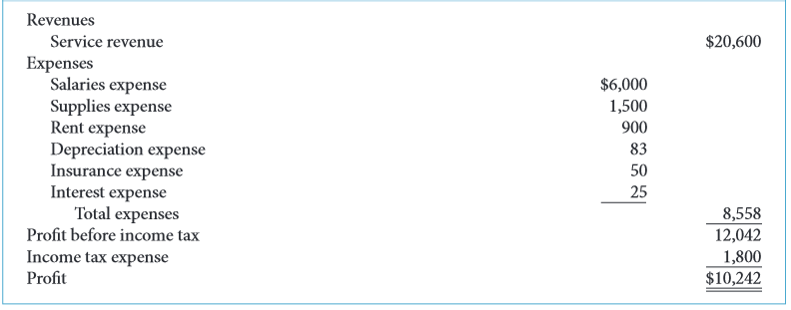

Statement of Changes in Equity
- Shows the changes in each component (and total) of shareholders’ equity for the period
- Ownership in the company is known as shareholders equity and it includes:
  - Share capital
  - Retained earnings
- Share capital
  - Amounts contributed by shareholders
  - May include common and preferred shares
- Adds any changes in share capital due to new issues shares (or deductions due to shares being repurchased)
- Changes in shares
  - Common shares, beginning of period + common shares issues (sold)- common shares repurchased = common shares, end of period
- Retained earnings/ deficit (losses- negative retained earnings= deficit)
  - Cumulative profit retained in the company
  - Profit that has not been paid out to shareholder that has accumulated since the company’s date of incorporation
- Changes in retained earnings
  - Retained earnings, beginning of period + profit (or loss) – dividends = retained earnings, end of period
** note profit = revenue- expenses

Sierra Corporation
Statement of Changes in Equity
Month Ended October 31, 2015
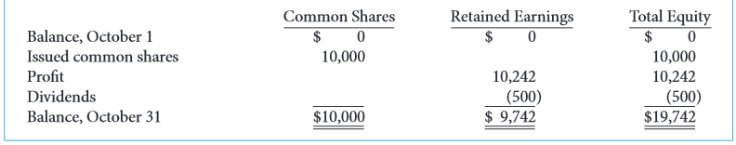

Statement of Financial Position (Balance Sheet)
Consists of:
- Reports Assets (resources owned by a business) and claims to those assets at a specific point in time
- Liabilities (claims of lenders and other creditors)
- Shareholders’ equity (claims of shareholders)
- Accounting eqn’ (assets = liabilities + shareholders’ equity)=> balance sheet must balance

Sierra Corporation
Statement of Financial Position
October 31, 2015
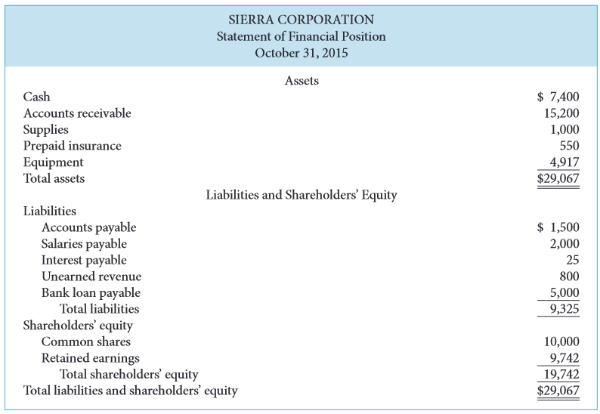

Statement of Cash Flows
- Main function is to provide financial information about the cash receipts and cash payment of a business for a specific period of time
- To help investors, lenders and other creditors analyze the company’s cash position
- Reports the effect on cash of the company’s
  - Operating activities
  - Investing activities
  - Financing activities
- Shows net increase or decrease in cash for the period

Sierra Corporation
Statement of Cash Flows
Month ended October 31, 2015
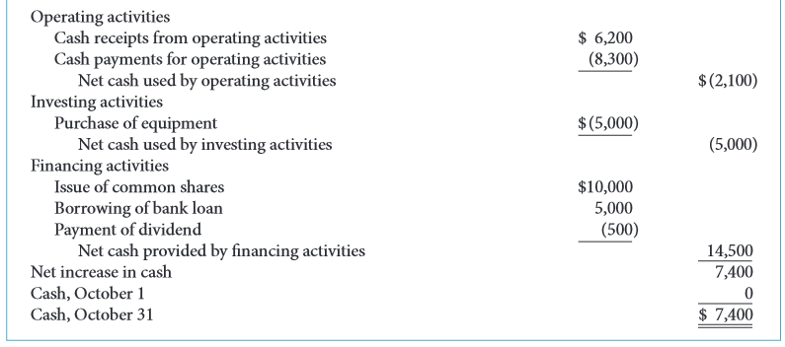

Relationship Between Statements
- Statements are interrelated: results from some statements are used as data in other statements
- Profit from income statement is reported in statement of changes in equity
- Ending balances of each shareholders’ equity account is reported in both statements of financial position and changes in equity
- Statement of cash flows is related to statement of financial position

