COMM 212 (Business Communication)

Chapter 1: Getting the Message Across
Communicating for a changing workplace
- Our country is on the cusp of an advanced technology revolution
- This transformation encompasses a changeover to:
- The knowledge economy
- Flatter organizations
- Business on a global scale
- Diverse employee base
- Team work environments
- Advancing communication technologies
The Knowledge of the economy
- Today’s economy is in the age of information and it is knowledge based
- Knowledge workers make and sell an idea based product: e.g. software, consulting
- Advantage of knowledge based ideas is that their value can rapidly grow as the global market expands

Flatter Organizations
- Hierarchies may be flattened as companies strive for cost- savings, efficiency, competitiveness, and sustainability
- The democratization of the workplace make shorter communication chains, there every individual must be a skilled communicator

Business on a global scale
- World’s economy has become increasingly global, and the world seems to have shrunk:
  - Netscape: promoting connectivity and the free flow of information
  - Software: promoting wider co-operation
  - Open-sourcing: software in the public domain
  - Outsourcing and offshoring: redistributing aspects of business to other countries
  - Amplifiers: digital, virtual, mobile and personal

More Diverse Employee Base
- Canadian workplace consists of all different kinds of ethnicities, races, ages, genders, physical abilities, sexual orientation
- You need to diversify the workplace, or you may miss out on the “diversity advantage”

Teamwork Environments
- Teams are the way to do business
- Collaboration through cross functional teams, in which people from different areas of expertise come together to share information for a common goal
- Good interpersonal and communication skills are essential for success in a team environment
- Virtual project team- eliminate time and space barriers

Advancing Communication Technologies
- Our communications are mediated through many different technologies (e.g. phones, fax, computer etc.)
- Allow us to communicate: farther, faster, and around the clock

Social Networking sites: Facebook, MySpace, Twitter
- Facebook’s purpose is to facilitate the spread of information through social networks allowing people to share information online the same way they do in the real world

3D Virtual Worlds
- User participants create avatars or alter-egos and in return receive and experience of synchronous virtual role playing action

Communication Defined
- Communication: transactional and relational process involving the meaningful exchange of information.
- Communication theory: a system of ideas for explaining communication.
- Rhetoric: the use of language to persuade an audience
- Semantics: the study of the words and symbols we choose
- Semiotics: the study of how meaning is assigned and understood
- Cybernetics: the study of how information is processed and how communication systems function

Communication Process
- Situated: embedded in particular environment or socio-cultural context
- Relational: ability to interact effectively and ethically with others, according to what is needed at the given moment
- Transactional: cooperative activity in which people adapt to one another
Transactional Communication Model:
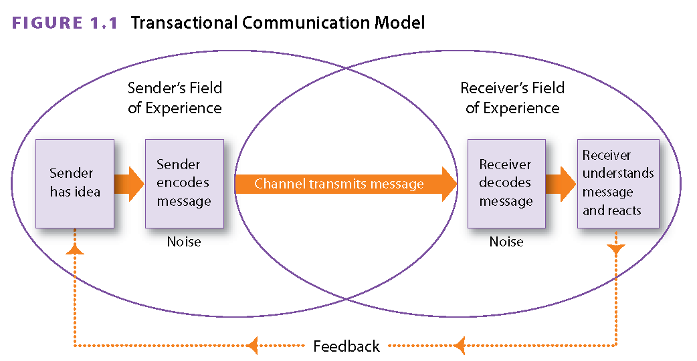
- Message: oral, written or non-verbal communication that is transmitted by a sender to an audience
- Sender: the participant in a transaction who has an idea and communicates it by encoding it in a message
- Encoding: the act of converting ideas into code in order to convey a written, oral, or non-verbal message
- Channel: a communication pathway or medium over which a message travels
- Receiver: the person for whom a message is intended, who decodes the message by extracting meaning from it
- Decoding: the act of extracting meaning from spoken, written, and non-verbal communication
- Feedback: the receiver’s response to a message that confirms if the original message was received and understood

Barriers to Effective Communication

- Communication Barriers: problems that can affect the communication transaction, leading to confusion or misunderstanding
- Noise: any form of physical or psychological interference that distorts the meaning of a message
- Channel Overload: the inability of a channel to carry all transmitted messages
- Information Overload: a condition whereby a receiver cannot process all message due to their increasing number
- Emotional Interference: a psychological factor that creates problems with the communication transaction
- Semantic Interference: interference cause by ambiguity, jargon, language, or dialect differences, and different ways of assigning meaning
- Bypassing: misunderstanding that result from the receiver inferring a different meaning from a message based on the various meanings of the words that are used.
- Physical Interference: interference external to the sender and receiver
- Mixed Messages: Conflicting perceptions of a signal or message that may result in miscommunication
- Channel Barriers: inappropriate choices of channel that impede communication
- Environmental Interference: interference that results from the preconceptions and differing frames of reference

Overcoming these Barriers:

- Be timely and sensitive: respond promptly, choose the right times (if emotionally charged)
- Be Purposeful: always state your purpose at the beginning in all but the briefest messages
- Be a good listener and a careful reader: give your full attention
- Be context-sensitive: consider the situation, use the right channel
- Be proactive: if you are in doubt about what is said, verify facts get the right information

Communication Contexts
- Interpersonal communication: between two people (dyadic: a group of two) either face to face or through mediated forms.
- Small-Group communication: interactional process between three or more (up to 20). Can be complex due to interpersonal and psychological issues
- Organizational communication: communication within a hierarchical social system. Composed of interdependent group striving for common goals.
- Intercultural communication: management of messages between people of different cultures.
- Mass communication: small group of people send a message to a large anonymous audience. Indirect, often through media. (NOT face-to-face public announcements)

Non-Verbal Communication
- 7% of the meaning is in the words that are spoken
- 38% of the meaning is paralinguistic
- 55% of the meaning is non-verbal expression

Examples of non-verbal cues: tone, inflection, facial expressions, body movements, posture, gestures, appearance, use of personal space and the use of time.
It is a communication that does not use words but takes place through gestures, eye contact and facial expressions.
5 Roles of non-verbal communication:
- Repetition: non-verbal cues can repeat the message (e.g. “fix this computer” (point at it as well)
- Contradiction: they can conflict with your intended message (e.g. saying you’re confident but not maintaining eye contact)
- Regulation: they can regulate conversations (e.g. tapping a person on the shoulder)
- Substitution: they can stand in for a verbal message, can sometimes speak louder than words (e.g. a facial expression)
- Accenting and complementing: they can amplify or tone down a verbal message (e.g. pounding a table)

Components of non-verbal communication:

- Proxemics: the study of use and perception of space
- Intimate distance for embracing, touching or whispering/close friends/family (46cm)
- Personal distance for communicating among close business associates (46cm-1.2m)
- Social distance for business conversations (1.2m-3m)
- Public distance used for public speaking (+3 m)

- Chronemics: the study of time in non-verbal communication
- Determining how long to do something, or how early to be at a meeting etc.

- Paralanguage (vocalics): non-verbal vocal qualities of communication

- Vocal qualities: pitch, volume, speed, emphasis etc. What makes each voice unique
- Vocal Characteristics: sounds that express emotion: crying, laughing, yelling
- Vocal Segregates: pauses or fillers: umm, ahh, you know

- Body language (Kinesics): non-verbal communication conveyed by gestures, eye contact, posture, and facial expressions.

5 types of Gestures:
- Emblems: easily translated into verbal statements: e.g. waving goodbye
- Illustrators: accompany speech and depict what is said: e.g. waving a forefinger when saying no
- Affect display: convey emotion: e.g. smile
- Regulators: control interaction: e.g. leaning forward to signal entry to a convo
- Adaptors: aid in the release of bodily tension: e.g. running your hand through you hair

Posture: Open body positions suggest openness and ease (unfolded arms, uncrossed legs). Closed body positions suggest defensiveness, or lack of respect (crossed arms, hands in pocket).

Eye contact: moderate eye contact. Too little is a sign of a lack of interest. Too much can be seen as intimidating.

Facial Expressions: provide a good source of feedback.

Image: clothing, possessions, and grooming communicate messages.

Communication in Organizations

- Internal communication: communication through the channels of an organization
- External Communication: communication with audiences who are part of an external environment.

Essential skills for workplace communication:
- Reading
- Active Listening
  - Listening that demands close attention to both the literal and emotional meaning of a message
  - Level of responsiveness that shows the speaker was both heard and understood
- Cognitive dissonance
  - Rejecting a message based on personal value systems

Informal and Formal Channels

- Formal communications network: a system of communication sanctioned by organizational management
- Informal oral network: unofficial internal communication pathways that carry gossip and rumours- sometimes accurate sometimes not (aka grapevine/ water cooler talk)

The Flow of Information

- Formal Communication Channels: facilitate the flow of information through an organization’s hierarchy
- Upward communication: channels information from subordinates to superiors
- Downward communication flow: channels information from superiors to subordinates
- Horizontal communication flow: enables individuals at the same organizational level to share ideas and exchange information

Ethical Communication
- Business Ethics:
  - the socially accepted moral principles and rules of business conduct
- Ethical Lapses: rationalizations
- The safety-in-numbers: not wrong if everyone else did it/does it
- The head-in-the-sand ignoring the ethical problem will make it go away
- Between-a-rock-and-a-hard-place: justifiable if committed out of necessity
- Its-no-big-deal:: dismiss it, minimize wrong doing by making it unimportant
- Entitlement : do unethical things by feeling entitled, e.g. taking unjustified sick leave
- Team player: not calling out other members/leaders on their unethical behaviour

Ways to be a good corporate citizen:
Tell the truth
Avoid language that attempts to evade responsibility
Don’t suppress or de-emphasize important information
Offer good value for money
Be timely in you communication
Avoid libel (Libel: a false published statement that is damaging or injurious to a person’s reputation)
Distinguish between fact and opinion
Use a layout that doesn’t hide information
Know what you can and cannot disclose to certain parties according to corporate disclosure practices and confidentiality agreements
Be especially careful communicating in cyberspace
Don’t claim authorship of documents you have not written

Cross-cultural Communication

Culture: the shared customs and patterns of behaviour of a particular group or society, including its language, rules, beliefs, and structures.
Ethnocentrism: the tendency to make false assumptions, based on limited experience, that one’s own cultural or ethnic group is superior to other cultural or ethnic groups
Research on Intercultural Communication:
- Attitudes to individualism and collectivity
- Reliance on logic and feeling
- Communication styles
- Relational role of communication in business transactions
- Attitudes to gender roles, elderly, life partnerships
- In time orientation
- Propensity for risk and uncertainty
- Formality
- Interpretations of non-verbal communication and body languages

Keys to Intercultural Communication:
- Show respect
- Develop awareness
- Avoid negative judgements
- Cultivate a work environment that values diversity
- Ask questions
- Prepare to be flexible and seek a common ground
- Tolerate ambiguity and uncertainty
- Listen to others; not your own ethnocentrism
- Bridge cultural gaps
- Encourage your employer to commit to a harassment and discrimination free workplace

High and Low Context Communication Styles:
- Low-context cultures: cultures that favour direct communication and depend on explicit verbal and written messages exclusive of context (North America, Germany).
- High-context cultures: cultures in which communication depends not only on the explicit wording of a message but also on its surrounding context (China, Japan, Arab countries).
Communicating Interculturally:
Speaking:
- Pay attention to non-verbal behaviours
- Use simple English and speak slowly
- Adjust the level of formality to what is considered culturally acceptable
- Excuse misunderstanding
- Encourage feedback and test comprehension of the audience

Listening:
- Don’t interrupt
- Practice active listening
- Be sensitive and patient

Writing:
- Adopt formats that are used in the readers country
- Address readers using their professional titles; not first name
- Use only words found in English language dictionaries
- Keep sentences as simple/direct as possible
- Use correct grammar
- Be polite
- Avoid humour or irony and sarcasm
- Use international measurement standards (such as the metric system)

Chapter 2: Planning and Writing Business

The Writing Process

Planning – best insurance against miscommunication

Contributes to business communication that is:
  - Purpose driven (what is the purpose/reason?)
  - Audience-focused (who is the message intended for?)
  - Concise (ideas should be presented clearly)

- Prewriting – process of gathering ideas and establishing the purpose, audience, and most appropriate channel for the communication

- Identify purpose – what you want to say and what result you want from the receiver; most often to inform and/or to persuade, eg.:
  - Request/provide information
  - Create a record
  - Explain policy/procedure
  - Give instructions
  - Persuade/encourage action
  - Convey good wishes/promote goodwill

- Estimate scope of subject –depth of detail in document
  - Helps weed out irrelevancies that can bury important info
  - How detailed must it be to accomplish the purpose?
SCOPE: refers to the level of detail required
What is the reader expecting? Consider:
- length
- format
- visual elements

- Audience Profile: determine receiver’s needs – evaluate receiver’s context within their organizational culture and cultural environment
  - Audience focused message has relevance to them – they are more likely to care
  - Audience analysis – process of assessing needs and knowledge of readers and listeners and adapting messages accordingly
    - What are their responsibilities/positions?
    - What are their attitudes/interests/questions?
    - How much do they know about subject? (knowledge)
    - What is their likely response? (neutral, negative, resistant)
    - What words define your relationship with them?
    - Is there more than 1 receiver? (primary vs. secondary)
    - Do you need to adapt message for international receiver?
    - Do they have particular expectations?

- Medium or Channel
  - Medium/Channel – physical means by which an oral or written message is transmitted
  - Consider:
    - Accuracy of transmission required (susceptibility to technical difficulties; it is reliable?)
    - Speed of transmission required (is it time sensitive?)
    - Cost of channel (is there a budget?)
    - Need for permanent record
    - Detail of message (is written or spoken better?)
    - Importance of message (is there a certain level of formality required?)
    - Privacy required (is the message confidential?)
    - Size/location of audience
    - Level of formality required
    - Immediacy of feedback required
    - Level of control over how message is composed
    - Richness of channel – types of verbal/visual cues from which meaning can be derived
    - Preferences of your organization

Traditional transmission: memo, letter, meeting, telephone.
Modern transmission: fax, e-mail, voicemail, text message.

- Content generation
  - Brainstorming – generates content by listing ideas as they come to mind – stimulates creative thinking, unlocks ideas, reveals hidden connections
  - Mapping/Clustering – generates content by visualizing the main topic and its subcategories – helps define relationships between ideas
  - Asking journalistic questions – who, what, where, why, when, how – to frame inquiries and prepare points for a clear and compelling document

- Organizing and Outlining – process of arranging information for clarity and impact

4 methods of development for structuring your message:
  - Sequential method – mapping the steps in a process
  - Chronological method – tracing an event from beginning to present
  - General to Specific method
  - Cause-and-Effect method – links events with the reasons for them

- Long, important or complex business documents need an outline – framework for a document, showing its divisions and elements

- Drafting – preliminary writing of a document
- Prepare well
- Remember you can edit/make corrections later
- Start with what you find easiest
- Don’t stop once you’ve started
- To overcome writer’s block:
  - Start early
  - Work on a computer
  - Talk it out
  - Skip around (jump from part to part when inspiration strikes)
  - Take a break
  - Practice free-writing
  - Adopt a positive attitude towards writing
- Working under pressure:
  - Budget your time
  - Limit your distractions
  - Get the most from word-processing software (use outline feature, cut & paste etc.)
  - Plan your work
  - Remember your reader
  - Go with the flow (start with the easy parts)
  - Revise later

- Revising and Editing – reviewing/making changes to a document structurally and technically (grammar, spelling)
- Before starting, take a break to be able to look at document objectively
- Work from a paper copy of your draft
- Read slowly
- Look at document from reader’s perspective
- Read one issue at a time
- Read your draft aloud
- Use spell- and grammar- checkers but remember they are far from perfect
- Pay attention to:
  - Accuracy of information
  - Conciseness
  - Completeness
  - Structure and coherence
  - Sentence and paragraph construction
  - Consistency and format
  - Readability, word choice and punctuation
  - Typographical errors

Collaborative Writing:
- The process of writers working together to create finished reports, proposals and other important documents
- Tips on working and writing collaboratively:
  - Practice active listening
  - Designate a team coordinator
  - Plan up-front
  - Agree on writing-style standards and format
  - Use technology to overcome constraints of physical location
  - Determine who is responsible for each segment of the document
  - Foster a spirit of co-operation
  - Harmonize writing styles

Chapter 3: Business Style: Word choice, conciseness and tone
Business Style:
- The rules, conventions and options you need to consider whenever you write.
- A business style is a reflection of how you and your company do business.
Key things to consider:
- Use correct grammar.
- Consider the “sound” of your words.
- Eliminate frustrating and confusing messages.
Good business style helps with:
- Career growth
- Personal growth
- Corporate credibility
Plain Style
A style of writing that places values on simplicity, directness, and clarity.
- Use common, everyday words, except for necessary technical terms (no slang)
- Use reasonable sentence lengths
- Active-voice verbs and phrasal verbs
- Use personal pronouns (I, You, We)
- Use ambiguous language (double meaning expression)
- Place the subject as close as possible to the verb

Voice: A term that describes a verb’s ability to show whether the subject of a sentence acts or is acted upon.
Phrasal Verb: A verb that combines with one or more prepositions to deliver its meaning.
Word Choice:
Word Choice Step 1: Use Familiar Words
- Curb your use of words: (Words ending in –ize and –ization.) utilize/utilization, finalize/finalization
- Avoid words delivered from French: apprise, converse, commence, etc.
- Avoid foreign words and phrases: raison d’etre
- Use only job-related jargon
- Avoid Bypass buzzwords: (fashionable, technical, or computer jargon)

Word Choice Step 2: Use Language that is fresh and current
- Replace Clichés (Overused, tired expressions): Push the envelope, tighten our belts, all over the map, outside the box
- Retire outdated business expressions: Pursuant to - According to / Thanking you in advance – Thank you
- Eliminate Slang: Greenback – US dollar / Serious coin – large sum of money
- Avoid instant messaging abbreviations and emotions (text message language)

Word Choice Step 3: Keep language specific, precise and functional
- Provide specific details and concrete nouns that help readers act on information and requests
- Quantify facts and avoid vague qualitative statements: How much, How many, What type, When etc. Ex: The service department received 40 complaints about our online request form.
- Avoid ambiguous and non-idiomatic expressions:
- Idiom: A word or phrase that has a meaning different from its literal meaning.
- Ex: she said on Wednesday she will drop by the office.
- Use comparisons and analogies to clarify meaning

Word Choice Step 4: Practise factual and ethical communication
How you communicate reflects both your own and your organization’s ethical practices.
- Be reasoned, factual, and moderate in your judgments
- Consider the impact your communications has on others as well as yours.
- Consult qualified colleagues.
- Avoid libelous language.
- Be timely and accurate in your communication
- Avid untrue, deceptive, or misleading statements.
- Know what you can and cannot disclose to certain parties
- Distinguish between fact and opinion.
- Don’t claim authorship of documents you have not written.

Achieving Conciseness
- Achieving conciseness requires a fine balance.
- Conciseness is desirable, but too much can make writing uneven, blunt or rude.
- Aim to:
- Eliminate long lead-ins.
- Revise noun conversion.
- Eliminate redundancies.
- Eliminate or revise empty words and phrases.
- Use strong, precise, accurate verbs.
- Revise prepositional phrases.
- Eliminate fillers. (There is/was)
- Shorten multiple that/which/who clauses.
- Combine shorter sentences, reduce clauses and phases. (Use words like that, which, who).

EXAMPLE #1:

Original: This is just a very brief memo to inform you that it is the opinion of the employee council that at the present time it is expedient to undertake an investigation of the possible institution of a proposed on-site fitness centre. Kindly be advised that anytime up to 31 August you should make your views knows to your employee council representative.

Revised: The employee council invites your input on the proposed creation of an on-site fitness centre. Please contact your employee council representative before 31 August.

EXAMPLE #2:

Wordy: Please note that you are requested to read and offer your comments on the attached file.
Terse: Read this. Get back to me.
Concise and polite: Please review the attached file.

- Revise prepositional phrases: in, to, at, of, after, with, between, combine with other words.
- An error in computation was discovered in the report from last spring
- A computational error was discovered in last spring’s report.
- Eliminate fillers: Avoid beginning sentences with there is/are and it is/was
- There are three bids that the board is considering.
- The board is considering three bids.
- Shorten “that”, “which”, and “who” clauses.
- We offer prices that are competitive.
- We offer competitive prices
Tone and Style
It is the implied attitude of the author to the reader, as reflected by word choice.
- Denotation: a words literal or dictionary definition.
- Connotation: the implied (positive or negative) emotions created by words.
  - Is she “skinny” or “slender”?
  - Are his clothes “plus size” or “executive fit”?

Key points to remember to establish a good tone
1-Keep your style conversational:
- Formality: the level of writing
  - Whether the writer is using the appropriate register based on an observance of the rules and conventions of writing.
  - Tone is reflected in the level of formality through:
    - Word choice
    - Sentence length
    - Sentence structure

2-Select the right level of formality: Personal and Impersonal style
- Personal Style: a style of writing that seems warm and friendly based on its use of first and second person pronouns.
- Impersonal Style: a style of writing that seems objective and detached based on its use of third person pronouns.
  - A mix of sentence lengths
  - No personal pronouns
  - No first names or personal references
  - A legitimate use of the passive voice
Ex: “Employees should submit all inquiries to their supervisors.”
3-Be Positive
- Always right with a positive attitude

4-Stress reader benefits and relevance
- Reader Benefits: the benefits or advantages a reader can gain by complying with the action the writer endorses.
- Present meaningful content.
- Develop a positive you – attitude.
- You-Attitude: a writing style that focuses on the reader than the writer.
- We-Attitude: a writing style that focuses on the shared goals and values of the writer and reader.
- Emphasize benefits to readers.

5-Be Polite
- Makes readers feel good

6-Use Inclusive Language
- Don’t make discriminatory comments.
- Use only gender-neutral job titles and situations.
- Use masculine pronouns reasonably.

7-Write with Confidence

Readers will accept your decisions and opinions when you:

- Use definite, forward-looking language: cautious use of “seems”, “could”, “might” and “may”.
- Don’t make unnecessary apologies.
- Use strong, assertive phrasing rather than “weasel words”.
- Be knowledgeable and informative.
- Guard against overconfidence: bragging or boasting.

Chapter 4: Business Style: sentences and paragraphs
Effective Sentences
The building blocks of complete sentences: phrases and clauses.
- Phrase: a group of words containing a subject or a verb, but not both.
- Clause: a group of words containing a subject and a verb.
- Independent Clauses: grammatically complete and can stand on their own as sentences.
- Dependent Clauses: grammatically incomplete and reliant on independent clauses for their meaning.

Types of sentences
- Simple Sentence: one independent clause.
  - Ex: “we love to learn about grammar.”

- Compound Sentence: two or more independent clauses joined by one or more coordinating conjunctions.
  - Ex: “English is our favourite course and we love to learn about grammar.”

- Complex Sentence: one independent clause and one dependent clause. Shows relative importance of ideas.
  - Ex: “When we come to class, we love to learn about grammar.”
  - Ex: “Although tomorrow’s marketing seminar is cancelled, you will have the opportunity to learn about marketing during the lectures in April.

- Compound-complex sentence: one dependent clause and two independent clauses.
  - Ex: “When we come to class, we learn about writing, and we learn about grammar.”

Improving Sentence variety and length
- Pay attention to sentence variety and length
- Vary the rhythm (alternate) short and long sentences.
- Turn a clause into a prepositional phrase.
- Prepositional Phrase: a phrase beginning with a preposition that sets out a relationship in time or space.
- Ex: The plan has the support of upper management. It will include extended health benefits (2 independent clauses).
- Convert a sentence defining or describing something into a phrase or clause.
- Appositive: a word or group of words that rename a preceding noun.

Basic types of questions
- Closed Questions (yes or no): a question with a limited number of possible answers.
  - Ex: Can you ship the order today? Will you attend the meeting?

- Opening Questions (fuller response): a question with an unlimited number of possible responses.
  - Ex: How can we reduce production cost? Why do you support this initiative?

- Hypothetical Question (what if): a question that poses a supposition.
  - Ex: If you were given control of this project, what would you do?

Improving Sentence Clarity
- Avoid broad references using this, that, and it.
- Avoid embedding dependent clauses.
- Limit multiple negatives.

Writing with Consistency
- Number: don’t switch from singular to plural when referring to a particular thing.
- Person: Don’t shift the frame of reference from the first person “I” to second person “YOU” or third person “he/she/one”.
- Verb Tense: Show time changes only when logic requires them.
- Voice: Don’t shift unnecessarily from active to passive voice.

Writing Balanced Sentences: Parallel Structure
- Parallelism: The use of the same grammatical forms or matching sentence structures to express equivalent ideas (all structures/forms within a piece of writing should be the same).

- This will make:
  - phrases consistent, rhythmic and readable
  - lists easier to read
  - Instructions easier to follow
Examples:
Balanced: “To qualify for funding you must submit an application and provide three letters of reference”.
Unbalanced: “To qualify for funding you must submit an application and three letters of reference must also be provided”.

Writing for Emphasis
Emphasis: in writing, the practice of making facts and ideas stand out from surrounding text.

- Put important facts first or last
- Use short, sentences to spotlight key ideas
- Use tags and labels to flag important ideas: “above all” and “particularly”
- Present important in list form (vertical point-form lists)
- Use precise and specific words to identify the main point
- Repeat key words and phrases

Example: March 15 is the new deadline for all funding application.
To create emphasis, use the following:
  - Underlining, boldface, and/or italics
  - large font size
  - capital letters
  - boxes
  - colours

Writing for De-emphasis
Bad news:
- Use complex sentences to de-emphasize bad news
- Use a subordinate clause
- De-emphasize unpleasant facts by embedding/burying them mid-sentence or mid-paragraph

“Our best-selling global positioning device, though currently out of stock, will be reissued in a new deluxe model next month.”

Example:
  - Emphasized: “We must reject your credit application at this time.”
  - De-emphasized: “Although credit cannot be extended to you at this time, we look forward to serving you on a cash basis.”
Applying Active and Passive Voice
Passive Voice
- Follows the order of [receiver] [action] [actor] and uses “to be” (am, is, are, was, were, be, seen) + past participle + by
- Conceals the “do-er” of the action
  - “The development plan was delivered on schedule.”
- De-emphasizes negative news.
  - “Specific salary information cannot be released”.
- Shows tact and sensitivity.
  - “All materials must be returned to the resource center”
- Reduces intrusive first-person pronouns.
- Maintains consistency or avoid awkward shifts in focus.

Active Voice
- Follows the order of [actor] [action] [receiver]
- Emphasizes the “do-er”
  - Active: Belinda authorized the purchase.
  - Passive: The purchase was authorized (by Belinda).
- States good news clearly
  - Active: John completed his expensed report before the April 1st deadline.
  - Passive: John’s expense report was completed by John before the April 1st deadline.
Writing Effective Paragraphs

A paragraph is a group of sentences that develop into one main idea.

- Paragraph length:
  - Single sentence
  - Short (up to six sentences)
  - Long (up to eight sentences)
*Note: Variety is important and long paragraphs should be divided.

- Paragraph Development:

- State a clear subject and purpose
- Use a chronological sequence of events
- Compare or contrast one idea with another
- Evaluate causes or relate them to effects
- Analyze a topic or offer a solution to a problem
- Classify the material
- Illustrate an idea or support a claim with examples
- Define terms

- Topic sentences:
  - Give the main idea of the paragraph
  - Help focus and clarify paragraph content.
*Notes: Topic sentences are not as important when delivering bad news.
- Eliminating grammar errors and awkwardness:
- Sentence Fragments
- Run-on sentences
- Comma Splice
- Misplaced modifiers
- Dangling modifiers
- Elliptical construction.
- Faulty predications and mixed constructions.

- Paragraph Coherence:

It is the “flow” of ideas or words.
Logical coherence: plan first and consider what the reader is expecting.

- Carry over topic from sentence to sentence
- Use pronouns to carry over a thought from a previous sentence
- Use transitional words (also, as well, although, in contras, but, before, therefore, meanwhile and of course)
- To add point
- To illustrate
- To show cause or effect
- To show similarity
- To summarize or conclude
- To concede a point
- To show time sequence

- Proofreading:

It is the process of checking the final copy of a document for errors.

- Read aloud quietly and slowly
- Use a pen or pencil on printed pages
- Read more than once, checking for the following:
  - Accuracy of names, facts, and figures
  - Appropriateness of format
  - Correct use of grammar
  - Punctuation
  - Spelling

Chapter 5: Memorandums, E-mail and Routine Messages
Memos
- Memos are generally internal or sent within an organization.
- They are:
  - Fast and efficient
  - A two-part structure:
    - header (to, from, date)
    - message (opening, body, closing)
  - Less formal than a letter
  - Usually one page in length
  - Focused on a single topic
  - Brief
- Longer memos require additional formatting techniques, such as:
  - headings
  - subheadings
  - boldfaced font
  - bulleted lists
  - numbered lists
Memo format

Date: follow company practice
To: names listed alphabetically (use first names, last names and titles at your own discretion)
From: identifies original author of the message (avoid Mr./Mrs. too formal for this type of communication)
Subject: identifies topic/purpose of the message (no longer than 1 line) should be specific or tell readers how to act on your info.
CC: carbon copy (used to send to others involved with the message)

Memo headings

DATE

- European: 23 May 2013
- North American: May 23 2013
- Metric Standard: 2013/05/23
TO

- Receiver’s name
- Job title (optional)
- Courtesy title (optional, except for superiors)
- List multiple names:
- Alphabetically by last name
- Descending order of importance
- Group name (Claims Processors, Marketing 105 Group)
FROM

- Sender’s name
- Courtesy title (optional)
- Initial the end of this line (paper copies only)

SUBJECT

- Can be called “Re”
- One line long
- Specific
  - Ex: Cost Reduction Estimate
- Gives action
  - Ex: Cost Reduction Estimate for Review

CC (“Carbon Copy”)

- Lists other people receiving a copy of the message

Memo organization

- Plan ahead.
- Consider the facts, issues and reader’s needs.

Opening:
  - The most important information (the purpose of writing or the required action).
Middle:
  - Include detailed information
  - Ideas should be in chronological order, order of specificity or order of importance.
Closing:
  - Detail the call for action, the reason for the request and the deadline.

Memo organization for longer memos

Summary statement(s)

  - Sub-headings:
    - Problem
    - Situation
  - Other elements:
    - Solution
    - Double space between paragraphs
    - Bold and italics
Effective Lists

- Begin with a strong lead-in summing up the purpose or context
- Make sure the lead-in make sense with each item
- Don’t overload the list. Limit number or items.
- Use parallel phrasing. Keep verb forms and tenses consistent
- Punctuate in a consistent way
- Choose the type of list -horizontal or vertical- based on the emphasis or sequencing you need to show
- Use similar types of lists for similar purposes throughout a document
- Don’t use lists so much that they lose their effectiveness

Lists need:
  - Lead-ins (introducing, explaining, and context for items)
  - Three to eight items (sub-divide if necessary)
  - Parallel phrasing
  - Semantic and grammatical continuity
  - Transitions to the sentences after the list

Paper or e-mail?

Consider the:

  - legality
  - confidentiality
  - document integrity

E-Mails

- E-mails can be both internal (within an organization) and external (outside an organization)
- They:
  - follow the memo format
  - are paperless
  - use a constantly evolving style
  - are usually one screen in length
- Benefits of e-mail include:
  - speed
  - ease of collaboration
- Limitations include:
  - public nature; possibility of a wider circulation than you intended
  - a lack of standard practice

E-Mail Guidelines

- Keep it brief
- Remember that e-mail is not your only option
- Compose crucial messages offline
- Follow organizational rules for e-mail
- Don’t use company e-mail for personal communications
- Aim for a balance of speed and accuracy
- Avoid emoticons
- Understand that e-mail is not guaranteed to be private
- Don’t “write angry” and avoid “flaming”
10. Don’t send unnecessary messages
11. Protect yourself and your company

Managing your e-mail

- Schedule time for reading and writing e-mail
- Complete regular inbox clean-ups
- Scan the entire list of new messages in your inbox
- Use filtering options and anti-spam software
- Capture your e-mail in a recognizable records system

E-mail Format

Suggestions:

- Type the electronic address correctly
- Wrap text after 70 characters
- Use regular mix of upper- and lower-case letters
- Avoid SHOUTING
- Keep paragraphs and sentences short

Message:

- Compose an action-specific subject line
- Use appropriate greetings (this is omitted in memos)
- Use the title and last name format if you don’t know the receiver (Mr Lopez, Ms Chan, Professor Smith)
- Get to the point immediately
- Use lists but don’t overload them
- Sign off with complimentary closings, such as “Thanks”, “Regards”, or “Cheers” & your name (to tell people who you are)
- Edit text and run spell check (creates credibility)
- Use common sense when sending attachments
  - size of attachments
  - number of attachments
  - clear file names for each attachment

Reply to an E-mail

- Reply promptly
Modify distribution lists:
  - Avoid the “reply all” option
- Keep the sender’s original message
- Use common sense when forwarding e-mail
  - Consider why and to whom you are sending a message
- Wait for a reply:
  - Be reasonable
  - Telephone to follow-up
  - If you are away from your e-mail, use an automatic or vacation response to let people know

Routine Messages

- Informative memos and e-mails are used for announcements, policies, guidelines, instructions and procedures.
  - Use a clear subject line
  - Write a direct action-specific opening
  - Explain the subject clearly
  - Include follow-up instructions (often numbered)
  - Write a good closing statement

- Request memos and e-mails seek routine information or action.
  - Use polite commands or direct questions
  - Outline multiple requests in a numbered or bulleted list
  - Justify a request
  - Write in an appropriate tone
  - Detail the reason for the request (s), the reader benefits, and the end dates

- Reply memos and e-mails respond to requests.
  - Open with the most important element first
  - Organize multiple responses (boldface or headings)
  - Sum up and offer assistance in the closing

- Goodwill e-mails offer gratitude and congratulations.
  - Identify the situation
  - Provide reader-focused details
  - Write a forward-looking closing
  - Avoid clichés

- Follow-up e-mails keep a record of correspondence details.
  - List meeting names and titles
  - Outline basic facts, agreements, directives and decisions
  - Provide written confirmation of oral agreements
  - Create opportunities for clarification and feedback
Instant Messaging

- When using instant messaging for business:

  - Limit the use of abbreviations
  - Use a mix of upper- and lower-case letters
  - Limit the number of participants
  - Use “away” or “busy” notices
  - Remember that instant messages can be recorded

Definitions

Memo: a specially formatted document that is sent to readers within an organization

E-mail: messages distributed by a computerized mail service

Header: a block of text appearing at the top of a document

Headings: visual markers consisting of words or short phrases that indicate the parts of a document and signposts its organization

Boldface: a thick black typeface used for emphasis

Bullets: visual cues usually round dots or squares that set off items in a vertical list or emphasize lines

Subject Line: indicate the title, topic, or purpose of a document, used to file ad retrieve the document; it tells readers what is important about that document

Italics: sloping letters used for emphasis or to distinguish foreign words

List: a group of three or more logically related items presented consecutively to form a record or aid to memory

Chunking: the grouping of items of information together to be remembered as a unit

Netiquette: the informal code of conduct governing polite, efficient, and effective use of the internet

Spam: an advertising message -electronic junk mail- sent widely and indiscriminately

Flaming: the act of sending out an angry e-mail message in haste without considering the complications of airing such emotions

Distribution List: group of e-mail recipients addressed as a single recipient allowing the sender to e-mail many users without entering their individual addresses

Shouting: the practice -often considered rude- of typing e-mail messages in upper-case letters

Salutation: the greeting in a letter, used to address the person being written to

Complimentary Close: a formulaic closing usually a word found after the body of the a letter and before that signature

Attachment: an independent computer file sent with a regular e-mail message
Informative Memo: a message to which the reader will react neutrally

Request Memo: a message that asks the reader to perform an routine action

Response: a message that answers the request or query

Goodwill Message: a message that enhances the value of a business beyond its tangible assets by creating a bond of friendship and establishing trust and understanding between the writer and recipient

Follow-Up Message: provides a record of a meeting -its time, place, purpose, and any agreements that may have been made

Instant Messaging: the exchange of messages over the internet between two or more users who are online simultaneously

Chapter Review Checklist

- Use hard-copy memos sparingly; use e-mail messages for internal and informal external communication

- Apply correct formatting rules and writing plans for memos and e-mails by using accurate headers, providing clear subject lines, and organizing messages with an opening, main body, and closing sentence/paragraph

- Incorporate horizontal and vertical lists for clarity and conciseness

- Eliminate common e-mail problems by avoiding dubious practices and observing proper netiquette

- Follow common sense steps in processing and managing e-mail

- Use the direct approach for most memos and e-mails that inform, request, respond, follow up, & convey good will

Chapter 12: Oral Presentations

Oral presentation:
- An informative or persuasive speech delivered using only notes and visual aids to guise the speaker’s performance
- Oral presentations are as important as written communication.
- They sell ideas, demonstrate competence, and show the value of the subject.
- Like writing, organization (structure), audience, and purpose are important.
- Presentations should be simply structured, identify a specific purpose, and outline clearly identified ideas.
Types of Oral Presentations:
- Workshops, seminars and training sessions
- Staff meetings
- Talks to clubs, societies and organizations
- Sales presentations
- Speech (conference or gathering)
- Oral reports or briefings (one-on-one)

Audience and Situation Analysis
Audience:
  - What is the reason for attending and what are the expectations?
  - What is the attitude towards the subject?
  - What are your role, relationship, and rank to the audience?
  - Are key decision-makers present?
  - Does the audience have a prior knowledge of the topic?
Situation:
  - What is the purpose? Are there any underlying concerns?
  - What is the level of formality?
  - What is the setting? (Formal or informal?)
  - Equipment, acoustics, and seating
  - Time (how long and when during the day)
  - Are you a keynote speaker or one of many?
Structure of a presentation
- An oral presentation must be integrated and cohesive
- It should include three to five key ideas
- Three common structures:
- Logical easy to follow
- Narrative accurate and credible
- Formal skilful handling of repetition
Logical:
- Points must clearly relate to the purpose
- Signposts and transitions are necessary
Narrative:
- A story must be told clearly
- Data and statistics need to be interesting and relevant
Formal:
- Tell them what you’re going to say
- Say it
- Tell them what you said
Three-Part Presentation
- Introduction
- Body
- Conclusion
Introduction:
- Creates interest
- Identify yourself and establish credibility
- Clarify your purpose
- Preview your main points
- Hook audience in first 90 seconds
    - A unique statistic or fact
    - A question or quotation
    - An anecdote or joke (clean and appropriate)
Body:
- Explain, persuade, and inform the audience
- Balance facts with content and analysis
- Organize the presentation according to a well-defined system:
  - Chronological order
  - Topical/logical order
  - Spatial order
  - Journalistic order

- Problem-solution
- Exclusion of alternatives
- Causal order-cause and effects
- Comparison and contrast
- Pro-con review arguments
- Process

Conclusion:

- Summarize your material
- Restate the main issues you want the audience to remember
- Restate the opening frame of your presentation
- Put forth a challenge or call to action
- Ask a question for the audience to think about

Audiovisual Aids
- Audiovisual aids make presentations more persuasive, credible, and professional
- Use aids sparingly for a maximum impact
- Be accurate
- Use a consistent format
- Tests the aids before the presentation
- Show the aid, discuss then remove it
Visual Aids
- Never allow visual aids to dominate so much that they prevent you from connecting to the audience
- Use aids sparingly for a maximum impact
- Make them of consistent size
- Limit the amount of information for each slide
- Give each visual a title
- Do not read from slides

Types
- Multimedia and Computer Visuals
- Handouts
- Videos, Films, Models, and Samples
- Overhead Transparencies
- Flip Charts and Posters
- Chalkboard, Whiteboard, Blank Flip Charts
Chalkboard, Whiteboard, Blank Flip Charts
- Advantage:
  - Best for small audiences: <30
- Disadvantages:
  - Difficult and messy
  - You could end up speaking into the board/chart
Flip Charts and Posters
- Advantages:
  - Good for complex information
  - Best for medium audiences: <50
- Disadvantages:
  - Awkward
  - Low-tech
  - Often look unprofessional
Overhead Transparencies
- Advantages:
  - Cheap, easy to store
  - Easy to add/modify data

- Disadvantages:
- Low-tech, lighting problems
- View is easily blocked
- Overused
Videos, Films, Models, and Samples
- Advantages:
- Reinforce ideas/concepts
- Easy to demonstrate and manipulate

- Disadvantage:
  - Can easily take over focus
Handouts
- Distribute before or after but not during
Multimedia and Computer Visuals
- Slideshow
- Paper
- Transparencies/35mm slides
Designing Powerpoint Presentations
- Use templates
- Choose a color scheme: use dark backgrounds with light text in darkened rooms, limit colours, use contrasting font and background colours
- Keep slides simple
- Put titles on slides
- Don’t use too many slides
- Create an agenda slide
- Use transitions and animations sparingly
- Proofread slides
- Provide paper copies (for editing and handouts)
- Use the Outline View
- Create speaker notes
- Rehearse the slide show (PRACTICE)
- Avoiding reading from a slides
- Save and back up your work

Delivery Methods
- Manuscript Method
- Memorization
- Impromptu Speaking
- Extemporaneous Method

Manuscript
- If your data is complex
- A manuscript speech is a prepared speech
- Maintain eye contact with the audience
- The manuscript should be written with large font, double spaced, and stapled so that it is easy to refer to and easy to keep organized
Memorization:
- Enlivens the connection with the audience
- Know the entire presentation
- Notes could be limited to key points, and opening and closing arguments
Impromptu speaking:
- Made on the spur of the moment without the aid of visual notes
- Little or no advance notice is given for this type of delivery
- The presentation usually takes less than two minutes to perform
Extemporaneous speaking:
- Combination of of spontaneous or ‘ad lib’ speaking and a prepared speech
- This method relies mostly on notes
- Memory aids, such as cue cards (outline of presentation, quotes, and statistics) are useful
- Natural delivery style that engages the audience and holds interest

Rehearsing
- Practice (out loud, on location, with aids)
- Review your timing
- Master the material
- Record yourself (audio or video)
- Familiarize yourself with the setting and equipment
- Use stress reduction techniques and visualization techniques to relax
Delivering the Presentation
- Dress appropriately
- Arrive early
- Maintain good posture and move in a relaxed, controlled and natural way
- Pause to collect yourself before beginning
- Maintain eye contact
- Speak in a clear, audible voice, but don’t shout (vary your pitch and tone)
- Pace yourself accordingly
- Shape your phrasing and use inflection to give the meaning and add interest
- Pause briefly to collect your thoughts
- Remember that you are a living, breathing human being
- Bring your presentation to a close
- Thank the audience

Tips
- Don’t use long sentences and big words
- Don’t use slang or bad grammar
- Don’t use “um”, “ah”, or “like”
- Don’t speed up just to finish
- Don’t stand rigidly
- Don’t just stop talking and walk away at the end
Handling Questions
Questions:
- Questions asked by the audience determine your understanding of the subject matter
- They may be left to a “question period” at end
- Using spontaneous questions directed to the audience can keep them engaged

  - Listen carefully to the entire question
  - Divide or breakdown complex questions
  - Be neither too long or too short with your responses
  - Don’t feel you have to answer every question
  - Never put down a questioner (no question is stupid; be patient and respectful)
  - Be firm with the overzealous questioners
  - Stay on topic (defer unrelated questions)
  - Don’t assume that a question is hostile
  - Control audience members who have too many or very long questions
  - Always respond using calm and positive language
  - End by thanking the audience for their questions and feedback

Team-Based Presentations

  - Pro: enhances scope and complexity
  - Con: requires extra coordination and planning

Tips:
- Establish ground rules for decisions and disagreements
- Create plans, timetables, and leaders
- Use transitions when moving from one presenter to the next

Presentations for Special Occasions

Types:
  - To introduce or thank speakers
  - To propose toasts
  - To give impromptu or after-dinner speeches
  - To deliver keynote addresses

Consider:
  - Preparation (If I did get asked to speak what would I say?)
  - Needs of audience
  - Brevity
  - Concrete facts

Meetings
- Types of meetings:
- Internal
- External
- Formal (Robert’s Rules of Order)
- Informal
- Popular perceptions of meetings:
- Waste of time
- Boring
- Long

- Preparing for a Meeting:

- Purpose
- Alternatives
- Participants
- Location
- Scheduling & Agenda
- Leading a meeting:

- Create an agenda in advance
- Assign responsibilities
- Establish ground rules
- Encourage participation
- Summarize decisions, assignments and actions

- Participating in a meeting:

- Choose your seat carefully
- Listen actively
- Contribute constructively
- Be prepared

- Formal minutes from a meeting should include the following:
- Name of group or committee
- Date, time, and place
- Topic and type of meeting
- List of present, absent, and regrets
- Call to order
- Approval of previous minutes
- New business and announcements
- Record of reports, discussions, resolutions, motions, votes, and key decisions
- Assignments, actions, and due dates
- Time convened, time adjourned, and location of the next meeting
- Name and signature of the recording secretary

Telephone Calls and Messages

- To make successful calls and leave good messages:

  - Dial accurately
  - Identify yourself
  - Plan what topics will be covered
  - Leave a clear message and a specific callback time
  - End positively

- Consider the following when receiving a call or message:

  - Answer promptly
  - Identify yourself
  - Be professional and discrete
  - Listen actively
  - Learn the phone system
  - Take accurate messages

- Consider the following about your answering machine or voicemail message:

  - Is your voicemail professional?
  - If potential employers were calling, would they be impressed?

Dealing with the Media

- Anticipate audience needs and questions
- Know your key message(s)
- Use a calm and positive tone
- Use common language
- Be truthful
- Remember to develop “sound bites”
- Avoid speculation and off-hand comments
- Keep on track
- Be “real” and confident

Chapter 6: Routine and Goodwill Messages
Direct Approach
Delivering Positive and Neutral Information
- Take the direct approach:
  - Give the main idea in the first sentence or paragraph
  - Use this approach for good news, and for informative and routine messages that are neutral
- The direct approach is appropriate in North America (a low-context culture)
  - Not appropriate for high-context cultures (japan, china and arab nations), where directness is considered rude and politeness comes first
Direct Approach writing plan
- Opening:
- Address a specific request or answer your reader’s most important question

- Middle:
- Explain details, give clarification, and supply background information
- Present additional supporting information in bulleted lists using parallel form

- Closing:
- Provide contact information
- Ask for action, input, or a response
- Give deadlines or timelines
- Communicate goodwill or appreciation
Requests
Opening
- Detail the main idea:
- Sometimes the main idea is phrased as a question or polite command.
- Example: Could you please answer a few questions we have about your onsite technical support services?
Middle
- Provide the reason for the request or its benefit.
- Use a summary statement to introduce multiple requests or questions
- Anticipate the details the reader needs
- Use the right tone for the reader
- Be courteous
- Edit out unrelated facts
- Use a layout that focuses on your request
  - Bulleted or numbered lists
  - White space
  - Boldface
  - Italics
Closing
- Close courteously and efficiently
- Focus on actions the reader must take
- Include specific dates and deadlines when needed
- Avoid canned or cliché phrases
- Use positive language to communicate goodwill
Summary
- Put main idea first
- Give reason for request or its benefit in 2nd paragraph
- Phrase request in a polite question requiring no question mark (e.i: will you please review the following questions.)
- Anticipate the details your reader might need to complete the request
- Strike a tone that is write for you and the reader (firm & respectful)
- Keep minor points to a minimum (need to know not nice to know)
- Use layout that focusses on your request (bullet points to highlight/make important points stand out)
- Close in courteous and efficient way (focus on action needed and appreciation)

Asking for Information, credit and action
- Open with the main idea or request
- Introduce multiple itemized questions with a summary statement
- Use open-ended questions
- Provide details that will help you obtain a meaningful response
- Outline benefits to the reader.
- Close courteously:
  - Ask for specific action or information
  - Include end dates/deadlines
  - Express appreciation
Order Requests
Opening
- Include a subject line to identify the purchase order and shipping method
- Authorize the purchase and specify the shipping method
Middle
- Use a list with columns, aligned numbers, and dollar figures
- Supply all the necessary details of an order:
- Specific product names
- Descriptions
- Quantities
- Order numbers
- Delivery date/method
Closing
- Include a number of details
- Special instructions
- Payment method
- Delivery date expected
- Expression of appreciation
Claim Letters
- Claim letters are used to seek a refund, replacement, correction, or apology
- You should never write a claim letter when you are angry
- Opening:
- Explain what you expect the reader to do
- Outline the situation logically and give specific details
- Include copies of related documents (not originals)
- Use objective language
- Offer an alternative solution
- Closing:
- End positively
- Restate the solution/action
- Express confidence in the settlement of the claim
- Include an end date
- Provide contact information
- Thank the reader
Responses
- Determine the correct person to handle the response
- Reply promptly
- Begin with good news or most important piece of info
- Anticipate information the reader will need
- Be ethical and accurate (according to your company’s ethical guidelines)
- Use the closing to enhance relationships (avoid clichés)
Information Response
- Include a subject line that identifies previous correspondence
- Open directly with the requested information or a summary statement that introduces multiple answers
- Answer each inquiry fully and logically, and provide additional information that the reader may need
- Close with goodwill
Personalized Form Letters
Form letters:
- Deliver routine information
- Can be easily personalized
- Save time and money
- Answer “Frequently Asked Questions” (FAQs)
Order Acknowledgements
An order acknowledgement:
- Details when and how the order/product will be sent
- Outlines the shipping details, identifies complementary products and services, and builds confidence in the purchase
- Expresses appreciation for the order

Claim Adjustment Letters
- Purpose:
- To inform the customer of the adjustment
- To resolve the complaint
- To repair, rebuild, and restore goodwill
- Opening:
- Announce a favourable adjustment immediately
- Offer an apology when the situation merits one

- Middle:
- Include details of adjustment without admitting fault or liability
- Explain how customer feedback helps
- Outline policy or procedural changes that will prevent a recurrence of the problem

- Closing:
- Emphasize a continuing relationship
- Build goodwill
- Avoid restating the problem

Goodwill Messages
- Goodwill messages enhance the value of a business by establishing trust and mutual understanding between the writer and the reader
- Effective goodwill messages are:
- Personal
- Prompt (while the news is still fresh)
- Spontaneous, short, and sincere
Thank You Messages
- Thank you messages express appreciation for assistance, gifts, favours, hospitality, or business.
- Effective thank you messages are:
- Brief and sincere
- Honest and meaningful
- Reader-focused
- Avoid generic, cliché, or canned statements

- Thank the reader:
- Identify the situation and purpose
- Include reader-focused details:
    - Explain why you appreciate the gift and how you will use it
  - Explain what the favour meant to you
- Closing:
  - End with a compliment, further thanks, or good wishes
Congratulations
- Letters of congratulation must:

- Be genuine
- Avoid patronization
- Avoid back-handed compliments
  - Example: You didn’t used to be a very good assistant, but now you are an exceptional one.
- Share the reader’s happiness or success
Letter of Sympathy
- Letters of sympathy are written responses to news of a loss, death, or tragedy
- Effective letters of sympathy are:
- Handwritten
- Immediate
- Brief
- Opening:
  - Acknowledge the loss tactfully and convey sensitivity in your reaction to it
- Middle:
  - Recall positive attributes or memories of the deceased, if applicable
- Closing:
  - Offer assistance, if appropriate
Announcements
- Use a direct approach
- Place important news first
- Clarify details and answer questions
- Explain how the reader benefits
Informative Letters
Cover or Transmittal Letters
- Identify the documents being sent and the reason for sending them (this is also a record of the exchange)
  - Ex: Enclosed is a copy of the article you recently wrote for us
- Briefly summarize the attached documents

  - Ex: Point out important details: The proof copy you received reflects minor editorial changes, including the abbreviation of some subheadings

- Offer further assistance or explain the next steps in the process
  - Ex: You should expect to receive a copy of the magazine in early June

Instructional Letter or Memo

- Clear and Accurate: no ambiguity or guesswork
- Precise: include only instructions the reader needs to know, give exact times, use positive phrasing
- Complete: specialized terms should be defined. Self-sufficient instructions
- User-Friendly: Analyze audience. Use list forms and bullet points to make things easier to understand and find
- Action-Oriented: Active voice and imperative (command) gives clarity and authority. Each step should start with an action verb, and transitions (next, before) help mark time sequence and order
Letter Formats

Letter Balance & Placement

- Centered on the page
- 1 inch margins (1.5 inch for short letters of less than 200 words)
- Jagged right margins (justification off)
- 2 or 3 lines between date line and beginning of letter (4-10 for shorter letters)

Style & Layout

- Three common formats:
  - Full-block letter style (all left-aligned)
  - Modified-block letter style (date & signature = right-aligned, letter content = left-aligned)
  - Simplified letter style (salutation replaced by subject line, and complimentary close is omitted)

Letter Elements

- Standard Elements:
  - Heading/Return Address
  - Dateline
  - Inside Address (receiver’s address
  - Full name of receiver (professional title)
  - Company name (street address, city, province and postal code)
  - Salutation
  - Message body
  - Complimentary Clos
  - Signature Block

- Optional Elements:
  - Reference Line
  - Delivery or confidential notation
  - Attention line
  - Subject line
  - Identification initials
  - Enclosure notation
  - Copy Notation
  - Postscript
  - Continuation Page Heading

Addressing Envelopes
- Always check if the information is correct
- Return Address must be formatted as the same way as destination address and placed at upper left hand corner
- Municipality, province abbreviation and postal code should be on same line
- Postal codes should be written in upper case letter and the first 3 elements should be separated by one space from the last three
- Stamps should be placed at upper right hand corner
Definitions
Direct Approach: a message that presents the main point in the first paragraph

Request Memo: a message that asks the reader to perform a routine action

Order Request: a request for merchandise that includes a purchase authorization and shipping instructions

Claim: a demand or request for something -often a placement or refund- that is considered one’s due

Adjustment: a written response to a complaint that tells the customer what will be done about the complaint in terms of solving the problem, correcting an error, granting a refund, or adjusting the amount due

Response: a message that answers a request or query

Inquiry: a message that asks or seeks information. (An inquiry or information response is a message that supplies information)

Personalized Form Letter: a letter in which the identical message is sent to more than one person; it is adapted to the individual reader with the inclusion of the reader’s name, address, and other info, all of which can be stored in a database and merged with the form letter

Order Acknowledgment: an informative letter that confirms the details of a merchandise purchase and shipment

Claim Adjustment: a response to a claim letter telling the customer what your company intends to do to correct the problem

Goodwill Message: a message that enhances the value of a business beyond its tangible assets by creating a bond of friendship and establishing trust and mutual understanding between the writer and the recipient

Thank-you Letter/Letter of Appreciation: a message thanking someone for helping you , extending hospitality to you, or doing business with your company

Letter of Congratulations: a message conveying pleasure at someone’s happiness or good wishes on someone’s accomplishment

Letter of Sympathy/Condolence: a message expressing sadness at someone’s bereavement and offering words of comfort
Informative Letters: messages that provide important/relevant info and to which the reader will react neutrally

Announcement: a message that makes something known about a policy, event or personnel change

Cover/Transmittal Letter: informative letter that accompanies materials sent from person to another explaining why those materials are being sent

Ragged Right Margins: unjustified margins that end unevenly on the right side of the page

Full Block Letter: letter format in which all elements are aligned at the left margins

Modified-Block Letter: letter format which the return address, dateline, complimentary close & signature block are aligned to the right of center page and all other elements are aligned at the left margin

Simplified Letter: letter format in egig the salutation is replaced by a subject line and the complimentary close -expect for the writers signature- is omitted

Letterhead: a printed heading on company stationery that has the address of an organization or individual but not the individual’s name

Dateline: identifies the date on which a message was written

Delivery/Confidential Notation: an optional letter element identifying how a message is transmitted and who is authorized to open and read it

Inside Address: standard letter element supplying the name & full address of the recipient

Attention Line: optional letter element identifying the individual, officer or department to whom or which the letter should be directed

Reference Line: an optional letter element identifying a file or policy number

Salutation: greeting that identifies the individual for whom the letter is intended, including the recipient’s personal title and surname (Dr. Mrs. Gill)

Subject Line: optional letter element that identifies the content or focus of the message

Complimentary Close: formal closing after the body of the letter and before the signature (“Sincerely”)

Signature Block: includes the writer’s name, title and organization in a neatly formatted arrangement

Identification Initials: indicate the writer (capital letters) and typist (lower-case letters) of a message

Enclosure Notation: indicates that copies of the letter have been sent to individuals other than the addressee

Continuation Page Heading: identifies second and succeeding pages of a letter with a heading that includes the name of the addressee, date and page number

Chapter 7: Delivering Unfavourable News
Negative Messages
Goals of communicating bad news
Primary Goals:
- To give bad news in a clear, brief/concise and respectful way
- To help reader accept bad news by showing the fairness and logic to the situation and offering possible explanations
- To maintain and build goodwill
- Convey a one-time message, reducing the need for clarification or additional correspondence
Secondary goals:
- Balance business needs and sensitivity to the reader’s position
- Reduce impatience and hostility by being prompt, accountable, and considerate
Types of bad news
- Refusing requests for information, actions, favours (use indirect)
- Refusing claims (use indirect)
- Refusing credit (use indirect)
- Turning down job application (use direct or indirect)
- Bad news to employees (direct or indirect)
- Announcements
- Assessments or appraisals
- Declining invitations (generally indirect)
Ways to achieve the right tone when delivering bad news
- Don’t plead or name-call
- Avoid mixed messages
- Use facts and jargon-free language
- Assume the reader will agree
- Avoid opinions and reduce the number of writer-centered phrases
- Don’t be over-apologetic and don’t be timid
- Avoid expressions of sympathy such as sorry, I regret, unfortunately, etc.
- Use a positive emphasis, sincerity and politeness
Subject Lines and Complementary Closing
- Subject lines are what set the tone for the message
- Subject lines can be omitted from letters
- The three types of subject lines are:
- Positive
- Neutral
- Negative

- Positive subject lines state a solution
- Neutral subject lines indicate the topic but not the bad news. Appear in routine memos to peers and subordinates. Generally used when bad news is expected or minor.
- Negative subject lines reveal the bad news in the subject line. Uncommon but appropriate when delivering serious bad news.

- Complementary closing lines reinforce the tone (should match the overall tone)
Writing Plans
Direct Writing Plan
Used when:
-You know the recipient well (you know the reader’s preference of directness)
-The bad news is expected or related to a known problem
-The new isn’t that serious or significant or detrimental to the reader
-When you want to end a business relationship
-Your company’s practice is directness
Direct approach process:
- Clearly state the bad news (be brief/simple)
- Provide a clear explanation
- Provide alternatives (next best thing)
- Close with a good will statement (you don’t restate bad news in this statement)
Indirect Writing Plan
- Can be thought of as the opposite of the direct writing plan.
- Instead of stating bad news first, it is stated later on.
Used when:
-You don’t know the reader that well
-The news is not anticipated by the reader
-When you expect a negative reaction
Indirect approach process:
- Start with buffer (a short, neutral statement that cushions the bad news
- Provide an explanation that will help the reader understand and adjust to the bad news.
- State the bad news so that its impact is minimized.
- Close with goodwill statement
Bad News Buffers
- Buffers are one to three sentences that:
  - Neutralize bad news
  - Establish rapport
  - Reduce the reader’s shock
- Avoid using negative language such as “no”, “unfortunately”, and “regrettably”

Types of Buffers:
- Expression of appreciation
- Good or neutral news
- General principle or fact
- Chronology of past communication
- Statement of agreement or common ground
- Apology or statement of understanding
- Compliment
Explaining Bad News
- A good explanation is the key to a successful negative message. It shows that the decision is based on valid reasons.
- The explanation should be objective and give only the necessary information.
- Stick to the facts.
- Refer to, but don’t hide behind, company policy.
- Use positive or neutral words.
Revealing Bad News
- Explain the situation and then reveal the bad news.
- How?
  - Put the bad news in a dependent clause
  - Suggest a compromise or alternative
  - Use the passive voice
  - Use longer sentences (this way the message is deemphasized; don’t spot light the bad news)
  - Use positive language
  - Imply the refusal of the request

Goodwill Closing
- Focus on the continued relationship with the reader.
- Be “you”-focused.
- Don’t repeat the bad news.
- Offer good wishes.
- Don’t invite further correspondence.
- Don’t apologize for saying “no”.
- Don’t take credit for work not provided.
Apologies
- Apologies show the reader that you care.
  - Note: this sort of message can be misinterpreted; it could invite further correspondence.
- Don’t apologize for minor errors that were promptly corrected or beyond your control.
- Do apologize early in the message for serious trouble.
Tips
Refusing Requests
- Say “no” tactfully.
- Buffer the opening.
- Give reasons for your refusal.
- Soften or subordinate the bad news.
- Offer an alternative or compromise.
- Renew goodwill.
Refusing Claims
- Is the claim valid, reasonable, or fraudulent?
- Emphasize the explanation:
  - Begin with a statement of appreciation, common ground, or understanding.
  - Use a concise factual explanation.
  - Don’t apologize for saying “no”.
  - Use a friendly, confident, or conciliatory closing.
Refusing Credit
- Remember to think of the future consequences of lost business.
- Use a lawyer-reviewed form letter, if possible.
- Be courteous and use a respectful tone (don’t blame).
- Buffer the opening.
- Be discreet in explaining the reasons for refusal (especially when/if you are providing credit agency information).
- Soften the refusal by using the passive voice.

Turning down a Job Application
- When rejecting job applicants, be sure to consider:
  - The volume of rejections to be made
  - The cost per rejection
  - The corporate image of your company
- Use a form letter for applicants who were not interviewed.
- Use personal letters for applicants who were interviewed.
- Opening:
  - Cushion the refusal.
- Middle:
  - Give reasons (if possible).
  - Avoid confidential information.
  - Move directly to the bad news.
- Closing:
  - Gently encourage the applicant in future endeavours.
  - Offer good wishes.

Announcing Bad News to Employees
- Announcing bad news to your employees requires knowledge of both the audience and the organization.
- The news will affect morale and performance, so the way it is announced must encourage compliance and acceptance.
- Address the following questions:
  - Why has the decision behind the bad news been made?
  - What is the purpose of the change?
  - How are employees affected by news?
Declining Invitations
- Your response should be determined by the event’s size and the value of your attendance.
- At a large event your absence is unlikely to cause disappointment.
- Send brief regrets and an expression of thanks.
- At an intimate event, first ensure that your refusal cannot be perceived as a personal rebuff.
- Make an extra effort to rescue goodwill by using a warm tone and being positive about the situation.
- Opening:
  - Show appreciation or issue a compliment.
- Middle:
  - Express regret and provide an explanation (if applicable).
  - Use the passive voice or a vague tone if you need to soften refusal.
  - Propose a constructive alternative.
- Closing:
  - Renew goodwill with thanks, praise, or a forward-looking remark.
Chapter 8: Persuasive Messages
Persuasion is the process of gradually influencing attitudes and behaviours and motivating the audience to act
Writing Persuasively
- We will all need to ask for a favour, present a new idea, promote a product, or explain how to solve a problem.
- We will all need to persuade someone of something at some point in our lives.
To write persuasively, you must (5 STEPS):
- Know your purpose and what you want your reader to do
  - Make your request seem reasonable and beneficial.
  - Include information that will overcome resistance and make follow-up easy.

- Understand what motivates your reader (Maslow’s hierarchy of needs examines this)
  - Know your reader’s goals and needs.
  - Will your goal save time or money, solve a problem, or help to achieve a work objective?

- Design a proper layout
  - Opinions will be made on the “look” of your document.
  - Layout, typography, and white space should be professional and attractive

- Use accurate facts and be positive
  - Use a sincere, confident tone.
  - Use “you”-centered language.
  - Avoid creating the impression that you are “giving orders.”

- Anticipate objections from your reader
  - Respect the views of your reader.
  - Frame your request as “win-win.”
  - Use a “concession statement.”
  - Consider the long-term benefits or the “bigger picture.”

Maslow’s Hierarchy of Needs
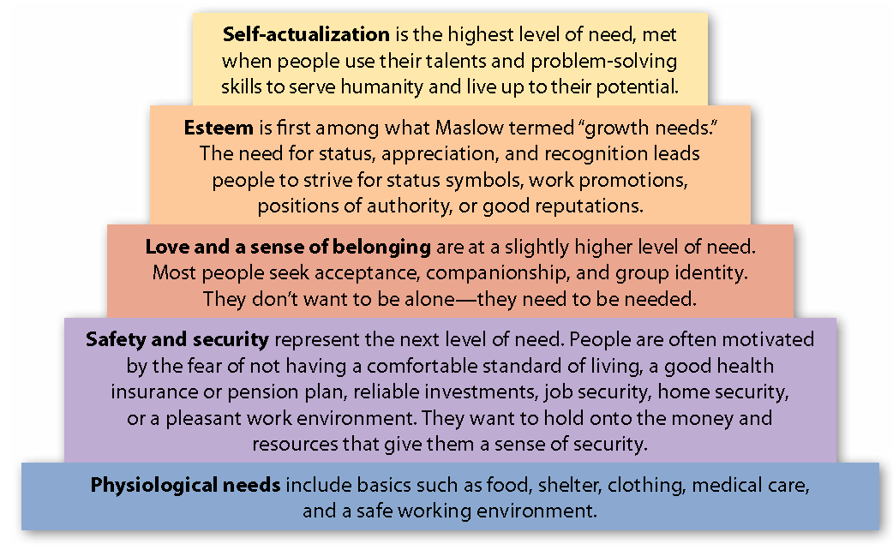

Persuasive Appeal
- An appeal is an attempt to persuade
- Persuasive messages appeal to the reader’s:
  - Sense of reason
  - Emotions
  - Sense of what is right (ethics)
Sense of Reason
- Support your argument with strong evidence, such as non-numerical facts, expert opinions, statistics, examples, and analogies.
- Show clarity and use logical argument development.
  - Cause/effect
  - Problem/solution
  - Chronological
- Answer questions the reader will ask or will be thinking about.
- Avoid errors in logic:
  - Mistaking coincidence for cause
  - Circular arguments
  - Begging the question
  - False analogies
Emotions
- Highlights emotional factors
- Used to create the desire to act
- Base an emotional appeal on fact or reason.
- Select words with emotional power (special, deserve, free, safe) and create “sense impressions” (by using words like see, feel, hear, taste, or smell) to appeal emotions
Ethics
- Establish your credibility
- Strive to be believable, responsible and ethical.
- Personal credibility is based on specialized knowledge, reputation, position, and familiarity.
- Specialized knowledge is the evidence you use to make a logical presentation.
- Cite experts or sources trusted by your reader.
- Remember that reputation is determined by your character and past conduct.
- Authority:
  - Business titles add leverage and respect (when not perceived as pompous or bullying).
- Familiarity:
  - Trust is built by having a good relationship or sharing common ground.
Indirect Writing Plan
- Used when a direct plan is likely to be unsuccessful.
- Breaks down resistance and prepares readers for your message
- Illustrates a gradual and deliberate attempt to earn trust and show reason
- Allows the reader to easily see benefits
3-Step Process
1) OPENING: Obtain interest.
- This can be accomplished by grabbing your readers’ attention.
- Define a problem, identity common ground, cite reader benefits and ask a question
2) MIDDLE: Prove how beneficial your proposal will be to your readers.
- Explain how the product/proposal meets a particular need
- Give further details concerning direct or indirect benefits
- Give information that will deal with any objections
3) CLOSING: Ask the reader to take action.
- Link the action to incentives that will appeal to your reader and to a deadline
- Favour and Action Requests:
      - Are you asking the reader to donate money or volunteer time with little or no return?
      - Use an indirect strategy to focus on the indirect benefits of compliance.
Types of Persuasive Messages
- Favours and action requests
- Persuasive memos
- Claim request
- Collection letters
- Sales letter
Favours and Action request
- Opening:
  - Gain favourable attention.
  - Use genuine compliments or facts of social conscience.
  - Avoid closed questions.
- Middle:
  - Persuade the reader to accept your message.
  - Give background information and outline the potential benefits (e.g., the chance to show leadership, showcase talent, network, help others, or change workplace/community).
  - Provide dates, times, and locations.
- Closing:
  - Ask for action.
  - Provide contact names and numbers, and a reminder of the necessary response.
Persuasive memo
1) Summarize problem
- Show the cause or source of the problem
- Avoid accusations and negative language
- Use a subject line that shows the positive results or benefits of what you’re requesting
2) Explain the solution
- Cite statistical evidence (facts, figures, benefits)
3) Minimize resistance
- Anticipate objections (money, time, threats to authority, professional status, or status quo)
4) Ask for a specific action
- Be firm but polite
- Set a deadline and offer incentives for a prompt response
Claim request
- Use a direct plan if the claim is justified.
- Use an indirect plan for situations that are open to interpretation.
- Warranty expired? Contract violated?
- Use a moderate tone without threats or accusations.

- Gain positive attention & rapport:
  - Paying compliments, reviewing the actions taken and explain why you bought the product or service

- Prove the validity of your claim:
  - Explain what happened
  - Provide supporting data (order numbers, delivery dates and item descriptions)
  - Lead with the strongest
  - Anticipate any possible blame

- Request a specific action:
  - Express confidence in a company’s ethical standards, pride and reputation
  - Answer the following questions: how can the claim be satisfied? What do you expect?
Collection letters
- A series of persuasive appeals to a customer asking for an overdue payment for products already received while preserving customer relations.
- The three types of collection letters are:
1) Reminder letter
2) Inquiry letter
3) Demand letter (most direct)
Reminder letters:
  - Assume the customer has forgotten.
  - Mention a previous good record or relationship.
  - Alert the customer to the problem and request a response.
Inquiry letters:
  - Assume a legitimate reason for non-payment (money problem, vacation).
  - Request an explanation or immediate payment.
  - Make a positive appeal to a customer’s sense of fairness, reputation, sympathy, and self-interest.
  - Include contact information (envelope or web payment details).
Demand letters:
  - Act as an urgent appeal for payment.
  - Outline penalties for non-payment.
  - Refer to previous correspondence.
  - Set a time limit for payment and outline follow-up actions.
Sales letter
- An affective sales message should:
- Analyze the product and audience
- Study the product or service (design, construction, ease of use, special features and price)
- Address a target audience (age, sex, education, income, lifestyle, location)
Step 1: gain attention
Step 2: Introduce the product
Step 3: Make the product or service desirable
Step 4: Ask for action and make responding simple
- A strong sales follow-up letter must confirm the purchase, express goodwill and promote future business and finally, confirm the details of the sale.

Fundraising Messages
Encourage or request donations to a worthy cause.
Step 1: Identify the problem or worthy cause
Step 2: Show that the problem is solvable and how your organization can respond
Step 3: Explain what the organization is doing to solve the problem (be specific)
Step 4: Ask for a donation
Chapter 9: Communicating for Employment
Career Goals and Qualifications
- Assess your skills and values.
  - What are your values, interests, and marketable skills?
  - What are you good at?
  - Do you have any new skills?
  - What are your short-term and long-term goals?
  - What’s important to you?
- Assess your work preferences and personality.
  - Are you an introvert or extrovert?
  - Would you prefer to work for a large or a small organization?
  - Do you like a fast pace or a slow pace?
  - Do you thrive on challenges and risks, or would you work better in a stable environment?
  - What job rewards motivate you?
  - What sort of colleagues and working conditions would provide you with enough job stimulation?
- Assess your work history.
  - What are your previous accomplishments?
  - What are some of your most satisfying/dissatisfying experiences?
  - Do you have good communication skills?
  - What are your hard and soft skills?
    - Hard skills – school
    - Soft skills – learned skills on the job
Job Hunting
- Get to know the job market, sources of employment, and organizations where you would like to work.
- Read the career pages, classified ads, and financial sections or your local newspaper.
- Master electronic job-search techniques.
- Learn to network.
- Tap into the hidden job market.
- Visit employment agencies.
- Think ahead.
- Polish your interpersonal and communication skills.
Resumés
- A resumé is a summary of your qualifications and past work experience.
- It should be professional, accurate, and formatted for easy reading.
- Prospective employers must be able to read your resumé quickly (usually in less than a minute), or scan it electronically to be searched for key words.
Format
- Your resumé should:
  - be tight, action-oriented, and in point form
  - use capitals and boldface for headings
  - use consistent indenting
  - use space between sections and have wide margins
  - be error-free!

- Include your name and contact information.
  - Format your name in bold, and list your telephone number and appropriate e-mail address.
- Include your career objective (optional).
  - List your main qualifications and career path.
- Detail the position you desire or your professional goal.
  - Include details specific to each, job rather than general information about your goals.
- Include a summary of your qualifications or your profile (optional).
  - Use one or two sentences (or a short list).
  - List your skills and qualifications as they relate to the job.
- Include information about your education.
  - List undergraduate and graduate degrees, diplomas, and certificates in reverse chronological order.
  - Include the diploma name, academic honours (if applicable), name of institution, location, field of study or specialization, and years of attendance.
  - Include relevant courses taken and your GPA (optional).
- Include your work experience.
  - Use strong action verbs and specifics.
  - Quantify your activities and accomplishments.
  - List full-time, part-time, co-op, and volunteer work.
  - Include job title(s), company and location, and years of employment.
- Include your skills and capabilities.
  - List any technical training, special skills, and languages.
  - List academic awards, volunteer experiences, professional memberships, and school or community service.
- List your references.
  - “References supplied on request.”
    - References can be provided on the resumé or on a separate sheet.
  - Include your reference’s full name and job title, company name and address, telephone number, and e-mail address.
- Human Rights Act**
  - The Canadian Human Rights Act forbids employers from asking about age, race, religion, marital status, sexual orientation, or health.
Length and Style
- Length:
  - Check industry or company requirements.
  - Use a well-balanced design with plenty of white space.
  - Keep length to one or two pages.
- Style:
  - Chronological – work experience in field – presented in reverse time sequence
  - Functional – skills based – work-related skills (i.e. redirection of career or limited experience)
  - Combination – combines chronological and functional styles (i.e. recent graduates)
Key items to remember
- Be honest.
- Don’t embellish, exaggerate, or alter the truth.
- Be current.
- Include recent accomplishments, responsibilities, and activities.
- Have both a scannable and a traditional version of your resume.
- Customize each résumé.
- Revise and clarify the focus for each job.
- Keep it professional.
- Use good paper, a muted colour, traditional fonts, and a good printer.
Types
Scannable Resumes
- A keywords section with relevant words (current and previous job titles, professional jargon, synonyms, and marketable skills and traits) is essential on a scannable resumé.
- Use white space and blank lines in your formatting.
- Avoid fancy fonts or graphics.
Resumes by e-mail
- Read the job advertisement carefully for instructions.
- Put the job title or reference number in the subject line.
- Attachments:
  - Be sure to consider the readability of the file and potential SPAM filters. Use computer-friendly formatting (.pdf, .doc).
  - Use keywords.
  - Attach your cover letter and include a covering e-mail message.
Cover Letter (Application Letter)
- Opening:
  - Get attention and define the position you are applying for.
  - Please accept my resumé in consideration for the Marketing Representative position with Concordia University.
  - I am writing in reference to the Marketing Representative position advertised on Linkedin.
- Middle:
  - Build interest with a summary of your qualifications.
  - Match your strengths to the job requirements.
- Closing:
  - Request an interview and provide contact information.
  - “I am confident in my ability to build immediate and long-term contributions to Concordia University and welcome an opportunity to discuss, in further detail, my qualifications and candidacy.”
Tips for Cover Letters
- Avoid using “I”, “me”, and “mine”.
- Get the names correct.
- Use keywords from the job posting.
- Use a consistent font for the cover letter and resumé.
- Write short paragraphs.
- Don’t plead, apologize, or exaggerate.
- Don’t use generic letters.
- Be strong and clear.
- Keep the letter to one page in length.
- Keep a copy for yourself.
Solicited Application
- Opening:
  - Gain attention by using a summary + request opening style.
  - Demonstrate shared values and an interest in the company.
- Middle:
  - Relate your skills to the job posting and job requirements.
  - Summarize your skills and emphasize those related to the job.
  - Use bullet points.
  - Refer to your resumé.

- Closing:
  - Ask for an interview.
  - Include contact information (telephone or e-mail).
Tips for Unsolicited Applications
- Show enthusiasm.
- Use an indirect approach.
  - Demonstrate your interest and knowledge.
  - Articulate what you can do, your qualifications, and the benefits you would bring to the company.
  - This approach demonstrates initiative and creates opportunities.
Interviews
Tips
- Before the interview:
  - Research and prepare.
  - Know your non-verbal communication habits.
  - Dress appropriately.
  - Anticipate typical questions.
  - Be ready to talk about your previous experiences.
  - Have thoughtful questions for the interviewer.
  - Practice, practice, practice!
- At the interview:
  - Be on time (or a little early).
  - Go alone.
  - Bring copies of your resumé, references, work samples, or your portfolio.
  - Be courteous.
  - Make a good first impression (handshake, eye contact, and smile).
  - Listen carefully to questions and instructions.
  - Use correct English grammar.
  - Show interest with body language.
  - Be positive.
  - Demonstrate knowledge of the company.
  - Don’t make salary and benefits a priority.
  - Don’t expect a decision before you leave.
- After the interview:
  - Use one of the following types of letters:
    - Thank you letter (sent within 24 hours)
      - Thank the interviewer for his or her time.
    - Restate your interest in the job.
    - Personalize the letter with information about skills, qualifications, or topics covered during interview.
- Follow-up letter (if you haven’t received a response):
  - Let the employer know you are still interested.
  - Ask if they need any additional information.
  - Provide any new or updated contact information.

Other Letters in the Application Process
- Job-offer Acknowledgement Letter
- Job Acceptance Letter
- Job Refusal Letter
- Reference Request Letter
Chapter 10: Informal Reports
Report Writing
- Reports allow managers and co-workers to stay informed, review opinions, plan, and make decisions.
- Reports are considered legal documents.
- Reports must be accurate, complete, objective, selective, and structured.
Successful Reports
Content:
- Select and include the information necessary for actions to be taken or decisions to be made.
- Consider the reader’s needs and background knowledge.
- Organize the material logically for the reader.
Clarity:
- Use correct grammar and spelling.
- Include overviews, transitions, and topic sentences.
- Cite your sources.
- Use visual aids.
- Outline the criteria for options and conclusions.
Skimmability:
- Use easy-to-read fonts and font sizes.
- Use clearly distinguishable headings and sub-headings to organize data.
- Use white space and avoid a cluttered format.
Informal vs. Formal Reports
Informal reports
- are 1–10 pages in length
- follow a letter or memo format
- use personal pronouns and contractions
- include some visual aids
- are routine and internal

Introduction (Background):
- Detail the purpose of the report or reason for the report
- Preview the key points
- Outline the data collection methods
Findings/Results/Facts:
- Organize the data by subheadings
Summary/Conclusions/ Recommendations:
- List in order of importance (most to least)
- This section is often most interesting to the reader
Formal reports:
- are 10–100 pages
- do not use personal pronouns or contractions
- include a title page, cover letter, table of contents, and abstract
- are based on extensive research or study
- include many visual aids
- are distributed to external or internal superiors
Short Reports
Purpose:
- Information
- Information and analysis
- Information, analysis, and recommendations
Frequency of submission:
- Periodic
- One time (specific issue or project)

Formats and distribution:
- Memo report
- Prepared form report
- Letter report
- Formal report

Common categories of short reports:
- Periodic
- Incident
- Investigative
- Compliance
- Situational (trips, progress, and activity)
- Recommendation
- Justification
- Feasibility
- Summary
- “To file”
- Proposal
CONTENTS:
- Periodic reports are produced at regular intervals
  - Example: monthly sales figures, service data, or call volumes

- Incident reports:
  - address who, why, what, where, when and how
  - provide only the facts (no speculation)

- Investigative reports:
  - respond to requests for information
  - supply details (and sometimes analysis)

- Compliance reports:
  - provide information to governing bodies or agencies
  - follow laws and regulations

- Situational reports:
- Trip reports:
- Summarize event details.
- Give 3-4 interesting points.
- Highlight learning or benefits.
- Justify expenses.
- Progress and activity reports:
- Monitor the progress and status on a project
- Discuss problems and obstacles and suggest solutions
- Assist with schedules, personnel and budgets

- Recommendation reports:
- are commissioned by the recipients
- evaluate and express professional opinions
- recommend actions/interventions

- Justification reports:
- detail the rationale for purchases, hiring, or policy change
- outline what is needed and why it’s needed

- Feasibility reports:
- evaluate projects and alternatives
- ask questions such as “Do we need it?” and “Will it succeed?”
- consider the costs and benefits

- Summary reports:
- condense information for management
- include only essential information

- “To file” reports:
- record decisions, discussions, and directives
- are filed for future reference

- Proposal reports:
- address how problems can be solved,
- sell goods and services
- suggest changes to policy or spending for future improvements
Format of common short reports
- Opening summary (no heading)
- Work Completed
- Work in Progress
- Work to be Completed
- Closing/Forecast (no heading)
Direct vs. Indirect Approach
Are you persuading or just informing?
Direct Approach
- used for informational and analytical reports
- used for routine, non-sensitive information for recurring or one-time events
Informational format:
- Purpose/introduction/background
- Facts and findings
- Summary
Analytical format:
- Purpose/introduction/background
- Conclusions or recommendations
- Facts and findings
- Discussion and analysis
Indirect Approach
- expects resistance from the reader
- requires persuasion or education of the reader
Format:
- Purpose/introduction/background
- Facts and findings
- Discussion and analysis
- Conclusions or recommendations
Report Style
Report style:
- depends on audience and organization
- is written for primary and secondary readers
- uses clear references (pronouns and proper names) and unbiased language
Headings and Subheadings
2 main types of headings and subheadings:
- Functional headings
  - Example: Introduction, Findings, Summary

- Descriptive or “talking heads”
  - Example: New Policy on E-mail
Headings and subheadings must be:
- short and clear
- parallel
- ranked
- logically and clearly laid out
- formatted so that there are two subheadings in a section
- free of typographic widows and orphans
- not in quotation marks (“New Policy on E-mail”)
The Writing Process
Plan:
- What do you need?
- How long will it take?
- Who will complete each task?
Research:
- Brainstorm
- Think about the “big picture”
- Ensure that your data is current, valid, reliable, and accurate
Compose and revise:
- Create an outline
- Save copies of your work
- Ensure that your work answers questions the reader would ask
- Proofread
Visual Aids and Graphics
2 main purposes:
- To make numerical information easier to understand
- To clarify and simplify data
Are your visual aids:
- Clearly titled and labeled?
- Uncluttered and easy to understand?
- Accurate?
- Serving a purpose?
- Integrated at the correct place?
- Supported by an explanation?
Types:
- Table (simple & complex)
- Matrix
- Pie chart
- Bar Chart
- Picture Graphs
- Line Graphs
  - Gantt Charts
  - Flow Charts
  - Organizational Charts

SIMPLE TABLE
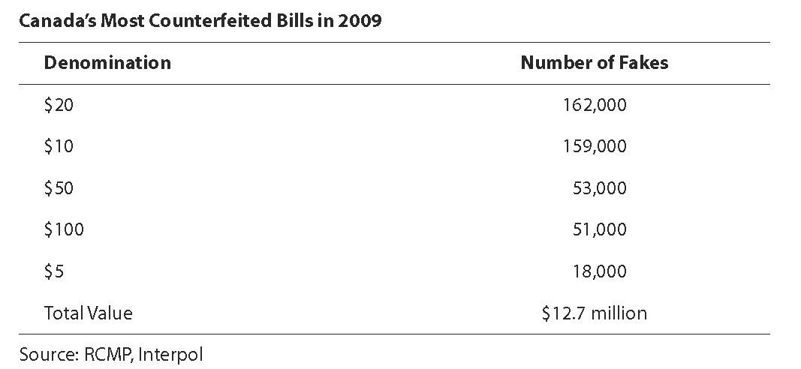
COMPLEX TABLE
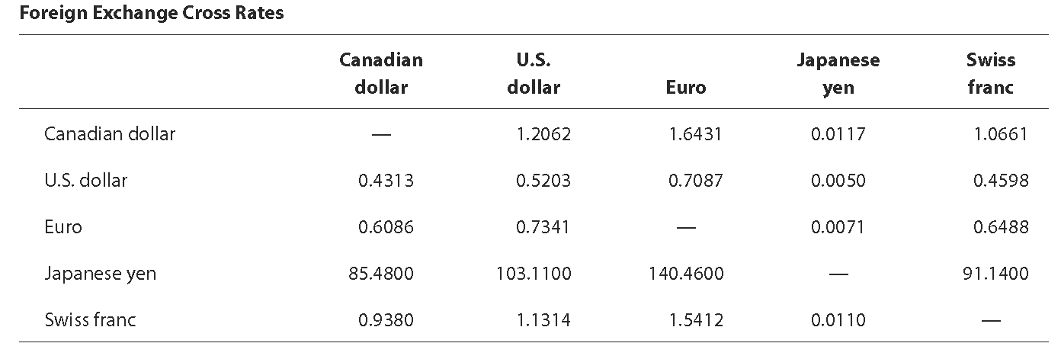
MATRIX
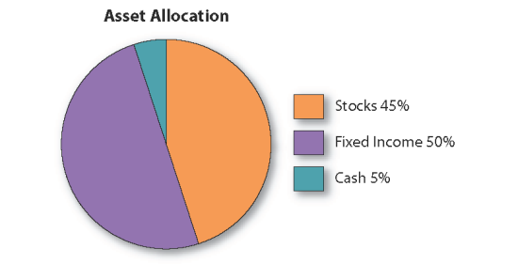
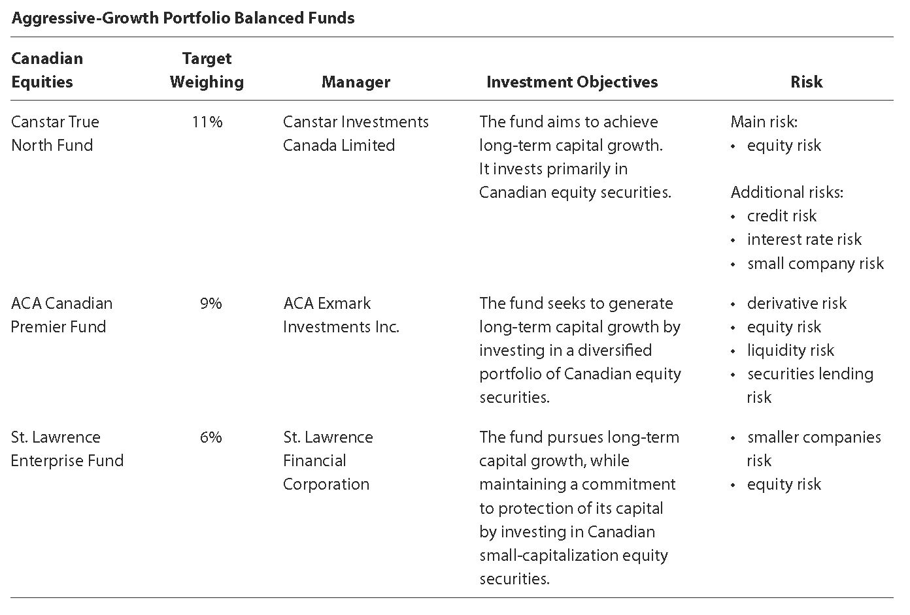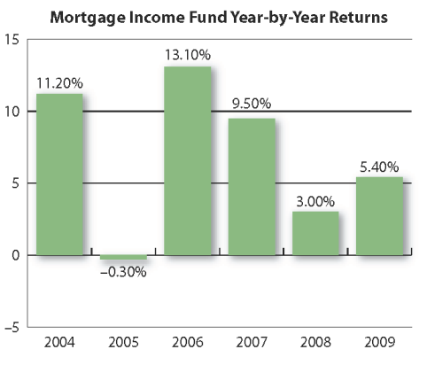
PIE CHART

BAR CHART (VERTICAL)

PICTURE GRAPH
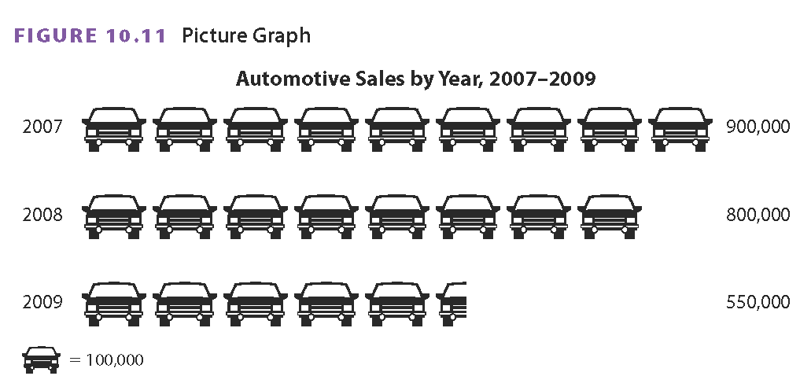

Chapter 11: Proposals and Formal Reports
Proposals
A business document that suggests a method for solving a problem or seeks approval for a plan
- Proposals suggest solutions to problems
- The direct approach is most commonly used (but may be informal)
- The goal is to persuade readers to follow or approve of a request for action, business, or funding and to agree to the development of the plans
- Done in order to implement a plan
- Proposals are sent to potential clients or customers outside the organization (external proposal)
- Most proposals are written in response to a request for proposals (RFP)

Internal Proposals
- Internal proposals can be formal or informal
- They respond to questions such as:
  - How can money be saved? How much?
  - When will the savings start?
  - Will sales or productivity be boosted?
  - Will the company be more competitive?
External Proposals
- External proposals can also be formal or informal
- They seek to create new business and generate income:
  - Solicited (responds to Request for Proposal [RFP])
  - Unsolicited (must convince the reader that a need or problem exists)
Elements of Informal Proposals
Introduction:
- Overview of the proposal
- Scope
- Qualifications
- Start and completion dates
- Previous work completed (positive associations your company has had with the client)
  - For external sales-driven proposals
Background:
- Define the problem details of which you aim or solve or address
- Purpose and goal of the project
- Convey your understanding of the client’s needs and how he/she stands to benefit from the implementation of the plan you propose
Proposal, Method, Schedule:
- This section details your solution to the problem:
- Explain the products or services offered
- Feasibility of the proposed method for solving the problem
- Procedures (how the company intends to proceed and timeframe)
- When each phase of the project will be completed (create a project timeline)
- What special material and resources you will use

Costs/Budget:
- Cost breakdown for the entire project and each stage of the project process
- The budget you submit is actually a legal contract that does not allow for later alterations (even if expenses increase; be realistic!)

Staffing, Qualifications:
- Shows that you, your team and you company are credible and have what it takes to do the job well (instills confidence)
  - Expertise and credentials
  - Resources/facilities
Benefits:
- The benefits section summarizes the reasons for accepting the proposal so that the client will be motivated to take action
  - Benefits of your solution, product or service and the advantages of your plan
Request for Authorization:
- This is the closing request
- It can sometimes be negotiated after the client has received the proposal
  - Expiry date for the proposal
  - Request for permission to proceed
  - Additional information
Elements of Formal Proposals
- Formal proposals differ from informal proposals in format and length
- The number of pages can vary from as few as 5 to as many as several hundreds

Front Matter:
- Copy of the Request for Proposals
- Cover letter
- Abstract or summary
- Title page
- Table of contents
- List of figures

Body of Proposal:
- Introduction
- Background or problem statement
- Detailed proposal, method
- Schedule
- Budget or cost analysis
- Staffing
- Authorization
- Benefits, conclusion
Back Matter:
- Appendix
- References
Cover Letter or Letter of Transmittal:
- Bounded inside the proposal as its first page and it is addressed to the decision maker or person responsible for making the final decision
  - Explain the proposal’s purpose, major features, and tangible benefits
  - It expressed confidence that those benefits will satisfy the needs of the client
  - Letter should end courteously by expressing appreciation for the opportunity to submit the proposal, for any assistance provided and for previous positive associations with the client
Executive Summary or Abstract:
- It is a synopsis of the body of the proposal or report specifying its highlights and recommendations
  - One page
    - Non-technical language (executive summary)
    - Technical language (abstract)
Title Page
Should include:
- Proposal title and subtitle bold faced
- The name of the client or organization/decision maker
- RFP reference #
- Name and title of the proposal writer and company name
- Date of submission
- Table of Contents and list of Tables, Figures, or Illustrations
Appendix:
- Graphics, statistical analyses, tables, generic résumés, photographs, and samples
- De-clutters the proposal body
- Labeled A, B, C
References:
- Bibliographic list of sources
- APA, MLA
Common Proposal Mistakes
- Doesn’t follow RFP instructions
- Project solution ≠ purpose
- Not reader-focused
- Inaccurate budget
- Not credible
- Similar to competition
- No clear plan/solution
Writing Styles for Proposals
- Good proposals are persuasive and use words that communicate strength, confidence, know-how, and credibility

Researching and Collecting Data
Reports are based on evidence.

- Look for information online
- Do a computer-based search
- Find information in print
- Investigate primary, in-house sources
- Conduct interviews
- Quantify observations
What are you looking for?
How much time do you have?
Is it important for the report?
- Paper, human, electronic:
- In-house
- Publicly available
- Restricted
Research

- Primary research:
- Your thoughts, observations, and experiences
- Your interviews, surveys, and ideas
- Secondary research:
  - Library or online research
TYPES
- Online:
  - Keywords:
    - Search engines
    - Library databases
- Web sources:
  - Use more than just Wikipedia.
  - Consider the quality, relevance, and value of the source.
- Print sources:
  - Periodical guides and indexes
  - In-house documents and reports
- Interviews:
  - Who? Why? What? Where? When? How?
  - Open-ended questions
- Observations:
  - Subjective
  - Specific and measurable?
Formal Reports
- Based on:
  - Major projects
  - In-depth analysis
  - Extensive research

- Prescribed structure:
  - Often a “house” style and “house” manual to be followed
  - Can be wide variation in styles
Preparing to write formal reports, consider the following:
- Purpose: What is the report for?
- Content and organization: What is it about?
- Audience: Who is it for?
- Status: Will other reports on the same subject follow?
- Length: How long should it be?
- Formality: How should it look and sound?
Elements of Formal Reports
Front Matter:
- Cover
- Title page
- Letter of transmittal
- Table of contents
- List of figures
- Executive summary
Body of the Report:
- Introduction
- Discussion of findings
- Conclusion
- Recommendations
Back Matter:
- Appendixes
- References or Works Cited
- Glossary
Cover:
- Company name and REPORT TITLE
Title Page:
- REPORT TITLE
- Prepared for, or Submitted to
- Prepared by, or Submitted by
- Date Submitted (title case)
Letter (external) or memo (internal):
- Report topic
- Report’s purpose and who authorized it
- Description of report highlights, conclusions, and recommendations
- Expression of appreciation and special help
- Conclusion with follow-up action, question assistance, and future discussion(s)
Table of Contents (TOC):
- Sections, leaders, and initial page numbers
- Introduction …………… 5 (FORMAT)
- List of Figures, List of Tables, List of Illustrations:
  - Separate sheet
  - Can be combined with TOC
Executive Summary:
- Uses non-technical language
- Highlights conclusions and recommendations
- 1/10th of the report length
- Read by managers/executives
Introduction:
- Purpose or Problem
- Scope
- Background
- Organization
- Sources and methods
- Defines key terms
- May restate or repeat information from other sections
Discussion of Findings:
- Interpretation and analysis of data/research
- Discussion of results/findings
- Logically, chronologically, order of importance, by region, or by topic
- Functional or descriptive headings
Conclusion:
- Interpretation or explanation of the findings
- Solution to problem
- No new information
- Follows the same order as the findings
Recommendations:
- Suggests specific actions, how they can be implemented, and timetables (optional)
- Financial feasibility and appropriateness
- Numbered or bullet point

Sources for research
Additional information (too lengthy or detailed for Findings)
Definitions of technical terms
Indexes sources
Works Cited/References:
- APA
- MLA
Appendix:
- Specialized or lengthy information
- Clarifies and supplements information in report
- One type of information per Appendix (tables, raw data, questionnaires)

**APA:
  - Used primarily in the Social Sciences
  - Helpful tips and guidelines:
    - Your college library website
    - Purdue University - APA Style
    - APA Guide (Seneca College)
**MLA:
  - Used primarily in the Humanities and Literature
  - Helpful tips and guidelines:
    - Bedford St. Martin's Citation Styles - MLA
    - MLA Guide (Seneca College)
Writing Style for Formal Reports
- Use an impersonal tone
- Write using third-person pronouns
- Avoid the words I, we and you
- Do not use contractions
- Aim for a mix of sentence lengths and keep paragraphs to less than seven lines
- Use verb tenses consistently
- Put URL’s in angle brackets <>
- Check organizational style guidelines before you begin to write to find out what style elements are permissible
Creating a Work Plan
Work Plan: a document that defines the approach, personnel responsibilities, resource needs, and scheduling for a major project.
A work plan is especially important when working with team or group. It outlines for the team how it will be done and who will do it
A work plan includes:
  - A statement of problem and purpose
  - A strategy for conducting research and responsibilities for data collection/research
  - A preliminary outline of the report
  - Work schedules for writing and submission
Time Management Tips
- Determine how and when you work best
- Set priorities
- Start early and plan extra time for problems
- Break tasks into smaller parts
- Ask for help when needed
- Inform your team or client if you will miss deadlines
Team Writing and Peer Reviewing
Agree on style points relating to:
- formality/informality
- use of personal pronouns
- editing sharp contrasts in writing style

