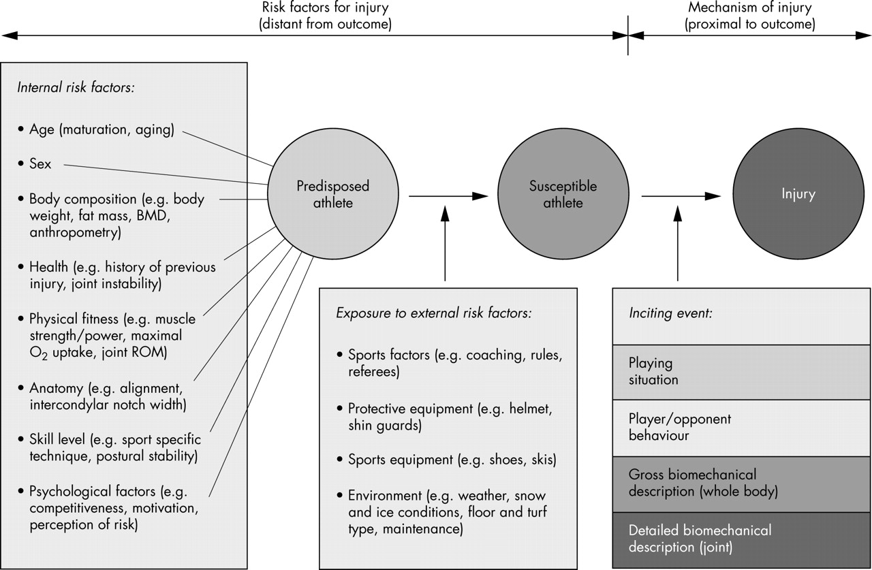
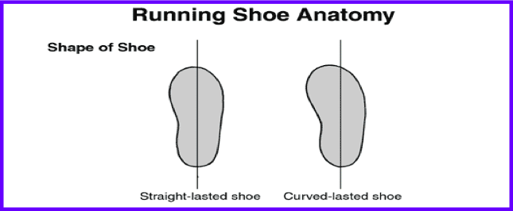
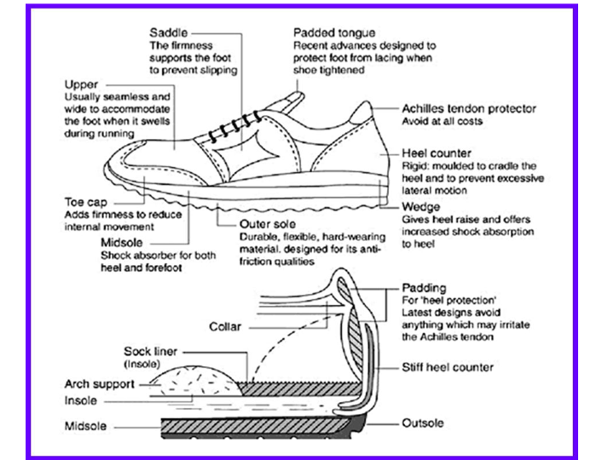
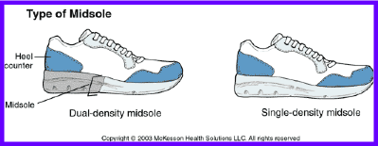
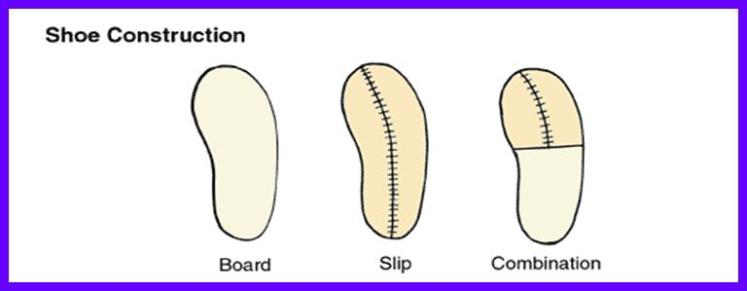
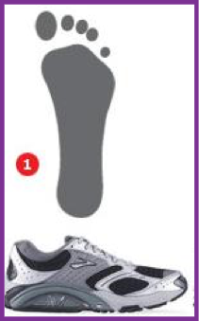
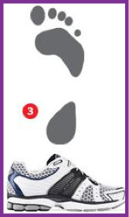
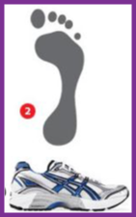
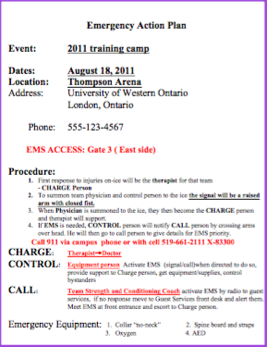
Tertiary
-Reducing the consequences of injury
Athlete – know own body, report injury
Surroundings – coaches trained, emergency medical coverage
Equipment – first aid equipment, EAP, spine board
Secondary
-Protect the athlete should a potentially injurious situation arise
Athlete –strengthen muscles, train falling techniques
Surroundings –safety nets for skiing
Equipment – helmet, shin pads, bracing

Primary
-Focuses on 1 of 3 dimensions
Athlete – technique, neuromuscular function, conditioning
Surroundings – floor /surface
Equipment – shoe friction)

Avoiding injuries in the first place, prevention
1-3 types of Prevention
Athlete, Surroundings & Equipment
PREVENTION
Injury Prevention: one of the most important roles is to minimize activity related injury
- Improve benefit: risk ratio
Characterized by:
- Primary
- Secondary
- Tertiary
Lecture 1: Introduction to Athletic Injuries

Injuries Midterm 1: Fundamental Principles and Team Management (Lec. 1-6)
Fitting Equipment – Firm but Comfortable
Fitting Helmets
✓Wet Hair ✓1-2 finger widths above eyebrow
✓ Covers occiput and entire skull ✓Mask 3 finger width from nose for vision
✓Strap snug to chin

Shoulder Pads – General Sizing
✓ Inner padding covers shoulders and cups deltoid
✓ ✓Lacing Snug BUT unrestrictive

Modifying Equipment
- ANY modifications should be done according to the manufacturers specifications
- NOT alter the fit of the original equipment
- Modifications should NOT increase stress or damage to original material
- No drilling, cutting or slicing - you weaken the plastic
Foam – Closed Cell
-Mainly for protection
-Air can’t pass through from one to another
-High resilience – material rebounds and returns to original shape quickly
-Less cushioning at low impacts – not as comfortable close to skin
Felt
-Made from matted wool fibers
-Fewer tendencies to shift or move over skin
-Absorbs fluid (sweat & blood)
-Must be replaced daily
-Heavy when wet
-Not resilient
Foam – Open Cell
-Sponge-like
-Low resilience – doesn’t bounce back
-Used to pad body prominences – comfort NOT protection
-Used to protect skin under hard edges of equipment

Lecture 2: Protective Equipment
Important in the prevention of athletic Injuries (primary and secondary – Protect & Prevent)

Practicality dictates that Protective equipment should be:
✓Simple and fit and maintain ✓Not be extremely Expensive
✓Be durable and reliable ✓Minimal Functional interference

Prevent Protect Principles - all equipment will use at least 1 or all of these principles
- Deflection – a turning aside or off course (Properties: Round, Smooth & hard)
- Dissipation – spread thin or scatter and gradually vanish (disperse focal force over a larger surface – Layers & various materials) FOOTBALL SHOULDER PADS – protect small AC joint, layered with various materials
- Deformation – alteration of form or shape (made to blow apart – bike helmets, change in shape or structure – cantilever pads so force does not go down on shoulder)
- Absorption – receive without recoil or echo (materials such as felt, open/closed foam, air, fluid)
Greater Density = Greater the resistance @ High Force
Lower Density = more absorption/resistance @ lower force

Absorption Materials

-Moulded plastic to cover knees and shins (foot for baseball) – deflection / deformation
-Some articulation around the knee – allows greater freedom
-Layered nylon/foam or felt lining – absorption
Helmet – high velocity/low mass (puck) & low velocity/high mass (player)
-Hard shell with high density
-Open & close cell foam
-Full cage or ½ visor
Goalie Mask – high velocity/low mass (puck) & minimal low velocity /high mass
-Hard shell with ridges - deflection
-Open and close foam - absorption
Neck protectors
-Soft cloth with Kevlar or plastic insert
-Purpose is to prevent throat lacerations
-Minimal padding against low mass high velocity projectiles
Shoulder Pads
-Designed with overlapping cup to protect clavicle and deltoid from lateral contact – dissipation
-Chest portion usually felt or nylon & foam- absorption
Shoulder Pads
-protect shoulders and limit force to lateral acromion (AC)
-shell of hard, smooth plastic - deflection
-layers of soft padding under – dissipation, deformation, absorption
Helmet – High Mass/Low Velocity
-Hard smooth outer shell with absorbing inner liners (closed cell) Deflection*
-Different mask depending on player
-2 or 4 point chin strap – limit fwd/back tilting
- Single strap = helmet will rotate
Sport Specific Equipment Analysis
Need to think about:
- Biomechanics of body part
- Individual activity level
- Specific protection/performance demands
- What are you trying to protect against?
- People vs. Projectiles? (High/low mass, high/low velocity)

Analysis: Look at
✓Outer Surface “Shell” ✓Inner Surface “Liner”
✓Method of Attachment (Strap/belt) ✓Sport Specific Design

Football

Hockey

Hockey & baseball Shin Pads: Similar
Helmet
-Outer designed for one massive impact at high velocity – deformation
-Foam inner lining – absorption/comfort
-Peaked front and back to protect face and occiput

Knee/elbow pads
-Soft open cell foam covered by hard plastic
Wrist guards
-Rigid plastic over open cell foam
-Deflects impact of FOOSH – Fall on outstretched Hands (absorption)

Helmet – high velocity/low mass and low velocity / high mass (person/stick)
-Sits off crown of head
-Mask farther from face for increased visibility
-Visor peak for sun
Gloves
-Often open palm
-Less wrist padding for greater movement (greater risk of injury)
Shoulder Pads
-Smaller than hockey pads
-Less AC protection

Arm Pads
-Protect length of arm from slash
Catcher Mask
-Conventional: protection from ball- poor vision
-Hockey Style- all around head – better vision – HOT & heavy
Chest Protector
-Soft foam – form fitting no gaps
-Heart guard – extra layer
Helmet – low mass/high velocity (ball)
-Hard round plastic – deflection
-Ear protection
-Designed to protect from focal impact – dissipate and absorb force
-Up to batter to turn face away

Baseball

Lacrosse

Bike/ Inline Skating

Footwear Basics
No best shoe, but best shoe for YOU: Design

Lasts
External Last: is the form on which the shoe is contracted
- Curved Last (C-Shape) : Neutral -> Stability , Medial deviation of Forefoot (FF), Hollowed out Medial deviation arch (MLA)
- Straight Last: Stability -> motion control, solid plantar surface, extended midsole in MLA, Increased base of Support

Footwear Fit
- Length/width – measure both feet and fit the larger on weight-bearing feet at the end of day
- Length should not be increased to accommodate width as this will increase lever under toes and cause hyperextension
- To test width place full weight on, pushing thumb together over top of shoe should ripple
- Toe box should be 1 – 1.5 cm from end of longest toe
- EVA compressed and wears out – watch mileage as the absorption will decrease over time
- Shape of shoe is classifies as straight, curved or semi-curved
- Rigid foot – curved last with sufficient cushioning vs. Mobile foot – straight last

Heel Counter
- Stiff material at the back of the shoe built to resist motion in the ankle, more pronation needs stiffer heel counter
- Ankle collar at top of heel counter to protect/cushion the ankle and Achilles tendon
- Should allow for snug fit of heel
- If too wide can be filled with felt or heel cup
- This is desirable to having a foot that is too tight in the forefoot
Anatomy of a Shoe
Upper
- All components above the mid sole
- Nylon, mesh leather, synthetics
- Contains midfoot control technologies
- Conforms to bony abnormalities
Midsole
- Between upper and outsole
- Shock absorption vs. motion control
- Densities depend on sport and foot type
- Absence of midsole in some shoes that require a better “feel” or ball control
- Polyurethane, EVA and compressed EVA
- PU controls heavier runners
- EVA is lighters – when compressed it increases durability and shock absorption
- Shape: tapered from heel to toe, with thickest portion under heel
Outsole
- Protective layer on the bottom
- Protection, durability, flexibility, traction
- Protection from ground & different rubbers and materials specific to sport surface

Internal Last: is the interface between the foot and the midsole (after taking out the insoles)
- Board Lasting “flat feet” : solid board stitched to upper of shoe, increased torsional resistance to pronation, better interface for orthotics – those that over pronate
- Slip Lasting ”high arched”: Solid line of stitching down center of shoe, increased flexibility, neutral or any king of shoe that require flexibility and torsion, more mobile foot (climbers, 5-fingers)
- High arch needs more flexibility b/c feet are firm; slippery flat feet needs support and will be board lasted; don’t want them rolling off shoe; increased torsional resistance

Lecture 3: Emergency Action Planning
Who are we protecting with an EAP? The Athlete and ourselves (law)
JUST KNOW WE CAN GET SUED
Civil Liability: when a person engages in conduct that results in harm to another private individual
Criminal Liability: when a person contravenes social standards as expressed by criminal laws
Intentional Torts: harm was intended to another (assault, battery or false imprisonment
Unintentional Torts: when a person ought to have foreseen that his or her actions would cause harm a person will be liable of a tort ONLY if he or she intends to do harm to others or is negligent in that reasonable precautions are not taken to prevent foreseeable harm

Elements of Negligence
Legal liability for Negligence is dependent upon three elements
- A duty of care
- A breach of the standard care (can each that care)
- Damage or injury that results from the breach (death- something happens from something we did/didn’t do)

Emergency Action Plan: a document to be followed in the event of a medical emergency which outlines mutually agreed upon areas of responsibility and methods of delivery via step-by-step procedures
WHO? WHAT? WHERE? WHAT? HOW?
Those involved? : Front of office, security/facilities staff, medical staff, players
Rehearsal: improve response and detect deficiencies
Debriefing: living document that incorporates change when they happen
3 types of shoes
If you correct one too much you will slide off too much – cant rebuild arch, can strengthen arch
Motion Control Shoe
Severe Over-pronators –flat foot
-Thermoplastic heel counter
-Triple density midsole
-Medial and laterally posted
-Extreme torsional rigidity
-Midfoot control
-Board lasted
-Straight lasted
-No torsion ability; keep foot on shoes so foot don’t slide off
-Help shock absorption b/c own feet cannot absorb
-Can’t roll in shoe

Stability Shoes
Mild Over-pronators - regular
-Thermoplastic heel counter
-Double density midsole-PU
-Moderate/extreme torsional rigidity
-Midfoot control
-Curved last
-Board lasted
Neutral Cushioning
Neutral foot – high arch
-Single density midsole
-Thermoplastic heel counter
-Mild torsional rigidity
-Proprietary cushioning – EVA otherwise too much pounding
-Slip/curve lasted use for “normal, neutral asymptomatic population”

Emergency Phone Information
- Type of emergency situation/suspected injury
- Present condition – unconscious, non-breathing, etc.
- Current assistance being given – CPR, AED, BOARDING, etc.
- Telephone number being used
- Location of Emergency
  - Name of facility
  - Street address, nearest intersection
  - Door to enter the facility
- Entry Limitations
  - Stair only access, drive in etc.
Emergency Action Plan
Event: BE SPECIFIC
Dates: Dates this particular EAP is active
Location: Name of complex, field/ice surface name/number
Address: stadium, street address and nearest intersection
Phone: one where the call person can be reached – may need to be personal cell phone number
EMA ACCESS:VERY IMPORTANT, known which doors/gates – have facility staff move obstructions and unlock
EAP Predetermined jobs
Charge Person: Runs the Show
Decides when to activate EAPs and call ambulance, decides if they trust the responder; are they well trained?
What happens in case of spinal or other life threatening condition – Therapist or physician at the head? Who best to monitor and triage? Who has the better rapport with athlete, What to do with shoulder pads/helmets? Stay on or off?
Control Person: Controls bystanders and assists charge person to get things Keeps people back and assists the charge person. Where will players/coaches go to get them out of the way? Use them or get them away! What happens on the bench, locker room, and practice? How do you let people know?

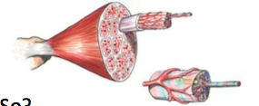
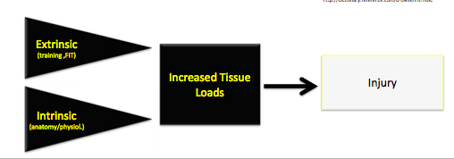
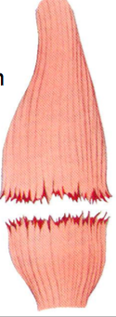
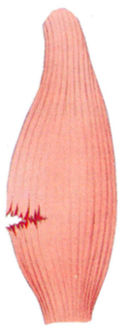
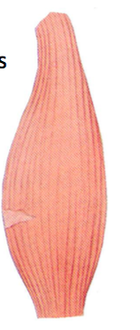
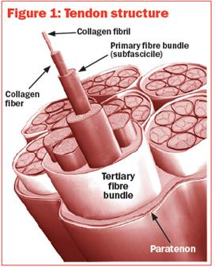
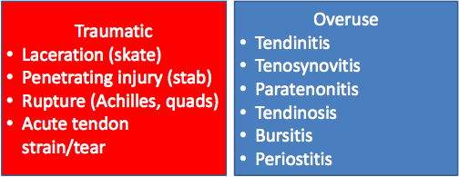
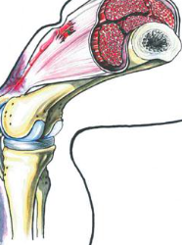
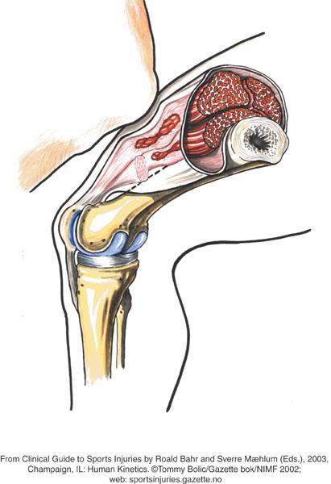
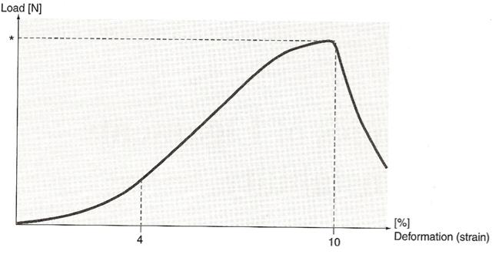
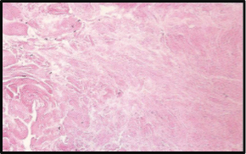
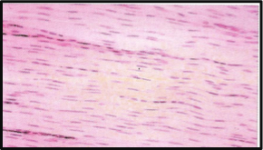
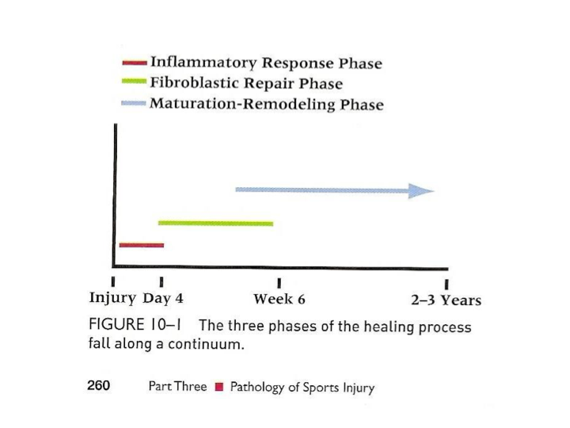
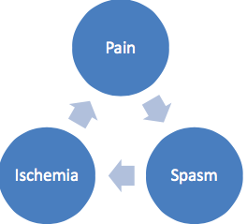
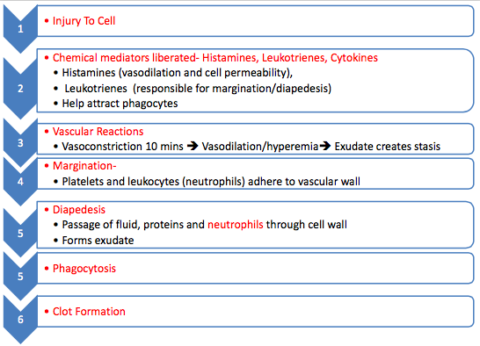
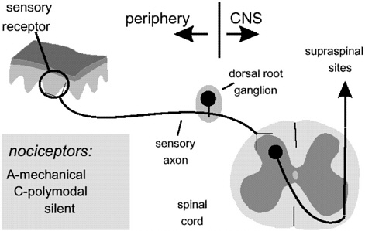
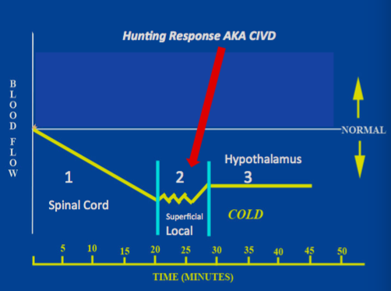
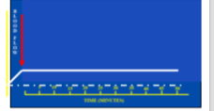
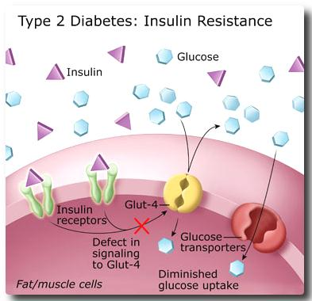
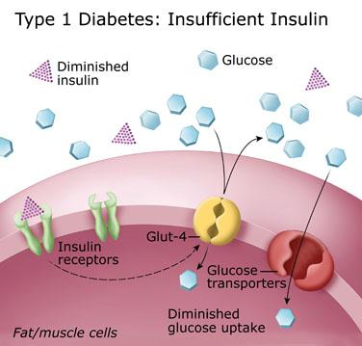
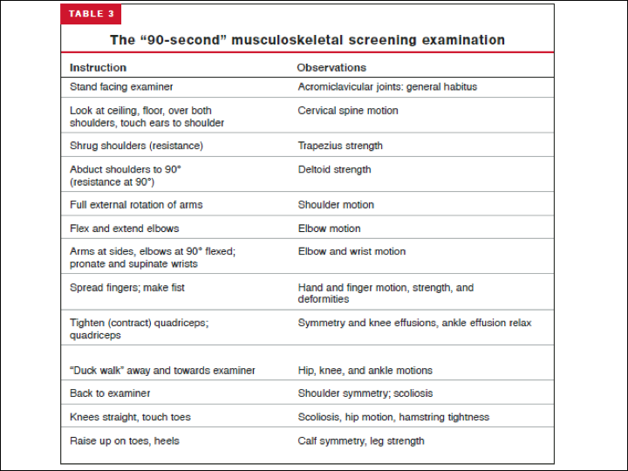
Call Person: gets the ambulance, told by control person
What is the signal for me to get to the playing surface, call 911?
What number do they call? Different country – on campus – etc.
What info do I need to tell them? Where do I meet them to bring to control and charge person? Will the Access be clear? – Have a Phone with them
Where do players keep their medications; keep their bags lined up. What happens in case of spinal or other life threatening – where is the call person?
Muscle Characteristics
- Contractile tissue with central function to generate power
- Well vascularised: good O2 & nutrients; good for quick recovery/healing
- Injuries to muscles bleed A LOT – more than other injuries; good/bad depending on where injuries are (intramuscular/intramuscular)
Factors causing Injuries
- Extrinsic/External originating outside the anatomical limits of a part
  - Ex – training, bad shoes
- Intrinsic/Internal belonging to or lying within a given part
  - Ex- anatomy/physiology, tight hamstrings
Lecture 4: Tissue Characteristics and Healing
Injury Classification
- Used to be called acute or chronic
- All injuries are technically acute – something initiates them
- At some point if injuries do not heal – they are termed chronic

Traumatic (acute)- occurs suddenly and a clearly defined cause or onset
- Tissue loading is sufficient to cause sudden irreversible deformation of the tissue
- Usually in HIGH speed sports with or without high energy contact
Overuse Injuries- occurs slowly over time, secondary to the repetitive dynamics of the sport or movement in question
- Repeated overloading, alone not enough to cause deformation – but which when accumulated over time exceeds the tissue threshold
- Seen in aerobic sports that require lengthy training schedules or in technical sports where a movement is repeated numerous times
- Preparation is key to responding to unexpected emergencies
- Does not need to be lengthy – ONE PAGE
- Every Program and facility should have an EAP
- You may think you have everything covered but you must but it in print
- Practice Practice Practice!
What? What do I have to help me at the venue?
★Do you know HOW to use the equipment ★?
★Do you have bolsters to support the head? ★Where is the AED? – On site? Does it work?
★ Is there oxygen in the tank? Do you know how to work it?
★ Is there a mask and hose?
Grading muscle STRAIN**
Grade 1 Strain Grade 2 Strain Grade 3 Strain
Fibers torn/stretched less than 10-20% 20-80% 80+% Complete
ROM Near FULL ROM Less ROM w/ Rupture; PROM
W some discomfort some discomfort
Near the end
Strength good 4-5 Poor Strength; 50%, Poor 0-1
Pain/discomfort slightly 2-3 significant Variable pain
Severed nerves &
Fibers

Other Slight Tear, can still Possible palpable divot no tension=
Go on that you can see (hole) minimal pain
Bruising – don’t want to
Stretch/contract
Grading muscle Strength **
Grade 0 – nothing happens when patient tries to contract
Grade 1 (Trace) – able to palpate a muscle contraction when patient tries to contract but no motion
Grade 2 (Poor) – can complete full available range w/o gravity (horizontal motion)
Grade 3 (Fair) – full range of motion against gravity only, no weights
Grade 4 (Good) – near full strength through available range when compared to other side
Grade 5 (Normal) – Full strength throughout available range compared to other side
Type of Contractions

Muscle Injuries - generally occur in 2 ways
★Dissentions (strains/ “pulled Muscle”) ★Direct Trauma (contusions/lacerations)

Muscle STRAINS
- Strain usually occurs at the musculotendinous junction
- More common in 2-joint muscles
- Strain occurs as a result of forcible stretching of a muscle, either passively or when the muscle is activated
Active contraction + passive Stretch = STRAIN

Muscle tears are called: STRAINS
Need to consider:
- % Of fibers torn
- Ability to move through range… stretch
- Strength that muscle can generate (out of 5) to grade injury
- Pain; sometimes pain is better than no pain
ECCENTRIC
-Muscle lengthens while contracting against resistance
-Maximal force, increased force with increased speed
-Greater risk of Injury
CONCENTRIC
-Muscle shortens while contracting against resistance
-reduced force with increased speed
ISOMETRIC
-Muscle contraction in which length of muscle stays constant
-Moderate force
Tendinitis -> Tendinosis
- If repetitive overuse continues and an inflamed or irritated tendon fails to heal, the tendon begins to degenerate
- Primary concern changes from tendon inflammation to tendon degeneration, a condition that is called Tendinosis
Tendinitis / Paratenonitis
Tendinitis – is inflammation of the tendon itself and is relatively rare
Paratenonitis – inflammation, pain and crepitation of the Parthenon as it slides over the structure
Acute Irritation – usually triggered by extrinsic factors/internal factors
-Rub from bone or equipment, External Factors such as: rub from equip. or too much too soon
-Internal factors such as rub over bone
Tendon Injuries: can be both traumatic or Overuse
Tendon Characteristics
- Connective tissue that attaches muscle to bone
- Function is to transfer force from muscles to the skeleton
- 80-90% type one collagen
- Arranged into parallel bundles of various sizes
INTRAmuscular
-No injury to fascia
-Blood trapped in muscle
-Significantly longer healing time
-Increased compartment pressure – decreased flow/o2/nutrients
-Chemical irritation (acidic blood making people sore)
-Longer healing time

INTERmuscular
-Fascia is injured
-Blood flows out b/w muscles- will see ecchymosis faster
-Heals faster; no increased pressure more blood flow, blood can be absorbed
-No chemical irritation (less pain)
-Less long-term discomfort

Muscle Contusions (bruises, hematoma)
- Can be any muscle, but quads are most common (heavily vascularized)
- Due to vascularity, hematomas are quite common
- All result in internal bleeding
- Can be intramuscular or intramuscular if there is no injury to the fascia
Properties of Ligaments: Structure and Morphology
- Wave or crimp across ligament
- Built into the structure of the ligament
- Injury can be closely correlated to the load-deformation curve
- 3 phase of curve
  - Toe Region
  - Linear Region
  - Rupture Region

Intra-articular
Inside a joint or joint capsule
-Total rupture will not heal
-Blood supply from ends-minimal to middle portion
-ACL
Capsular
Where ligament projects as a thickening of a joint capsule
-Total rupture; excellent healing (bc still connected by capsule)
-Good blood supply
-ATFL, MCL
Extra-Capsular
Outside of the joint capsule
-similar to intra-articular
-CFL, LCL
Ligaments
✓Connect one bone to another ✓Passive stabilizers; strengthen in rehab
✓Made out of predominately collagen, but higher content of elastic than tendons (some stretch
✓Usually a traumatic Injury ✓If NO rehab= more injuries down the road
✓Well innervated so info if position movement and pain; proprioception and rehab

3 Types of Ligaments
Achilles Tendinosis – What is Tendinosis/tendinopathy?
- Chronic pathological changes brought about by repetitive micro-trauma (running)
- Inflammatory cells are absent; not working anyways, so stops
- Characteristic changes in collagen fiber structure; breakdown
- Abnormal vascularity – new rope vs. old rope

Collagen Structural Changes
Normal Tendon
- Collagen fibers lined up
- Many nuclei
- Well developed and evenly spaced vasculature (art. & veins) – even blood flow

Tendinosis
- Collagen fiber disarray – not parallel bundles, fewer cell nuclei
- Hyper vascularity (more vasculature, but not organized) – some areas are getting more blood than others, crisscrossed
- Increased number of poor quality blood vessels
- Change it by breaking down bad vessels by hand
- Would not change if you thought it was tendinitis – inflammation
Know what you are dealing with before treating: if red hot and painful = tendinitis

Stages of Healing: (pictured here)
- Predictable sequence of healing
- Treatment dependent on the phase of healing
- Minimal ability to speed up process
- Interfering with this sequence will slow recovery AND return to play
Fractures
Characteristics
- Can be divided into Open (compound) or Closed (Simple)
  - Open- bone breaks through surrounding tissue
  - Closed- little or no displacement of bone through surrounding tissue
Fracture Classification
- Greenstick – paediatric, breaks on 1 side like a stick but bone not totally hard (won’t fully break
- Spiral – oblique angle
- Comminuted – many pieces, hard to put back together
- Transverse – straight across – most common (cast)
- Compound/Open

Fracture vs. Contusions
Direct pressure – pain contusion and fracture (can be both)
Indirect Pressure- pain with fracture
Grade 3 SPRAIN

AT LEAST 80%
Loss of Motion

Gross Laxity; only skin and muscle holding bones together – NO endpoint
Pain on palpation or no pain at all (no tension)
No proprioception (model) no stability, divots
Grade 1 SPRAIN

Little bit
FULL ROM

None- taken crimp out (no joint laxity)
Slight pain on palpation
Clinically stable, can continue, good stability
Grade 2 SPRAIN

At LEAST 50%
Significant loss

Will move more – joint laxity (has endpoint

Significant pain on palpitation
Cannot continue
Need to consider:

% of fibers torn
ROM (stretch)

Laxity on testing

Pain

Other

Ligament tears are called SPRAINS

Linear Region
-Pathological irreversible ligament elongation occurs
-As this continues intra and inter-molecular cross-links are disrupted until macroscopic failure is evident
-Early part- mild/grade I-<50%
-2nd part= Grade 2(50-80% fiber disruption
-Obvious Clinical Laxity- can pull two bones apart

Toe Region
-Initial concave region
-Represents normal physiological range of strain = 3-4% of length
-Due to flattening of Crimp
-Repeated cycling of stretch in this range IS reversible
-Normal everyday, no injury; step on stone
Rupture Region (peak)
-Failure point at ~10% deformation
-Complete Rupture
-Grade 3 – less pain (no tension)
-Won’t go back, no crimp

Need to break this cycle or will not recover
A sub cycle occurs as the result of pain, muscle spasm and ischemia increasing the possibility of atrophy over a period of time.
Signs & Symptoms of Inflammation
- Redness (rubor)
- Swelling (tumor)
- Pain (Dolar)
- Local Heat (Calor)
- Loss of Function (Functio Laesa)

HOW IT HAPPENS: Physiology
-Vasoconstriction to stop bleeding; dilate by histomines; swelling (exudate), everything goes to that area
-Margintaion changes permeability; more fluid from cap to injury site
-More fluid pouring out, less coming back in (puffy)
-Diapeedes; follows fluid, which attracts even more fluids
-Stagnists; so much pressure; no movement Margintaion moves out, diapedes flows through
-Plug clot to save blood
Primary and Secondary Damage
Primary = Damage at the time of injury (immediately irreversible) – cant do anything
ie: torn Ligament
Secondary= damage by released proteins, damage as a result of body processes (Edema; swelling, decreased flow resulting in decrease O2, tissue around primary site die off)
1. Inflammatory Phase
- Generally 3-4 days
- Cellular injury = altered metabolism + release of chemical mediator/proteins
- These cause the inflammatory response
2. Repair Phase
- 2 days – 6 weeks
3. Remodelling Phase
- 3 weeks – 3 years
Two Types of Pain Signals
- A Delta – Myelinated – fast pain (hand on stove) right at injury
  - Large diameter fibers
  - Sensitive to Touch, pressure (Door) and temperature (stove)
  - Located in skin
- C Fibers – unmyelinated – slow pain (sore pain that is prolonged) few days/weeks after
  - Pain and temperature
  - Located skin and deep tissue (muscle/ligament)
  - Small Diameter Fibers
Lecture 5: Pain and the Role of Hot and Cold

Pain Transmission
- Pain receptors called nocioceptors are sensitive to:
  - Mechanical
  - Thermal (hot, cold)
  - Chemical
- Afferent nerve fibers carry information from nocioceptors towards the spinal cord
Goals of Repair Phase: Remodelling/Maturation Phase
- Long-term process; 6 weeks to years
- With increased stress and strain the collagen changes to type 1 (stronger) and begins realignment
- Usually firm, strong non-vascular scar by end of 3 weeks – can be pushed in rehab
- Proper stress on bone and tissue at the right time and place
- Critical that injured structure be exposed to progressively increasing loads; can work up aggressive AROM and strengthening to facilitate remodelling and realignment
- Watch out for pain and swelling after exercise (done TOO much)
Goals of Inflammatory Phase: Repair (Fibroblastic) Phase
- 72 hours – 6 weeks
- Proliferative and regenerative healing leading to scar formation and repair of injured tissue
- Fibroplasia begins within the first few days and the inflammatory signs should be decreased
  - Wont feel pain, swelling, hotness, etc.
- Growth of endothelial capillary buds into the wound is stimulated by LACK OF O2
  - These new growths allow increase O2 and blood flow
- Body lays down Type 3 Collagen – weak tensile strength
- BEWARE: initially very delicate scar but increase in collagen fibers strengthens it
Don’t want to tear the tissue – MUST protect it
- Wont be in pain but still not better
- Main Goal: increase blood flow

Ice (Cryotherapy) - the body’s response to cold depends on..
- The cold media that is being applied (ice, cold water immersion, sprays, chemical packs)
- Conductivity of the area being cooled (high water content in tissue means the greater the cooling)
  - Muscles better than fat (takes longest to cool)
  - Joints>muscle
- Length of time of exposure – longer not always better
  - 10 on, 10 off, better than 20min straight – doesn’t bring blood flow to area
  - When blood flow comes, peaks a bit and heat body up again
What happens when you apply COLD?
Cold induced vasodilation; decrease in blood flow (10 min) from spinal reflex, then fluctuates (15-30 mins) at superficial local area, then levels off (mediated by hypothalamus)
What is happening with acute (traumatic) injuries?
- Tissue injury at primary and secondary sites – cell death due to hypoxia
- Increased bleeding into the area
- Pain
- Swelling/Edema
Cold and Superficial Heat
- Two of the most commonly applied therapeutic modalities
- They conduct heat to or away from the body
- Applied to speed up healing
- May cause injury if NOT used properly
- A-Beta will accommodation = rise threshold
- If a nerve is submitted to passage of constant stretch of current, the site of nerve under stimulation shows decrease of excitability and pain will increase
- Constant input= no sensation to body
- C Fibers WILL
- MUST change things up after 10-15 Mins (frequency)

Vibration
-4Hz on ankle x 10 min
=Release opiates and gate CLOSED
Position Sense
-Shaking Finger when you hit it on something
-AROM/PROM
Gate Control Theory - PT modalities built on this
- Without any stimulation, both A-Beta and Small C nerve fibers are quiet and the SG and inhibitory interneuron block the signal in the T-cell that connects to the brain. The gate is CLOSED and therefore NO PAIN
- WITH pain stimulation, C Fibers become active. They block the inhibitory SG and activate the T-cells. Because activity of the inhibitory interneuron is blocked, it CANNOT block the output of the T-cell that connects with the brain. The gate is OPEN= PAIN
- WITH NON-Pain stimulation, Large Nerve Fibers (A) is activated primarily. This activates the SG, which then activates the inhibitory interneuron, which then BLOCKS the signal in the T cell that connects to the brain. The gate is CLOSED=NO PAIN

Types of A-beta input

Pressure
-Mom Rubs head when you bump it
-Massage

-Decreased Hypoxic injury and future edema

-Use of towel, wet or dry compression bandage decreased conductivity

-Temp. of gel packs can be many degrees below 0

How to Ice People
-Apply Ice ASAP to avoid 2nd injury!
-Put ice on people don’t put people on the ice
-Best cooling effect comes from ice mixed w. water in bag on skin
-Compression over top is best
- NEVER apply gel packs directly to skin (below freezing temps)
ne
ICE IN INFLAMMATION STAGE – better for PAIN
- C not Myelinated
- For every 1degree drop in temp. you cool a nerve, you decrease conduction velocity
- With a 4 degree cooling – you knock out C fibers
- Can get to deeper tissues
- Can maintain temperature longer
- Decreased metabolism
- Doesn’t reduce swelling that is there = prevents more
Optimal Loading
- Optimal loading means replacing rest with a balanced incremental rehab program where early activity encourages early/fast recovery
- Injuries vary, sot here is no single one size fits all strategy/dosage
- Functional rehab of ankle sprain, involved early weight bearing usually with external support is SUPERIOR to cast immobilization for most types of sprain severity
Protection
- Protection and rest after injury are supported by interventions that stress shield, unload and/or prevent joint movement for various periods
- Recent animal models show that short periods of unloading are required after acute soft tissue injury and that aggressive ambulation or exercise should be avoided
GOAL: decrease blood supply and prevent further Injury!!
TREATMENT
P-Protect
O-Optimal
L-Loading
I-Ice
C-Compression
E-Elevation
Inflammatory Phase Goals: DECREASE SWELLING, PAIN & INFLAMMATION
OPTIMIZE HEALING ENVIRONMENT!
Thermotherapy
INCREASE
INCREASE
INCREASE
INCREASE
DECREASE
DEPENDS ON TIMING OF HEAT
DECREASE
Muscle Spasm – DECREASE
Cryotherapy
DECREASE
DECREASE
DECREASE, reduced o2
DECREASE
INCREASE
CONTROVERSIAL
DECREASE
Muscle guarding -DECREASE
Variable
Blood Flow
Capillary Permeability
Metabolic Rate
Collagen Elasticity
Joint Stiffness
Edema
Pain
Other
Physiological Responses to Cryotherapy & Thermotherapy

Heat (thermotherapy) –the body’s response to heat depends upon…
- The type of heat applied – moist heat (better for deep tissue), Dry heat (better tolerated), Ultra-sound (mechanical)
- Intensity of heat energy – some people are more sensitive
- Duration of the application – increased blood flow until heat source is removed
  - Will peak after 5 mins – body protects it from getting TOO hot
  - Only when heat source is removed will tissue temperature drop
Hyperglycemia
-Sugar present in blood stream, but can’t get in to tissue
-Cells starving
Body starts converting fat
-Acidosis – ketoacidosis present in breath – fruit smell, frequent unration, thirst
-Possible Coma
Hypoglycemia
-Minimal sugar in the bloodstream
-Too much insulin/not enough food, excessive exercise
-Decreased nutrients to brain
-Insulin shock/reaction
-Hunger
-Double Vision

Lecture 6: Medical Conditions

Diabetes
Type I – 10% aka juvenile diabetes ------ Insufficient Insulin
- Problem: pancreas fails to produce enough endogenous insulin
- Can’t get sugar out of blood and into cells
- Filtered out by kidneys
- Leads to dependence on exogenous insulin - insulin pumps/self injection
Type II – 90% ------ Inadequate insulin produced by the Pancreas
- Significant resistance at the cellular level
- Sugar CANNOT get in
Diabetic Problems

HEAT IN FIBROBLASTIC/REPAIR STAGE
- Increases blood flow to promote healing
- Decrease spasm – break the cycle
- Increase collagen elasticity
- Decrease stiffness
TREAT for FIBROBLASTIC
-Heat 10-15 minutes depending on tissue depth - idealize ROM
-Start low level strength and proprioception exercise
-Increase as able while you increase weight-bearing status
-Gentle and pain free – as we do not want to RE-injure / tear scars out
- Next stage pain is good; tear out things that aren’t aligned properly

Fibroblastic / Repair Phase Goals: DECREASE PAIN
INCREASE BLOOD FLOW / ROM
Elevation
-No reduction of blood flow until the injured area is at least 30cm above the heart
-At 50cm flow is to 80% of normal
-At 70cm flow is 65%
-Think about what people usually do with there sprained ankle
Compression
-Most essential component when limiting hematoma
-An elastic bandage pulled tight can limit blood flow by 95% within seconds
-Reduced blood flow increases linearly with pressure, so a loosely fit bandage will only decrease flow 60%
-Applying a pad or ice bag underneath will also increase pressure

Epilepsy & Exercise
- Fatigue, exertion and stress MAY be a trigger of seizures
- ONLY 2 of 400 listed exercise as a precipitant (more commonly: lack of sleep, fever/illness/menses)
- 2% have seizures in more than 50% of training sessions – intense activity, most had a structural lesion (due to closed head injury)
Management
- Lie them down, protect their head
- Remove objects close by
- Do NOT restrain
- DO NOT put any object in their mouth - they will choke
- Position on side in recovery position
- Assess for Injury - if fallen, contusions, dislocations, fractures
Generalized-bilateral discharge involving ENTIRE cortex
1. Convulsive Tonic-clonic Seizure (Grand mal)
-Athlete falls to ground
-Goes through a tonic phase of muscle stiffness
-Followed by “clonic” phase of muscle twitches

2. Non-convulsive-Absences (petit mal)
-Sudden interruption of activity followed by blank stare
-May or may not realize it occurred
-Make them comfortable
Partial (Focal) occur in one part of the brain and activate only a small number of neurons
- Simple
-NO loss of awareness, usually consisting of brief sensory, motor or memory-related symptoms

- Complex
-LOSS of awareness, usually associated with behavioural arrest, staring, blinking, and automatisms lasting minutes with postictal amnesia (trying to put things together)
Types of Seizures

Epilepsy
- Condition defined by the recurrence of unprovoked seizure
- Must have more than 2 to be termed epilepsy
- 10% of population will have at least one seizure, but only 2% will go on to have recurrent unprovoked seizures; epilepsy ***recurrence is key***
- Likely that many newly diagnosed patients will be participating in athletics at a time of diagnosis
- A seizure is a result of a discharge of electrical activity within the brain
Symptoms - check for medical alert bracelet/necklace
- Major signs and symptoms of Hyperglycemia and Hypoglycemia are similar:
  - Altered level of consciousness - dizzy, drowsy and/or confused
  - Rapid breathing
  - Rapid pulse
  - Feeling ill
Management
- Ask if they have eaten or taken insulin
- Give sugar – juice, hard candy, glucose tablets, non-diet soft drinks
- Monitor for 5 minutes
- If Hypoglycemic = see improvement
- If Hyperglycemic = no chance - refer for advanced emergency medical care (hospital)
Signs and Symptoms: chronic inflammation causes an increase in airway hyper-responsiveness leading to:
- Recurrent episodes of wheezing
- Breathlessness
- Chest tightness (or chest pain in children)
- Coughing (dry)
  - Particularly at night or early in the morning
  - After exercise in cold, dry environments
Exercise induced Bronchospasm (EIB/EIA)
- Bronchospasm: narrowing of the airways induced by strenuous exercise in which the patient has no symptoms is known as EIB
- When symptoms ARE present, EIB is described as EIA
  - 80% of asthmatics
  - 40% Season allergies
  - 12-15% general population
Pathophysiology of EIB
- Exercise triggers bronchoconstriction b/c it leads to dehydration of the lungs airways
- Symptoms peaks 8-12 mins after exercise
  - Inhaled air is dry & cool -> Air warmed/humidified in the lungs = drying out -> after exercise, the cells rehydrate via hyperemia (increased BF) , leading to a cascade of biochemical changes that trigger bronchoconstriction (no necessarily mucus
- The degree is dependent upon exercise intensity, the temperature and humidity of the inhaled air
- Asthma
- Chronic inflammatory disorder of the airways
- Excess mucus production and bronchial smooth muscle constriction, which results from a release of inflammatory mediators
- Maximal expiratory flow is reduced and residual lung volumes are increased as air is trapped behind the blocked airways
- The athlete must work harder to breathe as the thorax becomes over-inflated
- With progression of the attack, the diagram and intercostal muscles must compensate and muscle efficiency is eventually lost – leads to respiratory muscle fatigue and physical distress that MAY result in death
- TRIGGERS: Smoke, night-time, dust mites, pollen/mould, weather & Air pollution, animal dander, pests, strong scents/odours, exercise, respiratory infections and emotions
Benefits of Exercise: multiple studies have shown that exercise actually decreases seizure frequency
- Normalize the EEG = increase seizure threshold and decrease the likelihood of seizures
- Decreases discharges in EEG during exercise (increase seizure threshold = less seizures)
- Patients that exercised regularly had significantly less seizures than those that did not
- Physical activity also enhances alertness and focus = increases the seizure threshold
Must stress: proper diet, rest and adherence to medication for seizure control

Sport Participation:
- Should avoid: Scuba, rock climbing, motor racing and downhill skiing
- Frequency of seizures are important when considering swimming (4x more likely to be involved in submersion accidents, must swim with a buddy)
- No adverse effects with regards to contact sports

Typical PPE Set up
- Fees, drug education as per CIS
- History- self-report form and questions
- Trainer – height, weight, vision, mental
- Team PT/Trainer – MSK Screen
- Team Physician – Medical Exam

Components of the PPE
- Complete Medical Hx (most important)
- Medical evaluation form
- Musculoskeletal evaluation form
- Visual acuity
- Quick mental processing from (SCAT2, McGill)
- Player Status form (MSK. Medical Clearance)
Methods of Evaluation
Office Based
Clinic or MD Office
Usually just ONE examiner
May be one PT but consultations are necessary
VERY time consuming for large team
Much more expensive
Station Based
Less Expensive
Athlete meets more members
Divided into medical and musculoskeletal
Includes MD and other health professionals
Fosters improved communication by medical team & may reduce staff burnout – less personal
The PPE Team
Physician
PT/AT/Kinesiologist
Orthopaedic Surgeon
Nurse
ALSO MAY INCLUDE:
Dentist
Sport Psychologist
Dietician
Ophthalmologist
Coach
When does a PPE Occur?
-4-6 weeks prior to Season (generally occurs closer to the start of the season)
-End of Preceding Season
-1x /year
7 Objectives of PPE
According to Armsey and Hosey:
-Detect conditions that would restrict participation
-Detect conditions that may be life threatening or disabling
-Injury prevention evaluation
-Meet legal and insurance requirements
-Initiate and establish a rapport with the athlete
-Provide an opportunity for counselling
-Establish a database and record keeping system
Preparticipation Physical Examination - PPEs
-Medical physical examination assessing the ability to safely participate in sport activity
-Not intended to disqualify or exclude
-Help maintain health and safety in training and competition
Diagnosis of EIA
- Need 2 things to diagnose
- Symptoms (shortness of breath, coughing, chest tightness/wheezing)
- Obstructed airways 10-15% lower FEV1
- Both associated with exercise
- To test:
  - Athlete works 6-8 mins at 80%
  - Better if test is sport specific
  - May need cold air, if testing winter athlete
Management/Coping Strategies
- Educate on the signs, symptoms and triggers
- Avoid exercising around or near irritants if possible
- Using bronchodilators (beta 2 agonists) as prescribed, prior to exercise
- If bronchospasm occurs: use dilator as prescribed, position for ideal breathing, begin by slowing exhalation, then inhalation
Medical History
- A complete medical history, preferably from the athlete AND a parent, will reveal approx.. 75% of problems affecting initial athletic participation
- PPEs have been successful in identifying health issues such as: eating disorders, alcohol and drug abuse
- The strongest independent predictor of sport injury is a previous injury (odd ratio 9:4) and exposure time (odds Ratio 6:9)
Bone and Soft Tissue Tumors
- Primary Malignant tumors are rare – usually in young 2-3rd decade, pain aggravated by activity
RED FLAGS: Night pain, fever, loss of appetite, unwanted fatigue, weight loss (10-15 lbs in weeks)

Rheumatologic Conditions
- Rheumatoid arthritis, Ankylosing spondylitis, psoriatic arthritis
- Could report a single or multiple swollen joints – no history of trauma or injury
RED FLAGS: morning stiffness, rashes, fingernail pitting, bowel disturbances, eye irritation (conjunctivitis, iritis)

Infection
- Bone and joint infections/osteomyelitis are uncommon
- May report a single or multiple swollen joint –no history of trauma or injury
RED FLAGS: bone pain in children (both at night or with activity), night sweats, hot & swollen (with no history of major trauma)

Vascular Conditions
- Deep vein thrombosis (blood clot) - could be from recent air travel, surgery
- Presents with single limb pain
- Aggravated by exercise
RED FLAGS: tenderness on palpation over tissue, warmth, swollen, red, pale or bluish
RED FLAGS: if there is something about the history that doesn’t fit the pattern, then consider alternative less common conditions!
- Bone and soft tissue tumors
- Rheumatological conditions
- Cardiovascular disorders
- Infections
- Genetic Disorders
BEWARE: conditions masked as Sport Injuries

Key to recognizing that everything is not as the first impression might suggest is to take a thorough history and perform a detailed exam
Medical History
- Given 7-10 days in advance to facilitate complete family and past medical info
- Symptoms with exercise (cardio/syncope) requiring further evaluation
- Concussions
- Meds, Alcohol, Drugs
- Recent infections
- Female Athletes
- SPECIFIC: triad: Amenorrhea, anorexia/bulimia, Osteoporosis
Clearance to Play Questions
Is there a problem that places the athlete at increased risk of injury?
Is any other participant at risk of injury because of this problem?
Can the athlete safely participate with treatment of the problem?
Can limited participation be allowed while treatment is initiated?
If clearance is denied for certain activities, in what activities can athletes safely participate?
Is consultation with another healthcare provider necessary to answer the questions above?

IF they cannot respond to these questions, probably should not be playing and should be sent to another healthcare professional
AAP Committee on Sports Medicine
Individuals may be precluded from participation in contact sports or require further testing for any of the following reasons:
- Atlantoaxial (upper c-spin) instability) 1st 2 vertebrae
- History of significant head or spine trauma
- Acute/contagious illnesses
- Carditis
- Congenital heart disease
- Pulmonary compromise
- Absence of one kidney
- Enlarged liver/spleen
- Fever
- Significant musculoskeletal disorders
- Convulsive disorders (poorly controlled) *** never actually been an issue
Cardiovascular Conditions
Hypertrophic Cardio Myopathy (HCM) is a condition in which the heart muscle becomes thick. The thickening makes it harder for blood to leave the heart, forcing the heart to work harder to pump blood
When blood leaves the heart, it flows through the aortic valve, into the aorta. In aortic stenosis, the aortic valve does not open fully. This decreases blood flow from the heart
Medical Examination
Completed by: Physician
-Observation: look for health markers
-Dermatologic Conditions
-Vital Signs: HR, BP,RR, TEMP
-Cardiovascular Examination –listen to heart sounds (R/O- hypertrophic Cardio-myopathy, aortic Stenosis)

Medical Examination
Head, Eyes, Ears, Nose & Throat
Blood Tests
ECG
Diagnostic Tests
Diabetes
Allergies (Elastoplast)
Routine screen need not include non-invasive cardiac testing or lab tests
MSK Examination
Completed by: PT/CT/AT
-Screening Exam
-Specific tests based on History
-Functional Tests
-Perfect area for clearing tests
-Neurological Scans
Screening Phys. Exam is 51% sensitive and 97% specific = not very sensitive
-Previous Injuries
- Fractures, ligament and tendon injuries
- General strength/weakness
- Laxity
- Posture/scoliosis
90-second screening MSK test will detect 90% of significant MSK injuries
WATCH OUT!!
- US preventative services task force describes an effective screening test as satisfying two requirements
- Can detect target condition earlier than without screening
- Screening and treating should improve likelihood of a favourable outcome

People found based on review 176 articles that the PPR did NOT satisfy these basic requirements
- No compelling evidence that the PPE can accurately predict or prevent orthopaedic injury or cardiovascular sudden death
- Advising students about rules and equipment may decrease mortality and morbidity more effectively than the exam
Screens ONLY cover OUR asses

PPE can be done quickly and effectively
They CANNOT identify medical and orthopaedic problems of sufficient severity to place the athlete at risk for injury or illness
They CAN (a little) help identify correctable problems that may impair the athletes ability to perform (eating disorders, alcohol, drug abuse)
IT CAN help maintain the health and safety of the athlete
IT CAN assess fitness level for specific sport
IT CAN educate athletes and parents concerning sports, exercise, injuries and other health related issues
IT DOES meet legal and insurance requirements - saves our ass

YOU MUST AVOID COMPLACENCY IN CIRCUMSTANCES WHERE A PPE WAS UNREMARKABLE, YET THE ATHLETE DISPLAYS EARLY SIGNS OF DISTRESS, BE IT CARDIOVASCULAR, ORTHOPAEDIC, OR OTHERWISE
If someone comes in with a clean physical but acts funny on the court – physical does NOT always pick things up; have them get checked out; cannot always rely on what is on the paper

