- Tinbergen’s Four Questions: Proximate causation – causes of a trait during a single lifetime (mechanism – lesion studies for area of brain, development – ontogeny – babies 1 period or learn all the time); ultimate causation – evolutionary causes of a trait (function – affect reproductive success – is it loudest or most complicated song that increases success, evolution – how did it evolve - phylogeny)
- History:
  - Darwin + = instinct anecdotes, emotions/intelligence – instinct and tried to show animals can produce human behavior (Clever Hans)
  - Behaviorist (nurture) revolution = experiments on learning
  - Ethology (nature) not capable of quantitative predictions = observations and experiments on instinct; chicks and red spots – extreme versions better therefore basis for sex selective traits; lamb/mother imprint expt by Lorenz –control because 0 experience
  - behave ecol/sociobiol = cost/benefit predictions on behavioral strategies – crash of ethology because of bee dance! altruism
- Old vs. new paradigm: aggression – innate but can be changed with reward/punishment -> depends on relation and immediate cost/benefits for defense (kin relation); animal wouldn’t leave site with food left for another -> diminishing returns at one site with unexpected food at others; courtship –innate and species-specific…court in most adaptive way -> alternative strategies that decrease benefits of those using main mode
- Behavioural Ecology: function – use of evol and evol processes to explain adaptive significance of behavior patterns, predict ecological patterns, empirical/comparative analyses relating behavior to envt
- Problems in studying behavior: anthropomorphism (animals as people), anthropocentrism (visual tests for rats when smells better), anecdotes (single observation used as evidence), design and interpret studies (consideration of alternate hypotheses)
- Keep in mind parsimony – most simple explanation unless not possible
- Ethogram: catalogue of behavior patterns of a species
- Data reliability: Biases caused by observers
  - Expectancy effects – Clever Hans
  - Disturbance effect (hide video etc)
  - Demonstrator difference/influence
  - Inter/Intra observer reliability
- 3 criteria for adaptive evolution: heritable variation in traits, variations in rep success, trait correlated with +/- success (without this last one, can get evolution, just called neutral evolution)
- Implications of Evol theory: lifetime rep success (RS), not survival, drives natural selection; fitness is relative RS – alleles don’t have to be best for f to increase…just better than competing therefore traits don’t act for the good of the species…just increase RS; group selection likely to be weak in comparison to indiv selection *selfish mutants can invade
- Adaptation: character favoured by natural selection for its effectiveness in a particular role – diff from adaptive behavior: that increases rep success
- ADAPTIVE?

- ADAPTATION?

 | - Yes | - No
- Yes | - Current Adaptation | - Past Adaptation
- No | - Exaptation | - Dysfunctional Byproduct

Niche construction: active role of behavior in ecol. – earthworms change soil and that soil is inherited by next gen of worms (environmental evolution)
- Critique of Pinker: multiple meanings of the terms innate and instinct
- Developmental plasticity (gene-envt) same gen and depending on where you plant it, develops differently into different looking phenotypes
  - Mobbing reed warblers (genetic predisposition to learn to mob cuckoos) – if watch parrot, don’t mob either species.
  - Rat – maternal care affects stress responses and can be transmitted non genetically across generations. Epigenetic inheritance – cross fostering experiments…in enriched, high licking. Allows mother to program pups for whatever envt they are being born into (adaptive programming hypothesis)
- Behaviour / envt has affected genetics – lactose tolerance
- Smaller p-value = less likely pattern occurred by chance. Type 1 error – reject Ho incorrectly; type 2 – accept Ho incorrectly
- Testing Predictions:
  - Experimental: smaller groups show increased vigilance and decreased risky foraging by comparing groups with prairie dogs removed, not removed, and removed but replaced.
  - Observational: test by comparing nat. occurring groups of diff sizes
  - Comparative: need phylo info and test by comparing diff species or diff genetically isolated pops that had diff average group sizes
- Fundamental assumption of behave ecol – indivs expected to be designed by nat. selection to behave in ways which best promote their genetic contribution to future gens through own rep or helping relatives to rep.
- Gould – spandrels – can’t assume every trait is an adaptation
- Adaptive storytelling – just so stories – explanation without reasoning
- Tradeoffs:
  - Drosophila – early egg drop off die earlier
  - Opportunity costs (doing one thing reduces opp for something else), energy costs, survival costs (risk of mortality from predators, parasites etc)
  - Net benefits: nat selection should favour trait that max’s net bens.
  - Constraints: if trait not well adapted – eyes worked a little bit so must work with what it has; gene flow, time etc.
- Optimality Models: seek to predict which trade-off of costs and benefits will give the max net benefit to an indiv *economic analysis
- Clutch Size graph: max distance between costs and benefit curve = maximum rep success for clutch size. Costs = adult mortality and Benefits curve = number of surviving young produced. Y-axis – costs of benefits; x-axis = clutch size
- Optimal group size? Above line – better for bird to join group ~ 13 birds
- Max rate of food delivery for fixed travel time is at tangent – with longer trips (increased travel time), extends further along on curve and therefore increased loads per trip to max the delivery rate
- FORAGING
- Benefits – acquisition of energy and nutrients (can come from same food or diff nutrients from diff foods)
- Costs – requires energy for movement, time, higher risks from predation and defensive actions by prey/physical envt
- Measures – NREG (net rate of energy gain) diff between total intake and expenditure of energy to achieve that intake. Maxing NREG will min time to reach that amount and free up max amount of time for other activities. NREG not appropriate for a nutrient not well correlated with energy (more correlated with fitness such as aphid – obtains much more energy than they need from sap of plants they suck but protein is important limiting resource)
- Central place foraging – animal moves out from one location to one or more distant locations to forage and returns with food to fixed location (hoarders – chipmunks and honeybees) or to return to safe place for handling or for offspring (birds) travel – storing – loads
- Food processing – birds puncturing on sharp trees
- Simple Foraging Cycle
  - Search: detection of potential prey
    - Avoid encounters: Avoid high predator activity times/places, use locations that exclude predators, associate with protector species, reduce evidence of presence in that area, space out, actively discourage predator from hunting in vicinity (mobbing)
    - Avoid detection when encountered: reduce motion, smell, sounds etc, hide in cover, restrict activity to times of day when detection difficult (night), crypsis (bkgd matching – involves behavior and morphology), mimicry of inedible objects, vigilance
  - Pursuit: leads to physical contact with prey that have been detected/selected
    - Advertise dangerous qualities, mimicry of dangerous species, indicate detection or display escape capacity (stotting), grouping amplifies warning signal, reduces per capita risk
    - Capture reduction: increase distance from pred to refuge / cover, confusion affect
  - Handling: leads to consumption of contacted prey
    - Struggling to escape / fighting back, increasing effective size, withdrawing of vulnerable parts, increasing handling time, induce pred to attack less vulnerable body part, attract more preds, attract attention of conspecifics
  - Assessment: animal decides whether to continue the cycle
  - Trade-offs: handling reduction via heavy shells reduces speed of fleeing from preds that can break shells, crypsis may interfere with early pred detection and fleeing; organisms should not and do not always flee as soon as pred is detected (pred threat, value of alternative activity), arms races between preds and prey
- Foraging Theory: all living things require energy; bc food sources vary in quality and distribution, foragers need to decide where to search for prey, when to stop searching and move to diff patch, to capture all prey encountered or not, to forage along or in group; to understand consequences of these and other decisions for fitness; to predict foraging decisions that max rel. fitness
- Optimal Foraging Theory: predicts orgs will forage such that they max their net energy intake/unit time; assumes max rep success achieved by making net rate of energy gain
  - Lemon – zebra finch – see tray with seed or seed plus husks and sort adding cost – searchers have much lower fecundity and survivorship – SUPPORTS THEORY
- For calculations: assume prefer increased rate of gain, capable of distinguishing options, assessment costs minimal, capable of making a decision, no valuable nutrients in shell and no predation
- Optimization of Simultaneous Prey Choice
  - Rate of energy gain = prey value / (interval between discoveries and pursuit and handling time)
  - R = V/(d+h)
  - Cow and calf pairs discovered simultaneously – one can be taken and other will escape. V:cow = 900kg, calf = 500kg; h: cow = 6h, calf = 2h; d = same for cow and calf because they are always together; d = 5h **Assumes never satiated
  - Cow = 900/(5+6) = 82 kg/h; calf = 500/(5+2) = 71 kg/h – can manipulate with d.
- Sequential choice models: prey detected one at a time and choice is to pursue or continue searching for alternative
- Marginal Value Theorem (Chernov) – when prey consumed gradually, single prey can be considered as patches (spider); rate of gain may not be uniform (diminishing returns – prey become warier with time – prey depression)
  - Predicts abandon a patch when the instantaneous rate of gain (marginal capture rate) in the patch falls to the average for the environment
  - Bee on foxglove – bees spend most time foraging – each foxglove = patch; whether or not to forage in particular influorescence, how to forage within an acceptable patch and when to leave the patch; measured amount of nectar in both foxgloves and bottom flower gave most calories (diminishing returns) – starts at bottom flower therefore prediction true; plant benefits because female flower at bottom – bring pollen upwards and encourages to stay on plant towards male flowers and other plants therefore bees are selected to max energy gain and are examples of MVT
- HABITAT SELECTION
- Needs of individuals: food, water, shelter, but these needs might operate on diff time scale
- Needs of a population: reproduction, movement (metapopulation)
- Habitat: set of physical envtl factors that a species uses for its survival and reproduction etc.
- Habitat selection is a process – earth heterogeneous in all scales therefore it matters where you go – max rep output, expect strong selective pressure for organisms in optimal locations
- Fundamental assumption of behavioural ecology – indivs should be expected to be designed by natural selection to behave in ways which increase their genetic contribution to future gens through own rep or by helping rels rep.
- Generalists: raccoons etc.; specialists: koala, flatworms etc.
- Some species have more pressure to end up in the right place
  - Burn paper for moose – seeing less moose than we’d expect but at edge, get more moose than expected
  - 1st order (geographic range), 2nd order (placement of home range within landscape), 3rd order (actual placement of locations within home range, and 4th order (single location point on single time scale – which single peanut did it go for)
  - Home range: the area transversed by the individual in its normal activities of food gathering, mating, and caring for young
- Ideal Free Distribution – expected dist. Of foragers wen resource patches differ in quality and foragers compete for resources
  - Foragers have perfect info about relative patch quality and forager density in each patch; can move between patches without cost or time delay and are not excluded from patches by current occupants; prey arrive randomly at different rates in different patches and are consumed immediately upon arrival *handling time = 0
- INTELLIGENCE
- Intelligence: very general capability that involves the ability to reason, plan, solve problems, think abstractly, comprehend complex ideas, learn quickly and learn from experience
- Cognition: internal mental reps; cog. map = mental rep of the world
- Cognitive modularity issue: how general is intelligence – Fodor – gen mech applied to many problems
- Social / Machiavellian intelligence: demands of social living drives cog evol.
- Adaptive specializations: human cultural intelligence – had to do tasks in physical and social domains – all three apes have same intelligence in physical but HUGE jump in social/cultural intelligence in human children (learning from others). Initial advantage of social IQ that allows them to further develop physical IQ (using tools etc)
- EVOLUTION OF LEARNING
- Learning: change in an animal caused by a specific experience at a certain time, that is detectable later in the animal’s behavior
  - Costs: delayed rep, increased juvenile vulnerability, increased parental investment in offspring, increased brain size and complexity (energetic cost), developmental fallability
  - Expt: selected in Drosophila for good/bad larvae – low learning flies outcompeted increased learning in low food environment but with lots of food, both did equally.
  - Benefits: adaptation to envtl variability; sexual selection
- Social Learning: learning influenced by observation of, or interaction with, another animal or is products (info told by others include public info)
  - Food preferences in rats – learning safe foods from each other
  - Expt – diet with cocoa or with cinnamon and place rat in location of observer and learn food preference of other individual (not feeding at same time)
  - Benefits: same time, conserve energy and min risks of exploration
  - Costs: out of date info or incorrect info, info relevant to them and not for you (lactose intolerance)
- Public info: about quantity of resource
  - Collared flycatcher – assessing quality by number of offspring – immigration and offspring quantity correlate (example of habitat selection through use of public info)
- Social Learning Processes – Giraldeau
  - Area copying – using social info about places (local enhancement)
  - Object copying – using social info about objects (stim enhancement) – birds and milk bottles
  - Behaviour copying – using social info about behavior (limitation) – if also learning exactly how to peck
    - Stable transmission – golden standard therefore cultural evol., since imitation is rare, rare for cultural evolution
- Artificial Fruit Opening in Chimps: Two action methods (control for local and stimulus enhancement) allowing one to look at limitation – opening/twisting box
  - Coded behavior: if chimp saw twisting, did twisting and vice versa – saw influence of behavior copying – humans very strongly imitate
- Copying mate choice in guppies – female has preference for unattractive males when seen with another female but a limit (humans and music)
- Culture: group-typical behavior patterns shared by members of a community that rely on socially learned and transmitted info; intergenerational and more than 1 behaviour pattern
  - Most interesting differences in populations of chimps were about how to adapt to envt (ants on sticks – length)
- When would we expect social learning to evolve?
ENVIRONMENT CHANGES | PREDICTION
Random | No Learning
Rapid | Individual Learning
Intermediate | Social Learning
Slow | Genetic
- As frequency of imitators goes up, fitness goes down – always outdated info because no new discoveries – your fitness as an imitator depends on frequency of individuals
- Stickleback expt – food sources – place socially indicated as feeder but fish trained to know other feeder has best food – as increase number of days, rely less and less on personal known info
- Different ways to behaviourally track changing envts: genetic evolution, indiv behavior plasticity (devlptl plasticity, indiv learning, social learning)
- SOCIAL FORAGING
- Costs: disease transmission, conspicuousness, competition within group, cannibalism, cuckoldry (other indivs within group mate with your mate)
- Benefits: anti-predator defense, improved foraging efficiency, other (thermal benefits etc.)
- Anti-pred benefits: group defense, dilution effect, confusion effect, ‘many eyes hypothesis’ – foraging benefits of group living
  - These benefits facilitate foraging, locating food, learning about food and food locations *food pred in rats), group hunting (lion video)
- Highly structured groups or specialized roles may minimize some costs – gelada baboon are large groups on rich plateau grasslands (cliques – anti-predatory) but smaller on cliffs
- Behaviour may circumvent apparently dominant indivs: increased coalitions formation by elderly male baboons – low ranking indivs get more matings than expected.
- Social envt: effect of conspecifics (and other species acting in a similar fashion – mixed species groups) social effect (changed food availability, changed costs and benefits of foraging; kleptoparasitism)
- Foragers often affect each other’s energy gain either directly(when interacting), or indirectly (through depletion of shared resources or changes in prey behavior:
  - Exploitation: removal of prey; passive interference: prey depression (prey become less available); facilitation: prey become more available; interference competition: active defense of prey – resource defense theory; scramble competition: ‘milkshake effect’ – change behavior to avoid other foragers taking prey first
- Density-dependence: costs and benefits change with number of indivs/area
- F-dependence: costs and benefits change with proportion of indivs using different tactics or strategies
  - At larger scale, density of pigeon flocks – more food = more pigeons. 4 sites with some deviation because of violation of model assumptions (no perfect info – sits diffs etc)
- Social exploitation of resources
  - Foragers may obtain prey discovered by others
  - The producer-scrounger game predicts the frequency of such food exploitation
- PS game: assumptions
  - Population of foragers can be divided into two mutually exclusive foraging tactics: producers search the envt for food; scroungers search the envt for successful producers and join at discovered patches
  - Payoffs to both tactics are negatively f-dependent
  - Eqm point of about 0.4 in this example (switching from producing makes no difference at this point)
  - Nutmeg mannekins: not aggressive and cannot be simultaneously producer and scrounger – meets model
    - Expt 1: measured seed intake rate of p and s in varied group composition – only difference for scroungers and expect SEF. Scrounger, when rare, can do better than producer but does worse than producer when common. A f of scrounger exists when both producer and scrounger receive equal payoffs (SEF)
    - Expt 2: birds changed use of each tactic such that the group converged on the predicted SEF of scrounger after 5-8 days of testing – flocks reached two different SEF values therefore changes in individual behavior can lead to SEF / significant decrease in variation of mean number of scroungers therefore learning choice of tactic consistent with individual maximization of seed intake rate.
- Tactic use depends on indivs phenotypes – dominance, vulnerability to predation, energy reserves/body condition, foraging efficiently, basal metabolic rates, boldness
- Body condition and tactic use – when facing energetic shortfall, optimal to be risk-aversive: follow a tactic that minimizes the risk of immediate starvation by providing a small but reliable amount of food
  - Scrounging provides less variable feeding rates, and is thus a more risk-aversive tactic than is producing
  - Hungry indivs scrounged more than regular scroungers (wind-exposed) so they don’t underestimate prob of getting food
  - Birds in lower body condition scrounge more than birds in higher body condition
- GAME THEORY
- Choice of optimal behavior will often depend on what others are doing; studies choice of optimal behavior when costs and benefits of each option are not fixed but depend on the choices of other indivs
- GT & Cooperation: Prisoner’s dilemma: a model to examine whether reciprocity can be stable – reciprocal altruism

 | PLAYER B
PLAYER A | COOPERATE | DEFECT
COOPERATE | R = 3  Reward for mutual cooperation | S = 0  ‘Sucker’s pay-off’
DEFECT | T = 5  Temptation to defect | P = 1  Punishment for mutual defection
- GT & Aggression: in fight, standard optimality theory does not apply because the optimal response for one indiv depends on what other indivs in pop are doing. GT applied to several diff kinds of competitive interactions but we focus on CONTEST COMPETITION, where to indivs compete for a resource
  - Sometimes fight goes to death but in general, dispute ends before serious injury
  - Define a set of players, set of feasible strategies, info structure, pattern of interaction (spatially explicit: more likely to interact because close in proximity), pattern of payoffs from these interactions
- Hawk-Dove model – 2 strategies
  - Hawks always fight to injure and kill, risking injury themselves
  - Doves display and never engage in serious fights
  - These represent extremes seen in nature within particular species!
  - Benefits: winner gets 50, loser gets nothing; costs: 100 for injury and 10 for display; assume hawks and doves reproduce their own kind in proportion to their payoffs
  - Payoff matrix and interaction pattern – average payoffs to attacker in fight. Hawks always beat Doves and doves immediately retreat against hawks
  - In an all-dove population, hawks could invade. In an all hawk population, doves could invade and therefore, a population of all doves or all hawks could be invaded by the other
 | OPPONENT
ATTACKER | Hawk | Dove
Hawk | 0.5(50)+0.5(100)=-25 | +50
Dove | 0 | 0.5(50-10)+0.5(-10)=+15^2
- Evolutionary Stable Strategy (ESS): if all members of pop have it, no new mutant strategy can invade – pop strategy – neither all-hawk or all-doves have ESS
  - Mixture or hawks and doves – eqm where avg payoffs for H&D are same. If pop moves away from this Eqm, one or the other strategy would be doing better and the pop would not be stable
  - F-dependent selection drives the frequencies of the two strategies so they each gain the same success
  - The costs of competing are sufficiently high that some indivs find it profitable to go for a non-competitive strategy
  - H = prop hawks in pop (so prop of doves = 1-h)
  - Avg payoff is the payoffs for each kind of fight multiplied by the prob of meeting each kind of contestant
    - Hawk: -25h + 50(1-h)
    - Dove: 0h + 15(1-h)
    - At ESS, Hawk payoff = Dove payoff; -25h + 50(1-h) = 0h + 15(1-h); 35 = 60h
    - Eqm proportion of hawks, h=35/60 = 7/12 (and so eqm proportion of doves, 1-h = 5/12)
  - A population of 7/12 hawks and 5/12 doves will form an ESS. Thus a mixture of fighting and display is evolutionarily stable, in the sense that once the pop adopts this strategy then no individual who played a diff strategy could gain higher rep success.
  - ESS can be reached through 2 strategies:
    - Each individual in the pop could play a mixed strategy, playing hawk 7/12 of the time
    - Each indiv could play one pure strategy with a proportion of the population playing each strategy
  - ESS is stable, not optimal.
    - In this example, the ESS average payoff is 6.25 per contest
    - If all indivs could agree to fight as doves, avg payoff would be 15, therefore all-dove is the optimal strategy to maximize everyone’s fitness but this would NOT be stable – hawk would do better and invade
  - ESS are immune to treachery from within
- Adding new strategy – Bourgeois – hawk if owner of resource and dove if intruder and respectively fights hard or retreats
  - Must know whether owner or intruder

 |  | OPPONENT
ATTACKER | Hawk | Dove | Bourgeois
Hawk | -25 | +50 | +12.5^2
Dove | 0 | +15 | +7.5^2
Bourgeois | -12.5 | +32.5 | +25^3

In an all-hawk pop, dove or bourgeois could invade

In an all-dove pop, hawk or bourgeois could invade

In an all-bourgeois pop, neither hawk nor dove could invade: Bourgeois is an ESS

Best indiv strategy depends on what others are doing. ESS depends on strategies in the game. A mixture of display and fighting is observed in real animals. ESS depends on pay-off values – if value of resource is greater than the cost of injury pure Hawk is an ESS
  - Most real contests involve assessment which is not included in Hawk-dove model and are decided upon based on differences in fighting ability or resource value or both
- Bourgeois involves ownership – lion males for consortships with oestrus females for about 4 days, guarding the female. Small or old males were less likely to gain access to a female, but in prime males, the first male to encounter a female guarded her and others gave way: there is an arbitrary convention rather like the Bourgeois strategy and fights can escalate when ownership is unclear
  - Damselflies defend territories of floating vegetation, with males usually expelling intruders rapidly. Longer fights can result when ownership is confused – when an intruder enters while an owner is away. Confusion experimentally created by pulling the territories gradually closer caused such escalated fighting
- Resource Value: Do animals assess values of resources?
  - Serious fights do occur (narwhals, musk ox, and fig wasps fight over females). In these examples value of resource probably exceeds the cost of injury: an all-Hawk situation. Models show assessment, role asymmetries and kinship can have little effect in these situations.. In other cases animals often assess resource value and fight appropriately
  - The observation that owners tend to win against intruders doesn’t necessarily mean a Bourgeois strategy is being adopted, but that instead owners may value the resource more highly
  - Owners may win because: they are better fighters, they have more to gain from a fight and so fight harder: owners may value the resource more than intruders, arbitrary roles settle the contests (a Bourgeois situation)
  - In great tits, birds were removed from their territories and other birds placed on the territory. The original owner was returned after various time intervals; Hypothesis 1 predicts that the original owner will win, Hypothesis 2 predicts that the winner will depend on the length of time spent on the territory, Hypothesis 3 predicts that the newcomer will win because he is now the owner. Data supported hypothesis 2: birds value the resource more the longer they spend there, and fight harder
- Assessment of Fighting Ability
  - Animals frequently assess one another’s fighting ability
  - Ex. In red deer, the strongest stags have the largest harems, but fighting risks injury. Fighting costs appear to be minimized by assessment of each others fighting potential, with several escalating stages of display: roaring, ‘parallel walk’ and finally fights with antlers.
  - Cichlid fish also show a consistent order of displays. As the size difference between competitors decreases (they become more closely matched), the more the fight escalates and lasts longer
  - Many animal contests proceed like this and are direct of indirect trials of strength.
    - Ex: frogs use the deepness of the croak to decide whether to attempt to take over a female.
  - Displays seem to be reliable indicators of size and strength: honest signaling which prevents bluffing. Displays involve a degree of cooperation perhaps because it benefits both parties.
  - There may be badges of status, backed up by ability (ex. Harris sparrows)
- Resource value and fighting ability may vary together
  - Experiments on spiders demonstrate that the length of fights over females is determined both by fighting ability (body size) and resource value (in this case knowledge about how many eggs have likely been fertilized)
- Summary
  - The pay-offs of many interactions, both competitive and cooperative, depend on what other individuals are doing
  - Game theory provides a route to gain insight about how various strategies might evolve. However, models are only as good as the assumptions they rest on.
  - Most real contests involve assessment and are decided by differences in fighting ability, resource value, or both. Models now incorporate both values.
- EVOLUTION OF SOCIAL BEHAVIOUR
- Selfish gene theory: A convenient shorthand for the idea that successful genes are genes that p ass on many copies of themselves to future generations HOWEVER, animals often appear to act unselfishly, even altruistically
  - Altruism: acting to increase the reproductive success of another individual at a cost to your own rep. success
  - Before 1960, altruism: for the good of the species but discredited once it was realized tat an organism’s objective is to contribute as many genes to future generations as it can
- Five Hypotheses for the evolution of cooperation:
  - Mutualism and individual benefit – shared gain of direct fitness (ex. Prey capture by lion pride)
    - Both individuals gain by cooperating, so we have cooperation but not altruism
    - Ex. Tasks that need team-work for success, such as lions hunting big prey
  - Manipulation by recipient
    - Ex. Cuckoos, egg dumping by starlings: the altruist is duped
  - Kin Selection
    - Characteristics are favoured due to them benefitting close relatives
    - In diploid species (like birds and mammals) each parent contributes 50% of its genes to the offspring
    - The probability that a parent and an offspring will share a copy of a particular gene is 0.5: this is the coefficient of relatedness, r.
    - r: Parent/offspring (0.5), Grandoffspring (0.25), Full Sibs (0.5), Half Sibs (0.25), Cousins (0.125)
    - Calculating r between 2 individuals (solid circles) , open circles are other relatives. Solid lines used in calculations, dotted lines are other links.
    - An allele’s rep. success is the number of copies that exist in the next generation, regardless of where those copies are replicated: in the individual or by relatives
    - Direct fitness: fitness gained through personal rep.
    - Indirect fitness: fitness gained from aiding non-descendent kin
    - Inclusive fitness: direct fitness + indirect fitness
    - For example, Worker bees sacrifice themselves by stinging predators and rarely reproducing. Bees have unusual genetic systems. Black-tailed prairie dogs give alarm calls when non-descendent relatives are present, more calls than when no relatives are present
    - Florida Scrub Jay: example of direct and indirect benefits of helping.
      - With non-human animals, experiments can be done
      - Animal studies can illustrate over-simplification in some models of human behavior
      - Breeding pairs may be helped by up to 6 others, with help mainly taking the form of anti-predator defense.
      - Removing helpers reduces offspring survival. However, helping may also aid helpers directly
      - Birds stay because chances of their own survival are increased, the chance of successful dispersal to a breeding site are low (the habitat is near saturation) and because (if male) they may inherit part of their father’s territory
      - Birds help because it increases parent’s survival, increases production of relatives, and may increase territory size
    - When breeding spaces are created experimentally, helpers od leave home (ex. Superb fairy wrens)
    - Other birds wait for high-quality vacancies, if they are helpers on good territories.
    - Lion takeovers:
      - Male lions for coalitions to take-over prides – large coalitions are more likely to be successful however subordinates in large coalitions have little chance of reproduction
      - DNA fingerprinting demonstrated larger coalitions were formed of close relatives: small groups are cases of mutualism whereas larger groups use kinship for cooperation.
      - Direct benefits: Most but not all helpers help close relatives: even non-relatives may sometimes benefit from helping, birds may even repel potential helpers accepting them only in poor conditions. Potential direct benefits: current or future rep. sharing, increased survival, improved parental skill, territory inheritance (‘hopeful reproductives’)
    - Helping may be adaptive but is it an adaptation? Ex. Helping may result from a crude rule of ‘feed offspring in my territory’ and helpers help because they have no territory of their own. But help is directed to related young (white-fronted bee eaters choose to help the most closely related brood in 94% of cases where they had the choice)
    - Cooperative breeding associated with savanna living (seasonal and variable rainfall) in African starling
  - Reciprocity – a good turn is paid back at a later time
    - Reciprocal altruism: when the benefit of an altruistic act to the recipient is greater than the cost to the actor, both participants will gain as long as the help is reciprocated at some later date
    - Cheating is a problem for the evolution of such behavior: what if an individual does not return help?
    - Reciprocal altruism can evolve if: large benefit to the receiver but small cost to the donor, repeated opportunities for cooperative interaction, individuals can detect cheaters (they can recognize and remember individuals)
    - Prisoner’s Dilemma: a model to determine whether reciprocity can be stable. If B cooperates, A should defect. If B defects, A should also defect therefore it always pays to defect even though by both defecting players get a lower payoff than if they both cooperated
      - In ESS, terms, defect is an ESS but cooperate is not. This is the case if: T>R>P>S and R>(S+T)/2
      - 0>-1>5>-10 and -1>(-10+0)/2
      - 5>3>1>0 and 3>(0+1)/2
      - Defect is the only stable strategy if players meet once, or if the number of interactions is known.
      - However, if there is a finite probability that players will meet again, other strategies may be able to invade
    - Axelrods computer tournament – Tit for Tat – simplest strategy won. It cooperates on first move and then does whatever competitor did on previous move: strategy of cooperation based on reciprocity. Its success was due to:
      - Retaliatory (discouraged repeated defection by competitors)
      - Forgiving (which helped restore mutual cooperation and consequent greater rewards)Tit-for tat displaced other rules and eventually went to fixation. All tit-for-tat is ESS as long as prob (w) that two contestants meet again is sufficiently high. However all defect is also ESS whatever the vale of w. Tit-for-tat cannot invade all defect, because it cooperates on the first move.
      - How would tit-for-tat establish in the first place? Cooperation emerges by kin selection and clustering of tit for tat individuals means they can interact with each other and enjoy the benefits of cooperation however if errors are introduced, all cooperate can invade an established population of tit-for-tat by random drift, and the population of all-cooperate is vulnerable to exploitation by defectors. Other strategies, eg. Win-Stay/Lose-Shift, can also invade.
      - Real Life-Examples: Vampire Bat – regurgitate blood to hungry indivs, but only close rels or f roost-mates. Experiments show regurg blood more to familiar individuals and moreover bats receiving blood reciprocated more later. The situation fits conditions necessary for reciprocity to evolve: the benefit of receiving outweighs the cost of donating (a small donation can be a huge benefit to a starving individual), there are repeated pairwise interactions so donor/receiver roles can be interchanged, and there is individual recognition
    - Constraints on reciprocal altruism: animal studies show cooperation in iterated prisoners dilemma can be unstable. Animals show a strong tendency to defect perhaps because many animals have strong prefs for immediate benefits (temporal discounting). Cognitive constraints potentially limiting reciprocal altruism in nonhuman animals include temporal discounting, a lack of precise numerical discrimination, memory constraints, or a lack of inhibitory control.
    - **Constraints test: Stephens tested blue jays with stooges that played all-defect or tit for tat. Jays cooperated more with reduced discounting (in this condition, birds could see their rewards build up, but could not access them)
  - Policing: The theory that indivs invest some resources into repressing comp between group members. This can theoretically increase the fair distribution of resources and enhance group cohesion. Policing in social insects – an example of the theory in action?
    - Punishment may promote human cooperation – public good games typically take the form of players having the choice to contribute money to a pot and there is a return depending on the amount invested. However this return split between all players regardless of whether they contributed or not. Therefore, in monetary self-interest of players to not invest, even though if all cooperated (invested_ they would earn more
      - Public goods or common pool resources: resources that cannot be monopolized or denied to individuals even though they may not have contributed towards them –ex. Blood banks or BBC broadcasts
      - Experiments ruled out reputation formation, because subjects did not meet each other again; cooperation often broke down. However, f punishment was allowed (at a cost to the punisher), cooperation increased. Defectors were punished harshly by cooperators and the threat of punishment was effective even before actual punishment began. Defection created anger, suggesting emotion as a proximate mechanism for punishment. Punishment will even occur in exptl situations even when delivered by a third party, who must pay a cost to punish.
- 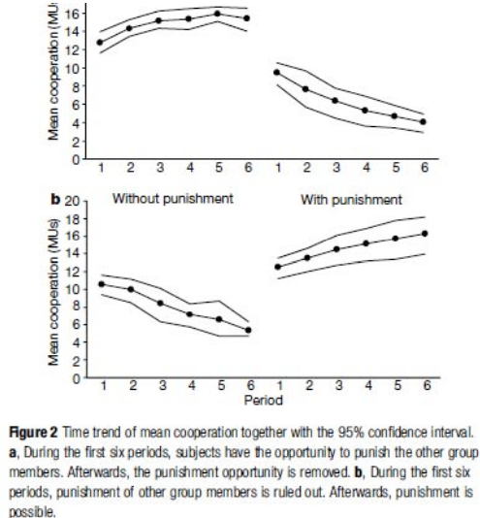
  - Raises the questions of who should bear the costs of punishing and how altruistic punishment evolved.
- MATING SYSTEMS AND RESOURCE DEFENSE
- Monogamy: A male and a female form a pair bond, typically both parents care for the young (Social versus genetic monogamy)
- Polygamy:
  - Polygyny – A male mates with several females, while females each mate with only one male
  - Polyandry – A female mates with several males, while males each mate with only one female
  - Promiscuity – Both sexes mate with several different individuals
- Intrasexual Selection in Drosophila – Bateman
  - Relationship between fecundity and mating success for female and male Drosophila melanogaster (Fecundity – offspring # on Y-axis; Mating Success - # of mates) Males are filled bars and points and Bars are numbers in that mating class
    - Females have a pretty even slope at around 60 offspring for 0 – 3 mates
    - Bateman concluded that male rep success limited by access to mates and is more variable than that of females; female rep success is limited by number of gametes she can produce “undiscriminating eagerness in males and discriminating passivity in females”
- Choosiness: increases quality of mates but reduces encounter rate of acceptable partners
  - Whether a sex is choosy depends on: mortality cost of breeding (high cost favours choosiness), mate encounter rate (high rate favours choosiness), operational sex ratio (biased ratio favours choosiness in rarer sex), mortality rate when seeking mates (low rate favours choosiness), variation in mate quality (highly variable mate quality favours choosiness)
- 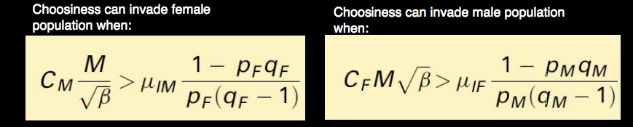
  - In human pops, male and female variances in RS are not significantly different for the monogamous Pitcairn islanders or the mildly polygynous Aka but are for the highly polygynous Dogon
- Male monogamy – mate guarding, (clown shrimp), mate assistance and female enforced
- Female polyandry – increased white blood cells with increased polyandry
  - Good genes (cryptic female choice), fertility insurance, genetic compatibility, mate assistance(parental care,, infanticide reduction, nuptial gifts), male enforced
- Forms of Polygynous mating systems
  - Females or their required resources clumped in space: Female defence polygyny and resource defence polygyny
  - Females widely dispersed or high male density: Scramble competition polygyny – extensive search and explosive breeding; Lek polygyny
    - Leks: display arenas with no other resources for females (ex. Sage grouse: females typically select a very small number of the males as their mates)
    - Dispersed Lek: Victoria’s riflebird: territories are somewhat dispersed
    - Why lek? Reduced costs to displaying (reduced predation risk) Hypothesized benefits:
      - Hotpot hypothesis: males cluster where females travel
      - Hotshot hypothesis: males cluster around attractive males
      - Female preference hypothesis: males cluster because females prefer large male groups
      - Mixed results: Little bustard: Male decoys, particularly symmetric, attracted to both sexes (for hotshot); more decoys attracted more females (for female preference
      - Black grouse: successful location can shift over years (against hotspot
      - Fallow deer: Lek location changed with changed female paths (for hotspot)
      - Uganda kob and barking treefrogs: more males did not attract more females (against female preference)
- COMMUNICATION
- Vervet monkeys – social groups – when sees aerial predator and produces call and run into bush; morphologically distinct call with leopard and run into tree; with python, diff call and stand on hind legs to look for snake
  - Referential signaling, listen to and respond to alarm calls of sympathetic birds (starlings etc) therefore give more calls in group than when alone; are calls innate or learned? Cheney and Seyfarth – infants produced alarm calls for birds but to all birds (even non-threatening). Juveniles more selectivity but still some error. With adults, much more selective (mostly main predator: marshall eagle)
- Transmission of communication of info from sender to receiver in a particular environment can deteriorate and decrease likelihood of accurate info transmission.
  - Types of info conveyed: identity (species, indiv), location, condition (rep, age, size), behavioural state (aggressive/courtship), presence of food, presence/type of predator
- Signals: communication acts that benefit for both signaler and receiver
  - Function of sending is to provide info to influence receiver to respond in a way that benefits signaler
  - Function in receiving is to increase chances of engaging in a behavior best for receiver
  - Ex. Species-specific calls of male frogs used to attract females towards reproductively active males
- Cues: benefit receiver but not signaler
  - Example: noise produced by mice during foraging can be used by owls
- Misinformation: an act that benefits the signaler but not the receiver
  - Ex. Mimicry of fire fly signals by predators
- Sometimes fuzzy boundary between signals and cues: calls of male frogs can also be used by predators (illegitimate receivers – eavesdropping)
- Types of Signals: Passive (Static) – aposematism, patches, odors; active (produced) – alarm calls, mating calls, dewlap extensions
- Signal Design – maximum signal:noise ratio; maximum reception and minimum predation
  - Sensory modality: visual, acoustic, chemical, electrical and tactile signals
  - All signals need to take ecology and evolutionary/mechanistic constraints
  - Sensory modality used depends on the environment
    - Terrestrial – open vs dense foliage; light vs dark
    - Aquatic – depth and visibility
- 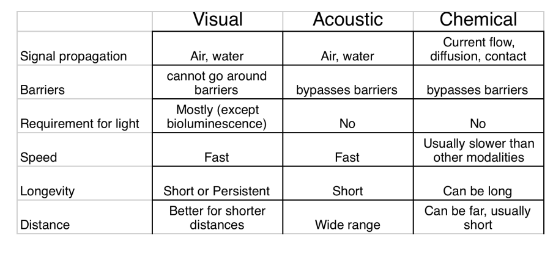
- Ecological Influences on the fidelity of the signal
  - Attenuation: reduction in the intensity of a signal
  - Degradation: alteration in the form of a signal
  - Masking: diminishing salience of a signal by noise
- Rufous – collard sparrow – forest vs grassland; fast components reflect and smear therefore need to create longer inter-syllabic distance (seen in forest)
  - High f tend to be ore degraded in forest than in grassland (Great Tit) therefore more time on low f sounds – sound of wind <2kHz and other species >4-5kHz therefore optimal of between 2 & 4 kHz (exactly in Great Tit)
- Green anole: increase signal:noise
  - Signal aggression and territoriality – extends dewlap and head bobs – variance in colours of dewlap morphology
  - Speed of dewlap extensions – wants to be different than background speeds of foliage but extensions increase with increased wind speed
- Effect of Urban Noise on song: increased signal to noise ratio
  - Min cost by changing time of day (no traffic), increased loudness and change pitch – traffic occupies particular f range and riverside birds when played highway noise, increase f (PLASTIC)
- 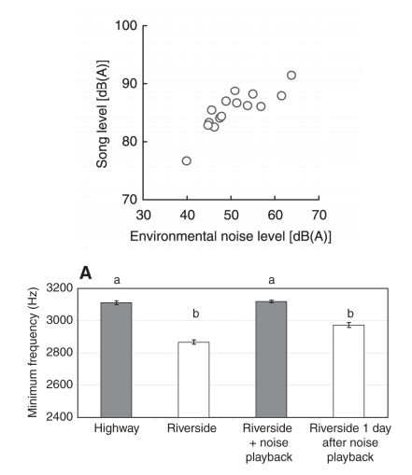
- Evolution of signals, sensory systems and behavior are coupled. Envtl conditions favour particular sensory characteristics
  - Many diurnal species live in dense forests. Given what you know about how signals attenuate and degrade, which of the following communication signals would you expect to have evolved in forest species?
- Fireflies – emit light flashes to signal and court females – females respond by producing mating answer to males’ signals. Males then approach females.
  - Pred flies respond to light signal males by emitting a mating answer. These fireflies approach pred signals, only to lead to their demise.
- Visual communication of cephalopods – chromatophores
- Tungara Frogs – calls to attract females
  - Whines and whine-chucks; whine-chucks preferred by females and lead to greater stimulation of the auditory system but chucks (broadband) also make localization of frogs easier for predators (fringe-lipped bat) and parasites (blood-sucking flies)
  - Female preference for whine-chuck exists even in species in which males do not produce whine-chucks (‘sensory exploitation’)
- Song Sparrow – can signal level of aggressiveness – depends on what neighbor produces – repertoire
- SEXUAL SELECTION AND MATE CHOICE
- Production constraints on song – looked at trills
  - Quantified bandwidth (how wide is spread on y-axis) and how many song elements
  - Tradeoff between trill rate and bandwidth because of motor constraints
  - Shorten length of vocal tract – high f and open beak; low f = closed beak therefore back and forth therefore tradeoff
  - Diagonal = performance limit
  - Songs closer to limit are increased in quality/performance songs
  - Song sparrows (1-3 types of trills) – females preferred increased performance songs
- 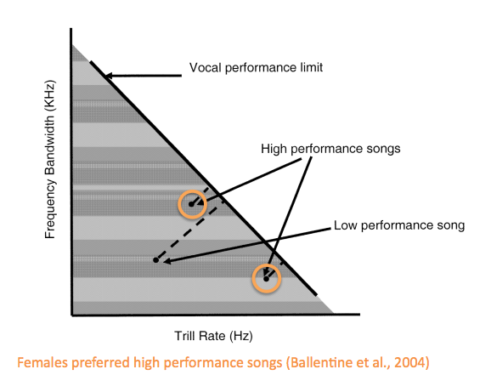
- Canaries – female song preference – produce more copulatory displays by A and F phrases (increased performance)
- Why have males evolved this signal and why female preferences? Sexual Selection
  - Evolutionary process resulting from indiv variation in traits that affect competition for reproduction
  - Sexual selection as part of natural selection
    - Tradeoff between mating success and survival therefore Darwin saw it as a distinct process
    - Now tradeoffs between components of fitness therefore sexual selection is widely seen as part of natural selection
- INTRASEXUAL Selection: male-male comp to increase chances of siring offspring – processes that favour weapons, large body size and aggression
  - Convergent evolution of male weaponry
  - Defense of resources needed by females; defense of females and social position
  - Ex. African cichlids – females deposit eggs into empty snail shells; males collect and defend patch of snail shells and use to allure females; bigger males can steal shells from smaller males and more effectively defend territories
  - Ex. (defense of females) – mates guarded particularly vigilantly when fertilization most likely – damselfly and blueband goby
  - Ex. Seychelles warbler: time spent mate-guarding is related to the number of neighbouring males (more males present, more mate guarding)
  - Ex (social position) - ~35% offspring is had by alpha male etc. Canine teeth to gain dominance
- 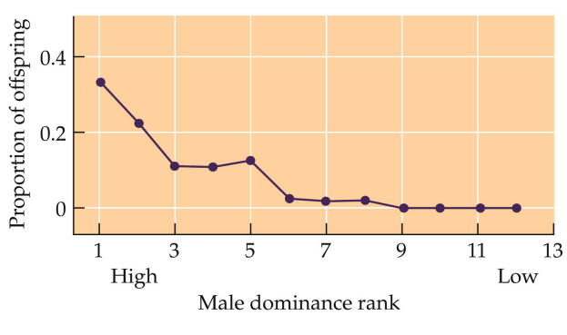
- Sexual Dimorphisms – degree of sexual dimorphism as a metric for the intensity of sexual selection pressure
  - Sex role-reversals: Jacanas – females larger and dominant over males; females compete with other females over access to males
    - Painted turtles – fecundity advantage for larger females
- Perception and Mobility – scramble competition
  - Garter snakes – males come out of hibernation (males first) and warm up. Then females come out and free for all (mating balls) – warmest, fastest males are more likely to copulate
- Probability of Fertilization – sperm comp
  - Increase prob your sperm and decrease others
  - Male black-winged damselflies can remove sperm of a previous male using his genitalia; sperm removal and sperm transfer
  - Male dunnock peck at his partner’s cloaca after he finds another male near her, and she ejects a droplet of ejaculate
  - Copulatory locks and obstructions (dogs) and orb-weaving spiders (tip of intromittent organ inflates after insertion and then the male dies)
  - Increase sperm production (birds) – relative testes size in apes as an index of the degree of sperm comp (promiscuity)
  - Human sperm competition – size of ejaculate positively correlated with time away from partner
    - Increased proportion of deformed sperm
    - Kamikaze sperm – type A: block passage of subsequent sperm; type B: attack sperm that have been delivered prior to themselves (deformed)
- INTERSEXUAL – female choice
- Generally, females prefer elaborate traits and difficult behaviours (body size, feeding/foraging ability, conspicuousness, age, symmetry)
  - For direct benefits: benefits to female; indirect: to offspring; no benefit: sensory exploitation
  - Direct:

protection from pred or rivals; nutritional gains from mate; access to resources defended by mate; reduced risk of disease and parasite transmission (sexual and non-sexual); contribution to parental care;
  - Indirect: Viability of offspring due to good genes; resistance to parasites; viability of offspring due to complementary genes (MHCs)
  - Can be difficult to distinguish between direct and indirect benefits: decreased parasite load could directly benefit the female and, if resistance to parasites is heritable, then selecting males with low parasite loads could lead to healthier offspring.
- Evolution of mate preferences when there are no direct benefits
  - Good genes hyp: prefs for certain male ornaments and displays evolved so that female an choose mating partners whose genes will help their offspring survive and reproduce. Females prefer honest signals (direct link between ability to roar loudly for sustained period of time and physical condition of deer; pitch of frog call is one too
  - Handicap hyp: females prefer exaggerated traits because they handicap the survival of the male. Only males of superior (genetic) quality can express and survive with this trait
    - Long-tailed widowbirds (Andersson) – cut tails; cut and others repasted; untouched and pasted additional (elongated) – elongated ones had the most copulations
    - Revision (Hamilton and Zuk) – disease widespread agent of selection; sexual displays or traits are reliable indicators of genetic resistance to disease; males only allowed to fully develop these displays.traits when they are free of disease; assumes resistance to disease is heritable
    - Barn Swallow – monogamous, insectivorous bird that feeds on wing. Males have longer outer tail feathers than females. Males compete amongst themselves to mate with females earlier (multiple clutches per year). Females prefer males with longer tails (exptl elongation of tails). Individuals with naturally longer tails had reduced parasite loads. Cross-fostering expt: parasite levels correlated with those of genetic parents, not foster parents
  - Fisher’s Runaway Selection
    - Elaborate traits evolved because they are attractive to females.
    - Link between the gene(s) for the preference and the gene(s) for the trait. Thus, the preference gene will be selected for because it is linked to the preferred trait.
    - Once the preference gene starts to spread, males with the trait will gain reproductive opportunities, leading to positive feedback for the trait.
    - This runaway process can lead to the exaggeration of traits, even beyond the optimum, until the preference is counterbalanced by its cost to survival.
- Sensory Exploitation: Female preferences can be influenced by evolutionary history – Tungara frogs
- REPRODUCTION
- Cost of female choice: time, energy, risk of injury/death/diminished fecundity
- Cost of rejecting potential mates must not be larger than benefits of non-selective mating (distribution of mates, variation in quality of potential partners, time of year, age)
- Male phenotypes to maximize possession of needed resources, access to females, and copulatory opportunities
- Alternative mating strategies: territorial males, sneaker males and female-mimics (3 types in male longears:
  - Relative testis size is much greater in sneakers males than in other morphs
  - Alpha, beta and gamma males in marine isopods
  - Plain midshipman – Type 1 (territorial) and Type 2 (satellite) males.
    - Migrate from Pacific to west coast of North America during summer to mate
    - Courting Type 1 males excavate nests beneath rocks and hum to attract egg-laying females. Male sing throughout breeding season to attract as many females as possible and guard eggs.
    - Type 2 males hang out in the periphery and try to sneak copulations
  - Some males smell like females (female-mimics) and therefore attract the attention of the males. These female-mimics then try to find and copulate with other females
  - Rock-Paper-Scissors Game in Lizards – phenotypes of male morphs
    - Orange morphs – aggressive and highly territorial males that guard their harems and mate with multiple females
    - Blue-throated morphs defend smaller territories with as few as one female throughout the breeding season
    - Yellow-throated morphs resemble females in coloration and often succeed in copulating with females on other territories
    - Orange beats blue. Blue beats yellow. Yellow beats orange.
    - F-dependent selection: little plasticity
  - Little plasticity – side-blotched lizards and plain midshipman; plastic strategy: A.burtoni (fish)
    - Dominant (colorful) adult male guards territory. Subordinate (drab) adult males hang out in periphery and suppress reproduction.
    - Within minutes after removal of a dominant, subordinates begin acting like dominants
    - Morphological and physiological changes follow
  - Plasticity – sex reversal
    - Terminal phase (TP) males, initial phase (IP) males, and females.
    - TP males are larger indivs that aggressively guard a nest site and court females.
    - IP males resemble females, and they either group spawn (multiple males to one female) or try to sneak copulations.
    - If TP male dies, either the largest female changes sex and becomes a TP male (protogyny) or an IP male becomes a TP male
    - Protandry (begins male and changes to female): black porgy; Bi-directional sex change: blue-banded goby
- When to breed: seasonal breeders, opportunistic breeders, continuous breeders
  - Factors that influence patterns of breeding:
    - Predictability of food: Predictability o food supplies allows for predictability of breeding and for animals to utilize environmental cues that signal food abundance to initiate reproduction
      - High predictability leads to seasonal breeders and low predictability leads to opportunistic breeding
    - Variability of food – variation in the availability of food supplies selects for variation in the timing of breeding.
      - If food availability varies, intermittent breeding and if food abundance always high, continuous breeding
  - Environmental control of reproduction: breeding timed so offspring emerge when food is abundant to support growth and development; species will rely on envtl cues that most reliably predict the availability of food. Time reproduction such that breeding starts before resources for offspring and growth become available
    - Photoperiod in song sparrow – breeding occurs in the spring and is activated by increasing day lengths. Eggs are laid ~May/June and hatch after several weeks. Food abundance and temperature (warm El Nino vs cool La Nina) can modulate the timing of reproduction
    - In red deer, males (stage) protect a group of females (hinds) to have access to mating. Rutting (breeding) season is from late summer to early winter. Triggered primarily by decreasing day lengths. Gestation period is 8-9 months therefore calves are born in the spring
    - Seasonal reproduction in spotted antbirds – breed during single, long rainy season (May-December) when insect food is most abundant. Reproductive change occurs 1-2 months before the onset of the rainy season. Photoperiod (1h variation across year) initiates reproductive changes and the rate of change is affected by supplementary cues.
    - Opportunistic reproduction in the Australian zebra finch: desert grassland species. Reproduction rapidly initiated by rainfall. Rainfall leads to the emergence of insect food and seed within days. Relatively weak dependence on photoperiod
    - Opportunistic reproduction in Galapagos marine iguanas – strong seasonal and yearly variation in rainfall and temp. Variability amplified by El Nino events, which bring strong and extended rains. Feed exclusively on microalgae. Nutritional quality of microalgae higher when waters are warmer. Timing of reproduction influenced by water temp and/or food.
- 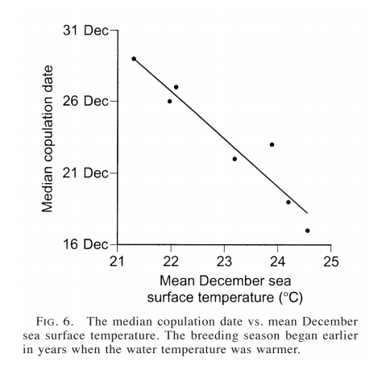
- Life-history characteristics that influence optimal breeding strategy and dependence on environmental cues
  - Longevity and age – generally speaking, shorter-lived species will show less sensitivity to environmental variation than longer-lived species. Older indivs generally show less sensitivity to envtl variation.
  - Length of gestation – for species with long gestational periods, many supplementary cues during the breeding season do not predict envt when young are born. Therefore, their reproduction is generally less dependent on supplementary cues.
- Implications of Global Warming on the evolution of reproductive cycles
  - Increases in global temps over the last decades correlated with earlier migrations, breeding, flowering, insect emergence etc.- tree swallows clutch dates 9 days earlier over past 30 years
  - Trophic mismatch between the timing of migration and food availability
    - Caribou – mate in fall (sept-nov); gestation period: ~8 months, calves born around may-june
- 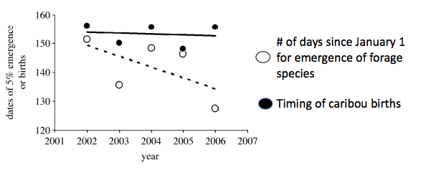
- 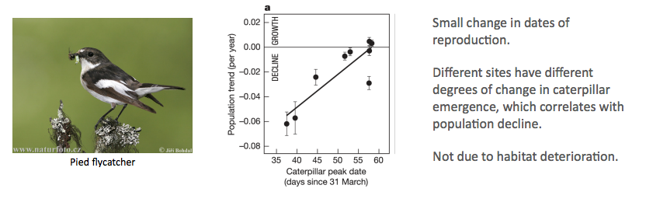
- PARENTAL CARE
- Parental investment: egg, gestation, nest building, feeding of young, feeding of mate, protection, grooming carrying, temperature (thermoregulation), instruction
- Amount of parental investments (r strategists: many offspring with little investment) (K-strategist)
- Altricial: underdeveloped – little birds (no feathers and immobile), humans
- Prococial: well-developed (sea turtles etc) ungulates
- Parental care <–> mating system
  - Where indivs allocate energy:
    - Polygynous – more effort to mating than parental. More selection pressures
  - Diversity of parental care
    - Mammals – vast majority only maternal care
    - Birds – vast majority bi-parental care
    - Fish – mostly no parental care but species with uniparental care, mostly paternal
- Birds
  - Geese – biparental care – young are so altricial – need both parents to bring food to the nest (success counts on it) benefits (in terms of RS) of male remaining with female and caring for the young generally greater than those for abandoning female
  - Benefits to biparental care – increased prob of offspring survival; improve quality offspring; increase clutch/litter size; increase future potential reproductive effort
  - Polygyny threshold model – females have the option to pair with single or already paired males
- 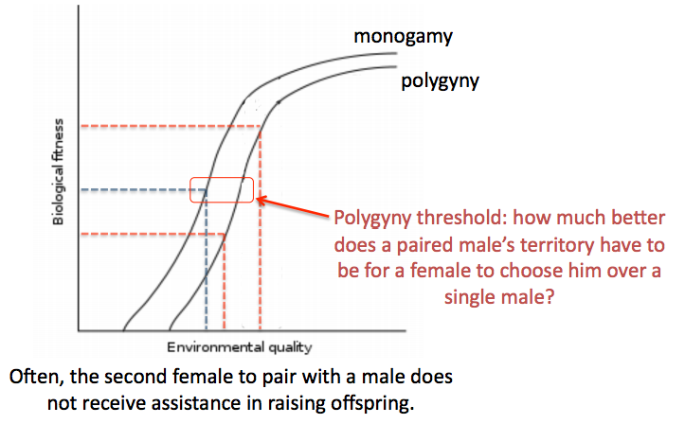
  - Examples of uniparental care in birds
    - Ruffs – only thing from males in copulation
    - Jacanas – females fight over access to males – males provide care (sex role reversals) – often found in water birds/shorebirds – selection pressure for females to have increased egg production, increased size (alligators eat eggs etc) – young are precocial
- Mammals
  - Biparental care
    - Marmosets: males very active role transporting and caring for infants (heterozygous twins)
    - Klipspringer – males play an active role detecting and defending his mate and his young from predators
    - Jackals, wild dogs – males play an active role in feeding the young
- Fish
  - External fertilization
  - Economic approach to parental investment in fish
    - Sexes have differential costs for investing in parental care (females have greater cost)
    - Providing paternal care can increase the attractiveness of a male
    - Differential costs – St Peter’s fish (either male or female mouth broods) – parental females produce smaller clutches after parental investment; no change in ability to fertilize eggs for males; female – interval between spawns different in engaging in parental care
- 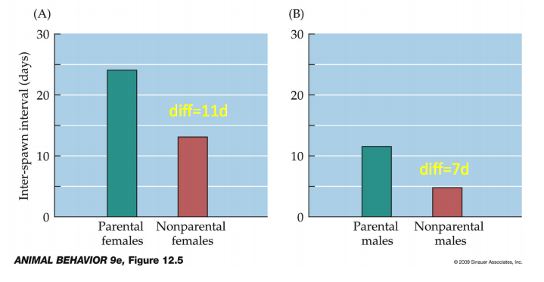
- Factors that influence degree of male parental care: development of young, opportunities of remating (many opportunities to remate – increased density of female – selection for males to desert or seek additional partners – nesting density) – nesting density decreases, often find only male care
- Paternal uncertainty – mammals – factors that increase parental uncertainty (internal fert, concealed ovulation, sperm storage, sneaker males) will tend to select against males parental investment and toward investment into mating effort
- 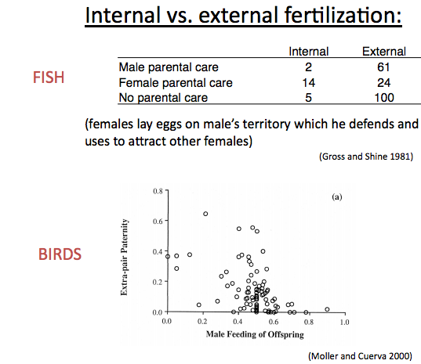
- Perceived relatedness and paternal investment
  - Males inc. and dec. parental effort based on perceived relatedness (via olfactory cues, presence of competition during spawning (Bluegill sunfish)
  - If males paired with females during fertile phase, invests in offspring care. If males paired with females after fertile phase, no investment in offspring (western bluebird)
- Viviparity vs oviparity – males have first opportunity to desert (‘cruel bind’); during gestation, male can do relatively little; searching for and copulating with new mates increase RS

Lactation – further opportunities for males to leave – costly

Ecological factors – distribution of food (clumped – more polygynous species); type of food (fruit vs seed vs grass – nutrient rich – uniparental maternal care); cold

Birds – altricial young, both sexes can feed young, internal fertilization

Fish – precocial young, both sexes care for eggs and fry, differential costs providing parental care for males & females, external fertilization; parental care can increase attractiveness of male

Birds with no parental care – leave eggs in decomposing leaves to incubate; brood parasites
  - Intraspecific (coot and starling) – egg dumping when nest not guarded; as breeding strategy when nesting sites rare
  - Interspecific (cuckoos, cowbirds) host specialists vs generalists
- Evolutionary arms race between parasite and host
  - Reject parasite eggs of relegate them to the periphery of the nest, using egg counting or visual cues (coots)
  - Remove a host egg before depositing parasite egg (starlings)
  - Parasitic egg can resemble host species egg visually, even in UV light
  - Destroy nests – mafia hypothesis (cowbird)
  - Host rejects parasite offspring after hatching
    - Parasite has begging calls mimic those of host species; also mouth colouration and gaping patterns also serve as a stimulus to evoke feeding; parasite nestlings kill or kick out host nestlings after hatching
- KIN SELECTION
- If a donor sacrifices C offspring and a recipient gains an additional B offspring from the altruistic act, then the gene causing the donor to act will increase in f if there is a net benefit ie: B/C > 1/r or rB>C (Hamilton’s rule); where B = benefit of act to recipient, C = cost of act to donor; r = relatedness. For a full sib to help his brother (r = 0.5) at a cost of 10 arbitrary units, the benefit B should be greater than 20 units. Therefore, a gene that results in the death of the donor but saves the lives of relatives will spread if, on average, it saves more than 2 brothers and sisters (r = 0.5) more than 4 half sibs (0.25) or more than 8 cousins (r = 0.125)
  - $r_{b}B>r_{c}C$
  - where rb = coefficient of relatedness to recipient’s offspring, rc = coefficient of relatedness to actor’s offspring, B = benefit (increased number of offspring) to recipient, C = cost (decreased number of offspring) to actor
- Problem with kin selection: limited dispersal was thought to favour altruism, by keeping relatives together. However, altruism towards a relative is less advantageous if their benefits come at a cost to your other relatives, and limited dispersal may increase competition between relatives
  - $r_{xy}b-c- r_{xe}d>0$
  - where rxy = altruist’s relatedness to beneficiary of its altruism (ie. r in Hamilton’s rule)
  - rxe = altruist’s relatedness to individuals that suffer increased competition from the beneficiary; d = general decrement in fitness associated with the altruistic act
- Examples:
  - Worker bees sacrifice themselves by stinging preds and rarely reproducing. Bees have unusual genetic systems
  - Black-tailed prairie dogs give alarm calls when non-descendent relatives are present, more calls than when no relatives are present
- Kin selection requires kin recognition, which can be achieved in several ways
  - Recognition alleles – ex. Green beards
  - Treat anyone in your home/est/den as kin; learn that those you grow up with as kin (imprinting) ex. Ground squirrels reared together rarely fight. However, females also distinguish on basis of relatedness even if reared apart
  - Self-referent phenotype matching: learn own phenotype
  - Green beard effects
    - Hamiltons formulation:
    - Gene gives rise to conspicuous phenotype (Dawkins gave the example of a ‘green beard’)
    - Uses this phenotype to distinguish between carriers and noncarriers of the gene
    - Leads bearer to be altruistic towards carriers
    - A more general formulation replaces the conspicuous phenotype with an assortment mechanism, such as a habitat preference
    - Facultative / obligate helping / hurting
    - Green beards are vulnerable to falsebeards – not necessarily genetically similar across the genome
- Eusociality: Extreme altruism
  - Cooperative care of young; reproductive division of labour (sterile castes); overlapping generations; Hymenoptera: the haploidiploidy hypothesis: haploid males and diploid females. Females or full-sisters = 0.75 r (supersisters); Termites & naked mole rats diplodiploid; Honeybees: haplodiploid but multiple matings
  - Ecological hypotheses for the evolution of eusociality: defendable nests (termite mound – primitively eusocial snapping shrimp in a cavity excavated in a sponge)
    - Patchy food; limited dispersal = eusociality
- HUMAN SOCIOBIOLOGY
  - Common errors: naturalistic fallacy: way things are is the way they ought to be; genetic determinism: idea that bejaviour is determined by genes; example: proposition that men can’t help philandering because it’s ‘in their genes’ with built in assumptions – genetic basis and men do it more than women
  - Lorenz’s book ‘On aggression’ argued that fighting and war were the natural expression of human instinctive aggression
  - Eugenics – eugenical sterilization in the US – hatches = laws in effect – huge wave – evolutionary theory and manipulating for their reasons
- Contrasting approaches
- 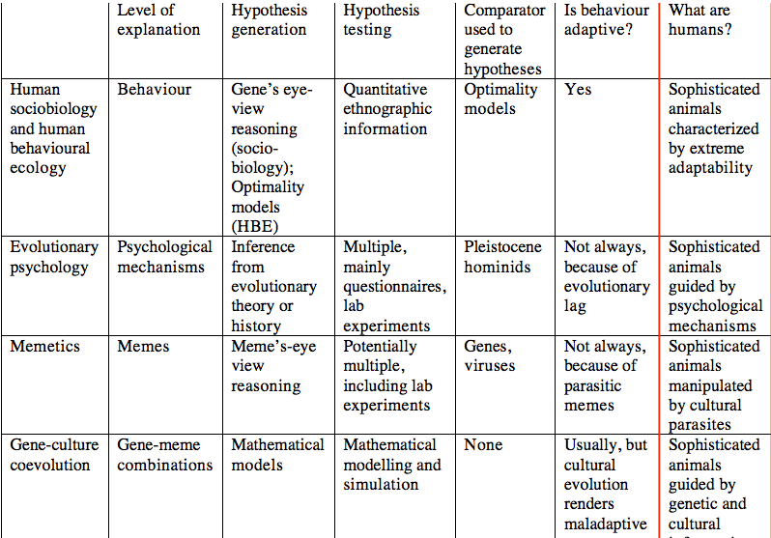
- *after maladaptive - outcomes possible; after cultural – information; comparator = where do these things come from (Pleistocene homonids – look at ancestors); meme – unit of cultural inheritance (similar to gene) why has smoking or religion spread? Look at epidemiology
- Laland is gene-culture coevolutionist – maybe reason for bias
- Specific Criticisms: evolutionary psych – envt of evol adaptiveness (EEA) defined as selection pressures that have operated over evol, EEA tends to be defined as some time in the Pleistocene (last 25 mys) before modern selection processes
- Generally, Levontin’s view of human sociobiology – criticisms applied most generally
  - Generalizing about human behavioural universals; asserting these traits are controlled by genes; providing an adaptive ‘justso ‘ story to explain why individuals with these traits leave more offspring
  - This raises at least 3 major problems: the definition of a trait is problematic; the genetic basis of a trait is often unknown; a trait may not be adaptive
  - Errors of description: male-male mounting is observed in many monkeys, and is described as ‘homosexual’ behavior – little evidence that male-male mounting in primates and homosexuality in men share identical proximate causation, development, function or evolutionary history
  - Problem 2: Genetics: knowledge about genetics underlying traits is generally lacking; ESS modellers ‘think of strategies and let genes look after themselves’ however there may be insufficient genetic variation for strategies or traits to evolve
  - Problem 3: traits may not be adaptive – evolutionary lag; insufficient genetic variation for new strategies to evolve; coevolutionary arms races: the red queen hyp; the role of chance – evolution is a complex, nonlinear, dynamic process;
- Case studies – human altruism
  - Kin selection: tribe in SA – how much childcare for diff types of kid in terms of degree of relation: Cdn wills – amount of money to diff degree of relatives: Cdn murders – more likely to murder non-relatives – controversial infanticide – increase in deaths by step-parents; Cdn vs Swedish infanticide – Swedish found no significant difference – young men tend to be murderers (still the fold increase is way higher in Chicago)
  - How do genes and culture co-evolve: genes keep culture on a leash; culture keeps genes on a leash; culture may be maladaptive, but spreads like a pathogen; genes and culture evolve like a system of obligate mutualists
    - Maladaptive – Fore of Papua New Guinea cannabilistic but spread Kuru (fatal) no such maladaptive cultural transmission uncovered in animals
  - Reciprocal Altruism – humans help each other even if favour unlikely to be returned – ESS models show indirect reciprocity, based on image scoring, can evolve. Large groups pose a problem that may be soved by info exchange
    - Opportunity to establish a reputation influence’s peoples behavior – humans ‘prosocial’ even when reputations are small/absent
    - Homo economicus – from Ultimatum game
- MECHANISMS OF BEHAVIOUR
- Hippocampus size correlates with differences in use of spatial info – London cab drivers
  - Cowbird is only brood parasite (only one with sex dimorphism in hippocampal size – increased in females);increase in species that store food, increase in homing pigeons, increase in males than in females in polygynous vole species but not in monogamous vole species
- Robert Sapolsky – olive baboons – dominance hierarchies
  - Dominant male baboons have greater access to food, hiding places, shady spots during day and females; subordinates – unpredictable world, dominants steal their food and displace aggression on them. Measure physiological changes after darting – dominant had surge of testosterone roughly half hour after injection: hyp (GnRH (LH-RH) – ant pit – LH & FSH – testes – testosterone (HPG axis)
  - In subordinates – increased beta-endorphins have negative influence on hypothalamus therefore decreased testosterone. Also, stress increased cortisol and decrease testes production of testosterone
  - In dominants – same thing but testes less sensitive to cortisol and inc. blood flow to testes for more LH to be exposed to testes leading to inc. testosterone (peak)
  - HPA axis – hyp releases CRH – ant pit releases ACTH – adrenal gland producing cortisol. In short term, cortisol mobilizes energy and increases vigilance, and inhibits rep. In longer term, chronic CORT elevation can lead to muscle wastage, hypertension and impaired immunity and fertility
    - Adaptive response to keep CORT low and only elevate during important challenges. Relative to subordinates, dominants have lower baseline levels of CORT and show more rapid rise in CORT following stressor. Relative to dominants, subordinates had increased basal levels of CORT, decreased circulating levels of HDL (good) cholesterol, fewer circulating lymphocytes and reduced number of neurons in hippocampus
    - Dominance vs stability – physiology of doms became more like subordinates during social instability (eg. Increase basal CORT levels, rapid decrease in T following stressor) Impact of social stressors affect behaviour through changed in physiology
- Seasonal Reproduction in the song sparrow – behavioural and phenotypic changes regulated by photoperiod; requires photoreceptors (generally opsins – rods and cones) in eyes and brain (pineal gland, hypothalamus etc.); melatonin produced by pineal gland in response to darkness (less melatonin during longer days)
  - HPG axis again but leads to gonads generally – reproduction activated by long days – melatonin inhibits GnRH release; Red deer reproduce in fall – decrease in photoperiod, increase in darkness triggers rep. and activates GnRH release
  - Predictability of food abundance affects dependence on melatonin; dec. predictable = dec. dependence on melatonin – opportunism breeders vs seasonal
- Whiptail lizards – hypothesized hybridization events – can compare ancestral to descendents
  - Donut copulatory – c.inornatus and c.uniparens (but all female – display male donut)
  - Performing donut were POST-ovulatory and those receptive were PREovulatory; alternation of male-female typically behaviours in the parthenogenic species – makes basically a clone of itself. Progesterone administration elicits male-like behavior in the parthenogen. In c.inornatus, only males are copulatory during breeding season elicited by testicular androgens
  - Progesterone can elicit male-specific behaviours – progesterone sensitivity is heritable; evolution of prog. Regulation of pseudosexual behavior in c.uniparens
- Evolution of Mating Systems
  - Prairie voles – mating leads to the establishment of a pair bond (partner pref) – inc. in motivation to be close to mate (as opposed to a stranger) inc. in aggression towards novel indivs (intruders)
  - In montane vole, no pair bond; no change in motivation to be close to mate (versus a stranger); no inc. in aggression toward novel indivs (intruders)
  - Nonapeptides – oxytocin & vasopressin – both released following/during mating
    - OT implicated in affiliative behavior (mother-infant bond). AVP implicated in aggression and social memory; AVP important for mating-induced intruder aggression and partner pref in male prairie voles
    - OT but not AVP antagonists block formation of mating-induced partner prefs in female prairie voles – OT into brain facilitates partner prefs
  - Genetic manipulations of vasopressin receptor expression to affect pair-bond formation – viral vector to increase receptor for AVP in ventral pallidum of meadow vole to show pair-bond – additive effect
  - Similar species differences in vasopressin receptor expression
  - Evolutionary changes in mating systems are mediate, in part, by evolutionary changes in expression and distribution of vaso and oxy receptors
- Evolution of Sociality
  - Estrildid finches – differ in how social they are but same mating system *all monogamous and parental; mediated by mesotocin and vasotocin systems
    - Blocking mesotocin receptors in lateral septum reduces preference for large groups in female zebra finches
    - Social/colonial species have increased vasotocin binding; blocking vasotocin receptors in LS reduces pref for large groups in male zebra finches

