Introduction

In the lab, we calculated various enthalpies which were given off by heated metals, chemical reactions and the dissolving of salts. These enthalpies allowed us to obtain the molar mass of the metal we used, the enthalpy of neutralization between the strong acid and base and the enthalpy of solution with the dissolved salt.

Enthalpy of Formation:

When one mole of a substance is formed from its element’s, heat is either given off or absorbed. This is known as the enthalpy of formation. For example, the standard enthalpy of formation of liquid water at 25°C can be found from the reaction:
H2 (g) + ½ O2 (g)-------> H2O (l)
ΔfH° = -68.3kcal/mol = -285kJ/mol.

The sign in front of the enthalpy value can either be positive (heat was absorbed) or negative (heat was released). Heat being absorbed in a reaction is known as an endothermic reaction, while heat given off is exothermic.

Hess’s law can be used to determine the enthalpy of more complex reactions and reactions that cannot be performed. This is done by adding together the enthalpies of different reactions that when added up, give the desired chemical reaction and enthalpy.

Calorimeters are used to accurately measure the amount of heat given off or absorbed by a chemical reaction. This is done by performing the reaction inside the calorimeter, where little heat escapes from the system to the surroundings and vice versa. We will be using a simple type of calorimeter, known as a coffee cup calorimeter. We assume that zero heat is lost or gained by the system from the surroundings.

Thermal energy is measured using the specific heat capacity, which is the amount of energy needed to increase the temperature of one gram of a substance by 1ºC. This value does not depend on the amount of substance used. We can determine the heat capacity of a metal that does not react with water by heating up the metal and transferring it to water, then measuring the increase in temperature by the water.

Specific Heat Capacity of a Metal:

The amount of energy required to change the temperature of a substance can be determined using the following equation: q=mcΔT. When the hot metal is placed in the water, if no heat is lost to the surroundings, the heat gained by the water is equal to the heat given off by the metal.
It is possible to estimate the molar mass of a metal once its specific heat capacity is known using the equation, cMetal x MMMetal ~= 25J/mol°C

Enthalpy of Neutralization:

The heat absorbed by the solution is equal to the heat given off by the reaction but opposite in sign.

qn = - mtot x csoln x ΔT

We can then calculate the amount of heat given off per mole of substance using:

ΔnH° = qn / nx

Enthalpy of Solution:

The dissolution of a salt may be exothermic or endothermic. This depends on the lattice energy of the salt because the lattice energy is the energy required to vaporize one mole of the salt into gaseous ions. The second factor is the hydration energy. This is the energy released when one mole of gaseous ions is dissolved in water. The enthalpy of solution can be expressed as
ΔsH° = (- heat loss of H2O) + (- heat loss of salt)

If the enthalpy of dissolution is negative, the hydration energy is greater than the lattice energy. If the enthalpy of dissolution is positive, the reverse is true.

Concept of the Experiment:

In the first part, the specific heat capacity of a metal is determined and the approximate molar mass from the specific heat capacity was determined. In the second part of the experiment, the enthalpy of neutralization of two strong acids with a strong base was determined. In the third part of the experiment, the enthalpy of solution of an unknown salt was determined.

Materials:
Refer to “What In The World ISN’T Chemistry”, Dr. V. Rashmi, Experiment 2, p6

Procedure:

Refer to “What In The World ISN’T Chemistry”, Dr. V. Rashmi, Experiment 2, pp 7-9

Observations:

Part 1:
Specific Heat Capacity of a Metal

Trial 1 Trial 2

Mass metal (g) | 10.3 | 10.3
Volume water (mL) | 20.0 | 20.0
Mass of Cup(g) | 1.87 | 1.87
Mass of Cup+Water(g) | 21.5 | 22.0
Temperature of Metal(ºC) | 100 | 100

Trial 1- ∆T= 1.70ºC

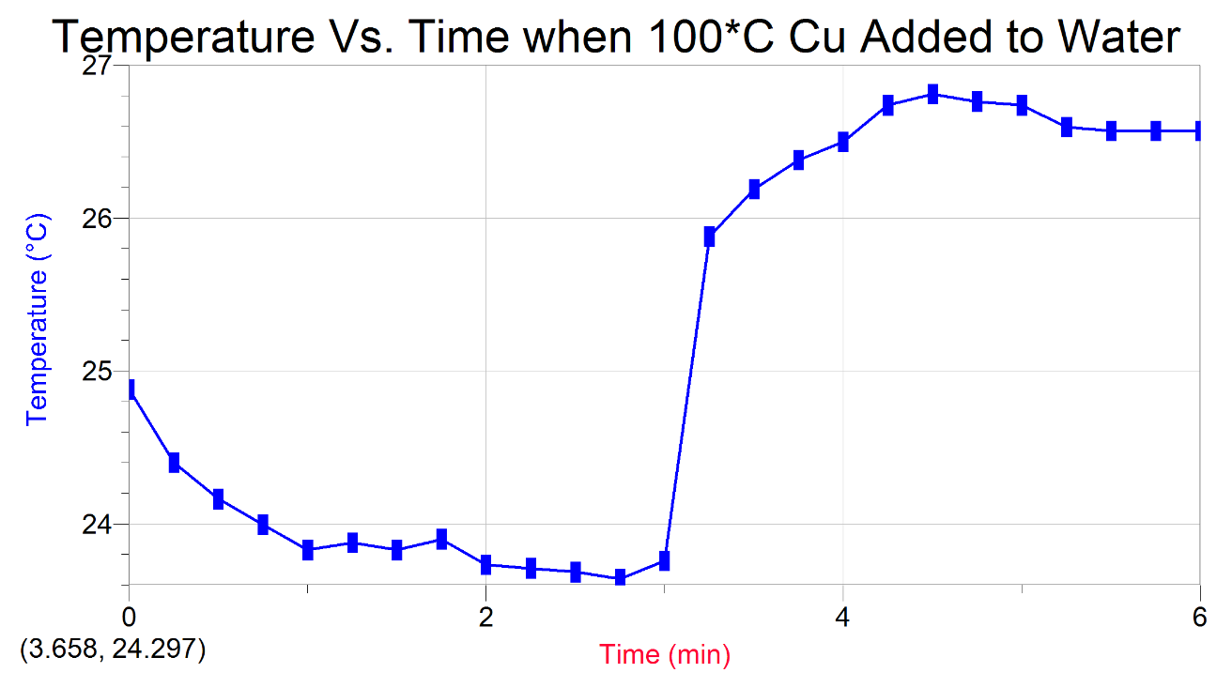

Trial 2- ∆T= 4.40ºC

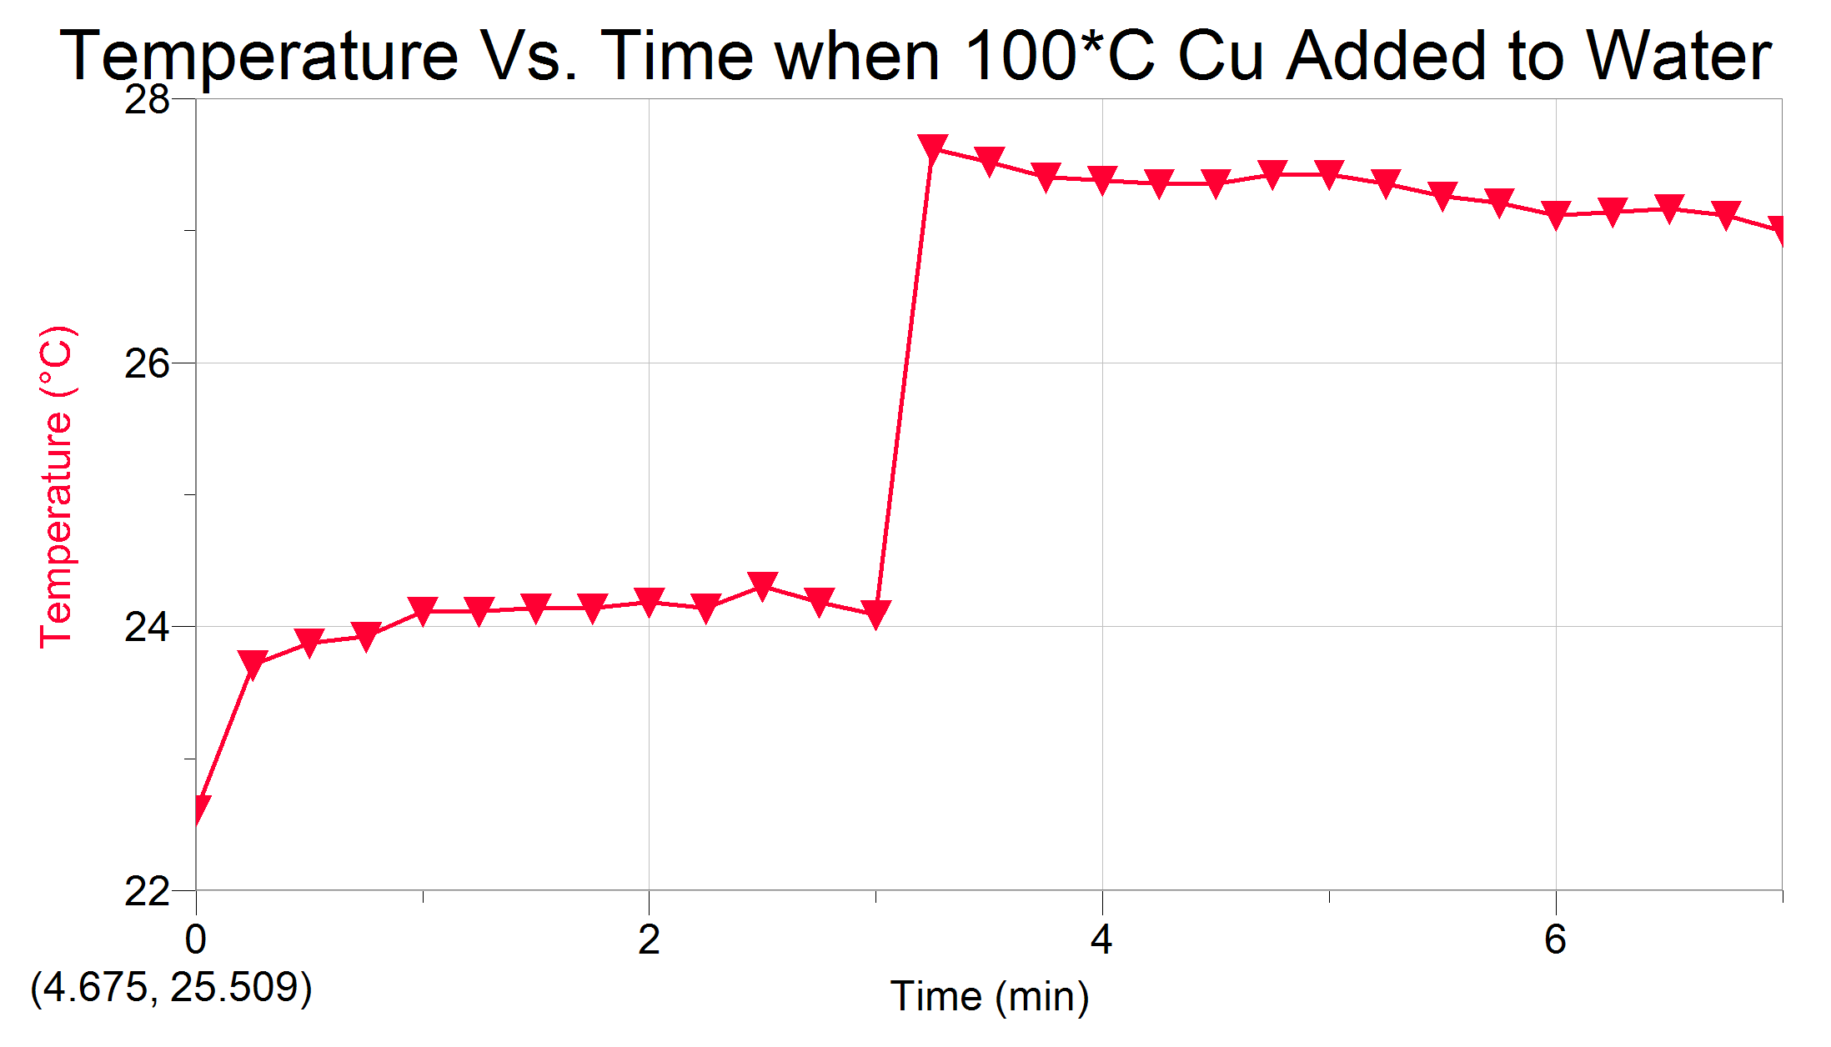

Copper is a bronze coloured, shiny metal. When the hot copper was put in the water, the temperature slowly increased.

Part 2:
Enthalpy of Neutralization
HCl

Trial 1 Trial 2
V_{NaOH}(mL) | 25.0 | 25.0
C_{NaoH}(mol/L) | 1.00 | 1.00
V_{HCl}(mL) | 25.0 | 25.0
C_{HCl}(mol/L) | 1.10 | 1.10
Mass of Cup+Solution(g) | 53.3 | 56.6

Trial 1- ∆T= 7.0ºC

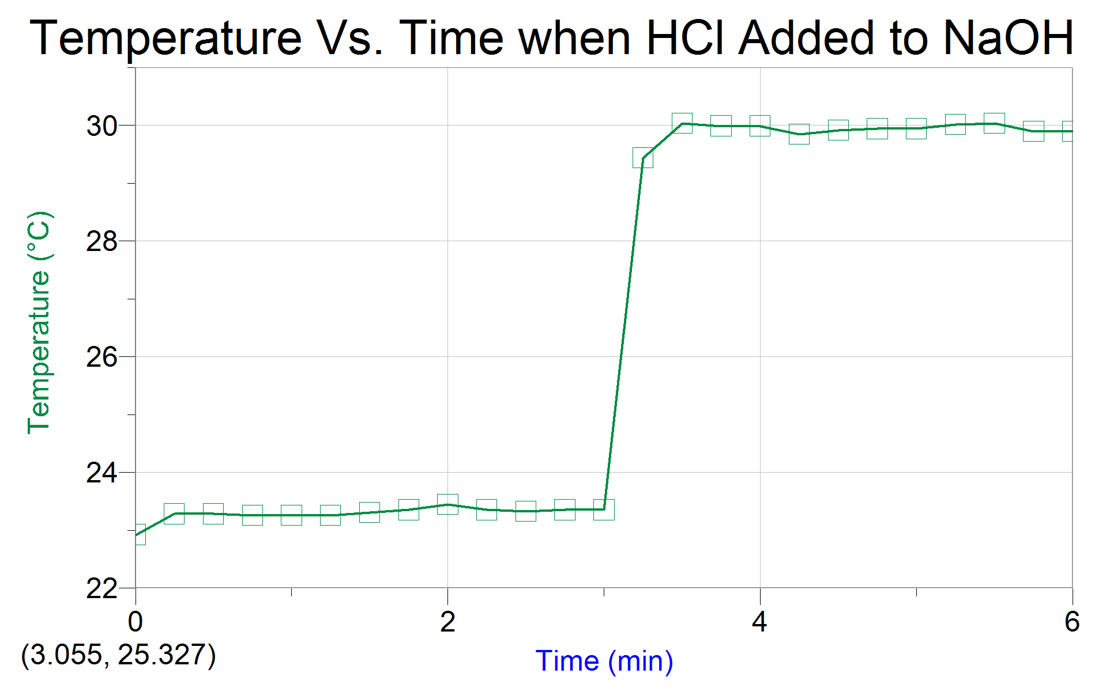

Trial 2- ∆T= 7.30ºC

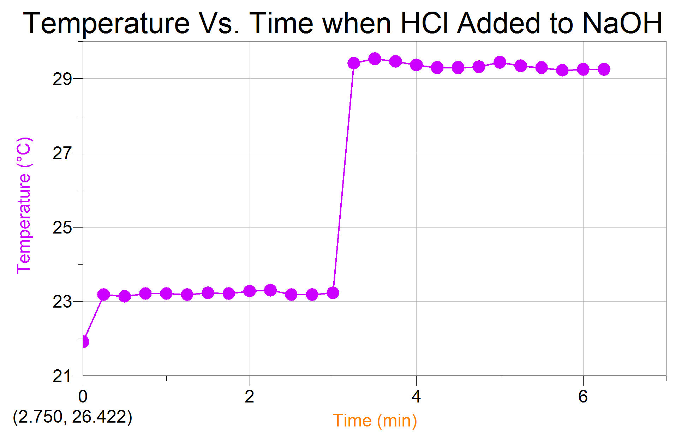

All solutions were clear and colourless. When the HCl was mixed with the NaOH, there was a sharp increase in temperature. This change was quicker, compared to the hot copper added to the water.

Part 2:
Enthalpy of Neutralization
HNO₃
V_{NaOH}(mL) | 25.0 | 25.0
C_{NaOH}(mol/L) | 1.00 | 1.00
V_{HNO3}(mL) | 25 | 25
C_{HNO3}(mol/L) | 1.10 | 1.10
Mass Cup+Solution(g) | 53.3 | 56.6

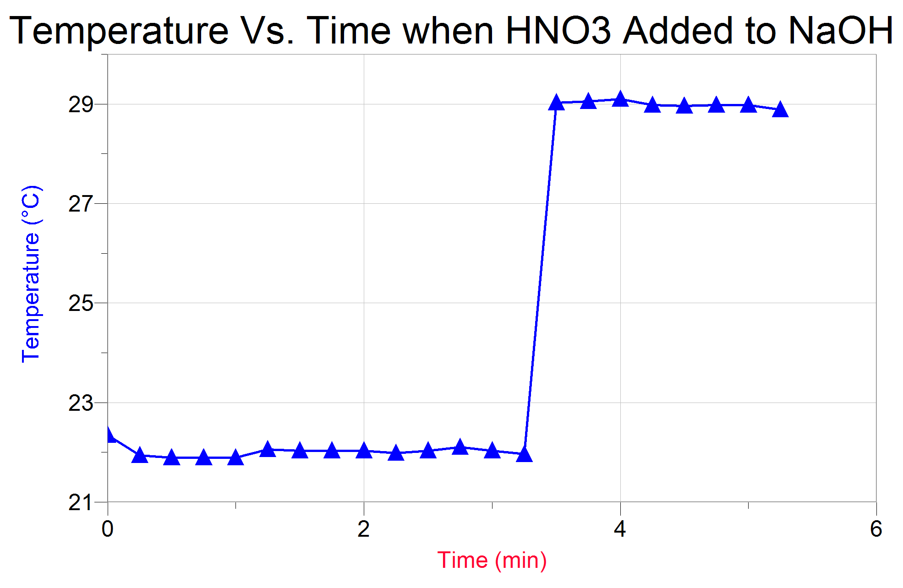
Trial 1- ∆T= 6.60ºC
Trial 2- ∆T= 6.80ºC

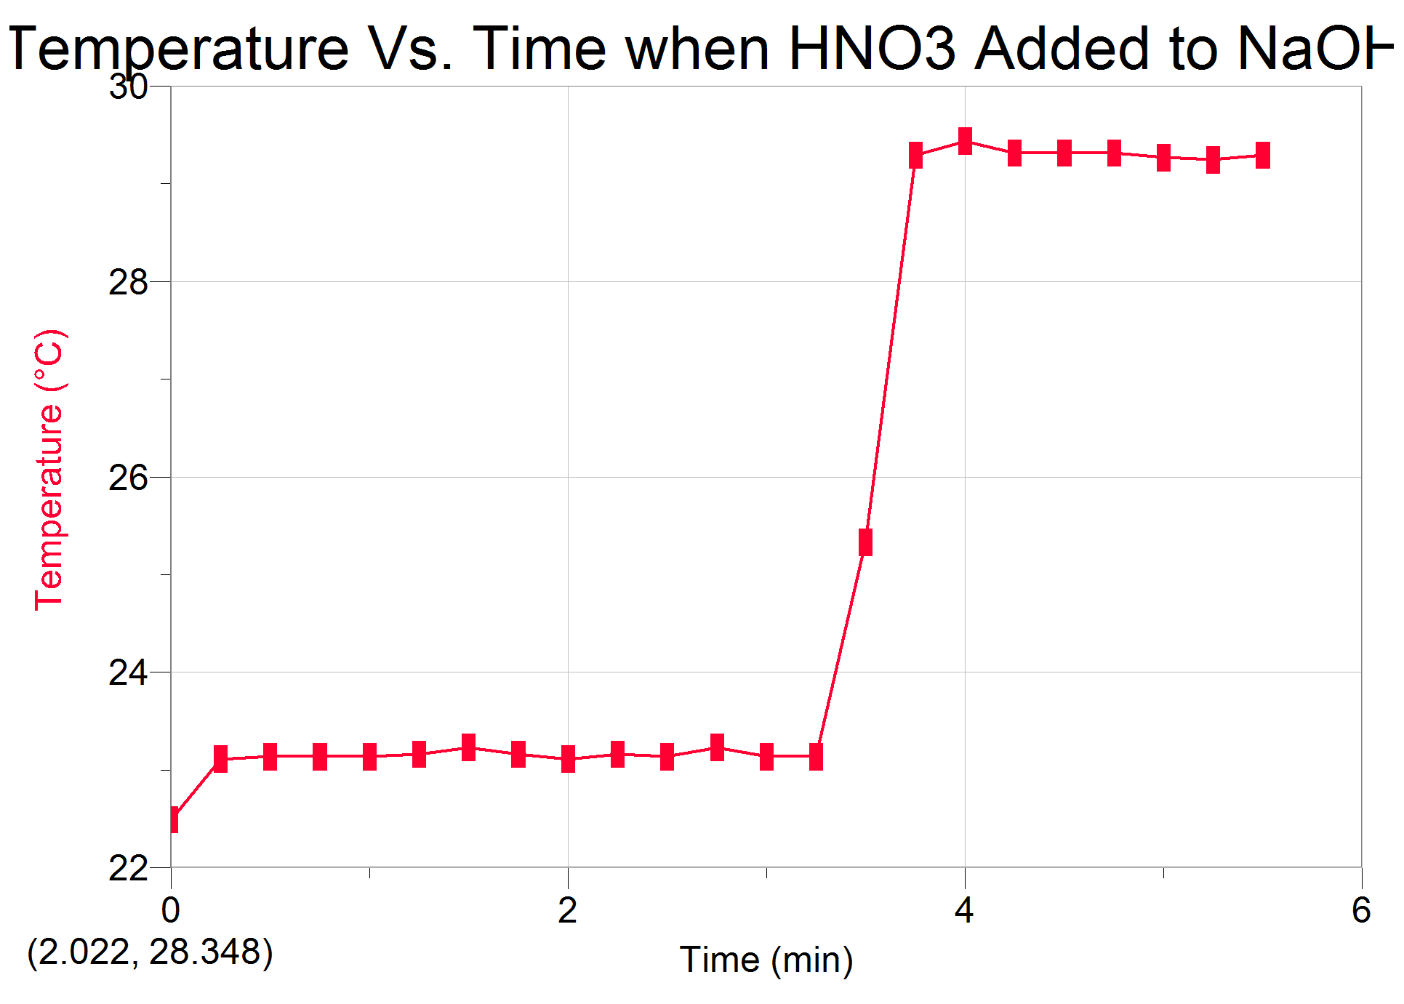
All solutions were clear and colourless. When the HNO₃ was mixed with the NaOH, there was a sharp increase in temperature. This change was quicker, compared to the hot copper added to the water.

Part 3:
Enthalpy of Solution

Mass Salt A(g) | 1.53 | 1.51
Molar Mass Salt A (g/mol) | 74.6 | 74.6
Mass Water+Cup(g) | 21.8 | 21.3
Mass Solution(g) | 23.2 | 21.3

Trial 1- ∆T= -5.40ºC

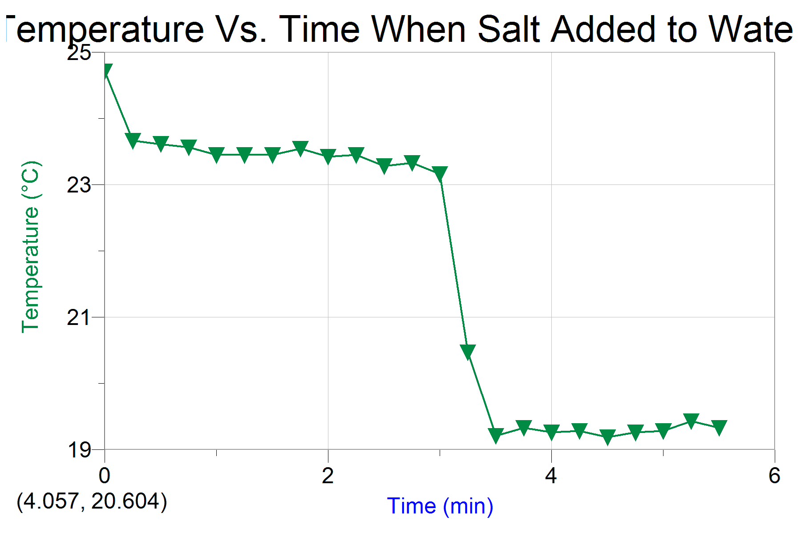

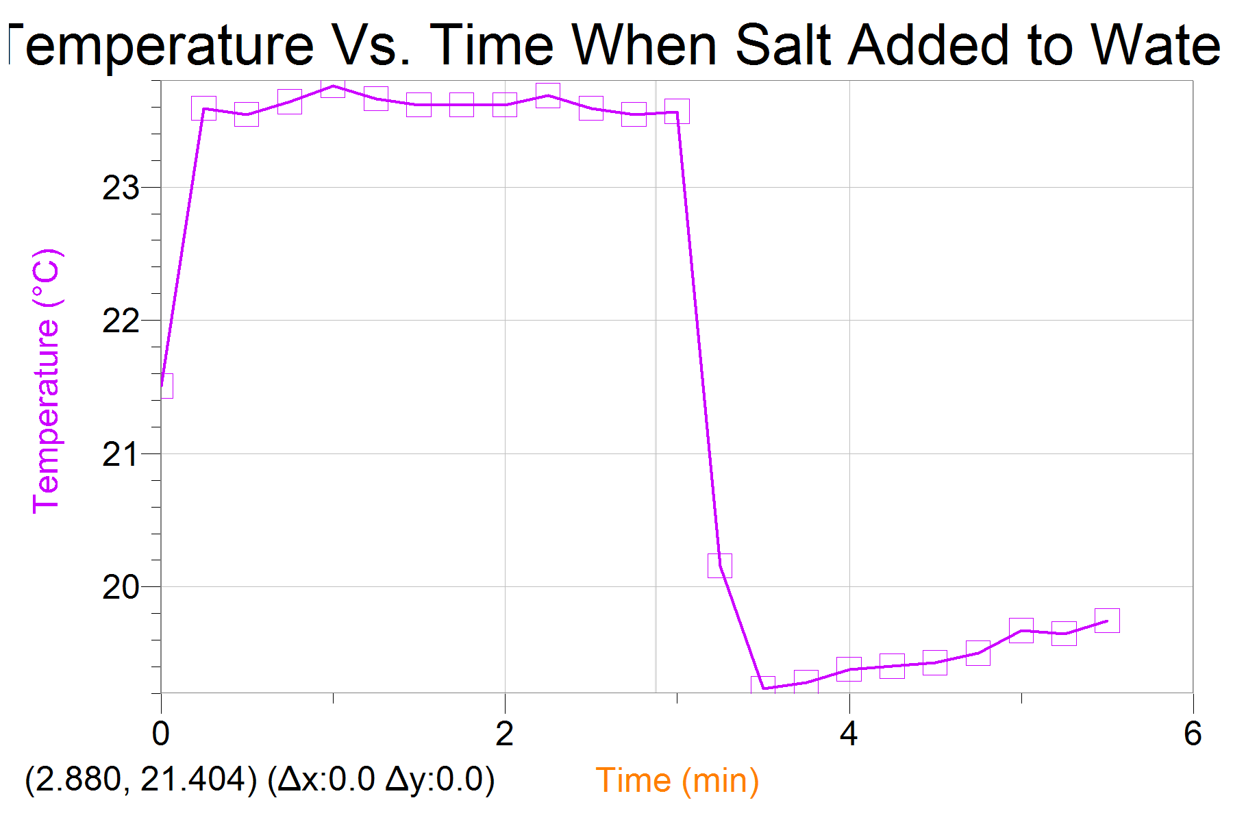
Trial 2- ∆T= -3.80ºC

The salt was white and powdery. The temperature quickly decreased when the salt was added.

Calculations:

*20mL water= 20g water

Part 1:
Trial 1:
- ∆T= T_{final}-T_{initial}
= 26.6ºC-24.9ºC
= 1.7ºC

- q_{water}=m_{water} C_{water}∆T
= (20.0g)(4.18J/gºC)(1.7ºC)
=142.12 J

- ∆T_{metal}=26.6ºC-100ºC
= -73.4ºC

- C_{metal}=q/m∆T
= (-142.12 J)
(10.34g)(-73.4ºC)
= 0.187 J/gºC

- (C_{metal})(MM_{metal})~= 25 J/molºC
MM_{meteal}~= (25 J/molºC)
0.187 J/gºC
~= 134 g/mol

- %error of heat capacity= experimental-actual x100
Actual
=134 g/mol-63.5g/mol x100
63.5 g/mol
=111%
- No, the mass of the copper did not make a difference in the experiment. If more copper was used, more heat would have been transferred to the water, resulting in a higher “q” value; however, to find the heat capacity of the metal, we then divided the heat value by the mass multiplied by the temperature, which would result in the same heat capacity.

Trial 2:

- ∆T= 4.4ºC
- q_{water}= 368J
- ∆T_{metal}= -73.0ºC
- C_{metal}= 0.489 J/gºC
- MM_{metal}= 51.0 g/mol
- %error = -20.0%
- Refer to question seven in trial one.

Part 2: HCl
Trial 1:

- ∆T_{solution}= 29.9ºC-22.9ºC
= 7.00ºC
- V_{sol}= V_{HCl} + V_{NaOH}
= 25.0 mL + 25.0 mL
=50.0 mL
- 50 mL
1g/mL
= 50.0 g

The measured mass of the solution was m_{sol}-m_{cup}= 50.43 g. Assuming that the solution completely turned into water and using the density of water is a more accurate because there is less measuring done, which means there is a smaller chance of human or technological error. Both values are very similar, therefore the difference is negligible when using this amount of solution.
- q_{solution}=(50g)(4.18J/gºC)(7ºC)
= 1463 J
=1460 J

- n_{OH}⁻=concentration of NaOH x volume NaOH
= (1 mol/L)(0.0250 mol)
= 0.0250 mol OH⁻ (NaOH Na⁺+OH⁻) 1:1 mol ratio of NaOH to OH⁻

- Because there is a 1:1 mol ratio of OH⁻ to H₂O, there are 0.0250 mols of H₂O.
(H⁺ + OH⁻ H₂O)

- ∆H_{neutralization} of water= q_{solution}
N
= -1463J
0.0250 mol
= -58.5 KJ/mol
- ∆H_{neutralization} HCl= q_{solution}
n
= -1463J
0.0250 mol
= -58.5 KJ/mol
This value is equal to the molar enthalpy of neutralization of water.

- %error ∆H_{neutralization}= (-58.5 KJ/mol)-(-57.1 KJ/mol) x100
-57.1 KJ/mol
= 2.98%
- Refer to question 17 in trial one of “Part 2: HNO₃”

Trial 2:

- ∆T_{solution}= 6.00ºC
- V_{solution}= 50.0 mL
- Mass_{solution}=50 g
- q_{solution}= 1526 J
- Moles of OH⁻ = 0.025 mol
- Moles of H₂O= 0.025 mol
- ∆H_{neutralization}= -61.0KJ/mol
- ∆H_{neutralization} HCl= -61.0 KJ/mol
This value is equal to the molar enthalpy of neutralization of water.

- % error= 6.80%
- Refer to question 17 in trial one of “Part 2: HNO₃”

Part 2: HNO₃
Trial 1:

8. ∆T= 22.9ºC-21.9ºC
=7.00ºC
9. V_{sol}= 25.0 mL NaOH + 25.0 mL HNO₃
=50.0 mL

10. Mass of solution= 50.0 mL
1g/mL
= 50.0g

11. q_{solution}= mc∆T
= (50.0g)(4.18 J/gºC)(7.00ºC)
= 1379.4 J
=1.38 KJ

12. n=concentration x volume
= (1.10 mol/L)(0.025 L)
= 0.0275 mol OH⁻

13. 1:1 mol ratio of H₂O to OH⁻, so 0.0275 mol H₂O.

14. ∆H_{neutralization}= -13.8 KJ
0.0275 mol
= -50.2 KJ/mol

15. ∆H_{neutralization} HNO₃= -13.8KJ
0.0275 mol
= -50.2 KJ/mol
This value is equal to the molar enthalpy of neutralization of water.

16. %error HNO₃= -50.2 KJ/mol-(-57.3 KJ/mol) x100
-57.3 KJ/mol
= -12.4%
17. There was an 8.3 KJ/mol difference between the heat of neutralization of HCL and HNO₃. If less base was added then this would result in a smaller number of moles of OH⁻ and a smaller heat value because there would be unreacted H⁺. If more base is added, there would be no difference in heat given off because the reaction would only continue until the number of H⁺ ions are used up. Once all the H⁺ is used up, the excess OH⁻ would be useless. I did expect the results I obtained because the ratio of H⁺ ions in 25 mL of 1.1 mol/L HCl is equal to that of the HNO₃. This means that the same number of H⁺ and OH⁻ ions react.

Trial 2:

8.∆T= 6.8ºC
9. V_{solution}= 50 mL
10. Mass= 50g
11. q=1421J
12. n= 0.0275 mol
13. n=0.0275 mol
14. ∆H= -57.7 KJ/mol
15. ∆H= -57.7 KJ/mol
16. %error= -9.8%

Part 3:
Trial 1:

- ∆T= T_{final}-T_{inital}
=19.3º-24.7ºC
= -5.40ºC

- q=mc∆T
=(25.20g)(3.815J/ºC)(-5.40ºC)
= -519 J

- ∆H_{disolution}= 519J
(1.53g)/(74.55g/mol)
= 25288 J/mol
= 25.3 KJ/mol
- The unknown salt is Potassium Chloride (KCl). “The enthalpies of solution of KCl in water at 303.15 K have been measured in a heat-flux calorimeter as a function of molality. The covered range is 0.01 to 0.06 mol/kg. The enthalpy of solution at infinite dilution is obtained using values for the enthalpy of dilution, L_{φ}. The proposed value is ΔH°(303.15) = 16426 J/mol.” (Elsevier B.V, 1985, Thermochimca Acta)

%error= 25.3 KJ/mol-16.426 KJ/mol x100
16.426 KJ/mol
= 54.4%

- No, the mass of salt does not matter. The amount of salt is proportional to the amount of heat given off, resulting in a higher “q” value; however, this is then divided by the number of moles of salt, which would be a higher value as well. This results in the same molar heat of solution.

Trial 2:

- ∆T= -3.8ºC
- q_{solution}=-349.4J
- ∆H=_{disolution}= 17.3 KJ/mol
- %error= 5.32%

Discussion:

In part one, the heat capacity of copper was calculated by heating the copper to 100ºC and mixing it with water at room temperature. The change in temperature of the water, mass of the water and heat capacity of the water allowed us to determine the amount of heat gained, which is equal to the amount of heat lost by the copper. Trial one was off by quite a bit, however, trial two was far more precise. In part two, the molar heat of neutralization was determined by mixing HCl with NaOH. The increase in temperature of the solution, heat capacity of water and mass of the solution were used to calculate the amount of heat gained by the solution, which is equal to the heat given off by the neutralization reaction. We could then divide the total heat transfer by the number of moles to calculate the molar enthalpy. All trials for part two were fairly precise; the percent error was only off by 2-15%. In part three, the molar enthalpy of dissolution was calculated by mixing an unknown salt with water. The decrease in temperature was measured by calculating the amount of heat lost by the water. The first trial was off by 54.0%, while the second trial was off by only 5.32%. Some sources of error may have been spillage of salt or acid when pouring into the calorimeter, spillage of material inside the calorimeter when agitating the apparatus and heat lost between the time of transferring the material and closing the calorimeter.

Conclusion:

In conclusion, the calculated heat capacities of copper were 0.187J/gºC and 0.489 J/gºC in trial one and two, respectively. The percent error for these trials were -51% and -27%. In part two, the calculated enthalpies of neutralization of HCl were-58.5 KJ/mol and -61.0 KJ/mol. These values were off by 2.98% and 6.8%. The enthalpies of neutralization of HNO₃ were -50.2 KJ/mol and
-51.7 KJ/mol. These values were off by -12.4% and -9.8%. In part three, the molar enthalpies of dissolution of KCl were 25.3 KJ/mol and 17.3 KJ/mol. These values were off by 54.4% and 5.32%.

