Lesson 1.1 - Study Materials

Slide 1

Lesson 1.1 : Scientific Method

1. Steps of the Scientific Method
The scientific method (performing a study in organized steps) consists of:
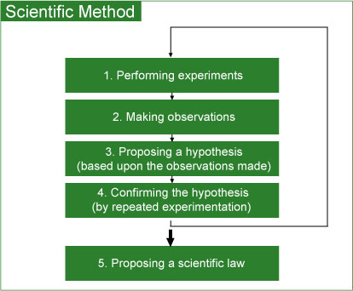
For example, applying the scientific method ultimately led to the enunciation of the Law of Conservation of Mass and Matter.

Slide 2

1. Steps of the Scientific Method

Step 1: Performing Experiments
An experiment is a set of steps (procedures) that are performed under controlled conditions to propose or test a hypothesis.

Step 2: Making Observations
Observations (a key factor in scientific studies as well as in everyday life) can be classified as:
Qualitative | Quantitative
Qualitative observation does not use numbers.  Examples:  - The flower is purple.  - Bubbles are produced when lemon juice is added to baking soda. | Quantitative observation is a measurement. It has two components:  - A measured quantity (numerical value) with an appropriate unit.  Example:  Observed temperature (measured using a thermometer) for the liquid was found to be  33°C.  In this case, the measured quantity is temperature and the appropriate unit is °C.

Step 3: Proposing a Hypothesis
A hypothesis is a tentative explanation to account for the observations of an experiment. A hypothesis is valid provided that one's assumptions to explain the observations of an experiment can be tested.

Step 4: Confirming the Hypothesis
The validity of the hypothesis needs to be confirmed via repeated and controlled experiments. In order to accept a hypothesis, there must be no inconsistencies between the hypothesis and the experimental observations. In the event of any inconsistencies, steps 1 through 4 must be repeated.

Step 5: Proposing a Scientific Law
By repeatedly performing experiments and modifying the hypothesis to account for the observations from these experiments, one is able to propose a scientific law.

Slide 4

Expression of Numerical Value
Certain rules apply to the expression of the numerical value and the system of units used in scientific measurements.
These include:
- Scientific notation
- Significant figures
- SI system of units

Slide 5

2. Scientific Notation
Scientific notation is a very convenient way of expressing very large or very small numbers and at the same time provides a method of increasing efficiency in scientific calculations.
It is a mathematical expression in which a number is expressed as: N x 10 ^{±n}
where N contains only one nonzero digit to the left of the decimal and n is an integer.
Examples:
Measurement | Scientific Notation
1.23 g | 1.23 x 10 ⁰ g
1000.4 mL | 1.0004 x 10 ³ mL
0.0012 mg | 1.2 x 10 ⁻³ mg
28.32 x 10 ¹⁵ L | 2.832 x 10 ¹⁶ L
21.0 million kg | 2.10 x 10 ⁷kg

Slide 6

3. Significant Figures (Digits)
Every measurement and thus all of the calculations performed by using such measurements always have some uncertainty (a characteristic of any measurement). This is due to experimental error. In the case of measuring devices, the last digit of the measurement is uncertain.
Significant figures (sig.fig.) in a measured number include all certain digits and one uncertain digit.

The concept of significant figures is:
• used to indicate the precision [reproducibility (closeness) of measurements] of a measurement or that of a calculated result using such measurements;
• does not apply to counted items such as exact numbers (e.g., 5 cars, 3 houses) and defined conversion factors (e.g.,1 inch = 2.54 cm, 1 cal = 4.184 J).
These have an infinite number of significant figures.

Slide 7

3. Significant Figures (Digits)

Rules for Determining Significant Figures (Digits) (1/3)
Rule #1: All nonzero digits are significant figures.
Examples:
Measurement | No. of sig. fig.
135.62 g | 5
23.6 cm | 3
17.9871 kg | 6
Rule #2: Counting begins from the left with the first nonzero number (thus leading zeros are not significant).
Examples:
Measurement | No. of sig. fig.
0.056 mL | 2
0.000356 L | 3
0.0225 kg | 3

Slide 8

3. Significant Figures (Digits)

Rules for Determining Significant Figures (Digits) (2/3)
Rule #3: Zeros between nonzero digits are counted as significant figures.
Examples:
Measurement | No. of sig. fig.
1.056 g | 4
30.78 cm | 4
300.5 mL | 4

Slide 9

3. Significant Figures (Digits)

Rules for Determining Significant Figures (Digits) (3/3)
Rule #4: Terminal zeros (zeros to the right of a number) are always significant if the value contains a decimal point.
Examples:
Measurement | No. of sig. fig.
2.3700 g | 5
17.50 mL | 4
Terminal zeros in other cases may or may not be significant. For example, a measured value given as 200 cm does not signify anything regarding the number of significant figures. In such cases, sometimes a decimal point makes the zeros significant, but mostly scientific notation is used.
Measurement | Intended no. of sig. fig.
200. cm | 3
2.00 x 10² cm | 3
2.0 x 10² cm | 2
2 x 10² cm | 1

Slide 11

3. Significant Figures (Digits)

Rules for Significant Figures in Chemical Calculations (1/3)
In calculations involving measured values (with a certain number of significant figures), the number of significant figures in the final answer depends on the operation performed.
Rule #1
In addition and subtraction of measured quantities, the final answer contains the same number of decimal places as are in the measurement with least number of decimal places (least precise measurement).
Examples:
Click on the �+� to view the corresponding answer, click on the �-� to hide it.
Example 1: 25.0 g + 22.41 g + 1.234 g = 48.6 g
Answer: The measurement 25.0 g has the least number of decimal places (one decimal place), therefore the answer has one decimal place.
Example 2: 4.85 mL - 0.02 mL = 4.83 mL
Answer: Both measurements have two decimal places, therefore the answer has two decimal places.

Slide 12

3. Significant Figures (Digits)

Rules for Significant Figures in Chemical Calculations (2/3)
Rule #2
In multiplication and division of measured quantities, the final answer contains the same number of significant figures as are in the measurement with the least number of significant figures.
Examples:
Click on the �+� to view the corresponding answer, click on the �-� to hide it.
Example 1: 9.20 g (3 sig. fig.) x 2.450 (4 sig. fig.) = 22.5 g
The measurement, 9.20 g, has the least number of significant figures, therefore the answer has three significant figures.
Example 2: 2.35 cm (3 sig. fig.) / 1.456 (4 sig. fig.) = 1.61 cm
The measurement 2.35 cm has the least number of significant figures; therefore the answer has three significant figures.

Slide 13

3. Significant Figures (Digits)

Rules for Significant Figures in Chemical Calculations (3/3)
Rule #3: In the final answer of a calculation involving exact numbers, unit conversion factors and constants, the number of significant figures is dictated by the measured quantity involved.
* Exact numbers, unit conversion factors and constants have no effect on the number of significant figures.
Examples:
Click on the �+� to view the corresponding answer, click on the �-� to hide it.
Example 1: If the mass of a steel ball is 2.35 g (measured quantity), what will be the total mass of 8 (exact number) identical steel balls?
Answer: The total mass of 8 identical steel balls is: 2.35 g x 8 = 18.8 g.
Example 2: How many centimeters are there in 31.10 inches (measured quantity)?
Answer: The unit conversion factor is 1.0 in = 2.54 cm.
31.10 in x 2.54 = 78.99 cm
There are 78.99 cm in 31.10 inches.
Example 3: Using the formula: c = a x b, calculate the value of b when a = 22.65 cm (measured quantity) and c = 1.2 cm/s (constant).
Answer: Substituting values for a, b and c: 1.2 cm/s = 22.65 cm x b
The value of b is:
b = 1.2/22.65 s⁻¹ = 0.05298 s⁻¹

Slide 14

Rules for Rounding Off In Chemical Calculations (1/2)
Rule #1: For multi-step calculations, all numbers are carried to the final result, which is then rounded off to give the correct number of significant figures.
Rule #2: If the digit being rounded off is > 5, you round the digit up by one.
Example:
For the measurement 8.379 g rounded to three significant figures, the digit 7 is rounded up to 8 because 9 > 5. Therefore, the final answer is 8.38 g.

Slide 15

Rules for Rounding Off In Chemical Calculations (2/2)
Rule #3: If the digit being rounded off is < 5, the preceding digit remains the same.
Example:
For the measurement 6.371 g rounded to three significant figures, the digit 7 remains the same because 1 < 5. Therefore, the final answer is 6.37 g.
Rule #4: If the digit being rounded off is equal to 5, the preceding digit is rounded up if it is odd and remains the same if it is even.
Example:
For the measurement 16.75 mL rounded to three significant figures, the digit 7 is rounded up to 8 because 7 is an odd number. Therefore, the answer is 16.8 mL.
For the measurement 16.65 mL rounded to three significant figures, the digit 6 remains the same because it is an even number. Therefore, the answer is 16.6 mL.

Slide 16

SI (Système international d'unités) System of Units
- The system (based upon the metric system) uses SI base units.
- Some SI based and SI derived units include length, volume, mass, density, temperature and time.
- Length: The SI unit for length is the meter (m).
- Volume: The SI derived unit for volume is the cubic meter (m³). The most common unit for volume is the liter (L) and the milliliter (mL):
1 L = 1dm³ = 10⁻³ m³
1 mL = 1 cm³ = 10⁻³ dm³ = 10⁻³ L = 10⁻⁶ m³
Volume depends on the size of the object. Some common types of equipment used to measure liquid volume include:

Slide 17

SI (Système international d'unités) System of Units (cont'd)
Mass: The SI unit for mass is the kilogram (kg). Mass refers to the amount of matter an object contains, thus mass is a constant. Like volume, mass also depends on the size of an object.
Density: The SI unit for density is the kilogram per cubic meter (kg/m³). Generally, in chemistry, density is expressed in the units of g/mL or g/L. Density is a physical property of a substance.
Density = Mass
Volume
Some SI Base Units:
Physical Quantity | Unit | Symbol
Length | Meter | m
Mass | Kilogram | kg

Slide 18

SI (Système international d'unités) System of Units (cont'd)
Common SI Prefixes
Prefix | Multiple | Symbol
Giga | 10 ⁹ | G
Mega | 10 ⁶ | M
Kilo | 10 ³ | k
Centi | 10 ⁻² | c
Milli | 10 ⁻³ | m
Micro | 10 ⁻⁶ | µ*
Nano | 10 ⁻⁹ | n
*Greek letter pronounced as 'mew'
Larger or smaller units than the base unit can be obtained by combining the base unit with one of the prefixes.

Slide 19

SI (Système international d'unités) System of Units (cont'd)
Examples:
Example 1: Combining the base unit second with the prefix nano gives nanosecond (symbol: ns = 10⁻⁹ s).
Example 2: Combining the base unit meter with the prefix micro gives micrometer (symbol: µm = 10⁻⁶ m).
Example 3: Once again, combining Liter with one of the prefixes gives other units. For example, combining Liter with the prefix milli gives milliliter (symbol: mL = 10⁻³ L). [1 L = (10 cm)³ = 10³ cm³ so, 1 mL = 1 cm³]
Combining Liter with the prefix micro gives microliter (symbol: µL = 10⁻⁶ L).
SI units for other physical quantities are derived as follows:
1) Area = d x d= m x m = m² [d = length]
2) Volume = d x d x d = m x m x m = m³ [d = length]

Slide 20

Dimensional Analysis
Dimensional analysis is a method of solving numerical problems using both the numerical value and the unit. Dimensional analysis involves the use of conversion factors to change the units that a measured quantity is expressed in.
In this method the identical units are multiplied or cancelled.
Examples:
1.0 cm x 2.1 cm = 2.1 cm ²
10.4 g / 2.0 g = 5.2

Slide 21

Dimensional Analysis (cont'd)
Step 1: Write the equation(s) relating the units. For example, to convert a mass from grams to milligrams, the equation must show the relationship between one gram and the number of milligrams in one gram:
1.0 g = 10³ mg
To convert a volume from liters to microliters, the equation shows the relationship between one liter and the number of microliters in one liter:
1.0 L = 10⁶ µL

Slide 22

Dimensional Analysis (cont'd)
Step 2: State the relationship as a fraction (also called conversion factor). The conversion factor can be expressed in two different ways:
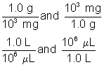

Slide 23

Dimensional Analysis (cont'd)
Step 3: Multiply the measured quantity by this conversion factor that cancels unwanted units and gives the final answer in the required unit. A conversion factor changes the units of the measured quantity, but the actual quantity does not change.
As in previous examples:
To convert from milligrams to grams, the initial unit of quantity is in the denominator (mg) of this conversion factor and the unit of quantity we are converting to (g) is in the numerator of the conversion factor. By multiplying the measured quantity by this conversion factor, the units of the measured quantity change from milligrams to grams.
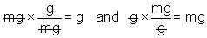
To convert from liters to microliters, the initial unit of quantity (liters) is in the denominator of this conversion factor and the new unit is in the numerator of the conversion factor. By multiplying the measured quantity by the conversion factor, the units of the measured quantity change from liters to microliters:

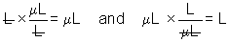

Slide 24

Dimensional Analysis (cont'd)
Examples:
Example 1: How many Canadian dollars would you have to pay to buy a souvenir in Delhi costing 251.10 Indian Rupees?
Answer:
Step 1: The equation relating the units is:
$1.00 = 31.00 Rupees
Step 2: The conversion factors are:
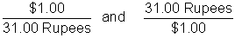
Step 3: Choose the conversion factor that cancels the units of Rupees and gives the answer in dollars (the conversion factor with units of dollars in the numerator):


Slide 25

Dimensional Analysis (cont'd)
Example 2: What is the mass of an object in milligrams that weighs 10.31 lbs?
Answer:
Step 1: The equations relating the units are:
1.0 lb = 453.6 g
and
1.00 g = 1.00 x 10³mg
Step 2: The conversion factors are:
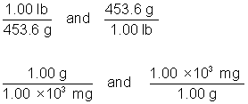
Step 3: The conversion factors that cancel the units of pounds and give us the answer in units of milligrams are:
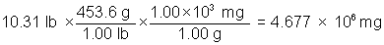

Lesson 1.2 - Study Materials

Slide 1

Lesson 1.2: Matter (Atoms, Molecules and Ions)

The term �matter� is used to describe things which:
• occupy space (hence possess volume and mass)
• are perceivable by our senses
Matter can be classified in terms of its:
• physical state, e.g., solid (wood), liquid (water), gas (air)
• chemical composition: element (e.g., copper), compound (e.g., sugar), or mixture (e.g., antifreeze)

Slide 2

Elements and Compounds
• Elements are composed of one type of atom. Elements are classified as metal, non-metal, or metalloid (semi-metal).
• Compounds are a combination of elements. The atoms of each of the individual elements are chemically combined to form the compound. The properties of the compound are different from those of the individual elements that it is comprised of. A chemical change can break down a compound into its individual elements.

Slide 3

Atoms
Atoms are composed of electrons, protons, and neutrons. The nucleus of the atom contains the neutrons and protons. The electrons surround the nucleus and are equal to the number of protons in a neutral atom.
• Electrons have a negative charge (e⁻)
• Protons have a positive charge (p⁺)
• Neutrons have no charge (nº)

slide 4

Atomic Number, Mass Number and Atomic Symbol
The atomic number of an element (Z) is equal to the number of protons in the nucleus of its atoms. Each element has a different atomic number.
The mass number (A) is equal to the number of protons and neutrons in the atom. To calculate the number of neutrons, subtract the atomic number from the mass number:
Number of neutrons = A - Z
Every element has an atomic symbol (X). Both the atomic and mass numbers are included with the atomic symbol.
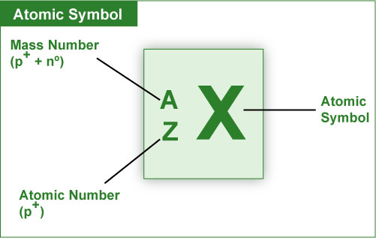

Slide 5

Molecules and Ions
Molecules are a combination of atoms in a definite proportion e.g., molecule of water
(H₂O; hydrogen:oxygen = 2:1).
Ions are charged species formed by loss or gain of electron(s) from an atom:
Cation generation: M (g) → M⁺(g) + e⁻ (loss of e⁻ ) [M = metal; g = gaseous state]
Anion generation : X (g) + e⁻ → X⁻ (g) (gain of e⁻ ) [X = non-metal ]
Lesson 1.3: THE PERIODIC TABLE
The periodic table is a chart (containing symbols) of all the known elements arranged by increasing atomic number.
- Elements are arranged into:
  - vertical columns called groups (or families)
  - horizontal rows called periods
- Elements in the same group (or family) have similar chemical properties. Elements in a period have different chemical properties.
- For each element, the atomic number is given at the top of the symbol and the atomic mass at the bottom.
- The periods are designated with the numbers 1 to 7.

Groups:
- The groups are designated with the numbers 1 (I) to 8 (VIII) and a letter A or B.
- The elements in the groups with the letter A designation are referred to as the main-group elements.
- The elements in the groups with the letter B designation are referred to as the transition elements.
- The inner transition elements (lanthanides and actinides) are located between groups 3B and 4B.
- Traditional Group Names: Group 1A elements are called alkali metals.
- Group 2A elements are called alkaline earth metals.
- Group 7A elements are called halogens.
- Group 8A elements are called noble gases (rare, inert).

Lesson 1.4 - Study Materials

Slide 1

Lesson 1.4 - Naming of Compounds
Chemical compounds are classified as:
- Organic: Compounds that contain at least one carbon atom.
- Inorganic: Compounds that contain atoms other than carbon. Exceptions are inorganic compounds such as carbon monoxide (CO), carbon dioxide (CO₂), etc.
For the purpose of nomenclature (systematic naming), inorganic compounds are classified as those:
- containing a metal and a nonmetal (ionic compounds)
- containing two nonmetals (covalent compounds)

Slide 2

Ionic Compounds
- Ionic compounds are composed of ions.
- They are formed by the electrostatic attraction between a positive ion (cation from the metal) and a negative ion (anion from the nonmetal).
- Electrons are transferred from the atoms of one element to the atoms of another element.
- In general, metals lose electrons and nonmetals gain electrons. Ionic compounds are charge neutral (zero net charge).
- Charges on ions involved in an ionic compound must be known in order to name the compound formed between them or to derive the formula for the compound.

Slide 3

Rules for Naming and Deriving Formulas of Ionic Compounds
Rule #1: For metals of Group 1A, 2A and 3A, the charge on the formed monatomic cation is equal to the group number. The cation has the same name as that of the metal and is always named first.
Common Monatomic Cations
Element symbol | Cation | Cation name
Li | Li⁺ | Lithium
Mg | Mg²⁺ | Magnesium
Al | Al³⁺ | Aluminum

Slide 4

Rules for Naming and Deriving Formulas of Ionic Compounds (cont'd)
Rule #2: For nonmetals of Group 5A, 6A and 7A, the charge on the formed monatomic anion is equal to the group number minus 8. The anion is comprised of the root of the nonmetal name and ends with the suffix ide-.
Common Monatomic Anions
Element Symbol | Anion | Anion Name
N | N³⁻ | Nitride
O | O²⁻ | Oxide
F | F⁻ | Fluoride

Slide 5

Rules for Naming and Deriving Formulas of Ionic Compounds (cont'd)
Rule #3: Many metals (particularly transition metals) form more than one cation, thus forming more than one ionic compound with a particular anion:
Main group metal cations | Transition metal cations
Sn²⁺ and Sn⁴⁺ | Fe²⁺and Fe³⁺
Pb ²⁺and Pb ⁴⁺ | Cu⁺and Cu²⁺
 | Cr²⁺ and Cr³⁺
To indicate which ionic compound is formed, the charge on the metal ion is specified by using Roman numerals within parentheses following the name of the metal ion.
Example: Iron forms Fe²⁺and Fe³⁺ ions. Thus, iron can form two different ionic compounds with chlorine: FeCl₂ [iron(II) chloride] and FeCl₃ [iron(III) chloride].

Slide 6

Rules for Naming and Deriving Formulas of Ionic Compounds (cont'd)
Rule #4: Ions that consist of two or more atoms bonded covalently possessing a net positive or negative charge are referred to as polyatomic ions:
Ammonium ion (NH₄⁺) is an example of a polyatomic cation.
Carbonate ion (CO₃²⁻) is an example of a polyatomic anion.
- For more than one polyatomic ion, the ion is written in parentheses with a subscript indicating how many there are of the same polyatomic ion:
Calcium nitrate contains Ca²⁺ and two NO₃⁻ ions. Thus the formula is Ca(NO₃)₂.

Slide 7

Rules for Naming and Deriving Formulas of Ionic Compounds (cont'd)
Rule #5: The name, formula and the charge for a number of commonly encountered polyatomic anions can be derived from common acids (H⁺ donors) and bases (producing OH⁻).
Examples:
Example 1: HNO₃ (aq) → H⁺ (aq) + NO₃⁻ (aq) [aq = aqueous]
(nitric acid) (nitrate)
Example 2: H₂SO₄ (aq) → H⁺ (aq) + HSO₄⁻ (aq)
(sulfuric acid) (hydrogen sulfate)
(bisulfate)
H₂SO₄ (aq) → 2H⁺ (aq) + SO₄²⁻(aq)
(sulfate)

Slide 8

Rules for Naming and Deriving Formulas of Ionic Compounds (cont'd)
Example 3: H₂CO₃ (aq) → H⁺ (aq) + HCO₃⁻(aq)
(carbonic acid) (hydrogen carbonate)
(bicarbonate)
H₂CO₃ (aq) → 2 H⁺(aq) + CO₃²⁻(aq)
(carbonate)
Example 4: H₃PO₄ (aq) → H⁺(aq) + H₂PO₄⁻ (aq)
(phosphoric acid) (dihydrogen phosphate)
H₃PO₄ (aq) → 2 H⁺ (aq) + HPO₄²⁻(aq)
(hydrogen phosphate)
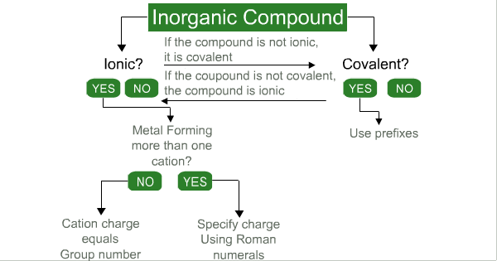

Slide 10

Rules for Naming and Deriving Formulas of Ionic Compounds (cont'd)
Common Polyatomic Ions
Name | Formula
Ammonium | NH₄⁺
Bicarbonate | HCO₃⁻
Carbonate | CO₃²⁻
Hydroxide | OH⁻
Nitrate | NO₃⁻
Phosphate | PO₄³⁻
Bisulfate | HSO₄⁻
Sulfate | SO₄²⁻

Slide 11

Exercise: Naming and Deriving Formulas for Ionic Compounds
Exercise:
Give the name or formula for the following ionic compounds:
a) NaCl
b) Calcium nitride
c) Iron (III) nitrate
d) Cu₂O
Please try to answer the questions on a piece of paper. Once you are done, you can compare your answers with the correct answers below. Click on the �+� to view the corresponding answers, and click on the �-� to hide them.
a) NaCl
Solution a) Metal Na (sodium); Nonmetal Cl (chlorine)
For sodium: Na is a Group 1A element hence has a charge +1
(Rule #1): Cation: Na⁺
Na⁺ is sodium since it is a cation(Rule #1).
For chlorine: Cl is a Group 7A element hence has a charge of -1
(Rule #2) Anion: Cl⁻
Cl⁻ is chloride since it is an anion(Rule #2).
The name of the compound is Sodium chloride.
b) Calcium nitride
Solution b) Calcium is Ca²⁺; nitride is N³⁻. Therefore, to have a zero net charge, three Ca²⁺ ions balance two N³⁻ ions. The formula is Ca₃N₂.
c) Iron(III) nitrate
Solution c) Iron is Fe³⁺(Rule #3); nitrate is NO₃⁻. Therefore, to have a zero net charge, one Fe³⁺ ion balances three NO₃⁻ ions. The formula is Fe(NO₃)₃.
d) Cu₂O
Solution d) Anion:O²⁻ and Cation: Cu⁺.
Copper is the cation Cu⁺ and the ionic charge is indicated by the Roman numeral (I) because it can form more than one cation. O²⁻ is oxide since it is an anion. To neutralize the charges, two Cu⁺ ions balance one O²⁻ ion. The name of the compound is Copper(I) oxide.

Slide 12

Covalent Compounds
The sharing of electrons between nonmetals forms covalent compounds.

Rules for Naming Covalent Compounds
Rule #1: Name the first element in the formula first.
Rule #2: Name the second element as an anion.
Rule #3: Use prefixes to indicate the numbers of atoms of each element.
Rule #4: Do not use the prefix mono- for the first element.

Slide 13

Covalent Compounds (cont'd)
Prefixes Used in Naming Compounds
Prefix | Number Indicated
Mono- | 1
Di- | 2
Tri- | 3
Tetra- | 4
Penta- | 5
Hexa- | 6

Slide 14

Covalent Compounds (cont'd)
Exercise: Naming and Deriving Formulas for Covalent Compounds
Please try to answer the following questions on a piece of paper. Once you are done, you can compare your answers with the correct answers below. Click on the �+� to view the corresponding answers, and click on the �-� to hide them.
a) What is the name of CCl₄?
Solution a) C is the symbol for carbon (nonmetal) (Rule #1).
The second element is named chloride (Rule #2). There are four chlorine atoms and this is indicated by the prefix tetra-. The name is carbon tetrachloride.
b) What is the formula of dioxygen difluoride?
Solution b) Oxygen is the first element. O is the symbol for oxygen (nonmetal) (Rule #1). Two oxygen atoms are indicated by the prefix di-(Rule #3).
F is the symbol for fluorine. Fluorine is the element corresponding to the anion, thus it is named fluoride (Rule #2). The prefix di- indicates two fluorine atoms in the formula (Rule #3). The formula is O₂F₂.
Some compounds are still known by their old names (and not by using the system of nomenclature):
- Water (H₂O) [not dihydrogen monoxide]
- Ammonia (NH₃) [not nitrogen trihydride]
- Hydrogen sulfide (H₂S) [not dihydrogen monosulfide]
- Hydrogen peroxide (H₂O₂) [not dihydrogen dioxide]
- Methane (CH₄) [not carbon tetrahydride]
- Ozone (O₃) [not trioxygen]

Slide 15

Representation of Chemical Reactions
Chemical reactions are expressed as an equation (chemical equation) using chemical formulas. For example, the reaction between calcium metal and oxygen gas is expressed as the balanced chemical equation:
2 Ca (s) + O₂ (g) → 2 CaO (s)
Balanced chemical equation: | (i) Identifies the reactant(s) and product(s).
 | (ii) Shows the relative amount of the reactant(s) and product(s).
 | (iii) Indicates the physical state of the reactant(s) and product(s) [s = solid; ℓ = liquid; g = gas, aq = aqueous].
 | (iv) Complies with the Law of Conservation of Mass and Matter (i.e., atoms and charges on both sides must be balanced).

Slide 16

Representation of Chemical Reactions (cont'd)
In writing chemical equations: | (i) Fractional coefficients are avoided.
 | (ii) Smallest whole-number coefficients are written.
Example 1: Reaction between hydrogen gas and oxygen gas can be written in several ways:
1) H₂ (g) + O₂ (g) → H₂O (ℓ)
Incorrect; does not comply with the Law of Conservation of Mass & Matter.
2) H₂ (g) + O (g) → H₂O (ℓ)
Incorrect; oxygen gas is O₂.
3) H₂ (g) + 1/2 O₂ (g) → H₂O (ℓ)
Correct; but fractional coefficients are avoided.
4) 2 H₂ (g) + O₂ (g) → 2 H₂O (ℓ)
Correct.
5) 4 H₂ (g) + 2 O₂ (g) → 4 H₂O (ℓ)
Incorrect; smallest whole-number coefficients are written.
The balanced equation to express the reaction is:
2 H₂ (g) + O₂ (g) → 2 H₂O (ℓ)

Slide 17

Representation of Chemical Reactions (cont'd)
- Balanced chemical equations are used for chemical calculations. As atoms, molecules or ions are the basic units, the coefficients in such equations denote their number. For example, according to the chemical equation: N₂ (g) + 3 H₂ (g) → 2 NH₃ (g)
1 mole of nitrogen molecules consumes 3 moles of hydrogen molecules to yield (to produce) 2 moles of ammonia molecules.
- A mole can be considered a �packaging unit� for atoms, molecules, ions, etc. As a dozen (also a packaging unit) always refers to the number 12, a mole always equals 6.022 x 10²³ (Avogadro's number).
- Atomic masses (mass of 1 mole of atoms or mass of 6.022 x 10²³ atoms) of elements are given in the Periodic Table. From these and the chemical formula, molecular masses (mass of 1 mole of molecules or mass of 6.022 x 10²³ molecules) and formula masses (term used for ionic compounds) can be calculated:
Molecular mass (or Formula mass) = sum of atomic masses

Slide 18

Representation of Chemical Reactions (cont'd)
For example, knowing the formula of calcium nitrate is [Ca(NO₃)₂] its formula mass can be calculated as:
Ca: 1 x 40.08 g/mol = 40.08 g/mol
N: 2 x 14.01 g/mol = 28.02 g/mol
O: 6 x 16.00 g/mol = 96.00 g/mol
------------------
164.10 g/mol
Similarly, the molecular mass of SF₆ can be calculated as:
S: 1 x 32.06 g/mol = 32.06 g/mol
F: 6 x 19.00 g/mol = 114.00 g/mol
-----------------
146.06 g/mol
Chemical calculations often involve conversion of mass to mole and vice versa. The following expression can be used in performing such conversions:
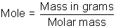

Lesson 2.1 - Study Materials

Slide 1

Lesson 2.1: Occupational Hazards

Introduction
Our physical and mental well-being (the state of our health), is determined by a combination of hereditary factors and the quality of the environment we encounter. However, it is very important to realize that the term environment includes home, community, workplace and recreational environments. All of these individually or collectively can have a significant impact on our health.

Slide 2
In a workplace, the worker may be exposed to:
- Safety hazards
- Health hazards
Based on the nature of the work, safety hazards are due to material handling, machines, energy, work practices, and confined spaces.
- Material handling hazards: These can lead to muscle strains due to lifting and carrying materials. The use of devices such as forklifts, cranes, etc. exposes the worker to accidental contact with the moving equipment.
- Machine hazards: Rotating shafts, moving belts, presses, etc. can cause very serious injuries.
- Energy hazards: All energy sources such as electricity, steam, hydraulic pressure, etc. can lead to serious injury.
- Work practice hazards: Failure to follow safe operating procedures may lead to serious injuries.
- Confined space hazards: In such spaces (for example, silos, storage tanks, pipelines etc.) hazards arise due to difficulty of entry and exit, build-up of hazardous materials and oxygen deficiency.
The extent of occupational health hazards varies with the type of activity. However, such hazards may have the potential to cause severe discomfort, illness, and lack of efficiency among workers. Based on the nature of the causative agent (or factor), occupational health hazards can be classified as physical, chemical, biological and ergonomic.
- Physical hazards are due to the presence of physical agents such as pressure and temperature extremes, excessive noise and vibration, and exposure to radiation.
- Chemical hazards are due to the presence of chemical agents such as dust, fume, gas, mist, smoke and vapor.
- Biological hazards are due to the presence of biological agents such as bacteria, moulds and viruses.
- Ergonomic hazards are due to ergonomic stresses such as fatigue and repetitious work.

Slide 3

Types of Occupational Hazards (cont'd)
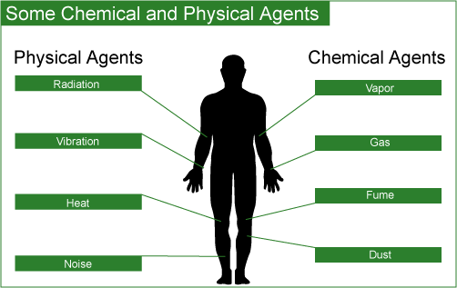
It is very important to note that the mere presence of a causative agent does not necessarily constitute a hazard. A causative agent is classified as hazardous in certain circumstances such as high concentration or intensity and a prolonged exposure.
Workers have the right to:
- Work in a safe and healthy environment
- Know the processes and substances they are working with
- Know potential hazards from these processes and substances

Slide 4

Assessment of Occupational Hazards
In order to recognize and assess the potential impact of occupational hazards, walk-through surveys are performed. Such surveys generally include a study of the following parameters in terms of their impact on the surrounding environment and thus the workers:
- Processes, operations and related activities
Generally various emissions are evaluated because the emission of any physical, chemical or biological agents has the potential to be a health hazard.
- Equipment
Equipment is generally assessed in terms of mechanical and electrical safety and the potential to create excessive noise and vibration.
- Properties of substances used and produced
These include an evaluation of raw materials and finished products in terms of their physical, chemical and toxic properties and effects.
- Control measures
All engineering controls in place for proper materials handling, storage, etc. are evaluated. Also considered are the ventilation system and the availability of personal protective equipment.

Slide 5

Physical Agents
Although we are constantly exposed to such agents, their intensity and duration of exposure may be more significant in the workplace. Such agents may cause immediate or cumulative adverse health effects. Commonly encountered physical conditions with a potential to cause adverse health effects include:
    - pressure and temperature extremes
    - excessive noise and vibration
    - poor illumination
    - various types of radiation
The action of physical agents consists of transfer of residual energy through the surrounding air or the equipment the worker is in contact with. Except for radiation, our senses can detect all other physical agents.

Slide 6

Pressure Extremes
Our bodies are conditioned to work at normal atmospheric pressure. Any extreme can be detrimental to one's health. Two types of abnormal pressure-related conditions are hyperbaric and hypobaric.
• Hyperbaric is defined as a pressure higher than normal atmospheric pressure. Mining and underwater workers may be exposed to hyperbaric conditions.
• Hypobaric is defined as a pressure lower than atmospheric pressure. Hypobaric conditions are encountered by those working at high elevations.

Slide 7

Temperature Extremes
It is important to realize that apart from the surrounding temperature, sensation of hot or cold depends on some other factors such as:
- Air movement
- Hot or cold objects in the vicinity
- Relative humidity
The biochemical processes in one’s body take place within a very narrow temperature range and hence the regulation of body temperature is an important function. Temperature extremes affect the working efficiency as well as the health of a worker.
The terms heat stress and cold stress refer to excessive exposure to very hot or very cold work environments. Both such conditions may interfere with worker’s performance and may even be fatal.
Some of the adverse effects in very hot work environments (depending upon the individual worker and the heat intensity) include:
- Heat exhaustion
- Fainting
- Heat stroke
Heat-related problems may arise for:
- Outdoor workers (working in construction)
- Industrial workers (working near furnaces)
In very cold work environments (depending upon the individual worker and intensity of cold), the adverse effects include:
- Frostbite
- Hypothermia
Workers at risk include:
- Outdoor workers (divers)
- Meat packers and handlers (working in refrigerated warehouses)

Slide 8

Noise
Noise is a form of irregular vibration. It may be conducted through gases (or vapors), liquids, or solids. Above a certain level, the noise becomes of concern because it may hinder communication between workers, thus leading to annoyance. This in turn may lead to poor job performance and compromise the safety of the worker. In addition, excessive exposure to high noise levels may cause loss of hearing.

Slide 9

Vibration
It is important to note that exposure to vibration is more than just a nuisance.
Whereas exposure to vibration may cause discomfort, intense vibration has been known to cause serious health problems such as back pain, carpal tunnel syndrome (a condition affecting the hand and wrist) and damage to bones and joints.
There are two types of occupational vibration: whole-body and hand-arm vibration. Whereas whole-body vibration is transmitted through the supporting surface (feet, back, etc.), hand-arm vibration is transmitted to the hands and arms.
Examples:
- Mining equipment (whole-body vibration)
- Hand-held power tools (hand-arm vibration)

Slide 10

Radiation
Radiation is the energy that travels through space from many different natural and human-made sources. Some different types of radiation include:
- Visible light
- Ultraviolet rays
- Microwaves
- X-Rays
- Radio waves
Thus, it is easy to see that we are exposed to radiation every day.
Depending on its energy, radiation is of two main kinds:
- Ionizing radiation: The energy associated with it is high and thus strong enough to damage cells and DNA. Some examples and sources of ionizing radiation include: x-rays (from x-ray machines) alpha, beta and gamma rays (from radioactive materials), high-energy ultraviolet (from germicidal lamps).
- Non-ionizing radiation: It is not as strong as ionizing radiation. However, prolonged exposure to some types of non-ionizing radiation can still cause harm. Some examples and sources of non-ionizing radiation include: visible light, microwaves (from telecommunications and microwave ovens), infrared (from infrared heat lamps), radio waves (from broadcasting) and low-energy ultraviolet (tanning lamps).
The hazard associated with a particular type of radiation depends on its energy and ability to penetrate the body tissue. Thus, even brief exposure to high energy and highly penetrating x-rays can cause severe damage to the tissue.
Infrared, ultraviolet and microwaves on the other hand do not penetrate appreciably below the skin and the damage is mainly restricted to burns to the skin and eyes. Severe damage to eyes may result from excessive exposure to ultraviolet radiation.
Some applications of radiation include:
- Industrial: Quality control, non-destructive testing using radiography
- Household: Television, smoke detectors
- Medical: Imaging, treatment
- Science: Material analysis, sterilization

Slide 11

Chemical Agents
A large variety of chemical agents are encountered in workplaces due to the diversity of raw materials and processes used. Chemical hazards in such environments arise due to the presence of certain chemical agents whose properties (physical and/or chemical) and/or toxicity may pose a potential risk to the health and safety of the worker coming in contact with it or handling it.
Chemical hazards may arise in operations involving:
- Compressed Gases
- Flammable and Combustible Materials
- Oxidizing Materials
- Poisonous & Infectious Materials
- Corrosive Materials
- Dangerously Reactive Materials

Slide 12

Chemical Agents (cont'd)
Chemical agents may be present in the air as:
- Fine particles
- Gases and vapors
- Both as particles and vapors at the same time
- Adsorbed or absorbed gases and/or vapors on particles

Slide 13

Fine Particles
The particles of size less than 5 microns (5 x 10⁻⁶ m) are potentially the most hazardous because of their effective entry and retention in the lungs.
The particles are classified as dust, fume and smoke (for solids), and mist (for liquids).
Sources of fine particles include:
- spray painting (mist)
- welding (fume)
- incomplete combustion of oil and grease (smoke)
- ore grinding (dust)

Slide 14

Gases and Vapors
These may be generated as a result of various operations and can mix and distribute rapidly throughout the workplace. In view of their small size, the gases can readily enter the bloodstream through the lungs.
Some sources of potentially toxic gases and vapors include:
- solvent degreasing (vapors of solvent used)
- spray painting (vapors of solvent used)
- welding (gaseous combustion products)

Slide 15

Biological Agents
Biological agents are living organisms, or substances produced by such organisms, that can cause illness or disease in humans.
These include:
- Bacteria
- Fungi
- Viruses
- Other microorganisms and their associated toxins
Many microorganisms pose a potential danger in a variety of workplaces due to their ability to:
- Reproduce rapidly
- Survive with minimum resources
The adverse health affects due to biological agents may range from allergic reactions to serious medical conditions and even death. Food poisoning, rabies, tuberculosis and hepatitis are some of the infections caused by biological agents.
Workplace exposure to work-related biological agents such as bacteria, moulds, and viruses is limited to certain occupations such as health care workers (i.e., hospital workers and veterinarians), meat handlers (i.e., ranchers, farmers, and meat packers), and those who work in sanitation or sewage operations.

Slide 16

Ergonomic Stresses
Over the recent years it has been fully realized that the traditional method of assigning people to jobs without accommodating their needs, limitations, sizes, strengths and weaknesses may lead to certain adverse job safety and health issues such as mental stress, loss of efficiency and accidents.
Ergonomics can be defined as the science or study of work. It is a way of designing a work environment to fit people.
It has been established that ergonomics, properly applied, can help:
- reduce workplace injuries and illnesses; particularly back injuries and cumulative trauma disorder (CTD) affecting, joints, muscles, nerves and tendons that can cause pain and swelling
- improve productivity and quality of work
- increase job satisfaction
- satisfy government regulations

Lesson 2.2 - Study Materials

Slide 1

Lesson 2.2: Toxicology
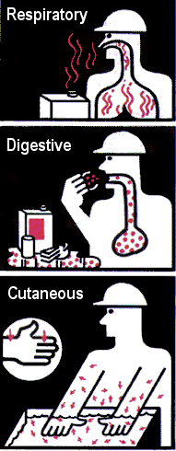
Source: CSST Service du
répertoire toxicologique
The interaction of physical, chemical or biological agents may produce adverse responses with our bodies. Such responses may range from minor irritation to dreaded diseases like cancer.
Toxicology is the science that involves the study of the properties and interactions of physical, chemical or biological agents.
Most common natural routes of entry of chemical agents into the body include:
- respiratory tract (by inhalation)
- digestive tract (by ingestion)
- skin (by absorption)
- eyes (by absorption)
In occupational settings, inhalation is the most important route followed by absorption through skin and eyes.
Some of the basic concepts of toxicology as applied to chemical agents will be discussed in the following slides.

Slide 2

Toxicity
Toxicity is the degree of danger of a material to injure a living organism by other than mechanical means.
Toxic hazards (toxicity) posed by a chemical are influenced by a number of factors such as:
  - physical properties
  - chemical properties
  - intensity of exposure (exposure dose)
[concentration x duration of exposure]
  - mode of handling
  - routes of entry
  - susceptibility of the worker

Slide 3

Dose and Exposure
Dose is defined as the amount of toxicant(s) actually delivered to the target organ. The units used to express dose are mg/kg (mass of toxicant/body mass).
Exposure on the other hand is the total amount of the toxicant(s) present in the workplace. However, exposure does provide an indication of the dose. Higher the exposure, greater the probability of larger amounts being delivered to the target organ and hence higher the dose. The units used to express exposure are:
- mg/m³ (mass of toxicant/volume of air) for particles
- ppm (parts per million) for gases and vapors.

Slide 4

Dose and Exposure (cont'd)
In order to provide guidelines for controlling occupational health hazards, threshold limit values (TLVs) for various physical and chemical agents have been developed by the American Conference of Governmental Industrial Hygienists (ACGIH).
According to ACGIH, one of the ways to specify these values is as Threshold Limit Value-Time-Weighted Average (TLV-TWA). It is the time-weighted average concentration of a substance for a normal 8-hour workday and a 40-hour workweek to which nearly all workers may be repeatedly exposed, day after day, without adverse effects.
Thus, the lower the TLV value, the more potentially dangerous (or high risk) the substance is.

Slide 5

Effects of Toxicants
Classification for the effects of over exposure to toxicants (or the commonly used term contaminants) can be based upon:
- Duration of the effect
- Organ affected
- Physiological action

Slide 6

Duration of the Effect
The duration of the effect can be classified as acute or chronic.
- Acute Effect:
The observed effect of a toxicant is considered acute if it appears soon after exposure. The effect generally results from brief exposure to a high concentration of the contaminant. The effect is also easy to observe and relate.
- Chronic Effect:
The effect is considered chronic if it is observed much later after exposure. Chronic effects result from low and repeated exposure over a long period of time; they may have latency periods. Chronic effects are more difficult to study and are very important to consider when dealing with hazardous wastes and pollution.
Acute | Chronic
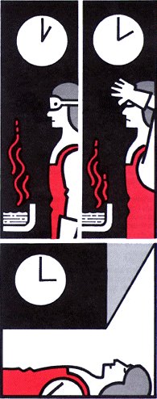 | 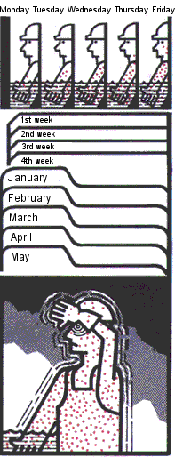
Source: CSST Service du répertoire toxicologique

Slide 7

Organ Affected and Physiological Action
The toxicant may change the normal functioning of one organ or a set of organs that operate as a system. For example, hepatotoxins affect the liver whereas immunotoxins act upon the immune system.
A variety of physiological effects have been observed due to the diversity of contaminants in the workplace. Based upon the observed physiological effects, the chemicals are classified as and described below:
- Asphyxiants: asphyxia (suffocation due to lack of oxygen)
- Irritants: eye, skin, mucous membrane irritation
- Anasthetics: depressants
- Narcotics: habit forming depressants
- Systemics: organ(s) or system(s) damage
- Lung scarring agents: lung damage
- Carcinogens: cause cancer
- Mutagens: changes in DNA
- Teratogens: malformations in newborns
Carcinogenic Effect
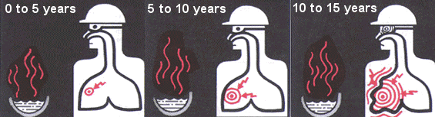
Source: CSST Service du répertoire toxicologique

Slide 8

Physiological Action
Mutagenic effect | Teratogenic effect
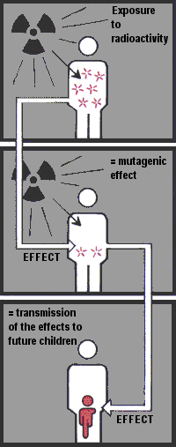 | 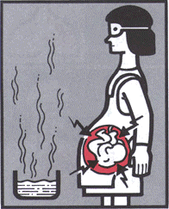
Source: CSST Service du répertoire toxicologique

Lesson 2.3 - Study Materials

Slide 1

Lesson 2.3: Workplace Hazardous Materials Information System (W.H.M.I.S.)
Several studies estimated a high social cost due to exposure to hazardous materials in the workplace. Due to the seriousness of such health & safety problems, it was agreed to implement an information system with the goal of reduced incidence of illnesses and injuries caused by the hazardous materials in the workplace.
WHMIS is a Canada-wide system developed over several years through the collective efforts of Labor, Industry, and Federal, Provincial, and Territorial Governments. Published in January 1988, it became legislation in October 1988.

Slide 2

Workplace Hazardous Materials Information System (W.H.M.I.S.)
The system consists of three key elements:
- cautionary labeling of containers of hazardous materials
- provision of Material Safety Data Sheet (MSDS), which provides more detailed information on the hazardous nature of the material
- provision of worker education program

Slide 3

W.H.M.I.S. - Symbols
Symbol | Classes and divisions
 | Class A:  Compressed Gas
 | Class B:  Flammable and Combustible Material
 | Class C:  Oxidizing Material
 | Class D, division 1:  Poisonous and Infectious Material:  Immediate and serious toxic effects
 | Class D, division 2:  Poisonous and Infectious Material:  Other toxic effects
 | Class D, division 3:  Poisonous and Infectious Material:  Biohazardous infectious materials
 | Class E:  Corrosive Material
 | Class F:  Dangerously Reactive Material
Source: Canadian Centre for Occupational Health & Safety

Slide 4

W.H.M.I.S. - Label
Standard label:
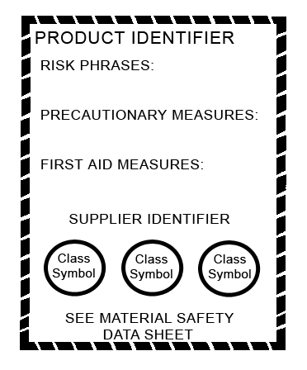
Example:
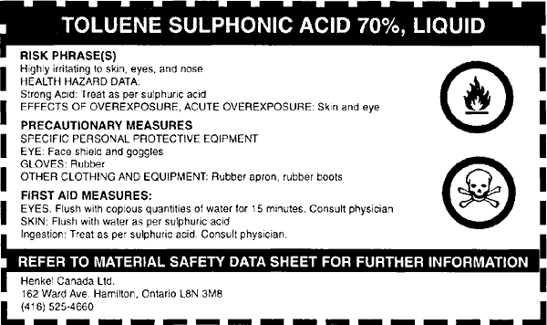
Image courtesy of the Province of Manitoba

Slide 5

W.H.M.I.S. - Material Safety Data Sheet
Standard data sheet:

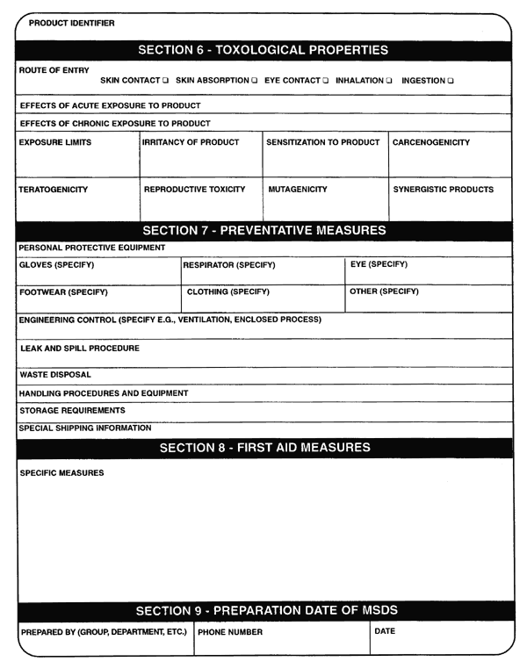
Image courtesy of the Province of Manitoba

Slide 6

Sucessful Implementation of W.H.M.I.S.
Successful implementation of WHMIS in the workplace requires cooperation of all parties involved. WHMIS sets the responsibilities of the parties involved:
- Suppliers: provide hazard information through labels and MSDS on all controlled products/containers of controlled products.
- Employers (Supervisors): ensure WHMIS labels, identifiers and MSDSs for all containers of controlled products. Employers also ensure availability and accessibility of MSDS information to employees and provide effective worker training to ensure understanding among employees of the labels, MSDSs, and precautionary measures for hazardous materials in their workplace.
- Employees: handle controlled products safely and inform supervisors of damaged/missing labels and missing MSDS information.
- Regulators: develop and administer WHMIS legislation.

Slide 7

Globally Harmonized System (GHS) for Hazard Classification and Labelling
Systems similar to WHMIS (for hazard communication) exist in other countries.
In 1992, the United Nations Conference on Environment and Development (UNCED) agreed to develop a Globally Harmonized System (GHS) for hazard classification and labelling. It is anticipated that such a system will facilitate safe use of chemicals and reduce trade barriers.
Some of the anticipated changes are:
- Inclusion of consumer, transport and workplace sectors rather than workplace only.
- Inclusion of all chemicals except pharmaceutical and cosmetic products intended for consumer use.
- Hazard classification format in the MSDSs.
- Hazard communication format in the labels.

Lesson 3.1 - Study Materials

Slide 1

Lesson 3.1: Air
Air (which all of us must breathe) composes the atmosphere and is a complex mixture of gases surrounding the Earth.
The atmosphere is a layered structure divided into layers according to a variety of criteria such as gradually changing:
• Altitude
• Pressure
• Chemical composition and concentration
• Temperature
• Electrical nature

Slide 2

The Atmosphere
According to altitude, the atmosphere is divided into layers:
• Troposphere
• Stratosphere
• Mesosphere
• Ionosphere/Thermosphere
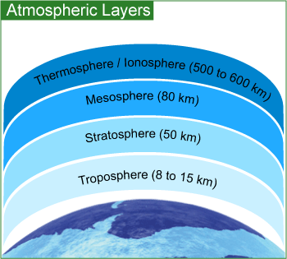

Slide 3

Composition of Air
The air we breathe is a mixture of several gases, fine particles and vapors. Dry air consists of 21% oxygen and 78% nitrogen plus traces of other substances that are both natural and human-made.
Major components of air:
- Nitrogen (N₂)
- Oxygen (O₂)
- Water (H₂O)
- Carbon dioxide (CO₂)
Some minor components of air:
- Carbon monoxide (CO)
- Ozone (O₃)
- Oxides of Sulfur (SO_{x})
- Oxides of Nitrogen (NO_{x})

Slide 4

Composition of Air (cont'd)
Whereas major components are essential for life, the minor components are pollutants, which under certain conditions may produce adverse environmental and health effects. These air pollutants are emitted directly into the atmosphere during combustion and production processes, changing the composition of atmosphere and causing poor air quality.
The burning of fossil fuels (i.e., petroleum, natural gas and coal) can be used:
- to generate energy (electricity, gas and steam)
- in transportation (combustion engines)
- in industrial processes that use a great deal of energy sources (i.e., pulp and paper mills, ore smelters, petroleum refineries, power generating stations and incinerators)
These elements are mainly responsible for the presence of minor components. That is, they are the major sources of human-created air pollution.

Slide 5

Carbon Monoxide (CO)
When there is an adequate supply of oxygen, there is complete combustion of fossil fuels thereby forming the major by-products: carbon dioxide and water. Most carbon monoxide produced in this process is immediately oxidized to carbon dioxide. However, when there is an insufficient supply of oxygen, there is incomplete combustion of fossil fuels and carbon monoxide gas is released.
Furthermore, carbon monoxide can also be produced by other processes such as combustion of organic matter during waste incineration. Natural sources of carbon monoxide include forest fires and volcanoes.
When a person inhales carbon monoxide, it binds to the oxygen-carrying site on the hemoglobin of red blood cells, causing a reduction of oxygen transport in the body. This is because the hemoglobin can no longer take up oxygen from the air, resulting in cell and tissue death.
Consequently, the health effects associated with exposure to carbon monoxide include:
- impaired ability to use oxygen
- decreased athletic performance
- cardiac problems

Slide 6

Ground-level Ozone (O₃)
Ozone is a naturally occurring gas that forms a protective layer in the atmosphere, present predominantly in the stratosphere. Ozone serves to protect the Earth by absorbing harmful ultraviolet radiation from the Sun.
Ground-level ozone is produced during photochemical reactions between volatile organic compounds (VOCs) released in automobile exhaust and oxides of nitrogen (NO_{x}) in the presence of sunlight.
Ozone is also generated in industrial processes such as arc welding.
Human health effects associated with exposure to ground-level ozone include:
- damaged biological tissues and cells
- reduced lung function
- breathing difficulties
- itchy, burning, and watery eyes

Slide 7

Oxides of Sulfur (SO_{x})
Oxides of sulfur are released mainly during processing (smelting) of mineral ores and the combustion of fossil fuels (i.e., burning of coal/petroleum).
Many industrial processes such as pulp and paper production and petroleum refining also generate oxides of sulfur. Such emissions include sulfur dioxide (SO₂) and sulfur trioxide (SO₃).
Further reactions in the atmosphere may lead to the formation of sulfuric acid (H₂SO₄) and sulfate (SO₄²⁻) salts. The most common natural source of sulfur dioxide is volcanoes.
Human health effects associated with exposure to high levels of oxides of sulfur include:
- problems breathing (particularly for asthmatic people)
- respiratory illness

Slide 8

Oxides of Nitrogen (NO_{x})
Some sources of the emission of oxides of nitrogen include: fuel combustion for transportation, home, and industrial use; manufacture of nitric acid; welding, etc. Oxides of nitrogen form in the air because fuel is burnt at high temperatures. This is mostly in the form of nitric oxide with a small amount as nitrogen dioxide (usually less than 10%). Once emitted, nitric oxide (NO) is oxidized, forming nitrogen dioxide (NO₂). In addition, nitric acid (HNO₃) and nitrate (NO₃⁻) salts may be formed due to further reactions.
The main oxides of nitrogen present in the atmosphere are nitric oxide (NO), nitrogen dioxide (NO₂), and nitrous oxide (N₂O).
Nitrogen oxides are also emitted from natural sources including lightning and microbial activity of soil bacteria.
Human health effects associated with exposure to oxides of nitrogen include:
- serious lung damage
- shortness of breath and chest pains

Slide 9

Entry into the Body
The air we breath (inhalation) is handled by the lungs, which provide an extremely efficient method of getting oxygen (required for metabolic processes) into and carbon dioxide (waste product of metabolic processes) out of the body.
Unfortunately, the lungs also provide an excellent opportunity for minor components (pollutants) to diffuse into the blood stream via gas exchange in the alveoli.
As breathing is a continuous process, considerable amounts of a pollutant (even if present as a minor component) can be inhaled and efficiently transported into the body. Once in the body, they may manifest adverse health effects.

Slide 10

Risk Assessment
In order to assess the health risks due to air pollutants, we require exposure and effects assessment.
Exposure assessment: estimates concentrations using chemical measurements.
Effects assessment: relies on toxicity testing (estimates of exposure toxicity) and computer models to extrapolate data from human population, animal, and bacterial toxicity studies. Quantitative analysis of epidemiological, toxicological and exposure data that are based on the accurate scientific evidence estimates exposure toxicity and risk.
Risk characterization integrates the exposure and effects components to estimate the risk.

Slide 11

Exposure Measurement
Exposure is measured by determining the pollutant concentration in air. Monitoring methods include:
- Air sampling followed by laboratory analysis of the pollutant(s) using established procedures.
- Real time monitoring using direct reading pollutant-specific monitors.
Commonly used concentration units
For gases and vapors:
- Parts per million (ppm)
- Parts per billion (ppb)
- Percent (%)
For particles:
- Milligrams per cubic meter (mg/m³)
- Micrograms per cubic meter (µg/m³)

Slide 12

Exposure Measurement - Examples
Review slides 21 through 26 in lesson 1.1 for a refresher on Dimensional Analysis.
Some useful conversion factors:
1% = 10⁴ ppm
1 ppm = 10³ ppb
Click on the �+� to view the corresponding answer, click on the �-� to hide it.
Example 1: A gas is toxic at a concentration of 500. ppm and any level of exposure above this value is considered unsafe for a worker. A real time monitor for the gas indicated a concentration of 0.0615% in a workplace environment. Is it safe to work in such an environment?
Answer: (0.0615 parts gas/10² parts air) x 10⁶ parts air = 615. ppm
It is not safe to work in such an environment.
Note: x% simply means x parts per hundred parts.
Example 2: In an office environment, sampling and subsequent analysis for carbon monoxide (CO) indicated a concentration of 9.0 x 10³ ppb. Express the concentration in the units of ppm and %.
Answer: 1ppm = 1 x 10³ ppb
(9.0 x 10³ ppb) x (1ppm/1 x10³ ppb) = 9.0 ppm
(9.0 x 10³ parts CO/10⁹ parts air) x 10² parts air = 9.0 x 10⁻⁴%

Slide 13

Exposure Measurement (Cont'd)
Thus, for pollutants, Threshold Limit Values (TLVs) have been developed and issued by the American Conference of Governmental Industrial Hygienists (ACGIH) to assist in the control of workplace health hazards.
According to ACGIH, Threshold Limit Value-Time-Weighted Average (TLV-TWA), is defined as the time-weighted average concentration for a normal 8-hour workday and a 40-hour workweek, to which nearly all workers may be repeatedly exposed, day after day, without adverse effect.
Substance | TLV-TWA
CO | 25 ppm
NO₂ | 3 ppm
O₃ | 0.1 ppm
SO₂ | 2 ppm

Slide 14

Air Quality
Air quality problems in many other parts of the world are much worse than those in Canada . This has led to some global concerns about our environment. It is important to note that in addition to the minor components, we are exposed to a large variety of environmental contaminants in industrial, commercial and residential areas. Some of these indoor air contaminants include:
  - Combustion products
  - Fibers
  - Particulates
  - Radon
  - Formaldehyde
  - Microorganisms
  - Pesticides
  - Volatile Organic Compounds (VOCs)

Slide 15

Control Strategies
Over the past two decades, stricter environmental emission control regulations and pollutant(s) mitigation (reduction) technologies have led to considerable reduction in the concentration of many pollutants.
The North American Free Trade Agreement (NAFTA) obliges all the three signatories to enforce environmental laws. Among the global initiatives is the establishment of the International Register of Potentially Toxic Chemicals (IRPTC). One of the objectives of the register is to identify the potential hazards of using chemicals and to make people aware of them.

Lesson 3.2 - Study Materials

Slide 1

Lesson 3.2: Water
Water (H₂O) consists of two nonmetals hydrogen and oxygen. The water molecule is formed by the covalent bonding of two hydrogen atoms to an oxygen atom.
Water is a unique substance that is literally everywhere. A vital substance to our well-being and very existence, water is intimately linked to our daily life. We use it for various purposes, such as:
- Cooking and Drinking
- Personal hygiene
- Recreation
- Agriculture
- Transportation
- Energy generation
Unique properties of water:
The polar nature and the capability to form hydrogen bonds are responsible for many of the unique properties of water. Such properties play an important role in making water essential for life and in determining its chemical behavior in the environment.

Slide 2

Polarity of Water
Water is highly polar. The polar nature of the water molecule is due to its:
Polar covalent bonds: The electron pair forming the covalent bond (between the oxygen atom and each of the two hydrogen atoms) is more strongly attracted by the oxygen atom due to its higher electronegativity (the ability of an atom in a molecule to attract shared electrons over another atom in the molecule).
- This leads to a partial positive charge on each of the two hydrogen atoms (represented as ⁺) and a partial negative charge on the central oxygen atom (represented as ⁻) making the water molecule behave like a dipole.
- Molecular shape: A water molecule has a bent (V-shape) shape (H-O-H bond angle of 104.5°). This, in combination with the polar covalent bonds, leads to a resultant dipole and hence the polarity of the water molecule.

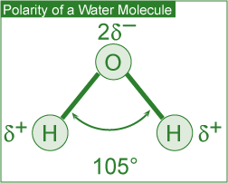

Slide 3

Hydrogen Bonding in Water
The partial charges present lead to intermolecular attraction between water molecules. A single water molecule can thus attract four other water molecules. These intermolecular attractive forces are called hydrogen bonds. These are much weaker than the forces holding the atoms in the covalent O-H bond.

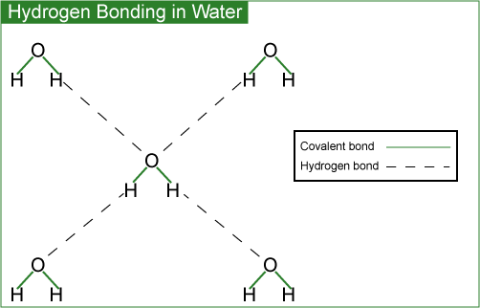

Slide 4

Solvent Properties of Water
Water is a powerful solvent due to its high polarity and hydrogen bonding ability. It is an excellent solvent for ionic (e.g., table salt), polar covalent (e.g., sugar) and non-polar (e.g., oxygen) compounds. In the case of ionic compounds, the ions are separated from the solid and caged (solvated) by polar water molecules, thus keeping them in solution.
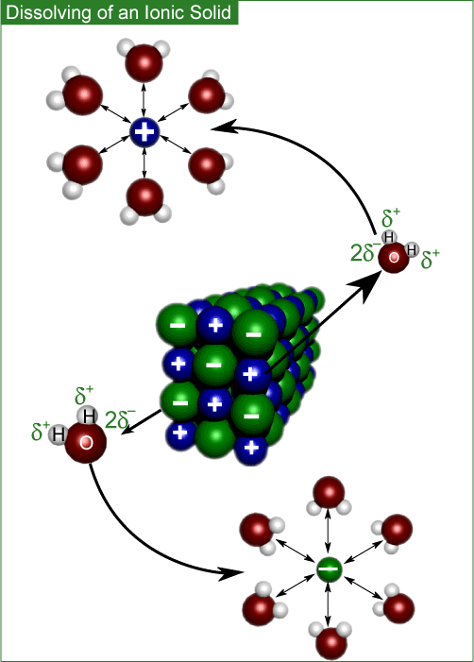
Polar covalent compounds (i.e., ethanol and glucose) dissolve in water by the formation of hydrogen bonds.
Water thus plays an important role in the transportation of nutrients and waste products in biological processes. Aquatic life and plants survive due to dissolved oxygen and carbon dioxide.

Slide 5
The presence of hydrogen bonds in water accounts for its exceptionally high boiling point, specific heat and heat of vaporization. A portion of the heat supplied is used up in breaking the hydrogen bonds.
Specific heat is defined as the amount of heat energy required to increase the temperature of 1 g of a substance by 1°C.
High specific heat of water regulates and stabilizes the temperatures of geographical regions and organisms within a narrow range. This in turn allows our planet to support life.
Heat of vaporization is defined as the quantity of heat required for the conversion of 1 g of a liquid entirely into its vapor at a constant temperature. High heat of vaporization of water helps in regulating the temperature of our body. It is also responsible for powering the winds and storms of our planet.

Slide 6

Density of Solid and Liquid Water
Ice has a hexagonal open structure due to the presence of hydrogen bonds. When ice melts, the open spaces are filled with liquid water, causing the crystal structure to break down.
This leads to a reduction in volume for the same mass and hence an increase in density
(density = mass/volume). The higher density (thus expansion and contraction of volume due to the freeze-thaw cycle) of liquid water than that of ice accounts for phenomena such as:
- Floating of ice on water
- Survival of aquatic life during winter
- Nutrient turnover in bodies of water
- Formation of pebbles, soil and sand
- Bursting of frozen water pipes
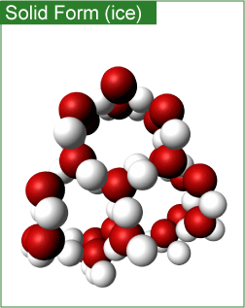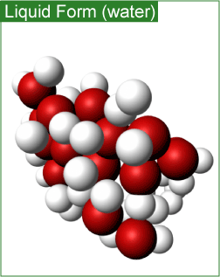

Slide 7

Surface Properties of Water
High surface tension and high capillarity of water is also due to the presence of hydrogen bonds. Water is the liquid with the highest surface tension. Plant debris rests (rather than sinks) on the surface of water bodies due to its high surface tension. This provides the aquatic life the needed shelter and nutrients. Capillary action (due to high surface tension) makes water in soil available to plants.

Lesson 4.1 - Study Materials

Slide 1

Lesson 4.1: Soaps and Detergents
Soaps and detergents play a very important role in our lives. These chemicals help us in making our surroundings cleaner (i.e., by removing soils and grease), healthier (i.e., by reducing the germs), and pleasant.
In order to make it more effective in the process of cleaning, the water must be made to spread and thus wet surfaces effectively, i.e., its surface tension must be reduced. This is achieved by using compounds called surfactants.

Slide 2

Surfactants
- Soaps and detergents are composed of surfactants;
- Surfactants are water-soluble and surface-active agents;
- Surfactants are composed of a hydrophilic (water-soluble) head and a hydrophobic (fat-soluble, water-hating) tail. The hydrophilic end is stable when solubilized in water and the hydrophobic end consists of a long chain hydrocarbon that is more stable when surrounded by other organic groups.

Slide 3

Surfactants (cont'd)
- There are different classes of surfactants categorized by the charge of the hydrophilic component of the surfactant molecule after dissociation in water:
  - Anionic surfactants have a negative charge;
  - Cationic surfactants have a positive charge;
  - Non-ionic surfactants have no charge;
  - Amphoteric surfactants have both positive and negative charges.

Slide 4

Composition and Limitations
Soaps (anionic surfactants) consist of the long hydrocarbon tails of fatty acids and the polar heads of sodium or potassium salts of fatty acids (found in fats and oils of animals and plants).
Traditionally, soap was made from animal fat and wood ash (composed of potassium hydroxide and potassium carbonate).
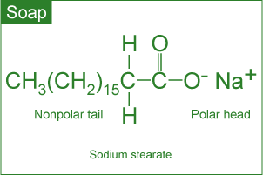

Slide 5

Composition and Limitations (cont'd)
Certain disadvantages of soap as a cleaning agent are:
- Formation of soap film (or scum) in water containing Ca²⁺ and Mg²⁺ ions (hard water). The calcium and magnesium ions react with soap molecules to produce calcium and magnesium salts of fatty acids. These salts are insoluble in water and impair the surfactant properties of soap because the amount of soap available for cleaning is reduced. Soap scum is difficult to rinse away and can be visible, i.e., on fabrics, bathtubs and sinks;
- Poor adaptability to diversity of fibers, washing temperatures and water conditions.

Slide 6

Composition and Limitations (cont'd)
Detergents (containing a variety of engineered anionic or nonionic surfactants) were developed to perform well under diverse conditions and almost eliminate the film formation. Detergents are synthetic surfactants.
They are made from petrochemicals. The main advantage to using detergents is that they are less affected by calcium and magnesium ions in water, thus acting as better cleaning agents.
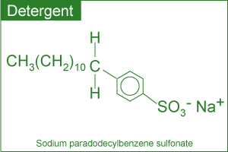

Slide 7

The Cleaning Process
In the cleaning process, the polar end of the surfactant molecule interacts with water (a polar molecule) and the non-polar end is attracted to oil or grease (non-polar molecules).
The cleaning process can be visualized as a combination of:
- Chemical Interaction (with soap or detergent) traps the oily and greasy soil molecules. In aqueous solution, surfactants cluster near the surface.
The hydrophobic tails are attracted to grease and the hydrophilic heads to the water, thereby forcing the grease away from the soiled surface. The grease is then surrounded by the individual surfactant molecules and removed from the soiled surface.
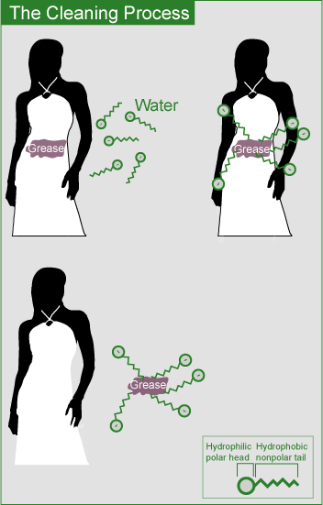

Slide 8

The Cleaning Process (cont'd)
- Thermal Interaction (with hot water) helps dissolve oil and grease molecules.
- Mechanical Interaction (machine agitation or hand rubbing) releases oily and greasy soil from the fabric.

Slide 9

Functional Classification
Depending upon the function, household soaps and detergents can be classified as those used for:
- Personal hygiene
- Laundry
- Dishwashing
- Household cleaning
It is important to note that in view of the functional diversity, these products are usually formulated by mixing many ingredients. For more information on this topic, please visit the Soap and Detergent Association's website.

Slide 10

Safety and Environmental Impact
As cleaning products are an integral part of our lives, it is very important to be aware of their impact on our health as well as the impact on the environment once discharged.
Health risks are very real, particularly in the case of some specialty household cleaners. Drain openers, oven cleaners and toilet bowl cleaners may contain reactive and/or corrosive chemicals. It is imperative that adequate safety precautions are taken while using such products.
The manufacturers are obliged by law to evaluate the environmental safety of the ingredients. Most of these products are formulated to work with water and end up in wastewater treatment plants, thus impact on the environment is minimized.
In an effort to handle these products in an environmentally wise way, we as consumers should buy them in usable amounts and dispose of them (if required) properly.

Slide 11

Recent Trends
In keeping with consumer demand for more efficient and environmentally friendly products, the present trend is to develop home and fabric care products that:
- Contain surface protectors or modifiers that repel soil and stains more effectively.
- Deliver active ingredients in a controlled way.
- Are effective in cold water.
- Contain natural or naturally derived ingredient(s).
- Do not contain chemicals of concern with respect to toxicity.
- Generate less carbon dioxide during production (smaller environmental footprint).

Lesson 4.2 - Study Materials

Slide 1

Lesson 4.2: Personal Care Products
Nearly all of us use personal care products for one or more reasons: to make our hair clean and colorful, skin free of wrinkles or to delight the senses. This is an expanding and dynamic field primarily because such products must be developed to take care of the changing needs of society. Some influencing factors include:
- Aging population
- Changing attitudes of men
- More women in the workplace
- Concerns about exposure to ultraviolet radiation
The chemical ingredients in these products are thus changing at a remarkably fast pace. The availability of biotech products and processes to produce new ingredients is going to revolutionize the development of personal care products in the future.
In addition to rapidly changing chemical ingredients, more efficient delivery systems are being introduced. These include a variety of encapsulation systems to deliver the active ingredients in cosmetics. Many shampoos, lipsticks, face creams and toothpastes contain these microcapsules. The active ingredient is delivered when the microcapsules rupture on the applied surface (e.g., skin) due to rubbing, presence of moisture, change in pH or the presence of naturally occurring bacteria.

Slide 2

Hair Care Products
These products are used for a variety of purposes such as to wash, condition, color or curl hair. Thus the products used include: shampoos, conditioners, styling agents and colorants.
Shampoos are cleansing agents containing anionic surfactants to remove oil and dirt from the hair and scalp. Surfactants produce foam, lifting the oil and dirt from the hair. In addition, fragrances, thickeners, foam boosters and other agents may also be added.
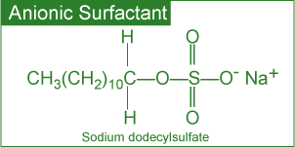

Slide 3

Hair Care Products (cont'd)
Conditioners usually contain cationic surfactants. These help in rinsing out any residual shampoo and at the same time provide softer and easy-to-manage hair.
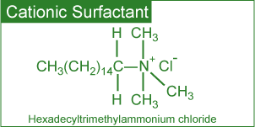

Slide 4

Hair Care Products (cont'd)
The curling of hair is carried out in three steps:
- Treatment of hair with a reducing agent (an electron donor) that breaks certain covalent bonds;
- Setting hair in the desired shape;
- Treating hair with an oxidizing agent (an electron acceptor) such as dilute solution of hydrogen peroxide to reform the previously broken covalent bonds in the new shape.
Hair coloring is a two-step process involving:
- Oxidation of natural hair pigments to colorless products using a bleaching agent;
- Application of an organic, synthetic dye to obtain the desired color.
In addition to the dye (or its precursor), the formulations contain ammonia, hydrogen peroxide and a surfactant. In order to reduce the damage to hair during the coloring process and reduce the smell of ammonia, the chemistry has been modified by replacing ammonia with ammonium carbonate.
Major developments in the field of hair coloring include the availability of:
- A large variety of colors.
- Improved delivery systems to enhance the adhesion of colors to the hair.
- More effective conditioners to neutralize the harsh effects of dye chemicals.

Slide 5

Skin Care Products
Functionally, skin care products can be classified as:
- Moisturizers
- Sunscreens
Various creams and lotions are used to maintain the moisture content of skin. Some of the chemical ingredients present in skin creams and lotions include:
- Various oils and waxes
- Emulsifiers
- Surfactants
- Perfumes
Skin care products (creams, lotions, shampoos and sun care products) containing plant-derived chemicals are being developed at a very fast rate.

Slide 6

Skin Care Products (cont'd)
Sunscreen (or sunblock) products are used to protect the skin against the harmful effects of ultraviolet (UV) radiation. It is believed that exposure to UV radiation can cause painful sunburn, damage the skin, and lead to skin cancer.
Sunscreen products (sold as lotions, ointments, creams and gels) are formulated with additional chemical ingredients that absorb UV radiation.
Two types of active ingredients commonly used can be classified as:
- Inorganic: Approved for use are titanium dioxide and zinc oxide. These work primarily by reflecting and scattering UV light.
- Organic: Wide varieties are approved for use. These work primarily by absorbing UV light and dissipating it as heat.
The effectiveness of a sunscreen in a formulation is rated by its ability to block the UV-B rays that cause skin burns. It is called Sun Protection Factor (SPF). The higher the SPF, the better is the protection against UV-B rays. In order to achieve a high SPF, formulations generally contain a combination of inorganic and organic ingredients.
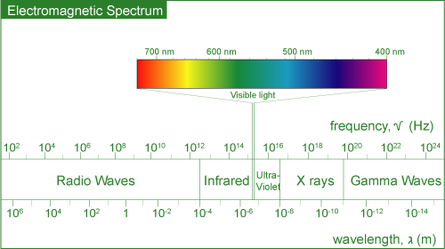
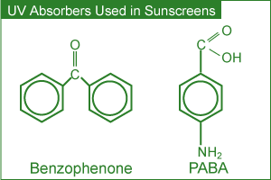

Slide 7

Cosmeceuticals
Whereas pharmaceuticals are defined as products that may affect the structure or any function of the body, cosmetics are something superficial to cover a deficiency or defect.
The term cosmeceuticals is used to describe cosmetics containing ingredients which may affect the structure or any function of the body like pharmaceutical ingredients.
During the late 1980s, alpha hydroxy acids (AHAs) became important ingredients in many cosmetic formulations claiming to reduce signs of aging, sun-damaged skin and wrinkles. These work by breaking down and lifting off part of the top layer of dead skin cells in order to get rid of some surface damage and accelerate growth of living cells. The cosmetic industry believed the ingredients to be more than simple cosmetics and hence were called cosmeceuticals.
Some of these products are only available with a doctor's prescription and supervision. They include, among others, Botox (for a more youthful look), Vaniqa (to eliminate unwanted facial hair) and Propecia (for bald men).

Slide 8

Perfumes
Perfumes are alcoholic solutions of organic compounds with pleasant odors (fragrant compounds). Today, a large variety of natural and synthetic compounds are available to create fragrances for perfumes. In creating perfumes, the ingredients are blended based on their molecular size and volatility. For this reason, the fragrances in perfumes are generally experienced in three different stages (notes).
A recent trend has been to develop more intense and long-lasting alternatives to the known fragrant compounds. Such low-volume production means less impact on energy, health and the environment.
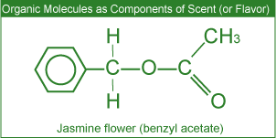
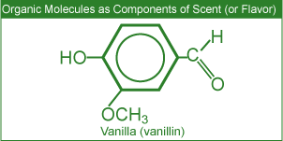

Slide 9

Miscellaneous Products
Body odors are reduced or masked by the use of deodorants. Such odors may originate from the conversion of certain compounds (present in the perspiration) to unpleasant odors by bacteria. Thus the effective chemical ingredients in such products are antibacterial agents and perfumes.
Facial cosmetics such as lipstick and mascara generally contain oils, waxes, pigments and perfumes.

Lesson 5.1 - Study Materials

Slide 1

Lesson 5.1: Introduction to Organic Chemistry
From the Sumerians (2200 BC) to the present, the discovery and usage of drugs has gone through a number of phases such as:
- Medicinal preparations and concoctions from plants, minerals and animal sources;
- Isolation and the use of plant ingredients as medications;
- Synthesis and testing of a variety of chemicals as potential cures for ailments;
- New areas of research into marine plants and organisms as potential drugs;
- Molecular modeling in designing drugs.
Extensive research with the available sophistication in the field of medicine has led us to engineer molecules that can be used to improve the quality of life by preventing, moderating or curing illnesses.

Slide 2

The Element Carbon
As the element carbon is present in the majority of drugs used today, some basic principles of organic chemistry (the study of carbon compounds) are discussed. The main characteristics of carbon that lead to the formation of such a large number of organic compounds (over 10 million known) with dramatically different physical and chemical properties include the ability to form:
- Covalent single, double and triple bonds with some other elements, including carbon;
- Covalent bonds with other carbon atoms to build chains and cyclic structures;
- Covalent bonds with elements such as hydrogen, nitrogen, oxygen and halogens.
In the structures shown below, each line (bond) represents a pair of electrons:
- Single bond: formed by the sharing of one pair of electrons.
- Double bond: formed by the sharing of two pairs of electrons.
- Triple bond: formed by the sharing of three pairs of electrons.
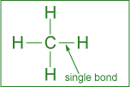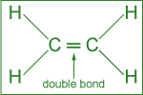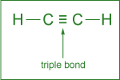

Slide 3

The Element Carbon (cont'd)
Among the cyclic structures, the arrangement of carbon atoms in 5- or 6-membered rings is quite common. The hexagonal (6-membered) ring with three single and three double bonds is called a benzene ring.
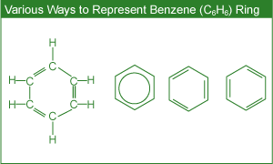
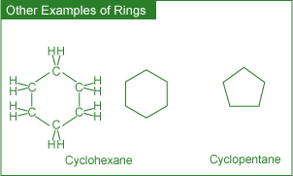

Slide 4

Functional Groups
Organic compounds are divided into some important families based on their characteristic functional group. A functional group can be visualized as a small structural unit or arrangement of atoms in a molecule that is the chemically functioning part of the molecule.
In the case of drugs, the functional group(s) are responsible for their action. In addition, the functional group(s) may also determine important parameters such as the rate of uptake and reaction as well as the time of residence of the drug in the body.
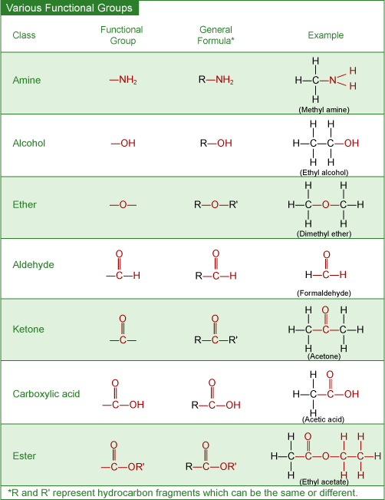

Slide 1

Lesson 5.2: Treatment of Infections and Diseases
Antibiotics
Antibiotic drugs are used to fight (prevention or treatment) bacteria that cause infectious diseases such as meningitis, pneumonia, tuberculosis, and so on.
Several different categories of antibiotics include:
- Penicillins
- Cephalosporins
- Tetracyclines
The discovery of a large number of chemically modified derivatives of these antibiotics led to the control of a large variety of bacterial infections.
Antibiotics are isolated from bacterial sources, but can also be human-made. Antibiotics act directly on bacteria and destroy them or inhibit their growth. Antibiotics will not kill viruses.

Slide 2

Antibiotics (cont'd)
The actual mechanism of antibacterial drugs is to alter or inhibit one of the following cellular structures/processes:
- Cell wall synthesis - prevents new bacterial cells from forming by preventing formation of the cell wall;
- Cell membrane permeability - kills bacteria cells by causing breakdown of the outer cell membrane;
- Protein synthesis- prevents the bacteria from converting proteins to energy, causing starvation and ultimate cell death;
- Nucleic acid synthesis - keeps bacteria cells from growing by interrupting DNA synthesis;
- Competitive inhibitor - mimics bacteria's growth factors, thus preventing spreading of the bacteria.

Slide 3

Antibiotics (cont'd)
Penicillins
- Treat infections caused by bacteria;
- Do not fight infections caused by viruses;
- Mode of action: affect the development (damagin) of bacterial cell walls.
Cephalosporins
- Cephalosporins have the structure similar to that of penicillins;
- Treat a much broader range of infections compared to penicillins;
- Mode of action: affect the development of bacterial cell walls.
Tetracyclines
- Chemical structure consisting of four rings;
- Used to treat penicillin-resistant infections;
- Mode of action: inhibit the synthesis of required bacterial proteins.

Slide 4

Antibiotics (cont'd)
The emerging concern in the use of antibiotics is the resistance many of the so-called superbugs have shown towards the known antibiotics. The suggested ways to decrease antibiotic resistance include:
- More cautious use of antibiotics
- Monitoring outbreaks of antibiotic resistances
- Developing new antibiotics
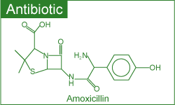

Slide 5

Antiviral Drugs
Antiviral drugs are used to treat (cure or control) viral infections such as flu, polio, herpes and AIDS (Acquired Immune Deficiency Syndrome).
A different strategy has to be used to combat viruses, as these do not respond to antibiotics. Two commonly used strategies to fight viral infections include:
- Prevention through vaccination
- Use of antiviral drugs

Slide 6

Antiviral Drugs (cont'd)
When a vaccine (consisting of inactivated virus) is injected, antibodies to fight off a virus are developed and stored in the body. The stored antibodies become available to fight future infection.
Commonly used antiviral drugs (particularly for the treatment of the AIDS virus) fall into three classes:
- Nucleoside derivatives
- Protease inhibitors
- Combination cocktails

Slide 7

Antiviral Drugs (cont'd)
Nucleoside derivatives inhibit the synthesis of viral DNA, thus preventing the virus from spreading.
Protease inhibitors, on the other hand, interfere with the viral protein formation, thus preventing their reproduction.
A three-drug cocktail consisting of different nucleoside derivatives and protease inhibitors has shown considerable promise in the treatment of AIDS. This triple cocktail treatment is also known as highly active antiretroviral therapy (HAART). The success of the therapy is probably due to the cocktail's ability to disrupt the viral replication at different stages. It is important to note that the therapy is very expensive and patients must adhere to their dosing schedule.
Some major problems associated with multiple drug therapy are:
- Moderate effectiveness
- Lack of response in some cases
- Serious to severe side effects
- Drug resistance by the virus
Recent efforts in the fight against AIDS have been directed towards the development of:
- Viral entry inhibitors ( i.e., the drugs that prevent HIV from attaching to and consequently entering the cell)
- Vaccines
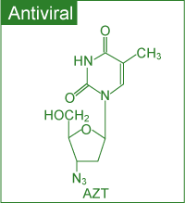

Slide 8

Anticancer Drugs
Cancer involves an uncontrolled division of some cells of the body due to mutation of DNA within the healthy cells. These cells invade nearby tissue and spread throughout the body via the bloodstream or lymphatic system. Thus the chemical treatment of cancer (chemotherapy) involves drugs targeting rapidly dividing cells to kill the cancerous cells. Some chemotherapeutic agents include:
- Alkylating agents
- Antimetabolites
- Topoisomerase inhibitors
- Hormones
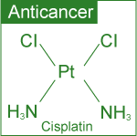

Slide 9

Anticancer Drugs (cont'd)
Alkylating Agents
- Mode of action: due to their high reactivity, alkylating agents introduce defects in the DNA, thus killing the rapidly growing cells by preventing cell growth and multiplication.
- Alkylating agent drugs also affect the growth of normal cells and cause mutations.
Antimetabolites
- Metabolite is a general term for the organic compounds that are synthesized, recycled, or broken down in cells.
- Antimetabolites inhibit DNA synthesis, thus stopping cell replication.
- Mode of action: compete for binding sites on enzymes and are incorporated into nucleic acids.
Topoisomerase Inhibitors
- Topoisomerase inhibitors damage DNA which causes cell death.
- Mode of action: act against the topoisomerase enzymes to prevent cancer cell growth.

Slide 10

Anticancer Drugs (cont'd)
Hormone therapy
- Hormone therapy is used against certain cancers that depend on hormones for their growth. Hormone treatment is used primarily for the treatment of breast cancer and that of the sexual organs. As these tissues require hormones for their growth, the chemotherapeutic agent acts by inhibiting the hormone supply thus stopping the tissue growth.
- Mode of action: stop the production of certain hormones or change their mode of function.

Slide 11

Antidepressants
A deficiency of certain neurotransmitters (any chemical that carries impulses between nerve cells), particularly serotonin in the brain, seems to be partly responsible for causing clinical depression. Neurotransmitters are needed for normal brain function and mood control, in addition to other functions.
Although the effects of antidepressants are not fully understood, there is substantial evidence to show that antidepressants help to restore the brain’s chemical balance. Commonly used antidepressants include:
- Selective Serotonin Reuptake Inhibitors (SSRIs) (e.g. Prozac, Paxil and Zoloft)
- Monoamine Oxidase Inhibitors (MAOIs) (e.g. Nardil, Marplan and Parnate)
- Serotonin and Norepinephrine Reuptake Inhibitors (e.g. Effexor)
- Norepinephrine and Dopamine Reuptake Inhibitors (e.g. Welbutrin)
- Tricyclics (e.g. Norpramine, Pamelor and Tofranil)
Whereas SSRIs target the serotonin levels only, tricyclics affect the brain levels of other neurotransmitters (including serotonin) as well.
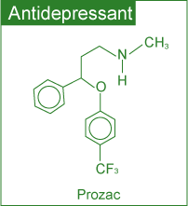

Slide 12

Anti-Inflammatory Drugs
Inflammation is the first response of the immune system to infection or irritation characterized by pain, swelling, redness and heat. An inflammation results from the rapid transport of blood proteins and other substances to a damaged tissue site or an area under attack by a foreign organism.
Certain steroids are used as potent anti-inflammatory drugs. These suppress the inflammatory responses of the body, thus reducing inflammation.
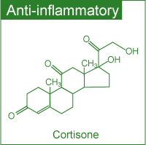

Slide 13

Over The Counter Drugs
Whereas all types of drugs discussed earlier require a prescription, a considerable number of drugs are sold over the counter (OTC) without a prescription.
According to the Non Prescription Drug Manufacturers Association, in the US alone there are more than six hundred OTC drugs. The criteria generally used by the regulatory agencies to designate a drug with OTC status or switch its status from R_{x}-to-OTC (i.e., from a prescription drug to one sold without a prescription) involves a benefit-risk comparison and making sure that patients alone can achieve the desired medical result without endangering their safety.
Although OTC drugs allow patients to participate in their own health care, experts emphasize that the labels must be followed closely because OTC drugs are not without risk.

Slide 14

Over The Counter Drugs (cont'd)
Aspirin
The best known OTC drug, Aspirin, was introduced more than a century ago. It has long been used as an:
- Analgesic (relieving minor pain)
- Antipyretic (lowering fever)
- Anti-inflammatory (reducing swelling) drug
Recent studies have shown its usefulness in treating heart attack and stroke.
It is believed that Aspirin's effectiveness as an analgesic, anti-inflammatory agent and its protective effects against heart attacks and strokes are due to its ability to reduce the production of prostaglandins (a hormone-like substance that promotes inflammation, fever and pain) and thromboxanes (responsible for platelet aggregation in the formation of blood clots) in the body.

Slide 15

Over The Counter Drugs (cont'd)
Aspirin (cont'd)
Some possible side effects of Aspirin include:
- Stomach irritation
- Ringing in the ears
- Allergy
- Reye syndrome (brain disorder) in children
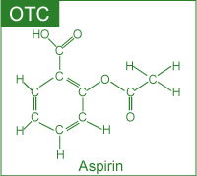

Slide 16

Drug Delivery Systems
Active pharmaceutical ingredient (API) in a medicine is delivered to the body in many forms, such as tablets, gelcaps, liquids and so on. Some newer alternate methods for drug delivery have been developed with three major advantages:
- User convenience
- Improved drug performance
- Better patient compliance
Some of these methods include:
- Pulmonary delivery: The system is noninvasive and facilitates the rapid absorption of the drug on the large surface area of the lungs followed by rapid desorption into the bloodstream.
- Skin absorption: Skin patches are being used to deliver the medication via skin absorption.
- Nanocrystals: This method reduces the drug particle size to nanoscale (<400 nm) making it more soluble in body fluids.

Slide 17

Environmental Effects of Pharmaceuticals
Recent research has led scientists to be concerned about the environmental impact of old and/or expired medications that are discarded. The pharmaceuticals enter the environment mostly through raw or treated sewage. Some of the effects observed include:
- Feminization of male fish due to estrogenic compounds
- Slow development of fish and frogs due to certain antidepressants

Slide 18

Recent Trends
In the field of pharmaceutical development the present trends include:
- A shift from blockbuster drugs (drugs that work for a large number of patients) to personalized medicine. In personalized medicine, therapies are catered towards genetic profiles of patients and their diseased cells.
- Exploring marine organisms in an attempt to obtain new compounds with therapeutic potential.

Slide 19

Conclusion
Drugs should not be considered risk-free chemical substances. It is strongly recommended by health professionals that patients should always bear in mind the fact that medications have side effects and may have serious interactions with other medications, dietary supplements, food and beverages consumed.
In order to reduce risks, it is strongly recommended that all individuals:
- Read drug labels carefully;
- Learn about the warnings of all drugs taken;
- Inform health care providers of all prescription and OTC drugs and dietary supplements taken;
- Keep a record of all medications taken.

Lesson 6.1 - Study Materials

Slide 1

Lesson 6.1: Acid Rain
Human activities producing particulate (i.e., soot and fly ash) and gaseous (CO, CO₂, SO_{x}, NO_{x}, Hydrocarbons, etc.) pollutants alter the atmosphere.
Some of these activities include:
- Generation of industrial emissions;
- Burning of fossil fuels (for power generation and transportation) and vegetation; and
- Agricultural practices.
The end result of these activities has been a deterioration of the environment, leading to several environmental concerns such as:
- Acid rain
- Global warming
- Ozone depletion

Slide 2

Acid Rain (cont'd)
The weakly acidic nature of rain can be explained by its formation of carbonic acid:
CO₂ (g) + H₂O (ℓ) → H₂CO₃ (aq)
which dissociates partially, generating only small amounts of hydrogen ions:
H₂CO₃ (aq) → H⁺ (aq) + HCO₃⁻ (aq)

Slide 3

pH Scale
The acidity (a measure of hydrogen ion concentration) of a solution is conveniently described in terms of pH scale. According to this scale, if:
pH < 7: solution is acidic  pH > 7: solution is basic  pH = 7: solution is neutral | 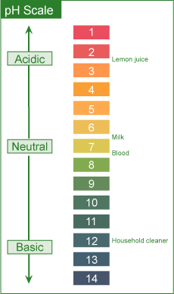

Slide 4

Virtual Laboratory

Slide 5

Origin
Based on the concentration of carbonic acid and small amounts of other natural acids, the estimated pH of rain (as well as fog, dew and snow) under normal atmospheric conditions should be around 5.3.
Field measurements in many areas, on the other hand, show much lower pH values (4.1- 4.5).
Higher acidity (lower pH) is due to the reactions of NO_{x} and SO_{x} present in the atmosphere.
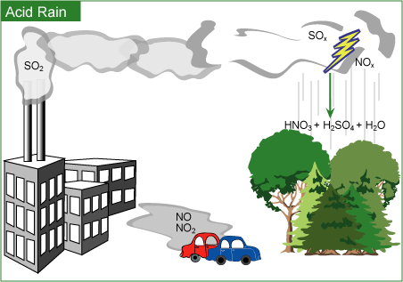

Slide 6

Origin (cont'd)
Various reactions of these oxides lead to the formation of acids. The dissociation of formed acids generates hydrogen ions and hence higher acidity (or lower pH).
2 SO₂ (g) + O₂ (g) + 2 H₂O (ℓ) → 2 H₂SO₄ (aq)
H₂SO₄ (aq) → H⁺ (aq) + HSO₄⁻ (aq)
HSO₄⁻ (aq) → H⁺ (aq) + SO₄²⁻ (aq)
4 NO₂ (g) + O₂ (g) + 2 H₂O (ℓ) → 4 HNO₃ (aq)
HNO₃ (aq) → H⁺ (aq) + NO₃⁻ (aq)

Slide 7

Effects
Material Damage
Marble and limestone (CaCO₃) used in many historic and irreplaceable statues and buildings react with acid in the rain.
CaCO₃ (s) + 2 H⁺ (aq) → Ca²⁺ (aq) + CO₂ (g) + H₂O (ℓ)

Corrosion of Metals
The corrosion process is accelerated in the presence of acid. Thus, iron structures, bridges, railroads, etc. show a faster rate of corrosion (rusting) in acid rain predominant areas.
4 Fe (s) + 3 O₂ (g) → 2 Fe₂O₃ (s)
Studies indicate that even painted or plated iron corrodes more rapidly in such areas.

Slide 8

Effects (cont'd)
Forest damage
Considerable damage to trees has been reported in various parts of North America and Europe.
Acid rain is implicated in depleting the nutrient supply to the trees by:
- Attacking the leaves whose protective coating has already been destroyed due to attack by other atmospheric pollutants such as O₃ and NO_{x};
- Mobilizing various metals (Al, Pb, etc.) in the soil that attack the roots.
Inadequate nutrient supply increases the possibility of destruction due to disease, drought, insects or high winds.

Aquatic life
Aquatic life is quite susceptible to changes in pH. Reduced pH has led to lakes with no fish or other living beings.
Adverse effects of acid rain on aquatic life are due to:
- Lowering of pH well below the required value of about 6.5 for healthy aquatic life;
- Increasing aqueous concentration of metals (Al, Pb, etc.) due to their higher solubility at lowered pH.

Slide 9

Suggested Control Strategies
- Reduction of SO_{x} and NO_{x} emissions by using emission control technologies;
- Using cleaner energy sources (such as alcohol and hydrogen) in transportation;
- Developing and/or using alternate energy (i.e., hydroelectric, nuclear or wind) sources.

Lesson 6.2 - Study Materials

Slide 1

Lesson 6.2: Global Warming
Origin
Global warming refers to an increase in the Earth’s average temperature.
Global warming is the result of increased absorption by the atmosphere of infrared (IR), a major source of heat, radiated back from Earth's surface. This is due to an increase in concentration of gases that trap heat in the atmosphere. These gases are often called greenhouse gases. The principal greenhouse gases that enter the atmosphere due to human activities include:
- Carbon dioxide (CO₂): It enters the atmosphere due to the burning of fossil fuels (oil, natural gas, and coal), waste materials, and as a result of other chemical reactions.
- Methane (CH₄): Main sources of emission are the production and transport of fossil fuels, livestock, agricultural practices and organic waste decay.
- Nitrous oxide (N₂O): It is emitted during agricultural and industrial activities as well as during the combustion of fossil fuels and waste materials.
- Fluorinated gases: These fluorine containing compounds are emitted from a variety of industrial processes and are sometimes called High Global Warming Potential (GWP) gases.
Based on measured concentrations of various greenhouse gases, computer models have been developed to predict the extent of global warming. It is estimated that the temperature of the atmosphere may increase anywhere from 1.5 ºC to 3.5 ºC during the next fifty years.

Slide 2

Effects
Possible effects include:
- Climatic changes;
- Changes in sea level due to melting of polar ice caps;
- Possibility of droughts and increased frequency of heat waves due to warming;
- Unforeseen problems in relation to vegetation, pests and other insects;
- Greater possibility of heat-related illnesses and deaths.

Slide 3

Suggested Control Strategies
- Reduction in CO₂ emissions;
- Development and use of alternate non-fossil energy sources such as hydroelectric, solar, nuclear, and wind;
- Energy conservation; and
- Replanting of forests, thereby creating a CO₂ sink.

Slide 4

Present Situation
In order to limit global warming (due to the trapping of heat in the atmosphere by greenhouse gases), the Kyoto protocol was signed in 1997. The document calls for industrialized nations to cut their emissions of greenhouse gases.
In 1988, United Nations Environment Program (UNEP) and World Meteorological Organization established Intergovernmental Panel on Climate Change (IPCC) to focus on:
- Assessment of scientific knowledge
- Examination of the environmental, economic and social impacts
- Formulation of response strategies
The final report released in 2007 states that global warming is clearly evident from diverse observations such as:
- Increases in average air and ocean temperatures
- Widespread melting of snow and ice
- Rising global average sea level
The report emphasises that global warming could cause irreversible damage to the planet. It is concluded and strongly suggested by scientists that global, sweeping, concerted action is urgently needed to drastically reduce greenhouse gas emissions.
In addition, a report on the global economic impact of global warming (the Stern Report) suggests that it could shrink the global economy by 20%.

Lesson 6.3 - Study Materials

Slide 1

Lesson 6.3: Ozone Depletion
Ozone plays a double role in our environment:
- In our immediate atmosphere, it acts as an air pollutant contributing to photochemical smog;
- In the stratosphere (in conjunction with oxygen), it filters the solar ultraviolet (UV) radiation, thus protecting us against its harmful effects.
Origin
Exposure to ozone may occur in operations involving:
- High-intensity UV light such as mercury vapor lamps, plasma torches, glass blowing, etc.;
- High-voltage electrical equipment; or
- Welding.
Interaction of high energy with oxygen in the surrounding atmosphere leads to the formation of O₃:
3 O₂ (g) + Energy → 2 O₃ (g)

Slide 2

Origin (cont'd)
In the stratosphere, oxygen and ozone interact with energy from solar radiation to form a dynamic system. This constitutes the O₂/O₃ screen that filters out the UV component of the solar radiation according to the following reactions:
O₂ + Energy ( ≤ 242 nm) → 2 O
O₃ + Energy ( ≤ 320 nm) → O₂ + O
The environmental concern in the case of ozone is its stratospheric depletion, which leads to less efficient filtration of harmful solar UV rays. The depletion is caused by both natural (water vapor, nitric oxide) as well as human-made (chlorofluorocarbons, halons) sources.
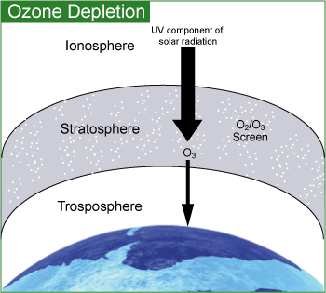
These ozone depleting substances (ODSs) destroy the stratospheric ozone layer. Chloroflurocarbons (CFCs) and halons have been used as:
- Foam-blowing agents
- Solvents
- Fire-extinguishing agents
- Refrigerants

Slide 3

Effects
Stratospheric ozone depletion, leading to less efficient filtration of the ultraviolet radiation from the sun, will increase the intensity of ground-level UV radiation. This increased intensity may have adverse effects on:
- Humans (such as higher probability of skin cancer and cataracts)
- Plants (physiological and developmental processes of plants may be affected)
- Marine ecosystems (may lead to decreased reproductive capacity)
- Materials (may accelerate the breakdown of polymers and biopolymers)

Slide 4

Control Strategy
In North America, the use of chlorofluorocarbons (as propellants in spray cans) was banned in 1978 in response to the threat of ozone depletion.
The global response to the threat of ozone depletion came with the signing of the Montreal Protocol (in 1987). It set out to reduce and ultimately ban the manufacture and use of CFCs.

