Modul 9 – Lecture 2
Fission yeast – S. pombe
- Naturally elongated-rod shaped cells
Mutation in cell cycle regulators
- Elongated cell = arrested in G2 + continues to grow instead of enter mitosis
Recessive + loss of function mutation inhibiting cell division0000
- Wee cell = Premature entry into mitosis – resulting cells = smaller
Dominant + gain of function mutation increasing cell division
G2 ends early, premature entry into mitosis = decreases amount of time for cell division = increases efficiency + speed of CD
Module 10 – Lecture 2
All cdk 2, 4, 6 are inactive
G0 – G1
Mitogens = extracellular growth factors that induce the G1-cyclinD-cdk 4, 6 to
After the Addition of mitogens
- Early gene expression begins
  - Regulated by already present factors that need to phosphorylated to be activated – b/c they are already present in G0 cell = the expression of early response mRNAs is not affected by inhibitors of protein synthesis
  - SRF + TCF factors = phosphorylation in/directly by MAP kinase (last part of the RTK signal transduction pathway) and turn on early response gene expression
  - SRF = serum response factor
  - TCF = Ternary complex dactors
- Peaks about an hour after activation
  - After the transcription + translation + protein modification + folding of the Early genes (rapid responses to growth factors):
  - Transcription factors c-Fos + c-Jun activate transcription of delayed response genes – and in turn induces the expression of the Cyclin/Cdks required for cell division
- Delayed response gene expression
  - Transcription factors: E2F
  - The genes now encode the Cyclins D, E and Cdk 2, 4, 6
  - Order of expression: Cdk 4, 6 (D type cyclins) – cyclin E and Cdk 2
  - Expression of some of these genes (Cyclin D/Cdk complex must be maintained until the cell passes through the restriction point
Restriction point = regulatory check point – passage through the cell becomes independent of the presence of mitogens
- E2F = inactivated b/c E2F + inhibitory retinoblastoma protein Rb = no cell cycle progression
- Cyclin D/Cdk kinase phosphorylates Rb which releases E2F = now active
- Active E2F = inducing expression of Cyclin E/ Cdk 2 which also phosphorylates Rb
- When enough E2F is present, it is constantly inducing Cyclin E/ Cdk2 and also self-replicating E2F = “Positive feed back loop” which is correlated with:
- Passage through the restriction point = end of the Cyclin D/ Cdk 4, 6 activity = beginning of cyclin E/ Cdk 2 expression
Cell cycle check points through out
DNA Damage
- Ionizing radiation = ds-DNA breaks = ATM pathway
  - ATM kinase activated when bound to ds-DNA breaks in DNA molecule
  - Target: Chk2 – phosphorylated = active
  - Chk2 target: p53 = unstable protein; ubiquinylated + degraded
  - Chk2 phosphorylates p53 – p53 = stable transcription factor = activates transcription of many target genes
  - P53 target: p21 – general Cyclin/ Cdk inhibitor binds to G1 Cyclin D/ Cdk 4, 6 and inhibits activity = stalls in G1
  - Delay = time to repair damage = once damage is repaired = ATP inactivates + dissociates from DNA = progression through check point
  - If cell damage is not repaired = perpetual activation of p53 to try to stall again and again = eventually induce expression of pro-apoptotic genes to cause cell death
- UV radiation = thymine dimers = ATR pathway
  - ATR = kinase activated when bound to thymine dimers
  - Target: Chk1 – when active phosphorylated Chk1 protein = kinase
  - Chk1 target = Cdc 25 = regulator of CDK activity = a protein that regulate MPF activity at the G2 – M-phase transition. Cdc25 phosphatase reverse inhibitory phosphorylation at Tyr 15 on Cdc2 of MPF = active MPF = Prophase can begin!
  - When Chk1 phosphorylates Cdc25 – Cdc25 = inactive = MPF inactive = Cell arrest in G2 – delay
  - Once damage is repaired, ATR inactivates + dissociates from DNA = reverses pathway = progression through Check point
DNA Replication checkpoint – Also ATR pathway
- Incomplete replication forks look like damaged DNA + bound by ATR protein = activation of ATR pathway = inactivation of MPF = delays M-phase entry until replication is complete

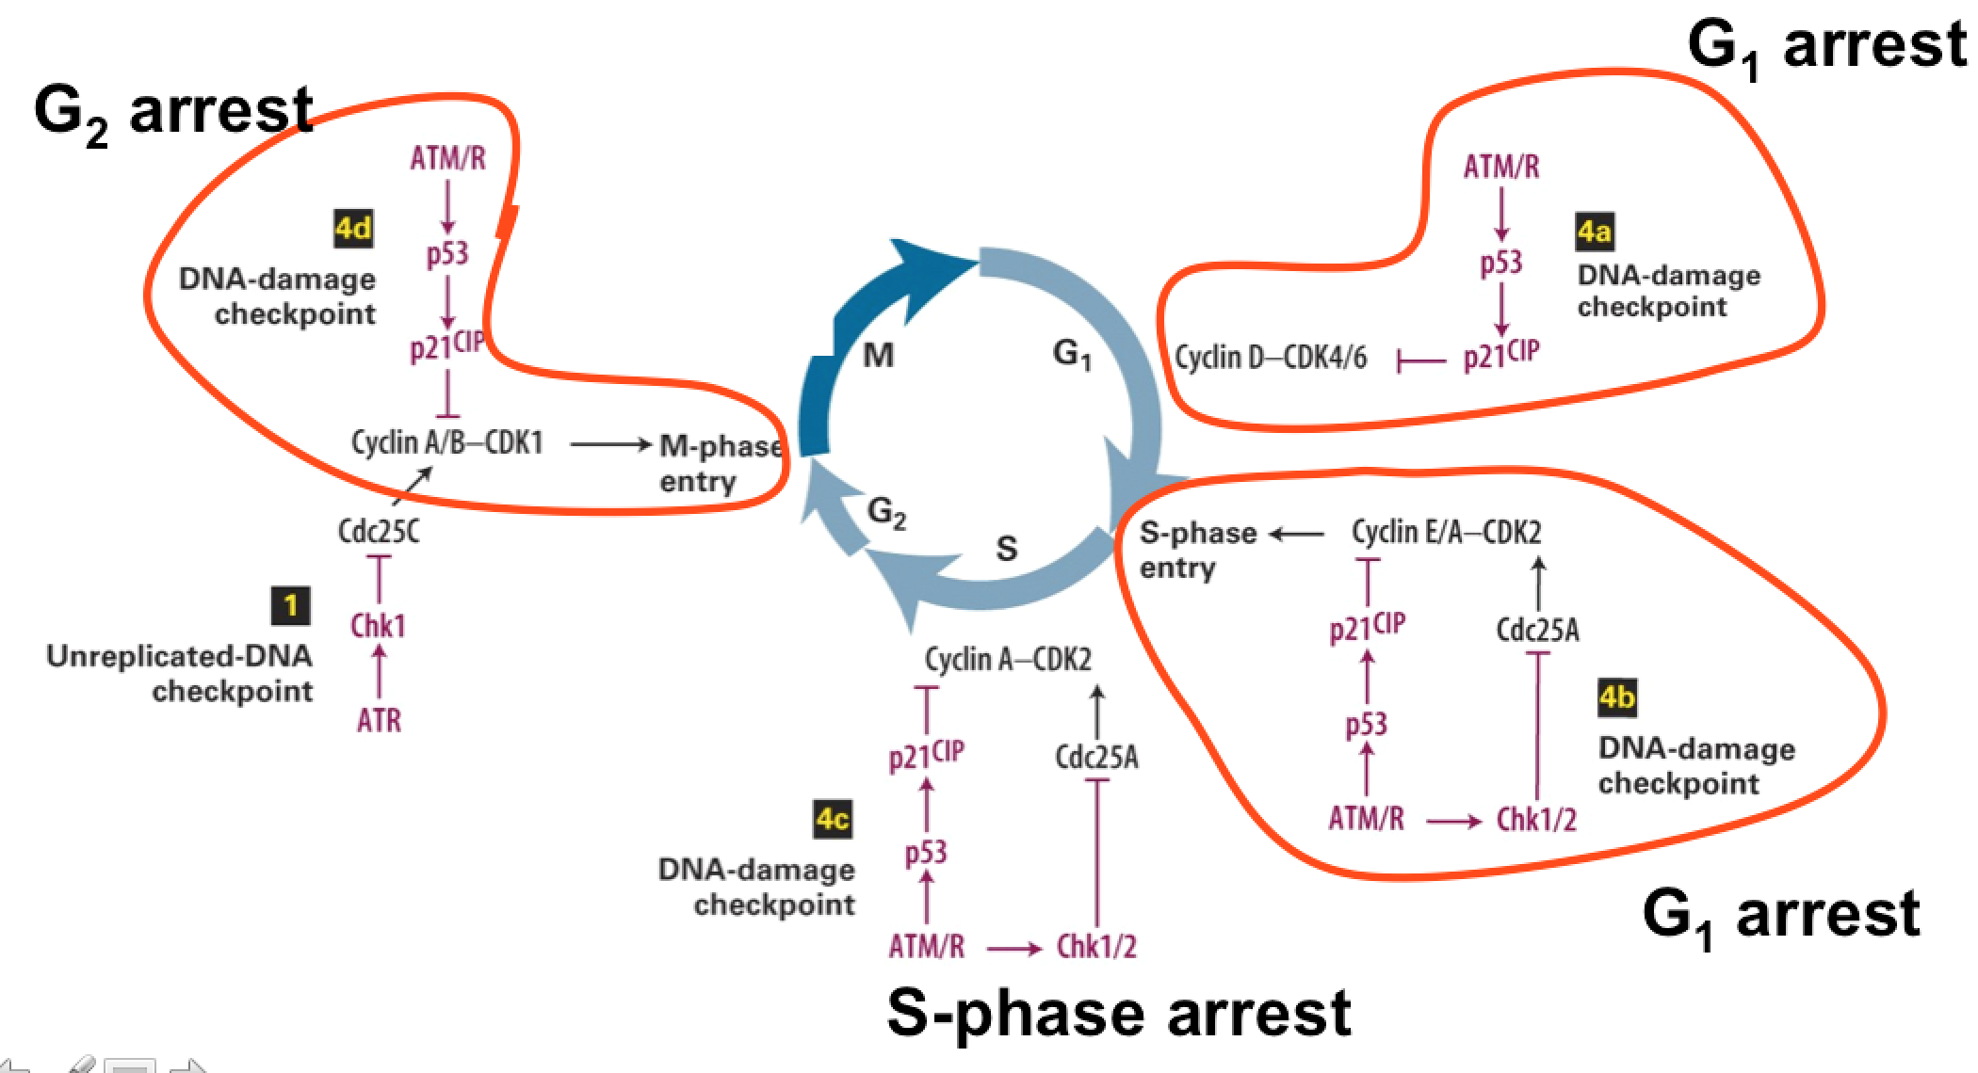
Spindle Assembly Checkpoint
- Transition from metaphase to anaphase – prevents entry into anaphase prior to the proper association of the kinetochore proteins of the chromosome to the microtubules of the mitotic spindle
- Mad2 = key regulator of SAC = inactivated APC-Cdc20 = securin protein remains intact + prevention of separase activation = no sister chromatid separation
- Mad2 = 2 conformations
  - Open – newly synthesized Mad2
    - Associates w/ kinetochores of the chromosome that are not attached to the microtubules
    - Mad1 also associated w/ unattached chromosomes
    - Mad2 + Mad1 = Closed conformation
  - Closed – Mad2 leaves the chromosome
    - Interacts directly with Cdc20
    - cMad2 + Cdc20 = Cdc20 cannot associate with Anaphase Promoting Factor (APF)
    - APF = inactive = cell remains in metaphase = Activated check point
- As long as at least one kinetochore is not attached to the mitotic spindle, Mad2 is converted quickly into close conformation + Cdc20 = inactive APC = prevents anaphase = SAC checkpoint is active
- Once every replicated chromosome achieves bipolar attachment to mitotic spindle + both kinetochores are attached to microtubules, Mad1 and Mad2 proteins are released from kinetochore
  - P31 + cMad2 = sequester complex away from chromosome + promotes conversion from close conformation to open
- = checkpoint inactivation = Cdc20 + APC – targets securin for degradation + activation of seperase that initiates sister-chromatid separation = anaphase
- Malfunction in SAC = cell goes from metaphase to anaphase with the sister chromatid separation of unattached chromosome occurring = splits the 2 constituent sister chromatids but because they are not attached to the spindle, the chromatids are not segregated to the opposite poles = non disjunction + aneuploidy where one cell may have an extra chromosome or more
- Loss of function in Mad2 causes cell to proceed prematurely into anaphase
Chromosome Segregation checkpoint = Mitotic Exit Network (MEN)
- Series of events must occur for the exit form mitosis:
  - Reassembly of nuclear envelop + chromosome de-condensation
  - Reassembly of mitochondrial + Golgi + ER networks
  - Disassembly of mitotic spindle
- All of the events require inactivation of MPF
Using budding yeast model system:
- Cdc14 is inactive b/c it cannot reach its target substrates within the nucleolus (during Interphase + early mitosis)
- Once anaphase occurs, Cdc 14 is released + activated
- Active Cdc14 = phosphatase activity and dephosphorylates Cdh1 = active Cdh1 which binds to APC
- APC-Cdh1 targets Cyclin B for degradation = inactivation of MPF
Inhibition of S phase by Cdc14
- Another target of Cdc14 phosphatase = un-phosphorylated Sic1 – binds to the S-phase Cyclin/Cdk and inhibits progression into S-phase
- Phosphorylation of Cdc14 by G1 Cyclin/Cdk inactivates Cdc14 = allows phosphorylation of Sic1 = target of SCF E3 ubiquitin ligase
- Degradation of Sic1 frees S-phase Cyclin/Cdk + allows entry into the cell cycle

Module 11: Cellular Mechanisms of Apoptosis
2 ways of cell death:
- Necrosis
- Damage, some agent might damage the cell exterior and the cell will undergo necrosis
- Cells swell + release contents into surrounding tissues – leads to infection
- Apoptosis / programmed cell death
- Regulated process – disposal of cellular debris that does not damage the surrounding cells
- Cells commit suicide either in response to stress or damage, or as a part of normal development
- The debris is contained + recycled
Apoptotic pathways
- Killing the cell – execution
- Chromatin is compacting + condensing
- Nucleus envelope and its contents are being broken down + DNA and proteins are degrading
- Cytoplasm also undergoes a process of condensation as cellular components aggregate
- Mitochondria becomes permeable + mitochondrial proteins are released into the cytosol
- Cell membrane begins to move and change shape, creating the blebs or protrusions
- Cells fragment, creating compartment of the cell that contain the debris of the dead cell
- Each of these little cell fragments will be phagocytized and the components will be recycled and reused
- Getting rid of the body – engulfment
- Phagocytosis
- Destroying the evident – clearance

Model system: Nematode: C.elegans
947 somatic cells have been identified leading back to a single fertilized zygotic cell. 131 cells undergo programmed cell death or apoptosis.
Developed an assay for identifying mutations in genes required for apoptosis, called cell death genes or ceds.
- Mutation in a gene called ced-1- Apoptotic cells are easily identified in SEM imagery = loss of function mutation of the ced-1 gene allows cell to undergo apoptosis, but the cells are not engulfed by phagocytosis.
- A genetic screen was developed to identify mutations in cell death genes that did not create these apoptotic cells, cells that were visible in the ced-1 mutant background
- Mutant ced-3 gene = no apoptotic cells are observed = ced-3 essential for apoptotic pathway, as there is no apoptosis in the absence of a functional ced-3 gene.
Four genes have been identified in this screen that code for proteins that are essential for the process of apoptosis. These genes are ced-3, ced-4, ced-9 and egl-1. Since the identification of these genes in C.elegans, the mammalian homologues have been identified for each of these genes.
Two of the mammalian homologs have been implicated in the formation of human tumors as a result of a failure in the removal of cells through apoptosis.
- Homologs of the EGL-1 ~ Bid and Bim. These are members of the BH3 family of proteins.
- The Bcl-2 ~ CED-9 and is found on the membrane of the mitochondria. Bcl-2 is controlling related proteins called Bak and Bax = acts by altering permeability of the outer mitochondrial membrane
  - Normally Bcl-2 functions to maintain low permeability of the outer mitochondrial membrane
  - Inactivation = leads to formation of pores in the outer membranes = permeabilization associated with apoptosis
- The CED-4 + CED-3 = caspase holoenzyme = protease that will target many different proteins for degradation.
Loss-of-function mutations in ced-3 and ced-4 prevent apoptosis.
In contrast, in a lost-of-function mutation in ced-9, all of the cells die.
- CED-9 = inhibitor of apoptosis that acts by inhibiting the activation of caspase holoenzyme.
- EGL-1 = signal for apoptosis that activates the pathway by inhibiting the inhibitor (CED-9).
The caspase holoenzyme is called the apoptosome in the mammalian cell.
- It contains direct homologues of the C.elegans proteins, Apaf 1 is similar to CED-4 and Caspase-9 is similar to CED-3, as well as additional proteins including inhibitors and effectors.
- In both cases, the protease activity of the caspase holoenzyme or the apoptosome, leads to protein degradation and cell death.
In C.elegans
- CED-9 + CED-4 dimers (keeps them inactive) = inhibits apoptosis
- EGL-1 + CED-9 ----CED-4
- CED-4 + CED-3 = caspase holoenzyme = activation = degradation of cytosolic + nuclear proteins
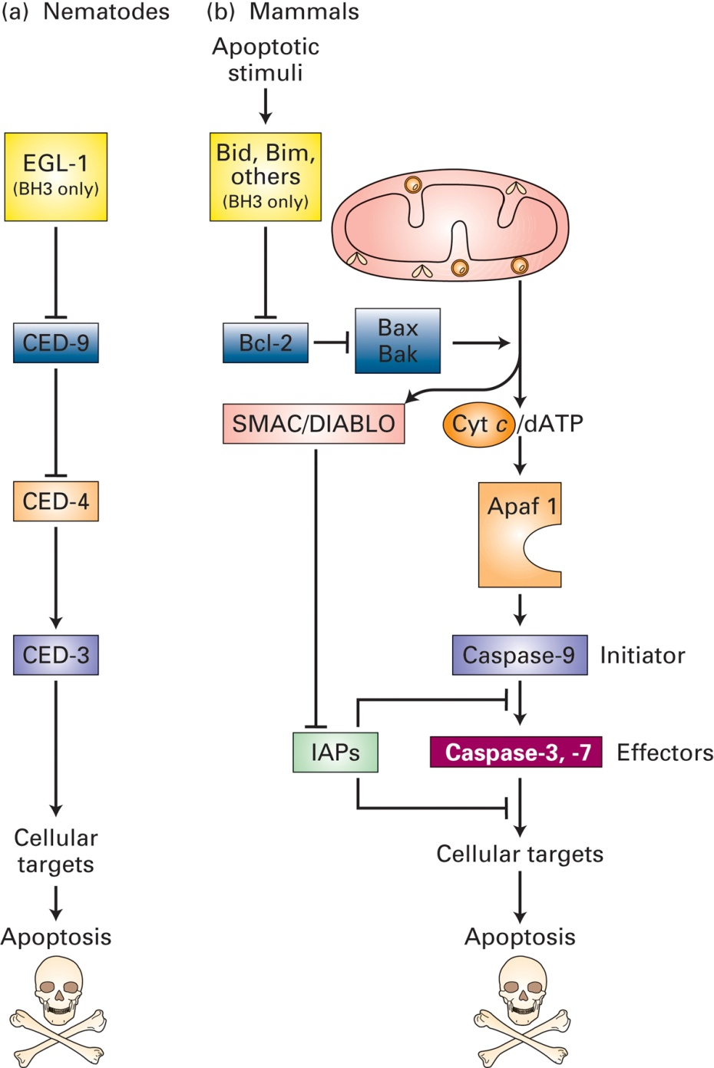

In a healthy cell:
- Outer membrane of the mitochondria carry the Bcl-2 protein (CED-9) = Bcl-2 inhibits apoptosis.
- The apoptotic signal, Bad, is inactive while phosphorylated and bound to the cytosolic adaptor protein, 14-3-3.
- Signaling pathways lead to dephosphorylation of Bad and release from 14-3-3 = Bad to bind to the mitochondrial-associated Bcl-2 protein.
- Another member of the CED-9 family is Bax. Activation of Bcl-2 = activation of Bax via reorganization of Bax in the outer mitochondrial membrane.
- Bax aggregates in clusters in the membrane to create pores = increase membrane permeability + release mitochondrial proteins from the intermembrane space into the cytosol, including a protein called cytochrome C.
- Cytochrome C is essential for the formation of the mammalian apoptosome.
Both intrinsic cell damage, including DNA damage and cellular stress and extrinsic signals, can lead to this apoptotic pathway.
While apoptotic signals promote Bad de-phosphorylation and apoptosis, trophic factor prevent apoptosis and keep the cell alive.
- Trophic factors initiate a kinase cascade that leads to phosphorylation of the Bad protein.
- However, once those trophic factors are removed, the Bad protein can be dephosphorylated and apoptosis can occur.

In Class 8: Anti-adhesion in infectious disease treatment

Stains of Uropathogenic E.Coli (UPEC) = causative agents in a vast majority of UTIS
Treatment? Antibiotics
- Sometimes they clear themselves; otherwise they take antibiotics- recurring infections
Problems?
- Antibiotic resistance – antibiotics being introduced into a system that doesn’t need it – random mutation making it resistant to the bacteria but not to the rest so that one resistant will end up propagating and there will be a complete shift of natural selection
- Perturbance of beneficial gut micro biome – Antibiotics are also non-specific so you're diminishing good bacteria populations as well, effecting subpopulations and over all health
Adhesion is required so that the organisms are not swept away by the natural cleansing mechanisms of the host
- Attachment – adhesion of europathogenic bacteria – flow of urine/air will allow the bacteria to be removed so attachment allows them to survive
- Invasion – may form a film around the cell + beneficial to the bacteria allowing it to progress – providing nutrient – cell damage
- Replication – cell damage
- Exfoliation – as they are replicating + dividing, they will rupture the infected cells and be released to further affect more
- Adhesion
- Allows the pathogen to stay at the site of infection long enough to multiply + cause damage
- Bacterial adhesion: Physicochemical property of fimbriae bacteria (fibria or pilli mediate attachment) to cells + tissue + nonbiological surfaces = factor in bacterial colonization + pathogenicity
- Initial attachment – weak b/w E. coli + host cell – may be specific or non-covalent interactions; as the bacterium are slowed down, they form:
- Intimate attachment
- Colonization + Inflammation – firm attachment + replication = growing in a colony (Accumulation at a site) = pathogenic infection
Type 1 pillus
- Lectins on the E. coli surface recognize oligosaccharide units on the surfaces of target cells. These lectins are located on slender hairlike appendages called fimbriae (pilli).
- Pilli – extend off the cell membrane surface – Fim = proteins involved in the formation of the fibria
- Fim H lectin = cell adhesion molecule that will allow the interaction between the E. Coli and the host cell = lectin so recognizes carbohydrate sugar group: Mannose (ligand of FimH), which means that the glycoproteins on the surface of the host cell should have mannose (carbohydrate derivative) attached to it
- Fim A – FimF – FimG – FimH – Lectin
Lectin are carbohydrate-binding proteins, macromolecules that are highly specific for sugar moieties.
Ex: Calnexin (protein folding chaperone); Selectins (Mediate cell-cell interactions); Influenza haemagglutinin (Viral infections); Plant Lectins (Often Toxic)
Adhesin + FimH lies at the end of the pili
- The FimH adhesin consists of two domains:
- COOH-terminal pilin domain involved in the incorporation of FimH into Type 1 pili
- NH3-terminal adhesin domain = carbohydrate binding pocket capable of binding to a D-mannose residue.
- Fim H – hinge region that is dynamic – can bend, allows for flexibility during host cell interactions
- Mutations in FimH can lead to prevention of infections but the mutation w/I the bacteria – FimH deficient mutants lack the ability to initiate infection
- FimH allows for the transfer of infection = NECESSARY
But is it sufficient?
Experiment: Internalization of E.coli requires FimH
- Took FimH – coated latex beads and had tested to see if the cell would internalize them similar to how it internalizes E.coli; persistent and recurrent infections are associated w/internalization
Result: Yes, the latex beads were internalized similarly to how E.coli gets internalized = FimH is sufficient for the transfer of infection

Blocking Adhesion?
If the bacteria are unable to bind to the urinary tract lining, they will be eliminated simply by the flow of urine, before they can start an infection.
Can Carbohydrates be used as anti-adhesion drugs?
- Find a molecule to block the lectin –mannose derivative to block the infector from interacting with the host cell – block the pili from being able to associate with the cell membrane of the urothelial cell
- Assays + Large scale screens
Assay for adhesion?
- SCFS
  - Measuring single cell adhesion forces
  - Single cell force spectroscopy (SCFS): Attach a single cell onto an atomic force microscopy (AFM) probe and measure the interaction forces between the cell probe and target surfaces.
- Bacteria expressing two different variants of FimH against RBCS – there is mannose on the surface of RBCs to determine the affinity (Mannose is a ligand of FimH)
  - Low Affinity mannose binding variant of FimH expressing bacteria do not form rosettes with the RBC, so they pellet to the bottom of round-bottom wells
  - High affinity FimH expressing bacteria bind the RBCs and form Rosettes
FimH: A target for drug discovery - Carbohydrate Inhibitors of Type 1 Fimbriae-Mediated Bacterial Adhesion
- Large scale non-bias screen across many plant derivatives for FimH inhibitors and the disturbances of the deletions are seen
- Rational Design - The x-ray crystal structures of FimH binding domain for α-d-mannose, and mannose derivatives (mannosides) can be used to rationally design FimH inhibitors with excellent cellular potency and low molecular weight
Anti-adhesion strategies:
- Early attempts at blocking adhesion required high doses of inhibitors and the competitive effect was rather weak – each bacterium has many pilli on its surface, each capable of binding to a host receptor—so pathogen-host interactions are highly multivalent and the inhibitors couldn’t block all of them but it did reduce the effect very slightly
- CRANBERRIES = a specific group of polyphenol molecules called proanthocyanidins
  - Reduce adherence (AFM)
  - Redcued infectivity
  - Acts through FimH
  - Infection of Primary BECs (bladder epithelial cells)
    - Decreased bacterial adherence from 6.9 to 2.2 bacteria per cell (T-test p <0.001).
  - Effect on Adherence:
    - Tested Adherence of UPEC in absence and presence of various concentrations of proanthocyanidin of both sensitive and multi-drug resistant E. coli.
    - Result: Both cases, the higher the [proanthocyanidin] the lower the E.coli adherence
    - Almost a straight line decline
Lingering Challenges:
Many bacterial pathogens carry a variety of adhesive structures
- Develop cocktails of anti-adhesive agents that target a variety of different adhesive structures, rather than to rely on a single compound with a single target.
- Alternatively, anti-adhesion agents could be combined with conventional antimicrobial agents.
Water Purification
- Reduction of bacterial (colony forming units, CFU) by mannose linked nanodiamonds
Summary:
- Adhesion of bacterial cells to host cells in the first step in pathogenecity.
- FimH lectin is required for adhesion of uropathogenic E.coli and infection.
- Blocking adhesion can prevent infection.
- Molecular mechanisms for blocking adhesion? FimH mannose-binding domain

In Class 9 & 10: Mitotic Spindle dynamics
Using motor proteins to power cell dynamics
- Establishing a bipolar mitotic spindle in prophase + attaching chromosomes in prometaphase/metaphase
- Orchestrating chromatid separation in anaphase
How are motor proteins employed in each of these?
Actin Filament based = Myosin
Micro tubulin based = Kinesin and Dynein
Point 1: microtubules are polar + dynamic
Plus end ------B-tubulin – a-tubulin alternating -----minus ends
+ end directed transport = kinesin
minus end directed transport = Dynein -
The mitotic spindle
Microtubules hold the DNA centromeres at the kinetochore point
Spindle assembly: A centrosome nucleates microtubules
- Minus end of microtubules is in peri-centriolar material (PCM)
Centrome duplication in G1/S phase + Centrosome Separation in M-phase
- Centriole disengagement in early G1 phase
- S-phase = duplication
- G2 phase = elongation
- M-Phase: metaphase= centrosome separation – they mature and separate to opposite sides of the cells to allow the chromosomes line up in the center
How is the centrosome separation linked to mitosis?
MPF indirectly lead to the activation of Nek2 kinase that enables the separation of centrosomes
- Cdk1 = MPF that inhibits Inh2: phosphorylates Inh-2 to inactivate it
- Inh 2 inhibits PP1
- When Inh2 is inhibited, PP1 = active – activate Nek2 – facilitates centrosome separation
Seperation is mediated by kinesin-5 –
- It binds to two microtubules and the motor walks to + end of each respective microtubule which are anti- parallel so they are both walking to + end but one is walking the left and the other to the right
- This walking slides the microtubules apart because it is pulling to maintain its middle size
- As a result the centrosomes are being pushed apart
Note: understanding the function of Eg5 in cells
- Performed the first single-molecule experiments of Eg5 and demonstrated that individual dimers are mechanically processive, even under significant load.
- Like kinesin, Eg5 moves in 8-nm steps toward the plus-end of the microtubules, but moves ~10-fold slower, and takes ~10-fold fewer steps, on average, before detaching from the microtubule.
- Additionally, by measuring Eg5's velocity as a function of ATP concentration and applied force, we found that Eg5 is significantly less sensitive to force.
- We suspect these differences have evolved to satisfy the distinct physiological demands of cell division and cargo transport. Additional measurements of Eg5 detachment kinetics and force-dependencies are underway.
Result of separation = Bipolar spindle
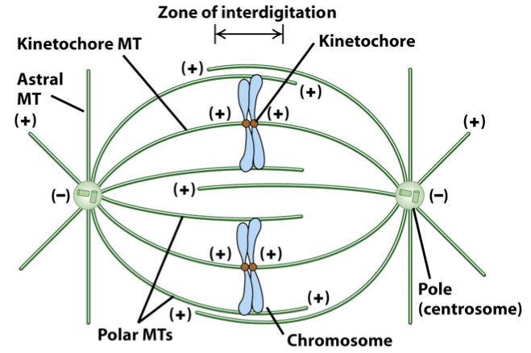
Kinetochore MTs: capturing chromosomes in pro-metaphase – the kinetochore microtubules from the centrosome capture the kinetochores of the chromosome
- 2 kinetochore MTs attached to the chromosome = bipolar attachment
- 1 kinetochore MT attached = monomer attachment
Attachment of kinetochore proteins to a dynamic (elongating + shortening) microtubule
Metaphase: all chromosomes must achieve a bipolar attachment for the cell to pass the spindle assembly checkpoint and enter anaphase
All cells of an organism undergo mitosis in tandem
Anaphase: the microtubules pull all the chromosomes at different intervals until there is bipolar attachment to all of them in the center and then they are pulled apart together
- Anaphase A = kinetochore microtubule shortening
  - Chromosomes are pulled foreword – shortening of kinetochores MTs; forces generated at kinetochores move daughter chromosomes toward their spindle poles
  - At which end does shortening occur? The MTs shorten and draw the chromosome towards the spindle

Testing models for Anaphase A
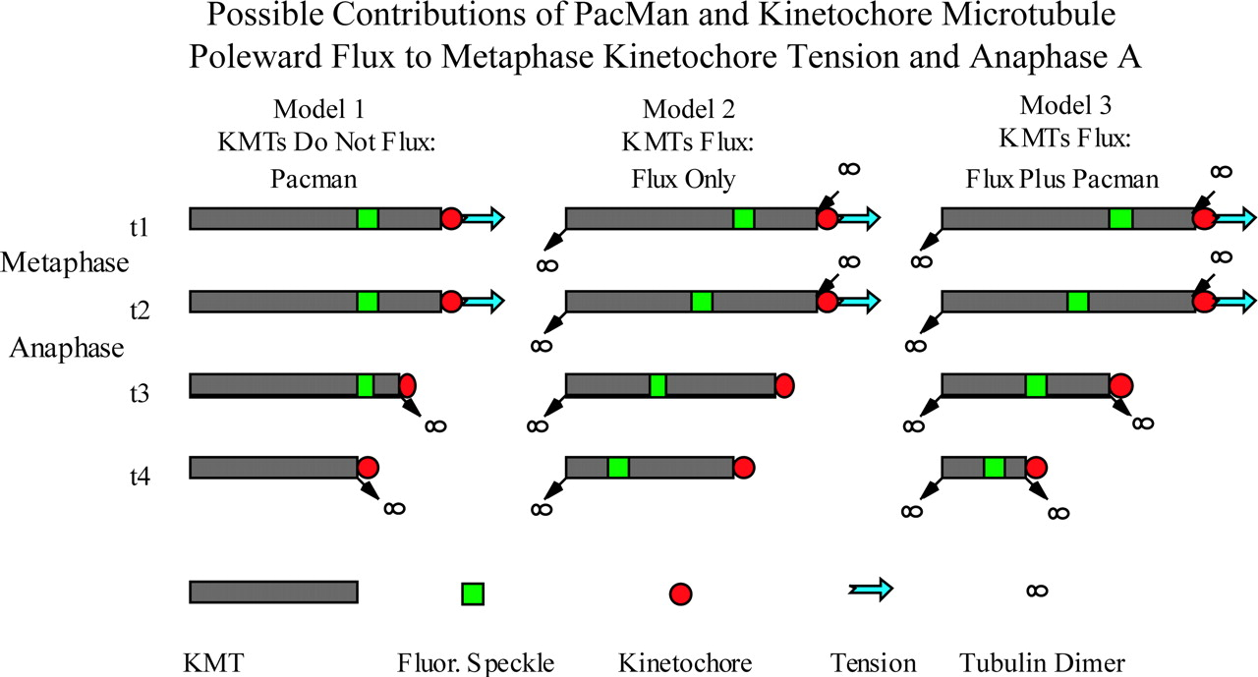
- Pac-man model – space b/w green tag + red kinetochore shortens; space b/w green tag and spindle pole remains the same (+ end shortening)
- Flux model – space b/w green tage + red kinetochore = constant; space b/w green tag + spindle pole shortens (- end shortening)
- Combined – Bothe + end and – end are shortening
Data was consistent fro model 3
- Anaphase B= separation of spindle poles
  - Sliding force is generated b/w polar microtubules from opposite poles to push them apart
  - A pulling force acts directly on the pole to move them apart
How might motor proteins separate chromosomes?
Sliding of Kinesin 5 between polar microtubules pushes poles apart
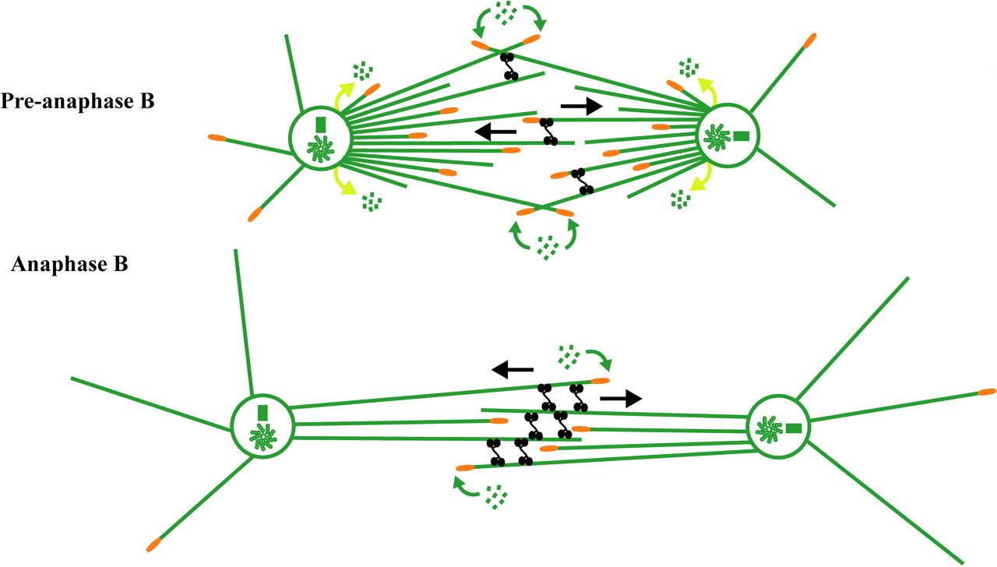
  - Shortening of Astral MTs using Dynein
    - The positive end of the microtubule is pointed towards the edge of the cell. If you used kinesin, it would push the centrosomes closer together since it's walking towards the edge of the cell. But dyenins will walk towards the centrosome (negative end) and pull the astral MTs towards the edge of the cell. This allows for the centroles to be split further apart.
    - The dyenin moves towards the centrosomes and into the cell, hence pulling the astral mts towards the edge of the cell and resulting in movement of centrioles.
    - Bipolar spindles will have double head kinesin that moves towards the middle of the cell (since the positive ends points to the middle) and will move the actual microtubules away from the middle.
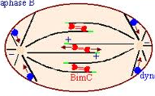
Blue = dynein
Red = Bim C = Kinesin 5

Summary
Establishing a bipolar mitotic spindle in prophase and attaching chromosomes in prometaphase/metaphase:
  - Separation of centrosomes requires kinesin
  - Attachment of kinetochores to KT microtubules – dynamic attachment
Orchestrating chromatid separation in anaphase
  - Anaphase A (microtubule shortening)
  - Anaphase B (kinesin and dynein)

