Prokaryotic cell reproduction - Binary fussion

Centromere
Kinetochore

Telomeres
Sister chromatids

Interphase

Genetic variation in meiosis
- Crossing over
- Random separation of homologous chromosomes

Term
Gene: An inherited factor (region of DNA) that helps determine a characteristic
Allele: One of two or more alternative forms of a gene
Locus: Specific place on a chromosome occupied by an allele
Genotype: Set of alleles possessed by an individual organism
Heterozygote: An individual organism possessing two different alleles at a locus
Homozygote: An individual organism possessing two of the same alleles at a locus
Phenotype or trait: The appearance or manifestation of a characteristic
Characteristic or character: An attribute or feature possessed by an organism

Q) Drosophila males and females sex determined by..
A) Ratio of the number of X chromosomes to the number of autosomes

A barr body ---

Epistasis - occurs when one gene masks the effect of another gene. It is thus a function of interaction between genes. epistatic gene – is the gen that does the masking – Labradors

Anticipation - The severity of a trait increases or age of onset gets earlier as it is passed from generation to generation.

autosomal recessive

autosomal dominant
cell cycle

genic sex determination

term sex refers to sexual phenotype….
The fundamental difference between males and females is gamete size, males produce small gametes; females produce relatively larger gametes..

Autosomes – are nonsex chromosomes

Grashopers
XX-XO
Males XO – ) repossent no chromosomes (there the heterogtamic sex)
Femlaes XX (homogrametic sex)

XY can pair because of pseudoautosomal regions

ZZ-ZW
Males are ZZ
Females ZW
Birds, snakes, butterflies, and some amphibians and some fishes…

Genic sex determinations----- plants fungi protozoans and fish

SRY on the Y chromosomes determines the male phenotypes

Sequential hermaphroditism – they can be both male and female just not at the same time…

Breaded grands – ZZ are males and ZW are females but when develop at high temputers ZZ can develop as phenotypic females…

Left off page 83

Female and male 2nddary sexual characteristics are not on the sex chromosomes but on the autosomes

Males cane only be hemizygous for x-linked loci

Red green color blindess is a on the X chromosomes and is reserive trait

Vary little crossing over with X Y,, but does with XX

8 large palindromes that allow crossing over within the Y chromosome.

Sex limited showing in only one sex

Dosage compensation?

Ended chapter 5 page 104

Incomplete dominance ratio 1:2:1
Phenotype of the heterozygote is intermediate (falls within the range) between the phenotypes of the two homozygotes.

Complete dominance 1:3
Phenotype of the heterozygote is the same as the phenotype of one of the homozygotes.

Codominance
Phenotype of the heterozygote includes the phenotypes of both homozygotes

Penetrance is the percentage of individuals having a particular genotype that express the associated phenotype

Incomplete penetrance – how much its expressed such as polydactyly

Lethal allele – only kill in homozygous

Number of genotypes possible will be [n(n+1)/2]

Gene interaction: interaction between the effects of genes at different loci (genes that are not allelic)

Gene interaction is interaction between genes at different loci. Dominance is interaction between alleles at a single locus.

Epistasis

hypostatic gene

Epistasis is the masking of the expression of one gene by an- other gene at a different locus. The epistatic gene does the masking; the hypostatic gene is masked. Epistatic alleles can be dominant or recessive.
12:3:1 ratio
12= W_Y_ and W_yy
3= wwY_
1= wwyy

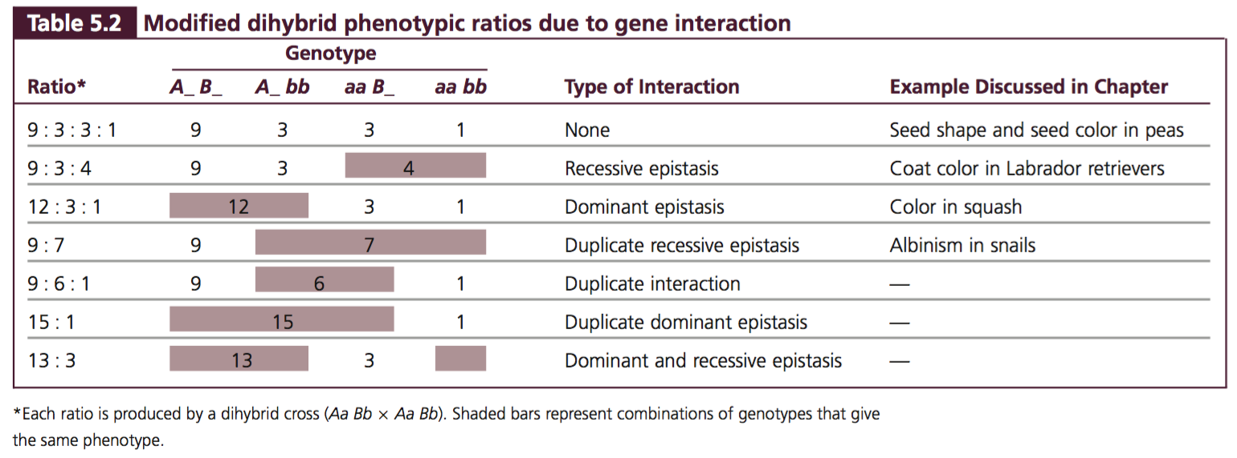

9:3:4,,, Suppose that we obtain the following phenotypic ratio: 9/16 black : 3/16 brown : 4/16 white. Which genotype do we assign to the brown progeny, A_ bb or aa B_? Either answer is correct because the letters are just arbitrary symbols for the genetic information. The important thing to realize about this ratio is that the brown phenotype arises when two recessive alleles are present at one locus.

Sex-influenced characteristics: goats beards
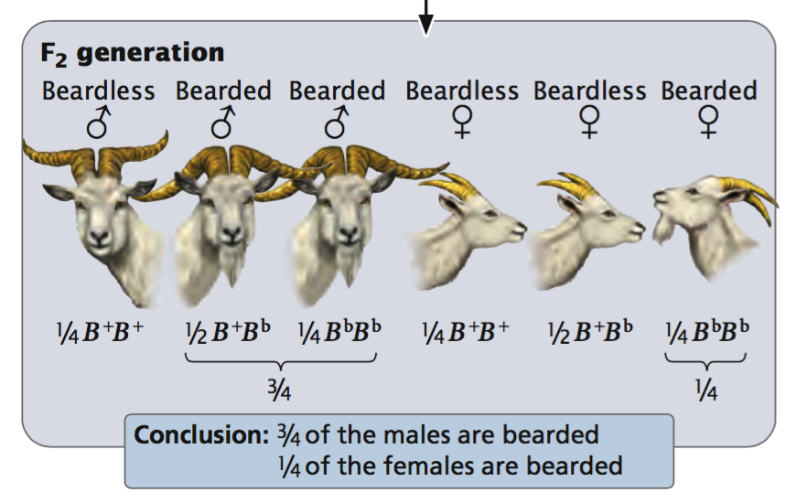

sex- limited characteristic: cock feathering, can be inherited from either parent but only displayed in one sex..
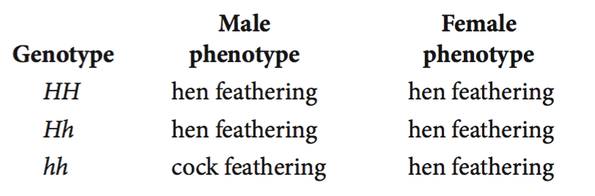

Both sex-influenced and sex-limited traits are encoded by autosomal genes whose expression is affected by the sex of the individual organism possessing the gene. Sex-linked traits are encoded by genes on the sex chromosomes.

Characteristics of cytoplasmically inherited traits. – think 4-o’clock plant
1. Present in males and females.
2. Usually inherited from one parent, typically the maternal parent.
3. Reciprocal crosses give different results.
4. Exhibit extensive phenotypic variation, even within a single family.

genetic maternal effect, in which the phenotype of the offspring is determined by the genotype of the mother. The genes are inherited from both parents, but the offspring’s phenotype is determined not by its own genotype but by the genotype of its mother.

Cytoplasmically inherited traits are encoded by genes in the cytoplasm, which is usually inherited only from the female parent. Therefore, a trait due to cytoplasmic inheritance will always be passed through females. Traits due to genetic maternal effect are encoded by autosomal genes and can therefore be passed through males, although any individual organism’s trait is determined by the genotype of the maternal parent.

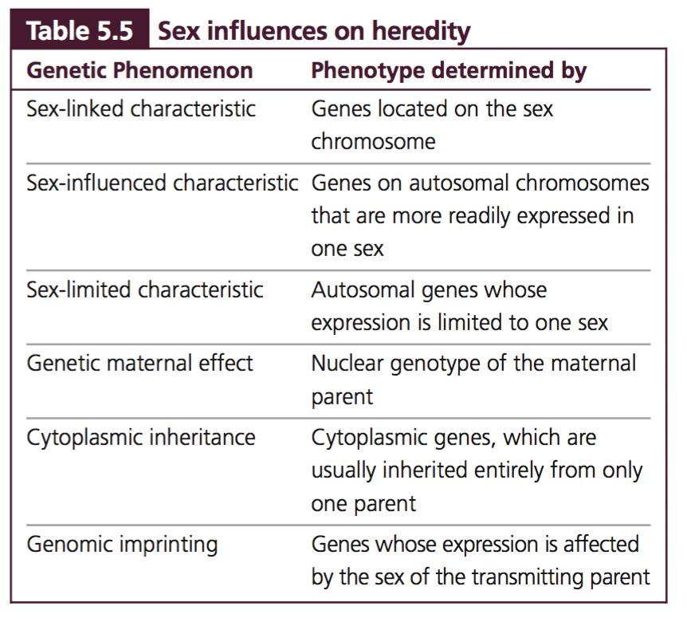

anticipation

Occasionally, environmental factors alone can produce a phenotype that is the same as the phenotype produced by a genotype; this phenotype is called a phenocopy

Characteristics, which have a few easily distinguished phenotypes, are called discontinuous characteristics.

Indeed, there are so many possible phenotypes of human height that we must use a measurement to describe a person’s height. Characteristics that exhibit a continuous distribution of phenotypes are termed continuous characteristics. Because such characteristics have many possible phenotypes and must be described in quantitative terms, continuous characteristics are also called quantitative characteristics.

Characteristics encoded by genes at many loci are called polygenic characteristics.

The converse of polygeny is pleiotropy, in which one gene affects multiple characteristics.
Polygeny refers to the influence of multiple genes on the expression of a single characteristic. Pleiotropy refers to the effect of a single gene on the expression of multiple characteristics.

Many continuous characteristics are both polygenic and influenced by environmental factors; such characteristics are called multifactorial characteristics

The genotypic ratio marches the phenotypic ratio under which types of inheritance? Incomplete dominances and codominance

