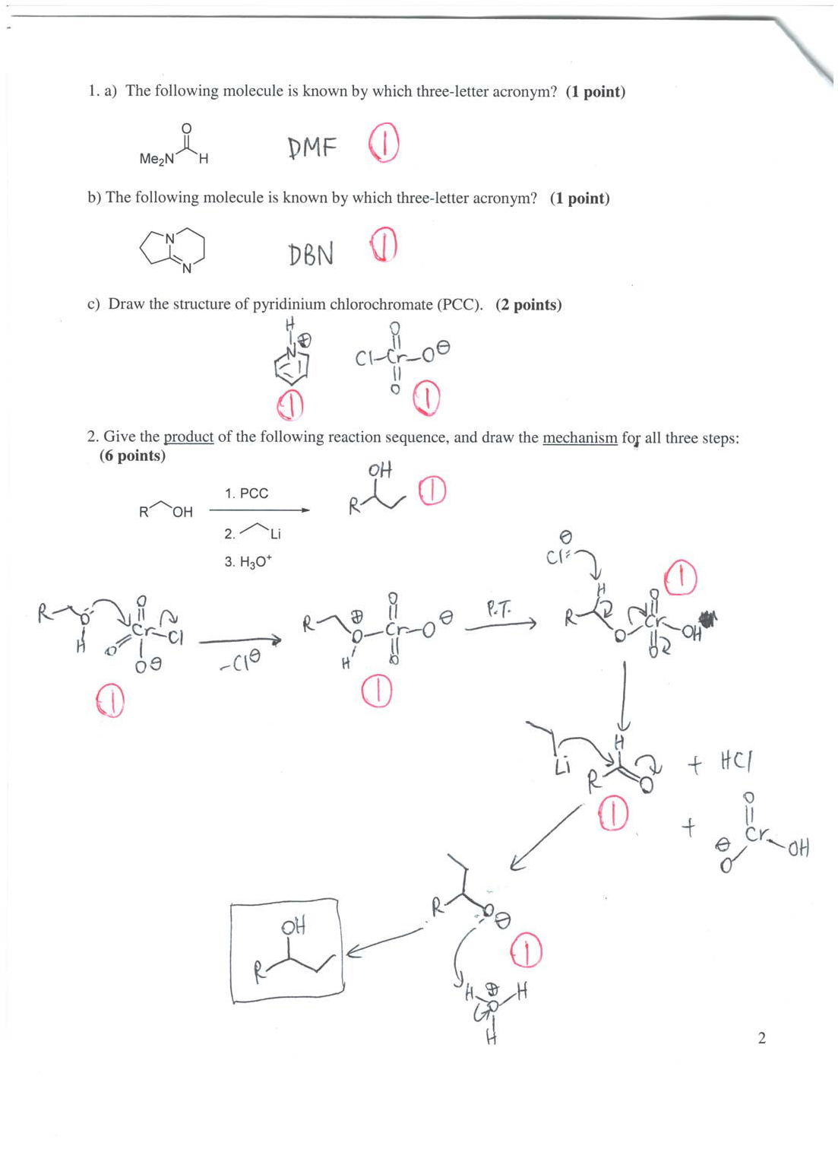

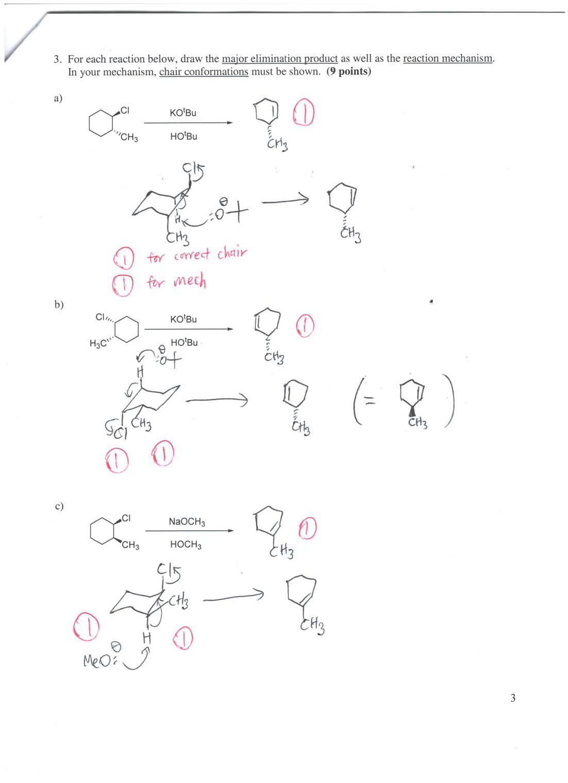

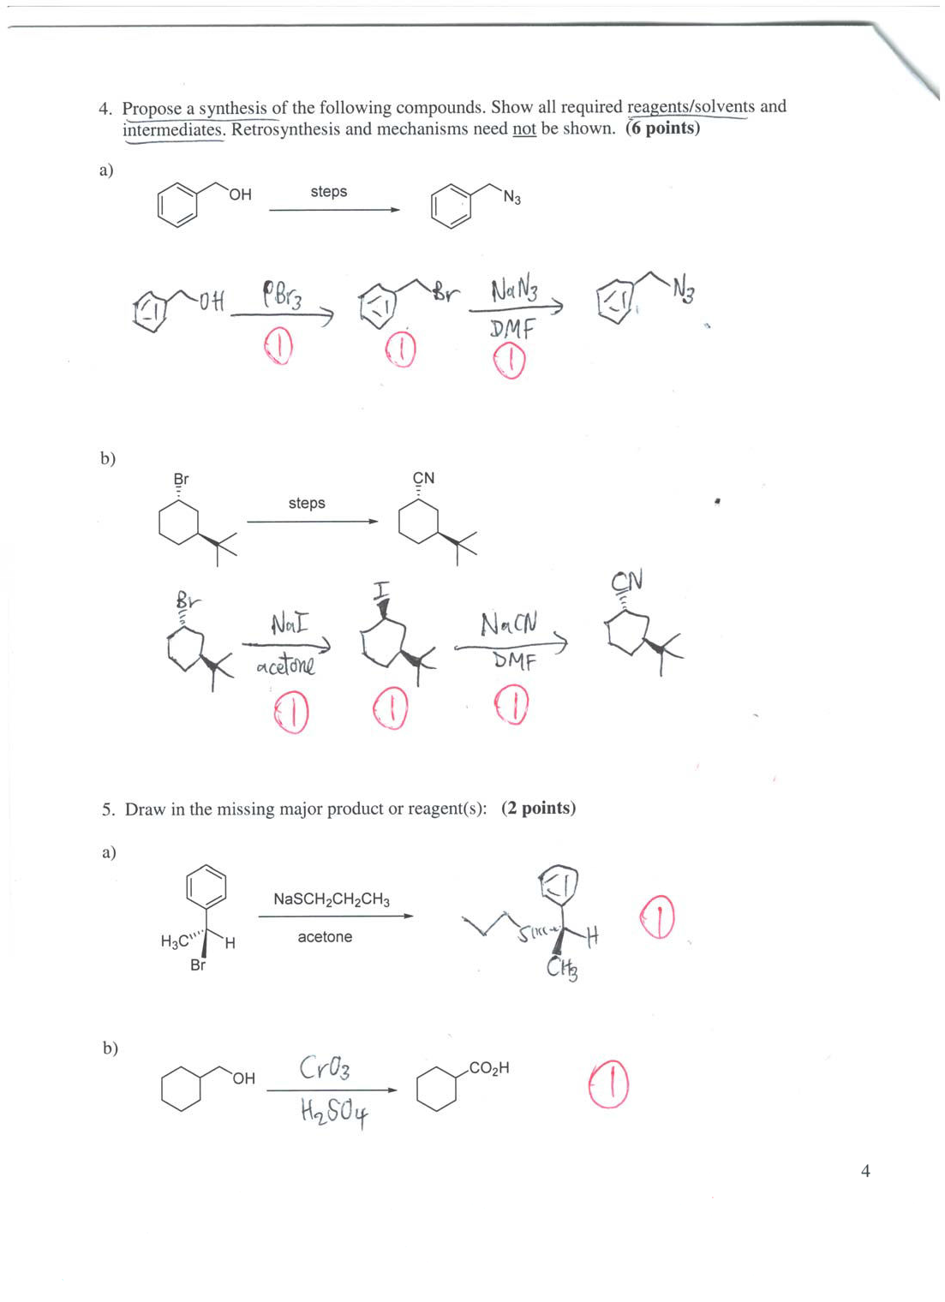

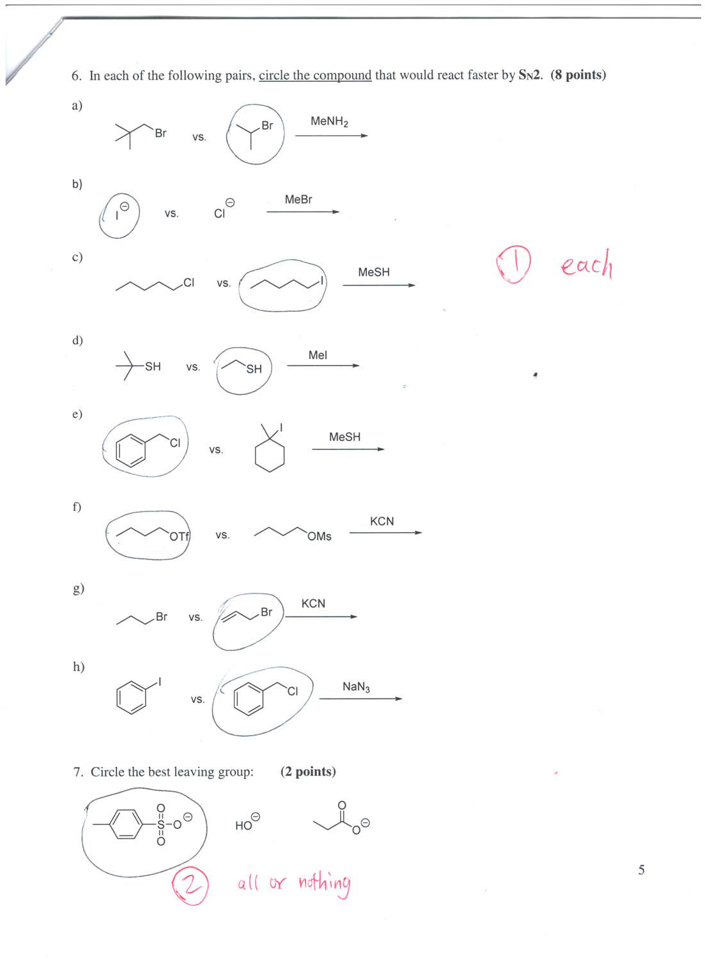

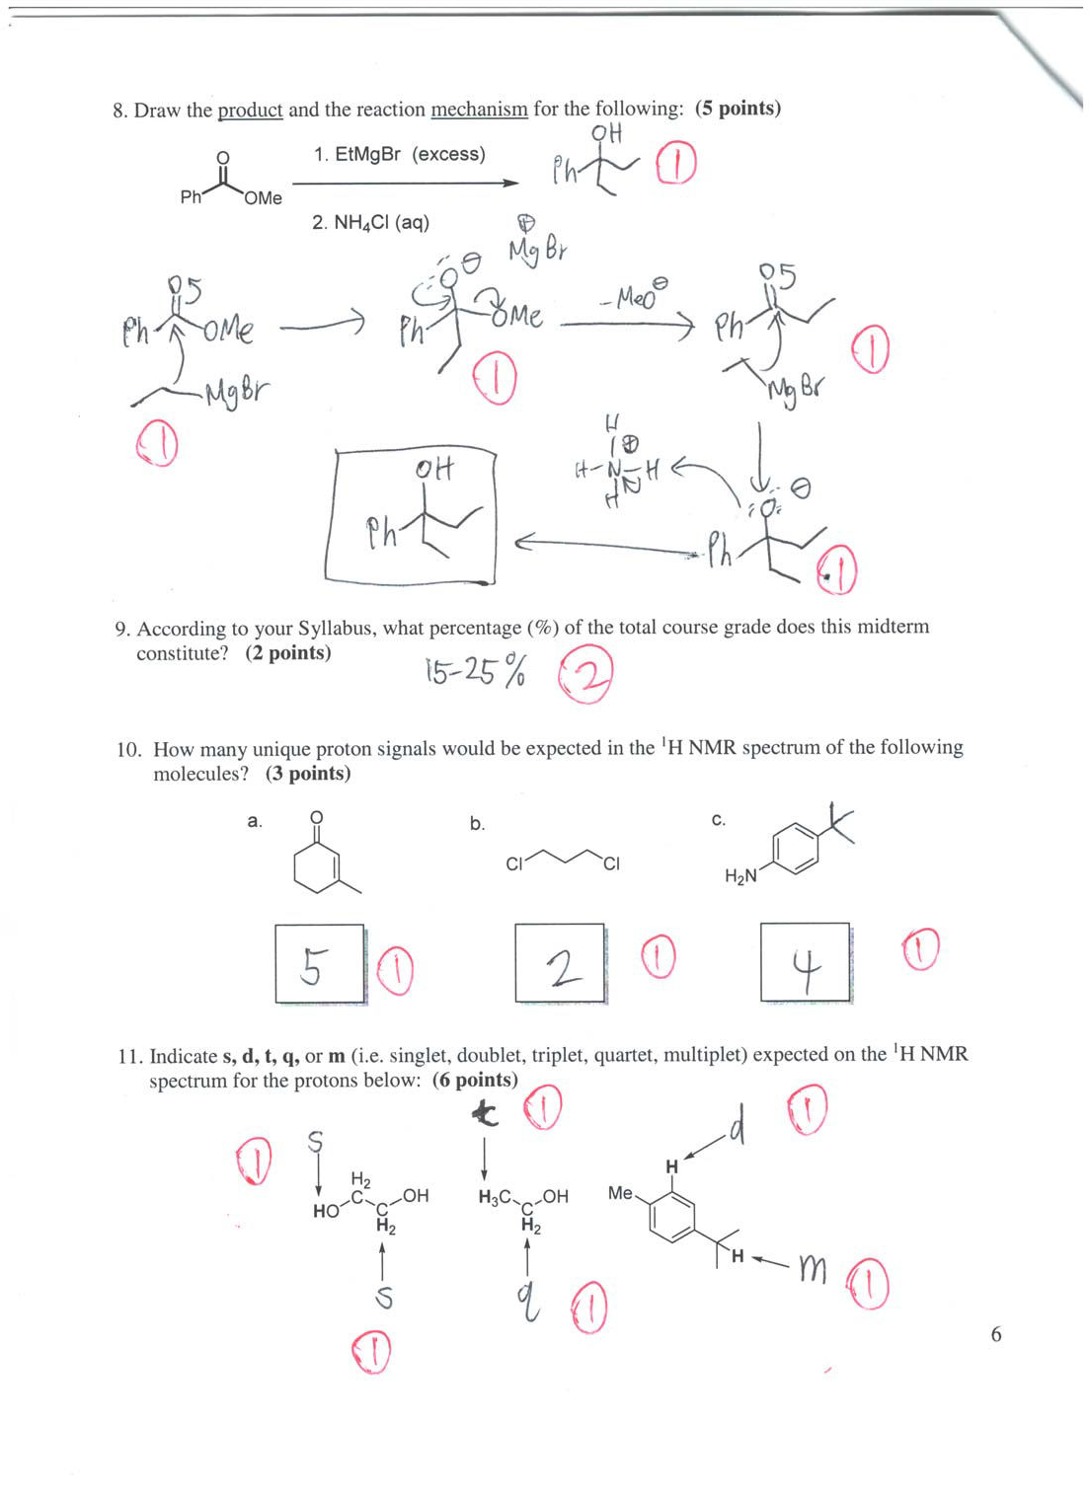

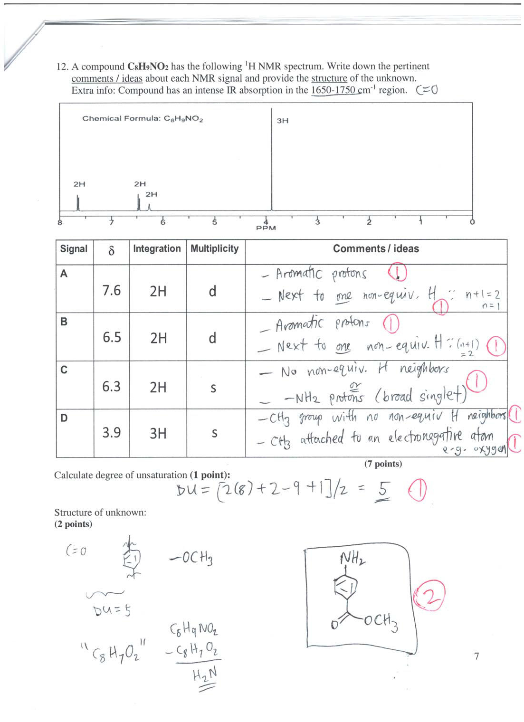

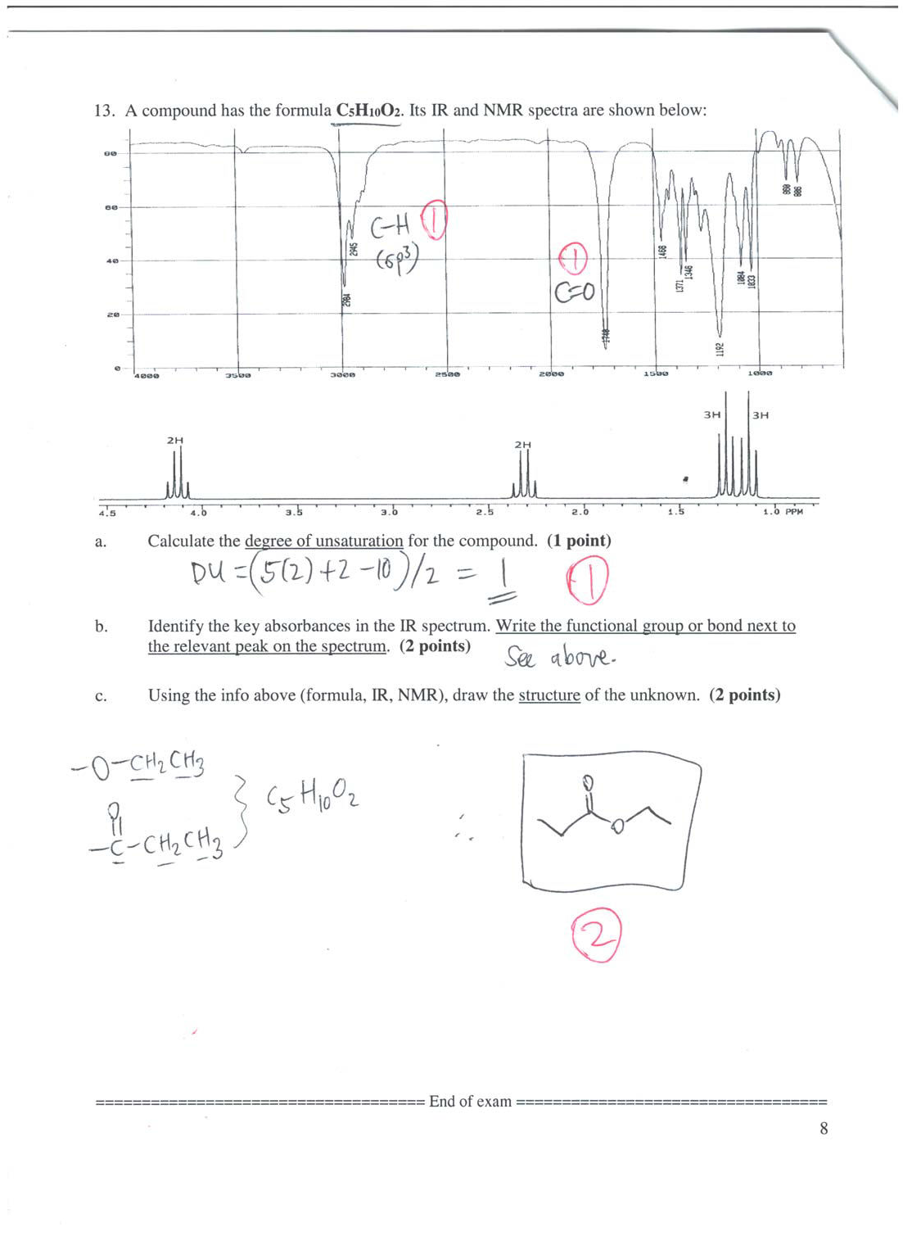

1. a) Polar aprotic solvent. Page 22 of Module 2 – SN2 (complete).pdf

b) Bulky hindered base. Page 22 of Module 2 – E2 complete (as of Oct 5).pdf

1. c) and 2. PCC – Pages 7, 17-18 of Module 2 – E2 complete (alcohol oxid).pdf

3. See Problem Set #1 – questions 5. a), c) and d).

4.a) Refer to Module 2 Problem 30 – concepts on pages 24-31 of Module 2 – SN2 (complete).pdf

b) Page 38 of Module 2 – SN2 (complete).pdf. There was also a similar problem on the sample midterm exam, with an alternative solution presented in that answer key.

5. a) Problem set #2 – question 5d

b) Jones oxidation – pages 5-6 of Module 2 – E2 complete (alcohol oxid).pdf 6.a) Neopentyl exception – pages 13-14 of Module 2 – SN2 (complete).pdf
- Larger and more polarizable iodide is the better nucleophile. Analogous to S vs. O. The reason has to do with hard-soft acid base (HSAB) principle, which is not part of CHM 2120.

- Iodide is the better leaving group. Compare HI vs. HCl pKa.

- Less sterically hindered species is the better nucleophile.

- Primary (and benzylic) halide vs. tertiary halide.

- Triflate vs. Mesylate – inductive effect of the fluorines stabilize the C.B. and make triflate a better LG. (OTf is a trifluorinated analog of OMs).

- Allyl bromide is a better electrophile – concepts on page 56 of Module 2 – SN2 (complete).pdf

- Aryl vs benzyl halide – concepts on pages 54-56 of Module 2 – SN2 (complete).pdf

- This was a poorly answered question on Midterm 1. Much better this time round. The best LG is tosylate. (Circle the whole thing.)

- See Module 4 – Problem 4 (Top Hat).

- Syllabus question – well answered. You were told to expect this (along with the reason why) in the Blackboard announcement posted on Tuesday, October 6, 2015 12:53:08 AM EDT.

- a) Five sets of non-equivalent protons.

  - There’s a plane of symmetry, therefore only 2 unique 1H NMR signals.

  - Plane of symmetry, therefore only 4 unique sets of protons.

- OH, SH, NH2, CO2H do not split neighboring proton signals nor do their signals get split. They are not involved in splitting because rapid exchange of these ‘acidic’ protons in solution lead to the loss of their spin identities. Watch out for the symmetry in ethane-1,2-diol. Equivalent protons do not split themselves, therefore they are all singlets in the first molecule. (Ethane-1,2- diol is antifreeze.) The second molecule is ethanol – Module 3 – Top Hat Problem 8 (once again, the OH proton does not split the neighboring CH2 protons). Last molecule - the aromatic proton is a doublet (one non-equivalent neighboring H). Long-range coupling effects may also give rise to a multiplet. Isopropyl group – see page 74 of Module 3 – complete notes.pdf.

- This NMR problem is Problem Set 3 question 44. The TA also went through a very similar problem in the DGDs.

- Probably the best answered question on the midterm. The pair of triplets/doublets suggests a pair of ethyl groups. The C=O is evident from the IR.

Distribution of Scores:

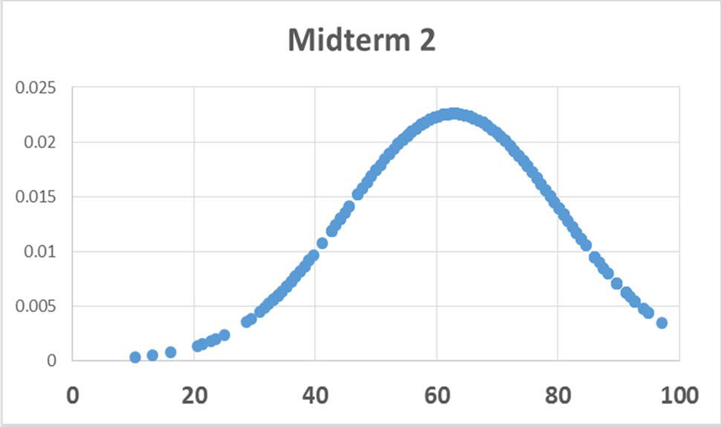

Average: 43 marks out of 68 (or 63%) Standard Deviation: 17.7%
Highest: 97%
23 students scored 90% and above.

Regrade request form

If you are requesting a regrade, please bring this completed form and your midterm to DRO 120 during my office hours.

Reason for request:

Terms of Agreement:

I have carefully looked through the answer key/grading scheme for this midterm. I have also read through the entire midterm feedback/report.
I understand that my entire midterm will be regraded and not just the question(s) in dispute.

I understand that my new score could be lower than my original one.

I will not request additional regrades after a regrade has been completed (i.e. new score is final).

I understand that I will be referred to the Academic Fraud Committee as well as the Vice-Dean of Undergraduate Studies if it is discovered that my midterm has been altered in any way.

By signing below, I agree to be bound by the terms and conditions stated above:

Student Signature Date

Student name: Student number:

