Enthalpy of Various Reactions
Introduction:
Heat is a form energy which flows from one object or substance to another. This energy can be measured based on the mass of the substance, the specific heat capacity of the substance and the change in temperature². When a warm or hot metal is added to water that has a lower temperature, the heat is transferred from the metal to the water. The amount of heat within the system can be calculated using the following equation where m is mass in grams, c is the specific heat capacity of the substance in joules per grams, degrees Celsius and ΔT is the change in temperature.⁶
q = m * c* ΔT [1]
It is assumed that within an isolated system, no heat can escape to the surroundings. However, this is hardly ever the case as it is almost impossible to achieve, because it is hard to create a perfectly isolated system. A coffee cup calorimeter mocks this type of system by being well insulated. Using this device, one can assume that the amount of energy lost is equal to the amount of energy gained. This is in accordance with the First Law of Thermodynamics which states energy cannot be created nor destroyed. ³
-q_{lost} = q_{gained} [2]
Once the amount of energy within the system has been calculated, the molar mass of the substance being used can be determined. In 1819 Dulong and Petit proposed that one mole of all metals had roughly the same capacity to absorb heat. That quantity is equal to 25J/mol°C which can be used to determine the molar mass or specific heat capacity using the following
C_{met} x MM_{met} ~ 25.0J/mol°C [3]
Once the amount of heat or q has been determined, the enthalpy of the reaction per mole of a substance can be calculated. The enthalpy of a reaction is also referred to as the energy change of a reaction. It is the amount of energy or heat absorbed within the reaction that has occurred¹. If the enthalpy of the reaction is positive, the reaction is endothermic because heat or energy is gained from the surroundings. However if the enthalpy is negative, the reaction is exothermic because the heat or energy is absorbed by the surroundings.
ΔH = q / n
The listed above equations can be used in a variety of different scenarios. These scenarios include the enthalpy of a solution being neutralized, a pure metal or even a solution containing a salt. Regardless of what is being reacted, as long as a chemical reaction occurs, the above equations can be used to determine the heat energy or enthalpy.
There are factors however that affect the specific heat capacity which is used to calculate the amount of thermal energy. When it comes to salt, the crystal lattice, or structure is a factor which effects the outcome of the calculations. The crystal lattice requires a certain amount of energy to break it, known as the lattice energy. The following experiment displays the effects such as this one along with others has on different reactions.⁶

Procedure: Procedure as stated in the lab manual
Data/Observations/Results:
Specific Heat Capacity of a Metal:
Table 1: Data Recorded in the Lab – Specific Heat Capacity of a Metal
 | Metal | m_{metal}  (g) | m_{cup}  (g) | V_{water}  (mL) | m_{cup+water}  (g) | T_{Initial}  (°C) | T_{boilingwater}  (°C) | T_{Final}  (°C) | Time  (s)
Trial 1 | Cu | 10.872 | 1.8924 | 20.000 | 21.568 | 23.850 | 100.00 | 27.050 | 405
Trial 2 | Cu | 14.137 | 1.8572 | 20.000 | 21.320 | 24.140 | 100.00 | 28.390 | 600

Figure 1: Graph of Trial 1 to Determine the Specific Heat Capacity of Copper
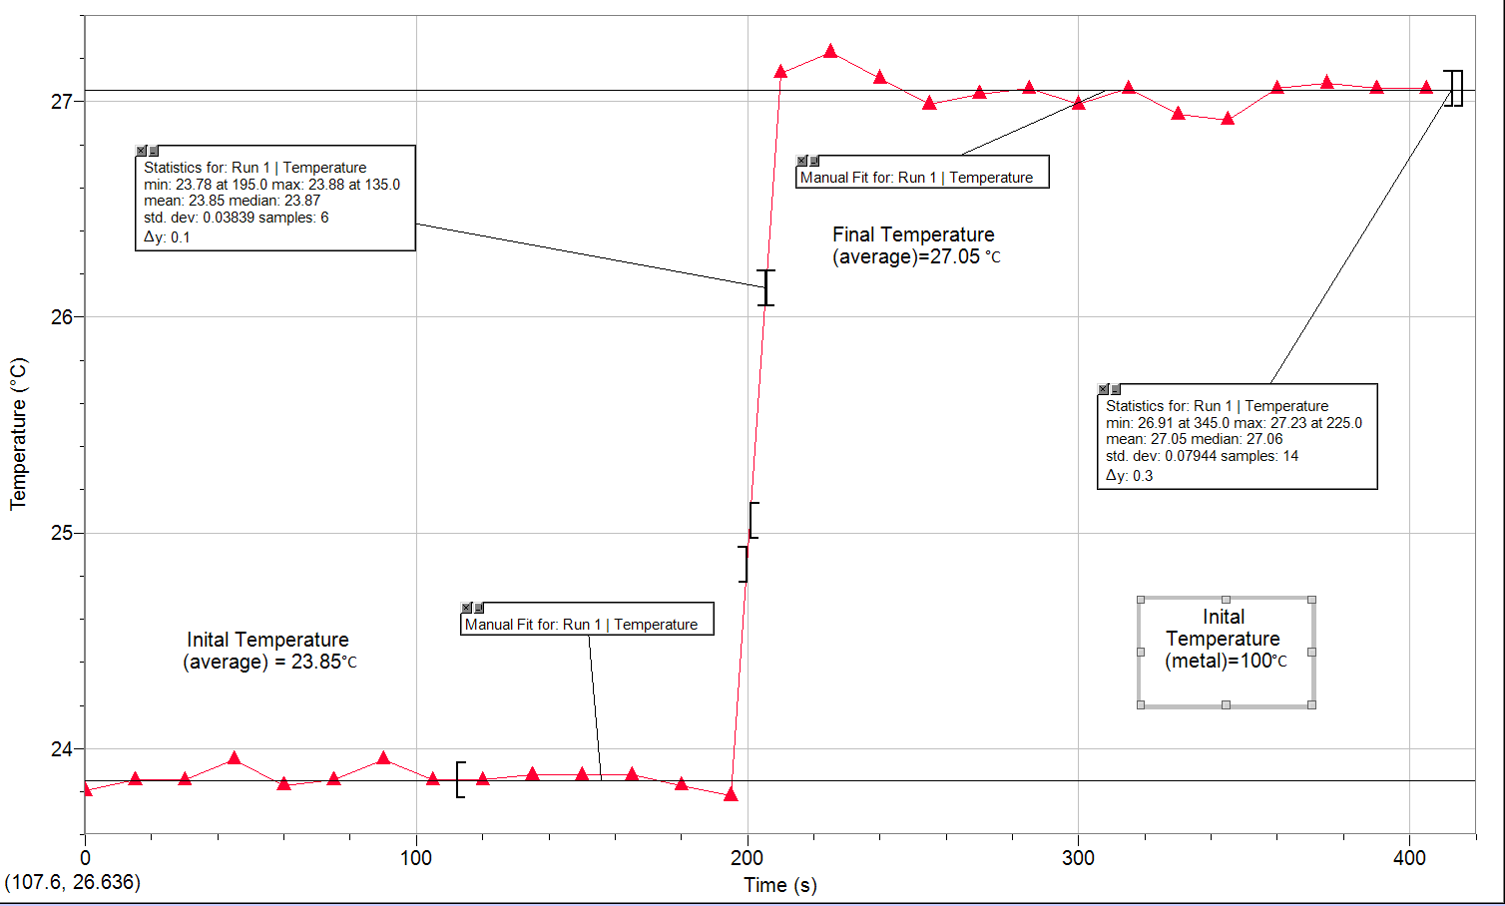
Observations:
- The initial temperature of the water was 23.88°C
- The water in the 400mL was bubbling and giving off steam indicating it had come to a boil
- No visible change occurred to the metal in the test tube
- When the metal was added to the calorimeter at 195 seconds, the temperature spiked
- The temperature stabilized with a final temperature of 27.05°C

Figure 2: Graph of Trial 2 to Determine the Specific Heat Capacity of Copper
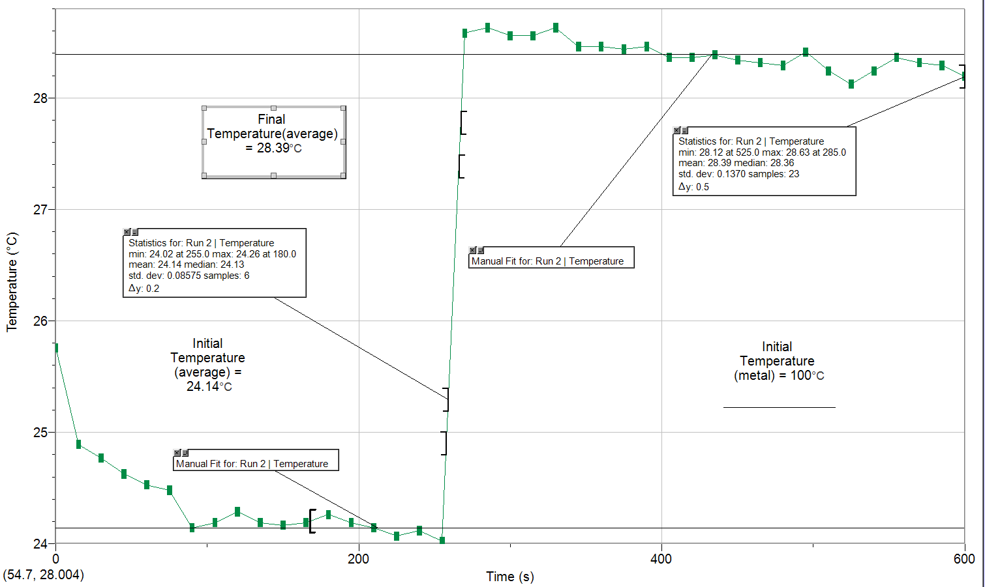

Observations:
- The probe was still hot from trial 1, so we waited until the temperature to stabilize again before we recorded the initial temperature of 24.14°C
- The water in the 400mL was bubbling and giving off steam indicating it had come to a boil
- No visible change occurred to the metal in the test tube
- When the metal was added to the calorimeter at 240 seconds, the temperature spiked
- The temperature stabilized with a final temperature of 28.39°

Enthalpy of Neutralization:
Table 2: Data Recorded in the Lab – Enthalpy of Neutralization of NaOH and HCL
 | Acid | V_{NaOH}  (mL) | C_{NaOH}  (M) | V_{acid}  (mL) | C_{acid}  (M) | m_{cup}  (g) | T_{Initial}  (°C) | m_{olution+cup}  (g) | T_{Final}  (°C) | Time  (s)
Trial 1 | HCl | 43.000 | 1.0000 | 43.000 | 1.1000 | 1.8608 | 24.250 | 50.879 | 30.950 | 600
Trial 2 | HCl | 35.000 | 1.0000 | 35.000 | 1.1000 | 1.9046 | 23.370 | 59.962 | 30.830 | 585

Figure 3: Graph of Trial 1 to Determine the Enthalpy of Neutralization of NaOH and HCl
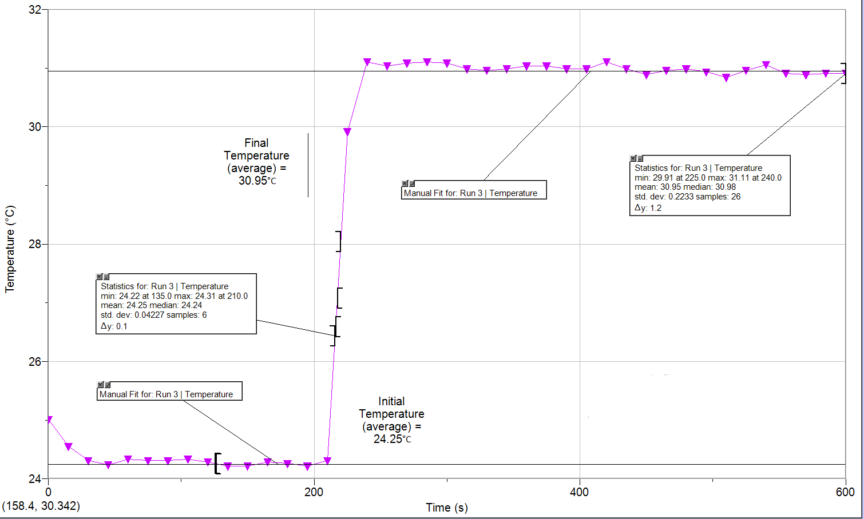

Observations:
- Both the acid and base are clear, colourless liquids
- We used a cool, damp paper towel to cool down the probe before taking the initial temperature
- The initial temperature of the NaOH was 24.25°C a
- When the acid was added to the base at 180 seconds, the temperature spiked
- Some of the solution spilled out of the cup while it was swirled
- The final temperature was 30.95°C

Figure 4: Graph of Trial 2 to Determine the Enthalpy of Neutralization of NaOH and HCl
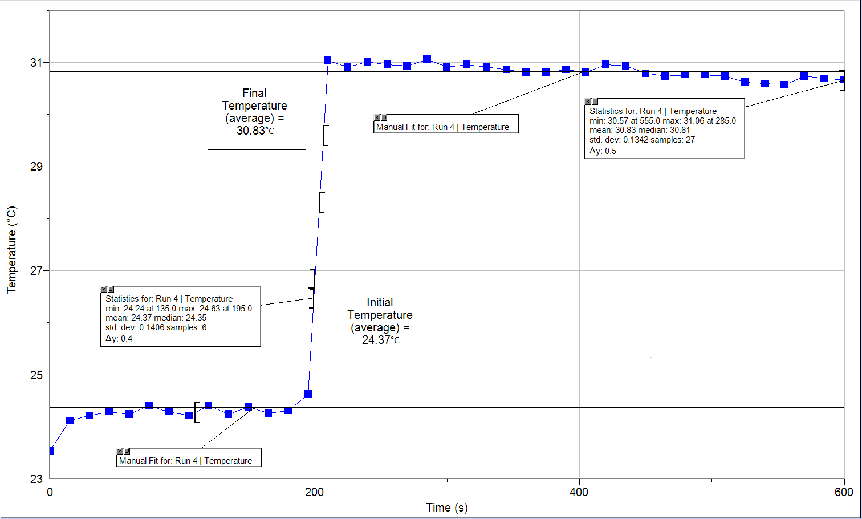

Observations:
- Both the acid and base are clear, colourless liquids
- We used a cool, damp paper towel to cool down the probe before taking the initial temperature
- The initial temperature of the NaOH was 24.37C
- When the acid was added to the base at 180 seconds, the temperature spiked
- Some of the solution spilled out of the cup while it was swirled
- The final temperature was 30.83°C
Table 3: Data Recorded in the Lab – Enthalpy of Neutralization of NaOH and HNO₃
 | Acid | V_{NaOH}  (mL) | C_{NaOH}  (M) | V_{acid}  (mL) | C_{acid}  (M) | T_{initial}  (°C) | m_{cup}  (g) | m_{olution+cup}  (g) | T_{final}  (°C) | Time  (s)
Trial 1 | HNO₃ | 37.000 | 1.0000 | 37.000 | 1.1000 | 24.070 | 1.8780 | 77.376 | 30.410 | 510
Trial 2 | HNO₃ | 39.000 | 1.0000 | 39.000 | 1.1000 | 23.900 | 1.8841 | 76.667 | 30.530 | 405

Figure 5: Graph of Trial 1 to Determine the Enthalpy of Neutralization of NaOH and HNO₃
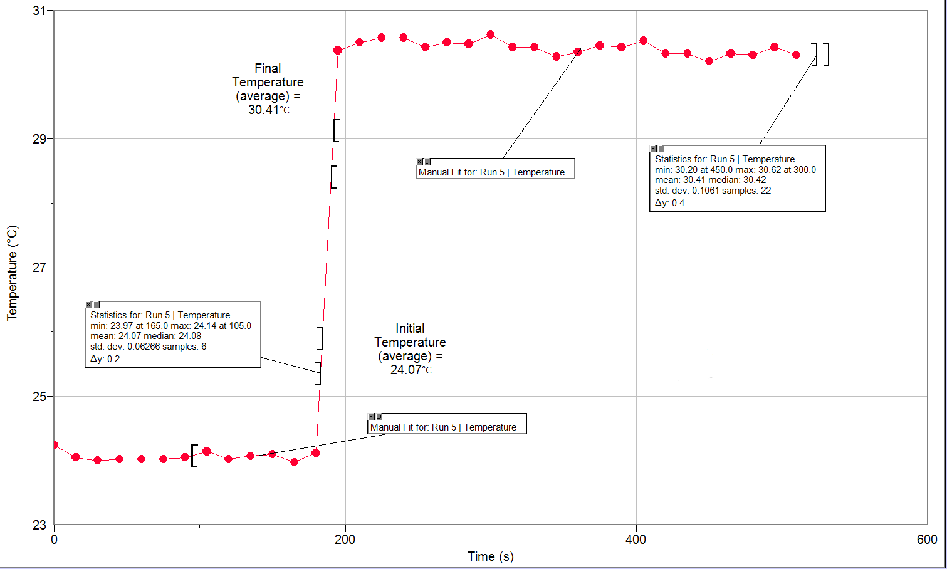

Observations:
- Both the acid and base are clear, colourless liquids
- We used a cool, damp paper towel to cool down the probe before taking the initial temperature
- The initial temperature of the NaOH was 24.07°C
- When the acid was added to the base at 180 seconds, the temperature spiked
- Some of the solution spilled out of the cup while it was swirled
- The final temperature was 30.3°C 41

Figure 6: Graph of Trial 2 to Determine the Enthalpy of Neutralization of NaOH and HNO₃
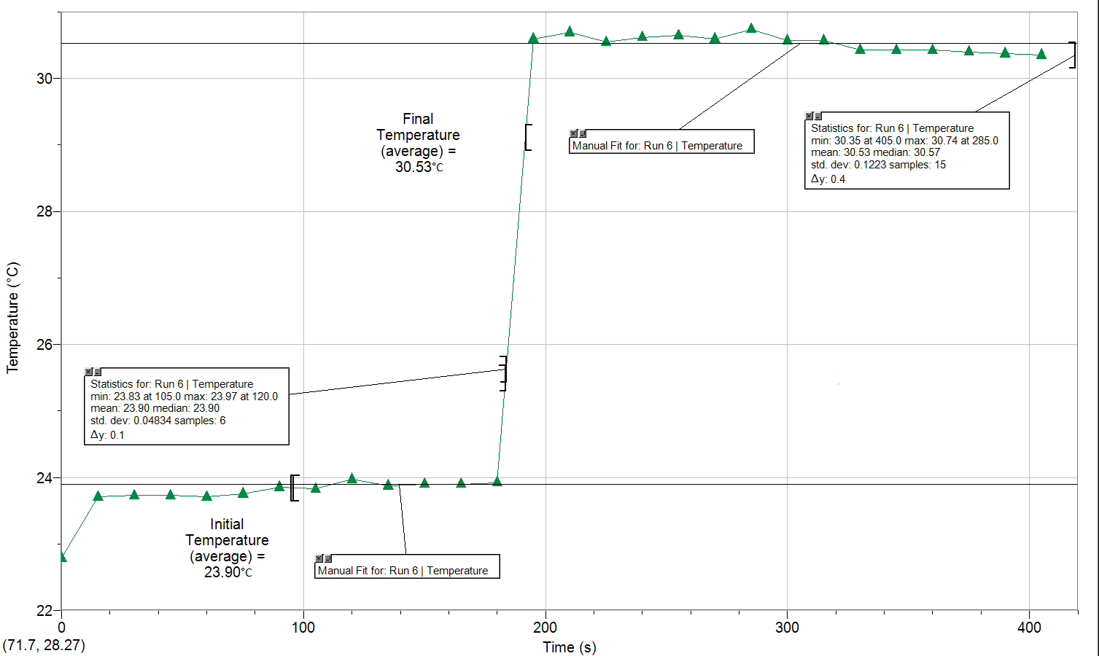

Observations:
- Both the acid and base are clear, colourless liquids
- We used a cool, damp paper towel to cool down the probe before taking the initial temperature
- The initial temperature of the NaOH was 23.90°C
- When the acid was added to the base at 180 seconds, the temperature spiked
- Some of the solution spilled out of the cup while it was swirled
- The final temperature was 30.53°C

Enthalpy of a Solution:
Table 4: Data Recorded in the Lab – Enthalpy of Dissolution of an Unknown Salt
 | Salt | m_{salt}  (g) | m_{cup}  (g) | V_{water}  (mL) | m_{cup+water}  (g) | T_{Initial}  (°C) | m_{solution+cup}  (m) | T_{Final}  (°C) | Time  (s)
Trial 1 | B | 2.5463 | 1.9100 | 20.000 | 21.376 | 23.850 | 23.910 | 22.190 | 540
Trial 2 | B | 2.5441 | 1.8941 | 20.000 | 21.186 | 23.440 | 23.698 | 21.450 | 420

Figure 7: Graph of Trial 1 to Determine the Enthalpy of Solution of an Unknown Salt
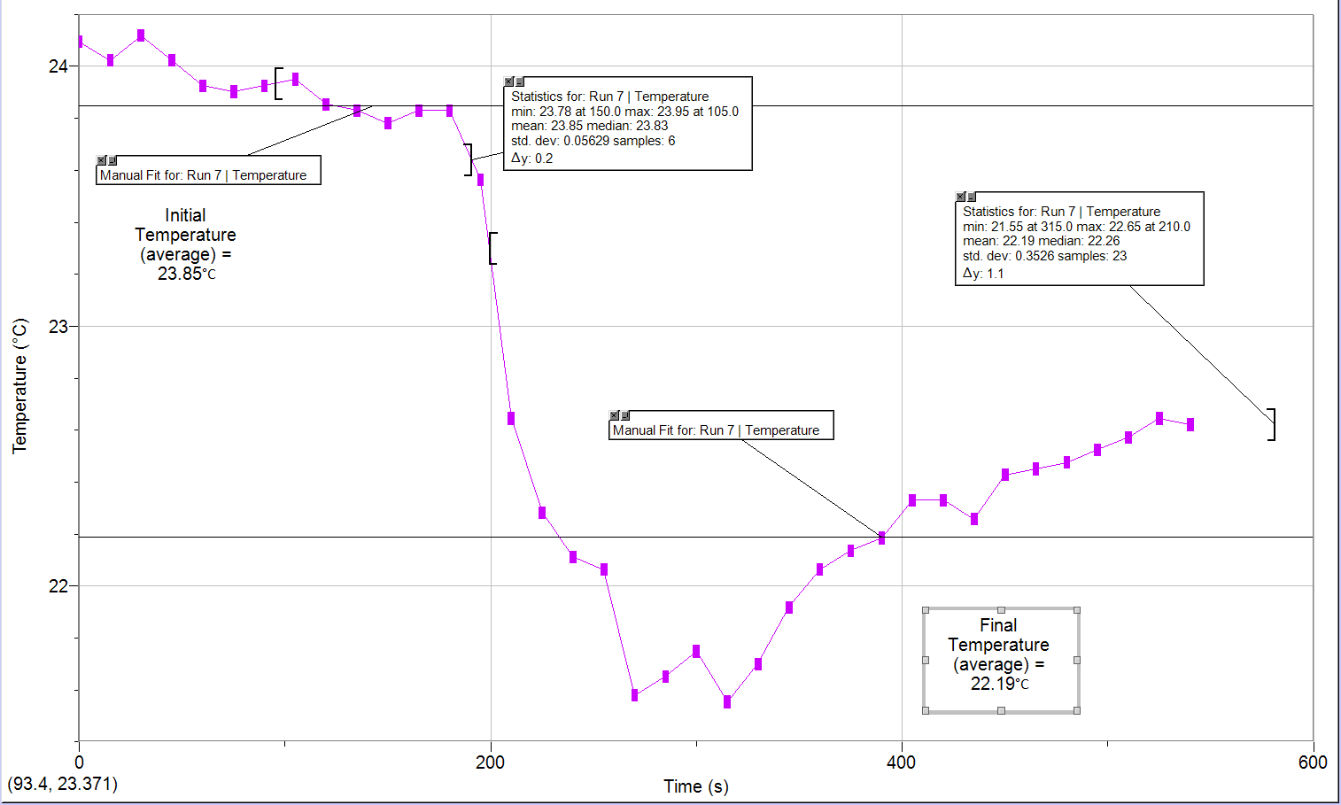

Observations:
- Salt is a fine white powder
- We used a cool, damp paper towel to cool down the probe before taking the initial temperature
- The initial temperature of the water was 23.85°C
- Temperature was stable when there was just water in the calorimeter
- Temperature decreased when the salt was added at 180 seconds
- After 360 seconds the temperature slightly increased
- The final temperature of the solution was 22.19°C

Figure 8: Graph of Trial 1 to Determine the Enthalpy of Solution of an Unknown Salt
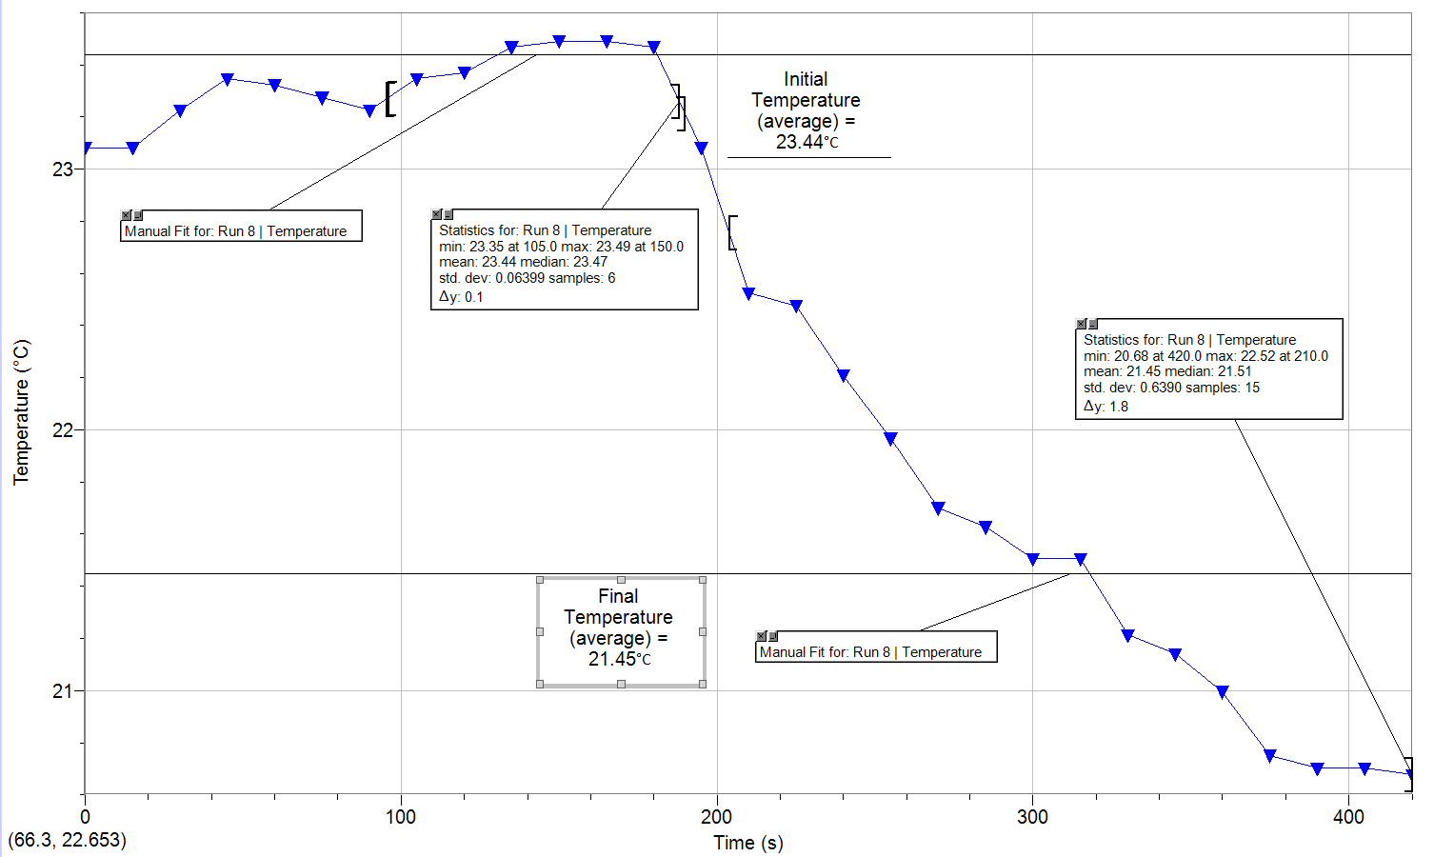
Observations:
- Salt is a fine white powder
- We used a cool, damp paper towel to cool down the probe before taking the initial temperature
- The initial temperature of the water was 23.44°C
- Temperature was stable when there was just water in the calorimeter
- Temperature decreased when the salt was added at 180 seconds
- The final temperature of the solution was 21.45°C

Calculations:
Part 1: Enthalpy of a Metal
Table 5: Calculated Data – Specific Heat Capacity of a Metal
 | Trial 1 | Trial 2
Δ_{water}T  (°C) | 3.200 | 3.200
q_{water}  (J) | 259.4 | 346.1
Δ_{metal}T  (°C) | -72.95 | -71.61
c_{metal}  (J/g*°C) | 0.3271 | 0.3419
MM_{Cu}  (g/mol) | 76.43 | 73.13
Percent Error  (%)(c_{metal}) | 15.04 | 11.20
Percent Error  (%)(M_{metal}) | 20.28 | 15.08

- Δ_{water}T=? Δ_{water}T = T_{f} – T_{i}
T_{i} = 23.85°C Δ_{water}T = 27.05°C-23.85°C
T_{f} = 27.05°C = 3.200°C

- q_{water}=? q=mcΔT
m_{H2O} = m_{cup+water} – m_{cup} = (19.3751g)*(4.184J/g*°C)*(3.200°C)
= 21.2675g-1.8924g = 259.41J
= 19.3751g
c_{H2O} = 4.184J/g*°C
Δ_{water}T = 3.200°C

- Δ_{metal}T = ? Δ_{metal}T = T_{f} – T_{i}
T_{i} = 100.0°C Δ_{metal}T = 27.05°C-23.85°C
T_{f} = 27.05°C = -72.95°C

- C_{metal}=? q=mcΔT
-q_{metal} = +q_{water} c=q / (mΔT)
q=259.41J = (259.41J) / (10.879g*72.95°C)
m_{Cu} = 10.8719g = 0.32708J/g*°C
Δ_{metal}T = -72.95°C = 0.3271J/g*°C
- MM_{Cu} = ? MM_{met} = (25.0J/mol*K) / (c_{met})
c_{Cu} = 0.32708J/g*°C = (25.0J/mol*K) / (0.32708 J/g*°C)
c_{Met} * MM_{met} = 25.0J/mol*K = 76.43g/mol

- % Error c_{Cu} = ?
c_{Experimental} = 0.32708 J/g*°C
c_{Theoretical} = 0.3850 J/g*°C
% = (Experimental – Theoretical) / (Theoretical) x100%
= (0.327085 J/g*°C – 0.3850 J/g*°C) / (-0.3850 J/g*°C) x100%
= 15.04%

%Error MM_{Cu} = ?
MM_{Experimental} = 76.43g/mol
MM_{Theoretical} = 63.546g/mol
% = (Experimental – Theoretical) / (Theoretical) x100%
= (76.43g/mol – 63.546g/mol) / (-63.546g/mol) x100%
= 20.28%

- The mass of the metal used did not make a difference within our results. Although the experimental heat capacity was not identical for trial 1 and trial 2, they were extremely similar. The difference between the two experimental heat capacities of copper and the actual heat capacity of copper can be explained by sources of error. In other words, mass used does not affect the specific capacity; the compound of substance does. Take water for example. Water that we drink has the same specific heat capacity as the water that is in a freshwater lake. The specific heat capacity of a substance is a constant calculate to give the amount of energy required to increase one gram of a substance by 1 degrees Celsius. Although the specific heat capacity is not dependent on the mass of the copper, the heat capacity is. The amount of energy required (ΔH°_{f}) is dependent on the number of moles, which is dependent on the mass; moles = mass divided by molar mass. Therefore, specific heat capacity of copper is not dependent on the mass used in the experiment.

Part 2: Enthalpy of Neutralization
Table 6: Calculated Data – Enthalpy of Neutralization of NaOH and HCl
 | Trial 1 | Trial 2
Δ_{solution}T  (°C) | 6.700 | 6.460
V_{Final}  (mL) | 86.00 | 70.00
m_{solution}  (g) | 86.00 | 70.00
q_{Solution}  (J) | -2411 | -1892
n_{OH-}  (mol) | 0.043 | 0.035
n_{H2O}  (mol) | 0.043 | 0.035
ΔH°_{f}  (kJ/mol)(Experimental) | -56.06 | -54.06
ΔH°_{f}  (kJ/mol)(Theoretical) | -57.1 | -57.1
Percent Error  (%)(ΔH°_{f}) | 1.812 | 5.329

- Δ_{solution}T=? Δ_{solution}T = T_{f} – T_{i}
T_{i} = 24.25°C Δ_{solution}T = 30.95°C-24.25°C
T_{f} = 30.95°C = 6.700°C

- V_{Final} = ? V_{Final} = V_{HCl} + V_{NaOH}
V_{HCl} = 43mL = 43mL + 43mL
V_{NaOH} = 43mL = 86mL

- m_{Final} = ? m = d*V
V=86mL = (1.0g/mL)*(86mL)
d=1.0g/mL = 86g
d = m /v
The calculated mass is more accurate the data in which we collected. This is due a number of sources of errors. Firstly, when we massed the cup and the solution, there were other substances such as salt and water on the analytical balance. This added mass to our total mass of solution. Secondly, when we measured the solution after the reaction, it was difficult to get the analytical balance to stop at a single mass. In other words the balance kept flocculating between numbers. Therefore, the mass calculated based off other data collected is more accurate to use.

- q_{solution} = ? q = mcΔT
m = 86.00g = (86.00g)*(4.184 J/g*°C)*(6.700°C)
c = 4.184J/g*°C = -2410.8208 J
ΔT = 6.700°C = -2411J

- n_{OH-} = ? C = n / V
C_{NaOH} = 1.0M n = C * V
V = 43mL * (1L/1000mL) = (1.0M)*(0.043L)
= 0.043L = 0.0430mol

- n_{H2O} = ?
NaOH_{(aq)} + HCL_{(aq)} NaCl_{(aq)} + H₂O_{(l)}
n_{NaOH} = 0.0430mol * 1:1 (mole ratio)
n_{H2O} = 0.0430mol

- ΔH°_{f} = ? ΔH = (-2410.8208J) / (0.0430mol)
q = -2410.8208 J = -56065.6 J/mol
n_{H2O} = 0.0430mol = -56.06kJ/mol
ΔH = q / n

- Trial 1 (HCl): ΔH°_{f} = -56.06kJ/mol Trial 1 (HNO₃) = -53.05kJ/mol
Trial 2 (HCl): ΔH°_{f} = -54.06 kJ/mol Trial 2 (HNO₃) = -55.48kJ/mol
In both trials of each of the strong acids the heat of neutralization for both were similar. Looking at the data collected, the heat of neutralisation using HCl was slightly larger than that of HNO₃. However, there is not enough data collected to see if there is an actual difference or not. The experiment would have to be repeated multiple times to gather lots of data. This is because there are sources of error within the experiment which could cause flocculation in data. The acids should both have equal and if not close heat of neutralisations. This is because both HCl and HNO₃ are strong acids, reacting with the strong base NaOH. Therefore the reaction will go right until equilibrium is established. From this one can infer that the only reaction actually taking place is the formation of water. Although the other two reagent form a salt, the energy required is to form water. Therefore if both are strong acids, reacting with the same strong base, the only reaction occurring is that of water which result in the same heat of neutralization for both acids. This is in accordance with Hess’s Law. One can react the reaction in one step or multiple and the result for both would be the same heat of neutralization.

- % Error of ΔH°_{f}
ΔH°_{Experimental} = -56.06kJ/mol
ΔH°_{Theoretical} = -57.10kJ/mol
% = (Experimental – Theoretical) / (Theoretical) x100%
= [(56.06kJ/mol)-(57.10kJ/mol)] / 57.10kJ/mol
= 1.812%

- Trial 1 (HCl): ΔH°_{f} = -56.06kJ/mol Trial 1 (HNO₃) = -53.05kJ/mol
Trial 2 (HCl): ΔH°_{f} = -54.06 kJ/mol Trial 2 (HNO₃) = -55.48kJ/mol
The two trials for each acid are similar. Although each case is not identical to the other, they are within the same range. The difference is a result of source of error. The volume of base will have an effect on the reaction. If the amount of strong base is not equal to that of the strong acid, then the reaction will not be neutralized. Therefore the heat will be different, because there is more than just a salt and water left; the solution will be acidic. Volume does not affect ΔH because it is used to calculate mass, which does not affect the heat either. The specific heat capacity will not be affected but the amount of energy required will be affected by mass, because q=mcΔT. The enthalpies of both acids are very similar and they should be. When a strong base and a strong acid partake in a neutralization reaction, the only thing that is really being formed is water. Therefore if this is the case for both of the strong acids, the enthalpy will be very similar.

Part 3: Enthalpy of Neutralization
Table7: Calculated Data – Enthalpy of Neutralization of NaOH and HNO₃
 | Trial 1 | Trial 2
Δ_{solution}T  (°C) | 6.340 | 6.630
V_{Final}  (mL) | 74.00 | 78.00
m_{solution}  (g) | 74.00 | 78.00
q_{Solution}  (J) | -1963 | -2164
n_{OH-}  (mol) | 0.037 | 0.039
n_{H2O}  (mol) | 0.037 | 0.039
ΔH°_{f}  (kJ/mol)(Experimental) | -53.05 | -55.48
ΔH°_{f}  (kJ/mol)(Theoretical) | -57.30 | -57.30
Percent Error  (%)( | 7.412 | 3.176

- Δ_{solution}T=? Δ_{solution}T = T_{f} – T_{i}
T_{i} = 24.07°C Δ_{solution}T = 30.41°C-24.07°C
T_{f} = 30.41°C = 6.340°C

- V_{Final} = ? V_{Final} = V_{HCl} + V_{NaOH}
V_{HCl} = 37mL = 37mL + 37mL
V_{NaOH} = 37mL = 74mL

- m_{Final} = ? m = d*V
V=74mL = (1.0g/mL)*(74mL)
d=1.0g/mL = 74g
d = m /v
The calculated mass is more accurate the data in which we collected. This is due a number of sources of errors. Firstly, when we massed the cup and the solution, there were other substances such as salt and water on the analytical balance. This added mass to our total mass of solution. Secondly, when we measured the solution after the reaction, it was difficult to get the analytical balance to stop at a single mass. In other words the balance kept flocculating between numbers. Therefore, the mass calculated based off other data collected is more accurate to use.

- q_{solution} = ? q = mcΔT
m = 7.004g = (74.00g)*(4.184 J/g*°C)*(6.340°C)
c = 4.184J/g*°C = -1962.9654 J
ΔT = 6.340°C = -1963J

- n_{OH-} = ? C = n / V
C_{NaOH} = 1.0M n = C * V
V = 37mL * (1L/1000mL) = (1.0M)*(0.037L)
= 0.037L = 0.0370mol

- n_{H2O} = ?
NaOH_{(aq)} + HNO_{3(aq)} NaNO_{3(aq)} + H₂O_{(l)}
n_{NaOH} = 0.0370mol * 1:1 (mole ratio)
n_{H2O} = 0.0370mol

- ΔH°_{f} = ? ΔH = (-1962.96544J) / (0.0370mol)
q = -1962.96544 J = -53053.12 J/mol
n_{H2O} = 0.0370mol = -53.05kJ/mol
ΔH = q / n

- Trial 1 (HCl): ΔH°_{f} = -56.06kJ/mol Trial 1 (HNO₃) = -53.05kJ/mol
Trial 2 (HCl): ΔH°_{f} = -54.06 kJ/mol Trial 2 (HNO₃) = -55.48kJ/mol
In both trials of each of the strong acids the heat of neutralization for both were similar. Looking at the data collected, the heat of neutralisation using HCl was slightly larger than that of HNO₃. However, there is not enough data collected to see if there is an actual difference or not. The experiment would have to be repeated multiple times to gather lots of data. This is because there are sources of error within the experiment which could cause flocculation in data. The acids should both have equal and if not close heat of neutralisations. This is because both HCl and HNO₃ are strong acids, reacting with the strong base NaOH. Therefore the reaction will go right until equilibrium is established. From this one can infer that the only reaction actually taking place is the formation of water. Although the other two reagent form a salt, the energy required is to form water. Therefore if both are strong acids, reacting with the same strong base, the only reaction occurring is that of water which result in the same heat of neutralization for both acids. This is in accordance with Hess’s Law. One can react the reaction in one step or multiple and the result for both would be the same heat of neutralization.

- % Error of ΔH°_{f}
ΔH°_{Experimental} = -53.05kJ/mol
ΔH°_{Theoretical} = -57.30kJ/mol
% = (Experimental – Theoretical) / (Theoretical) x100%
= [(53.05kJ/mol)-(57.30kJ/mol)] / 57.30kJ/mol
= 7.412%

- Trial 1 (HCl): ΔH°_{f} = -56.06kJ/mol Trial 1 (HNO₃) = -53.05kJ/mol
Trial 2 (HCl): ΔH°_{f} = -54.06 kJ/mol Trial 2 (HNO₃) = -55.48kJ/mol
The two trials for each acid are similar. Although each case is not identical to the other, they are within the same range. The difference is a result of source of error. The volume of base will have an effect on the reaction. If the amount of strong base is not equal to that of the strong acid, then the reaction will not be neutralized. Therefore the heat will be different, because there is more than just a salt and water left; the solution will be acidic. Volume does not affect ΔH because it is used to calculate mass, which does not affect the heat either. The specific heat capacity will not be affected but the amount of energy required will be affected by mass, because q=mcΔT. The enthalpies of both acids are very similar and they should be. When a strong base and a strong acid partake in a neutralization reaction, the only thing that is really being formed is water. Therefore if this is the case for both of the strong acids, the enthalpy will be very similar.

Part 4: Enthalpy of Dissolution of Salt
Table 8: Calculated Data – Enthalpy of Dissolution of Unknown Salt B
 | Trial 1 | Trial 2
Δ_{solution}T  (°C) | -1.660 | -1.99
q_{solution}  (J) | 15.48 | 18.61
ΔH°_{dissolution}  (kJ/mol)(Experimental) | 1.009 | 1.214
n_{solution}  (mol) | 0.0153 | 0.0153
ΔH°_{dissolution}  (kJ/mol)(Theoretical) | 1.210 | 1.210
Percent Error  (%) | 9.826 | 0.3686

- Δ_{solution}T=? Δ_{solution}T = T_{f} – T_{i}
T_{i} = 23.85°C Δ_{solution}T = 22.19°C-23.85°C
T_{f} = 22.19°C = -1.66°C

- q_{solution}= ? q = mcΔT
c = 3.662J/g*°C = (2.5463g)*(3.662J/g*°C)*(-1.66°C)
m=2.5463g = 15.48J
ΔT = -1.66°C

- Δ_{s}H° = ? Δ_{s}H° = q / n
M=166.0g/mol = (15.478754J) / (0.015539mol)
m=2.5463g = 1009.111024J/mol
n=0.015539 mol = 1.009kJ/mol
q=15.478754J

- % Error = ?
Δ_{s}H°_{Theoretical} = 1.210
Δ_{s}H°_{Experimental} = 1.009
% = (Experimental – Theoretical) / (Theoretical) x100%
% = (1.009-1.210) / 1.210
= 9.82%

- The mass of the salt will have an effect on the results depending on the type of salt. The greater the amount of salt, the greater the energy required to break the lattice energy. Lattice energy is the energy required to vaporize one mole of salt to form gaseous ions. Moles is dependent on mass, therefore the lattice energy is dependent on mass.
Discussion:
Part 1: Enthalpy of a Metal
During the first part of the experiment, the metal copper was heated in a hot water bath and the transferred to a coffee cup calorimeter where heat was transferred. From this experiment, the data gathered was the temperature changed over a period of time. When analyzing the graph to get data, the last six data point before the temperature spiked were used. This was done because the temperature prior to this point was unstable. This was a result of a source of error. The first source of error within this experiment was the thermometer probe. In other words, the trials were done so close together, that the probe never had time to cool down. This resulted in a higher temperature assumed to be the temperature of the water. The solution to this was taking the data points after time had passed because the system would then have had time to stabilize. Another source of error within this part of the experiment occurred when getting the mass of the metal. Due to the high volume of people using the analytical balances, some of them had things such as salt or water spilled on where the mass is taken. This could result in a higher mass than one actually has. To solve this source of error, one should wipe the balance before using it. Also, during the experiment, the calorimeter was not a completely isolated system. Although it is assumed to be, it is not. If one were to stir the solution using the thermometer probe, they would cause a hole to form in the lid where heat could escape. Heat also escapes during the transfer of the metal in the test tube to the cup, as human reflexes are not that fast. This again results in heat lost to the surroundings outside of the cup, which will result in a lower temperature than expected.
From the data collected, one was able to calculate the specific heat capacity of the metal used and the compare it to the theoretical heat capacity. Although they were not identical, the theoretical and experimental values for the specific heat capacity of copper were within the same range. This means that the mass of copper used does not affect the specific heat capacity. The specific heat capacity instead depends on the type of substance being used; every substance has different chemical and physical properties. The difference between the theoretical and experimental specific heat capacities can be accounted for in the above sources of error. If the experimental values of the specific heat capacity of copper were not the theoretical values, then the calculated molar mass will not be the same. This is because the molar mass is dependent on the specific heat capacity. Dulong and Petit made the approximation that one mole of all metals had the same heat capacity to absorb heat; this value can be used to find the molar mass. Therefore, the errors within the data can be accounted for, indicating that mass does not affect the specific heat capacity of a metal, however the specific heat capacity affects the molar mass.
Part 2 and 3: Enthalpy of Neutralization:
During the second and third parts of the experiment, a strong base was reacted with a strong acid resulting in a neutralization reaction. During part 2, HCl was used as the strong acid and in part 3, HNO₃ was used as the strong acid. AS there was in the first part of this experiment, there are sources of error during both of these parts. Firstly, when transferring the acid to the base, the lid of the calorimeter was not shut instantly, due to the natural delay of human reflexes. Therefore heat was able to escape to the surroundings resulting in a lower enthalpy than expected. Secondly, when massing the cup and solution, the results were not accurate due to the debris on the balances. This did not affect the data because this information was not used. Lastly during our experiment, some other the acid and base solution leaked from the calorimeter. Although we were unsure when it began, this could have an effect on the temperature. With less reactants than assumed, the temperature will be lower than expected, resulting in a lower heat enthalpy. When analyzing the data from the graph, again only the last 6 data points before the spike in temperature were used. This was done because the temperature prior to this point was unstable. By allowing the system to stable, we were able to get a more accurate temperature.
The enthalpies of the two acids were not only close to their theoretical values, but to each other as well. This is a result of the chemistry occurring during a neutralization of a strong base and strong acid. The thing one should really be looking for is the amount of water produced. During the reaction the only thing that actually happens is the production of water. This occurs because when a strong acid and base undergo a neutralization reaction, the system will go right to equilibrium. In other words, the products are water and a salt. However the salt is a result of the spectator ions pairing up. The water is formed by the OH⁻ ions in the base and the H⁺ ions in the acid. Therefore the heat of formation id dependent on the amount of water (in moles) that is being formed. The more water formed, the higher the heat of formation.
Part 4: Enthalpy of a Solution using an Unknown Salt (B)
Finally during the last part of the experiment, an unknown salt is added to distilled water to produce an endothermic reaction (ΔH is positive). Some sources of error during this part of the experiment, are again similar to the ones throughout the rest of the experiment. Firstly, when massing the salt, if one did not clean the balance prior to taking the mass, the mass will be incorrect. This could result in a higher or lower enthalpy, depending on the identity of the salt. A second source of error is not allowing the reaction to stabilize; this reaction took longer than the others to stabilize. If one were not to allow the temperature to even out, then the difference in temperature could be smaller or larger, again depending on the salt, resulting in an increase or decrease of the heat. Lastly the calorimeter was not a completely isolated system. Although it is assumed to be, it is not. If one were to stir the solution using the thermometer probe, they would cause a hole to form in the lid where heat could escape. Heat also escapes during the addition of the salt to the water. This would result in a heat smaller than expected, because some of it is lost to the surroundings. When analyzing the graph to get data, the last six data point before the temperature spiked were used. This was done because the temperature prior to this point was unstable.
The identity of our salt is believed to be HCN or NaCN, as they both have a Δ_{s}H° of 1.21kJ/mol. Although our values were not exactly 1.21, the average of the two results was 1.11, so very close to this value. Some of the sources of error contributed to our data not being exact. There are two things that affect the dissolution of a salt. Firstly, the lattice structure. Salts are crystals, therefore they form a structure known as a lattice which requires energy to break. This is known as the lattice energy. In other words, this is the energy required to vaporize the salt to form the gaseous ions. The higher the crystal lattice, the greater the amount of energy required to break it. This indicates that the reaction is endothermic, because energy is required from the system for the reaction to occur.
For all of the data taken during the experiment, the mean of the temperature was taken. This was done so that the results were more accurate. During the experiment, it was required to swirl the calorimeter and the contents within. The heat was not evenly distributed, especially with the metal (it sits on the bottom of the cup). Therefore as the contents with more heat passed over the thermometer, the temperature rose slightly. To avoid taking a temperature too great or little that didn’t actually occur, the average or mean of the temperature of the duration of time was taken.

Conclusion:
In conclusion the mass does not affect the specific heat capacity of a pure metal; the metal being used is what is examined when determining the specific heat capacity. When it comes to the neutralization of a strong acid and strong base, the only thing that forms is water. The other spectator ions form a salt. This is important in determining the values of the heat of dissolution because the volume of either acids does not matter, as long as they are equal and they reach a neutralized pH of 7. Lastly, the reaction of a salt being added to water is endothermic due to the energy required to break the crystal lattice of the salt.

References:
1. Enthalpies of reactions [Fact sheet]. (n.d.). Retrieved from http://www.science.uwaterloo.ca/~cchieh/cact/c120/heatreac.html
2. Enthalpy of solution of electrolytes. (n.d.). Retrieved from http://sites.chem.colostate.edu/diverdi/all_courses/CRC%20reference%20data/enthalpies%20of%20solution%20of%20electrolytes.pdf
3. First law of thermodynamics. (n.d.). Retrieved from NASA website: https://www.grc.nasa.gov/www/k-12/airplane/thermo1.html
4. A level enthalpy data table. (n.d.). Retrieved from http://www.docbrown.info/page07/delta1Hd.htm
5. Specific heat capacity of metals table. (n.d.). Retrieved from http://www.engineersedge.com/materials/specific_heat_capacity_of_metals_13259.htm
6. Venkateswaran, R., Dr. (2015). Experiment 2. In What in the world isn't chemistry (pp. 27-38).

