Ch 71
Externalities : is a cost or benefit to a third party that does not involve in the transaction, there are positive and negative externalities.

Public policy towards pollution;
Comand and control policies: forbids certain behaviors, and requires certain behaviors
Market-based polices: Government provides taxes and subsidies to align private incentives with social efficiency.

The Optimal Amount of Pollution Abatement

- Because pollution abatement requires real resources, zero environmental damage is generally not allocatively efficient

- The optimal amount of pollution abatement occurs at the point where the marginal cost of reducing pollution by one unit is just equal to the marginal cost to society inflicted by that unit

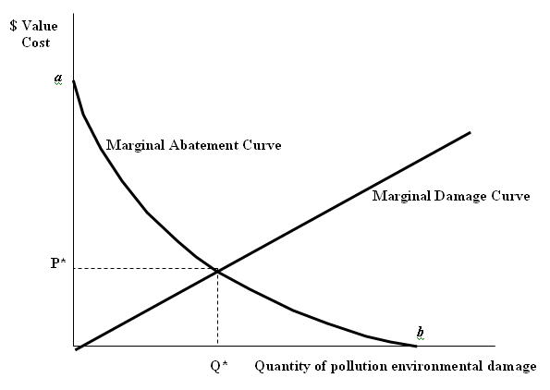

- Marginal Damage Curve represents the cost to society of each additional unit of pollution or gas

- The damage to society from each additional unit of pollution is increasing

- Marginal Abatement Curve reflects the cost to the society of reducing emissions by an additional unit

- The least-cost solution for polluting firms is to spend nothing on pollution abatement and produce “b” units of pollution

- If firms are required to install pollution-reducing devices, the cost of reducing one extra unit of pollution will be increasing

- The cost of removing the last unit of pollution is represented by “a”

- The Marginal Abatement Curve shows that the cost of reducing pollution increases (becomes more costly) the lower the level of pollution is

- The intersection of the two curves defines the equilibrium amount of pollution for the economy, Q*

- The equilibrium quantity of pollution is not zero

- At levels above Q*, the cost of reducing the pollution is less than the damage it inflicts. Therefore a net gain accrues to the society by going to Q*

- When reducing pollution at a level below Q*, the cost of reduction is greater than the damage it inflicts. Therefore, there is no net gain to the society by going there

Conclusion 1: An optimal quantity of pollution occurs when the marginal cost of abatement by one additional unit of pollution equals the marginal damage of that unit

Unequal Marginal Abatement Cost Curves for Different Polluters

- Assumptions:

- Firm “B” has higher Marg. Abatement Cost than Firm “A” at every level of pollution activity Q

- Society has a target level of pollution for each firm at Q* (which is a fraction of the total society’s Q*)

- Marginal cost of Damage by pollution that is accepted by the society is at P*

- Question: How much pollution should each firm emit if the objective is to keep total abatement costs associated with the target Q* at the lowest possible level?

- If both firms produce at the Q* pollution level, the solution might not be efficient

- If Firm “A” moved leftward from Q* (produced less pollution) it would be beneficial to society as the abatement cost would be less than the cost of the damage that the last pollution unit had produced

- The additional benefit to the society from lower pollution would be equal to the area KNR

- If Firm “B” moved rightward from Q* (produced more pollution) it would be beneficial to society in terms of resource savings

- The additional benefit to the society from resource cost savings would be equal to the area MNL

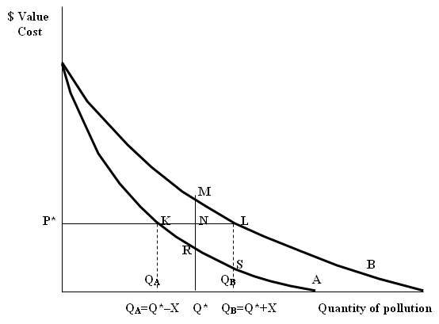

- At the pollution levels of Q_{A} for Firm “A” and Q_{B} for Firm “B” the two firms pay the same marginal abatement cost at P*

- As the two firms move away from Q*, Firm “A” incurs additional costs of Q*RKQ_{A}, while Firm “B” reduces its total cost by Q*MLQ_{B}. The net social gain is the difference between these two amounts, that is the sum of the two triangles, KNR and MNL.

Conclusion 2: To attain a target level of pollution at a minimum resource cost, the marginal abatement cost of each polluter should be the same. Therefore, controls that impose same emission limits on all firms may not be the least costly manner of achieving a target level of pollution

Incentive Mechanism 1: Pollution Permits

- A system of tradable permits, frequently called “cap and trade” system because it limits or caps the total permissible emissions, while at the same time it allows a market in permits to develop

- If the government grants pollution permits to each firm to emit up to a specific amount, (a fraction of the total pollution Q*) and then the firms are allowed to trade
these permits, then it should be possible for all firms to gain from the trade
- If the price of the permit is agreed to P*, then some firms (like “A”) could reduce their pollution at a level lower than the allowable limit and sell their pollution permits at P* to other firms “B”

- The sellers of permits would gain KNR, while the buyers of permits would also gain MNL (while increasing their pollution with the help of the permits)

Conclusion 3: Tradable pollution permits can attain a pollution target in an efficient manner

Incentive Mechanism 2: Corrective Taxes

- Pollution corrective taxes are generally called Pigovian Taxes

- Arthur Pigou had advocated taxing activities that cause externalities

- If the government established the P* as a tax on each unit of pollution, then, in deciding which level of pollution to produce, each firm would take this tax into account to find its equilibrium level with its own Marginal Abatement Cost Curve

- Some firms would find themselves in the position of Firm “A” and some in that of Firm “B”

Conclusion 4: Corrective taxes, if set at the appropriate level, can induce an efficient pollution reduction or emission

Taxes or Permits?

- Taxes differ from permits because taxes generate revenues while permits (allocated for free to the total amount of desired pollution Q*) do not.
  - Economists suggest that permits should be auctioned in the start-up phase

- Setting a tax requires knowledge of the cost and damage functions

- Despite the cost of monitoring and the incomplete information regarding costs of pollution, governments should act on something that is of crucial importance for future generations

- Direct controls may be fruitful in certain cases, while market-based tools are efficient when sufficient information is available

The Kaya identity:
The Kaya identity is an equation relating factors that determine the level of human impact on climate, in the form of emissions of the greenhouse gas carbon dioxide. This identity states that total emission level can be expressed as the product of four inputs: human population, GDP per capita, energy intensity (per unit of GDP), and carbon intensity (emissions per unit of energy consumed).^{[1]} This equation is both simple and tricky, as it can be reduced to only two terms, but it is developed so that the carbon emission calculation becomes easy, as per the available data, or generally in which format the data is available.

Canada immigration:
The point system and the 4 immigrant categories

- The most significant policy measure was implemented in 1967, following the development of the new philosophy in the early 1960s.

- This new philosophy was much influenced by the spirit of anti-discrimination of the Kennedy-Johnson years in the U.S. Henceforth, migrants would be classified into four broad groups:
  - independent/economic applicants, whose merits would be based on a points test;
  - close family members (family reunions)
  - assisted relatives;
    - Assisted relatives are, for example, cousins of earlier migrants who take the points test, but receive extra points because they have some family already in Canada to help them with the transition.
  - refugees.

- The points system is primarily based upon
- age,
- language proficiency,
- education, and
- work experience

The Categories of Immigrants:

Since 2002, the immigration program, based on IRPA and its regulations, defines three basic categories of permanent residents, which correspond to its objectives:

- The family class

This is comprised of foreign nationals sponsored by close relatives or family members in Canada and includes spouses, partners, dependent children, parents, grandparents, and other close relatives, within the goal to facilitate the reunification of families. Sponsors must demonstrate the ability to take financial responsibility for their family members with a sponsorship undertaking for a specified time period. In 2009, CIC initiated the process to make regulatory changes to refuse cases of suspected marriage fraud.

- Economic Immigrants

They are permanent residents selected for their skills and ability to contribute to Canada’s economy, including the following sub-categories

- Skilled workers are immigrants who are able to demonstrate their ability to enter the labour market and successfully establish in Canada by meeting federal and Quebec selection criteria regarding education, English or French language abilities, and work experience

ii. Business immigrants are permanent residents selected on the basis of their potential to build innovative companies that can compete on a global scale and create jobs, provided that they could get support for their start-up from a designated Canadian organization including venture capital funds, angels, and incubators. The old programs of immigrant investors were eliminated as of June 19, 2014.

- Provincial and territorial nominees are permanent residents designated by provinces and territories who will meet their local needs, who are not subject to the skilled worker selection grid for eligibility.

iv. Live-in caregivers are temporary foreign workers who are qualified to provide care for children, sick or elderly people, or persons with a disability. They are granted temporary resident status and a work permit and, after two years, are eligible to apply for permanent resident status

  - Canadian Experience Class covers temporary foreign workers or foreign students who have graduated in Canada and have the qualities to make a successful transition from temporary to permanent residence, since they are familiar with the Canadian society, they have knowledge of English or French and qualifying work experience, and can contribute to the Canadian economy

- Protected Persons

According to the United Nations High Commissioner for Refugees, there are currently over 8.4 million refugees within the meaning of the Convention on the Status of Refugees ("Convention refugees") that was adopted in 1951.

Canada is a prime destination for those seeking refuge and asylum. Since 1959, it is estimated that Canada has accepted over 850 thousand refugees from around the world. In recent years, however, Canada has tightened its admission criteria to allow only true Convention refugees.

Refugees include government-assisted refugees, privately sponsored refugees, refugees landed in Canada and dependents of refugees landed in Canada living abroad
  - Government-assisted refugees are permanent residents in the refugee category who are selected abroad for resettlement in Canada as Convention refugees.

- Other Immigrants

Humanitarian and compassionate cases involve permanent residents included in the other immigrant category who would not otherwise qualify in any category, in cases where there are strong humanitarian and compassionate considerations, or for public policy reasons.

Temporary Residents

- Foreign students are temporary residents in Canada principally to study in the observed calendar year.

Foreign workers are temporary residents in Canada principally to work in the observed calendar year

Evolution of the Point System for Independent Skilled Workers

- The points system that Canada has used to evaluate potential migrants has undergone changes in the distribution of points among the different categories depending on the policy emphasis.

- The current focus is more on the quality and adaptability of workers rather than on their specific skills. The following are the changes brought to the point system in 2013:

LANGUAGE: Requiring a minimum level of language proficiency (28 points max.)

  - Canadian research has consistently shown that language proficiency is the single most important factor in gaining better rates of employment, appropriate employment and higher earnings.
  - A minimum language requirement is established
  - The maximum number of points awarded is significantly increased for an applicant’s proficiency in English or French to 28.
  - Language ability is now the most important factor on the grid in recognition of its critical importance in ensuring successful outcomes.

EDUCATION: New Educational Credential Assessment (25 points max.)

  - Previously, points were awarded based on the applicant’s educational credentials in their home country and the years of education required to obtain the credential, without taking into account its comparative value when assessed against Canadian educational credentials.
  - The new regulations require a mandatory assessment of foreign educational credentials to determine their equivalency to a completed educational credential in Canada (which will also help to screen out fraudulent credentials)
  - Education points will be awarded based on the value of the educational credentials in Canada.

WORK EXPERIENCE: Redirecting points to other factors (15 points max.)

  - Foreign work experience is a weak predictor of success in the Canadian labour market and, as a result, the total number of points for work experience is reduced from 21 to 15
  - The years of experience required to get full points are increased.

AGE: More emphasis on younger workers (12 points max.)

  - Studies show that younger immigrants integrate more rapidly into the labour market and spend a greater number of years contributing to Canada’s economy.
  - The revised selection grid benefits younger immigrants by awarding a maximum of 12 points up to age 35, with diminishing points awarded from 35 to age 46.
  - There will be no points given after age 46; however, workers aged 47 or older will continue to be eligible for the Program.

ARRANGED EMPLOYMENT: Streamlining the process and reducing the potential for fraudulent job offers (10 points max.)

  - The FSWP evaluation showed that people who immigrate with a valid job offer do very well in Canada, earning 79% more in the first three years after arrival than people without arranged employment.
  - A more rigorous up-front assessment of the employer and job offer is established to curb the potential for fraud.
    - Employers are required to get a Labour Market Opinion (LMO), issued by Human Resources Development Canada which will verify that there is a need in the Canadian labour market for this type of worker and that the employer has tried to hire a Canadian or permanent resident first.
    - Once employers have established this labour market need, they can use the LMO to bring the worker in quickly on a work permit while the worker’s application to immigrate permanently is being processed.

ADAPTABILITY: Changes to reflect factors that help promote integration (10 points max.)

  - Changes to the adaptability criteria are brought to emphasize factors that are shown to have a positive impact on an immigrant and their family’s integration.
    - Increased points for previous work experience in Canada for the principal applicant.
    - Points for previous study in Canada will remain the same.
    - Replace the points factor for a spouse’s education with points for a spouse’s language proficiency to improve the likelihood of a family’s successful integration.
    - The points for previous spousal study and/or work in Canada, and having relatives in Canada will remain unchanged.
    - Applicants will have more opportunities overall to earn adaptability points, although the total points will remain the same.

Chapter 82

Canada promotes Multiculturalism, which we are a bilingual country but a country with no single cultural.
Multiculturalism in Canada is the sense of an equal celebration of racial, religious and cultural backgrounds. Multiculturalism policy was officially adopted by the Canadian government during the 1970s and 1980s.^{[1]} The Canadian federal government has been described as the instigator ofmulticulturalism as an ideology because of its public emphasis on the social importance of immigration.^{[2]} The 1960s Royal Commission on Bilingualism and Biculturalism is often referred to as the origin of modern political awareness of multiculturalism.^{[3]}
Canadians have used the term "multiculturalism" both descriptively (as a sociological fact) and prescriptively (as a political ideology).^{[4]} In the first sense "multiculturalism" is a description of the many different religious traditions and cultural influences that in their unity and coexistence in Canada make up Canadian culture.^{[4]} The nation consists of people from a multitude of racial, religious and cultural backgrounds and is open to cultural pluralism.^{[5]} Canada has experienced different waves of immigration since the nineteenth century, and by the 1980s almost 40 percent of the population were of neither British nor French origins (the two largest groups, and among the oldest).^{[6]} In the past, the relationship between the British and the French has been given a lot of importance in Canada's history. By the early twenty-first century, people from outside British and French heritage composed the majority of the population, with an increasing percentage of individuals who self identify as "visible minorities".
Multiculturalism is reflected in the law through the Canadian Multiculturalism Act and section 27 of the Canadian Charter of Rights and Freedoms and is administered by the Department of Canadian Heritage. The Broadcasting Act of 1991 asserts the Canadian broadcasting system should reflect the diversity of cultures in the country. Despite the official policies, segments of the Canadian population are critical of the concept(s) of a cultural mosaicand implementation(s) of multiculturalism legislation.^{[7]} Quebec's ideology differs from that of the other provinces in that its official policies focus oninterculturalism.^{[8]}

Further information: Quebec Charter of Human Rights and Freedoms
Quebec differs from the rest of the nine provinces in that its policy focuses on "interculturalism"- rather than multiculturalism,^{[64][65]} where diversity is strongly encouraged,^{[66]} but only under the notion that it is within the framework that establishes French as the public language.^{[67]} Immigrant children must attend French language schools; most signage in English is banned.^{[57]} In 1990, Quebec released a White paper called Lets Build Quebec Together: A Policy Statement on Integration and Immigration which reinforced three main points:^{[68]}
- Quebec is a French-speaking society
- Quebec is a democratic society in which everyone is expected to contribute to public life
- Quebec is a pluralistic society that respects the diversity of various cultures from within a democratic framework
In 2005, Quebec passed legislation to develop the Ministry of Immigration and Cultural Communities, their functions were:^{[57]}
- to support cultural communities in order to facilitate their full participation in Quebec society
- to foster openness to pluralism; and
- to foster closer intercultural relations among the people of Quebec.

92

Latest Developments

Future Earth

- Montreal is the new home of an international group, Future Earth, dedicated to research on global climate change. The group will get a budget of five million dollars over five years. The Quebec government will kick in three million dollars.

- The Montreal-based secretariat will oversee the activities of the other sister hubs in Paris, Tokyo, Stockholm and Boulder (Colorado). Each hub will employ between five to eight people but the secretariat is made up of thousands of scientists in countries around the world.

- Future Earth in Montreal will be headed by a former professor at Concordia University, Dr. Paul Shrivastava, who was also director of the David O'Brien Centre for Sustainable Enterprise at the John Molson School of Business

- The initiative is supported by several international research councils, including the Fonds de recherche du Québec, and United Nations organizations, including the United Nations Educational, Scientific and Cultural Organization (UNESCO).

- Concordia has committed to house the international headquarters of Future Earth and its global secretariat

National Environment Policy (?)

- A recent meeting of the Council of Federation showed that it is doubtful whether the provinces could agree on a “national environmental policy”, given their structural differences in energy sources and environment treatment models followed.
  - Alberta may meet 2020 target not because of policy change but because of lower production following the drop in oil prices
  - Saskatchewan is in favour of using Carbon Capture Storage technology, a process whereby CO₂ emissions are captured from large industrial facilities before being emitted to the atmosphere, transported through pipelines, and permanently stored in deep, secure underground formations
  - Ontario and Quebec signed a pact to expand trade in electricity. Furthermore, Ontario will join the cap-and-trade scheme of Quebec with California.

- Québec adopted Bill 42 An Act to Amend the Environment Quality Act and Other Legislative Provisions in Relation to Climate Change in 2009, which is the latest in a series of such plans that were first initiated in 1995. Bill 42 was followed by regulations for implementing the emissions trading system, as
  - Regulation Respecting a Cap-and-Trade System for Greenhouse Gas Emission Allowances in 2011 (“Québec Cap-and-Trade Regulation”),
  - Regulation Respecting the Delegation of Management of Certain Parts of a Cap-and-Trade System for Greenhouse Gas Emission Allowances adopted in 2012 (“Québec Cap-and-Trade Management Regulation”) and
  - Regulation respecting the determination of annual caps on greenhouse gas emission units relating to the cap-and-trade system for greenhouse gas emission allowances for the 2013-2020 period (“Québec Allowance Determination Regulation”). That same year, Québec launched its 2013-2020 Climate Change Action Plan

- Each jurisdiction’s cap-and-trade program, is divided into three commitment periods.
  - During the first commitment period, from 2013-2014, the emissions cap will address only emissions in the energy and industrial sectors—accounting for approximately 36% and 29% of total emissions in California and Québec, respectively.
  - From 2013 through 2014, the cap decreases by about 2% annually in both jurisdictions. At the beginning of the second compliance period, coverage expands to include the transport sector in 2015, at which point approximately 87% and 77% of emissions will be covered in each respective jurisdiction.
  - Between 2015 and 2020, the cap reduces at a rate of approximately 3% and 4% per year in California and Québec, respectively.

Ch 103
a. The Cost of Electricity

- The government has established the Régie de l’énergie that sets electricity and natural gas rates to reconcile the public interest, consumer protection, and fair treatment of the transmission and distribution utility.

- The Régie is funded according to the “user-payer” principle, which guarantees financial autonomy in relation to the government.

- The Régie is a link in the process of setting electricity rates – it gives an opinion of requests by Hydro-Quebec (which is responsible for requesting systematic reviews of electricity rates)

- The Régie has exclusive jurisdiction to set, following public hearings, the rates and the conditions of the transmission and distribution of electricity, which is the typical process to be followed by a North-American distribution monopoly

- The decision on rates is usually final and without appeal (not even the government is empowered to either review or amend it and even less to cancel it).

- The rates set by the Régie are based on the following costs:

  - The cost of providing service (the cost of the electricity that Hydro-Quebec Distribution purchases from Hydro-Quebec Production or other suppliers). This has two components
    - The cost of providing heritage pool electricity as defined by the Act, i.e. a volume of 165 TWh provided by Hydro-Quebec Production at a cost of 2.79 cents/kWh
    - The cost of providing electricity that Hydro-Quebec Distribution must acquire – in addition to that of heritage – in order to satisfy market requirements. This is the outcome of a tendering process that defines the quantity and price of purchase

  - The electricity transmission costs that Hydro-Quebec Distribution must pay to Hydro-Quebec TransÉnergie to cover transmission service delivery and a fair remuneration of assets used

  - The cost of distributing electricity to consumers, covering payroll, amortization of facilities, and taxes paid

  - A fair remuneration on the assets of Hydro-Quebec Distribution, i.e. a return on the capital invested by the State in its capacity as shareholder. The Régie defines a return that reflects the interest rate on the debt (for borrowed capital) and the rate of return on bank equity (for equity capital), considering a certain capitalization rate assumed by the Régie

Findings

- Unlike the cost of heritage pool electricity that is stable, the cost of post-heritage pool electricity varies depending on the outcome of the invitations to tender..

- Hydro-Quebec was authorized to raise its rates by 2.9% in 2008.

- The process for the setting of rates is depoliticized enough, transparent, considering actual costs, and generally deemed fair.

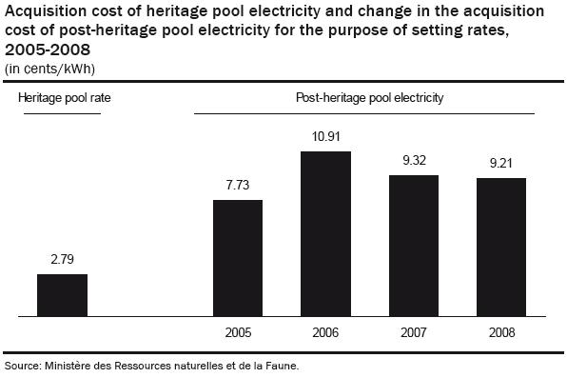

- The existing legislation prevents the Régie from setting a MC or opportunity cost price, even though the quasi legal procedure (based on public hearings and no government interference) is very good

- The government can influence the Régie before it hands down its decision with respect to price changes in such a way as to dictate certain parameters in it. The government is empowered to doing so by means of directives

- Political pressure is still present in defining electricity rates, as this comes from consumers who are also voters.

  - For example, in 2007, Hydro-Quebec presented what was needed in terms of rate increases on the basis of costs by user as 4.4% increase for consumers (who are more costly to serve) and 1.4% increase for big power users, for an average of 2.9%. The Régie approved a uniform rate increase of 2.9%

- The electricity distributed in Québec is not sold at its true price when account is taken of the increasing marginal cost of generation of new projects and the value of this electricity on export markets.

- In 2004, per capita electricity consumption in Québec was among the highest in the world and was virtually 50% higher than the Canadian figure – though we must recognize that we sell a lot at a low rate to industrial users – Aluminum producers in particular. But the situation in the residential sector also places us as an outlier

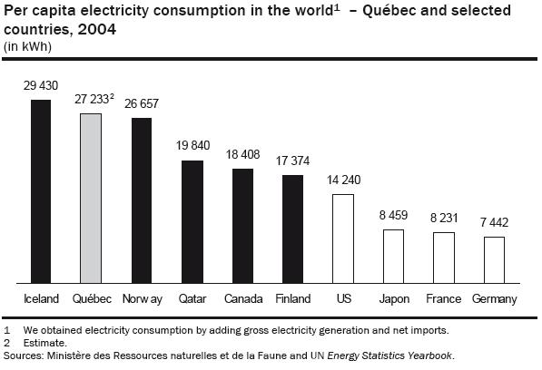

- The high consumption can be the result of very low pricing.

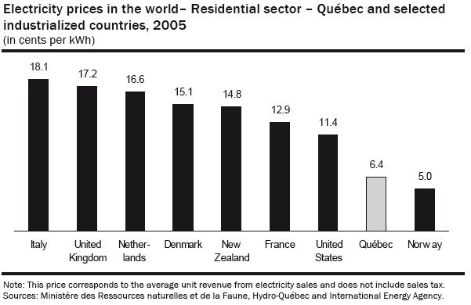

- In a North American context, we have virtually the lowest rates anywhere

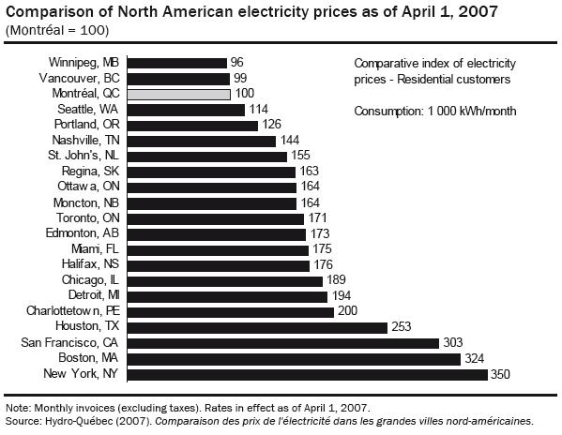

- The electricity rates applied in Québec send a poor price signal, for two reasons.

  - First, since rates are not defined in light of the marginal cost, they do not sufficiently take into account the rising cost of generating hydroelectric power. (average cost of 2.79 cents/KWH for the heritage electricity as compared to the average cost of 7.20 cents/KWH for electricity from new sources).

  - Second, the price of the electricity sold in Québec does not take into account its opportunity cost, i.e. the price at which the electricity could be sold on external markets.

- So who gains most from this under-pricing?

  - The Quebec consumers of electricity benefit at the expense of the Quebec shareholders of Hydro-Quebec (all of Quebecers-taxpayers).
  - Comparing Alberta and Quebec, the price that Albertans pay for their national resource, oil, is higher than the Canadian average, while in Quebec the rates that we pay for our national resource (electricity) are a lot lower than the Canadian average.

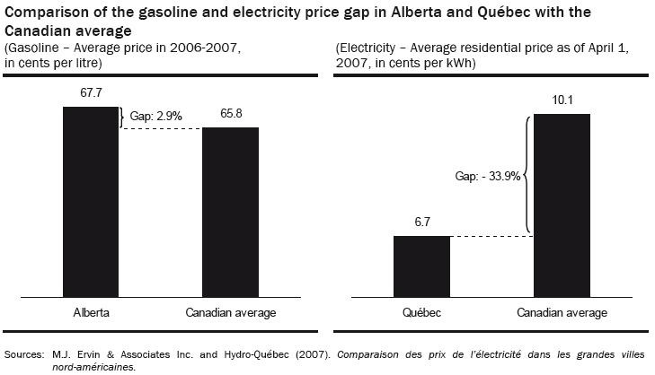

  - This economic rent is of greater benefit to households that consume more electricity.
  - There is a direct correlation between consumption and income level. Task Force calculations yield the following ‘rents’ for households of different income level:

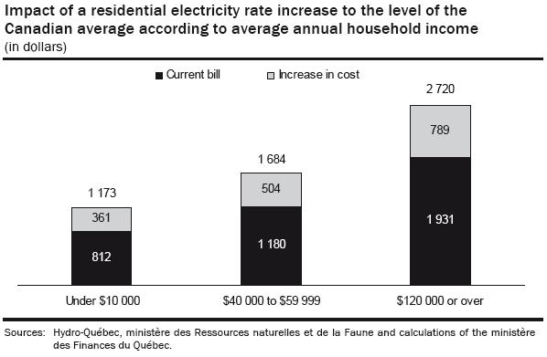

- Setting electricity rates at the average Canadian price would increase by just over $2 billion Hydro-Québec’s revenues on the Québec market.

- The higher rates would lead to an estimated 3.6-TWh reduction in electricity consumption that could be sold on export markets, where it would generate an estimated $300 million in revenues.

- Setting electricity rates at a price corresponding to the Canadian average would transfer a rent of $2.3 billion paid until now to consumers to the utility’s shareholder, i.e. the taxpayer.

- Setting the Quebec rate at the average Canadian rate would still leave it very low by standards of other regions in N America.

Recommendations

- The Task Force recommends bringing the price of electricity up to cover its cost

- The government should compensate low-income households for the price increases

- The additional funds from the price increase should be placed in a fund “Fonds the pérennité du patrimoine” from where monies could be earmarked for the development of new energy sources.

b. University tuition fees

- It has been thought that in the information age, society could not afford to have financial obstacles to learning. Thus, it was deemed necessary to keep university fees low.

- A consequence of failing to adjust university tuition fees on a regular basis, if only to keep up with the CPI, is that abrupt changes are called for from time to time, as shown in the graph below.
- In the past 40 years there has been a succession of freezes and abrupt increases in keeping with the accumulated shortfall relative to actual costs and fees collected by the universities

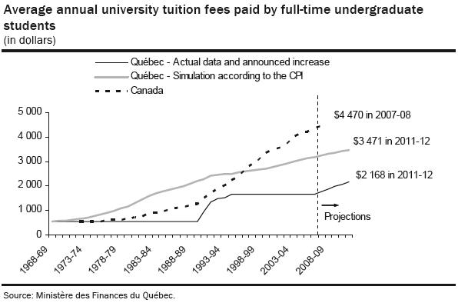

- In spite of the low university tuition fees, attendance in Quebec is one of the lowest in Canada.

- What is important to note is that when a substantial increase in fees (tripling) was brought in Quebec between 1988-89 and 1993-94, full-time equivalent attendance actually increased by 9.4%.
- Similar trend has been observed in Ontario.

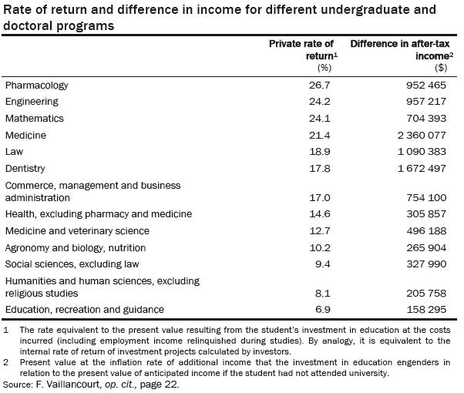

- Statistics Canada has reported that the university attendance by students from low-income families (less than $25,000) has remained stable overall in Canada in recent years in spite of increases in university tuition fees everywhere in Canada except Quebec.

- Numerous studies have confirmed the importance of other factors than the level of tuition fees in the decision about university attendance. Most important among them are the parents’ socioeconomic status and expectations, the quality of schools attended, and previous academic achievement.

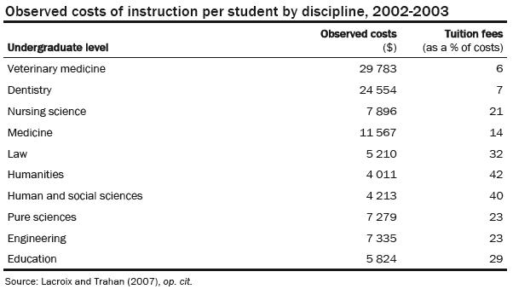

- Students who have the intellectual capacity and the desire to pursue university studies get high returns on their investment in higher education (including costs and forgone income). Therefore, it is logical that they should be required to pay more for their education.

- In addition to being low, the university tuition fees in Quebec are also uniform across disciplines. This is unique in Canada and rare in the rest of the world, while it is in general recognized that costs of training in different disciplines are not the same.

- Uniformity in tuition fees across disciplines is unfair in terms of redistributing resources and subsidizing more heavily certain disciplines than others, certainly the most profitable ones.

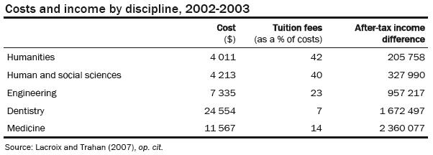

- If Quebec university students paid tuition fees equal to the Canadian average, Quebec would collect an additional $415 million.

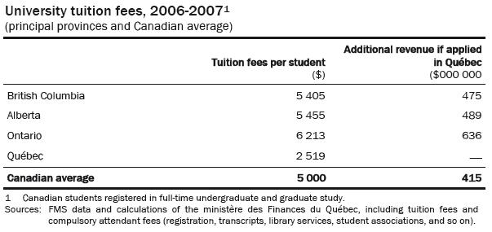

Recommendations

With respect to university fees, the task force recommends the following:

- That tuition fees be raised gradually to the Canadian average, to better reflect the economic profitability of university education.

- That a corresponding adjustment be made to student loans and bursaries.

- That a differentiation be made in the fees among disciplines to better reflect differences in the cost of training and subsequent returns.

- That an adjustment be made to the university subsidies, along with the changes in fees, with an annual indexation thereafter.

- That regular follow-up is undertaken in respect to the relative position of Quebec universities in relation to the universities in the rest of Canada.

- That a predetermined amount from the increases in fees be earmarked by the universities to offer bursaries to students of under-privileged background.

- That a serious examination be made for the implementation of student loan repayment system according to income.

Changes in University Tuition Fees Brought with the 2011-2012 Budget

- Presently, Quebec students pay the lowest tuition fees in the country

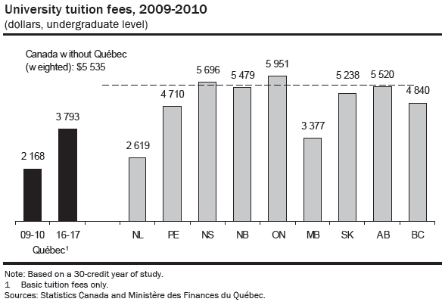

- The government tried unsuccessfully to raise tuition fees as of fall 2012 by $325 a year until 2016-2017, to bring them to the same level as in 1968, while taking inflation into account.

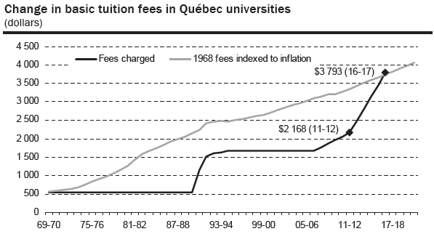

- 35% of the revenue from the tuition fee increase would be returned to students through the student financial assistance program.

- After the rise in tuition fees, Quebec would still be at the bottom in terms of university costs

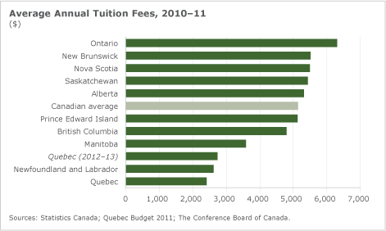

- Canadian students who do not reside in Québec pay $5,668 more and foreign students between $11,984 and $14,879 more. A new fee policy would take into account the current raise in basic fees.

c. Childcare

- In the case of parental insurance, the insured parties pay almost all of the cost of the insurance.

- As for childcare expenses, user fees account for only 16% of the cost of the service.

- The Québec government implemented the educational childcare services program in 1997. At the outset, the network comprised nearly 75 000 childcare spaces. The network was intended to provide childcare spaces at a low rate for the parents of children less than 5 years of age explicitly to:
  - facilitate the reconciliation of parental and occupational responsibilities;
  - foster children’s psycho-educational development and equal opportunities.

- Since 1997, the number of spaces has risen steadily. As of March 31, 2007, the government was subsidizing nearly 200 000 reduced-contribution spaces, nearly 35 000 more than in 2003. With the increase in the number of births recorded since 2006 and to satisfy demand from parents, the government intends to create, by 2012, 20 000 new childcare spaces.

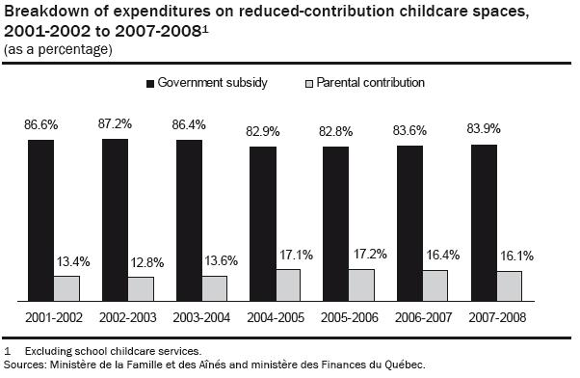

- Since the network’s inception, there has been only one increase in the childcare user fee, from $5 to $7 a day in January 2004.

- Support for childcare services is a popular policy. It is also a costly one. The adjustment of childcare expenses in 2004 only temporarily reduced the share of the program’s costs covered by the Consolidated Revenue Fund.

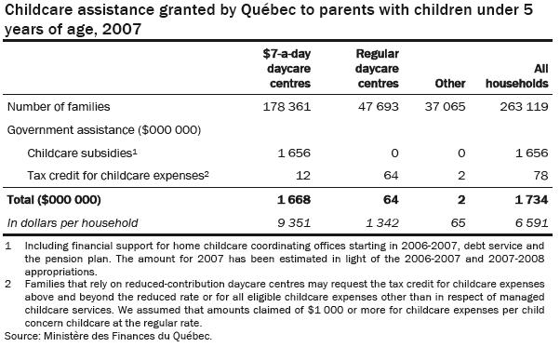

- The government funds 84% of the programs expenses.

- The budget earmarked for the program of reduced-contribution childcare for 2007-08 was $1.7 bn.

- The average cost per space to the government was estimated at $31 per day in 2007-2008. That is, $42 for childcare centre, $20 in a home childcare service, and $35 in a private daycare centre.

The Program’s Uneven Outcomes

- A little more than 178,000 families benefit from an average subsidy of $9, 351 per household irrespective of their income level.

- Some 48 000 families use daycare services at the regular rate, while benefitting from $64 million in tax assistance, equivalent to $1 342 per household, through the tax credit for childcare expenses.

- Many parents do not have access to childcare services because it difficult to satisfy all needs.

- Parents who choose not to rely on childcare services (preferring to look after their children themselves) receive less support for this purpose than the subsidy paid for childcare services.

- The childcare service program is applied independently of the parents’ income. Thus, parents with high incomes that could pay a large share of user fees benefit from it.

- Certain studies have established a positive link between the childcare service funding policy and the return by mothers to the labour market, especially the least-educated mothers.

- The impact on children’s cognitive development of childcare services has been the subject of numerous studies whose findings vary widely, which have fuelled highly divergent opinions.

- While the childcare service support program is a worthwhile, relevant means of responding to current demographic trends and lifestyle habits, it has a very high cost. We must be fully aware of it so that society’s collective choice to implement it is fully, transparently assumed.

Recommendations

- It seems obvious that, in the long term, the childcare service funding policy must be reviewed, especially because of its cost and the question of fairness mentioned earlier.

- A bigger financial contribution from those who benefit directly from the service could allow for the creation of additional spaces.

- The level of the basic contribution and the adjustment of parents’ contribution according to household income should also be examined

Ch 111
Definitions of Pension Plans

Retirement Plan
- Any program designed to provide income in old age.

Pension Plan
- A type of retirement plan, usually tax exempt, wherein an employer makes contributions toward a pool of funds set aside for an employee's future benefit.
- The pool of funds is then invested on the employee's behalf, allowing the employee to receive benefits upon retirement

Personal Pension Plan
- This is a retirement program that is not sponsored by an employer or government entity

Private Pension Plan
- This term is used to distinguish private versus public sector plans or employer sponsored versus government

Fully Funded Plan
- A pension plan that has sufficient assets needed to be able to provide for all accrued benefits (current and future benefits payments to pensioners)
- A plan's administrator is able to predict the amount of funds that will be needed on a yearly basis; a determination can be made regarding the financial health of the pension plan.
- The plan depends on capital contributions and returns on its investments to achieve financial stability (ability to make payments).
- Companies distribute annual benefits statements specifying whether or not the pension plan is fully funded. As such, employees can determine the financial strength of the plan

Pay-As-You-Go (PAYG) Pension Plan – Unfunded
- It means that no money is invested for the plan
- As retiree benefits become due, the plan sponsor makes the payments directly. No assets are held so if the plan sponsor goes bankrupt, the retirees and any other participants who are due benefits stand in line with the other creditors.
- An unfunded pension carries higher risk for both the pensioner and the sponsor
- Current employee contributions to an unfunded pension plan may not ensure their own pensions or retirement
- It is an illegal funding method (Ponzi scheme) for broad based private pension plans in the US.
- Unfunded pension plan uses actuarial assumptions to determine the periodic contributions it makes to the plan

Defined-Benefit Plan (DB)
- A retirement plan which is designed to provide a set benefit at retirement, regardless of the performance of the underlying investment pool
- Contributions are typically adjusted annually to ensure that the benefit is eventually funded
- It is an employer-sponsored retirement plan
- Investment risk and portfolio management are entirely under the control of the company
- There are restrictions on when and how you can withdraw these funds without penalties.
- Employee payouts are not dependent on the return of the invested funds. Therefore, employers will need to dip into the companies earnings in the event that the returns from the investments devoted to funding the employee's retirement result in a funding shortfall
- Employee benefits are determined by more personalized factors, such as salary history and duration of employment
- Defined benefit plans are more difficult to fund in advance because there are so many variables in computing the funding necessary to produce the benefit

Defined-Contribution Plan or Defined-Cost Plan (DC)
- A retirement plan which is designed to provide a retirement benefit based on a set contribution amount or percentage of money that is set aside each year by a company for the benefit of the employee.
- There are restrictions as to when and how these funds can be withdrawn without penalties.
- There is no way to know how much the plan will ultimately give the employee upon retiring. The ultimate benefit at retirement is the accumulated contributions with interest
- The amount contributed is fixed, but the benefit is not

Advanced Funded Pension Plan
- They are generally defined contribution plans, and are fully funded.
- They can be funded by the employer alone, or by some combination of the employer and the employee.
- This is a pension plan that is funded concurrently with the employee's accrued benefits such that the funds are set aside well before the employee's retirement.

Underfunded pension Plan

- There are several reasons why an underfunded pension plan may exist or why one may become underfunded.
  - Companies may dip in the accumulated funds as an easy way to finance operations
  - Companies may take contribution “holidays” in good times which eventually proved wrong
  - Many pension plans invest in stock, and if stock investments result in huge losses, this can mean a plan becomes underfunded
  - Pensions that are in savings accounts may not be accumulating the interest they need to be fully funded.
  - Mergers might create an underfunded pension plan
  - Bankruptcy can completely eliminate a plan. Current US laws favor paying debtors before employees who are due a pension

The Canada/Quebec Pension Plans

Introduction

- The Canada Pension Plan /Quebec Pension Plan was established to provide working Canadians with a foundation on which to build their retirement income.

- The CPP was a joint creation of the federal government and the nine provinces who participate in it with the exception of Quebec that created an identical instrument, the QPP.

- As the second tier of Canada's retirement income system, the CPP provides a retirement pension, disability benefits, benefits for survivors, children's benefits and a death benefit.

- Changes to benefit levels, contribution rates, CPP financing and investment policy require formal approval by Parliament, and two-thirds of the provinces with two-thirds of the population

Nature of Canada’s Pension System

- The pay-as-you-go system was chosen in the 1960s because it meant that an extra generation could be brought into its orbit without, it was believed, hurting any subsequent generation

- If the generation of workers in the 1960s agreed to essentially hand over some of their earnings to those who were retired, in return for a promise that the following generation would do the same for them, then they would be no worse off.

- This type of agreement is called a “Ponzi Game”, or in street language a “chain letter”

- Its advantage is that, provided the plan continues into the indefinite future, an additional generation of retired individuals can be brought into the system - something that could not have been achieved if the system were a form of compulsory RRSP.

- In sum then, the government chooses to invest primarily in the future earnings of workers rather than in bonds or stocks as a means of financing the pensions of future retirees.

Other Old Age Security Benefits

- The OAS program is the first tier of Canada's retirement income system and is financed from federal tax revenues.

- The Old Age Security (OAS) program provides a modest pension at age 65 for people who have lived in Canada for at least 10 years after the age of 18. It is a monthly payment available to all residents of Canada who are 65 or older and who meet the residence requirements.

- Low-income seniors may be eligible for other benefits as early as age 60.

- The beneficiary’s employment history is not a factor in determining eligibility, as one can receive the OAS pension even if he/she has never worked or is still working

- The Old Age Security pension is considered taxable income and is subject to a recovery tax if the recipient’s individual net annual income is higher than the net world income threshold set for the year

- The Guaranteed Income Supplement (GIS) provides a monthly non-taxable benefit to Old Age Security (OAS) recipients who have a low income and are living in Canada

- The Allowance is available to 60 to 64 year-old low-income spouses or common-law partners of OAS pensioners who receive the GIS

- The Allowance for the survivor is available to low-income widowed spouses or common-law partners between the ages of 60 and 64

- Payment amounts for the Old Age Security benefits (Guaranteed Income Supplement, Allowance and Allowance for the Survivor) are based on marital status and level of income. They are not considered taxable income

- The chart below shows the maximum monthly payment amount you could receive for the Old Age Security pension and benefits and the maximum annual income allowed to be eligible for the pension and benefits.

CCP Performance
The ccp are doing well, they are a top 10 in retirement funds in the world. During the 2009 ressesion they lost some money but made ut all back the decemeber the following year. Gained over 18% in 2015 highest ever. There have hgh operating cost. The use to be funded strictly on government and provincial bonds, now they have a wider varsity of real assets, and private and public equidties. The ccp is not runned by the government but by the CPPIP, the are separate from the government but they do report yearly reports.

QPP
They are runned hand in hand with the provincial government.
In 2008 they lost about 40 billion, with a -25% return, the loss was due to 3 factors
1-an error with there ABCP market, they had a big portion but when they did bad they were force to sell other assets that were also low value because everything was low at that time,
2- the drop of the Canadian dollar
the average return in the last 4 years was about 09 percent
the operating expense is low compared to other operating costs,

