Revision of Chapter 4
Sensation and Perception
* Illusion: perception in which the way we perceive a stimulus doesn’t match its physical reality.
* Sensation: detection of physical energy by sense organs, which then send information to the brain.
Transduction: the process by which the nervous system converts an external stimulus, like light or sound, into electrical signals within neurons.
Sense receptor: specialized cell responsible for converting external stimuli into neural activity.
Sensory adaption: activation is greatest when a stimulus is first detected.
Psychophysics: the study of how we perceive sensory stimuli based on
their physical characteristics.
Absolute threshold: lowest level of a stimulus needed for the nervous system to detect a change 50 percent of the time.
JND: just noticeable difference, the smallest change in the intensity
of a stimulus that we can detect.
Weber’s law: there is a constant proportional relationship between the JND and original stimulus intensity.
Signal detection theory: theory regarding how stimuli are detected under different conditions.
Sensory system stick to one sense:
Specific nerve energies: the doctrine which states that even though there are many distinct stimulus energies—like light, sound, or touch---the sensation we experience is determined by the nature of the sense receptor, not the stimulus.
Phosphenes: vivid sensations of light caused by pressure on your eye’s receptor cells.
McGurk effect: demonstrate that we integrate visual and auditory
information when processing spoken language, and
our brain automatically calculate the most probable
sound given the information from the two sources.
Rubber hand illusion: shows how our senses of touch and sight interact to create a false perceptual experience.
Synesthesia: a condition in which people experience cross-model sensations, like hearing sounds when they see colors or even tasting colors.
* Perception: the brain’s interpretation of raw sensory input.
Parallel processing: the ability to attend to many sense modalities simultaneously.
Bottom-up processing: processing in which a whole is constructed from parts.
Top-down processing: conceptually riven processing influenced by beliefs and expectancies.
Perceptual hypotheses
Perceptual set: set formed when expectations influence perceptions.
Perceptual constancy: the process by which we perceive stimuli consistently across varied.
Shape constancy: the tendency to perceive the shape of a rigid
object as constant despite differences in the viewing angle
Size constancy: our ability to perceive objects as the same size
no matter how far away they are from us.
Color constancy: our ability to perceive color consistently across different levels of light.
The role of attention:
Selective attention: process of selecting one sensory channel and ignoring or minimizing others.
Dichotic listening: in which subjects hear two different messages, one delivered to the left ear and one to the right ear.
Cocktail party effect: refers to our ability to pick out an important message, like our name, in a conversation that doesn’t involve us.
Inattentional blindness: failure to detect stimuli that are in plain sight when our attention is focused elsewhere.
Blind problem：one of the great mysteries of psychology.
Subliminal information processing: we process many of the sensory inputs to which we’re exposed unconsciously, and many of hour actions occur with little or no forethought or deliberation.
Subliminal perception: perception below the limen or threshold of conscious awareness.

Subliminal persuasion: subthreshold influences over our votes in elections, product choices, and life decision.
* Light
Electromagnetic energy: energy composed of fluctuating electric and
magnetic waves.
Visible light has a wavelength in the hundreds of nanometers.
* How do we represent the visual realm
Sclera: the white of the eye.
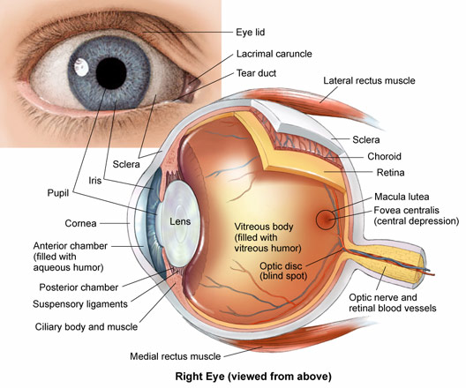
Iris: the colored part of the eye.
Pigment: the chemicals responsible for eye color, only two pigments account for all of the remarkable variations in eye colors, which are melanin, which is brown, and lipochrome,
which is yellowish-brown.
Pupil: a circular hole through which light enters the eye.
Cornea: a curved, transparent layer covering the iris and pupil. It shape bends
incoming light to focus
Incoming visual image at the back of the eye.
Lens: it also bends light, but unlike the cornea, the lens changes its curvature, allowing
us to fine-tune the visual image. The
lens consists of some of the most unusual cells in the body.
Accommodation: the lenses change shape to focus light on the back of
the eyes; in this way, they adapt to different perceived
distances of objects.
Myopia: nearsightedness, result when images are focused in front of the
rear of the eye, due to our cornea being too steep or our eyes being too long.
Hyperopia: farsightedness is an inability to see near objects well, with an intact ability to see far objects clearly.
Presbyopia: the loss of flexibility in the lens due to aging is called
presbyopia.
Retina: membrane at the back of the eye responsible for converting light
Into neural activity.
Fovea: the central part of the retina and is responsible for acuity.
Acuity: sharpness of vision.
The retina contains two types of receptor cells.
The far more plentiful rods: receptor cells in the retina allowing us to see in low levels of light.
Dark adaption: time in dark before rods regain maximum light sensitivity.
The less numerous cones: receptor cells in the retina allowing us to see in color.
The optic nerve: the ganglion cells, nerve that travels from the retina to
the brain.
Blind spot: region of the retina containing no rods and completely devoid
of sense receptors.
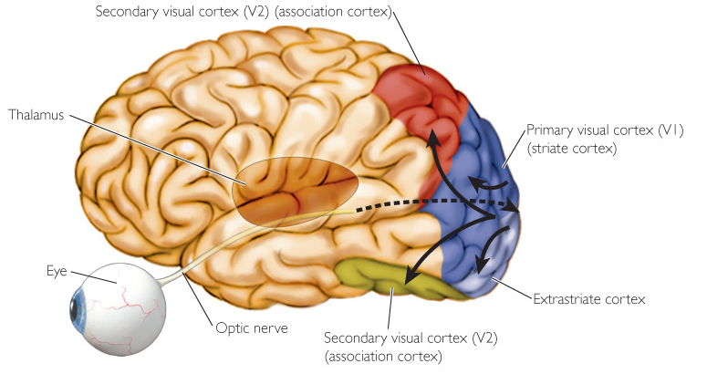
* Visual perception
Visual information from retina travels to the visual thalamus. Next, the visual thalamus sends inputs to
the primary visual cortex (V1), then along two visual pathways to the secondary visual
cortex (V2). One pathway travels to the parietal
lobe, which processes depth and motion, and o one travels to the temporal lobe, which
processes visual form and color.
Feature detection: ability to use certain
minimal patterns to
identify objects.
Gestalt principles: rules governing how we perceive objects as wholes
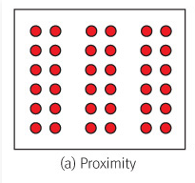
within their overall context.
- Proximity: objects physically close to each other tend to be
perceived as unified whole.
- Similarity: all things being equal, we see similar objects as
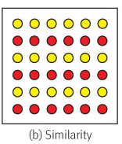
comprising a whole, much more so than dissimilar
objects. If patterns of red circles and yellow circles are randomly mixed, we perceive nothing special. But if the red and yellow circles are lined up horizontally, we perceive separate rows of circles.
- Continuity: we still perceive objects as wholes, even if other
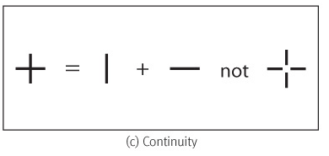
objects block part of them. The Gestalt principle of continuity leads us to perceive the cross as one long vertical line rather than four smaller line segments joining together.
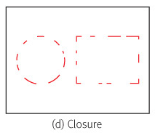
- Closure: when partial visual information is present, our brains fill
in what’s missing. When the missing information is a contour, this principle is essentially the same as subjective contours. This Gestalt principle is the main illusion in the Kanizsa figure.
- Symmetry: we perceive objects that are symmetrically arranged
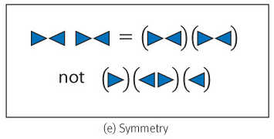
as wholes more often than those that aren’t. Two symmetrical figures tend to be grouped together as a single unit.

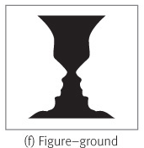
- Figure-ground: perceptually, we make an instantaneous
decision to focus attention on what we believe to be the central figure, and largely ignore what we believe to be the background. We can view some figures, such as Rubin’s vase illusion, in two ways. The vase can be figure, in which case we ignore the background. If we look again, we can see an image in the background: two faces looking at each other.
Bitable image: one picture we can perceive in two ways.
Emergence: a perceptual Gestalt that almost jumps out from page and hits us all at once.
Face recognition:
Lower part of temporal lobe responds to faces. Neurons in the
human hippocampus that fire selectively in response to celebrity
faces.
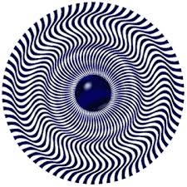
Motion perception: a fundamental aspect of vision, and is present in all visual organisms. Motion is an incredibly important stimulus, for both navigating and interacting with the environment.
Phi phenomenon: the illusory perception of movement produced by the successive flashing of images, like the flashing lights that seem to circle around a movie marquee.
Although we are exquisitely sensitive to moving stimuli, we can
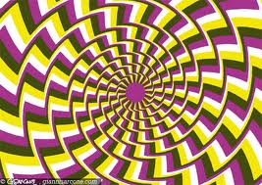
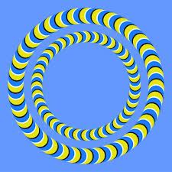
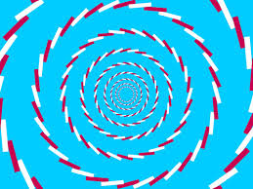
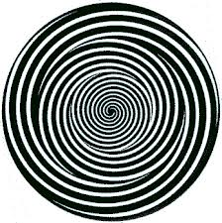
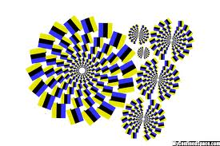
also be fooled into seeing motion when it’s not there.

Color perception: color delights our senses and stir our imagination, but how does the brain perceive color---we use lower pathway leading to the temporal lobe to process color, but it hardly starts there.
Trichromatic theory: proposes that we base our color vision on three primary colors—blue, green, and red. Trichromatic theory dovetails with our having three kinds of cones, each maximally sensitice to different wavelengths of light. Our vision is sensitive to three primary colors of light, and that other colors were combinations of these primaries.
Color blindness: color blindness is most often due to the absence or reduced number of one or more types of cones stemming from genetic abnormalities. Another cause is damage to a brain area related to color vision.
Monochromats: who have only one type of cone and thereby lose all color vision, which are extremely rare, making up only about 0.0007 percent of the population.
Dichromats: who have two types of cons and are missing only one type. Red-green dichromats see considerable color but can’t distinguish reds as well as can people with normal color vision.
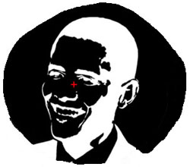
Trichromats: we and our close primate relatives possess three kinds of cones.
Opponent process theory: holds that we perceive colors in terms of three pairs of opponent cells: red or green, blue or green, black or white.
Afterimages: occur when we’ve started at one color for a long time and then look away. We’ll often see a different colored replica of the same image. It turns out that afterimages arise from the visual cortex’s processing of information from our rods and cones.
Depth perception: the ability to see spatial relations in three dimensions; it enables us to reach for a glass and grasp it rather knock it over and spill its content.
Monocular cues: stimuli that enable us to judge depth using only
one eye. We do so rely on pictorial cues to give a sense of what’s located where in stationary scenes.
Six pictorial cues:
- Relative size.
- Texture gradient.
- Interposition.
- Linear perspective.
- Height in plane.
- Light and shadow.
Parallax: One additional monocular cue that’s not pictorial is motion, the ability to judge the distance of moving objects from their speed.
Binocular cues: our visual system is set up so that we view each of our two visual fields with both eyes. We’ll recall that half of the axons in the optic nerve cross to the other side and half stay on the same side before entering the brain. Visual information from both side is sent to neighbouring cells in the visual cortex, where our brains can make comparisons.
Two binocular disparity:
- Binocular disparity:
like the two lenses from a pair of
binoculars, our left and right eyes transmit quite
different information for near objects but see
distant object similarly.
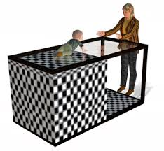
- Binocular convergence:
when we look at nearby
objects, we focus on them reflexively by using our eye muscles to turn our eye inward, a phenomenon called convergence. Our brain are aware of how much our eyes are converging and use this information to estimate distance
Depth perception appears in infancy:
We can judge depth at a very early age (use visual cliff). The visual demonstrates that depth cues present son after birth are probably partly innate, although they surely develop with experience.
When perception deceive us:
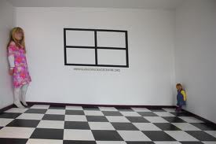
The moon illusion: the moon appears larger when it’s near the horizon than high in the sky.
The startling Ames room illusion: the illusion is due to the relative size principle.
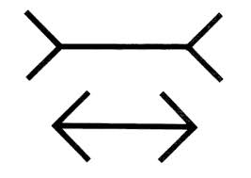
In the miller-lyer illusion: a line of identical length appears longer
when it ends in a set of arrowheads
pointing inward than in a set of
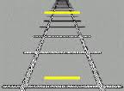
arrowheads pointing outward.
Ponzo illusion: the railroad tracks illusion, converging lines enclose two objects of identical size, leading us to perceive the object closer to the converging lines as larger.
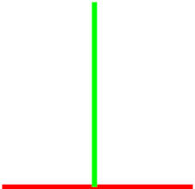
Horizontal-vertical illusion: cause us to perceive the vertical part of an upside-down T as longer than the horizontal part, because the horizontal part is divided in half by the vertical part.

Ebbinghaus-titchener illusion: lead us to perceive a circle as larger when surrounded by smaller circles and smaller when surrounded by larger circle.
* When we can’t see or perceive visually
Blindness: a dramatic reduction in the ability to see, or more specilically,
the presence of vision less than or equal to 20/200 on the familiar Snellen eye chart, on which 20/20 is normal vision. The blind can devote more cortex—somatosensory cortex and visual cortex—to a touch task, such as reading Braille.
Motion blindness: a serious disorder in which patients can’t seamlessly string still images processed by their brains into the perception of ongoing motion.
Visual agnosia: a deficit in perceiving objects.
Blindsight: the remarkable phenomenon in which blind people who’ve experienced damage to a specific area of their cortex can still make correct guesses about the visual appearance of things around them.
* Sound: vibration, a kind of mechanical energy travelling through a medium,
usually air.
Pitch: sounds have pitch, which corresponds to the frequency of the wave. Higher frequency corresponds to higher pitch, lower frequency to lower pitch, measuring pitch in cycles per second, or hertz.
Loudness: the amplitude—or height—of the sound wave corresponds to loudness, measured in decibels (db).
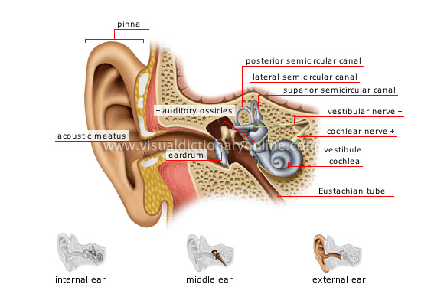
Timbre: refers to the quality or complexity of the sound. Different musical instruments sound different because they differ in timbre, and the same holds for human voices.
* Structure and function of the ear
Out ear:
Pinna: the part of the ear we see,
Namely, its skin and
Cartilage flap.
Ear canal: the simplest function,
It funnels sound
Waves onto the
Eardrum.
Middle ear:
Ossicles: the three tiniest bones in the
Body, named the malleus,
Incus, and stapes.
These bones are
Often referred to
As the hammer, anvil, and stirrup, named after their shapes. These ossicles vibrate at the frequency of the sound wave, transmitting it from the eardrum to the inner ear.
Inner ear:
Cochlea: converts vibration into neural activity.
Organ of corti: tissue containing the hair cells necessary for hearing.
Basilar membrane: membrane supporting the organ of corti and hair cells in the cochlea.
* Auditory perception
Pitch perception: the primary cortex processes different tones in different places.
Place theory: a specific place along the basilar membrane matches a tone with a specific pitch.
Frequency theory: rate at which neurons fire action potentials faithfuly reproduces the pitch.
Localization of sound: When the auditory nerve enters the brain stem, some of its axons connect with cells on the same side of the brain, but rest cross over to the other side of the brain.
Binaural cue: this difference between our ears t localize sound sources.
Echolocation: emit sounds and listen to their echoes to determine their
distance from a wall or barrier. Human echolocation may account for the fact that blind persons can sometimes detect objects a few feet away from them.
* When we can’t hear.
Conductive deafness: due to a malfunctioning of the ear, especially a failure of the eardrum or the ossicles of the inner ear.
Nerve deafness: due ti damage to the auditory nerve.
* Smell and taste: are the chemical senses because we derive these sensory experiences from chemicals in substances.
Smell: also called olfaction, and taste gustation. These senses work hard in hand enhancing our liking of some foods and our disliking of other.
Olfaction: our sense of smell.
Gustation: our sense of taste.
* Odors and flavors: our noses are veritable smell connoisseurs, capable of detecting between 2000 and 4000 different odors.
Odors: airborne chemicals that interact with receptors in the lining of our nasal passages.
We can only detect a few tastes.
* Sense receptors for smell and taste
Taste buds: sense receptor in the tongue that responds to sweet, salty, sour, bitter, umami, and perhaps fat.
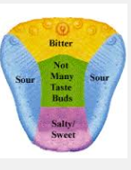
Umami taste receptors were controversial until physiological studies
replicated earlier results and showed that these receptors are
present on taste buds.
It’s clear that fat does something to our tongues. Merely putting fat
on people’s tongues alters their blood levels of fat.
* Olfactory and Gustatory perception
Pheromone: odorless chemical that serves as a social signal to members of one’s species.
We analyze the intensity of smell and determine whether it’s pleasing.
Emotional disorders, like anxiety and depression, can distort taste
perception. Smell plays a particularly strong role in sexual behavior.
* Somatosensory system: the system for our sense of touch, temperature, and pain.
Pressure, temperature, and injury:
Our somatosensory system responds to stimuli applied to the skin,
such as light touch or deep pressure, hot or cold temperature, or
chemical or mechanical (touch-related) injury that produces pain.
Specialized and free nerve endings in the skin:
Mechanoreceptors: specialized nerve endings located on the ends of sensory nerves in the skin.
Free nerve ending: far more plentiful than specialized nerve ending .
* How we perceive touch and pain:
Often touch and pain information activate local spinal reflexes before travelling to brain sites dedicated to perception. In come cases, painful stimuli trigger the withdrawal reflex. After activating spinal reflexes, touch and pain information travels upward through parts of the brain stem. Additional cortical areas are active during the localization of touch information.
Gate control model: idea that pain is blocked or gated from consciousness by neural mechanisms in spinal cord
Phantom limb illusion: persons with amputated limbs often experience the eerie phenomenon of phantom pain, pain or discomfort in the missing limb.
Pain insensitivity: just as some people are blind or deaf, others experience disorders that impair their ability to sense pain.
* Proprioception: our sense of body position
Vestibular sense: also called our sense of equilibrium, enables us to sense and maintain our balance as we move about.
Proprioceptors: we use proprioceptors to sense muscle stretch and force.
The vestibular sense: in addition to the cochlea, the inner ear contains three semicircular. These canals, which are filed with fluid, sense equilibrium and help us to maintain our balance.
* Ergonomics
A field of psychology called human factors optimizes technology to better
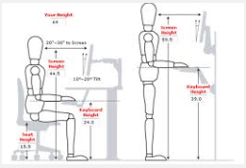
suit our sensory and perceptual capability/

