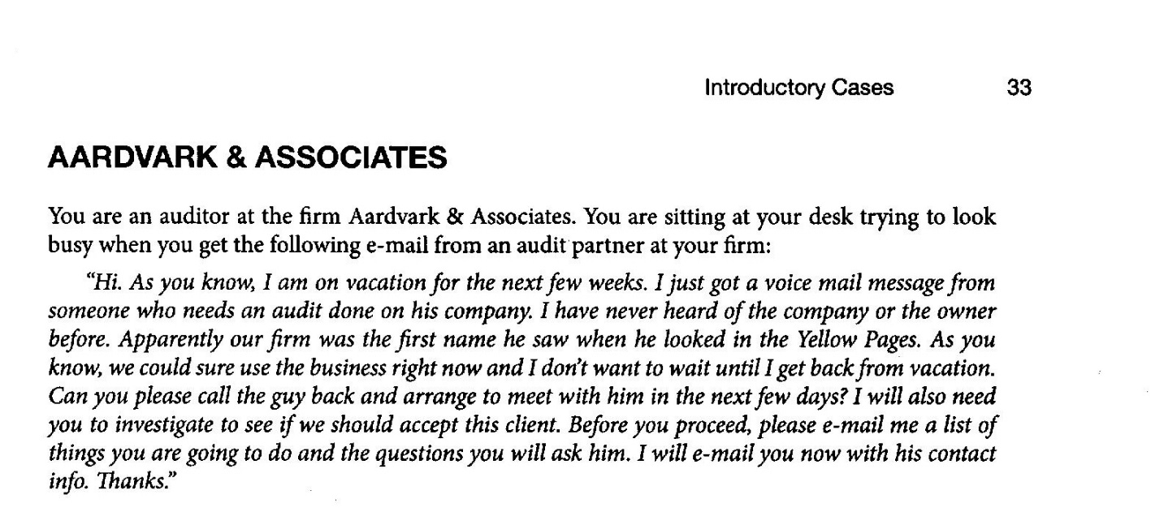

General acceptance conditions | What are you going to do? | What are you going to do if you are replacing prior auditor?
- Do the client need an audit?  - Have they been audited before?  - Independence  - Why are they changing auditors?  - Can we be paid?  - Is this a going concern?  - What is management’s reputation?  - Who are the stakeholders (associated risk)?  - Do we have the resources/expertise? | - Review financial statements  - Inquire of third parties about reputation (lawyer, bank)  - Assess if we have the time, expertise, people/personnel, and other resources | - Explain the need to talk to prior auditor and get permission  - Ask client to advise prior auditor  - Ask prior auditor about  - Mngt reputation  - Payment ability  - Why change auditors  - Relationship (disagreement with management?)  - If prior auditor doesn’t want to cooperate, take that into consideration in making decision

