Week 8A: Ethics in the Workplace, Chapter 12

Employees in the Workplace
Employee loyalty
- Commitment by employees to the organization they work • Employers can also demonstrate loyalty to employees
- Measuring loyalty can be difficult
- Loyalty can go to one’s self or one’s job, rather than the corporation
Employee engagement
- The emotional and intellectual commitment of an individual or group to an organization that supports building and sustaining business performance

Most Employees Not Engaged

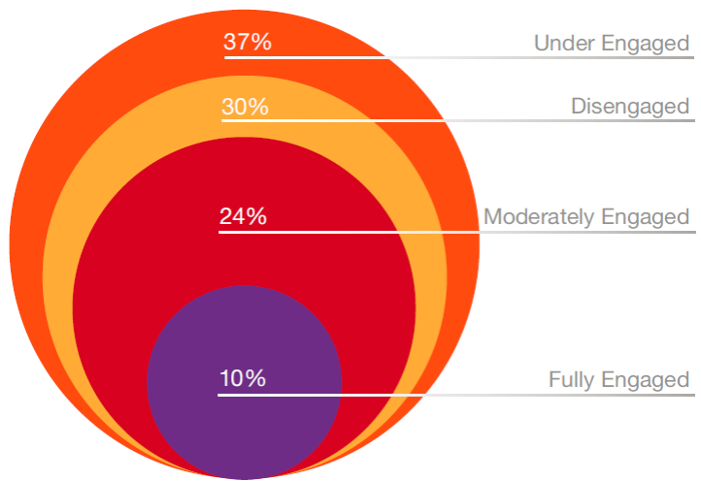

Employee Engagement Defined

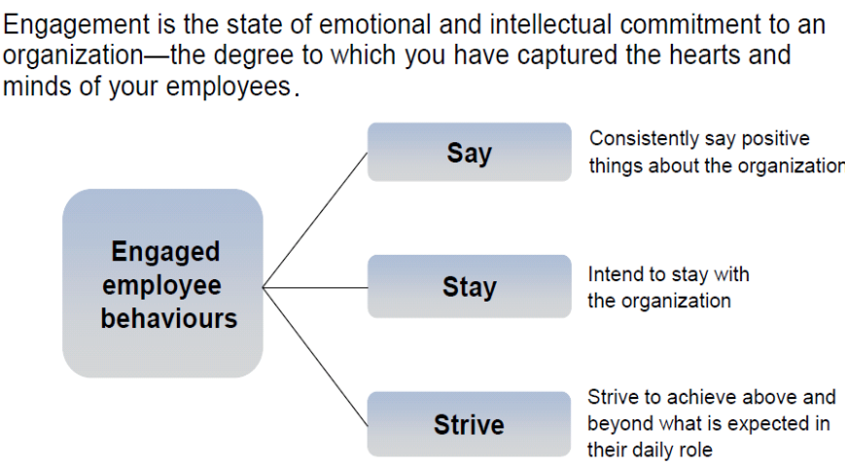

Engagement Drives Results
• Companies with engaged employees grew profits 3 X faster than competitors (Corporate Leadership Council)
• Highly engaged organizations have 87% less staff turnover and 20% better performance than average (Corporate Leadership Council)
• Operating income of companies with engaged employees improved by 19% in one year vs. a decline of 33% for companies with low levels of employee engagement (Global survey by Tower Perrins-ISR, involving an 664,000 employees in 50 companies)
• 59% of engaged employees say their job brings out their most creative ideas vs. 3% for disengaged employees

Drivers of Engagement

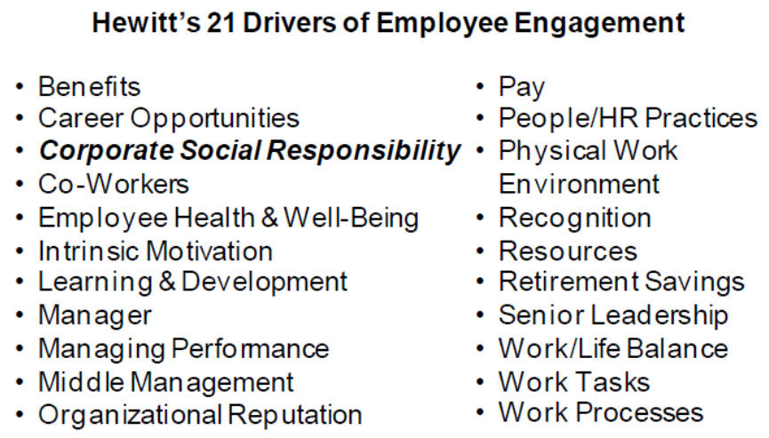

Potential Ethical Issues in Business

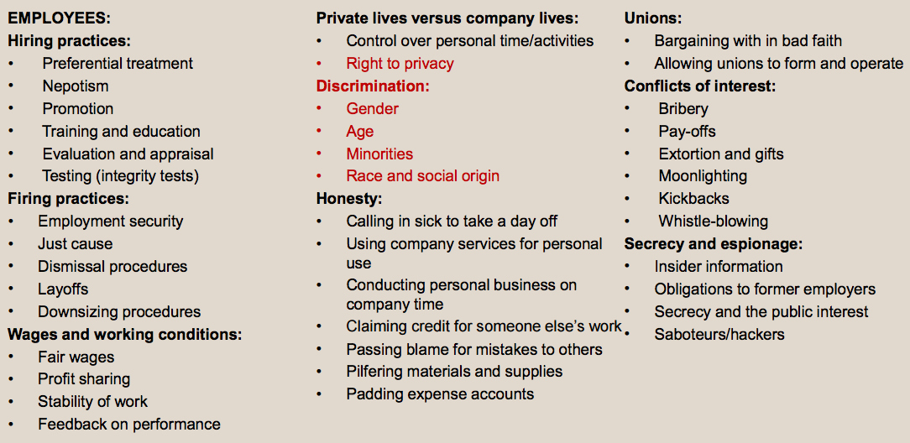
Employees in the Workplace
Workplace Privacy
- Privacy of personal information is regulated by the federal government’s Personal Information Protection and Electronic Documents Act (PIPEDA) and other provincial legislation.
- Digital Privacy Act (June, 2015)

The 10 Principles That Businesses Must Follow
1. Accountability
2. Identifying purposes
3. Consent
4. Limiting collection
5. Limiting use, disclosure, and retention
6. Accuracy
7. Safeguards
8. Openness
9. Individual access
10. Challenging compliance

Employees in the Workplace
Discrimination: The preferential (or less than preferential) treatment on bases not directly related to qualifications of the job or job performance

• Race
• Gender
• Nationality
• Age (young and old)
• Disability
• Sexual orientation
• Health

Legislation to address discrimination:
- Employment Equity Act; Canadian Human Rights Act
Employment equity
- The fair and equal treatment of employees
Diversity Management
- Voluntary initiative beyond what is required by law to eliminate discrimination

Discrimination – Hiring Practices
Blind auditions increase the probability that a woman will advance from preliminary rounds of auditions by 50%

The Business Case for Diversity
• Research shows mixed or neutral results when looking directly at effect of diversity on performance, BUT….
• You get higher performance from diversity when…
- You need to make a complex, multi-faceted decisionmaking and implement it
- You invest time to understand and work with the diversity
- You manage diversity well

Potential Ethical Issues in Business

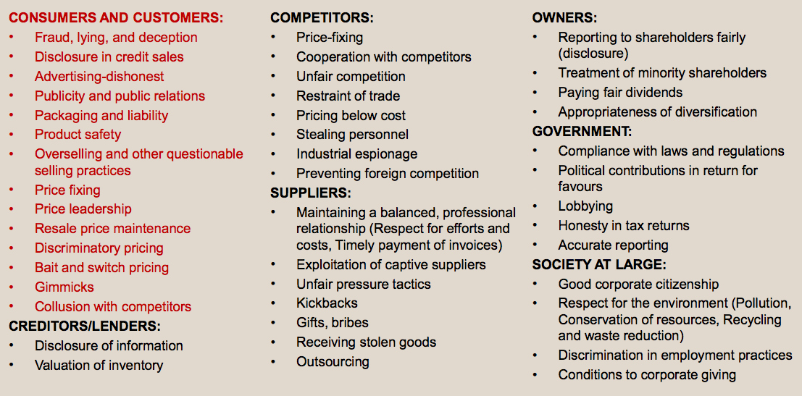

Competitors and Competition
• Competition is necessary for an effective market economy and benefits the consumer
• But can lead to questionable practices:
- industrial spying, espionage, sabotage, eavesdropping, hiring competitor’s key employees
• Causes: cutthroat global economy, aggressive competitive tactics, and shorter product cycles • Concentration of corporate power: Concern over collaboration and higher profitability

Government Influence to Encourage Competition
- Canadian Competition Act: Conspiracy, bid-rigging, predatory pricing, review of mergers, abuse of dominant position
Factors determining competitive behaviour
- Entrepreneurship; deregulation and privatization; technology; decline of natural monopoly; mergers/takeovers; global trends in trade

Consumer and Consumption
• Consumer rights
- To choose, to be heard, to education, to redress, to be informed, to safety, to a healthy environment
• Consumer sovereignty
- consumers dictate goods and services to be provided
- elements of democracy are present
- consumers make their own choices
- economic system operates more efficiently when consumers determine production
• Consumers and the marketplace
- Concerns: high information costs, misleading advertising, unsafe goods

Consumers starting to demand increased attention to corporate CSR:
- Food (organic, local, Fairtrade)
- housing (energy efficient)
- clothing (organic cotton)
- energy (light bulbs)
- transportation (hybrid vehicles)
- cosmetics (natural ingredients, no animal testing
- green weddings (catering)

Basic structure of global supply chain

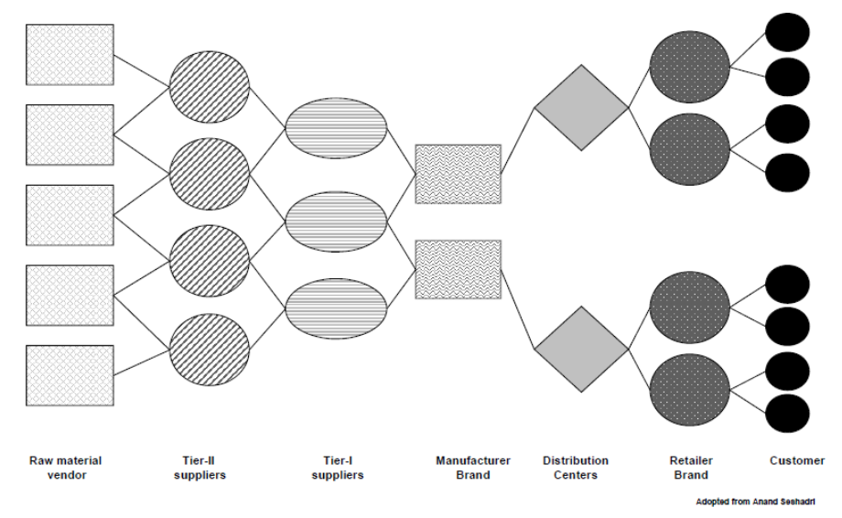

Suppliers and the Supply Chain

• Supply chain
- The route a product travels from the procurement of raw materials, the transformation into intermediate goods and then final products, and the delivery to consumer through a distribution system to its ultimate disposal by the consumer
• Extended producer responsibility
- “An environmental policy approach in which a producer’s responsibility, physical and/or financial, for a product is extended to the post-consumer stage of a product’s life cycle.”
• Business-to-business: Commercial activity where one corporation sells goods or services to another corporation rather than to consumers.
• Buyers are increasingly recognizing suppliers who are committed to considering social and environmental responsibilities

The supply chain is regulated by the Canadian Competition Act to prevent suppliers not taking advantage of their customers:
- Exclusive dealing, tied selling and market restrictions
- Price discrimination
- Price maintenance
- Refusal to deal

Learning Summary
• Employees are stakeholders internal to the corporation and their relationship gives rise to many ethical issues
• Consumers are important, because without them the corporation has no reason to exist.
• Competitors and suppliers are business-tobusiness stakeholders primarily involving economic or commercial relationships, but ethical issues also are evident.

Week 8B: The Environment, Chapter 14-15

Business, Its Stakeholders, and the Natural Environment
• Environmental issues confront virtually all aspects of the corporation, from the input of resources to the manufacturing process, and from workplace conditions through to the way products are packaged and sold.
• Commons: Any resource used as though it belongs to all.

Defining Environmental Ethic and Sustainable Development
• Environmental ethic:
- the set of values or principles that govern a corporation’s practices relating to the environment. • Sustainable development:
- development ensuring that the use of resources and the impact on the environment today does not damage prospects for the use of resources or the environment by future generations.
• Business Sustainable Development:
- “adopting business strategies and activities that meet the needs of the enterprise and its stakeholders today while protecting, sustaining, and enhancing the human and natural resources that will be needed in the future.”

Environmental Concerns in Business and Society
• Acid rain
• Air pollution
• Ecosystems
• Energy production and consumption
• Pollution
• Waste management
• Water quality
• Climate change/ global warming

Environmental NGO Influence
• Environmental non-governmental organizations (ENGOs): groups that hold shared values or attitudes about the challenges confronting the natural environment and advocate for changes to improve the condition of the environment.
• Such groups (e.g., Greenpeace) influence corporations through protests, blockades, boycotts, and annual shareholder meetings.

Factors Leading ENGOs to Target Firms
- Firm is the source of the environmental impact
- Extent of the consequences of the firm’s actions
- Denser relationships among firm’s ENGOs
- Larger the firm, greater influence of the firm
- Previous interactions with ENGO
- Closeness of the firm to consumers
- Firm’s brands are well known

Managing Responses to Environmental Concerns

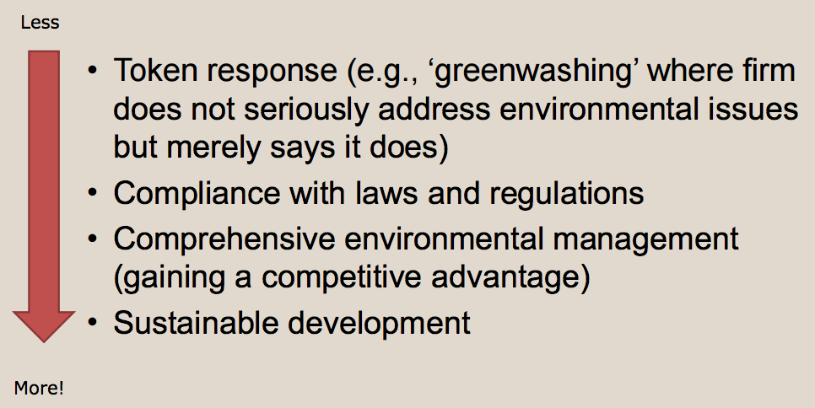

Measuring and Reporting on Environmental Sustainability
• Type and amount of materials used
• Source of energy and efficiency of use
• Source and quality of water
• Impact on biodiversity
• Reduction of emissions, effluents, and waste
• Product design that minimizes impact
• Compliance with environmental laws
• Use of efficient transportation

The Environment: Threat or Opportunity

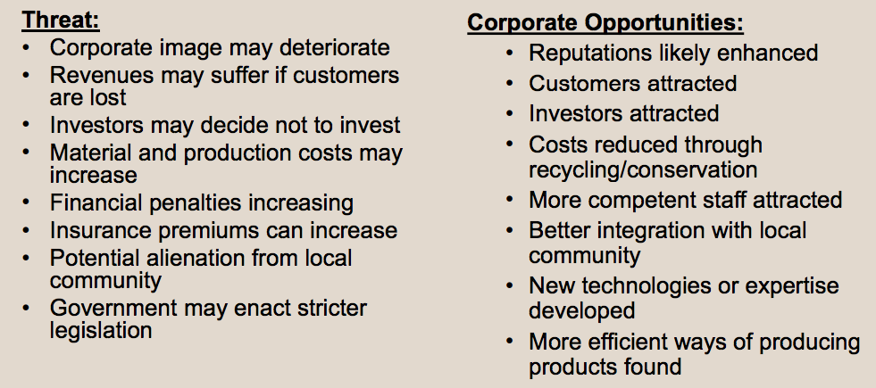

Learning Summary
• There is increasing concern for the natural environment in Canada and around the world; there is the need to preserve and protect the environment.
• Business has responsibilities toward achieving a sustainable environment.
• The depletion of the ozone layer, the greenhouse effect, acid rain, deforestation, pollution, energy depletion, and waste management are steadfast reminders of how compelling an issue our natural environment is.
• All stakeholders have an obligation to the environment and the key stakeholders influencing it are identified.
Week 10A: The Environment, Chapter 14

Case: Just Dump it in the Lake (p.404-405)
The Environment and Mining
• Mining has several impacts on the environment; a major one relates to disposing or storing of waste materials or tailings after a processing or refining process. In the past, the tailings were simply put in piles, dumped in bodies of water, including the ocean, or contained in human-made holding areas or ponds. All of these approaches threatened the environment and possibly the health of surrounding residents. As a result, the industry sought better ways to dispose of the waste materials. Research suggested an approach whereby waste materials would be deposited in natural lakes, which would contain the harmful chemicals. Ideal lakes for this approach would be near the plant, have limited watershed, and be deep. This approach was preferable to constructing open holding ponds that might leak and were expensive to build and maintain.
• In order to do this, some way had to be found to get around existing legislation, in particular, the Fisheries Act, which made it illegal to pollute fish-bearing waters. However, the “Metal Mining Effluent Regulations” of the Act allowed federal bureaucrats to redefine a lake as a tailing impoundment area. To date, 16 sites have been applied for and listed in Schedule 2 of the regulations. • In order for a lake to be listed, a notice must be issued exempting the lake from Section 22 of the Navigable Waters Protection Act. An Order in Council is necessary under Section 23 to place the lake on Schedule 2 and allow for the dumping of waste into the body of water.

Vale's Sandy Pond Proposal
• Vale planned construction of a hydromet nickel processing plant at Long Harbour, Newfoundland and Labrador, 100 kilometres west of St. John's. Plant construction was to begin in 2009, and completed by 2012 at an estimated cost of $2.17 billion. It would employ 1,600–2,000 persons in the construction stage and about 400–450 full-time employees when in operation. The plant is intended to process 50,000 tonnes of nickel, 3,270 tonnes of copper, and 2,460 tonnes of cobalt annually from ore mined at the company's Voisey Bay mine in NL.
• The facility required a disposal of tailings plan and the company decided to use Sandy Pond. About 400,000 tonnes of effluent would be dumped in the lake annually. The pond was about 6 kilometres from the plant and covered about 38 hectares. Dams would be constructed to enlarge the holding area to about 78 hectares. Vale was a signatory to the Mining Association of Canada's “Towards Sustainable Mining (TSM)” initiative. The company stated that it accepted responsibility for the environment and acted responsibly

Arguments Supporting the Use of Sandy Pond
• Vale said that it had seriously studied the alternatives and their environmental impact. It claimed that using Sandy Pond was the most environmentally friendly approach and stated that the Department of Fisheries and Oceans agreed. Submerging the waste prevents oxidization, which releases toxic substances. Ponds do not leak and human-made holding ponds would be much larger, requiring 180 hectares. Economically the pond made sense as costs of using the pond were $62 million versus $490 million for a human-made holding pond. Overall, using Sandy Pond was the least threat to the environment and the health of the community. Furthermore, the economic development was needed in the area of high unemployment after a phosphorus plant closed about 20 years

Arguments Opposing the Use of Sandy Pond
• Environmentalists stated that Sandy Pond was a pristine lake with trout, eels, and smelt and used for local recreation. Mining Watch complained that the government was making it too easy to use lakes as industrial waste dumps and disposal sites. Moreover, there was a “hidden subsidy” to the mining industry when it managed to get around the Fisheries Act enabling it to reduce costs.
• The controversy over Sandy Pond generated substantial public comment. Opposition to the dumping of wastes came from stakeholders such as Centre for Long Term Environmental Action NL (CLEANf/Ld), the Sierra Club of Canada, the Council of Canadians, the New Democratic Party, the Canadian Union of Public Employees, the David Suzuki Foundation, and Maude Barlow, a senior adviser on water to the United Nations

Questions:
1. Who are the stakeholders in this case?
2. What is their influence and/or how are they influenced by the situation?
3. What are the issues involved?
4. How can Vale justify the decision to dump toxic waste in the lake?
5. What should Vale do?
6.. What should the government do?
7. What should the community do?
8. What should the NGOs do?

Climate Change Risks

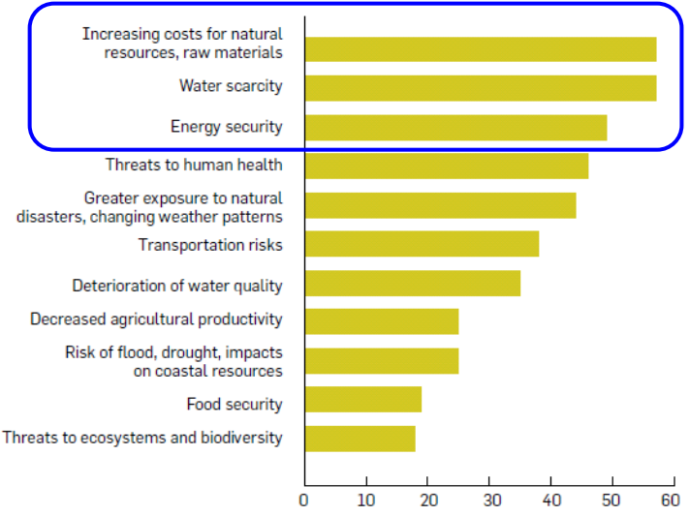
Canada and the Kyoto Protocol
• Canada signs Kyoto Protocol in 1997
• Ratifies it in 2002
• target was a 6% total reduction by 2012
• Instead GHGs have increased by about 24%
• (Note: China’s GHG’s have increased 200% in the same period, not part of Kyoto)
• Canada first country to withdraw from Kyoto in 2011

Government’s Influence
• Government departments and agencies:
- Environment Canada
- Canadian Council of Ministers of Environment
- National Roundtable of the Environment and the Economy
- Canadian Environmental Assessment Act Agency
• Regulation:
- Canadian Environmental Protection Act, Canadian Environmental Assessment Act, Kyoto Protocol

Market-Driven Environmentalism
• Standard Environmentalism
- Government regulation occurs when it is a necessary remedy for market’s failure to provide environmental amenities
• Market Environmentalism
- Economic incentives created by market are more effective at protecting the environment than government intervention
• Environmentalism affected by market factors
- Economic growth, free trade, property rights

Emissions trading: A system whereby corporations set targets for greenhouse gas reduction; if one corporation cannot meet the target, it purchases carbon credits from those that have met their targets (or “cap and trade”).

Offsets (emission reduction credits): Credits purchased from other corporations or organizations to mitigate greenhouse gases released into the environment.

The “Greening” of Business Functions
• Financial management (e.g., disclosure, SRI funds) • Marketing (e.g., green marketing)
• Human resources (e.g., environmentally friendly workplace)
• Operations (e.g., reduce, recycle, conserve, green buildings)

Learning Summary
• There is increasing concern for the natural environment in Canada and around the world; there is the need to preserve and protect the environment.
• Business has responsibilities toward achieving a sustainable environment.
• The depletion of the ozone layer, the greenhouse effect, acid rain, deforestation, pollution, energy depletion, and waste management are steadfast reminders of how compelling an issue our natural environment is.
• All stakeholders have an obligation to the environment.

Week 10B: Globalization, Chapter 14-15

Defining Globalization
• Globalization: a process of decreasing constraints on the interactions among the nations and peoples of the world.
• Economic globalization: the integration of fragmented markets into a global economy.
• Political globalization: the process by which world power relationships change, and there is a loss of sovereignty by the states.
• Social or cultural globalization: the emergence of a worldwide cultural system.

Globalization and the Implications for Business
• Damage to the environment
• Support for oppressive regimes
• Criticism of marketing practices (e.g., tobacco, pharmaceutical, baby formula, etc.)
• Arms trade
• Treatment of employees (e.g., sweatshops)
• Treatment of indigenous peoples
• Genetic modification of plants and animals
• Corruption and bribery

Does Globalization lead to increased poverty?
• Nearly 1/2 of the world’s population — more than 3 billion people — live on less than $2.50 a day. More than 1.3 billion live in extreme poverty — less than $1.25 a day.
• 1 billion children worldwide are living in poverty. According to UNICEF, 22,000 children die each day due to poverty.
• 805 million people worldwide do not have enough food to eat.
• More than 750 million people lack adequate access to clean drinking water.

Institutions of Globalization
Supranational Institution: an international organization that transcends national boundaries where the member states share in decision making on particular issues pertaining to the members

• The World Bank:
- Provides financial and technological assistance to developing countries.
• The International Monetary Fund (IMF):
- Fosters financial stability, international trade, employment, and reduction of poverty.
• International Labour Organization (ILO):
- UN agency that seeks to promote social justice and internationally recognized human and labour rights.
• World Trade Organization (WTO):
- Coordinates agreements reducing trade barriers.

International Non-Governmental Organizations (INGOs)
• INGOs are groups that hold shared values and attitudes about the issues relating to globalization and advocate for changes to improve conditions in developing countries
• INGOs put pressure on corporations and governments
• INGOs are also referred to as transnational non-government actors (TNGOs) or transnational social movement organization (TSMOs)

Globalization and Canadian Business and Society
• Pressure to forge international links
• Must meet challenges of global restructuring (e.g., R&D, education, competition policy, cost of capital, etc.)
• Attract more investment in natural resource plants • More direct investment abroad

The Debate Over Globalization

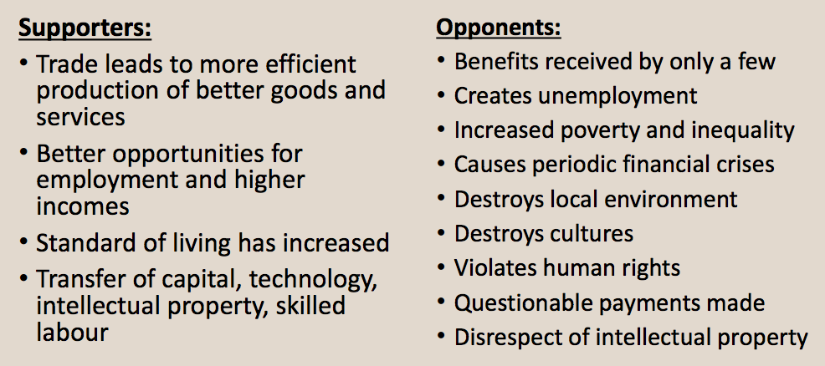

Mini Case: The Ethics of Exporting Asbestos (p. 382-383)
• Canadians were aware of the dangers of asbestos and it had been removed from many public buildings, including the Parliament Buildings in Ottawa. Exposure to asbestos endangered health through asbestosis, lung cancer, and a more serious cancer referred to as mesothelioma, cancer of the lung's protective lining. Most countries had banned all forms of asbestos as it was considered a health risk. Chrysotile, or “white” asbestos, was the only form that continued to be produced. It was mined in Canada, Russia, China, Kazakhstan, Brazil, and Zimbabwe, and about $100 million worth was exported annually by Canadian producers, primarily to India, Indonesia, Sri Lanka, and Brazil.

The Canadian Industry
• Chrysotile was first mined in Quebec in 1879, and in 2010 there remained two active mines that employed fewer than 1,000 persons, down from 7,000 when asbestos was more widely used. The two remaining producers were LAB Chrysotile Inc. of Telford Mines and JM Asbestos Inc. of Asbestos, both in Quebec. Ninety-five percent of the production was exported to developing countries where it was used in asbestos cement building products. The Governments of Canada and Quebec allowed these exports and had spent over $20 million since 1984 in promoting the product's use abroad.
• The use of chrysotile was promoted by an industry organization, the Chrysotile Institute, headquartered in Montreal. Its objectives were to promote the safe use of chrysotile, provide information to chrysotile producers and users, gather and disseminate medical, scientific, and technical data about chrysotile, and inform and advise all stakeholders of the potential risks related to breathable fibres. The Institute stated that some people mistakenly claimed chrysotile killed thousands and they did not distinguish between chrysotile and amphiboles asbestos. According to the Institute, the fibre from chrysotile was harmless even if inhaled or ingested. On the other hand, amphibole asbestos fibres had a different chemical composition that threatened health. It was pointed out that the industry only markets chrysotile when encapsulated in a cement or resin and there was minimal risk of danger to the user's health.
• In Canada, the production of chrysotile was politically sensitive. Political parties did not wish to alienate voters in the regions where the industry provides employment. Thus, governments supported the industry and contributed financially to the operation of the Chrysotile Institute. On the other hand, the federal government limited the use of any asbestos in Canada. Health Canada posted a consumer product safety notice about asbestos. In 2007, Health Canada concluded that chrysotile showed a “strong relationship of exposure to cancer.” Canada has been called hypocritical because it promoted the sale of asbestos to developing countries while banning its use within the country

Opposition to Asbestos
• The opposition to the use of chrysotile was widespread, including from the Canadian and Quebec Medical Associations, Canadian Cancer Society, and Canadian Lung Association. The World Health Organization (WHO) stated “all types of asbestos cause cancer in humans.” It was concerned about the continuing use of asbestos cement in the construction industry, as there was a large workforce and it was difficult to control exposure to asbestos fibres. The International Labour Organization (ILO) adopted a resolution at the 95th Session of the International Labour Conference, June 2006, stating, “the elimination of the future use of asbestos and the identification and proper management of asbestos currently in place are the most effective means to protect workers from asbestos exposure and to prevent future asbestos-related diseases and deaths.” The Office of the Auditor General of Canada, in a statement on “Canada's Policies on Chrysotile Asbestos Exports,” pointed out concerns about air quality, human health/environmental health, international cooperation, natural resources, and toxic substances.
• An editorial in the Canadian Medical Association Journal (CMAJ) in October 2008 was very critical of Canada's “asbestos mortality.” According to the editorial, Canada was “the only Western democracy to consistently oppose international efforts to regulate the global trade in asbestos.” Furthermore, the Canadian government had done so with political manipulation of science and in alliance with countries such as Russia and Zimbabwe. Canada's position was that chrysotile was safer and less carcinogenic, thus posing less of a risk to health. Another medical publication, The Lancet, the world's leading general medical journal, and specialty journals in oncology, neurology, and infectious diseases also criticized Canada for producing and exporting asbestos.
• The Canadian Auto Workers (CAW) had a “Ban Asbestos Campaign” that refuted the argument that asbestos was sa fe. Sample letters were provided that could be forwarded to politicians. The union published a 172- page report,Pure White: Asbestos—A Canadian Scrapbook, to provide useful information about the dangers of asbestos in workplaces and communities. A CAW “Health and Safety Fact Sheet” also described asbestos and its dangers

Use in Developing Countries:
The Customers
• Asbestos products had appealing properties in developing countries. They were cheaper than alternatives, did not corrode, and were virtually indestructible. Roofing tiles made from chrysotile and cement, for example, were far superior to alternatives available in these countries as they were fireproof, easily and securely installed, and reduced noise from rainfall. However, there was concern about the workers in plants producing or fabricating the products, as dust created could be dangerous to their health.
• There were some initiatives undertaken by non-governmental organizations (NGOs) opposing the sale of chrysotile in developing countries. An International Ban Asbestos Secretariat (IBAS) was formed in 2000 to coordinate opposition to asbestos and was working to achieve a global asbestos ban. It pointed out that although asbestos was seldom used in developed countries it continued to be used in developing nations.3At a conference in Hong Kong in April 2009, the Asian Ban Asbestos Network (A-BAN) was launched. It was a network of “organizations and individuals from countries and regions in Asia and the Pacific, which agreed to work together on activities towards achieving common objectives.”
• Canada's production and marketing of chrysotile received considerable media coverage. NGOs and world health organizations were opposed to trade in asbestos, yet Canada continued support production and encourage exports.

Death and Possible Revitalization of the Industry
• By 2011, the Canadian asbestos industry appeared to be on its last legs. LAB Chrysotile ceased production in December 2011 but still sold from inventory. In early January 2012 the company declared bankruptcy, but hoped to reform.38 The Jeffrey mine had reduced production and employed only 25 workers in July 2011. It requested a $58 million loan guarantee from governments to relaunch the mine. The mine had been an open pit operation but the accessibility to ore had run out and it was necessary to develop an underground mine.39 • There were continued warnings that the export of asbestos was ethically problematic, that it was harming Canada's reputation, and that it was hypocritical. Editorials in Canada's two national newspapers criticized the export of asbestos: “Subsidizing Shame” in The Globe and Mail and “Saying No to Canada's Asbestos” in the National Post. On July 24, 2012, the Joint Policy Committee Societies of Epidemiology issued a statement calling for a global ban on the mining, use, and export of all forms of asbestos. The statement had been endorsed by 150 public health and civil society organizations, and individual scientists from 20 countries.
• In June 2011, the United Nations' Rotterdam Convention met to compile a list of hazardous chemicals. Canada single-handedly blocked the inclusion of chrysotile asbestos on the list even though the major customers for the materials, Vietnam, Kazakhstan, Kyrgyzstan, and India, agreed to the listing. The list did not ban asbestos but would merely warn customers of the health hazards. Canada's Health Department had recommended that asbestos be added to the list

• The Canadian government supported asbestos exports. During the 2011 election campaign, Prime Minister Harper had defended asbestos exports despite the health risks. The Opposition parties in Parliament supported a motion to ban exports of asbestos: • That, in the opinion of the House, the government should:
- ban the use and export of asbestos;
- support international efforts to add chrysotile asbestos to the list of hazardous chemical products under the Rotterdam Convention;
- assist affected workers by developing a Just Transition Plan with measures to accommodate their re-entry into the workforce;
- introduce measures dedicated to affected older workers, through the employment insurance program, to assure them of a decent standard of living until retirement; and
- support communities and municipalities in asbestos producing regions through an investment fund for regional economic diversification.
• On November 11, 2011, the House of Commons defeated the motion 152–123 with the Conservative and Bloc Quebecois parties voting against and the New Democratic, Liberal, and Green parties voting for the motion. Despite all the criticism and warnings, the governments of Canada and Quebec were still supporting the export of asbestos. In July 2012, it was only a matter of time before further support for the industry would be announced. Many in Canada and around the world questioned this support, and wondered why Canada was exporting asbestos and death for some users.

Update:
- June, 2012: The Quebec government commits $58 million into Jeffrey Mine, one of the last remaining asbestos mines, which could keep the facility alive for 20 more years.
- Change in provincial government
- September, 2012: Reversal. Quebec government announces closure of last asbestos mine; $50 million to go to diversifying local economy
- May 2015, the Canadian government rejected the advice of its Health Canada scientific experts and refused to support the listing of chrysotile asbestos as a hazardous substance at the U N Rotterdam Convention Conference of the Parties in Geneva. Instead, the Canadian government sat on the sidelines and remained silent as to whether chrysotile asbestos is a hazardous substance.

Learning Summary
- The globalization of business has brought numerous issues relating to business’s economic, social, and environmental responsibilities.
- The impact of globalization on the Canadian corporation has been, and will continue to be, extensive.

Week 11A: Globalization, Chapter 15-16

Why did the Rana Plaza tragedy occur and who is responsible?

Stakeholders
- Private companies (multi-national corporations, approved contractors, sub-contractors) • Building owners
- Building inspectors
- Workers
- International organizations (ILO)
- NGOs
- Trade associations
- Government agencies
- Elected officials
- Consumers who buy garments made in Bangladesh

The High Price of Low Wages
Garment industry worker’s hourly wages in:
- Bangladesh: 24cents/hour
- Cambodia: 45cents/hour
- Pakistan: 52cents/hour
- Vietnam: 53cents/hour
- China: $1.25cents/hour

Special Challenges of Global Business – Human Rights
- Human rights: The fundamental rights and freedoms to which all individuals, groups, and societies are entitled (e.g., sweatshops).
- Child labour
- Forced labour
- Discrimination
- Environment
- Working Conditions

What should be done?

The United Nations Global Compact
Human Rights:
- Respect internationally proclaimed human rights
- Not be complicit in human rights abuses
Labour Standards:
- Uphold the right to collective bargaining
- Eliminate all forms of forced and compulsory labour
- Effective abolition of child labour
- Eliminate employment discrimination
Environment:
- Precautionary approach to environmental challenges
- Promote greater environmental responsibility
- Use environmentally friendly technologies Anti-Corruption: 10. Avoid corruption (e.g., extortion and bribery)

Standards of Conduct by International Organizations
Global Standards of Conduct:
• United Nations Global Compact
• Caux Round Table: “Caux Principles”
• OECD “Guidelines for Multinational Enterprises”
• “Principles for Global Corporate Responsibility” (Interfaith organizations)
• Global Reporting Initiative (GRI)

Standards of Conduct and Accountability for Global Business

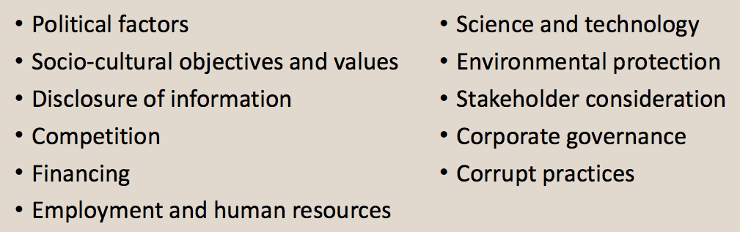

Special Challenges of Global Business - Corruption
• Corruption: The abuse of entrusted power for private gain (e.g., bribery)
- Bribery: making questionable payments, or bribes, to government officials to influence their decisions
- Three types of bribery assessed included:
- bribery of high-ranking politicians or political parties
- bribery of low-level public officials to ‘speed things up’
- the use of personal or familiar relationships to win public contracts.

Learning Summary
• The globalization of business has brought numerous issues relating to business’s economic, social, and environmental responsibilities.
• The impact of globalization on the Canadian corporation has been, and will continue to be, extensive.
• Several international standards of conduct have been developed that provide guidelines for corporate activities in developing countries.
• Trends toward relying on market systems and corporations more than requesting government involvement.
• Globalization has embraced capitalism: corporations are more likely to be privatized than nationalized.

Week 11B: Sustainability, Chapter 15-16

Sustainability strategy
• Sustainability strategy: A plan that views economic, ethical, social, and environmental responsibilities more intensively and integrates corporate social responsibility (CSR) into all facets of the corporation’s operations.
• also referred to as a CSR strategy

Strategic Management
Strategic management: The process through which a corporation establishes its mission and objectives, analyzes the environment and resource capabilities in order to formulate strategy, creates the organizational systems and processes needed to implement the strategy, and devises mechanisms for evaluating performance.

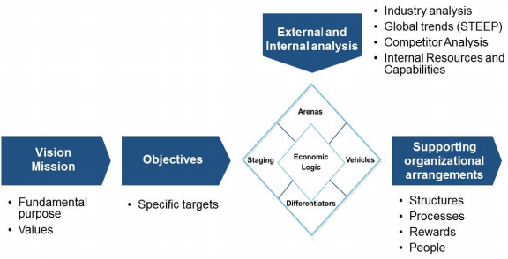

- Sustainability Strategy and Purpose
• Vision: A statement of what the corporation wants to become or where it wants to be at some date in the future.
• Mission: An enduring statement that specifies in broad, even philosophical, terms the organization’s “reason for being” and what distinguishes it from similar organizations.
• Values: The basic assumptions about which ideals are considered desirable or worth striving for.

- Sustainability Strategy Formulation
• Assessment of the external environment in which the corporation operates
- understand when and how this environment influences the corporation.
• Assessment of internal resources and capabilities
- Allows corporation to determine its ability to take advantage of opportunities in the environment and to overcome any threats.
• Establishment of objectives
- The ends the corporation seeks to achieve through its existence and operations.
• CSR strategy options and selection

- Sustainability Strategy Implementation
Sustainability implementation includes:
• designing the corporation’s structure;
• allocating resources;
• developing information and decision-making processes; and
• managing human resources, including such areas as the reward system, approaches to leadership, and staffing.

- Sustainability Strategy Evaluation
• It is important to have continuous monitoring and reviewing of the strategic management process
• It has become important to incorporate social policies into the strategic management process:
- Business legitimacy depends on it.
- Government can legislate compliance regulations.
- Business’s success and continued existence are interrelated with social policies.

Sustainability Strategy Continuum

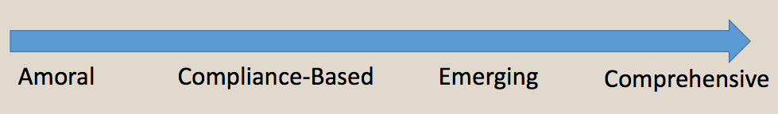

The Circular Economy

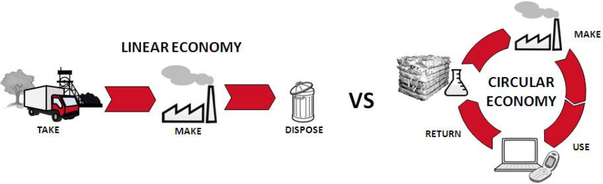

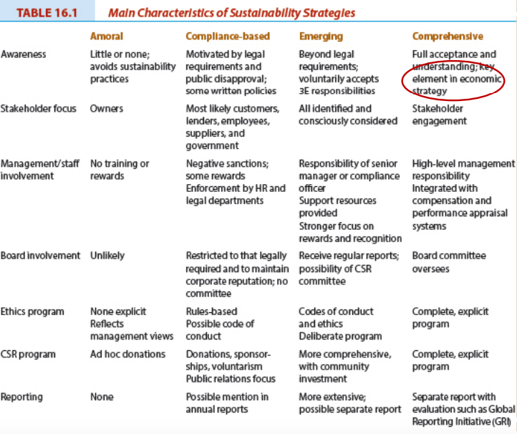

The Social Context of Business is Changing

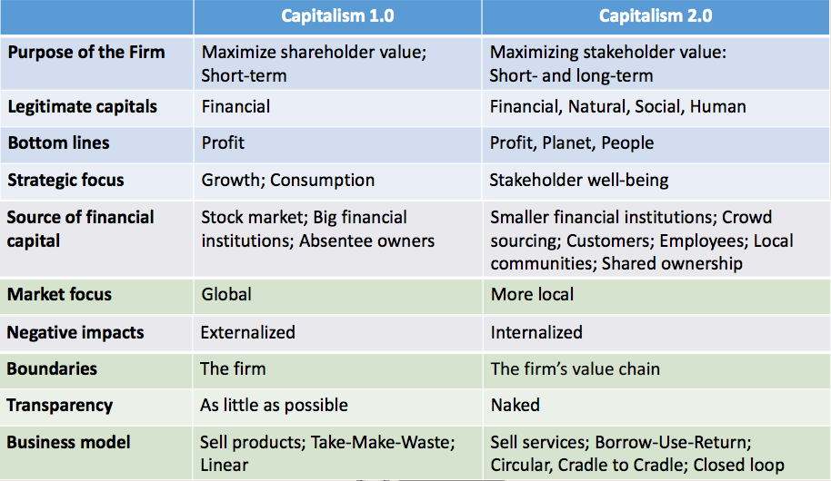
Week 7A: Regulating Business, Chapter 10

Spectrum of Regulation
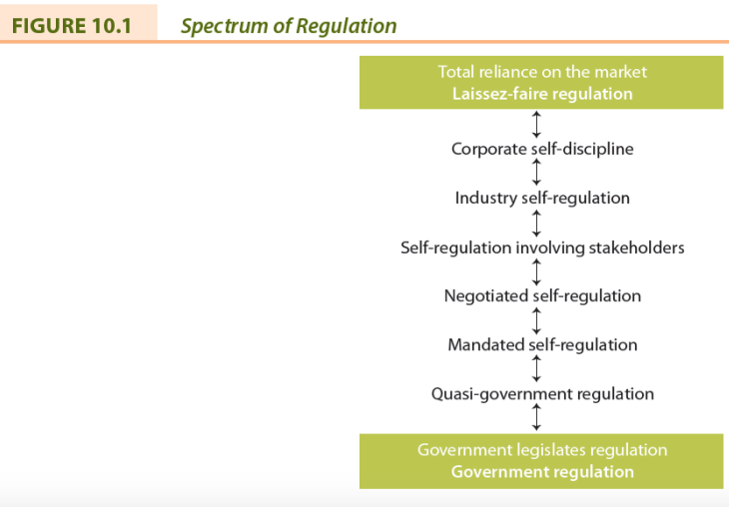

Market Regulation
• No need for government-imposed laws or regulations.
• Laissez-faire approach.
• Government does not interfere with business.
• Consumers can force companies to behave in particular ways by refusing to purchase goods or services or through boycotts

Self-Regulation
• Corporate self-discipline regulation
• mission, values statement, codes of conduct or ethics
• Industry self-regulation
• voluntary codes
• Self-regulation involving stakeholders
• Negotiated self-regulation
• Mandatory self-regulation

Government Regulation
• Necessary, because can’t trust business to regulate itself
• Government provides countervailing power to business by reflecting society’s concerns
• Yet, criticized for being oppressive, ineffective, costly, rigid and weakly enforced
Scope of Government Regulation

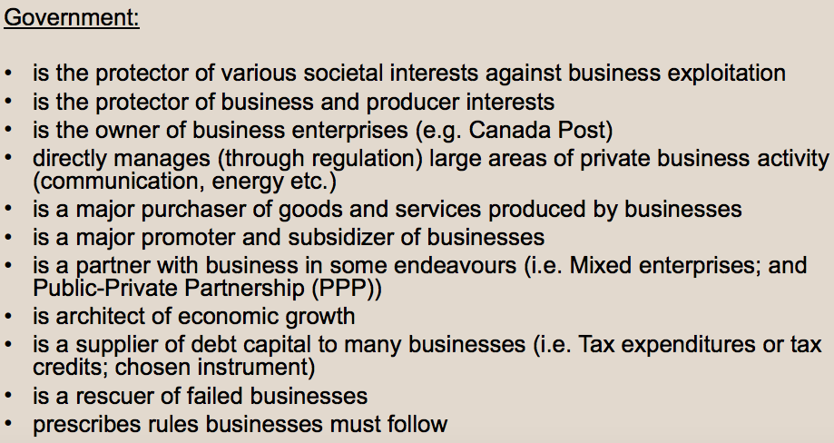

Business Involvement in Politics: Examples
• Financing of political parties (US, not Canada).
• Publicly expressed support for a candidate or party.
• Publicly expressed views on political issues.
• Executives running for public office.
• Management’s position on employee participation (e.g. August 2015, Tony Turner put on leave from Environment Canada for Harperman protest song).

Lobbying

• All attempts to influence directly or indirectly any government activity, and includes any attempt to influence legislators, their staff members, public administrators, and members of regulatory agencies.
• Business lobbying attempts to influence:
- Making or amending of legislation and regulations
- Making or changing of government policies or programs
- Government decisions in the awarding of grants, contracts, contributions, or any similar benefits
- Government appointments to boards, commissions, and any other public office

Corporate Welfare
• Any action by municipal, provincial, or federal governments that gives a specific corporation or an entire industry a benefit not offered to others
• Industries appear increasingly willing to advocate for and accept government assistance

Business Lobbying: Benefits & Criticisms

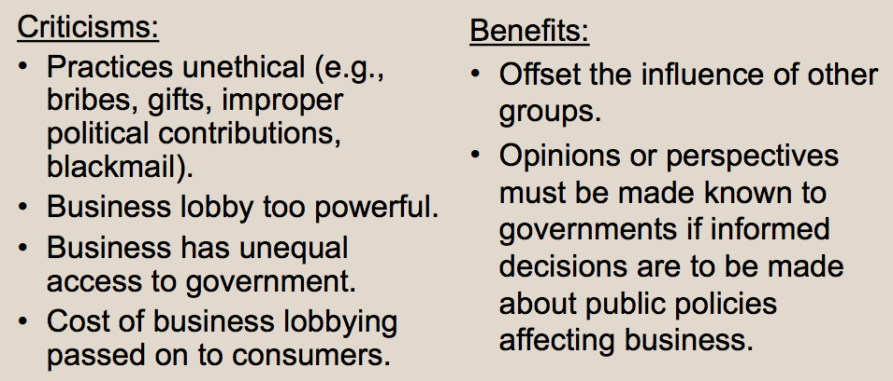

Week 6A: The Ethics of Business, Chapters 5-6

Six Steps to Ethical Decision Making
1. Define the problem
2. Identify alternatives
3. Evaluate the alternatives
4. Make the decision
5. Implement the decision
6. Evaluate the decision

Influences on Ethical Behaviour
• Influences become the bases for an individual’s value judgments and moral standards that determine behaviour.
- Influences on Individuals
- Corporate or Organizational Influences
- Economic Efficiency Influences
- Government and Legal System Influences
- Societal Influences

Ethical Decision Making
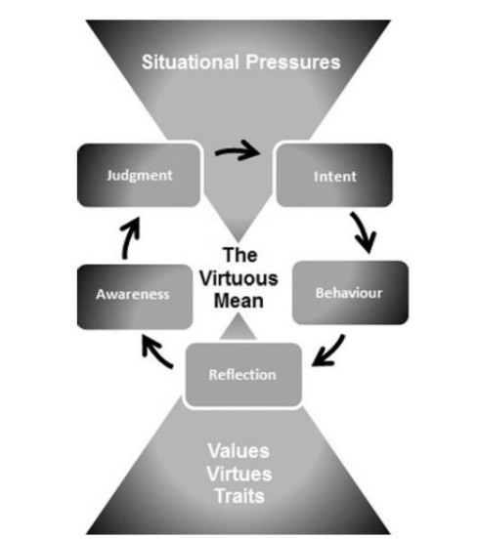

Assessing Ethical Implications
Three levels of assessing ethical implications:
- Level 1: awareness of moral or ethical implications of business decisions or actions
- Level 2: assessment based upon influences that are described as value judgments of purpose and moral standards of behaviour
- Level 3: assessment based on the use of fundamental ethical principles to evaluate the outcomes from decisions or corporate actions

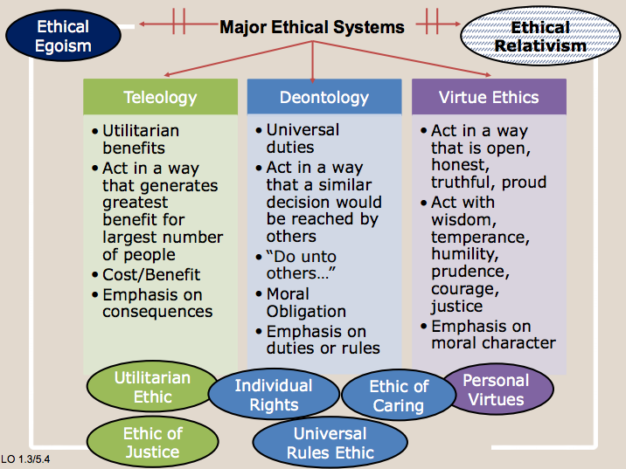

Corporate Ethics Programs
• Corporate ethics programs comprise some combination of the following: • a statement of values;
- code of conduct and/or ethics;
- ethics training;
- ethics audits and consulting services;
- ethics officers and committees; and
- ethics reporting systems.
• No model or standard program has emerged, and programs vary by business enterprise.

Why Ethical Programs Fail
• Managers are morally imperfect
• Self-interest
• Rationalization and self-delusion
• Threat of formal sanctions
• Threat of informal sanctions
• Tolerance to risk-taking behavior
• Pressure in particular situations

Statement of Values
• A description of the beliefs, principles, and basic assumptions about what is desirable or worth striving for in an organization.
• Key components:
- Key stakeholder interests to be satisfied and balanced
- Emphasis on quality and/or excellence
- Efficiency
- Work climate
- Observance of codes

Codes of Conduct and Ethics
• Code of conduct: explicitly states what appropriate behaviour is by identifying what is acceptable and unacceptable.
• Code of ethics: a statement of principles or values that guide behaviour by describing the general value system within which a corporation attempts to operate in a given environment.

Criticisms and Benefits of Ethics Codes and Programs

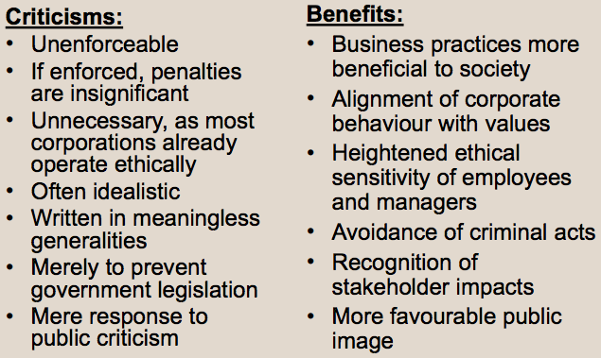

Conflicts of Interest
• A situation in which an individual has a private or personal interest that is sufficient to appear to influence the objective exercise of that individual’s duties.
• Three types of conflict: (1) real; (2) apparent; (3) potential
• Examples:
• self-dealing; accepting gifts or benefits; influence peddling; using employer’s property; using confidential information; outside employment or moonlighting; post-employment; personal conduct

Ethics Officers and Ethics Committees
• Ethics officers:
- Independent manager
- Reports to the board of directors or CEO
- Reviews complaints or information from anyone in the organization or any stakeholder
- Studies situation and recommends action
- Responsible for the ethics program
• Ethics committees:
- Comprising management, employees, and outside stakeholders

Ethics Reporting Systems and Whistleblowing
• Corporations have established reporting systems so that they can become aware of issues and concerns relating to corporate ethical conduct or irregularities (i.e. hotlines).
• Whistleblowing: an act of voluntary disclosure of inappropriate behaviour or decisions to persons in positions of authority in an organization.

Whistleblowing: Issues
• Remain silent, quit, or disclose wrongdoing?
• Does obligation to employer supersede obligation to self, profession, or industry?
• Will whistleblower be believed?
• Is whistleblower hero or snitch?
• Who should the whistleblower contact?
• What will the consequences be?

Ethics Programs: Compliance versus Values-based

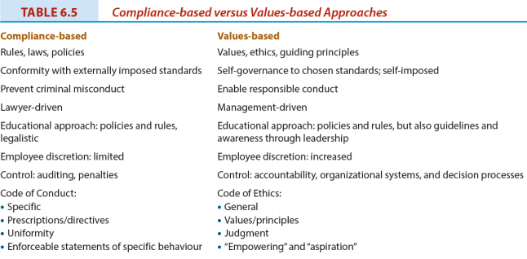

Challenges of Ethics in Business

• Indicating ‘just do the right thing’ is insufficient (i.e., too open ended)
• It’s not easy to be ethical
• Unethical behaviour not just due to a few bad apples
• People always have been (and always will be) unethical
• Most believe (due to implicit bias) that they behave ethically towards others
• Despite designing and implementing comprehensive ethics programs and an active role by management in emphasizing ethical behaviour, misbehaviour will still occur.

Week 1B: The Relationship Between Business and Society, Chapter 1

Factors Influencing Attitudes Toward Business
• Business wrongdoing
• Allocation of resources
• Inequities in society
• Standard of living
• Decentralized decision making
• Self-interest
• Business cycle
• Globalization
• Unemployment
• Innovation
• The Media
• Government

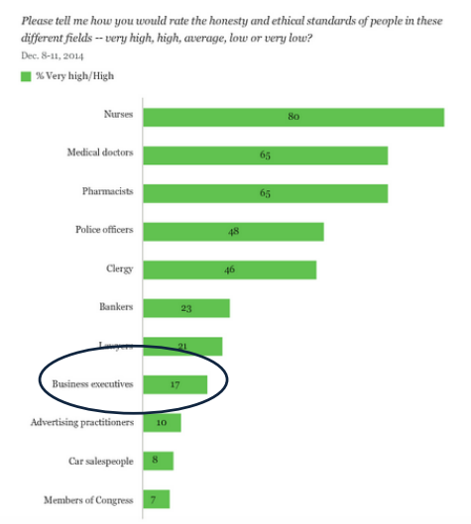

The Consent of Society
• Legitimacy: belief in the rightness of an institution, in this case the appropriateness of our business system to supply the goods and services wanted by Canadian society.
• Social license: is the privilege of operating in society with minimal formalized restrictions based on maintaining public trust by doing what is acceptable to stakeholders in the business and society relationship.
Week 2A: Understanding Business and its Stakeholders, Chapters 3-4

Issues Management: Definition
A systemic process by which the corporation can identify, evaluate, and respond to those economic, social, and environmental issues that may impact significantly upon it.

Issues in the Food and Beverage Industry

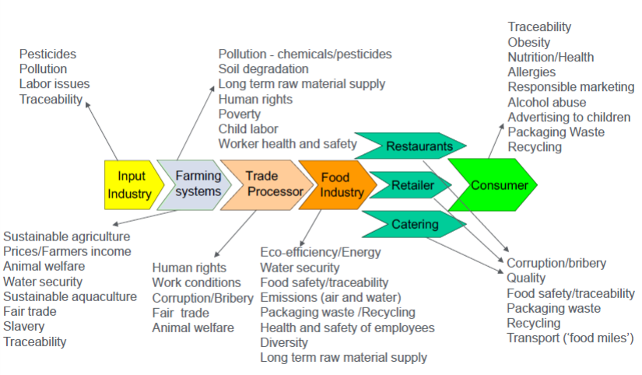

Issue Life Cycle

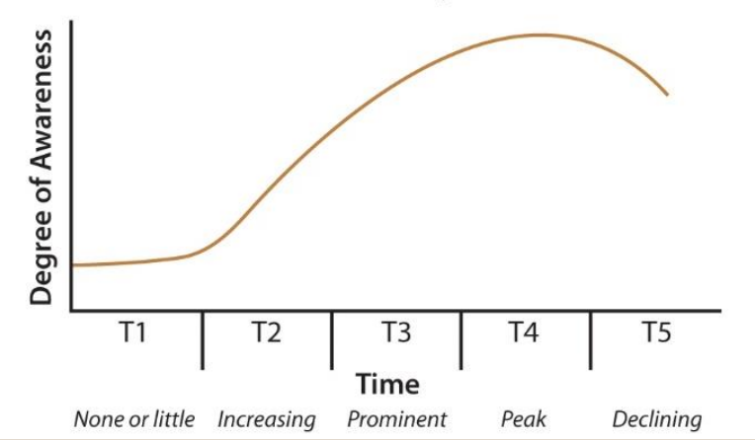

Issues are Important to Stakeholders
• Stakeholders: An individual, or group, who can influence and/or is influenced by the achievement of an organization’s purpose
• “…to manage effectively, then you must take your stakeholders into account in a systematic fashion.”

Purposes of Issues Management
• Minimize surprises relating to events or trends in society by serving as an early warning system • Prompts managers to be more systematic in coping with issues and stakeholder concerns
• Mechanism for coordinating and integrating management of issues

Benefits of Issues Management
• Maintain a competitive advantage over rivals
• Corporate behaviour is more likely to be consistent with societal expectations
• Less likely to make a serious social or ethical mistake
• Detect issues earlier and develop appropriate responses much sooner

Learning Summary
• Issues management enables the corporation to reduce vulnerabilities and enhance credibility
• Issues that are increasing, prominent or at their peak require immediate and comprehensive managerial responses
• Good issues management is the best crisis management strategy

Week 2B: Understanding Business and Stakeholders, Chapters 3-4

Managers’ Responsibilities
1. Identify stakeholders
2. Understand how corporation currently views stakeholders
3. Examine how each stakeholder will or might influence firm
4. Assess opportunities and threats
5. Rank stakeholders by influence
6. Prepare programs or policies detailing how to cope with stakeholders

Identifying Stakeholders

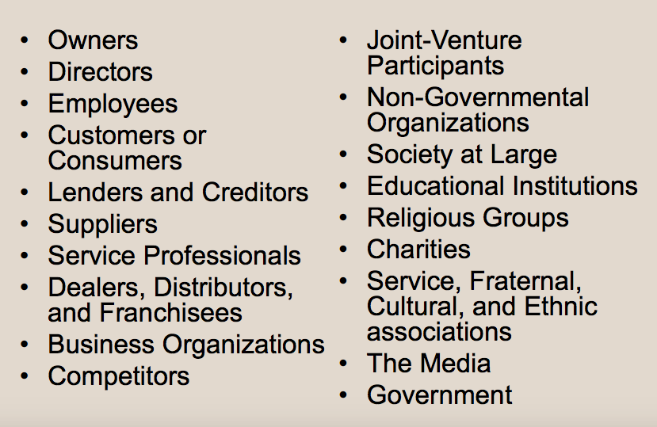

Identifying Stakeholders

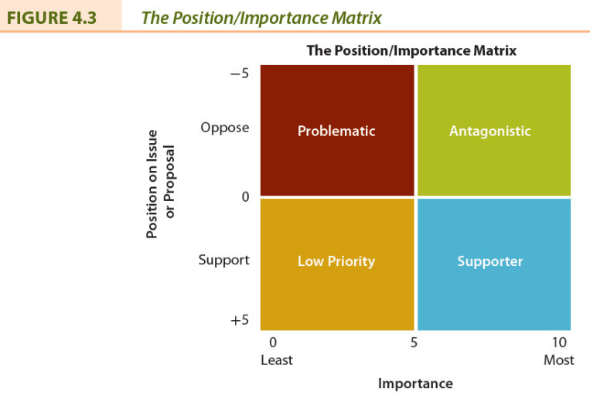

Diagnostic Typology of Organizational Stakeholders

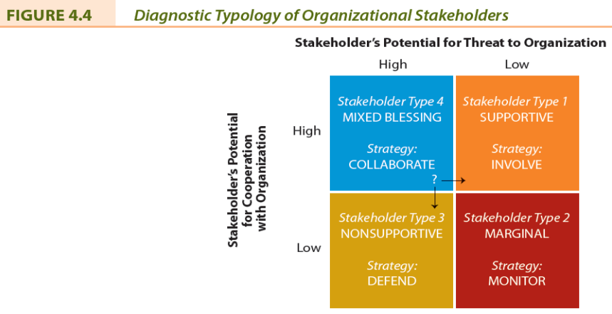

Stakeholder Identification and Salience

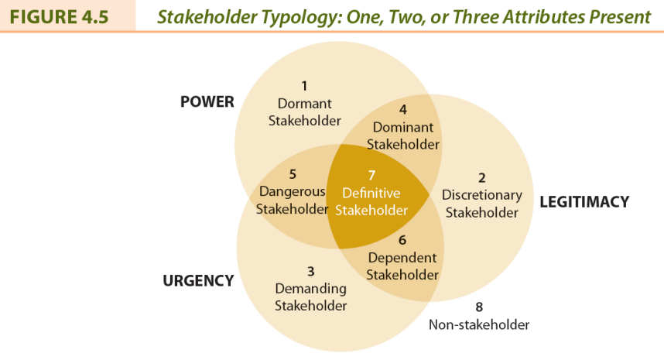

Stakeholder Identification and Salience
• Salience: The degree to which priority is given to competing stakeholders
• Power: The ability to get a firm to do something that it would not otherwise do based on force, threat, incentives, etc.
• Legitimacy: Perception or assumption that the actions of an entity are desirable, proper, or appropriate
• Urgency: The degree to which a stakeholder’s claim or relationship calls for immediate attention
Learning Summary

• The stakeholder concept is a systematic approach to recognizing the complex combination of desires and expectations in today’s society and deciding whether to respond
• Through an assessment of each stakeholder, the value of each to the corporation can be ascertained to suit the stakeholder and to suit the corporation’s purpose

• Approaches to understanding the relationships between the corporation and its stakeholders range from the basic listing and mapping to more complicated concepts such as stakeholder collaboration and social capital.
• These approaches help the corporation to consider their stakeholders’ moral concerns in strategic and operational initiatives.

• Stakeholder engagement is an integral aspect of corporate social responsibility or corporate sustainability.
• Stakeholder engagement involves creating value for all stakeholders and an honest, open, and respectful engagement of stakeholders vital to corporate strategy.

Week 3A: Understanding Business and Stakeholders, Chapter 13

Civil Society: Definition
• Civil society is composed of the voluntary, community, and social organizations or institutions that contribute to the functioning of society but are not related to or supported by government.

What is a Non-Governmental Organization (NGO)?
• An NGO is any group that holds shared values or attitudes about an issue confronting society and advocates for changes relating to the issue.
• Also called public interest, special interest or just interest groups
• Usually, but not always, non-profit.

NGO Tactics

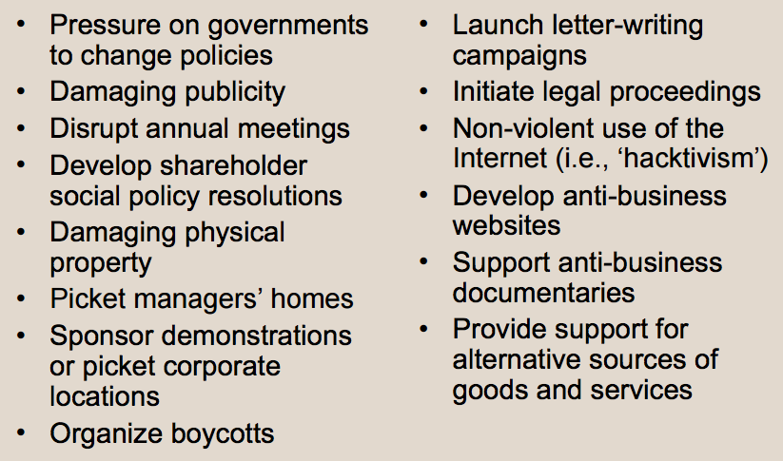

Strategies for Relationships with NGOs
• Continuum of possibilities: From resist to capitulate to pre-empt
• Do not underestimate NGO’s influence
• Reversing a decision from a project shouldn’t be viewed as a defeat
• Sometimes selective concessions are sufficient
• Sometimes better to deal with “realist” NGO, not radical ones
• A pre-emptive strategy may be feasible
• Proactively engage NGO

Partnership Relationships with NGOs
• Four key ingredients to a successful partnership:
- Corporate and NGO leaders must show leadership
- The corporation must be open to change
- Must be a commitment to being committed
- Partners must have a shared goal

The Case for NGOs: Benefits from Partnership
• Identifying opportunities and risks, influence on public opinion, innovation possibilities, reputation and trust by the public, expertise on specific issues, employee engagement
The Media Stakeholder
• Dealing with the media is part of managers’ responsibilities
• Legitimacy of business is dependent upon public’s knowledge of events and issues
• Information spread through newspapers, periodicals, radio, television, and social media

The Media and CSR
• Ethical, social, and environmental responsibilities of business of increasing interest to public
• This has led to increased coverage of ethics in business and CSR in the media
• Corporations owning media have also recognized importance of CSR or sustainability

The Interaction Between Business and the Media

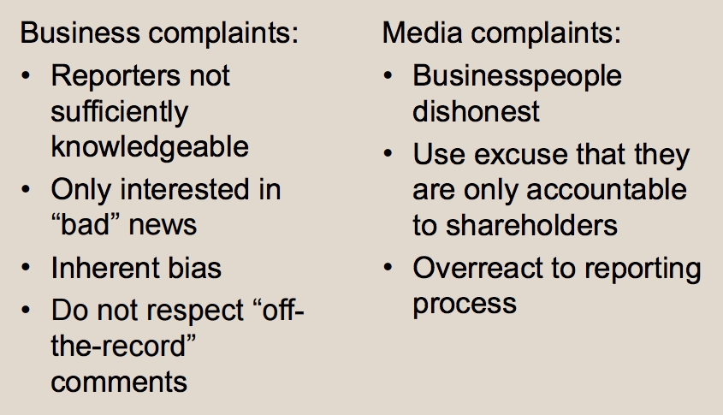

Learning Summary
• Corporations and their managers must develop a relationship with both NGOs and the media in which managers not only learn about these stakeholders but also recognize their role in society and develop mechanisms for interacting with them.
• This focus is not one-way but instead is a proactive relationship in which managers understand and respect the roles of these civil society stakeholders.

Week 3B: Understanding Business and Stakeholders, Chapter 3,4,13

Recognize business as just one institution in society
• Pluralistic society: is one where influence or power is decentralized by dispersing it among a variety of institutions
• No one institution is completely independent of others, but each institution does possess some autonomy to pursue its own interests

Stakeholders’ Influence
• Why are stakeholders important to a firm?
• What can happen to the firm if managers do not properly identify and satisfy the interests of their firm’s stakeholders?
• Why is it important to categorize stakeholders?
• Do stakeholders have differing goals and power/influence over time?

Arguments For and Against the Stakeholder Concept

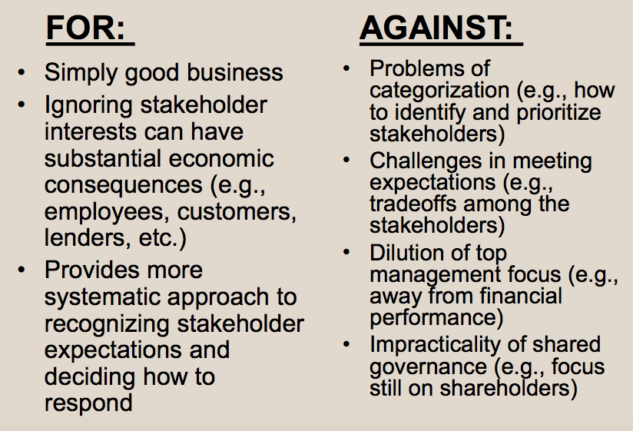

Crisis Management
• Crisis: A turning point, a crucial time, and a situation that has reached a critical point
• Crisis management: An approach involving planning and removing much of the risk and uncertainty, allowing the corporation to achieve more control over events

• Six Stages of Crisis Management:
- Stage 1—Avoiding the Crisis
- Stage 2—Preparing to Manage the Crisis
- Stage 3—Recognizing the Crisis
- Stage 4—Containing the Crisis
- Stage 5—Resolving the Crisis
- Stage 6—Profiting from the Crisis

Understanding Stakeholder Influence Strategies

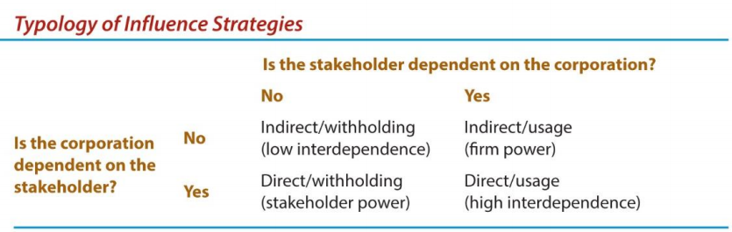

Stakeholder Influence Strategies
• Resource dependence
• stakeholder is supplying a resource and can exert some form of control over it
• Withholding strategies
• stakeholder discontinues providing a resource
• Usage strategies
• stakeholder continues to supply resource but specifies how it is to be used
• Influence pathway
• when withholding and usage strategies are used by an ally of the stakeholder

Stakeholders and Their Influence on the Canadian Mining Industry

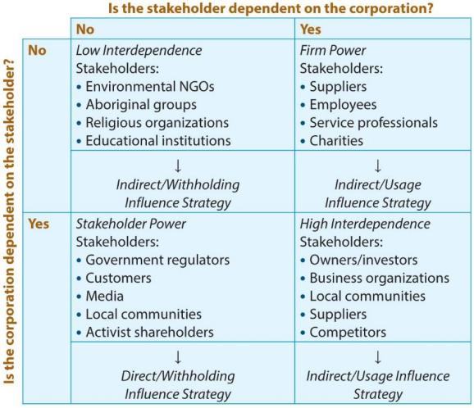
Understanding Stakeholder Collaboration
• Stakeholder Engagement:
- efforts by a corporation to understand and involve relevant individuals, groups, or organizations by considering their moral concerns in strategic and operational initiatives.

• Stakeholder engagement is an integral aspect of corporate social responsibility or corporate sustainability.
• Stakeholder engagement involves creating value for all stakeholders and an honest, open, and respectful engagement of stakeholders vital to corporate strategy.

• Framework for organizations to develop collaborative stakeholder relationships:
1.Creating a foundation
2.Organizational alignment
3.Strategy development
4.Trust building
5.Evaluation
6.Repeat the process

Old and New Approaches to Stakeholder Relations

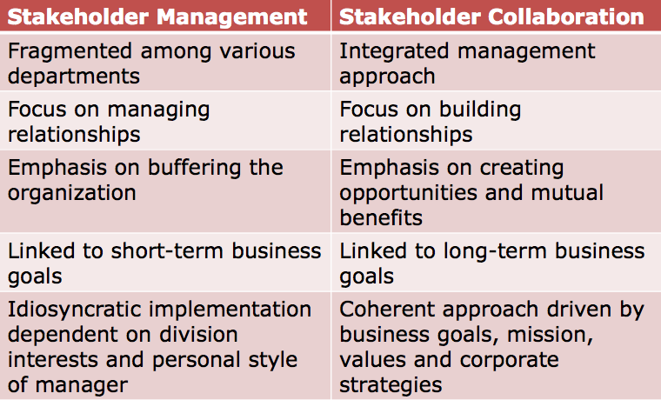

Learning Summary
• Approaches to understanding the relationships between the corporation and its stakeholders range from the basic listing and mapping to more complicated concepts such as stakeholder collaboration and social capital.
• These approaches help the corporation to consider their stakeholders’ moral concerns in strategic and operational initiatives.

Stakeholders and Social Capital
Social Capital: Any aspect of a corporation’s organizational arrangement that creates value and facilitates the actions of stakeholders within and external to the corporation.

From Stakeholder Management to Stakeholder Collaboration and Engagement

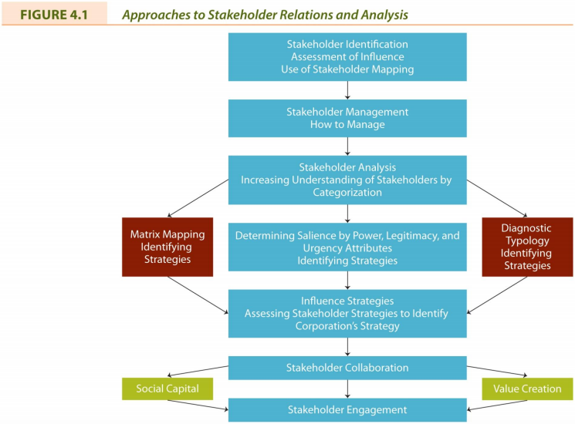

Week 4-5A: Corporate Social Responsibility (CSR), Chapters 7-9

Definition: Corporate Philanthropy
The effort of business to contribute to society socially, manifested by donations of money or goods and services in kind, voluntarism (where corporate employees work for social causes), and sponsorship of events that contribute to society.
Includes:
• Cause-related marketing: The purchase of a particular product results in a donation being made by a corporation to a non-profit organization’s program.
• Strategic giving: An attempt to rationalize the shareholder interests with corporate philanthropy whereby the corporation benefits directly from the funds given.

Definition: Social Venture Philanthropy
• The investment of human and financial resources by corporations in non-profit community development agencies to generate a social return instead of only a financial one.
• Also known as social venturing, the new philanthropy, and high engagement philanthropy

Arguments For & Against Corporate Philanthropy

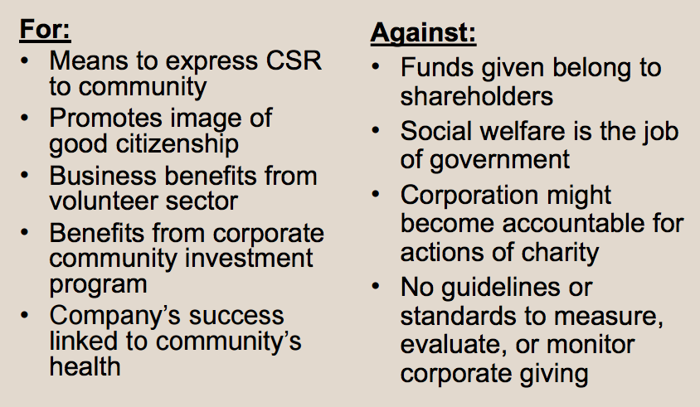

Definition: Corporate Voluntarism
• The time and talent employees commit to community organizations with support and/or consent from employers who recognize the value of such efforts to society.
• Forms of support:
- Providing facilities, allowing time off, assisting with personal expenses incurred while undertaking voluntary activities, special recognition to employees
• Corporate policies regarding voluntarism:
- encouraging; enabling; and promoting

Definition: Corporate Sponsorship
• A partnership which has been established for mutual benefit between a business sponsor and an event or a non-profit.
- Examples: sports, cultural, and educational events, literacy, race relations, drug abuse, environmental issues, etc.
• Arguments for: brand image, awareness, targeted marketing
• Arguments against: cause association

Definition: Reputation Management
• Reputation management is an effort to enhance a corporation’s image.
• Previous focus on media and public relations as well as crisis management.
• Today, focus is on relationships with all stakeholders.
• Reputations take a long time to be established, but can be destroyed quickly.

Definition: Corporate Social Responsibility
The way a corporation achieves a balance among it economic, social, and environmental responsibilities in its operations so as to address shareholder and other stakeholder expectations.

The Fundamental CSR debate

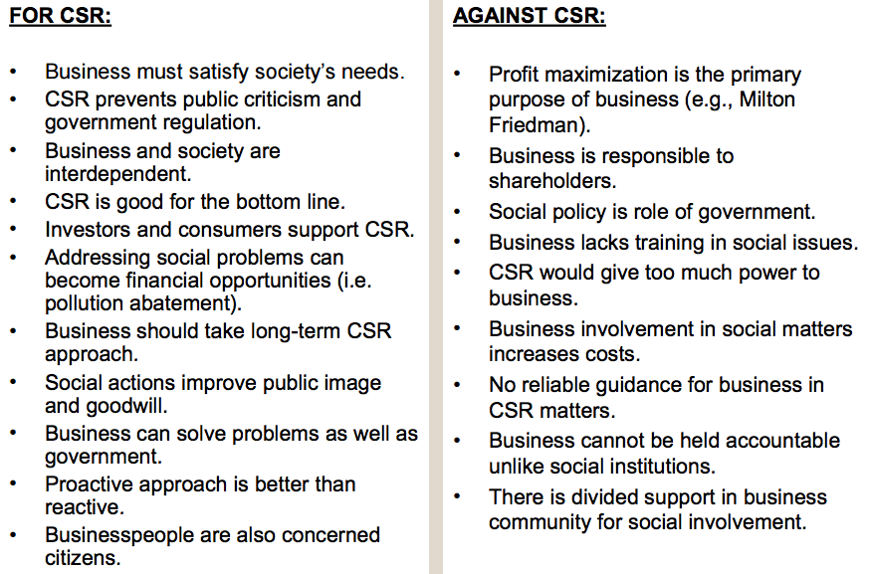

Definition: Corporate Citizenship
• Corporate citizenship occurs when a corporation demonstrates that it takes into account its complete impact on society, environment and economy.
• Business citizenship - includes the responsibilities of corporate citizenship on a local and national basis and extends it to a global or universal scope

Good Corporate Citizenship: Benefits

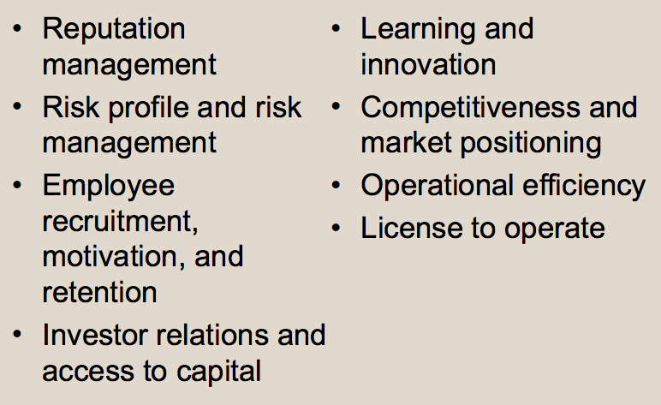

Definition: Corporate Sustainability
• Corporate Sustainability (CS) refers to activities demonstrating the inclusion of social, environmental and economic responsibilities in business operations as they impact all stakeholders.
• Sustainability = Enough, for all, forever
- Compliance-driven CS: follow regulations
- Profit-driven CS: focus on bottom line
- Caring CS: go beyond legal compliance
- Synergistic CS: well balanced solutions
- Holistic CS: fully integrated CS

Definition: Social Impact Management
• The field of inquiry at the intersection of business needs and wider societal concerns that reflects and respects the complex interdependency between the two.
• Evaluates three aspects of business:
- Purpose of business
- Social context of business
- Metrics: how performance is measured

Definition: Triple Bottom Line (TBL)
• Evaluates a corporation’s performance according to a summary of the economic, social, and environmental value the corporation adds or destroys.
• Often forms the basis for corporate reporting of economic, ethical, and environmental responsibilities.
• Has also been criticized as being of limited value and misleading.

Definition: Social Enterprise
• A model of business operation where some or all profits are deliberately used to further social aims.
• Two types:
(1) non-profit enterprises that contribute all profits to social initiatives (i.e. Shorefast Foundation);
(2) for-profit enterprises that divide profits between social initiatives and shareholders (i.e. Google)
• Social entrepreneurship involves the activities undertaken to enhance social wealth in some innovative way.
• Social Entrepreneur: An innovative, visionary leader of a non-profit with real-world problem-solving creativity and a high awareness of ethical considerations.

The Future of CSR and Social Reporting
• Fad-and-fade scenario:
• Awareness and practice of CSR will decline significantly
• Embed-and-integrate scenario:
• CSR is accepted, continuous enhancement continues
• Transition-and-transformation scenario:
• incremental changes to CSR are insufficient, redesign of corporation necessary

Why report?
• Enhances corporate reputation and trust
• Provides some protection against crisis
• Stakeholders expect accountability and transparency
• CSR linked to profitability

Six Steps to Ethical Decision Making
1. Define the problem
2. Identify alternatives
3. Evaluate the alternatives
4. Make the decision
5. Implement the decision
6. Evaluate the decision

Key Elements of Corporate Social Responsibility (CSR)
• Corporations have responsibilities beyond the production of goods and services.
• These responsibilities involve helping to solve social problems.
• Corporations have a broader constituency than just stockholders.
• Corporations have impacts beyond simple marketplace transactions.
• Corporations serve a wider range of human values than just economic values.

Principles of CSR
• Business and society are interwoven rather than distinct entities
• Expectations are placed on business due to its three roles: institutional; organizational; and individual.
• These three roles can be expressed in terms of three principles of corporate social responsibility: legitimacy; public responsibility; and managerial discretion.

Social Responsibility Theories
• Amoral view
• Traditional view of business as merely profit-making entity
• Personal view
• Corporations are like people and can therefore be held accountable for their actions
• Social view
• Corporations are social institutions with social responsibilities

Pyramid of CSR

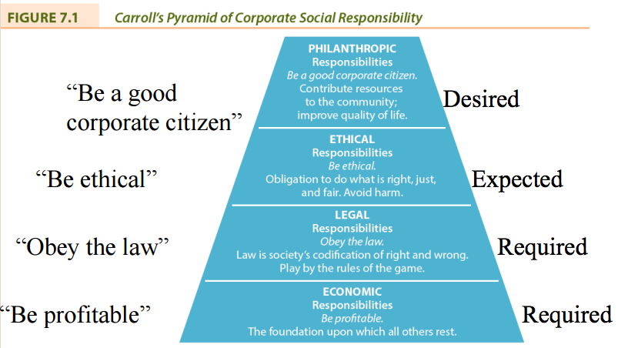

Week 7B: Ownership and Governance, Chapter 11

“The Corporate Agenda”
• The real or imagined alleged domination of public policy or government programs by corporations or business organizations in their own best interests.
• The corporate agenda might include:
- Reduction of government involvement
- Deregulation of business and industry
- Reduced corporate taxation
- Enactment of free trade agreements and support for globalization

Impact of Changing Government Involvement

Deregulation | Privatization
Definition: the reduction of government influence or impact over the economy allowing for a freer and more efficient marketplace | Definition: Strengthening of the market at the expense of the state
Pros: more competitive business environment, resulting in higher productivity, more efficiency, and lower prices | Provision of public service by the private sector
Cons: reduced environmental quality standards, greater financial uncertainty, and market control by monopolies. | Degrees of privatization (i.e. complete or partial)
 | Techniques or forms of privatization (i.e. divestiture, contracting out)

Ethical Implications in Business–Government Relationship
• Appropriateness of government involvement and interference in business operations
• Matter of accessibility to government
• Favouritism to some corporations regarding loans, grants, or protection
• Endorsement of political candidates or parties can be perceived as expecting favours in future
• Lack of transparency in relationship between government and business

Learning Summary
• Business is regulated by market forces, self-regulation by business itself, and government.
• The scope of government regulation of business is extensive.
• Business is involved in Canadian politics through a diverse set of strategies.
• The interaction between government and business has numerous ethical implications.

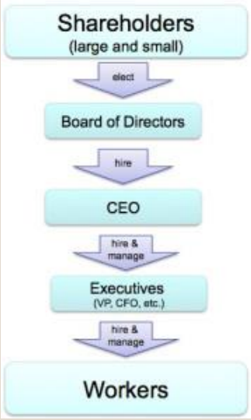
Corporate Governance
Definition: The processes, structures, and relationships through which the shareholders, as represented by a board of directors, oversee the activities of the corporation. (LO 11.6)
• “For most corporations, the basic governance structure is this: shareholders vote for, and hence empower, a board of directors, who then have a fiduciary responsibility to look out for shareholders’ interests. The board hires a CEO, who is accountable to the board. The CEO (sometimes with input from the board) hires a management team, and so on.
• At each step, there is a flow of power down the chain (from shareholders through to front-line employees), and a flow of accountability back up that chain.”

The People Who Run Canadian Business
Owners
- Direct ownership (e.g., shareholders); or
- Indirect ownership (e.g., mutual fund holders)
Boards of Directors
- Elected by shareholders
- Must fulfill legal and fiduciary obligations
Managers
- Top Managers are hired by boards of directors
- Oversee operations of corporation

Role of the Owner Stakeholder
• Owners, also referred to as investors or shareholders, are key stakeholders in a capitalist system as they provide a major portion of the capital to finance corporations.
• Governing system: The processes, structures, and relationships through which decisions are made.

The Ownership of Canadian Business
• Investors/Shareholders
• Entrepreneurs
• Employees and Managers
• Customers or Consumers
• Producers
• Mutual Funds

Rights of Shareholders
• Secure ownership registration
• Capability to transfer ownership
• Access to relevant corporate information
• Participation and voting at shareholder meetings
• Election and removal of board members
• Share in profits of the corporation
Shareholder Democracy: Passive versus Active Shareholders
• Shareholder Democracy: the exercise of power by owners to ensure they are treated fairly and enjoy equally the privileges and duties of ownership
• Passive shareholders: do not attempt to influence the affairs of the corporation even though they have a legal right to do so.
• Active shareholders: participate in the governance of the firm to the full extent allowed by law.

Issues of Ownership
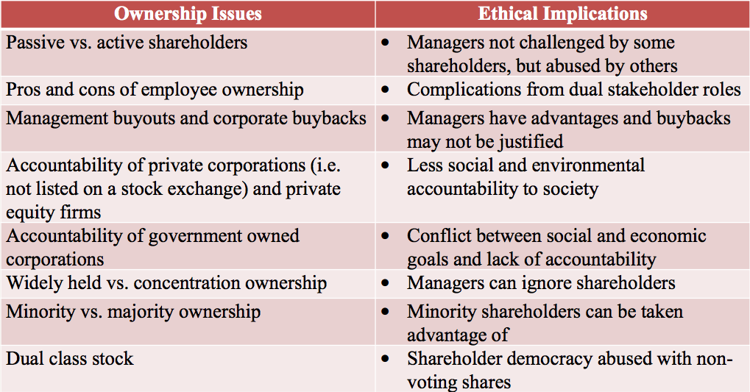

Responsibilities of the Board
Board of Directors: group of individuals elected by shareholders to govern or oversee the corporation’s affairs.
- Fiduciary duties: obligations of directors to shareholders that are prescribed by laws or regulations.
- Board’s written mandate must include board’s satisfaction with integrity of CEO and other executives and that they are creating a culture of integrity (Canadian Stock Exchanges)
- Board must apply high ethical standards and take into account the interests of stakeholders (OECD, 2004)

Protecting Owners and Investors
• Governments (e.g., US Sarbanes-Oxley Act, 2002)
• Self-Regulatory Agencies and Organizations (e.g., stock exchanges)
• Industry Associations (e.g., Investment Dealers’ Association)
• Individual and Institutional Activists (e.g., Small Investor Protection Association)

U.S. Sarbanes-Oxley Act (2002)
Public Company Accounting Oversight Board
• Auditor independence • Corporate responsibility
• Enhanced financial disclosures
• Corporate and criminal fraud accountability
• White-collar crime penalty enhancements U.S. Sarbanes-Oxley Act (2002) LO 11.4 Cop

Balancing Power in the Corporation and Criticism of Corporate Governance Reform:

Rebalancing Power | Criticism of Reform
CEOs have been too powerful | Audit fees have increased
New balance of power emerging among management, board, professional services (e.g., lawyers, auditors) | Management attention diverted away from operation of business
Directors now playing bigger role in strategic decision making and ethical responsibilities | Additional costs have made North American business less competitive in global market
Auditors more cautious | Changes may not make a difference to firm performance or in protection of shareholders
Legal counsel representing everyone | Approach should be principles-based, not rule-based
Some shareholders more active in pressuring boards

Board Membership & Structure
Independent director: A director who is free from any interest and any business or other relationship which could, or could reasonably be perceived to, materially interfere with the director’s ability to act in the best interests of the corporation.
• Board committee examples:
• audit; finance; human resources; pension; compensation; nominating; governance; and strategic planning.
• Audit committee is required to have independent members.
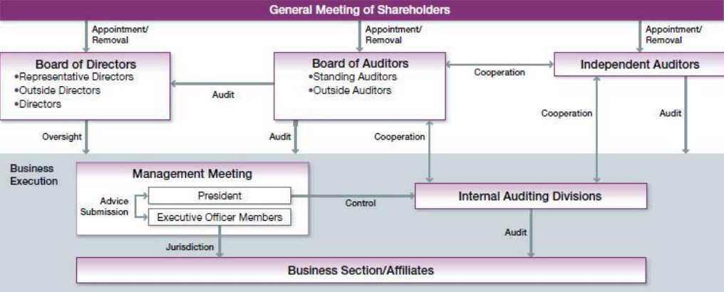
• Most experts recommend separation between the role of the board chair and the CEO.
Disclosure and Transparency
Disclosure requirements for Canadian public companies (National Instrument 58-201):
• Disclose whether board has adopted written code
• Describe steps board takes to encourage and promote a culture of ethical business conduct
• Disclosure of executives’ compensation
Board’s audit committee oversees the internal and external accounting auditing function to ensure that financial statements accurately and appropriately represent the condition of the corporation and that regulated disclosures are made.

Stakeholders Monitoring Responsible Investment
- Social Investment Organization (Canada)
- Jantzi Social Index (Canada)
- Domini 400 Social Index (US)
- Dow Jones Sustainability Indexes (US)
- FTSE4Good Index Series (UK)

Responsible Investing
• Screening investments in corporations or mutual and pension funds for their response to social or ethical responsibilities as well as their financial or economic actions.
• Use “positive” screens and “negative” screens (e.g., alcohol, tobacco, weapons, and nuclear power)

Corporate Governance and Performance
• Some research suggests that good corporate governance affects firm performance
• Effective boards:
  - Are accountable and independent
  - Have experienced, knowledgeable and effective directors with the highest level of integrity
  - Have clear roles and responsibilities
  - Engage with stakeholders

OECD Principles of Corporate Governance

- Rights of stakeholders are to be respected
- Effective redress for stakeholders when rights violated
- Stakeholders should have access to information
- Stakeholders should be allowed to blow whistle on illegal or unethical practices to board

Ownership, Governance, and CSR
Directors are encouraged to ask five questions about the corporation’s ethics management:
  - What is the strategy to manage ethics?
  - Who is responsible for ethics in our company?
  - Are people in our firm equipped to recognize and resolve moral dilemmas?
  - Are people in our firm provided with a safe opportunity to discuss ethical issues of concern?
  - Do we reward or punish ethical integrity and moral courage if it has a negative impact on the bottom line?

Learning Summary
• Owners have varying degrees of influence on corporate social responsibility and the moral behaviour of the corporation.
• Owners have an economic responsibility if they wish their corporation to survive while at the same time being responsible for the ethical or social impact of the business.
• A governing system includes the processes, structures, and relationships through which decisions are made.
• The board of directors has been the object of many suggestions for reform. The result has been the reform, or reorganization, of the board as the principal body involved with the processes, structures, and relationships through which decisions are made.

