Intracellular Compartments
Simpkins:
- Within eukaryotic cells there are membrane-bounded compartments
- These compartments interact with the cells environment
- Vesicles are what are used to transport proteins and lipids between the compartments
- exocytic pathway (carries material synthesized in the cytoplasm to various cell parts) and endocytic (internalizes material from the environment to the inside of the cell)
- Most prokaryotes contain only one membrane- the plasma membrane (surrounds the cell)
- All membrane-attached processes occur on it.
- In some prokaryotes specific patches of the Plasma Membreane specialize in separate functions
- These processes are more advanced in eukaryotic cells
In eukaryotic cells:
- There are membrane bound intracellular compartments that carry out specific functions e.g. nucleus-DNA replication, mitochondria-respiration
- This specialization allows for larger cells (1000-10,000 fold increase in volume)
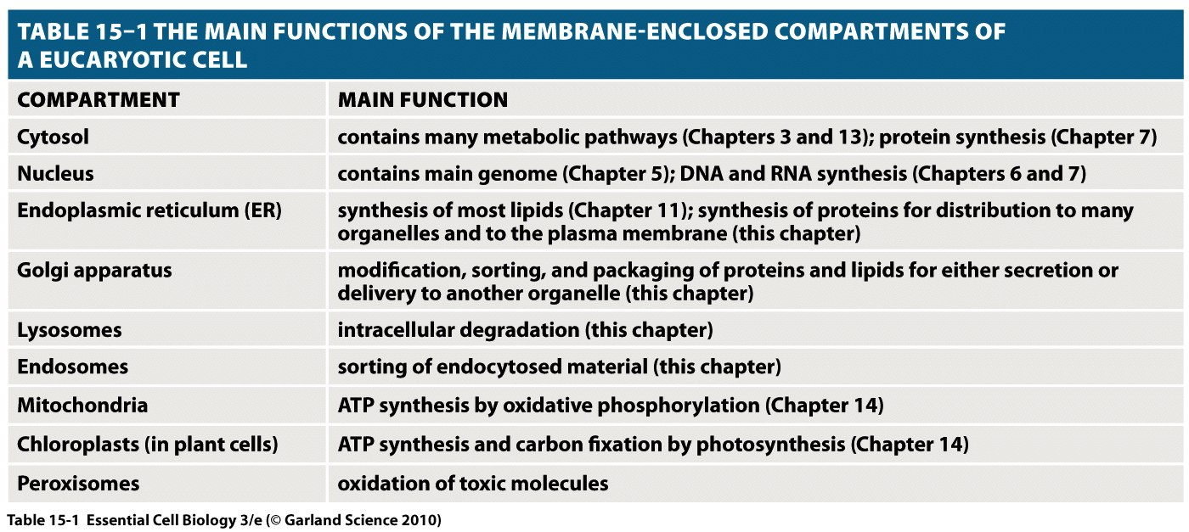
- The cell functions are separated efficiently

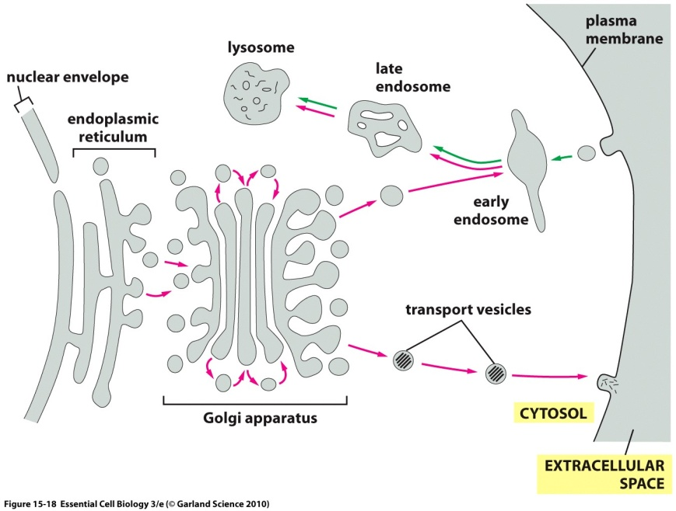
How will the different cellular compartments communicate?
Partly addressed by:
- Vesicular transport
  - Vesicle: a bubble like membranous structure that stores and transports cellular products, digests metabolic wastes
- The vesicle is separated from the cytosol by at least one lipid bilayer
- Cytosol-the liquid component of the cytoplasm surrounding the organelles and other insoluble cytoplasmic structures within a cell
- Organelles-structures within the cell that are membrane bound compartments and perform a specific function
Basically/textbook:
Vesicle: small, membrane enclosed, spherical organelle in the cytoplasm of a eukaryotic cell
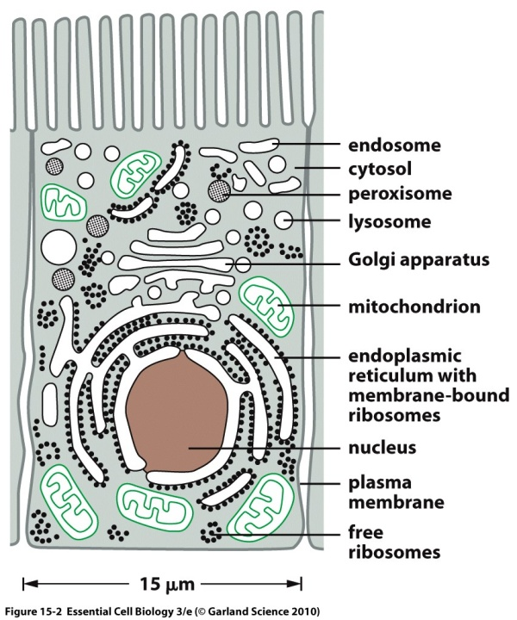
Vesicular transport: Transport of materials between organelles in the eurkaryotic cell via membrane-enclosed vesicles.

There are many organelles in eukaryotes:
- Nucleus
- Endoplasmic riticulum
- Golgi apparatus
- Mitochondria
- Chloroplast (plastid)-plants
- Some prokaryotes have organelles –(carboxysome for carbon fixation, chlorosome-light harvesting in bacteria)

Nucleus:
- Core of cell
- Contains genetic material (multiple-linear DNA molecules which form organized structures called chromosomes
- Control cellular activity like metabolism, growth and reproduction
- The nucleus has three components:
  - Nucleolus (protein&RNA), chromatin (nucleic acids, eg. DNA/RNA) and nuclear envelope (double layer membrane with nuclear pores that separates the nucleoplasm and the cytoplasm)
Textbook:
The nucleus is generally the most prominent organelle in eukaryotic cells. It is surrounded by a double membrane known as the nuclear envelope, and communicates with the cytosol via nuclear pores that perforate the envelope. The outer nuclear membrane is continuous with the membrane of the endoplasmic reticulum.
Endoplasmic Reticulum:
- Rough endoplasmic riticulum
- Smooth endoplasmic riticulum
- Membrane bound
- Interconnected flattened sacs or tubules
- Connect the nuclear membrane through the cytoplasm, may extend into the cell membrane
- Rough ER-has ribosomes on the outer surface giving it a rugged appearance
- Ribosomes-so involved in protein sythesis and secretion-secretes serum proteins eg. Albumin and hormones eg insulin and milk in the glands
- Smooth ER-no ribosomes-involved in synthesis of lipids, metabolism of carbohydrates and calcium concentration, detoxification, attaching receptors on cell membranes, intracellular transport eg to the golgi apparatus
Textbook:
The endoplasmic reticulum is a system of interconnected sacs and tubes of membrane that often extends throughout most of the cell. The ER is the major site of synthesis of new membranes in the cell. Large areas of the ER have ribosomes attached to the cytosolic surface and are designated rough endoplasmic reticulum. The ribosomes are actively synthesizing proteins that are delivered into the into the ER lumen or ER membrane. The smooth endoplasmic reticulum lacks ribosomes. It is scanty in most cells but is highly developed for performing particular functions in others. For example it is the site of steroid hormone synthesis in cells of the adrenal gland and the site where a variety of organic molecules, including alcohol are detoxified in liver cells. In many eukaryotic cells, the smooth ER also sequesters Ca²⁺ from the cytosol; the uptake and release of Ca²⁺ from the ER is involved in the rapid response to many extracellular signals.
Golgi Bodies
- Part of the GERL system
- Takes up ad processes secretory and synthetic products from the ER and then releases finished products into various parts of the cell cytoplasm or secretes them to outside the cell
- Layers of flattened sacs
Textbook:
The golgi apparatus, which is usually situated near the nucleus, receives proteins and lipids from the ER, modifies them, and then dispatches them to other designations in the cell.
G-golgi
E-endoplasmic
Riticulum
L-lysosome complex

Mainly performs endocytosis and exocytosis

At the train station how do you know where to go?
Simpkins:
- Signal sequences direct proteins to their correct organelle
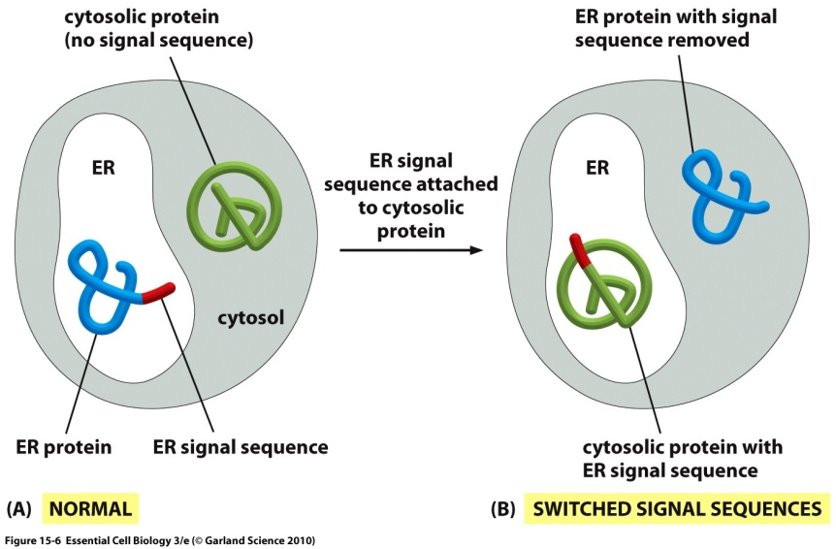
- Eg. Proteins destined for the ER posses an N-terminal SS
- Those that are suppose to stay in the cytosol lack this signal
- Discovered through experimentation

Textbook: Signal sequences direct proteins to their correct organelle.
A) Proteins destined for the ER possess an N-terminal signal sequence that directs them to that organelle, where as those destined to stay in the cytosol lack this sequence.
B) Recombinant DNA techniques can be used to change the location of the two proteins. If the signal sequence is removed from the ER protein and attached to the cytosolic protein, the proteins end up in an abnormal location in the cell. Such experiments indicate that the ER signal sequence is both necessary and sufficient to direct a protein to the ER.
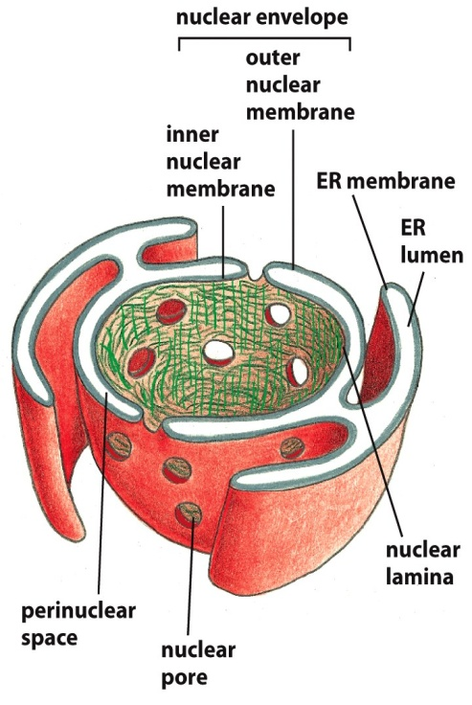
Simpkins:

- The outer nuclear membrane is continuous with the ER
- Double membrane of the nuclear envelope is penetrated by nuclear pores

Proteins bound for the nucleus are actively transported through the nuclear pores. The energy supplied by GTP hydrolysis drives nuclear transport

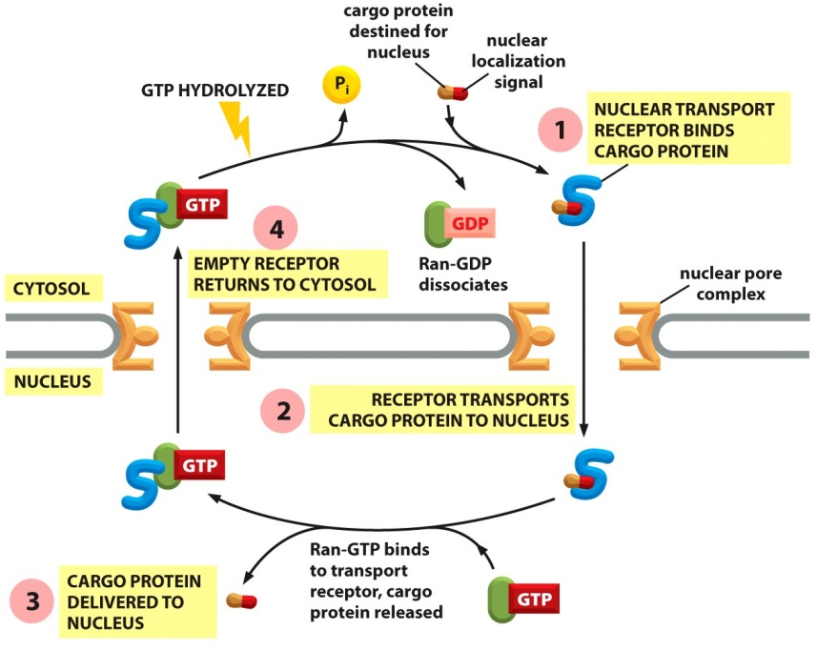
- Nuclear transport receptor picks up its cargo protein in the cytosol and enters the nucleus
- Reaches as small protein called Ran which carries a molecule of GTP
- The Ran-GTP binds to the nuclear transport receptor causing it to release its cargo to the nucleus
- The nuclear receptor still carrying the Ran-GTP is transported back
- An assessory protein triggers Ran to hydrolyze its bound GTP
- Ran GDP comes off the transport receptor which is then available to bind with another protein targeted for the nucleus

A similar process is used to export mRNAs and other large molecules from the nucleus into the cytosol

Proteins are imported into the mitochondria in an unfolded form
- A receptor in the outer mitochondrial membrane recognizes the signal sequence of the protein
- The complex (receptor and protein) diffuses laterally in the membrane to a contact site where the protein is translocated across both the outer and inner membranes by a protein translocator
- the signal sequence is then cleaved off by a signal peptidase inside the organelle
- Proteins are transported into chloroplasts by a similar mechanism
- (chaperone proteins assist in pulling the protein across the membrane and assist in refolding the protein on the other side-these are not shown)
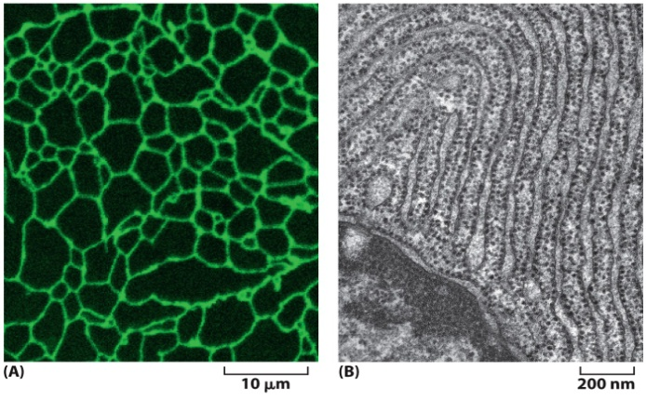
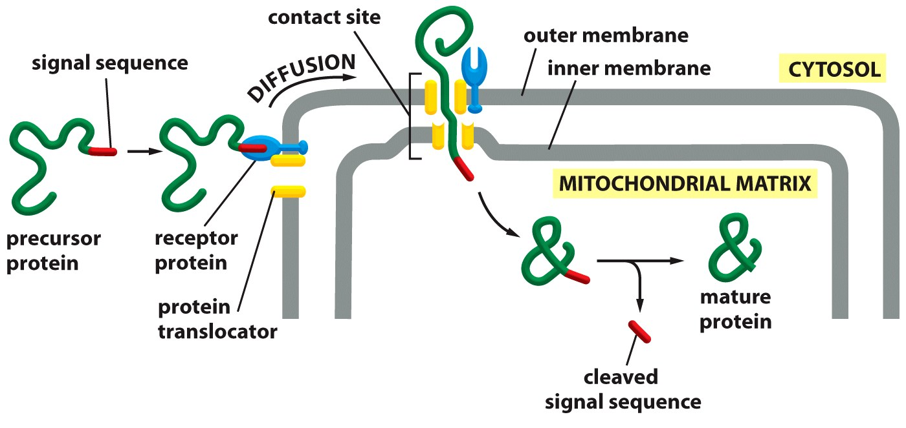
Endoplasmic Reticulum:
- Extensive network
- A) fluorescent micrograph
- ER in a living plant cell-look like tubes-fluorescing because of marker on the proteins
- B) electron micrograph of a cell in dogs pancreas
- Secretes large amounts of digestive enzymes
- Can see the sheets of ER in the cytosol with the ribosomes
- Common group of ribosomes is used to synthesize both the proteins that stay in the cytosol and those that are transported into membrane-enclosed organelles (including the ER)
- Ribosomes that are translating cytosolic proteins remain free in the cytosol
- For proteins that are going to the ER a signal sequence is attached (seen in red) on the growing polypeptide chain
- This signal ssequence directs the ribosome to the ER membrane
- Many ribosomes bind to each mRNA molecule forming a polyribosome
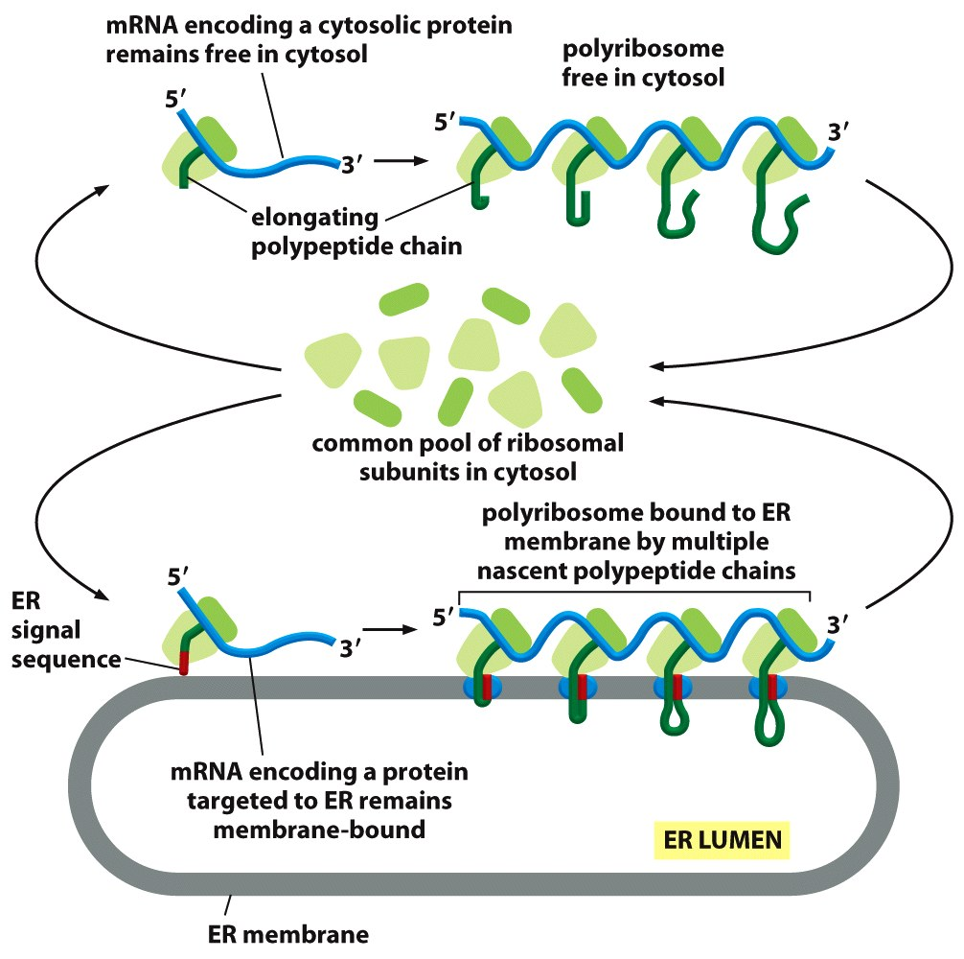
- After each round of synthesis the ribosomal subunits are released and rejoin the common “pool” in the cytosol
- In cases where the mRNA molecule encodes a protein with an ER signal sequence the polyribosome becomes attached the ER membrane by the growing polypeptide chains (these have become inserted into the membrane
- ER signal sequences and a Signal Recognition Particle direct a ribosome to the ER membrane
- SRP-signal recognition particle
- The srp binds to the exposed ER SS and to the ribosome thus slowing the protein synthesis by the ribosome
- The SRP-ribosome complex then binds to an SRP receptor in the ER membrane
- The SRP is released passing the ribosome to a translocation channel in the ER membrane
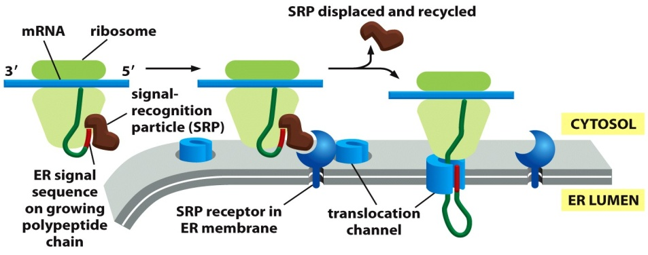
- The translocation channel inserts the polypeptide chain into the membrane and starts to transfer it across the lipid bilayer

Textbook:

Top image: A common pool of ribosomes is used to synthesize both the proteins that stay in the cytosol and those that are transported into membrane-enclosed organelles, including the ER. Ribosomes that are translating cytosolic proteins remain free in the cytosol. For proteins that will be sent to the ER, a signal sequence (shown in the image in red) on the growing polypeptide chain directs the ribosome to the ER membrane. Many ribosomes bind to each mRNA molecule, forming a polyribosome. At the end of each round of protein synthesis, the ribosomal subunits are released and rejoin the common pool in the cytosol.

Bottom Image: An ER signal sequence and a signal recognition particle(SRP) direct a ribosome to the ER membrane. The SRP binds to the exposed ER signal sequence and to the ribosome, thereby slowing protein synthesis by the ribosome. The SRP-ribosome complex then binds to an SRP receptor in the ER membrane. The SRP is released, passing the ribosome to a translocation channel in the ER membrane. Finally the translocation channel inserts the polypeptide chain into the membrane and starts to transfer it across the lipid bilayer.
Start and Stop Signals determine the arrangement of a transmembrane protein in the lipid bilayer

Soluble Protein Crossing

- A soluble protein crosses the ER membrane and enters the lumen in the following graph
- A translocatioin channel binds the signal sequence and actively transfers the rest of the polypeptide across the lipid bilayer as a loop
- During the process the signal peptide is cleaved from the growing protein by a signal peptidase
- The cleaved SS is expelled into the bilayer where it is degraded and the translocated polypeptide is released as a soluble protein in the the ER lumen
- Once the protein is released the pore of the translocation channel closes.

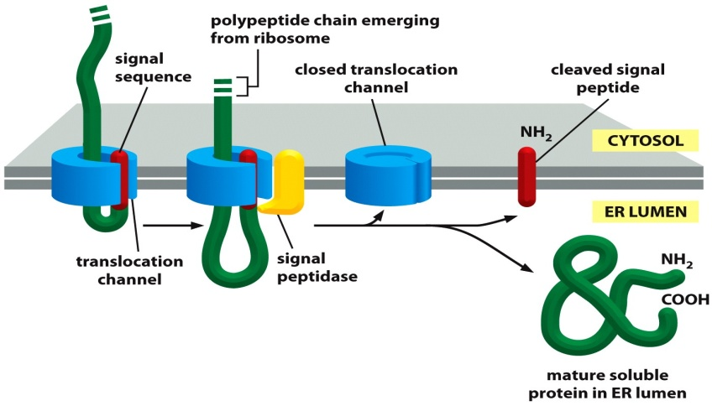
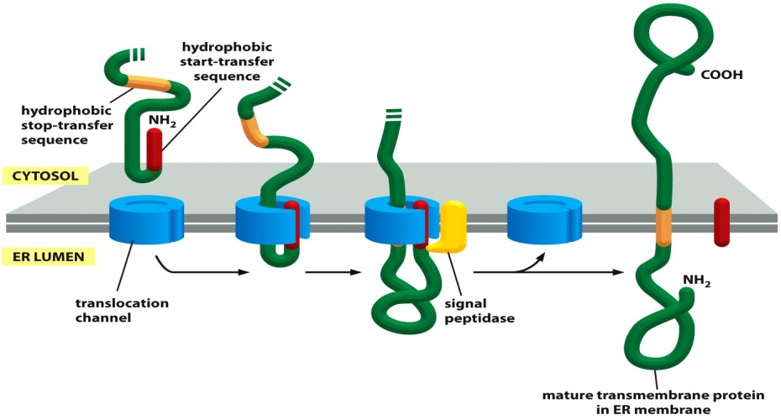
Textbook: A soluble protein crosses the ER membrane and enters the lumen. A translocation channel binds the signal sequence and actively transfers the rest of the polypeptide across the lipid bilayer as a loop. At some point during the translocation process, the signal peptide is cleaved from the growing protein by a signal peptidase. This signal sequence is ejected into the bilayer, where it is degraded, and the translocated polypeptide is released as a soluble into the ER lumen. One the protein has been released, the pore of the translocation channel closes. The membrane-bound ribosome is omitted from this and the following figure for clarity

A single-pass transmembrane protein is integrated into the ER membrane. An N-terminal ER signal sequence (red) initiates transfer as in the last image. In addition, the protein also contains a second, hydrophobic sequence, a stop-transfer sequence (orange). When this sequence enters the translocation channel, the channel discharges the protein sideways into the lipid bilayer. The N-terminal signal sequence is cleaved off, leaving the transmembrane protein anchored in the membrane. Protein synthesis on the cytosolic side continues to completion.

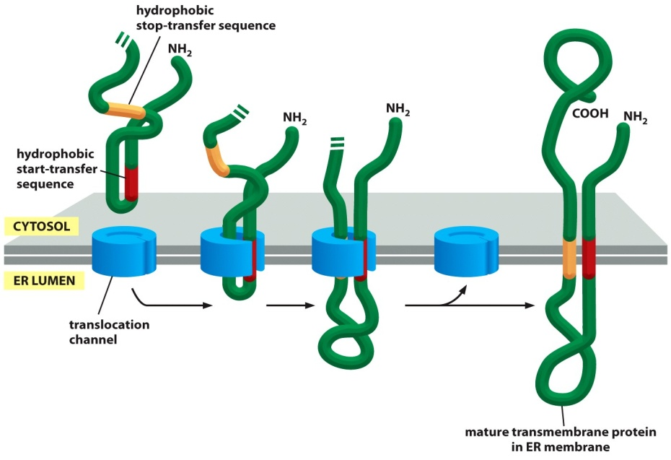
A double pass transmembrane protein uses an internal start-transfer sequence to integrate into the ER membrane. An internal ER signal sequence(red) acts as a start-transfer signal and initiates the transfer of the polypeptide chain. Like the N-terminal ER signal sequence, the internal start-transfer signal is recognised by a signal recognition particle that bring the ribosome to the ER membrane(not shown). When a stop-transfer sequence (orange) enters the translocation channel, the channel discharges both sequences into the plane of the lipid bilayer. Neither the start nor the stop transfer sequence is cleaved off, and the entire polypeptide chain remains anchored in the membrane as a double pass transmembrane protein. Proteins that span the membrane more times contain further pairs of start and stop sequences, and the same process is repeated for each pair.

Vesicular Transport

Vesicular transport between membrane –enclosed compartments of the endomembrane system is highly organised. A major outward secretory pathways starts with the synthesis of proteins on the ER membrane and their entry into the ER and it leads through the golgi apparatus to the cell surface; at the golgi apparatus, a side branch leads off through endosomes to lysosomes. A major inward endocytic pathway, which is responsible for the ingestion and degradation of extracellular molecules, moves materials from the plasma membrane, through endosomes to lysosomes.

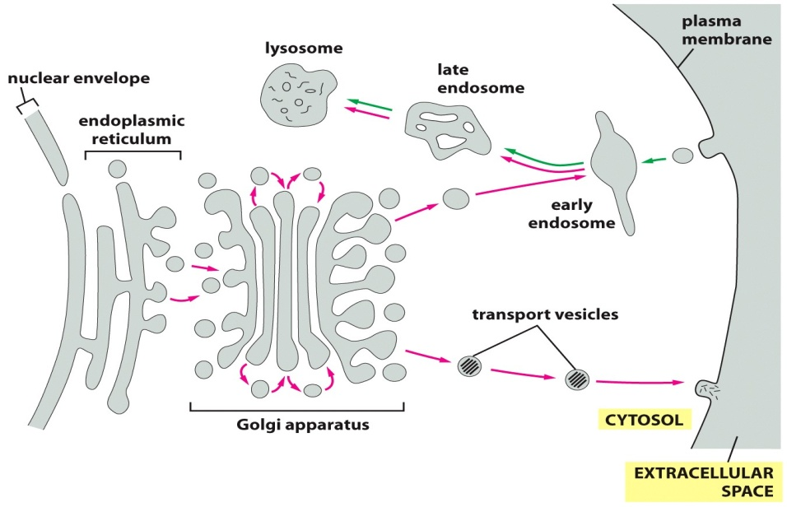
Vesicles bud from one membrane and fuse with another, carrying membrane components and soluble proteins between cell compartments. Each compartment encloses a space, or lumen, that is topologically equivalent to the outside of the cell. The extracellular space and each of the membrane-enclosed compartments (shaded grey) communicate with one another by means of transport vesicles, as shown. In the outward secretory pathway (red arrows), protein molecules are transported from the ER, through the golgi apparatus , to the plasma membrane or (via early and late endosomes) to lysosomes. In the inward endocytic pathway (green arrows), extracellular molecules are ingested in vesicles derived from the plasma membrane and are delivered to early endosomes and then (via late endosomes) to lysosomes.

Vesicle budding is driven by the assembly of a protein coat

Vesicles that bud from membranes usually have a distinctive protein coat on their cytosolic surface and are therefore called coated vesicles. After budding from its parent organelle, the vesicle sheds its coat, allowing its membrane to interact directly with the membrane to which it will fuse. Cells produce several kinds of coated vesicles, each with a distinctive protein coat. The coat serves at least two functions: it shapes the membrane into a bud, and it helps to capture molecules for onward transport.

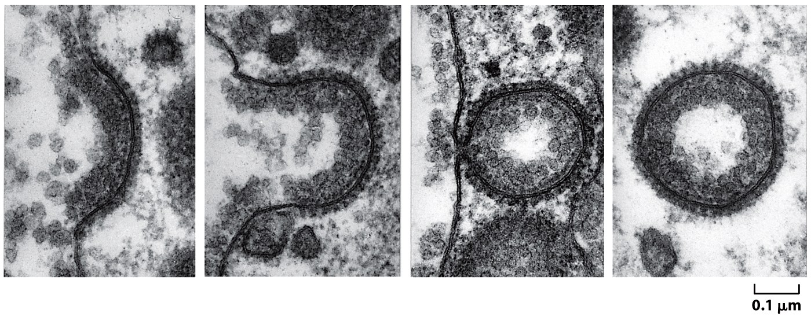
Chlathrin molecules form basket like cages that help shape membranes into vesicles.

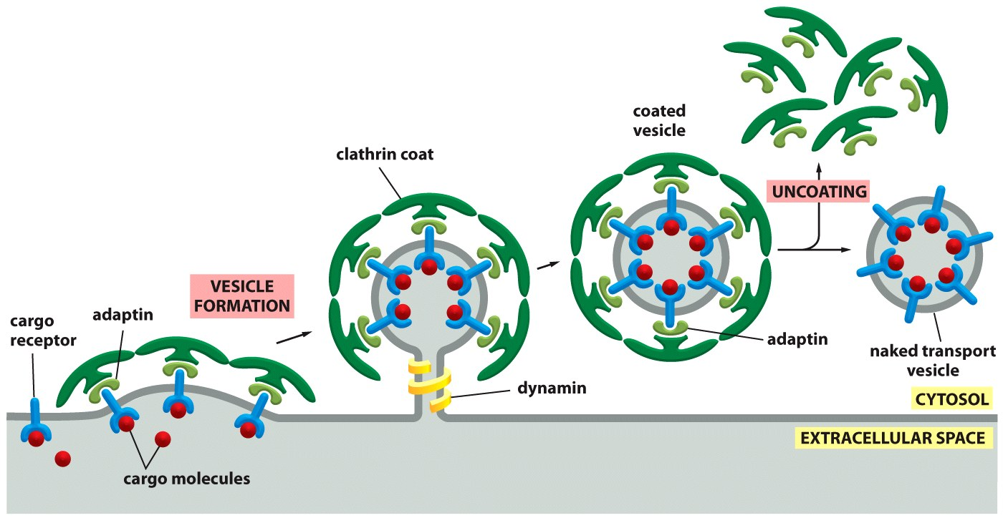
Clathrin-coated vesicles transport selected cargo molecules. Cargo receptors, with their bound cargo molecules, are captured by adaptins, which also bind clathrin molecules to the cytosolic surface of the budding vesicle. Dynamin proteins assemble around the neck of budding vesicles; once assembled, the dynamin molecules hydrolyze their bound GTP and, with the help of other proteins recruited to the neck (not shown), pinch off the vesicle. After budding is complete, the coat proteins are removed, and the naked vesicle can fuse with its target membrane. Functionally similar coat proteins are found in other types of coated vesicles.
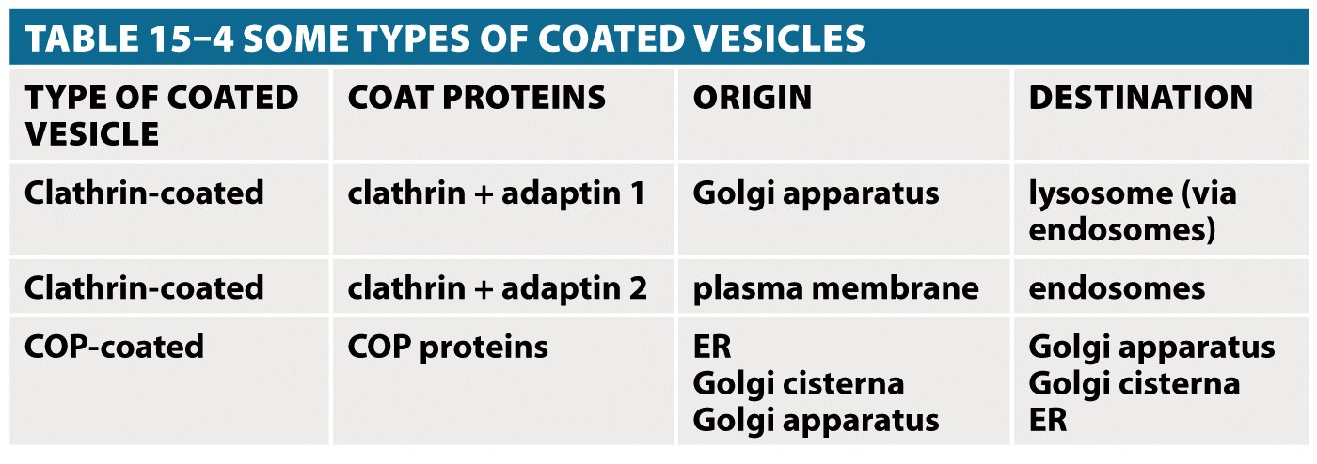
SNARE: One of a family of membrane proteins responsible for the selective fusion of vesicles with a target membrane inside the cell. SNARE on a vesicle = v-SNARE. SNARE on a target membrane = t-SNARE

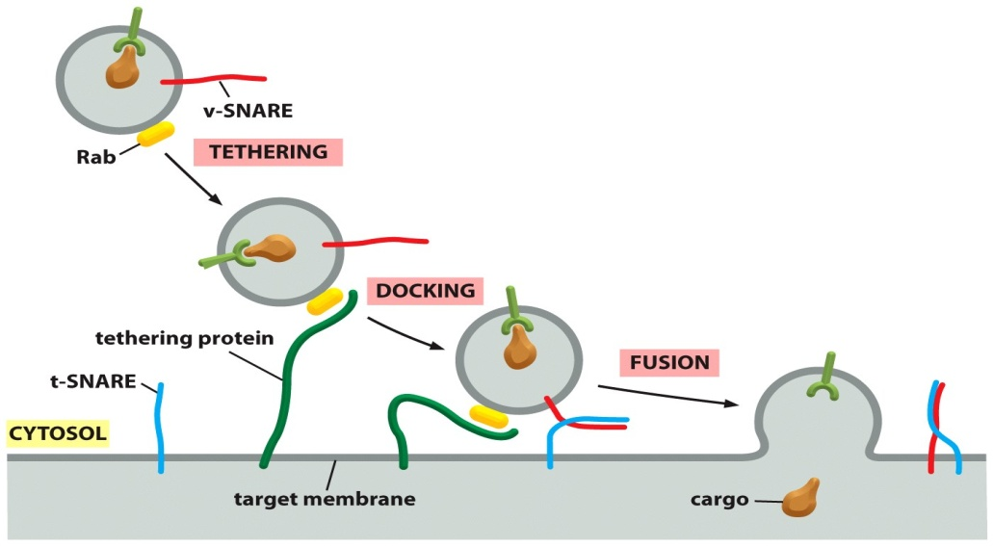
Rab proteins and SNAREs help direct transport vesicles to their target membranes. A filamentous tethering protein on a membrane binds to a Rab protein on the surface of a protein. This interaction allows the vesicle to dock on its target membrane. A v-SNARE on the vesicle then binds to a t-SNARE on the target membrane. Whereas Rab and tethering proteins provide the initial recognition recognition between a vesicle and its target membrane, the pairing of complementary SNAREs also helps ensure that transport vesicles reach their appropriate target membranes.

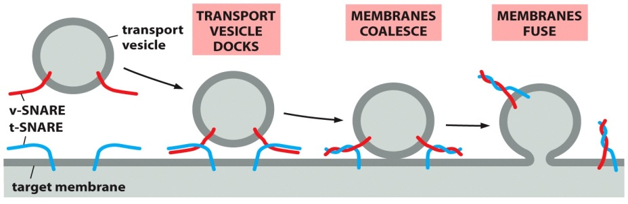
SNARE proteins play a central role in membrane fusion. Pairing of v-SNAREs and t-SNAREs draw the two lipid bilayers into close apposition. The force of the SNAREs winding together squeezes out any water molecules that remain trapped between the two membranes, allowing their lipids to flow together to form a continuous bilayer. In a cell, other proteins recruited to the fusion site presumably co-operate with SNAREs to initiate fusion. Additional proteins help to pry the SNAREs apart so that they can be used again.

The majority of the rest of this powerpoint were images. Rather than type them all up from the textbook, if you have the textbook, please read the figures in chapter 15, specifically pages 514-527.

