Lecture 1: Introduction

1.1 Ecology Defined
- Ecology- the scientific study of the relationships between organisms and their environment
  - How do the biotic components interact with the abiotic components
- Resources (mostly biotic)- consumed which makes it less available for others (food, water, mates)
  - Can undergo competition
- Conditions (mostly abiotic)- can influence an organism but cannot be consumed (temperature, day, length, acidity)
  - May alter competitive ability

1.3 Organisms and Ecosystems
- Ecosystem- collection of parts that function as an integrated whole (i.e. network)
    - Also defined as an environment in which organisms carry out their struggle for existence
  - Includes biotic community and abiotic environment
- Forest ecosystem-
  - Abiotic: air, soil, water, climate
  - Biotic: plants, animals, fungi, microbes

1.5 Importance of Scale
How does an ecologist examine each ecological level differently?
- Individual- discrete birth and death events
- Population- rates of birth and death, distribution of individuals
- Community- factors that influence the relative abundance of a species
  - Interaction of species within a given space
- Ecosystem- flow of energy and nutrients through the physical and biological systems
  - Abiotic/biotic factors coexisting within a community of species

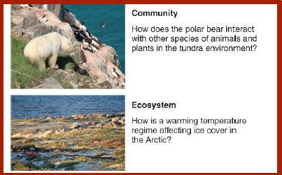
- Hierarchy level (e.g. community vs biome) is important to a study’s scale of resolution
  - Resolution: the time (temporal scale) and/or space (spatial scale) over which a pattern or process occurs

1.6 Ecology as a Science
- Observational study- explanatory variable (independent, e.g. elevation) and response variable (dependent, e.g. no. of species)
  - Nothing is manipulated, only measurements are taken and further correlated with one another
  - Difficult to infer causality, but can be done over a broad scale
- Field experiment (manipulative study) - applied in a natural setting; manipulating the environment
  - Difficult to control other influencing factors
  - Can infer causality since factors are being manipulated, but cannot be done over a broad scale ($$$$)
- Replication- must be performed in experiments to ensure consistency and accuracy
  - Small samples sizes are not ideal; creates difficulty in knowing the true pattern
    - Can cause insignificant statistical results
    - Not representative of the entire population

1.7 Classifying Ecological Data
- Statistical population- part of that population actually observed is the sample
- Data collected can be
  - Categorical (qualitative)
    - Unordered categories: hair colour, sex, etc.
  - Numerical (quantitative) –2 categoriesbinary, 0/1 representation
    - Discrete data: integer values, counts
    - Continuous data: within an interval (height, weight)
- How X- explanatory variable (independent) affects Y- response variable (dependent)

1.8 Displaying Ecological Data
- Histogram- illustrates categorical variable (X) and continuous variable (Y)
- Scatter plot- illustrates 2 continuous variables or sets of observations


