Chapter 6: Consumer Behaviour (Textbook)
6.1: Marginal utility and Consumer Choice
Utility: The satisfaction that a consumer receives from consuming some good or services.

We can construct a useful theory of consumer behaviour based on the idea of utility maximization

Total Utility: The total satisfaction resulting from the consumption of a given commodity by a consumer.
Marginal Utility: The additional satisfaction obtained from consuming one additional unit of a commodity.

Diminishing Marginal Utility
Law of Diminishing Marginal Utility:
- The utility that any consumer derives from successive units of a particular product consumed over some period of time diminishes as total consumption of the product increases (Holding constant the consumption of all other products).
Utility Schedules and Graphs
- Utility can be measured.
- Diff amount of utility received from consuming different units can be compared.
- Helps us see the difference in marginal utility and total utility.
- (Appendix 1)
  - Sean’s total utility $↑$
  - Sean’s marginal utility $↓$
    - As I get from 1 additional juice per day.
Maximizing Utility
Consumers want to maximize their total utility subject to the constraints they face. (income and prices)
The Consumer’s Decision:
- Consider the example products X and Y
- Maximize Utility: Consume both X and Y to the point where:
  - Marginal utility per dollar spent on the last X = marginal utility per dollar spent on the last Y
  - A utility-maximizing consumer allocates expenditures so that the marginal utility obtained from the last dollar spend on each product is equal.
- What if: MU for X > MU for Y.
  - To increase total utility: Spend less on X and more on Y
  - MU_{X} Higher = Spend less on X = Consume less when MU is higher.
  - MU_{Y} Lower = Spend more on Y = Consume more when MU is lower.
- The marginal utility per dollar spent on X:
  - $\frac{MUx}{Px}$
  - MU_{X} = Marginal Utility for Product X
  - P_{X} = Price of X
- The marginal utility per dollar spent on Y:
  - $\frac{MUY}{PY}$
  - MU_{Y} = Marginal Utility for Product Y
  - P_{Y} = Price of Y
- example: IF:
  - Last unit of X: $↑$MU_{X} by 30 and costs $3.
    - Marginal Utility per Dollar: $\frac{30}{3}$= 10
  - Last unit of Y: $↑$MU_{Y} by 10 and costs $1.
    - Marginal Utility per Dollar: $\frac{10}{1}$= 10
  - Marginal utility per dollar for X and Y are equal
$\frac{MUx}{Px}$=$\frac{MUy}{Py}$
Utility gained from last dollar spent on X is equal to the marginal utility gained from last dollar spent on Y

With only a given amount of income to spend, a consumer demands each good up to the point at which the MU/$Spent = MU/$Spent on every other good. (Can be multiple goods)
- When this is met for all goods, the consumer cannot increase utility further. (Utility Maximized)

An Alternative Interpretation:
$$\frac{MUx}{MUy}= \frac{Px}{Py}$$
- RHS = Relative Price of the two goods. (Beyond Consumer’s control)
- LHS = Relative Ability of the two goods to add to consumer’s utility (Consumer can control)
- If RHS $≠$LHS: Consumer can increase her TU by rearranging purchases of X and Y
example: RHS =$\frac{Px}{Py}$= $\frac{4}{2}$= 2
- MUx = 12
- MUy = 4.
LHS = $\frac{MUx}{MUy}= \frac{12}{4}$= 3
Since $\frac{MUx}{MUy}> \frac{Px}{Py}$ → 3 > 2
Consumer can increase TU by buying more X (High MU) and reducing Y (Low MU) purchases.
Note: Reducing the top makes the number smaller.
- (Buying more of X = Decreases MU)
- (Buying less of Y = Increases MU)
The Consumer’s Demand Curve
- A rise in the price of a product (with all other determinants of demand held constant) leads each consumer to reduce the quantity demanded of the product.
Market Demand Curves
- The theory of consumer behaviour that we have considered here predicts a negatively sloped market demand curve for each individual consumer.
- Market Demand Curve: the horizontal sum of the demand curves of individual consumers.
  - It is the horizontal sum because we want to add quantities demanded at a given price, and quantities are measured in the horizontal direction on a conventional demand curve.
  - Add the quantities demanded by all consumers at each price, and the result is the market demand curve.
  - (Appendix 2)
6.2: Income and Substitution Effects on Price Changes
Consumer loves ice cream. Price of ice cream falls. This affects him in 2 ways:
- Buys more ice cream. Reduction in price, which, with all other prices constant means a fall in the relative price of ice cream. → leads consumer to substitute away from other products towards ice cream.
- Consumer has more purchasing power or real income available to spend on all products.
Real Income: Income expressed in terms of purchasing power of money income - that is, the quantity of goods and services that can be purchased with the money income.
The Substitution Effect:
Substitution Effect: $Δ$Qd of a good resulting from a relative $Δ$P (holding real income constant ← Purchasing power held constant).
- Leads consumers to increase their demand for goods whose prices fall
- Consumer substitution away from other goods and toward ice cream.
The Income Effect
The Income Effect: The $Δ$Qd of a good resulting from a $Δ$Real Income. (Holding relative prices constant)
- Increased purchasing power.
- Leads consumers to buy more of a product whose price has fallen, provided that the product is a normal good.
- The size of the income effect depends on the amount of income spent on the good whose price changes and on the amount by which the prices changes.
example: If consumer were spending 50% of his income on ice cream, a reduction of price by 20% would be equivalent to a 10% increase in real income. (20% of 50% = 10%).
The Slope of the Demand Curve
Putting the income and substitution effects together:
- Because of the combined operation of the income and substitution effects, the demand curve for any normal good will be negatively sloped. Thus, a fall in price will increase the Qd. $↑$P = $↑$Qd
(Appendix 3)
- The sum of the income and substitution effects determines the total effect of the price change and thus how overall quantity demanded responds to the price reduction.
- Note: All normal goods and most inferior goods are negatively sloped.
Giffen Goods
Giffen Good: An inferior good for which the income effect outweighs the substitution effect so that the demand curve is positively sloped.
- Income effect > Substitution effect (Mostly means increased purchasing power)
  - Consumers buy more a product b/c their purchasing power increases. (I want to buy better thigns because I’m hella rich now)
- 2 things must be true:
  - The good must be an inferior good. ($↓$income = $↑$Qd - and Vice Versa)
  - The good must take a large portion of total household expenditure and therefore have a large income effect.
Conspicuous Consumption of Goods
- The more expensive such a commodity became, the greater might be its ability to confer status on its purchaser.
- example: People buying diamonds b/c they’re expensive. If they weren’t people would stop buying.
- In a case where people appear to buy more goods at a higher price because of the high price, that individual is buying it because other people think that he bought it for a higher price. (He still has negatively sloped demand curves)
6.3: Consumer Surplus
The Concept
Consumer Surplus: The difference between the total value that consumer place on all units consumed of a commodity and the payment that they actually make to purchase that amount of the commodity.
- A direct consequence of negatively sloped demand curves.
- For any unit consumed, consumer surplus is the difference between the maximum amount the consumer is prepared to pay for that unit and the price the consumer actually pays.
example:
Litres of Milk Sean consumes per week | Amount Sean is willing to pay for this litre ($) | Sean’s Consumer Surplus if I paid $1.00 / litre (My Profit) ($)
1st week | 6.00 | 5.00
2nd week | 3.00 | 2.00
3rd week | 2.00 | 1.00
4th week | 1.60 | 0.60
5th week | 1.20 | 0.20
6th week | 1.00 | 0.00
7th week | 0.80 | -
8th week | 0.60 | -
9th week | 0.50 | -
10th week | 0.40 | -
 | Total Value: $17.10 | Total Consumer Surplus: $8.80
(Appendix 4)
- The total valuation is the area below the demand curve
- Consumer surplus is the part of the area that lies above the price line.
- The market demand curve shows the valuation that consumers place on each unit of the product. For any given Q, the area under the demand curve and above the price line shows the consumer surplus received from consuming those units.
The Paradox of Value
- A good that is very plentiful - Low price and will be consumed to the point where all consumers place a low value on the last unit consumed, whether or not they place a high value on their total consumption of the product.
- A product that is relatively scarce in the marketplace will have a high market price, and consumption will stop at a point where consumers place a high value on the last unit consumed
- Because the market price of a product depends on both demand and supply, there is nothing paradoxically in there being a product on which:
  - consumers place a high total value (such as water) selling for a low price and
  - hence having a low marginal value.
(Appendix 5)

Quiz 6 Corrections:
- The marginal rate of substitution: is the amount of one good the consumer is willing to give up in exchange for another so as to keep total satisfaction unchanged.
- The total value that Doug places on his consumption of computer games equals: his total expenditure on computer games plus his consumer surplus.
- Consider the income and substitution effects of price changes. The income effect refers to the change in quantity demanded that occurs as a result of a change in: Real income, with relative prices held constant.
- Refer to Figure 6-2 - Price of X = $2 ; Price of Y = $1. Consumer’s income is $10. The consumer is currently buying 4 units of good X and 2 units of Good Y. What should he do to maximize utility?
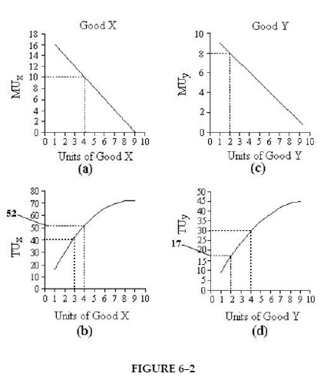
Answer: Buy less X and more Y

- Refer to Figure 6-9. In Part (i) the line joining points A, B, and C, is known as an income-consumption line which shows how consumption changes as income changes, with relative prices held constant.
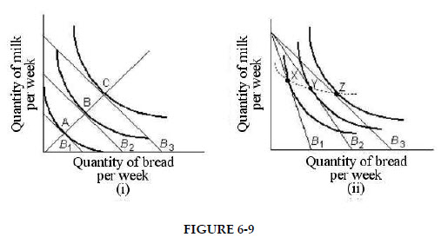
- If total utility from the consumption of some product is decreasing as more units are consumed, then marginal utility must be: negative
- The table below shows the quantities of toffee bars and bags of cashews that a consumer could consume over a 1 week time period.
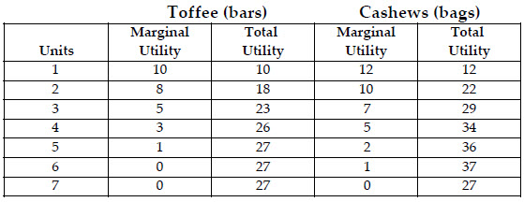
The max utility that a customer can obtain from toffee bags and bags of cashews per week is: 64

Quiz 6: Attempt 2 Corrections
- Refer to table above: If the prices of both toffee bars and bags of cashews are $2 and this consumer has $14 per week to spend on these two snacks, what is the maximum total utility achievable? - Answer: 57
- When a consumer’s marginal rate of substitution between X and Y is equal to the ratio of the prices for X and Y, and when the consumer is spending all available income, then: the budget line is tangent to an indifference curve.
- Marginal utility analysis predicts a downward-sloping demand curve for good X because: As PX falls, the consumer increases purchases of X until MUX/PX is equal to MU/P for all.
- In indifference curve analysis, a point to the left of the consumer’s budget line implies that the household is not spending all of its income on the goods in question.

- Refer to figure 6-11: Suppose the consumer begins at E1. The income and substitution effects of the reduction in the price of X are represented as follows: The distance Q1Q2 shows the substitution effect and the distance Q2Q3 shows the income effect.
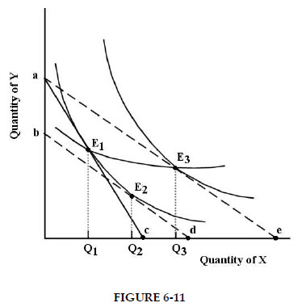
- Refer to Table 6-3: If the price of a 9-hole round of golf is $19, then Andrew will play __ rounds per month. Answer: 3


