Start with external analysis then to internal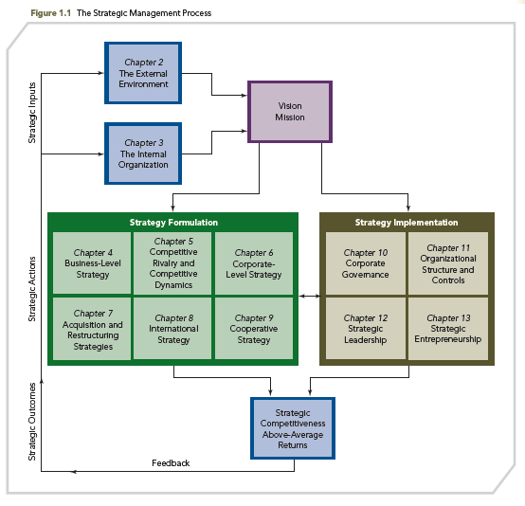

CHAPTER 1
Strategy & competition

Success depend on:
Market oriented, entrepreneurial, valuable competencies, innovative products / services

Strategic competitiveness & above average returns: formulation (core competencies – resources + capabilities), implementation, = competitive advantage (Valuable, rare, costly to imitate, non-substitutable)

Measurement of returns:
Acco: ROA, ROE, ROS
Market: RET (stock return)

Strategic management process = strategic competitiveness to get above-average returns.
(Analysis (SWOT), Strategy (formulate & implement) and Performance –A-S-P model)
- Capital Market Stakeholders:
  - Shareholders
  - Creditors (Banks etc.)
- Product Market Stakeholders:
  - Primary Customers
  - Suppliers
  - Host Communities
  - Unions
- Organizational Stakeholders:
  - Employees
  - Managers
  - Non-managers

Strategies:
Business Level Strategies:
  - Cost Leadership
  - Product Differentiation
Corporate Level Strategies:
  - Mergers And Acquisitions
  - International Strategies
  - Strategic Alliances

CHAPTER 2
External analysis – Opportunities & Threats

External analysis from 3 point of view: all are part of analysis of opportunities & threats
- General environment / Industry / competitor

General: Scan, monitor, forecast, assess (interpret) to evaluate Opp. + Threats
Economy / physical / demographic / political, legal / tech / global / socio-cultural

Industry:
Threats of new entrants / power of suppliers / buyers / product substitutes / rivalry

Threats of new entrants
Barriers to entry:
    - Economies of scale
    - Product differentiation
    - Capital requirements
    - Switching costs
    - Access to distribution channels
    - Cost disadvantages independent of size
    - Government policy

Expected retaliation

Competitors:
Actions / responses / intentions

Industry analysis = Attractive vs. unattractive

CHAPTER 3
Internal analysis – Strength & weaknesses

Resources: Tangible vs. Intangible

Tangible: Financial / Organizational / Physical / Tech
Intangible: Human / Innovation / Reputation

+ Capabilities: Distribution / HR / Mana. of info systems / Mark. / Manu. / R&D

Lead to core competencies: Valuable, Rare, Costly to imitate, Non-substitutable

Analysis core competencies through value chain:
Primary activities:
Supply-chain mana. / Operations / Distribution / Mark. / Follow-up service
Support:
Fina. / HR / Mana. of info systems

Outsourcing / value creating activities / Tool is good to share risk and gain resources and capabilities

CHAPTER 4
Business-level strategy
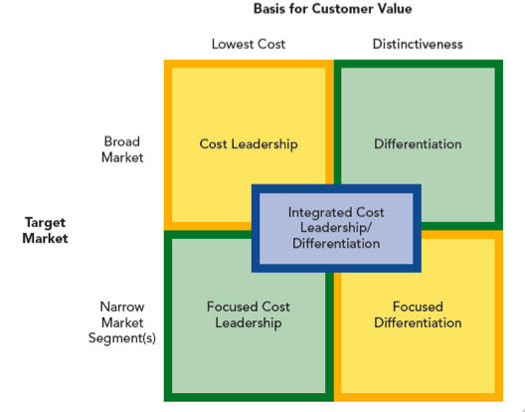
Business-level strategy = effective match

- Cost leadership (Inbound/out. Logistics)
- Differentiation
- Focused cost leadership
- Focused differentiation
- Integrated cost leadership/differentiation
  - FMS: Flexible manufacturing system (FMS)
  - Information network Customer relationship management (CRM)
  - Total quality management systems (TQM) solve problem with help of employees.
Risks:
1. Obsolescence, Cost reduction, Imitation
2. Differentiation: Price differential, Value diminishes, Experience, Counterfeit
3-4. Focused strategies: Out focused, Competition, Changing preferences
5. Stuck in the middle

CHAPTER 6
Corporate-level strategy – Group of businesses

- Related Constrained Diversification: + Constrained = + Related
- Both Operational & Corporate Related
- Unrelated Diversification
- Related Linked Diversification

Level of diversification: Products, Tech, Distribution Channels

Low: Related 70-95% revenue from single business area High: Unrelated -70% revenue from dominant business
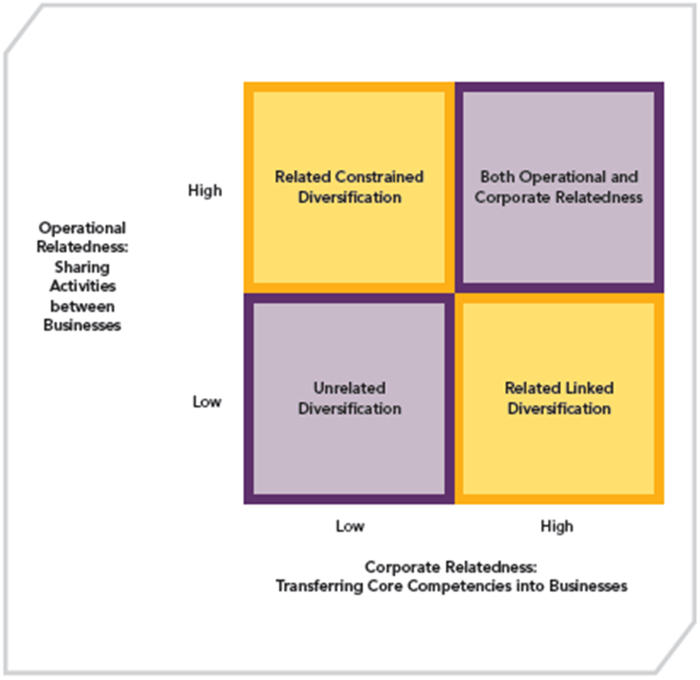

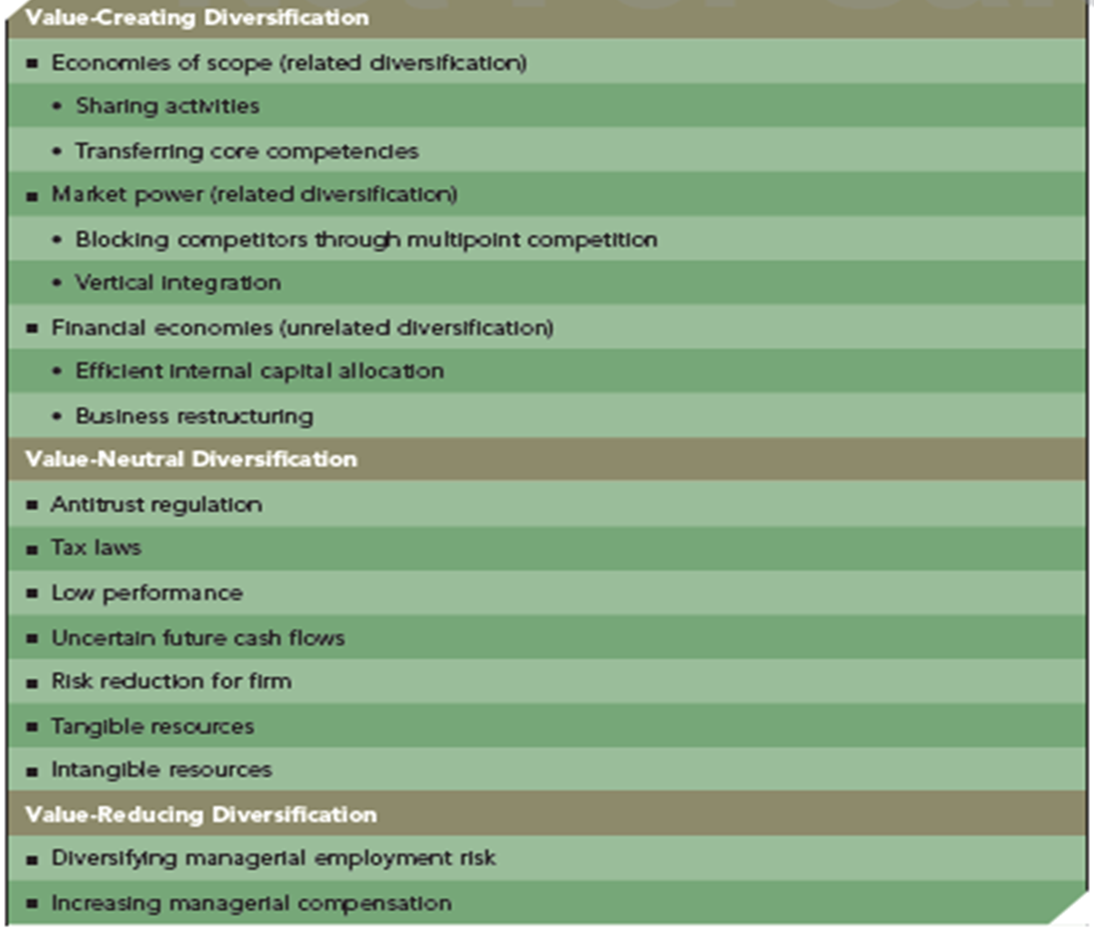

CHAPTER 7
Merger & Acquisition

Problems with acquisitions:
Too large
Integration difficulties, disparate cultures
Managers overly focused on acquisitions
Too much diversification
Inability to Achieve Synergy
Large or extraordinary debt
Inadequate target evaluation

Benefits of mergers and acquisitions:
Lower risks
Increase diversification (Related = probably more successful)
Reshape competitive scope (In intense rivalry market, acquisition = reduce rivalry)
New capabilities

How to do a successful acquisition?
Right target
Avoid paying too much
Integrate operations effectively
Retain human capital to understand culture

May need to restructure: Downsize, Downscope (Refocus, eliminate unrelated business segments), leverage buyouts (go back to private equity firm, no longer public)
Best is Downscoping, then LBO but more risky

Due diligence: Evaluating a target firm for acquisition

Increase Market Power:
Through vertical (supplier/ distributor), horizontal (Same industry) and related acquisition

Overcoming entry barriers: Cross-border acquisitions

CHAPTER 8
International strategy
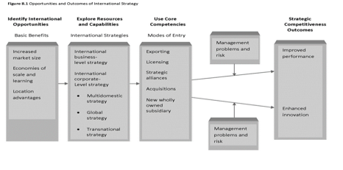

- Economies of scales: over more sales
- International strategy include either Business-level or Corporate-level or both
- New Wholly Owned Subsidiary: Greenfield Venture. New wholly own in new country/ market. + Control but high risks

Determinants of National Advantage:
- Factors of production
- Demand conditions
- Related & supporting industries
- Firm strategy, structure & rivalry

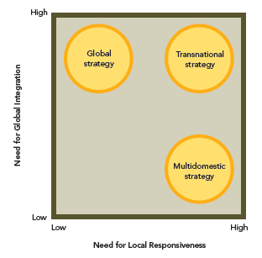
Global Strategy: home office determines strategy for country/region

Transnational Strategy: Centralization = Global coordination & Control
Decentralization = Local flexibility

Multidomestic Strategy: Operations decentralized to business units. Opportunity to tailor to local markets

Two environmental trends:
Liability of foreignness: Cost associated with entering foreign markets
Regionalization: influence on choice and use of international strategies

International diversification increases performance but geographic diversification causes negative returns: Complexity of managing international strategies:
- Geographic dispersion
- Costs of coordination
- Logistical costs
- Trade barriers
- Cultural diversity
- Host government

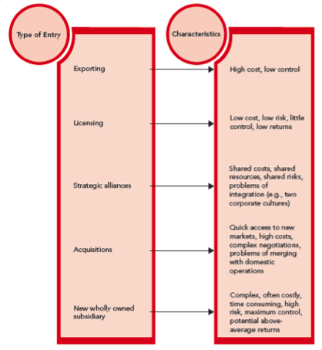

CHAPTER 9
Cooperative Strategy

*Being Trustworthy

Cooperative Strategies

- Strategic Alliance (SA)
  - Joint Venture (Long term)
  - Equity SA (Short term)
  - Non-Equity (No new entity)
    - Licensing Agreements
    - Distribution Agree.
    - Supply contracts
    - Outsourcing commitments

- Business-level (b. c. & d. are temporary)
  - Complementary SA Vertical^{*Best} or Horizontal
  - Competition Response Strategy (Getting attacked by rivals respond with SA)
  - Uncertainty-Reducing Strategy (In fast-cycle. Combine resources & capabilities)
  - Competition-Reducing Strategy
    - Explicit collusion: Illegal
    - Tacit/ indirect collusion
    - Mutual forbearance

- Corporate-level (broader and more costly than business-level)
  - Diversifying SA (Test for Merger/Acquisition, less risks & + flexible)
  - Synergistic SA (To attain Econo. Of scope)
  - Franchising

Competitive Market conditions:
Slow-Cycle (Almost monopoly, hard to imitate too costly)
SA to: Gain access to restricted market or establish franchise
Fast-Cycle: (Hypercompetitive, unpredictable, complex)
SA to: Maintain leadership, share risk, develop, enter new markets
Standard-Cycle: Between Fast and slow. Imitation moderately shielded
SA to: Access to complimentary resources, Econo. of scale, new business techniques.

Cross-border SA: (+)
- Multinational outperform domestically operated firms
- Limited domestic growth
- Government policies require partnership with local to enter market

Network cooperative Strategy: Several firms form multiple partnerships
Dynamic (Exploit new ideas) & Stable alliance (Exploit economies (Scale/scope)
(-): Can be lock by partnership. Can make a burden. Failure from one partner

Managing cooperative strategies is not easy therefore must use approaches:
- Cost minimization: (Contract that monitor and control partner to avoid opportunistic behaviours.)
- Opportunity maximization: (Informal relationship. Learn from each other, explore market opportunities)

