Lecture 7 – Gene Transcription and Translation

Learning Objectives:

- Define the relationship between genes and polypeptides
- Describe the flow of information through cells
- Summarize the steps in all stages of transcription: pre-initiation complex, initiation, elongation and termination
- Summarize the processing of hnRNA to mature mRNA, emphasizing the importance of the 5' cap, the poly(A) tail and splicing together of exons
- Define the different types of RNA, contrasting the roles of mRNA, rRNA and tRNA
- Describe the properties of the genetic code and the codon assignments
- Define the role of tRNAs in decoding the genetic code
- Summarize the steps in all stages of translation: tRNA charging, initiation, elongation and termination
From Genes to Proteins:

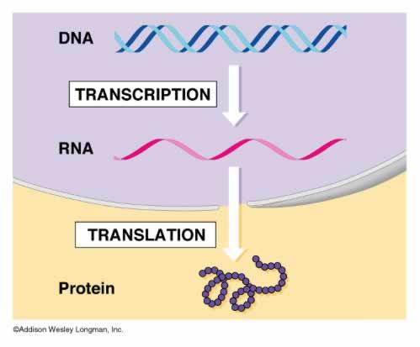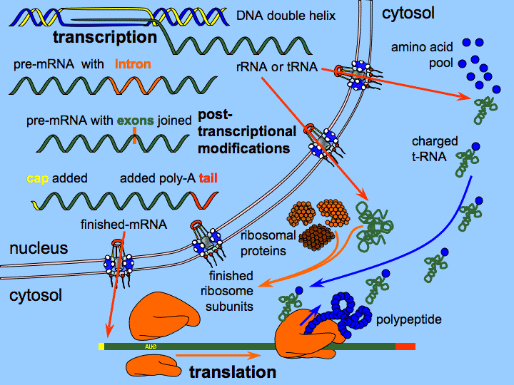

- Transcription = Synthesis of complementary RNA from a DNA template in the nucleus
- Required machinery:
- RNA polymerase
- Transcription factors – required for RNA polymerase to grab onto the DNA
- End product:
- Messenger RNA (mRNA) – the process of making mRNA relies on RNA polymerase 2.
- Translation = Synthesis of proteins in the cytoplasm using information encoded by mRNA
- Required machinery:
- Ribosomal RNA (rRNA)
- Transfer RNA (tRNAs)
- End product:
- Polypeptide
Transcription: RNA polymerase
- RNA polymerase = enzyme that binds to DNA and incorporates nucleotides into a strand of RNA whose sequence is complementary to one of the DNA strands (template strand)
- RNA polymerase binds to, and initiates transcription at a specific site on DNA > promoter region.
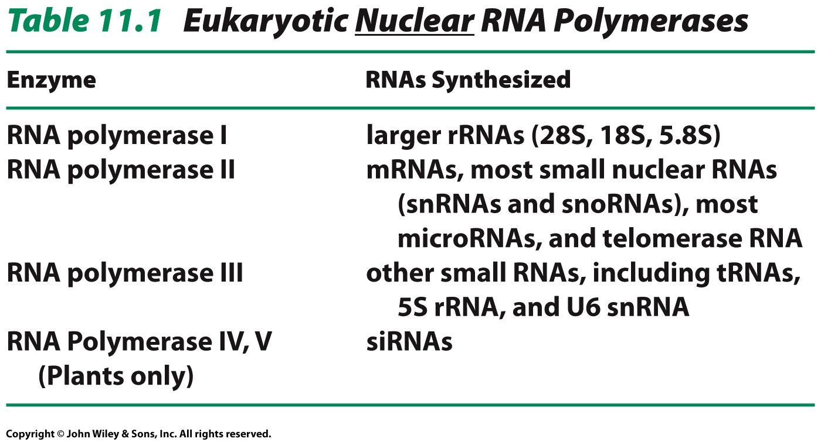

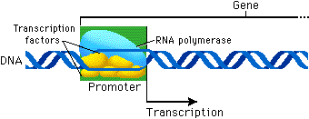
- Promoter region = site on DNA to which RNA polymerase binds prior to initiation of transcription, determines which strand is template (anti-sense).
- Large and variable, 100-1000 base pairs long.
- Core promoter elements:
- TATA element (consensus sequence TATAAA)
- Recognized by transcription factor TATA-binding protein (TBP)
- B recognition element (BRE)
- Recognized by transcription factor TFIIB
- Initiator element (INR)
- Recognized by TBP-associated factors (TAF) 1, 2.
- Downstream promoter element (DPE)
- Recognized by TBP-associated factors (TAF) 1, 2.
- +1 is where transcription begins.
- Transcription factors = Proteins that combine with RNA Pol 2 at promoter site to form a pre-initiation complex that can initiate transcription as soon as nucleotides are available.
- Regulate gene expression.
- General and specific transcription factors.
- General transcription factors (GTFs):
- TATA-binding protein (TBP)
- TBP-Associated Factors (TAF) 1, 2, 5, 6.
- Transcriptional pre-initiation protein complexes for RNA Pol 2
- TFII A, B, D, E, F, H
- TFIID > Consists of TBP + TAFs
- TFIID recognizes the TATA box

Transcription: Pre-initiation Complex

- Pre-initiation Complex (PIC)
- Helps position RNA Pol 2 over gene transcription start sites.
- Denatures the DNA
- Positions the DNA in the RNA pol 2 active site for transcription.

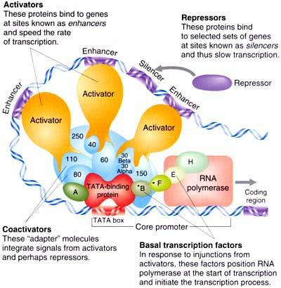

- TFIID (TBP + TAFs) binds to TATA box.
- Binding of TFIIA and TFIIB to complex
- TFII stabilizes PIC
- TFIIB provides specific binding site for RNA Pol 2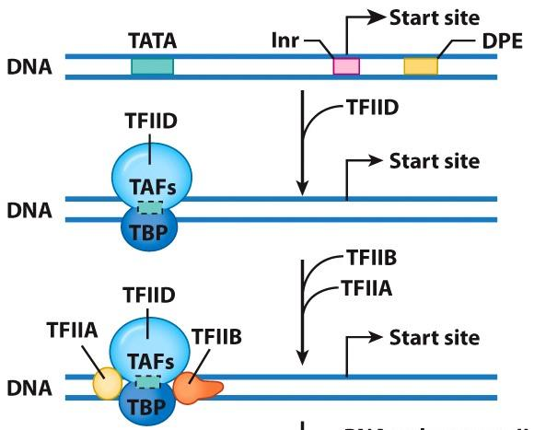

- The RNA Pol 2 – TFIIF complex binds to TFIIB in the PIC
- TFIIF play a role in elongation
- TFIIE and TFIIH binds to the PIC
- TFIIE helps with DNA unwinding.
- TFIIH contains 3 enzymatic subunits: Kinase (phosphorylates RNA Pol 2), helicases (unwind DNA at promoter start site), and hydrolysis of ATP by FIIH, which can form the transcription bubble (13 bp. Open formation)
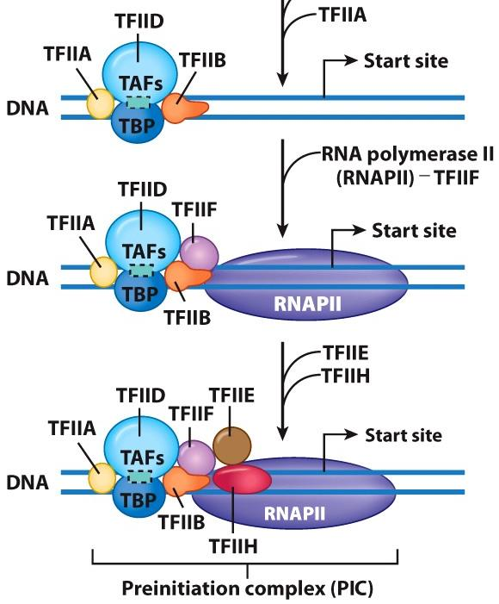
Transcription: Initiation

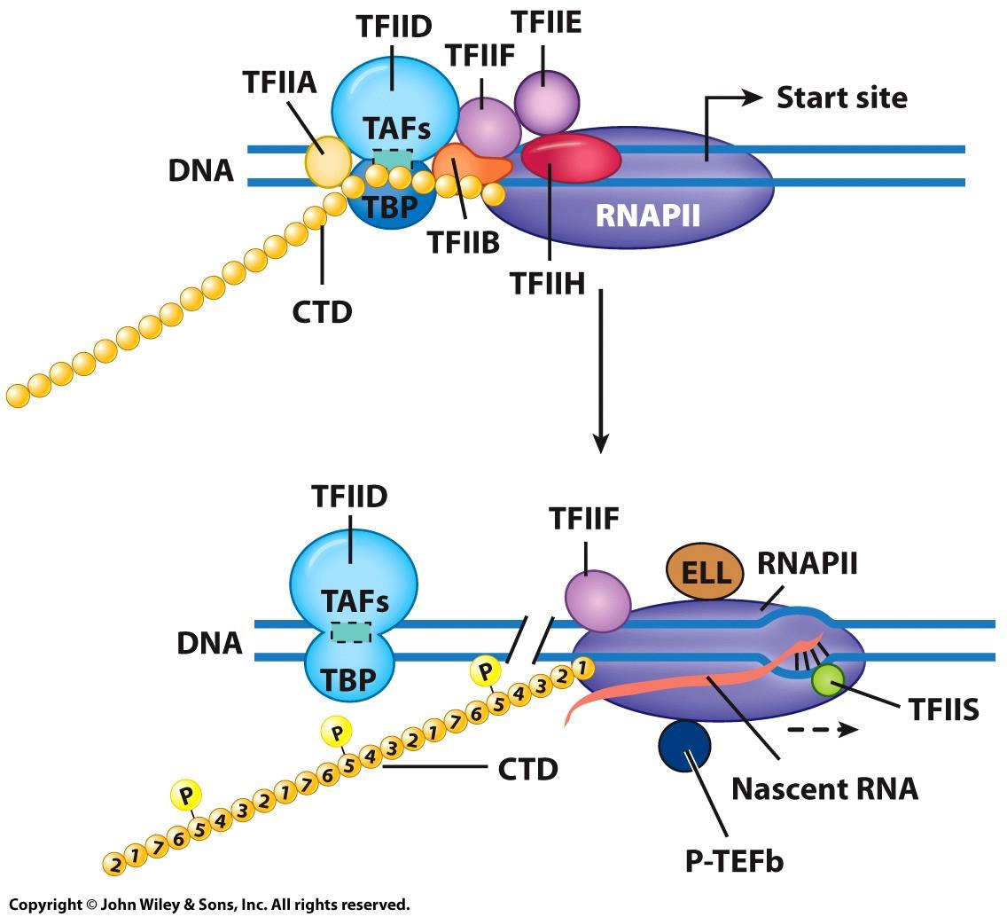

- Carboxyl-terminal domain (CTD):
- 7 aa repeating domain of RNA Pol 2 subunit (Tyr-Ser*-Pro-Thr-Ser*-Pro-Ser)
- Becomes phosphorylated by TFIIH
- Ser-5 > triggers uncoupling of RNA Pol 2 from PIC, promotes elongation, promotes 5’ capping of mRNA.
- TFIID remains bound to TATA and can initiate formation of additional PIC.

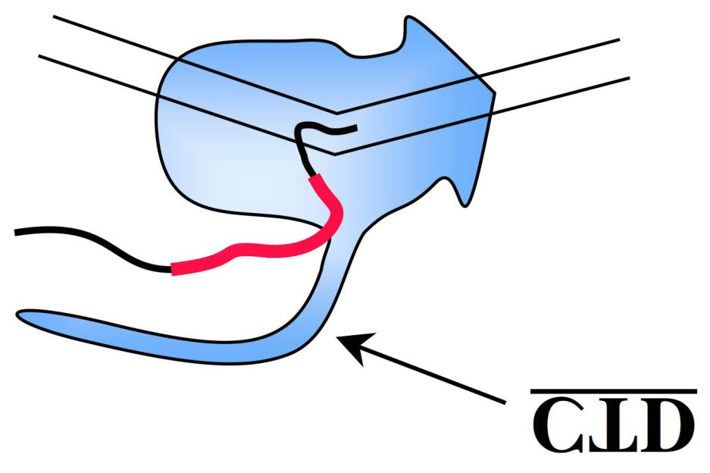

Transcription: Elongation

- Transcription Bubble: unwound section of DNA of approximately 13 bp regions
- DNA in front of RNA Pol are unwound, compensatory positive supercoils (ch 10)
- DNA behind RNA Pol are rewound and negative supercoils are present (ch 10)
- DNA-RNA hybrid: ~8-9 bp, stabilizes the elongation complex
- Topioisomerases relieve the stress of uncoiling and prevent recoiling.

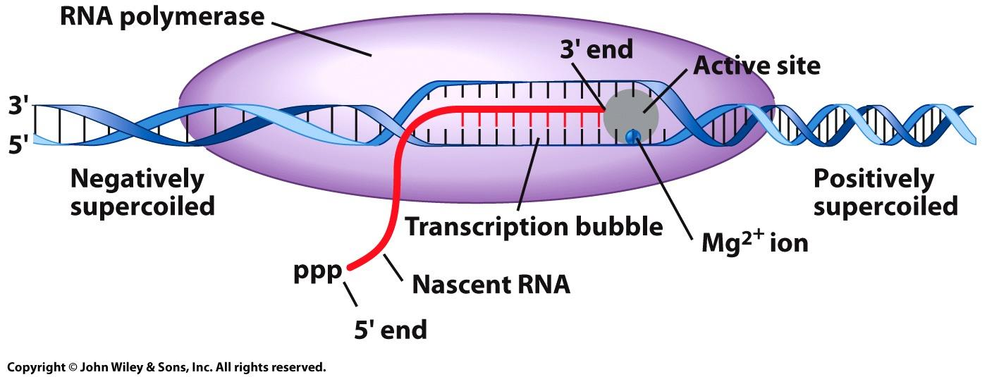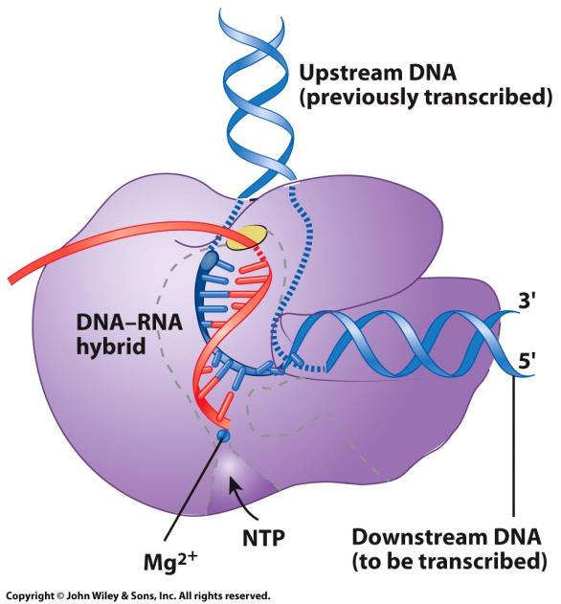

- Complementary nucleotides are incorporated by RNA Pol II in a 5’→3’ direction
- Incoming Adenosine-triphosphate pairs with the thymine containing nucleotide of the template (H- bonds)
- 3`OH of the previous nucleotide sugar binds to the 5’ α-phosphate of incoming nucleoside triphosphate
- Pyrophosphate (PPi) is released and hydrolyzed to 2 inorganic phosphates (Pi). This releases a large amount of energy → irreversible

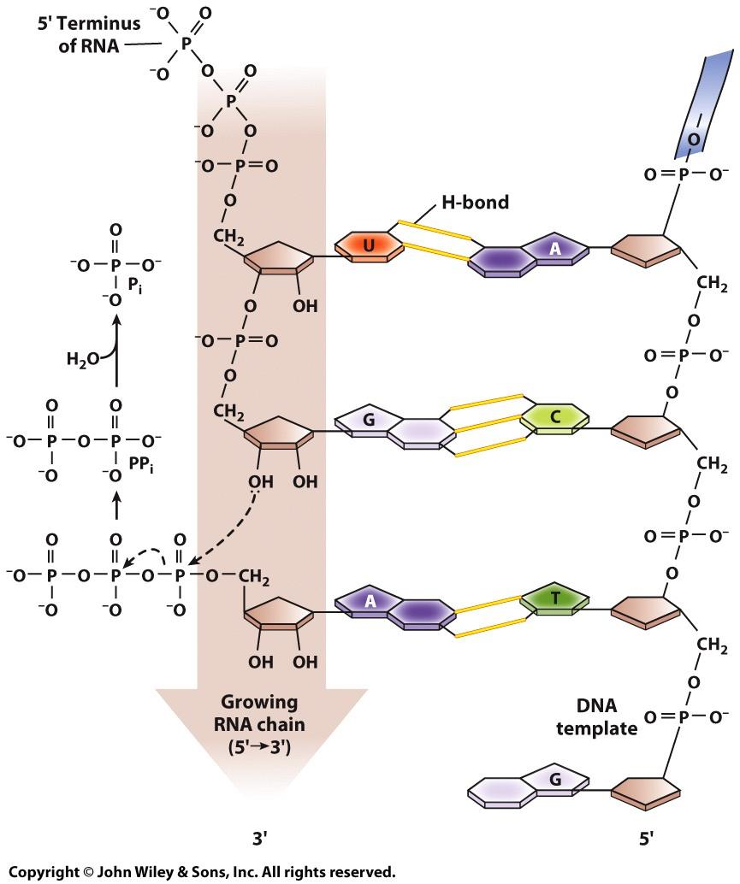

- Elongation Transcription Factors:
- 50 components involved in elongation
- P-TEFb > phosphorylates the CTD at Ser-2 leading to productive elongation and required RNA modifications (polyadenylation)
- ELL and TFIIF > weakens interactions between RNA Pol II and nonspecific binding sites of DNA, suppressing transient pausing of the polymerase
- TFIIS > stimulates elongation, RNA Pol II moving after pauses, proofread and correction of mistaken nucleotides
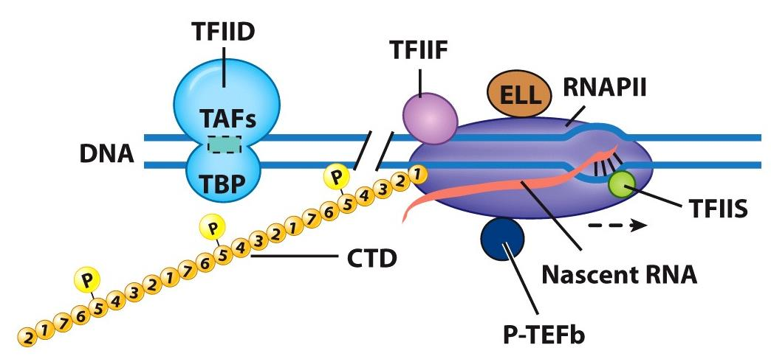
Transcription: Termination

- In bacterial cells > well defined termination sequences
- In eukaryotic cells > No well-defined sequence, not well understood
- AATAAA sequence well past end of coding region
- 3’ end of mRNA determined by series of processing steps
- Cleavage of the new transcript followed by template-independent addition of As at its new 3' end > polyadenylation.

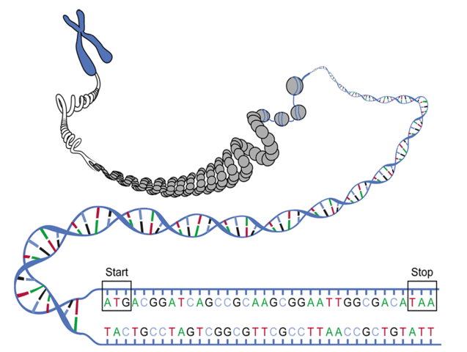

Transcription: mRNA

- Primary transcript (pre-RNA, hnRNA)= initial precursor RNA, equivalent in length to the full length of DNA transcribed (transcriptional unit)
- Always associated with proteins (not naked)
- Have a fleeting existence
- Heterogeneous nuclear RNA (hnRNA)
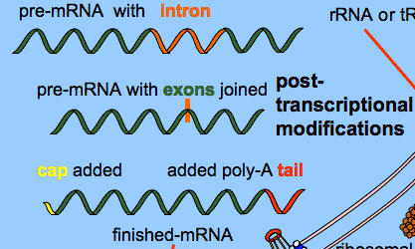

Transcription: Processing mRNA

- 5’ Caps:
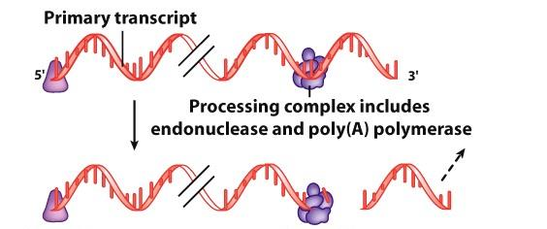
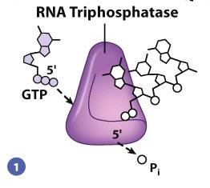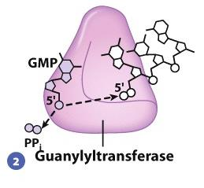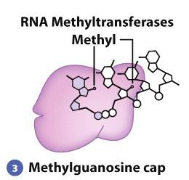
- Last 5’ Pi removed - 5’-5’ Triphosphate - Methyl groups added to
- GMP added in bridge formed terminal guanosine cap
inverted orientation and ribose of nucleotide.

- Capping enzymes recruited by phosphorylated CTD (Ser-5 by TFIIH)
- Functions:
- Prevents digestion of 5’ end from exonucleases
- Aids in transport of mRNA out of nucleus.
- Plays important role in initiation of translation.
- Methylated cap added to 5’ right away.
- 3’ poly(A) tail:
- Endonucleases cleaves primary RNA ~ 10-30 nucleotides downstream from AUAAA sequence.

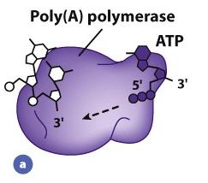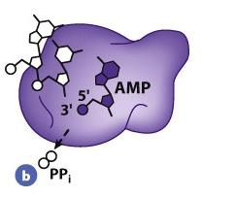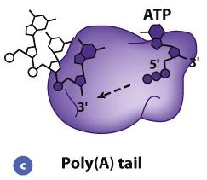
- Adenosine residues added to new 3’ end
- ~200-250 adenosine residues added to poly (A) tail
- Poly(A) tail enzymes recruited by phosphorylated CTD (Ser-2 by P-TEFb)
- Functions:
- Protects mRNA from premature degradation by exonucleases.
- RNA splicing:
- Exons: parts of the gene that contribute to mature RNA product
- Introns: intervening noncoding sequences. Not included in mature RNA product (~95% of pre-mRNA)
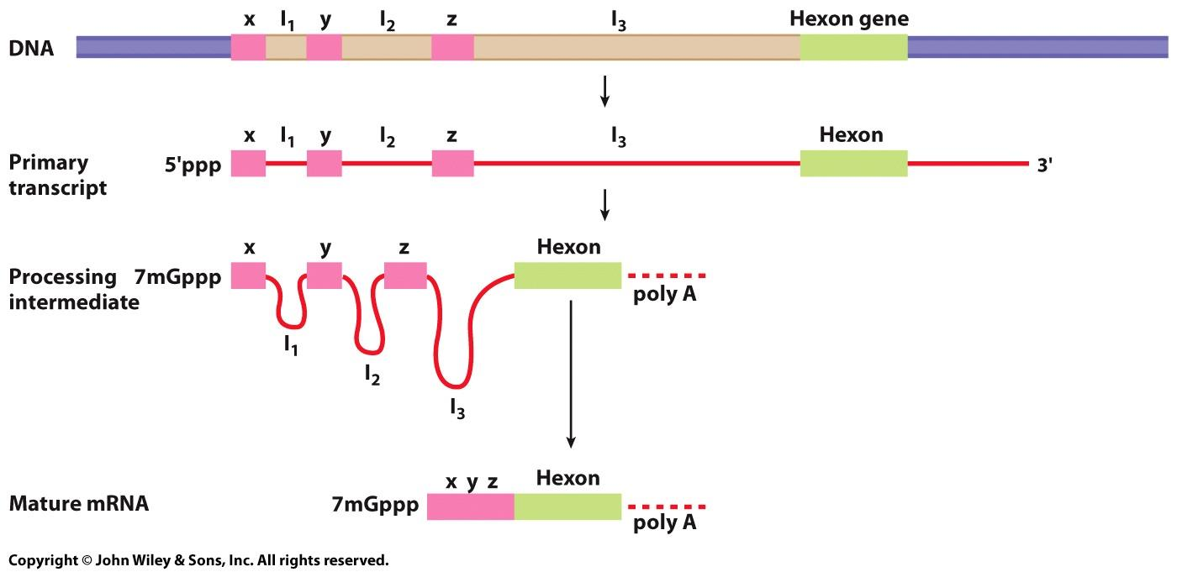

- Pre-mRNA is mostly introns. Introns allow us to have the ability to put the DNA code together in a variety of different ways and make a bunch of different proteins.
- Breaks are introduced at the 5’ and 3’ ends > splice sites
- Sequences between exon-intron boundaries are highly conserved
- 5’ splice site 􏰀 G/GU
- 3’ splice site􏰀AG/G
- Polypyrimidine tract > 10-20 YN (Y= pyrimidine, C or U)
- Branch point sequence􏰀~ 30 bases upstream of 3`
- Exonic splicing enhancers (ESE) 􏰀 within exons, help recruit snRNPs
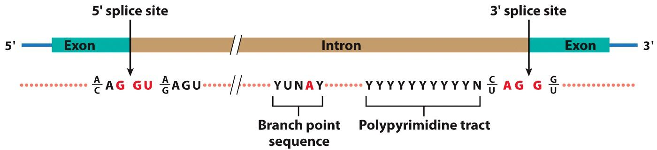
- Small nuclear ribonuclear proteins (snRNPs)􏰀 Particles that consist of small nuclear RNAs (snRNAs; 150 bp) and 12+ associated proteins. Play active role in splicing and ligating pre-RNA into final mRNA product (U1,U2,U4,U5,U6)
- Splicesome > macromolecular machine that associates with and processes an intron. Composed of a number of snRNPs and associated proteins
- U1 snRNP attaches to 5’ splice site
- The nucleotide sequence of U1 snRNA is complementary to the 5’ splice site of the pre- mRNA (G/GU)
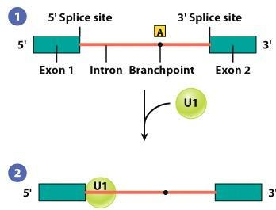
- U2 snRNP attaches to intron causing a specific adenosine residue (dot) to bulge out 􏰀 will become branch point of the lariat
- U2 recruited by U2AF protein (on polypyrimidine tract)
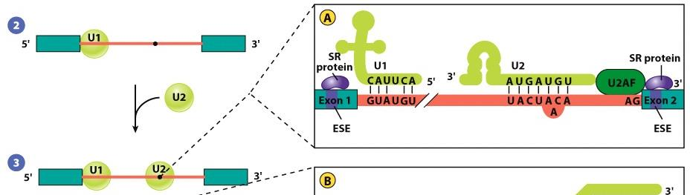
- U4/U6 and U5 snRNPs bind to pre-mRNA
- U4 and U6 snRNAs begin paired to one another . The U4 snRNA is stripped away from the duplex, and U6 pairs with U2 snRNA . The other portion of U6 displaces U1 and becomes associated with the 5` splice site
- U4 just brings in U6 and then leaves when U6 attached to U2.
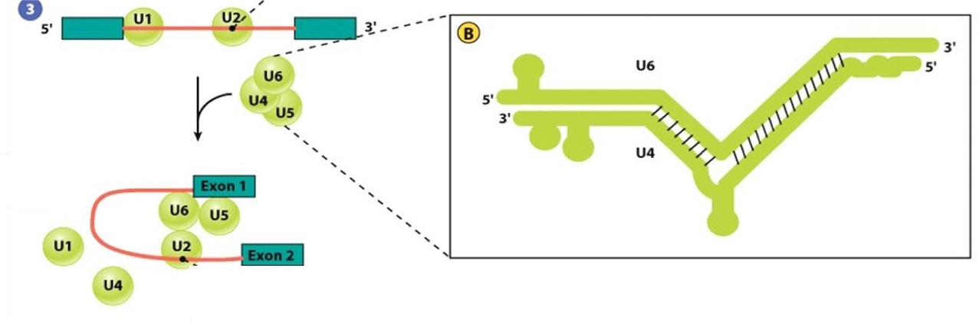
- U6 is a ribozyme > catalyzes cleavage of the 5’ splice site, forming a free 5’ exon and a lariat intron–3’ exon intermediate
- The free 5’ exon is held in place by its association with U5 of the spliceosome, which also interacts with the 3’ exon
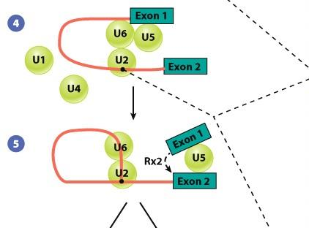
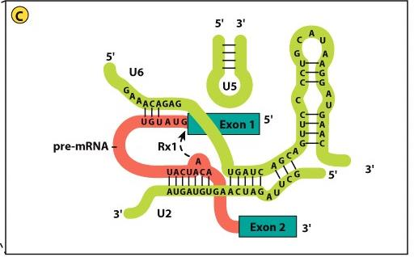

- second cleavage reaction at the 3’ splice site 􏰀 excises lariat intron and ligates two neighboring exons
- snRNPs are released from pre-mRNA, and reassembled at the sites of other introns
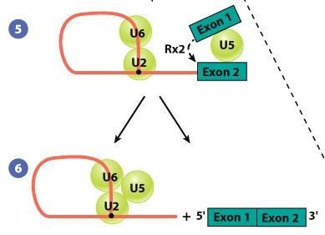
- Alternative Splicing: the same gene can code for more than one polypeptide. Very important in health and disease. (“splice variants”)

Transcription: Coordinating Events
- C-terminal domain (CTD) of RNA polymerase serves as a scaffold for the organization of factors involved in processing pre-mRNAs.
- Processing includes: capping, polyadenylation, and intron removal.
- Machinery for mRNA processing travels with the polymerase as part of a giant “mRNA factory”
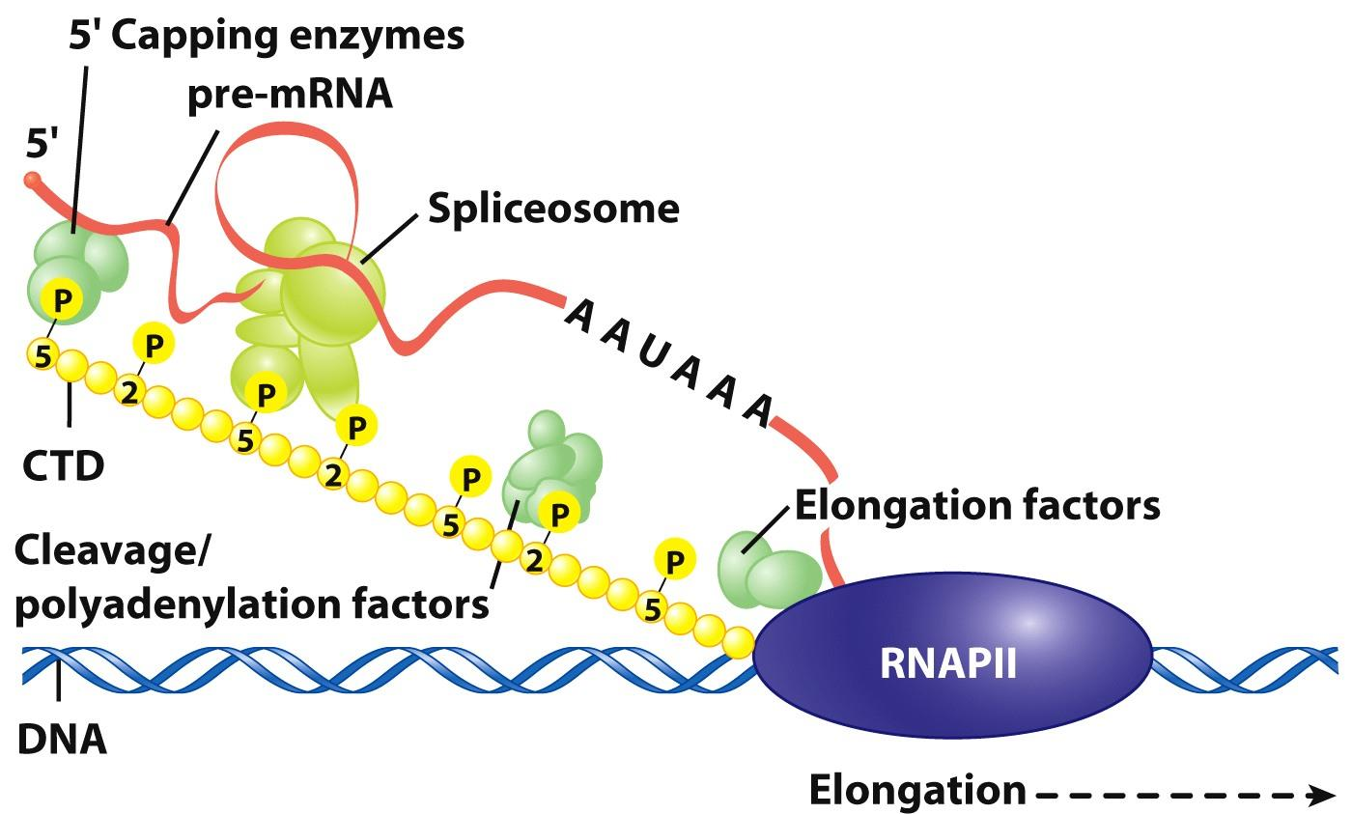

Transcription: rRNA and tRNA
- DNA > Primary transcript.
- mRNA
- rRNA = ribosomal RNA
- rRNA provides structural support and catalyze the chemical reaction in which amino acids are covalently linked to one another.
- tRNA = transfer RNA
- tRNA is required to translate the information in the mRNA nucleotide doe into amino acids of polypeptide.
- Activity due to complex secondary and tertiary structures.
- Base-paired regions form double-stranded stems connected to single-stranded loops.
Transcription: rRNA
- Eukaryotic cell contains millions of ribosomes.
- > 80% of cells RNA is rRNA.
- 4 distinct ribosomal RNAs:
- Large subunit > 5S, 5.8S, 28S
- Small subunit > 18S
- 5 rDNA clusters
- Clusters gathered in nucleoli > ribosome production.
Transcription: Synthesis of rRNA
- rRNA genes are arranged in tandem
- Nontranscribed spacer (NTS) separates transcription units in a ribosomal gene cluster.
- rRNA transcribed by RNA Pol 1 (28S, 18S, 5.8S) and RNA Pol 3 (5S).
- rRNA transcription has a “Christmas tree” pattern.
- Proteins that convert rRNA precursors into mature rRNA become associated with pre-rRNA during transcription. 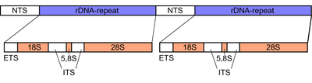
Transcription: Processing rRNA
- Processing takes place in the nucleolus:
- Fibrillar center (fc) contains rDNA
- Dense fibrillar center (dfc) contains the pre- rRNA transcripts
- Granular component (gc) contains ribosomes at various levels of assembly
- A single pre-rRNA is spliced into 3 rRNAs
- 28S, 18S, and 5.8S
- The 5S rRNA genes located outside the nucleolus, transported to the nucleolus
- Pre-rRNA contains large numbers of methylated nucleotides and pseudouridine residues
- Unaltered sections are discarded
- Small nucleolar ribonucleoproteins (snoRNPs) > Particles that consist of small nucleolar RNAs (snoRNAs) and associated proteins. Play active role in processing pre-rRNA in nucleolus
- > 200
- Box H/ACA snoRNAs > determine which uridines will be converted to pseudouridines
- Box C/D snoRNAs > determine which nucleotides in the pre-rRNA will have ribose methylated
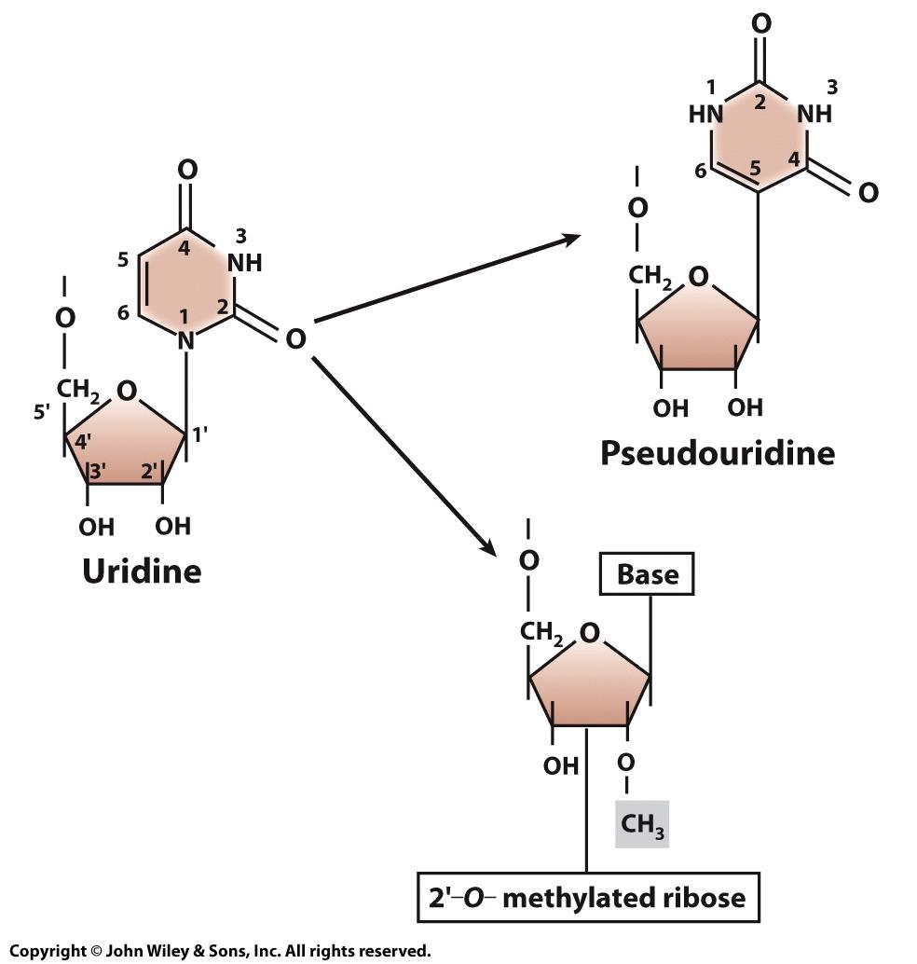

Transcription: tRNA
- Each tRNA is capable of binding a specific amino acid and also recognizing a particular codon in the mRNA
- Between 73-93 nucleotides in length
- ~ 50 different species of tRNA, ~ 1300 tRNA genes in humans
- tRNA genes are located in small clusters scattered around the genome
- tRNA genes are arranged in tandem
- Nontranscribed spacer (NTS) separates transcription units in a tDNA gene cluster
- tRNAs have promoter sequences within the coding region of the gene > transcribed by RNA pol III
- During processing, the tRNA precursor is trimmed and numerous bases are modified
Encoding Genetic Information
- Sequence of amino acids in a polypeptide are specified by the sequence of nucleotides in the DNA of a gene; mRNA acts as an intermediate.
- Each amino acids encoded by non-overlapping nucleotide triplets = codon.
- Clustering of amino acid codons minimizes changes to amino acid sequences following spontaneous mutations
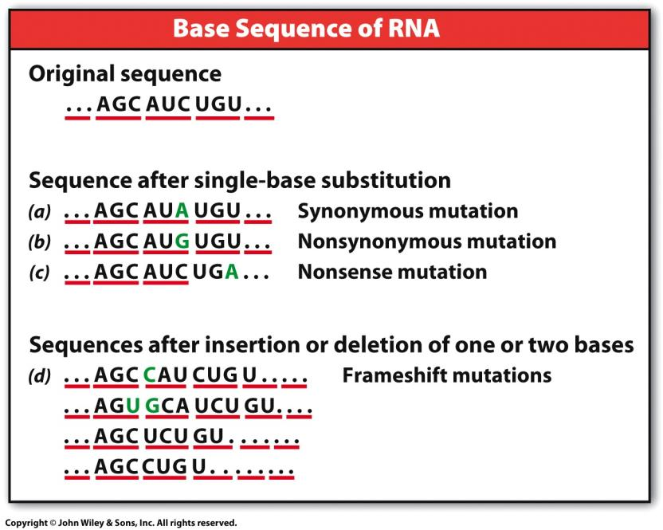
- Synonymous – codes for the same amino acids. (kind of mutation you want if you were to have one)
- Nonsynonymous – One different amino acid.
- Nonsense – Stop aa therefore the polypeptide is short.
Translation
Amino Acid Activation:
- Amino acids covalently linked to the 3’ end of their respective tRNA by aminoacyl-tRNA synthetases (aaRS)
- One of each amino acid (20)
- Acceptor arm/stem and anticodon important for enzyme recognition.
- ATP is used to activate the amino acid, which is then transferred to the tRNA molecule.
- ATP + amino acid > amino acyl-AMP + PPi
- Amino acyl-AMP + tRNA > aminoacyl-tRNA + AMP
- Initiation:
- Different process in prokaryotic and eukaryotic cells.
- Step 1 - ~12 initiation factors (eIFs) bind to 40S subunit.
- Step 2 – initiator tRNA-Met enter P site of 40S rRNA subunit in association with eIF2-GTP.
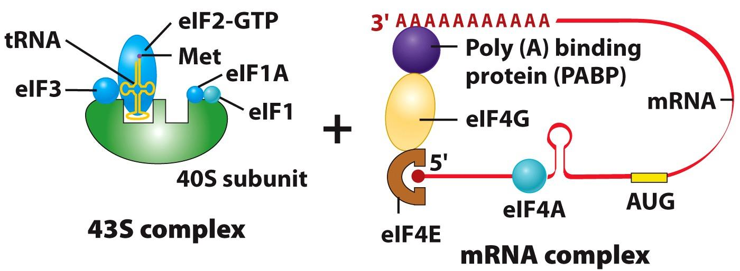
- Step 3 – 43S complex finds and binds to 5’ methylguanosine cap of mRNA. This is aided by several eIFs bound to mRNA.
- eIF4E > bound to 5’ cap
- eIF4A > removes mRNA double stranded regions.
- eIF4G > links 5’ cap to 3’ poly(A) tail (circular message).
- Step 4 – The 43S complex scans mRNA in search of initiation codon (AUG)
- In eukaryotes ribosomes scan for Kozak sequence (5’ ACCAUGG 3’)
- Step 5 – GTP bound to eIF2 is hydrolyzed and large 60S rRNA subunit associates with complex. This releases all initiation factors from the complex.
- Anticodon of initiator tRNA bound to AUG start codon in P site of ribosome.
- Initiation: Structure of the Ribosome.
- Ribosomes have three sites for tRNAs: the A (aminoacyl) site, P (peptidyl) site, and E (exit) site.
- Ribosomes receive each tRNA in successive steps of the elongation cycle.
- The mRNA is situated in a narrow groove that winds around the neck of the small subunit, passing through the A, P, E sites.
- A tunnel runs completely through the core of the large subunit beginning at the active site.
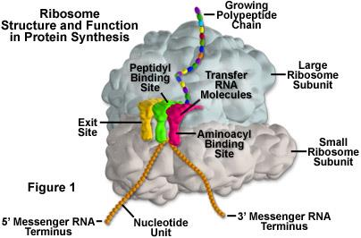
- Elongation:
- The elongation cycle is the process of adding subsequent amino acids to the growing polypeptide chain.
- A ribosome can catalyze the incorporation of approximately ten amino acids into a growing polypeptide per second.
- Step 1 – second aminoacyl-tRNA combines with elongation factor eEF1a-GTP.
- Step 2 – aminoacyl-tRNA is delivered to an placed within site A of the ribosome. GTP is hydrolyzed and eEF1a-GDP is released.
- Only tRNA with correct anticodon will trigger conformational changes within the ribosome.
- Step 3 – Amine nitrogen on A site tRNA carries out the nucelophilic attack on carbonyl carbon of P site tRNA.
- Peptidyl transferase (subunit of rRNA) catalyzes the formation of this peptide bond.
- No energy is required.
- Step 4 – Translocation > small rRNA subunit ratchets relative to large subunit, moving ribosome 3 nucleotides (1 codon) along the mRNA in the 5’-3’ direction.
- Dipeptidyl-tRNA in A site to P site.
- Deacylated tRNA in P site to E site.
- Driven by conformational changed in eEF2 following hydrolysis of bound GTP.
- Step 5 – deacylated tRNA leaves the ribosome, emptying the E site.
- Sep 6 – Elongation > repeat of steps 1-5
- Termination:
- Termination occurs at one of the 3 stop codons.
- UAA, UAG, UGA
- No tRNA have anticodons complementary to a stop codon
- Requires release factors, which recognize stop codons.
- eRF1 and eRF3 > work together and recognize all the stop codons.
- Step 1 – eRF1 tri-peptide interacts with stop codon in A site.
- Step 2 – ester bond linking the nascent polypeptide to the tRNA is hydrolyzed.
- Step 3 – Hydrolysis of eRF3-GTP releases eRF1 from A site.
- Step 4 – Release of deacylated tRNA from P site, dissociation of mRNA from ribosome, disassembly of ribosomal subunits.
- Requires several protein factors.
- Polyribosomes
- A polyribosome (polysome) > complex of multiple ribosomes on mRNA, allowing simultaneous translation.
- Increase the rate of protein synthesis.



