WIKI Module 1
Gives 4 definitions (reasoning skills, thinking skills, collaboration skills, experimental skills) then match right definition to its respective key word.

Robert Reich - Four Skills required for future job roles:

Abstract Reasoning Skills: The ability to analyze information, detect patterns and relationships, and solve problems on a complex and intangible level problems important to help you apply what you learned.

Systems Thinking Skills: Understanding how things, regarded as systems, influence one another within a whole.

Collaboration Skills: Specific ways in which students are expected to behave in order to achieve class norms. It is often associated with effective interactions and team work.

Experimentation Skills: The ability to effectively discover something unknown or to test a principle, hypothesis, etc. create and test alternatives
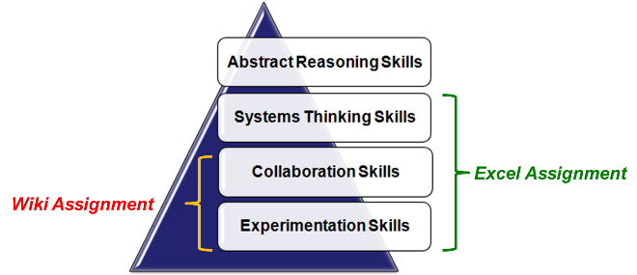
Know which ones are for Wiki and Excel:

Understand the definition of:

Business process
A business process or business method is a collection of related, structured activities or tasks that produce a specific service or product (serve a particular goal) for a particular customer or customers.

Digital firm
A digital firm is one in which nearly all of organization's significant business relationships with customers, suppliers & employees are digitally enabled and mediate (but firm could sell non digital goods or services)
- Question hint: A digital firm produces only digital goods or services. FALSE

Digitization
- Question hint: The term for the replacement of physical task by digital means is called ....automation/ digitisation/ revolution? Answer: Digitisation)

Digital good
Digital goods or e-goods are intangible goods that exist in digital form.
Example: e-books, downloadable music, internet television, internet coupons; electronic tickets, online casino (question hint: What is a digital good?)

Economics of Digital Goods
- Production cost is almost entire cost of 1st unit: marginal cost of producing 2nd unit is almost zero
- Delivery costs over the Internet are very low
- Marketing costs remain the same
- Consumer costs are also reduced

(Question hint: Digital goods have increasing marginal cost: False Cost the production of the first unit is the cost of producing all units: True)

RSS (Rich Site Summary) (Really Simple Syndication):
A standardized data format to publish frequently updated works, such as, blog entries and news headlines.
- Feed to allow users to view updates in real time.
- A web feed (or news feed) is a data format used for providing users with frequently updated content.
- Content distributors syndicate a web feed, thereby allowing users to subscribe to it.
- RSS (Web) Feeds are usually accessed through an aggregator tool. Making a collection of web feeds accessible in one spot is known as aggregation. Web feeds are an example of pull technology, although they may appear to push content to the user.
(Question hint: what at the advantages of RSS?)
- It gives you the latest updates.
- It gives the power of subscription to the user.
- It saves on surfing time.
- It is spam free.
- Unsubscribing is hassle-free; all you have to do is to delete the RSS feed
- It can be used as an advertising or marketing tool.

Social Media: is a group of mobile and web-based applications (social networks, blogs, microblogs, multimedia sharing ie youtube) that build on the ideological and technological foundations of Web 2.0 (widgets, Mashups, Syndication, API's) and that allow individuals and communities to share, co-create, discuss and modify user-generated content.

Social Network: Place where people create their own place and share ideas, pictures, blogs, videos etc..
- Blog: a discussion or informational site published consisting of discrete entries typically displayed in reverse chronological order.
- Wiki (means quick in Hawaiian) A wiki is a website or similar online resource which allows users to add and edit content collectively
- Wikis are collaboration tools / where Blogs and chats are more turned towards conversation
- No changes can be made without creating a record of who made those change and Reversion to an earlier version is always possible
- Image sharing - individuals upload images to an Internet website. The image host will store image onto its server, and show the individual different types of code to allow others to view that image

API (Application Programming Interface): specifies a software component in terms of its operations, their inputs and outputs and underlying types. Its main purpose is to define a set of functionalities that are independent of their respective implementation, allowing both definition and implementation to vary without compromising each other.

Widgets: Are standalone programs that can be embedded into web pages, blogs, profiles on social networking sites, and common desktops. A small application with limited functionality that can be used within a web page/mobile web.

Syndication: Uses standardized protocols to permit end users to make use of a site's data in another context (such as another web site, a browser plug in or separate desktop application.)

Mash Ups: A web application that combines data or functionality from more than one source into a single integrated interface or tool:
- Applications generated by combining content, presentation, or application functionality from disparate sources.
- Revolutionary because of their ability to combine content to form new content.

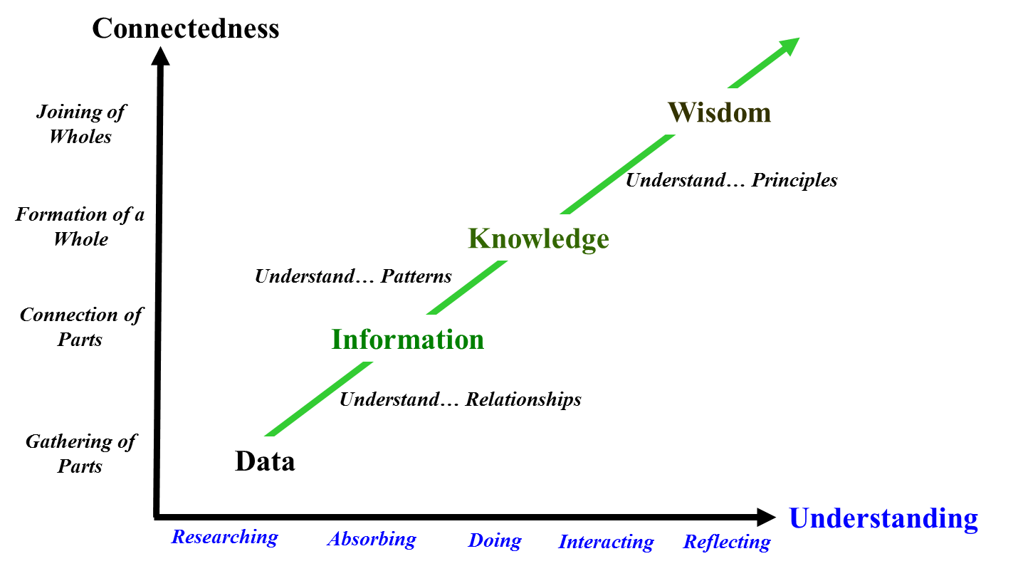
Know the graph on information systems

Question hint: given sequences and to choose right sequence:
Data Information Knowledge Wisdom

Data: Gathering of Parts
Information: Connection of Parts
Knowledge: Formation of a whole
Wisdom: Joining of Wholes

What are the differences between Web1.0, Web 2.0 AND Web 3.0?
Definition of Web 2.0: a second generation in the development of the World Wide Web, conceived as a combination of concepts, trends, and technologies that focus on user collaboration, sharing of user generated content, and social networking.
- Examples: Social Networking Sites, Video Sharing Sites, WIKIS, Blogs
- Mash-ups and API's (Application Programming Interfaces)

Some attributes for Web 2.0:
- The ability to tap into the collective intelligence of users
- Data is made available in new or never-intended ways
- Relies on user-generated and user-controlled content and data
- Lightweight programming techniques and tools let nearly anyone act as a Website developer
- The virtual elimination of software-upgrade cycles makes everything a perpetual beta or work-in-progress. Applications can be designed quickly to meet changing needs
Key Take-Away for Web 2.0:
  - Users can access applications entirely through a browser
  - Rapid and continuous creation of new business models
  - A major emphasis on social networks and computing
  - Strong support for information sharing and collaboration
  - An architecture of participation and digital democracy encourages users to add value to the application as they use it

Question Hint: What did web2.0 offer that could not be offered by web1.0?
Web 2.0 is all about people. It's a social thing focused on the ability for people to collaborate and share information online. Where the Web 1.0 contains static HTML pages, Web 2.0 is dynamic, in that it serves applications to users and offers open communications with an emphasis on Web-based communities.

Web 2.0 provides the technical and philosophical foundation for creating, implementing, and using social media applications and tools. (Social media is a subset of Web 2.0) The differences between the two are:
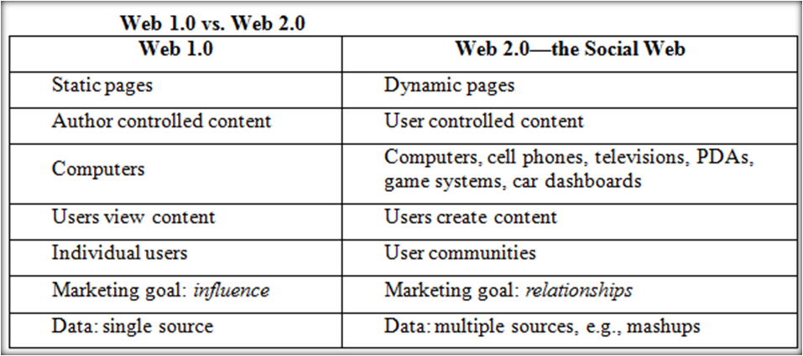

Web 1.0 was built on HTML. Web 2.0 was made possible by the development of languages like XML and Java script.

- Which one is considered to be the social web? Web2.0 because it is focused on people. The new technologies increase the ability of people to interact with businesses and each other, to share, find information and form relationships.

- Which one considered to be the semantic web? Web 3.0, because it is focused on machines. The Semantic Web is a project that aims to present Web page data in such a way that it is understood by computers, enabling machines to do the searching, aggregating and combining of the Web's information — without a human operator.

Web 3.0
Main benefit of web 3.0: allows us to track information because of tags on the information
Some of the barriers are around data. As more and more data is collected, how do we decide to bundle the data and tag it It becomes hard to organize.

Web 3.0 = (4C + P + VS) where

3C = Content, Commerce, Community
4th C = Context defines the intent of the user; for example, trying to purchase music
P = Personalization refers to the user’s personal characteristics that impact how relevant
VS = Vertical Search refers to a search strategy that focuses on finding information in a particular content area, such as travel, finance, legal, and medical.

Characteristics of web 3:
- Languages of Web 3.0: e.g., RDF (Resource Description Framework), OWL, and SPARQL; API (Application Programming Interfaces)
- Artificial intelligence (AI)
- Mobility – pushes drive for new technologies

Enterprise Web
Enterprise 2.0 refers to Web 2.0 technologies used for some business purpose: Promote collaboration and knowledge exchange among employees, consultants and company partner
- Business use of Web 2.0 technologies:
- Recruiting and professional networking
- Marketing, promotion, and sales
- Internal collaboration and communication
- Supply chain management 2.0

Hints from Quiz 1 (your prof gave no final exam hints all of above are from other year)

- Using the appropriate business model could be an example of an organizational complimentary asset. TRUE
- Complementary assets are assets, infrastructure or capabilities needed to support the successful commercialization and marketing of a technological innovation, instead of those assets fundamentally associated with that innovation

- What do need to modify the branding guidelines?
1. Tone of voice: To increase engagement in certain social media channels, such as Facebook, using a more conversational voice might be worth considering individual posts. You should also be aware of your target demographic group and ensure the voice you use in social media is aligned with their expectations.
2. Imagery: The use of imagery (eye candy), specifically photography and illustration, should be a part of any strategic plan, because it is an effective way to engage with social media users.
3. Video: Social media strategy uses video as an embeddable technology, Ex: link to YouTube

- Social media does not change the business processes we do……rather, it changes how we do the processes

- Objective of information system? To provide accurate, timely and useful information to aid the decision making process.

- Difference between information system and information technology
An Information System consists of 5 PARTS, each must be present and all of the elements must work together:
  - People,
  - Procedures,
  - Software,
  - Hardware, and
  - Data

Information system (IS) = IT + Procedures + People that produce & utilize information.
IT = hardware + software + data
You by IT but not IS because it includes people.

Information Systems aid the Decision-Making Process:
  - Improve productivity
  - Monitor organizational performance
  - Planning and decision-making
  - Enhance Competitive Advantage

Three core activities of information systems:
  - Input: Captures raw data from organization or external environment
  - Processing: Converts raw data into meaningful form
  - Output: Transfers processed information to people or activities that use it

IT Managers do not only work with the IT department!

- Three strategies for generating revenue from Web 2.0 applications:
- Advertising
- Subscriptions
- Commissions

- Question Hint: Mashups have been regarded as disruptive technology for enterprise computing. TRUE
Question Hint: The section on target market focus should look at potential markets that you want to engage with from a micro level. FALSE
- Target market focus should look at potential markets that you want to engage with from a macro level.
- Target demographic section of social media strategy should focus on target customer at micro level.
- Macro-level looks at large-scale social processes, such as social stability and change.
- Micro-level looks at small-scale interactions between individuals, such as group dynamics.

Essay questions
- Know attributes of Web 2.0
- Know very well Social Media Metrics (4) : Tool-Based Metrics Tactical Metrics Strategic Metrics Return On Investment Metrics
- How social media influencing business strategy (options)

A- Definitions
Term | Definition
Information System | Consists of five parts (people, procedures, software, hardware, data) to provide accurate, timely and useful information
Information Indigestion | fragments the market and is stress-inducing
3 core activities of information systems | inputs, processing, output
Technical Approach | emphasizes mathematically based models
Behavioral Approach | behavioral issues
Digital Persona of Business | how businesses, customers, suppliers etc. interact in the digital era
Peer to Peer (P2P) | changed how we access music; it put the sharing into social media
Social Media | a group of Internet-based applications that build on the ideological and technological foundations of Web 2.0 and that allow the creation and exchange of user generated content
Steps of A Social Media Strategy | Discover, Strategize, Manage
Socialnomics | how people and business interact
Socialommerce | transactional, search and marketing components of social media
Digitization | the replacement of physical tasks by digital means
8 Key Differences in the Digital Economy | ubiquity, global reach, universal standards, richness, interactivity, information density, personalization, social technology
The Five Forces Model | determines the relative attractiveness of an industry; rivalry among competitors, threat of new entrants, customers, threat of substitute products, supplier/buyer power
Flattener 4: Uploading/Open Sourcing | most disruptive flattener; individuals as consumers and producers of content
Flattener 9: In-forming | self-empowerment; the ability to build and deploy your own supply chain of information, knowledge and entertainment
Flattener 10: The Steroids | tools that start gettung us the things we can get in our hands to act on that information
Triple Convergence | the more one flattener developed, the more leveled the global playing field became
Multidomestic Business Strategy | federation of associated business units, decentralized; the majority of the decision-making takes place at the subsidiary locations
Global Business Strategy | centralized with standardized offerings across markets; strong home location presence that has most of the control over the subsidiaries
Transnational Business Strategy | some aspects centralized, others decentralized; hybrid of the other two strategies
Groundswell | spontaneous movement of people using online tools to connect, take charge of their own experience and get what they need - information, support, ideas, products and bargaining power - from each other
RSS | used to publish frequently updated content such as blog entries and news headlines
Mashup | a web application that combines data or functionality from more than one source into a single integrated interface or tool
API (Application Programming Interface) | an abstraction that defines and describes an interface from interaction with a set of functions used by components of a software system
Disruptive Technology | something that enters a field and changes the way business is done
Social Networking | an extended group of people with similar interests or concerns who interact and remain in informal contact for mutual assistance or support
Social Capital | the advantage created by a person's location in a structure of relationships
SNA (Social Networking Analysis) | the mapping and measuring of relationships and flows between people, groups, organizations, computers, or other information or knowledge processing entities
Social Networking Services (SNS) | represent a special type of virtual community and are now the dominant form of the online community
Crowdsourcing | problem solving and idea generation that marshalls the collective talents of a large group of people
Enterprise 2.0 | Web 2.0 technologies used for some business purpose
ROI Metrics (Return on Investment) | monetize the use of social media
Tool Based Metrics | identify information about a specific app
Tactical Metrics | determine the impact on social media activities
Strategic Metrics | aim to more fully capture the potential of social media than what is described by focusing on a specific Web 2.0 tool or tactical objective
Business uses of Social Media | marketing, sales, public relations, research and development, HR
World of Mouth | advancement of Word of Mouth; information spread more quickly and globally
Complementary Assets | organizational assets, managerial assets, social assets
Competitive Advantage | a product or service that an organization's customers place a greater value on than similar offerings from a competitor
First-mover Advantage | occurs when an organization can significantly impact its market share by being first to market with a competitive advantage
Wiki | a website or similar online resource which allows users to add and edit content collectively
Social Media Crisis | a crises issue that arises in or is amplified by social media, and results in negative mainstream coverage, a change in business process, or financial loss
Internet Business Models | virtual storefront, information broker, transaction broker, online marketplace, content provider, online service provider, virtual community, portal

A- Questions/Answers
Question | Answer
Characteristics of Web 2.0 (4points) | -Tap into users -Relies of user data/content -Lightweight programming allows ease of being a web site developer -Quick application changes to meet needs
What are Mashups? | A web application that combines data from more than one source into a single integrated tool
What are some of the benefits of using Mashups in organizations? | Simplicity, Usability, and ease of access.
Why are mashups referred to as a disruptive technology for businesses? | Business users with little technical ability will be able to create their own mashups and assemble them in dashboards. This will introduce security and privacy challenges for the IT industry
Web harvesting | The transformation of unstructured Web content into structured data that can be stored and analyzed
What is an API? Definition and 2points. | An API (application programming interface) is an abstraction that allows interactions used by software
What is Abstraction? | Abstraction takes out/hide/remove characteristic to reduce it down to the essentials. Takes out unwanted details
Enterprise system | Single software system that integrates key business process of entire firm, enabling seamless information flow. Focuses on the internal process
Digitization | Replacement of physical tasks by digital means Eg. Facebook = social digitization
Impact of IT | -Internet growth and convergence -Flattened and decentralized business enterprise -Growth of globally connected economy (world market competition) -Growth of knowledge/information based economies (Emergence of digital firm)
Mashup composition | - API content providers (content being mashed) - Mashup site (host) - Client’s web browser (use sees graphically)
Enterprise social network | Social network owned and operated by one enterprise, members are usually employees
Digital goods (and costs) | Goods that can be delivered over a digital network Insignificant marginal costs, lower delivery costs
Business social network | Social network owned and operated by one enterprise, members are usually employees
Social marketplace | Online community using social networking power to introduce, buy, sell products, services, and resources
Why is the world flattening? | Time and space used to be barriers, not anymore
IT impact on oganization/behaviour | -broadens distribution of timely information -increases speed of decision-making -empowers lower-level employees -increases management span of control -flattens organizations
Social Network | Place where people create their own place and share (ideas, pictures, blogs, videos etc...)

