Module 3: ACESS
Data and Information:
- Data: raw facts that describe the characteristics of an event (number of shares sold of a stock)
- Information: data converted into a meaningful and useful context (how stock performed last 6 month)
- Database: maintains information about various types of objects, events, people, and places

Importance of Data Information
- Transactional Data: data from business transactions, very detailed, large quantity and has a time factor
- Analytical Information: (uses transactional data) quantitative or qualitative used for decision making
Example - Transaction Data is from customers on sales receipt, package slips airline tickets
- Analytical Information is future growth trends, sales projections, product statistics

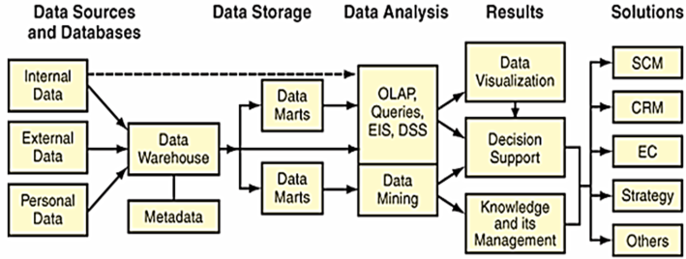
Data Management: is a structured approach for capturing, storing, processing, integrating, creating, and archiving data effectively throughout its lifecycle.

Data Lifecycle: defines way data travels through an organization.
- Data Sources and Databases Data Storage Data Analysis Results Solutions

Why does Data Management matter? No enterprise can be effective without high quality data that is accessible when needed.
- Data has become central and vital to organisations. Organizations need to manage their data assets to ensure data is easily accessed by managers and employees.
- Organizations with at least 1,000 knowledge workers lose $5.7 million annually in time wasted by employees reformatting data as they move among applications.

What is goal of Data Management? Provide infrastructure & tools to transform raw data into usable high quality information.

What are the Principles of Data Management?
- Principle of Diminishing data Value: the more recent the info, the more valuable. (time factor)
- Principle of 90/90 data use: 90% of data is seldom accessed after 90 days
- Principle of Data in context: Investment in Data Management infrastructure may be huge

What are the Challenges of Data Management?
- Volume of data is increasing exponentially
- Data is scattered throughout the organization
- Data is created and used offline without quality control checks
- Redundant and out-of-date data create huge maintenance problem

Traditional File Organisation
- When organizations began using computers, they used applications designed to be stand-alone systems (one for accounting, billing, and payroll) which led to data problems.

What are the problems with Traditional (stand-alone) File Organisation?
- Data redundancy: duplicate data in multiple data files stored in more than one place
- Data inconsistency: same attribute may have different values.
- Data isolation, lack of data sharing & availability: information cannot flow freely across organization
- Poor security: management with no knowledge of who is accessing or making changes to data

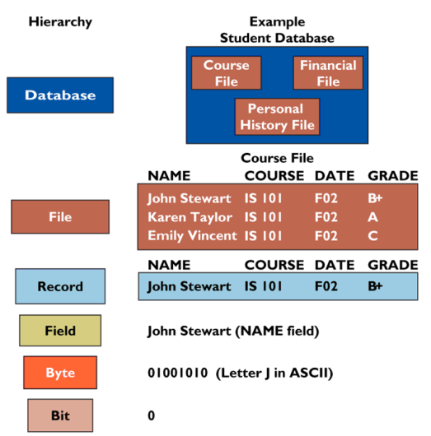
File organisation – Data Hierarchy
- Bit: smallest unit of data (binary digit of 0,1)
- Byte: group of 8 bits that represent a single character, number or symbol
- Field: group of bytes to form group of words or a complete number
- Record: group of related fields (vendor’s names, address and account data)
- File: Group of related records (listing of all vendors and their details)
- Related files are organised in a database.

Database Management Systems (DBMS)
What is a Database Management Systems?
- Software package to create and maintain databases
- Acts as interface between application programs and physical data files
- Separates logical and physical views of data
- Allows organization to centralize and manage data and give applications access to the stored data.
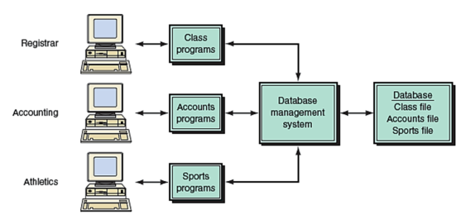

Logical view : presents data as perceived by end users or business specialists
Physical view : shows how data are actually organized and structured on physical storage media and depicts the system from a system engineer's point of view.
- The physical view is how and where the information resides.
- The physical view is a technical description of the implementation of the logical view.

Data Types:
- Data Entity (row) – a person, place, transaction, or event about which information a company wants to collect and store data. Common data entities are a customer, vendor, a product, or an employee.
- Entity class (table) – a collection of similar entities eg. CUSTOMER entity classes
- Attributes (fields, columns) – characteristics or properties of an entity class
- Rows in table contain the entities (ex. a record per customer)
- Columns in table contain the attributes (ex. columns for Customer ID, Customer Name, Phone)

What are the Functions of a Database Management System (DBMS)?
- Data filtering & profiling: Inspecting data for errors, inconsistencies, redundancies & incomplete information.
- Data quality: Correcting, standardizing, and verifying the integrity of the data.
- Data synchronization: Integrating, matching, or linking data from disparate sources.
- Data enrichment: Enhancing data using information from internal and external data sources.
- Data maintenance: Checking and controlling data integrity over time.

Relational Database Management System
What is a Relational DBMS? Represents data as 2-dimensional tables.
- Relates data across tables based on common data element
- Examples: MSAccess, DB2, Oracle, MS SQL Server

What is Structured Query Language (SQL)? is a standard computer language for relational database management and data manipulation. SQL is used to query, insert, update and modify data.
The format of the basic SQL statement, a conditional selection, is defined by:
- SELECT column_names
- FROM table_name
- WHERE condition

What are the 3 basis operations of a Relational DBMS?
- Select: Creates subset of rows that meet specific criteria
- Join: Combines relational tables to provide users with information
- Project: Enables users to create new tables containing only relevant information

Primary keys and foreign keys identify the various entity classes (tables) in the database:
- Primary key – a UNIQUE IDENTIFIER FIELD
  - a field (or group of fields) that uniquely identifies a given entity in a table
- Foreign key – A KEY TO LINK 2 or MORE TABLES TOGETHER
  - a primary key of one table that appears as an attribute in another table and acts to provide a logical relationship between the 2 tables.

