Chapter 1

Explain entrepreneurship and discuss its importance.
Entrepreneurship is defined as the process by which individuals pursue opportunities without regard to resources they currently control.
The art of turning an idea into a business.

Describe corporate entrepreneurship and its use in established firms.
Established firms with an orientation to acting entrepreneurially practice corporate entrepreneurship.
All firms fall along a conceptual continuum that ranges from highly conservative to highly entrepreneurial.
The position of a firm on this continuum is referred to as its entrepreneurial intensity.

Discuss three main reasons people decide to become entrepreneurs.
Be Their Own Boss many entrepreneurs want to be their own boss because either they have had a longtime ambition to own their own firm or because they have become frustrated working in traditional jobs. Sometimes the desire to be their own boss results from a realization that the only way they’ll achieve an important personal or professional goal is to start their own business.
Pursue Their Own Ideas Some people are naturally alert, and when they recognize ideas for new products or services, they have a desire to see those ideas realized. Established firms, however, often resist innovation. employees are left with good ideas that go unfulfilled.
Pursue Financial Rewards This motivation, however, is typically secondary to the first two and often fails to live up to its hype.

Identify four main characteristics of successful entrepreneurs.
Passion for the Business This passion typically stems from the entrepreneur’s belief that the business will positively influence people’s lives.
FIVE PRIMARY REASONS PASSION IS IMPORTANT FOR THE LAUNCH OF A SUCCESSFUL ENTREPRENEURIAL ORGANIZATION
- The ability to learn and iterate
- willingness to work hard for an extended period of time
- Ability to overcome setbacks and “no’s”
- The ability to listen to feedback on the limitations of your organization and yourself
- Perseverance and persistence when the going gets tough
While entrepreneurs should have passion, they should not wear rose-colored glasses.

Product/Customer Focus the two most important elements in any business—products
and customers.
A product/customer focus also involves the diligence to spot product opportunities and to see them through to completion.

Tenacity Despite Failure Because entrepreneurs are typically trying something new, the failure rate associated with their efforts is naturally high.
developing a new business idea may require a certain degree of experimentation before a success is
attained.

Execution Intelligence The ability to fashion a solid idea into a viable business is a key characteristic of successful entrepreneurs.
The ability to effectively execute a business idea means developing a business model, putting together a new venture team, raising money, establishing partnerships, managing finances, leading and motivating employees, and so on.

Explain the five common myths regarding entrepreneurship.
Myth 1: Entrepreneurs are born, not made. The consensus of many hundreds of studies on the
psychological and sociological makeup of entrepreneurs is that entrepreneurs are not genetically different from other people.
people with parents who were self-employed are more likely to become entrepreneurs.
Myth 2: Entrepreneurs are gamblers. The truth is, entrepreneurs are usually moderate risk takers, as are most people.
entrepreneurs typically have jobs that are less structured, and so they face a more uncertain set of possibilities than managers or rank-and-file employees.
Many entrepreneurs have a strong need to achieve and often set challenging goals, a behavior that is sometimes equated with risk taking.
Myth 3: Entrepreneurs are motivated primarily by money. money is rarely the primary reason entrepreneurs start new firms and persevere.
Myth 4: Entrepreneurs should be young and energetic. Although it is important to be energetic, investors often cite the strength of the entrepreneur (or team of entrepreneurs) as their most
important criterion in the decision to fund new ventures. What makes an entrepreneur “strong” in the eyes of an investor is experience in the area of the proposed business, skills and abilities that will help the business, a solid reputation, a track record of success, and passion about the business idea.
Myth 5: Entrepreneurs love the spotlight. the vast majority of them do not attract public attention.

Types of Start-Up Firms
Explain how entrepreneurial firms differ from salary-substitute and lifestyle firms.
Salary-substitute firms Dry cleaners, convenience stores, restaurants, accounting firms, retail stores, and hairstyling salons are examples of salary-substitute firms. Salary-substitute firms offer common, easily available products or services to customers that are not particularly innovative.
Lifestyle firms include ski instructors, golf and tennis pros, wine bars, and tour guides. These firms
are not innovative, nor do they grow quickly.
Entrepreneurial firms bring new products and services to market. the essence of entrepreneurship is creating value and then disseminating that value to customers.

Discuss the changing demographics of entrepreneurs in the United States.
Women Entrepreneurs the number of women-owned businesses is increasing.
Minority Entrepreneurs There has been a substantial increase in minority entrepreneurs in the United States from 1996 to 2010.
Senior Entrepreneurs This increase is attributed to a number of factors, including corporate downsizing, an increasing desire among older workers for more personal fulfillment in their lives, and growing worries among seniors that they need to earn additional income to pay for future health care services and other expenses.
Young Entrepreneurs Interestingly, a drop in new entrepreneurial activity for people in the 20 to 34 age range occurred between 1996 and 2010. nonetheless, the number of young people interested in entrepreneurship remains strong.

Discuss the impact of entrepreneurial firms on economics and societies.
Economic Impact of Entrepreneurial Firms
creative destruction entrepreneurs develop new products and technologies that over time make current products and technologies obsolete. creative destruction stimulates economic activity.

Innovation is the process of creating something new, which is central to the entrepreneurial process.
Job Creation Small businesses are the creators of most new jobs in the United States, and employ more than half of all private sector employees.
Entrepreneurial Firms’ Impact on Society
The innovations of entrepreneurial firms have a dramatic impact on a society. Think of all the new products and services that make our lives easier, enhance our productivity at work, improve our health, and entertain us.
However, innovations do create moral and ethical issues with which societies are forced to grapple.

Identify ways in which large firms benefit from the presence of smaller entrepreneurial firms.
entrepreneurial firms also have a positive impact on the effectiveness of larger firms.
many entrepreneurial firms have built their entire business models around producing products and services that help larger firms be more efficient or effective.
entrepreneurial firms partner with larger companies to reach mutually beneficial goals. Participation in business partnerships accelerates a firm’s growth by giving it access to some of its partner’s resources, managerial talent, and intellectual capacities.

Explain the entrepreneurial process
Step 1 Deciding to become an entrepreneur: Usually, a triggering event prompts an individual to become an entrepreneur.
Step 2 Developing successful business ideas: Developing a successful business idea includes opportunity recognition, feasibility analysis, writing a business plan, industry analysis, and the development of an effective business model. A business plan is a written document that describes all
the aspects of a business venture in a concise manner.
A firm’s business model is its plan for how it competes, uses its resources, structures its relationships, interfaces with customers, and creates value to sustain itself on the basis of the profits it generates.
Step 3 Moving from an idea to an entrepreneurial firm: to prepare a proper ethical and legal
foundation for a firm, including selecting an appropriate form of business ownership.
assessing a new venture’s financial strength and viability
building a new-venture team
getting financing or funding and identifies the options that a firm has for raising money
Step 4 Managing and growing the entrepreneurial firm: marketing issues facing entrepreneurial
firms, including selecting an appropriate target market, building a brand, and the four Ps—product, price, promotion, and place (or distribution)—for new firms.
intellectual property in the growth of entrepreneurial firms.
Preparing for and evaluating the challenges of growth
strategies for growth, ranging from new product development to mergers and acquisitions.
Chapter 2

Explain why it’s important to start a new firm when its “window of opportunity” is open.
entrepreneurs recognize an opportunity and turn it into a successful business.
An opportunity is a favorable set of circumstances that creates a need for a new product, service, or business.
Some ventures are externally stimulated an entrepreneur decides to launch a firm, searches for and recognizes an opportunity, and then starts a business an entrepreneur decides to launch a firm, searches for and recognizes an opportunity, and then starts a business.
Other firms are internally stimulated An entrepreneur recognizes a problem or an opportunity gap
and creates a business to fill it.
an opportunity has four essential qualities: It is.-
- attractive, (2) durable, (3) timely, and (4) anchored in a product, service, or business that creates or adds value for its buyer or end user
The term window of opportunity is a metaphor describing the time period in which a firm can realistically enter a new market. Once the market for a new product is established, its window of opportunity opens. As the market grows, firms enter and try to establish a profitable position. At some point, the market matures, and the window of opportunity closes.

Explain the difference between an opportunity and an idea
An idea is a thought, an impression, or a notion. An idea may or may not meet the criteria of an opportunity.
An opportunity is a favorable set of circumstances that creates a need for a new product, service, or business. Most entrepreneurial ventures are started in one of two ways.

Describe the three general approaches entrepreneurs use to identify opportunities.
Observing Trends
it’s important to distinguish between trends and fads.
even though we discuss each trend individually, they are interconnected and should be considered
simultaneously when brainstorming new business ideas.
Economic Forces
- State of the economy
- Level of disposable income
- Consumer spending patterns

Social Forces
- Social and cultural trends
- Demographic changes
- What people think is ”in“

Technological Advances
- New technologies
- Emerging technologies
- New uses of old technologies

Political Action and Regulatory Changes: Political and regulatory changes also provide the basis for opportunities
- New changes in political arena
- New laws and regulations

Solving a Problem
The second approach to identifying opportunities is to recognize problems and find ways to solve them.
many companies have been started by people who have experienced a problem in their own lives, and then realized that the solution to the problem represented a business opportunity.
Advances in technology often result in problems for people who can’t use the technology in the way it is sold to the masses.
Some problems are solved by entrepreneurs who frame a problem differently than it’s been thought of before, and then propose an appropriate solution. The solution is often easier and less expensive than traditional fixes.
Some business ideas are gleaned by recognizing problems that are associated with emerging trends.

FINDING GAPS IN THE MARKETPLACE
There are many examples of products that consumers need or want that aren’t available in a particular location or aren’t available at all.
Part of the problem is created by large retailers, like Walmart and Costco, which compete primarily
on price and offer the most popular items targeted toward mainstream consumers. While this approach allows the large retailers to achieve economies of scale, it leaves gaps in the marketplace.
Product gaps in the marketplace represent potentially viable business opportunities.
A common way that gaps in the marketplace are recognized is when people become frustrated because they can’t find a product or service that they need and recognize that other people feel the same way.
A related technique for generating new business ideas is to take an existing product or service and create a new category by targeting a completely different target market.
One thing a new firm has to be careful about is that if it says it’s capitalizing on an environmental trend, solving a problem, or filling a gap in the marketplace, it has to deliver on its promises. If a start-up’s initial customers find out its more hype than substance, they will quickly abandon it.

List the personal characteristics that make some people better at recognizing business opportunities than others.
opportunity recognition refers to the process of perceiving the possibility of a profitable new business or a new product or service. That is, an opportunity cannot be pursued until it’s recognized.

Prior Experience helps entrepreneurs recognize business opportunities.
corridor principle, which states that once an entrepreneur starts a firm, he or she begins a journey down a path where “corridors” leading to new venture opportunities become apparent.

Cognitive Factors: entrepreneurial alertness, which is formally defined as the ability to notice things without engaging in deliberate search. Alertness is largely a learned skill, and people who have more knowledge of an area tend to be more alert to opportunities in that area than others.

Social Networks People who build a substantial network of social and professional contacts will be exposed to more opportunities and ideas than people with sparse networks.

solo entrepreneurs who identified their business ideas on their own

network entrepreneurs who identified their ideas through social contacts
network entrepreneurs identified significantly more opportunities than solo entrepreneurs but were
less likely to describe themselves as being particularly alert or creative.
Strong-tie relationships are characterized by frequent interaction and ties between coworkers, friends, and spouses.
Weak-tie relationships are characterized by infrequent interaction and ties between casual acquaintances.

it is more likely that an entrepreneur will get a new business idea through a weak-tie than a strong-tie relationship38 because strong-tie relationships, which typically form between like-minded individuals,
tend to reinforce insights and ideas the individuals already have.

Creativity is the process of generating a novel or useful idea.
Identify the five steps in the creative process.
Preparation. Preparation is the background, experience, and knowledge that an entrepreneur brings to the opportunity recognition process.
Incubation. Incubation is the stage during which a person considers an idea or thinks about a problem; it is the “mulling things over” phase.
Insight. Insight is the flash of recognition—when the solution to a problem is seen or an idea is born.
Evaluation. Evaluation is the stage of the creative process during which an idea is subjected to scrutiny and analyzed for its viability.
Elaboration. Elaboration is the stage during which the creative idea is put into a final form: The details are worked out and the idea is transformed into something of value, such as a new product, service, or
business concept. In the case of a new business, this is the point at which a business plan is written.

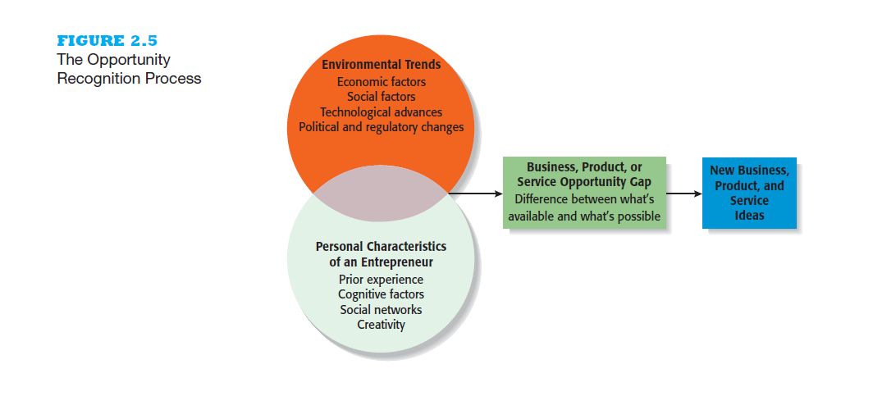

TECHNIQUES FOR GENERATING IDEAS
Brainstorming
Describe the purpose of brainstorming and its use as an idea generator.
brainstorming is simply the process of generating several ideas about a specific topic.
Brainstorming sessions dedicated to generating new business ideas are often less formal.

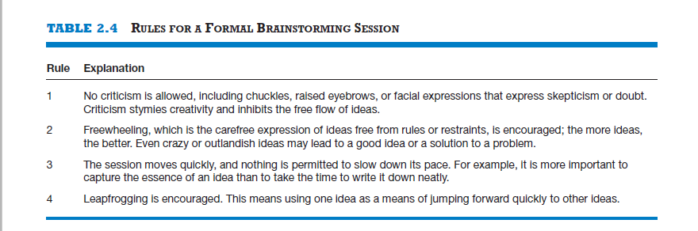

Focus Groups
A focus group is a gathering of 5 to 10 people who are selected because of their relationship to the issue being discussed.
Focus groups usually work best as a follow-up to brainstorming, when the general idea for a business
has been formulated.

Library and Internet Research
Describe how to use library and Internet research to generate new business ideas.
The best approach to utilizing a library is to discuss your general area of interest with a reference librarian, who can point out useful resources, such as industry-specific magazines, trade journals, and industry reports.
databases are also available through university and large public libraries, which would cost hundreds or
thousands of dollars to access on your own.
Internet research is also important.

Other Techniques
customer advisory boards that meet regularly to discuss needs, wants, and problems that may lead to new ideas.
companies conduct varying forms of anthropological research, such as day-in-the-life research. The company routinely sends teams of testers to the homes and businesses of its users to see how its products are working and to seek insights for new product ideas.

ENCOURAGING AND PROTECTING NEW IDEAS
Establishing a Focal Point for Ideas
Explain the purpose of maintaining an idea bank
idea bank (or vault), which is a physical or digital repository for storing ideas. It may have a file
for ideas that are being actively contemplated and a file for inactive ideas.

Encouraging Creativity at the Firm Level
creativity is the process of generating a novel or useful idea but does not require implementation.
creativity is the raw material that goes into innovation.
Although creativity is typically thought of as an individual attribute, it can be encouraged or discouraged at the firm level.52 The extent to which an organization encourages and rewards creativity affects the creative output of its employees.

Protecting Ideas from Being Lost or Stolen
Describe three steps for protecting ideas from being lost or stolen.
Intellectual property is any product of human intellect that is intangible but has value in the marketplace.
Step 1 The idea should be put into a tangible form—either entered into a physical idea logbook or saved on a computer disk—and dated. Make all entries in ink and have them witnessed. the signature of the
person who entered the idea into the logbook and the witness should be notarized.
Putting the idea into tangible form is important for two reasons.
the idea may qualify as a “property right” or “trade secret” and be legally protected under a variety of statutes.
if two inventors independently come up with essentially the same invention, the right to apply for the patent belongs to the first person who invented the product.
Step 2 The idea, whether it is recorded in a physical idea logbook or saved in a computer file, should be secured. if an idea has considerable potential and may be eligible for patent protection, access to the
idea should be restricted.
Step 3 Avoid making an inadvertent or voluntary disclosure of an idea in a way that forfeits your claim to its exclusive rights.

Chapter 3

FEASIBILITY ANALYSIS
Explain what a feasibility analysis is and why it’s important.
Feasibility analysis is the process of determining if a business idea is viable.
If a business idea falls short on one or more of the four components of feasibility analysis, it
should be dropped or rethought, as shown in the figure.
A feasibility analysis is an assessment of a potential business rather than strictly a product or service idea.
Feasibility analysis is investigative in nature and is designed to critique the merits of a proposed business.
The reason it’s important to complete the entire process is to avoid falling into the “everything about my opportunity is wonder” mode.
failure to properly investigate the merits of a business idea before the business plan is written runs the risk of blinding an entrepreneur to inherent risks associated with the potential business and results in too positive of a plan.

most effective businesses emerge from a process that includes
(1) recognizing a business idea
(2) testing the feasibility of the idea
(3) writing a business plan
(4) launching the business.

Discuss the proper time to complete a feasibility analysis when developing an entrepreneurial venture.
Primary research is research that is collected by the person or persons completing the analysis (talking to industry experts, obtaining feedback from prospective customers)
Secondary research probes data that is already collected (industry studies, Census Bureau data, analyst forecasts, and other pertinent information gleaned through library and Internet research)
The key objective behind feasibility analysis is to put an idea to the test—by talking to industry experts, surveying prospective customers, studying industry trends, thinking through the financials, and scrutinizing it in other ways.

Product/Service Feasibility Analysis
Describe the purpose of a product/service feasibility analysis and the two primary issues that a proposed business should consider in this area.
Product/service feasibility analysis is an assessment of the overall appeal of the product or service being proposed.
Product/Service Desirability The first component of product/service feasibility is to affirm that the proposed product or service is desirable and serves a need in the marketplace.
Explain a concept statement and its contents.
A concept test involves showing a preliminary description of a product or service idea, called a concept statement, to industry experts and prospective customers to solicit their feedback.
A description of the product or service. This section details the features of the product or service; many include a sketch of it as well.
The intended target market. This section lists the consumers or businesses who are expected to buy the product or service.
The benefits of the product or service. This section describes the benefits of the product or service and includes an account of how the product or service adds value and/or solves a problem.
A description of how the product or service will be positioned relative to competitors. A company’s position describes how its product or service is situated relative to its rivals.
A brief description of the company’s management team.

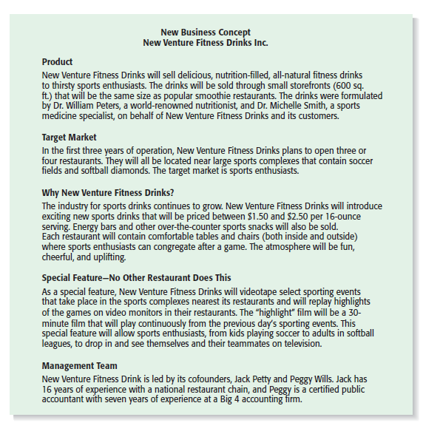
Product/Service Demand The second component of product/service feasibility analysis is to determine if there is demand for the product or service.

