13 – Personality
Personality an individual’s characteristic patterns of thoughts, feelings, and behaviours (persisting over time and across situations)
Psychodynamic/Psychoanalytic Theories
- The theories of human personality focus on the inner forces that interact to make us who we are
- Behaviour, as well as human emotions, and personality, develop in a DYNAMIC (interacting, changing) interplay between conscious and unconscious processes, including various motives and inner conflicts
Sigmund Freud
  - Started his career as a Viennese physician
  - Decided to explore how mental and physical symptoms could be caused by purely psychological factors
  - Became aware that many powerful mental processes operate in the unconscious, without our awareness
  - Psychoanalysis = theory of the structure of human personality and its development
Psychoanalysis: Techniques
    - Free association: encouraged the patient to speak whatever comes to mind, then the therapist verbally traces a flow of thoughts into the past and into the unconscious
    - Suggested meanings for slips of the tongue and for the “latent” content of dreams
Personality/Mind Iceberg
    - Personality develops from the efforts of our ego, our rational self, to resolve tension between our id, based in biological drives, and the superego, society’s rules and constraints
    - The unconscious, in Freud’s view: a reservoir of thoughts, wishes, feelings, memories, that are hidden from awareness because they feel unacceptable
The Developing Personality

Freud’s Theory of Psychosexual Stages
    - The id is focused on the needs of erogenous zones, sensitive areas of the body
    - People feel shame about these needs and can get fixated at one stage, never resolve how to manage the needs of that zone’s needs
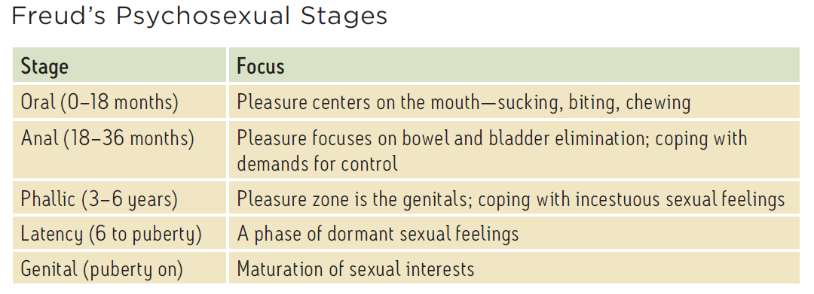

Male Development Issues
    - Freud believed that as boys in the phallic stage seek genital stimulation, they begin to develop unconscious sexual desires for their mothers and hate their fathers as a rival, feeling guilt and fearing punishment by castration
    - Resolution: boys identify with their fathers rather than seeing them as a rival
Defending Against Anxiety
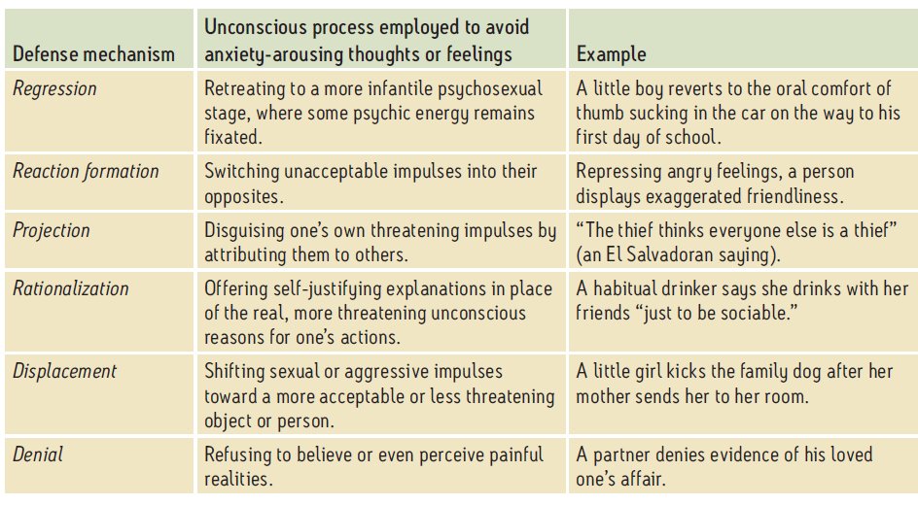
    - Believed that we are anxious about our unacceptable wishes and impulses, and we repress this anxiety with the help of the strategies below

Neo-Freudian, Psychodynamic Theorists
Psychodynamic theorists accepted Freud’s ideas about… | Psychodynamic theorists differed from Freud in a few ways…
- The importance of the unconscious and childhood relationships in shaping personality  - The id/ego/superego structure of personality  - The role of defense mechanisms in reducing anxiety about uncomfortable ideas | - Adler and Horney believed that anxiety and personality are a function of social, not sexual tensions in childhood  - Jung believed that we have a collective unconscious, containing images from our species’ experiences, not just personal repressed memories and wishes

Carl Jung | Highlighted universal themes in the unconscious as a source of creativity and insight. Found opportunities for personal growth by finding meaning in moments of coincidence.
Alfred Adler | Focused on the fight against feelings of inferiority as a theme at the core of personality, although he may have been projecting from his own experience.
Karen Horney | Criticized the Freudian portrayal of women as weak and subordinate to men. She highlighted the need to feel secure in relationships.

Assessing the Unconscious
- Freud tried to get unconscious themes to be projected into the conscious world through free association and dream analysis
- Projective tests are a structures, systematic exposure to a standardized set of ambiguous prompts, designed to reveal inner dynamics
Evidence of Freud’s Ideas
- Development appears to be lifelong, not set in stone by childhood
- Infant neural networks are not mature enough to create a lifelong impact o childhood trauma
- Peers have more influence on personality, and parents less, than Freud assumed
- Dreams, as well as slips of the tongue, have many possible origins, less likely to reveal deep unconscious conflicts and wishes
- We may ignore threatening information, but traumatic memories are usually intensely remembered, not repressed
- Still, sexual abuse stories are more likely to be fact, less likely to be wish fulfillment, than Freud thought
- Gender and sexual identity seems to be more a function of genetics than Oedipus conflicts and relationships with parents
Flaws in Freud’s Scientific Method
- Unfalsifiability
  - Developed theories that are hard to prove or disprove
- Unrepresentative sampling
  - Did not built his theories on a broad sample of observations; he described all of humanity based on people with unusual psychological problems
- Biased observations
  - Based theories on his patients, which may give him an incentive to see them as unwell before his treatment
- Post facto explanations
  - Hindsight bias rather than predictions: whether or not a situation makes you anxious or not, you could either be fixated or repressing
The Unconscious as Seen Today…
- Schemas guide our perceptions
- Right hemisphere makes choices the left hemisphere doesn’t verbalize
- Conditioned responses, learned skills and procedures, all guide our actions without conscious recall
- Emotions get activated
- Stereotypes influence our reactions
- Priming affects our choices
Humanistic Theories of Personality
- In the 1960’s, some psychologists began to reject…
  - The dehumanizing ideas in behaviourism
  - The dysfunctional view of people in psychodynamic thought
- Maslow and Rogers sought to offer a “third force” in psychology – the humanistic perspective
- They studied healthy people rather than people with mental health problems
- Humanism = focusing on the conditions that support healthy personal growth
Maslow: The Self-Actualizing Person
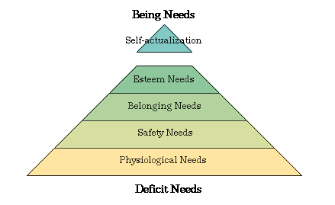
- Self-actualizing = fulfilling one’s potential and self-transcendence
Rogers’ Person-Centered Perspective
- Genuineness: being honest, direct, not using a façade
- Acceptance (Unconditional Positive Regard): acknowledging feelings, even problems, without passing judgement – honoring, not devaluing
- Empathy: tuning into the feelings of others, showing your efforts to understand, listening well (NOT sympathy)
Assessing the Self in Humanistic Psychology: Ideal Self vs. Actual Self
- The core of personality is the self concept, our sense of our nature and identity
- People are happies with a self concept that matches their ideal self
- Thus, it’s important to ask people to describe themselves as they are and as they ideally would like to be
Critiquing the Humanist Perspective What about evil?
- Some say Rogers did not appreciate the human capacity for evil
- Saw “evil” as a social phenomenon, not an individual trait
- Self-acceptance is not the end; it then allows us to move on from defending our own needs to loving and caring for others
Critiquing the Humanist Perspective Too much self-centeredness?
- The therapist using this approach should not encourage selfishness, and should keep in mind that “positive regard” means “acceptance”, not “praise”
Trait Theory of Personality
- Gordon Allport decided that Freud overvalued unconscious motives and undervalued our real, observable personality styles/traits
  - Trait: an enduring quality that makes a person tend to act a certain way
  - Trait theory of personality: that we are made up of a collection of traits, behavioural predispositions that can be identified and measured, traits that differ from person to person
- Myers & Briggs wanted to study individual behaviours and statements to find how people differed in personality
- The Myers-Briggs Type Indicator (MBTI) is a questionnaire categorizing people by traits
Factor Analysis and the Eysenck’s Personality Dimensions
- Factor analysis: identifying factors that tend to cluster together
- Using factor analysis, Hans and Sybil Eysenck found that many personality traits actually are a function of two basic dimensions along which we all vary
- Research supports their idea that these variations are linked to genetics

Traits: Rooted in Biology?
- Brain: extraverts tend to have low levels of brain activity, making it hard to suppress impulses, and leading them to seek stimulation
- Body: the trait of shyness appears to be related to high autonomic system reactivity, an easily triggered alarm system
- Genes: selective breeding of animals seems to create lifelong differences in traits such as aggression, sociability, or calmness, suggesting genetic roots for these traits
Assessing Traits: Questionnaires
- Personality inventory: questionnaire assessing many personality traits, by asking which behaviours and responses the person would choose
- Empirically derived test: all test items have been selected to because they predictably match the qualities being assessed
- Minnesota Multiphasic Personality Inventory (MMPI): designed to identify people with personality difficulties
  - T/F questionnaire; items were selected because they correlated with various traits, emotions, attitudes
  - I.e. depressed people tend to answer “T” to: “Nothing in the paper interests me except the comics”
The “Big Five” Personality Factors
- Conscientiousness: self-discipline, careful pursuit of delayed goals
- Agreeableness: helpful, trusting, friendliness
- Neuroticism: anxiety, insecurity, emotional instability
- Openness: flexibility, nonconformity, variety
- Extraversion: drawing energy from others, sociability
Questions about Traits
- Stability: does one’s profile of traits change over the lifespan? No, one’s distinctive mix of traits doesn’t change much over the lifespan. However, everyone in adulthood becomes:
  - More conscientious and agreeable
  - Less extraverted, neurotic/unstable, and less open (imaginative, flexible)
- Predictive value: can we use these traits to predict behaviour? Levels of success in work and relationships relates to traits
- Heritability: are traits learned or genetic? In general, genes account for 50% of the variation for most traits
Change vs. Consistency: Shifts with Age
- The evidence shows that it takes time for personality to stabilize
- Traits do change, but less and less so over time
- We change less, become more consistent

Person-Situation Controversy
- Trait theory assumes that we have traits that are a function of personality, not situation
- There is evidence that some traits are linked to roles and to personas we use in different cultures, environments
Social-Cognitive Perspective
- Albert Bandura believes that personality is the result of an interaction that takes place between a person and their social context, involving how we think about ourselves and our situations
- Questions raised in this perspective:
- How do we interpret and respond to external events? How do those responses shape us?
- How do our memories, expectations, schemas, influence our behaviour patterns?
- How do the personality and social environment mutually influence each other?
Reciprocal Influences in Becoming “the kind of person who does rock climbing”
- Reciprocal: a back and forth influence, with no primary cause
- Example: a tendency to enjoy risky behaviour, affects choice of friends, who in turn may encourage rock climbing, which may lead to identifying with the activity
Reciprocal Determinism:
- Why is Jake a happy, smiley person? He may have started with an “easy” temperament
- He may attract other happy people, and people are more likely to smile when around him, which reinforces his smiles
- His mind fills in the reasons why he’s smiling even if some of it was a reflection of his happy friends, and these happy reasons give him more reason to smile
External vs. Internal Locus of Control
- Locus of control: our perception of where the seat of power over our lives is located
- Internal locus of control: we feel that we are in charge of ourselves and our circumstances
  - Too much internal locus of control: we blame ourselves for bad events, or have the illusion that we have the power to prevent bad events
- External locus of control: we picture that a force outside of ourselves controls our fate
  - Too much external locus of control: we lose initiative, lose motivation to achieve, have more anxiety about what might happen to us, don’t bother developing willpower
Self-Control
- The ability to control impulses and delay gratification, sometimes called willpower
- This is a finite resource, an expenditure of brain energy, which is replenished but can be depleted short-term: people asked to resist eating cookies later gave up sooner on a tedious task
- With practice, we can improve our self-control
- There seem to be individual differences in this trait in childhood
- The Marshmallow Study: kids who resisted the temptation to eat marshmallows later had more success in school and socially
Biopsychosocial Approaches to Personality
Learned Helplessness vs. Personal Control
- Martin Seligman: give a dog no chance of escape from repeated shocks
  - Result: it will give up on trying to escape pain, even when it later has the option to do so
- Learned helplessness: declining to help oneself after repeated attempts to do so have failed
- Personal control: when people are given some choices, they thrive

Optimism vs. Pessimism
- Prediction: we can expect the best or the worst – at the extremes, we can get ourselves overconfident or simply depressed or anxious about the future
- Focus of attention: we can focus on what we have (half full) or what we don’t have (empty)
- Attribution of intent: we can assume that people meant to hurt us or that they were having a bad day
- Valuation: we can assume that we or others are useless, or that we are lovable, valuable
- Potential for change: we can assume that bad things can’t be changed, or have hope
Excessive Pessimism | Vs.  (Realism) | Excessive Optimism
I can’t do it, might as well forget it. | It might be hard; I’d better plan. | It will be easy, I won’t think about it.
I’m trapped, can’t get out of this. | I want to make changes or get out. | Someone will rescue me.
That person hates me, he is against me | I should ask what he feels about me, what he wants. | I’m sure he just wants what’s best for me, I’ll trust him.
Excessive pessimism can leave us depressed, inactive.
Excessive optimism can leave us unprepared, unsafe.

Positive Psychology
- Martin Seligman developed Positive Psychology, the “scientific study of optimal human functioning” finding ways to help people thrive
- Focus: building strengths, virtue, emotional well-being, resilience, optimism, sense of meaning
- Three pillars of positive psychology:
- Emotions, i.e. engagement
- Character, i.e. courage
- Groups, culture, institutions
Evaluating the Social Cognitive Perspective
- The social-cognitive perspective on personality helps us focus on the interaction of behaviours, thoughts, and social situations
- This focus, though, may distract us from noticing an individual’s feelings, emotions, inner qualities
- Critics notes that traits may be more a function of genetics and upbringing, not just situation
- Example of two people with different reactions in the same situation: two lottery winners sharing a jackpot; one sobbed, the other slept

Personality Theory | Key Proponents | Assumptions | View of Personality | Personality Assessment Methods
Psychoanalytic | Freud | Emotional disorders spring from unconscious dynamics, such as unresolved sexual and other childhood conflicts, and fixation at various developmental stages. Defense mechanisms fend off anxiety. | Personality consists of pleasure-seeking impulses (the id), a reality-oriented executive (the ego), and an internalized set of ideals (the superego). | Free association, projective tests, dream analysis
Psychodynamic | Adler, Horney, Jung | The unconscious and conscious minds interact. Childhood experiences and defense mechanisms are important. | The dynamic interplay of conscious and unconscious motives and conflicts shape our personality. | Projective tests, therapy sessions
Humanistic | Rogers, Maslow | Rather than examining the struggles of sick people, it’s better to focus on the ways healthy people strive for self-realization. | If our basic human needs are met, people will strive toward self-actualization. In a climate of unconditional positive regard, we can develop self-awareness and a more realistic and positive self-concept. | Questionnaires, therapy sessions
Trait | Allport, Eysenck, McCrae, Costa | We have certain stable and enduring characteristics, influenced by genetic predispositions. | Scientific study of traits has isolated important dimensions of personality such as the Big Five traits. | Personality inventories
Social-Cognitive | Bandura | Our traits and the social context interact to produce our behaviours. | Conditioning and observational learning interact with cognition to create behaviour patterns. | Our behaviour in one situations is best predicted by considering our past behaviour in similar situations.

Exploring the Self, Viewing the Self
- The field has refined a definition of “self” as the core of personality, the organizer and reservoir of our thoughts, feelings, actions, choices, attitudes
- Topics for our study of people’s sense of self
  - The Spotlight Effect (self-consciousness)
    - Experiment: students put on Barry Manilow t-shirts before entering a room with other students
    - Result: the students thought others would notice the t-shirt, assumed people were looking at them, when this was not the case; they greatly overestimated the extent to which the spotlight was on them
    - Spotlight effect: assuming that people have attention focused on you when they actually may not be noticing you
    - Lesson: people don’t notice out errors, quirks, features, and shirts as much as we think they do
  - Self-esteem, low and high, benefits and risks
    - People who have normal or high self-esteem, feeling confident and valuable, get some benefits:
      - Increased resistance to conformity pressure
      - Decreased harm from bullying
      - Increased resilience and efforts to improve their own mood
      - But maybe this “high” self-esteem is really realistic, and is a result, not a cause, of these successes
    - Low self-esteem, even temporarily lowered by insults, leads to problems: prejudice, being critical of others
  - Self-Serving Bias
    - We all generally tend to think we are above average
    - This bias can help defend our self-esteem, as it does for the people in this wheel
  - Narcissism
    - Empathy scores and skills are decreasing – people increasingly don’t bother trying to see things from the perspective of others
    - There is a rise in narcissism (self-absorption, self-gratification, inflated but fragile self-worth)
    - Narcissists see themselves as having a special place in the world
  - Self-disparagement
    - Left behind in the supposed increase in egotism – those who feel worthless, unlovable
    - Some people have a habit of self-disparaging self-talk
  - Secure self-esteem

