SILOS: MOLHAS / MIS
People use Processes to work with I.S. to produce Info/Business Success
Information Cultures: Functional / Sharing / Inquiring / Discovery / FSID
Organization Levels: Strategic / Management / Operational SMO
IS – Computer Based Tools to work with Info of an Organization / Enabler of a Business
IT – The processing, storage of voice, graphics, text by computers and tele networks
MIS – The function that plans, develops, and maintains hardware/software
Data – Raw Facts
Info – Data converted into Context
Business Intelligence – Analyze Patterns / Trends / Relationship for Strategic Decision Making
Knowledge – Skills, Experience, and Expertise
Priority given to people who have experience with EIS (SAP), Business/ICT Skills

IS Roles
CIO – Oversees all uses of IT
Game Changing activities / Service and Cost Centre activities
CKO – Collecting, Maintaining, Distributing Knowledge
CPO – Ensuring the ethical, and legal use of information
CSO – Ensures the safety of IT resources and people
CTO – Ensuring the throughput, speed, accuracy, availability, and reliability of IT

Chapter 2
Measuring IT Success:
KPI – Measures that are tied to business drivers, quantifiable metrics to evaluate progress (Turnover rates, #of product returns, #of new customers)
Efficiency IT metrics – measure the performance of the IT system: throughput, speed, and availability
Effective IT metrics – measure the impact IT has on business process/activities: Satisfaction, Conversion Rates, Sell-through increases
Benchmarking – process of continually measuring system results, comparing those results to optimal system performance, and identifying steps and procedures to improve system performance

Efficiency IT metrics – Throughput / Transaction Speed / System Availability / Info Accuracy / Web Traffic / Response Time
Effective IT metrics – Usability (ease) / Customer Satisfaction / Conversion Rates (# of first time customers) / Financial (Return on Investment)
Critical Success Factors – Crucial steps companies make to perform to achieve their goals and objs.

Key to Survival and Growth
Competitive Advantage (Customer place a greater value on one than the other)
Environmental Scanning – Acquisition and analysis of trends in the external environment
3 Tools to develop CA: Porters Five Forces / Porters three generic strategies / Value Chains
Supplier Power (Supply Chain, B2B, Private Exchange (Reverse Auction))
Ability of suppliers to set prices and terms
Organ as a buyer, sp to be low / bp to be high
Organ as a seller, sp to be high / bp to be low
Rivalry among existing competitors – Product Differentiation
Buyer Power (Switching Cost, Loyalty Programs)
Threat of Substitute
Threat of New Entrants
BF: Cost Leadership / Differentiation / Narrow Focus
VC: A Series of Business Processes, each adding value to the final product
First-mover Advantage (Limited usually copied)

Making Decisions: Need Recognition -> Search -> Evaluate -> Purchase -> Post-purchase
Operational Decision Making – Develop, Control, and Maintain Core Business Activities (Structured)
Managerial Decision Making – Evaluate company operations to identify, adapt to, and leverage change (Semi-Structured)
Strategic Decision Making – Develop overall strategies, goals, and objectives (Unstructured)

Types of info
Transactional data – All the raw facts, supports daily operational tasks, Order size, Stock price
Analytical Info – Summarized transactional data, support decision analysis, Trends
Types of Info Processing
OLTP – Online Transactions Processing: Captures, Stores, Updates and Process Data
OLAP – Summarization of raw data from transaction systems, transferred into information for S/M
Granularity – Level of detail from raw data (granular or fine) to summarized data (coarse)

Three major classes of IS:
TPSystem – Handles data for operational level, performs OLAP
DSSystem – Models data and info to support Managerial decisions, performs OLAP
Quantitative Models used by DSS
-Sensitivity Analysis, What-If Analysis, Goal-Seeking Analysis
Executive Information System – Highly aggregated data for strategic decisions, displayed in Visuals
Contains Market Pulse, Customer Service, or Cost Driver

Artificial Intelligence – Simulates human intelligence such as the ability to reason and learn
Intelligent System – Various commercial applications of AI
Expert Systems, Neural Networks, Genetic Algorithms, Intelligent Agents, VR
ES: Knowledge Base, Set of Rules, and User Interface
NN: Learning and adjusting to new circumstances, analyze non-linear probs
GA: Evaluates 1000s of options choosing one
VR: Environment that simulates real world or imaginary world experiences

Importance of Business Processes: Determine bottlenecks, eliminate duplication, and identify smooth running process
BP Re-engineering: Revolutionary, Set project scope, Study competition, Create new processes, Implement Solution
Order to Delivery Process: Market Sales Operations Accounting Customer Service
Customer & Business Facing Processes: Customer Process -> Industry Customer Process -> Business F.P

Chapter 3
Data and Information Quality
Accuracy, Completeness, Consistency, Uniqueness, Timeliness
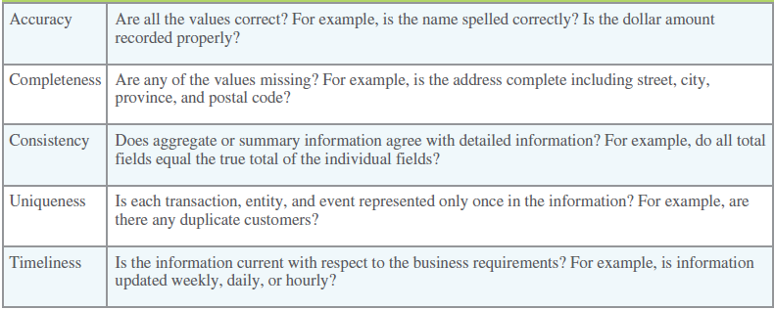
Data Governance – refers to the overall management of the availability, usability, integrity, and security of organizational data
Explicit Knowledge – that which can be documented
Tacit knowledge – Contained in people’s head
KM and KMS – Codifying employees, partners and customers knowledge
KM Technologies – Knowledge repositories (Databases)
Expertise tools often involving AI
Discussion and Chat technologies
SECI Model
(Tacit Knowledge)
Socialization – Creating tacit knowledge through direct experience
Internalization – Learning and acquiring new tacit knowledge by practice
(Explicit Knowledge)
Externalization – Articulating tacit knowledge through dialog and reflection
Combination – Systemizing explicit knowledge and information
Crowdsourcing – Collecting knowledge from outside the organization
Social networking analysis - is a process of mapping a group’s contacts to identify who knows whom and works with them, displays remotely connected employees, can identify experts.
Transactive memory system – Consists of knowledge stored in each individuals memory combined with metamemory containing information regarding the different group members’ domains of expertise
Strategic, Operational, Tactical BI | Helps with Planning, Helps with immediate action, daily analysis
Business Intelligence Benefits
Direct Quantifiable Benefits – Measurable and observable benefits
Indirect Quantifiable Benefits – Measurable but observed through other events
Unpredictable Benefits - Unexpected
Intangible Benefits – Not directly observable such as improved reputation or morale

Collaboration Systems
Unstructured (Informational Collaboration) – Document exchange, shared whiteboards, discussion forums and emails
Structured (Process Collaboration) – Participating in business processes such as workflow, where knowledge is hardcoded as rules
Businesses use collaboration to gain Core Competency, and have Information Partnership
When expertise is required that is beyond the scope of an individual or an organization
Core competency strategy - is when an organization focusses on what they do best
Information Partnership - Two or more companies integrate their information systems

Content Management Systems
Provide tools to manage, create, store, edit, search and publish information in a collaborative environment, reduces duplication, increases accessibility, improves security, and reduces fraud provided by large outside vendors but also smaller suppliers
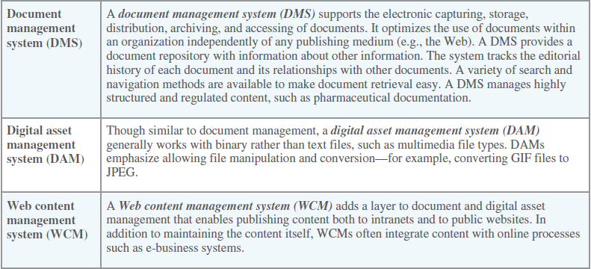
Workflow Management
Facilitates the automation and management of business processes and controls the movement of work through the business process
Defines all steps or business rules from beginning to end required for BP
Message-based workflow system – Uses e-mail to send out work document
Database-based workflow system – team members login to work on
Advantages of workflow systems
Unified format, process support, allows for communication and collaboration in a unified environment
Groupware – software that supports team interaction and dynamics
Synchronous – allows collaboration when team work together at same time
Asynchronous – Allows collaboration when group members are working at different times
Advantages
  - Facilitates communication (faster, easier, clearer)
  - Enables Telecommuting
  - Reduces Travel Costs
  - Allows for Sharing Expertise
  - Facilitates forming groups with common interests without problems of geographic distances.
  - Saves time and cost of coordination.
  - Facilitates group problem-solving
Videoconferencing - uses telecommunications to bring people at remote sites together for a meeting.
Point-to-point links two sites.
Multi-point links more than two sites.
Web conferencing - Blends audio, video, and document-sharing technologies to create virtual meetings.
Enterprise Portal - Single-point Web browser interface used within an organization to gather, share and disseminate information
Primary purpose is to help employees navigate organizational information
Secondary purpose is to provide unique content
IM - Synchronous real-time communications between two individuals
Mobile Learning – uses portable wireless computing devices to enable learning (SMS/MMS/Email)

Chapter 5 – The Internet and E-Business
Digital Darwinism - Implies that organizations which cannot adapt to the new demands placed on them for surviving in the information age are doomed to extinction
Disruptive Technology - A new way of doing things that opens new markets and destroys old ones
Sustaining Technologies - Provides improved products in an established market
Digital Divide - Identifies the social and economic disadvantage to those without Internet technology versus those who have it
E-Commerce - The buying and selling of goods and services over the Internet
E-Business - The conducting of business on the Internet including not only buying and selling, but also serving customers and collaborating with business partners
Customer Decision Making Process: Need Recognition - > Search - > Evaluation - > Purchase - > Post Purchase
Mass Customization - Provide a range of features in standard products that can be altered to customer specifics
The Long Tail - Because E-businesses are not limited by shelf space, they can offer a far wider selection of products that may suit only a few customers.
Intermediaries
Agents, business or software which provides an infrastructure to bring buyers and sellers together
Disintermediation
Occurs when business use the Web to connect directly to customers and by-pass intermediaries
Reduces costs & often improves responsiveness
Re-intermediation
The addition of entities into the value chain to improve the business process
Online Marketing Initiatives
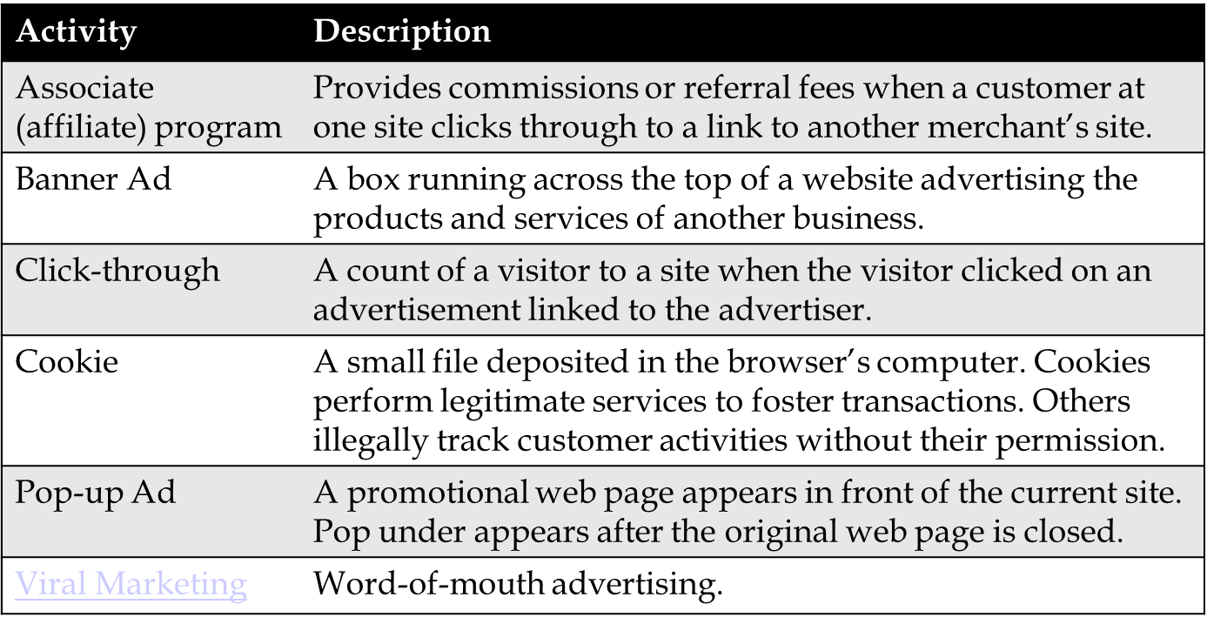
Basic Models
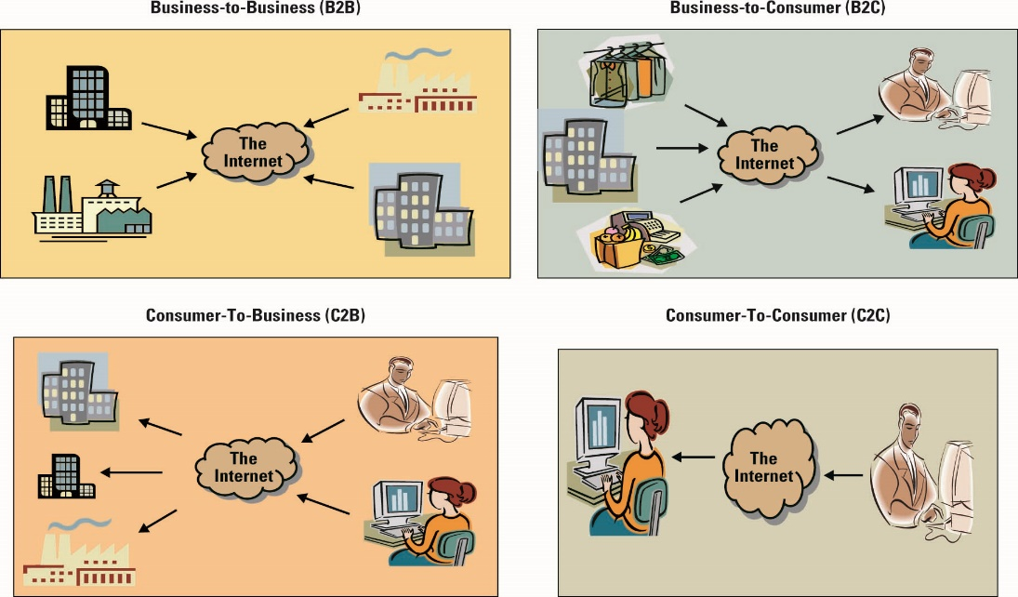
Extended E-business Models
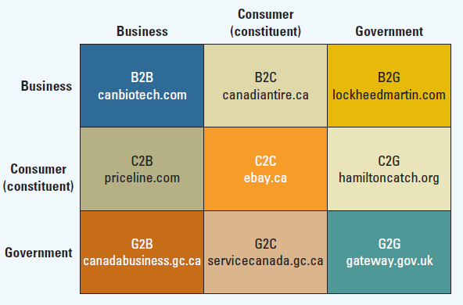
B2C – Amazon - Selling based on social media and mobile devices
C2B - Google Adsense - Promote products for companies / Priceline - Name your own price
C2C - eBay, Kijiji, Uber, Airbnb (sharing economy, collaborative consumption)
Web 3.0, the Semantic Web
Provides a way of describing relationships between web pages so that machines understand the meaning of hyperlinked information
  - Transforming the web into a database
  - Evolutionary to artificial intelligence
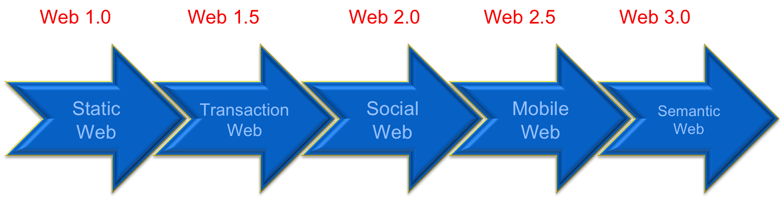
  - Evolution to 3D
Social Media and Business
Social commerce
Business host their own Facebook & Twitter and other social media sites
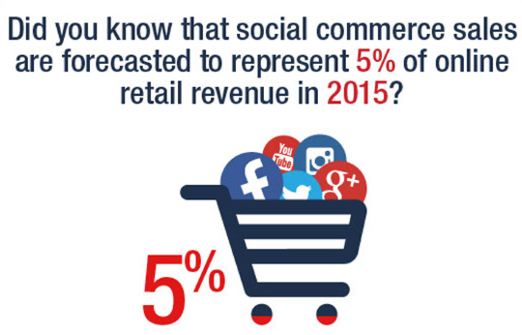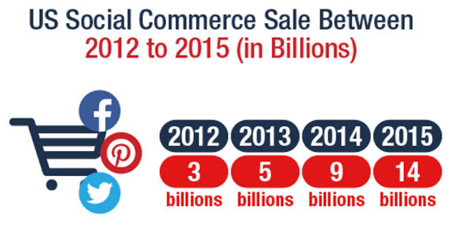
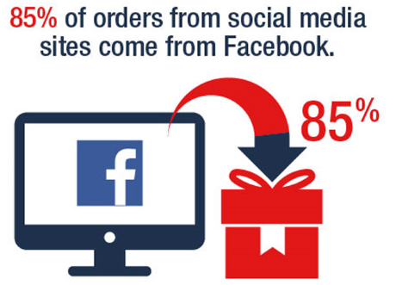
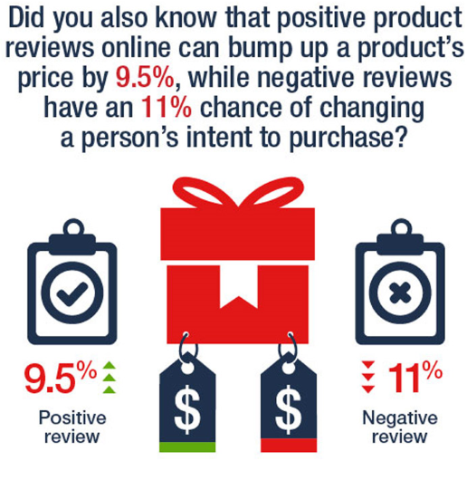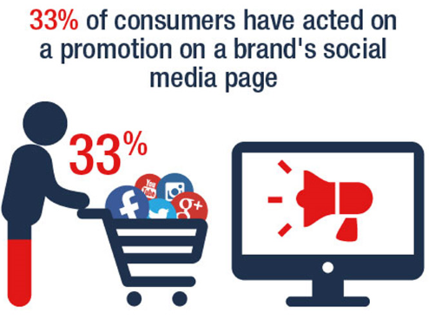

Mobile Commerce
Ability to purchase goods and services through a wireless Internet-enabled device.

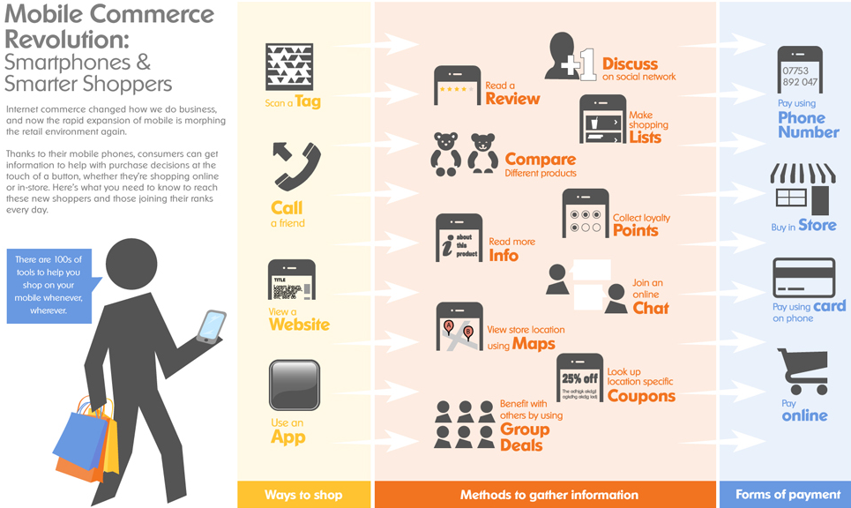
Chapter 7 – ERP Enterprise Resource Planning
Six Best Practices of Innovation
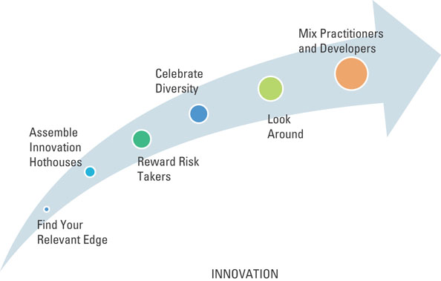
Businesses and Social Networks
Passive Search
Finding people for new jobs who are happy and productive where they are by using business networking sites.
Boomerangs
Former employees returning to old jobs.
Marketing Networks
Help businesses find employees but also suppliers, partners and needed resources
Forging communities among current and would-be customers
Social Responsibilities
Implies the individual or organization sees their responsibility to society at large.
Corporate Policy
Reflects the position a company takes on social and political issues.
Sustainable or “Green”
Describes systems that minimize damage to the environment.
Throughput Computing
Chip manufacturers focused not only on processing power but also the amount of energy being consumed.
Government Involvement
- Energy Rebates
- Limits on carbon emissions
Virtualization
- A framework of dividing resources of a computer into multiple execution environments.
- Manage multiple programs on a single machine, maximizing hardware and reducing energy.
E-waste - Refers to discarded, obsolete or broken electronic devices
Sustainable IT disposal
New manufacturing regulations to create products that reduce waste
Provincial governments levy recycling surcharges on the purchase of electronic equipment.
The safe disposal of MIS assets at the end of their life cycle.
Electronic Product Stewardship Canada (EPSC)
An industry association that educates and encourages e-waste control
Recent International laws restrict the use of hazardous materials.

Virtuality
Virtual World
While not as popular as in previous years, websites provide places for virtual meetings, events & virtual experiences
Virtual Workforce
Allowing employees to work away from the office.
Lowers fuel emissions, lower costs, increases productivity.

Tools for the Virtual Workforce
M-commerce (mobile commerce) - provides purchasing capability through an Internet-enabled device
Telematics - is the blending of computers and wireless telecommunications
Electronic tagging - identifies and tracks assets and individuals through RFID and smart cards.

Virtual Organization
Occur when employees from different organizations need to collaborate for a common purpose
Technology as an enabler

Enterprise Resource Planning (ERP)
Integrates all departments and functions into a single information system
Employees can make decisions by viewing enterprise-wide data
Legacy Systems
Older computer systems that remain in use because they still do their job
Functional Systems
An Information System that serves a single business unit
Not integrated with other units

Reasons Why ERP Systems Are Powerful Organizational Tools
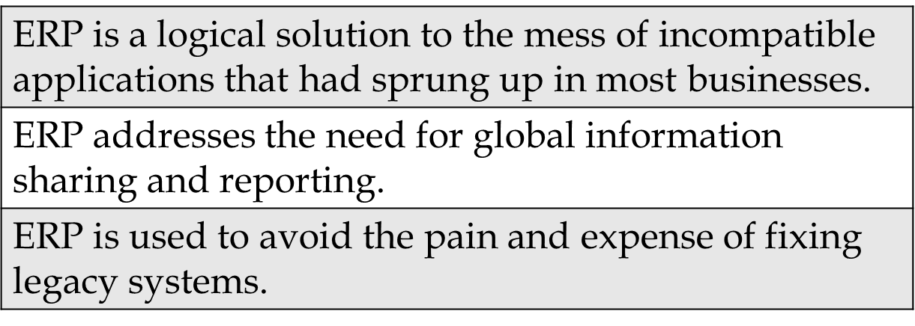
ERP Systems ERP Integrated Data Flows (The heart of ERP)
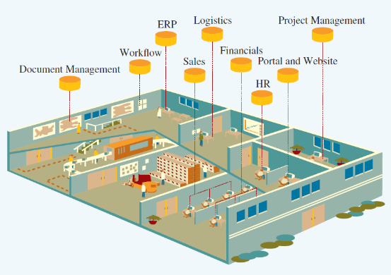
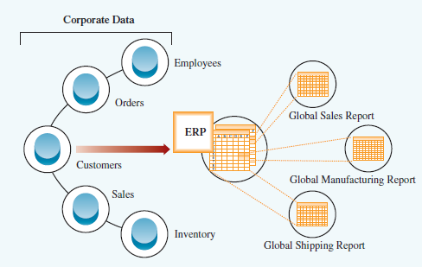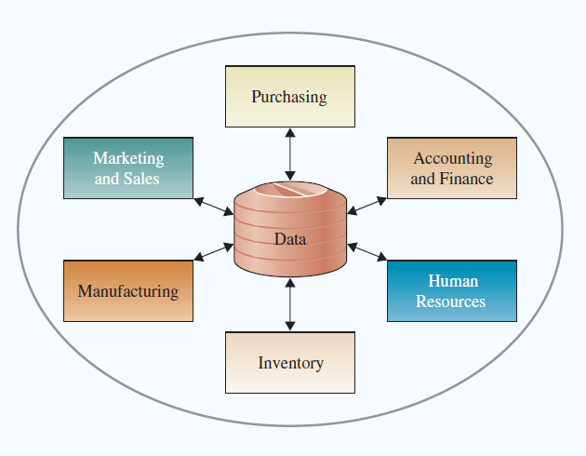
Order to Cash ERP Before ERP:
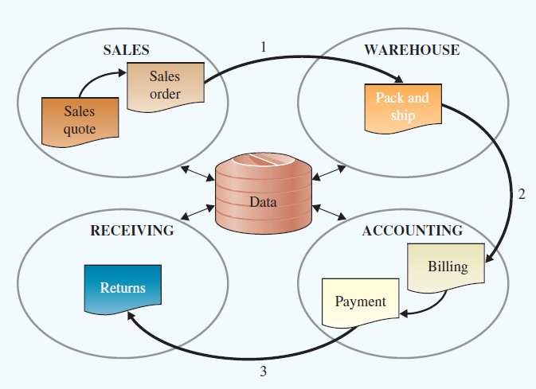
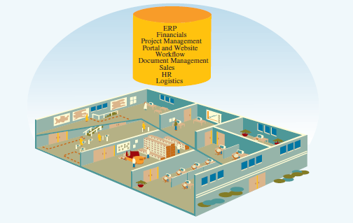
After ERP:

Extended ERP
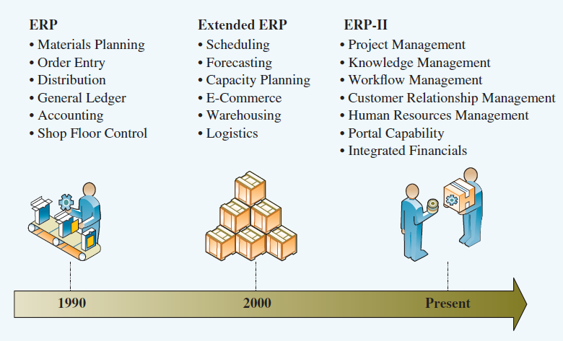
Core Components of ERP
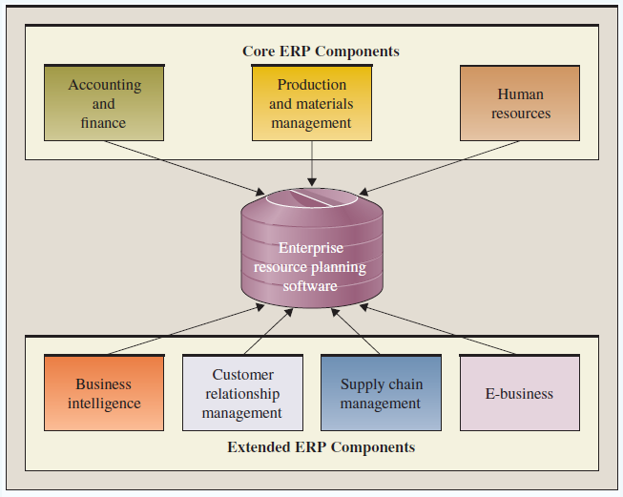
Accounting and Finance ERP Components
Manage a wide range of financial functions including general ledger, A/P, A/R, budgeting & asset management.
Includes a credit-management function setting and monitoring credit limits, product profit analysis and real-time customer account balances
Performs advanced profitability modelling.
Production & Materials Management
Handles production planning & execution from demand forecasting to quality control.
Each component is integrated in real-time to reduce excess or insufficient inventory, delayed production etc.
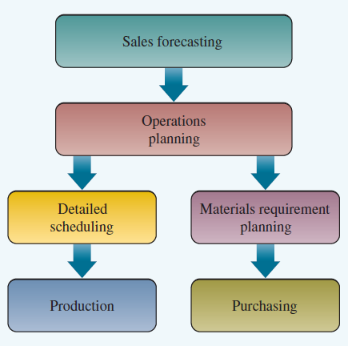
The production Planning Process Human Resources ERP Component
Tracks employee data
Manages payroll, benefits, compensation, performance assessment, and assures legal compliance
Identifies individual employees for training, rewards or disciplinary purposes
Analysis including productivity assessments, salary trends, health and safety metrics etc.

Extended ERP Components
Business Intelligence
Summarizes data, uses analytical tools to turn data into information, and to support decision-making
Customer Relationship Management
Identifies the relative value of each customer
Uses data to provide information on customer preferences and to improve customer experience to maintain customer loyalty
SCM (Supply Chain Management) manages data flows through the distribution stages to maximize profitability
Helps with planning, scheduling and controls of supply and delivery

The newest extension of ERP is to move outside the organization and connect to the organization’s stakeholders
E-logistics manages the transportation and storage of goods.
E-procurement is the business-to-business purchase and sale of supplies and services
They fulfill business orders effectively using the Web
Can provide stakeholders with useful data to improve service such as inventory levels, forecasts
Disadvantages of e-business ERP include security risks in trusting outside organizations with proprietary data
Integrating SCM, CRM, and ERP
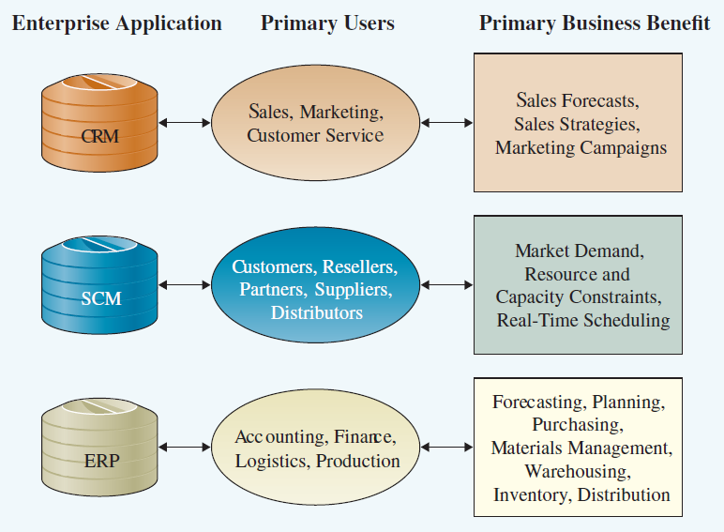
Integration Tools
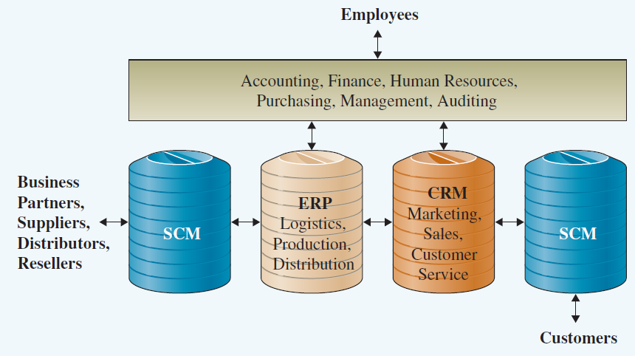
Measuring ERP Success
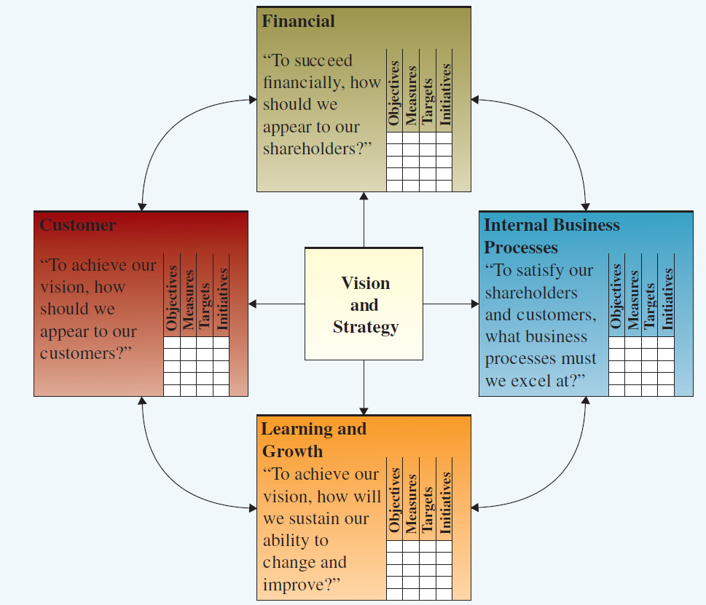
Finding the Right ERP Solution
Successful projects share three basic attributes:
- Overall fit between the system and the business process.
- Proper business analysis
- Solid implementation plans.
Three methods of implementation include:
Turnkey (off the rack/off the shelf)
Systems that have been previously designed and fit the business requirements. Usually for minor implementations.
Off the rack/off the shelf tailored to fit
- Previously designed but still require an investment in implementation
- Most common
Customer Designed
- Designed from scratch
- Usually the most expensive
The Small & Medium Enterprise Market is different:
SME’s purchase through resellers as direct sales are too small to be economical. ERP vendors are used to direct sales. Also SME has a greater requirement for affordability and ease-of-use.

