Name : Student number : .

Midterm exam #2 of BIO3124: General microbiology

This exam is closed book and is composed of two parts. The first part worth 25 points consists of 26 multiple choice questions. Make sure to indicate your answers to these questions on both this copy of the exam as well as on the scantron sheet provided. DO NOT forget to write your name and student number on BOTH this exam paper and the scantron sheet.

The second part of the exam worth 15 points consists of 4 short answer questions. You must answer ONLY 3 of the 4 questions, or else only the first three questions answered will be corrected.

Cellular phones, unauthorized electronic devices or course notes (unless an open-book exam) are not allowed during this exam. Phones and devices must be turned off and put away in your bag. Do not keep them in your possession, such as in your pockets. If caught with such a device or document, the following may occur: you will be asked to leave immediately the exam, academic fraud allegations will be filed which may result in you obtaining a 0 (zero) for the exam.

By signing below, you acknowledge that you have ensured that you are complying with the above statement.

In what section are your registered? BIO3124 _______ (0.5 points)
Part 1: Multiple choice questions. Provide your answers on this exam paper and the scantron sheet provided.

- Resistance against infection acquired after receiving several doses of a vaccine represents a case of:

- Artificially acquired passive immunity
- Naturally acquired passive immunity
- Artificially acquired active immunity
- Naturally acquired active immunity

- The taxonomic classification of a virus which infects arthropods is as follow: Orthomyxoviridae Thogotovirus Dhori virus Group V ((-) ssRNA). To which species does this virus belong too?

- Orthomyxoviridae
- Thogotovirus
- Dhori virus
- Group V

- Which strategy is most probably used by the virus described in the previous question to replicate its genome?

- It probably uses an RNA dependent RNA polymerase which it carries in its nucleocapsid
- It probably uses the cellular machinery to translate the viral RNA to synthesize its polymerase
- It probably uses the host’s DNA dependent RNA polymerase to transcribe it’s RNA genome
- It probably uses an the host’s RNA dependent DNA polymerase to transcribe it’s genome

- Which one of the following statements about HIV and AIDS is FALSE?

- HIV attacks subgroups of lymphocytes but not subgroups of myelocytes
- Death of the victim usually occurs due to opportunistic infections
- The virus has a (+) ss RNA genome
- A person who is HIV positive may be seronegative

- This schematic illustrates an experiment which was performed to test the sensitivity of a bacterium to an antibiotic. Following the incubation of the inoculated broths with different antibiotic concentrations (A), samples were taken from each tube to inoculate broths without antibiotic (B). What is the mode of action of this antibiotic?

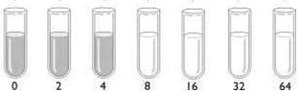
- Bactericide
A
B
- Bacteriolytic
- Bacteriostatic
- Bactericide or Bacteriolytic

- What is the MIC of the antibiotic described in the previous question?

  - 4 µg/ml
  - 8 µg/ml
  - 64 µg/ml
  - This antibiotic does not have an MIC it has an MBC
a
b
c
d
x
y
z
Kirby Bauer
E-Test
- Compare the Kirby Bauer and E-test illustrated. Which antibiotics are mismatched?

  - a and z
  - None of the E-tests corresponds to b
  - c and y
  - d and z

- A drug with which of the following targets would probably have the lowest selective toxicity?

- The bacterial ribosomes
- The cell wall
- The cell membrane
- A viral DNA polymerase

- Why is the transfer of resistance by transduction fairly improbable between bacteria of different species?

- Because viral tropism is fairly narrow
- Because the polymerases used for the replication of viral DNA are specific to each virus
- Because bacteria of different species cannot mate with one another
- Because different bacterial species have a different permeability to DNA

- Which of the following statement best describes an antimetabolite?

- An agent that prevents hemagglutinin to bind sialic acid
- An agent that cleaves the linkage between peptidoglycan units
- An agent that disrupts membranes by binding to cholesterol
- An agent that mimics a vitamin substrate used for the synthesis of NAD

- All of the following actions can minimize the development of antibiotic resistance EXCEPT…

- Avoiding using antibiotics in the absence of infection
- Stopping the intake of antibiotics before the end of the prescribed duration
- Changing antibiotics as soon as an organism shows signs of developing a resistance
- Using a combination of antibiotics to overcome an infection

- What is a viroid?

- Nucleic acid enclosed in a protein capsid
- An infectious naked RNA molecule
- An infectious protein
- A provirus

- An antiviral with which target is likely to have the highest therapeutic index?

- One which targets the neuraminidase of influenza virus
- One which targets the polymerase used by the HPV
- One which targets HIV’s envelope
- One which targets reverse transcriptase

- Which statement is NOT TRUE of both natural penicillin and aminopenicillins?

- They are broad spectrum antibiotics
- They contain a beta-lactam ring
- They can be inactivated by beta-lactamases
- They both act on Gram positive bacteria

- Which characteristic is NOT used for the taxonomic classification of viruses?

- Their route of transmission
- Their method of replication
- The nature of their nucleic acid
- Their shape

- A bacteria developed a resistance to several antibiotics by reducing the number of porins it expresses on its LPS layer. This resistance mechanism would be ineffective against which of the following antibiotics?

- Polymixin B
- Ampicillin
- Chloramphenicol
- Penicillin

- Which characteristic is NOT common to both antibiotics and probiotics?

- Both may act by inhibiting bacterial growth
- Both may lead to opportunistic infections in immunocompromised individuals
- Both may lead to a change in the microbiota’s equilibrium
- Both may exert a selective pressure

- What is the role of C3b?

- It opsonizes bacteria
- It directly injures bacteria
- It’s an anaphylatoxin
- It is chemotactic

- Which statement is FALSE about the Fab fragment of an IgG?

- It has a valence of one
- It is composed of disulfide linked polypeptides
- Is generated by the separation of heavy and light chains
- It binds antigen

- This diagram shows cells of the humoral immune system being stimulated to produce antibodies. Which cell (s) illustrate (s) presentation by MHC II?
Y
Y
Y
Y
I
II
III
IV

- II
- III
- II & IV
- II & III

- Which cell (s) in the diagram presented in the previous question is a (are) leucocyte (s) capable of discriminating self from non self?

- Only IV
- II, III, & IV
- Only III
- III & IV

- An immunoglobulin’s idiotype is located …?

- In the constant region of the heavy chain
- In the constant region of the light chain
- Only in the light chain
- In the variable regions of both the heavy and light chains

- T-cell help for antibody production…

- Depends on T-cell recognition of free antigen bound to a B-cell surface Ig
- Depends on T-cell recognition of antigen processed by the B-cell
- Involves MHC I on the B-cell
- Depends on cytokine secretion from the B cell

- Which disease may sometimes be considered a non-infectious disease?

- Creutzfeldt-Jakob disease
- Cold sores caused by the herpes virus
- Clostridium difficile associated diarrhea
- The flu

- Which of the following antibiotics would reduce the lethal dose of Pseudomonas aeruginosa in the blood stream?

- A carbapenem
- A quinolone
- A tetracycline
- Chloramphenicol

- Which of the following vaccines would not be presented to TH1 cells?

- The MMR
- The LAIV
- Gardasil
- The smallpox vaccine
Part 2. Answer ONLY 3 of the 4 questions or else only the first 3 questions will be corrected! (5 points/question)

- The following diagrams represent various antimicrobial drugs. Choose the (ONE) drug that corresponds best to each of the descriptions given on the next page. Each choice can be used more than once. If none of the drugs illustrated corresponds to the description indicate “X”
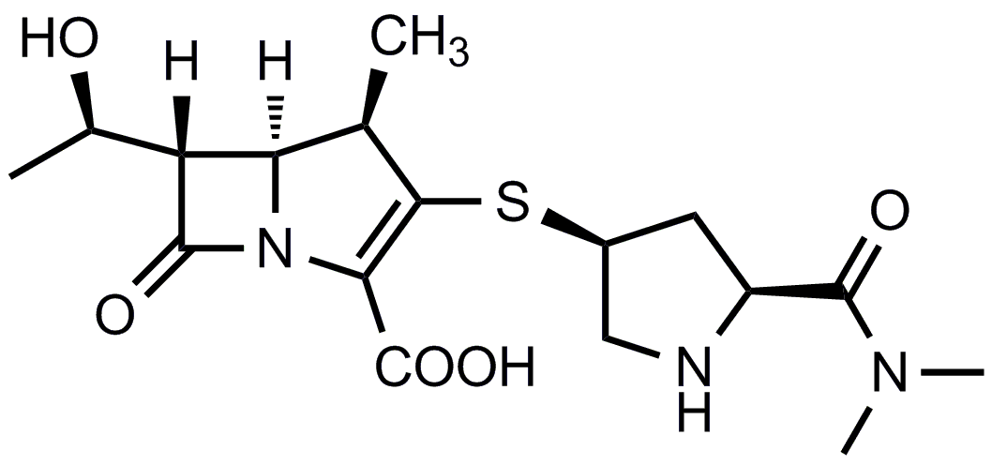
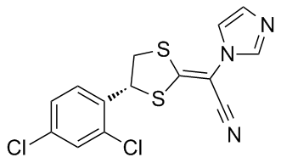
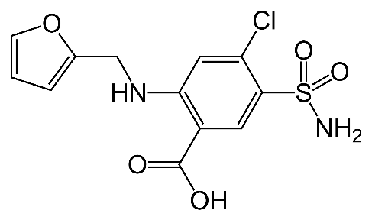
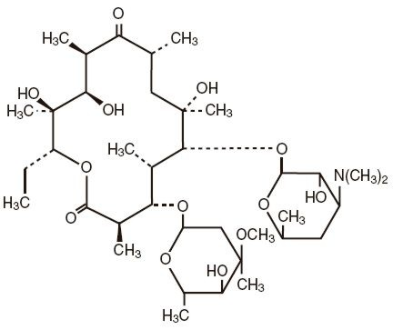
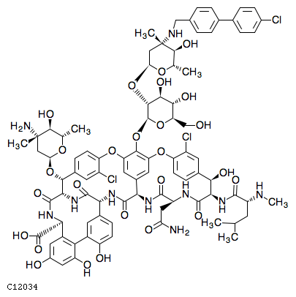
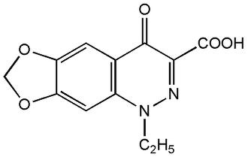
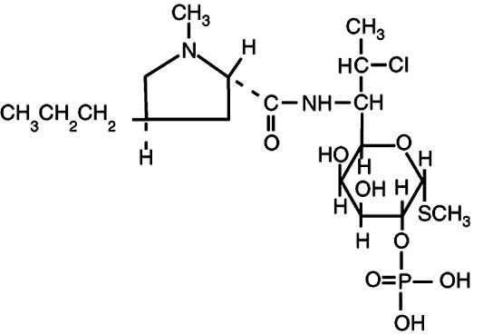
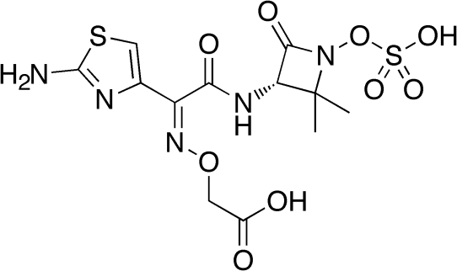
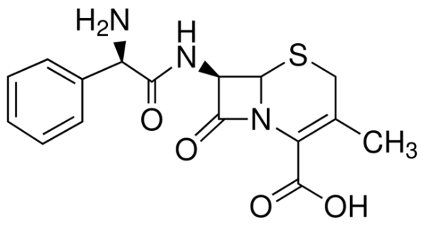
F
I
H
G
E
D
C
B
A
Description | Drug
Chloramphenicol
Targets the cell membrane
Beta lactam with the narrowest action spectrum
Cefalexin
Class of antibiotics that targets RNA synthesis
Class of antibiotics, other than beta lactams, that targets the cell wall
Best beta lactam for an empirical therapy of a bacterial infection
Antibiotic that extracts sterols
Inhibits DNA synthesis
Non macrolide that inhibits ribosomes

- A direct count is done on a viral suspension as follows: Counting beads are added to the suspension to obtain a final concentration of 10⁵ beads/ml. A sample of the suspension is then examined microscopically and revealed 20 beads and 2 viral particles. One milliliter of the original viral preparation was used to infect 10⁶ cells. After one complete infectious cycle a plaque assay was done to determine the number of virus produced. A 0.1 ml sample of a 10⁻³ dilution gave rise to 5 plaques. How many additional infectious cycles, NOT including the first one, can be initiated?

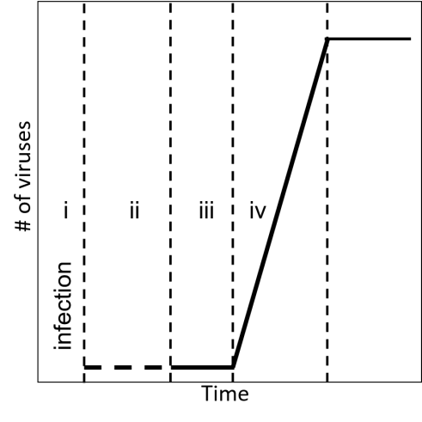
- This diagram illustrates a viral growth curve. An antiviral was developed which inactivates newly synthesized influenza M1 protein. During which phase of the viral growth curve would this drug act?

- An inhibitor of HIV proteases would act during which phase of the viral growth curve illustrated?

- An IgA that binds to virus like particles (VLP) of the HPV would act during which phase of the viral growth curve illustrated?

- One milliliter from a 10⁻⁸ dilution of a hemagglutinatng viral preparation gave 100 plaques on a plaque assay. This viral preparation was also used in a hemaggluntaion assay performed as follows: Samples of 0.1ml of the viral preparation were added to wells each containing 10⁴ red blood cells. If 10 viral particles per red blood cell are required to have agglutination, what is the highest 10 fold dilution which would show complete hemagglutination? (Ex. 10⁻¹)

- Refer to the following tables to answer the questions that follow.
Kirby Bauer Assay |  |  |  |  | Antibiotic | C_{max} – C_{min}  (µg/ml) | LD50  (µg/ml)
Bacteria | Diameters of zones of inhibitions (mm)  Antibiotics |  |  |  | Antibiotic | C_{max} – C_{min}  (µg/ml) | LD50  (µg/ml)
Bacteria | A | B | C | D | A | 20-70 | 100
S. aureus | 25 | 5 | 25 | 40 | B | 5-30 | 100
E. coli | 20 | 35 | 2 | 30 | C | 10-20 | 15
C. difficile | 15 | 50 | 5 | 8 | D | 2-10 | 8

Ab Conc. Vs. Diameter
Conc. (µg/ml) | Diameter (mm)
2 | 40
5 | 30
10 | 20
20 | 10
30 | 5
40 | 2

This table presents the antibiotic concentrations that correspond to different diameters on a Kirby Bauer diffusion assay

- Indicate the relative sensitivity of E.coli to each of the antibiotics. (Sensitive, Resistant or Intermediate Sensitivity) (2 points)

A: B: C: D:

- Which antibiotic would you recommend to treat an infection by C. difficile?

- A combination of the antibiotics “B” and “D” is being considered to treat an infection by S. aureus. The MICs of these antibiotics when used in combination are 9 and 4 µg/ml respectively. Would this treatment be a good idea? Indicate in one sentence or less why or why not?

- Which antibiotic has the lowest selective toxicity and broadest action spectrum?

- Several immune disorders influence the relative susceptibility to various pathogens. The following table presents various immune disorders.

- Indicate in the first column using the numbers 1-4 the most to the least severe deficiency as it relates to infections in general (1 being the least severe). Indicate in the second column to which type of pathogens would individuals suffering from each of these disorders be the most susceptible. Use the following key to indicate your answers. (2 points)
T : Gram positive and negative bacteria as well as viruses
B : Gram positive and negative bacteria
N : Gram negative bacteria
P : Gram positive bacteria
V : Viruses
VP: Viruses and Gram positive bacteria
VN: Viruses and Gram negative bacteria

 | Disorder | Relative susceptibility | Pathogen
I | Inability of monocytes/macrophages to digest
II | Low number of TH1
III | Low number of surface IgD and IgM
IV | C5 complement protein deficiency
- Which disorder (s) would render immunizations with inactivated viral vaccines ineffective?

- Which disorder (s) would delay seroconversion following a HIV infection?

- Symptoms associated with the inflammatory response following a first encounter with a Gram negative bacterial pathogen would be least severe in an individual suffering from which one of the above disorders?

