September 3, 2014
GRT 2100 – Psychosocial Aspects of Aging
Introduction Class – Professor Bio; Course Overview. Read “Professor Bio” and “Course Outline” on Blackboard Learn. Consider all judgments you make when getting to know a person. What does their personality, appearance, clothing, demeanor, etc. tell you about them?

September 5, 2014
Introduction to Psychosocial Aspects of Aging: Defining Psychosocial Aging, and Aging as a Social Process
Gerontology and Geriatrics
Gerontology | GOAL (of both) | Geriatrics
- Multidisciplinary field which is concerned with the physical, psychological, and social aspects and processes of aging | - To understand aging so that people can maximize their functioning and achieve a high quality of life | - A medical specialty which concerns the study of health and disease in later life, and the health care and treatment of older persons.
Same goal, different focuses. Concerned about bodily changes as well as society’s impact on the aging population. Used to apply to policies and programs.
- How does this influence society as a whole?
- Who should fund this?
Avoid making generalizations about older people.
Social Gerontology is concerned with two aspects of aging:
- Developing, evaluating, and critiquing social programs or policies for older people.
- Describing and explaining aging processes and older persons’ status in society and nature of their behaviours.
“Old” age being “elderly” or becoming a “senior” are socially constructed and reinforced by cultural values, beliefs, stereotypes, and misconceptions.

Social Aging – TRUE/FALSE
- Intellectual functioning decreases as we age (TRUE, there is a bit of decrease)
- Most seniors are women (TRUE)
- Older people who reduce their activity tend to be happier (FALSE)
- People become more difficult and resistant to change as they age, which makes it challenging to implement interventions (TRUE or FALSE depending on the person – some individuals are more open to change than others)
- Older people are less likely to experience clinical depression than younger people. (FALSE)

Psychosocial Aspects of Aging
- Psychosocial issues encompass the psychological and social aspects of a person’s life, which influence their thoughts, feelings, behaviours, health, functioning, well-being, and/or quality of life.
- Psychological aspects include cognition, emotions, personality, stress and coping, etc.
- Social aspects include socioeconomic status, religion, culture, education, social supports, job status, etc.
Psychosocial factors highly influence older persons’ health and overall well-being.

Psychosocial Health & Well-being
- Social Well-being (e.g. social participation and integration; communication and technology; ability to travel, and use of transportation)
- Psychological Well-being (e.g. mental health; mood; emotions; coping with stress, cognition)
  - Cognitive Well-being (e.g. action of knowing; processing information; learning; problem-solving)
- Spiritual Well-being (e.g. sense of meaning, purpose and connectedness; self-determination, drive, and motivation)
- Safety (e.g. minimize risk or harm to self/others; prevent injury or accidents)

Growing Old
- Optimal or Successful Aging: “The way the aging process is slowed or altered because the individual has engaged in preventative and compensatory strategies to avoid negative changes that would otherwise occur with normal or impaired aging.”
- Video: BBC Documentary 2014 “Don’t Grow Old”
  - Some people live for a long time even though they aren’t necessarily healthy (e.g. they smoke)
  - We have a lot of control over health and well-being
  - We are all aging, but don’t necessarily know or understand what will happen to us in the future
  - We often look to our own family as to what aging will mean to us as we get older
  - You may not feel old; you feel the exact same, but people treat you differently, and your body feels different
  - Aging is a very young field, so there is still a lot of competing theories as to why aging happens, and why people don’t know very much yet
  - Key is how different pathways relate to each other
  - Trying to find out more about aging – how can we slow down aging? CAN we slow down aging?

Can We Understand the Psychosocial Experiences of Older Individuals?
- Human beings have the ability to both sympathize and empathize with others
- Empathy: ability to understand and feel or approximate the feelings of others, and predict or understand the emotional responses they might experience in different situations; involves accurately sensing the other person’s feelings, as opposed to focusing on the feelings you had or might have had in similar situations.

Nature of Aging – examples
- Impaired/Secondary Aging: abnormal changes due to disease, which affect a segment of the older population.
- Normal/Primary Aging: changes within the organism, which progress at different rates among individuals but are still fairly universal, intrinsic, and progressive
- Optimal/Successful Aging: the way the aging process is slowed or altered because the individual has engaged in preventative and compensatory strategies to avoid negative changes that would otherwise occur.

Inter-Individual Differences/Variability
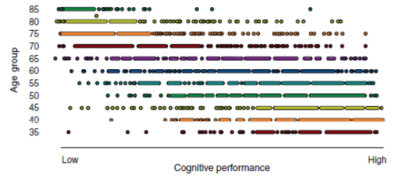
Cognitive abilities are all over the map in every stage of adulthood. There are high performers as well as low performers in each group, but there is a cle
ar negative trend between age and cognitive ability.
Biopsychosocial Model of Aging
- Biological
  - Physiological Factors, Genetics
- Psychological
  - Cognition, Emotions, Personality, Attitude
- Sociocultural
  - Social Context, History, Culture

Illustration of the Biopsychosocial Aspects of Aging & Intra-Individual Differences
- These all influence each other, and the process of aging. Can be positive/negative.
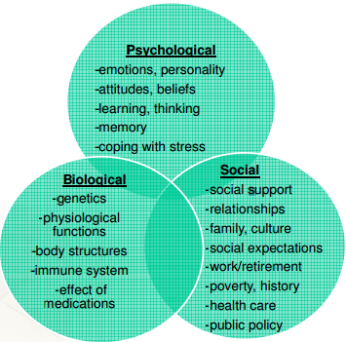
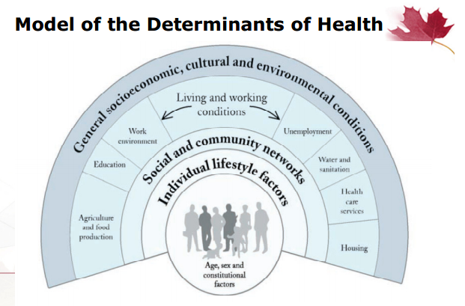
- All of these impact health.
- Health is multifactorial and multi-dimensional
- There is a negative relationship between income/social economic status, and overall health, and this relationship continues into one’s elderly years.

Social Determinants of Health & Aging
(key social determinants of health that are a concern for the aging population)
- Aboriginal Status
- Gender
- Disability
- Housing
- Early Life
- Income/Income Distribution
- Education
- Race
- Employment/Working Conditions
- Social Exclusion
- Food Insecurity
- Social Safety Net
- Health Services
- Unemployment and Job Security

“The primary factors that shape the health of Canadians are not medical treatments or lifestyle choices, but rather the living conditions they experience – these conditions have come to be known as the social determinants of health.”
Human Agency and Older Persons
- Human Agency: “A process in which individuals construct their life course by making choices and taking actions.”
  - People’s capacity and freedom to live a life they see as meaningful which requires:
    - A right to choose how to act (freedom) AND
    - A right to conditions which lead to effective action (sufficient material resources)

- Two important claims about agency and older persons:
  - Older persons have limited agency to inform their lives
  - Older persons have agency to improve their conditions

Principles of Adult Development & Aging
- Changes are continuous and gradual over the lifespan
  - You don’t feel as if you are aging, but other people may have reactions to you that show that you’re older (e.g. a student hit on Prof. Gulati but then he got all awkward when she said she was a professor)
  - Even people with health issues may say they don’t “feel” sick, even when they have a condition
- Only survivors grow old (“survival of the fittest” considering special characteristics and conditions)
  - Healthier people live longer, generally, as they have made good choices in their life and overcome a lot of the risk of aging
  - May have abstained from risky activity, which allows them to live longer
- Normal/primary and optimal/successful aging is different from disease or impaired/secondary aging
  - Fairly significant health care issues/disabilities, etc. would fall under impaired/secondary aging.
  - Wrinkles, thinning skin; universal; hair turns gray
- Individuality of the person, personal experiences (normative vs. non-normative), personal assets and resources, and cultural and social influences
  - Normative Age Experiences: based on cultural and social and legal norms (e.g. we start school at around 4 years old)
  - Normative Historical Experiences: larger scale events that have occurred in someone’s life, for most of the population. E.G. war, conflict, economic trends, etc.
  - Non-Normative Occurrences: random, personal events that happen over the course of one’s life that have an impact on you (e.g. death of spouse/parent; divorce, etc.

Homework – to be discussed next class!
(discuss what these terms mean/discuss what you know about them; judgments, pre-conceptions, etc.)
Seniors: legally those 65+, though socially, psychologically, etc., possibly debatable.
Centenarians: those who are 100+
Division of Age over 65 Years:
- Chronological Age (passage of calendar time from one birthday to the next)
- Legal Age and Privileges (chronological age defines “legal” age, ie. When we enter school, drive a car, vote, consume and purchase alcohol, and retirement)
- Functional Age (based on the fact that aging is a multi-faceted, diverse process in which individuals at a specific chronological age are either “older” or “younger” than age peers in terms of some relevant skill or ability)
- Biological Age (includes genetic and environmentally induced changes in the cellular, muscular, skeletal, reproductive, neural, cardiovascular, and sensory systems)
- Psychological Age (involves the interaction of individual cognitive and behavioural changes with social and environmental factors, such as the loss of a spouse or a change in housing that affects our psychological state)
- Social Age (varies within and across societies and across time, depending on the interactions between aging individuals and others in a particular family, society, or subculture at a specific period in history)
Biological, Psychological, and Social Aging
Subjective Age
Age Identity

September 10, 2014
Lecture 2: Canadian Demographics and Aging: Canadian Statistics and Trends in Aging, and Emerging Issues for Society to Consider

****Higher NUMBER of older individuals live in the DEVELOPING world. There are much more people there than the developed world.
****Higher PROPORTION of older individuals in the DEVELOPED world. There are many younger people in the developing world than older.

Quiz:
- Most Canadians aged 65 and older live in rural areas. (FALSE. 79% of people over age 65 live in urban areas)
- Women tend to live longer than men in Canada. (TRUE. Women tend to live longer than men in pretty much every country in the world)
- Considering all provinces, Ontario has the highest percentage of seniors aged 65 and older. (FALSE – Nova Scotia – 60.5% of their population in 2011 was over 65 years of age)
- About 25% of Canadians aged 65 and older were born outside of Canada. (TRUE – many came from Europe and Asia when they were very young. India and China are the most common origins of recent immigrants)

Canada’s Senior Population
- By 2015-2017, for the first time in Canadian history, there will be more people aged 65 and older than people aged 15 and younger.
- Video: Canada has higher proportion of seniors than ever before
  - Lower fertility rate results in fewer children
  - We live longer
  - Baby Boomer generation reaching age 65
  - The largest jump was for the group in age 4 and below (largest jump in 50 years) IMPORTANT
  - Older workforce (over 45). Fewer people entering the workforce. Slowing.
  - More people are leaving the workforce than entering the workforce.
  - Many changes in the next decade.
  - There will be different products and services marketed as there will be a significant number of consumers over 65 years old
  - Alberta is young, with quickly-growing population and workforce
  - VIDEOS ARE IMPORTANT. Study them carefully.

Population Aging
- Proportion of older people in society increases as a result of:
  - Improvements in life expectancy (and lower mortality rates)
  - Declines in fertility rates
  - Noticeable increase in the median age of a country
    - Median age: half the population is older than this age, the other half is younger than this age.
    - When the median age increases, that means the population is aging
    - Crude Birth/Death Rate: the actual number of births that have occurred per 1000 of the population

Canada: Life Expectancy
- Life expectancy at birth was 81.1 years in 2009
- Females: 83, Males: 79
- Disability-free life expectancy is about 69 years*
- Lower life expectancy among Aboriginal Canadians
  - Females: 78, Males: 73
- Women live longer than men in almost every country in the world and women’s life expectancy has increased more than men’s
- These numbers aren’t that important without considering quality of life, that’s why “disability-free” life expectancy is important to consider
- Average of 3 chronic conditions someone may have when they reach age 65
- Generally, older individuals overall report their quality of life to be very good, their health to be good, and that they are satisfied with the health care they’re receiving.
  - Rating on a scale of 1-5 (poor-excellent)
  - Canadians in general rate their health at around a 4 (very good) or 5 (excellent), across ALL age groups

Canada: Trends in Aging
- Median Age: chronological age at which the population divides into equal numbers of younger and older people
  - 2011: 39.9 years
  - 1971: 26.2 years
- Canadians (seniors) 65 years of age and older:
  - 1981-2011: people aged 65 to 74 increased from 6% to 8%
  - 75 to 84 increased from 2.8% to 4.9%
  - 85+ increased from 0.8% to 2%
  - 2011: 5 million individuals (14.8% of the population. 1/7 people)
  - 2041: 9 million (1 in 4)
- Centenarians (100 years of age and older)
  - 2011: 5,825 individuals

Note: Graph is important. Note trends/messages of the graph. Exact numbers aren’t important, but there most likely will be a question about this on the exam
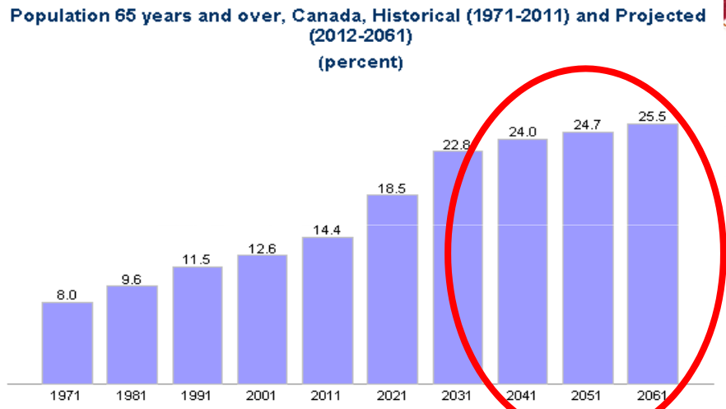
- Years 2041, 2051, and 2061 have much higher projected numbers and proportions of older people.
- Projecting 1 in 4 people being over 65 years old
- Huge jump especially with people being over 85, but more people are in the age of 75-84
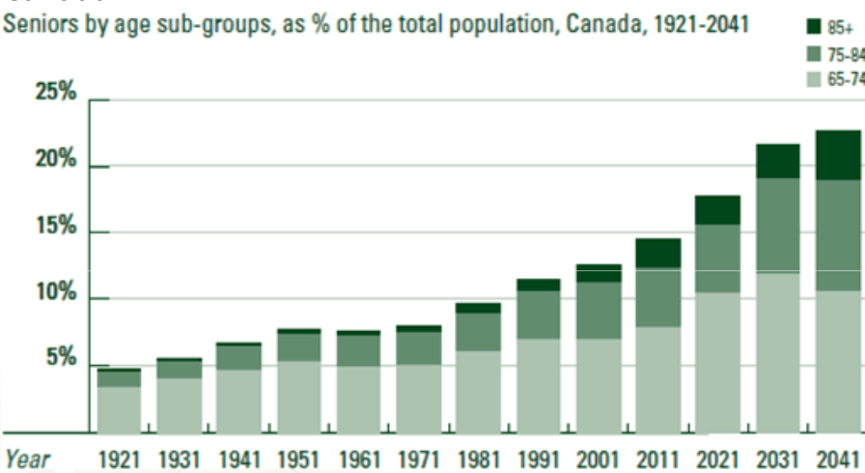
An increase in the aging population is due mainly to:
- Life Expectancy increases
  - Decline in mortality (for all ages)
  - Rates of morbidity have also declined
- Lower Fertility rates
  - Lower replacement fertility rate (ie. To have enough babies to have enough people for the next generation; “replacing” the previous generation)
- Baby Boomer population
- Improvements/Advances in Health Care
  - Advancements in Medical Technology
  - Advances in Public Health Measures
  - Improved Nutrition
- Improvements in Water Quality
- Improvements in Personal Hygiene
- Improvements in Immunizations/Antibiotics/Therapies/Soap
- Greater Education and Economic Development

Demographic Transition and Epidemiological Transition
- As countries become more industrialized or developed, you see a shift from:
  - High Fertility and High Mortality to Low Fertility and High Mortality
  - Infectious Diseases (e.g. tuberculosis) to Degenerative, Chronic or Non-Communicable Diseases (e.g. cancer, cardiovascular diseases)

Canada: Urbanization and Seniors:
- 2011: 79% of Canadians aged 65 and older lived in urban areas
- Among the three largest metropolitan areas, the median age of the population was:
- Montreal: 40 years
- Vancouver: 40 years
- Toronto: 39 years
  - High immigration rate, with more younger individuals

*3 Graphs
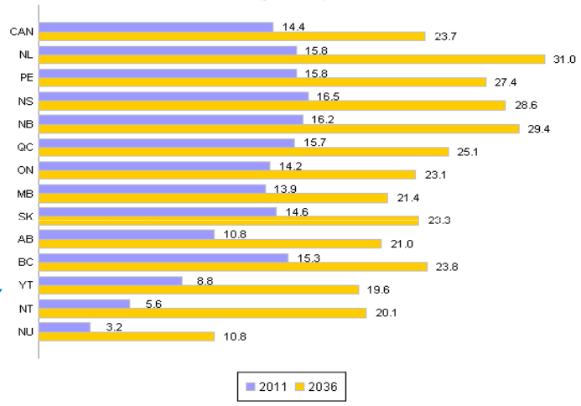
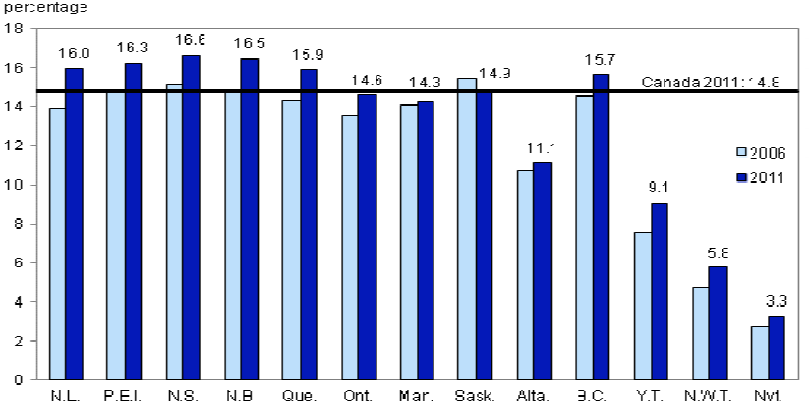
- Nova Scotia has highest percentage of seniors (oldest)
- Alberta has lowest (youngest)
- Pay attention to Aboriginal Statistics (only 5% over 65 and 1% over 75 - LOW)
- Fertility and Immigration Rates influence this as well as a variety of other factors (e.g. social assistance programs, workforce, economy, environment/climate, etc.)

Baby Boomer Generation
- Canada’s Birth Rate
  - 1946: 26.9 infants per 1000 population (at start of baby boom)
  - 2012: 11 infants per 1000 population
- People born between 1946 and 1965, post WWII, there was a marked increase in the birth rate: “baby boom”
- Country’s largest generation

Canada: Fertility Rate
- Total Fertility Rate: average number of children per women across a population
- Replacement Fertility Rate: level of fertility the population needs in order to replace itself from one generation to the next (in Canada, it is 2.1 per woman)
- Canada Fertility Rate (average total number of children born to each woman during her childbearing years from age 15 to early 40s)
  - 2021: 1.3 births per woman
  - 2011: 1.6 births per woman
  - 1979: 1.7 births per woman
  - 1959: 3.9 births per woman
- About 2-3 years between children
- Bonuses for having multiple children (baby bonuses, social assistance, maternity AND paternity leave benefits, etc.)
- Quebec and Alberta have highest fertility rates
- For the first time in Canadian history, women aged 30 to 34 had more babies than women aged 25 to 29
- 2272 stillbirths

*Demographic Pyramid Graph – note trends (compare from 1961 to 2013)
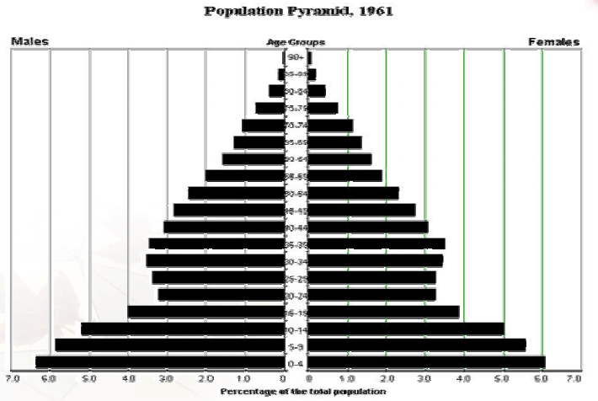
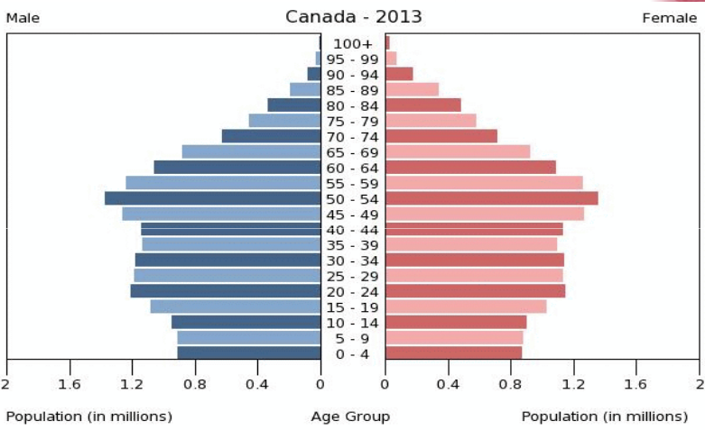
*Line Graph comparing Children <14 and Adults >65 1921 to 2011 – note trends
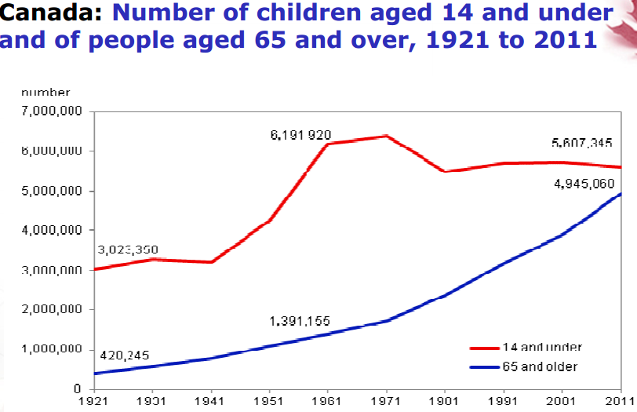

*Population Projections of children and seniors – note trends
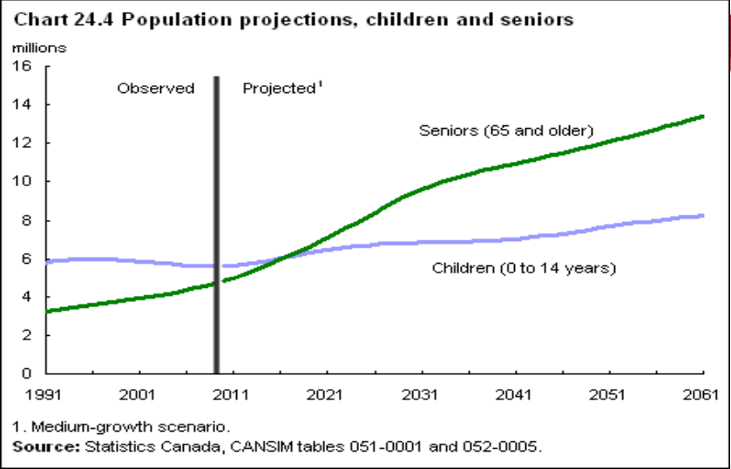

Canada: Sex and Aging
- Since women live longer, the majority of seniors are women, with the gender discrepancy increasing with age
- 2011: women made up 52% of seniors aged 65 to 74 years, 56% of seniors aged 75 to 84, and 68% aged 85 to older
- Women are not at as high an occupational risk as men; their bodies therefore don’t wear out as much in old age
- Women are more likely to try to get health care if sick
- Women are more likely to attempt suicide, but men are more likely to succeed
- Women are genetically a stronger species; more miscarriages/stillbirths are male fetuses; more childhood illnesses occur in males
- Women are less likely to engage in risky behaviours
- There is a greater focus on women and children’s health – this public health has increased lifespan
- Men’s illnesses and disabilities lead to death a lot more quickly than women’s

Older People in Contemporary Society
- Exaggeration and misinterpretation of population trends and statistics, and failing to recognize older persons as an untapped resource may lead people to have a pessimistic view of the impact the aging population will have on society
- Elders in contemporary society and in the future will generally be healthier, wealthier, and better educated, BUT future policies must strive to eliminate or reduce inequities in the provision of service, support, and assistance

Canada – Emerging Issues: Immigration
- 2011: Foreign-born population of about 6,775,800 people (20.6% of the total population)
- About 25% of Canadians aged 65 years and older were born outside Canada
  - 2011: 5% of Canadians aged 65 years and older spoke neither English nor French
- A higher fertility rate and higher levels of immigration could help to slow population aging but would not prevent it.
  - The effect of immigration on total population aging is modest because most immigrants arrive before they are 30 years old and age along with the rest of the population
  - Older immigrants are less likely to be economically disadvantaged

September 12, 2014
Canada – Emerging Issues: Working Age Population (15-64)
- Note: when tested, you may be asked for specific numbers, but they will be reasonable and not too close
- 2011: 68.5% of the Canadian population
- Life expectancy of the working-age population of the WORLD: 70 years
- About 5 Canadians of working age for every senior
- 2056: Projected that there will be 50 seniors for every 100 people of working age

Labour Force
- 2011: More people aged 55 to 64 (when people leave the labour force) than aged 15 to 24 (when people enter it)
- Rates of older workers (age 55 and over) have increased by over 8% since 2000
- Reduced labour market participation and lower growth in the population aged 15 and older – this is expected to reduce future labour supply growth
- How to lower working force age: create more jobs; hire more youth
- Age when you can collect old age security is increasing
- Increase productivity; Improve Resources for left-out people (e.g. immigrants, people with disabilities, less skilled people, Aboriginal people)? Trying to make accommodations to workforce by using untapped resources
- 2030: decrease in number of working age individuals per seniors (2.5-3 working individuals to 1 senior)

Economic Implications
- Demographic changes will make it difficult to improve the income and standard of living through increases in the employment rate
- Unless productivity growth and labour market participation improve, population aging is expected to lead to lower growth in output and income and increase the possibility of labour shortages
- Want to avoid increasing taxes while still accommodating this
- Workforce participation is a challenge for a number of Canadians, including Aboriginals, recent immigrants, less-skilled persons, young people, and persons with disabilities
- To increase productivity, Canada will need to continue to invest in the key drivers of productivity: innovation, human capital, and business investment
- Build on Government actions: Budget 2012: Economic Action Plan 2012 – A Plan for Jobs, Growth, and Long-Term Prosperity

Retirement and Pension System
- Concerns about the increasing costs of public pensions
- Canadian retirement system is based on private pensions, personal savings, and the public pension system

Public Pension has 2 tiers:
- Old Age Security (OAS):
  - Monthly payment to all citizens aged 65 and older (not contingent on employment history and does not require the person to be retired); these will quadruple by 2036
  - Payment is around $500/month for individuals over 65, but they don’t have to be officially retired (and meet other criteria)
  - Expected by 2036

  - Thinking about raising it to 66, if you start claiming it earlier, then they will reduce it by 30-36 percent depending on how early you start claiming. If you wait until 70 to claim it, they are considering giving you a bonus and increasing the payments by about 42%.
  - Dependents may also be taken into consideration (e.g. if they are full-time grandparents, etc.)

- Canada Pension Plan (CPP)
  - Earnings related to and funded through employee (49.5%) and employer (49.5%) contributions, which usually begin at 65; however, you can apply to receive payments sooner but legislative changes will provide workers with incentives to delay retirement

Health Care Delivery
- 2011: Total spending on health care – $200 billion (11.6% of Canada’s GDP & 38% of provincial government spending)
- If current trends continue, Ontario’s cost of health care will amount for 80% of its budget by 2030; the remaining 20% of the budget would be insufficient to fund the current public education system
  - Looking into other ways to fund the health care system
- In the U.S. and many developed countries, people aged 65 and over have the greatest frequency of doctor visits, hospital stays, and prescription medicine usage (most of which are privatized)
- Older adults account for about 45% of provincial health care expenditures
- What’s increasing/driving health care costs?
  - Chronic conditions (more prevalent in older people) make people access health care systems more often
  - Proximity to death (more older people are likely to die)
  - Using a lot more advanced technology and medicine that cost the system a lot of money

Transforming Health Care Delivery
- Integration of health & social services
- Continuity of care, quality of care, safety and efficiency
  - (ie. How do hospitals/health care institutions network with each other to help a patient who may travel/go other places; without repeating procedures or leaving out important information)
  - Electronic health care records (some are using this)
- Timely access to primary care
  - Initial contact with health care provider
  - E.g. Largest Group of Primary Care Providers: Family Doctors, Dentists, Chiropractors.
- Health promotion, self-care management, and lifestyle modification
  - Lacking here – better with acute care
- Disease prevention
  - Ditto above
- Focus on complex/continuing care, long-term care, and rehabilitation
- Technologies to support care of older adults
  - How to monitor people at home
  - Medication management
  - Lifeline/Fall Detectors
- Supporting and training older adults and their family members
- Patient/Client centred approaches considering individuality, diversity, culture, social context, language, and health literacy
- Professional training and workforce development

Lecture 3: Aging in the Global Context
Aging around the World
- The population aged 85 and older is the fastest growing age group globally
- The child population is maintaining stability
- Worldwide trends: Japan lives the longest (83 years). U.S.A has lower life expectancy (78 years) compared to the other developed countries
  - Why? Huge quality of life difference between rich and poor, especially with regards to access to health care. Wealth = health. This affects the health of the whole population.
  - Even health tourism doesn’t fix this problem? Why? Because the infrastructure may be flawed; climate change issues may be part of it as well; spread of diseases, crime, etc. affect people on a population level regardless of income. Smoking.
- Video: How to live to be 100 (notes are in next lecture)
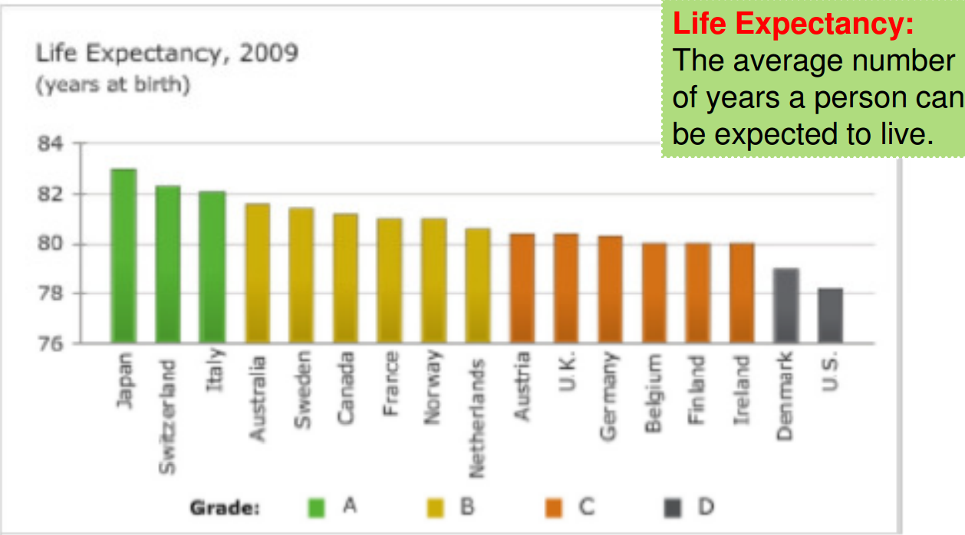

Aging around the World and the Social Determinants of Health
- Social inequality in a country is a significant predictor of the health of the population of the country
  - Countries with higher degrees of income inequality tend to have poorer health outcomes
  - Health of a population is better in many countries with less income disparity, and greater social equality/equity
- Greater Equality…means the absence of discrimination on the basis of social class, race, religion, culture, gender, age, sexual orientation, disability or health status, etc.
- Greater Equity…means fairness and justice in the distribution of benefits, power, resources, and responsibilities

Developed & Developing World
- While developed countries have a higher proportion of older people within their populations, the majority of older people in the world (64%) live in developing countries. Absolute number of people for every age group live in developing countries.
- 2012: 8% of the world’s population (562 million individuals) was 65 years of age or older
  - More developed regions: 16.5% of population is 65+
  - Less developed regions: 6.2% of the population is 65+
- 2050: 16.7% of the world’s population (1.53 billion persons) expected to be aged 65 years and older
  - 1 in 3 people in developed regions and 1 in 5 people in developing regions will be aged 60 years and older
- Median age of the world = 28.4 years
  - Median age in most developing nations is below 25 years
  - Median age in Canada was 41 years (2012)
- Life expectancy for males and females, respectively:
  - Developed countries: Japan 80, 86; Australia 79, 84
  - Developing countries: India 63, 65; Zambia 49, 49; Brazil 70, 77
  - Difference between male and female life expectancy rates are less pronounced in developing countries.
    - Mortality in childbirth “balances”; infectious diseases more prevalent than chronic diseases, which don’t discriminate on gender

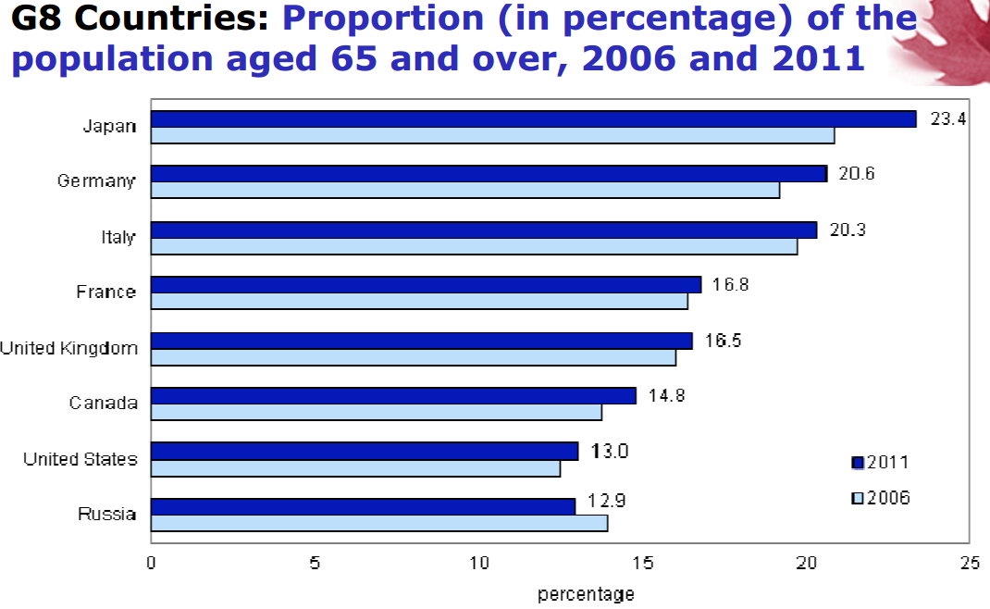

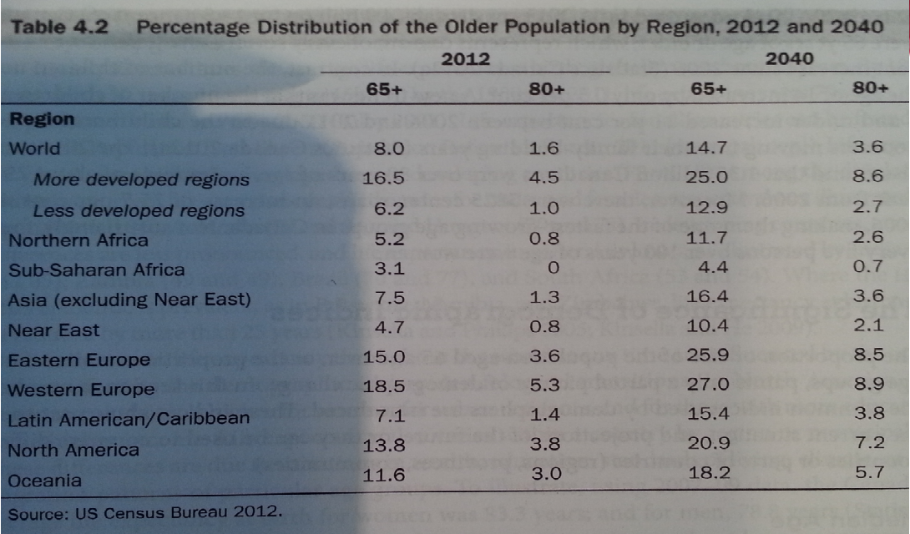

China & Japan
- China has the largest number of older adults (122 million in 2012) projected to increase by 327 million by 2040
  - China may be inadequately prepared to cope with changes associated with an aging society because they don’t have a formal pension system in place (many developing countries don’t). Health care system has criticism about not being very comprehensive. Population tends to be less educated in general, and also about age issues. Older adults tend to be emigrating out of the country rather than staying in it, since their adult children have left and they chose to follow. May live in rural locations or places where access to health care is very low. Proportion of older people in rural locations is higher in developing countries (it’s the opposite in developed regions). Most of China’s elderly will be women, specifically widows who are not well-educated.
- Japan has the highest percentage of people aged 65 and older (20% of their population); by 2100, more than half of the Japanese population will be aged 60+
  - Day to day life is very physical – people are constantly moving, even older people

Sub-Saharan Africa
- The only major region in the world in which the population is still relatively young
- Fertility and mortality rates remain high by global standards
  - Women have 5.5 children on average (compared to 2.8 in North Africa and 2.4 in Asia)
  - Children are more likely to survive
  - Absolute number of older people will increase as a result, but the life expectancy won’t increase much, if at all
  - Impact of HIV/AIDS on younger population – older individuals take over caregiving for children and grandchildren (concern about what will happen to older individuals in rural regions)
- Life expectancy of the region is approximately 50 years (13 years below average for all less developed countries)
- Proportion of older people in Africa is expected to increase only modestly in Africa, but the absolute number of older people will rise

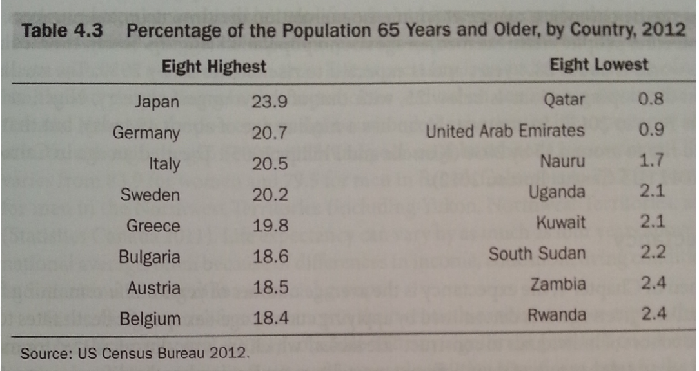

Global: Fertility Rate
- 2010: 2.56 births/woman
- 1960: 5 births/woman
- Fertility rates are below the replacement level in almost all OECD countries
- Crude Birth Rate: number of births that happen per year for 1000 of the population. 19.2 births per 1000 people worldwide.

Global Aging – Emerging Issues: Migration
- Migration of a young labour force to selected high-income countries leaves many older adults in low- and middle-income countries with fewer people to provide professional and personal care
  - Internationally, migration is at an all-time high
    - Estimated 2 to 4 million people per year leave their home country for another country
- Urbanization is a global phenomenon with about 50% of global population living in an urban area (projected to increase)
  - Rural areas have a higher proportion of older people, while urban areas have a higher absolute number of older people

Global Aging – Emerging Issues: A Boost in Economic Performance
- Reasons to be Optimistic:
  - Declining fertility rates has led to greater female labour force participation
  - Fewer children generally means healthier and better educated children
  - Gains in healthy life expectancy appear to provide a boost in saving rates as people accumulate more capital and wealth in expectation of a longer future
  - Longer work lives, increase in retirement age, and changes in pension policies to encourage longer work lives

Global Aging – Emerging Issues: Double Burden of Disease
- Despite issues of malnourishment, undernutrition, and hungry in developing countries, there is a rapid increase in overweight persons and obesity in many low- to middle-income countries
  - People are beginning to consume more “empty calorie and chemically processed foods”, resulting in an increased risk of non-communicable diseases as well (e.g. diabetes, cardiovascular disease, etc.)
- Therefore transitioning countries are seeing both communicable and non-communicable disease; as they get more developed, there will be more non-communicable diseases than communicable disease

Global Aging – Emerging Issues: Health Care Globally
- Consider the following arguments:
  - Elderly population will be a burden on health care systems
  - Aging population will inevitably render health care unaffordable
  - Long-term implications of providing health care to the aging population (ie. Inpatient, outpatient, community, home care, etc.)
  - Resulting increase in people surviving into old age will increase cost to the taxpayer

- Very negative, and not necessarily accurate
  - Proximity to death is the factor that drives up costs of health care – not necessarily age.
  - In fact, younger individuals tend to be treated more aggressively than older individuals (since they have more years left and the “fight” is “worth it”), resulting in more expense
  - Prevention generally will reduce the health care costs in the future. Developing better screening techniques to get diseases addressed and treated quickly.
  - Future view of health care may be more efficient; the Baby Boomers aging has caused us to take a look at our health care system – we will likely be able to make improvements to the health care system, be able to treat more patients more efficiently (e.g. utilize more preventative care and in-home support to prevent people from being forced to leave their homes), which will be a positive thing

September 17, 2014
Aging in the Global Context, cont’d
VIDEO – how to live to be 100
- Only about 10% of one’s lifespan is attributed to genetics. The rest is by lifestyle.
- There’s a lot of controversy and confusion about what makes us live longer.
- Only 1/5000 people in the US live to be 100 (we are not programmed for longevity, rather, we are programmed for procreative success)
- To live to be 100, you have to have a very healthy lifestyle, AND have one the genetic lottery; many things can go wrong with our cells and cause damage/age
- The capacity of the human body is about 90 years, while life expectancy is 78 (ie. People are missing out on about 12 years due to poor lifestyle choices)
- 3 Demographically Determined Areas – Cross Cultural Distillation
  - Sardinia, Italy (men live much longer than other areas of the world)
    - Diet is largely plant-based, with lots of healthy omega-3s, healthy wine, and whole wheats/durum.
    - Sociologically, older people are celebrated
    - The Grandmother Effect – children experience lower mortality due to support, love, and help from grandparents
  - Okinawa, Japan
    - Longest disability-free life expectancy in the world
    - Fewer disease
    - Plant-based diet, tofu; while preventing from overeating (e.g. eating smaller plates, don’t eat “family style” – have the food put away so once you’re served, you’re done); stop at 80% full
    - More social/friends, sociologically healthy; better support system
    - Older people don’t retire or lose their “reason to get up in the morning” – they keep doing things; work; hobbies
  - Lorna Linda, California
    - Very religious
    - Adventists
    - Very little difference between life expectancy of women and men; both are very high compared to the rest of the country
    - Take their diet from the bible; plant-based; focus on God, social network, nature walks, etc.
    - Older people have a lot of independence; continue doing things for themselves, working, activities, etc.

  - Move Naturally – not active exercise; set up their lives so they are nudged into activity every day (e.g. walking to places, getting up and down off the floor after mealtimes, etc.), and it’s activity that they enjoy
  - Sense of Purpose – keep your sense of purpose after you retire. Do things you enjoy, keep your support network up
  - Eat Wisely – eat a lot of plants, don’t overeat
  - Connect to Others – put family first, have friends, belong to positive, healthy people around them (ie. People who make healthy habits a way of life)

How to Be Successful in this Class:
*Do the readings, just not the ones that were not mentioned at all in class*
*Be familiar with important numbers (life expectancies)*
*Know trends from data/graphs; projections*
*prepare for applied questions; not just simple definitions*
*attendance is very important*

Theories and Models of Aging in Late Adulthood
What is a Theory?
- Aim to bind together – in a systematic fashion – knowledge about some particular aspect of the world or experience
- General statement(s) about logical relationships between variables to explain a class of phenomena
- Descriptive in nature and promotes understanding
- Function is to help make predictions
- Come from research (to find answers to questions; make sense of things; look for patterns; connect ideas; develop a logical statement)
- Examples:
  - Developmental Theories: Piaget’s Theory of Cognitive Development
  - International Development Theories: Conflict Theory, Dependency Theory, Modernization Theory, Human Rights Theory, Anti-Racist Theory
Inductive Reasoning
- Specific -> General
- Observation -> Pattern -> Tentative Ideas -> Theory
- Work your way UP to a theory, with an observation being the first step, and the theory becoming the final step
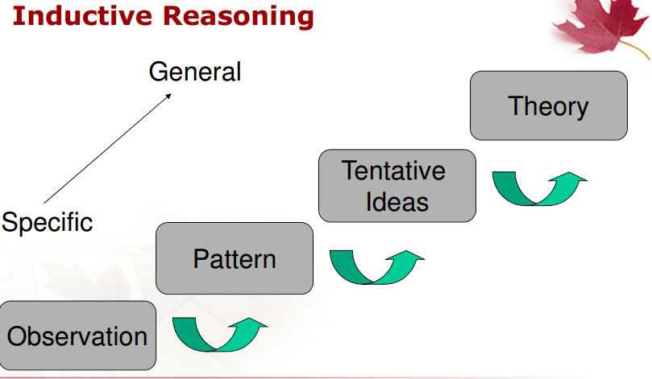
Deductive Reasoning
- General -> Specific
- Theory -> Hypothesis -> Observe and Test -> Confirmation
- Work your way DOWN from a theory to a smaller experiment that confirms/disconfirms the theory
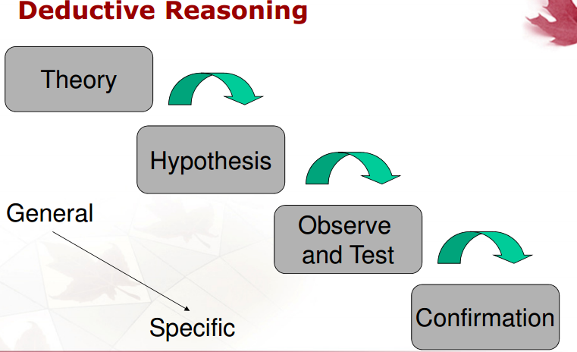
Relationship between Inductive and Deductive Thinking is cyclical – as you develop a project, you may switch between Inductive AND Deductive Thinking.

Development: Nature-Nurture Debate
- Developmental Science
  - Attempts to explain the underlying processes of development and aging (“why?” vs. simply describing things over time as people get old “what?”)
- Nature-Nurture Debate
  - People proceed through life stages based on genetics and inherited traits (NATURE) vs. based on life circumstances and how the environment shapes the course of their lives (NURTURE) – e.g. social determinants of health
  - Not much of a debate anymore – both are important, and some issues may have one aspect more important than the other
  - Living during a time of conflict has a huge impact on how we age/develop, as does sexual abuse (more so than other aspects of abuse), torture, experiencing the death of a loved one (parent, sibling, especially), significant accidents (resulting in severe impairment/disability), etc.

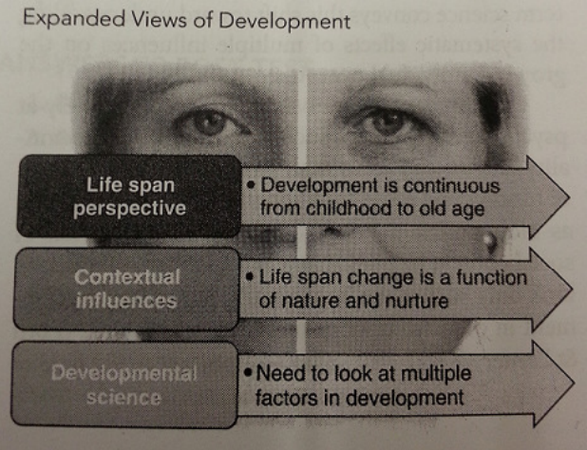
Life Span Perspective – development is continuous from childhood to old age
Contextual Influences – life span change is a function of nature and nurture
Developmental Science – need to look at multiple factors in development

Individual-Environment Interaction
- Organismic Model: “nature” – drives development
  - Development occurs in discrete steps, not continuous
  - Concerned with physical/mental aspects of development are a function of the predisposed, genetic aspects of an organism
- Mechanistic Model: “nurture” – drives development
  - Individual exposures to experiences, conditions, and contexts
  - Provide learning experience
  - More fluid, continuous; no clear-cut stages
  - The Learning Theory is most consistent with this model
- Reductionist vs. Holistic Views: breaking down the person into small, fundamental parts for study and treatment (REDUCTIONIST) vs. recognizing the interdependence of various bodily systems, including the body, mind, and spirit (HOLISTIC)
- Interactionist Model: genetics, the environment, and individual participation in development interact in complex ways to inform development
  - Multi-directionality
    - The person themselves is important and can effect change in their own development
    - Multiple paths – not just one path to aging
  - Multi-dimensionality
    - Development proceeds in multiple domains in life (work, school, home, etc.)
  - Plasticity
    - NOT NEUROPLASTICITY – different concept
    - The idea that the course of development can be altered depending on specific interactions that occur
    - E.g. If Dr. Gulati stays single her whole life, her life and development would take a very different path than if she got married and had different experiences that come with marriage, etc.
    - How do people modify their experiences and development?
    - People who can effectively compensate to changes in their lives will be more likely to experience optimal aging

Structure of the Environment and Reciprocity in Development
- The environment includes those contexts and conditions which occur outside individuals and have the probability of influencing the individual and eliciting responses from them
- Environment is not static – it is continuously changing; you respond to it; therefore you are also continuously changing as you effectively respond to your environment
- The environment is a multilevel, multidimensional, hierarchical system which ranges from physical features to specific proximal transactions
- The environment operates not only in space (objective environment) and within the individual (subjective environment), but also across time (temporal environment)
- Adults both shape and are shaped by their environment

Aspects of One’s Environment (and examples)
- Physical (architecture, natural environment, products and technology)
- Social or Psychosocial (family, peers)
- Cultural (norms, values, beliefs)
- Institutional (services, hospitals, community organizations)
- Legal (laws, regulations)
- Political (government, systems)
- Economic (assistance, policies)
- Temporal (time patterns and rhythms)

Transactional Approach: Environment-Performance Relationship and Aging
- Transactional Approach – assumes an interdependence of the person and the environment
  - Recognizes that a person’s context are continually shifting and as contexts change, the behaviours necessary to accomplish a goal also changes
- Environmental Press – the environment exerts a “press” – physical, interpersonal, or social force(s) or demand(s) – upon the person, which is either supportive (e.g. facilitating) or challenging (e.g. inhibiting)

Pictures
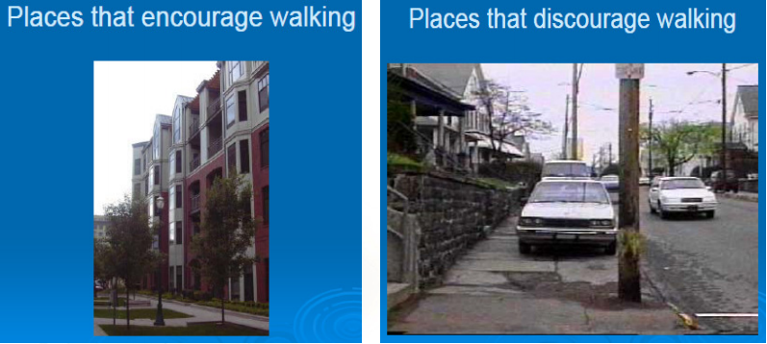
Physical demands of the environment are low in the first picture and high in the second picture. The second picture discourages walking.
Competency Aspects – physical and functional health, cognitive and affective functioning (emotional), sense of efficacy or mastery/confidence you feel in navigating your environment

Lawton and Nahemow’s Press-Competence Model
Meeting Demands of the Environment
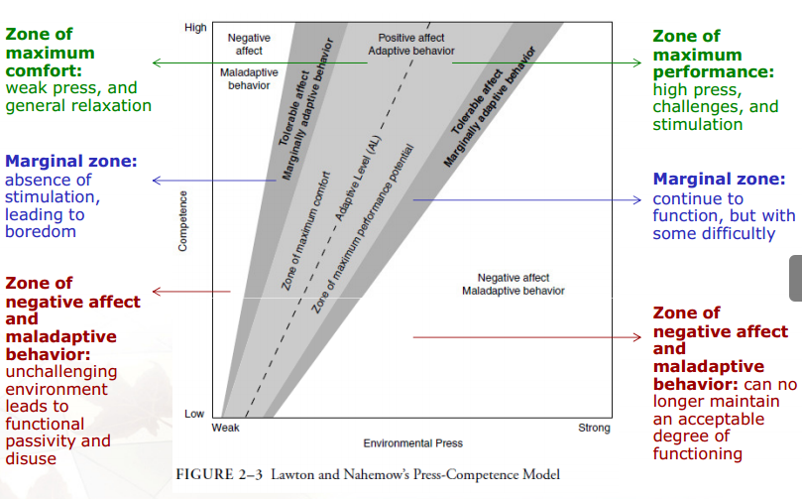
Zone of Maximum Performance – high press, challenges, and stimulation
Marginal Zone – continue to function, but with some difficulty
Zone of Negative Affect and Maladaptive Behaviour – can no longer maintain an acceptable degree of functioning (environmental demands are too difficult; may experience emotional dysfunction)
Zone of Maximum Comfort – weak press, and general relaxation
Marginal Zone – absence of stimulation, leading to boredom
Zone of Negative Affect and Maladaptive Behaviour – unchallenging environment leads to functional passivity and disuse (you don’t even want to use the environment anymore)

September 19, 2014
Bronfenbrenner’s Ecological Systems Theory
How do different aspects of society impact the individual?
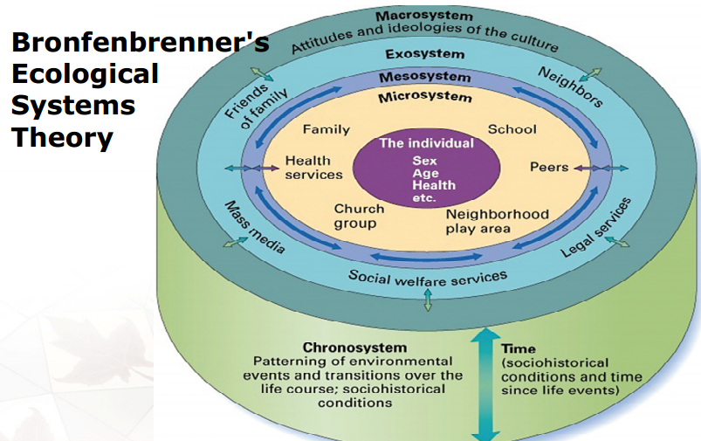
Definitions and Applications
- Microsystem: the immediate surroundings of the person (e.g. family, peers, school, neighbourhood) in which the most direct interactions with social agents occurs.
- Mesosystem: the connections between different microsystems or contexts (e.g. family and school)
- Exosystem: the connection between a social setting in which a person does not have an active role and the person’s immediate context (e.g. child’s interactions with a parent are affected by the parent’s job or place of employment)
- Macrosystem: the culture and society in which individuals live (e.g. norms, laws, socioeconomic status)
- Chronosystem: the person’s sociohistorical conditions, pattern of environmental events, and transitions over life (e.g. transition to adolescence, challenging life events, new job, etc.)

Bronfenbrenner’s Ecological Perspective
- Inner circle represents biological changes that take place over time (psychological, too)
- Cognition, Coping, and Personality on the circle outside of that (Adaptation Processes)
- Social Factors: Proximal Social Relationships, Work, School, Family, Peers
- Sociocultural Factors: Economic Systems, Public Policy, etc.

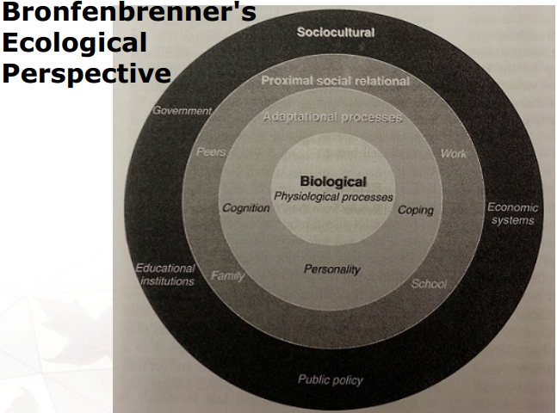

Cultural Environment: Multiculturalism and Aging
- May be significant variation in how mainstream and different ethnic populations define or address aging, the concerns regarding aging, and the solutions that are proposed
- Cultural beliefs and attitudes determine behaviours, guide decisions, and affect interactions with society
- People develop a mix of cultural roles, expectations, and ideologies that determine how its members view social networks, support systems, and communities

What is Culture?
  - The set of values, beliefs, patterns of behaviour, language, etc. that form a pattern of lifestyle.
  - Shared between individuals
  - Passed from generation to generation
  - The learned and shared way of life, traditions, values, beliefs, norms, dress, language, artifacts, attitudes, behaviours and knowledge that create a describable pattern in the lives of groups of people or communities.
  - Culture deals with 1) Actions of people (cultural behaviour); 2) knowledge of people (cultural knowledge); 3) objects or resources people create and use (cultural artifacts)
  - Static Perspective of Culture: Culture is considered a representative picture of an ethnic group (e.g. lifestyle, traditions, rituals); people are subjected to cultural traits and become passive recipients of such characteristics
  - Dynamic Perspective of Culture: culture is viewed as learned patterns of behaviour or shared perceptions among people; people become active learners about their culture
  - May lead to a lot of stereotypes of certain groups if not properly defined
  - In practice (when developing and implementing interventions), it may be best to:
    - View culture as a series of “guiding mechanisms” (e.g. rules, norms, and strategies) that direct behaviour and thought, rather than complex and concrete patterns of behaviour (e.g. customs and traditions)
    - Investigate cultural processes and how particular groups associate and negotiate to respond to human problems (e.g. exclusion of aging persons, lack of resources for the elderly)
  - Multiculturalism in Canada refers to the presence and persistence of diverse racial and ethnic minorities who define themselves as different and who wish to remain so. Ideologically, multiculturalism consists of a relatively coherent set of ideas and ideals pertaining to the celebration of Canada’s cultural mosaic. Multiculturalism at the policy level is structured around the management of diversity through formal initiatives in the federal, provincial, and municipal domains. Finally, multiculturalism is the process by which racial and ethnic minorities compete with central authorities for achievement of certain goals and aspirations.

Ecological Model and Aging Populations
- Ottawa Charter on Health Promotion uses socioecological framework as a foundation for its recommendations
- In the UN Convention on the Rights of Persons with Disabilities, “Disability is defined through an ecological model in which disability is seen as an evolving concept reflecting the interaction between the individual and social attitudes and the physical, economic, and political environment that hinders the full and equal participation of persons with disability in society.”
  - Traffic Lights; Walk Signals/Timers
  - The Green Bin
  - Ramps/Accessibility/Universal Design
- Aims is to:
  - reduce risk of injury, disease, disability, and death
  - promote health
  - enhance chances or probability for health mobility and longevity
  - multilevel interventions that involve environmental modification and adaptation

Life Course Perspective
- Social scientists distinguish life “course” from life “span” in order to emphasize the non-biological factors that influence changes over time
- Attempt to link social factors to individual adaptation

Disengagement Theory & Activity Theory
- Disengagement Theory: claims that normal, natural, desirable, and inevitable evolution of life results in older adults’ desire to loosen their social ties; retirement and social isolation are circumstances that older adults wish for and benefit from
  - Criticized – some social scientists feel that this encourages negative stereotypes of aging populations, and that it provides the excuse to exclude them from certain aspects of society
  - But could be good – if a person is doing a physically difficult job, it may be beneficial for them to retire and give their aging body a rest
  - Can lead to lower adjustment in middle age; lower self-esteem in middle age
- Activity Theory: view that older adults would rather be involved and not forced out of productive social roles, and prefer to remain active
  - Opposite of the Disengagement Theory
- Continuity Theory: proposes that whether disengagement of activity is beneficial to the older adult depends on the individual’s personality; inclusion in or inclusion from social roles and activities should be consistent with one’s will and desire
  - Middle ground/bridge between the DT and AT
  - Disengagement/Activity depends on the person, their self-identity, their wants and needs, their disabilities, etc.
  - Adds more meaning to involvement of activities
  - Person-centred, Client-centred view

Occupation is the sum of all meaningful activities that an individual has a need or desire to pursue, including activities for personal care and growth, productivity (school/work), and leisure.
- If occupational performance is maximal, they are doing the most occupational activities they can do without overwhelming themselves or their abilities
- If minimal, they may not have any occupational activities in their lives, or they are poorly performing the ones they have

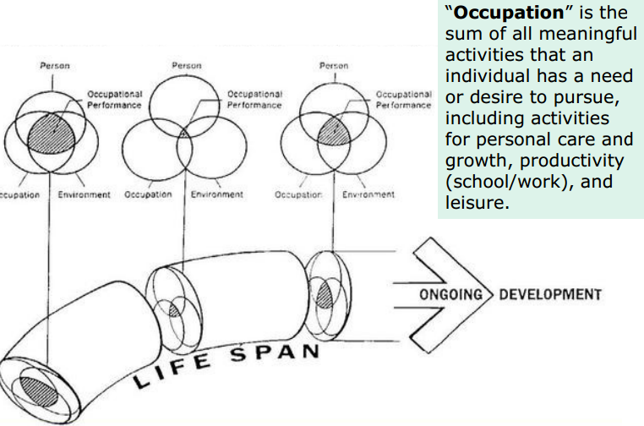

Person-Environment Fit: Enabling Environments for Performing Activities
- PE Theory offers a framework for assessing and predicting how characteristics of the person and environment together determine wellbeing
- “Fit” has been described as a usable environment that matches the person’s abilities with appropriate supports
- Psychosocial factors impinge on the definition of “fit” (e.g. self-image, motivation, social pressure, and expectations)
- The objective of interventions may be to ensure societal participation through environmental design, modification, or adaptation, with the aim to improve the person-behaviour-environment “fit”
- Person-level factors that can impact “fit”:
  - biological/psychological needs and values, goals, abilities, personality
- Environmental factors that can impact “fit”:
  - Intrinsic or Extrinsic
  - Demands of a job or a role, cultural values, characteristics of other people in your environment (very relevant to elderly individuals)

Erikson’s Psychosocial Theory
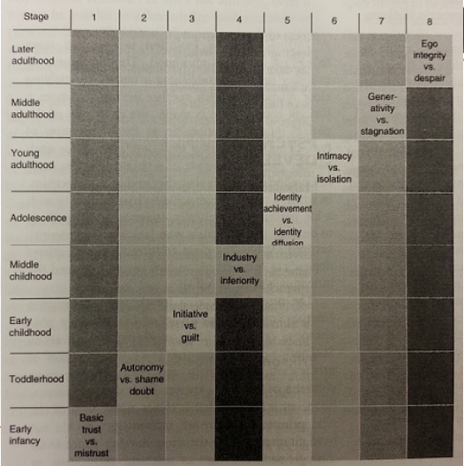
- Individuals pass through life stages in which they are especially vulnerable to a complex interaction of biological, psychological, and social forces
- Generally helps to explain how person-level adaptive abilities unfold over the course of one’s life
- Each level is prevented as a crisis that needs to be solved
- Focuses on development of self/“ego”
- Even in later life stages, the individual may revert back to earlier stages depending on what is going on in their lives
- Early Infancy Crisis: trust vs. mistrust (are parents meeting your basic needs?)
  - if not, leads to frustration, suspicion, withdrawal, and lack of confidence
- Toddlerhood Crisis: autonomy vs. shame or doubt (is it OK to be myself?)
  - Explore your environment and the people in it; parents should encourage and support you to explore your environment as you play
  - Highly restrictive parents can discourage their child from exploring their environment, which may instil a sense of doubt or reluctance in the child
  - The child may want to withdraw
- Early Childhood: initiative vs. guilt (is it OK for me to act, and do things?)
  - Initiative will add to autonomy/independence on undertaking and planning/executing actual tasks
  - If you are discouraged during this stage, and you are discouraged against becoming independent in activities, you may develop a sense of guilt about your abilities, and possibly even confusion about your needs
- Middle Childhood: industry vs. inferiority (can I make it in the world that exists of people and things?)
  - Becoming more aware of yourself as an individual; critical in developing self-confidence
  - If ridiculed constantly or punished for their efforts when they try to do something, they may develop feelings of their inferiority or questioning their abilities
  - It is important to give positive feedback for trying, even if they don’t succeed; children need a lot of cognitive reinforcement at this age; try to balance positive with negative feedback so as not to harm self-confidence, or ego
- Adolescence: Identity achievement vs. identity diffusion (what is your place in life?)
  - may have confusion/unclear sense of who you are or where you’re going
  - may feel you have no purpose or you don’t know what is going on
- Young Adulthood: intimacy vs. isolation (grappling with developing close relationships with other people)
  - Crisis may be that you will not achieve the close relationship with another person in a lifelong partnership sort of way
- Middle Adulthood: generativity vs. stagnation
  - Deciding whether or not to procreate
  - Productivity/ability to add skills to next generation
  - You can still contribute to the next generation even if you don’t procreate (e.g. teach, mentor, supervise younger people; produce things that younger people can use and enjoy, etc.)
  - Stagnation: you only care about yourself and people in your age group
- Later Adulthood: ego integrity or despair
  - If you’ve established a sense of yourself in a positive, healthy way, you won’t be afraid of death – it’s just something that happens
  - Despair – will often question if there are ways to avoid death; may be concerned about how quickly death will come up; may feel despair when it comes to fixing things that they didn’t do well – they want to make up what went wrong in the past
  - If feeling despair, you may disconnect with life, possibly prematurely, and may have trouble coming to terms with the thought of death

Erikson’s Psychosocial Theory: Adulthood
- Identity Achievement vs. Identity Diffusion: clear identity and coherent sense of self, purpose, and direction VS. unclear sense of self, vagueness about life’s purpose, and lack of direction
- Intimacy vs. Isolation: establishing a mutually satisfying close relationship (lifelong commitment) with another person VS. never achieving true mutuality with a life partner
- Generativity vs. Stagnation: focuses on psychosocial issues of procreation/parenthood, productivity, creativity, and concern for next generation VS. concern only for self and/or one’s own age group
- Ego Integrity vs. Despair: those who establish a strong sense of self can look back at their experiences and inevitability of death with acceptances VS. realization that death is unavoidable and will come soon with little/no time to make previous wrongs right.

Consider this scenario…
Considering Erikson’s Psychosocial Theory, describe the issues this woman is experiencing.
“An 80 year-old woman is mugged while walking on a city sidewalk, robbed of her purse, and left emotionally shaken. This incident traumatizes her for some time, and in the process, she becomes fearful of leaving her home. […] The woman is also left feeling vulnerable that with her increasing age, declines in her physical functioning have made her a target.”
- Feeling like she can’t trust people
  - (Early Infancy; Basic Trust vs. Mistrust)
- Like she can’t safely explore her environment/act on her own
  - (Toddlerhood; Autonomy vs. Shame/Doubt)

Piaget’s Cognitive-Developmental Theory
- Two ways in which people interact with their environment:
  - Assimilation
    - Have a set of mental structures, and you interpret/fit the new experiences in your pre-existing mental structures
  - Accommodation
    - Gain experiences that allow one to refine existing mental structures in order to better differentiate and categorize objects and experiences in the world
- Individuals become better able to adapt to the world through alternating between Assimilation and Accommodation

Identity Process Theory
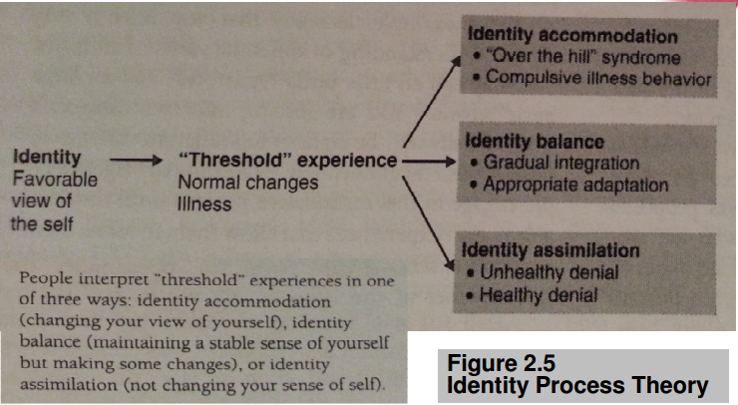
- People tend to have a certain, biased view of themselves in a positive light
  - E.g. if you get rejected for a job, you have a tendency to criticise the person interviewing you rather than say that you weren’t good enough
- You have a tendency to interpret new experiences relevant to your own self-view (Identity Assimilation) – usually view yourself as great/perfect
  - Downside: may lead to distorted interpretation of experiences; may challenge perfect picture you have of yourself; may have difficulty evaluating yourself in a realistic light; may not address real problems because you are constantly blaming other people
    - Overuse of thinking you’re great or perfect in adulthood
      - May lead to denial about how you’re actually doing
      - May fail to take advantage of preventative measures in order to attain optimal functioning (e.g. eat healthy and exercise)
- Between Assimilation and Accommodation, usually achieved in adolescence (Identity Balance)
  - Most positive way to react to age-related changes
  - Don’t adopt an attitude of defeat
  - You take steps to attain a healthy outlook and to remain healthy
  - Don’t become preoccupied with health problems and illnesses; just attend
- People change their identity/view of self that is not perfect, to include shortcomings that you have; may be very advantageous to you, as long as you don’t rely TOO heavily on them – then you will become overly critical of yourself and overly sensitive (Identity Accommodation)
  - Overuse of accommodation in adulthood may cause people to completely redefine who they are in a very negative way
    - Usually related to age-related changes because people feel like they are losing control over their fate, etc.

September 24, 2014
Aging and Maturational Changes: The Aging Brain, Normal Aging, and Role Changes
VIDEO – “Fountain of Youth”
Focusing on a Japanese village (Uzurihara) where people routinely live to 90 and beyond without developing signs of secondary/impaired aging/non-communicable or chronic diseases.
- Wondering if you can get the same health benefits in a pill – need to find their secret to longevity
- Many more disability-free years than other places in the world, they don’t even wrinkle
- 10% of their population is comprised over people over 85 (ten times our norm)
- Disease (cancer, diabetes, Alzheimer’s, etc.) very rare despite engaging in other behaviours that might reduce longevity (e.g. smoking)
- Genes? Low-stress environment? Or more? They believe it’s due to diet; they grow their own food and eat lots of vegetables (especially potatoes).
  - Villagers have abundance of Hyaluronic Acid (HA); something we lose as we get older – allows cells to retain moisture/smoothness, and lubricates joints; HA appears in the starches and vegetables that they grow at home
  - The food tastes “awful”
  - HA is used in moisturizers and medicinal products (in a syringe)
  - It’s being focused on right now as a possible key to aging
  - Chicken combs have a lot of HA in them – they are purified and people eat them as snacks
- Through urbanization, there has been a bit of Western diet practices being adopted in some areas in Japan – and in those areas, incidence of heart disease has doubled (upside-down death pyramid – older individuals are outliving their children because the children did not stick to their parents’ healthy, traditional dietary practices)

The Aging Brain – Quiz
- Intellectual functioning decreases as we age. FALSE
- Older people can successfully learn new technologies. TRUE – biggest age group to learn computer technology – need to adapt strategies to effectively learn how to use technology
- Developing dementia is a normal part of aging. FALSE.
- Memory declines as one ages. TRUE – there is a modest decline in short-term memory with recent events, meaningful past events within the memory usually stays very stable, retrieval of information can be troublesome, memory loss is not a predictable agent in aging. (will discuss this in more detail later)
- Older people usually take longer to learn something new. TRUE – processing speed does go down a little bit with age (factors that affect memory decline: lack of attention; fatigue; hearing loss)

Played Boggle.
Skills needed to play Boggle:
- Processing speed, degree of flexibility, ability to sustain focus, special recognition, short-term memory, problem-solving, and decision-making

Cognition
- Refers to mental processes involved in gaining knowledge or learning, thinking, understanding, remembering, judging, and problem-solving.
- Cognitive Skills and Abilities: mental functions required to carry out any task (most simplest to most complex task)
  - The mechanisms of how we learn, remember, pay attention, problem-solve, etc.
  - E.G. attention, memory, executive functioning, perception, language, visual and spatial processing, language, perception, etc.
  - Every human action has something to do with cognition
  - Sensation: we acquire information from our environment which is sent to our brain to interpret
  - E.G. Through sensation and perception, we hear the phone ringing and make a decision to answer it. Have to pick it up (motor skills), be able to speak, talk, and understand/comprehend the language from the other person (language skills), while interpreting someone’s tone of voice, and reacting to it in a manner you feel is appropriate (social skills).

Cognition and Aging
- Cognitive abilities such as memory and attention begin to decline as we get older.
  - However, such declines can be slowed or even reversed if cognitive abilities are exercised appropriately.
  - The ability to learn and remember new skills can be maintained well into a person’s 70s, 80s, and beyond
  - You will see some declines in cognition depending on what aspects you are focusing on
  - This decline can be slowed down or reversed; physical exercise helps slow down the decline

Cognitive Skills and Abilities
- Attention: ability to sustain concentration on particular stimuli, object, action, or thought
  - Sustained Attention: ability to remain focused on a task or specific stimuli
    - Basic requirement for information processing
    - How long can you stay focused and attain information at the same time?
    - How do you inhibit distractions? (turn off your phone, turn off your wi-fi/internet, goal-oriented focus)
  - Divided Attention: ability to attend to more than two things simultaneously (multi-tasking)
    - E.G. Watching TV while studying
    - Some studies will show that when you divide your attention, you will perform poorly/not as well on one of those tasks; others say that you will not do well on any of the tasks.
    - Reading, writing/typing, listening to music, tv on in the background, using smartphone/texting, browsing the internet, eating/drinking
  - Selective Attention: ability to attend to stimuli/messages that are meaningful or address a need or desire, while ignoring other stimuli
    - E.G. writing exams. You’re so into writing the exam, the professor stops the class to give instructions about the exam and you may not hear.

Practice: Focusing Your Attention:
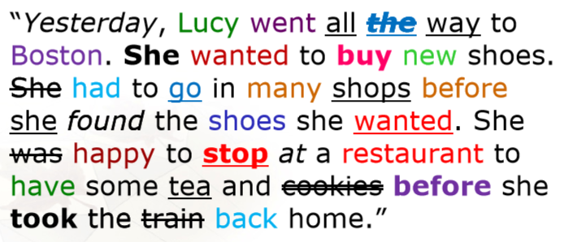
There are 7 Y’s in that short text. The distractions include colour/inconsistency of colours, bolding, underlining, strikeouts, and italics.

Attention and the Aging Brain
- Goal-directed behaviour requires attentional control
- As we get older, we become more distractible
  - Older adults exhibit poorer performance than younger adults on tasks that require the inhibition of interference (e.g. on the Stroop Task, the test where you have a word written in the wrong colour, and vice versa): 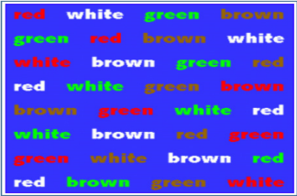
- Stroop Task/Test:
  - We are generally better at processing words than colours
  - The Stroop Task/Test is used to examine age-related differences in selective attention and your ability to suppress distractions
  - You are asked to name the colour of the word rather than the actual word itself – it’s easier to say the colour of a word if it actually matches the meaning of the word
  - Naming the actual colour of the word requires more attention than simply reading the text
  - People can read words much faster than they can name colours
  - The speed at which we read makes it difficult to concentrate on the colour (often we read really fast in sort of a skimming manner, but this forces you to slow down and concentrate hard)
- Older adults selectively attend to positive stimuli and are more likely to retrieve positive (instead of negative) memories
  - Older adults may be less sensitive to interference in a task, which requires them to make an emotional judgment

VIDEO – Attention and Memory
- The brain has weaknesses that limit its ability to process:
  - Attention Limitations
    - Can’t distribute attention everywhere at the same time
    - You have to make choices because your attention doesn’t focus widely enough to get every single stimulus (most of the time)
    - Cocktail Effect – Covert Attention; you can divert your attention elsewhere without moving.
      - For example, you’re at a cocktail party and you’re listening to someone but you’re kind of bored, so you stay there and “look” like you’re listening while actually overhearing other more interesting conversations at the cocktail party.
  - Working Memory Limitations
    - Ability to hold information online in minds for short periods of time *in order to guide your behaviour* (e.g. remembering a phone number)
    - Capacity limitations depend on the information being remembered: 7 digits, 6 letters, 5 words, 3-4 objects, 2 faces
  - Processing Speed Limitations
    - Process information very rapidly, at the level of the neuron
    - With complex mental tasks, processing speed adds up for each
- Interference: something prevents you from storing or recalling a memory
  - Internal
    - Intrusions (mind wandering) – mind leaves because you are accidentally preoccupied with other thoughts and can’t hold focus (accidental)
    - Diversions (multi-tasking) – focusing on something and thinking about something else at the same time (deliberate)
    - Difficult to measure as legitimate internal interference only occurs spontaneously/unexpectedly
  - External
    - Distractions (irrelevant stimuli) – external information that is irrelevant to your goals, that you try to shut out (unwanted)
    - Interruptions (multi-tasking) – trying to attend the external information rather than shut it out (wanted)
- Often people think they just “forgot” but really it’s because they were interrupted and that caused them to lose focus.
- “Senior moments” are interference-based, most of the time; not about memory, but rather interference and attention

September 26, 2014
Cognitive Skills and Abilities
- Memory: involves the storage and recall of information
  - Short-term Memory: info stored temporarily for a very short period; limited storage; 20-30 seconds or less
  - Working Memory: processes that are used to temporarily store, organize, and manipulate information. Sort of like short term memory, but you’re doing something with that information – you’re organizing it or storing it in some way. (e.g. remembering directions, a phone number until you have to dial it. P SHERMAN 42 WALLABY WAY SYDNEY)
  - Long-term Memory: info stored and retrievable over a long period of time (days, weeks, months, years); unlimited storage; personal experience, significant, meaningful things. Short-term memories can become long-term memories by association. Either permanent, or days, weeks, months or years.
    - Remote Memory: things that happened a REALLY long time ago (e.g. childhood memories)
      - Usually really good in older people, but it’s harder to recall NEWLY collected information
  - Episodic Memory: captures the “what”, “where”, and “when” of our daily lives, memory of experiences and specific events; connected to long-term memory
  - Semantic Memory: ability to recall concepts and general facts that are not related to specific experiences; understanding language; understanding what things are used for.
    - May actually improve in old age, not decline
  - Procedural Memory: remembering how to do things

Memory and the Aging Brain
- Some types of memory may improve or stay the same: semantic memory continues to improve for many older adults, procedural memory tends to stay the same
- Some types of memory may decline somewhat: episodic and longer-term memory decline somewhat over time
- The following common conditions may lead to memory problems:
  - Anxiety, depression, dehydration, infections, medication side effects, poor nutrition, stress, substance abuse, thyroid imbalance
- Older people may get confused over time especially with episodic memory. They forget what they’re doing, what they should be doing, what someone told them on a specific day, etc.
- Significant declines in memory are not normal and may indicate a more serious problem
- “Having a senior moment” = any instance of a memory lapse. Very common term. Usually has to do with forgetting an important/well-known piece of information (like if they get someone’s name wrong, or forget an important phone or house number)

Cognitive Skills and Abilities
- Executive Functioning: ability to enable goal-oriented behaviour such as planning and executing a task
  - Decision-making: ability to make decisions based on incomplete information or problem-solving
  - Flexibility: ability to efficiently switch to an appropriate mental function and adopt multiple approaches
  - Planning: ability to roganize steps for an activity and anticipate outcomes
  - Emotional Self-Regulation: ability to identift and manage one’s emotions for successful or good performance
  - Problem-Solving: ability to define a problem correctly in order to generate solutions and select the right one
    - Strategy: ability to plan a series of maneuvers for obtaining a specific result
    - Sequencing: ability to break down actions into manageable units and prioritize them in the correct order

Executive Functioning in the Aging Brain
- Research indicates altered patterns of brain activity in older versus younger adults when performing executive functioning tasks
  - Functional imaging studies suggest increased recruitment of brain areas in older adults that may reflect a form of compensation
- “The most commonly reported age-related pattern of brain activity during executive function tasks (e.g. working memory, inhibition, and task-switching) is increased recruitment of lateral aspects of the prefrontal cortex bilaterally.”


The bus is going left, because you can’t see the door. Preschoolers tend to get this right, but older adults (and evidently, university students) may get confused and get it wrong, since they may not take the bus every day and may not be nearly as excited as a preschooler would – the preschooler applies more associations to the bus, so is more likely to remember the details of it.

The Aging or “Changing” Brain in Healthy Aging
- Changes in brain may include:
  - Parts of brain may shrink (prefrontal cortex), communications between neurons; how messages are sent across the body, blood flow (especially to the brain), etc.
- Neuroplasticity (Brain Plasticity):
  - Brain’s capacity to reorganize itself by forming new neural connections and pathways throughout life
  - Brain’s ability to change can occur as a result of
    - Learning and experience
    - Damage to the brain by injury or disease (neurons compensate)
- Many studies tell us that the brain remains capable of relearning and reroute throughout the lifespan especially for individuals who get regular exercise and frequent intellectual stimulation

VIDEO: Neurologist Martin Samuels
- A bit of memory dysfunction is normal, but it’s important to make sure you’re not forgetting things you ought to remember and that it’s not negatively impacting your life
- To keep better control of memory, people should pay attention to what they’re doing, keep a list, get sleep, eat well, don’t drink a lot of caffeine or alcohol (especially near bedtime), don’t take stimulants, etc. Will give you better control over your cognitive abilities.
- There is a range of what is normal (some people maintain excellent cognitive abilities well into adulthood, and others decline a little bit while still being normal); try to slow the decline

*MEMORIZE THE GRAPHIC(S) WITH THE PARTS OF THE BRAIN*
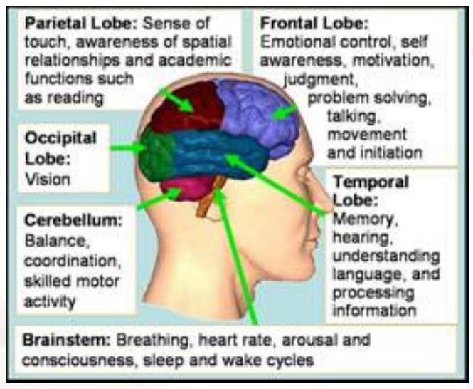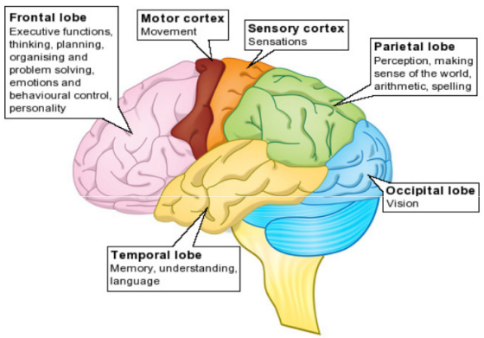
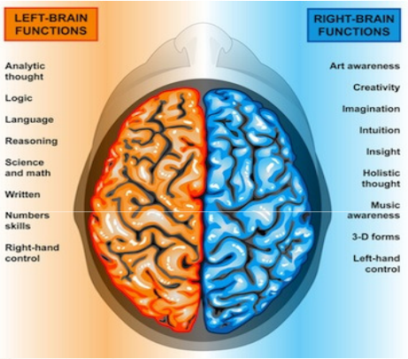

Prefrontal Cortex and the Hippocampus are both areas that are important in learning, memory, planning, and other complex mental activities.

Homework: look up where the hippocampus is. (important to know)
- It is located in the medial temporal lobe of the brain; beside the amygdala, which is associated with emotions
- One in each hemisphere
The hippocampus is important for memory-forming, organizing, and storing information.

Lateral aspects = things that are further away from the midline (of the body). Medial (towards midline) vs. Lateral (away from midline).

Brain Lateralization
- Idea that the left and right parts of the brain execute different types of functions
- Left Brain
  - Language, math, logic, reasoning, analytic thought, science and math, writing, numbers and skills, etc.
  - Controls the right side of the body
- Right Brain
  - Art awareness, special ability, visual imagery, music, imagination, creativity, intuition, holistic thought, etc.
  - Controls the left side of the body

What Impact Does Aging Have on Mental Function in Healthy Older People?
- Modest decline in ability to learn new things and recall info, but remote, semantic, and procedural memory are okay
- May improve in other cognitive areas, such as vocabulary and other forms of verbal knowledge
- May perform worse on complex tasks of attention, learning, and memory, and may present with slower information processing speed
- Additional brain regions may be activated in older adults during cognitive tasks (e.g. memory tests)
- Researchers don’t know why the brain is so plastic in older adults, but they are saying that parts of the brain tries hard to compensate for difficulty that other parts of the brain are experiencing. Because the brain can do that, you don’t necessarily see major cognitive decline in older individuals. You only notice an issue when there is a serious decline, and often they are related to health conditions, disease, or injury.
- Growing evidence of the adaptive (plastic) capabilities of the older brain, and interacting factors, such as lifestyle, overall health, environment, and genetics also may play a role
- Cognitive reserve – brain’s ability to operate effectively even when some function is disrupted OR amount of damage that the brain can sustain before changes in cognition are evident – may explain why some people remain cognitively healthy as they get older while others develop cognitive impairment
- Lifestyle does play a role – diet, physical exercise, sleep, intellectual exercise, other activities and hobbies

Dementia
- Group of symptoms affecting mental processes, thinking, reasoning, and social abilities severely enough to interfere with daily functioning; indicates problems with at least two brain functions (e.g. memory loss + impaired judgment or language, and inability to perform some daily activities)
- *graphic comparison of dementia brain vs. normal brain*
- Alzheimer’s is one type of dementia – biggest risk factor is age.
- Chronic or persistent disorder of mental processes often caused by disease, stroke, or brain injury, usually marked by memory disorders, personality changes, and impaired reasoning.
- Getting lost while driving, not knowing how to pay your bills, etc.

Alzheimer’s Disease
- The most common cause of dementia, progressive disease where the connections between brain cells and the brain cells themselves degenerate and die, causing a steady decline in and destruction of memory and mental function
  - Progressive disorder that results in cognitive difficulties resulting from neuritic plaques and neurofibrillary tangles
- Not a normal part of aging
  - Fewer than 1 in 5 people aged 65+ and less than half of those 85+ have the disease
- Supportive care is best – provide them assistance and keep them safe while still allowing them to live at home and be as independent as possible

To Preserve Healthy Brain Aging
- Controlling risk factors for chronic disease (e.g. a healthy weight)
- Engaging in regular exercise and physical activity
- Eating a healthy diet and getting enough sleep
- Participating in intellectually stimulating activities, and other meaningful activities
- Avoid distractions that divert your attention
- Maintaining close social ties, relationships, and interactions with family, friends, and community.
- Strategies to help your memory: to-do lists, don’t rush through tasks, focus on doing the task well rather than quickly, use a calendar, establish a routine

Positive Aspects of Aging
- Accumulation of experiences and general knowledge
- Better judgment and perspective (outlook)
  - Better able to cope with bad news; problems, etc.
- Developing wisdom
- Higher level of occupational skill
  - While people might perform slower at their job, they tend to have better occupational skill, make fewer errors, are more reliable, etc.
- Greater ability to assimilate and organize knowledge
  - Categorize information; problem-solving/categorization
- Refined, holistic sense of identity and purpose
- Increase in personal freedom
- Profound awareness of the life cycle, change, and evolution

Roles, Role Changes, and Aging
- Social Relationships: recurrent patterns of interactions, which include:
  - Social support for assistance
  - Companionship for enjoyment
  - Negative interaction with positive consequences
  - Goal: to acquire knowledge, ability, motivation, and to understand social norms and expectations surrounding a role; encourage self-expression and promote desire for social interaction (very very important)
  - Unpleasant social encounters that might lead to a positive outcome
- Role Set: the entire array of related roles associated with a particular status (e.g. a teacher associates with students, parents, other teachers, principal, administration, etc.), which change over the lifespan, depending on what your roles are
  - In old age, roles are often lost but not necessarily replaced with new roles
    - New roles may be added as others are given up or discarded
  - Experience of and response to role loss (reflected in disengagement, activity, and continuity theories)
  - Major role losses occur with retirement, widowhood, or becoming institutionalized
  - Giving up your major social roles is not necessarily considered natural or inevitable; according to the continuity theory: older persons are expected to find substitutes as they give up previous roles
- Role Ambiguity: there are no clearly defined guidelines or expectations regarding the requirements of a given role
- Role Continuity: learn new skills, norms and attitudes in order to prepare yourself to adjust to a new role (e.g. student -> employed; dating -> married)
- Role Discontinuity: results from a lack of preparation for new roles
- Anticipatory Socialization: preparing for a new role before assuming it (e.g. pre-retirement program, preparation, etc.)
- Resocialization: the replacement of former norms and values with new ones (e.g. shifting from home to a long-term care facility)

October 3, 2014
Watched “Tuesdays with Morrie.”
- Mitch is the main character (author) – he graduated from university
- Morrie is his favourite professor; Mitch promises to keep in touch with him, but he doesn’t, and bad things happen to Morrie
- Morrie is diagnosed with ALS and has to stop doing the things he loves as a result (dancing, teaching, etc.)
- Mitch was a musician but quits to become a journalist; he works hard but finds no passion or enjoyment in what he does, and his wife is unhappy because they have no kids
- Morrie is interviewed on television, and Mitch decides to contact him but he ends up not being able to talk to him much because he is bombarded by work calls
- Mitch begins to seek more meaning in his life – realizes he doesn’t have a passion for journalism; he decides to go and visit Morrie again
- Mitch decides to visit Morrie every Tuesday; Morrie gives Mitch lessons on the meaning of life and confides in Mitch about his greatest fear (not being able to wipe himself when he goes to the bathroom) that eventually happens
- Morrie is sentimental, emotional, and cries freely
- There are flashbacks; Morrie and Mitch had been very close at university – Morrie says that if he could have had another son, he would have liked it to have been Mitch
- Morrie had a sad childhood and didn’t have a lot of love and affection, so he seeks it out in old age
- Morrie describes feeling like he is a baby again and that it is difficult for him
- Morrie tells Mitch pop culture is based on greed and that he should make his own culture based on goodness; he also tells Mitch to accept the inevitability of aging and death
- Mitch asks his wife (a professional singer) to come and sing for Morrie
- Morrie encourages Mitch to call his estranged brother who is living in Spain and battling pancreatic cancer (the conversation doesn’t go well, but Morrie says that he is sure time will bring them close again)
- After Morrie’s death, Mitch continues “conversations” with Morrie in his head so that he isn’t truly gone

October 8, 2014
Aging as a Social Construction: Aging in Contemporary Society, Stereotypes of Aging, and Diversity and Aging
Social Stratification
- Social Stratification: a process by which social attributes (age, gender, social class, religion, race, ethnicity) are evaluated differently according to societal views and values – individuals may be ranked higher or lower than others
- Stereotypes: is defined as rigidly categorizing others and pre-judging others based on limited information. In contemporary society, the media is often considered a significant source responsible for highlighting negative stereotypes of older persons
- However, research and the media in recent years have portrayed many positive views of older persons (e.g. the wise elder)
- Positive stereotypes can usually be referred to as positive views rather than stereotypes
- These types of social structures can either promote integration (positive) or isolation (negative) of people
- Leads to a systematic way of discriminating against people

Socioeconomic Status
- Socioeconomic Status/Social Class: person’s position in system of social stratification/hierarchy that differentially allocates major resources, services, opportunities; often defined on the basis of education and income
- Social Structure (Social Hierarchy): used to think about how people in society differ from one another (placement on an “invisible social ladder”)
- Social Gradient (of Health and Illness): the lower the socioeconomic position, the worse the health
- Social Inequality/Inequity: uneven distribution of wealth and poverty; unequal/unfair opportunities for education, healthcare, leisure; and differential access to power and rewards
- Those who are at the bottom of social class usually have fewer opportunities, and more diseases
- Equality vs. Equity
  - Equality means that you will not be discriminated against because of your age, gender, race, religion, etc. and that you will get the same treatment as others.
  - Equity means that you receive fair or just treatment or allocation of resources; not necessarily equal, but just

Cumulative Inequality Theory
- Unequal or disadvantaged status and the accumulation of risk early in life can contribute to unequal situations and hardships later in life
- If you do really poorly in life, you tend not to do so well later on in life
  - Generational effect; great-grandma was poor, grandma was poor, mother was poor, odds are the child will also be poor (though there are exceptions)

Sex and Gender
- Sex: biological and physiological characteristics that define men and women
- Gender: socially constructed roles, behaviours, activities, and attributes that a given society considers appropriate for men and women; “masculine” and “feminine”
  - Gender Equality
  - Gender Equity
- Women generally take on a caregiver role but that does not mean that men cannot take on this role too
- Across the world: women generally have less access to education, tend to have lower/less income, less likely to own property, tend to have more responsibility for unpaid family responsibilities, less involved in paid work, more likely to be underemployed or not employed, experience more poverty, more vulnerable to being victims of violence and abuse, tend to face more violence in their home, tend to experience more difficulties later in life (widowhood, living alone, or being emitted to an institution)
- Women still get paid less for doing the exact same work as men, generally speaking, you see more women in post-secondary school than men

Culture
- Culture: learned and shared way of life, traditions, values, beliefs, norms, dress, language, artifacts, attitudes, behaviours and knowledge that create a describable pattern in lives of groups of people or communities; a series of “guiding mechanisms” (e.g. rules, norms, and strategies) that direct behaviour and thought AND complex and concrete patterns of behaviour (e.g. customs and traditions)
- Multiculturalism: “Presence and persistence of diverse racial and ethnic minorities who define themselves as different and who wish to remain so… Multiculturalism at the policy level is structured around the management of diversity through formal initiatives in the federal, provincial and municipal domains… Is the process by which racial and ethnic minorities compete with central authorities for achievement of certain goals and aspirations.”
- Low Context Culture: usually associated with individualism, value things like independence (e.g. Canada, USA)
- High Context Culture: usually associated with collectivism, usually value interdependence (e.g. Asia) Focus and value on family and group dynamics

Race and Ethnicity
- Race: biological construct which refers to a person’s physical appearance, features, and characteristics (e.g. skin colour, head size and structure, hair texture, and eye size)
- Ethnicity: sociological construct which relates to people sharing a common culture, origin, language, nationality
  - Race can be socially constructed as well; how we tend to socially evaluate people and make stereotypes based off of them
- Racialization: “The process through which groups come to be designated as different, and on that basis subjected to differential and unequal treatment. In the present context, racialized groups include those who may experience differential treatment on the basis of race, ethnicity, language, economics, religion, culture, politics, etc. That is, treated outside the norm and receiving unequal treatment based upon phenotypical (physical and visible) features.”
  - Idea that your culture is more superior than someone else’s

Social Construction of Aging
- Representations of aging are determined by social interactions, expectations, conditions, and policies (e.g. senior discounts)
- Health indicators such as life expectancy may be used to determine what is “old”
  - People may take some extreme measures to look and feel younger in the Western world
- Notions of aging and young-old vary globally:
  - high context cultures tend to highly value age, wisdom, and interdependence, while low context cultures tend to highly value youth and individuality
- Dominant individualistic view – which sees each person as a free agent capable of independent decision-making and choosing his/her own way of life – has influenced the view of aging

Social “Re”construction of Aging
- From a critical perspective, what may seem to be common socio-cultural practices across a community may in fact reflect the subordinate status of certain groups in society (e.g. elderly, women, persons with disability)
- Need to generate a positive “re”construction of circumstances that are often viewed as debilitating (e.g. reduced income, diminished physical attractiveness, declining physical/mental abilities, disability, the empty nest, widowhood, and end of life) by focusing on positive aging
- We think that the way we treat someone is a part of our culture
- We tend to start ranking people based on the ideas we socially construct of people
- Baby talk to older people – we think we are being compassionate yet we are treating them like a child
- Financial assets – we think we are helping them when in reality we are hindering them and not allowing them to make their own decision when they still have some rights making financial decisions

Stereotypes of Aging…
“In recent years, older people have been portrayed in a wider variety of occupations and social roles that more closely coincide with reality.”
- Elders bullied at the grocery store; people are frustrated with them because they’re not working quickly enough

What are some common stereotypes about older persons?
- Weak
- Easily sick
- All of them suffer from Alzheimer’s
- They’re “cute”
- Wise
- Lame/behind the times/not cool
- Erectile Dysfunction
- Asexual

What are some common positive views about older persons?
- Older persons are often more active and independent
- Have a positive influence on society
- Are seen as having valuable skills and experience (increase in volunteer work)
- Are considered important family members
- Are able to make decisions about important things.

Socioeconomic Status and Older Adults
- Poverty: 7.6% of older women and 3.6% of older men live below the low-income cut-off, which is mainly accounted by single or widowed older adults; among couples it is about 1.6%
- Income is potentially reduced due to retirement
  - 2008: mean after-tax income for women older than age 65 was 65% that of men, which translated to an annual income difference of $13,300 ($24,800 vs. $38,100)
    - Why are older women more likely to have low income? They are more likely to be unemployed or underemployed, work part-time, casually, or temporarily to flexibly be able to raise a family, lack of pay equity, and are more likely to take unpaid leave from work, etc.
  - Women’s CPP is a lot less than men’s (on average, it is about half)
  - 14% of women receive no CPP
  - Women’s wages are about 71% of a man’s wage
  - Women are more likely to engage in “women’s work”
  - People with lower incomes tend to report higher illness and disease, functional limitations, higher rates of disabilities and rank their health as being much poorer
- Considering the “oldest-old” category, educational attainment and income may be lower, especially for women – education/occupation impacts cognitive abilities/reserve
  - Income and assets you’ve accumulated over time = wealth
- Senior men living in Canada’s wealthiest neighbourhoods had longer life expectancies
- Older adults aged 50 and older from lower socioeconomic groups are also more likely to engage in negative or health-harming behaviours

Aging and Health/Social Disparities
- Health/social disparities are “described as differences in the incidence, prevalence, mortality, burden of diseases, and other adverse health conditions or outcomes between minority and majority population groups
- Health disparities have been observed in gender, age, ethnicity, socioeconomic status, geography, sexual orientation, disability, and special health care needs. Disparities occur among groups who have persistently experienced historical trauma, social disadvantage, discrimination, and systematically experience worse health or greater health risks than more advantaged social groups.”
  - Older adults aged 60 to 69 from lower socioeconomic groups are less likely to engage in health promoting and preventative behaviours
  - Lower income seniors are more likely to experience chronic conditions, and low health literacy and barriers to accessing health services

Gender and Older Adults
- “When it comes to research and knowledge development, older women face double jeopardy – exclusion related to both sexism and ageism.”
- Majority of seniors are women, with gender discrepancy increasing with age
  - 2011, Canada: Women make up 52% of seniors aged 65 to 74, 56% of seniors aged 75 to 84, and 68% aged 85+
  - Globally: 123 women for every 100 men aged 60 and over; by age 80+, there are 189 women for every 100 men
- Women tend to live alone after widowhood and have larger social networks outside the work environment than men

Race, Ethnicity and Older Adults
- According to the 2006 census, immigrant families comprise 19.8% of Canada’s population (expected to rise to 25-28% by 2031)
- Immigrants: 28% of seniors are immigrants, the majority of whom were born in Western Europe and Asia
  - Poverty among older Canadian immigrants has remained, while poverty rates among older adults born in Canada have declined
  - Attributed to inadequate state income, government policies that might not apply to them, reduced financial assistance by their family, often very subtle
  - Those who were born outside of the country are sometimes not aware of how to get access
- Aboriginals: Only 5% of the Aboriginal population is over 65, and 1% is over 75
- U.S.: African Americans exhibit poorer health and physical and cognitive functioning relative to the white population (e.g. higher rates of hypertension, arthritis)

How does culture impact seniors’ functional health, support system, housing, caregiving…?
- Fairly good functional health system
- Idea of making independent decisions are very positive
- Will also impact how long people wait to admit you to a longer term institution, cultural background also affects how emotional support you have
- Impacts the expectations we have of older individuals

Anti-Aging Medicine
- “The specialty is founded on the application of advanced scientific and medical technologies for the early detection, prevention, treatment, and reversal of age-related dysfunction, disorders, and diseases. It is a health care model promoting innovative science and research to prolong the healthy lifespan in humans. As such, anti-aging medicine is based on principles of sound and responsible medical care that are consistent with those applied in other preventive health specialties. The anti-aging medical model aims to both extend lifespan as well as prolong healthspan – the length of time that we are able to live productively and independently.”
  - Goes way beyond Botox and plastic surgery; talking about the signs of aging and how to reverse it.
  - Aging is not considered a disease so most insurances will not cover this

October 10, 2014
Challenging the “Negative View of Aging” using a “Positive Aging Perspective”
At the Level of the Individual:
- Assign positive attributes to self and re-defining “old age”
- Improvization to continuously reshape conditions
- Determining actual needs and resources
- Generating routes to resiliance
- Avoid accepting the traditional opinions of aging (ie. Age takes your beauty away)
- Look at needs; how to meet them best; what help you need to meet them
- Be more creative, meet your personal passions regardless of income
- Refocus your life (do you want to spend more time at home? Do you want to volunteer more? Do you want to spend more time outside, etc.)

At the Level of Society:
- Modifying legislation and policies that will involve discriminatory behaviour and attitudes
- Retirement policies; people should not be forced out of work at age 65 – some of them are still able and willing to work
- Redefine what older people can get involved in
- Universal design = make the environment more user-friendly for everyone (people with disabilities, aging populations, young populations, etc.)

VIDEO – Cultural Diversity in Aging (***very important***)
- Currently, the aging population is quite homogeneous, while the younger population is quite heterogeneous
- Need to use culturally relevant concepts in understanding ethnic minorities and how they contribute to the broader category of the elderly
- Where we have been, where we are now, and where we are headed
- Where we have been?
  - Each individual elderly person has had a variety of different experiences that has shaped who they are today and how they view the world around them; need to take that individual past into consideration
  - How do social scientists look at the aging process?
  - It’s better to consider and challenge their “paradigms” and “facts” in regards to the aging population as “one of more relative/relevant contextual and developmental process of the group being studied.”
  - Important to discuss experience of aging with a variety of different ethnic groups, while considering the fact that they may have different experiences due to being from different ethnic groups (what do people have in common with each other when it comes to aging? And is this ethnicity-based or not?)
  - Much of the current research is based on elderly white, middle class people (e.g. positive adjustment to old age); ignoring other ethnic minority elderly experiences and their perceptions on old age
    - May perceive aging differently; aging may mean different things in different cultures e.g. a process of survival; trying to maintain psychosocial balance without losing identity; some individuals may try NOT to “adjust”
- Where are we now?
  - “The Quiet Revolution” = current generation of elderly
  - Revolution of older individuals representing the broadest range of ethnic, racial, cultural, regional, religious, political, and socioeconomic diversity ever witnessed in American society.
  - More and more Americans identify as “multi-racial”
  - 31% Asians or 28% Hispanics married someone of a different race than them; compared to 16% of blacks and 9% of whites
  - African Americans are less likely to seek help outside of family than their white counterparts; they make up the largest ethnic group of older people other than white – more likely to live in inadequate housing or poverty; life expectancy 6 years less than other groups, with many different diseases
  - 14 categories under Hispanic; they tend to live in multi-generational houses due to their very strong family values; high percentage live in poverty (twice the percent of non-Hispanic whites)
  - Asian Americans: wide number of countries and ethnicities; 6% of over 66 years of age are Asian Americans; tend to have fear, mistrust, and lack of value for government; require traditional aspects of care (e.g. eldest son taking over care of elderly parents); live in multi-generational houses; tend to not have a lot of support, there are a lot of tensions as a result of Americanization of the children, and culture clash
  - Native Americans: substandard living conditions and poverty, less educated, higher dropout rate (twice national average), more likely to do unskilled labour, more likely to be unemployed, more likely to live in poverty, on a reserve and be addicted to drugs and alcohol
- Where are we going?
  - 2020: older adult population will reflect diversity of population
  - 2050: 30% of elderly population will be black, 36% Hispanic, 40% elderly whites
  - We will need competent health professionals who have been trained to work with elderly individuals, and we will need these people to be sensitive to the cultures that each elderly person comes from, to try to make sure they are as comfortable as possible

VIDEO – Cultural Diversity in Aged Care (***very important***)
- Culture influences how we view and treat other people, even in communication and care
- What is culture and how do we make communication relevant despite the differences in cultural groups?
  - Shared patterns of human behaviours (thoughts, beliefs, behaviours, etc.)

VIDEO – Aged Care and Cultural Diversity
- Need to understand what culture each individual person identifies with – not as simple as just knowing their ethnicity or nationality; diversity is so much more
- Knowing the person’s migration history, past traumas, occupational/educational history, community, culture, family, personality, as well as ethnicity and nationality is important to understand them and how best to help them in health care
- Family members can provide important information
- Relationship roles, decision-making roles, gender roles, family dynamics, rules and customs are extremely important to consider in health care
- Be aware and sensitive to others’ cultural needs – it’s best for them to receive the best care as possible, and it will also make your job easier when you understand

Sexuality and Aging
- Rate of HIV and STIs in the aging population is increasing
  - Likely because older individuals feel that it’s just a young person’s problem, or they aren’t as well-versed in information about STI prevention since it’s been so long since they learned it (and depending on how old they are and/or their religious background, they might not have learned it in school)
  - Also, more older individuals are engaging in more sex-related activities with different partners (especially if they are a widow or widower)
  - 85+ tend to be more sexually conservative, with boomers (50-70 year olds) being a bit more progressive since they grew up in the sex revolution, but they didn’t address STIs much
  - Not doing what their kids are told to do regarding sexual safety, and if the female partner has reached menopause, then they are less likely to use protection since pregnancy isn’t possible anymore
  - Male baby boomers tend to be more open to risky dating habits than female baby boomers
    - 40% of men 40+ would consider a one-night stand (5% of women)
    - 37% of men were just looking to have a good time rather than have a serious relationship (18% of women)
    - Men who are 60+ experience significant increase in gonorrhea cases
  - 2011: 1 in 4 AIDS cases (26%) were among Canadians who were 50+
    - This is because older adults are living longer due to improved treatment options and/or may receive an HIV diagnosis later in life
    - Individuals 50+ accounted for 12.2% of AIDS cases in 2006 and 19% in 2011
    - Sexual contact is main risk factor
      - 35% with heterosexual contact
      - 35% homosexual contact

TRUE or FALSE
- Most older people do not experience a loss of interest in, or capacity for sexual relations.
  - TRUE, generally. Sometimes, though, people’s ability to engage in sexual activities changes and makes it more difficult and then they don’t enjoy it as much. For example, loss of a spouse, hormonal changes, desire may decline slightly due to physiological changes, or the loss of a spouse.
- As you get older, it takes longer to get aroused.
  - TRUE. This doesn’t mean that you shouldn’t have sex, it just means that it takes a bit longer to get warmed up. Lubricants help. Erectile Dysfunction may be a problem, but it’s treatable. Changing sexual behaviours (e.g. longer foreplay) may help.
- Most men will have some kind of erectile dysfunction at some point in their life.
  - TRUE. Most men will. In fact, nearly 75% of individuals will experience some form of E.D. by the time they reach 70. It can be caused by minor or serious health problems, so it’s important to get it checked out by a health care professional. Often people who use medication to treat this are satisfied with the treatment.
- Older men are more likely than older women to be sexually active.
  - TRUE. Older men tend to have a partner later on in life if their spouse dies before them. They do often die before their partner though, but if they don’t, they are more likely to get together again, with a younger partner.
- Middle-aged men who have sex often are more likely to have a heart attack.
  - FALSE. The opposite. Frequent sex may actually lessen your risk of a heart attack. There may be a slight risk of triggering a heart attack while you’re having sex if you have a very sedentary lifestyle. Or if you have moderate to significant heart problems. Follow up with health care provider. Frequent sexual intercourse offers some protection from a heart attack (strenuous activity = good exercise).

VIDEO – The Truth about Sex and Aging
- Both men and women have more physical challenges and lots of life experience
- Similarities, though there are different physiological changes (e.g. E.D. in men)
  - Especially stressful as men are more likely to take serious identity problems
  - Women have menopause, though they eventually accept this over time and they tend to not take it as hard as men
- Single men and single women have more sex than married partners, and they tend to be more satisfied
- Shift in hormone levels
  - Males’ testosterone levels go down – hence the E.D.; can cause problems
  - Womens’ testosterone and estrogen levels go down – less tempered by the estrogen, and less aggressive
- Sex helps you feel younger and it is physically good for you in a variety of ways
- Big issue is whether or not you have a partner
- Boomers have more sex earlier in life; part of their life in the sexual revolution (lots of partners, encourage enjoyment of sex, talk about it more often, and do it before marriage; a lot more progressive about sex than their parents)
- Inability to talk about it is the worst thing about it; “silent sorrows” and “silent successes” so people can’t learn about it as easily
  - Cultural and generational differences make it a bit more awkward
  - Even the literature is a bit limited (ie. It doesn’t discuss other sexualities or trans* people)
- In older people, they have more time for each other, their kids are grown up, they don’t have as much occupational stress, and in the case of married couples, they know each other so well, it’s comfortable and nice
  - So sex often is better when you’re older
- There are certain positions that might be more comfortable for older people:
  - Pain in the back and the knee joints is common, so avoid positions that put stress on these parts of the body (doggy style on all fours may have back pain associated with it)
  - Stress on bladder is difficult for people who are on “the bottom”
  - Most recommended position is side by side: man is behind the woman and the woman is in front (most comfortable since it removes weight, though may be problematic if one person has had a stroke and has a weaker side of their body)
- It’s a good idea to try to look for other, non-sexual activities to do together – vaginal intercourse isn’t the only satisfying activity:
  - Oral sex
  - Manual stimulation – people should spend more time doing this; may require more foreplay when you get older because it takes longer to get stimulated when you get older
    - More foreplay will help you bond with your partner and stimulate yourself better
  - Cuddling, kissing, talking dirty, etc.
- It’s best to make love when your energy level is the highest (could be the morning, but it varies from person to person; may be after an afternoon nap)
- Getting some extra assistance may help too (possibly some psychological counselling)
  - Communication is very important
- Important not to internalize the negative stereotypes that come from society
  - Defy convention and do what works for you
  - It’s a common misconception that older people aren’t having sex
  - If you look at retired couples, a lot of them have extra time, so they are able to have more sex

Sex Positions
One Partner on Top Positions
Female on the Bottom:
Drawbacks of this Position
- Person on bottom = person B (female, in this scenario)
- This places pressure on the B’s bladder (bad if there are already issues with incontinence)
- Person A should not be overly heavy and/or have cardiac or breathing issues – if so, pick a different position
- Keep in mind that flexibility, mobility, and agility changes over time
- Not good if Person B has hip issues (requires significant hip abduction)
Positive Aspects of this Position
- Person B doesn’t have to do much
- Doesn’t have to expend much, if any, energy
How to Help:
- If Person B has back problems, it would be a good idea to put a pillow to support the lumbar section of the back
- It might help to have a pillow supporting under their knees, too

Female on Top:
Drawbacks of this Position
- Person on bottom = person B (male, in this scenario)
- Not good if Person B has bladder issues (but it would help if the woman sat upright on him because it relieves a bit of the pressure off the bladder)
- Person A (female) requires significant hip abduction to move here
Positive Aspects of this Position
- If Person B has had a stroke or is paralyzed in any way, this position is good
- If B has a weaker side due to a stroke, then it might be a good idea to give that weaker side pillow support
- Good if Person B has limited range of motion and low energy/endurance
- If Person A has back issues, being in a more vertical position will help
Side-lying
- In this scenario, the male is spooning the female
Drawbacks of this Position
- If the female partner has had a stroke and is weak on the side that the male is on, then this position probably won’t work for her
- A weaker part of the body may need support with pillows
Positive Aspects of this Position
- Removes weight from both partners
- You can move the urinary catheter out of the way (then you don’t have to see it)
- Doesn’t require a lot of energy from either partner
- Easily able to keep a neutral position
- No pressure placed on either partner’s bladder

Sidelying – 2
- In this position, the man and woman have overlapping legs
Positive Aspects of this Position
- Good if one of the partners has paralysis on one side of the body
- Also good if one or both partners have issues with low endurance
- Person A may avoid swayback in this position
- Removes pressure off the bladder for both partners
- May cause back issues; person A is more at risk for this

Supported Rear Position
- Woman (Person A) is supported/bent over a counter and the man (B) is behind, using rear vaginal entry
Drawbacks of this Position
- Requires strength from Person A (resists, using counter for support)
- This position would be problematic if either partner has hip, knee, or ankle joint problems
- Can be hard on Person A’s back
Positive Aspects of this Position
- Reduces strain on Person B’s back
- Requires only a little hip abduction from Person A
- Supports may help reduce strain on the knees (balance and stamina necessary)
- Stool makes it easier
- Catheter is out of the way so you don’t have to look at it
- No problems with bladder

Sexuality and Aging – Myths
- A lot of older people may internalize things that society overall tends to tell them, even though it may not be true
- A lot of older people may begin to feel asexual as they are constantly treated this way by society

- Masturbation is an immature activity of youngsters and adolescents, not older people, and especially not women. Why?
  - Historically, women are not supposed to enjoy sex – so since masturbation is just about pleasuring yourself, there is some stigma if a woman does it on her own (female circumcision, religious influences, etc.)
  - Older people having sex tends to be taboo

Intimacy and Older People
- 5 Major Relationship Components:
  - Commitment
  - Affective Intimacy
  - Cognitive Intimacy
  - Physical Intimacy
  - Interdependence
- Older people may be concerned about changes in sexual intimacy and physical intimacy of direct sexual relations
  - But social relationships, intellectual interactions, supportive love, and physical nonsexual intimacy are equally important and rewarding
  - Relationships with family, friends, caregivers
  - Spiritual connection
  - Idea that you feel that you’re wanted and needed in someone else’s life (you matter)
  - Ability to form satisfying social relationships with people
  - Need for intimacy and developing social relationships is an essential part of optimal aging
  - Intimacy is much more than sexuality

Sexuality
- Sexuality is a central aspect of being human. Includes:
  - Sex, gender identities and roles, sexual orientation, emotional closeness, pleasure, intimacy, sexual intercourse, and reproduction
  - At the core of sexuality is a process of “communication”
    - Sight (seeing someone attractive), senses of touch, smell, loving/being loved, ability to communicate with another person (e.g. flirt effectively: staring, head bob, hair flip, smiling), etc.
    - Verbal and Non-Verbal Communication
      - Look them up and down
      - Look in their face, eyes (give you so much information)
- Sexual Expression: engaging in desired sexual and intimate activities (e.g. expression of passion, affection, etc.)
- Sex: is not solely about the act of sexual intercourse, but encompasses a range of sexual feelings and behaviours
- Masturbation: involves stimulation of the genital organs for sexual self-pleasure
  - Everyone masturbates regardless of marital status, sexual orientation, gender, etc.
  - Lots of assistive tools/devices someone can use if they have a disability or are experience weakness associated with secondary aging, etc.
- Aspects of sexuality fluctuate in its important in one’s life

*Sexuality Graphic*
All of these factors influence sexuality/sexual expression:
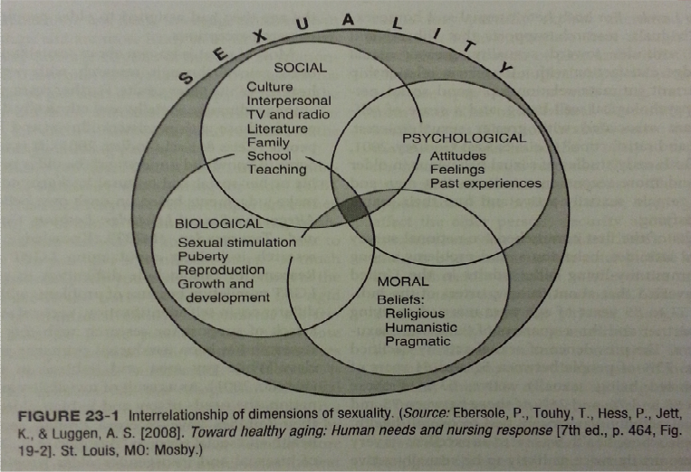

- SOCIAL
  - Interpersonal relationships, culture, media, literature, parents, family, school, teaching
  - E.G. censoring conversation, feeling uncomfortable talking about certain subjects, etc.
- PSYCHOLOGICAL
  - Attitudes, feelings, etc. towards themselves or others
  - Learn a lot from experiences
- BIOLOGICAL
  - Physiological responses to sexual stimulation (e.g. puberty changes, reproduction)
- MORAL
  - Beliefs: religious, humanistic, pragmatic
  - What do you think is right or wrong?
  - What should you do? What should you not do?

Sexuality and Older Adults
- Old age thought of as a period devoid of sexuality, sensuality, and intimacy
- Societal attitudes which consider sexuality in older age as abnormal, perverted, or disgusting
  - Name-calling: pervert, eunuch, “dirty old man”, pig, etc.
- Older persons seen as less physically attractive and sexually appealing due to changes associated with primary aging
  - Sagging skin
  - Changes definitely do take place as you get older
- Sexuality in older persons shifts its focus from procreation to companionship, physical closeness, intimate communication, and pleasure-seeking
- Aging itself does not lead to sex-related problems; while, medical/psychological problems, and absence of partner may.

Sexual Health
- Sexual Health: a state of physical, emotional, mental, and social well-being related to sexuality
  - Individually-defined, and sexual behaviour has the capacity to enhance self and others
- “Many men and women engage in vaginal sex, oral sex, and masturbation well into their 80s and 90s. Significant gender differences appear as older women are more likely to be limited by the availability of a partner and older men are more likely to be limited by physical health and erectile dysfunction.”

“Sexed-up seniors do it more than you’d think”
- A study: participants aged 57-85
- New England Journal of Medicine
- Found that society has a very negative view of old people and sex
- 2 hour face to face interview with 3000 men and women
  - Took blood, saliva, etc. samples to find out hormone levels, etc.
  - Gathered information about health issues that people may be experiencing
  - Took information about sexually-transmitted infections
  - Took sensory information (how well could they see, taste, hear, and smell? This influences sexual activities)
  - Interest in sex does decline a little bit when people are in their 70s, but more than 25% of those individuals up to age 85 reported having sex in the previous year
  - More than 50% of those between 57-75 said they gave or received oral sex in the previous year
  - About a third between 75-85 said that they also gave or received oral sex in the previous year

Some Results from Sex Survey with Seniors:
- Sex with a partner in the previous year was reported by
  - 73% of people ages 57-75; 53% of people ages 64-75, and 26% of people ages 75-85
- Sexually active participants reported that they had sex 2-3 times a month or more
- Women at all ages were less likely to be sexually active.
- People in excellent or very good health were twice as likely to be sexually active
- Biggest factor in whether or not they had sex was the male partner’s health
- Half of people having sex reported at least one related issue:
  - In men, erection trouble (37%); in women, low desire (43%), vaginal dryness (39%), and inability to have an orgasm (34%)

Many Seniors have Active Sex Lives:
- Later, will talk about sex positions

Sexuality and Aging: Neglected Issues
- Sexuality with or without a partner, diversity in sexual orientation, cross-cultural perspectives, changing relationships, and influence of the Internet and social media
- Sexual functioning within the context of chronic conditions, disability, medication use, and sexually transmitted infections
- Sexuality in long-term care, assisted living, hospitals, and other institutional settings
  - Lack of privacy
  - Physical issues (e.g. single bed)
  - Question person’s ability to consent to sexual activity, depending on cognitive issues
- Sexual consent capacity among older adults with cognitive impairment or dementia
- If interviewing about sexuality, ask open questions to include diversity (e.g. not “Are you married” -> “Do you have a partner?”; “What sexuality do you consider yourself?”)
- Older women’s issues: body image, vaginal dryness, breast cancer, and abuse
- Older men’s issues: erectile dysfunction, prostate cancer, and body image

Sexual Dysfunction
- Sexual Dysfunction: impairment in normal sexual functioning, which can result from many causes, physical and/or psychological
- Men: E.D.: Inability to achieve or sustain an erection that is sufficient enough for satisfactory sexual intercourse; can be a complication from diabetes, alcohol abuse, depression, hormonal changes, use of certain medications (side effects), and prostate disease/treatment
  - Common problem among men older than 50 years of age
  - Prevalence of E.D. increases with age
  - 30% of men between 40-70 may experience E.D.
  - Nearly 80% of men 70 and older may experience E.D.
- Women:
  - Change in sexual response
  - Lack of desire to engage in sexual activity
  - Vaginal dryness (pain in sexual intercourse)
  - Causes: medication side effects (e.g. antidepressants, cancer therapy), stress, surgeries, and urinary incontinence)
- 4 Categories:
  - Hypoactive sexual desire disorder
  - Sexual arousal disorder
  - Orgasmic disorder
  - Sexual pain disorders
- Consider impact of chronic conditions:
  - E.g. arthritis, heart disease, stroke, respiratory conditions, diabetes, cancers

Sex Tips in Older Adults:
- Communicate openly about sex-related issues
- Use a lubricant
- Try a new position (avoid other positions; consider impact of chronic conditions)
- Explore and discover (including alternatives to intercourse)
- Make love when energy level is highest (e.g. morning)
- Get some extra assistance
- Defy convention and disregard negative stereotypes
- Set the mood
- Build up to it by engaging in extended foreplay
- Increased genital stimulation

Sexual Devices:
- Five-speed Finger Vibe
  - Fits all fingers
  - Lightweight
  - Doesn’t require active grasp, so good if grasping is a problem
  - Needs a bit of wrist strength
  - Doesn’t require a lot of energy
- Hitachi Magic Wand
  - Vibrator
  - Requires wide grasp and strength (it’s heavy)
  - Good for people who can’t extend their arms very far
- Adapted Undergarments
  - Can ask PSW to put it in for you if you have restricted movement, then you can use it independently
  - Must address sanitation issue
  - Can be controlled with a remote
- Vibrating Device with Remote Control
  - Has a remote control
  - Lightweight
Bed and Furniture
- Double Bed with Bed Rails
  - Safe for sex (prevent falls)
  - Long-term care facilities might have single beds so this makes it difficult
  - Bed rails help with safety
- Cushions
  - High-end cushions that don’t move easily
  - Easy to clean (good for sweat or other bodily fluids)

October 24, 2014
Retirement and Financial Issues: Influence on Older Persons, and Factors Affecting Adjustment
- When thinking about retirement, people tend to think about no more work, money changes, being able to do what you want to do when you want to do it
Retirement
- Defining retirement
- Concept of retirement
- Model of retirement
- Transition
- Financial Consideration

Defining Retirement
- “act of retreating”
- “act of withdrawing into seclusion”
- “privacy”
- “withdrawal from occupation or business”
- May not be totally accurate, as people may not seclude themselves when they retire; they may keep a job just to be around people (e.g. a wal-mart greeter), and may be considered “semi-retired”

Retirement is:
- An important economic institution
- An event
- A process
- A complex stage of life
- A state of mind
- Very interesting, as people continue to develop past this stage; lots of new research
- There are certain ways of looking at life and self when you get close to retirement
- Some people deal with it better than others depending on their circumstances
- This can affect how we think about retirement

Individual and Societal Factors Influencing Retirement Decisions and Lifestyle
Individual Factors
- Work history (regular/irregular, part-time/full-time)
- Partner’s work history and age
- Economic status (earnings, savings, investments, entitlement to public and private pensions)
- Health status (perceived/objective)
- Leisure interests and experiences
- Informal support
- Attitudes about retirement
- Personal Factors
  - Age
  - Sex
  - Social class
  - Education
  - Race or ethnicity
  - Marital status (ie. Consider divorce rate of retired individuals(?))

Positive Attitudes are associated with:
- Good health
- High income
- High level of education
- High degree of support re: retirement from significant others and peers at work

Negative Attitudes are based on:
- Fear of financial difficulties
- High degree of interest and satisfaction with work
- Retirement can be viewed as an unwanted crisis that must be postponed or avoided
- Other reasons:
  - Wanting to stay in workforce for social reasons
  - Retirement reminds them of own mortality; seems like a “death sentence”

- To help people adjust to retirement, some employers offer pre-retirement programs
- Discussion with HR resource personnel
- Comprehensive educational programs
  - Finances, health, post-retirement options, leisure opportunities and community resources

VIDEO: Pre-Retirement Discussion
- 4 crucial conversations every couple needs to have preceding retirement
- Very very influential transition
  - Big change: different job; different schedules
- Need to get assumptions and beliefs on same page

- Resources Conversation
  - Reality that resources are going to dwindling a bit; insurance and budget need to be discussed and planned; rate of spending; in-flow and out-flow; expectations, needs, and wants
- Time Conversation
  - You’re going to be around each other ALL the time and that’s going to be a huge adjustment (might fight a lot or be bored)
  - How much time alone do you need every day?
  - What times are sacred (ie. We should be together at those times)?
  - How will weekends be different?
  - Remember that you can love each other, but go away from each other occasionally – that is healthy
- The Work Conversation
  - How do we distribute household workload/chores?
  - May want to give a bit of a break to the person who USUALLY stayed home and did all the household chores
    - But make sure that the other person doesn’t lose their sense of identity in this process – make sure everyone is happy with distribution
  - Switch roles (ie. Who plans parties, who pays the bills, etc.)
- The Legacy Conversation
  - How do you want to be remembered?
  - What motivates you at this stage of life?

Integrated Model of Retirement Adjustment
- Based upon the Life Course Theory
  - LCT asserts that both contextual and psychological factors need to be considered in order to understand the consequences of lifespan transitions (retirement represents a significant transition)
  - Examine the individual, organizational, psychosocial factors of an individual to understand the adjustment for that person
- The following factors influence retirement adjustment:
  - Individual
    - Demographic (The longer someone has been retired, the happier they tend to be because they’ve adjusted to it) and health characteristics (gender: women tend to have a harder time adjusting to retirement than men; Report loneliness, depression, lower self-esteem and morale)
  - Psychosocial
    - Mastery and planning
      - Mastery: you have control over what is going on in your life
  - Organizational
    - Conditions of workforce exit
      - Perceived choices in retirement decision (promoted to be more important factor in good retirement outcomes)

- Stage 1: Denial (external focus)
- (shock, attempt to keep busy and pretend they aren’t retired, withdrawal and numbness)
- Stage 2: Opposition (internal focus)
- (anger, anxiety, frustration, depression)
- Stage 3: Exploration (internal focus)
- (searching for meaning)
- Stage 4: Engagement (external focus)
- (energy, enthusiasm)

Other Options
- Learning in retirement

Retirement Funding in Canada:
- 1 – Public Sector Programs
  - OAS (Old Age Security)
    - Must be 65+ and Canadian citizen or legal resident to be eligible
    - Allocated regardless of work history and marital status
    - Pension paid monthly
    - Amount depends on how long you’ve been living in Canada during adult life (18+); need more than 40 years to receive full amount, or a minimum of 10 years for a partial amount
    - Based on consumer price index
    - For every month that you defer claiming it, you get 0.6% more
      - Encouraging people who CAN defer it will defer it
  - GIS
    - Guaranteed income supplement
    - Additional payment for low-income elderly individuals who receive OAS
    - You get the most if you are single, widowed or divorced, or your spouse does not receive the OAS
  - Allowance
    - Any common-law/married partner (between the ages of 60-64of someone who receives the GIS
    - More money if spouse received full OAS pension AND GIS
    - Allowance for the Survivor – person has a deceased spouse or common-law partner
    - Annual income is less than the maximum annual income
- 2 – Canadian Pension Plan
  - C/QPP
    - All Canadian workers contribute to this plan
    - Split between employer and employee unless individual is self-employed
    - Gives access to retirement pension, post-retirement benefits, disability benefits, etc.
    - Limit to how much you can contribute per year
- 3 – Private Pensions
  - Company Pension Plans
  - Individual Savings Plans

Poverty in Canada
- No specific measure of poverty, just has a low-income cut-off
- Numbers themselves aren’t needed; just need to know trends and how they figure out how to calculate the LICO (low-income cut-off)
- Income threshold below witch a family will likely devote a larger share of its income to necessities of food, shelter, and clothing than an average family would
- 2011: average family spends 42% of income on necessities
  - A LICO family spends 62%
- 2014: family of 1 was $23,647 in a *large city*
  - Bare minimum you can make

Retirement Pension
- Monthly benefit for retired Canadians (except for Quebec)
- Eligibility: worked and made at least one valid contribution to CPP
- Calculated based on numbers of years and amount contributed
- Reduced by 0.56% for each month before the age of 65
- Pension amount increases by 0.7% each month until the age of 70

CPP Investment Board
- Trying to manage and invest Canadian Pension Plan funds
- Trying to make sustainable

VIDEO: Retirement Savings
- Fear of retiring because there is a worry that there won’t be enough CPP to live on
- Public pensions in deficit by 151 billion
- All tax payers will have to pay for this (even those not eligible for the CPP)
- Outrage

Private Pensions
- Individual savings plans with the CRA
- Registered Retirement Savings Plan
  - Use to save money for retirement
  - Non-taxable
- Registered Retirement Income Funds
  - Defer the taxation
  - RRSP is a savings account and RRIF is a spending account
  - Minimum RRIF withdrawal per year
- Tax Free Savings Account
  - 2009: flexible savings account that enables Canadians to earn tax-free investment incomes
  - For Canadian residents 18+
  - Amounts withdrawn are automatically added to your TFSA

October 29, 2014
Sexuality portion incorporated into previous lecture on Sexuality and Aging.
Seniors Activities and Occupations: Self-Care, Productivity, Leisure/Recreation, and Technology:
Disengagement Theory
- It’s normal for people experiencing successful aging to withdraw from some activities that they did before they got old; in fact, it’s “inevitable”
- Critics say that it’s a poor fit with older people – doesn’t consider people being more diverse when they get older
- In the late 1900s, you see people talking about positive gerontology and the idea to positively engage in your lives and activities (more research; people are stronger in old age; people live longer and healthier than before; people have access to more types of activities)
- Biomedical field began making new distinction between regular aging process and secondary aging (disability, disease)

Overlapping: Activity Theory
- In successful aging, the individual should be involved and engaged socially
- Productive aging: refers to how older people make a social or economic contribution to their communities and benefit others
  - They can do this by engaging in things like paid work, volunteering, caregiving, etc.; all are productive ways of contributing to the social and economic fabric of your area
- Civic engagement: highlights older people’s contribution to their community
  - Can be involved by volunteering which is similar to “productive aging”, so there is some overlap
  - Raises public awareness

Both disengagement and activity theory are a concern with successful aging, but in opposite ways:
- Disengagement Theory claims that withdrawal from activities is successful aging
- Activity Theory supports older people engaging in some activities from the past, and disengaging in others – more diverse

Selective Optimization
- People will gravitate in doing activities where they can achieve success
  - This is consistent with their abilities and capacities
    - E.G. blind people don’t have the right to fly a plane because it’s putting other people’s safety at risk
    - Most people who cannot see would not gravitate towards this activity because it isn’t their strength (this is selective optimization), though they may engage in reasonably challenging activities
  - During aging – someone with visual issues or health issues likely would not want to drive a bus after they retire

BADLs
- Basic activities of daily living: are usually activities that you start learning at a very young age (or adolescence) and often require automatic and basic cognitive and physical skills and are usually activities that are for self or personal care
- Early adolescence there because of sexual expression
- Includes personal care, functional mobility, communication, and sexual expression
- Basic Health Maintenance:
  - Knowing when to go to the doctor
  - Breast cancer self-checks
  - Taking vitamins
  - Reading directions on simple medication properly, and following them

IADLs
- Activities or skills you acquire as you get older
- These activities allow you to engage in more successful independent living, and require more complex cognitive and physical skills
  - Managing finances
  - Meal preparation
  - Communication
  - Manage medication (organizing complex medication using instruments)

Meaningful Activity or Occupation
- Cluster of tasks or activities that you put together to give your life more purpose
  - Being a student is an occupation as is reading, though being a student is more meaningful
- Obligated Occupation = taking care of your child
- Three major categories in meaningful occupations
  - Activities for self/personal care
  - Productivity (ie. Contributing economically or through service)
    - Kids = play is productive; older people = caring/working part-time
  - Leisure (Fun)

Autonomy and ADLs
Independence
- Engaging in activities without the support or assistance of someone
- If you need to use a walker to do it, that’s modified independence, since without the walker, you might not be safe moving around in your community
Interdependence
- Can do some things on their own, but need help with certain things
- May just need occasional assistance
Dependence
- When someone cannot engage in activities without full or complete support of someone else
  - Problem: many think only about physical dependence; but this includes cognitive dependence
    - You can be physically independent but cognitively dependent
    - If concerned about ability of an individual to reason and use judgment, so it’s not safe for that individual to be alone

Assistive Devices for Personal Care:
- Reacher
- Long-handled bath sponges
- Sock aid
- Raised toilet seats

Productive Activity
- Issues around social politics
- Organizational institutional policies and how they can be improved or modified in order to increase older people’s access to productive activities
  - A major change: retirement policies
    - There is no mandatory age to retire – if you feel that you’ve been unfairly let go, you can file a complaint

Social and Civil Participation
- These numbers are increasing with age, for the most part
  - Seniors who are socially involved are less isolated and tend to have more close friends
  - 54% of seniors were involved in groups/organizations; 46% for 75+
  - 39% of seniors between 65 and 74 volunteered; contributed average of 250 hours of volunteer work (100 more hours than average for adults between 25-54)
- Rate of group involvement generally drops because of health-related issues
- Decline in volunteer hours also due to health issues
- Volunteer work increases as you get older

Activities and Services for Ottawa Seniors
- Lots!
- People who aren’t well-connected can use businesses where you can order things and have people bring them to your house (e.g. groceries, library books, etc.)
- You can also purchase other services online (e.g. house-keeping, volunteer driver)
  - You can also modify your home, get assistance with IADLs, get items delivered
- Some of these services are free or discounted
- Event calendars

Senior Clubs
- People who are cognitively and physically well and want to make friends with older people
- Vary in cost

Senior Adult’s Centre
- Similar to senior’s club
- People functioning independently and want to just go and hang out
- For people 50+, lots of different activities
- Membership $30/year, may increase depending on activities/field trips
- Promotes productive aging and civic engagement
  - Activities that provide for Heart and Stroke Foundation
  - School breakfast program
  - Help at food bank
  - Run bake sales for cancer society
- Senior clubs and organization, NOT adult day programs

Social Participation/Fun Activities
- Sometimes they need a doctor’s note to confirm they can go on the field trip
- Letter boxing: involves hiking and treasure hunting
- A variety of sports and outdoor activities
- Activities in nursing homes and long-term care facilities need to plan activities by balancing needs and activity levels of all participants
  - Mostly indoor
  - Supervised by multiple people
  - Additional resources needed

Adult Day Program
- Developed for people with disabilities or for individuals who are frail or have cognitive issues
- These people require supervision
- Some programs may specialize in specific group (e.g. adults who have dementia and are living in a community/retirement residence)
  - Class example cost $22/day
Technology
- 27% of seniors go online
  - 80% of the seniors that go online do so at least once a day; 70% view technology as a means to independent living
  - 53% use Facebook
  - 1/5 uses Skype/Facetime
- Computer training and loan of tablet and/or computer available at assisted living facilities or libraries
- Technology used most commonly for staying socially connected, email, reading, shopping, and puzzles
  - Greatest benefit of technology: being socially connective and active
- Health Risks: carpal tunnel syndrome, poor sitting balance, other ergonomic issues, headaches, other balance issues

Canada: Social Media Statistics:
- One of the most significant predictors of internet usage = age
- 94% of those under the age of 45 used the internet
  - 80% of those aged 45-64 used the internet
  - 51% for those aged 65-74
  - 27% for those 75 and over
- Age is a significant indicator of whether or not people go on the internet
- Graph: more and more seniors go online every year

Adapted Computer Technology:
- Larger print keyboards
- Different styles of mouse
- Eye tracking (for people who have disabilities and can’t use hands as effectively)
- Voice recognition software

Global Age-Friendly Cities Project

October 31, 2014
Guest Speaker – Living Conditions/Grief. (NOT ON EXAM)

