COMM 215 Notes
2014-09-03 Class 1
*make things that look good for the teacher for good grades / excel
Descriptive statistics, don’t do anything with the data but present them
Mean: average/moyenne
Population: anything that is a whole ex: the class
Sample: part of the whole: the first row
Sample is used because reaching the whole population is impossible / expensive
Inference: deriving logical conclusions
Try to understand the difference between estimation and hypothesis testing
Look at the data collection techniques and data collection issues to help for the quiz
- Data accuracy: using the right tools / measure
- Non responsive bias: not answering the phone
- Selection bias: you voluntarily select people that agree with your hypothesis
- If the selection bias is involuntary it isn’t seen as one
- Measurement error: not writing down things properly
- Internal and external validity: when you conduct an experiment you have to wonder if you’re fair
- Experimental drugs test: you have to treat both group exactly the same (group with placebo and group with drug) for your experience to be fair and the income to be internally valid. If you control the environment it is internal if it outside it is external validity. The difference has to be an issue to make the experiment not valid.
Numerical from a population=parameter
Numerical from a sample=statistics
Statistical vs nonstatistical
Clusters, logical division of groups (COMM 215 f) among which you randomly choose a sample (students).
Pannel data: cross sectional
1.4 Data types and data measurement levels
Data timing
- Time series: collectable over time about a specific subject over time. Ex: age of average 215 students that you measure each year for 10 year.
- Cross sectional: compare groups for one period of time. Ex: average age of 215 class compared between 2 classes at beginning of fall.

Data type
- Qualitative: descriptive
- Quantitative: numerical
Data levels
- Nominal: Colors, description, name
- Ordinal: list of your favorite for example rankings of teams. If a team is 18th and a team is 9th the team that is 9th isn’t twice as good.
- Interval: Temperature, it is a data without a true 0.
- Ratio: Has a true 0
Chapter 2
ex: 20,20,19,23,22,19,21,23,19,18,20,21,20,18,20,20,19,19,19
Age | Class | RF (relative frequency) | Cumulative frequency | Cumulative relative frequency
18 | 2 | .10 | 2 | .10
19 | 7 | .35 | 9 | .45
20 | 6 | .30 | 15 | .75
21 | 2 | .10 | 17 | .85
22 | 1 | .05 | 18 | .90
23 | 2 | .10 | 20 | 1.00

Putting the percentages next to each other on a graph at their respective position based on age (on the x axis) allows us to determine the slope.
Histogram: the category are related
Bar charts: categories are not related to each other therefore there’s a gap between them anyway you order them is fine see automobile example on page 2-21 of PWP
Stem and leaf diagram
- Put the data in order
18,18,19,19,19,19,19,19,19,20,20,20,20,20,20,22,23,23
2. Organize them (looks like a histogram on the side)
18 | 18 | 18
19 | 19 | 19 | 19 | 19 | 19 | 19 | 19
20 | 20 | 20 | 20 | 20 | 20 | 20
21 | 21 | 21
22 | 22
23 | 23 | 23
Or
10’s | 1’s
1 | 8,8,9,9,9,9,9,9,9
2 | 0,0,0,0,0,0,1,1,2,3,3

The yellow part is the “stem” and the rest is the” leaf”. Both variations work it depends on the data you have to organize. The upper part is a category. You multiply the leaf and the stem by the category.

Chapter 1-3 Reading notes
Chapter 1:
- Business statistic can be segmented in two categories: Describing data and drawing inferences from data (inferential and descriptive)
- Average=mean sum of all data values/Number of data values
- Two type of inferential statistics: estimation and hypothesis testing
- Estimation are based on samples out of which we estimate what the larger data will look like
- Hypothesis testing tests a population to draw a conclusion
- Typical data collection: experiment, telephone surveys, written questionnaires and surveys, direct observations and personal interviews
- Data collection issue: data accuracy (reliable source?), interviewer bias (tone/formulation), Non responsive bias, selection bias (accidental selecting a particular group), Observer bias (judgement error), measurement error (wrong numbers), internal validity and external validity (changing factors for test subjects internal=inside external=outside)
- Frame=population unit of the frame=sample
- Parameter are data that refer to the whole population while statistics refer to data from a sample
- Statistical sampling involves luck while nonstatistical sampling involves a certain decision.
- Sampling with no replacement= if the sample is random one of the participants could not be picked more then once. If they can=sample with replacement.
- Simple random sampling=everyone as an equal chance to be part of the sample
- N=population n=sample
- Random number=assign number to persons that from your sample then select numbers randomly trough excel or random number table
- Stratified random sampling=dividing your population into groups ex: small,medium,large. Then sampling this particular (proportionally) group and adding the information together n1+n2+n3 will be more representative this way
- Systematic random sampling= randomly selected but with an order example you take a list of name and every 40th is part of your sample
- Cluster sampling: Dividing a population into groups and then taking a sample from these groups
- Quantitative=numerical Qualitative=Categorical
- Time series data= analyzing data at multiple points in time
- Cross-sectional data= analyzing data at a fixed point in time ex: march 15 at 16:39

- Nominal: Lowest form, qualitative, names
- Ordinal: Ranking ordered categories, list where no.9 is not twice as good as no.18
- Interval: The distance between two data can be measured
- Ratio data: all the characteristics of interval but it has a true 0

- Data mining= establishing patterns based on data
Chapter 2
- Frequency: number of time it happens
- Relative frequency: percentage
- Discrete data: data that can only take a certain value. Example number of students, you can’t have half a student
- Relative frequency= fi/n fi=frequency of the ith value N=total number of observation
- Frequency distribution can also be qualitative. Ex how many people use dish, direct tv, cable, other
- Continuous data: possible values are uncountable and that may assume any value in an interval

- Rules to form a class:
- Mutually exclusive: classes don’t overlap
- All inclusive: must include all values
- Equal width classes: The distance between the lowest possible value and highest possible value should be equal
- Avoid empty classes

- How to select a number of class 2^{k} is superior to the number of variable (n) k=number of classes.
- Minimum class width Width=largest value-smallest value/Number of classes
- Cumulative frequency=add up frequency
- Cumulative relative frequency=add up relative frequency
- Frequency histogram can help us determine the center/average trough the distribution and the spread. It is a good way to display discrete numerical value
- You can use histogram to display frequency and relative frequency
- You can build a slope for cumulative frequency
- Joint frequency distribution use column and row for 2 distinct variables then get a total
- Bar charts: graphical representation of a categorical data. They are not histograms as histograms are used to present frequency distribution of a same group while bar chart present different groups. They cannot be used for numerical data.
- Pie Chart: displays relative frequency (%) to use a pie chart the sum off all frequency has to be meaningful. If not, use bar chart.
- Stem and leaf diagram: sort numbers then use stem as a measure (10) and leaf as another (unit) then display. See page 60
- Line charts are often used with time series data that are measured over time (monthly, quarterly, annualy)
- Scater Diagram another way to study two quantitative variables simultaneously
- Relationships of x and y on page 67
- Pareto chart is a histogram that shows percentage and cumulative percentage at the bottom
- See scatter diagram

Chapter 3
- Balance point is the mean
- Population=N Sample=n same goes for population mean and sample mean
- While the mean seems like a good way to estimate a middle value it can be affected by extreme measures (really low or high)
- Median: arrange the number in order i= 1/2n if I is an integrer (has to be a round number) if not we round it. In the case of an integrer we take the two numbers surrounding it and divide by 2 for the median or if it lands on one number from both directions we take this number. For example if it is a pair amount of number then you will have an integrer.
- Data can be symmetric or skewed (skewed mean the value are not evenly spread either left skewed or right skewed).
- Mode is another measure of central location. It is the value that occurs the most often. There can be more then one mode.
- Weighted mean should be used when the data value isn’t meaningful by itself
Example: x=wx/w
W=weigth of the ith data value x=the ith data value other w=weight of all values
Income=7600 days=50 Income=3900 days=30
7600x50+3900x30/50+30
- Percentiles: 50th percentile is the median i=(p/100)(n) where p is the desired percent and n the number of values in the data set. I corresponds to the position of the percentile (ex 31st)
- Quartile=25%
- Box and whisker plots incorporates the median and the quartiles (see instruction page 96) allows us to see and eliminate irrelevant outliers
- Mean should never be used with nominal data and it is contested as if it should be used with ordinal data instead you should use the media for interval data.
- If the mean and median are equal the distribution will be symmetrical
- Types of variation: range, interquartile range, variance and standard deviation.
- The range is simply the maximum value- minimum value it is flawed if there is extremes in our data
- Interquartile range is equal to third quartile range (75)-first quartile range (25)
- For a percentile if it is a round number you take the data value and the data value above then divide them by 2 to find the quartile if it an integrer. If it isn’t a round number you take the data value above ex 171.25=172.
- Variance: https://www.khanacademy.org/math/probability/descriptive-statistics/variance_std_deviation/v/variance-of-a-population The variance is how much data varies from the mean
- Standard deviation: The result of the square root of the population variance.
- Sample variance and sample standard deviation: same but instead of N: n-1
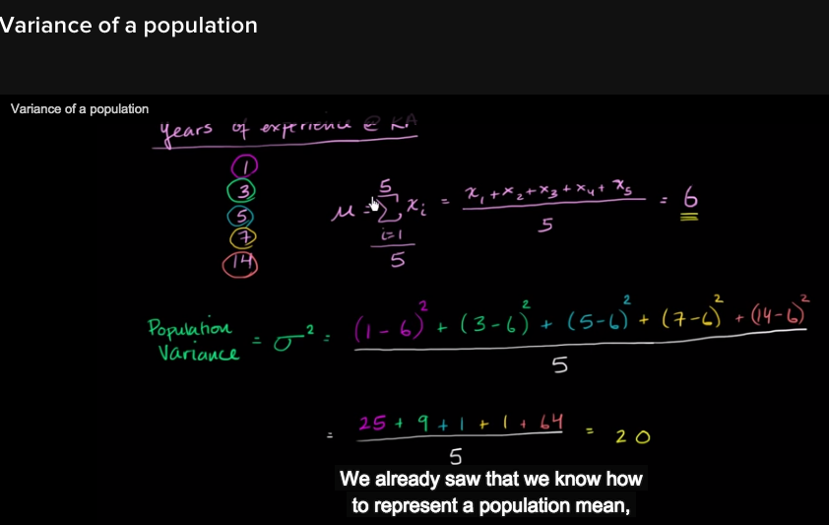
In this example population variance is 20 and its square root will be the standard deviation.
- Check the other way to calculate standard deviation in the book (p.107)
- Coefficient of variation: the ratio of the standard deviation to the mean expressed as percentage. Used to measure variation relative to the mean.
See Page 114 for formula
- σ=standard deviation
- μ=symbol for population mean (not sample mean x bar is a sample mean)
- http://www.rapidtables.com/math/symbols/Statistical_Symbols.htm
- Empirical rule 1 SD=68% 2SD=95% 3SD=97.5% only apply when bell shaped
- Tchebysheff theorem when not bell shaped or if you don’t know the distribution at least 75% within 2 SD at least 89% within 3 SD The rule is least (1 - 1/k²) K is the number of SD
- Standard data value or z score = the number of standard deviation in the result.
Review question 28
Review question 29

2014-10-09 Class 2
Chapter 2 (rest)
- Line chart
- Scatter diagram is not an indication of trend over time.
- X = independent y=dependant
Chapter 3
- Measures of center and location: Mean, median, mode, weighted mean
- Data is not measure
- Mean is good because it represent everyone but bad because it is affected by extreme numbers it is the most often used in case of outliers
- Median is not affected by extreme number but it doesn’t really represent the whole group
- Mode: Does not represent the population very well, you can also have no mode. Good to determine which is most likely to occur
- If you score in the 68 percentile you’re above 68% of the population
- Q3 – Q1= IQR
- If while doing box and whisker you get a negative value you still indicate it even if it goes beyond the scope of the data.
- Outliers will be outside the wiskers. Then you can choose what you want to do with the outliers. You can delete them or keep them then use what you get to calculate stuff like the mean, the median or the mode.
- 4=q3-q1
- q3+1.5x4= p.21 of pwp should be -4 and 12
- Range is sensible to extreme value
- n-1 (degree of freedom) (not in the exam)
- If CV is too big it shows the standard deviation is not relevant
- Standardization (z-score) allows us to compare data that are do not have the same unit or if one is too big to be compared to another

Reading chapter 4 Introduction to probability
- Probability: the chance that a particular event will occur ranging from 0 to 1.
- 0= Will never happen 1= always happen
- Experiment: A process that produces and outcome whose results cannot be predicted with certainty. (ex: flipping a coin)
- Sample space (SS): The collection of all outcomes that can result from a selection, decision or experiment. Every result you could get from an experiment (ex: heads or tail)
- Outcomes: e₁, e₂, e₃ … The sum of all outcome is equal to ss
- Mutually exclusive event: two events are mutually exclusive if the occurrence of one event precludes the occurrence of the other event; two events are mutually exclusive if they have no common outcome.
- Independent events: one happening does not affect the chance of the other event happening
- Dependant events: two events are dependent if one event impact the probability of the other happening
- P( E_{i}) =Probability of event Occurring
- Classical probability assessment: The method of determining probability based on the ratio of the number of outcome or event of interest can occur to the number of ways any outcome or event can occur when the individual outcomes are equally likely. Sometime this method cannot represent a situation really well for example: a business can either be a success or a failure but the odds of either happening is not ½.

P( E_{i})= Number of ways E_{i} can occur / total number of possible outcome
Ex: P (heads) = 1 / 2 =0.50

- Relative frequency assessment: the method that defines probability as the number of times an event can occur divided by the total number of times and experiment is performed in a large number of trial. See page 147 for example. The issues with this technique are that all of the observed frequencies must have the same conditions. Secondly the size of the denominator has to be large enough to be relevant.

P(E_{i})= Number of times E_{i} can occur / N N=Number of trials

- Subjective Probability Assessment: the method that defines probability of an event as reflection a decision maker’s state of mind regarding the chances that the particular event will occur.
- Probability rule 1: Probability of an event occurring is always between 0 and 1.
- Probability rule 2: All possible outcomes associated with an experiment form the sample space (SS) Therefore the sum of all possibility outcome is 1.

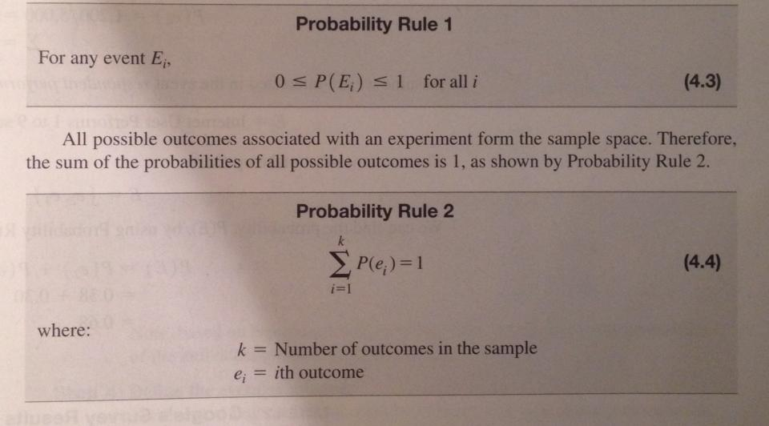
- Probability rule 3: if a single event is composed of two or more individual outcomes then the probability of the event is found by summing the probabilities of the individual outcomes.
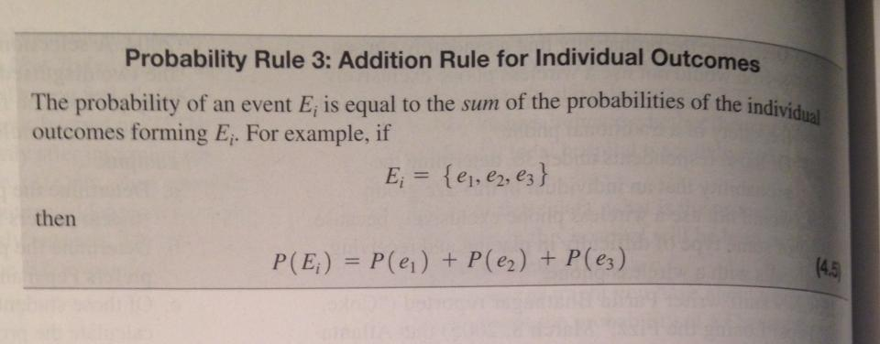

- The complement rule: The complement of an event E is the collection of all possible outcomes not contained in event E.

P (É) = 1- P (E) (É is E with a bar on it)

- Probability rule 4: Addition Rule for any two events E₁ and E₂. Use this in case of joined frequency and marginal frequencies
Example: picking a women and picking someone with glasses. Then picking a women with glasses could be E1 and E2.

P (E₁ or E₂) = P (E₁) + P (E₂) – P (E₁ and E₂)

- U = Union (Sum of the two) the “U” upside down means and.
- Probability rule 5 Addition rule for mutually exclusive element:
P (E₁ or E₂)= P (E₁) + P (E₂)
- Rule 6 Conditional probability: probability that an event will occur given that some other event happened. P (E₁ E₂) Reads probability of E₁ given event E₂ has occurred. Ex: what is the chance of choosing a woman given that the person chosen is wearing glasses? Women/Glasses 4/10 the condition is always the denominator

P (E₁ E₂) = P (E₁ and E₂) / P (E₂)
- Tree diagram: way of organizing the events of an experiments
- Conditional probability for independent events: Ex: Probability of men having beard

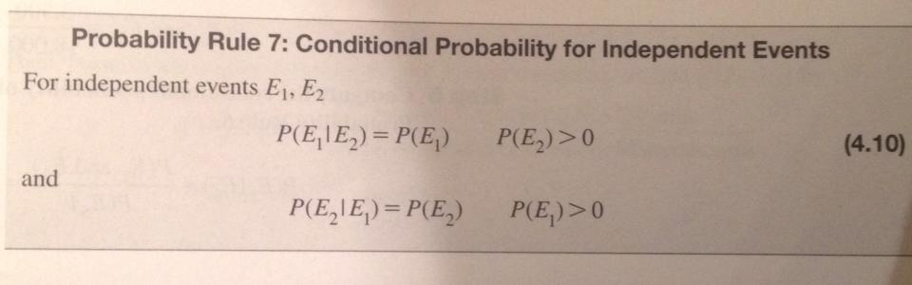
- Rule 8: Multiplication rule for any two events:
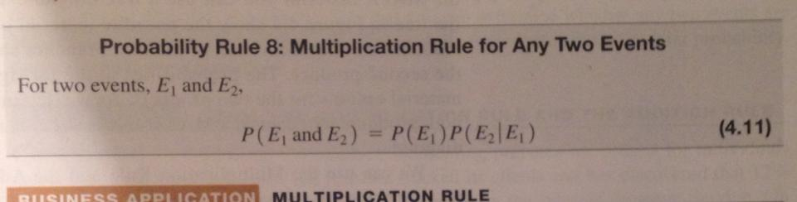
- Probability Rule 9: Multiplication rule for independent events
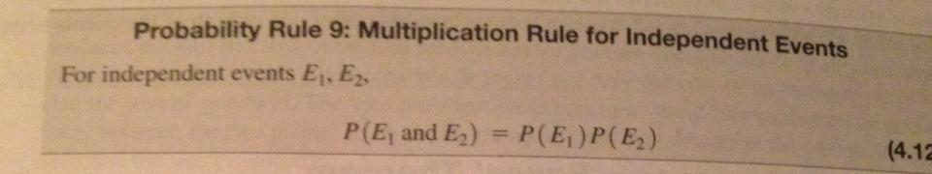

Notes 2014-09-16
- Mutually exclusive event: If something happened the other one couldn’t happen.
- Mutually exclusive event are by definition dependent event.
- Subjective probability: estimate
- Not = 1- P (E)
- Or = +
- And= x
- Given that, of the, from the, = division

- When its or:
- Mutually exclusive: Probability of a + probability of b
- Not mutually exclusive: Probability of a + probability of b – Probability of a and b

- When its and:
- Independent: Probability of A and B which is equal to (probability of A) X (Probability of B)
- Dependant: Probability of A and B is equal to (probability of A) X (probability of A given that event B has happened)
P.171-172
4-30
a)27%
b)35%
c)2.3%
d)77.6%

Problem 4-32
Win hotel=40% Lose Hotel=60%
Win Building=25% Lose Hotel=75%
 | Win Building | Lose building
Win Hotel | 10% | 30% | 40%
Lose Hotel | 15% | 45% | 60%
 | 25% | 75% | 100%

a) 10%
b) 55%
c) 45%
Problem 4-35
Men who ask=42% men who don’t ask=58%
Women who ask=61% women who don’t ask 39%
Man: 48.2% women 51.8%
 | Ask | Not Ask
Men | 20.2 | 28 | 48.2%
Women | 31.6 | 20.2 | 51.8%
 | 51.8 | 48.2 | 100%

  - 31.6%
  - 51.8%
  - 39%
Problem 4-41
Sport preferences | College Degree | No College Degree
NBA | 40 | 55 | 95
NFL | 10 | 95 | 105
 | 50 | 150 | 200

- 52.5%
- 20%
- 20% (10/50)
- No. They are dependant. (50/200) is not equal to (40/95)

Reading Chapter 5.1,5.2 and 6.1
5.1
- Binominal distribution, poisson distribution and hypergeometric distribution are all discrete probability distributions.
- Random variable: a variable that takes on different numerical values based on chance there are two types:
- Discrete random variable: a random variable that can only assume a finite number of values or an infinite sequence of value such as 0,1,2,..
- Continuous random variable random variables that can assume an uncountable infinite number of value.
- The mean of a discrete probability is called the expected value it is actually a weighted average. Formula on page 185. Multiply every x by its own probability.
- The standard deviation measures the spread of the value p.185-186 for example. “The standard deviation is the average distance from the mean?”
- Learn CV in the book percentage difference from the mean.

5.2
- A probability distribution is called theoretical when the mathematical properties of its random variable are used to produce its properties
- Binominal distribution: describes the process whose trial only has two possible outcomes. Ex: every item is labeled defective or capable. For the experience to be binominal there has to be:
- Two possible outcomes
- A fixed number, n, of identical trials.
- The trials of the experiments are independent (one does not affect the chance of the other)
- The process must be constant in generating successes and failures. That is the probability p associated with a success remains constant from trial to trial.
- If p represents the probability of success then (1-p)=q is the probability of failure.
- Counting rule for combinations allows us to count the sample space for binominal with large sample size. Rule on page 193.
- Binominal formula p.194
- Mean and expected value of binominal distribution p.197
- Standard deviation of the binominal distribution p.199
Chapter 6.1 Introduction to continuous probability distribution
- Use for continuous variable
- You can’t compute the probability for a continuous variable because it would technically be 0.
- Probability density function
- X=any value of the continuous random variable, o=Population Standard deviation, Pi=3.14159, e=base natural log=2.71828, u= population mean
- We won’t need this formula because we will be given the table
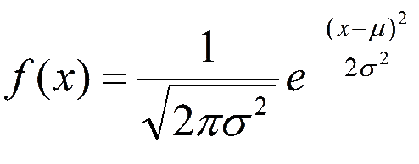
- The Standard normal distribution: A normal distribution that has a mean=0 and a standard deviation=1. The horizontal axis is scaled in z value that measures the number of standard deviation a point is from the mean. Value above the mean have positive z-values and values below the mean negative.
- 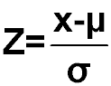z=scaled value (the number of SD a point x is from the mean)
- Applying this formula in a problem will tell us how far from the mean a sample is in terms of Standard deviation.
- Standard Normal Table in Appendix D (p.230) provides the probability based on the Z-Value (from 0 to 3.09)
- Approximate areas under the normal curve is slightly different then the empirical rule. 2SD=68.26%, 4SD=95.44%, 6SD=99.74% (pair because one SD on each side)
- If you go above the table, like 7 standard deviation above you answer relatively 0 chance.

2014-09-23
- Back on chapter 4
- If things are independent you can multiply numbers on the side to find the percentage inside the table.
- Chapter 5
- Discrete random variable includes negatives
- Formulas are all in PWP
- You take 17 shots and you want to take 4 of them.
N=17 x=4
17! / 4! (17-4!) =2380 represents the different numbers we can choose.
- N=5 shots P=80% q=20%
P (he makes exactly 3 shots)
Ex: mmmoo, mmomo, oommm, omomm…
.8x.8.x8.x.2x.2=0.02048 (same odds for every combination)
5! / (3!(5-3!))(0.8)³ (0.2)² =0.2048
- Remember that if its simpler to find probability of 20 and doing -1 instead of probability less then 20.
P.200 5-32
N=6 p=0.30 q=0.70
a) p (x equal or less then 1) =p(x=0) + p(x=1) (6!/(0!(6-0)!))0.3⁰0.7⁶) + (6!/(1!(6-1)!))0.3¹0.7⁵)
b) p (x equal or more then 2)

Chapter 5 review

1.Midterm. We have 5 students, n=5. Probability of passing the exam is 70%, p=70%. So fail is 30%, q=30%
Probability of 2 people passing?
5!/2!(5-2)!=10
There are 10 combinations for 2 students to pass
10 (0.70)² (0.30)³ = 13.23%
I we are looking for a really specific sequence then we don’t do the factorial part.
2.Probability of at least 2 passing? Do the same work as for last problem but for 2,3,4 and 5 then add them up.
Chapter 6 review
Normal curve: the mean, median and mode are equal
Its asymptotic, it will never reach 0% chance.
u=100 o=20
a. p(x superior or equal to 130)
Step 1: convert to z values:
Z= (x-u)/o = (130-100)/20 = 1.5
Step2. Find the probability for 1.5 which is = 0.4332
Step 3: 0.4332+0.500=.9332
1-.9332=0.0668 the answer is 6.68%

b. p (x is less then 90) z= (90-100)/20 = -0.5
19.15% from the mean
50-19.15=30.85% chance.
Chapter 6 review
Chapter 7 (assumtpions)
- When you take a sample, it will always have a different mean then the population. You always want to make this sampling error as small as possible.
- The sampling distribution is all the possible values of a statistics for a given sample size.
- Standard deviation of a sample means: this is how the samples means are different from each other we divide it by square root of “n”
- The central limit theorem: your sampling distribution will always be bell shaped no matter what your population looks like.
Chapter 8
- Confidence interval
- Our best guess at what the population average is call the point estimate
- Were going to have 4 situations
 |  | SD is known (σ) | SD is unknown (σ)
N is more or equal to 30 |  | z | z or t
N is less then 30 | z | t
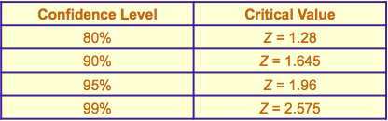

Chapter 9
Alpha (a) is equal to the probability of type 1 error that means you reject the null when it’s true. 0.05 alpha mean that’s there is only 5% chance of doing a type 1 error.

Chapter 13: goodness of fit tests and contingency analysis
We assume that population are normally distributed with a sampling error but when can we start assuming that the mistake is too big to be a distribution error?
Chi square goodness of fit test: the logic behind the test is to determine how far the actual observed frequency is from the expected frequency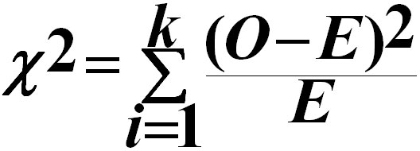
Null hypothesis: H₀ (original hypothesis)
Alternative hypothesis: H_{A} (other explanation)
Sample size should be around 30

