Chapter 9 Personality, Cultural, Values and Ability

Personality
-an individual’s characteristic patterns of thought, emotions, and behavior; reflects what people are like and creates their social reputation
-personality is a collection of multiple traits
-use adjectives called traits

Cultural Values
-shared beliefs about modes of conduct in a given culture, that influence the development of personality traits

Ability
-relatively stable capability people have to perform a particular range of different activities

What do these individual characteristics tell us?
-Personality/Cultural Values: capture what people are like as individuals
-Ability: captures what people can do as individuals
-The Big Five

Figure 9-1 Trait adjectives associated with the Big Five

The Big Five Personality Factors (CANOE)
1. Conscientiousness
-dependable, organized, reliable, ambitious, hardworking, persevering
-Conscientiousness has the biggest influence on Job Performance
-prioritize accomplishment striving
-a strong desire to accomplish task-related goals
-work harder and longer on task assignments
-what kind of jobs would this be helpful in?

2. Agreeableness
-warm, kind, cooperative, sympathetic, helpful, and courteous
-prioritize communion striving
-a desire to obtain acceptance in personal relationships as a means of expressing personality
-focus on “getting along”
-beneficial in some positions, not as beneficial in others

3. Neuroticism
-nervous, moody, emotional, insecure, and jealous (opposite is emotional stability which is what we want in job)

-synonymous with negative affectivity
-tendency to experience unpleasant moods
-most likely to appraise situations as stressful
-less likely to believe they can cope with the stressors that they experience
-strongly related to locus of control: whether people attribute the causes of events to themselves or to the external environment
-neurotic people tend to hold an external locus of control (chance, luck, fate)
-less neurotic people tend to hold an internal locus of control

Table 9-1 External and internal locus of control

4. Openness to Experience
-curious, imaginative, creative, complex, refined, and sophisticated
-also called “inquisitiveness” or “intellectualness”
-valuable in what type of jobs?
-e.g. artistic and scientific fields
-high levels of creative performance
-where employees need to generate novel?

Exhibit 2-5 How the Big Five traits influence OB
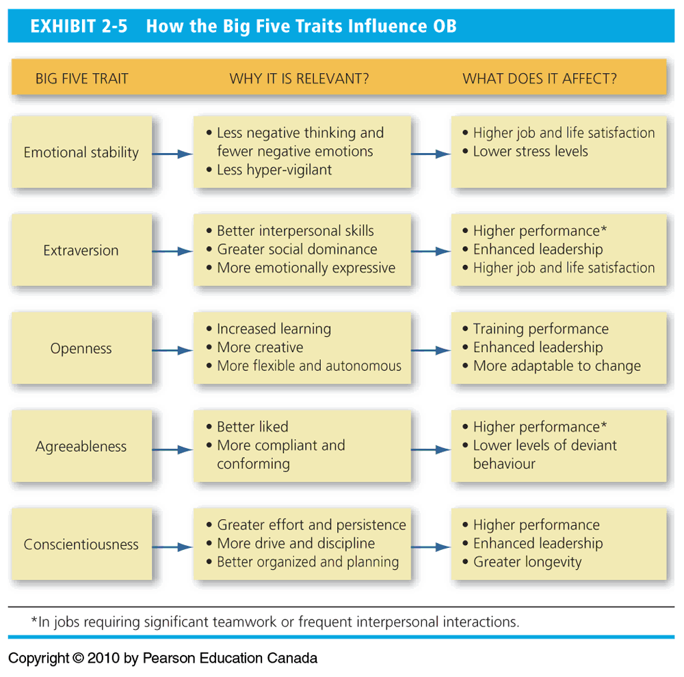

5. Extraversion
-talkative, sociable, passionate, assertive, bold, and dominant
-easiest to judge in zero acquaintance situations
-situations in which two people just met
-Prioritize status striving
-a strong desire to obtain power and influence within a social structure as a means of expressing one’s personality
-tend to be high in positive affectivity
-a dispositional tendency to experience pleasant moods
-e.g. enthusiasm, excitement, happiness
-best suited to what types of jobs?
-e.g. election, public relation, political

Cultural Values
Culture: the shared values, and beliefs that result from common experiences of members of a society
-Transmitted across generations
-Influences the development of our personalities
-Also shapes the way our traits are expressed

Values Across cultures
-Greert Hofstede’s study
-Discovered five basic dimensions

Hofstede Dimensions
1. Individualism/collectivism
-The degree to which a culture has a loosely or tightly knit social structure

2. Power Distance
-The degree to which a culture accepts unequal power distribution

3. Uncertainty avoidance
-The degree to which a culture tolerates ambiguity

4. Masculinity/femininity
- The degree to which a culture values stereotypically male traits

5. Long-term/short term orientation
-The degree to which a culture stress values that are short-term vs long-term
-past and present-oriented vs. future orientation

Table 9-2 Hofstede’s dimensions of cultural values

Exhibit 4-2 Cross-Cultural Comparisons
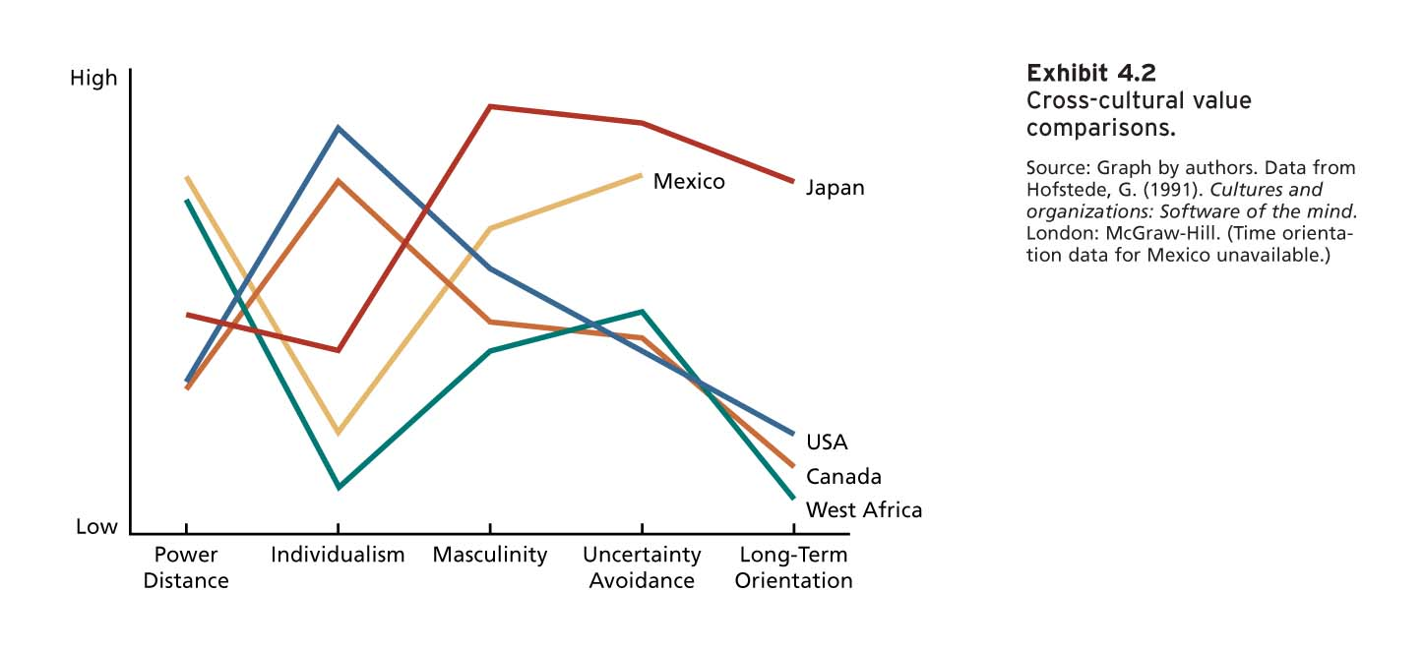
Project GLOBE- 9 dimensions
-Power Distance
-Uncertainty Avoidance
-Institutional
-In-group Collectivism
-Gender Egalitarianism
-Assertiveness
-Future Orientation
-Performance Orientation
-Human Orientation
Why is this important?
-need to avoid “ethnocentrism”
-Cultural differences can influence many things
-reactions to change
-management style
-reward preferences
-we are in a global community!

Figure 9-4 How can we describe what employees are like?

How can we describe what employees can do?
-Ability capture what people can do
-3 general ability categories:
-Cognitive, Emotional, Physical

Cognitive Ability
-Cognitive abilities are capabilities related to the use of knowledge to make decisions and solve problems
-People who are high in verbal abilities tend to be high on reasoning, quantitative, spatial and perceptual abilities

Table 9-3 Types and facets of cognitive ability
1. Verbal 2. Quantitative 3. Reasoning 4. Spatial 5. Perceptual

General Cognitive Ability
Figure 9-5 The G factor

Emotional Ability
-Emotional intelligence: a human ability that affects social functioning
1. Self-awareness: the ability to recognize and understand the emotions in oneself
2. Other awareness: the ability to recognize and understand the emotions that other people are feeling
3. Emotion regulation: the ability to recover quickly from emotional experiences
4. Use of emotions: the ability people can harness emotions and employ emotions to improve their chances of being successful in whatever they are seeking to do

Physical Ability
1. Strength: the degree to which the body is capable of exerting force
2. Stamina: the ability to engage in prolonged physical activity
3. Flexibility: the ability to bend, stretch, twist, or reach
4. Coordination: the quality of physical movement
5. Psychomotor: the capacity to manipulate and control objects
6. Sensory: capabilities associated with vision and hearing

Figure 9-6 What does it mean for an employee to be “Able”?

How important is personality?
Conscientiousness affects job performance.
-Key driver of typical performance
-performance in the routine conditions
-More likely to engage in citizenship behaviors
-Tend to be more committed
Ability is driver of maximum performance
-performance in special circumstance that demand a person’s best effort

