Chapter 6 Motivation
What is Motivation?
-The extent to which persistent effort is directed toward a goal

Motivation determines:
-intensity of effort
-persistence of effort
-direction of effort (towards organizational goals)

Types of Motivation
1. Intrinsic Motivation
-motivation that stems from the direct relationship between the worker and the task
Doing something because it is inherently interesting or enjoyable
-task performance serves as its own reward
2. Extrinsic Motivation
-motivation that sense from the work environment external to the task itself
Doing something to get a rewarded
e.g. promotions

Theories of Work Motivation
1. Expectancy Theory
-A theory that describes the cognitive process employees go through to make choices among different voluntary response
Premise: people will be motivated to perform work activities that they find attractive, feel they can accomplish, and lead to valued outcomes
-employees need to see clear links between effort, performance and outcomes
-based on the perceptions of individual worker

Figure 6-2 Expectancy Theory
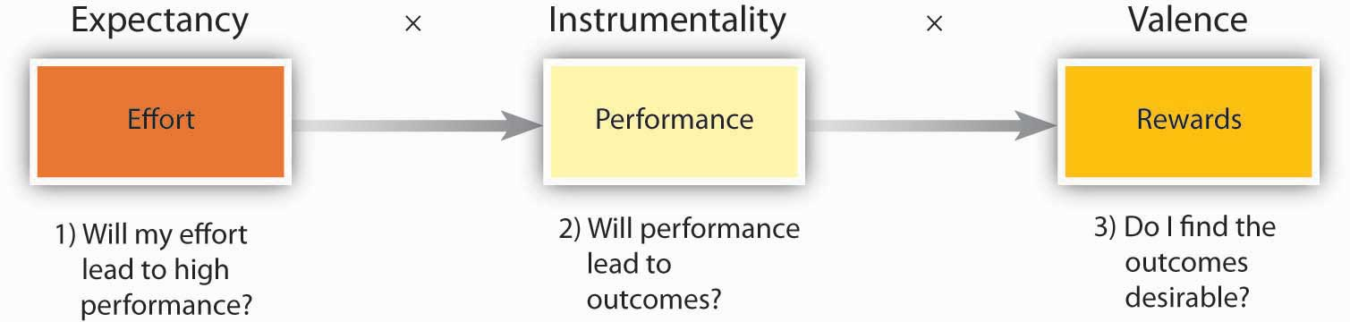
1) Expectancy
-belief that high level of effort will lead to successful performance (E→P)
-subjective probability, ranging from 0 to 1 (1=100% chance of success)
-Affected by Self-efficacy
-the belief that a person has the capabilities needed to succeed
-past accomplishment, vicarious experiences, verbal persuasion, emotion cues
2) Instrumentality
-the belief that successful performance will result in some outcomes (P→O)
-subjective probability, ranging from 0 to 1 (1=100% chance of success)
3) Valence
-the degree to which an outcome is valued by individual which related to performance
-can be positive, negative or zero (0 to 10)

What makes some outcomes more “positively valence” than others?
-Outcomes are deemed more attractive when they help satisfy need
-Needs: outcomes that have critical psychological or physiological consequences
-growth opportunity has higher positive valence

Commonly Studied Needs in OB
Maslow’s Hierarchy
-Self-actualization
-Esteem
-Belongingness
-Safety
-Physiological

The Expectancy Theory
-The total direction of effort: Motivation Force=
(E→P)*[∑(P→O)*V]
-Motivational force equals zero if any one of three beliefs is zero

Goal Setting Theory
-Goal setting theory views goals as the primary drivers of the intensity and persistence of effort
-Assigning employees specific and difficult goals will result in higher levels of performance.
Whys specific?

Figure 6-3 Goal Difficulty and Task Performance
-goal difficulty increase cause task performance increase till the difficulty reach the level of “impossible”, the task performance decrease

Assigned versus Self-Set Goals?
Need to affect people’s self-set goals:
-the internalized goals that people use to monitor their own task progress
-Increases the intensity and persistence of effort
-Can trigger the creation of strategies

What can we do as Managers…?
Affect moderators on task performance

-Feedback - updates on employee progress toward goal attainment
-Task complexity - how complicated the task is (information, degree of change, actions)
-Goal commitment - degree to which a person accepts a goal and is determined to try to reach it
e.g, SMART GOALS

Goal Setting Theory Figure

Equity Theory
-motivation also depends on what happens to other people
-Compare the inputs one invests in a job and the outcomes one receives in comparison to the inputs and outcomes of another person or group

Equity exists when:
$$\frac{My outcomes}{Other’s outcomes}=\frac{My inputs}{ Other’s inputs}$$
-Compare ourselves to a comparison other

“Cognitive calculus”
-Any imbalance in ratios triggers equity distress— an internal tension that can only be alleviated by restoring balance to the ratios.

-3 Possibilities…
Figure 6-5 Three Possible Outcomes of Equity Theory Comparisons

Psychological Empowerment
The belief that work tasks contribute to some larger purpose
-Meaningfulness
-the degree to which one feels that work tasks contribute to society
-Self-determination
-a sense of choice
-Competence
-a belief in ones ability to perform work tasks successfully (= self- efficacy)
-Impacts
-reflects the sense that a person’s actions “make a difference”; making progress
Figure 6-6 Why are some employees more motivated than others

How important is motivation?
The research shows…
-Motivation has a strong, positive effect on Job performance
-Strongest job performance effect is self-efficacy / competence
-Difficult goals are the second most powerful motivating force
-The motivational force described by expectancy Theory is the net most powerful
-Perceptions of equity have somewhat weaker effect on task performance

