Business Fundamentals
September 11, 2015
Chapter 1
Problem = money (sleepy = coffee companies $$)
Puzzles vs. Messes – puzzles only one solution, while messes are multiple solutions. Puzzles are safest because they have monopoly.
Competitive Advantage – when a business is capable of doing more than other businesses
Expenses:
Fixed – whether you sell or don’t sell (rent)
Valuable cost – coffee cups
Goods – tangible products
Services – are intangible products
Risk chance for a negative thing to happen, chance of loss, the degree of probability of loss, the amount of possible loss.
- Car alarm on new car vs. old car
Opportunity Cost – coming to class rather than sleeping (the cost of losing sleep)

September 18, 2015
Offshoring – entails sourcing part of the purchased inputs outside of the country.
Outsourcing – means contracting with other companies to do some or all off the functions of a firm. E.g., painting company gets contract with another company to paint houses (they take part of the jobs you use to do)
Non-profit Organizations – don’t care about money, though need good cash flow.
Always benefits and disadvantages to working or owning a company.
- Owning faces higher risk
- Working for a company does not make as much compared to owning, if the company is doing well
Factors of production:
- Land
- Labour
- Capital goods
- Entrepreneurship
- Knowledge (experience = knowledge)
Data vs. information (raw meaning)
Business environment
- Legal environment
- Economic environment
- Technological environment
- Competitive environment
- Social environment
- Global environment
LET’S GO … take out O and put C
Chapter 2
September 18, 2015
How Economic Issues Affect Business
Economics is the decision on how to allocate scarce resources.
- Micro
- Macro
High demand = higher price
If produced lots, the supply goes up and people will be willing to pay less.
Supply – quantity of products that manufacturers or owners are willing to sell at different prices at a specific time.
Demand – quantity of products that people are willing to buy at different at different prices at a specific time.
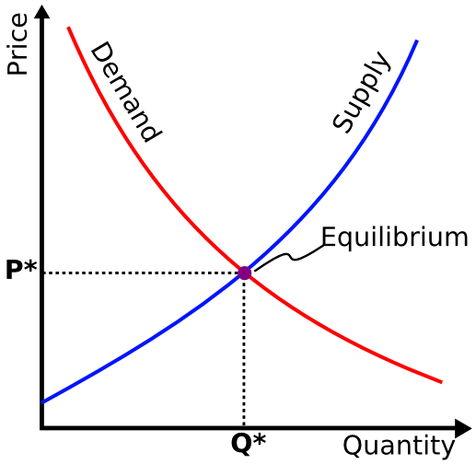 The equilibrium point is where quantity demanded and supplied meet.
Market Price – is determined by supply and demand and equals the equilibrium point in the long run.

Free Market Capitalism
- Economists generally agree that four different degrees of competition exist:
- Perfect competition
- Monopolistic competition
- Oligopoly
- Monopoly
Perfect Competition – exists when there are many sellers in a market and no seller is large enough to dictate the price of a product.
Monopolistic competition – when a large number of sellers produce products that are very similar but are perceived by buyers as different.
Oligopoly – exists when a few seller dominate a market.
Monopoly – exists when there is only one seller for a good or service, and that one seller controls the total supply of a product and the price.
Benefit of free market: - allows open competition among companies. Businesses must provide customers with quality products at fair prices with good service.
Danger of free market: - some people let greed dictate how they act.
  - Major benefit of socialism is supposed to be social equality
  - Socialism takes away some of business people’s incentives to work hard, as their profits will be heavily taxed.
Communism – an economic and political system in which the state (the gov’t.) makes almost all economic decisions and owns almost all of the major factors of production.
  - Communism government has no way of know what to produce because their prices don’t reflect supply and demand as they do in free markets.
Mixed Economies – exist where some allocation of resource is made by the market and some is made by the government.
Canada’s Mixed Economy
- The government’s role is to grow the economy while maintaining some measure of social equality.
- Factors determining Canada’s economic system:
  - One of the largest counties in the world geographically with one of the lowest population densities
  - USA to the south with 10 times the population, more than 10 times the same language, aggressive economically, and most powerful country
Three major indicators of economic conditions:
- The gross domestic product (GDP)
- The unemployment rate
- The price indexes
GDP – the total value of final goods and services produced in a country in a given year.
Unemployment rate – refers to the percentage of the labour force (15 years and over) that actively seeks work but it unable to find work at a given time.
The price indexes help measure the health of the economy by measuring the levels of:
- Inflation – refers to a general rise in prices of goods and services over time
- Disinflation – a situation in which price increases are slowing.
- Deflation – a situation in which prices are declining
- Stagflation – a situation in which the economy is slowing but prices are going up regardless.
Consumer Price Index (CPI) is monthly statistic that measures the pace of inflation or deflation.
Business Cycles – (also known as economic cycles) are the periodic rises and falls that occur in economies over time. These fluctuations are often measured using the real gross domestic product.
    - Four phases of long-term business cycles have been identified as boom, recession, depression, and recovery.
Chapter 3
Over 90% of the companies doing business globally believe it’s important for their employees to have experience working in other countries.
Exporting is selling products to another country
Importing is buying products from another country
Free trade is the movement of goods and services among nations without political or economic barriers
- Global trade enables a nation to produce what it is most capable of producing and to buy what it needs from others in a mutually beneficial exchange relationship.
Comparative Advantage Theory – states that a country should sell to other countries those products that it produces most effectively and efficiently, and buy from other countries those products it cannot produce as effectively or efficiently.
Absolute Advantage – if it has a monopoly on producing a specific product or is able to produce it more efficiently than all other countries.
Balance Trade: ratio of exports to imports
- Exports > Imports Trade surplus
- Imports > Exports Trade deficit
Balance of payments: the difference between money coming into a country (from exports) and money leaving the country (from imports) plus money flows coming into or leaving a country from other factors such as tourism, foreign aid, military expenditures, and foreign investment.
LEFCIF
Licensing, exporting, franchising, contract manufacturing, international joint ventures & strategic alliances, foreign direct investment.
From least amount of commitment, control, risk, and profit potential, to most.
Licensing - a firm (licensor) may decide to compete in a global market by licensing the right to manufacture its product of use its trademark to a foreign company. (The licensee) for a fee (a royalty).
Exporting – Canadian firms can engage in indirect exporting through specialists called export-trading companies that assist in negotiating and establishing trading relationships.
Franchising – a contractual agreement whereby someone with a good idea for a business sells the rights to use the business name and sell a product or service in a given territory in a specified manner.
Contract Manufacturing – involves a foreign company’s production of private-label goods to which a domestic company then attaches its own brand name or trademark.
International Joint Ventures and Strategic Alliances – a joint venture is a partnership in which two or more companies join to undertake a major project. A strategic alliance is a long-term partnership between two or more companies established to help each company build competitive market advantages.
Foreign Direct Investment – FDI buying permanent property and businesses in foreign nations. A foreign subsidiary is a company owned in a foreign country by another company (called the parent company)
Factor affecting trading in global markets:
- Sociocultural forces
- Economic and financial forces
- Legal forces
- Physical and environmental forces
Trade Protectionism – is the use of government regulations to limit the import of goods and services.
    - Supporters believe that it allows domestic producers to survive and grow, producing more jobs.
    - Opponents argue that it not only impedes global trade, but that it also adds millions of dollars to the price of products, costing consumers billions of dollars.
Dumping – is selling products in a foreign country at lower prices than those charged in the producing country
Tariffs: taxes on imports, thus making imported goods more expensive to buy.
Import quotas: which limit the number of products in certain categories that a nation can import.
Embargo: which is a complete ban on the import or export of a certain product of the stopping of all trade with a particular country.
GATT (General Agreement on Tariffs and Trade) – is a global forum for reducing trade restrictions on goods, services, ideas, and cultural programs.
In 1986 the World Trade Organization was established to mediate trade disputes among nations.
Producers’ cartels are organizations of commodity-producing countries formed to stabilize or increase prices, optimizing overall profits in the long run.
Common market (also called a trading bloc) is a regional group of countries that have a common external tariff, no internal tariffs, and the coordination of laws to facilitate exchange among member countries.
NAFTA (North American Free Trade Agreement) – came into effect which created a free-trade area among Canada, the United States, and Mexico.
European Union began in the late 1950’s as an alliance of 6 trading partners, and now is a group of 27 member nations, located primarily in Europe.
Chapter 4
Government activities that affect business may be divided into six categories:
- Crown corp.
- Laws and regulation
- Taxation and financial policies
- Gov’t. expenditures
- Purchasing policies
- Services
When Canada was formed as a country, the federal gov’t was given the power to “regulate trade and commerce”
- A National Policy was developed that placed high tariffs on imports from the US to protect Canadian manufacturing.
Crown Corporations are companies that are owned by the federal or provincial governments (via rail, Canada post corp, etc.)
- They provide services that were not provided by businesses
- To bail out a major industry trouble
- They provided some special services that could not otherwise be made available
Privatization is the process of selling publicly-owned corps.
Deregulation is when the government withdraws certain laws and regulations that seem to hinder competition.
Laws and Regulations
Laws are derived from four sources:
- The constitution
- Precedents established by judges
- Provincial and federal statutes
- Federal and provincial administrative agencies
Constitution defines the powers that can be exercised by the federal and provincial governments. In the event of a conflict, federal powers prevail.
- The primary responsibility of the federal government is to ensure and support the country’s economic performance. (national defence, taxation, unemployment, immigration, criminal law, fisheries, etc)
Industry Canada is the federal agency that administers a variety of laws affecting businesses and consumers. Some of the major federal consumer protection law are:
- Competition act - consumer packaging and label act
- Canadian agricultural - food and drugs act
- Hazardous products act
Under the competition act, it is a criminal offence when two or more competitors or potential competitors conspire, agree, or arrange to fix prices, allocate customers or markets, or restrict output of a product.

Marketing Boards – control the supply or pricing of certain agricultural products to give stability to an important area of the economy that is normally very volatile.
  - Farmers have experienced periods of severe drought, flooding, severe cold, and diseases that affected crops, livestock, and poultry
  - The market also depends on demand from major importers such as china and Russia
Taxation and Financial Policies
- Taxes are how all levels of government redistribute wealth
- Tax revenues allows governments to pay for public services, pay down debt, and fund government operations and programs
- Taxes have also been used as a method of encouraging or discouraging taxpayers
Fiscal Policy – refers to the federal government’s effort to keep the economy stable by increasing or decreasing taxes or government spending.
- Theoretically high tax rates tend to slow the economy as they discourage business ownership, while low tax rates tend to give the economy a boost.
The first half of fiscal policy involved taxation to move the economy in a desired direction
- For example, taxes may be lowered to stimulate the economy when it is weak. Similarly, taxes may be raised to slow down inflation
The second half of fiscal policy involves government spending. If a government spends over and above the amount it gathers in taxes for a specific period of time then it has a deficit
National/federal debt – is the accumulation of government surpluses and deficits over time.
Federal Budget – a comprehensive report that reveals government financial policies and priorities for the coming year.
- Federal budget shows how much revenue the government expects to collect, any changes in income, and other taxes, whether it is a deficit or a surplus is expected.
Monetary Policy – is the management of the money supply and interest rates and is controlled by the Bank of Canada
- When the economy is booming the Bank of Canada tends to raise interest rates in attempt to control inflation. Lowering interest rates will have the opposite effect.
- The Bank of Canada also controls the money supply
- The more money the Bank of Canada makes available to business people and others, the faster the economy grows.
Government Expenditures
- Governments in Canada help disburse tens of billions of dollars annually in old-age pensions, allowances to low-income families or individuals, employment insurance, welfare, workers’ compensation, and various other payments to individuals
- Increasing or lowering the rates of eligibility for these payments results in further fine-tuning of the economy
- All levels of gov’t. offer variety of direct assistance programs to businesses, including grants, loans, loan guarantees, consulting advice, information, and other aids that are designed to achieve certain purposes.
Transfer payments – direct payments from government to other governments or to individuals (eg., elderly benefits and EI)
Equalization – the federal government’s transfer program for reducing fiscal disparities among provinces.
Purchasing Policies
- Governments in Canada are the largest purchasers and consumers of goods and services. They use enormous purchasing power to favor Canadian companies.
- Contracts are often awarded to help Canadian businesses even if they are sometimes more expensive than bids by non-Canadian companies
Services
- Federal government has departments that provide services to businesses and consumers. Two of these important departments are: Industry Canada and Foreign Affairs and International Trade Canada
- Industry Canada publishes information informing business people of the help available and how and where to get it. Industry Canada also participates in the production of publications to promote Canadian businesses internationally.
Chapter 5

Ethics??
- Unethical behaviour has been found in many companies such as; Livent, CIBC World Markets, Nortel, WestJet, Lottery Corps.
- Laws don’t make people honest, reliable, or truthful, as laws have been put in place hoping to prevent unethical behaviour
- ALTHOUGH following the law is an important first step to ethical behaviour
- Ethics reflects people’s proper relations with one another:
    - How should people treat others?
    - What responsibility should they feel for others
We define ethics as the standard of moral behaviour; that is, accepted by society as right versus wrong.
- It can be tough to balance between ethics and other goals such as pleasing stakeholders or advancing in your career.
- When facing an ethical dilemma:
  - Is it legal?
  - Is it balanced?
  - How will it make me feel about myself
Managing Businesses Ethically and Responsibility
- Trust and co-operation between workers and managers must be based on fairness, honesty, openness, and moral integrity
- A business should be managed ethically for many reasons:
    - To maintain a good reputation
    - To keep existing customers and attract new ones
    - To avoid lawsuits
    - To reduce employee turnover
    - To avoid gov’t. intervention in the form of new laws and regulations controlling business activities
    - To please customers, employees, and society
    - Simply to do the right
Compliance-based ethics codes – emphasize preventing unlawful behaviour by increasing control and by penalizing wrongdoers.
Integrity-based ethics codes – define the organization’s guiding values, create an environment that supports ethically sound behaviour and stress shared accountability among employees.
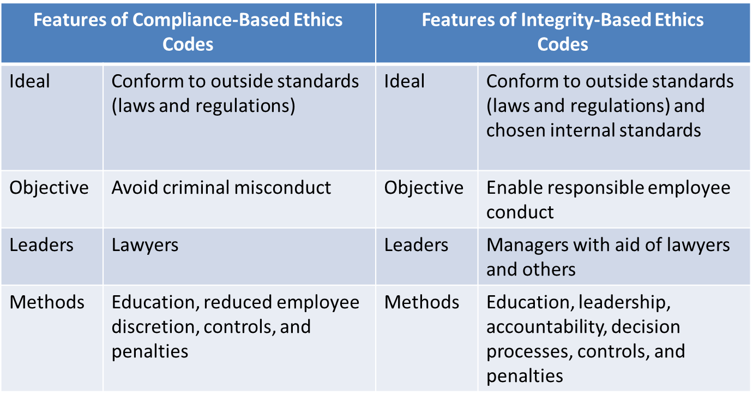
The six-step process can help improve business ethics:
- Top management must adopt and unconditionally support an explicit corporate code of conduct.
- Employees must understand that expectations for ethical behaviour begin at the top and that senior management expects all employees to act accordingly
- Managers and other must be trained to consider the ethical implications of all business decisions
- An ethics office must be set up and whistleblowers must feel protected from retaliation
- Outsiders such as supplier, subcontractors, distributors, and customers must be told about the ethics program
- The ethics code must be enforced
The Sarbanes-Oxley Act (SOX) was implemented in the US in 2002, it’s a legislation that:
    - Establishes stronger standards to prevent misconduct, and to ensure the accuracy and reliability of published financial information
    - It applies to all publicly traded companies
    - It also protects whistleblowers from any company relations
Corporate Social Responsibility (CSR) – is the concern businesses have for the welfare of society, not just for their owners
Social performances have several dimensions:
Corporate Philanthropy – includes charitable donate to non-profit groups of all kinds
Corporate Social Initiatives – include enhanced forms of corporate philanthropy that are more directly related to the company’s competencies
Corporate responsibility – includes everything from hiring minority workers to making safe products, minimizing pollution, using energy wisely, and providing a safe work environment
Corporate policy – refers to the position a firm takes on social political issues
There are two different views of corporate responsibility to stakeholders:
- The Strategic Approach: requires that management’s primary orientation be toward the economic interest of shareholders
- The Pluralist Approach: recognizes the special responsibility of management to optimize profits, but not at the expense of the employees, suppliers, or members of the community
Companies are responsible to their:
- Customers. Consumers have the right to safety, the right to be informed, the right to choose and the right to be heard
- Investors. Ethical behaviour adds to shareholder wealth, while unethical behaviour cause financial damage
- Employees. Employees need realistic hope of a better future, which comes only through a chance for upward mobility
- Society. One of business’s responsibilities to society is to create new wealth, which is disbursed to employees, suppliers, shareholders, and other stakeholders
- Environment. Businesses are often criticized for their role in destroying the environment
Social Audit – is a systematic evaluaton of an organization’s progress toward implementing programs that are socially responsible and responsive
Triple-bottom line: is used as a framework for measuring and reporting corporate performance against economic, social, and environmental parameters.
Sustainable development means implementing a process that integrates environmental, economic, and social considerations into decision making

