The Relationship between Business and Society

Chapters 1: The Relationship between Business and Society
CHAPTER AND LEARNING OBJECTIVE SUMMARY
The relationship between business and society is complex. It requires an understanding of the business system and of capitalism. There should also be an appreciation of the efforts being made by business to be responsive to society’s expectations of its social in addition to its economic responsibilities. Business integrity is the appropriateness of a corporation’s behaviour and its adherence to moral guidelines acceptable to society such as honesty, fairness, and justice. The concepts used to describe the integrity of business are ethics of business, corporate social responsibility, corporate sustainability, the triple bottom line, and corporate citizenship. The integrity of business is no different from that of individuals or other institutions in society.
The three main approaches to ethical thinking are: deontological, teleological, and virtue ethics. The Canadian business system is referred to by various terms, but usually as a form of capitalism. The business system does have some defects, but it is constantly changing to reflect society’s demands upon it. Several forms of business enterprise exist, but the most common is the incorporated enterprise referred to as the corporation. At one time, it was a privilege to form a corporation; that is, the monarch or government granted the right to incorporate. Today the corporation is viewed more as a free association of individuals who can incorporate as long as they are engaged in a legal activity. Thus, the modern corporation is accountable not only to the government, but also to society in general.
Owners, the board of directors, and managers are the three most important stakeholders in the actual operation of the corporation. Each has a distinct role, and all influence the integrity of the corporation. Society’s attitudes toward business are influenced by several factors. Corporate wrong doing receives a lot of attention and creates negative views of business. Society allows business to function as a system to provide goods and services. Two concepts help to understand this consent are legitimacy and social license.
Students and business academic programs are also challenged by issues of integrity. In particular, the behaviour of students has ethical implications, and they are no different than other stakeholders. There exists a reciprocal relationship between business and society; business needs society and society needs business.

Glossary
Capitalism | An economic system that allows for private ownership of the means of production (land, labour, and capital) and assumes that economic decision making is in the hands of individuals or enterprises who make decisions expecting to earn a profit. An early advocate of capitalism was Adam Smith, whose views are still influential as described in Responsibility for Ethics 1.2.
Clean capitalism | Corporate Knights magazine uses this term to associate capitalism with social responsibility. The magazine defines clean capitalism as "an economic system that incorporates the social, economic and ecological costs (and benefits) into our marketplace activities and the prices we pay."
Corporate citizenship | A corporation demonstrating that it takes into account its role in and complete impact on society and the environment as well as its economic influence.
Corporate social responsibility (CSR) | The way a corporation achieves a balance among its economic, social, and environmental responsibilities in its operations so as to address stakeholder expectations.
Corporate sustainability (CS) | Corporate activities demonstrating the inclusion of social and environmental as well as economic responsibilities in business operations as they impact all stakeholders to ensure the long-term survival of the corporation. The term sustainability was first used in the context of environmental sustainability, but corporate sustainability has the wider meaning and includes economic, ethical, and social responsibilities as well. The difference from CSR is that the responsibilities are completely integrated to the structure, policies, and operations of the corporation.
Economic system | An arrangement using land, labour, and capital to produce, distribute, and exchange goods and services to meet the needs and wants of people in society. The objective of an economic system is to use a society's resources to meet the society's needs.
Ethics of business | The rules, standards, codes, or principles that provide guidance for morally appropriate behavior in managerial decision making relating to the operation of the business enterprise's and business's relationship with society. It is broadly defined to include corporate social responsibility (CSR), corporate sustainability (CS), triple bottom line, corporate citizenship, corporate governance, accountability, and environmental stewardship.
Free enterprise system | An economic system characterized by ownership of private property by individuals and enterprises, the profit motive, a competitive market system, and a limited involvement by government. Also referred to as the private enterprise system.
Laissez-faire capitalism | An economic system operating with absolute minimum interference by the government in the affairs of business. Government involvement is strictly limited to providing essential services such as police and fire protection. Laissez-faire stems from a French term that means "allow to do."
Responsible enterprise system | An economic system operating as a free enterprise system but incorporating the element of accountability. This definition implies that business enterprises are responsible to society for their actions and are answerable or accountable for being the cause, agent, or source of something.
Stakeholder | An individual or group who can influence and/or is influenced by the achievement of an organization's purpose.
Stakeholder capitalism | An economic system in which corporations accept broader obligations beyond financial ones for shareholders. Corporations are expected to balance the interests of shareholders with those of other stakeholders in the business system, for example employees, suppliers, customers, and the community at large.In stakeholder capitalism, corporations are expected to behave with greater social responsibility and be sensitive to the ethical consequences of their actions.
Triple bottom line | The triple-E bottom line (3E) is the evaluation of a corporation's performance according to a summary of the economic, social or ethical, and environmental value the corporation adds or destroys. A variation is the triple-P bottom line (3P), which is an evaluation of the corporation's performance according to people, planet, and profits.
Deontological ethics | An approach to ethics that determines goodness or rightness from examining the acts, rather than from the consequences of the acts.
Integrity | The appropriateness of a corporation's behaviour and its adherence to moral guidelines acceptable to society such as honesty, fairness, and justice.
Legitimacy | The belief in the rightness of an institution, in this case the appropriateness of our business system to supply the goods and services wanted by Canadian society.
Responsible corporation | A business undertaking that responds to social, ethical, and environmental responsibilities in addition to its economic obligations.
Social licence | The privilege of operating in society with minimal formalized restrictions-that is, legislation, regulation, or market requirements-based on maintaining public trust by doing what is acceptable to stakeholders in the business and society relationship.
Teleological ethics | An approach to ethics that focuses on outcomes, or results of actions.
Virtue ethics | An approach to ethics that emphasizes the individual's character or identity, and focuses on being instead of doing.

Want to Learn More
Want to learn more about the documentary The Corporation?
Want to learn more about the changing attitudes towards business?
Want to learn more about Adam Smith?

LO 1.1 Complexities of Business & Society: Objectives
- Increase awareness of the Canadian business system
- Identify business’s response to its role in society
- Learn how business corporations have responded to environmental challenges
- Focus on the perspective of the manager or owner of a corporation
LO 1.2 Integrity in Business: Key Terminology
Ethics of business: The rules, standards, codes, or principles that provide guidance for morally appropriate behavior in managerial decision making relating to the operation of the business enterprise's and business's relationship with society. It is broadly defined to include corporate social responsibility (CSR), corporate sustainability (CS), triple bottom line, corporate citizenship, corporate governance, accountability, and environmental stewardship.
Stakeholder: An individual or group who can influence and/or is influenced by the achievement of an organization's purpose.
Corporate social responsibility (CSR): The way a corporation achieves a balance among its economic, social, and environmental responsibilities in its operations so as to address stakeholder expectations.
Corporate sustainability: Corporate activities demonstrating the inclusion of social and environmental as well as economic responsibilities in business operations as they impact all stakeholders to ensure the long-term survival of the corporation. The term sustainability was first used in the context of environmental sustainability, but corporate sustainability has the wider meaning and includes economic, ethical, and social responsibilities as well. The difference from CSR is that the responsibilities are completely integrated to the structure, policies, and operations of the corporation.
Triple bottom line (economic, ethical, and environmental): The triple-E bottom line (3E) is the evaluation of a corporation's performance according to a summary of the economic, social or ethical, and environmental value the corporation adds or destroys. A variation is the triple-P bottom line (3P), which is an evaluation of the corporation's performance according to people, planet, and profits.
Corporate citizenship: A corporation demonstrating that it takes into account its role in and complete impact on society and the environment as well as its economic influence.

LO 1.3 Three Approaches to Ethical Thinking
Deontological or rule-based theories: An approach to ethics that determines goodness or rightness from examining the acts, rather than from the consequences of the acts.
Teleological or consequential theories: An approach to ethics that focuses on outcomes, or results of actions.
Virtue ethics: An approach to ethics that emphasizes the individual's character or identity, and focuses on being instead of doing.
LO 1.4 Canadian Business Systems: Key Terminology
Economic system: An arrangement using land, labour, and capital to produce, distribute, and exchange goods and services to meet the needs and wants of people in society. The objective of an economic system is to use a society's resources to meet the society's needs.
Capitalism: An economic system that allows for private ownership of the means of production (land, labour, and capital) and assumes that economic decision making is in the hands of individuals or enterprises who make decisions expecting to earn a profit. An early advocate of capitalism was Adam Smith, whose views are still influential as described in Responsibility for Ethics 1.2.
Free enterprise system: An economic system characterized by ownership of private property by individuals and enterprises, the profit motive, a competitive market system, and a limited involvement by government. (Also referred to as the private enterprise system)
Laissez-faire capitalism: An economic system operating with absolute minimum interference by the government in the affairs of business. Government involvement is strictly limited to providing essential services such as police and fire protection. Laissez-faire stems from a French term that means "allow to do."
Responsible enterprise system: An economic system operating as a free enterprise system but incorporating the element of accountability. This definition implies that business enterprises are responsible to society for their actions and are answerable or accountable for being the cause, agent, or source of something.
Stakeholder capitalism: An economic system in which corporations accept broader obligations beyond financial ones for shareholders. Corporations are expected to balance the interests of shareholders with those of other stakeholders in the business system, for example employees, suppliers, customers, and the community at large.In stakeholder capitalism, corporations are expected to behave with greater social responsibility and be sensitive to the ethical consequences of their actions.
Clean capitalism: Corporate Knights magazine uses this term to associate capitalism with social responsibility. The magazine defines clean capitalism as "an economic system that incorporates the social, economic and ecological costs (and benefits) into our marketplace activities and the prices we pay."

LO 1.5 Corporations: The Main Economic Institutions
- The Canadian business system comprises business enterprises varying from sole or single proprietorships to partnerships and incorporated entities.
- Doctrine of Incorporation:
  - Freedom of association: The association of individuals coming together for some purpose is fundamental to forming a corporation.
  - When a business incorporates, a separate legal entity is created.

LO 1.6 The People Who Run Canadian Business
- Owners
  - Direct ownership (e.g., shareholders); or
  - Indirect ownership (e.g., mutual fund holders)
- Boards of Directors
  - Elected by shareholders
  - Must fulfill legal and fiduciary obligations
- Managers
  - Top Managers are hired by boards of directors
  - Oversee operations of corporation

LO 1.7 Factors Influencing Attitudes toward Business
- Standard of living
- Decentralized decision making
- Allocation of resources
- Self-interest
- Inequities in society
- Business cycle
- Business wrongdoing
- Globalization
- Unemployment
- Innovation
- The Media
- Government
LO 1.8 The Consent of Society
Legitimacy: belief in the rightness of an institution, in this case the appropriateness of our business system to supply the goods and services wanted by Canadian society.
Social licence: is the privilege of operating in society with minimal formalized restrictions based on maintaining public trust by doing what is acceptable to stakeholders in the business and society relationship.

LO 1.9 Academic Integrity
- What percent of students cheat?
  - 53 percent of students admit to cheating in written assignments (Maclean’s, 2007)
  - 56 percent of business students admit to cheating (Maclean’s, 2007)
- Will the lack of academic integrity have an influence on business integrity?

LO 1.10 Integration of Business and Society
- Must be a shared value in which both business and society benefit
- Goal is to reduce friction between society and business and to increase the benefits for both
- Integration is the focus of the textbook/course
Chapter Summary
- To understand the relationship between business and society, it is necessary to be knowledgeable of the business systems.
- Businesses need to be responsive to society’s expectations of its social and economic responsibilities.

Chapter 2: Ethics and Capitalism

CHAPTER AND LEARNING OBJECTIVE SUMMARY
Canada practices a degree of capitalism as most goods and services needed by Canadians are supplied by business enterprises. As a result, many ethical implications arise. In this chapter, eight fundamental elements of Canadian capitalism are identified: the right of private property, individualism and economic freedom, equality of opportunity, competition, profits, the work ethic, consumer sovereignty, and the role of government. The elements represent values that must be held to some extent by a society in order for capitalism to operate effectively as an economic system. Business operation in Canada is greatly facilitated by the right to private property, yet at the same time, these same rights create resentment among society because of the disparity in wealth associated with the right to accumulate wealth.
Individualism encourages participation in a capitalistic system, as people are free to make economic decisions in a marketplace. Some Canadians resent the focus on individuals and believe the economy should be directed more by governments. In order for capitalism to be widely accepted in Canada, it must permit equality of opportunity to share in economic well-being despite the variation in the outcomes between persons. Competitive rivalry must exist to ensure that capitalism is regulated in the best interests of stakeholders. Profits act as a signal to new businesses to enter the industry, however, market imperfections, including barriers to entry, inhibit competitive rivalry.
The ethics and responsibilities of a corporation are influenced by individuals’ view of the work ethic. The goods and services produced by capitalism should be determined by consumers as they make purchase decisions. However, it is often the case that consumer choice is restricted by business practices and government regulations. Government has a role in a capitalistic system, but its involvement should be limited to the protection of stakeholder interest and the provision of infrastructure for the market system to operate effectively.
The fundamental elements described earlier form the basis of Canadian capitalism. These elements give rise to many social or ethical issues that present challenges for Canadian businesspersons and managers. Therefore, the fundamentals discussed will provide a basis for an understanding of economic, social, or ethical responsibilities and of the relationships between business and its various stakeholders. Capitalism exists in several forms around the world. The functioning of capitalism faces changes, but does operate most of the time with moral standards. New forms of capitalism are always being proposed to make business more responsive to society’s needs. Throughout this book, the fundamentals of capitalism are to be viewed in light of developments in corporate social responsibility, business ethics, sustainability, corporate citizenship, and stakeholder management.

Glossary
Competition | The condition in a market system in which many rival sellers seek to provide goods and services to many buyers.
Conscious capitalism | The reorientation of business from a single focus on profits to emphasis being placed on integrity, higher standards of corporate behaviour, and inclusion of all stakeholders.
Consumer sovereignty | The assumption existing in an economy that consumers have and exercise power over producers through the decisions they make in purchasing the goods and services provided by corporations.
Creative capitalism | Places the resolution of social needs as primary, instead of secondary to economic activity and performance.
Economic freedoms | Exist when the business system operates with few restrictions on its activities.
Equality of opportunity | The assumption that all individuals or groups have an even chance at responding to some condition in society.
Greed | The excessive desire to acquire or possess more, especially more material wealth, than one needs or deserves.
Individualism | The view that the individual, and not society or a collective, is the paramount decision maker in society; assumes that the individual is inherently decent and rational.
Intellectual property | Umbrella term for patents, copyrights, trademarks, industrial designs, integrated circuit topographies, and plant breeders' rights.
Oligopoly | A type of competition where the few sellers in an industry behave similarly.
Profits | The excess of revenues over expenses; closely associated with competition.
Right of private property | The legal right to own and use economic goods, for example land and buildings.
Shared value | The idea that economic value to companies can be obtained by creating social value.
State capitalism | An economic system in which governments manipulate market outcomes for political and social purposes.
Work ethic | A code of values, or a body of moral principles, claiming that work is desirable, that work is a natural activity, and that work is good in and of itself.

Want to Learn More
Want to learn more about the right to intellectual property?
Want to learn more about business fundamentals and the story of The Little Red Hen?
Want to learn more about the pros and cons of capitalism?
LO 2.1 The Capitalist Business System
The Canadian economic system has been, and still is, largely comprised of business enterprises operating in a market system.
The theory of capitalism can be described by examining the eight fundamental elements of such a system.

LO 2.2 The Right of Private Property
- The legal right to own and use economic goods—for example, land and buildings.
- Ethical implications:
  - Uneven distribution of wealth
  - Infringement of copyright rights
  - Membership rights (e.g., labour unions) are sometimes preferred over individual rights

LO 2.3 Individualism & Economic Freedom
Individualism: The view that the individual, and not society or a collective, is the paramount decision maker in society; assumes that the individual is inherently decent and rational.
Economic freedoms: Exist when the business system operates with few restrictions on its activities.
Ethical implications:
  - Desirability of individual versus collective action
  - Extent to which economic freedoms should exist

LO 2.4 Equality of Opportunity
- The assumption that all individuals or groups have an even chance at responding to some condition in society.
- Ethical implications:
  - Difficult to achieve in capitalistic system
  - Wealth created not distributed equally
  - Inequities such as layoffs, drops in living standards, excessively high executive salaries

LO 2.5 Competition
- The condition in a market system in which many rival sellers seek to provide goods and services to many buyers.
- Ethical implications:
  - Oligopolies (few sellers in industry) or even monopolies (one seller) can be created
  - More difficult for some firms to enter certain industries
  - Firms might engage in anti-competitive activity

LO 2.6 Profits
- The excess of revenues over expenses; closely associated with competition.
- Ethical implications:
  - Profits sometimes viewed with disdain or as immoral
  - Taxation of excessive profits and the rates of inflation redistribute profits

LO 2.7 The Work Ethic
- A code of values, or a body of moral principles, claiming that work is desirable, a natural activity, and good in and of itself.
- Ethical implications:
  - Government programs and society’s expectations have influenced individuals’ attitudes toward work
  - Individuals now expect more from government and business enterprises in terms of working conditions, benefits, and salaries

LO 2.8 Consumer Sovereignty
- Consumers have and exercise power over producers through the decisions they make in purchasing the goods and services provided by corporations.
- Ethical implications:
  - Consumers not always aware of alternative products available
  - Consumers’ preferences are shaped by advertising
  - Producers have power to ignore consumer wishes

LO 2.9 The Role of Government
- Laissez-faire approach (“leave us alone”) suggests minimal involvement of government.
- Ethical implications:
  - Government now an influential stakeholder
(i.e. subsidies, taxation, tariffs, regulations, legislation, loans, grants, ownership)
  - Government can restrict capital movement, impose product standards, prevent businesses from shutting down plants

LO 2.10 The Fundamentals & Various Forms of Capitalism
- Capitalism: An economic system that allows for private ownership of the means of production (land, labour, and capital) and assumes that economic decision making is in the hands of individuals or enterprises that make decisions expecting to earn a profit.
- Several pros and cons exist regarding capitalism.
Various Forms of Capitalism
- Consumer capitalism
  - United States, Britain, Canada, Australia
- Producer capitalism
  - France, Japan, Mexico
- Family capitalism
  - Taiwan, Malaysia, Thailand, Indonesia
- Frontier capitalism
  - Russia, China
- Conscious capitalism
  - reorientation of business from a single focus on profits to emphasis being placed on higher standards of corporate behaviour
- Creative capitalism
  - resolution of social needs the primary goal of economic activity
- State capitalism
  - governments manipulate market outcomes for political purposes

LO 2.11 The Challenges, the Ethics, & a New View of Capitalism
- The Challenges:
  - Greed
  - Mistrust
  - Economic downturns
  - Business failures
  - Corporate crime and wrongdoing
- The Ethics:
  - An assumption exists that moral individuals operate the business system and that they are in the majority
  - For capitalism to operate effectively, a strong system of moral behaviour and integrity is necessary
- New View of Capitalism:
  - “Capitalism is under siege”
  - Corporations must think beyond social responsibility, philanthropy, and sustainability to what Michael E. Porter and Mark R. Kramer refer to as “shared value”
  - Shared value: The idea that economic value to companies can be obtained by creating social value

Chapter Summary
- The theory of capitalism can be described by the eight fundamental elements of such a system:
- The Right of Private Property
- Individualism & Economic Freedom
- Equality of Opportunity
- Competition
- Profits
- The Work Ethic
- Consumer Sovereignty
- The Role of Government
- These eight fundamentals are not isolated from one another but are linked to become the basis for the capitalist market system.
- These fundamentals are the basis of capitalism, but capitalism takes different forms around the world and at different times.

Understanding Business and its Stakeholders

Chapter 3: Identifying Stakeholders and Issues

CHAPTER AND LEARNING OBJECTIVE SUMMARY
Chapter 3 defines and identifies the stakeholders in the business system and describes the management of issues that arise in the system. A stakeholder is an individual, or group, that has some share, interest, or “stake” in the business system and the activities of corporations. Nineteen stakeholders are listed and described. This list is not necessarily complete but it includes the most commonly acknowledged stakeholders and comprises generic or general labels. The stakeholder names or participants have to be customized for each corporation. The dynamic nature of the relationships between business and stakeholders means that the importance of the various stakeholders will vary by corporation and over time. Sometimes conflict exists among stakeholders and/or their interests.
Overseeing the various stakeholder interests is an important aspect of the modern manager’s job. Despite the widespread use of the stakeholder concept in business organizations, it is not universally accepted as legitimate. However, today most managers believe that the stakeholder concept is a systematic approach to understanding and responding to various influences in the corporation’s environment.
Also described in this chapter is the identification and management of economic, ethical, and environmental issues that may confront the corporation. Issues always involve stakeholders, and their appropriate identification and management is important. Issue management is defined and its components and different perspectives described. Understanding issue cycles is important to identifying issues and to implementing a response. Management should use some systematic response to the issues it is confronting, and a process involving identifying, analyzing, ranking, responding, implementing, monitoring, and evaluating is described.
Some issues lead to crisis and the response must be timely and comprehensive. Crises in business have been studied and crisis management frameworks developed that enable the corporation to make appropriate actions in such situations.
The use of the stakeholder concept, and issue and crisis management provides a good framework for examining the economic, ethical, and environmental responsibilities of the corporation. The next chapter will explore how relationships among stakeholders, the relevant issues, and the corporation can be monitored and managed.

Glossary
Crisis | A turning point, a crucial time, and a situation that has reached a critical point.
Crisis management | An approach involving planning and removing much of the risk and uncertainty, allowing the corporation to achieve more control over events.
Issue | A point in question or a matter that is in dispute where different views are held of what is or what ought to be corporate performance-based management or stakeholder expectations.
Issues management | A systematic process by which the corporation can identify, evaluate, and respond to those economic, social, and environmental issues that may impact significantly upon it.
Non-governmental organization (NGO) | Any group outside of the public and private sectors that holds shared values or attitudes about an issue confronting society.
Owners | Those individuals or groups who have invested in a corporation in the form of equity or shares; usually referred to as shareholders.
Pluralistic society | One where influence or power is decentralized by dispersing it among a variety of institutions.

Want to Learn More
Want to learn more about identifying and engagine stakeholders?
Want to learn more about the approaches used to address issues?
Want to learn more about assessing information about stakeholders?
Want to learn more about assessing information about stakeholders? [page 56]
Management can obtain information about stakeholders in numerous ways. This table identifies some methods of assessing stakeholders’ influence and common sources of information on each stakeholder.

Issue Information Assessment by Stakeholder
Stakeholder | Method of Assessment | Common Source
Owners | Stock price, trading volume, market analysts’ reports | Investor relations departments,  financial media²
Directors | Evaluations | Media ratings of governance
Employees | Surveys, attrition rates | Human resource departments
Customers/consumers | Satisfaction surveys | Marketing department, media ratings of service
Lenders and creditors | Credit and bond ratings | Financial media
Suppliers | Surveys, internal assessment¹ | Supply chain
Service professionals | Professional standards and codes | Professional organizations
Dealers, distributors,  and franchisees | Internal assessment | Trade associations; trade publications
Business organizations | Surveys and studies | Membership in organizations
Competitors | Market analysis | Consulting firms, media
Joint-venture participants | Internal assessment
Non-governmental organizations (NGOs) | Internal assessment; hire consultants | Media, consulting firm services
Society at large | Surveys of communities | Public relations and communications, media
Educational institutions | Surveys, visits as guest lectures, involvement in governance, job acceptance | Human resource departments, institution reports and publications
Religious groups |  | Media
Charities | Internal assessment, surveys by consultants | Media, organization reports
Service, fraternal, cultural, and ethnic organizations | Internal assessment | Media
The media | Negative/positive story percentages, internal assessment | Monitor media internally or by press services
Government | Internal assessment. Freedom of information assessment. | Media, consulting firms
¹ Internal assessment: studies or reports performed by management or employees
² Media: all types of media, including Internet

LO 3.1 Role of Institutions in Society
- Pluralistic society: is one where influence or power is decentralized by dispersing it among a variety of institutions
- No one institution is completely independent of others, but each institution does possess some autonomy to pursue its own interests

LO 3.2 Identifying Stakeholders
- Stakeholders: An individual, or group, who can influence and/or is influenced by the achievement of an organization’s purpose
- “…to manage effectively, then you must take your stakeholders into account in a systematic fashion.”

LO 3.3 Stakeholders’ Influence
- Owners
- Directors
- Employees
- Customers or Consumers
- Lenders and Creditors
- Suppliers
- Service Professionals
- Dealers, Distributors, and Franchisees
- Business Organizations
- Competitors
- Joint-Venture Participants
- Non-Governmental Organizations
- Society at Large
- Educational Institutions
- Religious Groups
- Charities
- Service, Fraternal, Cultural, and Ethnic associations
- The Media
- Government
- Why are stakeholders important to a firm?
- What can happen to the firm if managers do not properly identify and satisfy the interests of their firm’s stakeholders?
- Why is it important to categorize stakeholders?
- Do stakeholders have differing goals and power/influence over time?

LO 3.4 Managers’ Responsibilities
- Identify stakeholders
- Understand how corporation currently views stakeholders
- Examine how each stakeholder will or might influence firm
- Assess opportunities and threats
- Rank stakeholders by influence
- Prepare programs or policies detailing how to cope with stakeholders

LO 3.5 Arguments Against and For the Stakeholder Concept
Arguments Against the Stakeholder Concept
- Problems of categorization (e.g., how to identify and prioritize stakeholders)
- Challenges in meeting expectations (e.g., tradeoffs among the stakeholders)
- Dilution of top management focus (e.g., away from financial performance)
- Impracticality of shared governance (e.g., focus still on shareholders)
Arguments For the Stakeholder Concept
- Simply good business
- Ignoring stakeholder interests can have substantial economic consequences (e.g., employees, customers, lenders, etc.)
- Provides more systematic approach to recognizing stakeholder expectations and deciding how to respond

LO 3.6 Issues Management: Definition
A systemic process by which the corporation can identify, evaluate, and respond to those economic, social, and environmental issues that may impact significantly upon it.

LO 3.7 Purposes and Benefits of Issues Management
- Minimize surprises relating to events or trends in society by serving as an early warning system
- Prompts managers to be more systematic in coping with issues and stakeholder concerns
- Mechanism for coordinating and integrating management of issues
Benefits of Issues Management
- Maintain a competitive advantage over rivals
- Corporate behaviour is more likely to be consistent with societal expectations
- Less likely to make a serious social or ethical mistake
- Detect issues earlier and develop appropriate responses much sooner

LO 3.8 Issue Life Cycle Stages
- Degree of awareness of issue over time
- Five stages of awareness:
  - none or little;
  - increasing;
  - prominent;
  - peak; or
  - declining.

LO 3.9 Issues Management Process
- Identification of issues
- Analysis of issues
- Ranking or prioritizing of issues
- Formulating issue response
- Implementing issue response
- Monitoring and evaluating issue response

LO 3.10 Crises Management
Crisis: A turning point, a crucial time, and a situation that has reached a critical point
Crisis management: An approach involving planning and removing much of the risk and uncertainty, allowing the corporation to achieve more control over events
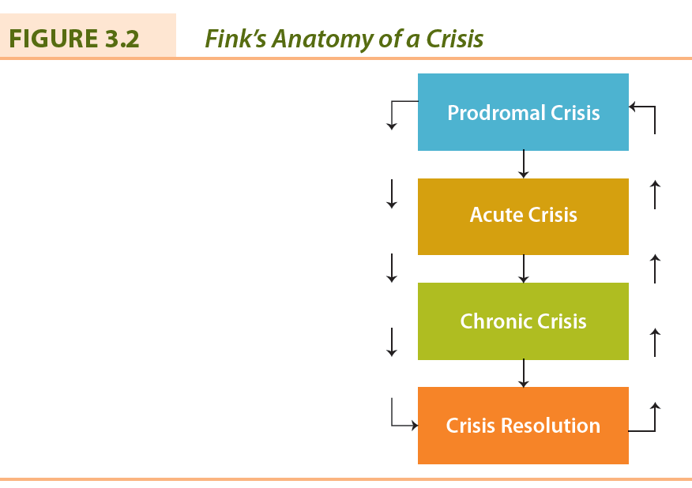
- Augustine’s Six Stages of Crisis Management:
  - Stage 1—Avoiding the Crisis
  - Stage 2—Preparing to Manage the Crisis
  - Stage 3—Recognizing the Crisis
  - Stage 4—Containing the Crisis
  - Stage 5—Resolving the Crisis
  - Stage 6—Profiting from the Crisis
Chapter Summary
- The stakeholder concept is a systematic approach to recognizing the complex combination of desires and expectations in today’s society and deciding whether to respond
- Through an assessment of each stakeholder, the value of each to the corporation can be ascertained to suit the stakeholder and to suit the corporation’s purpose
- Issues management enables the corporation to reduce vulnerabilities and enhance credibility
- Some issues appear suddenly and require immediate and comprehensive responses; crisis management is required in these situations

Chapter 4: Stakeholder Relations and Analysis

CHAPTER AND LEARNING OBJECTIVE SUMMARY
The appropriate identification of stakeholders is very important to business corporations as one approach to understanding the environment in which they operate. Identification should be only the first step, as managers must analyze the nature of the relationships between the corporation and its stakeholders.
Freeman’s stakeholder management capability provides a good starting point for understanding stakeholder relationships. Although he stresses the importance of proper identification of stakeholders, he also appreciates that appropriate organizational arrangements must be in place to understand the relationships and ultimately to interact with stakeholders.
The various stakeholder matrix mapping methodologies give managers a practical approach to assessing the influence of stakeholders. Matrices can be based on a variety of dimensions and designed to suit the corporation’s purpose in stakeholder understanding. The variables illustrated were position on an issue and importance of the issue to the stakeholder. The diagnostic typology of organizational stakeholders attempts to understand stakeholder influence by assessing the potential threat or potential for cooperation. The salience stakeholder typology increases the complexity of analysis by using three attributes to assess stakeholder importance: power, legitimacy, and urgency.
Frooman’s influence strategies provide another perspective on understanding stakeholders. He argues that managers should appreciate that stakeholders can influence one another and the corporation in direct and indirect ways and by withholding or specifying usage conditions. Understanding influence strategies further enhances managers’ understanding of stakeholder actions.
Finally, the most sophisticated approach to understanding stakeholders is through collaboration and the application of the concept of social capital. Collaboration changes the approach from managing stakeholders to dialoguing with them. The social capital concept identifies that business value can be created from meaningful and sincere stakeholder relations. Few managers or corporations have reached this level of sophistication in their understanding of stakeholder relationships.

Glossary
Collaboration | A meta-capability to establish and maintain relationships that allows the organization to tap into a powerful source of creative energy, a large pool of innovative ideas, and a wider network.
Influence pathway | Occurs where withholding and usage strategies could be performed by an ally of the stakeholder with whom the organization has a resource dependence.
Legitimacy | A generalized perception or assumption that the actions of an entity are desirable, proper, or appropriate within some socially constructed system of norms, values, beliefs, and definition that is based on the individual, the organization, or society.
Matrix mapping | A technique of categorizing an organization's stakeholders by their influence according to two variables; usually involves plotting them on a two-by-two matrix.
Power | A relationship among social actors in which one social actor, A, can get another social actor, B, to do something that B would not otherwise do.
Resource dependence | Exists when a stakeholder is supplying a resource and can exert some form of control over it.
Salience | The degree to which managers give priority to competing stakeholder claims.
Social capital | Any aspect of a corporation's organizational arrangements that creates value and facilitates the actions of stakeholders within and external to the corporation.
Stakeholder engagement | Efforts by a corporation to understand and involve relevant individuals, groups, or organizations by considering their moral concerns in strategic and operational initiatives.
Stakeholder management capability | The ability of managers to identify stakeholders and their influence, to develop the organizational practices to understand stakeholders, and to undertake direct contact with stakeholders.
Urgency | The degree to which the stakeholder's claim or relationship calls for immediate attention; exists when a claim or relationship is of a time-sensitive nature and when that claim or relationship is important or critical to the stakeholder.
Usage strategies | An approach in which the stakeholder continues to supply a resource but specifies how it will be used.
Withholding strategies | An approach where the stakeholder discontinues providing a resource to an organization with the intention of changing a certain behaviour.

Want to Learn More
Want to learn more about the prinicples of stakeholder management?
Want to learn more about matrix mapping?
Want to learn more about influence strategies?

Want to learn more about the principles of stakeholder management? [page 77]
A Canadian, Professor Emeritus Max Clarkson (1922–1998) at the University of Toronto, was a pioneer in business ethics and stakeholder theory. In 1988 he founded the Centre for Corporate Social Performance and Ethics in the Faculty of Management, now the Clarkson Centre for Business Ethics and Board Effectiveness. Clarkson believed that as the relationship between business and society increases in complexity, the need for business corporations to manage social and ethical issues becomes critical. Four conferences hosted by the Centre between 1993 and 1998 brought together management scholars to share ideas on stakeholder theory, an emerging field of study examining the relationships and responsibilities of a corporation to employees, customers, suppliers, society, and the environment. The Alfred P. Sloan Foundation funded the project, from which the Clarkson Principles emerged. More information on the Clarkson Centre is available at http://www.rotman.utoronto.ca/facultyandresearch/researchcentres/clarksoncentreforboardeffectiveness.aspx.
Even though these principles were formulated in the 1990s, they are still relevant today. Although Clarkson used the term “management,” the term “engagement” is appropriate. Stakeholder engagement is a concept introduced in Chapter 4, page 73, and is defined as efforts by a corporation to understand and involve relevant individuals, groups, and organizations by considering their moral concerns in strategic and operational initiatives.
Principles of Stakeholder Management
Principle 1 | Managers should acknowledge and actively monitor the concerns of all legitimate stakeholders, and should take their interests appropriately into account in decision making and operations.
Principle 2 | Managers should listen to and openly communicate with stakeholders about their respective concerns and contributions, and about the risks that they assume because of their involvement with the corporation.
Principle 3 | Managers should adopt processes and modes of behaviour that are sensitive to the concerns and capabilities of each stakeholder constituency.
Principle 4 | Managers should recognize the interdependence of efforts and rewards among stakeholders, and should attempt to achieve a fair distribution of the benefits and burdens of corporate activity among them, taking into account their respective risks and vulnerabilities.
Principle 5 | Managers should work cooperatively with other entities, both public and private, to ensure that risk and harms arising from corporate activities are minimized, and, where they cannot be avoided, appropriately compensated.
Principle 6 | Managers should avoid altogether activities that might jeopardize inalienable human rights (e.g., the right to life) or give rise to risks which, if clearly understood, would be patently unacceptable to relevant stakeholders.
Principle 7 | Managers should acknowledge the potential conflicts between (a) their own role as corporate stakeholders, and (b) their legal and moral responsibilities for the interests of stakeholders, and should address such conflicts through open communication, appropriate reporting and incentive systems, and, where necessary, third party review.

Source: Principles of Stakeholder Management: “The Clarkson Principles.” Clarkson Centre for Business Ethics, Joseph L. Rotman School of Management, University of Toronto, 1999. http://www.rotman.utoronto.ca/-/media/Files/Programs-and-Areas/Institutes/Clarkson/Principles%20of%20Stakeholder%20Management.pdf
LO 4.1 Basic Stakeholder Analysis
- Stakeholder Engagement:
  - efforts by a corporation to understand and involve relevant individuals, groups, or organizations by considering their moral concerns in strategic and operational initiatives.
- Corporation can increase understanding of stakeholders by asking the following:
- Who are our stakeholders?
- What are their stakes?
- What opportunities and challenges are presented to our firm?
- What responsibilities (economic, legal, ethical, and philanthropic) does our firm have to all its stakeholders?
- What strategies or actions should our firm take to best deal with stakeholder challenges and opportunities?

LO 4.2 Stakeholder Management Capability
- The ability of managers to:
  - identify stakeholders and their influence;
  - develop the organizational practices to understand stakeholders; and
  - undertake direct contact with stakeholders.

LO 4.3 Stakeholder Matrix Mapping
- A technique of categorizing an organization’s stakeholders by their influence according to two variables; usually involves plotting them on a two-by-two matrix:
  - Y Axis: Oppose or support corporation
  - X Axis: Importance of stakeholders
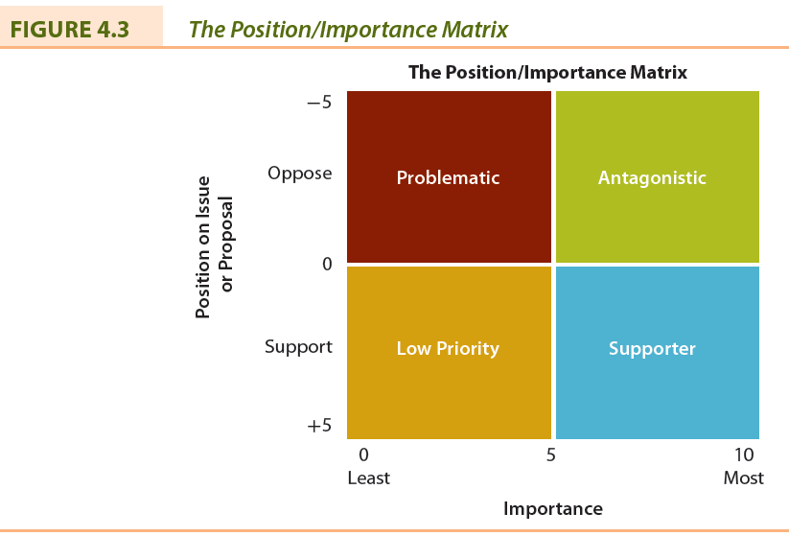

LO 4.4 Diagnostic Typology of Organizational Stakeholders
Type 1: Supportive stakeholder and strategy (i.e., involve)
Type 2: The marginal stakeholder and strategy (i.e., monitor)
Type 3: The non-supportive stakeholder and strategy (i.e., defend)
Type 4: The mixed-blessing stakeholder and strategy (i.e., collaborate)
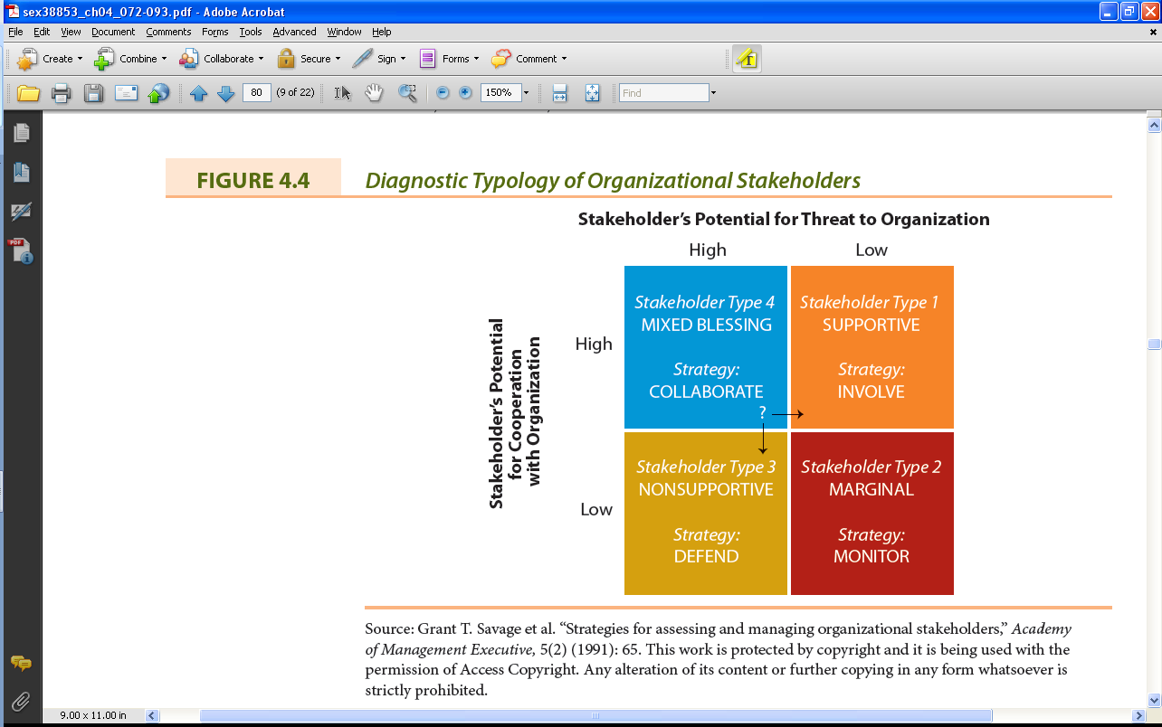

LO 4.5 Stakeholder Identification and Salience
- Salience
  - degree to which priority given to competing stakeholders
- Power
  - ability to get firm to do something that it would not otherwise do based on force, threat, incentives, etc.
- Legitimacy
  - Perception or assumption that actions of firm are desirable, proper, or appropriate
- Urgency
  - degree to which stakeholder’s claim or relationship calls for immediate attention
- Examples of Stakeholder Types:
  - Latent stakeholders: Managers may not recognize their existence (have one attribute)
  - Expectant stakeholders: Require more attention from managers (have two attributes)
  - Definitive stakeholders: Management must address the claims of these stakeholders immediately (have three attributes)
  - Non-stakeholders (have no attributes)
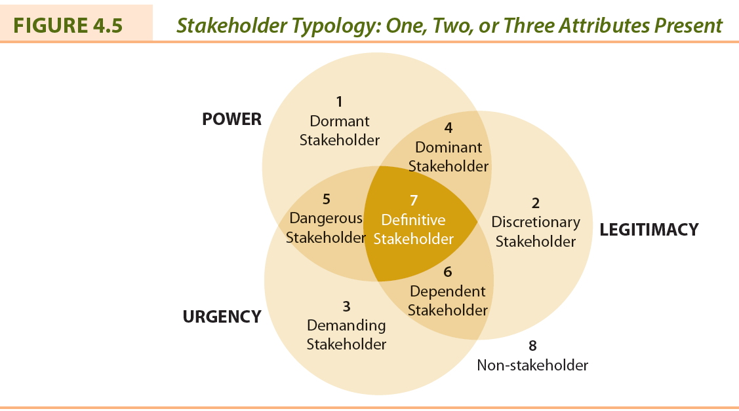
LO 4.6 Stakeholder Influence Strategies
- Resource dependence
  - stakeholder is supplying a resource and can exert some form of control over it
- Withholding strategies
  - stakeholder discontinues providing a resource
- Usage strategies
  - stakeholder continues to supply resource but specifies how it is to be used
- Influence pathway
  - when withholding and usage strategies are used by an ally of the stakeholder

LO 4.7 Stakeholder Collaboration
- Framework for organizations to develop collaborative stakeholder relationships:
    - Creating a foundation
    - Organizational alignment
    - Strategy development
    - Trust building
    - Evaluation
    - Repeat the process

LO 4.8 Stakeholders and Social Capital
- Social Capital: Any aspect of a corporation’s organizational arrangement that creates value and facilitates the actions of stakeholders within and external to the corporation.
- Question: What are the benefits to the firm of creating social capital?

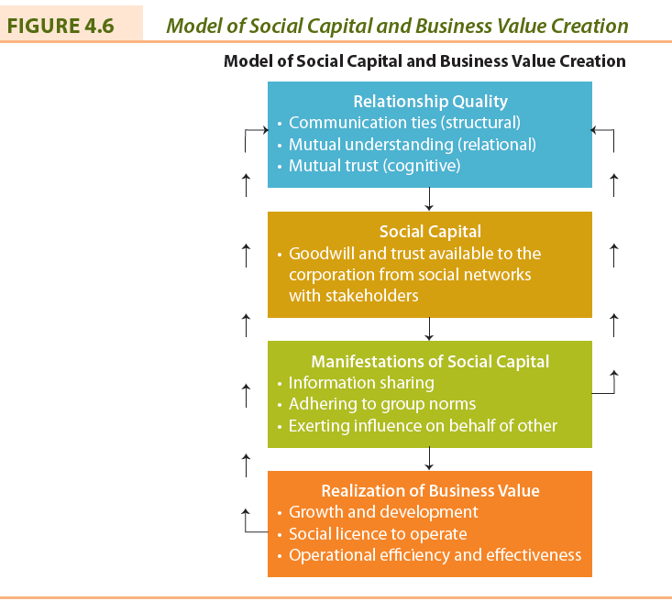

Chapter Summary
- Stakeholder engagement is an integral aspect of corporate social responsibility or corporate sustainability.
- Stakeholder engagement involves creating value for all stakeholders and an honest, open, and respectful engagement of stakeholders vital to corporate strategy.
- Approaches to understanding the relationships between the corporation and its stakeholders range from the basic listing and mapping to more complicated concepts such as stakeholder collaboration and social capital.
- These approaches help the corporation to consider their stakeholders’ moral concerns in strategic and operational initiatives.

Chapter 13: Civil Society Stakeholders

CHAPTER AND LEARNING GOAL SUMMARY
Civil society stakeholders are voluntary, community, and social organizations that represent society’s views on business and societal issues and influence the behaviour of corporations. There are many types of these stakeholders, five of which are discussed in this chapter: non-governmental organizations (NGOs), media, policy development institutions (think tanks), religious organizations, and educational institutions.
Non-governmental organizations are numerous, use a variety of tactics, and are varied in their positions on issues and influence on business. NGOs serve a beneficial role in society and their views should be identified and analyzed by corporations. A variety of strategies are possible in responding to NGO initiatives and the strategy selected depends on the issue involved and the influence of the NGO. NGOs do not always oppose business actions and some are consistent with business views. Recently, there have been many partnership initiatives between corporations and NGOs.
The media stakeholder is one that can influence society’s attitudes toward business and one that business can influence. The establishment of an appropriate relationship with the media is important to most corporations, and many have public relations or media departments to facilitate the relationship. Today, business enjoys extensive and largely favourable coverage in the media.
Policy development institutions or “think tanks” are numerous. They influence governments’ (and society in general) attitudes toward business. Many of these “think tanks” are supported by corporations and views consistent with capitalism are promoted.
Some businesspersons are influenced by organized religions or by spirituality. Here, corporate values are determined by religious beliefs and this is reflected in business operations.
There is considerable controversy about the relationship between business and the educational institution stakeholder. Businesses are increasing their presence on campus by supporting research, financing buildings and programs, and operating services. Some students and faculty members believe that the presence of business has an adverse influence on the educational institution, in particular reducing its academic independence.

Glossary
Civil society | The voluntary, community, and social organizations or institutions that contribute to the functioning of society but are usually not related to or supported by government.
Libel chill | Occurs when a business threatens legal action if a particular article or book is published.
Non-governmental organization (NGO) | Any group that holds shared values or attitudes about an issue confronting society.
Policy development institution (think tank) | An organization that researches and analyzes various important social, economic, and political issues confronting society.
Social media | Online technologies and practices that people use to share opinions, insights, experiences, and perspectives.
Spirituality | An individual's sense of peace or purpose with him/herself and the connection to others and even nature that provides meaning to life and a sense of one's self.

Want to Learn More
Want to learn more about watch sites?
Want to learn more about efforts to keep the internet affordable?
Want to learn more about the digital protest movement?

LO 13.1 Non-Governmental Organizations (NGOs)
- Any group that holds shared values or attitudes about an issue confronting society and advocates for changes relating to the issue.
- Usually, but not always, non-profit.
NGO Societal Issues Most Relevant to Business
- Animal rights
- Technology
- Economic
- Social development
- Workers’/human rights
- Environment
- Religious activism
Civil Society: Definition
- Civil society is composed of the voluntary, community, and social organizations or institutions that contribute to the functioning of society but are not related to or supported by government.

LO 13.2 The Case For and Against NGOs
The Case for NGOs: Benefits from Partnership
- Identifying opportunities and risks
- Influence on public opinion
- Innovation possibilities
- Reputation and trust by the public
- Expertise on specific issues
- Employee engagement
NGO Tactics
- Pressure on governments to change policies
- Damaging publicity
- Disrupt annual meetings
- Develop shareholder social policy resolutions
- Damaging physical property
- Picket managers’ homes
- Sponsor demonstrations or picket corporate locations
- Organize boycotts
- Launch letter-writing campaigns
- Initiate legal proceedings
- Non-violent use of the Internet (i.e., ‘hacktivism’)
- Develop anti-business websites
- Support anti-business documentaries
- Provide support for alternative sources of goods and services

LO 13.3 Strategies for Relationships with NGOs
- Proactively engage NGO
- Do not underestimate NGO’s influence
- Reversing a decision from a project shouldn’t be viewed as a defeat
- Sometimes selective concessions are sufficient
- Sometimes better to deal with “realist” NGO, not radical ones
- A pre-emptive strategy may be feasible

LO 13.4 Partnership Relationships with NGOs
- Four key ingredients to a successful partnership:
  - Corporate and NGO leaders must show leadership
  - The corporation must be open to change
  - Must be a commitment to being committed
  - Partners must have a shared goal

LO 13.5 The Media Stakeholder
- Dealing with the media is part of managers’ responsibilities
- Legitimacy of business is dependent upon public’s knowledge of events and issues
- Information spread through newspapers, periodicals, radio, television, and social media (i.e., online technologies)
The Influence of Popular Media
Documentaries:
- Super Size Me
- Roger & Me
- Wal-mart: the High Cost of Low Price
- Capitalism: A Love Story
Movies:
- Wall Street
- Erin Brockovich
- A Civil Action
- The Constant Gardener
- Blood Diamond
- In Good Company
- Up in the Air

LO 13.6 The Interaction Between Business and the Media
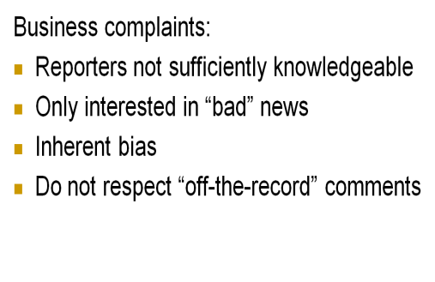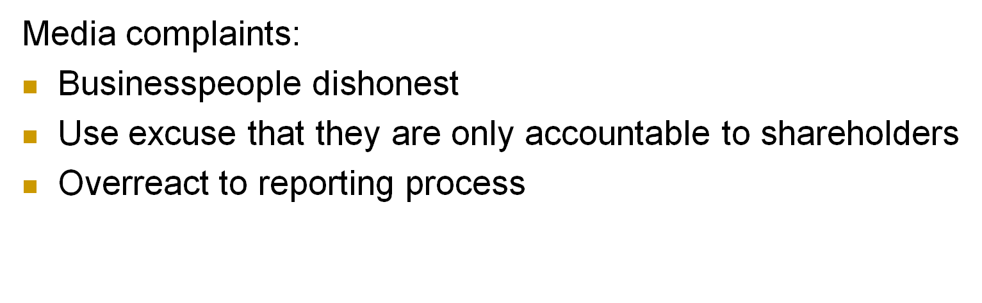
LO 13.7 Media Ownership
- Business enterprises now own and operate major media outlets.
- Issues:
  - Newspaper monopolies
  - Interlocking ownership between print and broadcasting media
  - Licensing process favours some corporations over others
  - Newspaper chains more focused on profits than professional journalism

LO 13.8 The Media and CSR
- Ethical, social, and environmental responsibilities of business of increasing interest to public
- This has led to increased coverage of ethics in business and CSR in the media
- Corporations owning media have also recognized importance of CSR or sustainability

LO 13.9 Policy Development Institutions (Think Tanks)
- An organization that researches and analyzes various important social, economic, and political issues confronting society
- Funded by government, corporations, trade unions, wealthy individuals, universities
- Examples: C.D. Howe Institute, Conference Board of Canada, Fraser Institute

LO 13.10 Religious Institutions
- Influence of religion on business:
  - The impact on managerial decision making
  - The existence of businesses supplying religious goods and services
  - Spirituality in the workplace
  - Corporate response to religious activism

LO 13.11 Educational Institutions
- Business now involved in the educational system from kindergarten to university
- Two distinct approaches:
  - Mutually beneficial partnership; or
  - Educational institutions should be unencumbered from corporate influence

Chapter Summary
- Corporations and their managers must develop a relationship with both NGOs and the media in which managers not only learn about these stakeholders but also recognize their role in society and develop mechanisms for interacting with them.
- This focus is not one-way but instead is a proactive relationship in which managers understand and respect the roles of these civil society stakeholders.

The Ethics of Business

Chapter 5: Ethics of Business: The Theoretical Basis

CHAPTER AND LEARNING OBJECTIVE SUMMARY

Business ethics has been an “in” topic for the past decade. The topic has been discussed extensively in the literature, the media, and the classroom as well as on the Internet. The operations of any business involve the potential that decisions will have ethical implications for managers and stakeholders. The phrase “ethics of business” is preferred and is defined as the rules, standards, codes, or principles that provide guidance for morally appropriate behaviour in managerial decision making relating to the operation of the corporation and business’ relationship with society.
There are three levels of ethical assessment: (1) awareness of moral or ethical implications, (2) ethical implications assessed upon individual and societal influences described as value judgments and moral standards, and (3) implications assessed upon use of ethical principles.
There are a multitude of influences on ethical behaviour, ranging from educational and religious backgrounds to professional organizations and governments. These influences lead to ethical relativism, the belief that ethical answers depend on the situation and there are no universal standards or rules to guide or evaluate morality. Seven theoretical bases, or ethics, for understanding ethical conduct are described: self-interest, personal virtues, caring, utilitarian, universal rules, individual rights, and justice.
The process of moral reasoning is described. In particular, Kohlberg’s theory of the stages of moral development is outlined as it has an application to the ethics of business. The pre-conventional, conventional, and post-conventional levels and the six stages illustrate the attitude that managers may have toward assessing the implications of ethics in the business environment.
The consideration of the ethical implications of business’ responsibilities is prevalent in what corporations do. The theoretical basis for ethics has been outlined and sets the stage for further examination of the ethics and responsibilities of business. But, there are several challenges to ethical behaviour in corporations.

Glossary
Business ethics | The rules, standards, codes, or principles that provide guidelines for morally right behaviour and truthfulness in specific situations.
Ethic of caring | Gives attention to specific individuals or stakeholders harmed or disadvantaged and their particular circumstances.
Ethic of justice | Considers that moral decisions are based on the primacy of a single value: justice.
Ethical relativism | The belief that ethical answers depend on the situation and no universal standards or rules exist to guide or evaluate morality.
Individual rights ethic | Relies on a list of agreed-upon rights for everyone that will be upheld by everyone and that becomes the basis for deciding what is right, just, or fair.
Moral reasoning | A systematic approach to thinking or reasoning through the implications of a moral problem or issue.
Moral standards | The means by which individuals judge their actions and the actions of others based upon accepted behaviour in society.
Personal virtues ethic | An individual's or corporation's behaviour is based upon being a good person or corporate citizen with traits such as courage, honesty, wisdom, temperance, courage, fidelity, integrity, and generosity.
Self-interest ethic | Individuals or corporations set their own standards for judging the ethical implications of their actions; only the individual's values and standards are the basis for actions.
Universal rules ethic | Ensures that managers or corporations have the same moral obligations in morally similar situations.
Utilitarian ethic | Focuses on the distribution of benefits and harms to all stakeholders with the view to maximizing benefits.
Value judgments | Subjective evaluations of what is considered important; based on how managers intuitively feel about the goodness or rightness of various goals.

Want to learn more
Want to learn more about your ethics?
Want to learn more about ethics "cowboy" style?
Want to learn more about Ayn Rand?

LO 5.1 Business Ethics
- Business Ethics: rules, standards, codes, or principles that provide guidelines for morally right behaviour and truthfulness in specific situations.

LO 5.2 Ethical Implications in Business
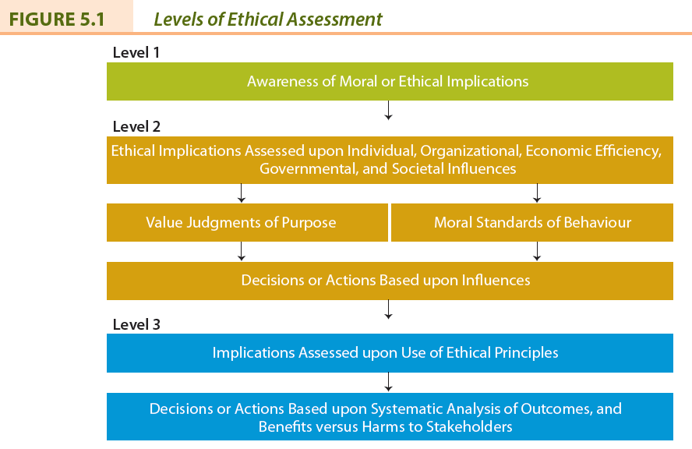

Ethical Implications in Business
- Value judgments: subjective evaluations of what is considered important.
  - based on how managers intuitively feel about the goodness or rightness of various goals
- Moral standards: the means by which individuals judge their actions and the actions of others.
  - based upon accepted behaviour in society
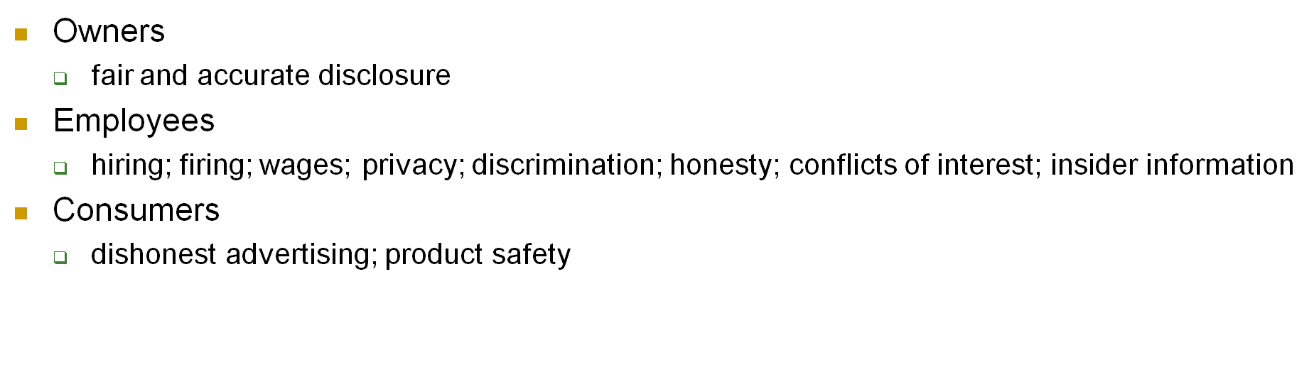
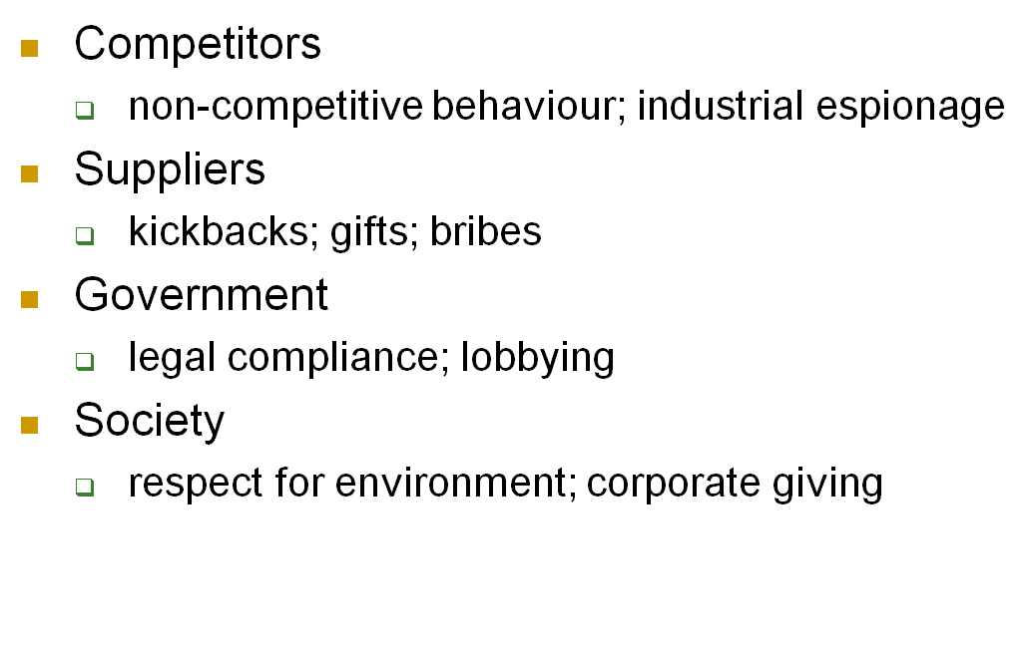

LO 5.3 Influences on Ethical Behaviour
- Influences become the bases for an individual’s value judgments and moral standards that determine behaviour.
  - Influences on Individuals
  - Corporate or Organizational Influences
  - Economic Efficiency Influences
  - Government and Legal System Influences
  - Societal Influences

LO 5.4 Theoretical Basis for Ethical Conduct
- Moral problems should be defined as resulting in harms to some and benefits to others.
  - This introduces more realism in the business context
- Ethical principles are applied the same way in any context.
  - Not subjective measures rather objective statements

Self-Interest (Ethical Egoism)
- Individuals or corporations set their own standards for judging the ethical implications of their actions; only the individual’s values and standards are the basis for actions.
- Self-interest not necessarily the same as: selfishness, greed, disregard for the rights and interests of others, hedonism, or materialism.
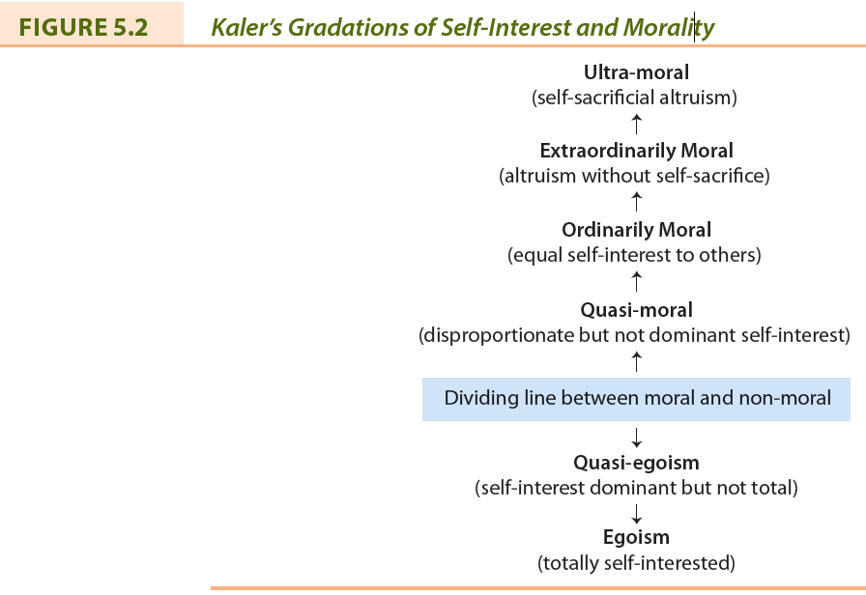
Personal Virtues Ethic
- An individual’s or corporation’s behaviour is based upon being a good person or corporate citizen with traits such as courage, honesty, wisdom, temperance, and generosity.
- Ask, how would I feel if my actions were explained on television?
Ethics of Caring
- Gives attention to specific individuals or stakeholders harmed or disadvantaged and their particular circumstances.
- Golden rule: Do unto others as you would want done to you.
Utilitarian Ethic
- Focuses on the distribution of benefits and harms to all stakeholders with the view to maximizing benefits.
- “The greatest good for the greatest number.”
Universal Rules Ethic
- Ensures that managers or corporations have the same moral obligations in morally similar situations.
- Treat people as means in themselves (i.e., with respect) and never as a means to one’s own ends.
Individual Rights Ethic
- Relies on a list of agreed upon rights for everyone that will be upheld by everyone and that becomes the basis for deciding what is right, just, or fair.
- Examples: Rights to safety, information, privacy, property.
Ethics of Justice
- Considers that moral decisions are based on the primacy of a single value: justice.
- Different types of justice:
  - Procedural justice
  - Corrective justice
  - Retributive justice
  - Distributive justice

LO 5.5 Moral Reasoning Process
- Moral Reasoning: a systematic approach to thinking or reasoning through the implications of a moral problem or issue.
Steps to moral reasoning:
- Define moral issue or decision
- Gather all relevant information
- Identify the stakeholders involved
- Develop possible alternative solutions
- Consider applicable value judgments, moral standards, ethical principles
- Identify harms/benefits to stakeholders
- Determine practical constraints
- Decide on action
Kohlberg’s Stages of Moral Development
Pre-Conventional Level (Self)
Stage 1 – Punishment and obedience orientation
Stage 2 – Individual instrumental purpose/exchange
Conventional Level (Others)
Stage 3 – Mutual interpersonal expectations
Stage 4 – Law and order orientation
Post-Conventional Level (Humankind)
Stage 5 – Social contract orientation
Stage 6 – Universal ethical principle orientation

LO 5.6 Challenges of Ethics in Business
- Indicating ‘just do the right thing’ is insufficient (i.e., too open ended)
- It’s not easy to be ethical
- Unethical behaviour not just due to a few bad apples
- People always have been (and always will be) unethical
- Most believe (due to implicit bias) that they behave ethically towards others

Chapter Summary
- Three levels of assessing ethical implications are identified:
  - Level 1: awareness of moral or ethical implications of business decisions or actions
  - Level 2: assessment based upon influences that are described as value judgments of purpose and moral standards of behaviour
  - Level 3: assessment based on the use of fundamental ethical principles to evaluate the outcomes from decisions or corporate actions
- Seven most cited principles of ethical analysis are: self-interest, personal virtues, caring, utilitarian benefits, universal rules, individual rights, and justice.
- Challenges to ethics in business including simplistic approaches, myths, and lack of awareness.

Chapter 6: Ethics of Business: Management and Leadership

CHAPTER AND LEARNING OBJECTIVE SUMMARY
As emphasized in Chapter 5, increasing sensitivity to the ethical implications of managerial actions in general is a start. In addition, corporations must take deliberate actions to reinforce the importance by considering ethical implications in decision making. The components of a corporation’s ethics program to accomplish this are described in the chapter. The initial stage should be a statement of values or the equivalent that states in general terms the behaviours expected. These values become the foundation for the corporation’s ethics program.
A code of ethics reflects the values of an organization. A distinction should be made from a code of conduct, which focuses on compliance to rules or regulations instead of values. The contents of codes are outlined and drawbacks presented. Today, corporations are not leaving an understanding of morality to chance and are engaged in a variety of training for everyone in the organization.
Ethics audits are becoming more common as an approach to assessing the ethical implications of a corporation’s practices. Usually, such audits are conducted by outside consultants who can also provide a range of advice about ethics programs.
In larger corporations, there is a trend toward an ethics officer of some type being responsible for all aspects of compliance and morality in the organization. Ethics committees in many corporations facilitate the implementation of ethics programs.
Ethics reporting systems are being established. Closely associated with such systems is the practice of whistleblowing. Several complicated issues are associated with whistleblowing and whistleblowers. Managers must carefully monitor the practice to make sure the benefits of it outweigh the drawbacks.

Glossary
Code of conduct | Explicitly states what appropriate behaviour is by identifying what is acceptable and unacceptable.
Code of ethics | A statement of principles or values that guide behaviour by describing the general value system within which a corporation attempts to operate in a given environment.
Conflict of interest | A situation in which an individual has a private or personal interest that is sufficient to appear to influence the objective exercise of that individual's duties.
Corporate ethics programs | Some combination of a statement of values, code of conduct and/or ethics, ethics training, ethics audits and consulting services, ethics officers and committees, and ethics reporting systems.
Ethics audit | A systematic effort to discover actual or potential unethical behaviour in an organization.
Ethics committee | A group, comprising directors, managers, or staff, formed to monitor ethical standards and behaviour.
Ethics officer | An independent manager, reporting to the board of directors or CEO, who reviews complaints or information from anyone in the organization or any stakeholder, studies the situation, and recommends action if necessary.
Integrity management | An ethics program that combines a compliance-based and a values-based approach.
Statement of values | A description of the beliefs, principles, and basic assumptions about what is desirable or worth striving for in an organization.
Whistleblowing | An act of voluntary disclosure of inappropriate behaviour or decisions to persons in positions of authority in an organization.

Want to Learn More
Want to learn more a guide to practical ethics?
Want to learn more about giving voice to values?
Want to learn more about a business ethics blog?

LO 6.1 Statement of Values
- A description of the beliefs, principles, and basic assumptions about what is desirable or worth striving for in an organization.
- Key components:
  - Key stakeholder interests to be satisfied and balanced
  - Emphasis on quality and/or excellence
  - Efficiency
  - Work climate
  - Observance of codes

LO 6.2 Codes of Conduct and Ethics
- Code of conduct: explicitly states what appropriate behaviour is by identifying what is acceptable and unacceptable.
- Code of ethics: a statement of principles or values that guide behaviour by describing the general value system within which a corporation attempts to operate in a given environment.
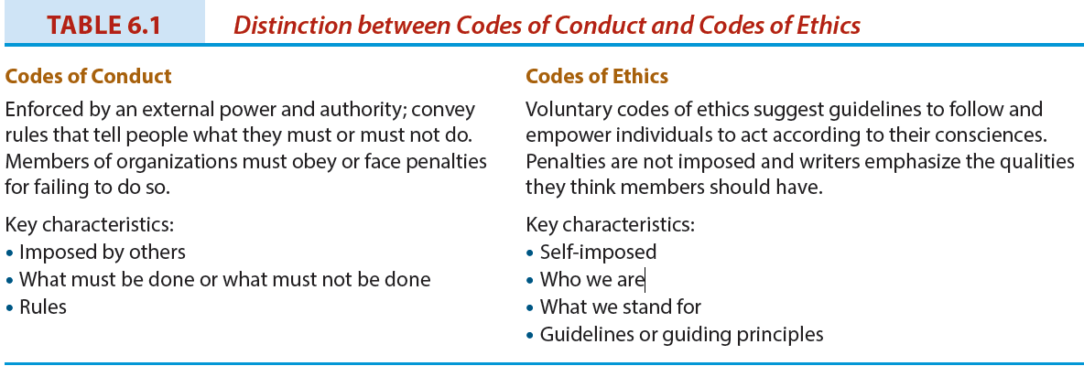
Types of Codes
- Corporate or business enterprise
- Professional organizations
- Industry and sector
- Single issue
- Codes from national and international bodies
Criticisms of Codes
- Unenforceable
- If enforced, penalties are insignificant
- Unnecessary, as most corporations already operate ethically
- Often idealistic
- Written in meaningless generalities
- Merely to prevent government legislation
- Mere response to public criticism

LO 6.3 Ethics Training
- Managers or outside consultants
- Online exercises
- Practical checklists and tests
  - Is it legal
  - Benefit/cost test
  - Categorical imperative
  - Light of day test
  - Do unto others
  - Ventilation test
Conflicts of Interest
- A situation in which an individual has a private or personal interest that is sufficient to appear to influence the objective exercise of that individual’s duties.
  - Three types of conflict: (1) real; (2) apparent; (3) potential
- Examples:
  - self-dealing; accepting gifts or benefits; influence peddling; using employer’s property; using confidential information; outside employment or moonlighting; post-employment; personal conduct

LO 6.4 Ethics Audits
- Systematic effort to discover actual or potential unethical behaviour in an organization.
- Preventive and remedial purpose
- Useful in conjunction with a code of ethics
- Conducted by consultants

LO 6.5 Ethics Officers and Ethics Committees
- Ethics officers:
  - Independent manager
  - Reports to the board of directors or CEO
  - Reviews complaints or information from anyone in the organization or any stakeholder
  - Studies situation and recommends action
  - Responsible for the ethics program
- Ethics committees:
  - Comprising management, employees, and outside stakeholders

LO 6.6 Ethics Reporting Systems and Whistleblowing
- Corporations have established reporting systems so that they can become aware of issues and concerns relating to corporate ethical conduct or irregularities (i.e. hotlines).
- Whistleblowing: an act of voluntary disclosure of inappropriate behaviour or decisions to persons in positions of authority in an organization.

Whistleblowing: Issues
- Remain silent, quit, or disclose wrongdoing?
- Does obligation to employer supersede obligation to self, profession, or industry?
- Will whistleblower be believed?
- Is whistleblower hero or snitch?
- Who should the whistleblower contact?
- What will the consequences be?

LO 6.7 Ethics—Who Is Responsible?
- Boards of directors?
- Management?
- Three models of moral management:
  - Immoral (devoid of ethical principles)
  - Amoral (without ethics, but not actively immoral)
  - Moral (conform to high standards of ethical behaviour)

LO 6.8 Ethics Programs: Approaches
- Formal approach
  - based on organizational norms that are written as a code of conduct
- Monological approach
  - allows organizational members (e.g., managers, employees) to determine for themselves what is right or wrong
- Dialogical approach
  - Emphasizes communication before decisions are made and implemented

Ethics Programs: Compliance versus Values-based
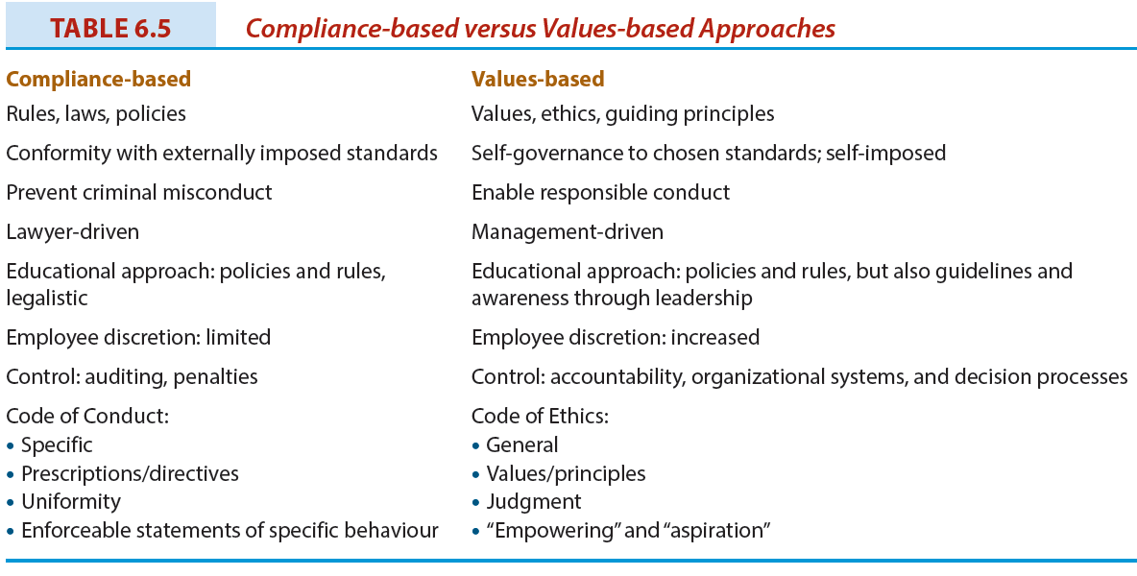
LO 6.9 Ethics Programs: Evaluation and Benefits
- Criteria for an effective ethics program:
  - Visibility
  - Ownership
  - Fit
  - Balance
Ethics Programs: Potential Benefits
- Business practices more beneficial to society
- Alignment of corporate behaviour with values
- Heightened ethical sensitivity of employees and managers
- Avoidance of criminal acts
- Integration of values with quality and strategic management
- Recognition of stakeholder impacts
- More favourable public image

LO 6.10 Why Ethical Leadership and Programs Fail
- Managers are morally imperfect
- Self-interest
- Rationalization and self-delusion
- Threat of formal sanctions
- Threat of informal sanctions
- Tolerance to risk-taking behaviour
- Pressure in particular situations

Chapter Summary
- Corporate ethics programs comprise some combination of the following:
  - a statement of values;
  - code of conduct and/or ethics;
  - ethics training;
  - ethics audits and consulting services;
  - ethics officers and committees; and
  - ethics reporting systems.
- No model or standard program has emerged, and programs vary by business enterprise.
- Despite designing and implementing comprehensive ethics programs and an active role by management in emphasizing ethical behaviour, misbehaviour will still occur.

Corporate Social Responsibility

Chapter 7: Corporate Social Responsibility: The Concept

CHAPTER AND LEARNING OBJECTIVE SUMMARY
Corporate social responsibility is a reflection of the fact that business and society are interwoven and can be expressed in terms of three principles: legitimacy, public responsibility, and managerial discretion. The principle of legitimacy refers to society’s granting of legitimacy and authority to business, along with business’s appropriate use of that power; the principle of public responsibilitymeans business is responsible for outcomes related to its areas of involvement with society; and the principle of managerial discretion refers to managers as moral actors who are obligated to exercise such discretion as is available to them to achieve socially responsible outcomes.
The debate as to whether social responsibility is an appropriate concept is summarized in arguments for and against corporate social involvement. These arguments are reflected in Klonoski’s summary of social responsibility theories, categorized according to three alternative views of the corporation as amoral, personal, and social. The arguments and theories are presented not to provide a definitive answer to the question of corporate social responsibility but to review the background to the debate. In fact, the debate has not been resolved to date, as evidenced by the critique of CSR in a leading business magazine.
A pyramid of corporate social responsibilities is presented in this chapter. A hierarchy of responsibilities exists; economic and legal obligations are primary and basic. In recent years, the ethical and philanthropic responsibilities have received more attention.
Social responsibility has evolved, and today other terminology is being used to describe the concept. This terminology includes corporate sustainability, reputation management, social impact management, triple-E bottom line, and corporate citizenship. Definitions are provided so that a distinction can be made among the terms. Corporate citizenship is another term used interchangeably with CSR. It is an inclusive term to capture the economic, social, and environmental responsibilities of the corporation and relies on stakeholder theory. As with CSR, various interpretations are given to the term, and it is argued that the term business citizenship would be even more inclusive as it is global or universal in scope.
The VBA Model is an attempt at unifying and integrating the various frameworks within CSR around three core concepts, value, balance, and accountability. This model reduces the confusion resulting from the various terminology used in the business and society and CSR field.

Glossary
Business citizenship | Includes the responsibilities of corporate citizenship on a local and national basis and extends it to a global or universal scope.
Corporate citizenship | Occurs when a corporation demonstrates that it takes into account its complete impact on society and the environment as well as its economic influence.
Corporate social responsibility (CSR) | The way a corporation achieves a balance among its economic, social, and environmental responsibilities in its operations so as to address shareholder and other stakeholder expectations.
Corporate sustainability (CS) | Corporate activities demonstrating the inclusion of social and environmental as well as economic responsibilities in business operations as they impact all stakeholders.
Reputation management | Any effort to enhance the corporation's image and good name; in the past, the focus of these efforts was on media and public relations and, to some extent, crisis management.
Social impact management | Defined by the Aspen Institute as "the field of inquiry at the intersection of business needs and wider societal concerns that reflects and respects the complex interdependency between the two."
Triple-E (economic, ethical, and environmental) bottom line | Evaluates a corporation's performance according to a summary of the economic, social, and environmental value the corporation adds or destroys.

Want to Learn More
Want to learn more sustainability?
Want to learn more about CSR jobs?
Want to learn more about Corporate Knights?

LO 7.1 Describing Corporate Social Responsibility (CSR)
Corporate Social Responsibility: Definition
The way a corporation achieves a balance among it economic, social, and environmental responsibilities in its operations so as to address shareholder and other stakeholder expectations.
Key Elements of Corporate Social Responsibility (CSR)
- Corporations have responsibilities beyond the production of goods and services.
- These responsibilities involve helping to solve social problems.
- Corporations have a broader constituency than just stockholders.
- Corporations have impacts beyond simple marketplace transactions.
- Corporations serve a wider range of human values than just economic values.
Principles of CSR
- Business and society are interwoven rather than distinct entities
- Expectations are placed on business due to its three roles: institutional; organizational; and individual.
- These three roles can be expressed in terms of three principles of corporate social responsibility: legitimacy; public responsibility; and managerial discretion.

LO 7.2 The CSR Debate
Case for Involvement
- Business must satisfy society’s needs.
- CSR prevents public criticism and government regulation.
- Business and society are interdependent.
- CSR is good for the bottom line.
- Investors and consumers support CSR.
- Addressing social problems can become financial opportunities (i.e. pollution abatement).
- Business should take long-term CSR approach.
- Social actions improve public image and goodwill.
- Business can solve problems as well as government.
- Proactive approach is better than reactive.
- Businesspeople are also concerned citizens.
Counterarguments
- Profit maximization is the primary purpose of business (e.g., Milton Friedman).
- Business is responsible to shareholders.
- Social policy is role of government.
- Business lacks training in social issues.
- CSR would give too much power to business.
- Business involvement in social matters increases costs.
- No reliable guidance for business in CSR matters.
- Business cannot be held accountable unlike social institutions.
- There is divided support in business community for social involvement.

LO 7.3 Social Responsibility Theories
- Amoral view
  - Traditional view of business as merely profit-making entity
- Personal view
  - Corporations are like people and can therefore be held accountable for their actions
- Social view
  - Corporations are social institutions with social responsibilities

LO 7.4 The Pyramid of CSR
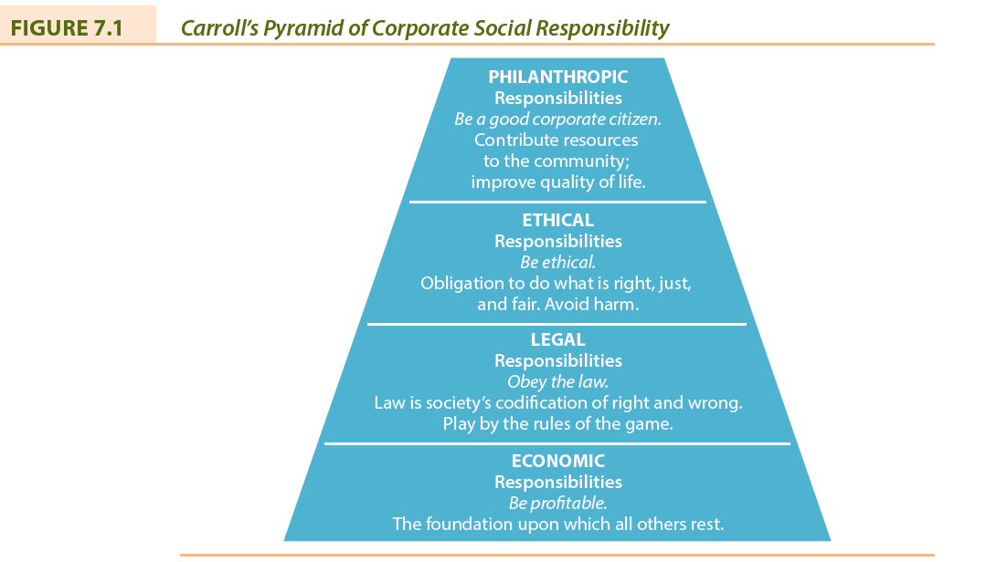

LO 7.5 Contemporary CSR Concepts
Corporate Sustainability (CS)
- CS refers to activities demonstrating the inclusion of social, environmental and economic responsibilities in business operations as they impact all stakeholders.
  - Compliance-driven CS: follow regulations
  - Profit-driven CS: focus on bottom line
  - Caring CS: go beyond legal compliance
  - Synergistic CS: well balanced solutions
  - Holistic CS: fully integrated CS
Reputation Management
- Reputation management is an effort to enhance a corporation’s image.
- Previous focus on media and public relations as well as crisis management.
- Today, focus is on relationships with all stakeholders.
- Reputations take a long time to be established, but can be destroyed quickly.
Social Impact Management
- The field of inquiry at the intersection of business needs and wider societal concerns that reflects and respects the complex interdependency between the two.
- Evaluates three aspects of business:
  - Purpose of business
  - Social context of business
  - Metrics: how performance is measured
Triple Bottom Line (TBL)
- Evaluates a corporation’s performance according to a summary of the economic, social, and environmental value the corporation adds or destroys.
- Often forms the basis for corporate reporting of economic, ethical, and environmental responsibilities.
- Has also been criticized as being of limited value and misleading.
Corporate Citizenship
- Corporate citizenship occurs when a corporation demonstrates that it takes into account its complete impact on society, environment and economy.
Good Corporate Citizenship: Benefits
- Reputation management
- Risk profile and risk management
- Employee recruitment, motivation, and retention
- Investor relations and access to capital
- Learning and innovation
- Competitiveness and market positioning
- Operational efficiency
- License to operate
New Approach to Corporate Citizenship
- Limited
  - Focus on corporate giving
- Equivalent
  - Emphasis on sustainability
- Extended
  - Defined as a set of individual, social, civil, and political rights

LO 7.6 Views on Corporate and Business Citizenship
The Business View of Corporate Citizenship
- Business Citizenship
  - Includes the responsibilities of corporate citizenship on a local and national basis and extends it to a global or universal scope

LO 7.7 The VBA Model: An Integration of CSR Concepts
- Integrates and unifies five frameworks in common usage by academics and managers based on three core concepts: value; balance; and accountability
  - Corporate Social Responsibility (CSR)
  - Business Ethics (BE)
  - Stakeholder Management (SM)
  - Sustainability (SUS)
  - Corporate Citizenship (CC)
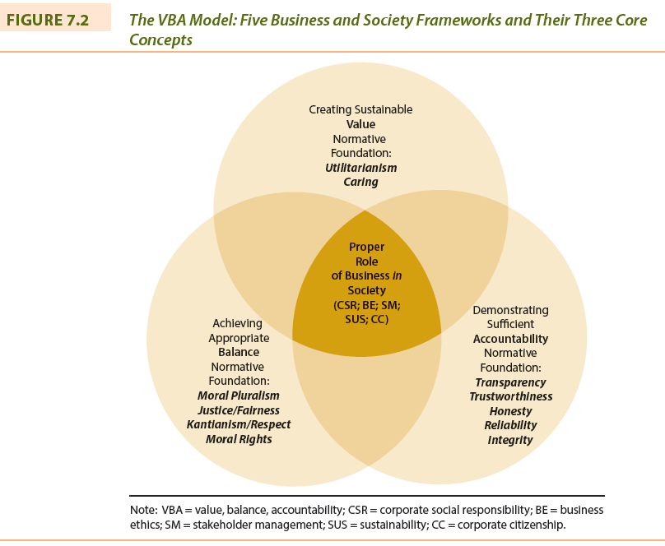

Chapter Summary
- Corporate social responsibility is a reflection of the fact that business and society are interwoven and can be expressed in terms of three principles: legitimacy, public responsibility, and managerial discretion.
- A pyramid of corporate social responsibilities is presented, based on economic, legal, ethical, and philanthropic responsibilities.
- Corporate citizenship is another term used interchangeably with CSR. It is an inclusive term to capture the economic, social, and environmental responsibilities of the corporation and relies on stakeholder theory.
- The VBA model is an attempt at unifying and integrating the various frameworks within CSR around three core concepts: value, balance, and accountability.

Chapter 8: Corporate Social Responsibility: In Practice

CHAPTER AND LEARNING GOAL SUMMARY
A spectrum of some corporate social responsibility or corporate sustainability approaches is described in this chapter: corporate giving or donations, voluntarism, sponsorship, social venture philanthropy, and social enterprise. Most corporations practise one or more of these approaches as they seek the most effective way to practise CSR. There are arguments for and against corporate donations, and in particular the issue of whether such activity is in the best interests of the corporation and its shareholders has not been resolved. Once the corporation decides to become involved in corporate giving, another challenge emerges—how to manage the process. A decision making process involving committees or foundations should be established if the corporation wants to be consistent and perceived to be treating all requests fairly. Although something positive can be gained from donations, there is the possibility of negative outcomes when requests are rejected. Rejections must be handled as professionally as successful requests. Philanthropic decision making is even more challenging given the increasing demands for corporate support and the limited amount of funds available. In addition, there is a trend toward tying giving to economic gains, an issue that re-emerges throughout the chapter.
Voluntarism is receiving more attention as an approach to corporate philanthropy. Employees and retirees of corporations make contributions to charitable organizations, often with the encouragement of managers. Many corporations have well-defined policies relating to employee volunteer activities to avoid conflicts with work obligations or to protect the reputation of the corporation. Although voluntarism is usually encouraged, it is not without challenges for management. Sponsorship has grown as a form of philanthropy. Discussion continues as to whether such an activity is in support of a charity or an aspect of marketing. Corporations are pressured for greater return on donation funds, and tying support to sponsorship of projects or events appears to result. The discussion of sponsorship is a logical lead-in to the examination of the trend toward corporations seeking to satisfy economic as well as social objectives with corporate philanthropic initiatives. Corporate management is demanding more efficiency and accountability from non-profit charities, and receivers of support from corporations in “sin industries” are being challenged for accepting it.
Social venture philanthropy is a newer approach to CSR where donors believe their funds should be invested rather than merely handed over as a cheque. The approach also involves more engagement with the recipient organization to encourage the use of entrepreneurial and managerial approaches. Social enterprises can be viewed as two types. One type is as a commercial enterprise operated by a non-profit organization with the goal of making profits, which are devoted completely to social purposes. Another for-profit type distributes its earnings to social causes and to shareholders. Both types are committed to contributing to the alleviation of social problems in society. The for-benefit corporation is another approach to the social enterprise that has emerged recently.
Small businesses are involved in CSR but receive less recognition than large corporations. CSR decisions are driven by the entrepreneur and focus on local community social issues. Corporate philanthropy appears to be a relatively straightforward matter. But in practice this is not the case, and managers must plan and establish policies to implement initiatives to support charitable endeavours. Observers of CSR are monitoring the impact of the economic downturn on CSR.

Glossary
Cause-related marketing | The purchase of a particular product results in a donation being made by a corporation to a non-profit organization's program.
Charitable foundation | A corporation or trust that is constituted and operated exclusively for charitable purposes.
Community bond | A debt instrument issued by a social enterprise to a network of supporters and used to finance or advance a specific proposal.
Community investment | The efforts of a corporation to help develop a community and create economic opportunities through a variety of means, from donations to direct involvement in commercial undertakings.
Corporate philanthropy | The effort of business to contribute to society socially; manifested by donations of money or goods and services in kind, voluntarism (where corporate employees work for social causes), and sponsorship of events that contribute to society.
Corporate sponsorship | A partnership between a business sponsor and an event or a non-profit organization that is established for mutual benefit.
Corporate voluntarism | The time and talent employees commit to community organizations with support and/or consent from employers who recognize the value of such efforts to society.
For-benefit corporation | Operates to make profits but also has a strong commitment to addressing social and environmental problems.
Philanthrocapitalism | Draws upon modern business practices and an entrepreneurial spirit to get more from corporate social responsibility.
Social enterprise | A model of business operation where some or all profits are deliberately used to further social aims.
Social entrepreneur | An innovative, visionary leader of a non-profit or for-profit business with real-world problem-solving creativity and a high awareness for ethical, social, and environmental considerations.
Social entrepreneurship | The activities undertaken to enhance social wealth in some innovative way.
Social venture philanthropy | The investment of human and financial resources by corporations in non-profit community development agencies to generate a social return instead of only a financial one.
Strategic giving | An attempt to rationalize the shareholder interest with corporate philanthropy where the corporation benefits directly from the funds given.

Want to Learn More
Want to learn more about the Giving Pledge?
Want to learn more about CSR and small business?
Want to learn more about Canadian social enterprises?

LO 8.1 Responses to Corporate Social Responsibility
- Corporate Giving, or Donations
- Voluntarism Programs
- Corporate Sponsorship
- Social Venture Philanthropy
- Social Enterprise
- Community Investment
Planning for CSR
- Conduct CSR assessment
- Develop a CSR strategy
- Develop CSR commitments
- Implement CSR commitments
- Verify and report on progress
- Evaluate and improve

LO 8.2 Corporate Philanthropy
- The effort of business to contribute to society socially, manifested by donations of money or goods and services in kind, voluntarism (where corporate employees work for social causes), and sponsorship of events that contribute to society.
Arguments For Corporate Philanthropy
- Means to express CSR to community
- Promotes image of good citizenship
- Business benefits from volunteer sector
- Benefits from corporate community investment program
- Company’s success linked to community’s health
Arguments Against Corporate Philanthropy
- Funds given belong to shareholders
- Social welfare is the job of government
- Corporation might become accountable for actions of charity
- No guidelines or standards to measure, evaluate, or monitor corporate giving
Trends and Concerns in Corporate Giving
Cause-related marketing: The purchase of a particular product results in a donation being made by a corporation to a non-profit organization’s program.
Strategic giving: An attempt to rationalize the shareholder interests with corporate philanthropy whereby the corporation benefits directly from the funds given.

LO 8.3 Corporate Voluntarism
- The time and talent employees commit to community organizations with support and/or consent from employers who recognize the value of such efforts to society.
- Forms of support:
  - Providing facilities, allowing time off, assisting with personal expenses incurred while undertaking voluntary activities, special recognition to employees
- Corporate policies regarding voluntarism:
  - encouraging; enabling; and promoting

LO 8.4 Corporate Sponsorship
- A partnership which has been established for mutual benefit between a business sponsor and an event or a non-profit.
- Examples: sports, cultural, and educational events, literacy, race relations, drug abuse, environmental issues, etc.

LO 8.5 Social Venture Philanthropy
- The investment of human and financial resources by corporations in non-profit community development agencies to generate a social return instead of only a financial one.
- Also known as social venturing, the new philanthropy, and high-engagement philanthropy.

LO 8.6 Social Enterprise and Entrepreneurship
Social Enterprise
- A model of business operation where some or all profits are deliberately used to further social aims.
- Two types:
(1) non-profit enterprises that contribute all profits to social initiatives (i.e. Value Village thrift stores);
(2) for-profit enterprises that divide profits between social initiatives and shareholders (i.e. The Body Shop)
Social Entrepreneurship
- Social entrepreneurship involves the activities undertaken to enhance social wealth in some innovative way.
- Social Entrepreneur: An innovative, visionary leader of a non-profit with real-world problem-solving creativity and a high awareness of ethical considerations.
- Also referred to as philanthrocapitalism
- Social entrepreneurship involves the activities undertaken to enhance social wealth in some innovative way.
- Social Entrepreneur: An innovative, visionary leader of a non-profit with real-world problem-solving creativity and a high awareness of ethical considerations.
- Also referred to as philanthrocapitalism
For-Benefit Corporation
- Operates to make profits but also has a strong commitment to addressing social and environmental problems.
- For-benefit corporations (B Corporations) are expected to have a material impact on society and to consider how their actions affect stakeholders.
- Accountability and transparency are requirements.

LO 8.7 Small Business and CSR
- Challenges:
  - Entrepreneurs do not have time
  - Expenses involved
  - Lack of knowledge of CSR planning
- Typical issues for small business:
  - underground economy; misleading advertising and financial reporting; improper gift giving and receiving; tax evasion; nepotism.
Differences in CSR: Large vs. Small Business
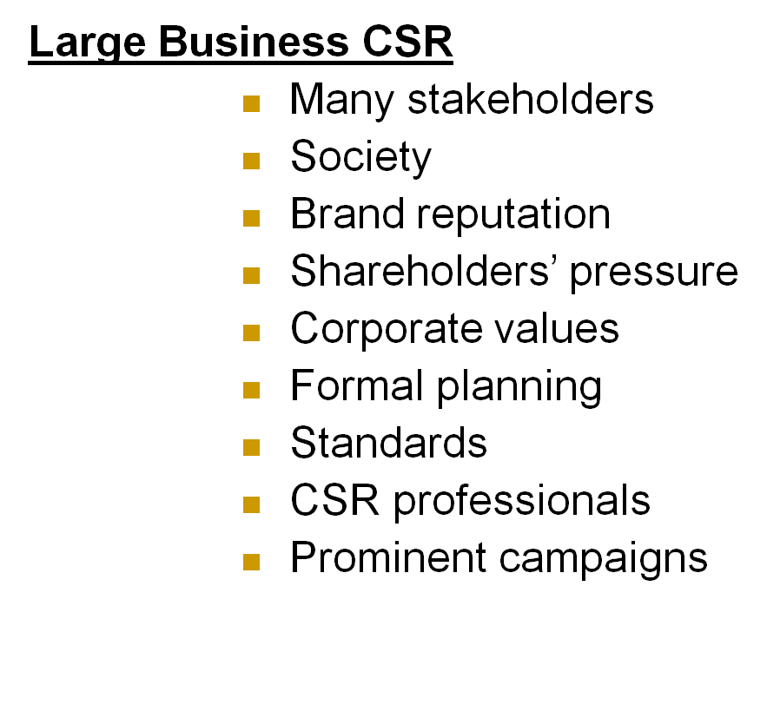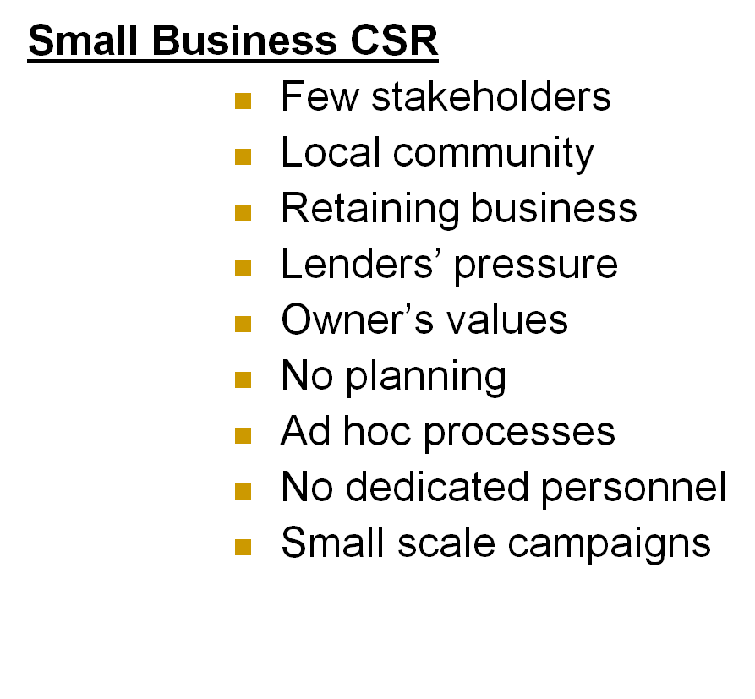
Small Business Strategies
- Investment: provides information or resources to the community.
- Involvement: uses community input to shape its actions.
- Integration: company and the community jointly manage projects.

LO 8.8 Trends and Issues in Contemporary CSR
- Community investment: The efforts of a corporation to help develop a community and create economic opportunities through a variety of means, from donations to direct involvement in commercial undertakings.
- Motivation may be based on: religious principles; making a difference in society; personal experience; giving something back; and self-interest (e.g., tax incentives and recognition)
- Community bond: A debt instrument issued by a social enterprise to a network of supporters and used to finance or advance a specific proposal.
- Potential concern that CSR will receive less attention during an economic downturn.

Chapter Summary
- There is a range of approaches to social responsibility practices:
  - Corporate Giving, or Donations
  - Voluntarism Programs
  - Corporate Sponsorship
  - Social Venture Philanthropy
  - Social Enterprise
  - Community Investment

Chapter 9: Measuring, Reporting, and Communicating CSR

CHAPTER AND LEARNING GOAL SUMMARY
Corporate reporting of social responsibility and sustainability has become a management function in many organizations. Social auditing is performed and the results become the basis for social reporting. Today, economic, ethical, and environmental standards or measures are being developed and used by corporations. The ultimate in social reporting is to evaluate the corporation’s performance on these standards and to have the results externally verified. An important reason for social reporting is to sustain the corporation’s reputation; that is, the stakeholders’ perceived views of the corporation. There is a connection between reputation, the corporation’s stakeholders, the management of the issues they raise, and the approach to strategic management. Today, corporate reputation rather than image has become important to a successful corporate strategy.
CSR reporting is demanded or expected by several stakeholders, in particular shareholders, employees, consumers, society at large, service professionals, NGOs, charities, the media, and government. There are too many stakeholders interested in the corporation’s social and environmental initiatives for reporting to be ignored by management.
The relationship between CSR and profitability has been extensively studied. A majority of studies have found a positive relationship, but the research approaches and techniques used are being questioned.
There are several organizations establishing criteria to be used in social auditing, which in turn determine the contents of CSR reports. Organizations assisting managers in this area include Canadian Business for Social Responsibility, the Conference Board of Canada, the Accountability Project, and the Global Reporting Initiative. The latter is the most prominent and its indicators are utilized by many corporations in their CSR reports. The CSR reports produced by Canadian corporations are evaluated by newspapers, magazines, consulting firms, and professional organizations. This evaluation provides best-practice examples for corporations beginning to develop CSR reports. The act of producing the CSR report is a good learning exercise for the corporation, but it is necessary to communicate the results to stakeholders in various formats and delivery modes.
Few business schools produce a CSR report on themselves. But, they are being evaluated about how they are integrating corporate social responsibility and the ethics of business into programs, courses, faculty activities, and student initiatives.
The future of CSR and reporting is not certain. It is thought that it will become a required management function with a minimum baseline standard being established. What happens to CSR will determine the changes in social measuring, reporting, and communicating approaches.

Glossary
Corporate reputation | As defined by Fombrun, "a perceptual representation of a corporation's past actions and future prospects that describes the corporation's overall appeal to all of its key constituents [stakeholders] when compared with other leading rivals."
Corporate social responsibility reporting (sustainability reporting) | A management function that documents the corporation's economic, ethical/social, and environmental responsibilities and initiatives, and communicates this information to relevant stakeholders.
Global Reporting Initiative (GRI) | A non-profit organization that works toward a sustainable global economy by providing guidance in sustainability reporting.
Social auditing | A systematic assessment that identifies, measures, evaluates, reports, and monitors the effects an enterprise has on society that are not covered in the traditional financial reports.

Want to Learn More
Want to learn more about evaluating sustainabilty reports?
Want to learn more about CSR in Canadian business?
Want to learn more about the best CSR sustainability reports?

LO 9.1 Measuring and Reporting CSR
Social Auditing: Definition
Systematic assessment that identifies, measures, evaluates, reports, and monitors the effects an enterprise has on society that are not covered in traditional financial reports.
Social Auditing: Approaches
- Inventory
- Program management
- Process
- Cost or outlay
- Social responsibility accounting
- Social indicators
- Social objective setting
- Triple bottom line reporting
- Social reports
- Sustainable guidelines
- Externally verified social reports
LO 9.2 Corporate Reputation and CSR
CSR Reporting: Definition
- A management function that documents the corporation’s economic, ethical/social, and environmental responsibilities and initiatives and communicates this information to relevant stakeholders.
- Also known as sustainability reporting.
Corporate Reputation and CSR
- Corporate Reputation: “a perceptual representation of a corporation’s past actions and future prospects that describes the corporation’s overall appeal to all of its key constituents [stakeholders] when compared with other leading rivals.” (Fombrun, 1996)
- Often associated with corporate image, but today related more to “character” of corporation
- An intangible asset for the corporation.

LO 9.3 Stakeholders Expect CSR Accountability
- Shareholders and financial institutions
- Employees
- Consumers
- Society at large
- Service professionals
- Non-governmental agencies
- Charities
- Media
- Government

LO 9.4 CSR and Profitability
- Relationship between profitability and CSR has been extensively studied, but with mixed results:
  - Expenditures on CSR do not contribute to profits;
  - Expenditures on CSR do contribute to profits;
  - Expenditures on CSR might contribute to profits.
- Network for Business Sustainability (NBS) has taken the view that initiatives, which can result in positive impacts, fall into one of three categories:
  - Firm processes
  - Firm outcomes
  - External outcomes

LO 9.5 Social Auditing and Reporting Criteria
- Canadian Business for Corporate Social Responsibility’s seven checklists:
  - Community (9 criteria)
  - Employee (19 criteria)
  - Customer (7 criteria)
  - Supplier (9 criteria)
  - Environment (6 criteria)
  - Shareholder (6 criteria)
  - International operations (4 criteria)
- Each criterion has six assessment items:
- Accountability/Transparency
- Stakeholder Involvement
- Program Evaluation and Measurement
- Program
- Policy
- Commitment

LO 9.6 Evaluating Canadian CSR Reporting
Global Reporting Initiative (GRI)
- A non-profit organization that works toward a sustainable global economy by providing guidance in sustainability reporting.
- Among GRI’s principles are those:
  - intended to define report content: materiality, stakeholder inclusiveness, sustainability context, and completeness
  - intended to define report quality: balance, comparability, accuracy, timeliness, reliability, and clarity
- Sustainability Reporting Guidelines include the following standard disclosures:
  - Strategy and Profile
  - Economic
  - Environmental
  - Social
Global Corporate Reporting Guidelines
- OECD Guidelines for Multinational Enterprises
- UN Global Compact
- Caux Round Table Principles for Business
- International Code of Ethics for Canadian Business
- ISO CSR Reporting Standards
CSR Reports: Best Practices
- Identify stakeholders
- Identify trends, risks, challenges, opportunities
- Prioritize issues
- Identify stakeholder approaches
- Identify which standards used
- Objectives for future and previous accomplishments
- Enhance appearance and readability (e.g., illustrations, graphs, etc.)
- Indicate manager responsible for CSR

LO 9.7 Communicating CSR and Sustainability Results
- How to inform employees:
  - Articles in newsletters
  - Information on employee intranet
  - Agenda item at meetings
  - Corporate reputation committees
- How to inform other stakeholders:
  - Customer invoices or billings
  - Corporate web sites
  - Newspaper and magazine articles and television news programs
  - Word of mouth

LO 9.8 Business Schools and Sustainability Reporting
- US: “Beyond Grey Pinstripes” survey
- Canada: “Knight Schools: The Annual Knight School Guide to Business Education”
- Association to Advance Collegiate Schools of Business (AACSB):
  - "The institution or the business programs of the institution must establish expectations for ethical behaviour by administrators, faculty, and students."

LO 9.9 The Future of CSR and Social Reporting
- CSR Lite
  - superficial and marginal
- CSR Compliant
  - take on obligations to maintain license to operate
- CSR Strategic
  - create strategic niches
- CSR Integrated
  - comprehensive policies
- Deep CSR
  - mission is to improve social or environmental conditions
- Fad-and-fade scenario:
  - Awareness and practice of CSR will decline significantly
- Embed-and-integrate scenario:
  - CSR is accepted, continuous enhancement continues
- Transition-and-transformation scenario:
  - incremental changes to CSR are insufficient, redesign of corporation necessary

Chapter Summary
- CSR and sustainability performance is measured, reported, and communicated in Canada by:
  - Establishing the existence of this reporting and examining why it is taking place.
  - Evaluating the quality of the reporting in terms of the reliability of the information.
  - Reviewing the verification or assurance mechanisms used to enhance the credibility of the reporting.
  - Identifying the efforts made by corporations to communicate the reports to stakeholders.

Influencing Business

Chapter 10: Regulating Business

CHAPTER AND LEARNING GOAL SUMMARY
Business is regulated by market forces, self-regulation by business itself, and government. Eight forms exist: laissez-faire market, corporate self-discipline, industry self-regulation, self-regulation involving stakeholders, negotiated self-regulation, mandated self-regulation, quasi-government, and complete government regulation. There is no one form of regulation that is preferable to others, and regulation should vary to suit the circumstances within an industry.
Government influences economic growth and lays out the rules that business will follow in conducting its affairs. Government is a major purchaser of the goods and services provided by business. Many subsidies are given to business including tax credits, grants, loans, and loan guarantees, and on occasion government rescues failing corporations or industries. Government protects business and producer interests, a common approach being protection from foreign competitors. Some businesses are owned completely or in part by government, although this is becoming less common. Most industries are regulated to some degree with the extent of regulation constantly shifting. Lastly, government protects various interests in society against exploitation by business and redistributes resources to meet social ends.
The Federal Government has recognized the importance of corporate social responsibility and has been involved with several initiatives to insure that Canadian corporations behave in ways that are socially and environmentally responsible.
Business is involved in Canadian politics through financing political parties, supporting particular candidates, expressing views on public issues, allowing employees to participate in the political process, and through businesspersons seeking public office. Lobbying is any attempt to influence directly or indirectly any government activity, and includes any attempt to influence legislators, their staff, public administrators, and members of regulatory agencies. Corporations or industry organizations can have their own employees as lobbyists or can hire consultants to perform the function. Lobbying is controversial and is being increasingly regulated. Even though business devotes considerable resources to lobbying, its efforts are not always successful.
Corporate public affairs departments perform the management function responsible for monitoring and interpreting the governmental environment of the corporation or industry and for managing the responses necessary to protect the interests of the corporation or industry. A corporate agenda is the real or imagined domination of public policy or government programs by corporations or industry organizations in their own best interests. While business advocates the deduction of government involvement in the economy, it also seeks government assistance and protection—a practice known as corporate welfare.
There has been an ideological shift away from relying on government to solve society’s problems. This decline in government involvement has implications for corporations and their stakeholders. One result of this trend has been the privatization of many government functions; that is, the strengthening of the market at the expense of the state. In 2008, the financial crisis and economic downturn reversed the trend of less government involvement.
The interaction between government and business has numerous ethical implications. Government itself is aware that society expects a higher standard of ethical behaviour and has instituted various aspects of ethics programs, as corporations have done.

Glossary
Chosen instrument | A corporation within a particular industry that receives some form of special attention from government through grants, loans, purchasing policy, or tax incentives.
Corporate agenda | The real or imagined alleged domination of public policy or government programs by corporations or business organizations in their own best interests.
Corporate public affairs | The management function responsible for monitoring and interpreting the governmental environment of the corporation or industry and for managing the responses necessary to protect the interests of the corporation or industry.
Corporate welfare | Any action by municipal, provincial, or federal governments that gives a specific corporation or an entire industry a benefit not offered to others.
Deregulation | The reduction of government influence or impact over the economy allowing for a freer and more efficient marketplace.
Lobbying | All attempts to influence directly or indirectly any government activity; includes any attempt to influence legislators, their staff members, public administrators, and members of regulatory agencies.
Mixed enterprises | Those in which a government owns equity in a private-sector enterprise.
Privatization | According to Heald, the "strengthening of the market at the expense of the state."
Public-private partnership (PPP) | A cooperative venture between the public and private sectors, built on the expertise of each partner, that best meets clearly defined public needs through the appropriate allocation of resources, risks, and rewards.
Self-regulation | Regulation imposed by the corporation or industry and not by the government or market forces.
Self-regulatory organizations (SROs) | Industry groups that are delegated or designated a regulatory function including the development, use, and enforcement of standards.
Tax expenditures or tax credits | Potential revenues the government chooses not to collect; any form of incentive or relief granted through the tax system rather than through government expenditures.

Want to Learn More
Want to learn more about the view of government regulation?
Want to learn more about lobbying government?
Want to learn more about ethics in government?

LO 10.1 The Spectrum of Regulation
- Self-regulation: regulation imposed by the corporation or industry and not by the government or market forces.
  - Pros?
  - Cons?
- Government regulation
  - Pros?
  - Cons?
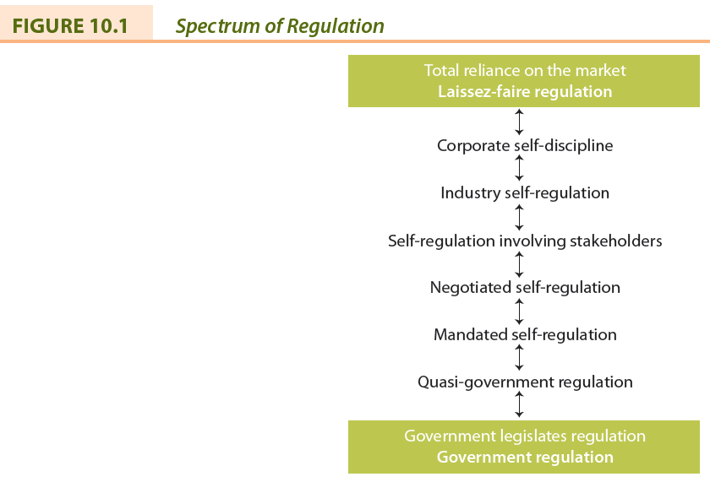
LO 10.2 Types of Regulation
Market Regulation
- No need for government-imposed laws or regulations.
- Corporation influenced by market forces.
- Laissez-faire approach.
- Government does not interfere with business.
- Consumers can force companies to behave in particular ways by refusing to purchase goods or services or through boycotts.
Self-Regulation
- Corporate self-discipline regulation
  - mission, values statement, codes of conduct or ethics
- Industry self-regulation
  - voluntary codes
- Self-regulation involving stakeholders
- Negotiated self-regulation
- Mandatory self-regulation

LO 10.3 Government Regulation of Business
Scope of Government Regulation
- Government:
  - is architect of economic growth
  - prescribes rules businesses must follow
  - is a major purchaser of goods and services produced by businesses
  - is a major promoter and subsidizer of businesses
  - is a supplier of debt capital to many businesses (i.e. Tax expenditures or tax credits; Chosen instrument)
  - is a rescuer of failed businesses
  - is the protector of business and producer interests
  - is the owner of business enterprise
  - is a partner with business in some endeavours (i.e. Mixed enterprises; and Public-Private Partnership (PPP))
  - directly manages (through regulation) large areas of private business activity
  - is the protector of various societal interests against business exploitation

LO 10.4 Government Involvement in CSR
Legislating CSR
- Legal system can be used to protect stakeholders (e.g., investors, consumers, employees).
- Attempts have been made to legislate CSR in U.S., UK, and Canada but with only limited success.

LO 10.5 Business Involvement in Politics
- Financing of political parties.
- Publicly expressed support for a candidate or party.
- Publicly expressed views on political issues.
- Executives running for public office.
- Management’s position on employee participation.

LO 10.6 Business Lobbying
- All attempts to influence directly or indirectly any government activity, and includes any attempt to influence legislators, their staff members, public administrators, and members of regulatory agencies.
Business Lobbying
- Business lobbying attempts to influence:
  - Making or amending of legislation and regulations
  - Making or changing of government policies or programs
  - Government decisions in the awarding of grants, contracts, contributions, or any similar benefits
  - Government appointments to boards, commissions, and any other public office
Types of Business Lobbyists
- Business interest groups or associations.
- Consultants who specialize in government–business relations.
- “In-house” lobbying capability through Government relations or public affairs staff.
Business Lobbying: Benefits
- Offset the influence of other groups.
- Opinions or perspectives must be made known to governments if informed decisions are to be made about public policies affecting business.
Business Lobbying: Criticisms
- Practices unethical (e.g., bribes, gifts, improper political contributions, blackmail).
- Business lobby too powerful.
- Business has unequal access to government.
- Cost of business lobbying passed on to consumers.

LO 10.7 Corporate Public Affairs Departments
- The management function responsible for monitoring and interpreting the governmental environment of the corporation or industry and for managing the responses necessary to protect the interests of the corporation or industry.
- Role expanded to include community relations, media relations, environmental monitoring, issues management, lobbying, and public relations.
Corporate Agenda
- The real or imagined alleged domination of public policy or government programs by corporations or business organizations in their own best interests.
- The corporate agenda might include:
  - Reduction of government involvement
  - Deregulation of business and industry
  - Reduced corporate taxation
  - Enactment of free trade agreements and support for globalization
Corporate Welfare
- Any action by municipal, provincial, or federal governments that gives a specific corporation or an entire industry a benefit not offered to others
- Industries appear increasingly willing to advocate for and accept government assistance

LO 10.8 The Impact of Changing Government Involvement
- Deregulation
  - Definition: the reduction of government influence or impact over the economy allowing for a freer and more efficient marketplace
  - Pros: more competitive business environment, resulting in higher productivity, more efficiency, and lower prices
  - Cons: reduced environmental quality standards, greater financial uncertainty, and market control by monopolies.
- Privatization
  - Definition: Strengthening of the market at the expense of the state
- Common themes of privatization:
  - Provision of public service by the private sector
  - Degrees of privatization (i.e. complete or partial)
  - Techniques or forms of privatization (i.e. divestiture, contracting out)
  - Terms are used that have overlapping meanings (i.e. “contracting out service delivery”)

LO 10.9 Ethical Implications in the Business–Government Relationship
- Appropriateness of government involvement and interference in business operations
- Matter of accessibility to government
- Favouritism to some corporations regarding loans, grants, or protection
- Endorsement of political candidates or parties can be perceived as expecting favours in future
- Lack of transparency in relationship between government and business

LO 10.10 Ethics in Government
- The relationship between business and government involves the ethical behaviour of politicians and public administrators.
  - Governments have developed codes and conflict of interest guidelines
  - Business codes and guidelines often include clauses identifying appropriate behaviour when dealing with government
- Morality of operating some government-owned business corporations

Chapter Summary
- Business is regulated by market forces, self-regulation by business itself, and government.
- The scope of government regulation of business is extensive.
- Business is involved in Canadian politics through a diverse set of strategies.
- The interaction between government and business has numerous ethical implications.
- Government itself is aware that society expects a higher standard of ethical behaviour and has instituted various aspects of ethics programs, as corporations have done.

Chapter 11: Governance of the Corporation

CHAPTER AND LEARNING GOAL SUMMARY
Although other stakeholders have an influence on the corporation, it is owned by shareholders or investors. Direct owners include investors, entrepreneurs, managers, employees, and producers, while indirect owners include mutual, pension, and investment funds.
The ethical and responsibility issues associated with ownership include: the appropriateness of widely held versus concentrated ownership, the treatment of minority shareholders, non-voting shares, dual-class shares, the pros and cons of employee ownership, the accountability of both private and government-owned corporations. It is necessary to protect the rights of owners through government legislation, self-regulatory agencies, industry association, and individual and institutional activists. Corporations often have “investor relations” departments to maintain good relations with owners.
Responsible investing is the screening of investments by corporations or mutual and pension funds for their response to social or ethical responsibilities, in addition to financial/economic actions. This process is also referred to as ethical, green, environmental, and social conscience investing. Investments are examined by a screen comprising negative or positive criteria. There are several stock market indices identifying corporations as responsible investors.
Traditionally, the definition of corporate governance referred only to shareholders, but stakeholders are now included. The rights of shareholders have expanded recently and respecting and enhancing these rights is the responsibility of boards of directors in Canadian corporations. The board of directors is elected by the shareholders and is mandated to represent shareholder interests. The board oversees all the affairs of the corporation; this includes the ethical conduct and social responsibility of the corporation.
There are several issues relating to corporate governance, including the selection process, the need for independence of directors, the qualification of directors, and the size of the board. Corporate governance reform has focused on: disclosure and transparency of the corporation’s operations; financial reporting and disclosure; social and environment accountability; and executive compensation. The evaluation of the board’s and the individual directors’ performance has been a recent reform and has meet resistance. It is criticized as intrusive and cumbersome. The implementation of appropriate governance practices is recognized by two Canadian rankings prepared by the business media. The evidence about the relationship between corporate governance and financial performance is mixed. Regulatory agencies and many shareholders, especially the large institutional investors, strongly believe there is a positive relationship between governance practices and performance.
Corporate governance reform has been praised and criticized. The reform has resulted in a change of the relationship between management and the Board with managers losing influence while the board and owners have increased their influence.
Finally, there is a connection between corporate governance and stakeholder theory, ethical conduct, and CSR. In fact, governance is now considered one influence on corporations to conduct their affairs appropriately in the interests of shareholders and other stakeholders, and as a part of the corporation’s overall corporate social responsibility.

Glossary
Active shareholders | Those who participate in the governance to the full extent allowed by the law.
Audit committee | Comprises members of the board of directors and oversees the internal and external accounting auditing function to ensure that financial statements accurately and appropriately represent the condition of the corporation and that regulated disclosures are made.
Board of directors | A group of individuals elected by shareholders to govern or oversee the corporation's affairs.
Corporate governance | The processes, structures, and relationships through which the shareholders, as represented by a board of directors, oversee the activities of the corporation.
Dual-class stock | More than one type of share or stock with different voting rights and dividend payments is issued by a single corporation.
Fiduciary duties | Obligations owed by directors to shareholders that are prescribed by laws or regulations.
Governing system | The processes, structures, and relationships through which decisions are made.
Independent (or unrelated) director | "A director who is free from any interest and any business or other relationship which could, or could reasonably be perceived to, materially interfere with the director's ability to act in the best interests of the corporation."
Investors | Individuals who personally hold equity interests for investment purposes and who are not involved in the corporation as entrepreneurs or managers.
Labour-supported investment funds (LSIFs) | Funds that provide venture capital primarily to private corporations to create employment.
Mutual fund | A pool of money from many individual investors that is invested on their behalf, usually in a specific kind of investment.
Non-voting shares | Common shares without voting privileges.
Passive shareholders | Those who do not attempt to influence the affairs of the corporation even though they have a legal right to do so.
Private equity firms | Firms that manage large pools of money acquired from wealthy individuals or families and big institutions such as pension and mutual funds.
Responsible investing | Screening investments in corporations or mutual and pension funds for their response to social or ethical responsibilities as well as their financial or economic performance.
Restricted shares | Involve some limit on voting, for example only one vote for every 10 or 100 shares owned; sometimes called "uncommon shares."
Shareholder democracy | The exercise of power by owners to ensure they are treated fairly and enjoy equally the privileges and duties of ownership.
Venture capital company | A type of private equity firm that usually acquires part ownership of business enterprises for which they provide financial and management assistance.
Worker capitalism | Describes employee ownership as workers are turned into capitalists through stock ownership.

Want to Learn More
Want to learn more about what stakeholders are demanding of corporations?
Want to learn more about responsible investing?
Want to learn more about Facebook governance?

LO 11.1 Role of the Owner Stakeholder
- Owners, also referred to as investors or shareholders, are key stakeholders in a capitalist system as they provide a major portion of the capital to finance corporations.
- Governing system: The processes, structures, and relationships through which decisions are made.

LO 11.2 The Ownership of Canadian Business
- Investors
- Entrepreneurs
- Employees and Managers
- Customers or Consumers
- Producers
- Mutual Funds
- Pension Funds
- Union Sponsored Investment Funds
- Corporate Ownership
- Private Equity firms
- Venture Capital Company
- Not-for-profit organization ownership
- Government Ownership

LO 11.3 Ethics and Responsibility Issues of Ownership
- Widely held versus concentration ownership
- Minority versus majority shareholders
- Dual-class stock (non-voting or restricted shares)

Passive versus Active Shareholders
- Passive shareholders: do not attempt to influence the affairs of the corporation even though they have a legal right to do so.
- Active shareholders: participate in the governance of the firm to the full extent allowed by law.
Pros and Cons of Employee Ownership
Pros:
- Increases morale
- Increases company loyalty
- Motivates employees, leading to higher productivity
- Sometimes can save failing firms
Cons:
- Jobs and often savings and pensions depend on fate of firm
- Employees seldom have majority ownership
- Management may still not relinquish control to employees
Issues of Accountability
- Accountability of Non-public Corporations
- Accountability of Government-owned Corporations

LO 11.4 Protecting Owners and Investors
Shareholder Democracy: the exercise of power by owners to ensure they are treated fairly and enjoy equally the privileges and duties of ownership
- Governments (e.g., US Sarbanes-Oxley Act, 2002)
- Self-Regulatory Agencies and Organizations (e.g., stock exchanges)
- Industry Associations (e.g., Investment Dealers’ Association)
- Individual and Institutional Activists (e.g., Small Investor Protection Association)

U.S. Sarbanes-Oxley Act (2002)
- Public Company Accounting Oversight Board
- Auditor independence
- Corporate responsibility
- Enhanced financial disclosures
- Corporate and criminal fraud accountability
- White-collar crime penalty enhancements

LO 11.5 Responsible Investing
- Screening investments in corporations or mutual and pension funds for their response to social or ethical responsibilities as well as their financial or economic actions.
- Use “positive” screens and “negative” screens (e.g., alcohol, tobacco, weapons, and nuclear power)
Stakeholders Monitoring Responsible Investment
- Social Investment Organization (Canada)
- Jantzi Social Index (Canada)
- Domini 400 Social Index (US)
- Dow Jones Sustainability Indexes (US)
- FTSE4Good Index Series (UK)

LO 11.6 Defining Corporate Governance
The processes, structures, and relationships through which the shareholders, as represented by a board of directors, oversee the activities of the corporation

LO 11.7 The Rights of Shareholders and the Responsibilities of the Board
- Secure ownership registration
- Capability to transfer ownership
- Access to relevant corporate information
- Participation and voting at shareholder meetings
- Election and removal of board members
- Share in profits of the corporation
- Knowledge of extraordinary transactions or decisions
- Disclosure of dual-class shares
- Rules and regulations to ensure transparent functioning of capital markets
- Capability to exercise ownership rights
- Ability to consult other shareholders relating to their rights
Responsibilities of the Board
Board of Directors: group of individuals elected by shareholders to govern or oversee the corporation’s affairs.
Fiduciary duties: obligations of directors to shareholders that are prescribed by laws or regulations.
- Board’s written mandate must include board’s satisfaction with integrity of CEO and other executives and that they are creating a culture of integrity (Canadian Stock Exchanges)
- Board must apply high ethical standards and take into account the interests of stakeholders (OECD, 2004)

LO 11.8 Corporate Governance Issues
Board Membership
Independent director: A director who is free from any interest and any business or other relationship which could, or could reasonably be perceived to, materially interfere with the director’s ability to act in the best interests of the corporation.
Disclosure and Transparency
- Disclosure requirements for Canadian public companies (National Instrument 58-201):
  - Disclose whether board has adopted written code
  - Describe steps board takes to encourage and promote a culture of ethical business conduct
  - Disclosure of executives’ compensation
- Board’s audit committee oversees the internal and external accounting auditing function to ensure that financial statements accurately and appropriately represent the condition of the corporation and that regulated disclosures are made.
Evaluating Board and Director Performance
- Criteria for evaluating board performance:
  - Legal
  - Strategic and social
  - Financial
  - Business
  - Human resources
  - Governance
Criticism of Corporate Governance Reform
- Audit fees have increased
- Management attention diverted away from operation of business
- Additional costs have made North American business less competitive in global market
- Changes may not make a difference to firm performance or in protection of shareholders
- Approach should be principles-based, not rule-based
Rebalancing Power in the Corporation
- CEOs have been too powerful
- New balance of power emerging among management, board, professional services
(e.g., lawyers, auditors)
- Directors now playing bigger role in strategic decision making and ethical responsibilities
- Auditors more cautious
- Legal counsel representing everyone
- Some shareholders more active in pressuring boards

Corporate Governance and Performance
- Some research suggests that good corporate governance affects firm performance
- Effective boards:
  - Are accountable and independent
  - Have experienced, knowledgeable and effective directors with the highest level of integrity
  - Have clear roles and responsibilities
  - Engage with stakeholders

LO 11.9 The Relationships among Ownership, Corporate Governance, and CSR
OECD Principles of Corporate Governance
- Rights of stakeholders are to be respected
- Effective redress for stakeholders when rights violated
- Stakeholders should have access to information
- Stakeholders should be allowed to blow whistle on illegal or unethical practices to board
Ownership, Governance, and CSR
- Directors are encouraged to ask five questions about the corporation’s ethics management:
  - What is the strategy to manage ethics?
  - Who is responsible for ethics in our company?
  - Are people in our firm equipped to recognize and resolve moral dilemmas?
  - Are people in our firm provided with a safe opportunity to discuss ethical issues of concern?
  - Do we reward or punish ethical integrity and moral courage if it has a negative impact on the bottom line?

Chapter Summary
- Owners have varying degrees of influence on corporate social responsibility and the moral behaviour of the corporation.
- Owners have an economic responsibility if they wish their corporation to survive while at the same time being responsible for the ethical or social impact of the business.
- A governing system includes the processes, structures, and relationships through which decisions are made.
- The board of directors has been the object of many suggestions for reform. The result has been the reform, or reorganization, of the board as the principal body involved with the processes, structures, and relationships through which decisions are made.

Chapter 12: Ethics in the Workplace

CHAPTER AND LEARNIG GOAL SUMMARY
Numerous ethics and responsibilities issues arise in the relationship between the corporation and employees, consumers, competitors, and suppliers.
Canadian employers and employees face many challenges in their relationship and three topics were discussed. Most Canadians still believe in the work ethic, several factors affect the loyalty of the employee to the employer, and employment diversity is a matter that employers must manage in today’s workplace.
According to consumer sovereignty, consumers should be determining what goods and services are available in the marketplace. In reality, this does not occur and consumers must also rely on rights and government legislation and regulation. Corporations are placing numerous “ethical” products in the marketplace.
It is desirable that competitive rivalry exists in the marketplace, but many ethical and responsibility issues arise. Government has enacted legislation to encourage honest, fair, and open competition in the marketplace. Several factors in the economy determine competitive behaviour.
There has been increasing pressure on suppliers and the supply chain to consider ethics and responsibilities in the marketplace. In general, the relationship between suppliers and their customers has changed from an adversarial one to a cooperative one. The supply chain identifies the progress of a product from raw material sources through to the consumer and ultimately disposal. Sustainability purchasing takes into consideration ethical, social and environmental factors in acquiring materials and products. Fair trade is a version of this type of purchasing attempting to improve the economic well- being of peoples working in the upstream component of the supply chain.

Glossary
Business-to-business | Commercial activity where one corporation sells goods or services to another corporation rather than to consumers.
Consumerism | A social movement seeking to protect and augment the rights and powers of buyers in relation to sellers.
Discrimination | The preferential (or less than preferential) treatment on bases not directly related to qualifications of the job or performance on the job.
Diversity management | A voluntary initiative that goes beyond what is required by law to eliminate workplace discrimination.
Employee engagement | The emotional and intellectual commitment of an individual or group to an organization that supports building and sustaining business performance.
Employment equity | The fair and equal treatment of employees.
Extended producer responsibility | "An environmental policy approach in which a producer's responsibility, physical and/or financial, for a product is extended to the post-consumer stage of a product's life cycle."
Fair trade | A term commonly used to identify products that are involved with sustainability purchasing; usually focuses on the beginning of the product chain.
Feminist ethics | Diverse, gender-focused approaches to ethical theory and practice.
Supply (or value) chain | The route that a product travels from the procurement of raw materials, the transformation into intermediate goods and then final products, and the delivery to consumers through a distribution system to its ultimate disposal by the consumer.
Sustainability purchasing | According to Industry Canada, "the acquisition of goods and services ('products') in a way that gives preference to suppliers that generate positive social and environmental outcomes. It integrates sustainability considerations into product selection so that impacts on society and the environment are minimized throughout the full life cycle of the product."
Work ethic | A set of values that holds that work is important to members of society insofar as work influences the qualities or character of individuals; that work is a purposeful activity requiring an expenditure of energy with some sacrifice of leisure; that some gain, usually monetary, is involved; and that through work a person not only contributes to society but also becomes a better individual.

Want to Learn More
Want to learn more about sustainable global supply chain?
Want to learn more about ethical products and services?
Want to learn more about ethical practices in the workplace?

LO 12.1 Explore ethics and responsibility issues associated with key stakeholders
Issues Associated with Key Stakeholders
- There are four stakeholders to be discussed:
  - Employees
  - Consumers
  - Competitors
  - Suppliers

LO 12.2 Employees in the Workplace
- Work conditions
  - safety, working hours, work-life balance, wellness program, etc.
- Workforce reduction
  - notice, severance, etc.
- Privacy
  - health and drug testing, monitoring, etc.
- Unions
  - anti-union tactics, change in work rules, etc.
- Fair compensation
  - pay based on performance, pay equity, pension plans, etc.
- Employee loyalty and duties
  - complying with contracts, work quality, respect for property and use of resources, etc.
- Diversity management
  - Freedom from discrimination and harassment, employment equity, etc.
- Right to due process
  - promotion and dismissal policies, access to employment files
- Employee participation
  - freedom of speech and whistle blowing, right to join union, etc.
- Right to work
  - fairness in interviews, non-discriminatory, etc.
- The Work Ethic
  - Set of values which holds that work is important to members of society; is a purposeful activity; that some gain (e.g., money) is involved, and that through work person contributes to society and becomes better individual
- Contemporary implications on the work ethic:
  - Workplace stress, fringe benefits changing, compensation based on performance, work balance, moonlighting, job insecurity, labour skills shortage
- Employee loyalty
  - Definition: Commitment by employees to the organization they work
  - Employers can also demonstrate loyalty to employees
  - Measuring loyalty can be difficult
  - Loyalty can go to one’s self or one’s job, rather than the corporation
- Managing Employment Diversity
- Discrimination: The preferential (or less than preferential) treatment on bases not directly related to qualification of the job or job performance
  - Categories: race, gender, nationality, age (young and old), disability, marital status, physical appearance, sexual orientation, and health
- Legislation to address discrimination:
  - Employment Equity Act; Canadian Human Rights Act
- Employment equity
  - The fair and equal treatment of employees
- Diversity Management
  - voluntary initiative beyond what is required by law to eliminate discrimination
- Workplace Privacy
  - Privacy of personal information is regulated by the federal government’s Personal Information Protection and Electronic Documents Act (PIPEDA) and other provincial legislation.
- Employees and CSR
  - Employee engagement: The emotional and intellectual commitment of an individual or group to an organization that supports building and sustaining business performance.

LO 12.3 Consumers and Consumption
- Consumer sovereignty
  - consumers dictate goods and services to be provided
  - elements of democracy are present
  - consumers make their own choices
  - economic system operates more efficiently when consumers determine production
- Consumers and the marketplace
  - Concerns: high information costs, misleading advertising, unsafe goods
- Consumerism
  - A social movement seeking to protect and augment the rights and powers of buyers in relation to sellers
- Consumer rights
  - To choose, to be heard, to education, to redress, to be informed, to safety, to a healthy environment
- Issue: But is the customer always right?
- Consumers and CSR
- Examples of ethical products:
  - Food (organic, local, Fairtrade); housing (energy efficient); clothing (organic cotton); cosmetics (natural ingredients, no animal testing; green weddings (catering); financial products (ethical mutual funds); travel (eco-resorts); jewelry (conflict free diamonds); energy (light bulbs); transportation (hybrid vehicles)
- Issue: But are socially conscious consumers willing to pay for ‘ethical’ products?

LO 12.4 Competitors and Competition
- Competition and Ethics and Responsibilities
- Competition is necessary for an effective market economy and benefits the consumer
- But can lead to questionable practices:
  - industrial spying, espionage, sabotage, eavesdropping, hiring competitor’s key employees
- Causes: cutthroat global economy, aggressive competitive tactics, and shorter product cycles
- Concentration of corporate power: Concern over collaboration and higher profitability
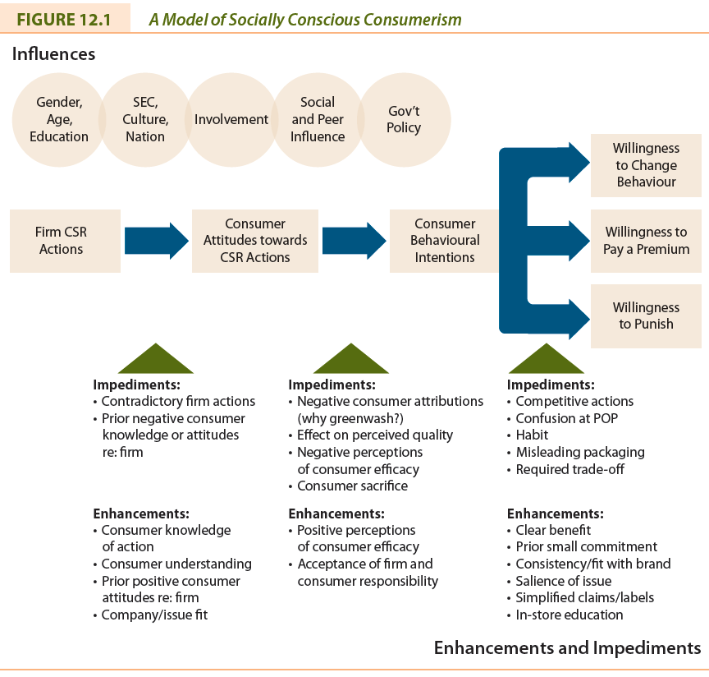
- Government Influence to Encourage Competition
  - Canadian Competition Act: Conspiracy, bid-rigging, predatory pricing, review of mergers, abuse of dominant position
- Factors determining competitive behaviour
  - Entrepreneurship; deregulation and privatization; technology; decline of natural monopoly; global trends in trade; mergers/takeovers

LO 12.5 Suppliers and the Supply Chain
- Business-to-business: Commercial activity where one corporation sells goods or services to another corporation rather than to consumers.
- Buyers are increasingly recognizing suppliers who are committed to considering social and environmental responsibilities
- The supply chain is regulated by the Canadian Competition Act to prevent suppliers not taking advantage of their customers:
  - Exclusive dealing, tied selling and market restrictions
  - Price discrimination
  - Price maintenance
  - Refusal to deal

LO 12.6 The Supply Chain
- Supply chain
  - The route a product travels from the procurement of raw materials, the transformation into intermediate goods and then final products, and the delivery to consumer through a distribution system to its ultimate disposal by the consumer
- Extended producer responsibility
  - “An environmental policy approach in which a producer’s responsibility, physical and/or financial, for a product is extended to the post-consumer stage of a product’s life cycle.”
- Sustainability purchasing
  - “The acquisition of goods and services (‘products’) in a way that gives preference to suppliers that generate positive social and environmental outcomes. It integrates sustainability considerations into product selection so that impacts on society and the environment are minimized throughout the full life cycle of the product.”
- Fair-Trade
  - A term commonly used to identify products that are involved with sustainability purchasing; usually focuses on the beginning of the product chain.

Chapter Summary
- Employees are stakeholders internal to the corporation and their relationship gives rise to many ethical issues
- Consumers are important, because without them the corporation has no reason to exist.
- Competitors and suppliers are business-to-business stakeholders primarily involving economic or commercial relationships, but ethical issues also are evident.

The Environment, Globalization, and Strategy

Chapter 14: The Environment and Business Responsibilities

CHAPTER AND LEARNING GOAL SUMMARY
A concern for the natural environment is widespread in society and business has responsibility to respond. Responding to this concern is challenging as many stakeholders and issues influence corporations. Corporations must develop an environmental ethic or set of values relating to their practices toward sustainable development in the economy. Each corporation must develop its own strategies and practices to meet its and the stakeholders’ needs today while ensuring that future resources will be available.
Environmental concerns are summarized in the descriptions of several topics: acid rain, air pollution, ecosystems, energy production and consumption, nature and wildlife, ozone, pollution, waste management, and water quality. Together these topics influence climate change or global warming.
Governments have implemented environmental policies through legislation and regulations and the establishment of various agencies. Environmental assessments are now commonplace. However, the Federal Government is reducing its regulation of environmental impacts.
Influence of a different type comes from environmental non-governmental organizations (ENGOs). Hundreds of such organizations exist and corporations are learning how to respond to or cooperate with them. Another possibility is to leave solutions to environmental concerns to market-driven initiatives. Instead of being required by governments to respond, it is argued that relying on market forces is more effective. Emissions trading and offsets are two examples.
When corporations act on environmental concerns, the responses must be managed with an appropriate organizational structures, environment management systems, and corporate strategies. As corporations attempt to respond to environmental concerns, there are implications for all the major functions of business: financial management, marketing, human resources, and production.
Many sustainability measures and standards have been developed by ENGOs, business organizations, and industry associations. Indicators that measure a corporation’s environmental performance are used. Many corporations issue elaborate environmental reports.
Dissenting views on the environment are held in the business community and by other stakeholders. Not all businesspersons believe that climate change is a problem. Even public attitudes are mixed in that surveys indicate consumers are concerned, but this concern is not always reflected in purchasing decisions. This inconsistency complicates business decision making. The environment presents corporations with opportunities and threats. But, many corporations are developing an environmental ethic that achieves sustainable development.

Glossary
Acid rain | A generic term used for precipitation that contains an abnormally high concentration of sulphuric and nitric acid.
Business sustainable development | According to the IISD, "adopting business strategies and activities that meet the needs of the enterprise and its stakeholders today while protecting, sustaining, and enhancing the human and natural resources that will be needed in the future."
Carbon capture and storage (CCS) | Carbon emissions are captured and injected into underground formations.
Climate change (global warming) | "The result of human activities altering the chemical composition of the atmosphere through the build-up of greenhouse gases that trap heat and reflect it back to the Earth's surface."
Commons | Any resource used as though it belongs to all.
Ecosystem | A biological community of interacting organisms and their physical environment.
Emissions trading | A system whereby corporations set targets for greenhouse gas reduction; if one corporation cannot meet the target it purchases credits from those corporations that have met their targets.
Environmental ethic | The set of values or principles that govern a corporation's practices relating to the environment.
Environmental non-governmental organizations (ENGOs) | Groups that hold shared values or attitudes about the challenges confronting the natural environment and advocate for changes to improve the condition of the environment.
Green marketing | Selling environmentally friendly goods and services to consumers.
Greenwashing | Occurs when the corporation does not seriously address environmental issues but merely talks about how it does, or takes token actions rather than really solving the problem.
Kyoto Protocol | An agreement formulated by the United Nations Framework Convention on Climate Change where countries agreed to reduce emissions of carbon dioxide and other greenhouse gases to 6 percent below 1990 levels by 2012.
Market environmentalism | Exists where economic incentives created by the market are more effective at protecting the environment than is government intervention.
Offsets (emissions-reduction credits) | Credits purchased from other corporations or organizations to mitigate greenhouse gases released into the environment.
Ozone | Naturally occurring gas, formed from normal oxygen, that protects Earth by filtering out ultraviolet (UV) radiation from the Sun.
Standard environmentalism | Occurs when government regulation is a necessary remedy for the market's failure to provide enough environmental amenities.
Sustainable development | Development ensuring that the use of resources and the impact on the environment today does not damage prospects for the use of resources or the environment by future generations.
Waste management | "Disposal, processing, controlling, recycling and reusing the solid, liquid, and gaseous wastes of plants, animals, humans and other organisms."

Want to Learn More
Want to learn more about the tragedy of the commons?
Want to learn more about environmental jobs?
Want to learn more about calculating your carbon footprint?
LO 14.1 Business, It’s Stakeholders, and the Natural Environment
- Environmental issues confront virtually all aspects of the corporation, from the input of resources to the manufacturing process, and from workplace conditions through to the way products are packaged and sold.
- Commons: Any resource used as though it belongs to all.

LO 14.2 Defining the Environmental Ethic and Sustainable Development
- Environmental ethic:
  - the set of values or principles that govern a corporation’s practices relating to the environment.
- Sustainable development:
  - development ensuring that the use of resources and the impact on the environment today does not damage prospects for the use of resources or the environment by future generations.
- Business Sustainable Development:
  - “adopting business strategies and activities that meet the needs of the enterprise and its stakeholders today while protecting, sustaining, and enhancing the human and natural resources that will be needed in the future.”

LO 14.3 Environmental Concerns in Business and Society
- Acid rain
- Air pollution
- Ecosystems
- Energy production and consumption
- Nature and wildlife.
- Ozone
- Pollution
- Waste management
- Water quality
- Climate change/ global warming

LO 14.4 Government’s Influence
- Government departments and agencies:
  - Environment Canada
  - Canadian Council of Ministers of Environment
  - National Roundtable of the Environment and the Economy
  - Canadian Environmental Assessment Act Agency
- Regulation:
  - Canadian Environmental Protection Act, Canadian Environmental Assessment Act, Kyoto Protocol

LO 14.5 Environmental NGO Influence
- Environmental non-governmental organizations (ENGOs): groups that hold shared values or attitudes about the challenges confronting the natural environment and advocate for changes to improve the condition of the environment.
- Such groups (e.g., Greenpeace) influence corporations through protests, blockades, boycotts, and annual shareholder meetings.

LO 14.6 Market-Driven Environmentalism
- Standard Environmentalism
  - Government regulation occurs when it is a necessary remedy for market’s failure to provide environmental amenities
- Market Environmentalism
  - Economic incentives created by market are more effective at protecting the environment than government intervention
- Environmentalism affected by market factors
  - Economic growth, free trade, property rights
- Emissions trading:
  - A system whereby corporations set targets for greenhouse gas reduction; if one corporation cannot meet the target, it purchases carbon credits from those that have met their targets (or “cap and trade”).
- Offsets (emission reduction credits):
  - Credits purchased from other corporations or organizations to mitigate greenhouse gases released into the environment.

LO 14.7 Managing Responses to Environmental Concerns
- Token response (e.g., ‘greenwashing’ where firm does not seriously address environmental issues but merely says it does)
- Compliance with laws and regulations
- Comprehensive environmental management (gaining a competitive advantage)
- Sustainable development
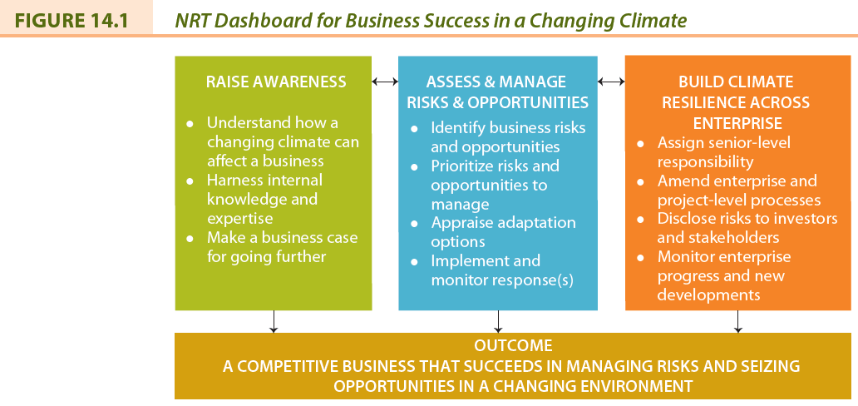

LO 14.8 The “Greening” of Business Functions
- Financial management (e.g., disclosure)
- Marketing (e.g., green marketing)
- Human resources (e.g., environmentally friendly workplace)
- Operations (e.g., reduce, recycle, conserve, etc.)

LO 14.9 Measuring and Reporting on Environmental Sustainability
- Type and amount of materials used
- Source of energy and efficiency of use
- Source and quality of water
- Impact on biodiversity
- Reduction of emissions, effluents, and waste
- Product design that minimizes impact
- Compliance with environmental laws
- Use of efficient transportation
Measuring and Reporting on Environmental Sustainability
- Coalition for Environmentally Responsible Economies (CERES)
- International Organization for Standardization ISO 14000
- International Institute for Sustainable Development (IISD)
- Canadian Sustainability Indicators Network (CSIN)
- Environmental and Sustainable Development Indicators Initiative (ESDI)

LO 14.10 Dissenting Views on the Environment
- According to some business journalists:
  - Concept difficult to define and understand
  - Means stopping or constraining economic development
  - Implies capitalism is unsustainable
  - Lacks understanding of markets
  - Executives are being misled

LO 14.11 The Environment: Corporate Opportunities and Challenges
The Environment: Corporate Opportunities
- Reputations likely enhanced
- Customers attracted
- Investors attracted
- Costs reduced through recycling/conservation
- More competent staff attracted
- Better integration with local community
- New technologies or expertise developed
- More efficient ways of producing products found
The Environment: Corporate Threats
- Corporate image may deteriorate
- Revenues may suffer if customers are lost
- Investors may decide not to invest
- Material and production costs may increase
- Financial penalties increasing
- Insurance premiums can increase
- Potential alienation from local community
- Government may enact stricter legislation

Chapter Summary
- There is increasing concern for the natural environment in Canada and around the world; there is the need to preserve and protect the environment.
- Business has responsibilities toward achieving a sustainable environment.
- The depletion of the ozone layer, the greenhouse effect, acid rain, deforestation, pollution, energy depletion, and waste management are steadfast reminders of how compelling an issue our natural environment is.
- All stakeholders have an obligation to the environment and the key stakeholders influencing it are identified.

Chapter 15: Globalization and Business Responsibilities
CHAPTER AND LEARNING GOAL SUMMARY
The globalization of business has brought numerous issues relating to business’s economic, social, and environmental responsibilities. The impact of globalization on the Canadian corporation has been, and will continue to be, extensive. A general definition of globalization is a process of decreasing constraints on the interactions among the nations and peoples of the world. The three global dimensions important to business are economic, political, and social. Those in favour of globalization (globalists) and those opposed (anti-globalists) continue to debate the pros and cons.
Many non-governmental organizations focus on globalization. They have exerted considerable influence on international corporations and in some cases are partnering with business on projects to reduce poverty in developing countries. Supranational institutions are influencing globalization economically, socially, and environmentally. Four prominent supranational institutions described are the World Bank, the International Monetary Fund, the International Labour Organization, and the World Trade Organization.
Globalization impacts on Canadian business and society in several ways. Canadian business must remain competitive with corporations from other countries. The International Code of Ethics for Canadian Business provides guidelines for corporate behaviour. Many Canadian corporations are setting an example for corporate citizenship in developing countries.
Several international standards of conduct have been developed that provide guidelines for corporate activities in developing countries. These standards can also be used as frameworks for reporting of their global responsibilities.
Along with globalization comes the trend to rely on market systems and corporations more than requesting government involvement. This trend presents some special challenges for business, including responding to corruption, accommodating human rights in all operations and in particular in sweatshops, and contributing to the accomplishment of the UN’s Millennium Development Goals.
Globalization has embraced capitalism. Today, corporations are more likely to be privatized than nationalized. Microfinance and fair trade are examples of initiatives based more on business models than government ones. Entrepreneurship is increasingly taking hold in developing countries.

Glossary
Anti-globalists | Individuals and organizations that oppose globalization or are critical of it.
Bribery | Making questionable payments, or bribes, to government officials to influence their decisions.
Corruption | According to Transparency International, "the abuse of entrusted power for private gain."
Economic globalization | The integration of fragmented markets into a global economy.
Globalists | Individuals and organizations that support globalization.
Globalization | A process of decreasing constraints on the interactions among the nations and peoples of the world.
Human rights | The fundamental rights and freedoms to which all individuals, groups, and societies are entitled.
International non-governmental organizations (INGOs) | Groups that hold shared values and attitudes about the issues relating to globalization and advocate for changes to improve the conditions in developing countries.
Microfinance | The provision of financial products, such as micro-credit, micro-insurance, and savings accounts, to persons living in areas of poverty without access to banking services.
Political globalization | The process by which world power relationships change and there is a loss of sovereignty by the state.
Social or cultural globalization | The emergence of a worldwide cultural system.
Supranational institution | An international organization that transcends national boundaries, where the member states share in decision making on particular issues pertaining to the members.

Want to Learn More
Want to learn more about Tranparency International?
Want to learn more about international principles of responsible investment?
Want to learn more about defining the Canadian mining industry's social licence?

LO 15.1 Global Business Responsibilities
- Not a new phenomenon: goods have been traded between regions since ancient times
- Corporations now seen as more efficient than governments in distributing goods and services needed by citizens
- Today, new view toward trade and market systems is referred to as globalization

LO 15.2 Defining Globalization and the Implications for Business
- Globalization: a process of decreasing constraints on the interactions among the nations and peoples of the world.
- Economic globalization: the integration of fragmented markets into a global economy.
- Political globalization: the process by which world power relationships change, and there is a loss of sovereignty by the states.
- Social or cultural globalization: the emergence of a worldwide cultural system.
The United Nations Global Compact
Human Rights:
1. Respect internationally proclaimed human rights
2. Not be complicit in human rights abuses
Labour Standards:
3. Uphold the right to collective bargaining
4. Eliminate all forms of forced and compulsory labour
5. Effective abolition of child labour
6. Eliminate employment discrimination
Environment:
7. Precautionary approach to environmental challenges
8. Promote greater environmental responsibility
9. Use environmentally friendly technologies
Anti-Corruption:
10. Avoid corruption (e.g., extortion and bribery)
Globalization and the Implications for Business
- Damage to environment
- Support for oppressive regimes
- Criticism of marketing practices (e.g., tobacco, pharmaceutical, baby formula, etc.)
- Arms trade
- Treatment of employees (e.g., sweatshops)
- Treatment of indigenous peoples
- Genetic modification of plants and animals
- Corruption and bribery
The Debate Over Globalization: Supporters (Globalists)
- Trade leads to more efficient production of better goods and services
- Better opportunities for employment and higher incomes
- Standard of living has increased
- Transfer of capital, technology, intellectual property, skilled labour
The Debate Over Globalization: Opponents (Anti-globalists)
- Benefits received by only a few
- Creates unemployment
- Increased poverty and inequality
- Causes periodic financial crises
- Destroys local environment
- Destroys cultures
- Violates human rights
- Questionable payments made
- Disrespect of intellectual property

LO 15.3 Globalization and International Non-governmental Organizations (INGOs)
- INGOs are groups that hold shared values and attitudes about the issues relating to globalization and advocate for changes to improve conditions in developing countries
- INGOs put pressure on corporations and governments
- INGOs are also referred to as transnational non-government actors (TNGOs) or transnational social movement organization (TSMOs)

LO 15.4 Institutions of Globalization
- Supranational Institution: an international organization that transcends national boundaries where the member states share in decision making on particular issues pertaining to the members
- The World Bank:
  - Provides financial and technological assistance to developing countries.
- The International Monetary Fund (IMF):
  - Fosters financial stability, international trade, employment, and reduction of poverty.
- International Labour Organization (ILO):
  - UN agency that seeks to promote social justice and internationally recognized human and labour rights.
- World Trade Organization (WTO):
  - Coordinates agreements reducing trade barriers.

LO 15.5 Globalization and Canadian Business and Society
- Pressure to forge international links
- Must meet challenges of global restructuring (e.g., R&D, education, competition policy, cost of capital, etc.)
- Attract more investment in natural resource plants
- More direct investment abroad
International Code of Ethics for Canadian Business Principles
- Community participation and environmental protection
- Human rights
- Business conduct (e.g., bribery and compliance with the law)
- Employee rights and health and safety

LO 15.6 Standards of Conduct and Accountability for Global Business
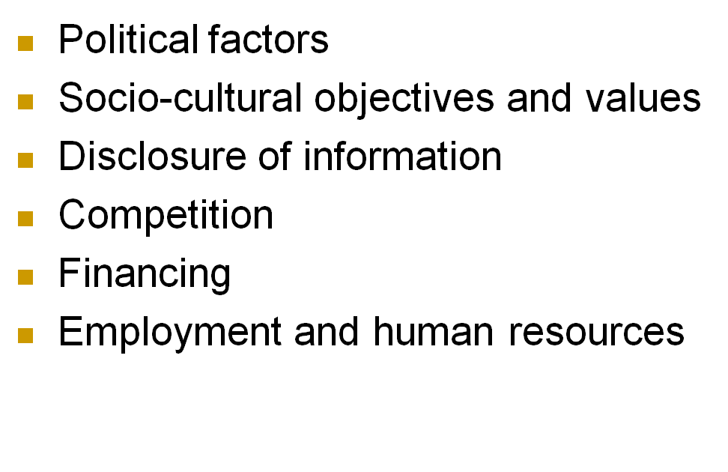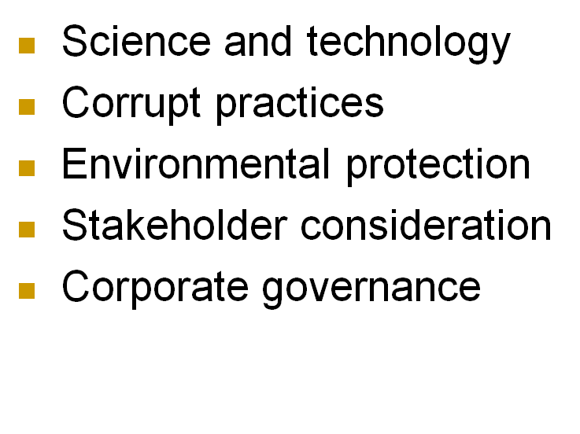
Global Standards of Conduct
- Caux Round Table: “Caux Principles”
- OECD “Guidelines for Multinational Enterprises”
- “Principles for Global Corporate Responsibility” (Interfaith organizations)
- United Nations Global Compact
- Global Reporting Initiative (GRI)

LO 15.7 Special Challenges of Global Business
- Corruption: The abuse of entrusted power for private gain (e.g., bribery)
  - Bribery: making questionable payments, or bribes, to government officials to influence their decisions
  - Three types of bribery assessed included:
    - bribery of high-ranking politicians or political parties
    - bribery of low-level public officials to ‘speed things up’
    - the use of personal or familiar relationships to win public contracts.
- Human rights: The fundamental rights and freedoms to which all individuals, groups, and societies are entitled (e.g., sweatshops).
  - Child labour
  - Forced labour
  - Discrimination
  - Environment
  - Working Conditions

LO 15.8 The Acceptance of Global Capitalism
- Bottom of the Pyramid: Corporations should not ignore as consumers the world’s population living in poverty (4 billion people)
- Fair trade: Trading partnership which aims at sustainable development for excluded and disadvantaged producers (e.g., Fairtrade Foundation, Oxfam, and Traidcraft)
- Microfinance: Provision of financial products such as micro-credit or micro-insurance to people living in poverty (e.g., Grameen Bank in Bangladesh)

Chapter Summary
- The globalization of business has brought numerous issues relating to business’s economic, social, and environmental responsibilities.
- The impact of globalization on the Canadian corporation has been, and will continue to be, extensive.
- Several international standards of conduct have been developed that provide guidelines for corporate activities in developing countries.
- Trends toward relying on market systems and corporations more than requesting government involvement.
- Globalization has embraced capitalism: corporations are more likely to be privatized than nationalized.

Chapter 16: Sustainability Strategy
CHAPTER AND LEARNING GOAL SUMMARY
Corporate sustainability is a more comprehensive form of corporate social responsibility (CSR) which integrates social/ethical, environmental, and governance issues into the corporation’s planning through strategic management. Corporations are at different stages on the sustainability continuum: amoral, compliance-based, emerging, and sustainability. There is no definitive description of a sustainable corporation. Mission, values, and vision statements identify the corporation’s purpose. These statements should also contain some indication of the corporation’s approach to a sustainability strategy.
There are several components to strategy formulation. A thorough assessment of the corporation’s external environment will include identification of the key social and environmental issues. Internal resources and capabilities should be ascertained to understand how the corporation can respond to social and environmental issues. Objectives are established for the corporation’s strategy so that actual performance can be evaluated.
There are always alternatives to what the sustainability strategy should be. The selection will be based on the corporation’s purpose, the circumstances in the environment, and the resources and capabilities available. Following through with implementation is key to a successful sustainability strategy. Previous chapters contain many concepts, methodologies, and techniques applicable to implementation. There is no standard approach to implementation and corporations will use different ones.
The sustainability strategy will be evaluated internally by management, but also externally by NGOs, CSR-related organizations. Various award programs recognize successful strategies. It is argued that business should be thinking in terms of corporate social integration instead of corporate social responsibility, and seriously considering the redesign of the corporation so that it can respond more appropriately to the demands of ethics and responsibilities. The CERES Roadmap for Sustainability is an example of a process through which a corporation can achieve sustainability. But, there are many hurdles or challenges involved.
Business school programs are emphasizing the ethics of business and sustainability. Students are being prepared for confronting ethical dilemmas in the workplace and for understanding corporate responsibilities to society. Students can contribute to sustainability while attending colleges or universities.

Glossary
Beliefs | The basic assumptions about the world in which an individual operates and how it works.
Corporate culture | The complex set of values, beliefs, assumptions, and symbols that define the way in which an organization conducts its business.
Mission | An enduring statement that specifies in broad, even philosophical, terms the organization's "reason for being" and what distinguishes it from similar organizations.
Service-learning | A method of teaching, learning, and reflecting, combining classroom learning with service to the community either locally or in developing countries.
Strategic management | The process through which a corporation establishes its mission and objectives, analyzes the environment and resource capabilities in order to formulate strategy, creates the organizational systems and processes needed to implement the strategy, and devises mechanisms for evaluating performance.
Sustainability strategy | A plan that views economic, ethical, social, and environmental responsibilities more intensively and integrates corporate social responsibility (CSR) into all facets of the corporation's operations.
Values | The basic assumptions about which ideals are considered desirable or worth striving for.
Vision | A statement of what the corporation wants to become or where it wants to be at some date in the future.

Want to Learn More
Want to learn more about sustainability and strategy?
Want to learn more about organizational culture and sustainabiltiy?
Want to learn more about Canadian corporations with comprehensive sustainability strategies?

LO 16.1 Sustainability Strategy Continuum
- Sustainability strategy: A plan that views economic, ethical, social, and environmental responsibilities more intensively and integrates corporate social responsibility (CSR) into all facets of the corporation’s operations.
  - also referred to as a CSR strategy
Sustainability Strategy Continuum
- Amoral Sustainability strategy
- Compliance-based Sustainability strategy
- Emerging Sustainability strategy
- Comprehensive Sustainability strategy
Main Characteristics of Sustainability Strategies
- Awareness
- Stakeholder Focus
- Management/Staff Involvement
- Board Involvement
- Ethics Program
- CSR Program
- Reporting
Strategic Management
- Strategic management: The process through which a corporation establishes its mission and objectives, analyzes the environment and resource capabilities in order to formulate strategy, creates the organizational systems and processes needed to implement the strategy, and devises mechanisms for evaluating performance.

LO 16.2 Sustainability Strategy and Purpose
- Vision: A statement of what the corporation wants to become or where it wants to be at some date in the future.
- Mission: An enduring statement that specifies in broad, even philosophical, terms the organization’s “reason for being” and what distinguishes it from similar organizations.
- Values: The basic assumptions about which ideals are considered desirable or worth striving for.

LO 16.3 Sustainability Strategy Formulation
- Assessment of the external environment in which the corporation operates
  - understand when and how this environment influences the corporation.
- Assessment of internal resources and capabilities
  - Allows corporation to determine its ability to take advantage of opportunities in the environment and to overcome any threats.
- Establishment of objectives
  - the ends the corporation seeks to achieve through its existence and operations.
- CSR strategy options and selection
  - Beliefs: The basic assumptions about the world in which an individual operates and how it works.
  - Corporate culture: The complex set of values, beliefs, assumptions, and symbols that define the way in which an organization conducts its business.

LO 16.4 Sustainability Strategy Implementation and Evaluation
- Sustainability implementation includes:
  - designing the corporation’s structure;
  - allocating resources;
  - developing information and decision-making processes; and
  - managing human resources, including such areas as the reward system, approaches to leadership, and staffing.

LO 16.5 Achieving a Sustainability Strategy
- CSR model should become a corporate social integration model approach, which would integrate social perspective with business strategy.
  - CSR should be an opportunity, innovation, and competitive advantage.
Prevailing Justifications for CSR
- Moral Obligation
- Sustainability
- Licence to Operate
- Reputation
Corporate Social Integration Model Approach
- CSR should identify points of intersection between business and society then create a corporate social agenda, and integrate inside-out and outside-in linkages.
  - inside-out linkages: represent the corporation’s positive and negative influence on society through its operations.
  - outside-in linkages: represent society’s positive and negative influences on the corporation.
Three Types of Social issues
- Generic: do not significantly affect the corporation but are important to society.
- Value chain: significantly affected by the corporation as it carries out business.
- Social dimensions of competitive context: factors in the external environment that significantly affect the underlying drivers of competitiveness where the company operates.

Ceres Roadmap for Sustainability
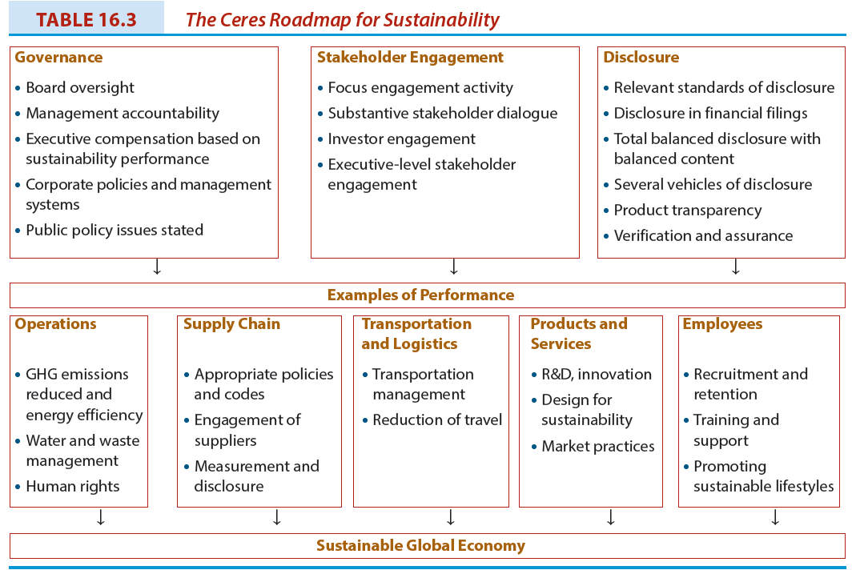
LO 16.6 Business Programs and Sustainability
- Business schools are responding to the increasing awareness of the ethics of business and corporate social responsibilities.
- The response takes various forms and business education programs are feeling the impact.
Argument For Teaching Ethics
- Many immoral or unethical events taking place.
- Business environment is changing radically and students must be made aware of this.
- Provide students with some tools or techniques for analyzing ethical issues.
- Ethics courses legitimize the consideration of ethical components as an integral part of managerial decision making.
Argument Against Teaching Ethics
- Business ethics are not a major problem.
- There is little likelihood that it can alter the ethical behaviour of students.
- There are few qualified teachers of ethics in business and management departments.
- Many business problems involve ethical considerations that are not resolvable.
- A separate ethics course suggests that ethics are considered “separate” in decision making.
Chapter Summary
- Corporate sustainability is a more comprehensive form of CSR that integrates social/ethical, environmental, and governance issues into the corporation’s planning through strategic management.
- Following through with implementation of strategy is key to a successful sustainability strategy.
- Business should be thinking in terms of corporate social integration instead of corporate social responsibility, and seriously considering the redesign of the corporation so that it can respond more appropriately to the demands of ethics and responsibilities.
- Business school programs are emphasizing the ethics of business and sustainability.

Sexty 3e PPT References
- Figure 3.2 Fink’s Anatomy of a Crisis
  - Source: Based on description in Chapter 3 of Steven Fink, Crisis Management: Planning for the Inevitable (New York: AMACOM, 1986), 20–28.
- Figure 4.3 The Position/Importance Matrix
  - Sources: Based on Paul C. Nutt and Robert W. Backoff, Strategic Management of Public and Third Sector Organizations: A Handbook for Leaders (San Francisco: Jossey-Bass Publishers, 1992), 191; and John M. Bryson, Strategic Planning for Public and Nonprofit Organizations: A Guide to
  - Strengthening and Sustaining Organizational Achievement, revised edition (San Francisco: Jossey-Bass Publishers, 1995), 284.
- Figure 4.4 Diagnostic Typology of Organizational Stakeholders
  - Source: Grant T. Savage et al. “Strategies for assessing and managing organizational stakeholders,” Academy of Management Executive, 5(2) (1991): 65. This work is protected by copyright and it is being used with the permission of Access Copyright. Any alteration of its content or further copying in any form whatsoever is strictly prohibited.
- Figure 4.5 Stakeholder Typology: One, Two, or Three Attributes Present
  - Source: Ronald K. Mitchell, Bradley R. Agle, and Donna J. Wood, “Toward a theory of stakeholder identification and salience: Defining the principle of who and what really counts,” Academy of Management Review, Vol. 22, No. 4 (1997): 874. This work is protected by copyright and it is being used with the permission of Access Copyright. Any alteration of its content or further copying in any form whatsoever is strictly prohibited.
- Figure 4.6 Model of Social Capital and Business Value Creation
  - Source: Ann Svendsen, Robert G. Boutilier, and David Wheeler (2003). Stakeholder Relationships, Social Capital, and Business Value Creation (Toronto: The Canadian Institute of Chartered Accountants, 12 with modifications)
- Figure 5.2 Kaler’s Gradations of Self-Interest and Morality
  - Source: Adapted from John Kaler, “Reasons to be ethical: Self-interest and ethical business,” Journal of Business Ethics, Volume 27 (2000):163. With kind permission of Springer Science and Business Media
- Table 6.1 Distinction between Codes of Conduct and Codes of Ethics
  - Source: About Manulife, “Corporate Culture” accessed at http://www.manulife.com/public/about/index/0,,lang=en&navId=610009,00.html on October 19, 2012.

- Figure 7.1 Carroll’s Pyramid of Corporate Social Responsibility
  - Source: Archie Carroll, “The pyramid of corporate social responsibility,” p. 42 in Business Horizons journal, July/August 1991. Copyright Elsevier & Kelley School of Business, Indiana University.
- Figure 7.2 The VBA Model: Five Business and Society Frameworks and Their Three Core Concepts
  - Source: Mark S. Schwartz and Archie B. Carroll, “Integrating and Unifying Competing and Complementary Frameworks: The Search For a Common Core in the Business and Society Field,” Business and Society, Volume 47, Number 2, June 2008, 175.
- Figure 12.1 A Model of Socially Conscious Consumerism
- Source: June Cotte and Remi Trudel, Socially Conscious Consumerism: Executive Briefing on the Body of Knowledge, Network for Business Sustainability, Richard Ivey School of Business, University of Western Ontario, 2009, 38, http://www.nbs.net/Docs/NBS_Consumerism_2009.pdf . The authors and the Network for Business Sustainability granted permission to reproduce this diagram
- Figure 14.1 NRT Dashboard for Business Success in a Changing Climate
- Source: Adapted from Figure 14.1 , NRT Dashboard and case studies business success in a changing climate, Facing the Elements: Building Business Resilience in a Changing Environment/Case Studies, Ottawa: National Round Table on the Environment and the Economy, Cat. No. En133-40/5-2012E-PDF, p. 13. Used with permission

