Intro to Communications – Chapter 1

Jargon: Sender, source, message, encoding, receiver, destination, channel, feedback, noise, environment, context, cultural/political/social, or other variables in the environment

Contributions of Early Models:

Aristotle- simple communication model with a sender transferring a message containing information to a receiver

Speaker Speech Audience

-Linear model
-Focused on act of persuading
-Based on knowledge of audience demographics (age & status)

Three kinds of Appeal

Ethos- Appeals based on source credibility of speaker
Logos- Appeals based on logic and reasoning
Pathos- Appeals based on emotions

Ethos
-Perceived as safe & trustworthy
-Perceived expertise (use experiences to accept them)
-Perceived sociability (handshaking, kissing babies, etc…)
-Perceived composure (no stuttering, confusion (not trustworthy), not too smooth)
-Perceived dynamism (assertive, for change)
-We tend to trust communicators who are “one of us”

Logos
-Speaker’s use of evidence (examples, stats, etc.) to support their point of view
-Speaker’s use of argumentation and reasoning (general to specific, cause-effect, sign or analogical) to support their point of view
-Communicators make emotional appeals based on fear, compassion, pride, guilt, generosity, patriotism, and loyalty
-Emotions such as those listed above stimulate physical changes in the body
-Reasoning from generalization involves moving from the general to the specific
-Ask the question of “What caused this effect?”

Pathos
-Appeals of compassion, anger, fear, pride, empathy, guilt, humility, and respect for their audiences
-When we react emotionally to a person we physiological changes
-Most have learned to control their emotions in a public setting
-See emotional arousal as unnatural and an undesirable state of being
-A sign of weakness
-What causes an emotional response in one person may create no reaction in another
Example- Steel workers are able to walk over really high steel beams without being nervous at all, but the same person might bee nervous when talking in front of a crowd of 20 people.

Lasswells Model (1948)

Who (said) What (speech) In what channel To whom (audience)
= With What Effect

-Added concepts of channels and effects
-Often applied in political contexts
-Transition model of communication
-One-way linear process
-The emphasis on channel reflected the role that radio had played in communicating to the masses in WWII

Channel= The medium used to transmit a message
Effects=The intended or unintended impact(s) of a message

Shannon-Weaver Model (1949)
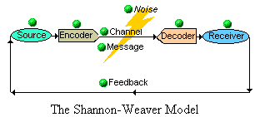

Info source Transmitter NOISE SOURCE Receiver Destination

(Message) (Signal) (Received signal) (Message)

- Extended Aristotelian Model
- Added concepts of noise, feedback, which can be physiological, internal, or external
- Shannon-Weaver added concepts of “noise source”
- Interactive Model rather than a liner model
- Noise can arise in the environment, the channel, the source, or the receiver (ex. Passing traffic, ringing cellphone, coughing, malfunctioning microphone)
- Interrupt the ability of he speaker to convey the proper message
- The addition of feedback loop to the later model changed the process from linear to circular

Information source= When the message is conceived
Transmitter= Mechanism for encoding the message
Signal= The message
Receiver= Mechanism for decoding the message
Destination=Where the message ends up
Noise source= Any interference that occurs in the process of transmitting or receiving signals
Feedback= The response to a message or activity
External noise= Interference from an environmental source
Internal noise= Interference from an internal source
Physiological noise= Interference from a biological condition or function
Psychological noise= Interference from a mental state

Shramm Model (1965)

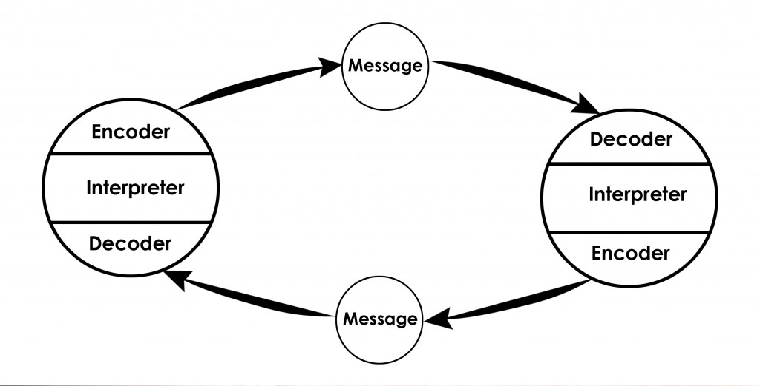

-Added idea that we can communicate with each other to the extent that we have a “shared” field of experience
-Where our backgrounds engage us, in how we interpret messages
-Idea is we can communicate with someone of different backgrounds if you share some sort of the same experiences.
-Emphasis on decoding and encoding messages (how we create, interpret, and assign meaning to words and actions)
-Backgrounds have a large ability to communicate with others (Gender, sexual orientation, age, race, ethnicity, birthplace, educational level, social status, etc…)
-Everyone has a unique set of life experiences

Field of experience= The totality of all we are at the moment of communication
Culture= The shared ideas, traditions, norms, symbols, and values that define a community

Dance Model (1967)

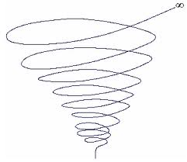

- Communication is a never ending process
- NO fixed beginning, middle, or ending
- Dynamic, ongoing, unrepeatable, additive
- Communications patterns are always progressing and widening (learning more knowledge as your go through life)
- Helical model
- Cumulative in its effects
- The likelihood of “Learning, growth, and discovery”
- These visitations can be negative or positive in their implications

Barlund’s Transactional Model (1970)

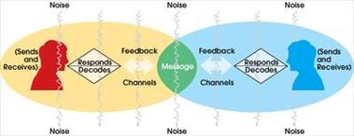

- Always sending and receiving
- Both verbally and non-verbally
- Very against linear model
- Respond to perceived weakness in the interactive models of communication
- Communicators act simultaneously as senders and receivers
- The theory recognizes the importance of context
- It sees communication as a dynamic and fluid process, shaped by changes in the communicators and the environment in which they operate
- Even when we are listening, we are communicating through our facial expressions, body language, and paralanguage
- Non stop communication
- The increased emphasis on the role of the listener as simultaneous sender of messages and the focus on unintentional aspects of communication elevate the role of nonverbal communication in the transactional model
- The relationship of the communicators becomes very important in the transactional model because they are ‘interdependent’
- How communicators feel about themselves will also effect the way they communicate with others
- The outside culture influences how we view a situation, and the physical setting influences our interactions
- When views in society change, our communication on topics of importance also shift focus
- Communication is a dynamic and fluid process characterized by continuous change
- Some settings encourage more positive exchanges than others

Transactional theory= Theory that sees communication as a dynamic process, involving continuous changes in communicators and environments
Paralanguage= Elements of speech that are not recognized as language (tone of voice, rate of speech, vocal sounds)

Fergusons Critical Thinking Model (2003)

Outcomes – short or long term
Costs of Achieving Outcomes- Individuals, groups, society
Judging costs- motivate the communicator (intent) / means employed (legitimacy)

Factors that Contribute to Communication Breakdown

-Speed affects our ability to comprehend
-Personality affects our ability to comprehend & communicate
-Linguistic differences affect our ability to understand
-The use of Jargon can inhibit our ability to understand a concept if we are unfamiliar with the jargon
-Expectancy affects comprehension
-Redundant information creates noise in the communication experience
-Fear of pain can inhibit communication
-Ambiguous or non specific info makes communication more difficult
How to Avoid Communication Breakdown

-Be flexible in communicating and interpreting communication from others
-Be succinct and clear, and listen for unspoken messages
-Wait until someone finished speaking before responding
-Be specific
-Use language that is accessible
-Practice communicating with others
-Develop a large repertoire of communication skills
-Stick to more formal language patterns when working in a second language
-Be aware of the meaning of non-verbal signs
-Ask questions and give feedback
-Find alternative ways of explaining a point
-Use analogies and comparisons to convey meaning

Chapter 3 Summary

-Communication can be intentional or unintentional
-Communication has a relational, as well as content, dimension
-Communication benefits from shared fields of experience
-Communication is irreversible and unrepeatable
-Sending and receiving occurs simultaneously with verbal and nonverbal elements
-Communication is a dynamic and on going process
-Environment affects communication
-Noise affects communication
-Channels matter
-Communication has a cultural component
-Communications has a power dimension
-Communication has a strong ethical dimension

Standpoint theory= Theory that holds that our backgrounds and experiences determine our perspective
Reward power= Power that comes from offering benefits or gifts
Legitimate power= Power that comes from holding an office, title, or other legitimate position
Expert or information power= Power that comes from knowledge or expertise
Coercive power= Power that comes from making threats or intimidations
Referent power= Power that comes from personal attractiveness
Trickle-down access= Controlled and restricted access to information, flowing mostly downward
Simultaneously access= Unrestricted access to information flowing from mass media and reaching everyone at the same time
Open access= Unrestricted and uncontrolled sharing of information on open platforms, accessible to everyone

