11: Exercise is Medicine
- Physical inactivity is the 4th leading global risk factor for mortality
- 150min mod/vig activity in 10m bouts is recommended for adults, 15% achieve this

An Exercise Pill?
- AICAR activates AMPK= signal for host of cascades in fat and CHO metabolism
- AICAR artificially tells the body there is a demand similar to exercise

in sedentary mice:
- 4wks AICAR treatment induced metabolic genes & enhanced endurance
- BUT it led to increased liver weight (fatty liver)

Metformin
- An antidiabetic drug that works through AMPK
- AMPK content in obese/diabetic muscle is normal:
  - AMPK is not part of the problem in obese/diabetes
  - AMPK is therefore a viable pharma target with the goal of improving glucose uptake and FA ox.

Diabetes-prone subjects studied over 4 years:
- 2 Groups:
  - 1) metformin
2) lifestyle modification: 150min mod. exercise/week, follow food pyramid
- Results: BOTH groups showed blood glucose improvements
- (glycosylated hemoglobin instead of blood glucose was measured– GC can change quickly!)
- Lifestyle changes brought the greatest % change… duh

THP: exercise is better than drugs for all of CHD, stroke, heart failure & prediabetes

HF Diet and Lipid Metabolism
- Two groups: one w/ caloric deficit from the night prior OR brisk walk @ 60% VO2 max
- exercise better on postprandial lipid metabolism compared to CD alone after eating next day

THP: single bout of exercise prior to eating improves postprandial TAG response to lipid ingestion in subjects w/ fasting TAG

12: Obesity and IR
- Peripheral obesity: fat below waist (hips, butt, thighs)
  - subcutaneous fat, not a major health risk factor
- Central (abdominal) obesity: fat around stomach, waist
  - visceral fat, surrounds heart, liver, kidneys, intestines
  - major health risk, is more pro-inflammatory
  - accurate independent predictor of all-cause mortality in men

Mechanism of Action
- increase lipolysis
- increased FFAs
- increased secretory products (adipokines)
- therefore, increased IR
What is IR?
- defects in insulin signalling leading to impaired GLUT4 translocation to the membrane
- leads to reduced insulin-stimulated glucose uptake in muscle

IR and T2D
- Fasting hyperglycemia (>7mM), inc., normal, low conc. of insulin
- Assessed by oral glucose tolerance test (OGTT) / euglycemin or hyperinsulemic clamp

Hyperinsulinemic Euglycemic Clamp
- “Gold Standard” to measure whole body insulin sensitivity (therefore expensive)
- Measures responsiveness to insulin
- Procedure:
  - ^ insulin levels via infusion to supra-physiological levels
  - monitor glucose infusion req’d to maintain normal/steady blood glucose levels, check every 5-10min
  - high glucose infusion rate (GIR): >7.5mg/min = insulin sensitive
  - low GIR: <4.0mg/min = insulin resistant

Notes on IR and excess visceral fat
- inc. lipolysis and plasma FFAs
- “-ve factors” secreted by fat cells (adipokines) = induce IR in only 4-6 hours
- there is increased FA uptake into muscle by T2D patients
- this is due to greater FAT/CD36 on plasma membrane
- contractive GLUT4 is still responsive in obese rats
- ATP turnover to induce AMPK activation can still promote GLUT4 translocation in obesity/diabetes
THP: insulin stimulated glucose transport is impaired, but contraction stimulated is not!

Storage of lipids?
- inverse relationship between IMTG and whole body insulin sensitivity
- there is however high IMTGs in BOTH T2D patients AND trained endurance athletes! the “athlete’s paradox”
- IMTG seem to be inert intracellular metabolites, unlikely to directly interfere with insulin action
- However, IMTGs are markers for other FA-derived metabolites w/ -ve effects:
  - DAG (diacylglycerol)
  - LCFACoA (cytosolic long chain fatty acyl CoA)
  - ceramide
THP:
- Overexpression of DGAT (RLS in TG synth) improves insulin sensitivity
- promoting TG synthesis is protective– it is an “inert” lipid storage form. TGs are the way we are supposed to store fat.

Relationship between LCFACoA and whole body glucose disposal
- skeletal muscle LCFACoA content is a better predictor than IMTG of insulin sensitivity/resistance
- Lipid intermediates suppress insulin signaling cascade
  - LCFA-CoA and DAG activate PKC
  - PKC phosphorylates serine and threonine residues at IR and IRS-1
  - this inhibits akt/PKB and GLUT4 translocation
  - we prolly don’t need to know these steps tbh (lol)

Other Key LCFACoA points
- inc in LCFACoA promotes increase in FA entry to mitchondria, while preventing the dissipation of membrane potential by inhibiting ANT (adenine nucleotide translocase)
  - ANT = reversible transporter of ATP/ADP (in/out of cell)
- LCFACoA disease state promotes ROS formation = oxidative stress!
- Build up of LCFACoA
  - during exercise: physio response to promote FA Ox– good thing!
  - during chronic over-eating state: is in the absence of ADP (unlike in exercise)
    - therefore there’s no need to bring in LCFACoA
    - Does not move through system and builds up/inhibits ANT
    - = promoted ROS production
    - not a good thing!
Bottom line: dysregulation in how FAs are stored?
- IMTG: the way we want to store fat
- DAG/ceramides: sometimes, but do not always coincide with insulin resistance
- LCFACoA: seems to be “reactive”– can suppress the insulin sig. pathway and influence fuel supply to mitochondria

Weight Loss in Morbid Obese Subjects
- product of Beriatric surgery
- Key results:
  - 25% reduction in blood glucose
  - 75% red in insulin
  - large improvement in insulin sensitivity with weight loss (no shit Sherlock)
  - Change in muscle lipids?
    - Yes: red. in LCFACoA content
      - Specifically palmitoyl CoA showed the most impressive decrease, as well as stearyl CoA
      - Both are SFAs (more implicated in dev. of IR
      - other LCFACoAs were not as sig. decreased

- Similar study: morbid obese adults studied 2 yr. after GB surgery, control group was “weight matched” but had not had GBS
  - Subjects exercised @ v.low power output
  - Showed that fat oxidation did not improve with weight loss

Aerobic Exercise Training (w/ weight loss) in Obese Men and Women
- Weight loss study: 16wks moderate-intensity exercise + caloric restriction
- THP: weight loss improved insulin-stimulated glucose disposal in those with T2D
- Also saw increased FA ox after ex. training, but we know this

Effects of Exercise Training with no Weight Loss on lipids in IR Skeletal Muscle
- Obese, non-exercisers: 8wks, 5days/wks cycling @ 65-70% VO2max
- Diet was monitored to maintain weight!
- Insulin sensitivity was improved
- CPTI activity in mitochondria increased with exercise-training (no weight loss)
- Lipid metabolism key results:
  - DAGs and ceramides both decreased 25-30, especially saturated lipids
  - Mitochondrial FA ox increased

Conclusions on the Problems with Lipid Metabolism in Obesity/Diabetes
- Likely not any one thing wrong
  - Imbalance b/w FA uptake (too much) and FA ox (too little) will lead to lipid accumulation
  - Related to LCFACoA, DAG/ceramides, but not likely TAG
- Exercise is medicine in obesity/diabetes
  - Can improve FA ox and insulin action, indicating that individuals with obesity/diabetes are not resistant to the health benefits
- Related THP: regarding exercise duration and benefit: all groups (low/high/med amounts of exercise/week) saw improved insulin sensitivity
  - ~170min/wk was best, regardless of ex. intensity or volume
Resistance Training versus Endurance Training for Insulin Sensitivity (IS)
- 6 months endurance or resistance training in nonobese women
- No ∆ in total body fat, subcut. or visceral
- IS improved in both groups
- However: when expressed per kg of lean mass, there was no observed effect with resistance training
- THP: suggests that improvement with resistance training was due to an increase in muscle mass (ie. the main tissue for glucose “disposal”)

13. Obesity – Adipokines

Leptin
- Signal to maintain healthy adipose tissue
- Secretion is proportional to adipocyte size
- Adipocyte growth → Increase Leptin secretion
- Function:
- Decrease food intake (CNS effect) + Increase energy expenditure (peripheral tissue)
- Leptin and Human Lipodystrophy
- Individuals have no fat and no leptin, thin and very insulin resistant
- Insulin sensitivity was recovered with 3 months of leptin treatment
- Treatment restores sensor of energy supply
- Indicates when necessary fuel sources have been reached to decrease energy intake
- Leptin and Insulin Sensitivity
- Leptin treatment increases insulin-stimulated glucose uptake in induced obesity and IR subjects
- Leptin affects insulin signaling pathway:
- Increase IRS-1 protein content
- Increase insulin-stimulated PI3K activity
- Increase akt phosphorylation
- Increase plasma membrane/total GLUT 4
- Leptin and FA Oxidation
- Leptin increases AMPK activation to increase FA oxidation in skeletal muscle

Leptin and Obesity
- Paradox: If plasma leptin increases with obesity, why do people stay obese?
- Leptin Resistance: Stimulatory effect of leptin is lost in muscle of obese humans
- Plasma leptin chronically elevated in obesity
- Loses ability to signal in CNS and peripheral tissue
- Leptin regulation of energy balance is lost
- Analogous to development of IR
- Rat Study: Leptin resistance develops within 4 weeks of a high-fat diet
- Exercise training can reverse obesity and IR induced leptin resistance
- Treadmill training while maintaining high fat diet saw recovery of insulin-stimulated glucose uptake and leptin-stimulated fat oxidation in skeletal muscle

Adiponectin
- Inverse relationship with body fat
- Function:
- Decrease inflammation
Adiponectin Circulating Form | Percentage of Total in Circulation | Receptor | Receptor Location  (Primarily)
Globular Head | 1% | AdipoR1 | Skeletal muscle
Full Length | 99% | AdipoR2 | Liver
- Increase insulin sensitivity
- Activate AMPK to increase FA oxidation

Adiponectin and Obesity
- Obese humans are resistant to adiponectin-stimulated FA oxidation and AMPK activation
- The activation of AMPKα2 is blunted in obese muscle

The Relationship between Adiponectin and Insulin
- Adiponectin resistance precedes development of IR
- High fat diet:
- AR → 3 days
- IR → 4 weeks
- BUT, exercise-induced recovery of skeletal muscle insulin response is not dependent on restoration of adiponectin response!
- Adiponectin is not likely to be important in the development of IR
- Effects of Dietary Modulation on Adiponectin and Insulin Impairment Study:
- n-3 PUFA can prevent high SFA diet-induced impairment of adiponectin-stimulated FA oxidation
- n-3 PUFA does not restore impaired FA oxidation
- n-3 PUFA can prevent and restore diet-induced impairment of insulin-stimulated glucose uptake

Tumor Necrosis Factor Alpha (TNFα)
- mRNA and protein overexpressed in adipose tissue of obese humans

TNFα Key Actions
- Induce Insulin Resistance
- Alters insulin signal transduction to directly impair glucose uptake and metabolism
- Promotes lipolysis
- Inhibit Adiponectin and Induce IL6
- Important mechanism leading to reduced adiponectin in obesity
- Adipose Tissue: suppress genes involved in uptake and storage of FFAs and glucose
- Liver: suppress genes involved in glucose uptake and FA oxidation

TNFα and Exercise: Kawanishi Study
- 16 week treadmill training decreased MCP-1 and TNFα mRNA expression on a high fat diet
- Exercise prevents adipose tissue inflammation
- Exercise inhibited the higher levels of mRNA expression of TLR4 (induces inflammatory cytokine production) associated with HFD
- Exercise promotes macrophage shift from M1 to M2 (good)

IL-6: a Dual Effect Adipokine
- Traditional inflammatory cytokine
- 30% of normal plasma IL-6 is from adipose tissue
- Muscle releases IL-6 into circulation during exercise
- Increases IL-6 in plasma and skeletal muscle

IL-6 Key Actions: Bad at rest, good during exercise
- Induce IR
- Elevated in insulin resistant humans
- 2x as much secreted from VAT
- Infusion impairs insulin sensitivity in muscle and liver (in mice)
- Improves Insulin Sensitivity
- Stimulates AMPK in active muscle
- Released from contracting muscle…feedback to increase hepatic glucose production and lipolysis
- Overall: Good or Bad??...Chronically elevated [IL-6] is BAD
- IL-6 stimulates JAK-STAT signaling cascade in insulin responsive tissues
- Considered to impair insulin signaling and induce insulin resistance

14: Obesity, Insulin Resistance, and Type 2 Diabetes
What happens to adipose tissue in obesity?
- Adipocyte “growth”, in one of two forms:
  - Hypertrophy: increased size of adipocyte
  - Hyperplasia: increased # of adipocytes

- Spillover of FAs into blood– lipotoxicity

- Decreased adipose tissue blood flow– angiogenesis, hypoxia
  - As adipocyte tissue expands, the vasculature may be unable to meet the oxygen demands of the tissue
  - Adipocytes become hypoxic leading to inflammation and macrophage recruitment
  - This also means decreased ability to clear TAGs and waste products from tissue

- Infiltration of adipose tissue by macrophages
  - MCP-1 (monocyte chemoattractant protein) is behind this
    - Is an inflammatory chemokine produced by adipose tissue, upregulated in obesity and diabetes
    - Recruits monocytes and other inflammatory cells
- N.B. What do macrophages do?
  - Angiogenesis: important in formation of new blood cells
  - Clearing of dead/dying tissue (necrotic tissue)
  - Secretion of inflammatory cytokines (ie. TNF-a)

- Unregulated production and secretion of adipokines

In obesity, shift from M2 → M1 promotes adipose tissue inflammation that contributes to insulin resistance
- M2 are alternatively-activated macrophages:
  - promote angiogenesis, clear pathogens, etc.
- M1 are classically-activated macrophages:
  - promote inflammation, extracellular matrix destruction

Macrophage Infiltration in Visceral (VAT) versus Subcut. (SAT)
- MCP-1: higher in VAT than SAT
- Weight loss decreases MCP-1 & macrophage infiltration in obese indiv.

The Portal Theory
- VAT drains directly into the portal vein
- VAT is highly lipolytic; FFAs drain into the portal vein (and into the liver)
- Accumulation of FFA in the liver = insulin resistance

Beneficial Effects of SAT Transplantation on Metabolism
- Purpose of the study: determine if there are intrinsic differences in SAT and VAT
- Design: Transplant SAT or VAT from donor mice to opposite regions in recipient mice
- Improved metabolic effects were specific to transplant of SAT, and were greatest when SAT was transplanted to VAT
- VAT → VAT had no differences
- Indicative that SAT has cell-autonomous (independent of other cells/controls) properties that can act on other tissues to improve insulin sensitivity
  - Cell-autonomous properties:
    - Differences in gene expression profiles, degree of cell proliferation, capacity to differentiate, lipid factors, unknown secreted factors…

THP:
  - Transplantation of SAT improves glucose uptake in adipose in the entire body!
  - Muscle glucose uptake was not significantly affected
  - SAT is intrinsically different from VAT & these differences can act to influence whole-body metabolism
  - More “storage depots” = less pressure on other tissues!

Is there a “safe” adipose tissue depot?
- Purpose: assess the effects of rosiglitazone on changes in adipose tissue distribution and insulin sensitivity
  - Rosiglitazone:
    - Insulin-sensitizing drug used in diabetes
    - Acts as PPARy antagonist
    - Leads to weight gain in most people
    - Increases SAT
    - Decreases: plasma FFAs; muscle and livid lipid content
- Design: Two groups of rats: 1) control, 2) rosiglitazone 15mg/kg bw/d for 7 days
  - Studied VAT and SAT for changes in glucose and lipid metabolism
- Results: Rosiglitazone improved insulin sensitivity in subcutaneous adipose tissue
  - Acts to shift adipose tissue to “safe” SAT depots
  - This means improvements in whole body IS (despite gain in body weight)

Summary
- Obesity leads to a number of changes in adipose tissue, including:
  - adipocyte dysfunction, hypoxia, abnormal secretion of adipokines, macrophage infiltration, etc.
- Infiltrated macrophages can communicate with adipocytes to influence whole body inflammation and insulin sensitivity
- VAT is more metabolically “dangerous”
- Rosiglitazone acts to relocate fat stores to “safe” SAT depots, thereby improving insulin sensitivity
15. Sleep

Purpose of Sleep
- Energy conservation
- Facilitate Learning and Memory
- Cellular Repair and Restoration
- Evolutionary Protection from Predators

Sleep Requirements
- Decrease with age
- Averages 8hrs per night
- Majority of population gets less than 7hrs per night

Consequences of Sleep Deprivation
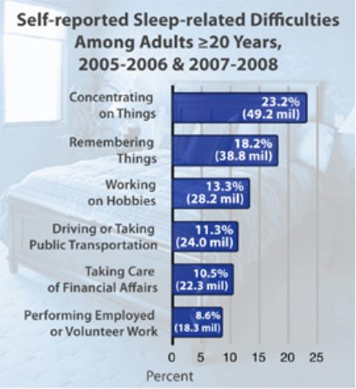

- Some people can function well on very little sleep
- Due to mutation in DEC2 gene?
- Conditioning/adaptation?
- More efficient sleepers? Deeper REM sleep?

Sleep Cycle
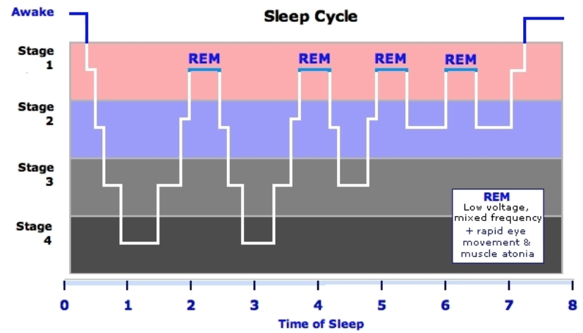

Sleep Metabolism
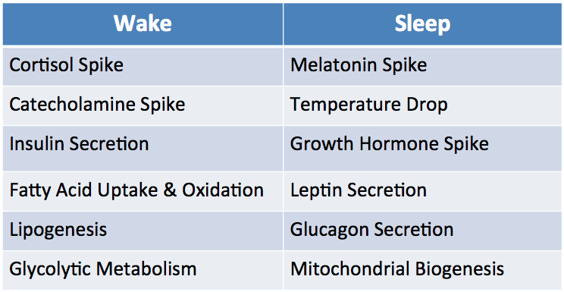

Sleep and Obesity: Viscous Cycle
- Lack of Sleep = decreased motivation, metabolic disruption, hormonal changes, more time to eat → obesity
- Obesity = sleep apnea and other sleep disorders, depression and anxiety, chronic inflammatory state → lack of sleep
- Study: Association between reduced sleep and weight gain in women
- Data from Nurses Health Study (16 year Prospective Cohort)
- Less sleep associated with increased body weight over time
- Study: Childhood Sleep Time and Adult BMI
- Each 1 hour reduction in sleep during childhood was associated with a 50% increased risk of obesity at age 32
- Study: Reported Insomnia and BMI/PA
- Increased reporting of insomnia in obese populations
- Increased reporting of insomnia in sedentary populations
- Study: Sleep and Appetite
- 12 healthy men
- Appetite rating after 2 days of 10-hour sleep, or 2 days of 4-hour sleep
- 4-hour sleep group
- Higher rating of appetite
- Higher ghrelin levels (ghrelin increases food intake)
- Lower leptin levels (leptin decreases food intake)
- Study: Sleep and Food Choices
- Less sleep resulted in higher rating of food desire, and higher rate of selection of high calorie meal
- Study: Sleep and Insulin Resistance
- Design: 4 days of 4.5-hrs sleep/night, 4 days of 8.5-hrs sleep/night
- Results: 4.5-hrs sleep/night decreased whole body insulin sensitivity by 16%, and decreased adipose insulin sensitivity by 30%

Sleep and Energy Expenditure
- Energy expenditure = BMR + Thermic Effect of Food + Physical Activity
- Drops 10% at most with adequate sleep
- Insufficient sleep
- Increases daily energy expenditure (slightly)
- BUT increases overall calorie intake due to increased consumption and hormonal disruption

Sleep and Depression/Anxiety
- Insomniacs are
- 10x more likely to have clinically significant depression
- 17x more likely to have clinically significant anxiety
- Antidepressants are often also used interchangeably as sleep aids
- Study: Sleep Deprivation as a “Negativity Bomb”
- Subjects (half sleep-deprived) shown positive, negative, or neutral words
- Asked to recall after 2 nights of recovery sleep
- Sleep-deprived group had 40% deterioration in total word recognition
- 50% deterioration in positive or neutral words (forget good things)
- 20% deterioration in negative words (remember/fixate on bad things)

Sleep and Immune Function
- Antibody response to vaccination increases with sleep
- Sleep = better immune function and protection

Sleep and Cardiac Health
- Shift workers have increase incidence of CHD
- MI incidence increases in the 7 days following spring daylight savings

Obstructive Sleep Apnea (OSA)
- Intermittent and repetitive cessation of breathing coupled with reductions in blood O₂ during sleep
- Sleep fragmentation and decrease in REM and slow-wave NREM sleep
- Obesity is a major risk factor
- Increased abdominal and chest wall fat → decrease lung volume
- 50% of TTDM also have OSA
- Sleep disruptions and hypoxemia contribute to TTDM development

Circadian Rhythms
- Internal clock, 24hr cycle
- Controlled by the suprachiasmatic nucleus (SCN) of the hypothalamus
- Controls production of melatonin in the pineal gland
- Regulated by light (blue light has greatest power to prevent melatonin production)
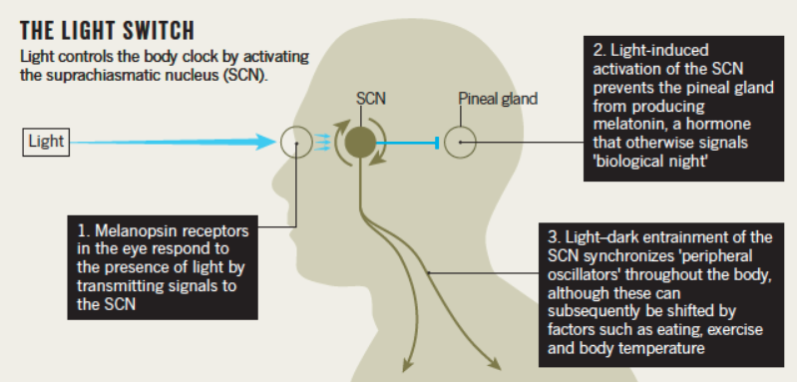

Biphasic Sleep and Naps
- In short photoperiods (time exposed to light), human sleep is biphasic
- “First and second sleep” style of two 4-hr sleep periods was changed by the industrial revolution
- Ideal nap is 20 minutes long
- Mentally refreshing
- Not long enough to go into deeper sleep stages which would result in grogginess and disorientation

Lifestyle Factors that Affect Sleep
- Exercise
- Exercise (vigorous especially) is associated with better sleep
- Promote physical exhaustion, reduce stress, weight loss
- Better to exercise after waking or well before sleep
- Diet
- Hunger or large meals prior to bed can impair sleep
- Fluid intake can disrupt sleep
- Sleep Eating (NSRED)
- Risk of physical injury and psychological stress
- Contributor to obesity
- Caffeine
- CNS stimulant, adenosine antagonist
- Acts fast, long half-life
- Disturbs sleep if consumed in the evening
- Alcohol
- Reduces REM
- Sleep onset is faster but quality is lower
- Smoking
- Nicotine is a stimulant
- Night withdrawal can disrupt sleep
- Dope
- Use of 3x month associated with problems falling asleep and staying asleep
- May be useful for sleep with pain
- Chronic users associated with lethargy and lack of motivation
- Technology
- Blue light before bed disturbs melatonin production

Insomnia Treatments
- Sleep hygiene practices
- Relaxation techniques, avoiding screens before bed, bed is place only for sleep
- Prescription, OTC, or natural sleep aids

The Health Trifecta
- Nutrition, Exercise, Sleep

16. Metabolically Healthy Obese

 | Lean Body Type | Obese Body Type
Healthy Metabolism | Lean, Healthy | MHO
Unhealthy Metabolism | Metabolically Obese, Normal Weight | Obese, Unhealthy

Obesity Driven Metabolic Dysfunction
- As BMI increases, risk of TTDM and CVD increase
- 3 Defining Populations:
- At risk
- Average
- MHO
- Risk increases less steeply for MHO individuals than for the general population

Study: Risk of Death in MHO vs. MUHO
- Purpose: study the examination between MHO and risk of CVD and all-cause mortality
- Study Design: Observational, prospective study
- 22,203 men and women (without known CVD)
- Classified by H or UH by metabolic syndrome criteria/inflammation
- Results (followed for >7 years):
- MHO were not at elevated risk for CVD compared to metabolically healthy non-obese
- Non-obese and obese with 2+ metabolic abnormalities were at elevated risk of death
- MUHO were at elevated risk of all-cause death compared with MHO
- Conclusion: MHO were not at increased risk of CVD and all-cause mortality over 7 years

Study: Differences in body composition between MHO and MUHO
- Purpose: to determine whether measures of body composition differs between MHO and MUHO among US men and women
- Design: N=395 obese adults, ages 18-68 y
- MHO had less than 2 CVD risk factors
- MUHO had 2 or more CVD risk factors
- VAT, SAT and total abdominal tissue (TAT) were measured with computed tomography
- Results: MUHO has greater amounts of VAT, SAT, and TAT than MHO
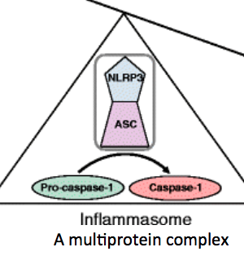
- MUHO and MHO cardiometabolic profiles are characterized by differences in body composition

Inflammasome Activation
- Inflammasome is a multiprotein complex
- Increased activity tips inflammatory balance in adipose tissue

Study: Differences in adipose tissue inflammasome activity and immune cells
- Purpose: to assess whether the inflammatory profile of visceral adipose tissue was different in MUHO compared with that in MHO, and to investigate the mechanisms that could contribute to such differences
- Design: MUHO and MHO undergoing bariatric surgery, lean controls
- Phenotypes defined by absence (MHO) or presence (MUHO) of metabolic syndrome (CVD risk factors)
- SAT or VAT samples obtained
- Assess cellular composition, secretory profile (adipokines), inflammasome activity
- Results: VAT of MUHO vs. MHO
- Increased expression and secretion of IL-1β, increased NLRP3 expression (IR)
- Significant reduction in T regs (compared to both SAT and VAT of MHO and lean)
- Increased macrophages with high caspase-1 activity, increased macrophages with higher IL-1β
- Significance of Study: first to show that VAT of MUHO has a less favorable inflammatory profile than that of MHO individuals
- Possible therapeutic target for the prevention and treatment of obesity-induced insulin resistance

Study: Omega-3 FA Prevent Inflammation and Metabolic Disorder through Inhibition of NLRP3 Inflammasome Activation
- Inflammasome as a Therapeutic Target
- Purpose: To study anti-inflammatory activity of N-3 PUFA and possible mechanisms
- Design: WT (control) or Nlrp3 -/- mice
- Fed a normal diet or HFD for 10 weeks
- With or without DHA treatment
- Results: DHA suppressed HFD-Induced NLRP3 inflammasome activation in vivo

Study: Lifestyle Intervention Improves Cardiometabolic and Exercise Parameters in MHO and MUHO
- Purpose: To assess effects of lifestyle intervention (HIIT and Mediterranean diet) on body composition, cardiometabolic, and exercise parameters in MHO and MUHO adults
- Design: MHO and MUHO undergo 9 month lifestyle modification
- Results: Lifestyle intervention improved:
- Body composition
- Blood pressure
- Fasting blood glucose
- Insulin sensitivity
- VO₂ peak
- Muscle endurance
- Prevalence of MUHO was reduced by 17.91% after program

Study: MHO phenotype – cardiovascular prognosis and role of fitness
- Purpose:
- Do MHO have higher fitness levels than MUHO peers?
- Is MHO a benign condition, in terms of CVD mortality
- Methods: Prospective study, fitness assessed by maximal treadmill test, BF % assessed
- Results:
- Better fitness should be considered a characteristic of MHO
- MHO is associated with a 30-50% lower risk for mortality and morbidity than MUHO
- Conclusion: Fitness plays a key role in cardiovascular prognosis for MHO!

Obesity – Adipokines

Leptin
· Signal to maintain healthy adipose tissue
· Secretion is proportional to adipocyte size
- Adipocyte growth à Increase Leptin secretion
· Function:
- Decrease food intake (CNS effect) + Increase energy expenditure (peripheral tissue)
· Leptin and Human Lipodystrophy
- Individuals have no fat and no leptin, thin and very insulin resistant
- Insulin sensitivity was recovered with 3 months of leptin treatment
- Treatment restores sensor of energy supply
- Indicates when necessary fuel sources have been reached to decrease energy intake
· Leptin and Insulin Sensitivity
- Leptin treatment increases insulin-stimulated glucose uptake in induced obesity and IR subjects
- Leptin affects insulin signaling pathway:
- Increase IRS-1 protein content
- Increase insulin-stimulated PI3K activity
- Increase akt phosphorylation
- Increase plasma membrane/total GLUT 4
· Leptin and FA Oxidation
- leptin increases AMPK activation to increase FA oxidation in skeletal muscle

Leptin and Obesity
· Paradox: If plasma leptin increases with obesity, why do people stay obese?
· Leptin Resistance: Stimulatory effect of leptin is lost in muscle of obese humans
- Plasma leptin chronically elevated in obesity
- Loses ability to signal in CNS and peripheral tissue
- Leptin regulation of energy balance is lost
- Analogous to development of IR
· Rat Study: Leptin resistance develops within 4 weeks of a high-fat diet
- Exercise training can reverse obesity and IR induced leptin resistance
- Treadmill training while maintaining high fat diet saw recovery of insulin-stimulated glucose uptake and leptin-stimulated fat oxidation in skeletal muscle

Adiponectin
· Inverse relationship with body fat
· Function:
- Decrease inflammation
Adiponectin Circulating Form | Percentage of Total in Circulation | Receptor | Receptor Location  (Primarily)
Globular Head | 1% | AdipoR1 | Skeletal muscle
Full Length | 99% | AdipoR2 | Liver
- Increase insulin sensitivity
- Activate AMPK to increase FA oxidation

Adiponectin and Obesity
· Obese humans are resistant to adiponectin-stimulated FA oxidation and AMPK activation
· The activation of AMPKα2 is blunted in obese muscle

The Relationship between Adiponectin and Insulin
· Adiponectin resistance precedes development of IR
- High fat diet:
- AR à 3 days
- IR à 4 weeks
· BUT, exercise-induced recovery of skeletal muscle insulin response is not dependent on restoration of adiponectin response!
· Adiponectin is not likely to be important in the development of IR
· Effects of Dietary Modulation on Adiponectin and Insulin Impairment Study:
- n-3 PUFA can prevent high SFA diet-induced impairment of adiponectin-stimulated FA oxidation
- n-3 PUFA does not restore impaired FA oxidation
- n-3 PUFA can prevent and restore diet-induced impairment of insulin-stimulated glucose uptake

Tumor Necrosis Factor Alpha (TNFα)
· mRNA and protein overexpressed in adipose tissue of obese humans

TNFα Key Actions
1. Induce Insulin Resistance
- Alters insulin signal transduction to directly impair glucose uptake and metabolism
- Promotes lipolysis
2. Inhibit Adiponectin and Induce IL6
- Important mechanism leading to reduced adiponectin in obesity
3. Adipose Tissue: suppress genes involved in uptake and storage of FFAs and glucose
4. Liver: suppress genes involved in glucose uptake and FA oxidation

TNFα and Exercise: Kawanishi Study
· 16 week treadmill training decreased MCP-1 and TNFα mRNA expression on a high fat diet
· Exercise prevents adipose tissue inflammation
- Exercise inhibited the higher levels of mRNA expression of TLR4 (induces inflammatory cytokine production) associated with HFD
- Exercise promotes macrophage shift from M1 to M2 (good)

IL-6: a Dual Effect Adipokine
· Traditional inflammatory cytokine
· 30% of normal plasma IL-6 is from adipose tissue
· Muscle releases IL-6 into circulation during exercise
- Increases IL-6 in plasma and skeletal muscle

IL-6 Key Actions: Bad at rest, good during exercise
· Induce IR
- Elevated in insulin resistant humans
- 2x as much secreted from VAT
- Infusion impairs insulin sensitivity in muscle and liver (in mice)
· Improves Insulin Sensitivity
- Stimulates AMPK in active muscle
- Released from contracting muscle…feedback to increase hepatic glucose production and lipolysis
· Overall: Good or Bad??...Chronically elevated [IL-6] is BAD
- IL-6 stimulates JAK-STAT signaling cascade in insulin responsive tissues
- Considered to impair insulin signaling and induce insulin resistance

17. CANCER
What is Cancer?
- Abnormal cell growth → mass of tissue
- Tumour types:
  - Benign: non-cancerous, rarely life-threatening, do not spread
  - Malignant tumour: cancerous
- Metastasis: spread of cancer cells, development of secondary tumours

The Cancer Process (Jenny says know this!!!!)
- Initiation
  - DNA damage irreversible changes to the cell (could be from ROS)
- Promotion
  - Evade immune system
  - Promotes cell survival
  - Angiogenesis
- Progression
- Metastasis

The Good Ol’ One-Two (marks):
Cancer is:
- Increase in cell proliferation
- Decrease or block apoptosis

Abdominal Obesity is Assc. with Metabolic Abnormalities That May Increase Cancer Risk
- IR and hyperinsulinemia
- Hyperglycemia
- Hyperlipidemia
- Altered Hormone Metabolism:
  - Increased IGF-1 (in colon)
  - Sex hormones, ie. increased circulated estrogen (breast)
- Abnormal adipokine production:
  - Potential mediators of metabolism– metabolic signals
  - Linked to IR, high insulin and thus risk of some cancers
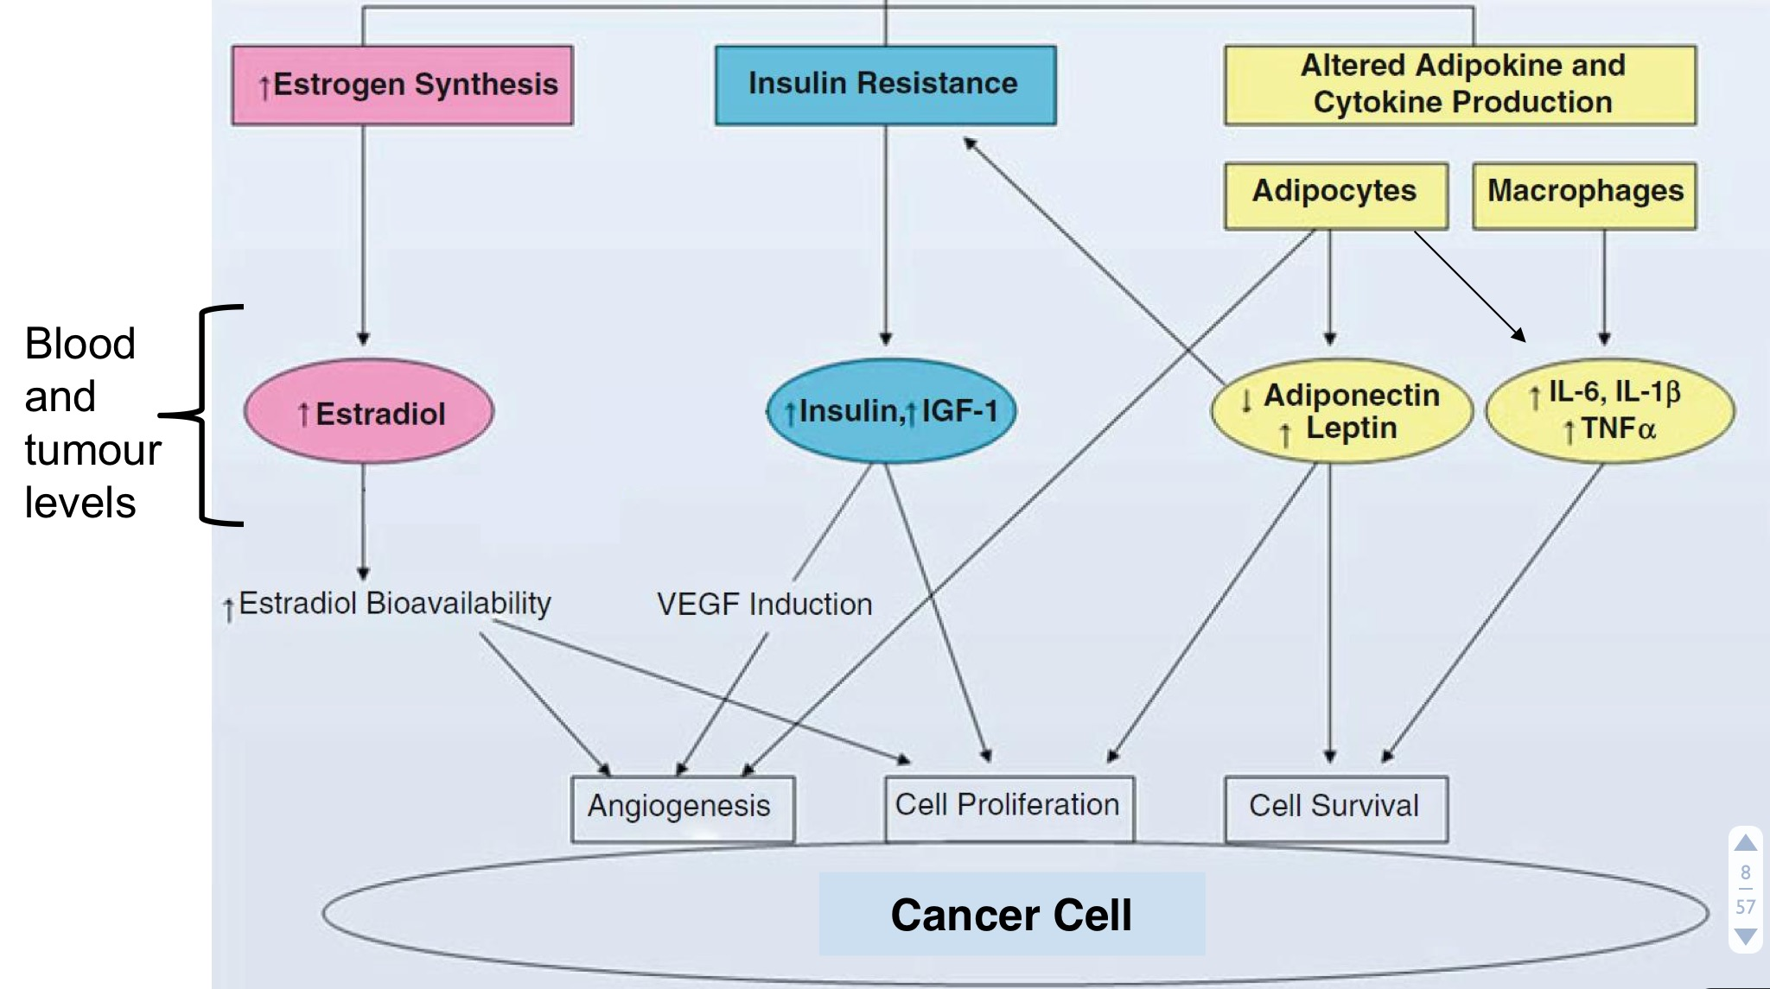
Leptin and Cancer
- Increases NFkB and STAT3 activation → increases inflammatory cytokine production (TNF-a and IL-6, respectively)
- Promote cell proliferation and cell survival
- Attracts neutrophils and other immune cells into the tumour microenvironment (chemotactic), where they can:
  - increase ROS production and induce DNA damage
  - Secrete pro-inflammatory cytokines → IL-1B, IL-6, IL-8, TNFa
- Antagonizes anti-inflammatory mechanisms (adiponectin and IL-10)

Adiponectin (APN) and Cancer
- in vitro: reduces cancer cell proliferation and survival
- APN +/- mice exhibit increased tumour number and size
- APN inhibits signalling pathways resulting in reduced cell growth and proliferation:
  - Pro-Apoptotic
    - Activates caspases
    - Stimulates cyto-C release from the mitochondria
  - Anti-Inflammatory
    - Stimulates PPARy → block NFkB activation and inflammatory cytokine production (eg. TNFa)
    - Increases IL-10
- Binds to the adiponectin receptor and activates APPL1:
  - Anti-oxidant effects, reduces ROS production
Insulin and Cancer
- Obesity
  - Increased insulin levels
  - Decreased growth factor binding protein 1
    - Increases (free) insulin like growth factor (IGF-1)
- Hyperinsulinemia
  - Promotes colon cancer cell growth
- Insulin Receptor and IGF-1 receptor (IGFR-1) are over-expressed in many types of cancer

Insulin and IGF-1
- Increase cell growth/proliferation
- Decreases apoptosis
- Stimulates VEGF expression and promote angiogenesis

Inflammatory Cytokines/Transcription Factors and Cancer
STAT3 activation results in increased IL-6 production
- Constitutively activated in >50% of tumours
- Anti-apop: reduces pro-apop gene exp. in cancer cells → cancer cells survive
- Promotes cell proliferation
- Pro-angiogenic: stim VEGF expression
- Induces prolonged NFkB expression

NFkB activation results in increase TNFa production
- Aberrant (unexpected) activation in >50% of tumours
- Increases cell proliferation and angiogenesis
- Inhibits apoptosis
  - Increases cIAP (cellular inhibitor of apoptosis) expression which inhibits caspase activation
- Promotes cell invasion and metastasis via MMP activation

Cancer Cachexia: progressive loss of body weight characterized by depletion of both skeletal muscle mass and adipose tissue, despite adequate nutritional intake
- 30-80% of patients
- Severe (15% of cancer patients) > 10% loss of initial body weight
- Highest frequencies in: pancreatic, gastric, SI cancers
- Lowest: non-Hodgkin’s lymphoma, breast cancer
- Death occurs w/ 25-30% of total body weight loss
Cachexia is assc. w/ numerous metabolic changes:
- IR
- Increased glucose production (in liver)
- Increased lypolysis

Causes/Contributors to Cahexia
- Tumour by-products: inflammatory cytos: TNFa, IL-6, leptin
- Dysphagia (difficulty swallowing): common in head, neck, esophageal tumours
- GI Disturbances: obstruction/constipation
- Malabsorption: fat/CHO not metabolized or absorbed
- Treatment Toxicities (nausea/vomiting): common side effect of chemo/radiation
- Uncontrolled Symptoms: pain, dyspnea (difficulty breathing)
- Xerostomia (dry mouth) or altered oral condition or sense of taste: result of infection, poor hygiene, dehydration, medication side-effects, alteration in taste buds

Depletion of Muscle Mass Leading to Cachexia (know this)
- Decreased protein synthesis (hypoanabolism)
  - failure of normal stimuli for protein synth (decreased anabolic hormones)
  - and/or lack of substrate (AAs and energy) for net +ve nitrogen
- Increased Protein Breakdown (hypercatabolism)
  - activation of intracellular proteolytic enzymes
  - increased proinflammatory cytokines (TNFa, IL-6)
  - increased tumour-derived catabolic factors

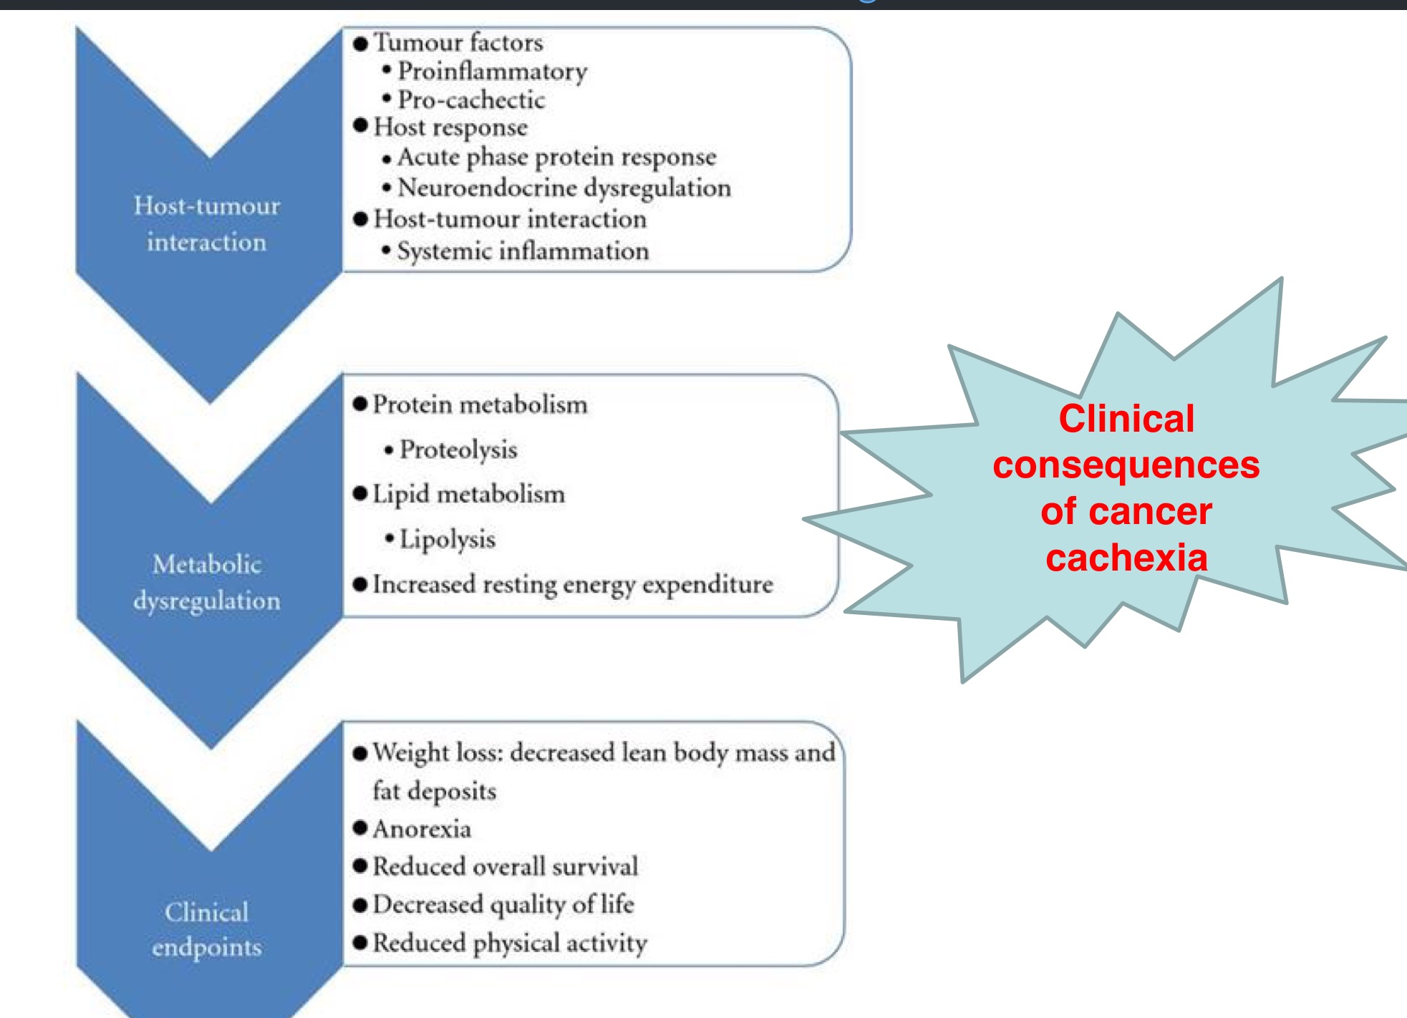

Diagnostic Criteria for Cachexia:
- Weight loss of at least 5% in 12 months or less, AND:
- 3 of the 5 following symptoms:
- Decreased muscle strength
- Fatigue
- Anorexia
- Low fat-free mass index
- Abnormal biochemistry:
  - increased inflammatory markers
  - anaemia
  - low serum albumin

Implications of Cachexia
- Increased risk of complications/death
- Decreased treatment response (ie. to chemo)
- Increased therapy toxicity
- Increased hospital stay, rehospitable state
- Decreased quality of life

Starvation versus Cachexia
- In starvation there are adaptations present to reduce energy expenditure:
  - Conserve protein, utilize FAs/ketones
- These are not present in Cachexia:
  - Increased REE
  - Muscle protein loss continues and cannot be reversed w/ supplementation
  - Variations w/ tumour phenotype, host response

Primary versus Secondary Cachexia
- Primary
  - Cancer-mediated metabolic abnormalities
  - Inability to conserve protein = extreme loss of muscle tissue
  - Occurs despite sufficient energy (calorie) intake
- Secondary
  - Inability to consume adequate kcal
  - Can be due to treatments/tumour:
    - dysphagia, poor oral hygiene, GI obstruction, etc.

Why is Treatment Important?
- Large % of cancer patients suffer from it
- So many symptoms:
  - Weight loss (with muscle and adipose tissue wasting) ← 2 FREE MARKS
  - Anorexia
  - Asthenia (weakness)
  - Malabsorption, nausea
  - Metabolic changes (poor macro metabolism)
- Cachexia prevention and/or intervention is a necessary component of cancer treatment to improve:
  - patient survival
  - tolerance to chemo
  - quality of life

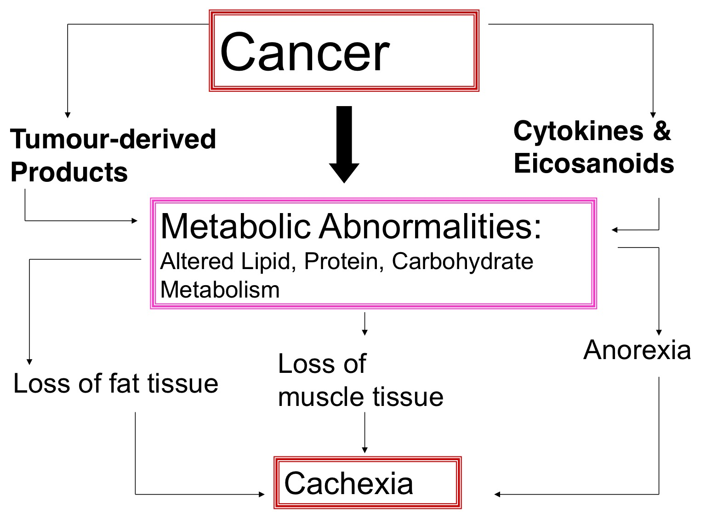

Inflammation and Cancer Cachexia: Proinflammatory Cytokines
- TNFa
  - Induces muscle protein degradation
    - activates NFkB
    - induces ROS formation
  - Stimulates lipolysis in adipose tissue
    - upreg’s MAPK and JNK pathways
    - PPARy activity
    - activates NFkB

- IL-6
  - Increases muscle protein degradation
    - activates non-lysosomal (proteasome) and lysosomal (cathepsin) pathways
    - Works w/ TNFa and other mediators
  - Upreg’s STAT3

Inflammation and Cancer Cachexia: Eicosanoids
- Inflammatory mediators (can activate NFkB)
- Induce peripheral tissue loss
  - directly and indirectly (via activation of the acute phase protein response)
- Produced by some tumours and by the host (patient)
- Derived from:
  - arachidonic acid
  - eicosapentaenoic acid
- Remember that n-3-derived eicosanoids have less biological potency (ie. are more anti-inflammatory)

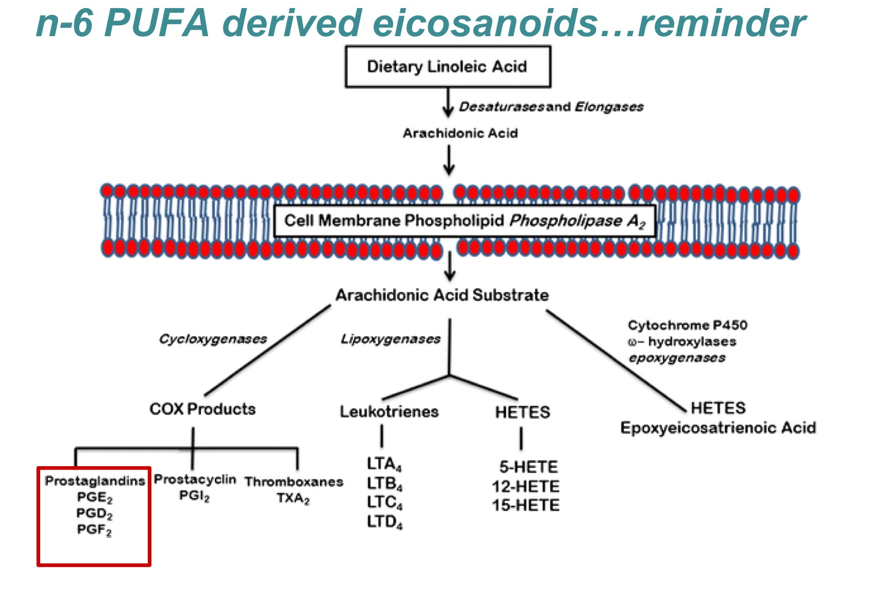
There are double the PGE2 levels in carcinoma versus control tissues!

Prostaglandin E2 (PGE2)
- Levels increased in human colorectal tumours, and other types
- Inhibits apoptosis via decreased Bcl2 expression
- Activates B-catenin signaling → promotes cell survival and cell proliferation
- Induces VEGF (promoter of angiogenesis)
- Induces MMP activation → degrades the extracellular matrix
  - helps tumour metastasize
- Pro-inflammatory

Inflammation and Cancer Cachexia: Tumour-Derived Products
Proteolysis-inducing factor (PIF) (starred in my notes for some reason)
- Has receptors in skeletal muscle, liver
- Detected in urine of weight-loss cancer patients with a variety of tumour types
- Absent in urine from cancer patients without weight loss
- Assc. with:
  - greater total weight loss and rate of weight loss than patients whose urine did not contain PIF
- Has effects on loss of skeletal muscle mass due to:
  - depression in protein synth (by 50%)
  - increase in protein degradation (50%
- Increases ubiquitin-proteasome expression and activity
- Activates NFkB, leads to ROS formation
- Induces IL-6 production

Lipid-Mobilizing Factor (LMF)
- Also in urine of weight-losing patients
- Identical to ZAG protein in mice
- Induces lipolysis (inc lipolytic enzyme expression)
  - UCP-1 and UCP-3 in BAT (contributes to increased substrate utilization)
  - TAG lipase (ATAG)
  - HSL
- Secreted by adipose tissue and the tumour

Supplementation of L-carnitine to cachexia patients
- Facilitates transfer of activated LCFAs from cytoplasm to mito– processed by ox to produce ATP
- 75% of carnitine in the organism is derived from dietary sources (red meat/dairy), 25% synth’d in liver and kidneys from lysine and methionine
- Skeletal muscle and myocardium are carnitine-dependent (FA ox as main source of energy)
- L-carnitine supp. to tumour-bearing rats improves liver lipid metabolism and reduces inflammatory cytokine levels

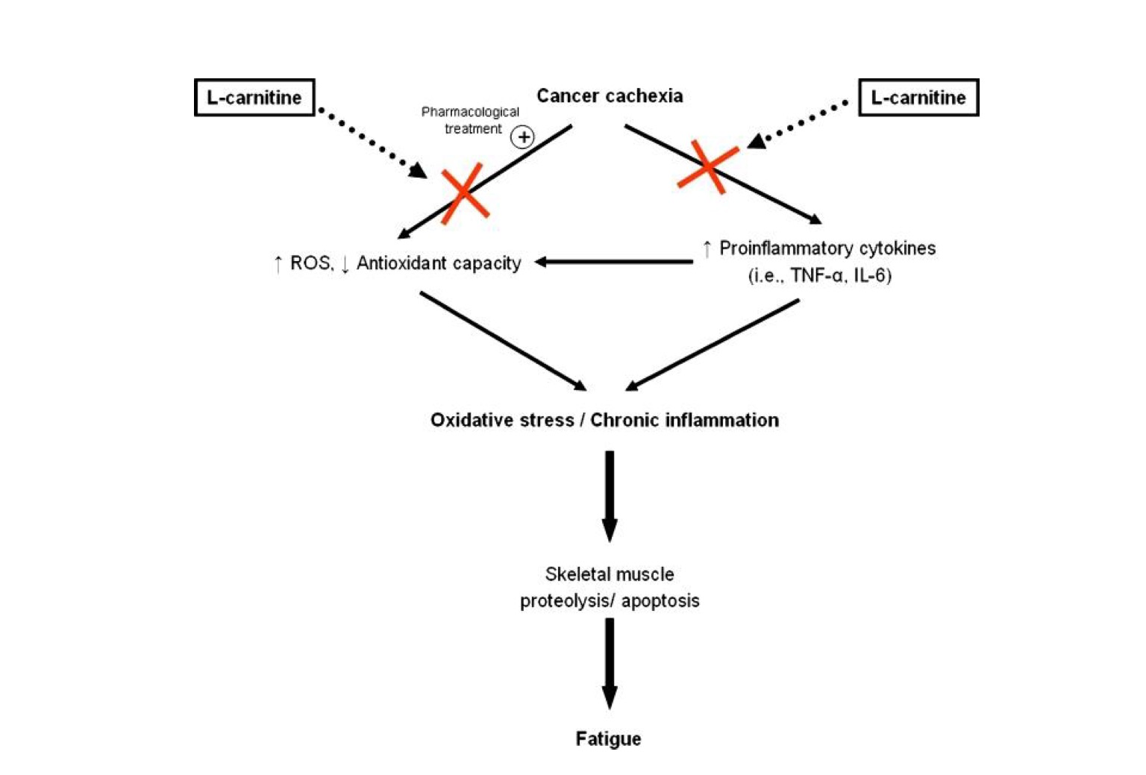

Management of Metabolic Response to Cancer
- Tumour and/or Treatment lead to:
  - pain
  - nausea/vomiting/diarrhea
  - altered taste & smell; food aversion
  - mouth/swallowing/dental problems
  - Malabsorption
  - fatigue/depression/anxiety
- All of these pose BARRIERS TO FOOD INTAKE

Treatment strategies
- Appetite stimulants– target CNS
  - ie. megesterol acetate
    - appears to at via CNS to enhance appetite, mech of action not known
    - Reverses weight loss
    - Does not facilitate increase muscle protein synthesis or arrest muscle loss
    - weight gain = fat accumulation (enhances lipogenic enzymes)
    - Edema is a possible side effect

- Muscle anabolics (drugs, nutrients, exercise), any of the following or in combination:
  - Steroids
  - AAs or dietary protein sources
  - Creatine
  - Exercise
    - treatments typically aimed at controlling tumour growth → little attention given to controlling systemic effects of cancer
    - exercise can improve these cancer-related symptoms:
      - reduce skeletal muscle loss
      - improve blood flow and lower the risk of clotting
      - reduce nausea and fatigue
      - quality of life: mood, self-esteem, reduce dependency, etc.
    - decreases inflammatory response (IL-10, reduce effects of TNFa)
    - increase glucose transport (GLUT4 synthesis)
    - increase insulin sensitivity (PI-3-K)

- Anti-catabolic and anti-inflammatory agents
  - NSAIDS
  - Cytokine inhibitors
  - PUFAs (ie. eicosapentaenoic acid)
- Nutritional supplement
  - Cachexia is resistant to intervention with enternal or parenteral or parenteral nutrition (ie. total nutrient mixtures)
    - Likely due to metabolic changes– increased tumour or host production of proinflammatory cytokines and mediators that cannot be overcome

n-3 PUFA and Cancer Cachexia: Mechanisms of Action
- Precursor of eicosanoids with less biological potency (anti-inflammatory)
- Decrease proinflammatory cytokines, attenuates cytokine-induced catabolic effects
- Impairs effects of PIF, tumour-assc. muscle proteolysis
  - EPA can decrease exp. of proteasome subunits
  - EPA may support anabolic qualities in muscles: improves sensitivity to insulin (shown in diabetes, not in cachexia)
- Weight-stabilizing in some patients, may improve survival and QOL
- Most effects shown in pancreatic cancer

n-3 versus regular care
- Goal: compare fish oils compared to regular care regarding body weight, skeletal muscle and adipose tissue in chemo patients
- Methods– ten weeks of: 1) fish oil (2.2g/day EPA), 2) regular care
- CT used to measure muscle mass and adipose
- Results 1) overall maintenance of weight and skeletal muscle: 69% of patients, 2) weight and muscle loss: 29%, 4 became sarcopenic, lost muscle and inc fat
17. Sarcopenia: loss of muscle mass and strength
- Leads to:
  - Neuromuscular impairment
  - Loss of mobility / balance problems / increased falls and fractures
- Occurs naturally with aging

Defining and Quantifying Sarcopenia
- CT/MRI/DXA
- Muscle mass index 2 std. dev. below sex-specific mean for young, healthy adult
- Decreased “metabolic quality” occurs with aging
  - decline in strength and muscle mass
  - decreased:
    - oxidative capacity
    - capacity for transport of glucose
    - capacity for transport of lipids
- NB: “metabolic syndrome”: clustering of metabolic abnormalities in a person that increases CVD risk

Age-related changes in body comp
- Fat mass inc from birth, peak around 60-75yrs
- Differences in partitioning of adipose
- VAT and intramuscular fat inc through life, SAT does not
- Fat infiltration into muscle: lower muscle strength
- More adipose tissue = more muscular strength needed

Sarcopenic Obesity: synergistically effect with sarcopenia and obesity: maximizes disability in this population

Factors in Sarcopenic Obesity
- Nutrition (dec protein intake can lead to sarcopenia, increased energy intake contributes to obesity)
- Physical inactivity (muscle disuse/atrophy contribute to sarco)
- Low-grade inflammation: cytokines/adipokines contribute to ob-related IR
  - pro-inflammatory cytokines can also induce muscle catabolism
- Insulin resistance
  - normally stimulates protein synthesis
  - decreased ability to respond to anabolic stimuli
  - insulin is vasodilatory, allows AAs to be delivered to muscle for protein synth
  - stimulatory effect of food intake on protein synthesis is blunted in old/aging muscle
- Hormonal changes
  - decreased growth hormone, decrease testosterone

Summary of Sarcopenic Obesity (SO)
- SO is a “silent” condition characterized by increased fat mass that masks reduced skeletal muscle mass and function; assc. with poor outcomes
- Not possible to ID SO merely by body mass/BMI
- CT scans useful, not widely available
- Firm diagnostic criteria are lacking
- Mechanisms are uncertain but likely multi-factoral/synergistic including:
  - dysreg’n of energy balance
  - malnutrition/overnutrition
  - hormonal, inflammatory mediators
  - reduced physical activity

Treatment of SO
- Goal is to simultaneously increase muscle mass and decrease body fat
  - resistance training and caloric restriction via nutrition/aerobic exercise!
- Low grade inflammation is another important target for interventions aiming to limit sarcopenia and muscle weakness in elderly/obese populations

