FOR THEO TEST
Lesson 2: Christianity in the Roman World
- The Roman World
  - Animated map of the Roman world (from 510 BC to 1453 AD)
- Roman Society
- Roman Religion
- The Role of Religion in Roman Society
- Opposition to New Religious Movements
  - Roman opposition to new religious movements (video)
- Opposition to Christianity
Listen to Dr. Turcescu's descriptive audio recording: Christianity in the Roman World Vallée: Chapter 1: Christianity in the Roman World, pages 11-22

Lesson 3: The Jewish legacy
History of the Jewish People (slides 2-3)
Biblical Stories
From Creation to the God of Abraham
Egypt: Bondage and Exodus
The First Temple of Jerusalem
Return to Jerusalem
Jewish Groups around the Year 0
- Jewish Groups (video)
Rabbinic Judaism
- Rabbinic Judaism (video)
Perceptions of God
Listen to Dr. Turcescu's descriptive audio recording: The Jewish Legacy. Vallée - Chapter 2: The Jewish Legacy, pages 23-41 Listen to Dr. Turcescu's descriptive audio recording: Dead Sea Scrolls Fragment (War Scroll)Read excerpt from the Dead Sea Scrolls: The War Scroll(Translation source: Canadian Museum of Civilization,http://www.civilization.ca/civil/israel/isrel54e.html)
QUIZ 1: LESSONS 1-2-3: October 15th:
If you encounter any technical problems, please contact the helpdesk immediately (with an email copy to your TA and Dr. Turcescu at theo206@econcordia.com). Please note that the helpdesk is open during regular hours (from 9:00-17:00h) and thus you may hear from them on the next day outside of that window.

LESSON 1: The Earliest Christian Writings
Video: Methods of biblical interpretations (literal, allegorical – not face value, mystical (apply it to god, life) moral method (lessons about spiritual life, code of conduct)
Today, most recognized and widespread is the historical critical method
Valee (introduction): The Patristic Period: First century of the Christian tradition, “Patristic Period.” Christianity: its formation can be approached from various angles, depending on one’s major interest or on what one considers central to the development of the Christian tradition in those centuries. Patristics as a Field of Research and Study: investigate the history and literature of the first century of the common era. Sources and Tools: Previous centuries were often satisfied with written testimonies and built their reconstructions of the past almost exclusively on textual remains. Today archaeology, and other means come to help. Topicality of Patristic Studies: due to criticism in 18th c (enlightenment) second, emergence of historical consciousness. Trends in Recent Research: increasing research in context of European and World history, second trend recent work in patristics. Third, outside observer, direct, resolute and extensive dealing with sources. Finally, present – day patrologists carry out their work with secular institutions, their work is judged by how the value of their scholarship. History and Literature: Christianity evolved as a religious and social movement, development mainly through literature and historical remains.
The Christian Bible
Christianity is the faith based on Jesus Christ’s:
- life
- teachings
- death
- resurrection and ascension into heaven
Jesus lived some 2000 years ago.
The Christian Bible contains:
- Old Testament (OT) + apocrypha/deutero-canonical books
- New Testament (NT): 27 books, including 4 Gospels (“good news”)
- Gospels were written some 40-50 years after Jesus’s death

Methods of Biblical Interpretation:
Video: The Historical critical methods exemplification; Gospels three, synoptic (together) – scholars have asked themselves why they are so similar, Luke and .. based on Gospel of Mark (quelle) source. Other appothel (secret) Gospels of Peter, Marie Magdalen..
These methods include:
  - Historical Critical Method
  - Literal Method
  - Allegorical Method
  - Mystical Method
  - Moral Method
The most widespread with scholars today is the historical method which looks at:
  - historical context (writers put it in the context it was produced)
  - intended audience of the author (Jewish to hear about Jesus or Roman audience not familiar with the Hebrew writings..)
  - desired effect of the author (was it to convert people, message of salvation, parallel with a lesson..)
Biblical Interpretations: (continued)
The Gospels
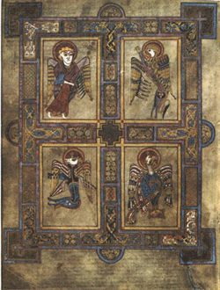
Synoptics (Greek for “seen together”):
  - Matthew (Mt), Mark (Mk), Luke (Lk).
  - Matthew and Luke are based on Mark and Q (from the German word “Quelle” = source)
The historical critique method established that:
  - Matthew targets the Jewish-Christian audience, because Jesus is presented as the second Moses and Messiah.
  - Luke targets a German audience, because it speaks in universal terms (explain who Moses was)
The Gospels of John (Jn): (fourth Gospel)
  - Jesus is the eternal Son and Logos (or Word) of God, the incarnate God on Earth
  - There are also apocryphal (or secret) gospels attributed to Thomas, Peter, Mary Magdalene, Philip, and even Judas – most of them come from Gnostic circles and are later
The evangelists, along with their symbols in iconography from the Book of Kells (image) are:
  - Matthew the Evangelist, symbolized by a man, to represent the human nature of Christ
  - Mark the Evangelist, symbolized by a lion, to represent Christ as king.
  - Luke the Evangelist, symbolized by a bull or a calf, to represent Christ as sacrifice and as priest
  - John the Evangelist, symbolized by a eagle, to represent the Christ as God
The Life and Teachings of Jesus:
  - Jesus was born in the year 0 of the Common Era (CE) (this is the secular alternative to AD (Anno Domini))
  - These are Old Testament prophecies about the Messiah being born in Bethlehem
  - Jesus’s parents: Mary and Joseph
  - The gospel tell us about Jesus’s birth, then an episode at age 12, and his life around the age of 30
Continued:
John the Baptist: An important character, was Jesus’s forerunner and baptized people for the forgiveness of their sins
Jesus’s baptism by John has been seen as:
  - Consecration by God as the Messiah
  - John publicly announcing that the Messiah has arrived
  - Jesus identifies himself with sinful humanity
After the baptism:
  - Jesus undergoes a 40-day retreat in the desert before starting his ministry
  - Jesus begins to gather his first disciples: Simon, Peter, Andrew, James and John
  - The emphasis of Jesus’s ministry is on a spiritual life
Jesus’s Ministry:
Video: Second important element is miracles of Jesus, (miracles as suspension of the physical law). Jesus performed ‘miracles’ seen as the presence of the Kingdom of God (talked about like the glimpse of a better world – less suffering) Kingdom oG = new reality. Creative Tension between the already here and not yet fully realized, KoG is present in the healing, but these people will keep on dying after a while.. keep seeing injustice (tension is the foretaste, we don’t have the full taste). Already view vs Not yet here.. “die kingdom come” – not yet here.. connections between miracles and KoG
Miracles are seen as a sign of the presence of the Kingdom of God:
  - Turning water into wine
  - Healing the sick
  - Restoring life to the dead
  - Casting devils out of the possessed
  - Multiplication of bread
- The kingdom is “already” here, but “not yet” fully realized.
The Kingdom of Heaven:

Texts supporting the “Already” view
Matthew (Mt) | - 12.28  - 11.5-7  - 13.44-46  - 22.1-14
Luke (Lk) | - 4.16-21  - 17.20-21
Mark (Mk) | - 4.26-29

Continued:
Video: First testament was written in Greek, then translated into Latin
Texts supporting the “Not Yet” view
Matthew (Mt) | - 6.9-13  (“Our Father”  or “The Lord’s Prayer”)  - 5.3-12  (The Beatitudes)  - 8. 11-12

Jesus’s Radical ethics:
An important question: Is Jesus the Messiah?
Jesus reluctantly applies this title to himself because of misunderstandings
At the Transfiguration (witnessed by three disciples) Moses and Elijah appear to seal the fact that Jesus is the Messiah
Jesus’s Ethics and Teachings:
  - Touched lepers and bleeding woman to heal them
  - Welcomed women as disciples
  - Extended the command against adultery to adultery in one’ heart
  - Preached “turn the other cheek” (as opposed “an eye for an eye”)
  - Taught love your enemies
  - Proposed love is for God and for one’s neighbour
  - Offered forgiveness to those who repented
  - Challenged the interpretation of the Mosaic law (generally NOT the law itself)
  - Challenged the Jewish authorities
Jesus’s Crucifixion, Death and Resurrection
Sequence of events:
- Jesus returns to Jerusalem. Has Last Supper with disciples
- Judas betrays Jesus for 30 pieces of silver, Jesus is arrested
- At the trail Caiaphas, the high priest, ask Jesus if he is Christ (or the Messiah) and Jesus answers: “You have said so” , thus answering in the affirmative
- Caiaphas and the other priests see this declaration as blasphemy against God
- Roman authorities are asked to crucify Jesus
- The crucifixion occurs some time between 27-33 CE (apparent end of the story)
- Resurrection: women visit the tomb; Jesus’s appearances; women’s presence witnesses to the historical truth in claims of Jesus’s resurrection
The Early Church
After Jesus’s Death and Resurrection:
  - Acts of the Apostles (author Luke), Paul’s Letters, the other letters of the New Testament
  - Jesus’s ascension to heaven is followed by the descent of the Holy Spirit at the Pentecost (Acts 2)
  - Paul’s attempts to convert both Jews and Gentiles to Christianity
  - Anti-Christian feelings among Jews which led to anti-Jewish feelings among the early Christians
  - The new message Christianity proposes: salvation is by faith (not by circumcision, says Paul)
The Spread of Christianity
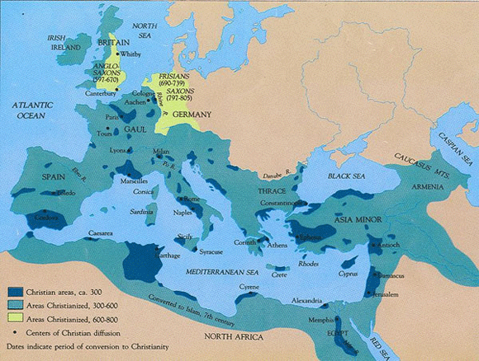

LESSON 2: Christianity in the Roman World
Video: understand how Christianity as a new religion came to be and why it was persecuted. Empire organized thus survived 1000 years.. Roman religion (paganism)’s encounter with Christianity.. Christianity become legalize, Jews only tolerated, and paganism stopped. Paganism, multiple gods = clash with Christians.. Christians now show respect to roman statues thus persecuted
Your Assigned Readings/Listening for this lesson are:
Reading Discussion MP3: Vallée; learn about Roman world social aspects; place of Christianity – connected with religious faith. For Roman religions morality was not about important, more rituals right balance with gods, not done by good morality.. Christianity odd as emphasizes morality so much, in line with Greek beliefs. Judaism emphasized morality too. Normative Christianity, nomoprotoz ,kanonical writings, accepted as normative, Christians start talking four gospels as normative. Romans did not have scriptures (writings). Christians did not have ideantity, then anti Jewish sentiment to find own Christians identity
Reading:
1 | Listen to Dr. Turcescu's descriptive audio recording:  Christianity in the Roman World (mp3, Length 04:43)  To download mp3 files, right-click on the file, select Save Target As, and in the Save As window select which drive or electronic storage device you wish to save your mp3 file in.  Vallée: Chapter 1: Christianity in the Roman World , pages 11-22 (Read Terms of Use below)

The Roman World:
Christianity was born in the Roman Empire
Roman colonization was militaristic and administrative
Culturally and religiously, the East colonized the Empire
Map animation of areas under Roman control from 510 BC to 1453 AD (wiki)

Roman Society:
All of the following provided a certain security and relative prosperity known as pax Romana (or Romani peace) for the populations around the Mediterranean basin
Administration:
  - Roman citizenship was possessed by entire cities, but it was bestowed on others as recompense for services rendered to Rome
  - Local administration was quite effective
System of Justice:
  - While respecting local customs, it applied the principles of Roman law and it enabled citizens to take their case to the Emperor himself
Currency:
  - Unified Throughout the Empire

Roman Religion:
  - Astrology – horoscopes were avidly compiled
  - Not Zeus, but rather Chance or Fate or Fortune (Greek, Tyche) was the most important god
  - Apostle Paul dismissed Roman religion (known as paganism) when writing:
    - “Now that you have come to know God…how can you turn back again to the weak and beggarly elemental spirits? How can you want to be enslaved to them again?” (Gal 4:9)
  - “Elemental spirits” are demonic beings or forces to whom Paul believed humans had been enslaved before their conversion to Christianity
Older view of the Roman Empire: an unprogressive society ruled by impersonal forces whose nature was not understood and which was morally degenerate
Newer scholarship: with some exceptions, this was not the case. Examples: grave memorials testify to the affection of family life, and surviving papyrus letters testify to its decency and sobriety
The Role of Roman Religion in Society
  - Religion ensured the existing world order and the prosperity of the Roman people, while the emperor was the supreme priest (pontifex maximus in Latin)
  - Fear of chaos if the empire fell was shared by all
  - Roman religion was a series of religious acts performed by professionals (the priests) and there were no scriptures
  - Religion was meant to achieve the right relationship between the gods and humans
  - Roman citizens were expected to revere and serve the Roman gods and not to practice and alien religion. In practice, however, any religion was allowed as long as it did not offend the laws and practices of Roman life
Opposition to New Religious Movements:
Video: Important, Christianity new movement which received opposition 2000 years ago. Do not use cult, use new religious movement, more neutral word. Why was there opposition? Opposition by organized religions, opposition from Judaism as seen as an offshore of Judaism. Judaism and Christianise both monotheistic, old religion so respected by Christians. Opposition by Nero (governments). Opposition by parents, schools, new practices are carefully sought after. Christians and Jews did not accept emperors as Gods.. persecusion
Oppositions From:
  - Previous organized and established religions
  - Governments struggling to balance religious freedom and public safety
Examples from the contemporary era:
  - Illegal businesses or money extortionists posing as religious groups
  - Neo-fascists disguised as medieval cults but promoting white supremacy
  - (Suite) and hatred of immigrants
  - Concern that NRMs (new religious movements) may cause psychological damage, especially to vulnerable young people
  - Loneliness and alienation from mainstream culture
Opposition to Christianity:
The Romans were open to enlarging the pantheon of gods.
At what stage did “foreign worship” become “evil worship” abominable to the Roman gods?
In Rome in 186 BC, Livy (Roman historian) describes the case of the Bacchanals (Dionysius’s feast) that degenerated into a conspiratorial orgy and had to be repressed
The Christians in the time of Nero were another “foreign religion” , sometimes understood as a superstition
Continued:
Christians (like Jews and Muslims) are monotheistic, that is, they believe in only one God – Christians claimed their God was Jesus Christ
Christians refused to worship foreign gods, especially emperors who claimed divine descent. That refusal led to persecution and martyrdom
Christians were also seen as revolutionaries by the state (because they did not behave like the rest of the population)
  - The result was the scapegoating of Jews and Christians with false accusations
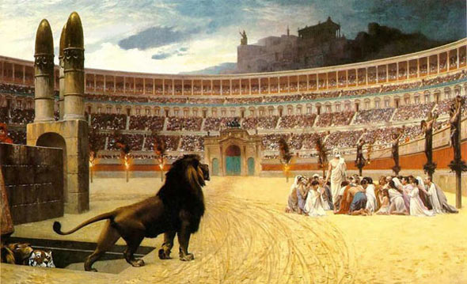

LESSON 3: The Jewish Legacy
Video: Christianity born of Judaism, Jesus was a Jew.
MP3: The Jewish Legacy: Messianic: expectation by a messiah. Process of anointmentl pour oil on top of head, on kings, kings seen as messiahs. Jesus, seen as messiah – saviour of the Jewish people. Jesus as a spiritual saviour, rather than a political saviour. Appocalicsism; both Jewish and Christian, 1, 2nd century, second return of Jesus in times of hardship. Philo of Alexandria p 28, promotes Judaism with Greek values. He was revered by Christian heads, happy for his insight.
MP3: War at the end of the war, stay loyal to the covenant. Suns of might, appocalicpit
Readings/listening for this leson:
1 | Listen to Dr. Turcescu's descriptive audio recording:  The Jewish Legacy (mp3, Length 05:53)  To download mp3 files, right-click on the file, select Save Target As, and in the Save As window select the drive or electronic storage device you wish to save your mp3 file in.  Vallée: Chapter 2: The Jewish Legacy , pages 23-41 (Read Terms of Use below)
2 | Listen to Dr. Turcescu's descriptive audio recording:  Dead Sea Scrolls Fragment (War Scroll) (mp3, Length 04:25)  Read excerpt from the Dead Sea Scrolls: The War Scroll (Translation source: Canadian Museum of Civilization, http://www.civilization.ca/civil/israel/isrel54e.html)

History of the Jewish People:
Judaism is the diverse tradition associated with the Jewish people
Jews – history experienced as a continuing dialogue with God
Below: Overview map of the ancient Near East (wiki)
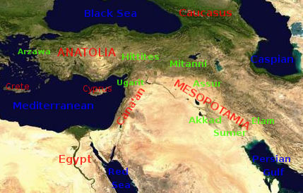
Meaning of “Israel”
  - The semi-nomadic tribes who answered God’s call to use the divine law
  - Those who answer the call and strive to obey the law through the Torah
Continued:
Jewish history starts with the stories recounted in the Hebrew Bible
(Tanakh in Hebrew, “Old Testament” for Christians)
Stories such as…
  - Creation of the world by a supreme deity or God
  - Patriarchs and Matriarchs
  - Moses, who spoke with God and led the people according to God’s commandments
  - Prophets who heard God’s warnings for sinners
- (Post-biblical evolving teachings and practices are collected in the Talmud – a great compendium of Jewish law and love)
Year 70 AD: Romans destroy the Jewish temple in Jerusalem and disperse the Jews throughout the world

Biblical Stories
Problem of Historicity: Scholars are uncertain about the historical accuracy of the early biblical stories because no other evidence exists about certain events and people genealogies mentioned in the Bible
Tradition Holds: Torah (Five Books of Moses) were revealed by God direclt to Moses, who wrote them down
Scholars Hold: Torah was an oral tradition reworked and redacted by later authors
(Continued)
Final form of Torah around 430 BCE: created by Ezra the Scribe and Priest and his editorial team
Intent of later authors: interpreting the formation of Israel from a religious point of view as the results of God’s actions in human history
Similarities of biblical stories with Mesopotamian legends: creation, the Garden of Eden, the great flood, the tower of Babel
Despite concerns about accuracy, biblical stories are religiously significant for both Christians and Muslims

From Creation to the God of Abraham
Genesis 1.1 – 2.4 “Priestly” source (God – referred to as Elohim) dates from after 586 BCE
  - Creation of heaven and earth by God in six “days”
  - Creation of material universe
  - Creation of man and woman in the divine “image”
  - Humans placed as masters of the earth
Genesis 2.4 – The “Yahwist” source (God – referred to as Yahweh) is thought to be an earlier account than Genesis 1.1 - 2.4
The Adam and Eve Story:
  - Theme of exile from paradise is present throughout Jewish history
  - Either punishment or straightening of the world through Jews
(Continued)
Noah’s story and the flood - (Ten generations after Noah):
  - The “patriarchs” (Abraham, Isaac, Jacob)
  - The “matriarchs” (their wives – Sarah, Rebecca, Leah and Rachel)
Abraham:
  - Born in Chaldean Citty of Ur, Mesopotamia, migrated to Haran, and then called by God to Canaan
  - Shows an example of obedience to God’s commandments through:
    - Circumcision – sign of the covenant with God
    - Ready to sacrifice his son Isaac (from Sarah) upon the request of God
  - Abraham’s son Ishmael and his mother (slave Hagar) are driven into the desert – Ishmael is an ancestor of the Arabs
  - Abraham is taught by God to be monotheistic
God was perceived as a ruler in relation to the people, like a parent to a child, or a sovereign to vassals, like a husband to a wife
Birth of Israel
  - Jacob, Isaac’s second son, receives the new name “Israel” after wrestling for a whole night with an angel of God
  - Israel – the one who struggled with God
  - Names are indicative of the person’s character
  - A new name means a new character, in this case of one reborn at a higher level of spirituality
  - Jacob is given the promise that many nations will be born from him
Egypt: Bondage and Exodus
The Twelve Tribes of Israel
Jacob/Israel had 12 sons and one daughter from his two wives
The 12 sons become heads of the twelve tribes of Israel
Biblical Stories:
  - Joseph and the Egyptian Pharaoh
  - Moses and the burning bush
  - Exit from Egypt: signs, plague, Passover, redemption from bondage, crossing of the Red Sea
  - God’s presence as a pillar of cloud/fire; then, Ark of the Covenant
  - The Ten Commandments
The First Temple of Jerusalem
1010 – 970 BCE: King David establishes Jerusalem as the capital
961 – 931 BCE: King Solomon builds a great Temple in Jerusalem
Burnt offerings of animals, grain and oil were made to God in the Temple
Solomon ended up an idol worshipper and womanizer
Division of Israel follows into the northern and southern kingdom (Israel and Judah)
722 BCE: Israel is conquered by Assyria – most Jews are sent into exile in Assyria
586 BCE: Judah is conquered by Babylonian King Nebuchadnezzar and the Temple is destroyed
The destruction of the Temple is interpreted as divine punishment for Israel’s infidelity towards God
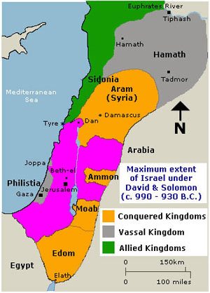
Return of Jerusalem:
530 BCE: King Cyprus of Persia allows the Jews to return to the land of Israel
515 BCE: The Temple is rebuilt
430 BCE: Ezra, a priest and scribe, coordinates the redaction of the Torah
Judaism becomes contaminated with foreign influences (Persian, Greek, Parthian, Roman)
175 – 164 BCE: Antiochus IV Epiphanes, a Hellenistic ruler of Syria, forces Greek ways upon the Jews
164 BCE: The Maccabean revolt rejects Antiochus IV’s rule and manages to re-establish a Jewish independent kingdom
63 BCE: Roman general Pompey conquers Israel

Jewish Groups around the Year 0
Video:
Sadducees:
  - Priests and wealthy businessmen
  - Conservatives who provide a literal interpretation to the Bible
  - Rejected oral law and traditions
  - Denial of an afterlife and coming of a messiah
Pharisees:
  - More liberal citizens of all classes
  - Studied the application of the Torah to everyday life
  - In 1st century BCE – civil war between Sadducees and Pharisees
Essences:
  - Monastic community disgusted with what they considered a corrupted priesthood
  - Apocalyptic group who wrote The Dead Sea Scrolls (discovered in 1947)
  - Some retreat to Qumran on the shore of the Dead Sea
Zealots:
  - Militias who in 66 CE revolted against the Romans
  - Roman general (later emperor) Vespasian and his son Titus suppressed the revolt and destroyed the Second Temple in the year 70 CE
Rabbinic Judaism:
Video: survived the destruction of temple in the. Rabbinic survived and Christians survived. Rabbinic Judaism, year 70, Jewish people centred around the temple, bring gifts to god, temple destroyed year 70. Where temple is located, important dome of the rock, Sinagoge replace the temple.
Destruction of the Temple by the Romans brought some revisions:
  - Synagogues replaces temples
  - Rabbis replaced priests
  - Prayers replaces sacrifices
Emphases on the Book and literacy (not for women, however)
Revelation was closer (with the completion of the Bible), but Interpretation (midrash) of the Bible has been encouraged in legal decisions (halakhah) non-legal teachings (haggadah) – folklore, historical knowledge, theological arguments, sermons and mystical teachings
Two messianic movements survived the destruction of the Temple:
  - Rabbis – inheritors of the Pharisee tradition; rabbis are teachers, religious decision – makers, creators of liturgical prayer
  - Jesus of Nazareth’s followers – Christianity
(Continued)
  - Interpretation led to the Mishnah (oral Torah) – completed in about 200 CE
  - Mishnah is divided into six sections: seeds, festivals, women, damages, holy things and purities
  - Subordination of women to men, but also directions for responsibilities
  - Mishna + rabbinic commentaries on it = The Talmud
  - The Jerusalem Talmud (completed c. 400 CE) emphasized continual study of the Torah as a spiritual practice
  - The Babylonian Talmud (completed c. 500 CE) the dominant version in theology and law
  - The Talmud continues to grow to this day
Perception of God
In early biblical narratives, God is perceived as a:
  - Burning bush
  - Pillar of cloud/fire
  - Smoking mountain
In the prophets, God is present through:
  - Visits by angelic messengers
  - Inner voices
Rabbinical Tradition:
  - God’s presence in the world is called Shekinah
  - Shekinah is a feminine quality representing God’s nurturing, motherly aspect
  - This is a non-anthropomorphic, transcendent presence
  - Sometimes Shekinah is depicted as a radiant, winged presence

