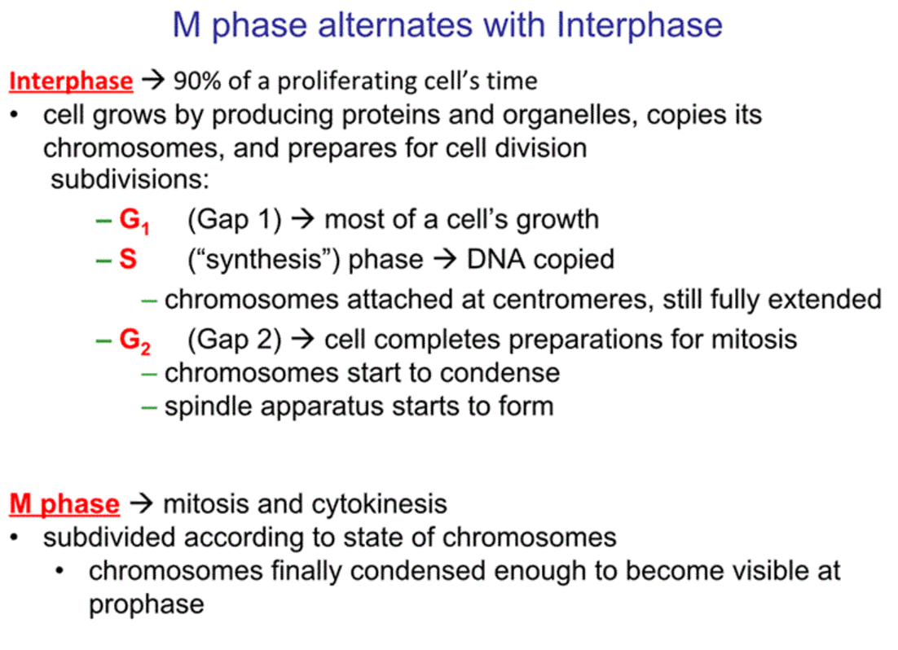
Two transient cytoskeletal structures are required for cell division in eukaryotes:
- Microtubules of the mitotic spindle
- Actin and myosin filaments of the contractile ring

Cytokinesis: Animal vs Plant Cells
- Involves ring of actin filaments just under plasma membrane in association with motor proteins (myosin)
- New wall must be constructed dividing plant cells

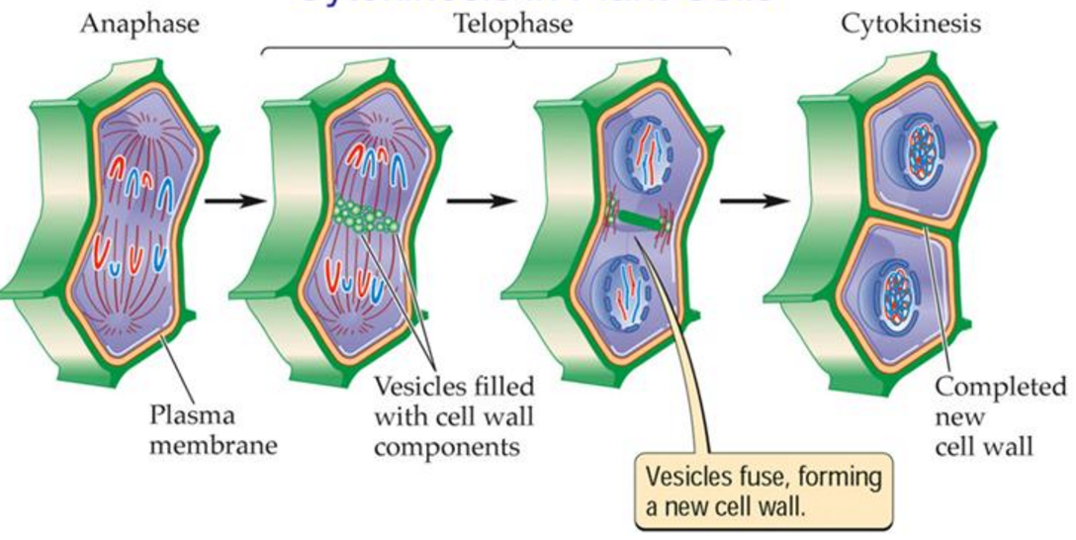

- Plants: microtubules and proteins define and organize the regions where new cell membrane and wall will form. Vesicles mostly form Golgi arrive, carrying polysaccharides and glycoproteins to lay down matrix for new cell wall. Later cellulose fibers are laid down to complete the wall.

Stages of Mitosis:

The first five stages of M phase—pro- phase, prometaphase, metaphase, anaphase, and telophase – constitute mitosis.


