BU275 Chapter 10
Decision Analysis
- Decision theory is important in decisions because it provides decision makers with a rational way of making a selection
  - It provides a logical framework for analyzing the situation and coming up with a selection
- Does not guarantee an “optimal” decision
- Characterized by at least some uncertainty, and very often, by a considerable amount of uncertainty
- Two important tools of analysis: payoff tables and decision trees
- Characterized by the following
  - A list of Alternatives
    - Set of mutually exclusive and collectively exhaustive decisions
  - A list of possible future states of nature
    - Refer to a set of possible future conditions, or events, beyond the control of the decision maker that will be the primary determinants of the eventual consequence of the decision
    - Mutually exclusive and collectively exhaustive
  - Payoffs associated with each alternative/state of nature combination
    - Idea of some payoffs that would be associated with each decision alternative and the various states of nature
    - Usually the measures are financial
    - Represent present values of future cash flows
  - An assessment of the degree of certainty of possible future events
    - Different degrees of certainty
    - One extreme is complete certainty and the other is complete uncertainty
    - Between these two extremes is risk, a term that implies that probabilities are known for the states of nature
  - A decision criterion
    - The process of selection one alternative from a list of alternatives is governed by a decision criteria
The Payoff Table
- Is a device a decision maker can use to summarize and organize information relevant to a particular decision
- General Format of a Payoff Table:
States of Nature
Alternative | S₁ | S₂ | S₃
A₁ | V₁₁ | V₁₂ | V₁₃
A₂ | V₂₁ | V₂₂ | V₂₃
A₃ | V₃₁ | V₃₂ | V₃₃
- A_{i} = the i^{th} alternative
- S_{j} = the j^{th} state of nature (event)
- V^{ij} = the value of payoff that will be realized if the alternative I is chosen and event j occurs
Decision Making Under Certainty
- Simplest of all circumstances occurs when decision making takes place in an environment of complete certainty
- When a decision is made under conditions of complete certainty, the attention of the decision maker is focused on the column in the payoff table that corresponds to the state of nature that will occur
Decision Making Under Complete Uncertainty
- Under complete uncertainty, the decision maker either is unable to estimate the probabilities for the occurrence of the different states of nature, or else he or she lacks confidence in available estimates of probabilities
- Consider five approaches to decision making under complete uncertainty
  - Maximin
    - Strategy is a conservative approach
    - Identifying the worst (minimum) payoff for each alternative and then selecting the alternative that has the best (maximum) of the worst payoffs
    - Setting a floor
    - Actual payoff cannot be less than this amount
    - Criterion as pessimistic
  - Maximax
    - The best payogg for each alternative is identified, and the alternative with the maximum of these is designated decision
    - Considered optimistic
  - Minimax regret
    - Ignores the possibility that an alternative with a slightly smaller payoff might offer a better overall choice
    - An approach that does take all payoffs into account is minimax regret
    - Necessary to develop an opportunity loss or regret table
    - The opportunity loss or regret reflects the difference between each payoff and the best possible payoff in a column
    - Determine the amount of payoff the decision maker would miss by not having chosen the alternative that would have yielded the best payoff of that state of nature (no center) occurs
    - The values in an opportunity loss table can be viewed as potential regrets that might be suffered as the result of choosing various alternatives
    - A decision maker could select an alternative in such a way as to minimize the maximum possible regret
    - This requires identifying the maximum opportunity loss in each row and then choosing the alternative that would yield the best (minimum) of those regrets
    - Opportunity loss or regret is represented by the following
      - r_{ij} = |V_{j}* - V_{ij}|
        - r_{ij} = the regret associated with the decision alternative a_{i} and state of nature s_{j}
        - V_{ij} = the value of payoff corresponding to the decision alternative a_{j} and the state of nature s_{j}
        - V_{j}* = value of payoff corresponding to the best alternative decisions for state of nature s_{j} (the highest value for a maximization problem or the smallest value for a minimization problem)
  - Hurwicz
    - Also referred to as weighted average or realism criterion, which offers the decision maker a compromise between the maximax and the maximum criteria
    - Specify a degree of optimism, in the form of a coefficient optimism, α
      - Possible values of α range from 0 to 1.00
      - If α is near 1.00 the more optimistic
      - If α is near 0, the more pessimistic
    - 1.00 would be equivalent to using the maximax criterion
    - 0 would be equivalent to using the maximin criterion
    - best payoff is multiplied by a α and the worst payoff is multiplied by 1 – α and the results are added
    - α(Best payoff) + (1 – α)(Worst payoff)
  - Equal Likelihood
    - Offers a method that incorporates more of the information
    - It treats the states of nature as if each were equally likely, and it focuses on the average payoff for each row, selection the alternative that has the highest row average
    - The basis for the equal likelihood criterion is that under complete uncertainty, the decision maker should not focus on either high or low payoffs, but should treat all payoffs (actually, all states of nature) as if they were equally likely
      - Averaging row payoffs accomplishes this
Method | Description of the Decision Making Criteria
Maximax | Choose the maximum of the largest payoffs from the payoff table (optimistic)
Maximin | Choose the maximum of the smallest payoffs from the payoff table (pessimistic)
Minimax regret | Choose the minimum of the maximum losses from the opportunity loss table (loss oriented)
Hurwicz | Weighted average approach where the largest payoff for an alternative is weighted with the coefficient of optimism (α) and the smallest payoff is weighted with 1 – α, and the largest weighted average is chosen
Equal Likelihood | Weighted average approach where each decision alternative is weighted equally and the largest average is chosen

Decision Making Under Risk
- The term risk is often used in conjunction with partial uncertainty
- The sum of the probabilities for all states of nature must be 1.00
- Expected Monetary Value (EMV)
  - Approach provides the decision maker with a value that represents the average payoff for each alternative
  - The average of expected payoff of each alternative is weighted average:
    - Expected monetary value for each alternative is:
      - EMV_{i} = Σ_{j=1}^{k} P_{j}V_{ij}
        - EMV_{i} = the expected monetary value for the i^{th} alternative
        - P_{j} = the probability of the j^{th} state of nature
        - V_{ij} = the estimated payoff for alternative I under state of nature j
  - Note that it does not necessarily follow that the developer will actually realize a payoff equal to the expected monetary value of a chosen alternative
  - Interpretation of the expected payoff
    - It is simply a long run average amount; the approximate average amount one could reasonably anticipate for a large number of identical situation
  - Expected value approach is more suited to an ongoing decision strategy
- Expected Opportunity Loss (EOL)
  - The approach is nearly identical to EMV approach, except that a table of opportunity losses is used rather than a table of payoffs
  - The alternative with the smallest expected loss is selected as the best choice
  - Always result in the same choice because they are equivalent ways of combining the values; maximizing the payoffs is equivalent to minimizing the opportunity losses
- Expected Value of Perfect Information
  - Sometimes be useful for a decision maker to determine the potential benefit of knowing for certain which state of nature is going to prevail
  - The expected value of perfect information (EVPI) is a measure of the difference between the certain payoff that could be realized under a condition of certainty and the expected payoff under a condition involving risk
  - Probabilities which are the original state of nature probabilities, can be used to weight the best payoffs, one of which will occur under certainty
    - This is called the expected payoff under certainty (EPC)
  - The difference between this figure and the expected payoff under risk is the expected value of perfect information
    - EVPI = EPC – EMV
    - The EVPI represents an upper bound on the amount of money that the real estate developer would be justified in spending to obtain perfect information
  - Note that the EVPI is exactly equal to the previously computed EOP
    - These two quantities will always be equal
    - The EOL indicates the expected opportunity loss due to imperfect information
  - There are two equivalent ways to determine the expected value of perfect information: subtract the EMV from the expected payoff under certainty or compute the EOL
  - EMV approach is particularly useful for decision making when a number of similar decisions must be made – it is a long run approach
  - For one shot decisions use the EMV approach may still be preferred

Decision Trees
- Obtain a visual portrayal of decision alternatives and their possible consequences
- Squares indicate decision points or decision nodes
- Circles represent chance events or chance nodes
- The lines or branches that emanate from a square represent alternatives
- The lines that emanate from a circle represent states of nature
- The dollar amounts alongside each chance node (circle) indicate the exact payoff of the alternative that leads into that particular chance node
- Not commonly used for problems that involve a single decision
- Benefit lies in portraying sequential decsions

Decision making with additional information
- Decision makers can sometimes improve decision making by bringing additional information into the process
- The benefit is that estimates of probabilities of possible future events tend to become more accurate
- In general, obtaining additional (sample) information includes an associated cost
- Whether the value of additional information is worth the cost of obtaining that information
- In sum, we can compute the expected value of sample (additional) information, or EVSI
  - EVSI = expected value with sample information – expected value without sample information
  - If the cost of obtaining the additional information is less than this amount, it would seem reasonable to spend the money to obtain the information
  - If cost equals or exceeds the expected value of information, it would seem reasonable not to spend the additional money
- Efficiency of Sample Information
  - One way to judge how much information is generated is by a sample is to compute the ratio of EVSI or EVPI – this is known as the efficiency of sample information
    - Efficiency of sample information n = EVSI/EVPI
  - To compute EPC, multiply the best payoff in each column by the column probability and sum the products
  - EVPI is the difference between ECP and EMV
  - The number can range from 0 to 1.00
  - 1.00 – closer the sample information is to being perfect
  - 0 – the less information there is in the sample
- Computing the Probabilities
  - Appling Bayesian analysis
  - A basic piece of information that is necessary to the procedure is the reliability of the source of sample information
  - Conditional probabilities – express the reliability of the sampling device given the condition of actual market type
  - To calculate the desired probabilities, we must combine these conditional probabilities with the original (prior) probabilities
  - Strong Market:
Actual Market | Prior Probabilities P(s_{j}) | Conditional Probabilities P(F/s_{j}) | Joint Probabilities P(F∩s_{j}) | Posterior Probabilities P(s_{j}/F)
Strong (s₁)  Weak (s₂) | .70 x .80 = .56  .30 x .10 = .03 |  |  | .56/.59 = .95  .03/.59 = .05
Marginal Probability showing a strong market = .59
  - Strong Market – Prior probabilities are the initial estimates of each type of market condition
  - Multiplying the prior probabilities by the conditional probabilities yields the joint probability of each market condition
  - The sum of these (e.g. .59) is the marginal probability that a test result will show a strong market
  - Probabilities for a market test that shows a weak market are computed in a similar way
  - The sum of the joint probabilities indicates the marginal probability of this test result
  - The ratios in the last column are the revised probabilities that is P(s₁/U)
  - J states of nature and K possible outcomes from research or a study for additional information
  - For each possible outcome O_{i}, i = 1, …., K,
    - 1) Compute the joint probability for each state of nature s_{j}, j = 1, … J as P(O_{i} ∩s_{j}) = P(O_{i}/s_{j}) x P(s_{j})
    - 2) Compute the marginal probability as P(O_{i}) = Σ ^{J} _{j=1}P(O_{i} ∩s_{j})
    - 3) Compute the revised probability for each state of nature s _{j} as P(s_{j}/O_{i}) = P(O_{i} ∩s_{j}) / P(O_{i})
    - Weak Market:
Actual Market | Prior Probabilities P(s_{j}) | Conditional Probabilities P(U/s_{j}) | Joint Probabilities P(O_{i} ∩s_{j}) | Posterior Probabilities P(s_{j}/U)
Strong (s₁)  Weak (s₂) | .70 x .20 = .14  .30 x .90 = .27 |  |  | .14/.41 = .34  .27/.41 = .66
Marginal Probability of showing a weak market = .41

Sensitivity Analysis
- Sensitivity of probability estimates is examined
- Sensitivity to payoff estimates is not covered
- Identify a range of probabilities over which a particular alternative would be optimal
- Consider an example that has two states of nature
- Because only two states of nature can occur, this permits us to use graphical analysis
- These ranges can easily be converted into ranges for state of nature #1, as you will see
- The line represents the expected value of alternative a for the entire range of P(#2)
- 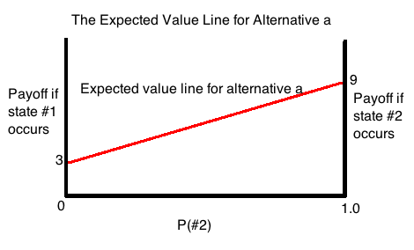
- 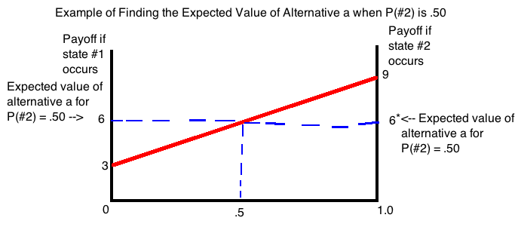
- 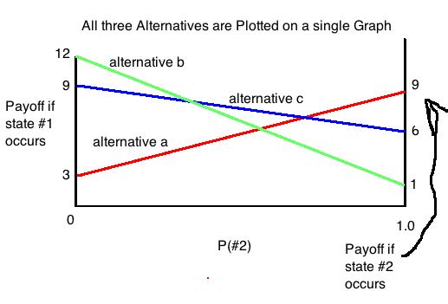
- Nearer P(#2) is to 0, the closer the expected value of alternative a will be to the payoff for state of nature #1
- The nearer P(#2) is to 1.0 the closer the expected value will be to the payoff for state of nature #2
- Highest line for any given value of P(#2) represents the optimal alternative for that probability
- Typically, the expected value (EV) is computed:
  - EV = P(#1) x Payoff #1 + P(#2) x Payoff #2
  - EV = (1 – P(#2)) x Payoff #1 + P(#2) x Payoff #2
  - EV = Payoff #1 + (Payoff #2 – Payoff #1)P(#2)
- These ranges give the decision maker important insight on probability estimates
- If payoff are costs or other values that are to be minimized rather than maximized – in such cases the lowest line for a given value of P(#2) would be most desirable
Utility
- Decision makers use multiple criteria, one of which is the potential satisfaction or dissatisfaction associated with possible payoffs
- Even though their chances of winning are close to zero, they have a greater utility for the potential winnings, despite a negative expected value, than for the amount of money they have to give up (pay) to participate in the lottery
- For purposes of wagering of in other forms of decision making, are sometimes referred to as risk takers
- Thus, even though buying insurance carries a negative monetary value, most individuals recognize the merit of doing so -- we refer to such individuals as risk averters
- If we replace the dollar payoffs with some measure of utility of that payoff, and then compute the expected utility, a somewhat different picture emerges
- Utility is a measure of the potential satisfaction derived from money
- Utility vary within an individual for different types of situations, but it also seems to vary among individuals for the same instructions

