Chapter 1:

Nutrition: the study of how food nourishes the body
Food: any substance the body can take in and assimilate; a source of nutrients
Diet: the food and beverages a person usually eats and drinks
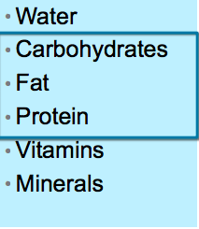
Nutrients = components of food that are indispensable to the body’s functioning.
- They provide energy
- Serve as building material
- Help maintain or repair body parts
- Support growth

Malnutrition: any condition caused by excess or deficient food energy or nutrient intake or by an imbalance of nutrients
- nutrient deficiencies
- nutrient imbalances
- nutrient excesses
A well-chosen array of foods will prevent malnutrition

A life-time of nourishment
- Foods consumed have a cumulative effect on your body.
- The effects become obvious with age.
- Diet has a significant impact upon long-term health prospects.

How Powerful is a Nutritious Diet in Preventing Diseases?
- Choice of diet profoundly influences long-term health prospects
- The only 2 things more influencing: alcohol & tobacco use
- Chronic diseases—heart disease, diabetes, some kinds of cancer, dental disease. Adult bone disease—all have a connection to poor diet

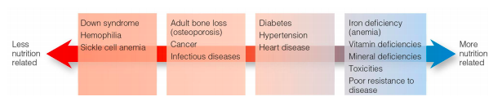
Nutrition & Disease
- Not all diseases are equally influenced by diet
- Some are purely genetic
- Some are more nutrient related like nutrient deficiencies
- Nutritional Genomics: the science of how nutrients affect the activities of genes and how genes affect the activities of nutrients
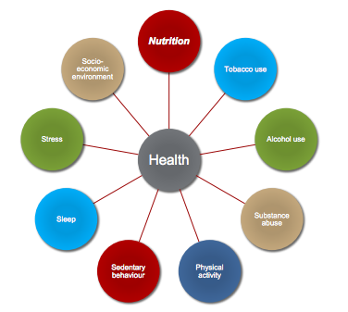
Our Lifestyle Choices:

- Besides food choices, lifestyle choices also affect people’s health
- Substance abuse can destroy someone’s health
- Improved lifestyle can help prevent or or reduce severity of chronic disease

Human Body Needs Food
- Energy: the capacity to do work
- Energy that fuels humans comes indirectly from the sun via plants
  - Sunplantsconsumed
  - Or: Sunplantsanimalconsumed
- Food energy is measured in calories

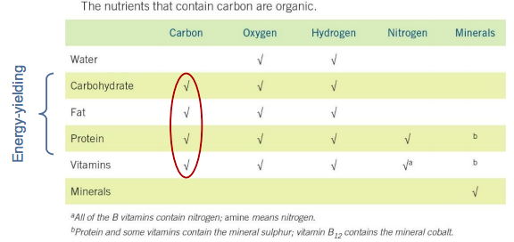
Six Classes of Nutrients

Nutrients in Food
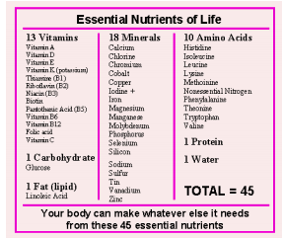
Essential nutrients:
- Nutrients that the body either cannot make, or cannot make fast enough, from other raw materials
- Nutrients that must be obtained from food
  - If not, deficiencies will occur
- Water—Must be replaced constantly
- A form of carbohydrate
- Some lipids
- Some parts of protein
- Vitamins & M—act as regulators
- Minerals & V—Assist in all body processes
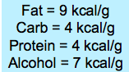
Food Energy
- Calories: units of energy
  - Kilocalorie = kcalorie = Calorie
  - Used to measure energy in food
  - Amount of heat energy needed to raise the temperature of 1 kilogram of water 1°C
- Gram: unit of mass
  - Foods and nutrient quantities are often measured in grams.

Dietary Supplements
Elemental diet: composed of purified ingredients of known chemical composition Intended to supply all essential nutrients to people who cannot eat foods (e.g., severely ill)
• These supplements are not superior to real food
• do not enable people to thrive over long periods
• do not support optimal growth and health
• can lead to medical complications
The intestine responds to food by releasing hormones that send messages to the brain.
• The eater then experiences a feeling of satisfaction.
• Eating offers physical and emotional comfort

Foods contain:
• Non-nutrients: compounds other than the six nutrients present in food that have biological activity in the body
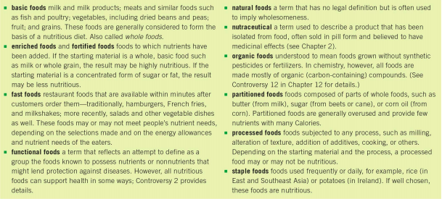
• Phytochemicals: non-nutrient compounds that confer colour, taste, and other characteristics on foods

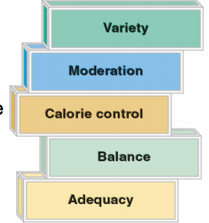
Ingredients of a Nutritious Diet
The A, B, C, M, V principles
• It is important to recognize that ALL five principles must be applied to obtain a nutritious diet
- Adequacy: the dietary characteristic of providing all of the essential nutrients, fibre, and energy in sufficient amounts to maintain health and body weight
- Balance: the dietary characteristic of providing foods of a number of different types in proportion to each other, such that foods rich in some nutrients do not replace foods that are rich in other nutrients
- Calorie control: control of energy intake
- Moderation: the dietary characteristic of providing constituents within set limits
  - Nothing in excess
- Variety: the dietary characteristic of providing a wide selection of foods

Excuses for Not Eating Well
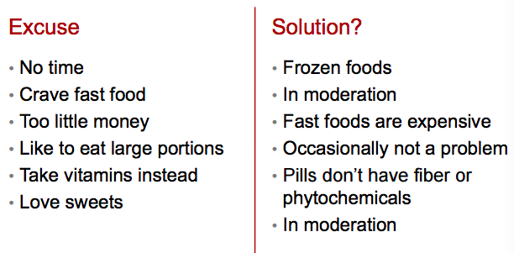

Why people choose foods
- Cultural and social meanings are attached to food.
- Traditional cuisines and foodways
  - Cuisines: styles of cooking
  - Foodways: sum of a culture’s habits, customs, beliefs, and preferences concerning food
- Ethnic foods: associated with a particular cultural subgroup within a population
Factors that drive food choices:
- Convenience: Food that takes little or no time to make
- Advertising: media persuaded you to eat these foods
- Availability: There are no other foods to choose from
- Economy: They are within your means
- Emotional comfort: They can make you feel better for a while
- Habit: Familiar; you always eat them
- Personal preference and genetics: You like the way they taste, determined from genes?
More factors that drive food choices:
• Positive associations: eaten by people you admire, indicate status, remind you of fun
• Region of the country: foods favoured in your area
• Social pressure: They are offered; you feel like you can’t refuse them
• Values or beliefs: fit your religious tradition
• Weight: you think they will control body weight
• Nutritional value: you think they are good for you

Nutritional Assessment
Individual assessment is a vital component of nutritional care.
• health and diet history
• anthropometric measurements
• laboratory test data
• Data is interpreted in accordance with current standards for individual’s age, gender, life stage, etc.
• Conducted by Registered Dietitians or other health-care professionals

Early Concepts of Nutrition
- Herodicus (5th century BC) Considered bad health to be the result of imbalance between diet and physical activity

The Science of Nutrition
• Nutrition is a relatively young science and includes:
• clinical nutrition
• community nutrition
• public health
• food policy
• food science

Sorting Out Nutrition Information
• Does the claim make sense?
• Where did the information come from?
• Was the info based on well-designed experiments?
• Were the results interpreted accurately?
• Who stands to benefit?
• Has it stood the test of time?
• Does it pose a risk?

Studying Nutrition
Nutrition monitoring makes it possible for researchers to assess the nutrient status, health indicators, and dietary intakes of the Canadian population.
Scientific Challenge
• One experiment does not “prove” or “disprove” anything.
• A finding that has stood up to repeated rigorous testing may become a theory.
• Theories can always be challenged or revised

Can I Trust the Media to Deliver Nutrition News?
- News media often report ideas before they have been fully tested.
- Reporters, who may lack a science background, may misunderstand complex scientific principles.
- Sometimes scientists report their findings before they are subject to serious scrutiny

Dietary Guidelines and Nutrition Objectives
• Health Canada publishes Eating Well with Canada’s Food Guide.

Enjoy a variety of foods form the four food groups every day
- Satisfy your thirst with water
- Limit foods and beverages high in
  - Calories
  - Fat
  - Sugar (including that found in sweetened hot and cold drinks)
  - Sodium (salt)
  - Alcohol
- Include a small amount of oils and fat such as unsaturated fat each day.
- Read and compare food labels to make wise food choices.

How Can I Get Enough Nutrients Without Consuming Too Many Calories?
Nutrient density is a measure of nutrients provided per calorie of food that can help
distinguish between more and less nutritious foods.
• Foods that offer the most nutrients per calorie are vegetables, especially non-starchy vegetables.
• These foods are rich in phytochemicals and are inexpensive but take time to prepare.

Looking for Nutrient-Dense Convenience Food
- Today most households do not have time for food preparation.
- Busy people should look for convenience foods that are nutrient-dense, such as:
  - bags of ready-to-serve salads
  - refrigerated prepared meats
  - frozen vegetables
  - skim milk
Sorting the Imposters from the Real Nutrition Experts
• Dietitians of Canada
• Health Canada
• Canadian Nutrient File
• Heart and Stroke Foundations of Canada
• Canadian Council of Food and Nutrition

