Lecture 2
- Public Management (PM) has been described as an Art, a Science, and a Profession
- PM has also been defined as a Structure, a Craft, and an Institution
- A set of administrative practices and institutional arrangements constitutional mandated to execute the legitimate orders of government
- The function of politics was to express the state’s will and the function of administration was to execute the state’s will
- A bureaucracy is a way of administratively organizing large numbers of people who need to work together.
  - Personnel: bureaucracy is staffed by unelected public servants who wield a lot of power and discretion
  - Formal Rules: red Tape, formal rules, regulations and processes aimed at ensuring that citizens are treated fairly, equitably and in an accountable manner
  - Policy Instruments: Tools to enforce and implement policies and programs like laws, regulations, Crown Corporations etc
  - Conventions of Behaviour: internal (in)formal rules, hierarchies of power, divisions of labour, norms etc
  - Institutions: complex government Ministries, Departments, Crown Corporations, Central Agencies etc
  - Values/Ethics: Equity/fairness, accountability/transparency, public interest, social justice, professionalism, merit
- Public and Private sector becoming closer and closer, personal from both iteract with each other constantly and share ideas
- Private sectors goal is profit, Public is about the provision of public goods/services
- Because of the immense discretional power and resources at their disposal, public servants are held to a very high standard of ethical behaviour
Minimalist State
- A laissez-faire attitude
- A reduced and withdrawn state that sees little or no room and place for the government in the provision of public services such as critical welfare and social services like healthcare, Medicare, unemployment benefits
- Small enough to be irrelevant except on issues of national security, defense, peace and diplomacy
- Services are to be provided by the family, church or the market
Keynesian Welfare State
- An activist, interventionist, and involved state
- “In bad economic times the government could prime the pump of economic growth by investing and spending”. Therefore spending on public infrastructure and welfare services is justified
- Advocates a more involved and engaged public sector to provide critical social safety nets for citizens
Neo-Conservative State
- “Government is not the solution, government is the problem”
- Disapproving government by implying it is inept, corrupt, bloated and inefficient
- Public servants now came to be viewed as a problem and confidence and morale in the public service has plummeted
- Role of religious and charitable organizations and family re-emerged to fill the vacuum created by the withdrawn state

Lecture 3
Organizational Theory
- How to improve the operations, management and performance
- The need to understand what people do, how things are done, and why we have organizations” both in public and private sectors
Classical Theory
- Seek what effect the development of large-scale organizations will have or has on the power structure of society
Karl Marx
- Bureaucracy and public policies are a reflection of the interest of the capitalist class. It is an instrument in the hands of capitalists to be used for the purposes of maintaining the capitalist system and the interest of the bourgeoisies and serves the interest of capital, not ordinary citizens
- Capitalist society is marked by class conflict in which the capitalist oppresses and exploits the working class in the pursuit of profits
- Government is focused on its own survival and the career building and advancement activities of its own employees
- Bureaucracy is nothing more than a special interest that hides behind a more dignified picture of a faithful servant of the general will
- Finally, “class struggle will result in revolution, leading to a classless society in which the state (bureaucracy) will gradually wither away”, and the revolution has not yet occurred
Max Weber – Ideal Type
- Bureaucracy was essentially a “system of administration carried out on a continuous basis by trained professionals according to prescribed rules”
- Bureaucracy as a “rational, systematic, logical, and scientific approach to organization”
- Constructed Ideal Type Bureaucracy:
- Hierarchy: people have clearly defined roles based on division of labour and is answerable to a superior
- Continuity: people have full-time salaries and tenure occupations and career structures for life
- Impersonality: work is based on prescribed rules and written records, not on the whims and caprices of individuals
- Expertise: personnel, selected based on the basis of merit, are trained and control access to knowledge and stored files.
- Political Neutrality: people should serve any government that is in power at any particular time.
Criticism
- It is an ideal type and may not work as planned in the real world
- May lead to systemic discrimination against people who due to circumstances beyond their control do not have access to participate in the system
- Regulation, control and intervention grows the government and hinders ‘the risk taking initiative and entrepreneurial spirit of capitalism’
- Assumes a view of human nature as constantly striving for power and self-gain and in need of discipline and control
Max Weber – 3 Types of Authority
- Traditional Authority. e.g. The Monarchy
  - Legitimated by the sanctity of tradition
  - The ability and right to rule is passed down
  - Does not change overtime, tends to be irrational and inconsistent
- Charismatic Authority: e.g. Jesus Christ, Martin Luther King
- found in a leader whose charisma, mission, and vision inspire others and is based upon the perceived extraordinary characteristics of an individual
- Such individuals possess a magnetism that binds who they are to what they say and when they say it
- Not institutionalised, is very tenuous, and usually dies with the individual.
- Legal-Rational Authority: e.g. Modern Leaders
- Is empowered by a formalistic belief in the content of the law (legal) or natural law (rationality)
- Respect and obedience is to the institution/office, not the individual
Today’s Problems
- Todays political scene becoming over crowded
- New actors include: lobbyists, interest and advocacy groups, think tanks, research institutes, policy consultants and the media
- Public Servants no longer control their work environment to anything like the extent they did 25 years ago
- Traditional world is collapsing because on policy matters, politicians no longer want neutral advice
- Modern politicians come to office with a policy agenda or at least a policy bias and look to career officials to embrace the bias and make it work
- Public servants know that if they are not willing to offer the required responsive policy advice, politicians can now turn to many other sources to secure it
Lecture 4
Structuralist Theories
- Views workers in administrative and bureaucratic organizations as little more than interchangeable parts – cogs in a machine to be lubricated by money and to maximise organizational efficiency
- Little or no regard is given to the needs, aspirations and desires of the workers
- Relies on a particular view of human nature that suggest that: people are only motivated by material and financial gain and that workers require strict regime of rules and regulations, determined and clearly spelled out by management in order to function at maximum efficiency
Scientific Management
- A school of thought emerged in the 1800s in response to increasing industrialization and technological change in the work place, fathered by Fredrick Winslow Taylor
- Created by timing shortest time possible to do a job and this was what was used to analyze performance. Called time and motion Studies. Later called One Best Way model as there was only one way a worker should do a certain task. A division of labour should be present as well
Criticism of Scientific Mangement
- fails to see the worker as a member of and influenced by the broader society and social group
- Personal feeling, initiative, drive, and independent action ignored and or marginalised the physiological and sociological needs and lost elements of a team
Humanist Theories
- Argues that maximising efficiency in any organization requires paying equal attention to workers as individuals with identifiable needs beyond material rewards
- Primary role of management to be sensitive to those needs of workers in order to maximise efficiency
- Uses less intrusive techniques such as questionnaires, surveys, and work place observations
- Hawthorne Experiment: Illumination was tested to see if it affected productivity. It was found that working conditions were not the reason for higher productivity but the concern that others had for the woring conditions. People cared so the workers cared enough to put in the extra effort
- “the most powerful motivators on the job were the social norms and values of the group and the ability of supervisors to act as leaders in modifying those norms and values”
- Maslow”s basic needs for satisfaction are:
- The Physiological Needs: food, water, sleep;
- The Safety Needs: accommodation, health, war/violence, crime, natural hazards;
- The Love Needs: Love, sex, affection, belonginess; and,
- The Esteem Needs: ‘What a man can be, he needs to be’, self-actualization, purposeful.
Human Side of Enterprise – Theory X
Three Propositions:
- Management is responsible for organising the elements of productive enterprise --- money, materials, equipment, people --- in the interest of economic ends;
- With respect to people this is a process of directing their efforts, motivating them, controlling their actions, modifying their behaviour to fit the needs of the organization;
- Without these active intervention by management, people would be passive – even resistant – to organizational needs
Beliefs behind Theory X: The average man works for as little as possible, prefers to be led, indifferent to organizational needs, resistant to change, not very bright

Lecture 5
- It is important to remember that Canada is a Capitalist country, and Federalism is in effect
- Federal Government can however use its spending power even in provincial jurisdiction
- Cabinet-Parliament Government (Westminster)
  - Executive Branch consists of The Monarch, The Governor General, and Cabinet (PM and his Ministers)
  - Legislative Branch is made up of the elected House of Commons and the appointed Senate
  - Judicial Branch consists of the Supreme Court and all the courts and judges below it in the Federal and Provincial court system
- Myth because Monarch has little to no power
- The Privy Council Office (PCO) consists of all current and former ministers of the crown
  - Brings together quality, objective and non-partisan policy advice and information to support the Prime Minister and Cabinet
  - As Secretary to the Cabinet, the PCO facilitates the smooth, efficient and effective functioning of Cabinet and the Government of Canada on a day-to-day basis
  - Ensuring that Canada and Canadians are served by a quality public service
- Departments are statutory bodies and created by a law passed by parliament. The Head of each department is the Minister, appointed by the Prime Minister
- The Public Service Commission of Canada (PSC) is an independent agency responsible for safeguarding the values of a Professional Public Service
  - seeks to ensure that the public service reflects and respects our diverse society
  - accommodate the needs of persons through all stages of the appointment process to address, undue hardship, disadvantages arising from prohibited grounds of discrimination
- Vertical Constituency Departments:
- They exist to provide services directly to the whole population (Health, Education) or a segment of the population (Indian Affairs and Northern Development)
- They are vertical because they provide a direct link between citizens and the government
2. Horizontal Administrative Coordinative Type:
- They exists to provide services to other departments and have little or no direct contact with citizens.
- E.g. The Department of Public Works and Government Services
- Horizontal Policy Coordinating Type:
- Their responsibilities include developing a broader policy framework within which other government functions are carried out.
- E.g The Ministry of Finance
Central Agencies
- Central Agencies are responsible for coordinating line departments in the Canadian system
- They exists to support the decision-making abilities of cabinet with information and advice and by communicating cabinet decisions to other parts of governmen
- They ensure there is consistency across departments and that departments spending activities fits the governments revenue-raising capacity
- The Finance Department - most powerful actor in the Federal Government. Develops policies and provides advice to the Government with the goal of creating a healthy economy for all Canadians
- Treasury Board Secretariat (TBS) - tasked with providing advice and support to Treasury Board ministers in their role of ensuring value-for-money provides oversight of the financial management functions in departments and agencies
- Privy Council Office (PCO) - provides essential advice and support to the Prime Minister and Cabinet. PCO has three main roles: Advisor to the Prime Minister, Secretary to the Cabinet, and Public Service Leadership
- Prime Minister’s Office (PMO) - staffed by partisan supporters and appointees of the Prime Minister and a Chief of Staff that drafts the annual Speech from the Throne, which spells out the government’s agenda for the coming year
- The Minister is responsible for all the official acts of the department and public servants under his supervision by the order of the Ministerial Responsibility doctrine
- Collective Ministerial Responsibility is the convention whereby Ministers must always show support and solidarity with their colleagues in Cabinet

- Regulatory Agencies are used to ensure compliance and respect for government directives, laws and policies. They have influence over:
- Private sector behaviours through prices, condition and quality of services (restaurants, bars)
- Contents or goods for sale (alcohol, tobacco)
- Methods of production (environmental pollution)
- Crown Corporations are 100% owned by the government. Function in most cases like private firms but exists under conditions of greater accountability to government than private firms. Their features include:
- legal entities engaged in the sale of goods/services to citizens or businesses
- varying degrees of operational autonomy from government
- serve some public policy goal or more generally, ‘the public interest’
- usually have a commercial orientation, legal or regulatory privileges unavailable to private sector actors
- venture into areas where the private sector might be unable or unwilling to venture due to high transactional costs of lower profit motivations
- Operate and exist based on Efficiency, Political, and Ethical Reasons such as Nation Building, To Present Natural Monopolies, Regional Economic Development, and Continentalism (Prevention of U.S Domination)
- Left view CC’s as a way to protect social safety, Right views them as unnecessary, burden to the state and should be privatized
- Right calling for dismantling as of late due to being costly, unresponsive and unaccountable

Lecture 6
New Public Management (NPM)
- Political-right are advocates who argue that the NPM was the antidote to the dysfunction and bureaucratic pathologies of the welfare state
- Left-wing opponents who stress that the NPM is a slippery road to dismantling a century’s work of building a distinctive public service culture and ethic
- NPM emerged to ‘shrink the size of the state’ to reduce the role and impact of bureaucrats in the policymaking and implementation process
- Also to maximise the benefits of Globalization. Refered to as the ‘Internationalization of Public Administration’
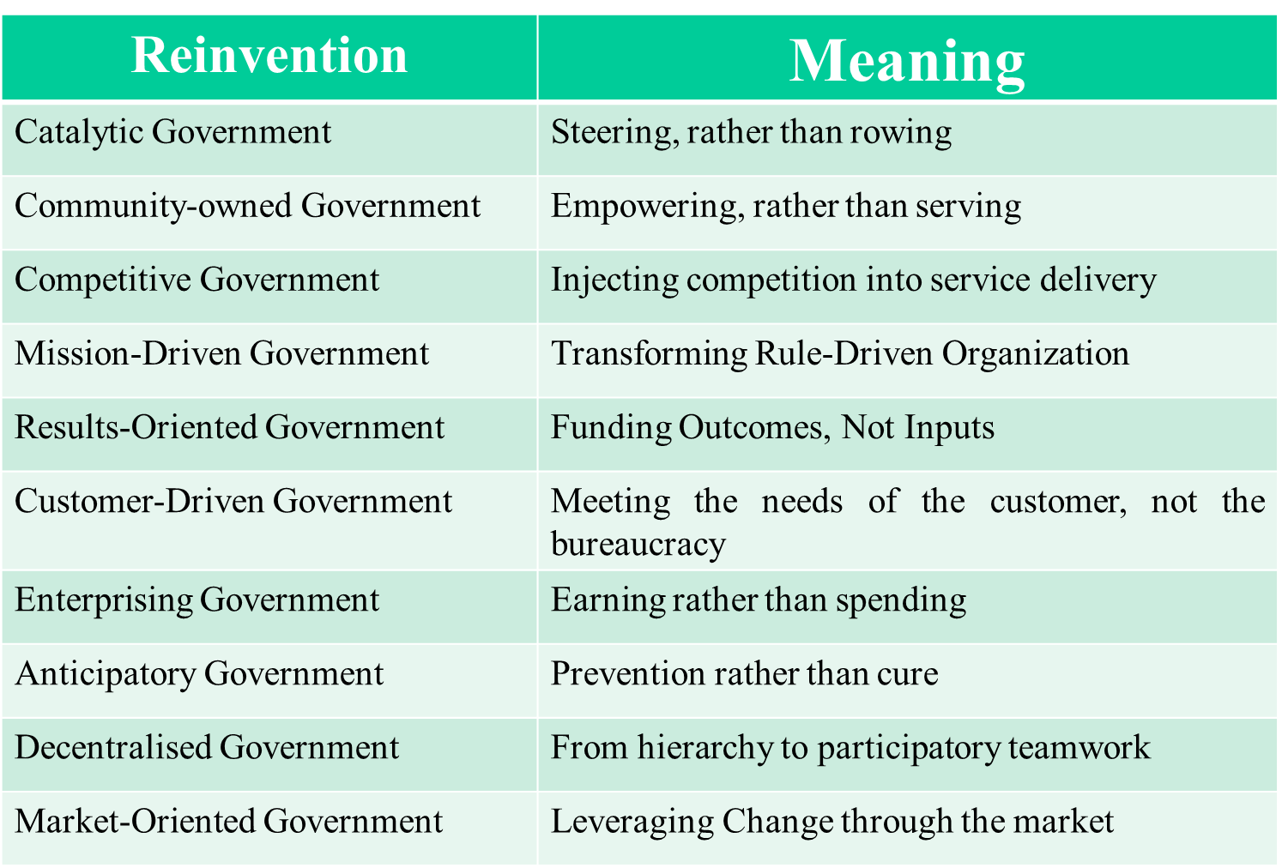
Components of this reinvention of PM:
- Generic Managerialism is an attempt to distil the principles of management that have evolved in the private sector and transplant these principles into a public sector context
- Government Failure, Privatisation, Market Failure, Nationalization all concerns
- NPM is in theory the restructuring of government, and this has happened to some degree in over the past 20 years and especially in certain provinces
- There has been a Decentralization of Public Service Delivery to the provinces and in turn gave more responsibilities to the municipalities
- Private sector management approaches were introduced in Canada, using concepts such as downsizing, re-engineering, corporate culture, and value for money
- Incentives and performance measurement efforts used, new internal markets where departments sold services to each other
- NPM recommends privatization of Crown Corporations, budgetary and programme cut-backs, withdrawal from programmes, tax reductions, and privatization of a number of government services including
- Cut back programme spending and transfers to other governments and individuals, reducing overall spending, and reducing the size of public services, and deregulation
- It can be said that Canada has more adapted, not just adopted the NPM

Lecture 7
Forces Driving the NPM
- Large and expensive public sectors were created during earlier periods of strong economic growth
- The citizens/client is demanding quality and service from both public and private sector producers, and comparing the performance of all organizations
- Employees are looking for work in either the public or private sectors that provides opportunities for personal growth and fulfillment, rather than just a pay cheque
- ICT’s have given the public sector a major opportunity to increase efficiency

- NPM is not slavishly following private sector ideas nor failing to recognize the differences between the public and private sectors
- it acknowledges that both the public and private sectors are confronting similar forces
- it is receptive to learning about how the private sector has responded
- where appropriate, adapting private sector learning to the public sector

NPM Accountability
- Emphasizing clear objectives and written performance contracts
- argues that the two enemies of accountability are unclear objectives and anonymity
- Performance management/measurement and performance pay/bonuses are all NPM means of encouraging high performance while increasing accountability
NPM Skepticism
- The NPM has reshaped government operations and dismiss long-established traditions simply because it suits the moment or the occasion
- The NPM has little appreciation of the fact that politics and politicians do matter in government and government operations
- The rules, regulations, supervisory roles and monitoring of public administration are meant to make the process work the way it is supposed to
- Problems with bureaucracy has more to do with parliament, politicians and Canadians themselves than with public servants
- In the public sector, there is no try and error. You can have a lot of successes, but there is an extremely low tolerance for mistakes
- The principle of Ministerial Responsibility makes the minister “blamable” for both policy and administration
- The NPM belittles the noble side of the public service profession and reduces morale in the public sector
- “Government should not be run like a business; it should be run like a democracy”
- Public servants should serve citizens, not customers
- accountability isn’t simple, hence the need to serve, rather then steer
- NPM narrowly focuses on Economy, Efficiency and Effectiveness, But it ignores Accountability, transparency, rule of law, equity/fairness
- Makes messy politics in the policy making process, while emphasising results and outputs

Lecture 8
Canadian Law
- To be effective, Laws must be: Knowable: citizens must be aware of the law, and behaviour they are expected to uphold. Also, Predictable: the law can’t be arbitrary and capricious in its application
- One of the main pillars or sources of Law in Canada is the Common Law tradition, also known as English Common Law. It is a system of Law whereby judges:
- Dispense justice based on past customs, and;
- On the precedents built up over the years in prior legal findings
- it is unfair to treat similar facts differently on different occasions
- In cases where the parties to a case disagree on what the law is, a common law court looks to past precedential decisions of relevant courts. If a similar dispute has been resolved in the past, the court is bound to follow the reasoning used in the prior decision.
- In Quebec, the legal system is based on the Civil Law Principle. Judges in Civil Law cases are not constrained by precedence, its core principles are codified into a referable system which serves as the primary source of law
- Administrative Law is focused more on the relations between citizens and the administrative arm of government.
- It is more concerned with the day-to-day legalities of how administration takes place and seeks to outline the legal basis of such actions
- Since there can be no specific law that can foresee and cover every circumstance that might arise on a day-to-day level, most public servants fall on discretion. There is concerns that administrative law may lead to arbitrariness and inconsistencies though

