Chapter 12: Purchase and Payables
Learning Objectives
LO1 Describe the purchases, payables, and payments process, including typical risks, transactions, account balances, source documents, and controls.
LO2 Describe the auditor’s control risk assessment and control tests for auditing control over the purchase of inventory, services, and fixed assets, and for the disbursement of cash.
LO3 Describe the typical substantive procedures used to respond to the assessed risk of material misstatement in the main account balance and transactions in the purchases, payables, and payments process.
LO4 Explain the importance of the completeness assertion for auditing the accounts payable liabilities, and the procedures used to search for unrecorded liabilities.
LO5 Identify audit considerations for observing the physical inventory count.
LO6 Explain the main auditing procedures used for property, plant, and equipment and intangible assets

Understanding the Purchases, Payables and Payments Process pg.489
Purchases of goods and services are a major part of cash outflow in most organizations because of this they will be subjected to a High level of management planning and control

Risk Assessment for Purchases Payables and Payments
To assess risks in the purchasing-related processes, the auditor considers purchasing and cash payment transactions and accounts payable.
- Understanding of business will point auditors towards specific risks and the related f/s misstatement risks that can arise.
Existence risks could involve inventory being overstated due to double counting or other errors in the year-end physical inventory count. Purchased assets may include improper capitalization of costs to increase reported profits. Improper cutoff can lead to overstating inventory on hand at period-end if shipments received after period-end are included.
Ownership risks can include inventory held on consignment being recorded as the company's own inventory, in error. In an owner-managed business, some personal expenses of the owner may be run through the company to avoid income taxes.
Valuation risks can exist when purchases are denominated in foreign currency; if inventory or property values decline because of market conditions, obsolescence, or improper storage; or if intangible assets are improperly valued. Frauds relating to purchases and payables can arise from collusion between suppliers and employees to overstate purchase transactions payments, for example, via kickback schemes.
Completeness risks relate mainly to the possibility of unrecorded liabilities. Goods or services received but not yet paid for at year-end may not have been accrued. Provisions for future costs, such as warranties, may be missing or understated. Improper cutoff can also lead to incomplete recording of liabilities if purchased goods that are still in transit are not accounted for at period-end.
Presentation and disclosure risks include not properly presenting separate categories of inventory, PPE, or intangible assets; inadequate capitalization policy notes; and failure to disclose contractual commitments to make future purchases at fixed prices.

Purchases, Payments, and Payables Process: Typical Activities
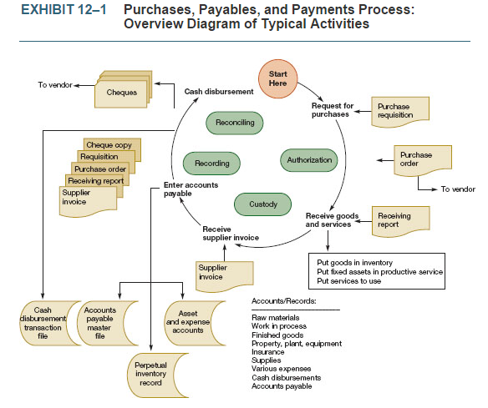
Exhibit 12-1 shows the activities and transactions, accounts and records in the purchases, payables, and payments processes.
  - The basic activities are:
- Requesting purchases of goods and services
- Receiving them
- Recording costs and liabilities
- Paying the bills

Authorization
Purchases are made by purchasing departments or authorized purchasers.
  - Purchasing controls such as competitive bids should be in place as this will produce the best prices and it reduce the risk of frauds involving collusion between suppliers and purchasing department employees.
Cash Disbursements are authorized by an accounts payable department.
  - Purchase orders, receiving reports invoices and invoices are matched prior to payment.
  - Cheques are signed by authorized personnel.
  - Invoices should be marked “Paid” or stamped to show that they have been processed to make sure they will not be paid a second time.

Custody
- A receiving department receives goods purchased and forwards them to the proper departments. Prior to passing on to the proper department the receiving department is responsible to inspect received goods for quantity and quality.
- Custody of cash is the responsibility of personnel assigned to authorize and sign cheques.
- Blank documents—such as purchase orders, receiving reports, and blank cheques—or access to a computerized purchase authorization program, are also custody issues. If unauthorized persons can access these or has authorization involving them, they can forge a purchase order to a fictitious supplier, forge a receiving report, send a false invoice from a fictitious supplier, and then prepare a company cheque in payment, which is embezzlement.

Recording
- Purchases should be recorded once the purchase order, receiving report, and vendor invoice are matched.
- Disbursements are recorded when the cheques are prepared.

Periodic Reconciliation
Periodic comparison of existing assets to recorded amounts in various accounts occurs in several ways. It occurs when
(1) A physical inventory count compares inventory on hand with perpetual inventory records
(2) A bank account reconciliation compares book cash balances with bank cash balances
(3) An inspection compares fixed assets with detail fixed asset records
(4) Preparation of an accounts payable trial balance compares the detail of accounts payable with the control account in the general ledger
(5) Accounts payable personnel compare suppliers' reports and monthly statements with recorded liabilities.

Audit Evidence in Management Reports
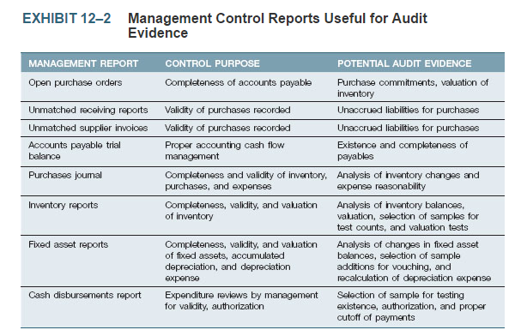

Open Purchase Orders
Held in an open purchase order file, purchase orders are open from the time they are issued until the goods and services are received. Generally, no liability exists until the transactions are complete. However, auditors may find evidence of losses on purchase commitments in this file if market prices have fallen below the purchase order price.
Unmatched Receiving Reports
Normally, liabilities should be recorded on the date the goods and services are received and accepted. Sometimes, however, supplier invoices arrive later and the accounts payable department holds the receiving reports, unmatched with invoices, until the information for recording an accounting entry arrives. Auditors can inspect the unmatched receiving report file to see if the company has material unrecorded liabilities on the financial statement date. The matching control procedures ensure purchases are valid as they verify the purchases are real and approved prior to processing the payment.
Unmatched Supplier Invoices
Supplier invoices may arrive in the accounts payable department before the receiving processing is complete. These invoices are held, unmatched with receiving reports, until there is information that the goods and services were actually received and accepted. Systems failures and human coding errors can cause unmatched invoices and receiving reports to sit around unnoticed when all the information is actually at hand. Auditors can inspect the unmatched invoice file and compare it with the unmatched receiving report file to determine whether liabilities are unrecorded.
Accounts Payable Trial Balance
This trial balance is a list of payable amounts by supplier, and the sum should agree with the accounts payable control account in the general ledger. (Some organizations record by individual invoices instead of by supplier names, so the trial balance is a list of unpaid invoices, which still should agree with the control account balance. This type of system is sometimes called an “open invoice system.”) The ideal trial balance for audit purposes contains the names of all of an organization's suppliers, even if their balances are zero. The audit “search for unrecorded liabilities” should include the small and zero balances, especially for regular suppliers, because these may be the places where liabilities are unrecorded. Major suppliers will send regular statements of amounts outstanding. These statement amounts can be reconciled with accounts payable, and the details can be audited to detect any unrecorded liabilities.
All paid and unpaid accounts payable should have supporting documents—purchase requisition (if any), purchase order (if any), supplier invoice, receiving report (if any), and cheque copy (or notation of cheque number, date, and amount),
Purchases Journal
This listing of all purchases may exist only in a computer transaction file, not in print. In either event, it provides raw data for (1) computer-audit analysis of purchasing patterns, which may exhibit characteristics of errors or fraud, and (2) a sample selection of transactions for control tests of supporting documents for validity, authorization, accuracy, classification, accounting, and proper period recording. (A company may have already performed analyses of purchases, and auditors can use these for analytical evidence, provided the analyses are produced under reliable control conditions.)
Inventory Reports (Trial Balance)
A wide variety of inventory reports are useful for analytical evidence. An item-by-item trial balance should agree with a control account (if balances are kept in dollars). Auditors can use this trial balance
(1) To scan for unusual conditions (e.g., negative item balances, overstocking, and valuation problems)
(2) As a population for sample selection for a physical inventory observation (audit procedures to obtain evidence about the existence of inventory included in the account). The scanning and sample selection may be computer-audit applications on a computerized inventory report file.
Fixed Asset Reports
These reports are similar to inventory reports because they show the details of fixed assets in control accounts, and they can be used for scanning and sample selection as well. A sample selection of fixed assets acquired can be verified against costs shown on purchase invoices. The information for depreciation calculation (cost, useful life, method, and salvage) can be audited by sampling, or a computer application could perform recalculations.
Cash Disbursements Report
The cash disbursements process produces a cash disbursements journal—sometimes printed, sometimes maintained only as a computer file. This journal should contain the date, cheque number, payee, amount, account debited for each cash disbursement, and a cross-reference to the supplier invoice number or other reason for the payment. A sample can be selected from the population of transactions in the cash disbursements journal for control tests of supporting documents for validity, authorization, accuracy, classification, accounting, and proper period recording of payments.

Control Risk Assessment
Control risk assessment governs the nature, timing, and extent of substantive audit procedures that will be applied in the audit of account balances in the purchases, payables, and payment process.
  - Accounts included in acquisition and expenditure:
    - Inventory,
    - capital assets,
    - amortization expense,
    - accumulated amortization,
    - accounts and notes payable,
    - cash, and
    - Expense categories (administrative, selling, and manufacturing).

General Control Considerations
Ensure proper segregation of responsibilities for authorization, custody, recording, and reconciliation.
- Persons who have custody of assets and cash disbursements authority should not do accounting.
Controls should provide evidence for detail control checking activities.
- Signatures, initials, physical security, policies and procedures.
Internal controls should provide for detail-checking control procedures.
(1) All purchase requisitions and purchase orders are approved by authorized personnel
(2) Purchase order master files changes are made by authorized persons only
(3) Physical security for inventory warehouses and fixed asset locations (storerooms, fences, locks, etc.) is adequate
(4) Accounts payable are recorded only when all the supporting documentation is in order (purchases and payables as of the date goods and services were received and cash disbursements on the date the cheques leave the organization's control)
(5) Supplier invoices are compared with purchase orders and receiving reports to verify the price and that the quantity billed is the same as the quantity received.

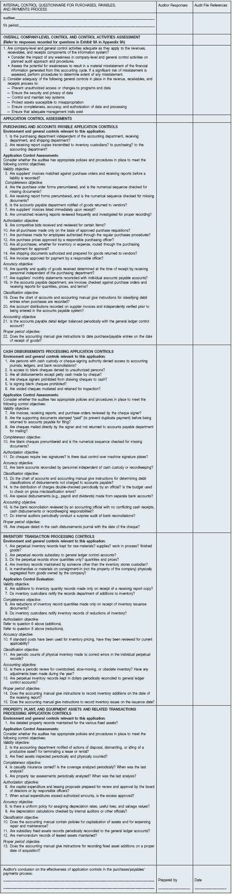

Control Tests
An organization should have detail control procedures in place and operating to prevent or detect and correct accounting errors. You studied the general control objectives in Chapter 9 (validity, completeness, authorization, accuracy, classification, accounting, and proper period recording). Exhibit 12–3 demonstrates these in a purchasing activity situation, with examples related to specific purchasing objectives. Study this exhibit carefully.
Control tests consists of
(1) Identification of the data population from which a samples of items will be selected for audit and
(2) Expression of the action that will produce relevant evidence.
The actions involve vouching, tracing, observing, scanning, and recalculating—procedures for obtaining evidence used in a final control risk assessment. If control procedures are not well performed, auditors need to design substantive audit procedures to try to detect whether control failures have produced materially misleading account balances.
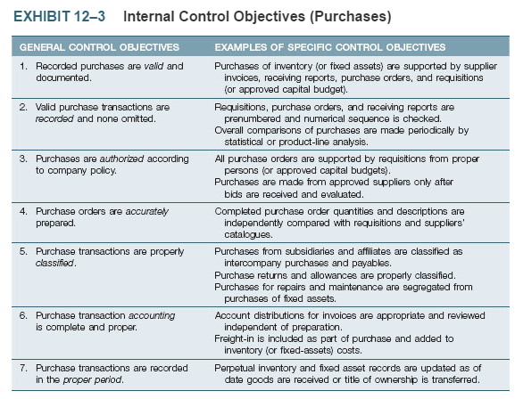
Tests of controls should address all of the control objectives.
- Cut-off is important to valuation of inventory.
- Tests include identification of population and expression of the action to be taken.
  - Note dual direction of testing for completeness and validity requires selection of sample from appropriate population.
Purchase cutoff tests provide assurance, as indicated in objective seven of Exhibit 12–3. In a perpetual inventory system, the inventory records are kept up-to-date continuously. In a periodic system, the inventory level is known only at the physical inventory count date. Even in perpetual systems, however, there should be an annual inventory count to reconcile records with actual inventory. The inventory count procedures are described in more detail later in this chapter. Thus, for both types of inventory systems, the inventory cutoff test date is the date the physical inventory is taken and accounting records are adjusted to distinguish between sales and purchases before the cutoff date and those after it.
Cutoff error is a failure to assign a transaction to the proper period. For example, the shipping terms FOB destination and FOB shipping point indicate the date that legal title to the inventory is transferred to the purchaser: When goods are received, in the case of FOB destination, and when goods leave the seller's premises, in the case of FOB shipping point. Delivery time can thus have a major impact on proper recording of purchases, payables, inventory, sales, and receivables. The appropriate accounting depends on the shipping terms and whether the auditee is the buyer or seller in the transaction. These are major considerations in cutoff procedures related to inventory. Note that the auditee control system's ability to detect and correct cutoff errors justifies the auditor's decision to perform more or fewer cutoff procedures.
The auditee may use a cutoff date other than the balance sheet date if controls are strong enough to ensure transactions between the cutoff and year-end are recorded accurately and completely. In this situation, the auditor verifies both the cutoff and the transactions in the roll-forward period, the period between cutoff and year-end, to ensure the year-end balance is not misstated.
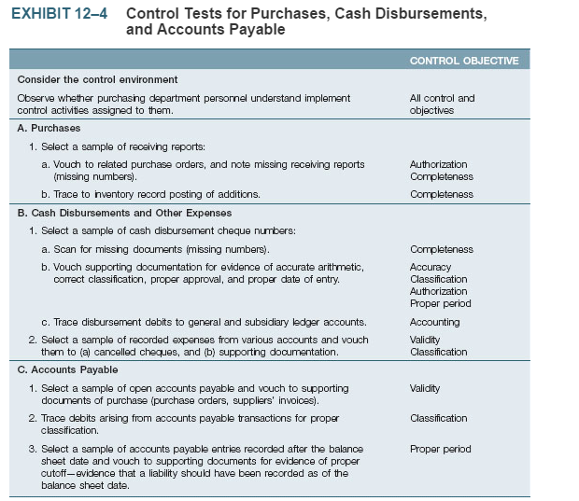

Substantive Audit Programs for the purchases, payables, and payments process
Example of Substantive Audit

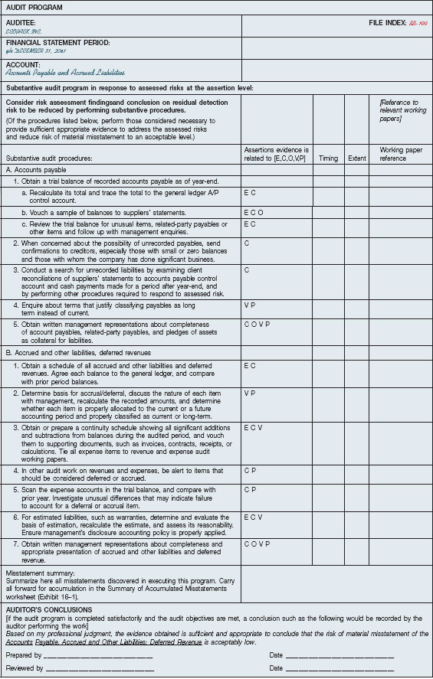

Special Note: The Completeness Assertion
When considering assertions and obtaining evidence about accounts payable and other liabilities, auditors must put emphasis on the completeness and obligations assertions.
- Emphasis because companies tend to be less concerned about recording expenses and liabilities.
- Auditors cannot rely entirely on the management assertion of completeness.

Search for Unrecorded Liabilities
The search for unrecorded liabilities is designed to yield audit evidence of liabilities that were not recorded in the reporting period.
- Objective is to search all the places where evidence of liabilities might exist.
The following list of procedures is useful in the search for unrecorded liabilities. The audit objective is to search all the places where there might be evidence of them, and if none is revealed, it is reasonable to conclude that all material liabilities were recorded.
- Scan the open purchase order file at year-end for purchase commitments at fixed prices. From current prices, determine if any adjustments for loss and liability are needed.
- List the unmatched supplier invoices and, from the unmatched receiving report file and receiving reports prepared after year-end, determine when the goods were received. Determine which invoices, if any, should be recorded.
- Trace the unmatched receiving reports to accounts payable entries, and determine if any recorded in the next accounting period need to be reported in the current accounting period under audit.
- Vouch a sample of cash disbursements from the accounting period following the balance sheet date against supporting documents (invoice, receiving report) to determine if the related liabilities were recorded in the proper accounting period.
- Trace liabilities reported by financial institutions to the accounts. (See the bank confirmation in Exhibit 11–8.) Since a bank may not report all auditee liabilities to auditors, other corroborating evidence for possible unrecorded debts should also be obtained.
- Canada Revenue Agency notices of assessment may contain evidence of income or other taxes in dispute that may need to be recorded as liabilities.
- Confirm accounts payable with suppliers, especially regular suppliers showing small or zero balances in the year-end accounts payable. (Suppliers' monthly statements controlled by the auditors also may be used.) Verify supplier addresses so confirmations will not be misdirected—perhaps deliberately.
- Study the accounts payable trial balance for dates showing fewer payables than are usually recorded near the year-end, evidence that invoices are not being recorded.
- Review responses from auditee's lawyers to requests for information about pending or threatened litigation, and about unasserted claims and assessments. These may indicate a need for contingent liability accruals or disclosures. (As explained in Chapter 15, when the auditor assesses a risk of material misstatement due to litigation or claims, Canadian Auditing Standard [CAS] 501 requires that enquiry letters prepared by the auditee be sent to the auditee's lawyers. These letters request the lawyer to communicate directly with the auditor.)
- A checklist of accrued expenses will help determine whether the company has been conscientious in expense and liability accruals, including accruals for wages, interest, utilities, sales and excise taxes, payroll taxes, income taxes, real property taxes, rent, sales commissions, royalties and warranties, and guarantee expense.
- When auditing the details of sales revenue, the terms of sales will help determine if any amounts should be deferred as unearned revenue. (Initial information is gained by enquiries to management about terms of sale, such as customers' rights of cancellation or return.)
- A schedule of casualty insurance on fixed assets is used to determine the adequacy of insurance in relation to asset market values. Inadequate insurance and self-insurance create risks that should be disclosed in the notes to the financial statements.
- Confirm life insurance policies with insurance companies to ask whether the company has any loans against the cash value of the insurance. Also request the names of the beneficiaries of the policies. If a party other than the company benefits from the insurance, it may be a creditor on unrecorded loans. Enquire about the business purpose of making insurance proceeds payable to other parties.
- Review terms of any debt due within one year but classified long-term because the company plans to refinance it on a long-term basis. This cannot be based on management's intent; holders of the debt or financial institutions must have shown (preferably in writing) a willingness to refinance the debt before it can be classified as long-term.
- Apply analytical procedures appropriate in the circumstances. In general, accounts payable volume and period-end balances should increase when the company increases physical production volume or engages in inventory stockpiling. Some liabilities may be related to other activities; for example, sales taxes are functionally related to sales dollar totals, payroll taxes to payroll totals, excise taxes to sales dollars, or volume and income taxes to income.

