1.0 Introduction

1.1 Report Purpose

This report breaks down three major careers in mechanical engineering. The three career branches are:

- Aerospace Engineering
- Automotive Engineering
- Petroleum Engineering

The purpose of this report is to provide students studying mechanical engineering, students enrolled in postsecondary education wishing to switch into mechanical engineering, and students thinking about applying to mechanical engineering information about possible career options. Each career is divided into four subsections:

- Career Summary
- Education
- Career Opportunities
- Salary and Demand

1.2 Report Background

Mechanical engineering is considered the bare bones of engineering as it is the most fundamental engineering discipline. Mechanical engineering is the branch of engineering concerned with designing, manufacturing, installing, and operating of engines and machines with manufacturing processes. It is particularly concerned with forces and motion. (Ross, 2014)

Mechanical engineers are concerned with the principles of engineering, physics, calculus, and materials sciences. With all that in unison, the designing, analyzing, manufacturing, and maintaining of mechanical systems are run smoothly by these engineers.

1.3 Report Outlook

With the many branches of mechanical engineering, graduates will be working in an array of fields. According to Statistics Canada’s National Household Survey (2011), the percentage of mechanical engineers working in specific industries is as follows: about 42% of mechanical engineers work in the manufacturing industry, while 33.2% work in a professional engineering service and 5.2% work in the trades sector.

Again, Figure 1 shows the different industries mechanical engineers work in:
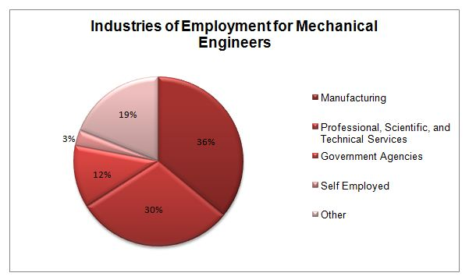
Figure 1: Industries of employment for mechanical engineers in Canada (2013)

This shows the variety of fields a mechanical engineer is capable of pursuing a career in. The purpose of this report is to provide students and potential mechanical engineers information on three specific careers.

2.0 Aerospace Engineering

2.1 Career Summary

For the air and space enthusiasts, interested in the principles of aircraft and spacecraft designing or engine manufacturing, aerospace is the engineering for you. Aerospace engineering is the field of engineering concerned with designing, developing, constructing, testing, and functioning of vehicles operating in the Earth’s atmosphere or in outer space such as airplanes and spaceships. (Al Stanzione, 2015)

2.2 Education

A student wishing to pursue a career in aerospace engineering can earn a top rated aerospace engineering degree at Carleton University, or they can specialize into aerospace engineering after completing a degree in mechanical engineering. Students in high school wishing to get into an undergraduate mechanical engineering or aerospace program should be extremely strong in mathematics and sciences. During postsecondary education, the course load for both programs becomes drastically difficult, with courses such as thermodynamics and fluid dynamics which require a strong understanding of mathematics. Some universities that offer the mechanical and/or the aerospace program in Canada include:

- University of Waterloo (Mechanical Engineering)
- University Of Toronto (Mechanical Engineering & Aerospace Engineering)

- Carleton University (Mechanical Engineering & Aerospace Engineering)
- University of British Columbia (Mechanical Engineering)

2.3 Career Opportunities

A graduate in aerospace engineering or specialization in aerospace engineering has the ability to work in many different industries. Many universities also offer a co-op option where students can gain work experience and potentially earn a spot with a company after graduation. Within Canada, major jobs for aerospace engineers are:

- Aircraft Design Engineers: are responsible for designing, testing, maintaining and supervising the manufacturing of the aircraft.
- Test Engineers: are responsible for determining how to create a process which tests the object being manufactured for quality assurance and safety.
- Aerodynamics Engineers: are responsible for performing tasks in designing, and testing of aircrafts and spaceships.

2.4 Salary and Demand

Aerospace engineering is an exciting discipline to study and is in extremely high demand. The average salary an aerospace engineer can earn is around $60,000-$100,000, but there are many factors that can affect the salary such as, the company or firm and your experience. According to the Bureau of Labor Statistics (2012), employment of aerospace engineers is expected to increase about five percent during the 10-year period between 2010 and 2020.

3.0 Automotive Engineering

3.1 Career Summary

For the car savvy students, interested in how your favorite cars were designed and how it was manufactured, automotive engineering may be for you. Automotive engineering is a combination of mechanical, electrical and materials science. Engineers in this field can design new vehicles or look for ways to improve existing automotive engineering technology. Automotive engineers are responsible for designing and testing brake systems, engines, safety mechanisms, fuel technologies, and transmissions. (“Automotive Engineering,” 2013)

3.2 Education

A student wishing to pursue a career in automotive engineering can earn an automotive engineering degree at specific universities that offer the program, or they can specialize into automotive engineering after completing a degree in mechanical engineering similar to aerospace and petroleum engineering. Students in high school wishing to get into an undergraduate mechanical engineering or automotive program should be strong in mathematics. During postsecondary education, the courses you can expect are vehicle dynamics and vehicle thermal management which like any engineering course require a strong mathematics background.
Some universities that offer the mechanical and/or the automotive program in Canada include:

- McMaster University (Mechanical Engineering & Automotive Engineering)
- University of Windsor (Mechanical Engineering & Automotive Engineering)
- University of Ontario Institute of Technology (Automotive Engineering)

3.3 Career Opportunities

An automotive engineer graduate has the ability to work in many different fields such as manufacturing or technical services. Most universities offer a co-op program for all engineering disciplines, where students can gain work experience and even earn a salary to save up and use for tuition or other fees. Within Canada, specialized jobs for automotive engineers are:

- Automotive Engineering Technician
- Automotive Design Engineer
- Automotive Engineer
- Automobile Designer
- Vehicle Designer

3.4 Salary and Demand

Automotive engineering is becoming highly popular due to the increasing demand for vehicles. According to PayScale (2014), automotive engineers employed by General Motors earn the most, with an average salary of $84,000. Chrysler Group LLC offers a luxurious payroll, with top-end employees earning around $120,000 but a median salary of $79,000/year.

4.0 Petroleum Engineering

4.1 Career Summary

For students interested in figuring out where the crude oil and gas used in our daily lives come from and how it was produced, petroleum engineering may be suitable for you. Petroleum engineering is a specialized branch of engineering involving the extraction and production of petroleum, utilizing hydrocarbons and managing natural gas. The goal of a petroleum engineer is to efficiently extract liquid and/or gaseous hydrocarbons from the ground, which are used to produce crude oil or natural gas. Petroleum engineers are responsible for overseeing drilling, processing and producing of crude oil and natural gas. They are also responsible for many off site tasks such as transporting oil and managing environmental and renewable issues.

4.2 Education

A student wishing to pursue a career in must earn a degree in petroleum engineering or a specialization in petroleum engineering after receiving a degree mechanical or chemical engineering. In Canada, the University of Calgary and University of Alberta have reputable petroleum engineering programs specializing in drilling and fluid dynamics of natural gases and crude oil, petroleum reservoir management and petroleum engineering mechanics. Students in high school wishing to get into a petroleum engineering program should be strong in mathematics and sciences, especially chemistry. During postsecondary education, the courses you can expect to take are fluid mechanics and drilling mechanics requiring a firm science background.

4.3 Career Opportunities

During the evolution of petroleum engineering, the following areas of specialization are: drilling engineering, production engineering, reservoir engineering, and petro-physical engineering (Honeycutt, 2015).

- Reservoir Engineers: use engineering principles to resolve drainage problems during the production and development of oil and natural gas.
- Production Engineers: supervise oil sand controls and manages oil extraction methods.
- Drilling Engineers: responsible for designing and using drills in an environment and economical manner.
- Petro-physical Engineers: focus is on hydrocarbons. Petro-physical engineers analyze rock fluids, study gaseous nature and fluid flows in reservoirs.

The University of Calgary and University of Alberta both have reputable co-op options linked with the petroleum engineering degree. The university will help you find job placements in companies where you will gain work experience while enrolled as a full-time student.

4.4 Salary and Demand

One prime location for petroleum engineers in Canada is Calgary, as approximately 75% of petroleum engineers in Canada work in Calgary. Figure 2 shows the weekly wages of a petroleum engineer in different provinces in Canada:

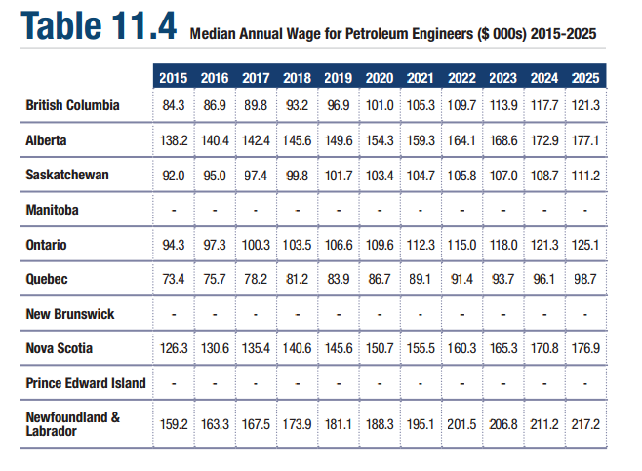
Figure 2: Median annual wages and projected wages for Petroleum engineers across Canada
Entry level petroleum engineers are expected to make around $86,000/year and a mid-level petroleum engineer can make up to $150,000/year.

5.0 Report Conclusion

Without a doubt, a degree in mechanical engineering provides an excellent salary but the career choice rests in your hands. You may decide to pursue an engineering degree in one of the amazing 65 Canadian universities, that offer the degree, but it is important that you have all the information required to make a choice regarding your future as an aspiring mechanical engineer. Whether you decide to pursue a career in aerospace engineering, automotive engineering, petroleum engineering or any other engineering profession, I hope this report will assist you in making a confident and informed decision. I want to personally wish you best of luck in all your future engineering endeavours.

