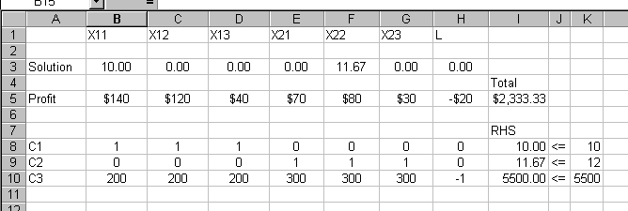
The Pennsylvania Water Authority has just announced its yearly water allotment, with the Young farm receiving 7,400 acre-feet. Each parcel can only tolerate a specified amount of irrigation per growing season, as specified below:
Parcel Area (acre) Water Irrigation Limit (acre-feet)
Southeast 2000 3200
North 2300 3400
Northwest 600 800
West 1100 500
Southwest 500 600
Each of Young’s crops needs a minimum amount of water per acre and there is a projected limit of each crop. Crop data follow:
Crop Maximum Sales Water Needed per Acre (acre-feet)
Wheat 110,000 bushels 1.6
Alfalfa 1,800 tons 2.9
Barley 2,200 tons 3.5
Young’s best estimate is that she can sell wheat at a net profit of $2 per bushel, alfalfa at $40 per ton, and barley at $50 per ton. One acre of land yields an average of 1.5 tons of alfalfa and 2.2 tons of barley. The wheat yield is approximately 50 bushels per acre.
Formulate Young’s production plan. (Define the decision variables, objective function and the constraints).

A If it costs $70 to produce 1000 tools at plant 1 and ship them to customer 1, what would be the new solution to the problem and the profit? ( 1 point)
This corresponds to a decrease in the objective function coefficient of X11 from $140 (= 200 – 60) to $130 (=200 – 70). A decrease of $10 is within the allowable decrease of 20 thus the optimal solution will not change however the profit will decrease.
The optimal decision calls for the production of 10,000 tools at plant 1 and shipped to customer 1 (X11 = 10) and the production of 11,670 tools at plant 2 and shipped to customer 2 (X22 = 11.67). The profit will decrease by $100 and will be $2,233.33 (= 130(10) + 80(11.67))
B If the price of an additional hour of labor were reduced to $4, would the company purchase any additional labor? (1 point)
This corresponds to a change in the objective function coefficient of the decision variable L. The objective function coefficient originally at -20 is now at -4. That represents an INCREASE of 16. An increase of 16 units is within the allowable increase of 19.73, thus the optimal solution will not change (L = 0) and the company will not purchase any additional hour of labor.
C A consultant offers to increase plant 1’s production capacity by 5000 tools for a cost of $400. Should the company take the offer? (1 point)
This corresponds to an increase of 5 to the right hand side of the first constraint, C1. Since this increase is within the allowable increase 17.5 the value of the shadow price of 86.67 will remain valid.
The maximum price that the company is willing to pay for 1000 tools is $86.67. However the consultant is offering the 1000 tools at a price of $80(= 400/5). Thus the company should take the offer (they will be gaining $6.67 per 1000 tools for a total of $33.35 for the additional 5000 tools)
Alternative solution: A capacity increase of 5000 tools will increase profit by: 5*86.67 = .433.35, which is greater than the cost of $400 (a profit of 33.35). Thus the company should take the offer.
D If the company were given 5 extra hours of labor, what would the profit become? (1 point)
This corresponds to an increase of 5 hours to the right hand of the third constraint, C3. Since this increase is within the allowable increase of 100, the value of the shadow price of 0.27 will remain valid.
The profit will increase by: (5)*(0.27) = $1.35. The new profit: 2,333.33 + 1.35 = $2,334.68

Reduced Cost= amount the price/cost needs to increase before it becomes profitable
Shadow price= price per unit
100% rule= change/allowable change x(100) if less than 100, slt’n will not change.
A company produces tools at two plants and sells them to three customers. The cost of producing 1000 tools at a plant and shipping them to a customer is given in Table below:
Customer1 Customer2 Customer3
Plant 1 $60 $30 $160
Plant 2 $130 $70 $170
Customers 1 and 3 pay $200 per thousand tools; customer 2 pays $150 per thousand tools. To produce 1000 tools at plant 1, 200 hours of labour are needed, while 300 hours are needed at plant 2. A total of 5500 hours of labour are available for use at the two plants. Additional labour hours can be purchased at $20 per labour hour. Plant 1 can produce up to 10,000 tools and plant 2, up to 12,000 tools. Demand by each customer is assumed unlimited.
If we let Xij = number of tools (in thousands) produced at plant i and shipped to customer j, and L = number of additional hour purchased.
The problem when formulated as an LP and solved is as follows:
Max. Z = 140 X11 + 120 X12 + 40 X13 + 70 X21 + 80 X22 + 30 X23 - 20 L
Subject to
C1 1 X11 + 1 X12 + 1 X13 <= 10
C2 1 X21 + 1 X22 + 1 X23 <= 12
C3 200 X11 + 200 X12 + 200 X13 + 300 X21 + 300 X22
+ 300 X23 - 1 L <= 5500

X1= 4, X2 = 2 (intersection of constraint 2 with constraint 3)
Z = 18

Min Z = 3x1 + 3x2

Subject to
12x1 + 4x2 >= 48
10x1 + 5x2 >= 50
4x1 + 8x2 >= 32
x1, x2 >= 0

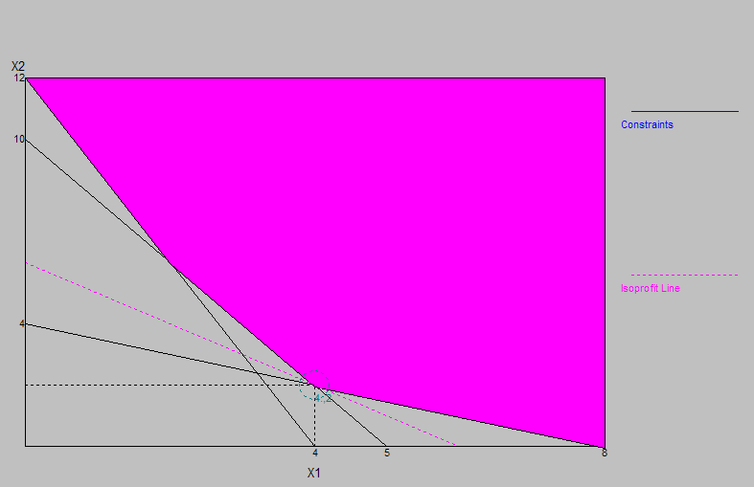
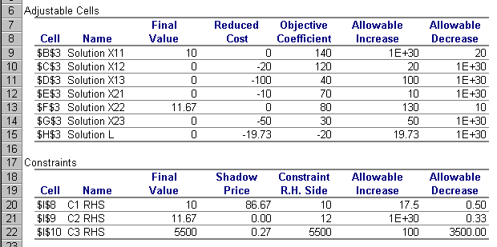

Let Xi,j _ acres of crop i planted on parcel j
where i =1 for wheat, 2 for alfalfa, 3 for barley and
j = 1 to 5 for SE, N, NW, W, and SW parcels
Max Z =
Subject to
Irrigation limits:
1.6X11 + 2.9X21 + 3.5X31 <= 3,200 acre-feet in SE
1.6X12 + 2.9X22 +3.5X32 <=3,400 acre-feet in N
1.6X13 + 2.9X23 + 3.5X33 <=800 acre-feet in NW
1.6X14 + 2.9X24 +3.5X34 <= 500 acre-feet in W
1.6X15 + 2.9X25 + 3.5X35 <= 600 acre-feet in SW

<= 7,400 water acre-feet total
Acreage availability:
X11 + X21 + X31 <= 2,000 acres in SE parcel
X12 + X22 + X32 <= 2,300 acres in N parcel
X13 + X23 + X33 <= 600 acres in NW parcel
X14 + X24 + X34 <= 1,100 acres in W parcel
X15 + X25 + X35 <= 500 acres in SW parcel

All Xij >= 0 i= 1, 2, 3 and j= 1, 2, 3, 4

Sales limits:
X11 + X12 + X13 + X14 + X15 <= 2,200 wheat in acres
(=110,000 bushels)
X21+ X22 + X23 + X24 + X25 <= 1,200 alfalfa in acres
(= 1,800 tons)
X31+ X32 + X33 +X34 + X35 <= 1,000 barley in acres
(= 2,200 tons)

An airline with operations in San Diego, California must staff its ticket counters inside the airport. Ticket attendants work six-hour shifts at the counter. The requirements for number of agents are a function of the numbers of people expected to pass through the airline’s ticket counters during various hours. The airline believes that the need for agents between the hours of 6 a.m. and 9 p.m. are as follows:

 |  | 6a - 9a | 9a – 12 n | 12 n - 3p | 3p - 6p | 6p - 9p
 | Ticket Agents Needed | 12 | 20 | 16 | 24 | 12
Agents begin work either at 6 a.m., 9 a.m., 12 (noon) or 3 p.m. The shifts are designated as Shifts A, B, C, and D, respectively. It is the policy of the airline that at least half of the agents will speak English as the first language. Further, at least one-quarter of the agents should be fully bilingual (English and Spanish). How many and what type of agents should be hired for each shift to meet the language and staffing requirements for the airline?
Shift A 6am-12noon XA1+XA2>=12
Shift B 9am-3pm XB1+XB2>=20
Shift C 12noon-6pm XB1+XB2+XC1+XC2
Shift D 3pm-9pm XC1+XC2+XD1+XD2
XD1+XD2
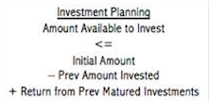
Bilingual

XA2 3
XB2 5
XB2+XC2 4
XC2+XD2 6
XD2 3
English

XA1 6
XB1 10
XB1+XC1 8
XC1+XD1 12
XD1 6
Example: 100% RULE
c1: 40 50 and c2: 30 35
Percentage allowable increase for c1
= (50-40)/ (allowable increase for c1) %
= (50-40)/20 *100 = 10/20 = 50 %
Percentage allowable increase for c2
= (35-30)/ (allowable increase for c2) %
= (5)/20 *100 = 25 %
Sum= 50% + 25% = 75% <100%
Thus, the optimal solution does not change

Zero value decision variable (unused activity)
For example, the optimal solution shows that it’s better not to produce any basketballs and to only produce soccer balls and footballs. It will be a moot point for the marketing team to debate how much more to sell them.
The value of the objective function, Z, will not change.
Non Zero value decision variables
The value of Z, will change.

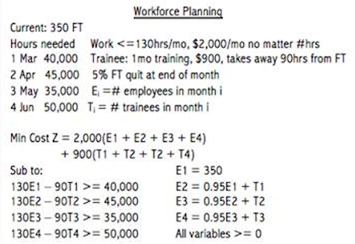
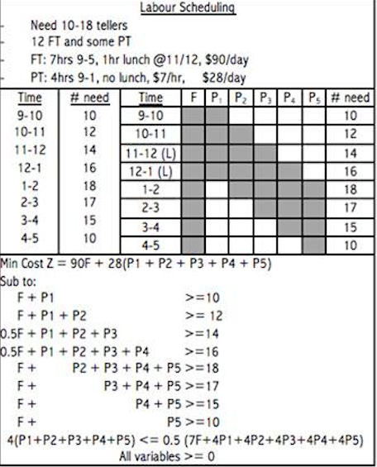
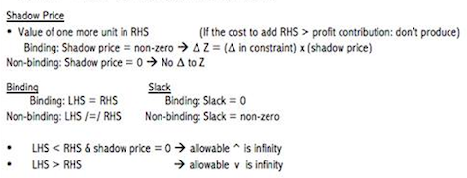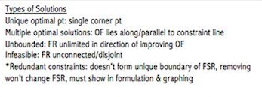
Change in Coefficient with 100% rule= allowable increase/decrease (Range of optimality)

Change in RHS constraint with 100% rule= allowable increase/decrease (Range of Feasibility)

