Lab 1

Part I: Spatial Compatibility (respond to a target with a key press)

Spatial Mapping Hand placement

Ipsilateral Normal

Contralateral Normal

Ipsilateral Crossed

Contralateral Crossed

Spatial mapping is the fastest overall, then SR compatibility has more of an effect than anatomical congruence (ie crossed hand ipsilateral)

Part II: Simon Effect

Respond to the shape of the stimulus, not the location (note that simon effect means that even when the location is irrelevant, it still effects RT

Results:

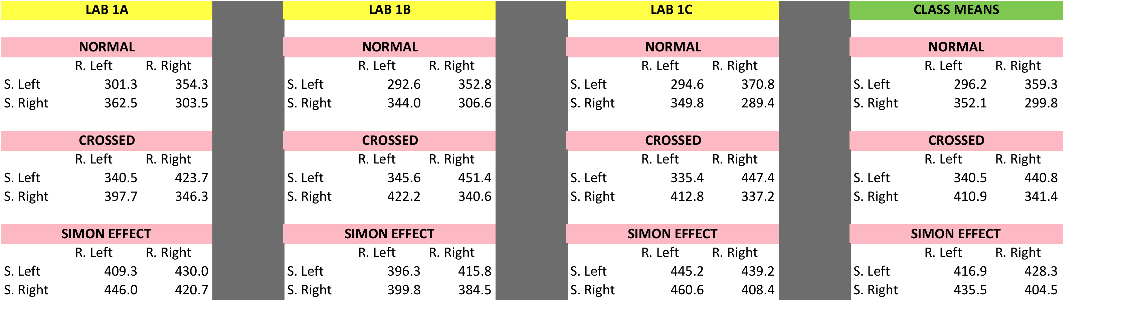

Graphs:

Normal

Crossed

Simon Effect

Questions:

1. Graphs 1A, 1B, and 2 as described above.

2. Provide a description of the relation between reaction time and stimulus-response assignments, for both the Normal and Crossed Hand Placement conditions, as observed in the spatial compatibility proper Experiment Part I (i.e., the results). Describe the influence of the Hand Placement conditions on the RT results in Part I.

reaction time (RT) is faster when the stimulus-response couple is congruent/compatible.

Normal – fastest if ipsilateral

Crossed hands – (although overall slower than normal) fastest if ipsilateral

Hand Placement: to differentiate between the effect of anatomical congruence and SR compatibility. Proving than an cong is more important than SR compatibility.

3. Provide a description of the relation between reaction time and stimulus-response assignments, as observed in the Simon effect Experiment Part II (i.e., the results).

Simon Effect: RT is faster when SR is compatible even when the stimulus location is irrelevant.

4. Discuss the theoretical frameworks underlying the present experiments (e.g., a discussion of the spatial compatibility effect and the Simon effect, as well as their possible theoretical explanations). Discuss the links between the methods, experimental conditions, and theoretical framework underlying the spatial compatibility effect and the Simon effect.

a. Discuss the Spatial Coding Model as it pertains to the spatial compatibility effect.

The Spatial Coding Model states that the speed of translation of stimulus into response depends on the correspondence between the spatial code that specifies the position of the target. Therefore if the spatial code is based on location, reaction times will be faster if the stimulus and response are in compatible (ipsilateral) location

-Spatial coding = when Stim and Resp are coded together to be similar, this increases the compatibility and explains why spatial compatibility produces a faster RT

b. Discuss the purpose of the Hand Placement conditions. Discuss the underlying rationale for their inclusion and the potential theoretical implications (i.e., cognitive vs. anatomical congruence) with respect to spatial stimulus-response compatibility.

-Purpose of Hand Placement was to divide cognitive congruence (spatial compatibility of stimulus and response) from the anatomical congruence causes of fast RT. Also divides the effector and response.

c. Describe and discuss the Simon effect and distinguish the Simon effect from the Spatial Compatibility effect.

Simon Effect: RT is faster when SR is compatible even when the stimulus location is irrelevant.

-Simon effect = SR location irrelevant yet still faster RT

Compatibility effect = SR location is relevant and strong compatibility yields a faster RT

d. Discuss and explain the dual-process model as it relates to the Simon effect. Explain how this model accounts for the Simon effect and how it might also apply to the Spatial Compatibility effect.

-dual process model – default automatic response

-response check to see if the auto response matches actual response

-if so, RT is fast

-if not, you must inhibit your auto response and code a new one … slow RT

-as it relates to simon effect…

-the spatial compatible response is always coded as an auto response so its faster, if it is contralateral (less compatible) you will be slower because you must inhibit the auto response to the ipsilateral location

Reading:

L1 Chen J, & Proctor RW (2012). Up or down: Directional S-R compatibility and natural scrolling. Proceedings of the Human Factors and Ergonomics Society, 56, 1381-1385.

Experiment 1: press up or down arrow to see how people naturally scroll on a computer

Experiment 2: To see if participants of the previous study just moved the screen toward the direction that a certain number was seen, which would tamper with the results of the scrolling task. Target location is the opposite to the movement direction.

Findings: Best results when the control direction is compatible with the display content movement direction, not target location. The best way to scroll on computers is by ‘natural scrolling’ (consistent with the Mac OS X) in which the content moves in the direction of the finger movement. DIRECTIONAL SR COMPATABILITY. Content up is compatible with finger movement up etc.

Experimental question: which way is easier to scroll?
Hypothesis: Natural scrolling is the most compatible way to scroll
Methods: -move diamond up or down on screen so they all show
- they are given arrows
- checked their RT and number of errors
Results: -faster RT to move the page
- macs scroll more directionally compatible

Purpose of Experiment # 2
- making sure that they weren’t studying spatial compatibility, and they were actually studying directional compatibility

Introduction
-What is the primary experimental question (or questions)?
Experimental question: which way is easier to scroll?
-Briefly explain the basis for the research question.
To see which way it is easier / matches people’s pre-existing model to allow operating systems to be easier to use
- What concepts of S-R compatibility are involved?
Directional Compatibility
-Describe the authors’ hypotheses.
Hypothesis: Natural scrolling is the most compatible way to scroll
Method
-Describe the basic task and procedures.
Methods: -move diamond up or down on screen so they all show
- they are given arrows
- checked their RT and number of errors
-Identify and describe the independent variables (manipulated by the experimenter) and the dependent variables (measured by the experimenter).
IV= the directional arrows that the participants are able to use
DV= the speed at which the participants were able to move the number back onto the screen
Results
-Describe the main findings.
Results: -faster RT to move the page
- macs scroll more directionally compatible
Discussion
-What conclusions are drawn from the results?
It appears that it is more natural for people to scroll in the direction that the content on the screen moves rather than scrolling as if they were moving the window that views the content. Therefore, operating systems should move towards copying macs’ scrolling system.

Lab 2

Unidirectional 20

Unidirectional 60

Reversal Continuous

Reversal Pause

Questions:
1. Plot the trials (that you have chosen to analyze) for each movement type and movement parameter.

Plot a figure that shows:
• Displacement profile of manipulandum (potentiometer voltage signal) as a function of time
• Velocity profile
• Acceleration profile
• EMG pattern from agonist (rectified) as a function of time
• EMG pattern from antagonist (rectified and negated [negative values]) as a function of time

2. Show and label on these plots the performance, kinematic, and EMG measures/landmarks that you have been asked to derive.

3. Based on your results, indicate how each of the performance (movement accuracy), kinematic (velocity and acceleration peaks), and EMG measures might change as a function of Movement Type (Uni-directional vs. Reversal), Movement Amplitude (for Uni-directional movements), and Reversal Type (for Reversal movements).

1. In the data collected from the Lab #2, consider the following:

a) How many triphasic patterns are associated with a uni-directional movement?
ONE
b) How many triphasic patterns are associated with a continuous reversal movement? Why? How does the triphasic pattern in a uni-directional movement compare to the continuous reversal movement?
ONE. Because the it goes AG1(acceleration), ANT1 (deceleration) blending with ANT switching into the new agonist to accelerate in the opposite direction, AG2 (decelerating to stop the movement)

Unidirectional vs. continuous reversal: longer ANT EMG for Continuous reversal

c) How many triphasic patterns are associated with reversal movement with a pause? Why?
TWO. Because you fully separate the two movements, therefore there is no blending of ANT EMGs.

Performance Measures: (derive for a trial for each movement type and each movement parameter)

1. Constant error (volts) of final limb position with respect to target.

2. Constant error (volts) of limb reversal position with respect to reversal target.

3. Reaction time (ms) based on onset of movement of the manipulandum.

4. Premotor Reaction Time (in milliseconds).

5. Motor Time (ms).

6. Movement time (ms) based on end of manipulandum movement.

Kinematic Measures: (derive for a trial for each movement type and each movement parameter)

1. Displacement profile (volts): Show start and end points of displacement based on your estimate.

2. Velocity profile (volts/sec): Show peak velocity in forward (and backward) direction(s).

3. Acceleration profile (volts /sec2): Show peak acceleration and peak negative acceleration

Reading

L2 Cooke JD, & Brown SH (1990). Movement-related phasic muscle activation II: Generation and functional role of the triphasic pattern. Journal of Neurophysiology, 63, 465-472.
Triphasic mvmts : AG1, ANT1, AG2
-occurs for fast movements
-AG1 amplitude and duration depend on mvmt amplitude
-ANT magnitude depends on mvmt amplitude
-ANT timing depends on mvmnt duration
IN THIS EXPERIMENT
They identified a Quadriphasic movement
-AG1/ANT1 in acceleration
-ANT2/AG2 in deceleration
-in short movements, these are very close together and ANT1/2 blend
1. AG 1 movements start acceleration ANT 1 start deceleration
2. Basic unit = quadriphasic of EMG
Constant velocity = quadriphasic (reversal pause)
3. If there is a constant velocity
4. Triphasic is really just a merging of ANT 1 and 2

1. What is the basic function of the phasic bursts of muscle activity typically observed during fast movements?
AG1 – to accelerate the limb to the target position
ANT1 – to decelerate the limb so it does not overshoot the target
AG2 – acts to make any necessary corrections
2. Cooke and Brown propose that the triphasic EMG pattern “is not a basic unit of movement control.” In their view, and based on their data, what is the “basic unit?” Describe and discuss how these authors supported their claim.
The basic unit- agonist/antagonist pairings to control movement (biphasic)

-AG1/ANT1 in acceleration
*tonic phase (for movements with constant velocity)
-ANT2/AG2 in deceleration
*triphasic has been seen because in experiments they usually use movements with
3. With respect to #2, what was the critical aspect of Cooke and Brown’s experimental procedures? Explain the importance of this experimental procedure to the authors’ investigation and theoretical position regarding the functional role of phasic muscle bursts in movement control.
Critical aspect of experimental procedures- they used constant velocity to separate the patterns
4. According to Cooke and Brown, what is the basis for the triphasic EMG pattern? Is it actually “triphasic?” Explain.
The triphasic EMG pattern is really an AG1, ANT 1/2 molding together, AG2 so it is not actually a triphasic movement, it is a melding of two biphasic patterns.

Lab 3
Prism Goggles
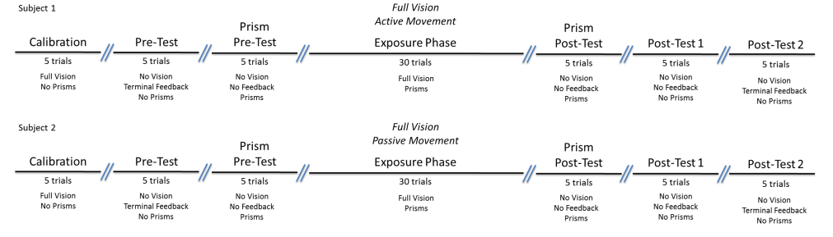
Purpose of Phases:

Calibration – To make sure that the participant is accurate to begin with
Pretest – To see how much no vision effects the participant
Prism Pretest – To see if the participant sees the target at a diff location than it is
-compare with prismpost test
Exposure – To let the participant adapt to the prism vision (new calibration)
-Active- Person gets reafference (from own movement) feedback and starts to make corrections based on their own movement and how the prisms look (VISUOMOTOR)
-Passive- purely VISUAL system giving them feedback on how their body is moving
Prism Posttest- To show that the participant held onto their visual drift
Post test No Feedback-To show that even when the goggles are off, there is a shift in the participant’s perception of their environment
Post test Terminal Feedback-This shows that when they are shown that they have been affected by the prisms they can adjust back to what they used to do
* prisms on
AFTER EFFECT
Results: The active exposure phase should yield a difference between prism post test and prism pretest but the passive exposure should have no difference.

Difference in performance suggests that you have to actively move in order to calibrate to the prism goggles

• What is the purpose of including the Calibration, Pre-Tests, and Post-Tests phases?
Set a baseline to compare results to
(terminal feedback present to allow for corrections for cal and pretest and post 2) These should all be zero in the passive condition because there is no adaptation. In the active condition, posttest 1 should show an after effect with no feedback to show that they have adapted to the prisms (no terminal feedback) posttest 2 should start bad and start to improve toward zero due to terminal feedback.
• What is the purpose of including the Prism Pre-Test and Prism Post-Test phases?
Prism pre-test – to compare the prism pretests between passive and active group, if both were affected, they should both have an error based on the prisms
Prism post test- It shows which group has adapted their accuracy to the prisms based on practice during exposure phase
-active should have zero error but passive should still have error
• What were the effects of the prisms on pointing performance during the Exposure phase in the Full-Vision, Active Movement condition?
The active movement participants get to experience sensory feedback from their own movement (reafference) so in the exposure phase with full vision the participant made initial errors but then they adapted and their accuracy improved by the end.
• For Subjects 1 and 2, what happened to pointing performance during the Prism Pre-Test and Prism-Post Test? If there was a difference in performance during these two phases, what would it suggest?

• For Subjects 1 and 2, what happened to pointing performance in the Post-Test trials? Were there any performance differences between the Pre-Tests and Post-Tests? Were there any after-effects of wearing the prisms? If so, how long did the after-effects last? Were there differences in terms of the after-effects?

• Describe (and draw) the hypothesized (expected) results for the conditions performed by Subjects 1 and 2 in the present experiment.

• What do you think is necessary to adapt to the visual displacement caused by the prisms? What might be the underlying reasons for after-effects of prism exposure? What do these after-effects reveal?

• Discuss the purpose and rationale behind the experimental design and the experimental variables. What theoretical and empirical questions are we able to address with the present lab experiment?

Reading
*Methods included pointing tasks in which they had to point as fast as they could
Experiment 1:
-seated arm prism adaptation generalizes to leg STRONG
Experiment 2:
-seated leg prism adaptation generalizes to arm WEAK
Experiment 3:
-standing leg prism adaptation generalizes to arm WEAK
Findings:
*prism adaptations during arm movements are not limb specific

-Experimental Question: Whether prism adaptations are limb specific or if the effects will generalize
-Hypothesis – they thought they would find generalization from leg to arm (based on walking study)
IV = limb movement
DV = accuracy
-generalization of arm movement to legs is asymmetric (only arm to leg)
-falsified hypothesis

1. What is the general question of interest in the article?
-Experimental Question: Whether prism adaptations are limb specific or if the effects will generalize
2. What is the purpose and question of each experiment?
-
3. Describe and discuss the experimental protocol and the basic rationale for the experimental design.

4. What is the primary dependent measure in the experiments?
DV= accuracy of pointing to target
5. Describe the main findings for each experiment.

6. Describe and discuss the take-home message provided by each experiment.

Lab 4
Primes = not consciously seen, too quick
Masks = Cover primes and consciously seen
-You aren’t consciously aware of the primes but if they are incongruent or congruent they affect your reaction time (slow if inc & speed up if con)
-speeds up RT when prime and masks were the same
-yes they were successfully masked because they could not guess accurately whether the prime was a circle or square
-yes, it sped up the RT of congruent trials

Based on the data collected:

1. Describe the influence of the congruency of the prime-mask sequence on reaction times.

2. Was there evidence that the prime stimuli were successfully masked from conscious awareness?

3. Was there evidence of an influence of unconscious visual stimuli on motor responses?

Reading
GY blindsight
-can respond to things but they cant actually see it
-can verbally say that is red but cant see it
-Cant see slot but can put something through it
DF visual form agnosia
-can still see but doesn’t know what to do with things
-can see the slot but cant tell how to put something in it

For each trial they did:
-action = pointing task to identify prime (judged by speed ie fitts law)
-perceptual = say how big the object is (small / large)
-if cue stays up then you can say if it was the big one or small circle
-if mask appears and disappears with the rest of the screen you cant say

-There is a speed/accuracy trade off (Fitts law)
-move slower to small targets or farther away

-dependent measure was the speed to which they brought their arm toward the target
-if fast then it must be bigger
-if slow then it must be smaller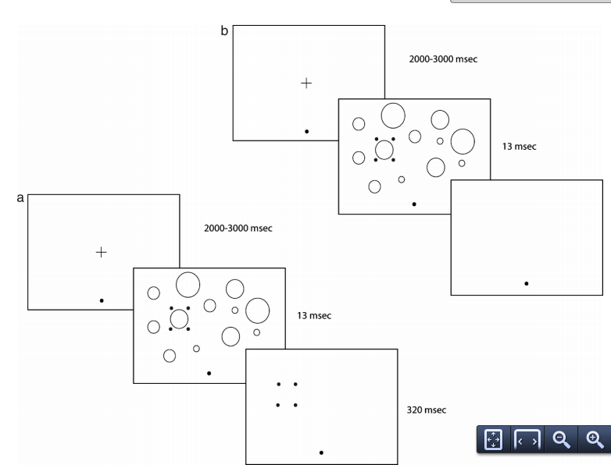

-unconscious (A)= red circles stay
-guess by chance
-conscious (B)= red circles disappear
-fairly accurate

1. Describe the task and procedures from Binsted et al. (2007). Describe the differences between the “conscious” and “unconscious” visual stimulus sequence.

2. Describe how the authors assessed conscious awareness of the masked stimuli.

3. Describe how the authors determined that participants were able to execute target-directed reaching movements in the absence of conscious awareness of the target properties. (Hint: How did Fitts’ law come into play?)

