ADM 3323 – Market Research Final Review

Seminar 6

5 Types of Statistical Analysis (DIDAP)

- Descriptive analysis
  - Describe the sample dataset
  - E.g. mean/mode/median, variance, SD, percentiles, quartiles, skewness
- Inferential analysis
  - Generalize the results of the sample to the target population
  - E.g. Findings from a representative sample of Telfer’s students on their beer drinking habits could be generalized to the population of Telfer’s students
- Differences analysis
  - Determine the degree to which real and generalizable differences exist in the population
  - E.g. differences in average number of beer intake between male and female students; difference in percentages of students with a drinking problem between male and female students
- Associative analysis
  - If and how two variables are related
  - E.g. graduate and undergraduate students love for cars: BMW, Chevy, Honda, Rolls Royce
- Predictive analysis
  - Statistical procedures and models to help make forecasts about future events
  - E.g. Relationship between price of burgers and demand for burgers

Testing for Significant Differences Between Two Groups
- t Test: statistical inference test to be used with small sample sizes (n ≤ 30)
- z Test: statistical inference test to be used when the sample size is 30 or greater

Independent samples are treated as representing two potentially different populations.
- E.g. Male vs. female, smokers vs. non-smokers

Null hypothesis
- The hypothesis that the difference in the population parameters is equal to zero
- If the null hypothesis were true, we would expect 95% of the z scores computed from 100 samples to fall between +1.96 and −1.96 standard errors.

Analysis of Variance
- ANOVA will “flag” when at least one pair of means has a statistically significant difference, but it does not tell which pair.
- Green flag procedure: If at least one pair of means has a statistically significant difference, ANOVA will signal this by indicating significance

If significance = 0, then there is a significant difference between the two compared groups

Null hypothesis: no difference between percentages, means of two groups, and means of all paired groups (populations)

Paired Sample
- Repeated measures on the same sample at different time intervals
- E.g.: Students’ anxiety level before and after a test
- Paired samples test for the differences between two means: a test to determine if two means of two different questions using the same scale format and answered by the same respondents in the sample are significantly different.

Associative Analysis

- Determine where stable relationships exist between 2 variables
- Relationship: consistent and systematic linkage between levels or labels for 2 variables
- Levels: characteristics of description for interval or ratio scales
- Labels: characteristics of description for nominal or ordinal scales

Types of relationships (NMCL)
- Non-monotonic: Two variables are associated, but only in a very general sense. The presence (or absence) of one variable is associated with the presence (or absence) of another.
- Monotonic: The general direction of a relationship between two variables is known – increasing or decreasing relationship
- Curvilear: some smooth curve pattern describes the association (E.g. S-shape or J-shape)
- Linear: “straight-linear association” between two variables (y = mx + b)

Characterizing Relationships Between Variables
- Presence: whether any systematic (statistical) relationship exists between two variables
- Direction or pattern: whether the relationship is positive or negative
- Strength of association: whether the relationship is consistent

Non-monotonic Relationships – Nominal Variables

Cross-tabulation: rows and columns defined by categories classifying each variable; used for non-monotonic relationships
Cross-tabulation table: four types of numbers in each cell
- Frequencies: raw numbers in the cell
- Raw percentages: cell frequencies ÷ grand total
- Row percentages: row cell frequencies ÷ its row total
- Column percentages: column cell frequencies ÷ its column total

Example
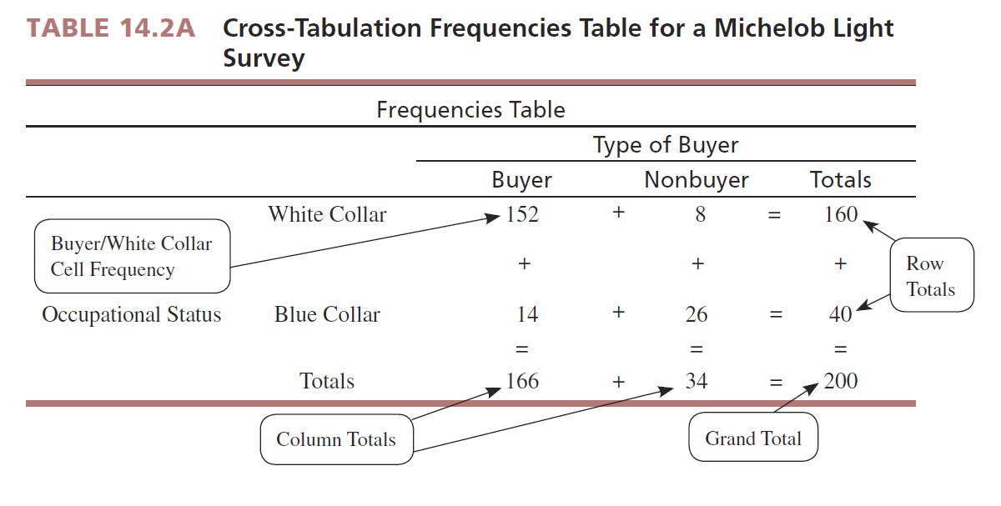

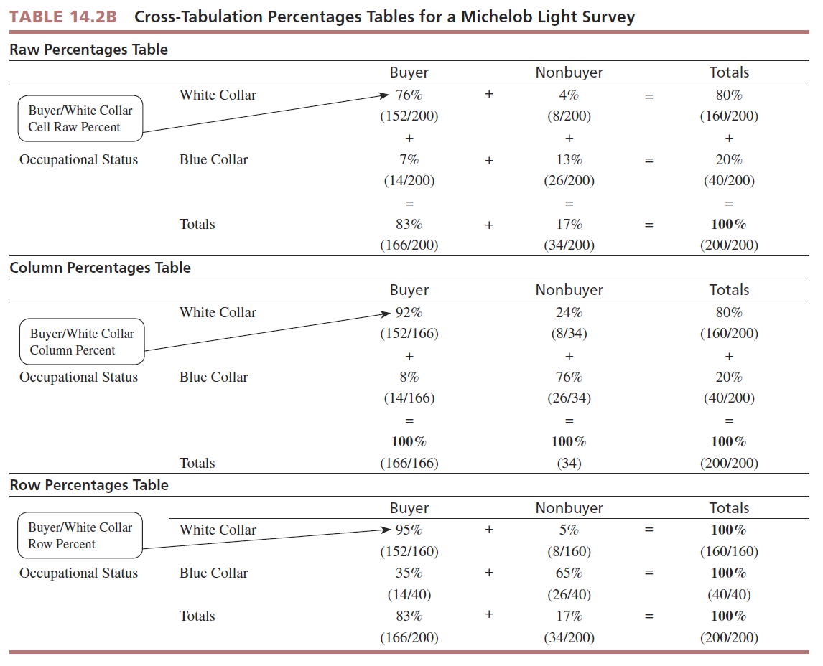
Expected cell frequency = (cell column total) * (cell row total) / grand total
Degrees of freedom = (r-1)(c-1)

- The Chi-square analysis yields the likelihood or probability that the researcher would find evidence in support of the null hypothesis.
- If the P value is ≤ to 0.05, this means there is little support for the null hypothesis of no association.
- Therefore, we have a significant association and have the PRESENCE of a systematic relationship between the two variables.

Monotonic Relationships – Interval and Ration Variables

Correlation coefficient:
- An index number, constrained to fall between the range of −1.0 and +1.0
- Communicates both strength and direction of linear relationship between 2 variables

Cross-tabulation table:
- The amount of change in one variable systematically associated with a change in another variable

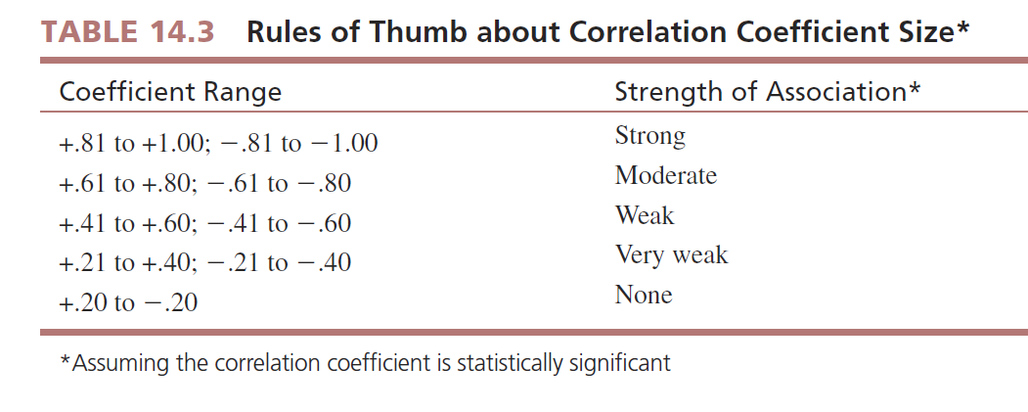

Pearson product moment correlation: Measures the degree of linear association between the two variables (r)

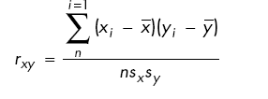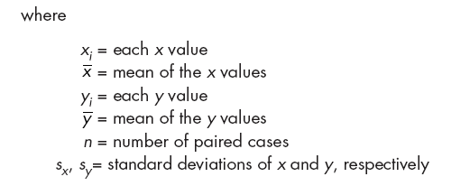

Summary: What Test Do I Want to Do?

- If comparing 2 groups (treatment/control) – t-test
- If comparing >2 groups – ANOVA (F-test)
- If measuring association between 2 variables – Pearson r correlation
- If trying to predict an outcome (crystal ball) – Regression or multiple regression
- Nominal data: chi-square and cross-tabulations

Seminar 6b

Parametric Tests: Use means, assumes that sample means are ‘normally’ distributed

Non-Parametric Tests: Use median rather than the mean
- The median is another judge of location, which makes more sense in a non-parametric test, and is considered the center of a distribution.
- NP tests have less stringent assumptions

Advantages of NP Tests
- Used with All Scales
- Easier to Compute
- Make Fewer Assumptions
- Need Not Involve Population Parameters

Disadvantages of NP Tests
- May waste information
  - Parametric model more efficient, if data permits
- Difficult to compute by hand for large samples
- Tables not widely available
Popular NP Tests

- Sign Test
  - Used for test of median
  - Sample size n are expressed in $
- Wilcoxon Rank Sum Test
  - Test of median
  - Find difference between each value and the median
  - Ignore 0’s and rank absolute values of remaining scores
- Wilcoxon Signed Rank Test
  - Divide population into two sub-samples of size n1 and n2

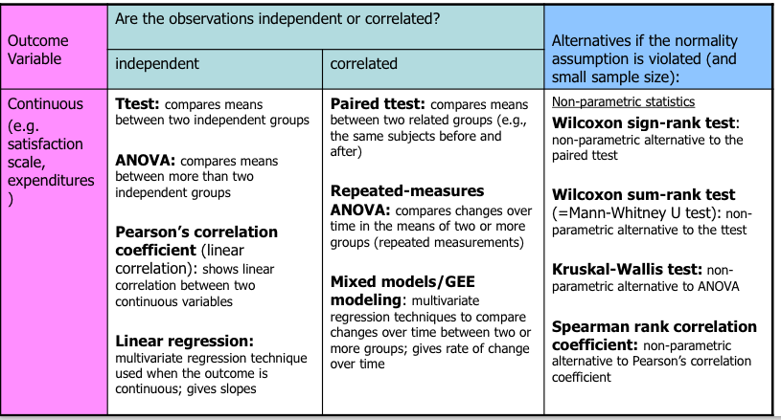

Seminar 7

Cluster Analysis

- Especially useful for market segmentation
- Segmentation – consumers in same group are similar with respect to a given set of characteristics
- Product characteristics and identification of new product opportunities
- Allows to reduce # of observations, by grouping them into homogenous clusters

Clustering Methods
- Hierarchical procedures
  - Agglomerative – start from n clusters to get to 1 cluster
  - Divisive – start from 1 cluster to get to n clusters
- Non-hierarchical procedures
  - K-means clustering
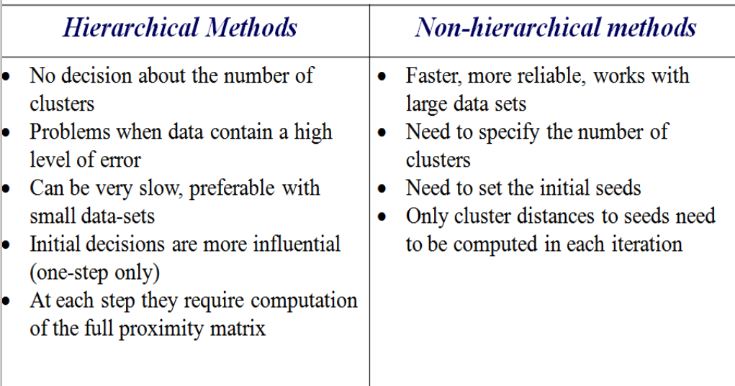
K-Means Method
    - Number k of clusters fixed
    - Initial set of k “seeds” is provided
    - Given a criteria fixed threshold – all units assigned to nearest cluster seed
    - New seeds computer
    - Go back to step 3 until no reclassification necessary

Determine number of clusters, c:
- Determined by analysis
- Fixed by researchers

For segmentation purposes, it’s less advisable to constrain the analysis to a fixed number of clusters

Determining Optimal Number of Cluster from Hierarchical Methods

Graphical
- Dendrogram
- Scree diagram
Statistical
- Arnold’s criterion
- Pseudo F statistic
- Pseudo t2 statistic
- Cubic clustering criterion (CCC)

Two-Step Clustering Procedures

- First perform a hierarchical method to define the number of clusters
- Then use the k-means procedure to actually form the clusters

Ideal if the desired number of clusters is unknown – finds the proper number of clusters
Or you can pre-specify the number of clusters required - flexibility

Seminar 8

Bivariate Linear Regression Analysis

- Regression analysis is a predictive analysis technique in which one or more variables are used to predict the level of another by use of the straight-line formula.
- Bivariate regression means only two variables are being analyzed, and researchers sometimes refer to this case as “simple regression.”

Independent variable – x (e.g. income level)
Dependent variable – that which is predicted, y (e.g. demand for luxury cars)

Y_{i} = b₀ + b₁X_{i} + E_{i}

b₁ – Regression coefficient for the predictor, slope, direction/strength
b₀ – Intercept, point at which regression line crosses y-axis

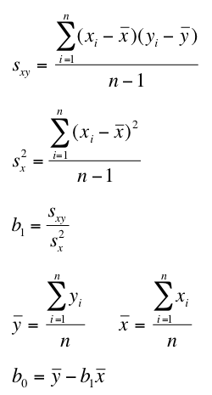

- SS_{T} – Total Sum of Square = Total variability (variability between scores and the mean).
- SS_{R} – Residual Sum of Squares = Residual/Error variability (variability between the regression model and the actual data).
- SS_{M} – Mean Sum of Squares = Model variability (difference in variability between the model and the mean).

Pearson Correlation Coefficient Squared: R² = SS_{M} / SS_{T}
Regression: Example

- A record company boss was interested in predicting album sales from advertising.
- Data
  - 200 different album releases
- Outcome variable:
  - Sales (CDs and Downloads) in the week after release
- Predictor variable:
  - The amount (in $) spent promoting the album before release.

Album sales _{i} = b₀ + b₁ advertising budget
= 134.14+(0.096*advertising budget)
= 134.14 + (0.096*100) 143.47

Outlier: Observation that is unusually small or unusually large

Multiple Regression Analysis: uses the same concepts as bivariate regression but uses more than one independent variable

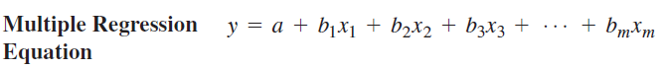

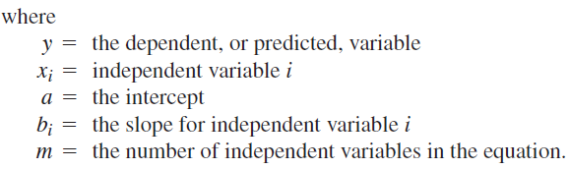

Multiple regression is a powerful tool because it tells us the following:
- Which factors predict the dependent variable (existence of the relationship)
- Which way (the sign) each factor influences the dependent variable (Direction of the relation)
- How much (the size of bi) each factor influences it (the strength of the relation)

Multiple R
- A.k.a. coefficient of determination
- Measure of strength of the overall linear relationship in multiple regression
- Indicates how well the independent variables can predict the dependent variable
- Ranges from 0 to +1 and represents the amount of dependent variable that is accounted for by the combined independent variables
- Researchers convert multiple R into a percentage – e.g. multiple R of 0.75 means that the regression findings will explain 75% of the dependent variable

Basic Assumptions of Multiple Regression
- Independence – independent variables must be statistically independent and uncorrelated
- Variance inflation factor (VIF) – can be used to assess and eliminate multicollinearity
  - Statistical value that identifies which independent variables contribute to multicollinearity (and should be removed)
  - Any variable with VIF > 10 should be removed

Stepwise Regression Procedure
- Useful when there are many independent variables and researcher wants to narrow down to smaller number of statistically significant variables
- The one independ ent variable that is statistically significant and explains most variance is entered first into MR equation
- Then each stat. significant indep. variable is added in order of variance
- All insignificant independent variables are excluded

