Shoulder Girdle
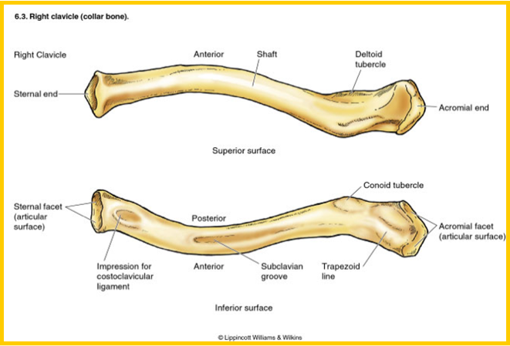
Clavicle | Bone inferior to the neck
Acromial extremity | Site of clavicle closest to the shoulder
Sternal extremity | Attachment site of the clavicle closest to the sternum
Conoid tubercle | Posterior of the clavicle, where bone is protruding outwards
Deltoid tubercle | On the clavicle near the acromial extremity
Trapezoid line | Posterior of the clavicle, diagonal line between the acromial extremity and the conoid tubercle
Subclavian groove | Posterior of the clavicle, in the center where there is a dent
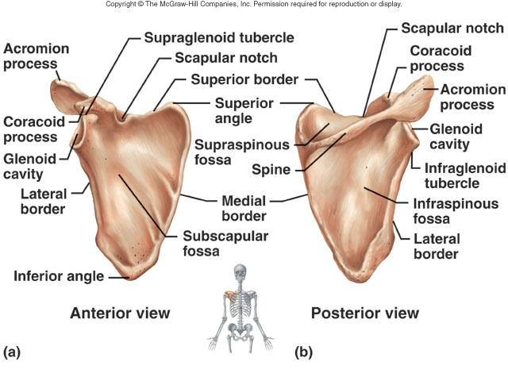
Scapula | Shoulder blade
Borders | Medial (vertebral): inner margin  Lateral (axillary): outer margin  Superior: top margin
Inferior angle | Bottom angle
Superior angle | Top angle
Spine | Posterior surface of the bone, that joins the clavicle from the acromion
Acromion (process) | Rounded bone between the spine and the clavicle, tip of the shoulder (the step)
Coracoid process | Protruding bone closest to where the scapula and the humerus meet, a little hook like structure on the scapula
Glenoid cavity | The dent where the head of the humerus slides into
Fossae | Supraspinous: posterior, dent above the spine  Infraspinous: posterior, dent below the spine  Subscapular: anterior, dent in the center
Supraglenoid tubercle | Outer lip of the glenoid cavity “above” on the scapula, where the head of the humerus attaches
Infraglenoid tubercle | Outer lip of the glenoid cavity “below” on the scapula, where the head of the humerus attaches
Scapular notch (superior notch)/ Suprascapular notch | Dent between the coracoid process and the superior border (small dip)

Arm
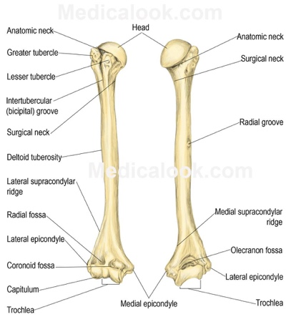
Humerus | Upper bone of the arm
Head | The round shaped end of the bone, which attaches to the shoulder
Anatomical neck | Region of the bone right below the head the neck of the humerus, where it attaches to the scapula
Surgical neck | Slightly below the anatomical neck
Greater tubercle | Outer protruding part of the bone between the anatomical and the surgical neck
Lesser tubercle | Inner protruding part of the bone between the anatomical and the surgical neck
Intertubercular (bicipital) groove | Groove between the greater and lesser tubercles
Shaft (body) | Skinniest part of the bone, in between the two ends
Radial groove | Posterior view, the dent in the middle of the bone
Deltoid tuberosity | A protruding point in the middle of the shaft of the humerus
Medial and lateral supracondylar ridges (crest) | Outer edges of the bones, above the epicondyles, right before its at the biggest
Medial and lateral epicondyles | Outer edges of the bone, the protruding parts that stick out at the elbow
Trochlear | Medial tip of the bone near the elbow
Capitulum | Lateral tips of the bone near the elbow
Fossae | Coronoid: anterior indents on the bone closest to the elbow  Radial: anterior indents on the bone closest to the elbow  Olecranon: the elbow, posterior indents on the bone closest to the elbow
Forearm *Refer back to anatomical position
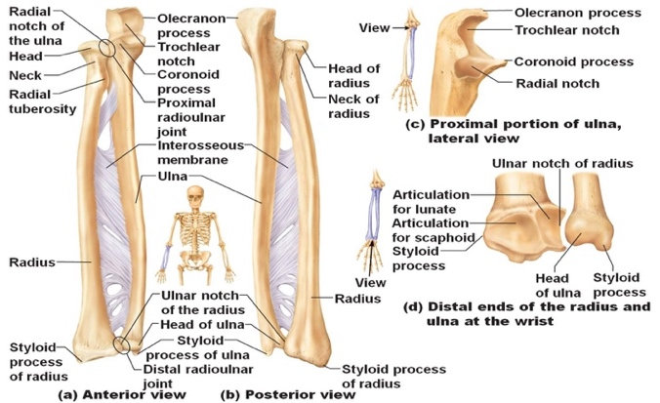
Radius | Lateral bone, thumb side
Head | Where it meets the humerus, circular in shape
Neck | Skinniest part right under the head
Radial tuberosity | Protruding part of the bone right below the neck of the radius
Shaft | The body of the bone
Interosseous margin | Interior part of the bone (kind of pointed) where the membrane attaches too
Dorsal tubercle (Lister’s tubercle) | Posterior view of the bone, near the base of the shaft the protruding bone in the center
Styloid process | Pointy part of the wrist, thumb side
Ulnar notch | Where the ulna rests, at the base of the shaft near the wrist
Ulna | Medial bone, pinky side
Olecranon (olecranon process) Elbow | Top tip of the ulna at the elbow where the humerus sits
Coronoid process | Bottom tip of the ulna at the elbow where the humerus sits
Trochlear notch | Hole where the humerus sits
Radial notch | Where the radius rests on the ulna, near the top of the shaft
Ulnar tuberosity | Protruding bone below the coronoid process
Supinator crest | Protruding bone under the radial notch and it meets with the interosseous margin
Shaft | The body of the ulna
Interosseous margin | Interior part of the bone (kind of pointed) where the membrane attaches too
Head | Top of the bone, the region where the olecranon is
Styloid process | Pointy part of the wrist, pinky side
Wrist
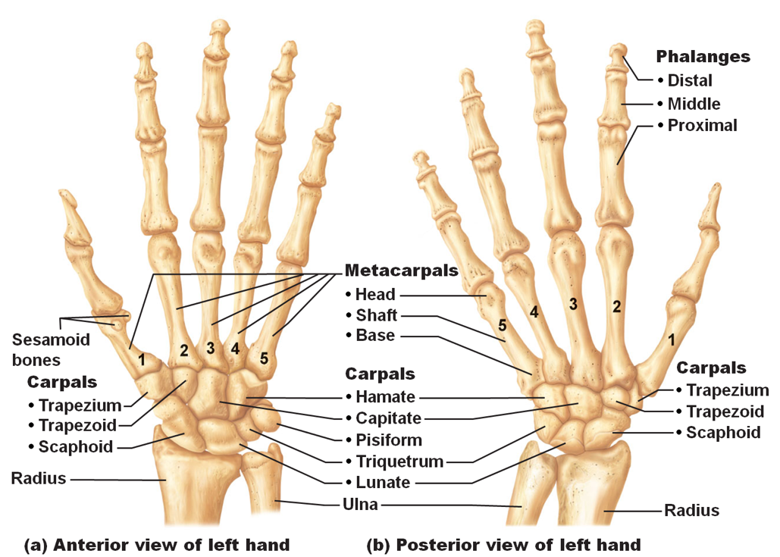
Carpal bones | Trapezium (1)  Distal  Trapezoid (2)  Capitate (3) in line with the 3rd metacarpal  Hamate (4 & 5)  Proximal  Scaphoid (1)  Lunate (2)  Triangular (3)  Pisiform (5) base of the pinky
Metacarpals (hand)
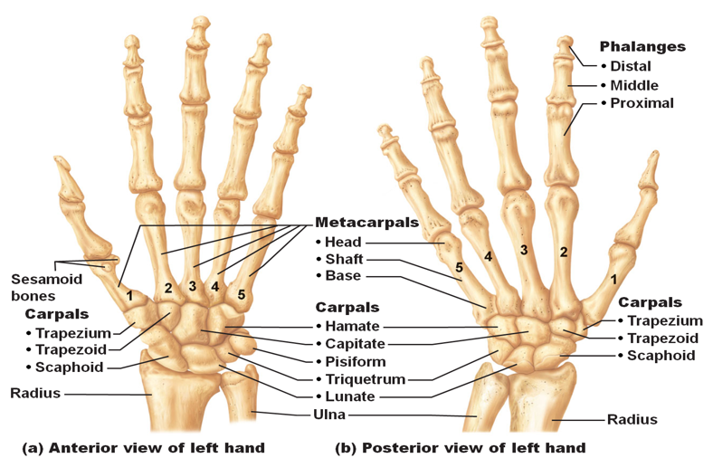
Metacarpals (5) | Numbered 1 to 5, from lateral to medial (thumb to pinky)  Base (proximal)  Shaft (middle)  Head (distal)
Fingers
Phalanx (14) | Proximal  Middle (digits 2 to 5)  Distal  Proximal (thumb/hallux)  Distal (Digit 1)
Classification of Joints
Synarthrosis | Fibrous; immoveable (slightly moveable), ex: skull:  Suture  Syndesmosis
Amphiarthrosis | Cartilaginous; slightly moveable, ex: rib cage:  Symphysis  Synchondrosis

Diarthrosis | Synovial; freely moveable:  Arthrodial (gliding) nonaxial, ex: clavicle  Ellipsoidal (condyloid) biaxial, ex: wrist  Ginglymus (hinge) uniaxial, ex: elbow  Sellar (saddle) biaxial, ex: thumb  Enarthrodial (ball & socket) multiaxial, ex: shoulder  Trochoid (pivot) uniaxial, ex: radius and ulna, radius pivots and the ulna is fixed
Joints and Major Ligaments of Shoulder Girdle and Upper Extremity
Sternoclavicular joint (synovial gliding)  - Clavicle  - Center where the sternum is  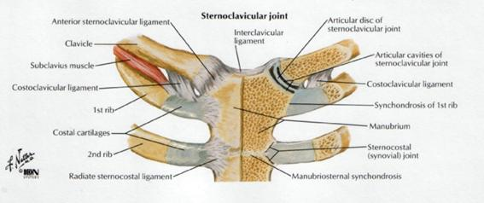 | Articular capsule (capsular ligament): envelop that holds everything together  Anterior and posterior sternoclavicular ligaments: tissue from clavicle to sternum  Costoclavicular ligament: tissue between the clavicle and the ribs  Interclavicular ligament: tissue at the top of the sternum
Acromioclavicular joint (synovial gliding)  - Clavicle  - Between the clavicle and the acromium  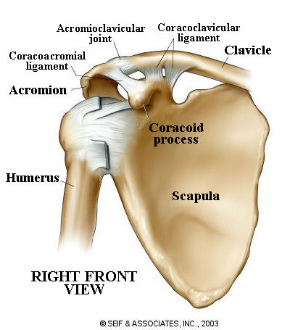 | Articular capsule (capsular ligament): envelop that holds everything together  Acromioclavicular ligaments (superior and inferior): between the clavicle and acromion  Coracoclavicular ligament: between the clavicle and the scapula  - Trapezoid ligament: attaches to the trapezoid line, it is anterior  - Conoid ligament: attaches to the conoid process, it is posterior
Glenohumeral joint (ball and socket joint)  - Shoulder joint  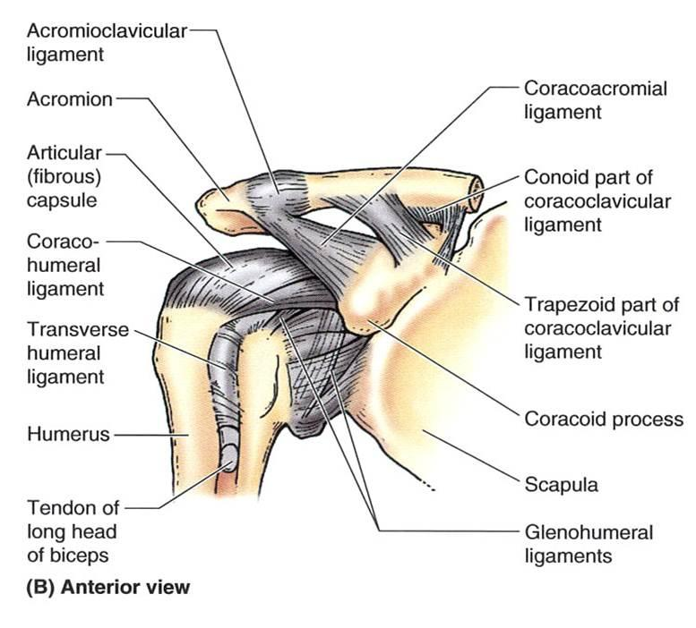 | Articular capsule (capsular ligament): envelop that holds everything together  Glenohumeral ligaments (superior, middle, inferior): between the glenoid cavity and the humerus  Coracohumeral ligament: between the coracoid process and the humerus  Transverse humeral ligaments: tissue going from one tubercle to the other on the humerus  Coracoacromial ligament: between the coracoid process and the acromion  Glenoid labrum: near the glenoid cavity of the scapula (small piece), a cartilage ring surrounding the glenoid fossa so there is no bone on bone
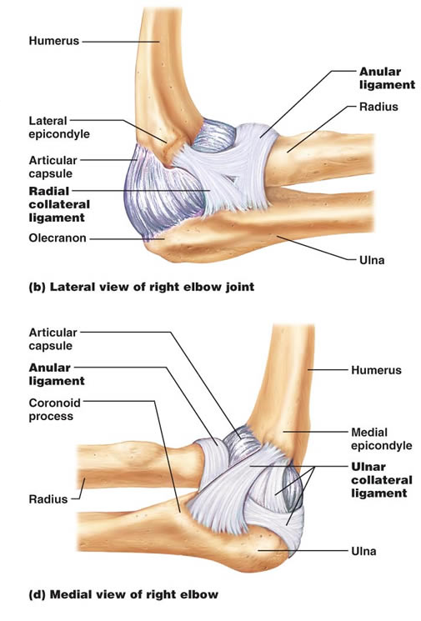  Elbow joint (synovial hinge) | Articular capsule (capsular ligament): envelop that holds everything together  Ulnar collateral ligament: between the ulna and the humerus, the outer side  Radial collateral ligament: between the radius and the humerus, the inner side
Proximal radioulnar joint (synovial pivot)  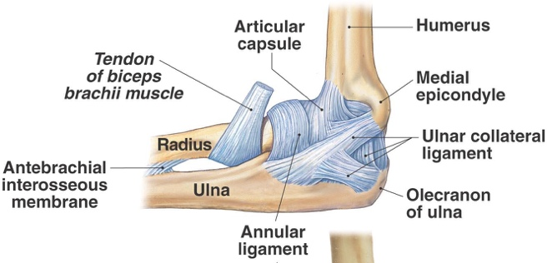 | Articular capsule (capsular ligament): envelop that holds everything together  Annular ligament: around the head of the radius

Muscle | Origin | Insertion | Action | Innervation
Pectoral region:
Pectoralis major | Clavicular head: medial clavicle  Sternocostal head: sternum and costal cartilages of second to 6th ribs (sometimes to 7th) | Greater tubercle and lateral lip of intertubercular sulcus of humerus | Flexion, adduction and medial rotation of humerus | Medial and lateral pectoral n.
Pectoralis minor (deep to pec major) | Ribs 2 to 5 (sometimes 3 to 5 or 2 to 4) near their costal cartilages | Coracoid process of scapula | Abduction and downwards rotation of the scapula (helps in the elevation of the ribs when pectoral girdle is fixed) | Medial pectoral n.
Subclavius | 1st rib | Subclavian groove of the clavicle | Depresses the clavicle | Subclavian n.
Serratus anterior | Ribs 1 to 8 (sometimes 1 to 9) | Vertebral (medial) border and inferior angle of the scapula | Abduction and upward rotation of the scapula (protraction) | Long thoracic n.
Serratus posterior superior (deep to rhomboids) | Lig. Nuchae, spinous processes of C7 to T3 vertebrae (cervical to thoracic) | Superior border of ribs 2 to 4 | Elevation of ribs | 2 to 5 intercostal n.
Serratus posterior inferior | Spinous processes of T11 to L2 vertebrae (thoracic to lumbar spine) | Inferior borders of ribs 8 to 12 near their angles | Depression of ribs | 9 to 12 thoracic spinal n.
Muscles connecting the upper limb to the vertebral column
Trapezius (trapezoid shape from base of the skull, lining the spine and to the acromion | Occipital bone, lig. Nuchae , spinous processes of C7 to T12 | Lateral third of the clavicle, spine and acromion of the scapula | Superior fibers: upward roation of the scapula, sup. fibers can also help extend the head  Middle fibers: adduction (retraction) of the scapula  Inferior fibers: depression and upwards rotation of the scapula | Accessory (C XI) and cervical spinal nerves C3 to C5
Latissimus dorsi (superficial) | Spinous processes of T7 to L5, sacral crest, iliac crest and inferior four ribs (thoracic, lumbar and sacral spine) | Floor of intertubercular groove of the humerus | Extension, adduction and medial rotation of the humerus | Thoracodorsal n.
Levator scapulae (neck to scapula) | Transverse processes of atlas (C1), axis (C2), C3 to C4 | Upper third of the medial (vertebral) border of the scapula | Elevation and downward rotation od the scapula | Dorsal scapular n. and cervical n. (C3-C4)
Rhomboid major (inferior to minor but bugger in size) | Spinous processes of T2 to T5 | Lower third of the medial (vertebral) border of the scapula | Elevation, adduction and downward rotation of the scapula; stabilizes the scapula | Dorsal scapular n.
Rhomboid minor (above major) | Spinous processes of C7 to T1 | Medial (vertebral) border of the scapula superior to the spine | Elevation, adduction and downward rotation of the scapula; stabilizes the scapula | Dorsal scapular n.
Scapular and Rotator Cuff Group
*Deltoid (shoulder muscle) | Lateral third of clavicle, acromion and spine of scapula | Deltoid tuberosity of humerus | Lateral fibers: abduction of arm (lat. raises)  Anterior fibers: flexion and medial rotation of the arm (punching)  Posterior fibers: extension and lateral rotation (elbowing) | Axillary n.
*Supraspinatus (posterior above the spine of the scapula) | Supraspinous fossa of the scapula | Greater tubercle of the humerus | Assists deltoid muscle in abduction of the arm at the shoulder joint | Suprascapular n.
*Infraspinatus (posterior below the spine of the scapula) | Infraspionous fossa of the scapula | Greater tubercle of the humerus | Lateral rotation of the arm at the shoulder joint | Suprascapular n.
*Teres minor (posterior below the infraspinatus, in the deltoid) | Inferior lateral border of the scapula | Greater tubercle of the humerus | Lateral rotation of the arm at the shoulder joint | Axillary n.
Teres major (below teres minor but bigger in size, in the deltoid) | Inferior angle of the scapula | Medial lip of the intertubercular groove of the humerus | Extends the arm at the shoulder joint and assists in adduction and medial rotation of the arm | Lower subscapular n.
*Subscapularis | Subscapular fossa of scapula | Lesser tubercule of the scapula | Medial rotation of the arm at the shoulder joint | Upper and lower subscapular n.
*Those with the asterisk make up the rotator (musculotendinous) cuff muscles

Muscles of the Arm
Biceps brachii (2 parts) | Long head (lateral): supraglenoid tubercle of the scapula passing through the intertubercular groove  Short head (medial): coracoid process of the scapula | Radial tuberosity of the radius and deep fascia of the forearm via the bicipital aponeurosis (blends with the fascia of the forearm) | Flexion of forearm at the elbow joint, supination of the forearm at the radio-ulnar joint, flexion of the arm at the shoulder joint | Musculocutaneous n.
Brachialis | Distal, anterior surface of the humerus (midway down) | Ulnar tuberosity and the coronoid process of the ulna | Flexion of the forearm at the elbow joint | Musculocutaneous and radial n.
Coracobrachialis (coracoid process to biceps, crosses underneath biceps brachii) | Coracoid process of the scapula (finishes mid shaft of the humnerus) | Medial surface (middle third) of the shaft of the humerus | Flexion and adduction of the arm at the shoulder joint | Musculocutaneous n.
Triceps brachii (3 parts) | Long head: infraglenoid tubercle of the scapula  Lateral head: lateral and posterior surface of the humerus (above the radial groove)  Medial head: posterior surface of the humerus below the radial groove (deep) | Olecranon process of the ulna (elbow) | Extension of the arm at the shoulder joint and extension of the forearm at the elbow joint | Radial n.

Anterior forearm (superficial group)
Pronator teres (1) | Medial epicondyle of the humerus and the coronoid process of the ulna | Mid-lateral shaft of the radius | Pronation of the forearm at the radio-ulnar joint, flexion of the forearm at the elbow joint | Median n.
Flexor carpis radialis (1) (anterior) | Medial epicondyle of the humerus | Base of second and third metacarpals | Flexion and abduction(radial deviation) of the hand at the wrist joint | Median n.
Palmaris longus (1) (middle forearm) | Medial epicondyle of the humerus | Flexor retinaculum and palmar aponeurosis | Tenses palmar aponeurosis, flexion of the hand at the wrist joint | Median n.
Flexor carpi ulnaris (1) (posterior to the left) | Medial epicondyle of the humerus | Pisiform, hook of hamate and base of the 5th metacarpal | Flexion and adduction (ulnar deviation) of the hand at the wrist joint | Ulnar n.
Flexor digitorum superficialis (2) (outside of the forearm deeper to the first layer) | Medial epicondyle of the humerus, proximal radius and ulna | Middle phalanx of the digits 2 to 5 | Flexion of the middle phalanges of digits 2 to 5, flexion of the hand at the wrist joint | Median n.

Anterior forearm (deep group)
Flexor digitorum profundus (3) (outside of the forearm) | Anterior medial shaft of the ulna, interosseous membrane | Base of the distal phalanges of the digits 2 to 5 | Flexion of the distal phalanges of digits 2 to 5, flexion of the hand at the wrist joint | Median and ulnar n.
Flexor pollicis longus (3) (below the ulna head) | Anterior surface of the radius and the interosseous membrane | Base of the distal phalanx of the thumb | Flexion of the distal phalanx of the thumb | Median n.
Pronator quadratus (4) (at the bottom like a wrist band, across) | Distal shaft of the ulna | Distal shaft of the radius | Pronation of the forearm at the radio-ulnar joint | Median n.
Posterior forearm (superficial group)
Brachioradialis (at the top, on the posterior near the elbow) | Lateral border of the distal end of the humerus | Superior to the styloid process | Flexion of the forearm at the elbow joint | Radial n.
Extension carpi radialis longus (at the top, on the posterior near the elbow) | Lateral supracondylar ridge of the humerus | Base of the second metacarpal | Extension and abduction of the hand at the wrist joint | Radial n.
Extensor carpi radialis brevis (posterior) | Lateral epicondyle of the humerus | Base of the third metacarpal | Extension and abduction of the hand at the wrist joint | Radial n.
Extensor digitorum (posterior, below the elbow) | Lateral epicondyle of the humerus | Middle and distal phalanges of digits 2 to 5 | Exrtension of digits 2 to 5, extension of the hand at the wrist joint | Radial n.
Extensor digiti minimi (posterior forearm, pinky side) | Lateral epicondyle of the humerus | Tendon of extensor digitorum on the 5th phalanx | Extension of the 5th digit | Radial n.
Extensor carpi ulnaris (posterior, in the middle) | Lateral epicondyle of the humerus, posterior border of the ulna | Base of the 5th metacarpal | Extension and adduction (ulnar deviation) | Radial n.
Anconeus (anterior, at the bottom of the lateral epicondyle, not always present and it assist in elbow extension) | Lateral epicondyle of the humerus | Olecranon of the ulna | Extension of the forearm at the elbow joint | Radial n.
Posterior forearm (deep group)
Supinator (on the radius below the head) | Lateral epicondyle of the humerus and the supinator crest of the ulna | Lateral proximal third of the radius | Supination of the forearm at the radio-ulnar joints | Radial n.
Abductor pollicis longus | Posterior middle surface of the radius and ulna, interosseous membrane | Base of 1st metacarpal | Abduction and extension of the thumb, abduction of the hand at the wrist joint | Radial n.
Extensor pollicus brevis | Posterior middle surface of the radius, interosseous membrane | Base of the proximal phalanx of the thumb | Extension of the proximal phalanx of the thumb, extension of the 1st metacarpal and abduction of the hand at the wrist joint | Radial n.
Extensor pollicis longus | Posterior middle surface of the radius, interosseous membrane | Base of the distal phalanx of the thumb | Extension of the distal phalanx of the thumb, extension of the 1st metacarpal and abduction of the hand at the wrist joint | Radial n.
Extensor indicis | Posterior distal surface of the ulna, interosseous membrane | Blends into the tendon of the extensor digitorum of the 2nd digit | Extension of the index finger, extension of the hand at the wrist joint | Radial n.

Muscles of the thumb (thenar muscles)
Muscle | Innervation
Abductor pollicis brevis | Median n.
Flexor pollicus brevis | Median n.
Opponens pollicus (deep to the abductor and the flexor) | Median n.
Adductor pollicus (oblique and transverse heads) (near the web) | Ulnar n.
Muscles of the little finger (hypothenar muscles)
Abductor digiti minimi | Ulnar n.
Flexor digiti minimi brevis | Ulnar n.
Opponens digiti minimi | Ulnar n.

Muscles of palm
Muscle | Action | Innervation
Lumbricales (4) (between the metacarpal bones) | Flexion of the metacarpo-phalangeal joints, extension of the interphalangeal joints | 1-2 median n.  3-4 ulnar n.
Palmar interossei (3) (sometimes 4) | Adduction of the fingers | Ulnar n.
Dorsal interossei (4) | Abduction of the fingers | Ulnar n.
Capri = wrist
Pollicus = thumb
Digitorum = digits 2 to 5
Indicis = digit 2 (index)
Digiti minimi = digit 5 (pinky)
Fascia and synovial sheaths
Flexor retinaculum (transverse carpal ligament)
Extensor retinaculum (dorsal carpal ligament)
Palmar aponeurosis
Flexor synovial sheaths (protective cushion)

Spinal Cord
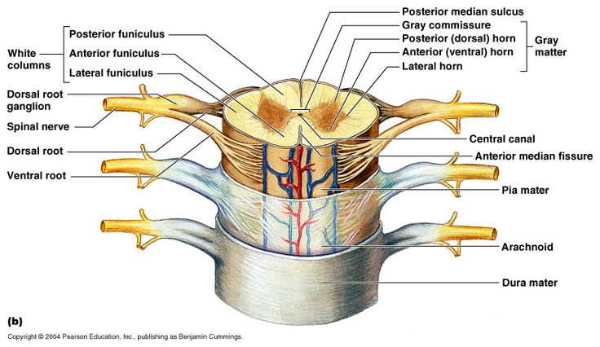
White matter (white appearance are myelinated portion of the neurons) | Posterior (dorsal) median sulcus  Anterior (ventral) median sulcus
Grey matter (non-myelinated portion) | Grey commissure  Central canal  Anterior horns (bigger)  Posterior horns
Dorsal root ganglia (posterior) (has a big bump)
Dorsal root (posterior)
Ventral root (anterior)
Spinal nerve (when they come together)
- 31 pairs of spinal nerves
- come off segmentally from the spinal cord by joining the anterior and posterior roots
- Pass through the intervertebral foramina and classified as:
        - 8 Cervical (C)
        - 12 Thoracic (T)
        - 5 Lumbar (L)
        - 5 Sacral (S)
        - 1 Coccygeal (C_{o})

Innervation: | Muscles:
Dorsal scapular (C5) | Rhomboids, levator scapulae
Long thoracic (C5, C6, C7) | Serratus antherior
Suprascapular (C5, C6) | Supraspinatus, infraspinatus
Upper subscapular (C5, C6) | Subscapularis
Lower subscapular (C5, C6) | Subscapularis, teres major
Thoracodorsal (C6, C7, C8) | Latissimus dorsi
Lateral pectoral (C5, C6, C7) | Pectoralis major
Subclavian (C5, C6) | Subclavian
Musculocutaneous (C5, C6, C7) | Flexors on the anterior aspect of the arm
Axillary (C5, C6) | Deltoid, teres minor
Radial (C5-T1) | Posterior arm muscles
Median (C5-T1) | Flexors of the forearm (except flexor carpi ulnaris)
Ulnar (C7, C8, T1) | Flexors on the ulnar side of the forearm and the hand
Median pectoral (C8, T1) | Pectoralis major, pectoralis minor

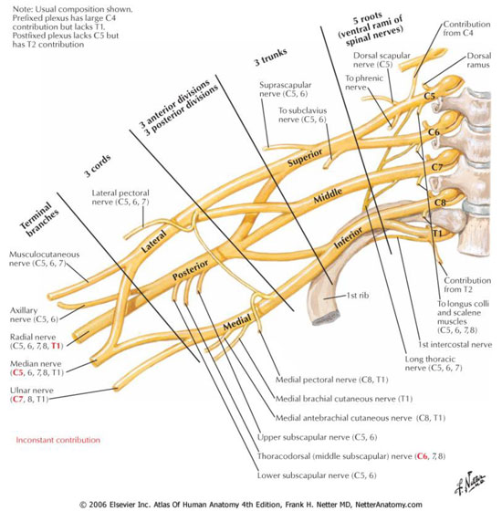
Armpit
Anterior
Anterior
Anterior
Posterior
Posterior
Posterior

Introduction to the nervous system

- Neuron = nerve cell
- The basic structural and functional component of the nervous system
- Conducts impulses to and from the two main nervous systems
  - Central Nervous System (CNS)
  - Peripheral Nervous System (PNS)’

The Neuron (3 parts) – motor and sensory
- Dendrites
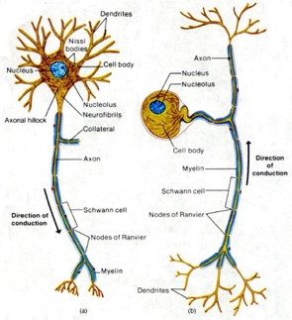
- Cell body
- Axon

- Dendrites
- Cytoplasmic processes
- Reception of stimulus
- Impulses to cell body
- Several to each neuron

- Cell body
- Many dendrites entering
- One 1 axon leaving

- Axon
- Cytoplasmic process
- Only one neuron
- Conducts impulses away from cell body
- May have several collateral branches
- Axon = nerve fiber
- Neurofibrils

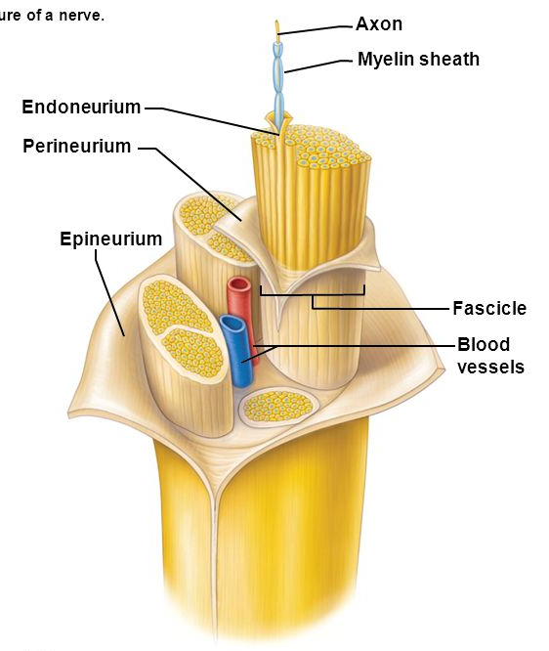
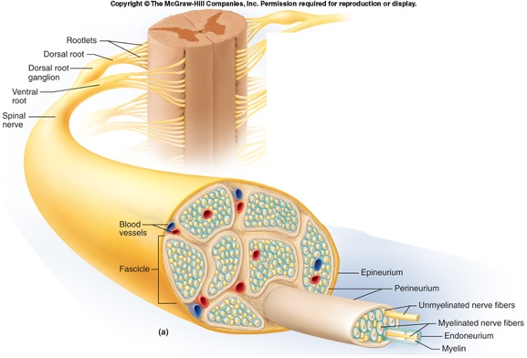
Nerve structure (coverings)

- Epineurium: around the whole nerve
- Perineurium: around the fascicles
- Endoneurium: around nerve fibers (axon)
- Axon: myelinated/non-myelinated

Qualities of a nerve

- Excitability: the ability of a neuron to respond to a stimulus and convert it to an impulse.

- Conductivity: the ability to transmit an impulse to another neuron or other tissue

Spinal Cord

- Surrounding grey commissure are areas of white matter
- White matter: nerve fibers with myelin sheath coverings
- Each white nerve bundle = tract
- Tracts within the spinal cord and brain
- Ascending tracts: sensory or afferent
- Descending tracts: motor or efferent
- White tracts found anterior, posterior, and lateral to the grey commissure

- Dorsal roots: groups of nerve fibers entering the dorsal horns:
  - contain sensory neurons
- Ventral roots: groups of nerve fibers leaving ventral horns
  - Contain motor neurons
DORSAL ROOT + VENTRAL ROOT = SPINAL NERVE
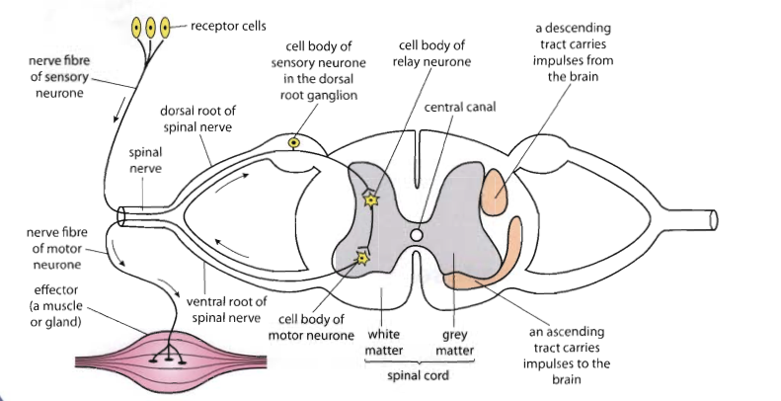

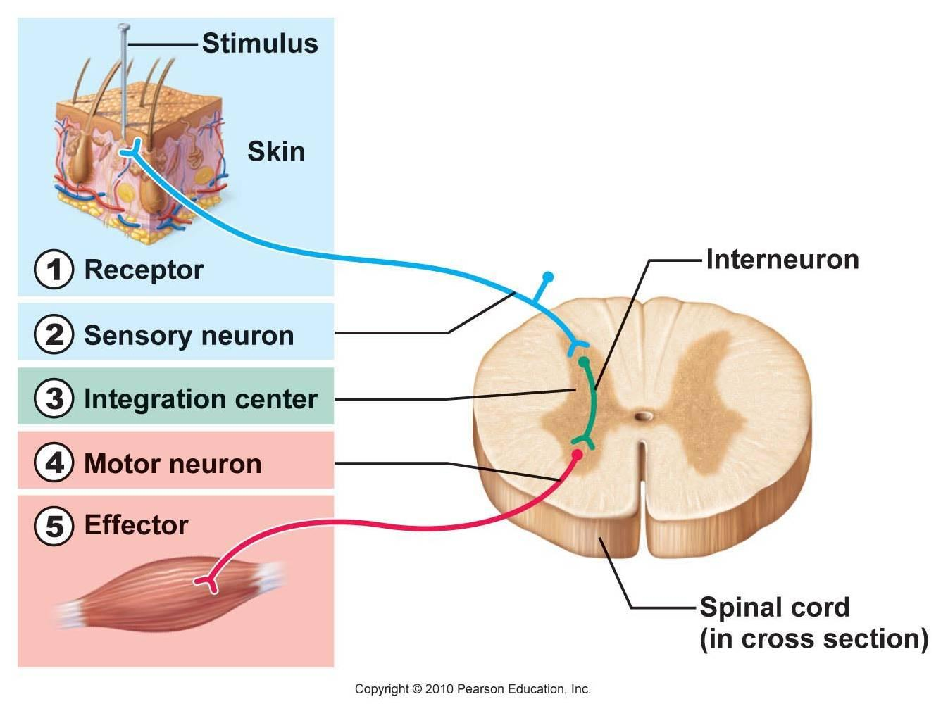
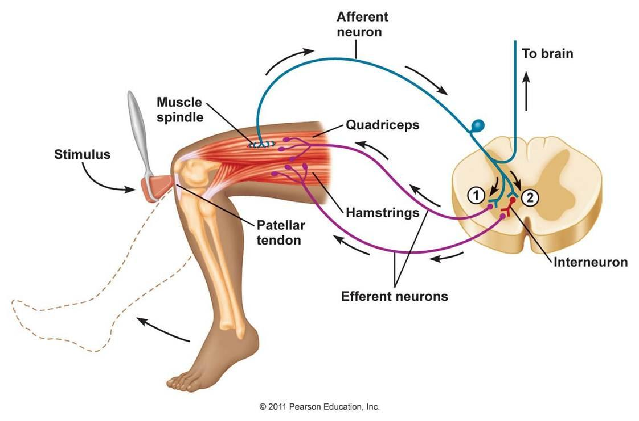
Monosynaptic

Spinal Nerves

- Spinal nerves = mixed nerves
- Mixed nerves: sensory + motor
- 31 pairs of spinal nerves
- Spinal nerve divides after leaving intervertebral foramen (holes of the sides)
- Ramus/Rami (neck)
- Dorsal rami: innervate skin of back, paravertebral muscles
- Ventral rami: innervates all extremity muscles, lateral and ventral trunk

VERTEBRAE | SPINAL NERVES
Cervical = 7 | Cervical = 8
Thoracic = 12 | Thoracic = 12
Lumbar = 5 | Lumbar = 5
Sacral = 5 | Sacral = 5
Coccygeal (coccyx) = 4 | Coccygeal = 1
Total = 33 | Total = 31 pairs

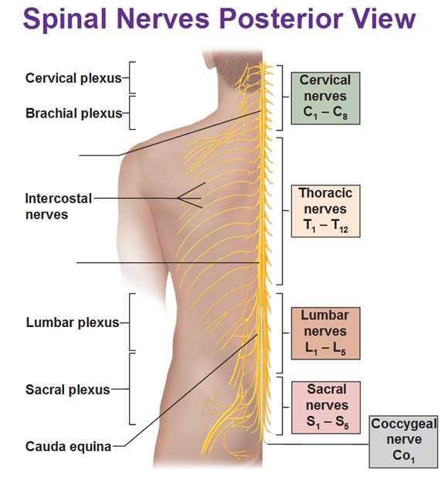

- Ventral rami of spinal nerves form plexuses (plexi) = networks

- Except T2 –T12 and S5 – Co1

- Plexuses
  - Cervical: C1 – C4
  - Brachial: C5 – T1
  - Lumbar: L1 – L4
  - Sacral: L4/L5 – S4

- Lumbar + Sacral = Lumbosacral

Brachial Plexus
- Rami
- Trunks
- Divisions
- Cords
- Branches
- Axillary nerve (C5, C6)
- Musculocutaneous nerve (C5, C6, C7)
- Median nerve (C5, C6, C7, C8, T1)
- Ulnar nerve (C7 others), (C8, T1)
- Radial nerve (C5, C6, C7, C8, T1)

- Descends, passes over the first rib, behind clavicle, and into the armpit (axilla)
- Accompanies axillary artery and vein
- Connective tissue covering: axillary sheath
- Posterior to pectorals major
- Cords names in relation to axillary artery

- Ventral rami of C5 and C6 join to form the upper trunk
- Ventral rami of C7 continues as middle trunk
- Ventral rami of C8 and T1 join to form lower trunk

- Each trunk divides into an anterior and posterior division
- The 3 posterior divisions join to for the posterior cord
- Posterior cord becomes the radial nerve
- Main branch of radial nerve is the axillary nerve
- Medial cord from anterior division of lower trunk
- Lateral cord from anterior divisions of upper and middle trunks

Radial Nerves (C5, C6, C7, C8, T1)
- Largest branch of the brachial plexus
- Lies behind the axillary artery
- Lies in front of supraspinatous
- Innervates whole posterior upper extremity
- Winds behind humerus, under triceps, in radial groove
- Deep into ante cubital fossa, behind brachialis and brachioradialis
- Ends in lateroposterior forearm in several branches
- Reflexes: brachioradialis (C6), triceps (C7)

Axillary Nerve (C5, C6)
- Branch of posterior cord
- Runs lateral to radial nerve
- Media to surgical neck of humerus
- Into deltoid and teres minor muscles
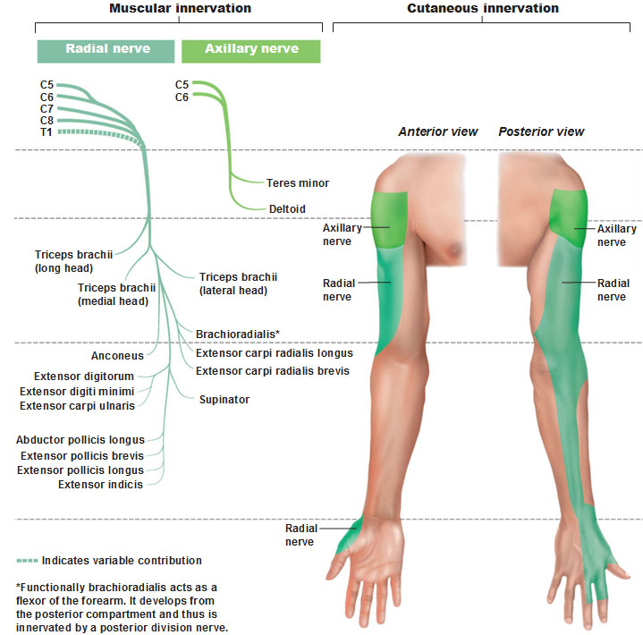

Musculocutaneous Nerve:
- Pierces the coracobrachialis muscles
- Supplies anterior arm muscles
- Reflex: Biceps (C5)

Median Nerve (C5, C6, C7, C8, T1)
- Innervates most of the forearm flexor mucles
- Thumb side of hand and wrist
- Superficial and anterior wrist

Ulnar Nerve (C7) C8, T1
- Passes behind medial epicondyle
- Runs down medial forearm
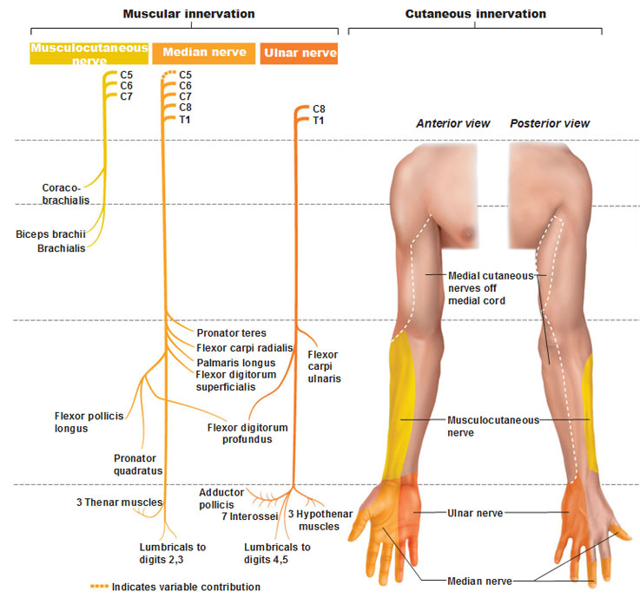
- Innervates some flexor muscles and many intrinsic muscles of the hand
Dermatomes

- skin supplied by Somatic Sensory Nerves
- Afferent nerves
- All spinal nerves have branches from the skin except C1
- “The area of skin providing sensory imput to the posterior roots or one spinal section called a DERMATOME”
- No exact boundaries
- Considerable overlap
- Lesion to one spinal nerve, may be little or no loss of sensation
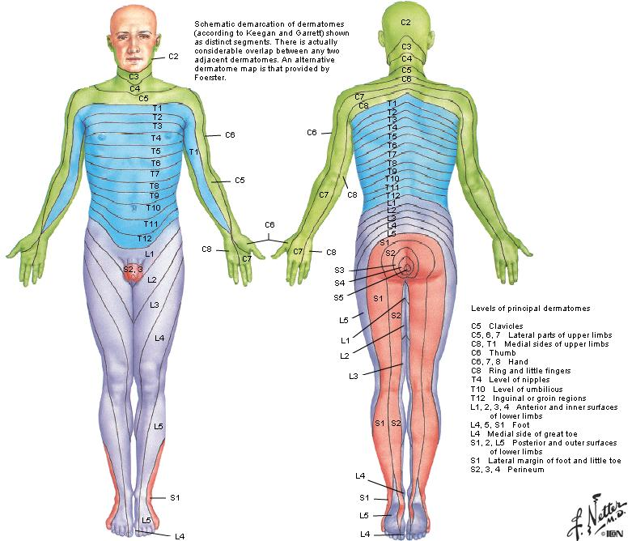
- Usually 3 adjacent lesions for there to be complete anesthesia to a dermatome

General Circulation
- Blood moves away from the heart in arteries
- Branch to form smaller arteries
- Small arteries <0.5mm diameter = Arteriole
- Disperse O2 and nutrients into capillaries
- Diffusion takes place in capillaries
- Waste products are picked up by here by Venules
- Venules join to form larger vessels = Veins

Arteries
- Small adjacent arteries can form to accommodate blood flow
- Connecting arteries = anastomosis
- Anastomosis is collateral circulation

Arteries Layers
- Tunica Intima (Internal)
  - Inner layer is formed by Squamous epithelium
  - Inner wall forms the hole (Lumen)
  - Attached by connective tissue membrane to the Tunica media
- Tunica media:
  - thick intermediate layer formed by smooth muscle and elastic tissue
- Tunica Externa (Adventitia):
  - Outermost fibrous layer
  - Can contain some smooth muscle

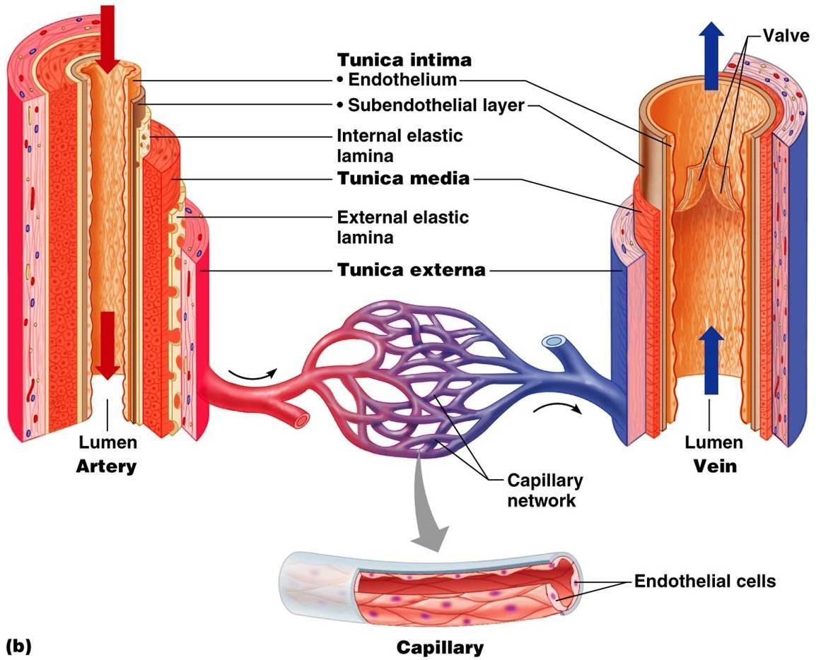

Capillary
- 1mm long and 8-10 microns diam
- Walls formed by single layer of epithelial cells (simple squamous)
- Penetrate every (?) of the body
- Forms most important part of the circulatory system (capillary bed)
- Between arterioles and venules
- Essential exchange of materials to maintain consistency of internal environment

Venules
- Small veins that come from capillaries to form veins

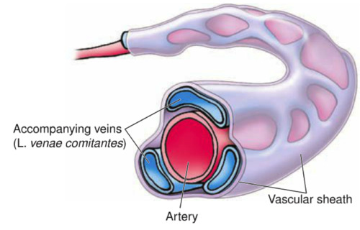
Veins
- Same 3 coats as arteries (tunics)
- Tunical media is much thinner
- Limited layer of smooth muscle
- Often 2 or more veins to accompany each artery (Venae Comitantes)
- Veins have valves
- Valves are made from folds of the Tunica Intima
- Aids in blood flow back to the heart

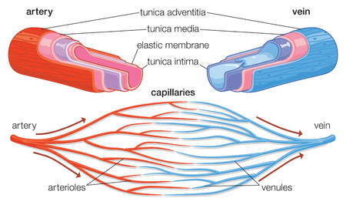

Arteries of the upper extremity
- Aorta
- Ascending aorta
- Aortic arch:
  - 3 branches
  - (Right) brachiocephalic trunk (Artery)
    - Right subclavian artery
    - Right common carotid artery: enters the head and neck region
  - Left subclavian artery
  - Left common carotid artery: enters the head and neck region
- Descending aorta
- Right & Left vertebral arteries: branch from the subclavian and enters the head and neck region

- Subclavian artery exits from under the first rib, and changes name to Axillary artery
- Axillary artery reaches the humerus at bicipital groove, it changes its name to Brachial artery
- Anterior and posterior Humeral Circumflex arteries around humeral neck (they anastomose (join) together)
- Brachial artery bifurcates below elbow (usually) into the Radial artery (lateral) and Ulnar artery (medial)
- In wrist area, these both divide into superficial and deep Palmar Arches
- Digital branches run through the fingers from the arches

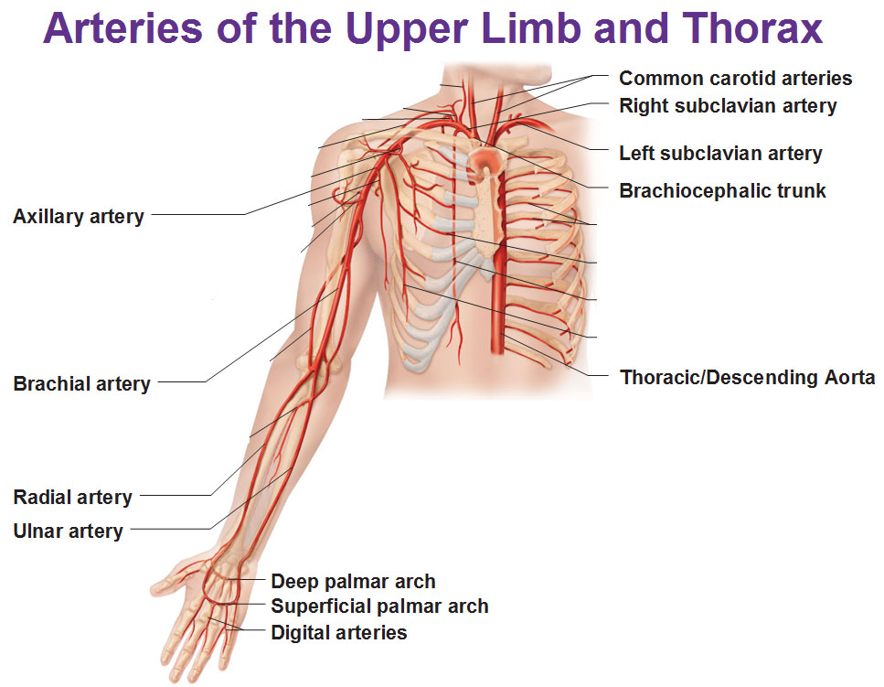
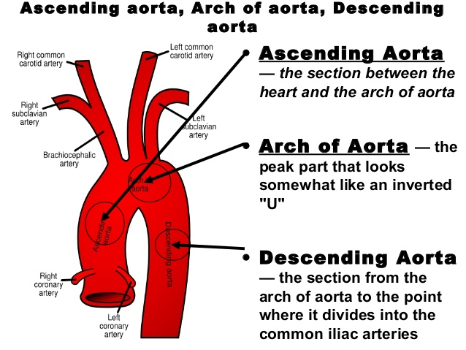

Humeral circumflex

Veins of the upper extremity

- In the hand, there are many Tributaries
- Many join from larger veins
- Main large veins in the hand, forearm, and arm are:
  - Cephalic Vein
  - Basilic Vein

- Cephalic Vein travels through the delto-pectoral groove and then into the axillary vein
- In the elbow (cubital) region, the cephalic and basilic veins are connected by the median cubital vein

- Deep veins in the arm form the Brachial Vein/s
- Brachial and basilica veins join together to form the axillary vein
- Axillary artery and vein are together in axillary sheath
- External jugular veins enter the subclavian vein
- Internal jugular vein joins subclavian vein to form the Brachiocephalic vein
- At the heart, the right and left Brachiocephalic Veins join to form the Superior Vena Cava

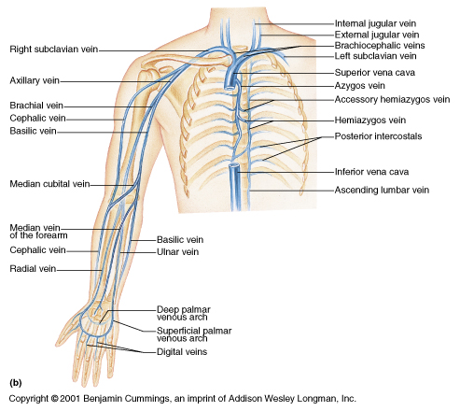
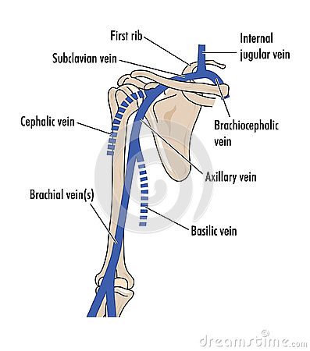

The axilla
- “A pyramid (cone) interval between the arm and the chest wall”

Boundaries of the axilla
- Base
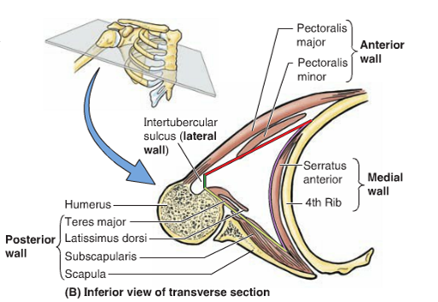
  - Skin/fascia of armpit
- Apex
  - Posterior clavicle
  - Superior scapula
  - External border of first rib
- Anterior wall
  - Pectoralis major and minor
  - (Anterior axillary fold)
- Posterior wall
  - Subscapularis
  - Teres major/Latissimus dorsi
  - (Posterior axillary fold)
- Medial Wall
  - Upper ribs
  - Intercostal muscles
  - Serratus anterior
- Lateral wall
  - Bicipital groove of humerus
  - (bicep brachii, coracobrachialis, triceps brachii)

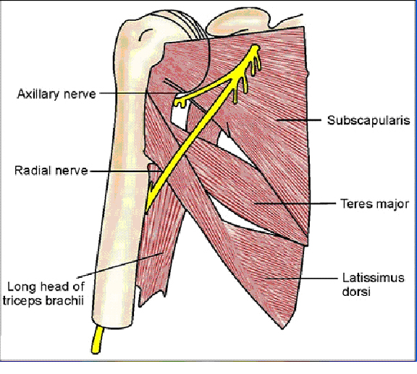
Contents of the axilla
- Axillary artery
- Axillary vein
- Brachial plexus and branches
- Fascia
- Lymph nodes
- Proximal part of Cephalic vein

Landmarks of the axilla

- Triangular space
  - Lateral: long head of the tricep brachii
  - Superior: teres minor
  - Inferior: teres major
Contents: branch of Subscapular nerve (circumflex scapular)

- Quadrangular space
  - Lateral: humerus
  - Medial: long head of the tricep brachii
  - Superior: teres minor
  - Inferior: teres major
Contents: axillary nerve, posterior humeral circumflex artery
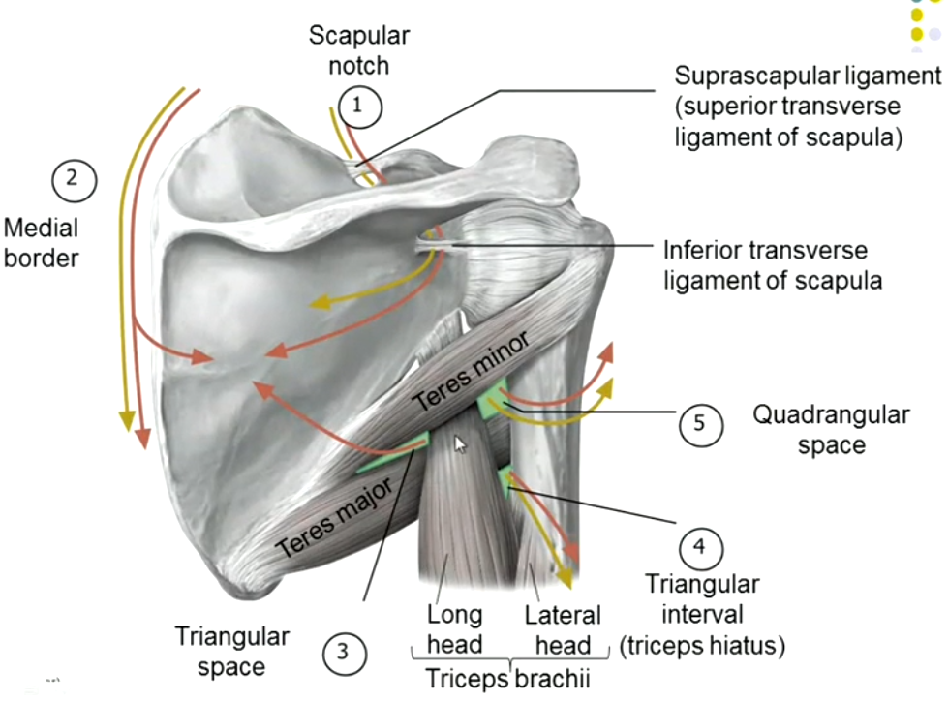

(Ante) Cubital Fossa boundaries

- Lateral: brachioradialis
- Medial: pronator teres
- Apex: where the 2 muscles meet
- Base: imaginary line across both epicondyles

- Floor:
  - brachialis
  - supinator
- Roof:
- fascia
- biceps brachii aponeurosis
- Contents:
- Biceps brachii (tendon)
- Brachial artery
- Median and Radial nerves

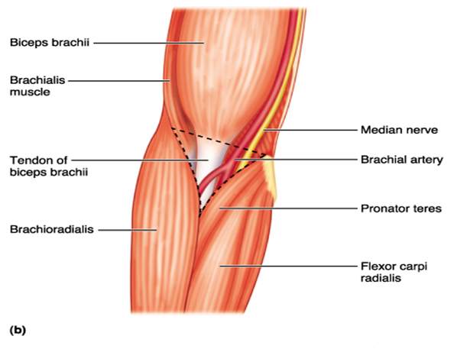

Muscle Tissue
Characteristics of muscles cells/fibers

- Irritability:
  - muscles react to stimulus (nervous tissue)
  - receives and then responds to a stimulus
- Contractility:
  - muscles shorten
  - get thicker
- Extensibility:
  - Muscles stretch
  - Get thinner (long + thin)
** As bicep gets shorter and thicker, the opposing muscle (triceps) gets longer and thinner. Same goes for the leg while it kicks, the quadriceps and hamstring **
- Elasticity:
  - Allows muscle to return back to its original shape

Types of muscle tissue (mesoderm)

- Skeletal
  - Striated (striped)
  - Voluntary (under our conscious control, lift hand to drink water)
- Smooth
  - Non striated (any way)
  - Involuntary (no conscious control)
  - Visceral (organs intestines)
- Cardiac
  - Striated
  - Specialized
  - Involuntary (no conscious control, heart beat)

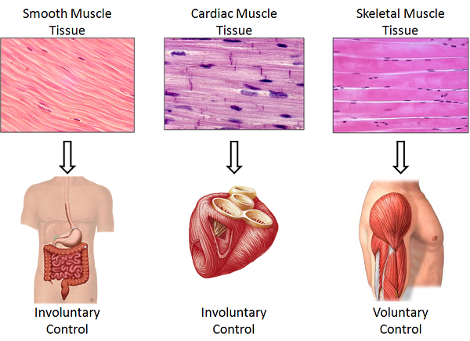

Fascia
- Dense irregular connective tissue
- Completely surrounds the muscle or groups of muscle
- Skeletal muscle is found deep to it
- Extension of the fascia = Epimysium
- Epi = on top

- Entire muscle covered by Epimysium
- Whole muscle = group of fascicles
- Fascicle/ fasciculus
- Fascicles/ fasciculi
- Each fascicle is covered by Perimysium

- Each fascicle is made up of bundles of muscle fibers
- Each muscle fiber is covered by Endomysium
- Muscle fiber = muscle cell

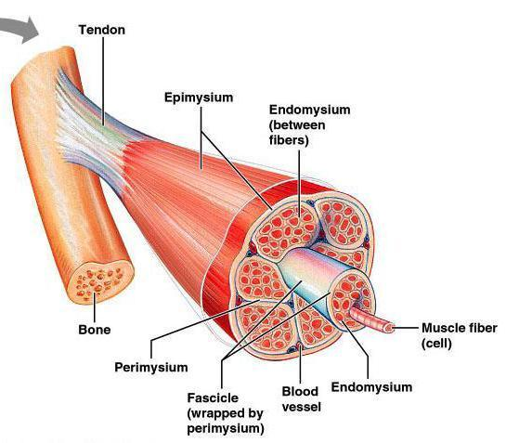

- Deep to endomysium, muscle fibers covered by Sacrolemma
- Each myofibril is covered by Sacroplasmic reticulum
- Each muscle fiber is made up of bundles of Myofibrils

- Each Myofibril is made up of Myofilaments (proteins)
- Each myofilament
- 3000 Actin (thin) myofilaments*
- 1500 Myosin (thick) myofilaments*
- *within each sarcomere
- *glide between each other in the contraction/relaxation of muscle

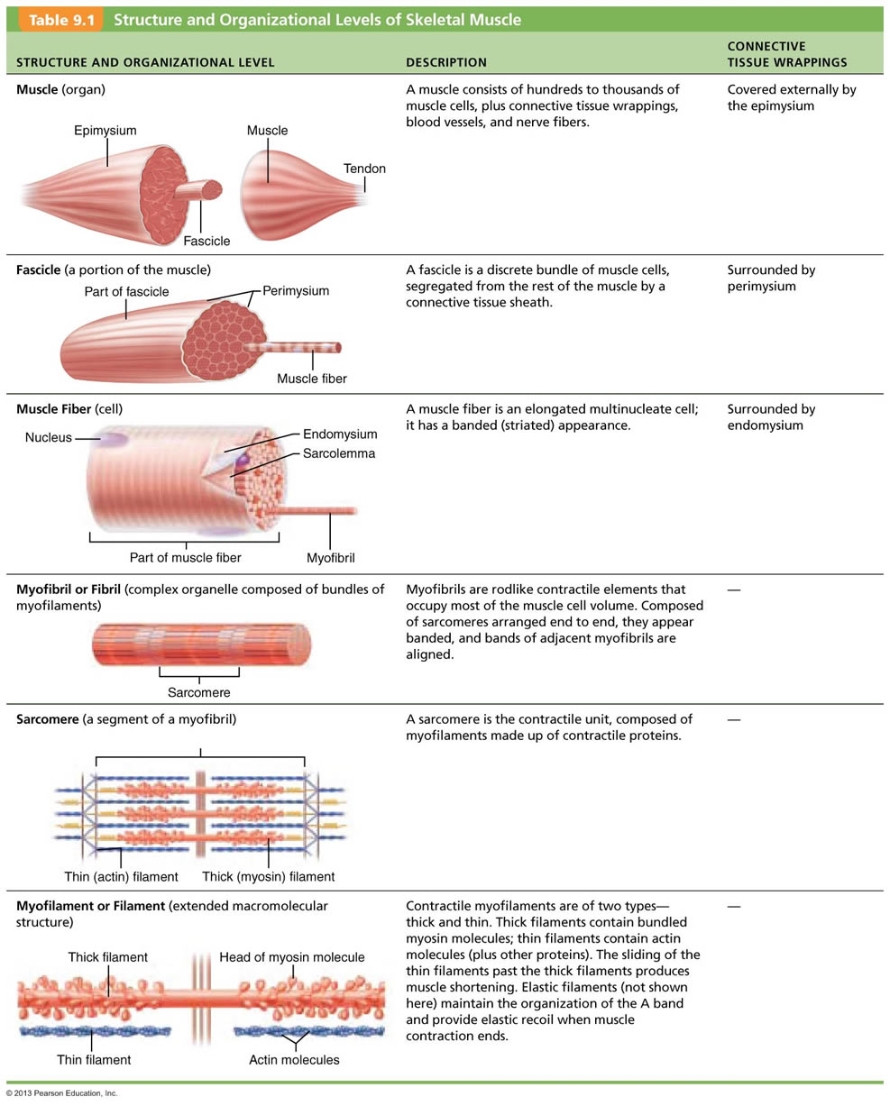

Sacromere “the microfunctional unit of a muscle”

- Cross striations
- Dark bands (A bands): Actin + Myocin
- Light bands (I bands): Actin only
- H zone
- Z lines (discs)
- M line (protein bands)

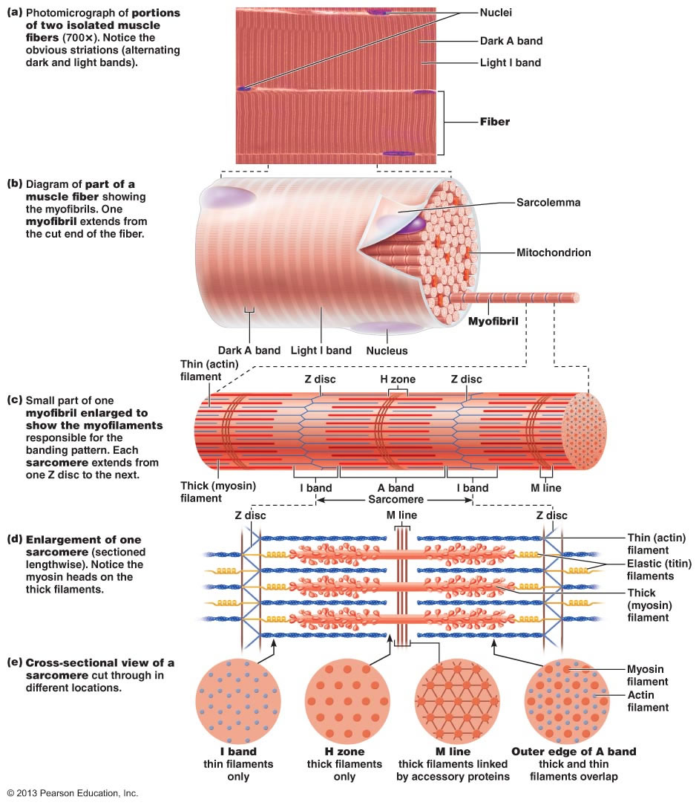

- Cross bridges: 50 pairs
- Sarcoplasmic reticulum
- Transverse “T” tubules

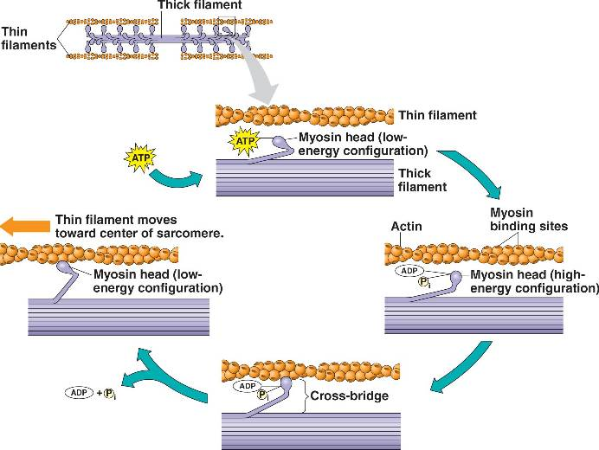

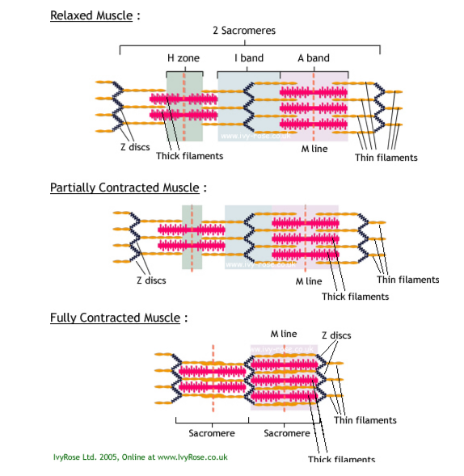

Muscle contraction
- Neuron
- Motor neuron
- Motor unit = Gross functional Unit of the muscle
- Motor unit = motor neuron + muscle fiber
- Motor unit found at the Myoneural junction
- Skeletal muscle... “all or none principle”
- Smooth muscle… peristalsys

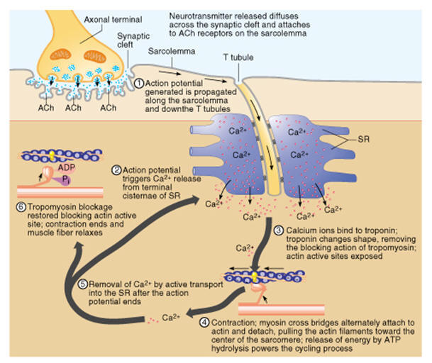

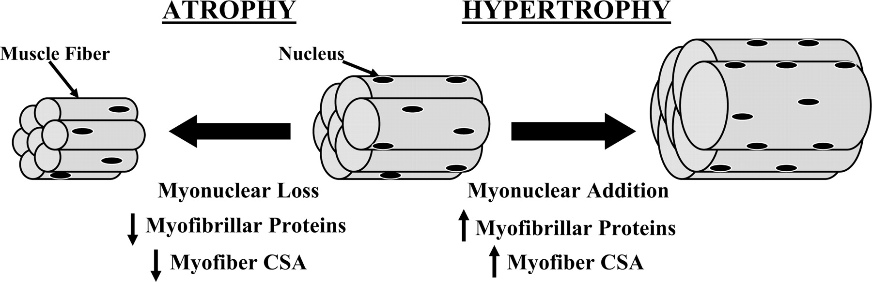

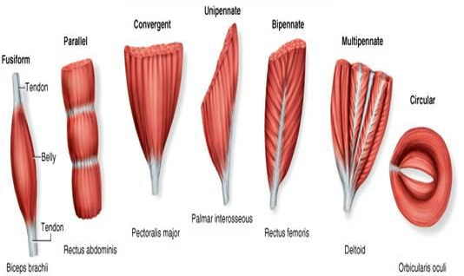
Muscle Fiber shapes

- Longitudinal (parallel)

- Unipennate

- Bipennate

- Multipennate

- Radiate (convergent)

- Circular

Muscles are named by:
- Action
- Direction of fibers
- Location
- Size
- # of origins
- shape
- origin/insertion

Terminology

- Origin: proximal end, less mobile bone
Agonist (Prime Mover) | Antagonist
Pectoralis Major | Trapezius/Rhomboids
Deltoids | Latissimus Dorsi
Rectus Abdominus | Erector Spinae
Biceps | Triceps
- Insertion: distal end, more mobile bone
- Belly (head): fleshy or meaty part
- Aponeurosis: a broad, flat tendon
- Agonist (prime mover): main action muscle
- Antagonist: opposing muscle
- Synergist: helps in action of agonist
- Synergist (fixator): stabilizes to help agonist

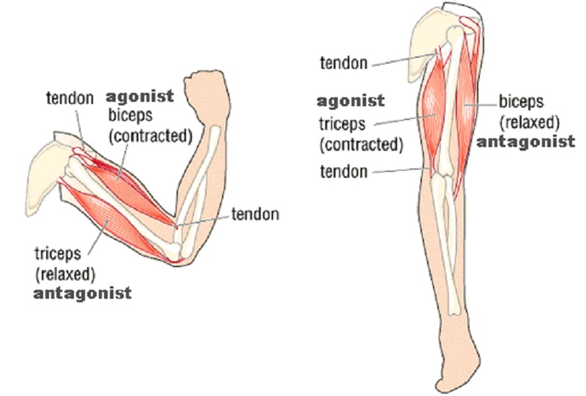
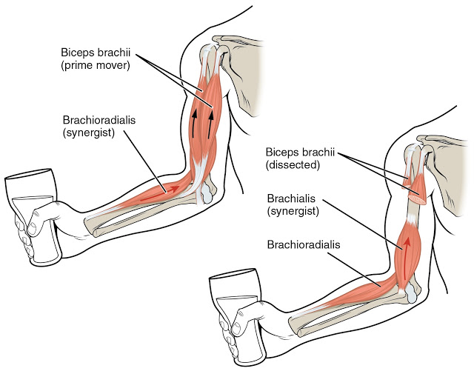

Muscle Tendon: attaches muscle to bone

- Extensions of the:
  - Epimysium, perimysium and endomysium
- Dense, regular connective tissue
- Parallel bundles of collagenous fibers
- Attaches muscle to bone (at the periosteum)
- May or may not have a synovial sheath

Ligament: attaches done to bone

- Dense, regular or irregular connective tissue
- But mostly parallel fibers
- Mainly collagenous fibers
- Some elastic fibers
- Attaches to the bones periosteum
- For joint stability
- Joint (fibrous) capsules offer strength/stability
- Also offer certain flexibility for movement

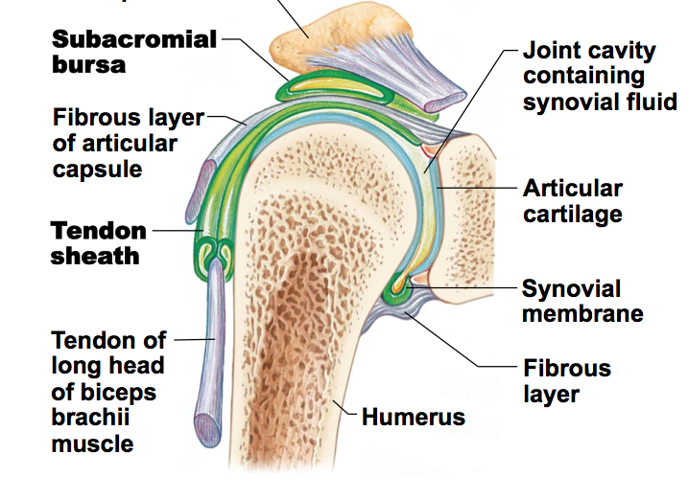

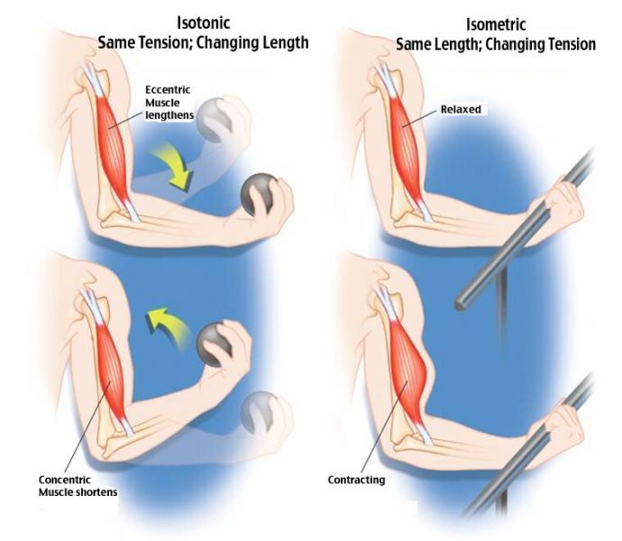
Types of Exercise

- Isometric:
exercise is where tension is developed but no mechanical work is performed. Shortening or lengthening is prevented where there is no observable joint or functional movement.

- Isotonic:
This is called Progressive Resistive Exercise (PRE) or traditional weight training. iso'- means 'the same' and 'tonic' refers to 'tension or force' - in this case, in the muscle. In an isotonic contraction, tension develops to a point and then remains constant while the muscle changes its length

- Isokinetic: (accommodated resistance)
Means constant speed. Provides and accommodating resistance that allows the participant to maximally load his/her dynamically contracting muscles at each point of a joints range of motion, thus enabling him/her to do more work than is possible with either constant or variable.
  - Benefits: movement at the joint specifically
  - Maximal contraction throughout the entire ROM
  - ** Can’t train for all sports because it only has one speed, good for swimmers and kayakers.

Type of Contraction

- Concentric: (positive work)
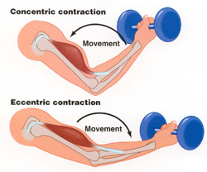
Is the most common type of muscle contraction. It occurs in rhythmic activities (aerobics) when the muscle shortens as it develops tension.

- Eccentric: (negative work)
Is where the muscle is lengthening in a constant state of tension. While lowering a weight, the muscle gives in to the resistance of the weight by stretching. An eccentric contraction can bring about a braking action. Chronic inflammation injuries can be manifested through eccentric overload.
** example: using the biceps as a break to bring the weight back down or using/bending your knees to absorb a shock.
  - Eccentric overloading can cause tendonitis (tennis elbow = swelling of the lateral epicondyle, golfers elbow = swelling of the medial epicondyle)
Muscle Spindle

- Amount of stretch and speed of stretch
- Found in the muscle bellies
- When it lengthens too fast(stimulus), it sends an impulse to the central nervous system (spinal cord) which helps it to lengthen slower and tells it to contract.
- It is a proprioceptor: ex. Helps us to land on our feet
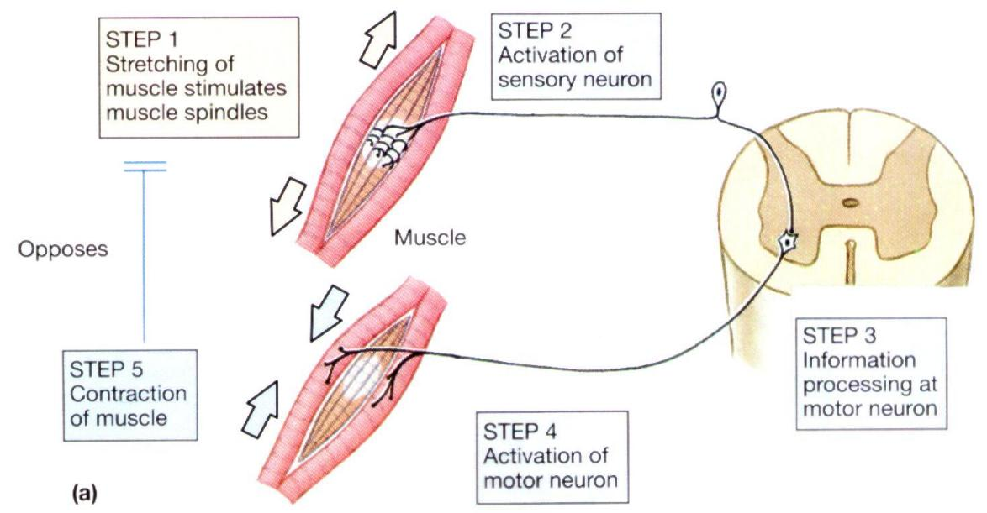

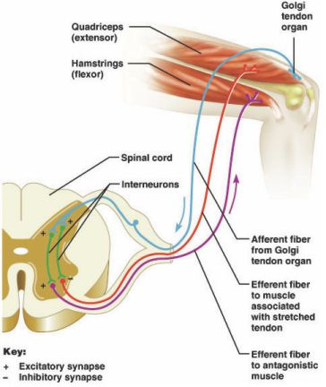
Golgi Tendon Organ

- Tension
- Proprioceptor: found in the tendon
- Specialized tissue wrapped in sensory nerves
- When you do a stretch and feel tension and hold it, the pain/tension disappears after a while. This is because there was an impulse sent to the CNS and then the muscle is able to relax.

