6 - Respiratory system (p. 807-822)
Major function of respiratory system
Supply O₂ and dispose of CO₂ and oxygen radicals (toxic materials, highly chemical active, can attack proteins in body)

Involves 4 distinct processes:
- Pulmonary ventilation: Movement of air in and out of lungs
- External respiration: Exchange of gases between blood & air of alveoli (in Lungs)
- Transport of respiratory gases: Role of blood in transport of gases between lungs & tissues of body
- Internal respiration: Exchange of gases at the level of tissues (between blood in systemic capillaries and tissue cells)

*First 2 functions handled by respiratory system; other two by CV system (Cardio-vascular)

2) Nasal Cavity
Air enters nasal cavity via external nares (nostrils), divided by midline nasal septum (Cartilage)
- Air then goes via internal nares to nasopharynx
- Roof of nasal cavity formed by ethmoid & sphenoid bones of skull
- Floor of nasal cavity formed by palate (hard anterior; soft posterior)

Vibrissae: Nose hair, to trap particles
Nasal cavity lined by 2 types of mucosa
- Olfactory mucosa: Contains receptors for sense of smell
- Respiratory mucosa: Contains goblet cells, mucous & serous glands
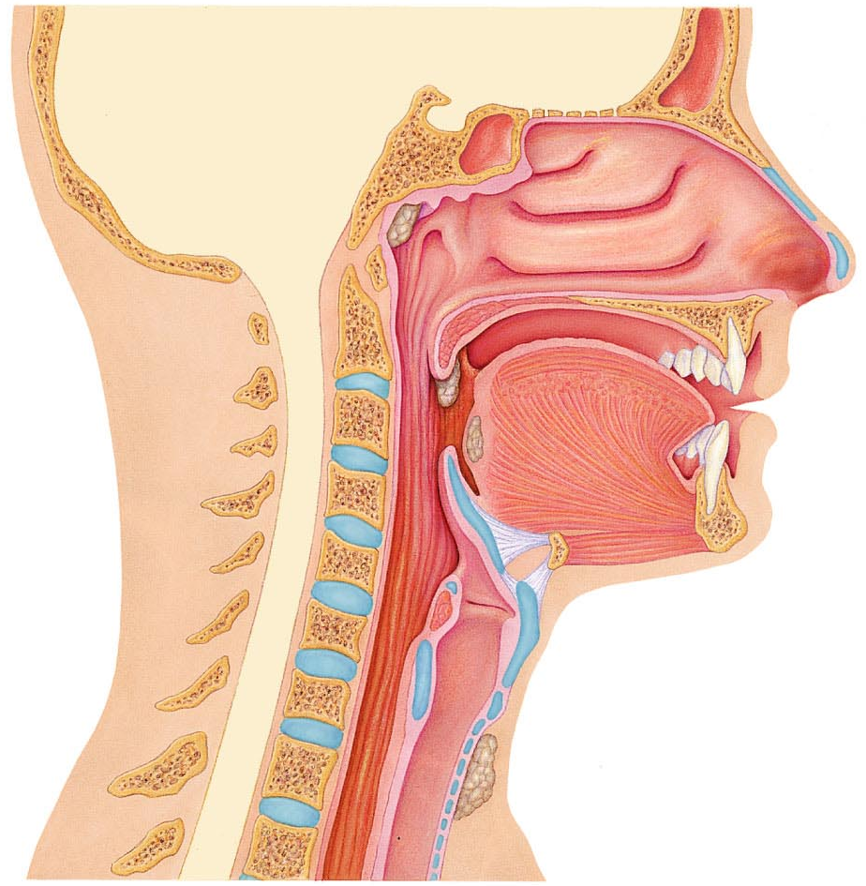
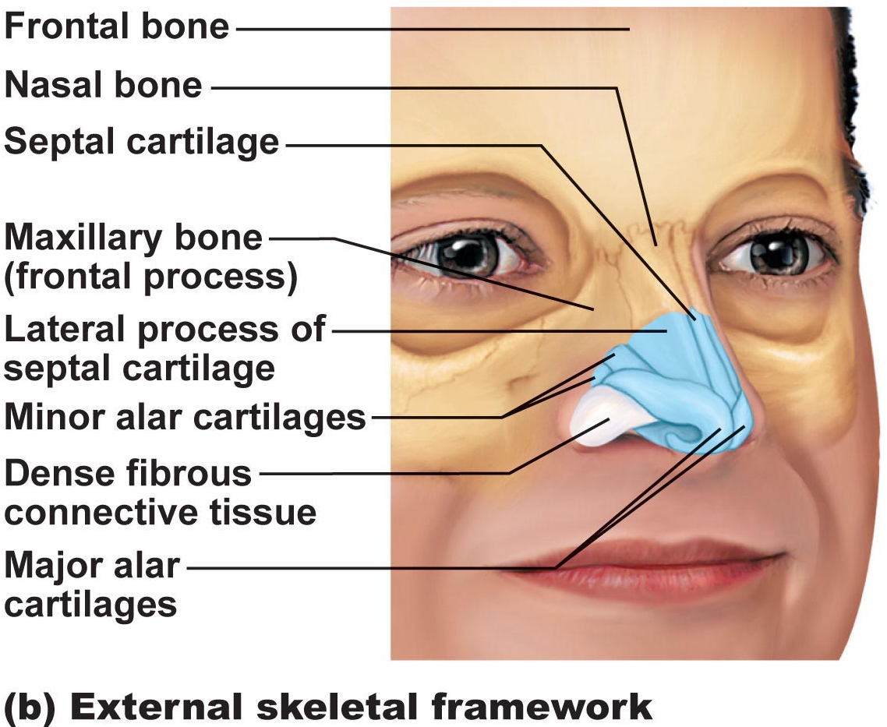
- Nose
Functions-
- Airway for respiration
- Moistens & warms incoming air
- Filters & Cleans inspired air
- Resonating chamber for speech
- Olfactory (smell) receptors
- Structure of external nose: differences in nose size/shape due to difference in nasal cartilages
*Skin covering dorsal/lateral aspects of nose is thin, contains many sebaceous (oily) glands
[6.1] Conduction and Respiratory zones
Conducting zone (Passage ways) –
Nose Nasal cavity Pharynx Larynx Trachea Bronchi, bronchioles, terminal bronchioles
*Conducting zone organs also cleanse, humidify and warm incoming air

Respiratory zone (Site of gas exchange) –
Composed of respiratory bronchioles, alveolar ducts, alveoli
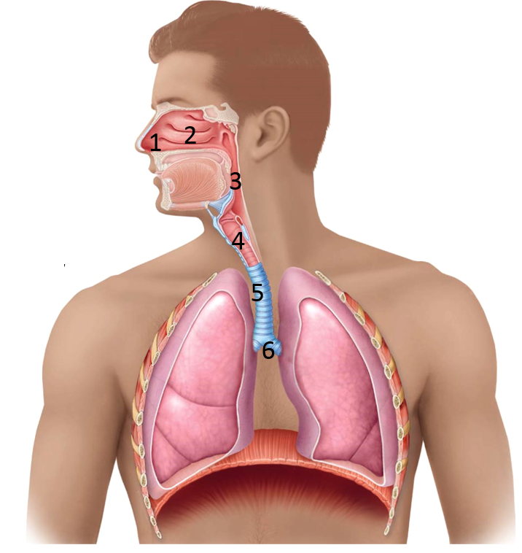
**Nose is mostly cartilages

3) Pharynx
Common pathway for food and air, wall composed of skeletal muscle throughout
~13 cm length; mucosal lining varies

3a) Nasopharynx ------------
- Below sphenoid bone, above soft palate
- Only and air passageway
- Pseudostratified ciliated epithelium
- Pharyngeal tonsils
- Pharyngotympanic (auditory) tubes drain from middle ear
(Opening of mouth will cause air flow into middle ear to balance the pressure)
- Soft palate rises when swallowing, prevent food going up the nasal cavity

3b) Oropharynx ------------
- Fauces connect oral cavity with oropharynx
- From soft palate to epiglottis (air and food)
- Epithelium becomes stratified squamous
- Paired palatine tonsils + single lingual tonsil
3c) Laryngopharynx ------------
- Air and food
- Remain Stratified squamous
- Epiglottis to larynx Diverge respiratory & GI pathways
- Epiglottis rise to block the respiratory pathway, prevent food getting in
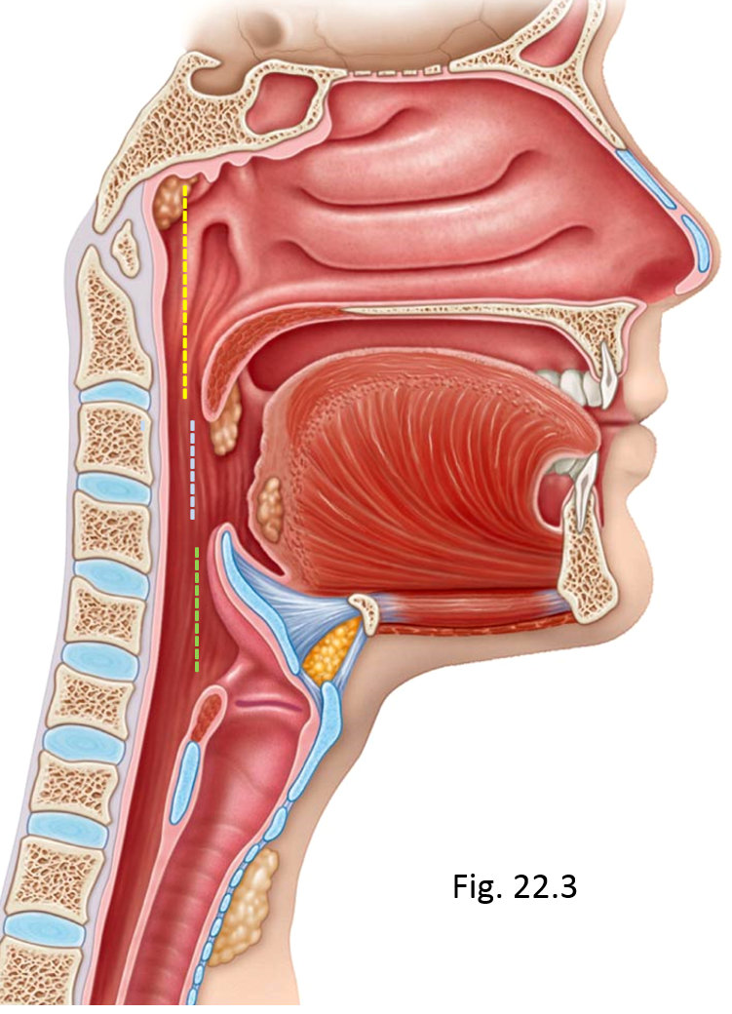
Paranasal Sinuses
Surround nasal cavity
- Frontal, sphenoid, ethmoid, maxillary bones
- Lighten skull, produce mucus, also warm & moisten air
- Sinus mucosa continuous with nasal mucosa Spread of infections

Sinus headache: Passage ways connecting sinuses to nasal cavity blocked
- Air in sinus absorbed Partial vacuum
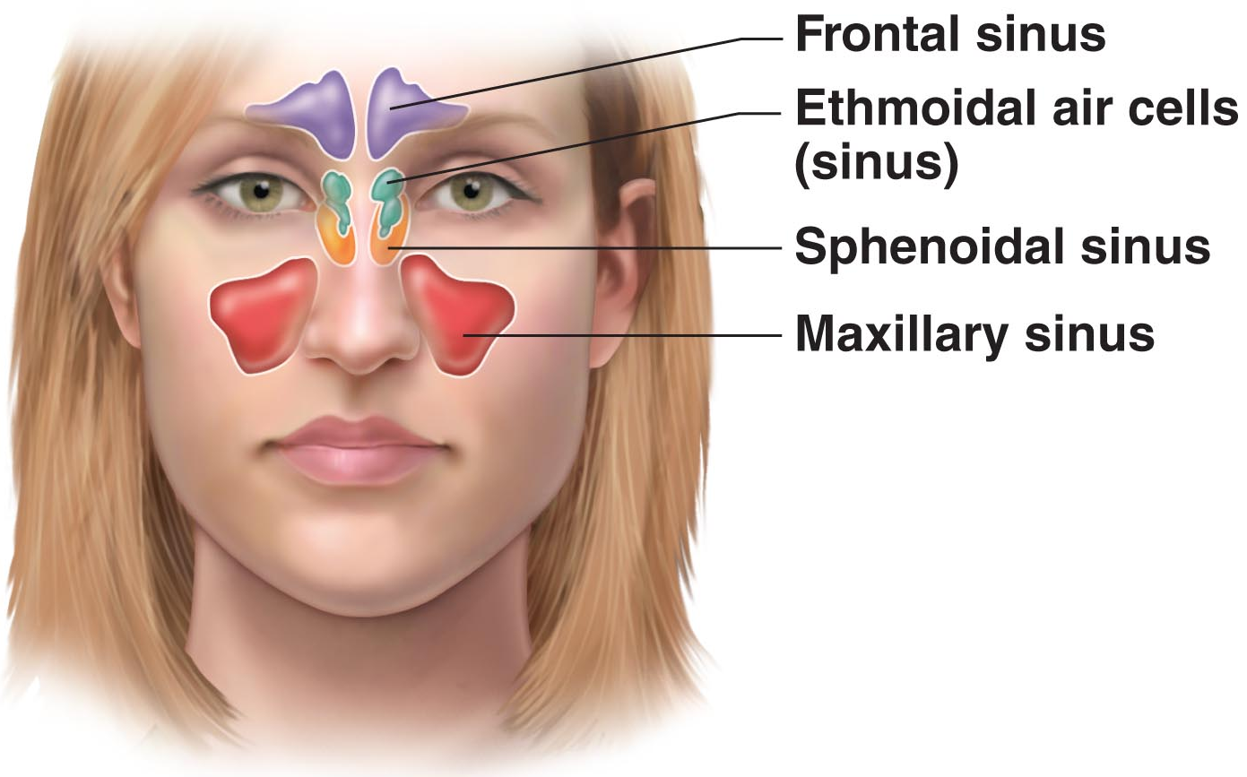
Respiratory mucosa
- Pseudostratified ciliated columnar epithelium with:
- Goblet cells;
- Lamina propria has mucous & serous glands (1L /day sticky mucus containing lysozyme)

- Respiratory mucosa cilia move contaminated mucus posteriorly to pharynx
Cold air slows cilia Cause of runny nose
Thin-walled veins under nasal epithelium to warm up the incoming air
- Nasal conchae: enhances the cleaning, humidification, and warming of the air coming into the lungs
- Nasal mucosa richly supplied with sensory nerves Irritants trigger sneeze reflex
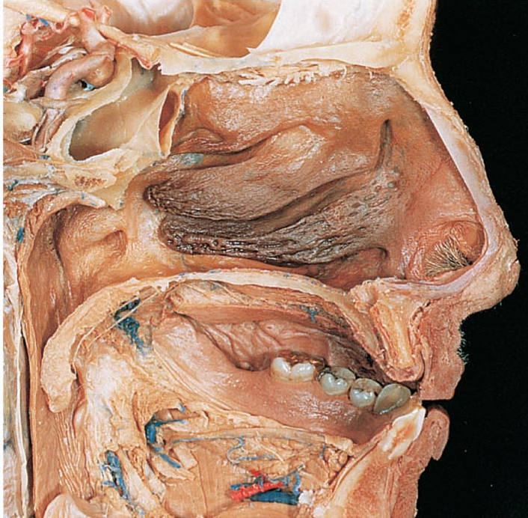
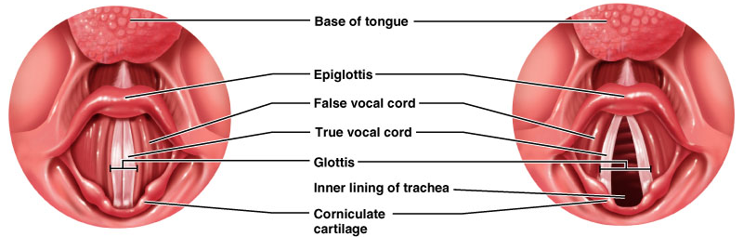
Voice Production
Speech = intermittent release of expired air + opening & closing of glottis (The gap between the vocal cord, act as a valve)
- Length of vocal cords & size of glottis altered by action of laryngeal muscles that move arytenoid cartilages
- Male voice at puberty: vocal cords vibrate more slowly
(Because of enlargement of larynx Thicker and longer vocal cords deeper voice)

Loudness of voice: Force of air across vocal cords

- Laryngitis: Inflammation of vocal cords Vibration impaired
- Sphincter functions of vocal cords:
- Epiglottis closes respiratory tract during swallowing
- Valsalva’s maneuver: equalizing pressure in ears
Glottis closing when straining to lift a heavy load
(The ‘hup’ sound when we use much strength) [when I pitch]
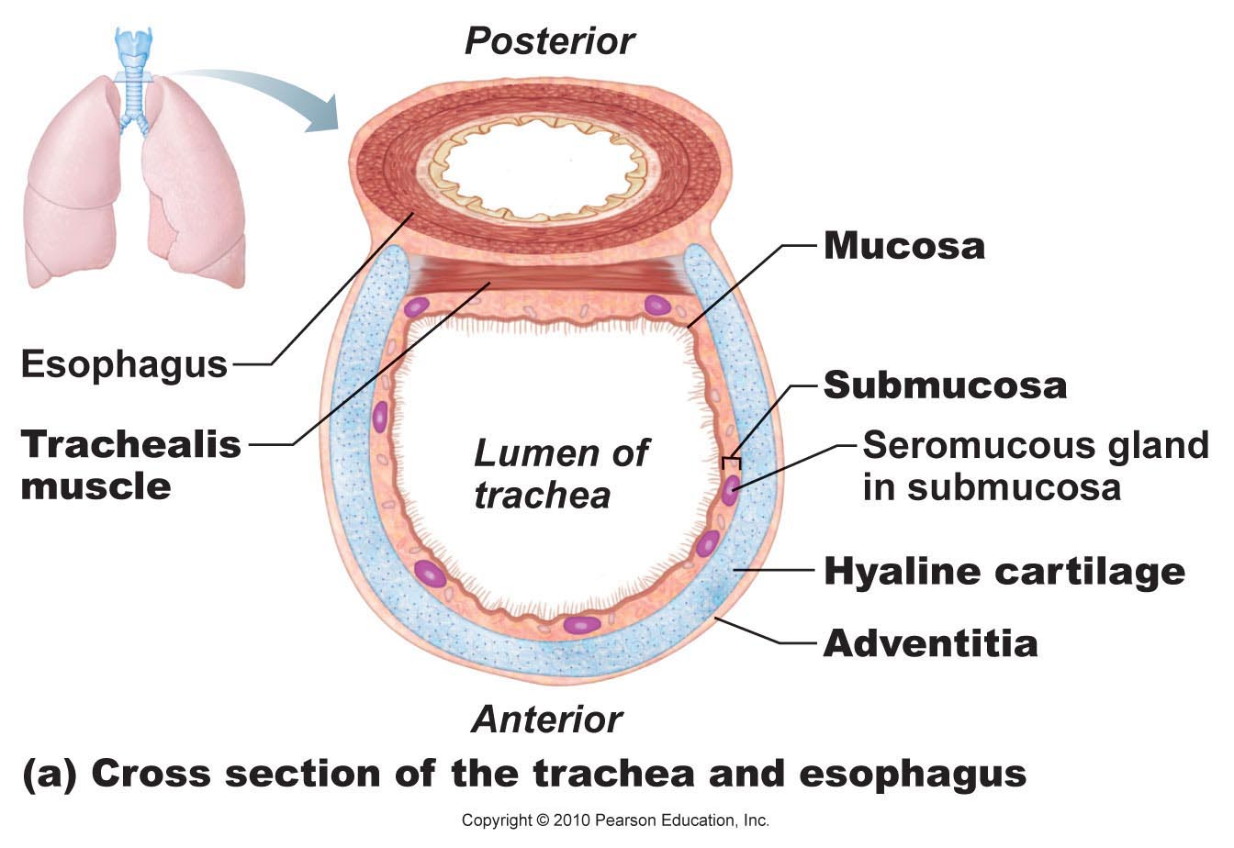
5) Trachea
10 – 12 cm long; ~2.5 cm diameter; flexible, mobile
- Pseudostratified ciliated columnar; cilia move mucus up to pharynx
- Smoking inhibits & destroys cilia
Only coughing can clear mucus if cilia damaged or destroyed
Constant coughing

- Submucosa is CT with seromucous glands

- Outer adventitia reinforced internally by 16-20 C-shaped cartilaginous rings;
keep airway open during pressure changes associated with breathing
4) Larynx
Attached to hyoid bone (above); continuous with trachea (below)
- ~5cm (4th – 6th cervical vertebrae)
- 3 functions:
- Open, 2-directional airway
- Switching: food vs air
- Voice production
- 9 cartilages in total:
Thyroid cartilage: Large, shield-shaped cartilage in front (Puberty in males enlarge)
Arytenoid cartilages (2): Lateral, pyramid-shaped, anchor vocal cords
9th cartilage: Epiglottis: elastic cartilage, anchored to anterior rim of thyroid cartilage & extends up to base of tongue

True vocal cords: White (avascular); vibrate in response to air movement up from lungs
False vocal cords: Above true vocal cords
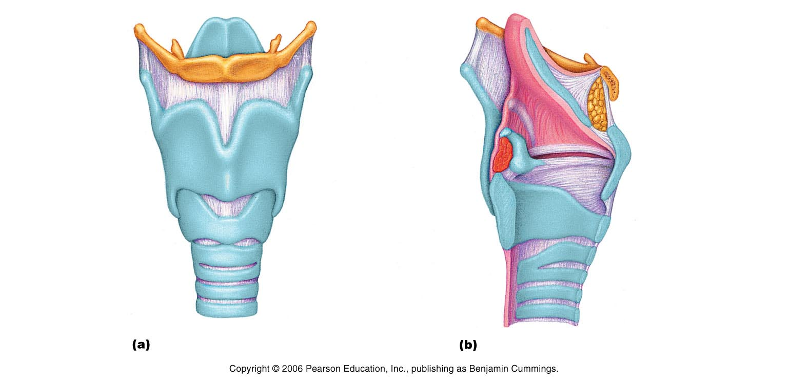
The bronchial tree
- Conducting zone structures:
- Right primary bronchus is wider, shorter, more vertical than left
- Air in bronchi is warm, cleansed of most impurities & humidified
- ~ 23 orders of branching air passages in lungs = bronchial or respiratory tree

Bronchi Bronchioles (<1 mm) Terminal bronchioles (<0.5 mm)

Changes in wall composition as one moves through tree:
- Cartilage: Rings plates none
- Epithelium: pseudostratified columnar cuboidal; no cilia or mucous cells in bronchioles
- Smooth muscle: relative amount increases as passages become smaller

- Respiratory Zone
Terminal bronchioles Respiratory bronchioles
Huge S.A. for gas exchange: ~300 million alveoli

Alveoli:
Contains 4 different cells to optimize the exchange
of gas

Yellow: Type 1 alveoli cell- Gas exchange
Green: Type 2 alveoli cell- Secretes surfactant
Purple: Macrophages
Red: RBC in capillary

Respiratory membrane = Alveolar wall + Capillary wall + Basal laminae

- Respiratory membrane is an air-blood barrier; gas exchange by simple diffusion
- Other characteristics of lung alveoli:
- Surrounded by fine elastic fibers
- Alveolar pores: Allow equalization of air pressure throughout lung; alternate air routes if bronchi collapsed
- Alveolar macrophages = dust cells; inner alveolar surface; clear & swallow > 2 million dust cells/hour
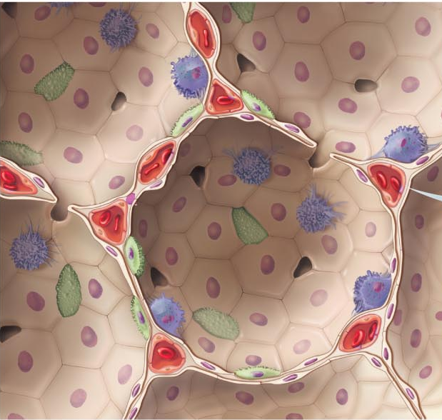
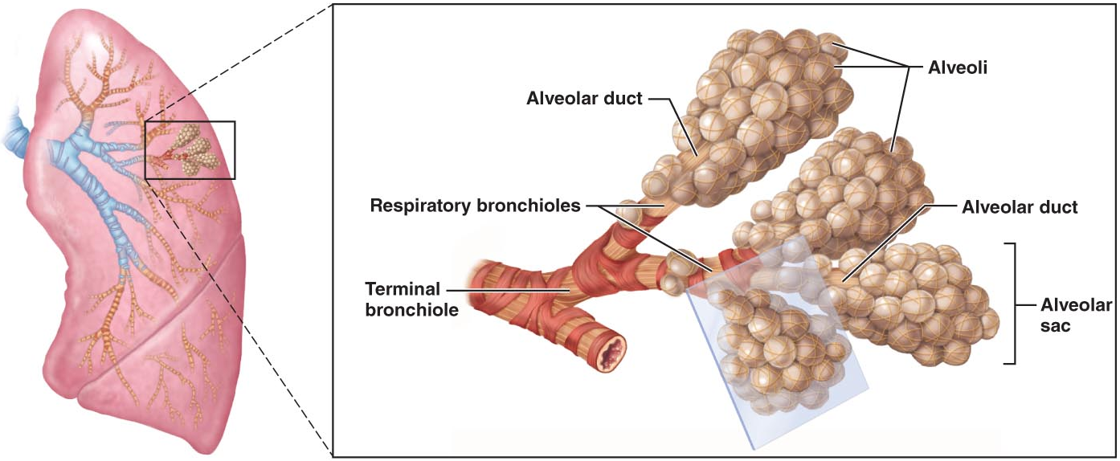
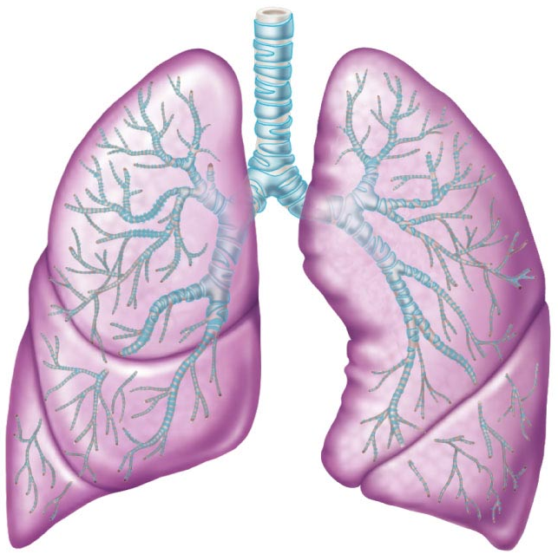
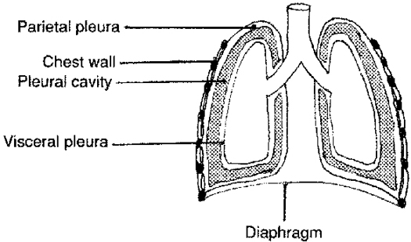
Pleura (胸膜)
Thin, double-layered (parietal & visceral) serosa (漿膜)
- Pleural fluid: Serous secretion that fills pleural cavity Lungs slide easily during breathing;
- Surface tension keeps pleurae from separating
- 3 Chambers: central mediastinum + 2 lateral pleural compartments
- Pleurisy: Inflammation of pleurae
Blood supply & Innervation
- Pulmonary arteries: Bring blood to be oxygenated
- Pulmonary veins: Return oxygenated blood
- Bronchial arteries: Provide systemic blood to lungs Bronchial veins

Innervation primarily parasympathetic + some sympathetic
Vasoconstriction (innervation of lungs): Parasympathetic (Do not need large oxygen input during resting and digesting)
Sympathetic: active, need more oxygen due to exercise, fight-or-flight etc.

[6.2] Lungs and the Pleural coverings
- Paired lungs occupy entire thoracic cavity except mediastinum
- Each lung suspended in own pleural cavity: Connected to mediastinum by vascular & bronchial attachments (root)
- Costal surface = anterior, lateral & posterior lung surfaces in close contact with ribs

Apex, base; also hilus Blood vessels enter & leave lungs
(Hilus: indentation of surface, where blood vessels, ducts, nerve fibers enter/leave it)

1⁰ bronchus enters lungs

Fissures: oblique, horizontal septa subdivide each lung into 10 bronchopulmonary segments
(CT divisions; own artery & veins)
- Pulmonary disease often segmental & can be treated that way

Lobule: Smallest subdivision seen with naked eye; hexagon, ~size of pencil eraser, served by large bronchiole

Lung: Primarily air spaces, rest is elastic CT

