ESSENCIAL OUTCOMES
Sex vs. Reproduction
- Sex is not reproduction
- Sex is the exchange of genetic information and formation of new genetic variants
  - Sex is recombination
- Reproduction is creation of offspring
- Two do not have to occur together
  - Bacteria divide by binary fission and transfer genetic information between cells

Principles underlying evolution by natural selection: origin of variation, heritability, differential reproduction, change in genotype of the population over time
- Variation: the difference between the genes in a population
  - Sex causes variation before of the combination between mom and dad
  - Mutations are random and cause a change that may be favoured in the environment
  - Genetic drift – introducing new genes to a population
- Heritability
  - The ability of a favoured trait to be passed on
- Differential reproduction
  - Mate with trait that will survive
  - Not all traits can survive in all environments
- Change in genotype of population
  - Changing the type of genotype in a given population

Evidence from the fossil record, historical biogeography, comparative morphology and molecular biology that support the idea of descent with modification from a common ancestor
- Fossil record
  - Layers of fossil represented organisms that lived at sequential times in the past, abrupt changes between the geological layers marked the dramatic shifts in ancient environments
  - We know that huge catastrophes can cause extinction of many species
    - Ex. Disappearance of dinosaurs and the end of the Cretaceous
  - Darwin proposes that all species that ever lived are genetically related
    - Fossil records also documents continuity in morphological characteristics - provides evidence of ongoing changes in biological lineages
      - Biological lineages: evolutionary sequences of ancestral organisms and their descendants
    - Evolution of modern birds can be traced back to dinosaur ancestor through fossils such as Archaeopteryx lithographica (intermediate species)
- Historical biogeography
  - Studies of the world distribution of plants and animals
  - Interpret the products of natural selection as evolutionary adaptations
  - Species on oceanic islands often closely resemble species on the nearest mainland - island and mainland species have a common ancestry
    - Species on continental land mass are related to one another and often distinct from those on other continents
- Comparative morphology
  - Comparing the morphology (anatomical structure) of organisms
  - Buffon proposed that animals must have changed since their creation and that the vestigial structure of the organism must have functioned in ancestral organisms
  - Analyses of the structure of living and extinct organisms are based on the comparisons of homologous traits
    - Homologous trait: characteristics that are similar in two species because they inherited basis of the trait from their common ancestor
  - Ex. Forelimbs of all four legged vertebrates are homologous because they evolved from a common ancestor with a forelimb composed of the same component parts
    - Pigs, dolphins, and bats have diff shaped bones but the similarities are apparent
    - Differences in structural details happened over evolutionary time
    - Arms of humans and wings of bat are constructed of comparable elements - share common ancestor
- Molecular biology
  - Early embryos of related species are often similar, morphological differences appear as the embryos grow and develop into adult forms
    - Early embryos of most 4 legged vertebrates develop limb buds - legs or wings grow from here
    - Forelimbs and supporting structures grow at base of neck
    - Hindlimbs grow right behind the ribcage
    - Similarities in the limb buds and the positions of their limbs in these animals provide evidence of their descent from a shared ancestor
  - Difference in their adult structures are caused by additional genetic instructions that have evolved over time
  - Ex. Snakes
    - Snakes also evolved from 4legged ancestors - early snakes had small hindlimbs and the recently evolved snakes have no limbs
    - Most ancient snakes (pythons, boas) have traces of limbs -vestigial hind limbs that support the idea of descent with modification from a common ancestor

Characteristics of a scientific theory and the importance of falsifiability
- Roles of proof, falsification, and falsifiability in determining whether a theory is "scientific".
  - a theory is “scientific” if it can be proven, or falsified
  - intelligent design (“ID”, religion based, God is the Creator) is not scientific because it cannot be proven, nor falsified
  - we need ample evidence and logical explanation in order for theory to become fac

Changes in amount of dna throughout the cell cycle
- Interphase: 2n, 2C
- S phase-anaphase: 2n, 4C→ in anaphase it goes to 2C
- Telophase - next interphase: 2n,2C

Main features of each stage of mitosis with respect to cytoskeleton and chromatin
- Prophase:
  - Chromosomes begin to condense and compact
  - Appear to be thin threads under a microscope
  - Nucleus disappears (shutdown of RNA synthesis)
  - Mitochondric spindle begins to form between the two centromeres
- Prometaphase:
  - Spindle microfibres (microtubules) grow from centrosomes at opposing spindle poles toward the centre of the cell
  - A kinetochore form on each chromatid at the centromere - kinetochore microtubules bind to these
  - these connections determine the outcome of mitosis
- Metaphase:
  - Spindle microtubules move the chromosome to align at the spindle midpoint (metaphase plate)
  - Chromosomes complete their condensation and their size is dependant on location
  - When all chromosomes are at midpoint, metaphase can give way to the separation of chromatids
- Anaphase:
  - Sister chromatids separate & move to opposite poles (movement powered by motor proteins on kinetochores)
  - Movement continues until the daughter chromosomes move to opposite poles
- Telophase:
  - The spindle disassembles
  - Chromosomes decondense
  - Nucleolus reappears New nuclear envelope forms at each pole, producing the two daughter nuclei

Structure of a replication bubble
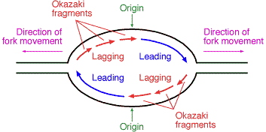

Relationship between dna replication and metaphase chromosome structure
Difference between dna damage and mutation
- DNA mutation is double-stranded change in the sequence of DNA - anything else is damage
- DNA damage is a physical abnormality that can be recognized by enzymes and therefore repaired e.g. thymine dimers
- Mutations in the DNA of reproductive cells are heritable, damage is not because a DNA strand is unable to replicate until the damage has been removed
- Often mutation begins with damage
  - if a repair mechanism does not identify the abnormality in the chemical composition of the dna sequence, the damage remains in the dna and is replicated. the replicating mechanisms may assume the change was intended and will produce a modified version of the original base to accommodate the change. this results in a double stranded change

Origin of various types of genomic variation
- SNP’s, CNV’s, in/del’s, etc
- 1.2 million variants in the human genome
- Africa

Main differences between meiosis and mitosis
 | Meiosis | Mitosis
Type of Reproduction | Sexual | Asexual
Occurs in | Humans, animals, plants, fungi | all eukaryotes
Genetically | different | identical
crossing over | yes, mixing of chromosomes can occur | no, crossing over cannot occur
pairing of homologues | yes | no
function | produce gametes that are genetically diverse through sexual reproduction, reduction of chromosome # | cellular reproduction and general growth and repair of the body
number of division | 2 | 1
number of daughter cells produced | 4 haploid cells | Can produce 2 or 4 diploid cells, depending on the organism
chromosome number (n value) | reduced by half | remains the same
Steps | Meiosis 1: Prophase I, Metaphase I, Anaphase I, Telophase I  Interkinesis (no recombination occurs)  Meiosis II: Prophase II, Metaphase II, Anaphase II and Telophase II | Prophase, Metaphase, Anaphase, Telophase

Products of meiosis in animals vs. Plants, fungi and algae
- Meiosis in Animals:
  - Animals are only haploid as sperm and eggs, besides that, animals are diploid for the rest of their life
- Meiosis in Plants
  - Alternate between diploid and haploid
  - Zygote divides by mitosis to make a diploid body (sporophytes)
  - Some sporophyte cells undergo meiosis to make spores (reproductive cells - n)
  - These spores then divide through mitosis (n) to make gametophytes which makes gametes through mitosis
- Meiosis in Fungi/Algae
  - The diploid phase immediately after fertilization
  - the only diploid phase is a zygote and the rest of the times the phases are in haploid.
  - diploid zygote undergoes meiosis to make haploid spores, spores germinate and undergo mitosis to make (+, -) gametes
Characteristics of homologous chromosomes
- The two representatives of each chromosome in a diploid cell
- They have the same genes, arranged in the same order in the DNA of the chromosomes
- one is from the mother (maternal) and the other is from the father (paternal)although two homologous chromosomes carry the same genes arranged in the same order, different versions of these genes (alleles) may be present on either chromosome
- Same centromere (region of DNA found near the middle of a chromosome) position and staining pattern
- With alleles for the same characteristic at corresponding loci (specific location of a gene or DNA sequence on a chromosome)
- Homologous chromosomes are very likely to be different in having different distributions of mobile element insertions
Mechanism by which recombination creates new combinations of alleles
- Recombination generates genetic variation by generating new combinations of alleles
  - Generates new genotypes and sometimes new phenotypes
- Recombination creates new alleles through cross over
- Independent assortment/random segregation
  - The tetrads align and recombination occur randomly – swap at different locations
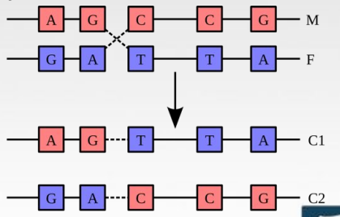

Various mechanisms by which meiosis generates variation
- During fertilization, 1 gamete from each parent combines to form a zygote. Because of recombination and independent assortment in meiosis, each gamete contains a different set of DNA. This produces a unique combination of genes in the resulting zygote.
- Recombination or crossing over occurs during prophase I. Homologous chromosomes – 1 inherited from each parent – pair along their lengths, gene by gene. Breaks occur along the chromosomes, and they rejoin, trading some of their genes. The chromosomes now have genes in a unique combination.
- Independent assortment is the process where the chromosomes move randomly to separate poles during meiosis. A gamete will end up with 23 chromosomes after meiosis, but independent assortment means that each gamete will have 1 of many different combinations of chromosomes.
- This reshuffling of genes into unique combinations increases the genetic variation in a population and explains the variation we see between siblings with the same parents.

Segregation of various alleles during meiosis in monohybrid, dihybrid and sex-linked situations
Conditions under which allele frequencies change, or not, in a population over time
- Any type of selection will change allele frequencies; thus, if no selection is present, allele frequencies will not change.
- Allele frequencies change during gene flow, and due to mutations (but there must be a very large amount of random mutations)
Populations that are, or are not, at genetic equilibrium, given observed genotype frequencies
- Genetic equilibrium: point at which neither the allele frequency nor the genotype frequencies change in succeeding generations.
  - let p equal one allele, q equal another allele
  - equation that predicts genotype frequencies in offspring generation: (p+q)x(p+q)=p2+2pq + q2
  - If population is at genetic equilibrium, p2 is predicted frequency for CRCR, 2pq is predicted frequency for CRCW, and q2 is predicted frequency of CWCW
- Conditions that must be met for genetic equilibrium to occur
1) No mutation
2) Closed to migration
3) Random mating
4) No genetic drift, infinite in size
5) No selective advantage (All genotypes survive + reproduce well)

Calculate relative fitness from absolute fitness
- Absolute Fitness (W): number of surviving offspring produced over an individual’s lifetime
  - Influenced by survival to adulthood, longevity, fertility, offspring survival
  - Hard to measure, especially in natural populations
  - Sometimes have to estimate W based on 1 or 2 of these components of fitness and assume others are similar across genotypes
- Relative Fitness (w): calculated by standardizing a genotype’s absolute fitness; fitness of an individual is compared to fitness of an individual within the same species (divide by highest fitness)
  - Fittest genotype in a population has a relative fitness of 1
  - All other genotypes (between 0 and 1) w = W/W_{max} (most successful genotype)

How the dominance status of alleles affects the response to selection
- When selection favours the recessive allele (will reach fixation) the dominant allele will eventually be eliminated from the population (reach 0)
- When selection favours the dominant allele (will keep increasing but never reach fixation), the recessive allele was harmful but selection was never able to get rid of the alleles (never reached 0)
  - Will never truly outcompete the harmful recessive allele
  - The harmful recessive allele is shielded from elimination because it is in heterozygotes
    - Allows harmful recessive alleles to persist in populations at low frequencies
    - When these harmful alleles are rare, most of the copies will be found in heterozygotes with normal fitness
      - Due to fact that when q is low, q² is much lower than 2pq
  - Pigs with 1 copy of each were fine and were not eaten by wolves and so lived on to pass on their genes when they reproduce
  - Selection can usually weed out all harmful dominant alleles with genetic disorders (less common) but not recessive alleles

Relationship between selection and evolution
- Natural selection is the driving force of evolution. Variants that are best suited to the environment are the most likely to survive and reproduce, so these variants are more prevalent in subsequent generations

Processes that reduce, remove, or maintain heritable variation in populations
Reduce variation → genetic drift (bottleneck and founder effect)
→ natural selection (depends what it selects for)
Increase variation → Gene flow
→ Mutations
Maintain variation → Nonrandom mating
→ Natural selection (depends what it selects for)

Which assumptions of hardy-weinberg equilibrium have likely been violated, given an observed set of genotype or phenotype frequencies
- Depends on the scenario I guess.
- Assumptions Made in order for Hardy-Weinberg Equilibrium
- large population
- little mutations (negligible)
- no selection pressure (genotypes have equal fitness)
- randomly mating
- no immigration/emigration
So if the observed genotype does not match the expected genotype (that was calculated using p^2 + 2pq + q^2) then the HWE was violated, and external factors caused this discrepancy. (such as a small population, or selection pressures).

Examples and predictions of size-advantage model of sex change
- Male to female
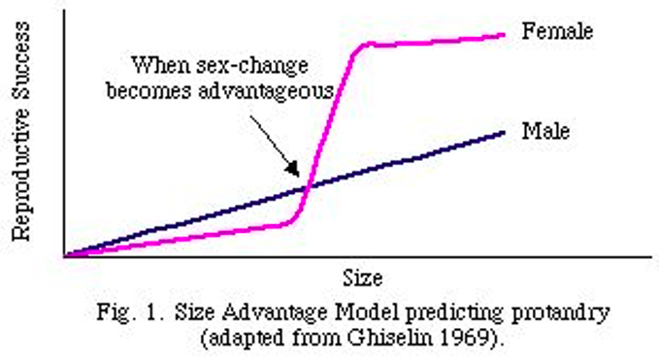
- Female to male
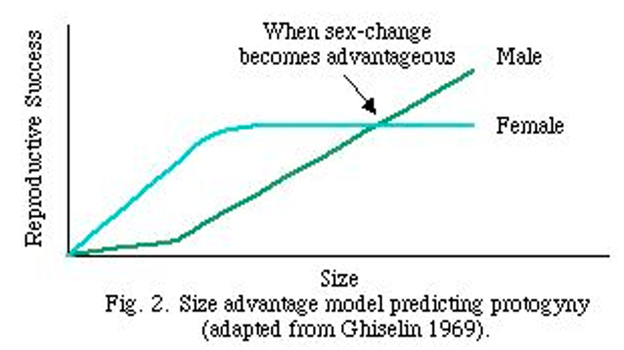

CYCLE 7
Examples of genetic exchange/ recombination without reproduction, and of reproduction without genetic exchange/ recombination
- Can have reproduction without sex (ex. Binary fission)
  - Obligatory asexual-- all born female and must reproduce asexually
  - Facultative sexual vs asexual
- Can have sex without reproduction (bacteria)

How recombination contributes to population genetic variation
- Recombination creates new combinations of alleles and new genotypes and fewer mutations
- Sexual recombination allows 2+ advantageous mutations to occur together
- Without recombination advantageous mutations compete against each other (clonel interference)
Meanings of monoecious, dioecious
- Monoecious
  - Male and female sexual organs are present in 1 individual; hermaphroditic
  - Only one individual in reproduction
- Dioecious
  - Male and female sexual organs are present in 2 individuals
  - Two individuals required for reproduction
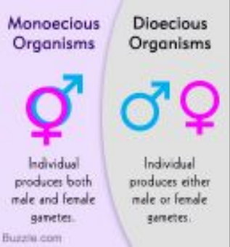

Difference between sequential and simultaneous monoecy
- Simultaneous
  - At any given time, organism has both male and female function, both male and female gametes produced
- Sequential
  - Individuals are born members of one sex and change sex later in life

Examples and predictions of size-advantage model of sex change
- Balancing male and female function: when and in what direction should an individual changes sex
- Size is more beneficial for one sex than the other
  - Cross-over of two fitness functions is where one changes to the other
  - Male female is protoandry
  - Female male is protogyny
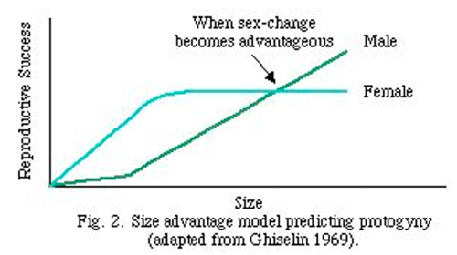

Examples and predictions of adaptive sex ratio manipulation
- Issue of sex allocation to offspring
  - One sex benefits more from its mother being in good condition (i.e. lots of resources, or high social rank)
  - Id this is the case, mothers in good condition overproduce that sex
- Want to propagate their genes into the next generation
- Applies to individual litters, individual mothers
- Does one sex benefit more benefit more than the other from its mother’s condition or rank?
  - Individual mothers in good condition/high rank may overproduce that sex

Reason why most populations have 1:1 sex ratios
- On population level, sex ratio is still around 1:1
  - Due to negative frequency dependent selection
  - As soon as one sex becomes rare, it gains an advantage over the other sex
    - Becomes more beneficial to produce the rarer sex because it will have better reproductive success

Prevalence of sexual vs asexual reproduction in animals, plants and other forms of life
- First living organisms and first eukaryotes reproduced asexually
  - Parthenogenesis, binary fission, etc
- Diploid sex first appeared 1.5 billion years ago
  - Isogamy (equal gamete size) came before anisogamy (unequal gamete size)
- Most living things other than plants and animals reproduce asexually
  - Some animals reproduce asexually, these lineages are young and very spread out

Costs of reproducing sexually as opposed to asexually
- Costs with attracting a mate
- Fitness cost associates with meiosis, only pass on 50% of genes
- Cost of males: sexual reproduction grows a population more slowly that asexual reproduction
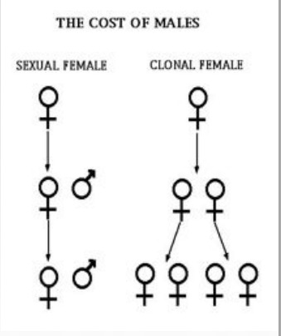

Benefits of reproducing sexually as opposed to asexually
- Muller’s Ratchet
  - Asexual lineages accumulate harmful mutations, frequencies of harmful mutations only increases
  - Sexual recombination breaks this pattern by continually generating new genotypes with fewer harmful mutations
- Rubies in the rubbish
  - Some fraction of offspring from sexual reproduction will have more harmful mutations and some will have less (the rubies)
    - Improved survivability

How environmental stability influences whether sexual or asexual reproduction is favoured
- Asexual reproduction is favoured in environments that are stable, better to create clone that has same fitness as you
- In changing, unpredictable environment, better to create a very diverse group of offspring in regard to phenotype

Lottery principle and red queen principle as environmental (short-term) benefits of sex
- Lottery principle
  - By creating very diverse group of offspring in regard to phenotype, parent hopes that some offspring are well-adapted to the changing environment
    - Hit the lottery by receiving advantageous traits for new environment
- Red Queen Principle
  - Organisms are co-evolving, in an evolutionary arms race with other competing organisms
    - Not evolving puts an organism at a disadvantage
    - Ex. Hosts co-evolve with parasites
      - New (rarer) genotypes have higher fitness because parasites have not seen them before
Benefits of sex
- Long-term benefits
  - Combines helpful mutations and removes deleterious ones, reduces extinction risk
- Short-term benefits
  - Hedge your bets in a changing environment, and compete with natural enemies

How sexual reproduction places different selective forces on males vs. Females
- Differences in potential fitness are what leads to differential selective forces on males and females
  - Can lead to sexual dimorphism
- Different selective pressures result in selection for traits that help one sex attract members of the opposite sex

Distinction between intrasexual selection and intersexual selection
- Intrasexual selection
  - Favours evolution of weapons
  - Used in combat between males of the same species to get access to females
- Intersexual selection
  - Favours evolution of ornamentation
  - Used to attract members of the opposite sex

Why males usually compete for access to females (rather than vice versa)
- Males investment is much lower than the female’s
  - Sperm are inexpensive to create
  - Males also usually don’t incubate egg/zygote after fertilization
  - Female does most of the child-rearing
- Female want to ensure that mate is of highest quality possible

Which sex has higher potential fitness
- The gender that makes the largest investment in offspring will be “choosier” in regards to their mate
  - Will want their mate to be of highest genetic caliber possible
  - Whichever sex invests less competes for access to other sex

Which sex has higher average fitness
- Potential fitness
  - Males have higher potential fitness
  - Sperm is constantly being produced, no fertilization period for males
  - Females have fixed number of eggs and a gestation period
- Average fitness
  - Males and females have same average fitness
  - More variation around the mean for males

Relationship between sexual selection and parental investment
- Females usually invest more time in their offspring in comparison to males but not always
  - Ex. Seahorse and red phalaropes
  - Species that invest more in parental care are the limiting resource in those that invest less
- What if both sexes invest heavily in parental care?
- Females are picky on whom they will mate with
  - Some males just have better alleles than others
- Direct benefits (attractive males are good dads)
  - Food, territory, protection of female or offspring
- Indirect benefits
- Facial symmetry used to be a good indicator of genetic benefits
  - Males and females both prefer symmetrical faces and bodies
- What makes a good mate? Some preferences depend on chooser's sex and context of mating
  - Short term (hook up) -- indirect benefits
  - Long term (marriage) -- direct benefits

CYCLE 8
Advantages and disadvantages of living in a group
Advantages | Disadvantages
- foraging/hunting is easier and more efficient in a group  - prey subject to high predation can benefit from group defence (safety in numbers) | - increased competition for food  - can facilitate the spread of contagious diseases and parasites

Meaning of dominance hierarchy, kin selection, altruism, reciprocal altruism, eusocial,
haplodiploidy
- Dominance hierarchy
  - Members of a social group interact aggressively to create a pecking order
- Kin selection
  - Individuals are more likely to help close relatives, increasing relatives’ fitness increases chance of propagating own alleles
- Altruism
  - Doing something that helps the recipient at a cost to the actor
- Reciprocal altruism
  - Individuals help nonrelatives if the recipient is likely to return the favour later on
- Eusocial
  - Thousands of genetically related individuals live and work together for reproductive benefit of one individual: the queen

Calculate degree of relatedness between two individuals, given the type of relationship
(parentoffspring, cousins, etc)
- Full siblings share 0.5 of their alleles, 0.25 from mother, 0.25 from father
  - Half siblings share 0.25 of alleles from their shared parent
- Relatedness between parent and child is 0.5
- Multiply connecting degree of relatedness to find desired degree of relatedness
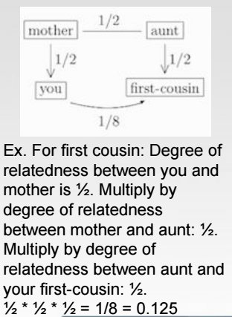

Identify why haplodiploidy can favour high levels of cooperation in social insects
- Female bees are diploid, males are haploid
  - All sperm made by males is identical
  - Workers are related to each other 75% on average, higher than offspring they’d produce
- Insects cooperate because it provides best way to pass on most of their genetic material

Whether a particular social behaviour represents cooperation, competition, spite or altruism
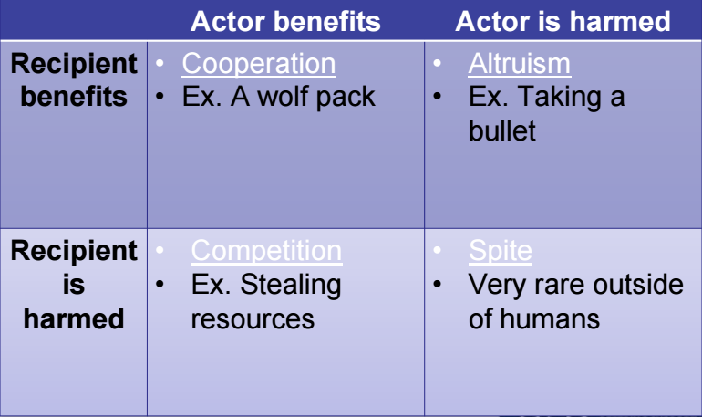

Why "altruistic" and "spiteful" behaviours are both difficult to reconcile with natural selection
- There are no true altruistic behaviors
  - Cooperation (kin selection, reciprocal altruism)
- No spiteful behaviours
  - Spiteful: decreases fitness of both initiator and recipient

How kin selection theory explains the persistence of helpful behavior
- Favours indirect fitness (inclusive) at the cost of direct fitness
  - Ex. Family gathering, see a person with a gun, yell to warn relatives, person kills you

Situations in which kin selection does, or does not, favour helping non-descendant relatives
- Hamilton’s rule: rb>c
  - R: genetic relatedness
  - B: reproductive benefit gained by recipient
  - C: cost to the initiatior of “altruistic” act
- Using Hamilton’s rule
  - Comparing r1b1 & r2b2 or r1n1 vs. r2n2
    - Ex. Raising 6 half siblings vs. producing 3 offsprings
      - (0.25)(6)=1.5
      - (0.5)(3)=1.5
      - Fitness is equal
- Kin selection favoured when benefit>cost

Meaning of direct fitness, indirect fitness, inclusive fitness
- Direct fitness: personal reproduction
- Indirect fitness: reproduction of relatives
- Inclusive fitness: direct+indirect

Why interests of parents may conflict with interests of their offspring
- Offspring 100% related to itself, 50% to each parent, 50% to each sibling
- In utero, mother and child compete for nutrients
- Compete with siblings for nutrients
  - Ideal: 2x resources than sibling

Meaning of cultural intelligence, ultimatum game, rational maximizer
- Ultimatum game
  - Chimpanzees are rational maximizers
    - Disregard fairness, intersts of others
  - Humans are not rational maximizers
    - Favours fairness, considers interest of others

Similarities and differences between humans and closely related species (eg chimpanzees) in cognitive ability, "cultural intelligence", response to the "ultimatum game", and the value of fairness
- By having larger brains, humans are able to perform many cognitive tasks more rapidly and efficiently than other species with smaller brains. Tasks include those associated with memory, learning time, long range planning and complexity of interindividual interactions.
- large brain size in humans reflects cognitive skill sets absent in great apes
- Chimps are rational maximizers because proposers typically offer 40 to 50% of the reward, and responders typically reject offers of less than 20%. They follow the economic model and show little sensitivity to fairness or the interests of others. Humans are not rational maximizers because they are sensitive to fairness and the interests of others
Relative risk of child abuse in families in which not all the adults are genetically related to all of the children
- 40% higher in families with biologically unrelated parents

How mating system affects intensity of parent-offspring conflict
- More intense in promiscuous mating systems
  - Polygyny
  - Polyandry
- Decreased genetic relatedness with future siblings compared to offspring of monogamous parents

Conflict hypothesis for how different interests of maternally vs paternally derived alleles influence embryonic growth
- Maternal: slow
- Paternal: fast
  - Sacrifices mother because father unrelated to the mother

Why the interests of uniparentally transmitted genomes can differ from those of biparentally transmitted genomes
- MtDNA transmitted maternally
- cpDNA transmitted maternally and paternally
- Nuclear DNA transmitted biparentally
- mtDNA shuts down male functions in plant to maximize it own probability of being transmitted

Conditions that favour or disfavour cooperation between non-relatives, in the Prisoner's dilemma
- As a whole, more favourable to cooperate
- At individual level, more favourable to defect
- Cooperation favoured with small population
- Defect favoured with large population
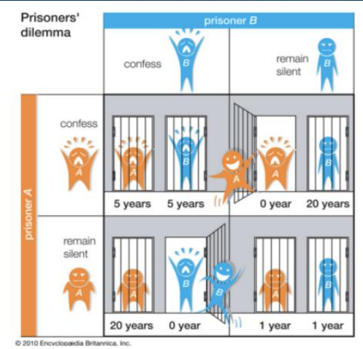

CYCLE 9
How the relative position of fossils in sedimentary rock strata (higher vs lower) reveals their
relative age
- The lower the sedimentary rock strata, the older the fossil.
- If they have not been disturbed, the strata are arranged in the order in which they formed, with the youngest layers on top. However, strata can be uplifted, warped, or inverted by geologic processes. The fossils in the lowest strata are the oldest and get newer as you go up
Ways in which fossils can form
- Prints
- Bones solidify due to minerals
- Freezing and drying
- Petrified forests
- Insects trapped in sap=amber
- Compression shortly after death

Reasons why the fossil record is incomplete
- Organisms don’t fossilize completely
- Some organisms more likely to fossilize
- Destruction by natural processes

Importance of animal skeletons to the fossil record
- Easier to preserve
- Technology
  - Tomography – thin slices
  - X-ray – fine details
  - Specimen reconstructed

Approximate age of the first living things, the first eukaryotes, and the first multicellular
eukaryotes, based on fossil evidence
- First organism: stromatolites, 3.5 bya
- First eukaryote: 2 bys
- First multicellular: 1.2 bya

What types of traits are useful in determining evolutionary relationships
- Morphology – at times
- Physiology, molecular sequence
- Homologous traits
- Analogous traits: not useful
- Ancestral and derived traits
Meanings of mosaic evolution, ancestral character, derived character
- Mosaic evolution
  - Organisms evolve at different rates
    - Pervasive
- Ancestral trait
  - Old forms of traits present in distant common ancestor
- Derived trait
  - New forms of traits present in more recent common ancestor (MRCA)

Whether ancestral or derived characters are more useful in determining evolutionary relationships
- Derived traits provide more useful information regarding evolutionary relationship
  - Present in all descendants

Ways in which cladistic systematics differs from traditional evolutionary systematics
- Traditional evolutionary systematics is an approach to systematics that uses phenotypic similarities and differences to infer evolutionary relationships, grouping species that share both ancestral and derived characters. Cladistic systematics place species with the same derived characters in the one group. They ignore morphological divergence producing phylogenetic hypotheses and classifications that reflect only the branching pattern of evolution

Difference between homologous and homoplasious traits
- Homologous traits
  - Similarity that reflects recent common ancestry
- Homoplasious traits
  - Are misleading
    - Eg. Crocodiles and hippos have similar placement of eyes at top of head, this is a result of similar selection pressures, they aren’t particularly close in ancestry
    - Convergent evolution a source of homoplasy

Relatively close and relatively distant relatives, given a phylogenetic tree
- Can be determines by looking at the last common ancestor

Whether or not two phylogenetic trees convey the same information
- If flipped the information is the same

Monophyletic and non-monophyletic groupings, given a phylogenetic tree
- Only monophyletic groups (clades) make sense in classification
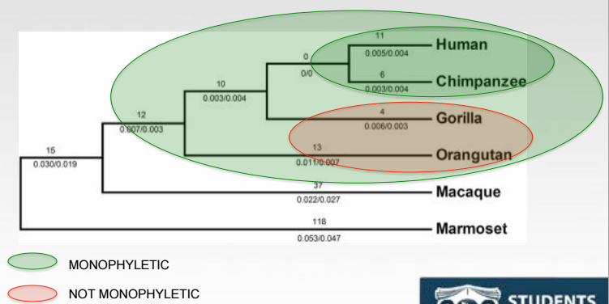

Meaning of synapomorphy, symplesiomorphy, autapomorphy; and know which of these is considered informative in cladistic analysis
- Synapomorphy
  - Traits shared between 2 groups, that have been derived from a common ancestry
- Symplesiomorphy
  - Trait shared between 2 or more groups that is ancestral (the trait existed before just two groups diverged)
- Autapomorphy
  - Unique to and derived from a single group
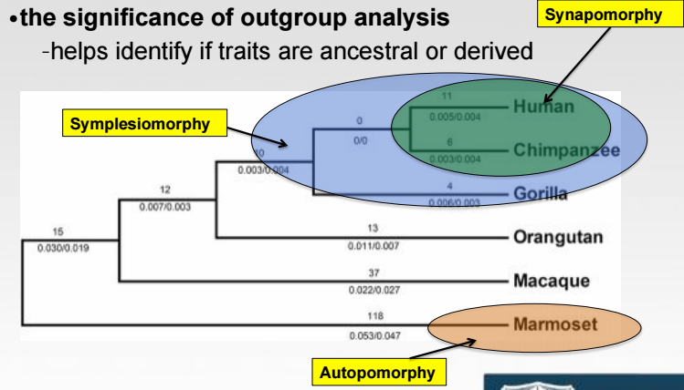

Traits that are probably derived vs probably ancestral, given a phylogenetic tree and a suitable outgroup
- Present in outgroup and all of ingroup
  - Eg. If humans and chimps (outgoing) have a certain trait, and the rest of the group (ingroup) have the trait, then the base of this phylogenetic tree probably had that trait (MRCA)
  - It is possible that it was evolved independently by all, but probably not
- Present in outgroup and some of ingroup
  - This is probably an ancestral trait, with some lineages losing the trait over time
- Absent in one group, present in some of ingroup
  - This trait is probably derived
- Present in outgroup, but none in ingroup
  - 2 equally likely possibilities
    - could be ancestral, with the outgroup lineage losing the trait early on after the MRCA
    - could also possibly be derived by the group
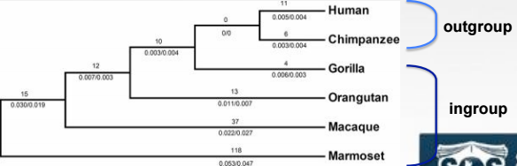

Distinction between parallelism and convergence, and how both of these differ from homologous
Similarities
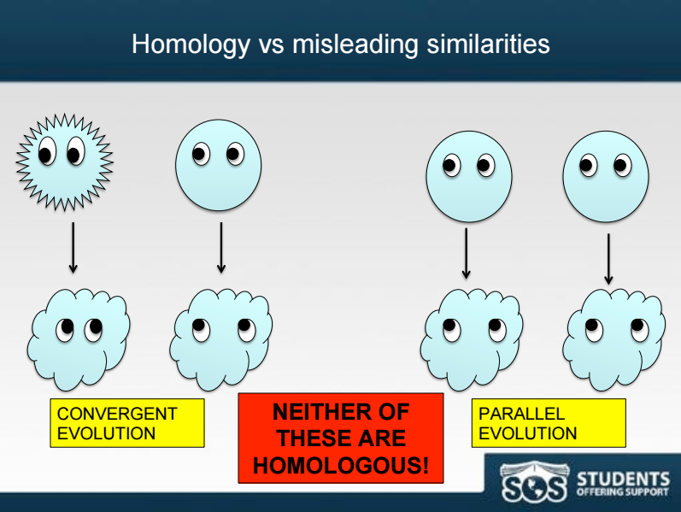

Whether carnivorous plants have likely evolved once or multiple times, and thus whether this trait
is homologous or homoplasious
- Carnivorous plants evolved multiple times
- The trait is homoplasius

How the principle of parsimony informs outgroup analysis and helps identify the most likely phylogeny
- Parsimony: simplest explanation is best
- Whichever tree requires least amount of evolutionary changes (trait gains and losses),is probably correct
- By changes doesn’t mean branched or speciation, changes are the gain or lass of traits

Distinction between homology and homoplasy
- Homologous traits
  - Traits that are inherited from a common ancestor however they serve as different functions in different species
- Homoplasious traits
  - a product of convergent evolution shared by species in the same environment but not by their common ancestor
  - Unlike homologous traits, homoplasious traits are excluded from systematic analyses because they don’t provide information about shared genetic ancestry.

CYCLE 10
Criteria used by the morphological, biological and phylogenetic species concepts to define species
- Morphological species concept
  - A distinct cluster in ohenotypic space, non overlapping with other such clusters (aka how different do they look)
- Biological species concept
  - Defines species as group of organisms that can successfully interbreed and produce fertile offspring
  - Drawbacks
    - Extinct species no available evidence
    - Allopatric populations geographically separated
    - Asexual reproduction excludes all bacteria
- Phylogenetic species concept
  - Defines species as a group of organisms bound by a unique ancestry

Weaknesses/limitations of these different species concepts
- Morphological
  - “a distinct cluster in phenotypic space, non overlapping with other such clusters”
  - or, things that look the same probably belong to the same species
- Biological
  - “an interbreeding or potentially interbreeding group of individuals, reproductively isolated from other such groups”
  - or, things that freely interbreed and produce fertile offspring belonging to the same species
  - offspring has normal fitness
- Phylogenetic
  - “irreducible clade or organisms, diagnosably distinct from other such groups”
  - Many groupings categorized as “subspecies” by BSC are monophyletic would be recognized as species by PSC
Distinguish between pre-zygotic and post-zygotic isolating mechanisms and recognize examples of each
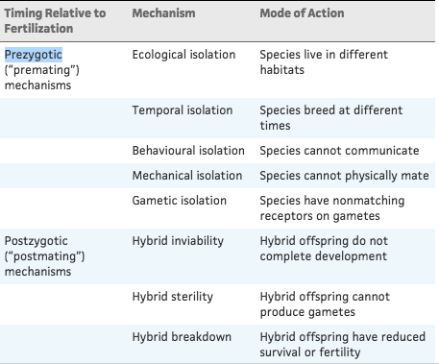
How does speciation occur
- Allopatric speciation: there is a physical barrier to gene flow
  - Isolation+divergence speciation
  - Eg if part of the population ends up on an island it is subject to different selection pressures
- Sympatric speciation: speciation within an overlapping geographical area (no physical barrier to gene flow)

Whether coming into secondary contact is required for speciation to occur
- Secondary contact: if 2 separated populations come back in to contact
  - If they aren’t much diverged may interbreed
  - If populations have become reproductively isolated will observe pre and/or post-zygotic isolation
- It is not required

Ways in which secondary contact can affect speciation
- If the species have not become different enough for post or pre zygotic isolation then it has the possibility to reverse speciation since the two will interbreed and produce fertile offspring again
  - Known as species collapse
- If the species have not come into contact for a long enough period, and postzygotic isolation has been established, once secondary contact occurs, the evolution of prezygotic mechanisms is increased

Whether prezygotic or postzygotic isolating mechanisms tend to be more costly
- Pre-zygotic isolating mechanisms: prevents interspecific mating’s or fertilization (between species)
  - Ecological isolation: species living in same geographical region may live in different habitats
  - Temporal isolation: species live in same habitat but mate at different times of day or even year
  - Behavioral isolation: signals used by one species aren’t recognized by another
  - Mechanical isolation: difference is structure of copulatory organs b/w species (could also be true for other body parts, eg. Petals of flowers shaped for bees)
  - Gametic isolation: incompatibility b/w sperm of 1 species and egg of another (eg. Marine invertebrates release gametes into the environment, but the sperm and egg will only recognize surface of the same species)
- Post-zygotic isolating mechanisms: barriers after fertilization – differentiates inter-specific hybrids from intraspecific/within species offspring
  - Hybrid inviability: the 2 sets of developmental instructions might not interact properly for the embryo to develop; therefore hybrid organisms frequently die as embryo or at early age
  - Hybrid sterility: often when parent species differ in number of chromosomes, can not pair properly during meiosis, so have zero fitness
    - Ex, mule
  - Hybrid breakdown: F1 generation is healthy and fertile, but F2 generation (produced either by 2 hybrids or by hybrid and 1 of parent species) has reduced survival or fertility; reproductive isolation maintained between species because little long-term mixing of gene pools

Competing theories about where modern humans (homo sapiens) evolved, and which is best supported by available evidence
- African Emergence Hypothesis is the best supported
- We evolved from Africa.
- The African Emergence Hypothesis proposes that early hominin descendents left Africa and settled in the Middle East, Asia, and Europe. 1-2 hundred thousand years ago, homo sapiens arose in Africa and migrated to Europe and Asia. Homo sapiens drove away the hominins. All modern humanity is from Homo sapiens.
- The Multiregional hypothesis states that Homo erectus came to Europe and Asia 500 thousand+ years ago and homo sapiens came from them.
- There was no reproductive isolation due to gene flow between the geographically separated populations prevented reproductive isolation
- Paleontological data doesn't clearly support either hypothesis, but genetic data slightly supports African Emergence Hypothesis. Further work of Y chromosomes on men from Africa, Europe, Asia, the Americas, and Australia suggest all humans were a result of a single African migration.
How different species concepts resolve (or do not resolve) the question of whether homo sapiens, neandertals and denisovans were all members of the same species
- Phylogenetic species concept: different species
- Morphological species concept: different species
  - Physically different, especially in brain structure
- Biological species concept: same species
  - All 3 interbreed

Conditions necessary for reinforcement to occur
- If they diverged long enough, then they may have evolved reproductive isolation discovered when come in secondary contact
- If no pre-zygotic isolation, and instead are post-zygotic isolated, their hybrids may have low or zero fitness this is risky because parents devoting resources to an offspring will be an evolutionary dead end
- “reinforcement” (a type of selection - favours pre-zygotic isolation

Arguments for and against the idea that human are no longer evolving
- Aren’t mutation rates lower now because fewer older men are reproducing while in our past a small group of alpha males would reproduce well into their old age (reproducing at an older age yields more mutations)?
- genetic drift is lower. But the gene pool is much bigger
- Selection
- In the developed world, the majority of people born survive until 21If don’t have kids, probably because you don’t want
- In other parts of the world, the majority of people born don’t survive until 5
- Although we don’t see the struggle for existence up-close and personal anymore, in many parts of the world there is a tremendous amount of infant mortality
- Selection is stronger in some parts of the world than others
  - Genetic drift
- Weaker now, because of population size
- Populations are much bigger now so genetic drift is low
- Mutation
- More opportunities for mutations to occur because of radiation and population
- Older men having children can give rise to mutations
  - Gene flow
Populations are connected around the world

Evidence for recent evolution in humans
- sexual selection when choosing mates
- 7% of our genes show evidence of strong recent selection over the last 40000
  - About 100x more than previous 40000 years
- If a mutation is favoured, it can increase the frequency of the genes close to it.
- you don’t find the same SNPs in the same population
Costs of large brains
- It’s hard to give birth when the woman’s pelvis is still small but the child’s head is much bigger
- Metabolically costly
Possible advantages of large brains as proposed by the "utility hypothesis" vs. The "mating mind
Hypothesis"
- utility hypothesis: language, tool use, planning leads to survival
  - the human vocabulary consists of about 60,000-100,000 words, and about 10 new words are learned per day from ages 1-18
- The mating mind hypothesis states that our large brains are used to impress our potential mates and the utility hypothesis says our large brains are used to aid our survival.

CYCLE 11
Mutualistic, competitive and antagonistic relationships between species, given 'real world' examples
- Mutualistic
  - Both species may benefit
  - Ex. Acacia plants and acacia ants
    - Plants provide ants with food and shelter, while the ants protect the plant in turn
  - Ex. Plants and pollinators
    - Plants get to spread their gametes, while pollinators get nectar
  - Ex. Domestic animals and their owners
- Competition
  - Both species may incur costs
  - Two or more species competing for the same limiting resources
  - Both species are incurring costs that wouldn’t occur if the other species weren’t there
    - Both species that are involved suffer
    - Lose-lose situation
  - Example: Lions and cheetahs
    - The food that the lion eats is not available to cheetahs, and vice versa
  - Example: Tall trees competing for sunlight
- Antagonism
  - One species benefits, the other incurs costs
  - Example: Predator-prey relationships
    - Predator species benefits by getting food, prey species incurs cost by losing the lives of many
  - Example: Herbivores and plants
    - Similar reasons as predator-prey
    - May just reduce plant growth rate an longevity, not kill the plant
Factors that advantage one side or the other in an evolutionary arms race
- If each species poses a selection pressure on the other, it gives rise to an evolutionary arms race
  - Recall: The Red Queen metaphor
- When a parasite is co-evolving rapidly, the host species needs to co-evolve just as fast simply to keep up
- Selection pressure gives rise to adaptations in one species to improve ability to interact (combat) with the other species
  - The second species develops a counter-adaptation
  - A cycle of adaptations continues
- Example: Garter snake eating rough-skinned newt
  - Newt releases a toxin that continually adapts to be stronger and more potent, but
  - Snake adapts in ability to break down the new toxin
- Who wins the arms race?
  - May keep escalating until costs outweigh benefits
  - Red Queen Equilibrium: arms race halt when both species com time where is it more costly to adapt then invest in other traits
  - Sometimes, a species may win, if one species
    - They have the potential to evolve faster, so selection operates quicker
  - Has a larger population size
    - Increases likelihood of favourable mutations, and thus influences selection speed
  - Is given a stronger selection pressure from the other species than vice versa
    - Life-dinner principle
Meaning of 'life-dinner principle'
- Predator vs. prey situations
- Selection acts stronger on the prey species than the predator species
  - This is because the prey needs adaptations to stay alive, while the predator just needs them to get more food (prey)
  - Example: Roadrunner vs Wile E. Coyote
    - If roadrunner loses, he’s dead; whereas if coyote loses, he just doesn’t eat that day
Difference between prudent-parasite hypothesis and trade-off hypothesis, in terms of the evolution of virulence
Prudent-parasite hypothesis
- Predicts virulence decreases over evolutionary time
- Parasites that are highly virulent have probably only recently jumped to a new host
  - Haven’t had time to evolve to new host species and its physiology
    - Example: AIDS virus has just begun to infect humans over 100years ago, and hasn’t had time to become less virulent
    - Example: Ebola virus associated with recent transition event to humans, and hasn’t had the time to become less harmful
- Trade-off hypothesis
  - How does high virulence harm the parasite?
  - How does high virulence benefit the parasite?
  - If there are things the parasite can do to increase transmission ability (to colonize new hosts) by making it more virulent
    - Example: Apatient carrier high hiral load of the AIDS virus it is easier for virions to infect a new host if all bodily fluids are teaming with virions
  - Balancing cost of virulence with befits of being virulent
  - Correlation between virulence with benefits of being virulent

Factors that influence the optimal virulence of a given host/parasite relationship
- Some parasites require direct contact between mobile hosts
  - Less virulent because parasites require that host be healthy enough to walk around and interact with over individuals
  - Ex. Cold sore viruses (through kissing)
- Others can spread through indirect contact (insect-borne, water-borne) even if host is immobilized
  - More virulent
  - Immobilizing the current host may help speed at which parasites can spread
Costs and benefits of being highly virulent (from the point of view of the parasite)
- Benefit: more virions being replicated means a high concentration in the host, which will increase the speed at which it can spread between hosts
- Cost: it may kill the host too quickly, giving the virus no time to jump to new host
Why improving equipment for survival does not always translate into 'winning' an evolutionary arms race
- Because both parties are evolving in the evolutionary arms race, improving the equipment doesn’t necessarily improve fitness so neither party is better off or more successful than the other

PAST EXAM QUESTIONS
According to sexual selection theory, when should females complete for mates more intensely than males do?
- Whenever females have higher potential fitness than males
  - Females will compete for males more intensely when females invest less in offspring than males do. This occurs when females have higher potential fitness than females

According to the “ruby in the rubbish” hypothesis, which of the following is an important advantage of sex?
- Sex increases the chance that at least some offspring will have fewer harmful mutations than their parents

According to the phylogeny shown, which species is most closely related to T?
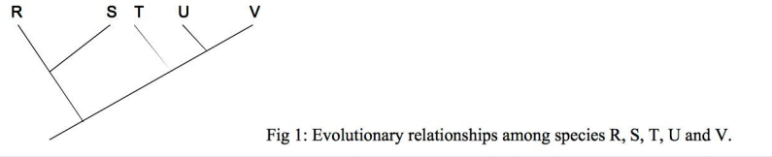

U and V are equally closely relayed to T

DNA sequenxe data suggest that modern humans last shared a common ancestor with OLD World monkeys about 15 million years ago. In contrast, we last shared a common ancestor with New world monkeys about 40 million years ago
What can you conclude about evolutionary relationships among these groups?
Humans are more closely related to Old World monkeys than to New World

For what type of population is the Biological Speciation Concept most useful?
Populations that are sympatric

Many years ago, when Dr. MacShack first went bird watching, myrtle warblers and Audubon’s warblers were thought to represent two different species. Based on the Biological Species Concept, myrtle warblers and Audubon’s warblers are now considered all part of the same species. What must have been discovered about these birds
Myrtle and Audubon’s warblers interbreed in the wild to produce fertile offspring

Which of the following examples represent postzygotic isolating mechanisms?
- When male donkeys mate with female horses, the offspring are sterlle
- When male goats mate with female sheep, the offspring die before being born

