MODULE 5: UNDERSTANDING AND ASSESSING HARDWARE: EVALUATING YOUR SYSTEM.

To Buy or Upgrade
- A rule of thumb often cited in the computer industry, called Moore’s Law, describes the pace at which CPUs improve.
- When deciding whether to upgrade or buy new, consider:
- Moore’s Law.
- Cost of upgrading Vs. buying.
- Time to install software and files.
- Needs and wants.
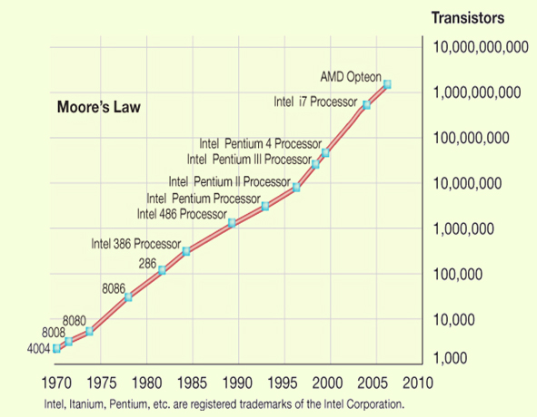
- Determine your ideal computer system.
- Assess existing computer’s subsystems.
- CPU
- RAM
- Storage devices
- Video
- Audio
- Consider training needs.

Desktop or Notebook
- Desktop
- Hard to move around.
- Less expensive.
- Hard to steal.
- Easier to expand and upgrade.
- Difficult to transport.
- Larger monitors.
- Notebook
- Portable.
- More expensive.
- Easily stolen.
- Difficult to upgrade.
- Easy external expansion.
- Prone to damage.
- Smaller displays.

How Does the CPU Work?
- The CPU or processor is the “brains” of the computer. It processes instructions, performs calculation, manages the flow of information through the computer system, and is responsible for processing the data you input into information.
- The CPU is located on the motherboard.
- The CPU is composed of 2 units: the Control Unit and the Arithmetic Logic Unit (ALU).
- The control unit coordinates the activities of all other computer components.
- The ALU is responsible for performing arithmetic calculations and makes logic and comparison decisions, such as comparing items to determine if one is greater than, less than, equal to, or not equal to another.
- Every time the CPU performs a program instruction, it goes through the same series of steps, called a machine cycle:
- First, it fetches the required pieces of data or instruction from RAM.
- Next, it decodes the instruction into something the computer can understand.
- It then executes the instructions.
- Last, it stores the result to RAM before fetching the next instruction.

Differentiating CPUs
- Processing power:
- Core: a complete processing section from a CPU embedded into the same physical chip.
- Clock speed: how quickly the processor works.
- Cache: the amount of immediate access memory the CPU has.
- Front side bus: connects the processor to system memory.

Evaluating CPU
- Identify your current CPU.
- Determine whether it is meeting your needs.
- Go to Task Manager to review CPU usage.
- Consider how quickly data moves to or from the CPU.

Evaluating RAM
- Random access memory (RAM) is your computer’s temporary storage space.
- Memory modules (or memory cards), the small circuit board that holds a series of RAM chips, fit into special slots on the motherboard.
- Most memory modules in today’s system are called Dual Inline Memory Modules (DIMMs).
- Several types of RAM are available.
- DDR2
- DDR3
- SRAM
- DRAM
- SDRAM

How Much RAM Do You Need
- Physical memory Vs. kernel memory.
- The amount of RAM actually sitting on memory modules in your computer is your computer’s physical memory.
- The memory that your operating system uses is referred to as Kernel Memory.
Application | RAM Recommended
Windows 7 | 2,000 MB (or 2 GB)
Microsoft Office Professional 2010 | 512 MB
Internet Explorer 8 | 512 MB
iTunes | 512 MB to 1,000 MB (1 GB)
Adobe Photoshop Elements | 1,000 MB (1 GB)
Total RAM required to run all programs simultaneously | 4,536 MB to 5,024 MB (or 4.5 GB to 5.0 GB)
- To determine how much RAM your computer needs, look at the memory requirements for each program and add them up.
- RAM is needed for system software, productivity software, and entertainment and graphics programs.

Adding RAM
- Adding RAM can have a big positive affect on system performance.
- Things to consider:
- Types of RAM module
- Amount of RAM
- Maximum limit.
- Number of slots.
- Operating system.

Storage
- RAM is a form of temporary storage – anything residing in RAM is not permanently saved. Therefor, it’s critical to have the means to store data and software applications permanently.
- Several storage options exist, including:
- Hard drive.
- USB flash drive.
- Optical drive.
- External hard drive.
- When you turn off your computer, the data stored to these devices is saved. These devices are therefor referred to as nonvolatile storage devices.

The Hard Drive
- Storage capacity is up to 2 terabits (TB).
- Access time is measure in milliseconds.
- Data transfer is measured in megabits or megabytes per second.

How Hard Disk Works
- A hard disk drive is composed of several coated platters stacked on a spindle.
- When data is saved to a hard disk, a pattern of magnetized spots is created on the iron oxide coating each platter.
- Each of these spots represents a 1.
- The spaces not spotted represent a 0.
- These 0’s and 1’s are bits (or binary digits), the smallest pieces of data that computers can understand.
- Siting between each platter are special arms that contain read/write heads. The read/write heads move from the outer edge of the spinning platters to the center to read and write the magnetic data to and from the hard disk.
- When data stored on the hard disk is retrieved (or read), your computer translates these patterns of magnetized spots into the data you have saved.
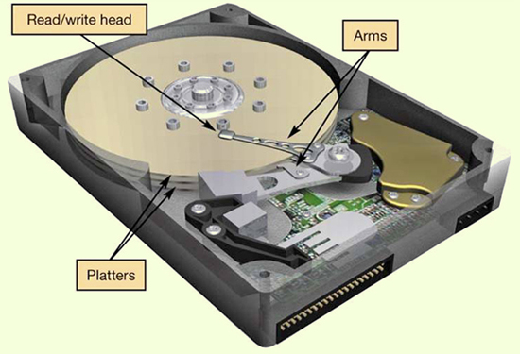

Evaluating Storage
- Identify your hard drives total capacity.
- Determine your storage capacity needs.
- Consider data transfer rates.
- Internal
- External

Optical Storage
- Optical media: store data as tiny pits burned into a disc by a laser.
- Prerecorded
- CD-ROM, DVD-ROM, BD-ROM.
- Recorded
- CD-R, DVD-R, BD-R
- Rewritable
- CD-RW, DVD-RW, BD-RW.
- Consider replacing CD/DVD drive with BD burner.
Evaluating Video
- How video is displayed depends on two components:
- Video card (adapter)
- Monitor
- It’s important that your system have the correct monitor and video card to meet your needs.
- If you used your computer system to display files that have complex graphics, such as video on DVD or from your camcorder, or if you play graphics – rich games with a lot of fast action, you may want to consider upgrading your video subsystem.

Video Cards
- A video card (or video adapter) is an expansion card installed inside your system unit to translate binary data into images you view on your monitor.
- Modern video cards include parts allowing you to connect to different video equipment as well as their own RAM, called video memory.
- Video cards also come with their own processors. Calls the CPU for graphics processing are redirected to the processor on the video card, significantly speeding up graphics processing.
- The video card also controls the number of colors your monitor can display. The number of bits the video card uses to represent each pixel on the monitor (referred to as the bit depth) determines the color quality of the image displayed. The more the bits the better the color detail of the image.
- A 4-bit card displays 16 colors, the minimum number of colors your system can work with (referred to as standard VGA).
- Most video cards now are 24-bit cards, displaying over 16 million colors, this mode is called true color mode (SVGA).
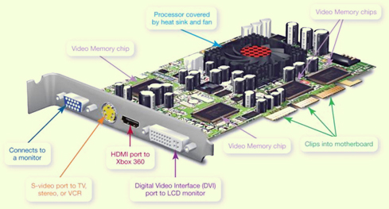

Graphics Processing Unit
- Performs the same work as a CPU.
- Specialized handle:
- 3D graphics.
- Image and video processing.
- CPU performs better with GPU handling graphic computations.

Evaluating a Video Card
- Identify the amount of video memory on your video card.
- Determine your video needs.
- Consider how many monitors you want to use.

Evaluating Audio
- Sound cards attach to the motherboard and enable your computer to produce sounds.
- Attach to motherboard.
- Process digital data into sound.
- 3D soundcards.
- Allow you to connect audio devices.
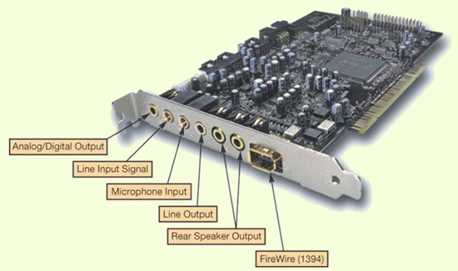

Evaluating System Reliability
- Before you buy a new system thinking yours is unreliable, make sure the problem is not one you can fix. Proper upkeep and maintenance may postpone and expensive system upgrade or replacement.
- Performance:
- Is slow.
- Freezes.
- Crashes.
- Upkeep and maintenance:
- System tools.
- Control panel.
- Update software.

Upkeep and Maintenance
- There are several procedures you can follow to ensure that your system performs reliably:
- Clean out your start up folder. Some programs install themselves into your start up folder and are automatically run each time in the computer reboots. This unnecessary load causes extra stress on the RAM. Make sure you delete on those programs you know for sure are unnecessary.
- Clear out unnecessary files. Temporary Internet files can accumulate quickly on your hard drive. Running the disk clean up utility is a quick and easy way to ensure these files do not take up hard drive space. Likewise, delete unnecessary files from your hard drive regularly.
- Run spyware and adware programs. These can detect and remove various pests and should be used in addition to your regular antivirus package.
- Run the disk defragmenter utility on your hard drive. When your hard drive becomes fragmented, its storage capacity is negatively affected. When you degraf you’re hard drive, files recognized, making the hard drive work more efficiently.

Update Software and Hardware Drivers
- Software
- Having the latest version of software products makes your system much more reliable.
- You should upgrade or update your operating system, browse software and application software and application software. As often as new patches (or fixes) are reporting for resolving errors. Sometime these errors are performance related; sometimes they’re tied to maintaining better security for your system.
- You can configure Windows to automatically check for downloads and install any available updates for itself and for Internet Explorer. In addition, products such as MacAfee’s Oil change enable you to sort through numerous websites and quickly find the fixes for most application software.
- Hardware
- Download updated drivers.

The Last Resort
- When all else fails you have two options:
- Upgrade your operating system to the latest version. There are substantial increases in reliability with each major release of a new operating system. However upgrading the operating system may require hardware updates, such as additional RAM and updated graphics processor, and even a larger hard drive. The Microsoft Windows 7 Upgrade Advisor will perform a scan of your system to determine what upgrades may be required before converting to Windows 7. Be sure to examine the recommended (not just required) specifications of the new operating system.
- Reinstall the operating system. To so you’ll need to backup all of your data files before the installation and be prepared to reinstall your software after the installation. Make sure you have all the original discs for the software installed on your system, along with the product keys, serial numbers, or other activation codes so that you can reinstall the software.
The Final Decision
- When a decision about upgrading versus replacing your computer is required, you have to ask yourself how you use your computer system.
- How might you use it if it were more capable?
- Can your existing system do what you want it to?
- If not, can you purchase the parts and install them to achieve the desired capability?
- Add up the cost of the parts, figure the value of the headaches and labor required to install those parts and compare the total to the costs of a new machine that will do the same task and more. You should then arrive at a point when the decision is easy.

MODULE 5 SUMMARY QUESTIONS:
- How can I determine whether I should upgrade my existing computer or buy a new one?
- What does the CPU do and how can I evaluate its performance?
- How does memory work in my computer and how can I evaluate how much memory I need?
- What my computers main storage devices, and how can I evaluate whether they match my needs?
- What components affect the output of video on my computer, and how can I evaluate whether they match my needs?
- What components affect the quality of sound on my computer and how can I evaluate whether they match my needs?
- How can I improve the reliability of my system?

MODULE 6: NETWORKING: CONNECTING COMPUTING DEVICES
Networking Fundamentals
- Computer network: two or more connected computers.
- Node: any device connected to a network.
- Benefits of computer networking.
- Facilitates resource sharing.
- High speed Internet connections.
- Peripheral devices such as printers.
- Files.
- Disadvantages of computer networking.
- Network administration.
- Installing new computers and devices.
- Monitoring the network’s performance.
- Updating and installing new software.
- Configuring network security.

Network Architectures
- Architecture: design of the network.
- Peer-to-peer network.
- Local administration.
- Each node can communicate directly with every other node.
- Client server.
- Central administration.
- Clients: used to accomplish tasks.
- Server: administers network functions.

Network Based on Distance
- LAN: Local area network.
- HAN: Home are network.
- WAN: Wide area network.
- MAN: Metropolitan are network.

Network Components
- Transmission media.
- Wireless networks connect nodes with radio waves.
- Wired networks use cables to connect nodes.
- Twisted pair cable.
- Coaxial cable.
- Fiber optic cable.

Data Transfer
- Data transfer rate.
- Bandwidth.
- Speed of data transmission.
- Throughput.
- Actual speed of data transfer achieved.
- Always less than or equal to the data transfer rate.

Network Adapters
- Devices connected to, or installed in network nodes.
- Enable nodes to communicate with each other and access the network.

Wireless Signals
- Might have decreased throughput:
- Interference from magnetic and electrical sources.
- Interference with other wireless networks.
- Building materials and metal.
- Distance from networking equipment.
- Coded signals.

Network Navigation Devices
- Control the flow of data through a network.
- Data sent in bundles called packets.
- Routers.
- Transfer packets between two or more networks.
- Switches
- Send packets to intended nodes on same network.

Networking Software
- Home networks.
- P2P supporting operating system.
- Windows.
- OS X.
- Linux.
- Client/server networks.
- Network operating system (NOS) software.
- Windows server 2008 R2.
- SUSE Linux Enterprise server.

Home Ethernet Networks
- Use Ethernet protocols as standard for network communication.
- Wireless 802.11.
- Wired 802.3.
- Routers and network adapters.
- Translate electronic data into radio waves.
- Broadcast radio waves to other nodes.
- Receive signals from other nodes.

Throughput Speeds
- Can be measured utilities like Net Meter.
- Wired connections provide best throughput.
- Wi-Gig will be faster than current-wired or wireless standards.
- Will not be available for several years.

Network Cabling
- Unshielded twisted-pair (UTP) cable.
- Most popular cable for Ethernet networks.
- Composed of four pairs of wires that are twisted around each other to reduce electrical interference.
- RJ-45 connectors: used on cable ends.
- Cat 6 cables: best UTP for home networks.
- Signal degrades after 100 meters (328 ft.).

Home Ethernet Network Equipment
- Router (broadband router).
- Includes integrated switches.
- Most have wireless capability.
- Can contain broadband modem.
- Wireless devices needs wireless network interface cards (NICs).
- Network-ready devices can connect directly to router.

NAS Devices
- Network attached storage (NAS) device.
- Store and manage data.
- Home network server.
- More sophisticated NAS device.
- Performs only a limited set of functions performed on client/server networks.

Digital Entertainment Devices
- Connect to network to access and share digital content.
- Use gaming devices to play multiplayer games with players all over the world.
- Network-ready TVs and home theater systems.
- Blu-ray players.
- DVRs

Specialized Devices
- Internet appliances.
- Used to access Internet.
- Apple iPad.
- Digital picture frames.
- Security monitoring cameras.
Securing Wireless Networks
- Piggy backing
- Connecting to a wireless network other than your own without permission of the user.
- Can be unintentional.
- Most wireless adapters are set up to access the strongest wireless signal detected.
- Hackers can intercept packets of information broadcast on a wireless network.
- Precautions to secure a wireless network:
- Change your network name (SSID).
- Disable SSID broadcast.
- Change the default password on your router.
- Turn on security protocols.
- Implement media access control.
- Limit your signal range.
- Apply firmware upgrades.

Configuring a Home Network
- Windows 7 automates setting up networks.
- Before running the automated wizards:
- Make sure there are network adapters on each node.
- For any wizard connections, plug all cables into the router, nodes, and so on.
- Make sure broadband modem is connected to your router and that modem is connected to the Internet.
- Turn on your equipment in the following order (allowing, the modem and the router about one minute each to power up and configure):
- Broadband modem.
- Router.
- All computers and peripherals (printers, scanners, etc.)
- Access Network and Sharing Center from within Control Panels.
- Turn Network Discovery on.
- Turn File and Printer Sharing on.
- Turn Public Sharing Folder on.
- Use Set Up a New Connection Wizard.
- Use Connect to the Internet Wizard.
- Use Set Up a Wireless Router Wizard.

Connecting Mac Wirelessly
- Set up a router security (as Windows).
- Logging onto network requires SSID and passphrase.
- Choose network, enter password, and join.
- Networks with SSID broadcast turned off will not appear as an available network.
- Click “other” and enter the network and name password.

Wireless Node Configuration
- Hook up devices like DVRs or gaming consoles.
- Wired connection.
- Plug cable into device and router.
- Wireless connection.
- Follow steps in devices setup menu.
- SSID name and security passphrase required if network secured.

Test Internet Connection Speed
- Internet sites allow you to test speed of downloading and uploading files.
- Speedtest.net
- Broadband.gov
- Run test at several different times during the day over the course of a week.

Troubleshooting Network Problems
- Throughput decreases as device moves farther away from router.
- To increase throughput:
- Move the router within the room or to another room.
- Move the device closer to the router.
- Amplify your wireless signal by adding a wireless range extender.

MODULE 6 SUMMARY QUESTIONS:
- What is network? And what are the advantages/disadvantages of setting up one?
- What is the difference between a client/server network and peer-to-peer network?
- What are the main components of every network?
- Which type of network is most commonly found in the home?
- What equipment and software do I need to build a network in my home?
- Besides computers, what other devices would I connect to a home network?
- Why are wireless networks more vulnerable than wired networks, and what special precautions are required to ensure my wireless network is secure?
- How do I configure the software on my computer and set up other devices to get my network up and running?
- What problems might encounter when setting up a wireless network?

