MODULE 3: APPLICATION SOFTWARE: PROGRAMS THAT LET YOU WORK AND PLAY

Software
- The term software refers to a set of instructions that tells the computer what to do. These instruction sets, also called programs, provide the means for us to interact and use the computer.
- Your computer uses two basic kinds of software:
- System software.
- Application software.

System Software Vs. Application Software
- System software
- Coordinates instructions between software and hardware.
- Includes:
- Operating system.
- Utility programs.
- Application software
- Programs used to complete task.
- Includes:
- Productivity software.
- Specialty software.
- Entertainment software.
- Educational and reference software.
- Personal software.

Application Software
- Here you see the carious types of application software available. In this module, we look at all these types in detail, starting with productivity software.
- Application software
    - Productivity
      - Word processing
      - Spreadsheet
      - Presentation
      - Database
      - Personal information manager
      - Personal finance
- Application software
    - Media
      - Image editing
      - Audio editing
      - Video editing
      - Media management
- Application software
    - Home/Entertainment
      - Gaming
      - Education
      - Reference
      - Drawing
- Application software
    - Business
      - Home business
      - Large business
      - Specialized business

Productivity Software
- Programs that allow you to perform various tasks generally required in home, school and business.

Word Processing Software
- Used to create and edit documents.
- Features include:
- Quick and easy editing
- Formatting options
- Graphics
- Templates
- Wizards
Example…:
- Corel WordPerfect
- Microsoft Word
- Open Officer Writer
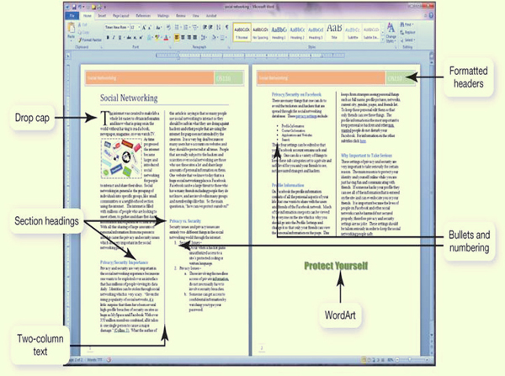

Spreadsheet Software
- Used to perform calculations and numerical analysis.
- Feature include:
- Worksheets without cells.
- Values formulas and functions.
- Automatic recalculations.
- The basic element in a spreadsheet program is the worksheet, columns and rows, which form boxes called cells. There are several of data you can entre into a cell:
- Labels are descriptive text that identifies the components of the worksheet.
- Values are numeric data entered either directly or as a result of a calculation.
- Formulas are equations that you build yourself.
- Functions are formulas that are programmed into the spreadsheet software.
- The primary benefit of spreadsheet software is its ability to re-calculate all functions and formulas in the spreadsheet automatically when assumptions are changed.
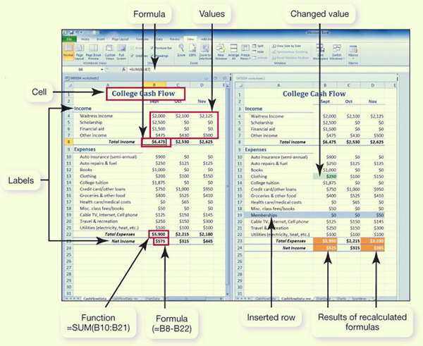

Presentation Software
- Used to create slideshows
- Features include:
- Templates and layouts
- Animations
- Transitions
- Can use animation effects to control how and when text and other objects enter and exit each slide. Similarly, slide transitions add different effects as you move from one slide to the next during the presentation.
Examples…:
- Microsoft PowerPoint
- Open Office Impress
- Zona Show

Database Software
- Used as a complex electronic filing system.
- Features include:
- Ability to group, sort and retrieve data and generate reports.
- Organized into field’s records and tables.
Example…:
- Microsoft Access
- Oracle
- My SQL
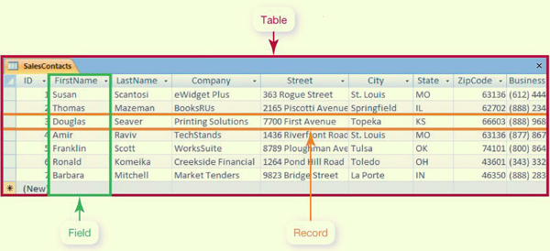

Note-Taking Software
- Microsoft OneNote
- Allows students who have tablet PCs to write their notes directly onto the tablet, using it as an electronic notebook.

Personal Information Manage (PIM) Software
- Used to replace the traditional tools found on a desk, such as a calendar, address book, notepad and to-do list.
- Features include:
- Calendar, address book, notepad and to-do list.
- Some contain e-mail management features.
Example…:
- Microsoft Outlook
- Lotus Organizer

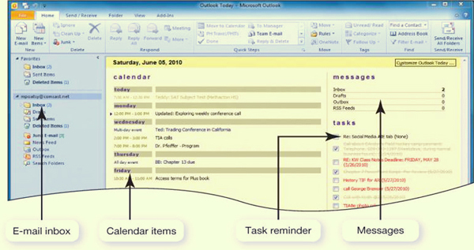

Productivity Software Tools
- Whether you are working on a word-processing document, spreadsheet, database or slide presentation, there are several tools you can use to increase you efficiency:
- Wizards are step-by-step instructions that walk you through the necessary steps to complete a complicated task.
- Templates are predesigned forms included with software.
- Macros are small programs that group a series of commands to run as a single command. Macros are best used to automate a routine task or a complex series of commands that must be run frequently.

Integrated Software Vs. Software Suites
- Integrated software application
- Single program that incorporates many software programs.
- Complex features are not included.
- Less expensive.
Example… Microsoft Works
- Software Suite
- Collection of stand-alone software programs packaged together.
- Share common menus and toolbars.
- Integrate well.
- Developers: Microsoft, Corel and Lotus.

Personal Financial Software
- Used for tax preparation and financial planning
- Tax preparation software enables you to prepare your taxes on your own rather than hiring a professional. Each program offers a complete set of tax forms and instructions as well as expert advice on how to complete each form.
Example… Inuit’s Turbo Tax and H&R BLOCK’s tax cut
- Financial planning software helps you mange your daily finances. These programs include electronic checkbook registers and automatic bill payment tools. With these features, regular monthly payments with automatically scheduled online payments or printed checks.
Example…:
- Inuit’s Quicken and Microsoft Money.
- Web based programs: mint.com and websabe.com

Media Software for Home
- Graphics and multimedia software.
- Desktop publishing software.
- Image editing software.
- Drawing (illustration) software.
- Computer aided design software.
- Video editing software.
- Web page authoring software.

Digital Image Editing Software
- Used to edit photographs and other images.
- Remove red-eye.
- Modify contrast.
- Fix scratches.
Examples…:
- Adobe Photoshop.
- Corel Paint Shop Pro.
- Google Picasa

Digital Audio Software
- Used to edit audio files in formats such as MP3, WAV, WMA and AIFF.
- Most popular MP3: compresses audio file size.
- Hundreds of applications allow you to rip, play and organize MP3s.
- Features include recording, editing, adding special affects, and format conversion.

Digital Video-Editing Software
- Used to create and edit windows media player, Apple Quick Time, or RealPlayer video files.
Examples…:
- Adobe Premier Pro
- Microsoft Live Movie Maker
- Apple iMovie HD
- Buy application that supports your file format.
- Many portable devices play MP4 format.

Media Management Software
- Software to organize media files.
- Sort by filter, and search by artist, album or category.
Examples…:
- Windows Media Player
- Nullsoft Winamp
- Apple iTunes
- Manage tracks and generate playlist.
- Burn songs to CDs and print liner notes.

Online Photo Management
- Web based sites allow easy management and sharing of digital photos.
- Allow creation photo albums.
- Offer professional printing services.
Examples…:
- Flickr.com
- Snapfish.com
- Kodak.com
- Shutterfly.com

Software Fun for Home
- Processing power.
- Memory (RAM).
- Hard disk capacity.
- Sound Card.
- Video Card.
- Speakers.
- Monitor.
- CD or DVD Drive.
- Specialized Controllers.

Game Rating System
- The entertainment software rate board (ESRB) providers:
- Rating symbols:
- Everyone (E)
- Teens (T)
- Mature (M)
- Adult Only (AO)
- Content descriptors.

Educational Reference and Software
Educational Software
- Provides instructions or training.
- Types include:
- K-12 education
- Skill development.
- Test Preparation.
- Brain Training.
- Simulations.
- Online Courses.

Drawing Software
- Used to create and edit.
- Two-dimensional drawings.
- Technical diagrams.
- Animations.
- Geometric shapes.
Examples…:
- Adobe Illustrator.
- Microsoft Vision.

Business Software for Home and Office
- Programs for home business.
- Accounting software.
- Desktop publishing software.
- Webpage authoring software.

Accounting software
- Help small business owners efficiently manage their finances.
- Provides a tool for tracking accounts receivables and accounts payable.
- Includes templates for invoices, statements, and financial reports.
Example…:
- Inuit’s QuickBooks
- Peachtree by Sage

Desktop Publishing (DTP) Software
- Used arranged text and graphics for publication.
- Features include:
- Text formatting.
- File importing.
- Graphics tool.
- Web publishing.
Examples…:
- QuarkXPress
- Adobe InDesign

Webpage Authoring Software
- Used to create webpage.
- Knowledge of HTML is not necessary.
- Features include:
- Wizards and templates.
- Reference materials.
- Interactive content.
Examples…:
- Microsoft Expression Web
- Adobe Dreamweaver
- Office applications can save documents as a web page.

Large Business Software
- Used across a variety of industries.
- Includes:
- Business and marketing plan software.
- Project management software.
- Customer relationship management (CRM) software.
- Enterprise resource planning (ERP) system.
- E-commerce solution.

Mapping Software
- Provides nationwide street maps and directions.
- Supplies geographic data for decision-making.
- Available versions:
- Online
- PC
- Smart Phone
- GPS device

Specialized Business Software
- Vertical market software: tailored to the needs of a particular industry.
Example…:
- Estimating software.
- Property management software.
- Scheduling and dispatching software.
- Proprietary software can be custom developed for a company.

Compute-Aided Design (CAD) software
- Used to create 3-D automated designs, technical drawings and model visualizations.
- Industrial use includes:
- Architecture
- Automotive
- Aerospace
- Medical engineering industries
Example… Autodesk’s AutoCAD

Getting Help with Software
- Types of help:
- For general help or for information about the product, many websites offer frequently asked questions (FAQs), which include answers to the most common questions.
- Some programs also offer online help and support. Sometimes, online help allows you to chat with a member of an online support team.
- Some applications are context-sensitive and offer help based on the task you’re doing or ScreenTips to explain where your cursor is resting.
- In Microsoft Office application, on the far top right of the screen, you’ll find a question mark icon. This takes you to the main help interface. Integrated help means the documentation is built directly into the program. You type a question, search for a term, or browse to help topics.
- There is help menu on the menu bar of most applications when you can choose to search an index or content to find out the nature of almost any feature.
- There are also many online sites, such as Malektips.com, that provide a vast array of multimedia tutorials.

Software licenses
- You buy a license not the software itself.
- Check license for:
- Ultimate owner software.
- Number of installations allowed per license.
- Per computer, per user, or per family (Apple)?
- Warranties.
- Multiuser licenses available.
- Per seat.
- Concurrent.

Acquiring Software
- Software can be purchased.
- Through retail stores.
- Online.
- By mail order.
- Virtually every computer comes with some form of application software installed, although the applications depend on the hardware manufacturer and the computer model. You can usually count on your computer having some form of productivity software preinstalled.
- Web based application software:
- Hosted on a website.
- Requires no installation on your computer.
- Discounted software.
- Custom developed software.

Freeware and Shareware
- Freeware is any copyrighted software you can use for free.
- Some software developers offer beta versions of their software free of charge. Beta versions are still under development. By distributing free beta versions, developers hope to have users report error bugs they find in the program. This helps them correct any errors before they launch the software on the market at retail price.
- Software that allows users to test software (run it for a limited time free of charge) is referred to as shareware. Shareware is not freeware. If you use the software after the initial trial period is over. You will be breaking the software license agreement.
- Open source software is free to use on the condition that any changes you make to improve the source code also must be disrupted for a fee.

Software Versions
- Numbers are used to represent major and minor upgrades.
- Major upgrade: version 2.0
- Minor upgrade: version 2.1
- Years (Microsoft Office 2010) and letters (WordPerfect Office X3) are also used.
- When an upgrade is released, consider if it is cost efficient to purchase it.

System Requirements
- Minimum standards for the operation system, processor, RAM, and hard drive capacity.
- Specifications for video card, monitor, CD drive and other peripherals.
- Need sufficient storage, memory capacity and processing capabilities.

Installing/Uninstalling Software
- Installing software from CD or DVD.
- Installation wizard.
- Choose full or custom installation.
- Downloading software from the web.
- Unzip files.
- Launch setup program.
- Uninstalling software
- Software un-install utility.

MODULE 3 SUMMARY QUESTIONS:
- What is the difference between applications software and system software?
- What kinds of applications are included in productivity software I might use at home?
- What are the different types of multimedia software?
- What are the different types of entertainment software?
- What are the different types of drawing software?
- What kinds of software do small and large businesses use?
- What kind of software is available online?
- Where can I go for help when I have a problem with software?
- How can I purchase software or get it for free?
- How do I install, uninstall and open software?

MODULE 4: USING SYSTEM SOFTWARE: THE OPERATING SYSTEM, UTILITY PROGRAMS AND FILE MANAGEMENT

System Software: The OS
- The operating system (OS) is the main program that:
- Control how system functions and manages the computer’s:
- Hardware
- Processor
- Memory
- Peripheral devices
- Provides means for software to work with the CPU is responsible for management, scheduling and interaction of tasks.
- Provides user interface such as the desktop, icons and menus.

System Software: Utilities
- System software also includes utility programs. These are programs that perform computer housekeeping tasks.
- Backup
- Security
- Diagnostic
- Recovery

Operating System: Categories
- Operating systems can be classified in four categories.
- Real time (RTOS): Embedded systems.
Example… Found in measurement instruments.
- Multiuser: Network operating system.
Example… Microsoft Windows Server OS
- Single-user Multitask
Example… Apple Mac OS
- Single-user, Single-task
Example… MS-DOS

Real-time Operating System (RTOS)
- Machinery that performs repetitive series of specific tasks in an exact amount of time that requires a real-time operating system.
- This type of operating system is a program with a specific purpose.
- Uses include:
- Automobiles
- Printers
- VoIP phones
- Medical devices
- Appliances
- Robotic equipment

Multiuser Operating System
- Also known as network operating systems.
- Enables more than one user to access the computer system at one time by efficiently juggling all the requests from multiusers.
- A network operating system is installed on the server and manages all user requests, ensuring that they do not interfere with each other.
- Systems include:
- Linux
- UNIX
- Windows Server 2008
- Mac OS X
- IBMi
- Z105

UNIX
- UNIX is a multiuser - multitask operating system.
- Used primarily with main frames as a network operating system.
- Also often found on PCs.
- Vendors can modify code.
- Hewlett-Packard HP/UX
- Sun Solaris
- IBM AIX

Mainframe and Supercomputers
- Other computers utilizing multiuser operating systems.
- Mainframes
- Handle requests from hundreds or thousands of users simultaneously.
- Supercomputers
- Used by scientists and engineers.

Smartphones
- Do more than let the user make and answer phone calls.
- Have productivity features, in addition to features found on personal media players and cameras and the ability to connect to the web.
Example… :
- BlackBerry devices
- Apple iPhone
- Google Android
- Palm Pre

Desktop and Notebook Operating Systems
- The combination of operating system and processor is referred to as computer’s platform.

Example…:
- Microsoft Window OS/ Intel and AMB Processor
- Apple Macintosh OS/ Motorola, IBM and Intel Processor
- Application software is platform specific.

Microsoft Windows
- Multiuser, multitasking OS.
- Windows 7 is the newest version.
- Features:
- Increased functionality.
- User friendliness.
- Improved Internet capabilities.
- Enhanced privacy and security.

Mac OS
- First commercially available OS with point and click technology (GUI)
- Excellent in:
- Graphic display.
- Processing capabilities.
- System reliability.
- File backup utilities.
- However, there are fewer software applications available for the Mac platform than for the Windows-based PCs.

Linux
- Open source operating system.
- Based on UNIX.
- Stable system.
- May be downloaded free from the Internet.
- Can be tweaked to meet any OS needs.
- Runs on PCs, notebooks, iPods and gaming systems.

What OS Does
- Provides user interface.
- Manages the CPU.
- Manages memory and storage.
- Manages hardware and peripheral devices.
- Coordinates application software with the CPU.

The User Interface
- Enables you to interact with the computer.
- Types of interfaces:
- Command-driven interface: meaning that the user had to type very specific commands to get the computer to load the program. The commands were not always easy to understand; therefore the interface proved to be too complicated for the average user.
- Menu-driven interface: the user chooses a command from menus displayed on the screen. Menu-drawn interfaces eliminated the need to know every command because you could select most of the commonly used commands from a menu. However, they were still not easy enough for most people to use.
- Graphical user interface (GUI): display graphics and uses point-and-click technology of the mouse and cursor, making operating systems much more user friendly.

Processor Management
- Controls the timing of events the processor works on:
- Multitasking
- Interrupts
- Interrupt handler
- Interrupt table
- Stack

OS Architecture
- Systems with more than 4GB or RAM feature a 64-bit version of Windows (Windows Vista or Windows 7).
- If you purchase a 64-bit system, you will need to make sure that all your hardware and software programs are updated to work well with the 64-bit version of your OS.
- Previous versions of Windows used 32-bit systems.

Random Access Memory (RAM)
- RAM has limited capacity.
- Running multiple programs at one time requires more RAM.
- Most editions of Windows 7 require more than 1GB of RAM for the OS alone.
- The translucent aero user interface requires at least 2GB of RAM and a video card with at least 256MB of RAM.

Virtual Memory
- Instructions and data are stored on the hard drive when RAM is full.
- Swap file
- Paging
- Trashing
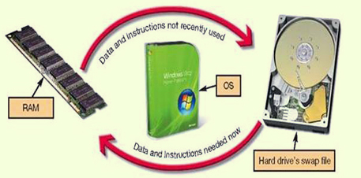

Hardware and Peripheral Device Management
- Device Drivers
- Each device attached to your computer comes with a special program called a device driver that facilitates the communication between the device and the OS.
- The device driver translates the specialized commands of the device to commands that the OS can understand, and vice versa. Thus, devices will not function without the proper device driver because the OS would not know how to communicate with them.
- Plug and Play
- Today, most devices come with the drive preinstalled in Windows. Devices whose drivers are included in Windows are called Plug and Play (PnP).
- Plug and play is not a driver, instead, it is software and hardware standard designed to facilitate the installation of a new piece of hardware in computers by including in the OS the driver the device needs to run. Plug and Play enables users to plug their new device into a port on the system, turn on the system, and immediately use the device. The OS automatically recognizes the device and its driver.

Software Application Coordination
- For software programs to work with a CPU, they must contain code that the CPU recognizes. Rather than having the same blocks of code that the CPU recognizes similar procedures in each software application, the OS includes the block of code that the software applications need. These blocks of code are called Application Programing Interfaces (APIs).
- To create programs that can communicate with the operating system, software programmers need only to refer to the API code blocks in their individual application itself. Not only do APIs avoid redundancies in software code, but they also make it easier for software developers to respond to changes in the OS.
- Microsoft DirectX, for example, is a group of multimedia APIs built into the Windows operating system that improves graphics and sounds when you’re playing games or watching video on PC.

Starting the Computer
- For a computer to go from a dead stop to ready for use, a start-up process is required. This is often referred to as booting up the computer, or the boot process.
- The boot process consists of four basic steps:
- The basic input/output system (BIOS) is activated by powering on the CPU.
- The BIOS checks that all attached devices are in place (called a power-on self-test, POST).
- The operating system is loaded into RAM.
- Configuration and customization settings are checked.
- Once the boot process has completed these steps, the computer is ready to accept commands and data.
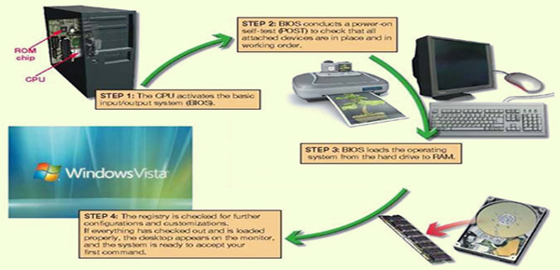

Handling Errors in the Boot Process
- Errors during the boot process are often very simple to correct. It is helpful to be aware of the most common problems.
- Sometimes Windows does not boot properly and you end up with a screen with the words SafeMode in the corners.
- SafeMode is a special diagnostic designed for troubleshooting errors.
- While in SafeMode, only the essential devices of the system (such as the mouse, keyboard and monitor) function.
- If after you boot, you end up in SafeMode; try re-booting the machine before doing anything else.
- Of you still end up in SafeMode and if you have recently installed new software or a new hardware device, try uninstalling it.

The Desktop
- The desktop is the first interaction you have with the OS and the first image you see on your monitor. As its name implies, your computer’s desktop puts at your fingertips all of the elements necessary for a productive work session that typically are found on or near the top of a traditional desk, such as files and folders.
- The Recycle Bin is a location for deleted files and folders from the C: drive only.
- A gadget is an easy-to-use mini program that gives you information at a glance or quick access to frequently used tools including weather information, calendar items, calculators, games, photo albums and system tools.
- The task bar displays open and favorite applications for easy access.
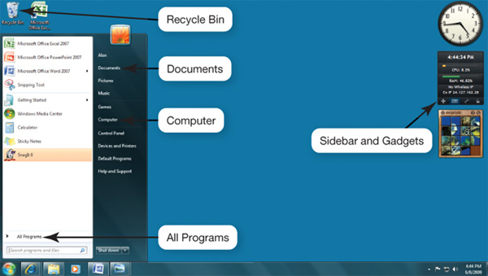

Mac Vs. Window
- Similar functionality.
- Streamlined user interface.
- Window-like work areas on the desktop.
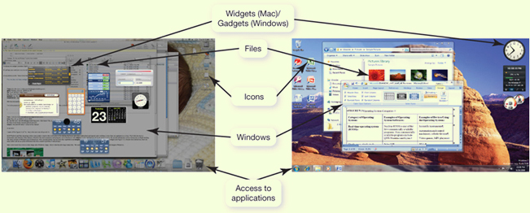

Windows
- The standard window in the Windows has consistent features. Once a user is familiar with the setup of these features, he or she will be immediately familiar with the windows in any windows-based software. How many of the features can you name?
- Title bar
- Menu bar
- Tool bar
- Window view options
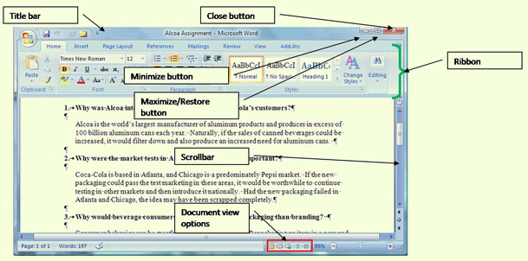

Viewing Windows
- Side-by-side
- Stacked
- Cascading
- Flip 3D
- Snap
- Aero shake

File Management
- The operating system provides an organizational structure for the computer’s contents.
- The OS allows you to organize the contents of your computer in a hierarchical structure of directories that includes:
Drivers
Folders
Subfolders
Files
- Windows 7 introduces the concepts of libraries, which are collections that gather files from different locations and display them as if they are physically stored.
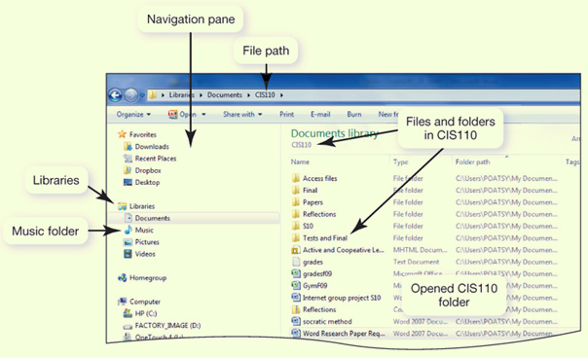

Viewing and Sorting Files and Folders
- Many views available:
- Large icons.
- Extra large icon view.
- Tiles view.
- Details view.
- List view.
- Small and medium icon views.

Filename Extensions
- Following the filename and after the dot (.) comes an extension, or file type. This extension identifies what family of files the file belongs to or which application should be used to read the file.
Extension | Type of Document | Application
.doc | Word-processing document | Microsoft Word 2003
.docx | Word-processing document | Microsoft Word 2007 and 2010
.wpd | Word-processing document | Corel WordPerfect
.xlsx | Spreadsheet | Microsoft Excel 2007 and 2010
.accdb | Database | Microsoft Access 2007 and 2010
.pptx | PowerPoint presentation | Microsoft PowerPoint 2007 presentation
.pdf | Portable Document Format | Adobe Acrobat or Adobe Reader
.rtf | Text (Rich Text Format) | Any program that can read text documents
.txt | Text | Any program that can read text documents
.htm or .html | Hyper Text Markup Language for a Web page | Any program that can read HTML
.jpg | Joint Photographic Experts Group (JPEG) image | Most programs capable of displaying images
.gif | Graphic Interchange Format (GIF) image | Most programs capable of displaying images
.bmp | Bitmap image | Windows
.zip | Compressed file | WinZip
Example… If the bio report file is word 2003 document, it has a .doc extension and is named bioreport.doc. If the file is created in a word 2007 or 2010, the file extension is .docx and is named bioreport.docx.
- All word, Excel, PowerPoint files created in the 2007 and 2010 version have an “x” at the end of the traditional three-letter extension.

Naming Files
- Filename: name assigned plus file name extension.
- “Bioreport” may be the name you assign to a report you have completed for biology, if:
- If it were created in Works, it would be named bioreport.wks.
- If it were created in Word 2007 or 2010, it would be named bioreport.docx.
- File and Folder name length is up to 255 characters.
- Characters not legal in Windows filenames:;”\/*?<>|:
- Characters not legal in Mac filenames: “:”
- Mac filenames are case sensitive and do not need file extensions.

File Path
- You can tell a location of a file by its file path. The file path starts with the drive in which the file is located and includes all folders, subfolders (if any), the file name and extension.
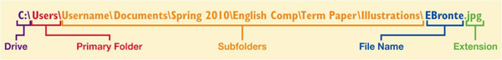
- For example, if you were saving a picture of Emily Bronte for a term paper for an English Comp course, the file path might be C:\MyDocuments\spring2009\EnglishComp\TermPaper\Illustrations\Ebronte.JPG

Working With Files
- File management actions:
- Open: open a file by clicking the storage location. The operating system then determines which application need to be loaded to open the requested file and opens the file within the correct application automatically.
- Copy: when you copy a file, a duplicate file is created and the original file remains in its original location.
- Move: when you move a file, the original file is deleted from its original location.
- Rename.
- Delete.
- The Recycle Bin is a folder on the desktop in Windows where files deleted from the hard drive reside until you permanently purge them from your system. Files in the Recycle Bin can be easily restored to their original location.
- Mac systems have something similar to the Recycle Bin, called Trash.
- Files deleted from other drives, such as floppy drive, DVD, flash drive, or network drive do not go to the Recycle Bin, but are deleted from your system immediately.

Utility Programs
- Utility programs are small applications that perform special functions.
- Some utility programs (such as disk defragmenter utilities) manage system resources.
- Some (such as screensavers) help you make your time and work on the computer more pleasant.
- Others (such as file compression utilities) improve efficiency.

Display Utilities
- Right clicking on the desktop opens the Display Properties dialog box, This dialog box can also be accessed from the Control Panel using the display icon.
- From here you can change the appearance of:
- Desktop
- Background
- Screen savers
- Window colors

Add or Remove Programs
- When you install a new program, the program runs a wizard that walks you through the installation process. If a wizard does not initialize automatically, however, you should go to the Add or Remove Programs folder in the control panel. This prompts the OS to look for the setup program of the new software and starts the installation wizard.
- Most programs include support files that are not located in the main program folder. By selecting the Add or Remove Programs icon in the control panel and choosing particular program, you delete the main file and all supporting files as well.
- Programs should NOT simply be deleted.

File Compression Utilities
- A file program utility is a program that takes out redundancies in a file to reduce the file size.
- File compression is helpful because it makes a large file more compact making it easier and faster to send over the Internet, upload to a web page, or save onto a disk.
- Windows has built-in compression (or zip) file support.
- There are also several stand-alone freeware and shareware programs such as:
- WinZip (for windows)
- StuffIt (for windows or mac)
- Most compression programs look for repeated patterns of letters and replace them into a shorter placeholder.

System Maintenance Utilities
- A set of maintenance utilities is built into Windows primarily for system efficiency.
- Disk cleanup
- Remove unnecessary files from you hard drive.
- Choose files to be deleted:
- Download program files.
- Temporary Internet files.
- Offline web pages.
- Recycle Bin.
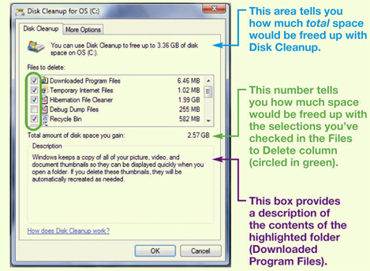

- Disk Defragmenter Utilities regroup related pieces of files together on the hard disk, allowing the OS to work more efficiently. Using the Windows Disk Defragmenter Analyzer feature, users should check their hard drive several times a year.
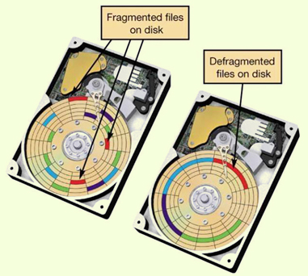

- Error checking, once known as ScanDisk, checks for lost files and fragments as well as physical errors on your hard drive. Sometimes error checking can remove the lost data, but more often, it deletes files that are taking up space unnecessarily.
- If a program in your system stops working, you can use the Windows Task Manage Utility to check on the program or to exit the non-responding program.

System Restore
- Windows has a utility called System Restore that lets you restore your system setting back to specific date when everything was working properly.

System Backup
- Backup
- Create a copy of hard drive to another storage device, such as a CD or an external hard drive.
- Task Scheduler
- Schedule tasks can run automatically at predetermined times, with no interaction necessary on your part.

Accessibility Utilities
- Windows Vista and 7 have created and Ease of Access Center, a centralized location for assistive technology and tools that adjust accessibility settings.
- Centralized location for assistive technology:
- High contrast.
- Magnifier.
- On-screen keyboard.
- Windows speech recognition.

MODULE 4 SUMMARY QUESTIONS:

- What software is included in system software?
- What are different kinds of operating systems?
- What are the most common operating systems?
- How does the operating system provide a means for users to interact with the computer?
- How does the operating system help manage resources such as the processor, memory, storage, hardware and peripheral devices?
- How does the operating system interact with application software?
- How does the operating system help the computer start up?
- What are the main desktop and Windows features?
- How does the operating system help me keep my computer organized?
- What utility programs are included in system software, and what do they do?

