Module 1: Looking at Computers; understand the parts

Computers are Data Processing Devices
Strictly defined, a computer is a data processing device that performs four major functions:
- It gathers data (or allows users to input data).
- It processes that data into information.
- It outputs data or information.
- It stores data and information.

Data VS. Information
- Data is a representation of a fact, figure, or idea. Data can be a number, a word, a picture, or even a recording of sound. For example, the number 6125553297 and the names Derek and Washington are pieces of data.
- Information is data that has been organized or presented in a meaningful fashion. When your computer provides you with a contact listing that indicates Derek Washington can be reach by phone at (612)-555-3297, the data mentioned earlier suddenly becomes useful – that is it becomes information.
*Input data processing (organizing information) into data using a database output information

Bits and Bytes: The Language of Computers
- Bit
- In order to process data into information, computers need to work in a language they understand. This language, called binary language, consists of just two digits: 0 and 1.
- Everything a computer does is broken down into a series of 0’s and 1’s is binary digit, or bit for short.
- Byte – eight binary digits (or bits) combines to create 1 byte.
Example…. 0000 1111

How much is a byte?
- Not only are bits and bytes used as the language that tells the computer what to do, they are also what the computer uses to represent the data information it inputs and outputs.
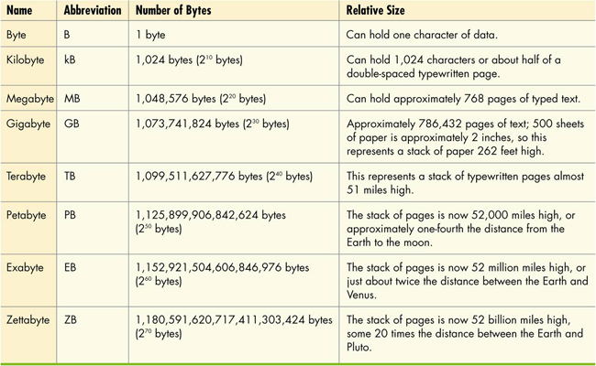
- Kilobytes, megabytes, and gigabytes are therefor simply amounts of bytes.

Computer Hardware
- Hardware: any part of a computer you can touch.
- Hardware components consist of the system unit and peripheral devices, such as monitors and printers that are connected to the computer.
- Other hardware devices, such as routers, help a computer communicate with other computers to facilitate sharing documents and other resources.
- Together the system unit and peripheral devices perform four main functions: they enable the computer to input data, process that data, output and store that data information.

Computer Software
- Software is a set of computer programs that enables the hardware to perform different tasks.
- There are two broad categories of software.
- Application software is a set of programs you use on a computer to help you carry out tasks. If you’ve ever typed a document, created a spreadsheet, or edited a digital photo, for example, you’ve used a form of application software.
- System software is the set of programs that enables your computers hardware devices and application to work together. The most common type of system software is the operating system (OS). It manages the computer system’s hardware – such as the monitor and the printer. The operating system also provides a means by which users can interact with the computer.

Types of Computers
- Basic computer designs
- Portable
- Notebook computers
- Notebook
- Tablet PC’S
- Stationary
- Desktop computers
- Mainframe: Supports hundreds of users simultaneously.
- Supercomputer: Performs complex calculations rapidly.
- Embedded: Self-contained computer performing dedicated functions.

Input Devices
- An input device enables you to enter data (texts, images and sounds) and instructions (user responses and commands) into the computer.
- The most common input devices are the keyboard and the mouse.
- You use keyboards to enter typed data and commands, whereas you use the mouse to enter user responses and commands.
- There are other input devices as well:
- Microphone
- Scanner
- Digital camera
- Stylus (devices that look like skinny pens that have no ink) and tablet

Keyboards
- The QWERTY layout is standard on most PC’S.
- Enhanced keyboard features include number, function, and navigation keys.
- Notebook keys have alternate functions when used in conjunction with the F (function) keys.

Specialty keyboards
- Virtual laser keyboard
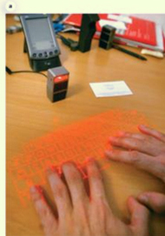

- Configural keyboard
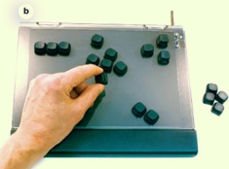

Mice
- Optical mouse
- Need no mouse pad
- Does not need cleaning
- Trackball
- Easier on wrists
- Stays stationary on desk
- Wireless mouse
- Sends data to the computer by radio or light waves
- Integrated pointing devices
- Touchpad
- Trackpoint
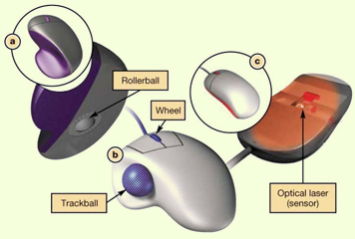

New mouse features
- Magnifier: pulls up on a magnification box that you can drag around the
- screen to enhance the viewing of hard-to-read images. People with visual disabilities can use this feature.
- Customizable buttons: extra buttons on the mouse can be programmed to perform the functions you use most often to help you speed through tasks.
- Web search: allow you to quickly highlight a word or phrase and then press the search button (on the mouse) to start a web search.
- File storage: includes a wireless USB receiver that contains flash memory to store or backup your files (for example, a USB drive).

Other Input Devices
- Game controllers
- Touch screens
- Digital pens (stylus and tablet)

Image Input
- Digital cameras, camcorders, and cell phones
- Pictures
- Videos
- Scanners
- Webcams
- Live videos

Sound Input
- Microphones are used for:
- Podcasts
- Video conferencing
- Internet phone calls
- Speech recognition

Input Devices for the Physically Challenged
- Visually impaired users can input data
- From voice recognition
- By using large keyboards
- Users with severe motor control problems can use:
- Special trackballs designed for one-finger use that can be mounted anywhere.
- Head-mounted pointing devices, when arm motion is severely restrained.

Output devices
- Output devices enable you to send processed data out of your computer. This can take form of:
- Text
- Pictures (graphics)
- Sounds (audio)
- Video
- One common output device is:
- A monitor, which displays text, graphics and video as soft copies (copies you can see only on-screen).
- A printer, which creates tangible or hard copies of text and graphics.
- Output devices make:
- Soft copies (video, sound, and control signals).
- Hard copies (print).

Monitor types
- LCD: Liquid crystal display
- Flat panel
- Light and energy efficient
- LED: Liquid-emitting diode
- More energy efficient that LCD monitors.
- Better colour accuracy and thinner panels.
- CRT monitors legacy technology

LCD Monitor Features
- Screens are grids made up of millions of tiny dots called pixels.
- Each pixel is composed of red, blue, and green sub-pixels (and sometimes yellow)
- Liquid crystal is sandwiched between two transparent layers to form images.

LCD quality factors
- Aspect ratio: the width-to-height proportion of a monitor.
- The most important factor to consider when choosing an LCD monitor is a resolution.
- Contrast ratio: a measure of the difference in light intensity between the brightest white and the darkest black that the monitor can produce.
- Viewing angle: how far you can move to the side of (or above or bellow) the monitor before the image quality degrades to unacceptable levels.
- Brightness: a measure of the greatest amount of light showing when the monitor is displaying pure white.
- Response time: the time it takes for a pixel to change color. The lower the response time, the clearer the moving images will appear.

Screen size
- 21-inch monitor 1680X10150 pixels.
- 19-inch monitor 1440X900 pixels/ 1280X1024 pixels.
- HD-DVD’S and Blu-ray movies require at least 1920X1080 pixels.

Printers
- Inkjet printers
- Spray tiny drops of ink onto a page.
- Laser printer
- Use laser beams and static electricity to deliver toner to page.
- All in one printers
- Plotters
- Thermal printers

Nonimpact Printers
Inkjet printer:
- Work by spraying tiny drops of ink onto paper.
- Less expensive device.
- Print high-quality colour images cost effectively
Laser printer:
- Often preferred for their quick and quiet production and high quality printouts.
- More expensive device.
- Over the long run, for high volume printing, laser printers are more economical that inkjet (they cost less per printed black and white page) when you include the price of ink and special paper on the overall cost.
- Recently, the prices have fallen, making them competitive with high-end inkjet printers.

Choosing a printer
- Speed (PPM): a printer’s speed determines how many pages it can print per minute (called pages per minute or PPM). Printing speeds range from 8 to 30 ppm for both laser and inkjet printers.
- Resolution (DPI): a printer’s resolution (or printed image clarity) is measured in dots per inch (DPI). The higher the DPI, the greater the level of detail and quality of the image. For general-purpose printing, 300 DPI is sufficient; for printing photos, 1200 DPI is better.
- Colour Output: some printers come with a single ink cartridge for all colors; others have two ink cartridges, one black and one for colour. The best setup is to have individual cartridges for each colour, so you can replace only specific ink cartridge that empty.
- Use and cost: if you will be printing mostly black and white, text based documents or will be sharing your printer with others, a black and white laser printer is best because of its printing speed and overall economies for volume printing. If you’re planning to print color photos and graphics, and inkjet printer or colour laser printer is a must, even though the cost per page will be higher.
- Cost and consumables: you should investigate carefully the cost of consumables (printer cartridges and paper) for any printer you are considering purchasing.

The Motherboard
- The motherboard is the circuit board holding the essential processing parts.
- Attached directly to the mother board are the:
- CPU
- RAM
- Expansion card and slots
- Built in components
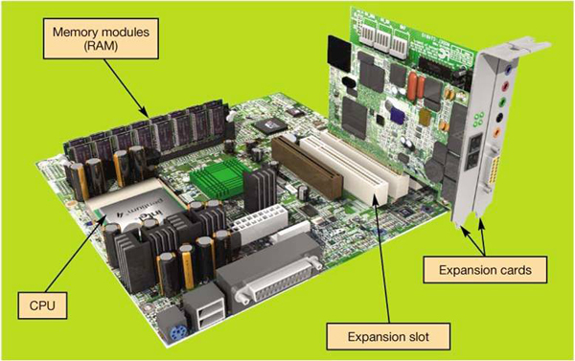

Ram VS. Rom
- Random access memory (RAM)
- Stores instruction and data
- Temporary (volatile) storage
- Consists of several memory cards or modules
- Read-only memory (ROM)
- Stores start up instructions
- Permanent storage

Central processing unit (CPU)
- Referred to as the brains of the computer because it controls all the functions performed by the computers other components.
- Controls all functions of the computer
- Processes all commands and instructions
- Can perform billions of tasks per second without error, making them extremely powerful components.

CPU Performance Measures
- Speed megahertz (MHz) / gigahertz (GHz)
- Cores single, dual and quad
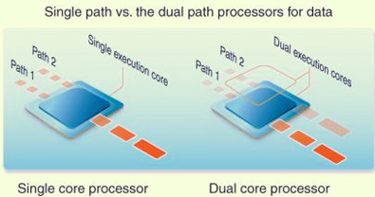

Drive Bays
- Internal drive bays:
- Cannot be seen or accessed from outside the system unit.
- Are reserved for internal hard drives.
- External hard drives:
- Can be accessed from outside the system unit.
- House CD and DVD drives are covered by a faceplate.
- Floppy and zip drives (legacy technology)

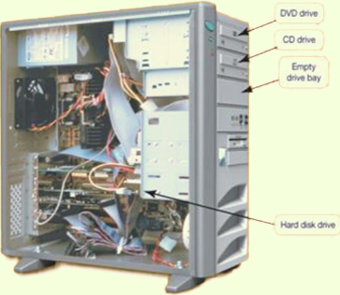

Hard Drive
- Hard drive is your computers primary device for permanent storage of software and documents.
- The hard drive is a nonvolatile storage device; meaning that it holds the data and instructions your company needs permanently, even after computer is turned off.
- Originally, all hard drives were installed in the system unit. Today external hard drives are readily available.

Optical Storage

- Compacts discs (CDS)
- Digital video discs (DVDS)
- Blu-ray discs (BDS)

Flash Drives and Flash Memory
- Flash drivers (sometimes referred to as jump drives, USB drives, or thumb drives)
- Are the new alternatives to storing portable data.
- Plug into USB ports.
- Flash memory cards
- Slide into the slots in the system
- Solid state (SSD) hard drives

Types of Ports
- USB
- Serial and parallel
- Audio and video
- Fire wire
- Connectivity
- Ethernet
- Modem
- HDMI
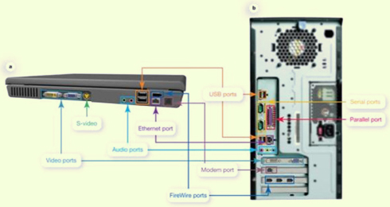

Adding Ports
- Expansion cards
- New port standards
- Expansion hubs
- Enable several devices to be connected to one port

Power Controls
- Power-on button on the front panel: although you see this button to turn on your system, you do NOT want to use it to turn off your system, you turn off the power by clicking on a shutdown icon on the desktop.
- Cold boot: powering on your computer from fully turned off state.
- Other options:
- Sleep mode: all the documents and data you were using are stored in RAM, from which they are quickly accessible upon restarting your computer.
- Hibernation: another power saving mode that stores your data in memory and saves it to you computers hard disk.
- If your using windows 7, you can restart the computer when you click the right arrow on the start menu. This is called a warm boot. You might need to perform a warm boot if the operating system or other software application stops responding or if you have installed new programs.

Setting it all up: Ergonomics
- In terms of computing, ergonomics refers to how you set up your computer and other equipment to minimize your risk of injury or discomfort.
- The following are some guidelines that can help you avoid discomfort, eyestrain, or injuries while working at your computer.
- Position your monitor correctly. This should be at least 25 inches from your eyes and at eye level or so that it is at angle 15 to 20 degrees below your line of sight.
- Purchase and adjustable chair. Adjust the height of your chair so that your feet touch the ground. The chair should include back support.
- Assume proper position while typing. Your wrist should be flat with respect to the keyboard, and your forearms should be parallel to the floor. Specially designed ergonomic keyboards and wrist rest can help you achieve the proper position for your wrists.
- Take a break from computer tasks.
- Ensure lighting is adequate.

MODULE 1 SUMMARY QUESTIONS:
- What exactly is a computer and what are its four main functions?
- What is the difference between data and information?
- What are bits and bytes and how are they measured?
- What devices do you use to get data in the computer?
- What devices do you use to get information out of the computer?
- What is on the motherboard?
- Where are information and programs stored?
- How are devices connected to the computer?
- How do you set up your computer to avoid strain and injury?

MODULE 2: USING THE INTERNET THE MOST OF THE WEBS RESOURCES
History of the Internet
- Developed for secure military communications.
- Evolved from advanced research projects agency network (ARPANET).
- Funded by the U.S. government in the 1960’s.
- Enabled computers at leading universities and research organizations to communicate with each other.

The Web Vs. the Internet
- The web is part of the internet, distinguished by:
- Common communication protocols.
- Navigation links.
- 1989: Web invented by Tim Berner-Lee.
- 1993: Mosaic browser released.
- 1994: Netscape navigator marked beginning of all the webs major growth.
- 1997: Internet access global.

Internet Communications
- Forms of internet-based communication include:
- E-mail
- Instant messaging
- Group communication
- Social networking
- Web logs and video logs
- Wikis
- Podcasts
- Webcats

E-mail
- Electronic mail.
- Asynchronous communication
- Types of e-mail accounts:
- Client-based (requires client-mail software).
- Web based (does not require software).
- Not private
- Can be printed or forwarded
- Can be monitored by employers

E-mail etiquette
- Be concise and to the point.
- Use spell check.
- Avoid texting abbreviations.
- Include meaningful subject line.
- Use smiles (emoticons) sparingly to convey emotion.
- Include signature line with contact information.
- Do not type in all capital letters, which is interpreted as shouting.

Instant Messaging
- Instant messaging (IM) uses real-time text based conversations, similar to chat rooms.
- Users set up a list of contacts often called a buddy list.
- Contacts must be online to participate.
- IM software detects the presence of members who are online.
Example… AOL messenger

Group communication
- There are many ways you can interact with a wide variety of people online.
- Chat rooms
- Newsgroups
- Blog and Vlogs
- Wikis
- Podcasts and Webcasts
- Social networks

Chat Rooms and News Groups
- Chat rooms
- Real time text-based conversations.
- Can focus on specific topics or interests or be general interest.
- Username can allow anonymous interaction.
- Newsgroup
- Online discussion forum.
- Members post and reply to messages.
- Create or respond to “threads”.

Netiquette
- Introducing yourself when entering a chat room.
- Specifically address the person to whom you are talking.
- Refrain from swearing, name-calling, and using explicit or prejudicial language.
- Do not post the same text repeatedly with the intent to disrupt the chat, that behavior is called flooding.

Wen 2.0
- Web interactions among people, software and data.
- Social web where the user is also a participant.
- New applications that combine the functions of multiple applications.

Social Network
- Used to communicate and share information among immediate friends, meet and connect with others through common interests, experiences and friends.
Example…. Myspace.com and Facebook.com
- Members communicate by voice, chat, IM, and videoconference.
- Growth has been explosive.

Blogs and Vlogs
- Personal journals posted on the web.
- Weblogs (Blogs):
- Primarily text based.
- Simple to create, read and manage.
- Entries listed on single page, with most entries at the top.
- Searchable.
- Video blogs (Vlogs):
- Digital clips playable on media player software.

Wikis
- Wikis: website that allow anyone to edit/change their content.
- Provide a source for collaboration writing.
- Eliminate exchanging e-mails.
- Track revisions.

Podcasts
- Podcasts: compressed audio or video file distributed on the Internet.
- Really simple syndication (RSS) technology allows constant updates for subscribers.
- Podcasts are all over the web.
- Need aggregator software to gather podcasts.
- Need media player software to play them.
- Simple to create.

Webcasts
- Webcasts: broadcasts of audio or video content over the Internet.
- Often live.
- Delivered to your computer.
- Using streaming media

Twitter
- Social networking and micro-blogging service that enables you to exchange short text messages in real time with your friends or “followers”.
- Twitter messages, called tweets, are limited to 140 characters.
- Businesses are using twitter to respond to customer queries or to broadcast new services or products.

Web entertainment
- Multimedia is anything that involves one or more forms of media in addition to a text.
- All kinds of multimedia are available on the web and involve for of media and text.
- Graphics
- Audio
- Video
- Streaming audio and video can deliver on demand pictures and sounds. Sites like CNN.com offer clips from their broadcasts.
- Games
- Multiplayer online games.
- Interact with other players.

E-commerce
E-commerce grows in importance everyday, with billions of dollars worth of transactions.
- In business-to-commerce (B2C) transactions, such as amazon.com, the end buyer purchases goods or services over the Internet.
- In business-to-business (B2B) transactions, businesses sell to on another.
- In consumer-to-consumer (C2C) transactions, like ebay.com, consumers sell to another.

Secure Websites
- Online transactions can be safer than traditional retail shopping.
- VeriSign is a company that certifies that online transactions are secure. Businesses hire security companies such as VeriSign to certify that their online transactions are secure. Thus, if a website displays the VeriSign seal, you can usually trust that the information you submit to this site is protected.
- Another indication that a website is secure is the appearance of a small icon of a closed padlock (IE) or keys (NETSCAPE) on the status bar at the bottom of the screen.
- In addition, the beginning of the URL changes from http:// to https://, the S standing for “secure”.

Online shopping guidelines
To shop safely online follow these guidelines:
- Shopping at well known reputable sites helps ensure a safe shopping experience. If you are not familiar with a site, check it out with the better business bureau, and also make sure that the company has a phone number and street address before ordering from it.
- Avoid making online transactions when using public computers.
- Pay by credit card and not by debit card. Debit cards do not have the same level of protection as credit cards under the U.S. federal consumer credit card laws. Use a card with a small limit or consider using a pre-paid credit card.
- Check and print out the return policy. You may need it when filing a complaint to prove what the policy showed at the time of your order. Websites can be changed easily and rapidly and can also be shutdown overnight.

Web browsers
- A web browser is software installed on your computer system that allows you to locate, view and navigate the web.
- Graphical.
- Enable web navigation.
- Popular browsers:
- Microsoft internet explorer
- Mozilla Firefox
- Apple safari
- Google chrome

Browser features
- Quick tabs show thumbnail images of all open webpages in open tabs.
- With tabbed browsing, web pages are loaded in “tabs” within the same browser window. Rather than having to switch between web pages on several open windows, you flip between tabs in one window.
- The browser also includes a built-in search box in which you can designate your preferred default search engine. Tools for printing, page formatting and security settings are allocated to a special toolbar.
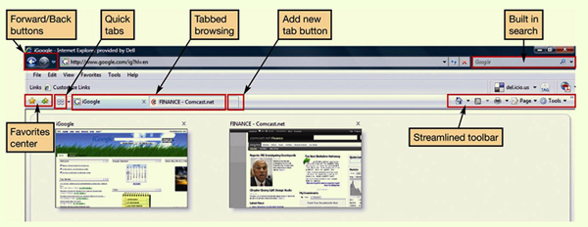

URLS
- A URL is a websites address. It is composed of several parts that help identify the web document it stands for.
- Uniform resource locator.
- Unique website address.
- The first part of a URL indicates the set of rules (or protocol) used to retrieve the specified document. HTTP is most common. Another popular protocol is FTP.
- The protocol is generally followed by a colon, two forward slashes, www (indicating world wide web), and then the domain name. The domain name is also referred to as the host name. At times a forward slash and additional text follow the domain name. The information after the slash indicates a particular file or path (subdirectory) within the website.
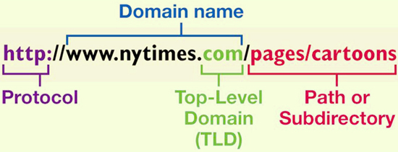

Top-Level Domains
- .biz business
- .com originally for commercial sites but can be used for anyone now
- .edu degree-granting institutions
- .gov united states government
- .info information service providers
- .mil united states military
- .name individuals
- .net originally for networking but no longer restricted
- .org organizations (often non-profits)

Hyperlinks
- Once you’ve reached a website, you can jump from one page to another within the website or to another website altogether by clicking on specially coded text called hyperlinks.
- When programming HTML, the web page author can code any word or image to be a hyperlink.
- Generally, text that operates as a hyperlink appears in a different colour (often blue) and/or is underlined. Sometimes images can also be hyperlinks.
- When you pass your cursor over a hyperlink, the pointer turns from arrow into a hand. To retrace your steps, some sites also provide a breadcrumb list – a list of pages within a website that have visited that usually appears at the top of the page.
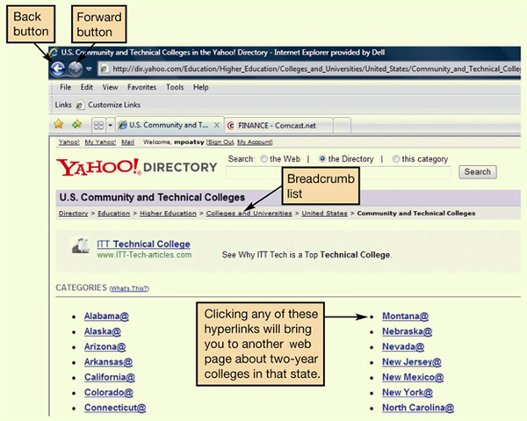

Favorites and Bookmarks
- Allow you to return to webpages
- IE and Safari favorites
- Firefox and Chrome bookmarks
- Stay up to date
- Live bookmarks Firefox
- Organize and share
- Social bookmarking sites: websites such as del.icio.us and dig.com provide proprietary toolbars and tagging tools that incorporate into your web browser and you to tag and organize websites using your own keyboards.

Popular Search Sites

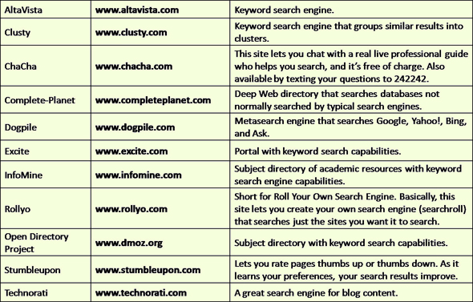

Search Engines
- User types word or phrase into search box.
- Spider or web crawler program scans we pages.
- Results are indexed and sent to the client.
- Different engines produce different hit lists.
- Multimedia search functionality is also available.

Improve search results
- Place quotation marks around phrases.
- Search within specific website.
- Enter wild card symbols.
- Use the advanced search form.

What can you borrow from the web?
- Avoid:
- Plagiarism: representing someone else’s ideas or words as your own.
- Copyright violation: using another person’s material for your own economic gain.
- Properly credit information you quote or paraphrase.
- Obtain written permission from copyright holder.

Evaluating Websites
- Evaluating the content of a website is important. Before you believe what the site says or take action based on the information presented, several questions need to be answered.
- Who is the author of the article or website sponsor?
- Is the site biased?
- Is the information current?
- Towards what audience is the site geared?
- Are links available?
- The same information should exist on at least three different websites.

Internal Client Server
- The Internet is a client/server network.
- Thus, a computer connected to the internet acts in one of two ways:
- Client computer
- Users connected to the Internet.
- Requests data and web pages.
- Server computer
- Stores webpages and data.
- Returns the requested data to the client.
- Internet backbone
- IP addresses are the means by which all computers connected to the Internet identify each other.

Connecting to the Internet
- Take advantage of the resources the Internet offers; you need means to connect your computer to it. Home users have several connection options.
- Originally, the means to connect to the Internet was with a dial-up connection. With dial-up connections, you connect to the Internet using a standard telephone line.
- However, other connection options, collectively called broadband connections, offer faster means to connect to Internet.
- DSL
- Cable
- Fiber-optic server
- Satellite

Broadband Connections
- Cable Internet
- Uses coaxial cable and a cable modem
- Fast connection speed.
- Speed depends on number of users.
- Not available in all areas.
- Digital Subscriber Line (DSL)
- Uses telephone lines.
- Faster than dial-up.
- Does not tie up phone line.
- Requires special DSL modem.
- Not available in all areas.
- Satellite
- Uses satellite dish and coaxial cable.
- Slower than cable or DSL.
- Expensive.

Wireless access
- Increases mobility and productivity.
- Requires Wi-Fi hotspot.
- If device is not wireless ready, wireless adaptors are available.
- Air cards provide wireless access through mobile devices when Wi-Fi hotspot is unavailable.

Dial-up Connections
- Use standard telephone line.
- Tie up phone line.
- Require a modem to convert analogue and digital signals
- Slowest connection speed (56KBps)
- Modern computers have internal modems built into the system unit.
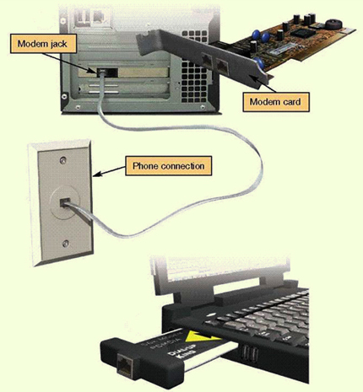

Comparing Internet Connection Options
- DSL
- Average download speed 1.5MBps.
- Maximum download speed of 7MBps.
- Lets you access the Internet and talk on the same phone line simultaneously.
- Speed drops as you get farther from the phone companies central office.
- Not available on every phone line.
- Cable
- Average download speed of 5MBps.
- Maximum download speed of 30MBps.
- Speed is not dependent on distance from central office.
- Line is shared with others in the neighborhood.
- Speeds may very due to peak/non-peak usage.
- Might require professional installation if cable is not already present.
- Fiber Optic
- Average download speed of 20MBps.
- Maximum download speed of 50MBps.
- Increased speed.
- Service not shared or dependent on distance from central office.
- High cost, but becoming lower as the technology continues to be deployed.
- Not available in all areas.

Future of the Internet
- Large-scale networking (LSN).
- Research and development of cutting-edge networking and wireless technologies.
- Internet 2
- Project sponsored by universities, government and industry to develop new Internet technologies.
- Internet 2 backbone supports transmission speeds of up to 8.8Gigabites per second.
- Internet entrenched in daily life.
- Web based services for professional and personal interactions.
- Internet-enabled appliances and systems.

MODULE 2 SUMMARY QUESTIONS:
- What is the origin of the Internet?
- How can I communicate through the Internet?
- How do I communicate and collaborate using web 2.0 technologies?
- What are the various kinds of multimedia files found on the web and what software do I need to use them?
- What is e-commerce and what e-commerce safe guards protect me when I am online?
- What is a web browser, what is a URL and what are its parts?
- How can I use hyperlink and other tools to get around the web?
- How do I search the Internet effectively and how can I evaluate websites?
- How does data travel on the Internet?
- What are my options for connecting to the Internet?

